Designing and construction of Kurtis for adults by Batik printing using crayons

By
PRATHEEPA. R
(15PTF007)

A Thesis submitted to the
Avinashilingam Institute for Home Science and Higher Education for
Women, Coimbatore-641 043

In Partial Fulfillment of the Requirements for the Degree of
Master of Science
in
Textiles and Fashion Apparel

April, 2017

Designing and construction of Kurtis for adults by Batik printing using crayons

By
PRATHEEPA. R
(15PTF007)

A Thesis submitted to the
Avinashilingam Institute for Home Science and Higher Education for
Women, Coimbatore-641 043

In Partial Fulfillment of the Requirements for the
Degree ofMaster of Science
in
Textiles and Fashion Apparel

April,2017

Certified as Bonafide Research Work

Signature of the Signature of the Guide
Head of the department

ACKNOWLEDGEMENT

The investigator places her humble salutations and prayer to the ALMIGHTY GOD for his uncountable blessings showered upon her throughout the study.
The investigator expresses her sincere thanks to the former chancellor of Avinashilingam Institute for Home Science and Higher EDUCATION for women,Coimbatore, and AYYA THIRU.Dr. T .S. AVINASHILINGAM and HONY. COL.PADMASHRI,AMMA, Dr. (Tmt). RAJAMMAL P. DEVADAS,M.A., M.Sc., Ph.D. (ohio state), Hon. D.SC. (Azad Agri. University, Kanpur), for heavenly blessing.
The investigator expresses her sincere thanks to PadmashriDr.P.R.KRISHNAKUMAR ,ChancellorofAvinashilingam Institute for Home Science and Higher Education For Women, Coimbatore, for providing the infrastructural facilities for the conduct of the study.
The investigator is indebted to Dr. (Mrs.) PREMAVATHY VIJAYAN, M.Sc.,M.Ed.,Dip.spl.Edn.M.Phil.,Ph.D., Vice-Chancellor of Avinashilingam Institute for Home Science and Higher Education For Women, Coimbatore, for providing all the amenities required for the conduct of the study.
The investigator records her gratitude to Dr. (Mrs) S.KOWSALYA, M.Sc., M.Phil., Ph.D., Registrar, Avinashilingam Institute for Home Science and Higher Education For Women, Coimbatore, for providing all the help for the smooth conduct of the study.
The investigator records her respectful and tribute to Dr.(Tmt) N.VASUGI RAAJA, M.Sc., M.B.A., M.Phil. (Madras), Ph.D., Dean , Faculty Of Home Science, Professor Department Of Textiles And Clothing, Avinashilingam Institute for Home Science and Higher Education for Women, Coimbatore, for constant support , guidance and encouragement which have helped in the successful completion of this study.
She express her respectful regards and sincere thanks to
Dr. (Tmt) S.AMSAMANI, M.Sc., M.Phil., Ph.D., Professor and Head of the Department, Department Of Textiles And Clothing, Avinashilingam Institute for Home Science and Higher Education for Women, Coimbatore, for rendering all helps needed for the successful completion of the study.
The investigator feels extremely proud and privileged for having worked under the guidance of her esteemed guide Dr.(Tmt) U. RATNA, M.Sc., M.Phil, Ph.D., Assistant Professor, Department of Textiles And Clothing, AvinashilingamInstitute of Home Science and Higher Education for Women, Coimbatore, for her constant motivation, keen interest, restless support, untiring patience, innovative ideas, suggestion, constant love and easy approach throughout the study.
She also wishes to thank all the TEACHING AND NON TEACHING STAFF of the department who helped her to carry out the research work.She is also thankful to Avinashilingam Institute of Home Science and Higher Education for Women, Coimbatore,, for providing tests laboratory and library facilities.
The investigator gratefully acknowledges the encouragement, timely help and support received from her friends. She expresses her deepest sense of gratitude to her Beloved Parents,Friendsandspecial thanks to her sister Preethma. Rfor extending their support without them the study would never have seen the light of the day.

LIST OF CONTENT
CHAPTER NO. TITLE PAGENO
List of tables
List of Figures
List of Plates
List of Appendix
I Introduction10
  - Objectives 12
IIReview of literature13
2. Fashion 14
2.1. Fashion design 15
2.1.1. Types of fashion 15
2.1.1.1. Haute couture 15
2.1.1.2. Ready to wear 16
2.1.1.3. Mass market 16
2.2. Design 16
2.2.1. Classification of design 17
2.2.1.1. Structural design 17
2.2.1.2. Decorative design 17
2.3. Principles of design 17
2.3.1. Balance 18
2.3.2. Proportion 18
2.3.3. Rhythm 19
2.3.4. Emphasis 19
2.3.5. Harmony 20
2.4. Elements of design 20
2.4.1. Line 20
2.4.2. Shape/form 21
2.4.3. Texture21
2.4.4. Colour 21
2.4.4.1. Hue 22
2.4.4.2. Value 22
2.4.4.3. Intensity 22
2.5. Textile design 22
2.6. Colour theory 22
2.6.2. Prang colour system 23
2.6.2.1. Primary colours 23
2.6.2.2. Secondary colours 23
2.6.2.3. Tertiary colours 23
2.7. Colour harmonies 23
2.7.1. Monochromatic colour harmony 23
2.7.2. Analogous colour harmony 23
2.7.3. Complementary colour harmony 24
2.7.4. Double complementary coloury harmony 24
2.7.5. Split complementary coloury harmony 24
2.7.6. Triad coloury harmony 24
2.7.7. Tetrad coloury harmony 24
2.7.8. Neutral colour harmony 24
2.8. Motifs 25
2.8.1. Introduction 25
2.8.2. Classification of motifs 25
2.8.2.1. Geometric motifs 25
2.8.2.2. Stylized motifs 25
2.8.2.3. Naturalistic motifs 26
2.8.2.4.Ethnic motifs 26
2.8.2.5. Abstract motifs 26
2.8.2.6. Floral motifs 26
2.9. Kurti 27
2.9.1. Introduction 27
2.9.2. History 27
2.9.3. Types of kurti 27
2.9.4. Styles of kurtis 28
2.10. Khadi fabric 29
2.10.1. History 29
2.10.2. Types of khadi 30
2.10.3. Properties of khadi 30
2.10.4. Present status 31
2.11. Printing 31
2.11.1. Textile printing 31
2.11.2. Styles of printing 32
2.11.2.1. Direct printing 32
2.11.2.2. Resist printing 32
2.11.2.3. Discharge printing 32
2.11.3. Methods of printing 32
2.11.3.1. Hand block printing 33
2.11.3.2. Screen printing 33
2.11.3.3. Tie dyeing 33
2.11.3.4. Batik printing 33
2.11.4. Types of batik printing 34
2.11.5. Crayon batik 35
III Experimental procedure 36
3.1. Selection of subject 37
3.1.1. Preference of age group 37
3.2. Conduct of survey 37
3.2.1. Selection of the sample 38
3.3. Design development through manual sketching 38
3.3.1. Selection of motif 38
3.3.2. Preparation of theme based sketching 39
3.3.3. Selection of theme based sketching 39
3.3.4. Computer aided designing 40
3.4. Standardizing body measurement 41
3.4.1. Taking body measurement 41
3.4.2. Grouping of body measurement 42
3.4.3. Standardizing the body measurement 42
3.5. Selection of fabric 42
3.5.1. Preparation of fabric for printing 43
3.5.2. Selection of tools used for printing 43
3.6. Printing procedure 44
3.6.1. Preparation of wax for batik printing 44
3.6.2. Printing on fabric 44
3.6.3. Removal of wax 45
3.7. Construction of kurti 45
3.7.1. Preparation of basic pattern for kurti 45
3.7.2. Preparation of fabric for cutting 45
3.7.3. Layout, transferring and cutting of fabric 45
3.7.4. Construction of kurti 46
3.8. Nomenclature 48

IV RESULT AND DISCUSSIONS 49
4.1. Consolidated rating of manual sketching 51
4.2. Opinion of the adult girls regarding the handloom fabrics 52
4.3. Standardizing the body measurement of the adult girls 53
4.4. Evaluation of constructed outfits 54
4.4.1. Evaluation of fitness of the outfit 54
4.4.2. Evaluation of constructed outfit 55
4.4.3. Cost estimation of the garment 57
V SUMMARY AND CONCLUSION 58
VI BIBLIOGRAPHY 62
VII APPENDIX 67

NO LIST OF TABLES PAGENO
3.4.2. Grouping of body measurement 42
3.8. Nomenclature 48
4.1 Consolidated rating of manual sketching 51
4.2. Opinion of adult girls regarding the handloom fabrics 52
4.3. Standardizing the body measurement of adult girls 53
4.4.1. Evaluation of fitness of the outfits 54
4.4.2. Evaluation of constructed outfits 55
4.4.3. Cost estimation of the garment 57

NO LIST OF FIGURES PAGENO

4.2. Opinion of adult girls regarding the handloom fabrics 52
4.4.1. Evaluation of fitness of the outfits 54
4.4.2. Evaluation of constructed outfits 56

NO LIST OF PLATES PAGENO
1. Prepared motifs 38
2. Prepared manual sketches 39
3. Prepared CAD designs 40
4. Printing on fabric 44
5. Finished garments 48

NO LIST OF APPENDIX PAGENO
- Schedule used to find out the opinion of adult girls 68
regarding the handloom fabrics
- Fabric swatch 69
3. Standardizing of the bust circumference 70
4. Construction of basic bodice 71
5. Evaluation of fitness of the outfits and constructed outfits 73

INTRODUCTION

I Introduction
Fashion is the state of mind. It is a spirit, an extension of one’s self. Fashion is a way of expressing one self. It’s a way celebrating the diversity and variety of the world in which we live. Fashion is about change that makes life interesting (Ezekiel, 2005).
The term fashion symbolises a characteristic means of expression or presentation. Fashion may follow trend, in which they gain or lose popularity. Fashions are social psychology phenomena common to many fields of human activity and thinking. Although that concept frequently applies to clothes and other aspects of appearance. Fashion exists in the intricacies of aesthetics with innovation, couples with pleasing detail. Design is the process can take many forms depending on the object being designed and the individual or individuals participating (McClaud, 2006).
Designs of various types can be inspired from a variety of sources like nature or from the folk arts and crafts such as wall paintings, floor paintings, sculptures, carvings etc. They can also be created through adaptation of a specific design base. The rich motifs and design of the existing arts and crafts can be readily adapted into contemporary forms in an attempt to make them suitable to incorporate them into textile products (Rani,2012).
Khadi or khaddar is a term used for hand spun and hand woven cloth from India mainly made out of cotton. In India, khadi is not just a cloth, it is a whole movement started by Mohandas KaramchandGadhi. The khadi movement promoted a socio-cultural aesthetics, an ides that Indians could be self-relient on cotton and be free from foreign clothing. The khadi movement aimed at boycotting foreign goods and promoting Indian goods, thereby improving India’s economy khadi is being promoted in India by khadi and village industries commission. (www.chandrakantalrks.org/khadi/Historical-Background-khadi.hml).
Textile printing is the process of applying colour to fabric in definite patterns or designs. In properly printed fabrics the colour and friction bonded with the fabric, so as to resist washing and friction. In printing, wooden blocks stencils, engraved plates, rollers or silk screen are used to place colours on the fabric. Colorants used in printing contain dyes thickened to prevent the colour from spreading by capillary attraction beyond the limits of the

pattern or design. Traditional textile printing techniques may be broadly categorized in three styles such as direct printing, resist printing and discharge printing (Mishra, 2012).
Batik involves the application of hot wax to resist colour application in specified areas. The wax is applied by hand depending on the designs and is then left to harden. The fabric then piece dyed and the hardened wax prevents the penetration of colour into the waxed areas. The spaces where white colour is to be retained are waxed first. Then, the first dyeing is carried out in the lightest colour. The spaces are then waxed to retain the light colour and then the fabric is dyed in second colour. The wax is later removed to get the batik printed fabric. Wax removal from the fabrics is a slow and time consuming process (Kaur, 2010).
The kurtis are usually short and are worn in the summer month are usually made of thin silk or cotton fabric. As the kurtis are comfortable for the college going girls and these are frequently worn by the girls (http://en.wikipedia.org/wiki/kurta).

    - Objectives
- To design the kurti styles.
- Standardize the body measurement for kurti
- Developing the basic pattern for kurti.
- To print the fabric with crayons for batik printing.
- Construction of kurti
- Evaluation of finished outfits.

REVIEW OF LITERATURE

II REVIEW OF LITERATURE
The review of literature pertaining to the title “Designing and construction of Kurtis for adults by Batik printing using crayons” are discussed under the following headings.
2) Fashion
2.1. Fashion design
2.2. Design
2.3. Principles of design
2.4. Elements of design
2.5. Textile design
2.6. Colour theory
2.7. Colour harmonies
2.8. Motifs
2.9. Kurti
2.10. Khadi fabric
2.11. Printing
2) Fashion
The term “fashion” is frequently used as a synonym for glamour and style. In this sense fashions are a sort of communal art, through which a culture examines its notions of beauty and goodness. ( Pundir, 2007).
Fashion is most commonly associated with clothing, but it even applies to anything from interior architecture, to models of toys. It is a spirit, where an individual is comfortable with his mode of clothing and converts this comfort into a personal style. It is a way of measuring mood that can be useful in many aspects, culturally, socially even psychologically. Perhaps the most distinctive quality about the fashion since the early times is

that it is increasing in simplicity.However, fashion is commonly used to describe a style of clothing worn by most people of a country.Each season does bring into fashion a particular colour and style. The trend of the sixties and seventies are in with the gypsy style being a preference.
Fashion is something we deal with every day. And one thing which is certain in the fashion world is change. More and more designers are drawing their inspiration from life on the street. Thus from various surveys one can say that India has about three categories of buyers.
- The hi-class, people who are fashion conscious and who go for labels and name. Instead of the budget, they are more interestedin designer clothing.
- The upper middle class people who are fashion conscious and who make it a point to stay up to date with the going fashion trends.
- The last and final category consists of the youth, corporate group, who look out for regular wear clothesline and are budget conscious.(Tyagi 2012).
2.1. Fashion design
Fashion design is the applied art dedicated to the design of clothing and lifestyle accessories created within the cultural and social influences of a specific time. Fashion design differs from costume design due to its core product having a build in obsolescenceusually of one to two seasons. (Pundir 2007).
2.1.1. Types of fashion
The garments produced by clothing manufacturers fall into three categories, although these may be split up into additional, more specific categories.
      - Haute couture
Haute couture refers to the creation of exclusive custom fitted clothing. Haute couture is made in order for a specific customer and it is usually made from high quality expensive fabric and sewn with extreme attention to detail and finished by the most experienced and capable seamstresses. Often using time consuming, hand executed techniques. “Couture” means dressmaking, sewing, or needlework and is also used as a

common abbreviation of haute couture and refers to the same thing in spirit “Haute” meanselegant or high. A haute couture garment is made specifically for the wearer’s measurements and body stance. (Tyagi 2012)
      - Ready to wear
Ready-to-wear clothes are a cross between couture and mass market. They are not made for individual customers, but great care is taken in the choice and cut of the fabric. Clothes are made in small quantities to guarantee exclusivity, so they are rather costly. (Pundir, 2007).
      - Mass market
The mass market is the general business term describing the largest group of consumers for a specified industry product. The mass market is the group of consumers who occupy the over whelming mass of a bell curve for common household products i.e. they could be tagged as being “average”. Yet, this group consists of such a wide variety of people their desires towards a certain process may be totally different from each other’s. (Tyagi 2012).
  - Design
Design is the plan intended for some definite purpose. A design may be anything to which a man has put his mind or talent to change or organize natural material. Designing is a cardinal human act whenever we do something for a definite purpose (Neelima 2012). Designs are of great importance when it comes to give an enchanting and intriguing look to the textile products. They play a vital role in bringing about a drastic change in appearance of different items produced by the textile industry. A fabric or cloth with designs is capable of having a more captivating impression than the ones without them. (Rani, 2012).Design has different connotations in different fields. In some cases, the direct construction of an object is also considered to be design. (http://en.wikipedia.org/wiki/design)
The pattern on the fabric has always been an important part of our surroundings. As a two dimensional art commercial textile design has little message very unlike graphic design. However its prime intention has always been apparent in its most obvious form that is the embellishment of surface decoration. This surface designing can be achieved by:

- Drawing from a source of ideas and figurative are abstract design.
- By use of geometric motif, repeated to create a pattern(motif repeat).
- By use of colour, one of the most attractive modes of surface decoration drawn from principles of art and design(dying).
- By the use of print media, creation of patterns by applying colours in pre-determined area(printing).
- By the use of yarn interlacement order, to create self-designs, or coloured extra warp and weft figuring through weave media(weaving). (Naik Et. al, 2009).
2.2.1. Classification of design
2.2.1.1. Structural design
It is one of the most important means of identification which represents the fundamental character of the article under consideration. Structural design is also includes colour, texture of the material from which the article has been formed. As Goldstein says structural design is defined as the design made by the size, form, colour and texture of an object worked out on paper.
A design is a garment comprises the basic lines within the dress, since the dress is to be worn on a human figure its line should suggest some relationship with the lines of the figure and the dress
2.2.1.2. Decorative design
This is the surface enrichment of structural design. Any lines, colours or materials that have been applied to a structural design for the objective of adding a richer quality to it, constitutes its decorative design. Decorative design adds to the luxury of design, e.g, frills, belts, tucks, embroidery, pockets etc. a decorative design to the garment is not necessary. Beautiful decorative effects in dress may be obtained through the use of well-planned tucking or bands. (Neelima, 2012).

2.3. Principles of design
Designing basically involves giving form to a particular idea by keeping into mind the different aspects of designing such as proportion, flow, balance etc. it is ultimately the end result, which has to be seen and admired. (Davis, 2008).
2.3.1. Balance
In clothing balance refer to a visual attribution of weight, from a central area. Balance implies a sense of equilibrium. Pleasing balance brings about a satisfying relationship among all design parts to produce visual harmony. In clothing designs, three kinds of balance are observed.
- Formal balance
- Informal balance
- Radial balance. (Sumathi, 2005)
      - Formal balance
Formal balance results when objects of equal weight are placed on each side and of the equal distances from the centre, when they are identical the balance is formal or symmetrical. Formal balance gives a feeling of neatness, strength, straight for wardness, thus it seems suitable for tailored clothes which have same pockets, tucks or darts on one side as on the other. (Swami, 2011).
      - Informal balance
An informal balance that is attention attracting and dynamic. The modern feel an asymmetrical design creates its complex and takes skills to distribute the blank space. (Khurana, 2012).
      - Radial balance
Occurs when major part of the design radiate from the central part. Formal balance is the least expensive to produce apparel in mass production. Informally balanced garment is more difficult to produce. For each section of the garment cuts will have to be probably handled differently. (Sumathi, 2005).
2.3.2. Proportion
Pleasing relationship of area sometimes referred to as scale. The relative length of two parts of a garment is termed as proportion. The degree and method of subordinating some part of design to other is shown as proportion. (Davis, 2008).

2.3.3. Rhythm
It is that quality of design which imports, graceful, flowing movement throughout the design. The process of leading the eye from one part to the other in a design is termed as rhythm.
      - Repetition
Repetition or a sense of movement, is necessary to create interest in a design and to carry out the central theme. This can be achieved by the repetition of lines, shapes, and colours. We can see a rhythm of lines and shapes in repetition of pleats, gathers etc. The use of repetition is one of the most helpful guidelines in designing. (Frings, 2005).
      - Gradation
Rhythm may also be developed when there is orderly arrangement of details according to size. This is rhythm by means of gradation. The details are arranged from small to large; from light to dark, and from bright colours to dull ones. Colour gradation is very forcible and effective and is achieved where tones are carefully blended from brilliant to pale tints. (Gupta Et al, 2005).
      - Transition
Is secured when two lines gradually come together from different directions. Traditional lines and shapes which donot show value contrasts are preferred which are conspicuous and have zigzag movement. (Swami, 2011).
      - Opposition
Rhythm through opposition is found in the opposing lines of the checks and plaids patterns common in textiles. Rhythm is often suggested here by the regular repetition of hue, value and intensity as well as by the regular opposition of line direction
      - Radiation
Radiation is usually included in the lesser factor in creation rhythm. In its application there is an arrangement of lines all originating in a single point or axis. (Sarkar, 2010).

2.3.4. Emphasis
Emphasis creates a centre of interest by focusing the viewer’s attention on a specific area of the garment. It is basically the use of subordination in various parts in order to emphasize and highlight certain parts. (Davis, 2008).
2.3.5. Harmony
Harmony otherwise called unity. If the principles of proportion, balance, rhythm and emphasis are applied creatively, the resultant design is said to have the harmony.Unity means that all elements of the design work together to produce a successful visual effects. Lack of application of any one principles of design, will result in a design which is not harmonious. (Sumathi, 2005).
2.4. Elements of design
Design elements are the basic units of a visual piece that make up a painting, drawing, design, etc. These elements include:
2.4.1. Line
Line refers to the edge or outline of a garment and the style line that divides the space within a garment. Line creates visual illusions. Line leads the eye and is used in apparel design to reinforce the theme of a garment. The characteristics of lines are its path and its length.

2.4.1.1. Vertical lines
A straight vertical line has a heightening effects and divides the body, making seem thinner. (Tate, 2004).
      - Horizontal lines
Horizontal lines can help a short slender girl appear taller if the narrow to medium crosswise stripes extend across the full width of a garment. Horizontal tends to cut height, especially when used to divide a figure in half. One horizontal, however, used above or below the middle, makes a focal point of the smaller area, seeming to lengthen the longer one.
      - Curved lines
Curved lines usually adds softness, grace and feminity. When these lines are used in yokes, collars and necklines, they give an effect of roundness and tend to broaden. Curved lines are most effective if used sparingly, too many will become confusing. Curve lines produce the same effects as straight lines of similar length and placement but more subtly. (Gupta Et al, 2005).
      - Diagonal lines
A diagonal line slims the figure A V neckline formed by an open shirt collar or jacket makes the figure seem slimmer and taller. This neckline also makes a round or square face slimmer. The effect is even stronger if the shape is emphasized by wearing a light- coloured blouse under a darker jacket. (Tate, 2004).
2.4.2. Shape/ form
A shape is defined as an area that stands out from the space next to or around it due to a defined or implied boundary, or because of differences of value, colour, or texture. All objects are composed of shapes and all other ‘Elements of Design’ are shapes in some way. (Khurana, 2012).
2.4.3. Texture
The word texture indicates the nature of the fabric surface. Each type of texture has its own effect which is to be considered while preparing a design. (Parchure , 2009). Texture is probably the most potent single guide we have in choosing what is appropriate for the occasion. The different textures give a certain feeling of fitness to the weather-rustle cleanliness or efficiency. Materials used for designing may be divided under three headings:
- Rough, harsh, heavy dull and durable looking.
- Medium, soft, dull.
- Fine smooth, shear, sheen.
2.4.4. Colour
Colour is more potent than line or texture in giving interest to a design. It tends to attract and hold care to great extent. Colour has three dimensions: hue, value, intensity. (Rastogi, 2009).
      - Hue
Hue is the term used to name a colour, i.e. red, yellow, blue. It gives no of exact colour, only the family to which the colour belongs. (Diane Et al, 2005). It is the quality of the colour, which helps us distinguish one colour from the other. It helps us to be aware of them as different from black, greyand white e.g. red, blue, yellow and green. (Sodhia, 2005).
      - Value
The value of the colour is its clarity or purity. Pure colours have no added white, black or grey and are often termed as brights; whereas colours with an added amount of white is known as tints. Colours with an added amount of black are known as shades and those with an added amount of grey are known as tones. Values alone can be used as colours with no added hue and these are known as achromatics.
      - Intensity
Intensity is the strength of colour. This may also be referred to as colour’s saturation or brightness. A pure hue can be fully saturated or less saturated without altering the hue itself, only its strength. (Diane Et al, 2005).
2.5. Textile design
Textile design is the process of creating designs and structures for knitted, woven, non-woven or embellishment of fabrics. Textile designing involves producing patterns for cloth used in clothing, household textiles and decorative textiles such as carpets. The field encompasses the actual pattern making as well as supervising part or all of the production process. In other words, textile design is a process from the raw material into finished product. Textile designing is a creative field that bridges fashion design, carpet manufacturing and any other cloth- related field. Textile design fulfils so many purposes in our lives. Designs for both woven and printed textiles often being with a drawing or watercolour sketch of the finished design. (Naik, 2013).
2.6. Colour theory
Colour is the property of an object that results from the reflection, transmission or emission of light waves which cause a visual perception in the eye depending upon the specific wavelength involved. Each colour has a different wavelength and frequency. Colours are perceived differently when placed next to each other; generally bright colours can seem larger than darker ones.
2.6.1. Prang colour system
The prang colour system is the eldest colour system which is based on the theory that there are three primary colours from which all other colours are derived. This system or colour wheel consists of 12 colours and their colours are primary colours, secondary colours, intermediate or tertiary colours.
      - Primary colours
Red, blue, yellow are considered as primary colours and it cannot be obtained by mixing colours. They are the first progression of the colour wheel.
2.6.1.2. Secondary colours
When two primary colours are mixed the secondary colour is obtained. Orange, green and violet are the secondary colours, which are obtained by mixing equal parts of two primary colours.
      - Tertiary colours
The colour which is obtained by mixing the adjacent primary colour with secondary colour. The six tertiary colours are yellow-green, blue-green, blue-violet,
red-violet, red-orange and yellow-orange. (McKelvey Et al, 2005).
  - Colour harmonies
Colour is one of the most important feature of art. Colours, renders a meaning to the design. When colour in a design are in harmony it is a pleasing sensation but when colours clash your experience discord.

    - Monochromatic colour harmony
It means one colour harmony, where mono-is one and chroma-is colour.
Several values of one colour illustrates this harmony. E.g. sky blue, blue, navy blue.
    - Analogous colour harmony
It is a combination of neighbouring colours with one colour in common.
E.g: yellow green, yellow orange illustrate analogous colour harmony, where yellow is common. Analogous colours tend to be families of colours such as blues and yellows.
2.7.3. Complementary colour harmony
It is obtained by using two colours exactly opposite to each other on the colour wheel.E.g. blue and orange, red and green. These colours are of different nature, without any similarity. They are also called contrasting colours (Sodhia, 2005).
    - Double complementary colour harmony
When two directly adjacent colours and their compliments are used together, they form double complimentary colour harmony. In this colour harmony one hue should be used in large amount and it should the dullest of all colours. E.g. violet+ red, violet with yellow- yellow green. Red+ red orange with green+ blue green.
    - Split colour harmony
It is obtained by choosing the colours, for instance red and the colours one either side of its complement is yellow green and blue green.
    - Triad colours harmony
It is a combination of any three colours that form an equilateral triangle on the colour wheel. This harmony combines the three primary colours or the three secondary colours or three intermediate colours.
    - Tetrad colour harmony
The tetrad colour scheme is the richest of all the schemes because it uses four
Colours arranged into two complementary colour pairs. This scheme is hard to harmonise and requires a colour to be dominant or subdue the colours. This scheme uses four colours arranged into two complementary pairs and offer plenty of possibilities for variation.
    - Neutral colour harmony
It is the one in which the largest areas are in neutral colours such as grey, white or black with one bright colour used to highlight the design. This is a very effective harmony. (Kapoor, 2012).

2.8. Motifs
2.8.1. Introduction
The basic foundation for designing the textiles of any kind is the ability to draw with ease and freedom. The other purpose, which is served by learning to draw, is in the development of a feeling for beauty of line and form.The necessary part of work of a designer is to study as much as possible from other’s work and the designs observed in the museums, exhibitions, and shop windows. Much useful information can be gained from objects of decorative art such as pottery, tiles, wall papers etc. which can only be used as suggestions and not for the purpose of imitation. Because the aim of such studies is not to imitate the work of others but to use as a source of inspiration to create designs of their original with distinctive characteristics. All the printed designs have the base of a single motif repeated across the length and breadth of the fabric in a definite order to form a pattern. In other words a ‘motif’ may be defined as an isolated or independent shape or figure.
In this field, design is a pattern or figure or motif, which is repeated at regular intervals and thus the substrate is referred as patterned fabric. Often several methods of designing are combined in a single fabric. The design is achieved on the fabric either by weaving or printing or by both the ways. (Naik Et al, 2009).
2.8.2. Classification of textile motifs
A motif is an individual part of the pattern, which can be repeated in different ways to produce patterns motifs can be classified as follows:
      - Geometric motif
Includes lines in various forms, such as vertical, horizontal, diagonal and curved. They form fabric designs, such as stripes, plaids, checks and circles and their associated designs.
      - Stylized motif
Includes variations of natural things. These motifs are full of creativity, as they are the results of a designer’s interpretation of naturally existing things.

      - Naturalistic motif
Portray a direct replica of things as they exist in nature, such as flowers on trees, animals in jungle and other natural things.
      - Ethnic motif
The ethnic designs are those inspired by traditional design work from
different native cultures may be African, Indian, North American and South American.The religion and religious belief have always been an influential force in the decoration of textiles and representation of nature, the almighty, god, goddess, mythological features and fertility symbols.
      - Abstract motif
This motifs lack any resemblance to natural or man-made objects. They are full of colour and add interest to the fabric (Kaur, 2010).
      - Floral
The flora and fauna are the most common patterns or designs seen around in
Textiles and other several objects. These are inspired from flowers and foliage which may be represented in naturalistic, stylized or geometrical form, similar made-up is also possible with the bird or animal motifs. Floral motifs have been the most common and bestselling printed fabrics in apparel and interiors for the past several years. The motifs may be naturalistic or stylized. These motifs were never monotonous and had any negative connotation, and may be represented either naturalistically or realistically or stylized or geometrically.
More than any other symbols, flowers and foliage’s dominate the textile design. Probably nature has been the noblest source of inspiration for every human kind and who is basically an artist who meticulously imitated the flora and fauna. The flowers captured on the cloth have a certain poignancy; flat blossoms without fragrance, blooming forever to remind a largely urban society of nature’s infinity various and sensual pleasures. On the other hand they also signify that flowers are far too deeply embedded in our imaginative life take uprooted from it. Floral, in fact, are easily the most popular genre of fabric patterns.
A fashionable “floral look” may have no more than a season life before it retires to the back of the closest. Since flowers at their lushest are both so beautiful and so fragile, they are a particularly poetic image of life’s simultaneous richness and transience. In this way, floral prints and real flowers are alike. (Meller Et al. 1991).
2.9. Kurti
2.9.1. Introduction
Indian women always wish for something that looks trendy and very westernized but still with the beautiful touch of Indian traditional style. Thus this developed a beautiful garment known as kurtis. These kurtis are most stylish with a combination of Indian or western or ethnic style. The trend of wearing kurtis in casual routine is as much common as that of salwarkameez in Pakistan, India & Bangladesh and other Asian countries. (Admin 2014).
The kurti is a tunic and it is similar to Indian kameez or kurtis for ladies. It is usually worn with parallel pants or jeans or leggings that give more elegant and traditional look at both casual and internal occasional. (Adha Fashion 2013).
Teenagers are very conscious about their looks and therefore want to dress conforming to their groups. Teenagers are concerned with the fashion quotient of the garment rather than it’s durability and quality. (Devi, 2015).
2.9.2. Types of kurta
2.9.2.1. Cotton kurtis
Cotton is the most graceful fabric for making any attire. It looks smart, decent and heat. Apart from that, kurtis are more comfortable, durable easy to wear and economical too. They are light and embellished by thread work embroideries and beads. They are suitable for casual wear more than occasional wear.
2.9.2.2. Designer kurtis
The designer kurtis are the most modern, with stylish look which suits all the occasion. They highly reflects on the perfection of the wearer. They are beautiful and comfortable to our cultural heritage. They are rich and have a grand look with vivid colour effects. (Sharma 2013).

2.9.2.3. Party-wear Indian kurtis
They are completely stunning with exquisite craftsmanship on rich fabrics like silk, brocades, chiffon. Party wear Indian kurtis are decorated with crystals, mirrors and beads. They are fashionable and stylish using creative unique patterns. They are flattering attires that can look effortlessly great. (Ravimirez 2013).
2.9.3. Styles of kurta
2.9.3.1. Kali kurta
A kali or kalidarkurta is similar to a frock and has many panels. The kalidarkurta is made up of several geometrical pieces. It has two rectangular central panels in the back and the front. The kali kurta is worn by both men and women.
2.9.3.2. Bhopalikurta
The bhopalikurta is a loose kurta with pleats at the waist , flowing like a skirt reaching midway between the knees and ankles. It is worn with a straight pyjama. The bhopalikurta was popular with the local, royal amilies and is believed to have been adopted from the dress of Turkey by Sultan Jehan Begum who reigned between 1901 and 1926 A.D.
2.9.3.3. Straight-cut kurta
The straight-cut kurta or simply Punjabi kurta consists of rectangular fabric pieces with perhaps as few gusset inserts and is cut so as to leave no wasted fabric. The cut is usually simple although decorative treatments can be elaborate. The sleeves of a traditional kurta fall straight to the wrist they do not cuffed, just hemmed and decorated. The front and back pieces of a simplekurta are also rectangular.
The kurta usually opens in the front and the front opening is often a hemmed slit in the fabric buttoned at the top. The traditional straight-cut kurta does not have a modern versions.
2.9.3.4. Jeans and straight-cut kurta
Kurta are often worn with jeans. Women sometimes wear kurta as blouses usually over jean pants. Jeans are sometimes preferred over pyjamas or leggings as they are more durable for rough use. Most colours of kurtas match with blue jeans. (https://en.wikipedia.org/wiki/kurta)

2.10. Khadi fabric
Khadi or Khaddar is a term for handspun and hand-woven cloth from India, Bangladesh and Pakistan mainly made out of cotton. The cloth is usually woven from cotton and may also include silk or wool which are all spun into yarns on a spinning wheel called a charkha. It is a versatile fabric, cool in summer and warm in winter. (https://en.wikipedia.org/wiki/khadi).
Khadi is not merely a term identifying a class of hand woven cloth made of hand spun yarn out of cotton silk and wool fibre. It is rather a movement started by father of our nation aiming towards promoting Indian goods and thereby causing self-employment and self-reliance. (Choudhuri, 2014).
Khaddar is a part of warp and weft of India. This cloth is usually woven from cotton and may also include silk, or wool which are all spun into yarn on a spinning wheel called CHARKHA. After independence the khadi and village industries commission was established to strengthen khadi as means of strengthening the rural economy. (Singh Et al, 2016).
Khadi before independence was considered as the fabric far the political leaders and the rural people .But now it has found its way into the wardrobe of fashion conscious people. The current situation is that the demand is more than the supply. However many varieties of khadilike khadisilk,khadi wool and khadi cotton are available now, which makes it a fashionable fabric and likable by the masses. Very attractive and designers apparel are made by doing handwork on them garments made from it. Khadi spinning is generally done by girls and women and wearing mostly by men. Apart from their unique property, it also provides warmth in winter season which is quite surprising factor (www. Fabric2fashion.com /industry. article/959/khadi the pride- of-india?page=1).
2.10.1. History of khadi
The hand spinning and hand weaving have been around for thousands of years, thus making the craft of khadi ancient. The Indus civilization, around 2800 B.C had a well-developed tradition of textiles. Discovery of terracotta spindle whorls for spinning yarn, bone tools for weaving, terracotta beads with textile impressions and figurines weaving woven fabrics are evidence supporting such claims. It was introduced with intention of boycotting foreign goods, khadi has became a national movement under Gandhi. All India spinners association was launched with the intention of propagation, production and the selling of khadi in 1925. Techniques were improved upon, and employment to the scale of two lakh was created. After independence, the movement continued, and the All India Khadi and village industries board was created, which later culminated in the formation of khadi, village and industries commission. KVIC today is responsible for the planning, promotion, organisation and implementation of programs for the development of khadi and other village industries in rural areas with the co-ordination of other agencies in rural development whenever necessary. (www.chantrakantalrks.org/khadi/historical-background-khadi-html).
2.10.2. Types of khadi
The khadi fabrics are usually woven from several fibres, which are categorized as:
- Cotton khadi
- Silk khadi
- Woolenkhadi
- Muslin khadi. . (http:// culture trip.com/asia/india/articles/the-story-of-khadi-indias-fabric/).
2.10.3. Properties of khadi
- It is light and soft, making it comfortable to wear.
- Its weave creates air packets which make it cool in summers and warm in winter.
- It has a handcrafted, self-textured making each khadi cloth unique and expensive.
- Its inherent strength makes it highly durable.
- Certain khadi, such as mulmul has a translucent quality.
- Khadi silk which had upto 50% silk is priced for its richness and sheen.
- In colder northern states woollen Khadi is produced whereas in Madhya Pradesh special weave such as Tussar silk are made.
- The fabric is dyed in varieties of colours and decorated by block prints or it is tie-dyed.
- In Gujarat, Khadi is embellished with embroidery and mirror-work. (Trivedi 2001).

2.10.4. Present status of khadi
Khadi a magic woven by hands, khadi is handspan and hand-woven fabric made largely out of natural fibres like wool, cotton and silk. Mahatma Gandhi, father of Indian nation, made khadi the fabric of millions. Khadi became a potent symbol of the resurgence of India’s rural industries. Today, khadi remains vocal representatives of the Indian cottage industry.Khadi, a handmade, eco-friendly product has given India unique identity. The effort put in by various people at various stages gives it a character of its own, imbuing it with a ‘human touch’.
At present khadi fabric is used to produce ready made garments like men’s short sleeve slack, long sleeve shirt, long kurtas, churidhar, dhoti, saree, shawl are being manufactured.(http:// textile learner. blogspot.com/2013/overview of khadi industry in india.html).
2.11. Printing
Textile decoration is an ancient art. It refers to the various process by which fabrics are printed in coloured design print fabrics. The different ways of decorating a fabrics includes dyeing, printing, embroidery etc. More recent printing processes includes screen printing, this is a hand method especially suitable for large patterns with soft outlines. Direct printing is practised all over India where a bleached cotton or silk fabrics is printed with the help of carved wooden blocks.
In printing, wooden blocks, stencils, ungraved plates, rollers or silk screens are used to place colours on the fabrics, colorants used in printing contain dyes thickened to prevent the colour from spreading by capillary beyond the limits of the pattern or design. (Jain, 2012).
2.11.1. Textile printing
Textile printing is the process of applying colour to fabrics in definite or designs. In properly printed fabrics the colour is bonded with the fibre, so as to resist washing and friction. Textile printing is related to dyeing but, whereas in dyeing the whole fabric is covered with one colour, in printing one or more colours are applied to it in certain parts only, and in sharply defined patterns. (Naik, 2013).
Colour may be applied by various processes directly; by the discharge method, which uses chemicals to destroy a portion of a previously dyed ground, or by resist, or reserve method. (Parvathi, 2007).
2.11.2. Styles of printing
2.11.2.1. Resist printing
Resist printing is just the opposite of discharge printing. A resist paste is printed on a white fabric which is then piece dyed. The waxed areas do not accept the dye, leaving uncoloured patterns against a coloured ground (Vidhyasagar 1998).
Bleached goods are printed with a resist paste a resinous substance that cannot be penetrated when the fabric is subsequently immersed in a dye. The dye will affect only the parts that are not covered by the resist paste. After the fabric has passed through subsequent dyeing process the paste is removed leaving a pattern on a dark ground. (Singh, 2007).
2.11.2.2. Direct printing
Direct printing it is the most common approach to apply a colour pattern onto a fabric. If done on coloured fabric, it is known as over printing. (Jain, 2012). Direct printing is a common method of printing a design on a fabric because it is easy and economical. (Kadolph, 2014).
2.11.2.3. Discharge printing
This process is used to remove colour from dyed fabrics in a desired pattern. A paste containing a chemical with a bleaching effect is applied through a printing process (Thomas, 2006). Printing such chemicals in selected areas allowed fairly intricate and fine patterns to be created and the areas where the colour was removed could subsequently be printed with a further colour. Nowadays colour discharges are produced using dyestuffs that are unaffected by the chemical discharging agent. (Wilson, 2005).
A plain dyed fabric is printed with a discharging or decolourising paste which leads to the removal of colour in the printed areas. Such designs are generally characterized by a white pattern on a dark background (Sekhri, 2011).
2.11.2. Methods of printing
There are several distinct methods at present in the use for producing coloured patterns on cloth.
2.11.2.1. Hand block printing
This process though considered by some to be the most artistic, is the earliest, simplest and slowest of all methods of printing. In this process, a design is drawn upon, or transferred to, a prepared wooden block. A separate block is required for each distinct colour in the design. Fine details are very difficult to cut in wood, and, even when successfully cut wear down very rapidly or break of in printing. Block printing by hand is a slow process, however, capable of yielding highly artistic results, some of which are unobtainable by any other method (Neelima, 2009).
2.11.2.2. Screen printing
This method of printing uses screens consisting of a very fine mesh. The part of the design to be printed in a specific colour requires its own screen. Photographic techniques are used to transfer the image on to the screen. In the hand screen printing the fabric is stretched out on a long table. The screens are moved methodically along the fabric. When the screen is in position the dye paste is pressed through the open mesh with a squeegee blade. The screen is moved to each pattern area and the process repeated (Thomas, 2006).
      - Tie dyeing
In this resist dyeing process, waxed thread is tightly tied around the areas chosen to resist the coloured dyestuff and the fabric is dipped into the dye. The waxed thread is removed and the fabric is dried (Thomas, 2006).
      - Batik printing
Batik describes a special technique of resist dyeing. Before dyeing, the fabric is pile spread with wax.the waxed areas remain in the original colour while the rest of the fabric adopts the dyeing colour (Sarkar, 2013).
East Indian method of wax printing whereby wax is applied to certain areas of the fabric to prevent those areas from being dyed (Glover, 2008). However, it is on the island of Java in Indonesia where the term “batik” originated and where high technical and artistic skill of batik print really developed (Singh 2007).
Indonesian batik made in the island of Java has a long history of acculturation, with diverse patterns influenced by a variety of cultures, and it is the most developed in terms of patterns, technique and quality of workmanship. Javanese batik was introduced in the 19th century by Dutch and English traders. The local people there adapted the Javanese batik,.making larger motifs with thicker lines and more colours. (https://wikipedia.org/wiki/Batik).
The commercial production of batiks still occupies a considerable number of people in modern Java. The basic design is normally applies by the ‘tjanting’ used to complete the later stages and dyeing operations. Batiks produced in this way normally have rich but sombre colourings with brown and oranges predominating. (Clarke, 2004)
This is one of the oldest form of resist techniques. Wax is applied to the parts of a design that are not to be coloured, with a special tool called tjanting. After dyeing, the wax is removed. A feature of many batik designs is a crackled effect. This is deliberately produced by crushing the cloth when the wax is has hardened, causing the wax to crack and the dye to seep through these tiny cracks. (Wilson, 2005).
Batik is generally a hand process in which hot wax is applied to a fabric in a design. When the wax has set or hardened, the fabric is piece dyed in a cool or cold dye bath. Dye penetration is prevented in the wax covered portions. (Kadolph, 2014).
Indonesian batik shows a glimpse of batik. Batik motifs of Indonesia carry Indian, Chinese and Arabic influences in the art. Designs may be repeated at intervals on the material or the design may be without repetition and continuous. Natural fibres are best fabric to be used for batik like cotton, linen, silk (Jain, 2010). Batik design is very popular among men and women, though original batik is very costly due to its long and laborious process.but its uniqueness is the main aspect for which it has aristocracy (Mukherjee, 2013).
    - Types of batik printing
2.11.3.1. Hand drawn batik
Hand draw batik is where the designs are drawn on the fabric with hot liquid wax by using a metal object called canting. When the wax outlines are done, artists use the brushes to paint the dyes within the outlines. The use of brush allows for the creation of shaded and multihued designs. (http://jadibatek.com/index.php/en/types of batik).
2.11.3.2. Block printed batik
In this the canting is replaced by a copper block or sometimes a wooden stamp with artistically patterned bottom. The block is dipped into the melted wax pot and then it is pressed against the cloth. The process is repeated until entire cloth has been filled with wax patterns. The printer can change between different blocks as needed for the design. When waxing is finished the cloth is soaked in dye. Later the wax is removed. (http://www.worldbatikcouncil.com/batikhistory/typesof batik.htm).
    - Crayon batik
A large range of fabric crayons are now available. These can be used to decorate all types of fabrics, either by themselves or combined with other pattering techniques to create texture and highlights.
Fabric crayons and pastels can be simply applied to the fabric like crayon on paper. Textures is created by gently rubbing the crayons onto a fabric that has been placed over an interesting surface or object, such as barks or leaves. (Wells 1997).

EXPERIMENTAL PROCEDURE

III EXPERIMENTAL PROCEDURE
The methodologyof the study on “Designing and construction of Kurtis for adults by Batik printing using crayons” are discussed under the following headings.
3.1. Selection of subject
3.2. Conduct of survey
3.3. Design development through manual sketching
3.4. Standardizing body measurement
3.5. Selection of fabric
3.6. Printing procedure
3.7. Construction of kurti
3.8. Nomenclature
3.1. Selection of subject
Selection of the appropriate participant population plays a critical role in the experimental design. They must be selected and dealt with on the basis of the three principles of human research. The selection of participants must be equitable within the confines of the study. (https://orl.hhs.gov/education/products/ucla/chapter3/page02.htm?_e_pi=7%2CPAGE_ID10%2C2968367117)
3.1.1. Preference of age group
The age group is selected under the criteria of the suitability of the garment. Preferred age group for the study is around (18-21) as the girls under this age group are more conscious about the new trends and they are the trend setters. Participants were selected in terms of a random sampling method.
3.2. Conduct of survey
There are a variety of ways through which a survey can be conducted. They are personal approach, telephone survey, self-administered approach, online survey, mail survey. This study was carried out by the personal approach. Personal survey was selected in order to gather correct information. Some of the advantages of the personal interview are listed below.
- Personal interview can give the investigator more time to investigate with the participants.
- Investigator can gather more information about the survey than any other survey methods.
- By interviewing an individual personally the investigator can observe the clear thought of that person.
3.2.1. Selection of sample
The sampling method consists of selection of the participant in a random manner from the selected age group. Measurements was taken for the selected participants.
3.3. Design development through manual sketching
The sketches are created forclear understanding and representation of observations for the participants to rate the sketching. The designs are selected from the magazines and sketched out manually for the rating.
3.3.1. Selection of motifs
The motifs may be defined as an isolated or independent shape or figure. The floral motifs were selected for the printing. Floral motifs are the one which gives the fresh feel to the wearer. These motifs include flowers, leaves, foliage etc. such motifs are selected in terms of rating. The selected motifs are coded as M₁, M_{2,} M_{3,} M_{4,} M_{5.} The manual sketches for the motifs are prepared (plate 1).

PLATE 1
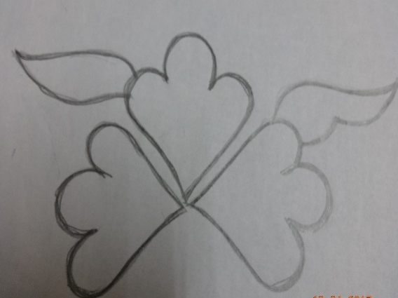
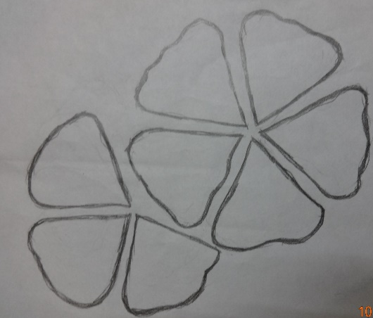
M₁ M₂

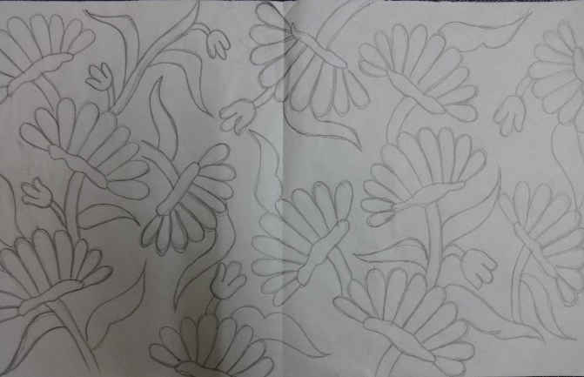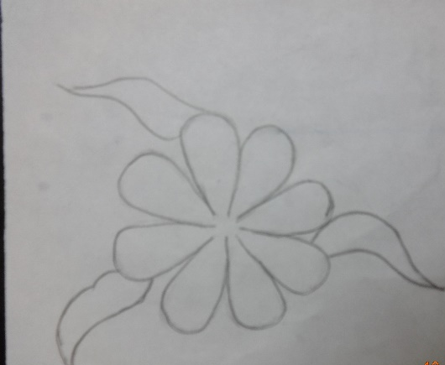
M₃ M₄

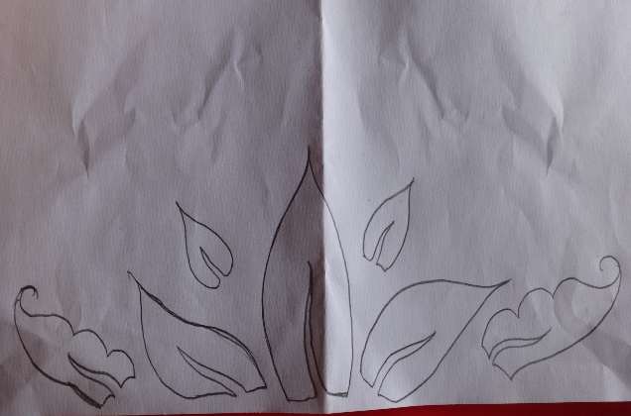

M₅

3.3.2. Preparation of theme based sketching
Sketching is a kind of drawing that puts forward the instant thoughts of an artist, ths it is a rough freehand and loose drawing which is not considered to be a finished piece of work. Sketching, usually results out of visualizing and immediately capturing them onto paper (Sarkar 2013). Various kurti styles were selected from the magazines for sketching. Twenty styles of kurtis were drawn along with the selected motifs in which the placement of motifs differs in each style of kurti. Which is coded as MS₁, MS₂, MS₃, MS₄, MS₅, MS₆, MS₇, MS₈, MS₉, MS₁₀, MS₁₁, MS₁₂, MS₁₃, MS₁₄, MS₁₅, MS₁₆, MS₁₇, MS₁₈, MS₁₉, MS_{20,} can be seen in plate 2.
3.3.3. Selection of theme based sketching
The theme based sketches are placed for the rating scale among the selected group of girls. Rating sheet was prepared in order to rate the sketched kurti styles. After rating the sketches are short listed to select the final five sketches.

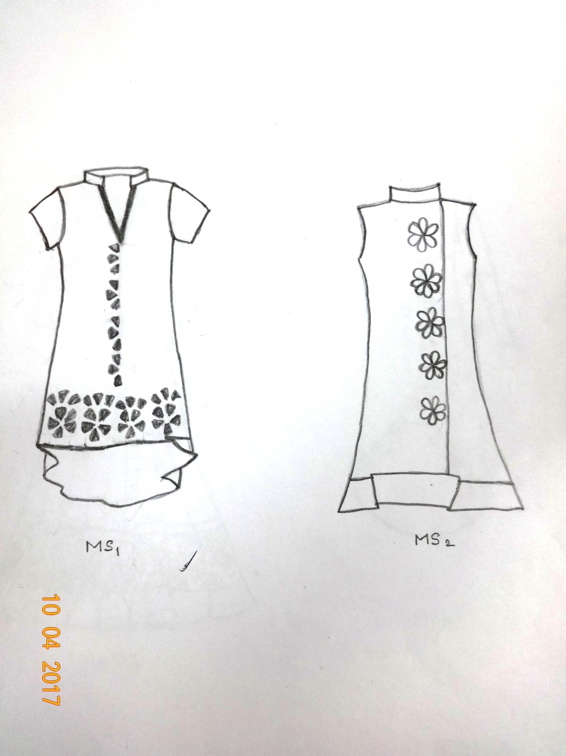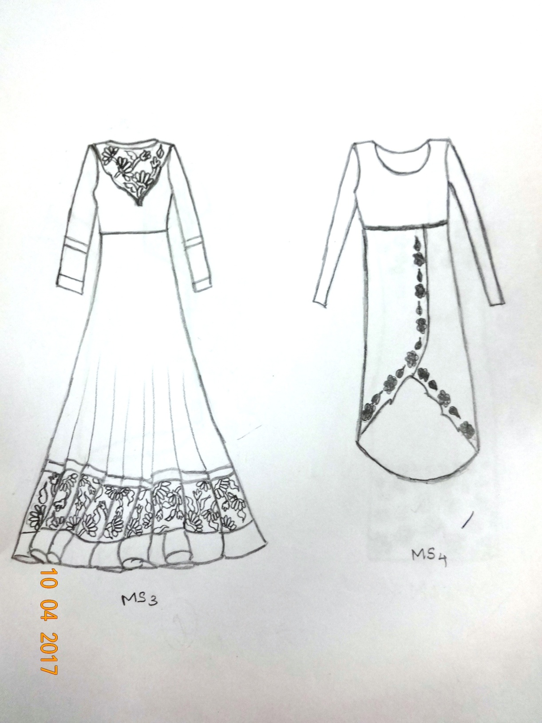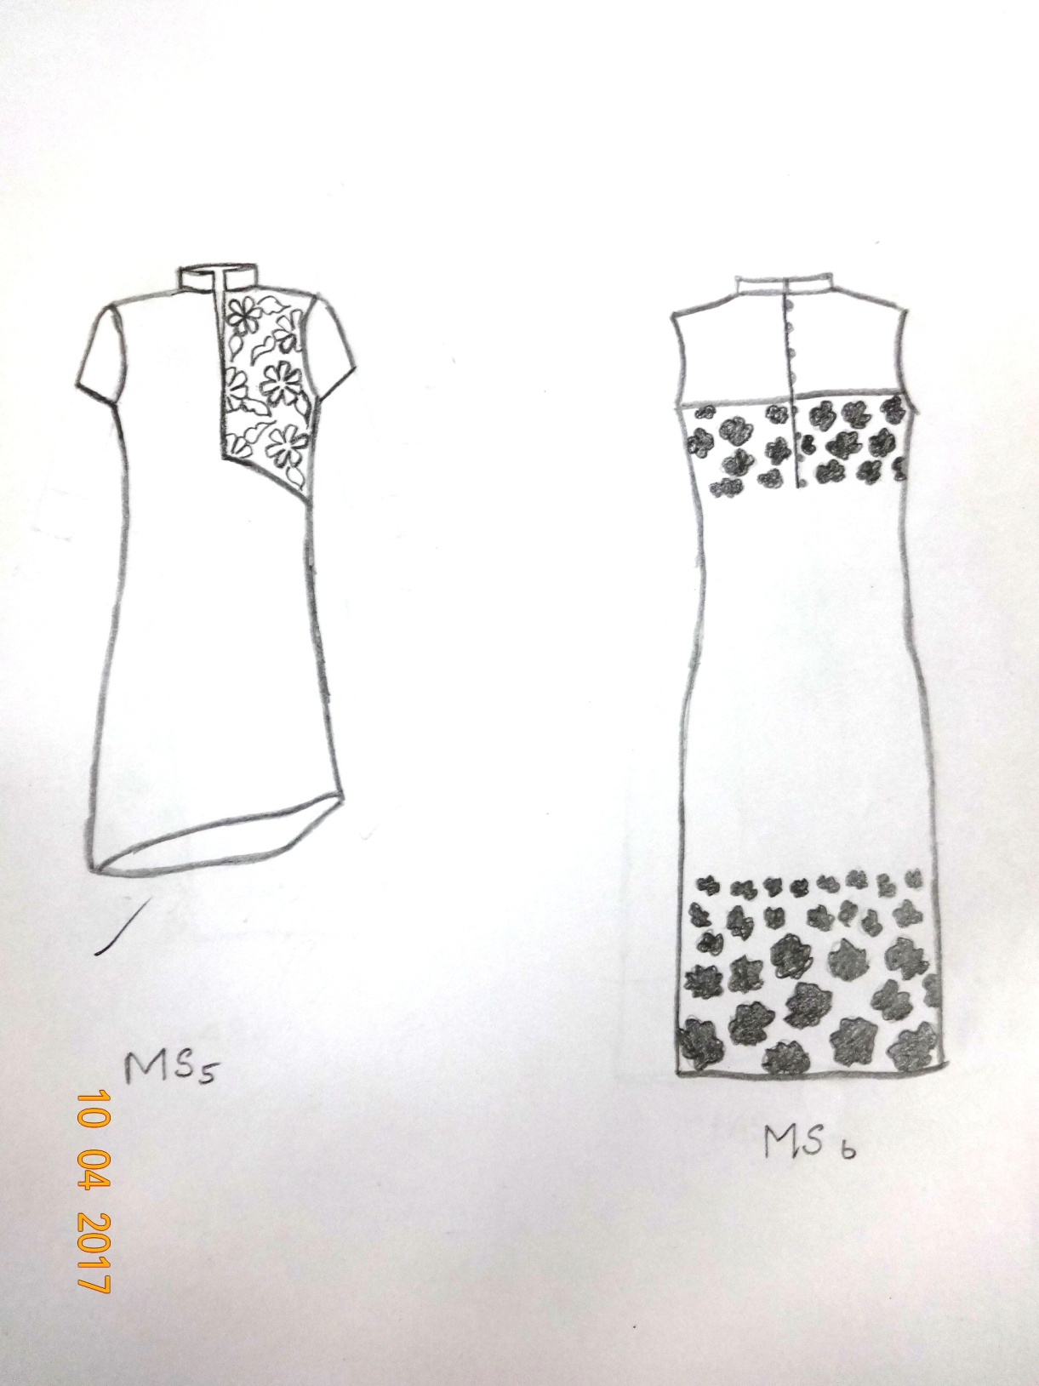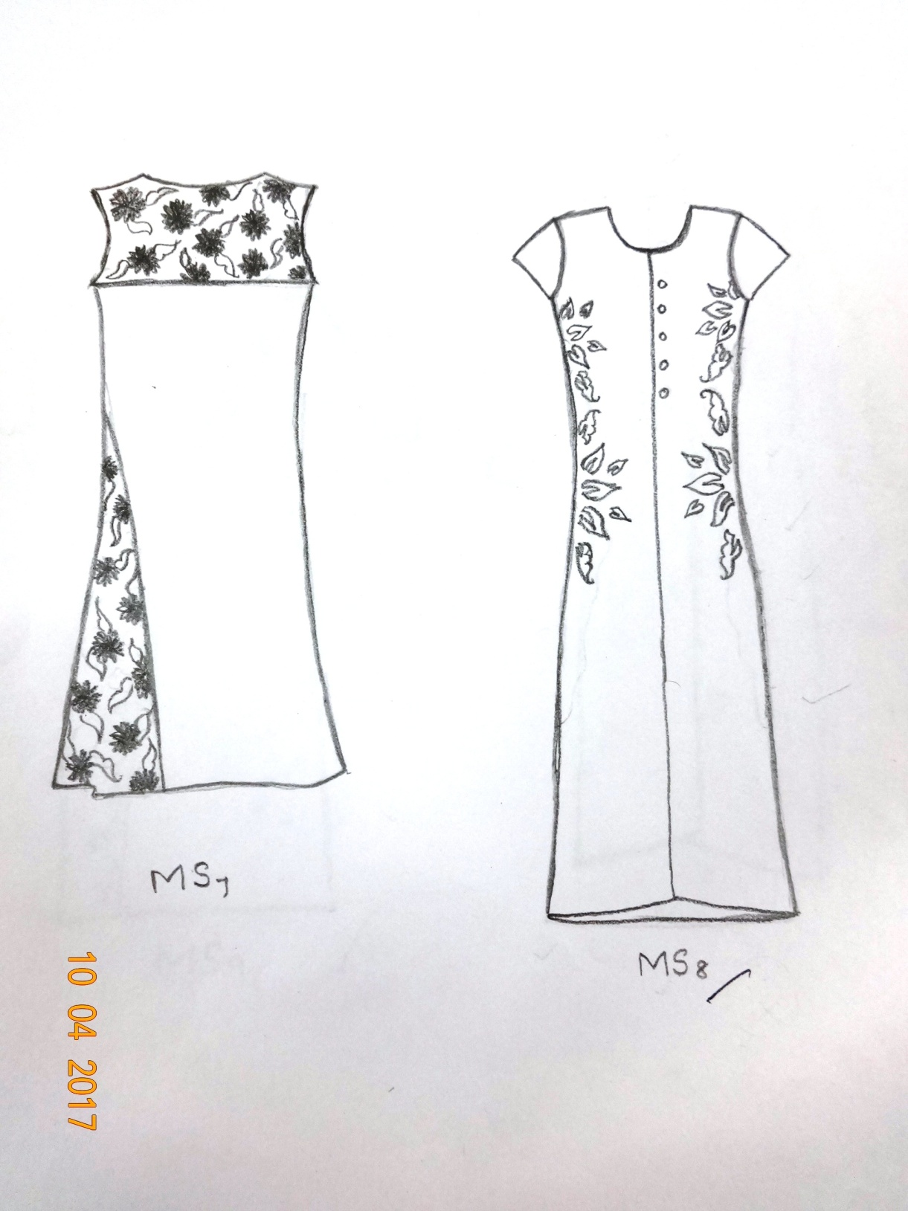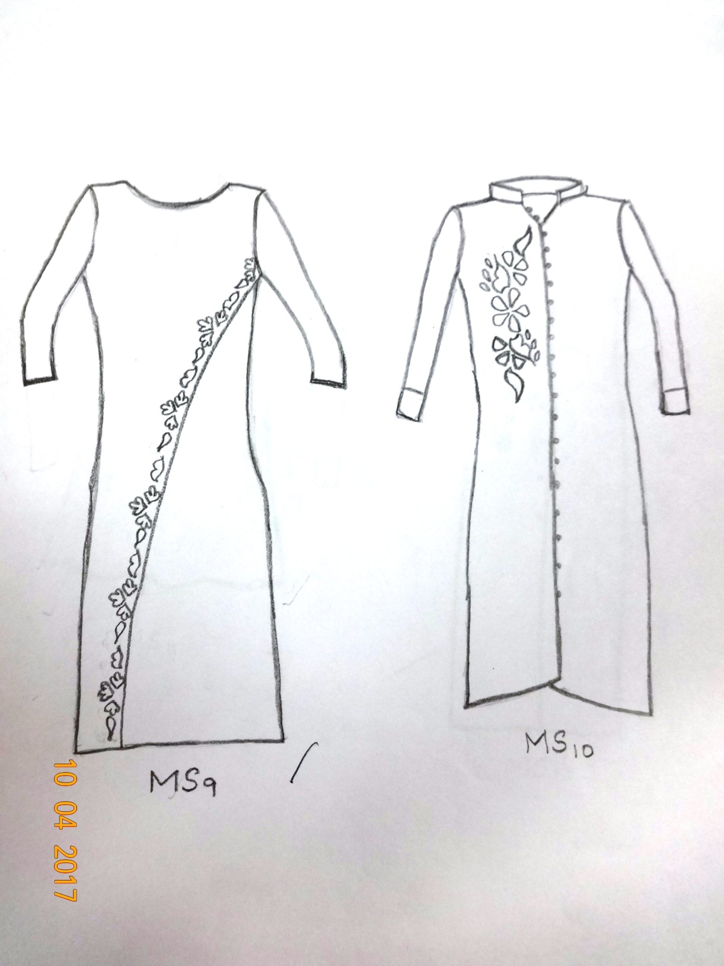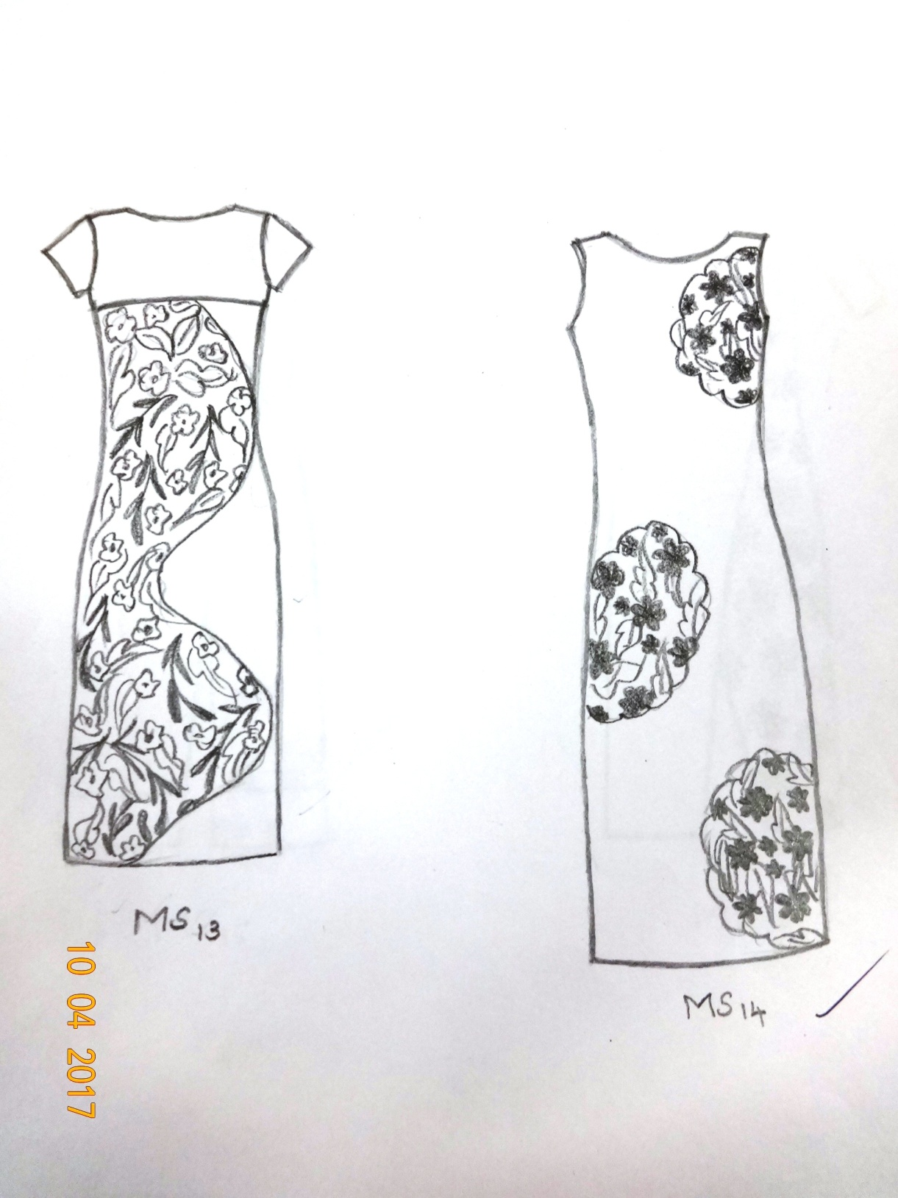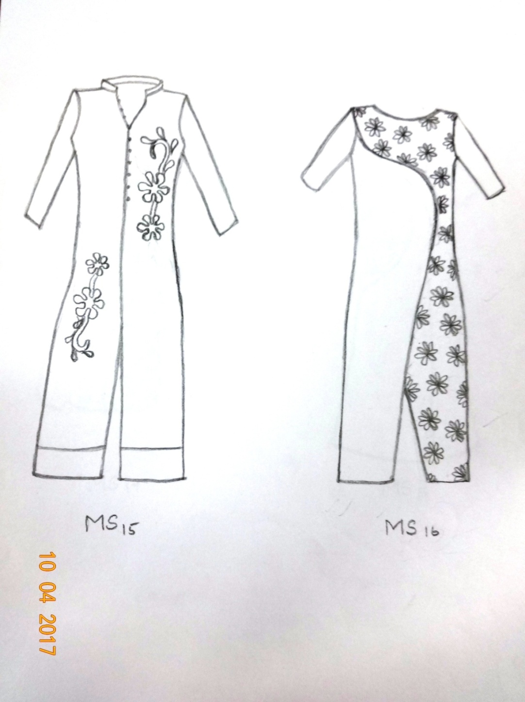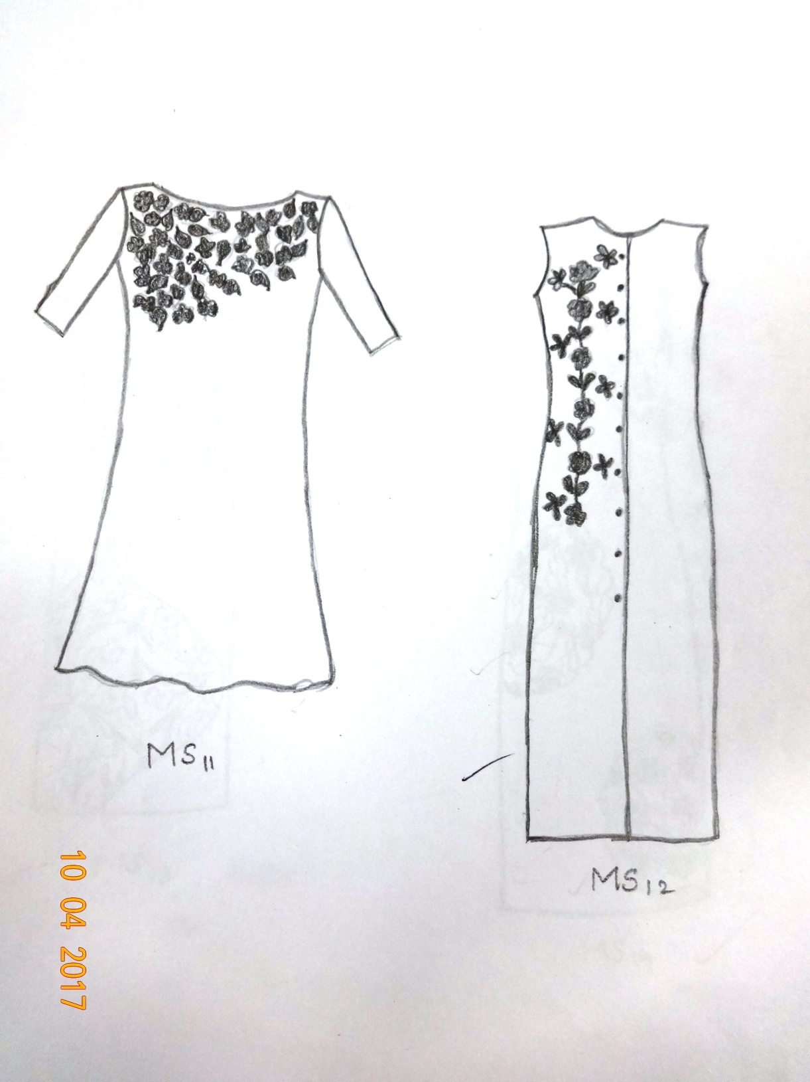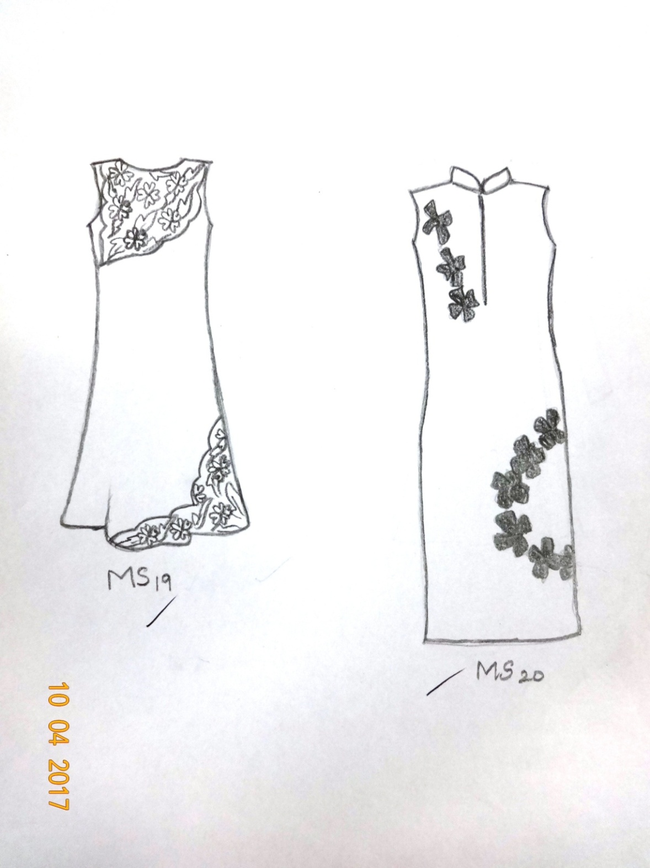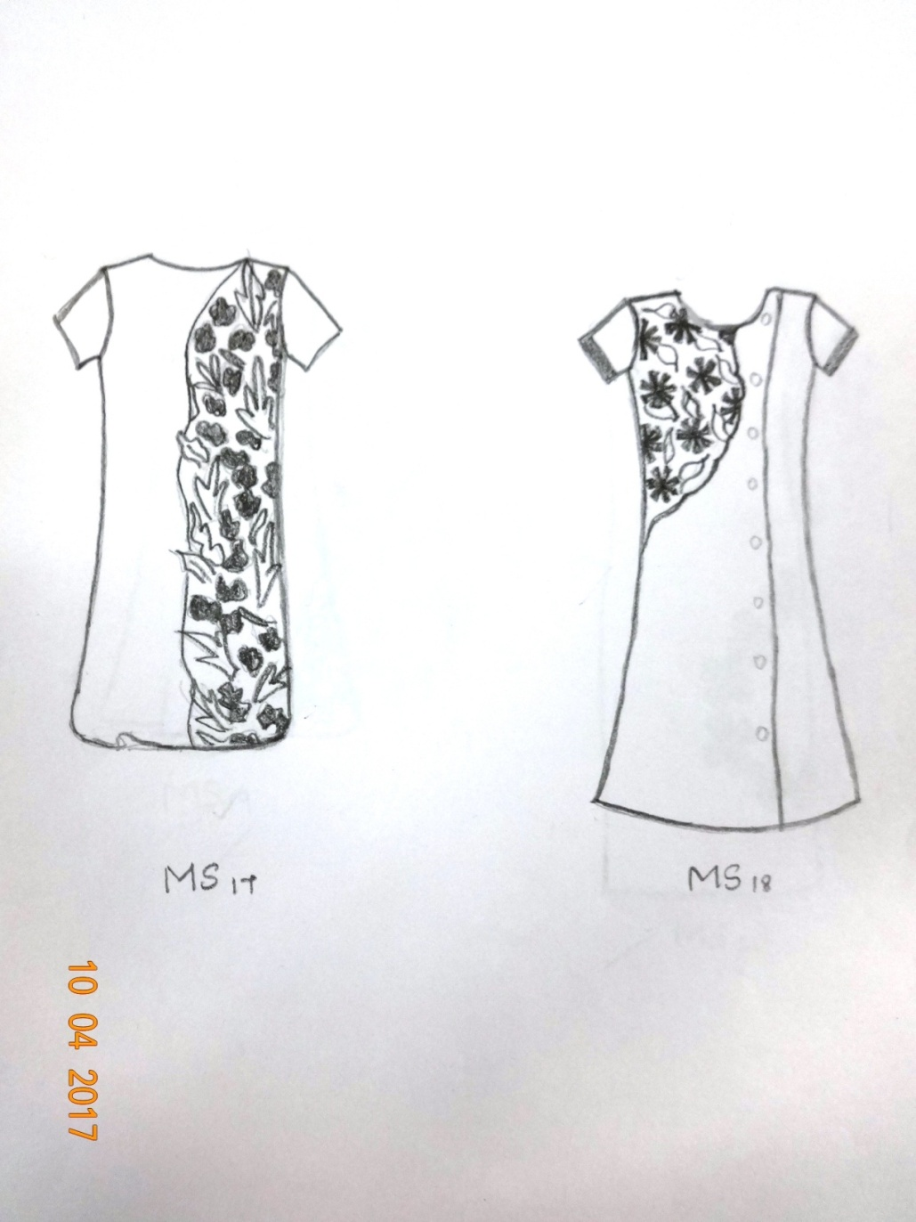

3.3.4. Computer aided designing
CAD designing is the method of designing the figures in the software application. This method of designing gives an visual attraction of the garment to be constructed. The finalised sketches are developed into coloured format using CAD application. This sketches are coded as CAD_{1,} CAD_{2,} CAD_{3,} CAD_{4,} CAD_{5,} which is shown in the plate 3.

3.4. Standardizing body measurement
The standardizing of the body measurement includes the following steps.
3.4.1. Taking body measurement
Taking body measurements from stitched garment is not advisable, as the garment may not be fitting well to get the correct measurement it should be taken from the actual body.The body measurements of the selected participants are taken and the required measurements are listed below:
- Bust
Measure around the figure over the fullest part of the bust, keeping the tape level across the back and not too tight. (Mullick, 2002).
- Waist
Thinnest part of waist is measured around horizontally and tightly (Sodhia, 2008).
- Hip
Hip line extends around the trunk in a plane parallel with the floor at the largest part of the hips. The tape should be loose enough that it will slip easily when this measurement is being taken (Sarkar, 2010).
- Seat
Seat is the lower level to the hip. Measure around the seat circumference horizontally.
- Full length
Measure from the shoulder line by keeping the tape perpendicular to the floor till the particular length required.
- Shoulder
Measurement is taken from one bone of shoulder to another (Verma, 2006)
- Neck
Measure around the neck where the collar rests. This measurement can be taken closer to the neck or a little away from neck.
- Sleeve
Measurement is taken from the shoulder point to the required length.
- Arm hole
Measurement is taken by fastening the tape around the arm scye.
3.4.2. Grouping of body measurements
TABLE I
S.NO | GROUP | RANGE OF BUST MEASUREMENT | NO. OF GIRLS
1 | A | 70-75cms | 6
2 | B | 75-80cms | 9
3 | C | 80-85cms | 21
4 | D | 85-90cms | 14

The bust circumference of the majority of the girls were between 80-85cms. Thus the bust measurement of group c is taken for the construction.
3.4.3. Standardizing the body measurement
Standardizing is the process of consolidating the body measurement of certain age groups. The standardized measurements refer to an average figure. The garment is made to fit many individuals, without having to make too many alterations. The garment should look well without necessarily fitting properly in every detail. These measurements are the average measurements of a large number of figures (Mullick, 2002).
The mode of a distribution is the value at the point around which the item tend to be most heavily concentrated. Mode is defined as the value of the variable which occurs most frequently in a distribution. The mode in a distribution is that item around which there is a maximum concentration. (Pillai Et al, 2000). Thus, the body measurements were standardized for the selected age group.
3.5. Selection of fabric
Fabric is the most important thing which should be selected in such a way which will be comfortable for the wearer. In this study, khadi cotton is selected for printing and the construction of the kurti. Khadi is a versatile fabric. It has the unique property of keeping the wearer warm in winter as well as cool in summer season. (www.fibre2fashion.com/industry-article/959/khadi-the-pride-of-india?page=1).
3.5.1. Preparation of fabric for printing
A woven fabric is said to be in the ‘loom-state’ if it has received no further processing since it left the loom. Depending on the origin of their component fibres, fabrics may contain both natural and other non-fibrous impurities. Such impurity removal operations are known as scouring treatments and they are followed by bleaching (Clarke, 2004).
- This study is carried out by using 100% finished khadi cotton.
- First wash the selected material to remove any remaining size.
- When dry cut the material in preferred size.
- Preliminary sketches of design are made by traced using a soft blunt pencil.
- Later printing is carried out.
3.5.2. Selection of tools used for printing
- Material
Fabric should be made from natural fibres such as cotton, linen, muslin or silk. For intricate designs it is important that the fabric has a high thread count. Synthetic fibres are not suitable as they cannot hold dye sufficiently.
- Frames
These can be bought or made depending on size and adjustability. It is possible to use stretcher bars or old picture frames, however, soft wood is preferred as it enables the fabric to be pinned. (Kapoor, 2012).
- Wax
The wax are available in the blocks, flakes or grains. Wax used for batik is the mixture of paraffin wax and bee wax. In this study crayons were chosen as the source for the wax as an alternative.
- Brushes
Varied size of cheap oil brushes are advised for use with wax. Stiff bristles prove beneficial when pushing the wax into the surface of the material. Brushes made from natural or synthetic fibres are also required in the dyeing process.

3.6. Printing procedure
The local application of colour is carried out by some form of printing. Printing consists of variety of methods in which this study focuses on the batik printing. The batik printing is carried out using crayons as an alternative of paraffin and bee wax. The fabric is printed with the melted crayons using brushes.
3.6.1. Preparation of wax for batik printing
The most commonly used wax for the batik printing is paraffin wax and bee wax, in this study crayons are taken as the source of wax for printing instead. The crayons are broken into pieces and added to the foil cup which is placed in the boiling water and allowed to melt. The temperature of the water is maintained at 50⁰C to keep the crayons stay melted.
3.6.2. Printing on the fabric
While applying the wax table should be layered with many layers of newspapers which should not have any crease or folds in it. Waxing can be done on both sides of fabric very easily, and penetration of wax in fabric can take place very quickly (Jain, 2010). The melted crayons is applied to the fabric using brush inside the motifs which is traced on the fabric earlier. Each colours are separately applied on the motifs with separate brushes for each colour. This method is continued until the motifs are entirely covered with wax. After the motifs are printed it is allowed to dry, is shown in plate 4(a), (b), (c), (d), (e).

PLATE 4 (a)

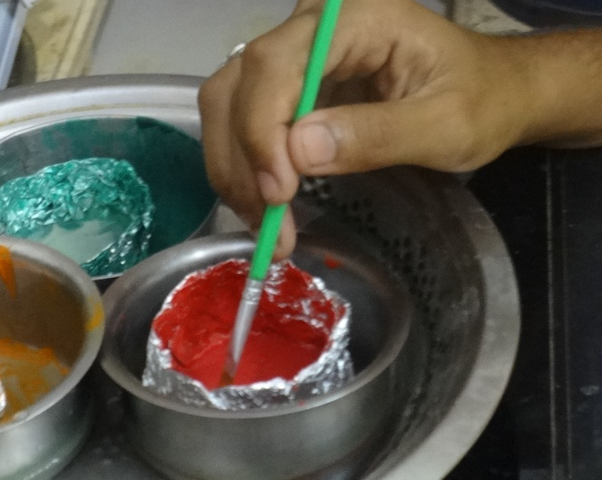

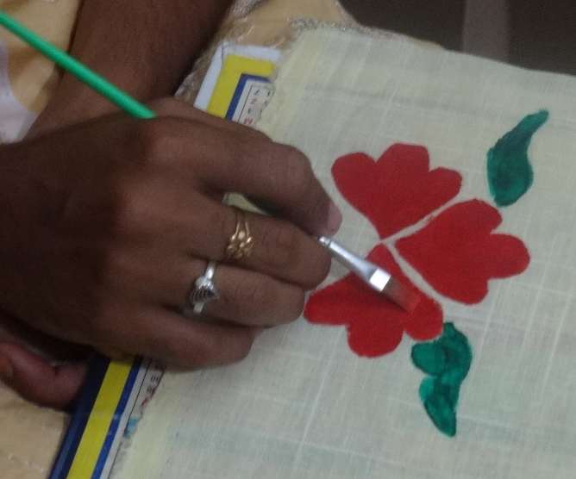

PLATE 4 (b)

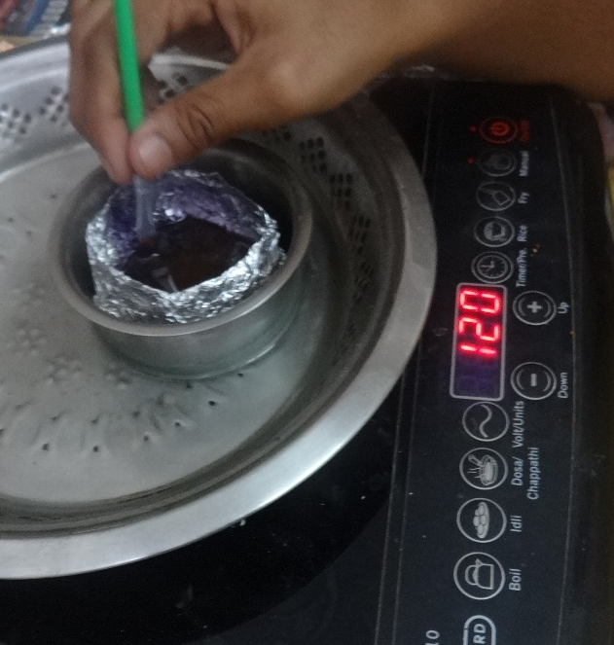

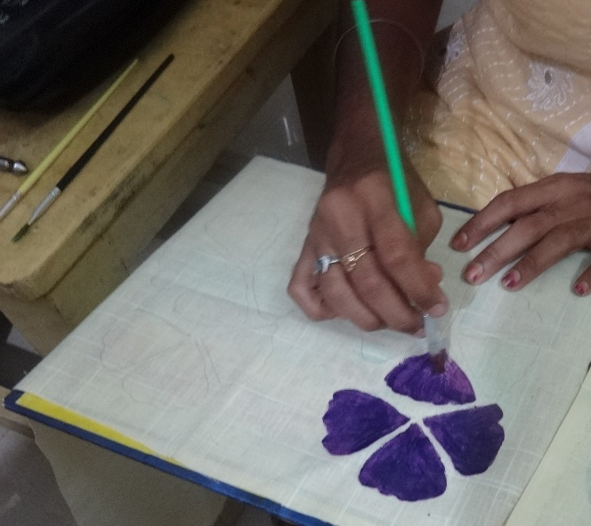

PLATE 4 (c)

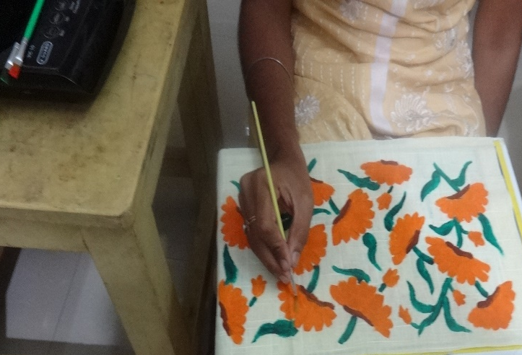

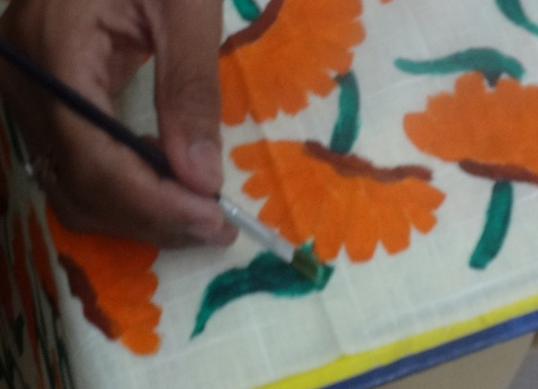

PLATE 4 (d)

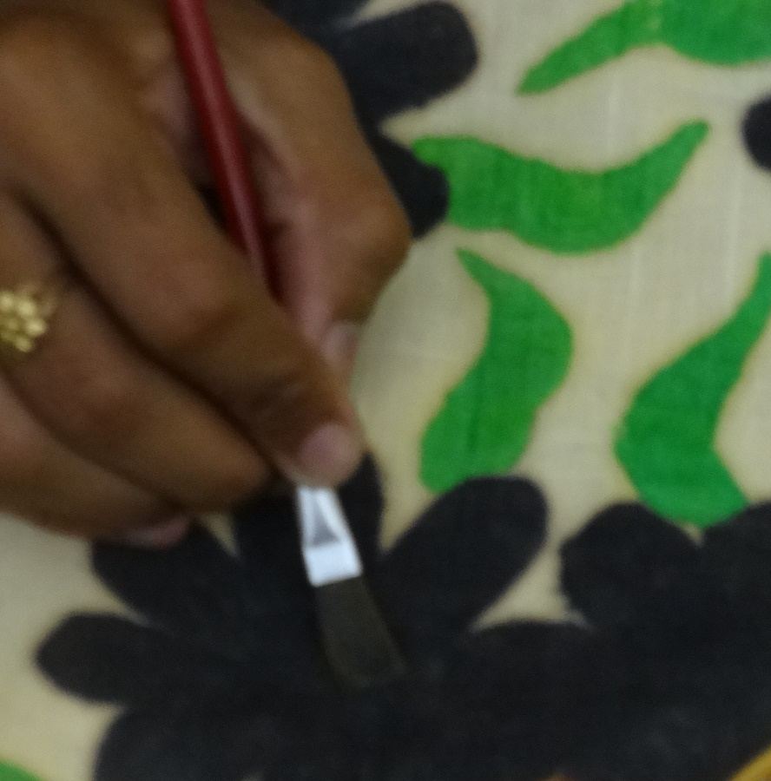

PLATE 4(e)

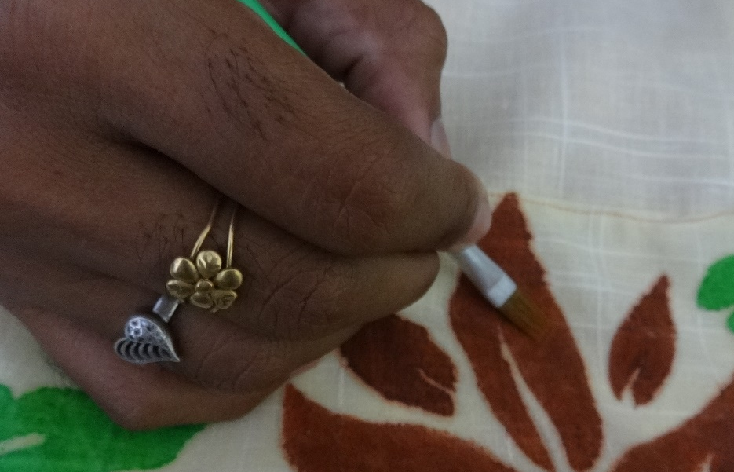

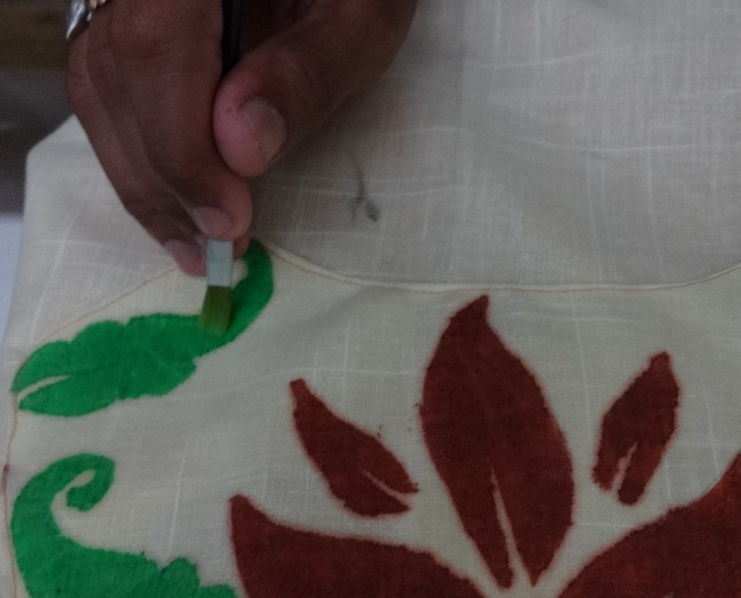

3.6.3. Removal of wax
The printed fabrics are then subjected for then subjected for the wax removal. For the removal of wax several layers of newspapers are used. The printed fabrics are placed between layers of papers and ironing is carried out to remove the wax. By ironing the wax melts and sticks on the paper, while the colour of the crayons remain on the fabric.
3.7. Construction of kurti
Based on the standardized measurement kurti is constructed by the following steps.
3.7.1. Preparation of basic pattern for kurti
Drafting is one of the basic content of the designing. A basic knowledge in the drafting is very important in the construction process. To eliminate the fabric wastage and fitting problems, drafting is an important part.The paper pattern were drafted for the selected style of kurtis. All the patterns details were marked on the pattern.
3.7.2. Preparation of fabric for cutting
Cutting is a compressive and shearing phenomenon, and occurs only when the total stress generated by the cutting implement exceeds the ultimate strength of the material of the object being cut. (Rastogi, 2009). Smart styling and a professional look in clothing construction requires correct use of the grain of the fabric. Garment pieces cut or pulled off grain will not fit correctly and will hang poorly when worn. (Saluja, 2006). Thus fabric should be handled with great care while cutting. Fabric is placed on the table stretched well without crease and pinned on the sides. The prepared pattern is then placed on the fabric surface and it is cut according to the size of the pattern.
3.7.3. Layout, transferring and cutting of fabric
For giving layout to a cloth fold the cloth into double layers and put the grain portions towards yourself, while the portion having double-fold may be kept in the outer side. In this way by proper layout, cutting of cloth may be very correct. It’s necessary to know the following principles of stitching:
- Before starting cutting, give a small cut on balance signs.
- Imitate the signs of darts, pleats, inlays and turnings with the help of tracing wheel on another layer.
- Baste dart or pleats, facings and designs and see whether they shall come out to be in nice looking or not.
- Designs may first be prepared, then join the shoulder and prepare the neck, thereafter join sleeves etc.
- Check the stitches of the machine on any other small cuttings.
- If the garment is being prepared for a man having abnormal structure of body then before completing the work, make one or more trials.
- Do not misadjust balance signs, neck points ends of both sides of the arm hole, otherwise garment will not be befitting the body.
- While stitching use press along the darts, pleats and pockets. It brings about greater finishing in the garment.
- For finishing, cut the thread simultaneously. Don’t break any thread inadvertently, lest the stitching on the edges should be destroyed after becoming weak. (Verma, 2006).
3.7.4. Construction of kurti
Sewing or stitching is fastening of cloth, leather, furs, barks or other flexible material using needle and thread.
Garment– 1
- Front bodice of the kurti two sections one in which the motifs is attached by cut work.
- Front and back bodice are separately attached with the lining and the necklines were finished.
- Shoulder line is stitched by placing the fabric right side facing each other.
- Sleeves were matched to the arm scye of the bodice and tacked around the arm hole.
- Side seam are stiched.
- Side cut of the kurti is finished and as well as the bottom of the kurti is also finished.
- The finished garment is shown in plate 5 (a).
Garment – 2
- Batik printed cloth is attached to the front bodice as a patch work on the bottom of the kurti and in the central part.
- Neck lines were finished and shoulder line is attached by placing the right side of the fabric facing each other.
- Collar is stitched.
- Contrast colour piping is made for the front neckline.
- Sleeve is tacked in and the side seam is finished.
- Lower edge of the fabric is finished by picoting.
- The finished garment is shown in plate 5 (b).
Garment - 3
- The cut out lower part of the kurti is attached with the batik printed border, and the bottom edge is finished.
- Upper part of the kurti is attached with the lining and neckline is completed.
- Shoulder seam is joined together.
- Patch work of batik printed fabric is made on the upper part of the front bodice.
- Sleeve is tacked around the armhole.
- Upper and lower part of the kurti is fastened together.
- Later side seam is finished.
- The finished garment is shown in plate 5 (c).
Garment – 4
- The front and back bodice of the fabric is attached to the lining.
- Neck line is finished and shoulder line is attached together.
- Placket is placed for the comfort ability of the wearer.
- Collar is attached.
- Batik printed fabric is done as a patch work on the top left side of the kurti.
- Later sleeve is stitched around the arm hole.
- Side seam is stitched together.
- Side cut of the kurti is finished along wih the bottom edge.
- Finished garment is shown in the 5 (d).
Garment – 5
- The neck line is finished by attaching the lining along with the fabric.
- Shoulder line is stitched together.
- Patch work of batik printed fabric is done along the side seam area.
- Sleeve is stitched to the bodice arm hole.
- Side seam is completed.
- Side cut and bottom edge is also finished.
- Fasteners like button is attached to the centre of the front bodice. 5 (e).

TABLE II
3.8. Nomenclature
S. No | Particulars | Nomenclature
1 | Motifs | M
2 | Manual sketching | MS
3 | Computer Aided Design | CAD
4 | Garment | G

PLATE 5

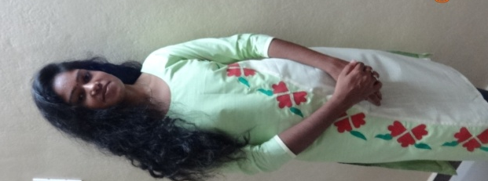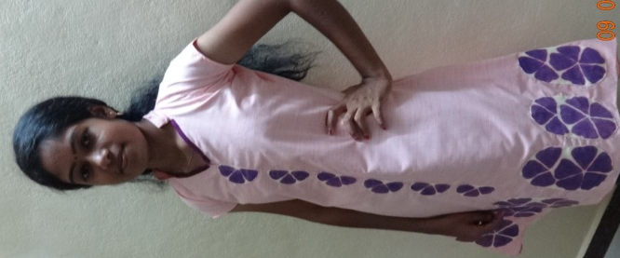

(a) (b)

PLATE 5
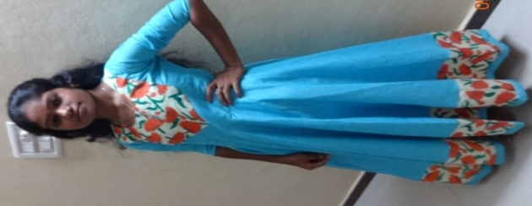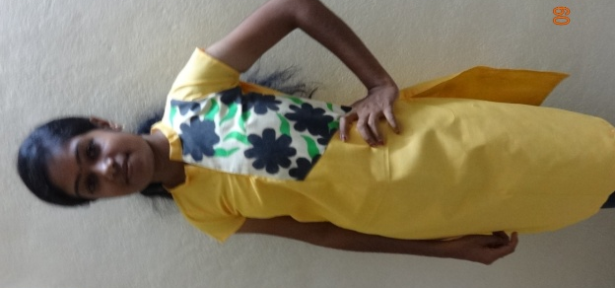

(c) (d)

PLATE 5

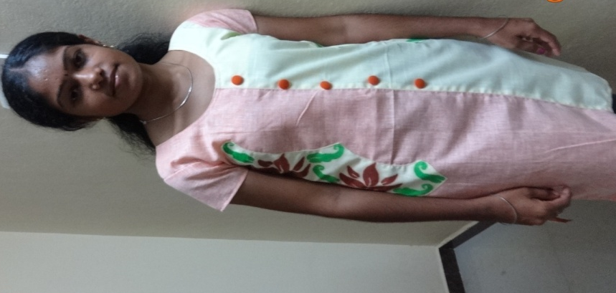

(e)

RESULT AND DISCUSSIONS

IV Result And Discussion
The result of the study on “Designing and construction of Kurtisfor adults by Batik printing using crayons” are discussed under the following headings.
4.1. Consolidated rating of manual sketching
4.2. Opinion of the adult girls regarding the handloom fabrics
4.3. Standardizing the body measurement of the adult girls
4.4. Evaluation of constructed outfits

4.1. Consolidated rating of manual sketching

TABLE III

S. No | Manual sketch code | Rating
S. No | Manual sketch code | Excellent | Very good | Good | Fair
1 | MS₁
2 | MS₂
3 | MS₃
4 | MS₄
5 | MS₅
6 | MS₆
7 | MS₇
8 | MS₈
9 | MS₉
10 | MS₁₀
11 | MS₁₁
12 | MS₁₂
13 | MS₁₃
14 | MS₁₄
15 | MS₁₅
16 | MS₁₆
17 | MS₁₇
18 | MS₁₈
19 | MS₁₉
20 | MS₂₀

4.2. Opinion of the adult girls regarding the handloom fabrics.

TABLE IV
S.NO | HANDLOOM FABRICS | NUMBER OF GIRLS STATING
1 | Cotton khadi | 52
2 | Silk khadi | 27
3 | Woollen khadi | 9
4 | Muslin khadi | 12

Figure I

4.3. Standardizing the body measurements of the adult girls

TABLE V

S. No | Particulars | Grouping of bust measurement
 |  | Group A  70-75 cms | Group B  75-80 cms | Group C  80-85 cms | Group D  85-90 cms
1 | Chest circumference | 29.1 | 30.4 | 33.1 | 31
2 | Waist circumference | 26 | 27.3 | 30 | 28.2
3 | Hip circumference | 27.4 | 29 | 32 | 30.1
4 | Seat circumference | 29.8 | 30.4 | 33.95 | 31.9
5 | Full length | 32 | 33.6 | 35 | 34
6 | Shoulder width | 28.2 | 29.9 | 33.8 | 31.5
7 | Neck | 27.6 | 29 | 32 | 31.1
8 | Arm hole | 29 | 30.7 | 33 | 31.6
9 | Front neck height | 8.1 | 8.9 | 9.5 | 9
10 | Sleeve | 43.5 | 45 | 49 | 47.5

4.4. Evaluation of constructed outfits
The evaluation of the garments are presented in the tables given below.
4.4.1. Evaluation of fitness of the outfits
TABLE VI
S. No | Code of outfit | Rating
 |  | Ease |  |  | Line |  |  | Grain |  |  | Set |  |  | Balance
 |  | VG | G | F | VG | G | F | VG | G | F | VG | G | F | VG | G | F
1 | G₁ | 100 | - | - | 100 | - | - | 100 | - | - | 100 | - | - | 100 | - | -
2 | G₂ | 96 | 4 | - | 98 | 2 | - | 98 | 2 | - | 96 | 4 | - | 100 |  | -
3 | G₃ | 100 | - | - | 100 | - | - | 100 | - | - | 100 | - | - | 100 | - | -
4 | G₄ | 100 | - | - | 100 | - | - | 100 | - | - | 100 | - | - | 100 | - | -
5 | G₅ | 100 | - | - | 98 | 2 | - | 100 | - | - | 98 | 2 | - | 100 | - | -

From the above table it is clear that the garments G_{1,} G_{2,} G_{3,} G_{4,} and G₅ were good in the ease, line, grain, set and balance. Hence, it is concluded that the outfit are as good as rated by the adult girls.
Figure II

4.4.2. Evaluation of the constructed outfits
The results of evaluation of the styles of constructed kurtis are listed below in the following table.

TABLE VII
S. No | Particulars | Rating of kurti
 |  | G₁ |  |  | G₂ |  |  | G₃ |  |  | G₄ |  |  | G₅
 |  | VG | G | F | VG | G | F | VG | G | F | VG | G | F | VG | G | F
1 | Suitability of design | 100 | - | - | 100 | - | - | 100 | - | - | 100 | - | - | 100 | - | -
2 | Suitability to current fashion | 100 | - | - | 100 | - | - | 100 | - | - | 100 | - | - | 98 | 2 | -
3 | Selection of material | 100 | - | - | 100 | - | - | 100 | - | - | 100 | - | - | 98 | 2 | -
4 | Colour combinations | 100 | - | - | 100 | - | - | 100 | - | - | 100 | - | - | 100 | - | -
5 | Trimmings and decoration | 100 | - | - | 98 | - | - | 100 | - | - | 100 | - | - | 100 | - | -
6 | Overall appearance | 100 | - | - | 100 | - | - | 100 | - | - | 100 | - | - | 100 | - | -

Figure III

4.4.3. Cost estimation of the garment
TABLE VIII
S. No | Garment code | Particulars | Cost | Total cost
1 | G₁ | Material cost | 220 | 510
1 | G₁ | Printing Charge | 50 | 510
1 | G₁ | Trimmings and decoration | 40 | 510
1 | G₁ | Stitching | 200 | 510
2 | G₂ | Material cost | 220 | 490
2 | G₂ | Printing Charge | 50 | 490
2 | G₂ | Trimmings and decoration | 20 | 490
2 | G₂ | Stitching | 200 | 490
3 | G₃ | Material cost | 520 | 970
3 | G₃ | Printing Charge | 100 | 970
3 | G₃ | Trimmings and decoration | 50 | 970
3 | G₃ | Stitching | 300 | 970
4 | G₄ | Material cost | 220 | 480
4 | G₄ | Printing Charge | 40 | 480
4 | G₄ | Trimmings and decoration | 20 | 480
4 | G₄ | Stitching | 200 | 480
5 | G₅ | Material cost | 180 | 430
5 | G₅ | Printing Charge | 40 | 430
5 | G₅ | Trimmings and decoration | 30 | 430
5 | G₅ | Stitching | 180 | 430

SUMMARY AND CONCLUSION

V SUMMARY AND CONCLUSION
Clothing is the expression of the person reflecting his/ her personality and the way of living. Clothing is an important thing for the human and for the young adults clothing play a vital role. They focus on the trendy designs for their clothing. They are more conscious about their clothing, style, colour combinations, pattern arrangements etc. At present consumers are need of new styles which gives more comfort. The most widely preferred fabric by the young girls were cotton. In order to construct the garment with cotton fabric and to promote khadi, khadi cotton fabric are used to construct the kurti.
Therefore, an attempt was made to develop the dress designs and construct the kurti by attaching the crayon printed fabric as a patch work on various parts of the kurtis by the following objectives.
- Find out the preference of girls about handloom fabrics.
- To design the kurti styles.
- Standardize the body measurement for kurti
- Developing the basic pattern for kurti.
- To print the fabric with crayons for batik printing.
- Construction of kurti
- Evaluation of finished outfits.
  - Experimental procedure
The investigator framed a schedule to gather the information regarding the latest outfits of college going girls. Sixty measurements of adult girls were collected and the data were collected and analysed.
The body measurement of the girls between the age group (18-25) were analysed and arranged in the sequential order by considering for grouping. The bust measurement of group A ranges from 70-75 cms, for group B the measurement ranges from 75-80 cms, whereas in group C is between 80-85 cms and group D is 85-90 cms.
Various design books and magazines were referred for the selection of the styles for sketching. Twenty styles were drawn on the drawing sheet along with the placement or motifs and these sketches are kept for rating.
Fabric selection was made by finding the opinion of the girls about the handloom fabrics. According to the opinion given by the girls’khadi cotton fabric was selected.
Fabric printing is the process decorating the surface with colours. This may include various styles such as direct printing, resist printing and discharge printing, in which this study focuses on the resist style of printing. The study is about printing the fabric with crayons as a source for wax as an alternative of bee wax and paraffin wax.
In order to evaluate the garment the finished outfits are placed for the rating. Rating scale was prepared to evaluate the garment. This scale includes about the details of the garment such as style, colour, patch work, finishing of the garment, fasteners and general appearance.
  - Finding of the study
    - Opinion of the girls about handloom fabrics
The participants were randomly selected and asked for their opinion about the handloom fabrics. The investigator approached the participants directly and asked their opinion. According to the information gained from the participants khadi cotton was selected. Khadi cotton is a versatile fabric which are comfortable to wear for all season. These fabrics have an unique property of keeping the wearer cool in summer and warm in winter.
    - Standardizing body measurement
Standardizing is done in order to obtain a garment of standard size which will be suitable for the wearer without making too many alterations. These measurements are the average measurement of large number of figures. Standardization was carried out by randomly selecting 60 participants and their measurement was taken and these measurements were standardized to get the basic measurement.
The standardized body measurement of adult girls from group C is as follows.
Bust circumference – 85cms, Waist circumference- 70cms, Hip circumference – 85cms, Seat circumference – 90cms, Full length – 90cms, Shoulder width – 38cms, Neck circumference – 35cms, Arm hole – 38cms, Sleeve length 3/4th – 39cms, Sleeve length 1/2- 15cms.

    - Evaluation of constructed outfit
The twenty manual sketches were short listed to five and these five sketches were constructed into garment. Each kurti has been decorated with the patch work, and cut work is placed at various parts on the kurti which is printed with the crayons. Thus the constructed outfits are placed for the evaluation evaluated for its style, colour, placement of motifs, general appearance etc. Evaluation form has been given to the individual and asked to evaluate the outfits.
    - Conclusion
As clothing is an important aspect and trend is towards pleasing and graceful colour combinations. As the latest trend mix and match collections are preferred for the kurtis so as to look good. Kurtis are the garments which is preferred a lot by all the age groups starting from the age of 10 – 50, as the kurtis are more comfortable to wear and are available in a wide range. Kurtis are selected for the study as they are worn in large number of groups, especially the teenagers.Thus investigator constructed the kurti with khadi cotton fabric by printing it with crayons which is an innovative idea for batiking.

BIBLIOGRAPHY

BIBLIOGRAPHY
Books and Journals

- Adha Fashions (2013) Ladies kurti and leggings-must have in wardrobe. From: www.http://www.veethi.com/articles/ladies-kurti-and*leggings-must-have-in-wardrobe-article1454htm
- Admin (2014), J. Junaidjamshad new stylish kurti/ tunic collection for women, from www. Styles glamour.com/j-junaid-jamshad-new-stylish-kurti-tunic-collection-for-women/
- Choudhuri, P. K., (2014), Exploitig yarn characters in khadi fabric, textile trends july 2014, vol: 4, p: 49-50.
- Clarke, W. (2004), An introduction to textile printing, Woodhead publishing ltd, p: 49, 214.
- Davis, J. (2008), Abhishek publications, p: 83-85.
- Devi, N. L. (2015), Designing and developing tops for teenage girls using draping technique, textile trends October 2015, vol: 4, p: 42, 43.
- Diane, T. and Cassidy, T. (2005), Colour Foecasting, Blackwell publishing, p: 52, 57.
- Ezekiel, J. (2005), An insight into Fashion History, Abhishek publications, p : 3
- Fringes, G. S. (2005), Fashion, from concept to consumer, Pearson Education, Inc, p: 204, 207-207.
- Glover, C. (2008), Fashion and Fashion designers, Thames and Hudson (pub), p: 28.
- Gupta, S., Garg, N., Saini, R. (2005), Text book of clothing textiles and laundry, Kalyani publishers, p: 61, 73, 74.
- Jain, H. (2010), Techniques of dyeing and printing, Ane books ltd, p: 96, 103.
- Jain, T. (2012), Textile designing, Theory and Concept, Yking books, p: 152, 169.
- Kadolph, S. J. (2014), Textiles, Dorling Kindersley India Pvt. Ltd, p: 461, 465.
- Kapoor, S. (2012), Dyeing of textile material, Sonali publications, p: 107, 119, 178.
- Kaur, N. (2010), Comdex Fashion Design, Vol 1, Fashion Concept, Dreamtech press, p: 63, 221.
- Khurana, K. (2010), Draping and pattern making for Fashion Design, Sonali publications, p: 134, 136, 138.
- McClaud, P. (2006), Past and Present Trends in Fashion Technology, Abhishek publications, p : 7
- McKelvy, K., Munslow, J. (2005), Fashion design, Process, Innovation and Practice, Blackwell publishing, p: 42.
- Meller, S., Elffers, J. (1991), Textile designs, Thames and Hudson, p: 27, 42.
- Mishra, T. (2012), Textbook of Textile and Laundry, Ritu publications, p: 167-168.
- Mukherjee, A. (2013), Batik with natural dyes, an innovation, textile trends February 2013, p: 45.
- Mullick, P. (2002), Garment construction skills, Kalyani publishers, p: 43, 47.
- Naik, S. (2013), Textile Design, APH Publishing corporation, p: 1, 2, 269.
- Naik, S. D. and Wilson, J. A. (2009), New age international publishers, p: 15-16.
- Neelima (2012), Fashion and Textile design, Sonali publications, p: 282-283.
- Neelima, (2009), Printing and washing of textiles, Sonali publications, p: 4-5.
- Pal Singh, K. V. (2007), Elementary ideas of textile dyeing, printing and finishing, Kalyani publishers, p: 138, 139, 150.
- Parchure, J. W. (2009), Fundamentals of designing for textile and other end uses, Wood head publishing India (p) Ltd, p: 13.
- Parvathi, K. (2007), Textile designing, Aavishkar publishers, distributors, p: 5-6.
- Pillai and Bagavathi. (2000), Statistics, schand and company Ltd, New Delhi, p: 32 and 170.
- Pundir, N. ( 2007), Fashion Technology (today and tomorrow), Mittal publications, p: 1, 3.
- Rani, A. (2012), Development of designs for textile designing, Textile Trends June 2012, Vol : LV, p : 29.
- Rastogi, M. (2009), Industrial Laundry, Sonali publications, p: 134-135.
- Rastogi, M. (2009), Textile forming, Sonali publications, p: 220.
- Ravimirez, R. L. (2013), Design principles and methods for composing artwork, Luniverse, p:119
- Saluja, N. (2006), Recent development in clothing construction, University book house (p) ltd, p: 56.
- Sarkar, S. (2010), Fashion, Pattern and Dress Design, Arise publishers and distributors, p: 14, 51, 52.
- Sarkar, S. (2013), Fashion and sketch book, Arise publishers and distributors, p: 1, 3, 4.
- Sekhri, S. (2011), Textbook of fabric science: fundamentals to finishing, PHI Learning private ltd, p: 233, 234.
- Sharma, R. (2013) designer kurtis- current and upcoming trend of fashion in India. From www.articlesfactory .com/articles/business/designer-kurti-current-and-upcoming-trend-of-fashion-in-india.html
- Singh, A., Tripathi, P., (2016), Fusion of batik printing and screen printing on khadisaree using geometrical motif, Asian journal of home science December 2016, vol II, p: 430.
- Sodhia, M. (2005), Dress Designing, Kalyani Publishers, p: 99
- Sodhia, M. (2008), Advanced drafting and draping, Kalyani publishers, p: 7-8.
- Sumathi, G. J, (2005), Elements of fashion and apparel design, New age international (p) Ltd, publishers, p: 34, 36.
- Swami, C. (2011), Textile design, theory and concept, New age international (p) Ltd, publishers, p: 119, 122.
- Tate, S. L. (2004), Inside, Fashion Design, , Pearson Education, Inc, p : 157.
- Thomas, K. (2006), Know anout fabric and their manufacture, Abhishek publications, p: 159-160.
- Trivedi, P. (2001), Mahatma Gandhi: A Play, BharatiyaVidyaBavan, p:
- Tyagi, A. ( 2012), History of fashion design, Sonali publications, p: 1, 2, 6.
- Verma, G. (2006), Cutting and tailoring course, Asian publishers, p: 62-63, 81.
- Vidyasagar, P. V. (1998), Hand book of textiles, Mittal publications, p: 182.
- Wells, K. (1997), Fabric dyeing and printing, Conran Octopus ltd, p: 79.
- Wilson, J. (2005), Handbook of textile design, principles, processes and practices, Woodhead publishing ltd, p: 107-108.
- Zaraapkar, (2011), p: 95-96
Websites
- http://wikipedia.org/wiki/Batik.
- https://the culture trip.com/asia/india/articles/the-story-of-khadi-indias-fabric/.
- www.chandrkantalrks.org/khadi/historical-background-khadi.html.
- www.fabric2fashion.com/industry-article/959/khadi-the-pride-of-india? Page=1.
- https://en.wikipedia.org/wiki/kurta.
- http://textile learner.blogspot.com/2016/03/overview of khadi industry in india.html.
- https://en.wikipedia.org/wiki/khctadi.
- http://jadibatck.com/index.php/en/types of batik.
- http://www.worldbatikcouncil.com/batik industry/types of batik.html.
- https://orl.hhs.gov/education/products/ucla/chapter3/page02.htm?_e_pi=7%2CPAGE_ID10%2C2968367117)

APPENDICES

APPENDIX I
SCHEDULE USED TO FIND OUT THE OPINION OF ADULT GIRLS REGARDING THE HANDLOOM FABRICS
Name of the interviewer :
Name o the interviewee :
Age :
- What is your opinion about handloom fabrics :
- Do you like to were garments made with handloom fabric :
If yes, why :
If no, why :
- State which type of material you prefer in handloom fabrics

TABLE VIII

S.NO | HANDLOOM FABRICS | NUMBER OF GIRLS STATING

APPENDIX II
FABRIC SWATCH

G₁

G₂ G₃

G₄ G₅

APPENDIX III
STANDARDIZING OF THE BUST CIRCUMFERENCE

Range of measurement | No. of girls
70-75 | 6
75-80 | 9
80-85 | 21
85-90 | 14

M₀ =L_{m0 +} [∆₁÷∆₁+∆₂] * C
= 6+ [ 21-9 ÷ (21-9) + (21-14) ] * 5
= 6 + [ 12/19] * 5
= 6.631*5
= 33.1

APPENDIX IV
CONSTRUCTION OF BASIC BODICE

MEASUREMENT
- Chest 80cms
- Waist 63cms
- Hip 80cms
- Seat 85 cms
- Full length 127 cms
- Waist length 36 cms
- Shoulder 16.5 cms
- Sleeve as to taste (half or full).
DRAFTING PROCEDURE
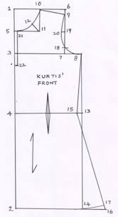
Front
Square lines from 0, fold at 4-0
- = one eighth chest plus 6.5 cm
- = waist length plus 2cm
  - = 18cm for seat line
4-0 = full length plus 2cm. square out from all thesepoints.
5-0 = one twelfth chest plus 1cm or to taste.
6-0 = one eighth chest or to taste. Shape neck 6-5.
7-0 = shoulder plus 1cm. square down 7-8.
9-7 = 2.5 cm. join 5-9, 10-8 = nearly 2.5 cm
11-1 = one fourth chest plus 4cm, shape scye 9-10-11.
Square down from 11 to 12
13-12 = 2cm, 14-3 = one fourth seat plus 4cm
15-4 = one fourth seat plus 5cm, shape side seam 11-13-14-15.
17-11 = one eighth chest plus 1.5cm
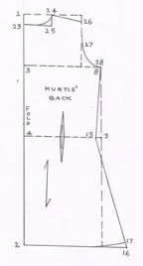
Back
Square lines from 0, fold at 4-0
- = one eighth plus 6.5cm, 2-0 = waist
3-2 = 18cm for seat line, 4-0 = full length
Square out from these points
5-0 = same as 5 to 0 of front, 6-0 = 2.5 cm to 4cm, shape neck 6-5.
Join 5-9, shape scye 9-10-11
Keep 4 to 5 inturns at 4-15 and 14-15 for fron and back.
Keep side opening at 15-14
18-2 = 7.5 to 10cm.
APPENDIX V

Evaluation of fitness of the outfits
TABLE V
S. No | Code of outfit | Rating
 |  | Ease |  |  | Line |  |  | Grain |  |  | Set |  |  | Balance
 |  | VG | G | F | VG | G | F | VG | G | F | VG | G | F | VG | G | F

Evaluation of the constructed outfits
TABLE VI
S. No | Particulars | Rating of kurti
 |  | G₁ |  |  | G₂ |  |  | G₃ |  |  | G₄ |  |  | G₅
 |  | VG | G | F | VG | G | F | VG | G | F | VG | G | F | VG | G | F

