Biosorption of malachite green using Rhizopus species and its impact on the growth of cow pea

ASHWINI, R.
(Reg. No. 11PZO01)

A thesis submitted to Avinashilingam Institute for Home Science and Higher Education for Women, Coimbatore

In partial fulfilment of the requirements for the

MASTER'S DEGREE IN ZOOLOGY

MAY 2013

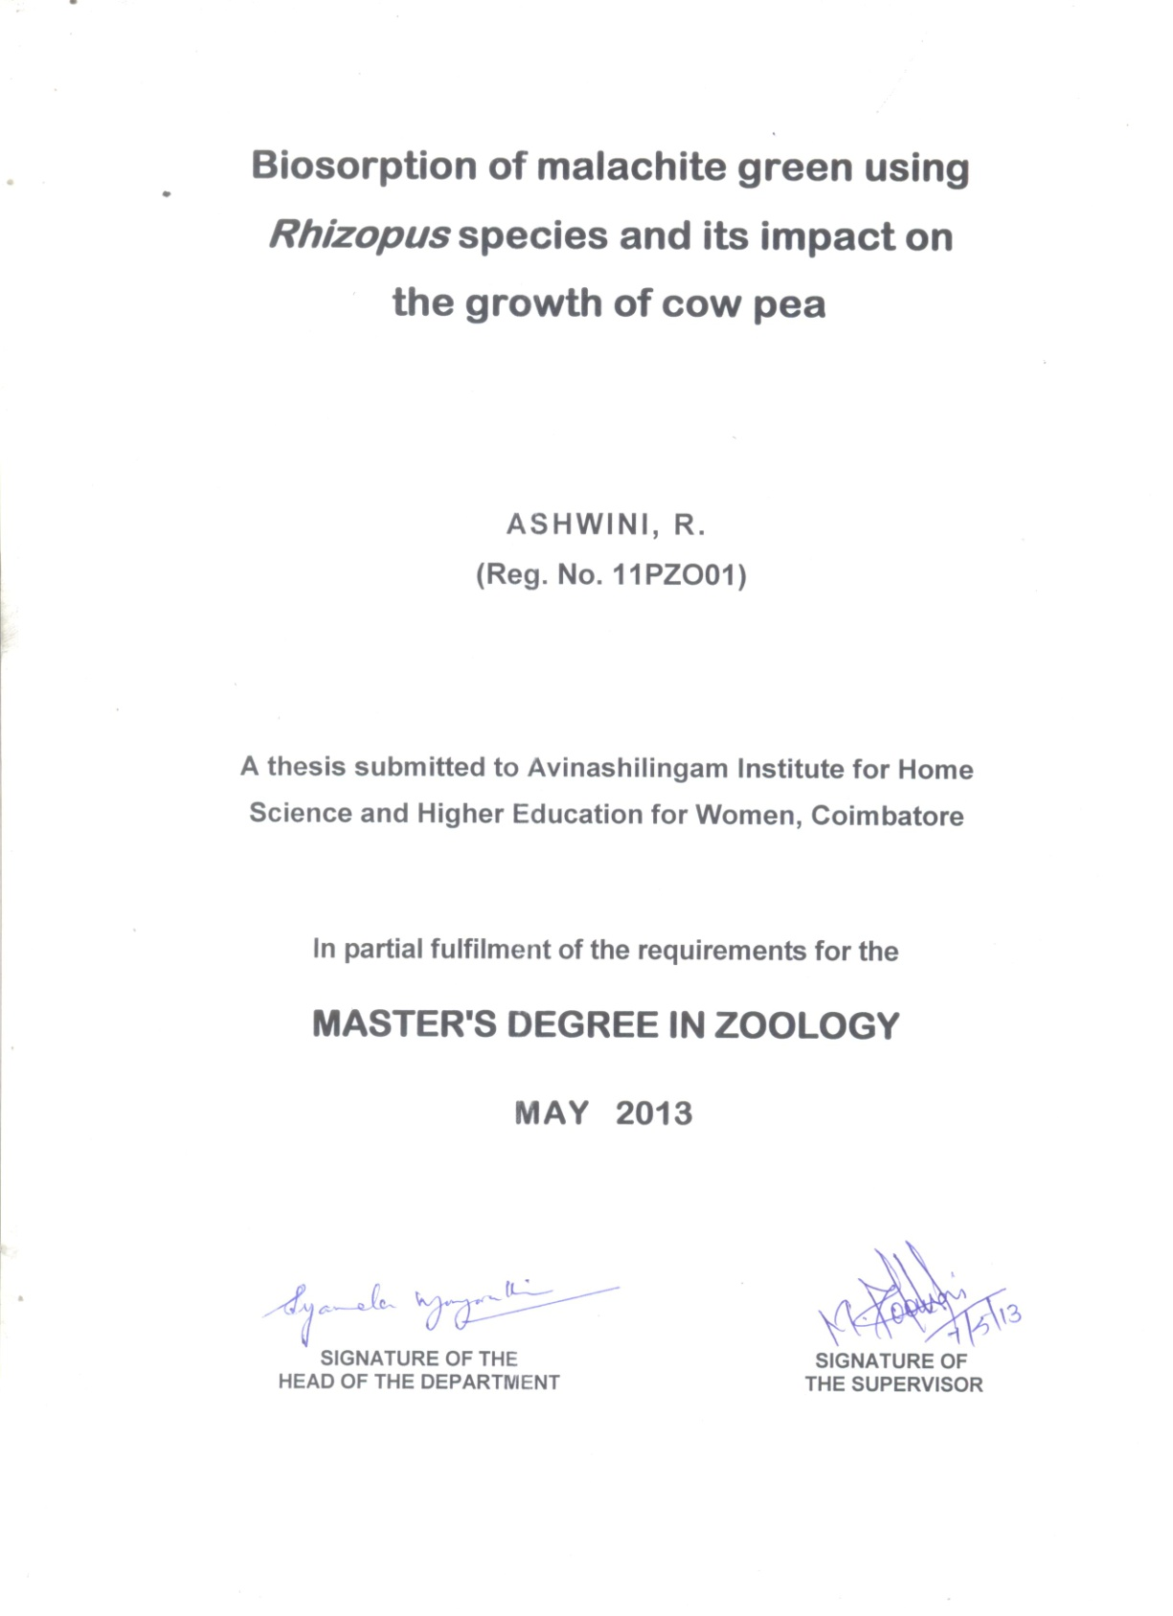

ACKNOWLEDGEMENT
The author owes her sincere thanks and gratitude to
Thiru. Dr. T.S.K. Meenakshisundaram, M.A., M.Phil., Chancellor, Avinashilingam Institute for Home Science and Higher Education for Women, Coimbatore for all the amenities provided for the conduct of the project.
The author place on her gratitude and heartfelt thanks to Dr. (Mrs.) Sheela Ramachandran, M.Sc., P.G. Dip., Ph.D., (Avinashilingam), Vice Chancellor, Avinashilingam Institute for Home Science and Higher Education for Women, Coimbatore, for extending all possible help towards the completion of the study.
The author feel greatly indebted and thankful to Dr. (Mrs.) Gowri Ramakrishnan, M.Sc. (Madras), M.Phil., Ph.D. (Avinashilingam), Registrar, Avinashilingam Institute for Home Science and Higher Education for Women, Coimbatore, for her continued interest and valuable guidance in the conduct of this project work.
The author is greatly indebted and thankful to
Dr. (Mrs.) R. Parvatham, M.Sc., Dip. Ed. (Madras), M.Phil., (Madras), Ph.D. (Avinashilingam), Dean, Faculty of Science, Avinashilingam Institute for Home Science and Higher Education for Women, Coimbatore, for her continued interest and constant support in the conduct of project work.
The author expresses her deep sense of gratitude
and special thanks to Dr. (Mrs.) B. Shyamala Vijayavathi, M.Sc., Dip. Ed. (Madras), M.Phil., (Bharathiar), Ph.D. (Avinashilingam), Professor and Head, Department of Zoology, Avinashilingam Institute for Home Science and Higher Education for Women, Coimbatore, for the constant support given during the period of investigation.
The author is highly grateful to her guide Dr. (Mrs.) M. Poonkothai, M.Sc., (Gandhigram Rural Institute), M. Phil., (Manonmaniam Sundaranar), Ph.D., (Avinashilingam), Assistant Professor, Department of Zoology, Avinashilingam Institute for Home Science and Higher Education for Women, Coimbatore, for the guidance rendered at every stage of the dissertation. Without her dynamic guidance, valuable suggestions, untiring help, meticulous efforts and enduring support, this study would never have seen the light of the day.
The author takes this opportunity to thank the Staff Members and Lab Assistants in the Department of Zoology for their help to carry out the study.
The author wishes to express the fact that the empathy, encouragement and inspiration from her father Mr. J. Rajan, mother Mrs. B. Regina, brother R. Abilash and uncle
Mr. B. Vinothbabu and friends who helped her to complete this endeavor.
Above all the author thanks God Almighty for his immense mercy for the successful completion of her studies.

CONTENTS

Chapter No. | TITLE |  |  | Page No.
 | LIST OF TABLES
 | LIST OF FIGURES
 | LIST OF PLATES
1 | INTRODUCTION |  |  | 1
2 | REVIEW OF LITERATURE |  |  | 5
 | 2.1.  2.2.  2.3.  2.4.  2.5.  2.6.  2.7.  2.8.  2.9.  2.10. | Pollution posing menace to life  Sources of textile dyeing effluent  Toxicity of textile dyeing effluent  Treatment of textile dyeing effluent  Environmental factors affecting dye degradation  Dye decolorizing mechanisms  Fungi as biosorbent in the removal of Xenobiotics  Synthetic dyes  Isotherm modeling studies  Impact of industrial effluent on plant growth |  | 5  6  7  9  10  12  14  17  18  19
3 | MATERIALS AND METHODS |  |  | 23
 | 3.1.  3.2.  3.3.  3.4. |  | Isolation, Screening and identification of malachite green decolorizing fungi  Optimization of different parameters for malachite green decolourisation using Rhizopus species  Decolourisation of malachite green using Rhizopus species under optimal conditions  Isotherm modeling biosorption studies | 24  27  30  30
 | 3.5.  3.6.  3.7.  3.8. |  | Characterisation of fungal surface before and after malachite green  Determination of biodegradable products by thin layer chromatography (TLC)  Impact of microbially treated malachite green on the growth of Cow pea  Statistical analysis | 32  33  34  36
4. | RESULTS AND DISCUSSION |  |  | 37
 | 4.1. Screening and isolation of malachite green decolorizing fungi |  |  | 38
 | 4.2. Identification of selected fungal isolate |  |  | 38
 | 4.3. Optimization studies for malachite green decolourisation using Rhizopus species |  |  | 40
 | 4.4. Decolourisation of malachite green using Rhizopus species under optimal conditions |  |  | 56
 | 4.5. Biosorption isotherm modeling studies |  |  | 58
 | 4.6. Thin layer chromatography (TLC) for biodegradation analysis  4.7. Characterisation of fungal surface before and after biosorption of malachite green  4.8. Impact of microbially treated malachite green on the growth of Cow pea |  |  | 62  64  70
5 | SUMMARY AND CONCLUSION |  |  | 76
 | REFERENCES

LIST OF TABLES

Table No. | Title | Page No.
1 | Decolourisation of malachite green by different fungal isolates | 38
2 | Effect of dye concentration on malachite green decolourisation using Rhizopus species | 40
3 | Effect of inoculum concentration on malachite green decolourisation using Rhizopus species | 42
4 | Effect of incubation period on malachite green decolourisation using Rhizopus species | 44
5 | Effect of pH on malachite green decolourisation using Rhizopus species | 46
6 | Effect of temperature malachite green decolourisation using Rhizopus species | 48
7 | Effect of different carbon sources on decolourisation using Rhizopus species | 50
8 | Effect of various nitrogen sources on decolourisation using Rhizopus species | 55
9  10 | Adsorption of malachite green by Rhizopus species in terms of Langmuir and Freundlich adsorption isotherm  Biometric parameters in 7 days old seedlings of Cow pea grown with different treatments | 59  74

LIST OF FIGURES
Figure No. | Title | Page No.
1 | Decolourisation of malachite green by Rhizopus species at different dye concentrations | 41
2 | Decolourisation of malachite green by Rhizopus species at different inoculum concentrations | 43
3 | Decolourisation of malachite green by Rhizopus species at different incubation period concentrations | 45
4 | Decolourisation of malachite green by Rhizopus species at different pH | 47
5 | Decolourisation of malachite green by Rhizopus species at different temperatures | 49
6 | Decolourisation of malachite green by Rhizopus species at different carbon sources | 51
7 | Decolourisation of malachite green by Rhizopus species at different nitrogen sources | 55
8 | The linearized Langmuir sorption isotherms of malachite green by Rhizopus species (100g/L) at optimum incubation period (5 days) | 61
9 | The linearized Freundlich sorption isotherms of malachite green by Rhizopus species (100g/L) at optimum incubation period  (5 days) | 61

LIST OF PLATES
Plate No. | Title | Page No.
1 | Macroscopic view of Rhizopus species | 39
2 | Decolourisation of malachite green using Rhizopus species under different operational parameters | 53
3 | Decolourisation of malachite green using Rhizopus species under optimal conditions | 57
4 | TLC profile of malachite green dye (D) and its metabolite (B) obtained after decolourisation using Rhizopus species | 63
5 a  5 b | FT–IR spectrum of Rhizopus species before biosorption  FT –IR spectrum of Rhizopus species after biosorption | 66  67
6 | Scanning electron micrographs depicting the effect of malachite green on the cell morphology at different magnification | 69
7 | Pot culture supporting the growth of 7 days old Cow pea | 73
8 | Root length and shoot length of 7 days old Cow pea | 73
- INTRODUCTION
Increased population and modernized civilization gave rise to blooming of textile sector in India. Textile manufacturing industries are established in most part of the world and their numbers have been increasing in recent days. In India, textile is one of the oldest establishments with nearly 1569 large cotton textile industries, which gives employment to nearly thirty million people. India is the second largest exporter of dye stuffs where 80,000 tons of dyes and pigments are produced annually (Saraswathi and Balakumar, 2009).
Textile industry occupies a unique place in the industrial map of India, where 82% of textiles are cotton and remaining 18% are synthetic industries. There are more than 680 mills manufacturing cotton and manmade fibers spread over the country (Sheth and Patel, 2004). Since 1856, when the first synthetic dye was reported, the use of dyes in industries and household has increased remarkably. There are more than 10,000 dyes available commercially and about 7 X 10⁵ metric tons of dye stuffs are produced annually (Aksu and Tezer, 2005). The main consumers of dyes are the textile plastic, tannery, paper and pulp and electroplating industries
(Rai et al., 2005). Dyes are also used as additives in petroleum products, in food, pharmaceutical and cosmetic industries (Harazono and Nakamura, 2005).
Textile dyes are classified as azo, diazo, cationic, basic, anthraquinone base and metal complex dyes based on the nature of their chemical structure. Synthetic dyes such as azo, xanthenes
and anthraquinone dyes are very toxic to living organisms
(Ponraj et al., 2011). Textile processing setup consists of desizing, scouring, bleaching, mercerising and dyeing processes (Santos et al., 2006). Fabrics after its manufacturing are subjected to several wet process collectively known as 'finishing'. The dyeing and printing is the major source of livelihood in many region of India. These industries provide substantial contribution to the economy in terms of income and employment generation (Koka and Srivastava, 2012).
The world's ever increasing population based life style has inevitably led to an increased anthropogenic impact on the biosphere. Pollutants that produced in an effort to improve human standard of living and fashion, but ironically their unplanned intrusion into the environment can reverse the same standard of living by imparting negative effect on the environment (Asamudo et al., 2005).
The azo and nitro compounds have reduced in sediments of aquatic bodies, consequently yielded potentially carcinogenic amines that spread in the ecosystem (Verma et al., 2003). The presence of dyes or their degraded products in water can also cause human health disorders such as nausea, vomiting, hemorrhage, ulceration of skin and mucous membranes and the presence of such compounds also resulted into severe damage to the kidney, reproductive system, liver, brain and central nervous system. These concerns have led to new and strict regulations compelling the dye manufacturers to adopt 'cleaner technology' for development of new lines of ecologically safe dyeing auxiliaries and improvement of exhaustion of dyes on to fiber (Hao et al., 2000, Rott, 2003 and Hai et al., 2007).
In the recent past, efforts have been made to develop efficient and sustainable methods for treatment of dye waste water due to rigorous Government legislations holding textile industries to increasingly higher standards of treatment regarding waste effluents (Corso and Almeida, 2009).
Emerging technologies developed based on physical and chemical treatment methods for the removal of dyes from waste water were successful (Ai et al., 2010, Khataee et al., 2009, Li et al., 2007 and Wang et al., 2009). However physical and chemical methods are not applied widely because of their high cost, inability to completely remove the recalcitrant dyes or their organic metabolites and the secondary pollution that can be generated by the excessive use of chemicals (Forgacs et al., 2004 and Zhang et al., 2004).
Consequently microbial degradation has been suggested as a viable alternative due to its ecofriendly nature and cost-competitiveness when compared to physico - chemical treatment methods (Jadhav et al., 2010 and Saratale et al., 2010). Several microorganisms belonging to different taxonomic group of fungi proved their ability to decolorize dyes by biosorption, biotransformation or degradation (Parashetti et al., 2007).
Hence, an attempt has been made to study the “Biosorption of malachite green using Rhizopus species and its impact on the growth of cow pea” with the following objectives:
- To screen the dye decolourizing fungi from textile effluent contaminated soil.
- To isolate and identify the fungal species from the effluent discharged soil.
- To optimize various parameters such as pH, inoculum and dye concentration, incubation period, temperature, various carbon and nitrogen sources on dye decolourisation by the isolated fungal species.
- To determine the adsorption capacity of malachite green by the selected fungal isolate with isothermal data.
- To analyse the FT – IR spectrum of the isolated fungal species before and after biosorption.
- To analyse the biodegradable products by Thin Layer Chromatography (TLC).
- To characterize the dye – biosorbent interaction and surface structure by SEM (Scanning Electron Microscope) analysis.
- To study the impact of microbially treated malachite green on the growth of cow pea.
The following chapter outlines the review of literature relevant to the present study.

2. REVIEW OF LITERATURE
The review of literature pertaining to the present investigation is organized and presented under the following headings.
2.1. Pollution posing menace to life
2.2. Sources of textile dyeing effluent
2.3. Toxicity of textile dyeing effluent
2.4. Treatment of textile dyeing effluent
2.5. Environmental factors affecting dye degradation
2.6. Dye decolorizing mechanisms
2.7. Fungi as biosorbent in the removal of Xenobiotics
2.8. Synthetic dyes
2.8.1. Malachite green
2.9. Isotherm modeling studies
2.10. Impact of industrial effluent on plant growth
2.1. POLLUTION POSING MENACE TO LIFE
Water is a vitally important commodity to all organisms. It is the medium which gave birth to the first primitive living molecule and without which life can ever exist. Many anthropogenic activities and industrialization play a main role to pollute the aquatic ecosystem (Vasanthy and Thamaraiselvi, 2006).
Environmental pollution is one of the major and most important problems of the modern world. Development in agriculture, medicine, energy source and all chemical industries is necessary in order to fulfill the needs and demands of the overgrowing human population. Almost all processes employed by man for the production of goods and services lead to environmental pollutants (Ali, 2010).
Industrialization and urbanization coupled with alarming rate of population growth have resulted in large scale pollution of the environment (Rajan et al., 2011). The effluent from dyeing, textile pulp and paper industries contains various types of dyes which should be removed before discharging into the environment. Many of these dyes are toxic and even carcinogenic and pose a serious hazard to the aquatic living organisms (Zaghbani et al., 2007).
With the recent advances in the field of microbiology and biotechnology, more and more research is conducted to answer the global problems. Control of water pollution is at present one of the major areas of scientific activity. The dyes impart colour which is one of the most obvious indicator of water pollution and the discharge of highly coloured synthetic dye effluents could damage the receiving water bodies (Nigam et al., 1996).
2.2. SOURCES OF TEXTILE DYEING EFFLUENT
Intensive industrial and agricultural activities during twentieth century have led to considerable contamination of soil and
water by toxic organic pollutants, which may have catastrophic
impact on human health and environment (Torres et al., 2003 and Bhole et al., 2004).
With increased demand for textile products the textile industry and its waste water have been increasing proportionally, making it one of the main source of pollution worldwide (Weisburger, 2002). Effluents from the industries are associated with heavy disease burden and this could be part of the reasons for the current shorter life expectancy in the country when compared to the developed nations (WHO, 2002 and WHO, 2003).
Two major source of dye pollutions are the textile and dyestuff manufacturing industries. Effluents of these industries are highly coloured and very difficult to treat. Since, the dyes are synthetic complex molecules that are resistant to aerobic digestion and stable to light, heat and oxidizing agents (Fu and Viraraghavan, 2001; Radha et al., 2005 and Crini, 2006).
The textile industry is one of the greatest generators of liquid effluent pollutants due to the high quantities of water used in the dyeing processes (Kalyani et al., 2009). The traditional textile finishing industry consumes about 100 litre of water to process about 1 kg of textile material (Couto, 2009). It is estimated that 2,80,000 tons of textile dyes are discharged in textile industrial effluent every year worldwide (Jin et al., 2007).
In dyeing process, dyes large quantity of other organic and inorganic chemicals like electrolytes, carriers, leveling agents, promoting agents, chelating agents, emulsifying oils, softening agents etc are also added in addition to dyes. About 10 to 20% of the dye remains in the dye bath and is discharged along with other chemicals into the environment without proper treatment (Reddy et al., 2008).
In addition to environmental problem, the textile industry consumes large amount of potable water. In many countries where potable water is scarce, this large water consumption has become intolerable and waste water recycling has been recommended in order to decrease the water requirements (Santhos et al., 2007).
2.3. TOXICITY OF TEXTILE DYEING EFFLUENT
Natural pigments used for colouring textiles have been replaced by 'fast colours' which do not fade on exposure to light, heat and water. These features unfortunately go with the perils of harmful effluent quality. About 15% of the dyes used for textile dyeing are released into processing waters (Mishra and Tripathy, 1993). Besides being unaesthetic, these effluents are mutagenic, carcinogenic and toxic (Chung et al., 1992)
Effluents from the textile industries containing dyes are highly coloured and therefore visually identifiable (Kilic et al., 2007). Colour is usually the first contaminant to be recognized in waste water (Wong and Yu, 2003), and its presence in dye effluents gives a straight forward indication of water being polluted. The discharge of these highly coloured effluents can damage directly the receiving waters (Chen et al., 2003).
Industrial effluents containing synthetic dyes reduce light penetration in receiving water bodies, affect the photosynthetic activities of aquatic flora and thereby damage the food source of the aquatic organisms. The thin layer of discharged dyes form over the surface of a receiving water body also decreases the amount of dissolved oxygen in the water, there by affecting the aquatic fauna. Furthermore dye containing effluents increase the biochemical oxygen demand of the contaminated water (Annuar et al., 2009).
The untreated dyeing effluents that are straightly used in agriculture have a serious impact on environment and human health (Pourbabee et al., 2006). The textile dyes leads to bioaccumulation that may incorporate into food chain and affect human health.
Azo dye inhibits the activity of tyrosinase enzymes that leads to inhibition of melanin synthesis and results in hypo pigmentation (Dubey et al., 2007).
Takshima and Hibiya (1995) reported that in Tilapia mossambica reflective changes in membrane permeability at cellular and tissue level in terms of swelling of epithelial cells, vacuolation or as oedema of the sub epithelial space were noticed. If the irritant stimulus is more severe there may be occurrence of lamellar oedema, hyperplasia, fusion and necrosis of pillar cells leading
to eurysm.
Dyes undergo alteration in their chemical structure and results in the formation of new xenobiotic compounds, which may be more or less toxic than the parental compounds (Vijaya and Sandhya, 2003). They can also cause human health disorders such as nausea, hemorrhage, ulceration of the skin and mucous membrane and severe damage to kidney, reproductive system, liver, brain and central nervous system. Even some dye causes allergic dermatitis, skin irritation, cancer and mutation in man (Kadirvelu et al., 2002 and Verma et al., 2003).
If the textile effluents can seep into the aquifer and pollute the ground water the metals in the effluents may increase fertility of the sediment, water column and consequently leads to eutrophication, which in open water can progressively lead to oxygen deficiency, algal bloom and death of aquatic life (Purdom and Anderson, 1980).
2.4. TREATMENT OF TEXTILE DYEING EFFLUENT
The decolourization of textile waste water is still a major environmental concern because of synthetic dyes, which are
difficult to be removed by conventional treatment systems
(Robinson et al., 2001).
Traditional methods for the cleanup of pollutants usually involve the removal of unwanted materials through filtration, sedimentation, floatation, irradiation, ozonation, anion exchange resins, flocculation, neutralization, activated carbon etc. Additionally the physical and chemical remediation techniques requires more energy and chemicals and also need disposal site or extra treatments for concentrated pollution as well as they are often time consuming and expensive (John, 2006).
Biological remediation is considered more efficient in term of its long lasting benefits and having almost no harmful effects on environment. In addition, it would be cheaper than other different physicochemical techniques tested (Batan and Monterio, 2001).
2.5. ENVIRONMENTAL FACTORS AFFECTING DYE DEGRADATION
Culture conditions affect the physiology, expression and activity of the microbes which is essential for effective dye degradation. Decolouization ability of the fungi can be substantially increased
by optimizing the operational conditions such as nutrient content
of the culture media, age of the fungus, environmental conditions,
pH, temperature, contact time, cell age etc. (Kumaran and
Dharani, 2011).
pH
pH is one of the very important factor in most biological processes (Lezcano et al., 2001 and Alaa et al., 2006). Further, the pH dependence on degradation is highly related to functional groups present in the biomass and also on the other reactive moieties present in the solution (Vinojkumar et al., 2006 and Raju et al., 2007).
For biosorption of textile dye pH is one of the most important environmental factor which influences not only the dissociation site of the biomass surface but also the solution chemistry of the textile dye (Esposito et al., 2002 and Wang, 2002).
The biosorption capacity of the dye increases with the increasing pH of the sorption system but not in a linear relationship. On the other hand too high pH can cause precipitation which wills leads to decreased biosorption efficiency of the dye (Gopalakrishnan and Jeyadoss, 2011).
Temperature
Temperature has also an influence on the biosorption of textile dye. Under a certain range of temperature ion exchange mechanism also exists. Biosorption process is usually not operated at high temperature because it will increase the operational cost
(Wang, 2002).
Temperature is well known to play an important role in both biosorption process and equilibrium uptake of dyes by microorganisms. For the treatment of textile effluent temperature should be optimized and maintained. Temperature above 40º C may yield colloidal solution which could not be cleared either by filtration or centrifugation (Wang and Chen, 2006).
Contact Time
Contact time is an important parameter in all transfer phenomena including adsorption. Consequently, it is important
to study its effect on the capacity or removal of textile dye.
The removal efficiency of the dye is increased with increase in contact time. Hence, it is necessary to optimize the contact time, considering the efficiency of desorption and regeneration of the biomass (Ferraz et al., 2004).
Initial dye concentration
The uptake of the textile dye increases along with the increasing initial concentration when the amount of biomass is kept unchanged. Contrary to that, biosorptive capacity of the textile dye is inversely proportional to the initial concentration of the biomass when it is kept constant (Wang, 2002). As the dye concentration is increased in the culture medium a decline in colour removal was attained (Mabrouk et al., 2008).
Cell – age
Cell – age of biomass also influences the dye biosorption. Usually the cells at lag phase or early stages of growth have a higher biosorptive capacity than that of stationary phase (Goyal et al., 2003).

Sources of Energy
Carbon Source
The carbon source commonly includes glucose, fructose, xylose, sucrose, maltose, mannitol, starch and galactose. Glucose is the most widely used carbon source which acts as an important source of energy. For the biosorption of living cells the addition of glucose and other trace elements into a biosorption system will enhance the growth of living cells and facilitate dye biosorption (Kalaiarasi and Lavanya, 2010).
Nitrogen Source
Nitrogen source commonly includes urea, ammonium chloride, potassium nitrate, sodium chloride etc. Different nitrogen source influences the rate of decolourization of the textile dye. There are few literatures which proved that nitrogen source also inhibit the decolourizing efficiency. A strong inhibitory effect was recorded at higher levels for all additional nitrogen sources under investigation (Zhang et al., 1999).
2.6. DYE DECOLORIZING MECHANISMS
Decolourization of textile dyes takes place in two ways, namely
- Adsorption on the microbial biomass
- Biodegradation of the dyes by the cells (Zhou and Zimmermann, 1993)
Adsorption
Adsorption of dyes may occur on living as well as on dead microbial cells. Adsorption methods for colour removal are based on the high affinity of many dyes for adsorbent materials. During adsorption the original structure of the dye remains intact (i.e.) not degraded into fragments.
Decolourization by adsorption is influenced by some physico-chemical factors like dye adsorbent interactions, adsorbent surface area, particle size, temperature, pH and contact time (Mattioli et al., 2002 and Anjaneyulu et al., 2005).
The main criteria for the selection of an adsorbent should
be based on characteristics such as high affinity and capacity for target compounds and the possibility of adsorbent regeneration (Karcher et al., 2001).
Biodegradation
Biodegradation is a natural process in which biological mediated break down of chemical compounds occurs. In biodegradation the original dye structure is destroyed and the pollutant is split into fragments by the microbial cells, sometimes achieving complete mineralization, (i.e.) conversion of the xenobiotics into CO₂, H₂O and some salts of inorganic origin.
Biodegradation is an energy dependent process and involves the breakdown of dye into various by products through the action of various enzymes (Kaushik and Malik, 2009). Biological degradation of dyes includes properties such as water solubility, large molecular weight and fused aromatic ring structure which inhibits permeation through biological cell membranes. Biodegradation of synthetic dyes not only results in decolourization of the dyes but also in fragmentation of the dye molecules into smaller and simpler parts. Decolourization of dye occurs when the chromophoric centre of the dye is cleaved (Kaushik and Malik, 2010). The effectiveness of microbial decolourization depends on the adaptability and the activity of the selected microorganisms (Chen et al., 2003).

2.7. FUNGI AS BIOSORBENT IN THE REMOVAL OF XENOBIOTICS
Bioremediation using a variety of microbes for the degradation of xenobiotics seems a green solution to the problem of environmental pollution. Microbes have been gifted by nature with the ability of degrading a wide spectrum of environmental pollutants. Different fungi have the potentials to degrade complex and recalcitrant organic compounds into simpler fragments, sometimes achieving complete mineralization (Ali et al., 2009).
Diverse fungal species have been investigated for biodegradation of textile dye stuffs due to their excellence in large biomass production, hostile growth, spacious hyphal reach and high surface to the cell ratio (Chivukula and Renganathan, 1995). Fungi have been extensively studied to degrade textile dye due to their extracellular oxidoreductive, non specific and non stereo selective enzyme system (Kaushika and Malik, 2009).
Devarajan and Sulaiman (2012) isolated two fungal species namely Trametes and Phanerochaete from textile dye effluent contaminated soil and both the species were used for decolourization study. The Trametes species showed higher growth and biomass production when fructose was used as carbon source and ammonium chloride as nitrogen source at optimum temperature and pH of 35º C and 6 respectively. Similarly Phanerocheate species showed higher growth and biomass production when fructose and peptone was used as carbon and nitrogen source at 35º C and pH 5 respectively.
Ponraj et al. (2011) observed the optimization conditions used to decolourize the textile dye true blue using Aspergillus niger. The carbon source maltose exhibited maximum decolourization of 96.75%. The decolourization activity of 97.82% was observed using yeast extract as the nitrogen source. The dye true blue was completely decolourized at room temperature at pH 6.
Kalaiarasi and Lavanya (2010) studied the dye decolourization effect using Aspergillus fumigatus isolated from reactive dye effluent contaminated soil. Aspergillus fumigatus at 3% inoculum concentration exhibited maximum decolourization on third day of incubation at 40º C at pH 8.
Raj and Ganthi (2009) experimented the degradation potential of synthetic textile dyes namely, Acid scarlet 3R, Brown EX – 399, Crystal Violet, Green G and Swiss pink using Rhizopus microsporus, Cryptococcus neoformans and Curvularia lunata. The fungal biomass was found to be more effective in decolourisation against Green G and swiss pink when compared to acid scarlet.
Ali and Muhammad (2008) investigated the decolourization of Acid violet 19 dye using deuteromycetes fungus Alternaria solani. The fungus showed promising potential for the decolourization of the dye (88.6%) at the dye concentration of 300mg/L within 4 days.
Mungasavalli et al. (2007) reported that the effectiveness of decolourization depends on the adaptability and the activity of selected microorganisms. Wide range of microorganisms including bacteria, fungi, yeast, actinomycetes and algae are capable of degrading azo dyes.
Asgher et al. (2006) isolated four white rot fungi from reactive textile effluent namely Phanerochaete chrysosoprium, Cariolus versicolor, Ganoderma lucidum and Pleurotus ostreatus. They were grown on defined media for decolourization of Drimarene orange
K-GL, Remazol Brilliant yellow 3GL, Procion Blue PX-5R and Cibacron Blue P-3RGR. It was observed that Phanerochaete chrysosporium and Cariolus versicolor effectively decolourized Remazol Brilliant yellow 3GL, Procion blue PX-5R and Cibacron Blue P-3RGR. Drimarene orange K-GL was completely decolourized only by Phanerochaete chrysosporium followed by Pleurotus ostreatus. Ganoderma lucidum did not decolourize any of the dyestuff to an appreciable extent except remazol brilliant yellow.
Devi and Kaushik (2005) studied the decolourization of Tryphan Blue, Black RL, Blue 3R, Yellow GR, Orange 3R using Aspergillus flavus isolated from textile effluent. As a result better decolourization was noticed in Tryphan blue, Black RL, Blue 3R and Yellow GR whereas orange 3R relatively showed less decolourization efficiency compared to other dyes.
Santos et al. (2004) observed the ability of 19 isolates of 13 different fungal species to decolourize the reactive dye blue BF-R. The isolates of Pleurotus pulmonarius, Pleurotus ostreatus, Pleurotus eous, Pleurotus citriropileatus, Lentinus edodes, Phanerochaete chrysosporium, Schizophyllum commune, Agaricus blazei, Ganoderma species were grown on different medium. The isolates of Phanerochaete chrysosporium CCB478 and Lentinus edodes CCB047 were the ones that presented the fastest and slowest growth respectively. They presented decolourization percentage ranging from 39% to 51%.
Selvam et al. (2003) experimented that white rot fungi was used for the decolourization of azo dyes such as orange G, Congo red and black 10B. The results revealed that the fungus could remove only 30.8% of orange G whereas, congo red and amido blacks 10B were removed at 74.0% and 98.8% respectively. The colour removal by fungus might be due to adsorption of the dyes to the mycelial surface and metabolic breakdown.
Fu and Viraraghavan (2002) reported that Aspergillus niger was capable of removing dyes from an aqueous solution and biosorption of dyes was influenced by the functional groups in the fungal biomass and chemical structure of dyes.
Tekere et al. (2001) screened the ability of Trametes cingulata, Trametes versicolor, Trametes pocas, Datronia concentrica and Pycnoporus sanguineus to degrade the polymeric dyes namely bluedextran, triphenylmethane dyes, cresol red, crystal violet and bromophenol blue.
Emtiazi (2000) isolated Aspergillus terreus from rotten wood which was used to decolorize solamine blue, solamine yellow, solamine red, solamine scarlet, terter direct orange, terter direct blue and aniline blue. The fungus decolorised all the above dyes by using wheat straw as the only carbon and nitrogen source.
2.8. SYNTHETIC DYES
Synthetic dyes are chemically diverse and divided into azo, triphenyl methane or heterocyclic polymeric structures (Cheunbarn et al., 2008). These dyes are designed to be stable and long lasting colorants and are usually recalcitrant in natural environment.
More than 10,000 different commercially available synthetic dye (mainly pigments belonging to azo, anthraquinone and triphenyl methane) groups are produced in over 0.7 million tons per year (Forgacs et al., 2004). Synthetic dyes are extensively used in various branches of textile industry, in paper production, food technology etc (Stampoval et al., 2001).
Among many different groups of synthetic dyes, azo dyes (containing one of more azo groups, R1-NN-R2) are extensively used as raw material in textile processing industry. Azo dyes consist of a diazotized amine coupled to an amine or phenol and characterized by the presence of one of more azo bonds (N = N) (Xu et al., 2006).

2.8.1. Malachite green
Malachite green (MG) is classified as triarylmethane dye. Formally MG is a chloride salt (C₆H₅C(C₆H₄N((CH₃)₂)₂Cl. Malachite green is prepared by the condensation of benzaldehyde
and dimethylanialine to give leuco malathite green (LMG). Malachite green is also called as aniline green, benzaldehyde green or
China green.
Malachite green a triphenylmethane dye is used for colouring variety of materials such as cotton, wood, silk, leather, jute and paper. More over it is an antiparasitic, antifungal and antibacterial agent extensively applied in the aquaculture and fisheries (Srivastava et al., 2004).
Malachite green is environmentally persistent and acutely toxic to a wide range of aquatic and terrestrial animals. It was found to be highly toxic to mammalian cells and can promote malignant cell formation (Azmi et al., 1998). Nevertheless, it is still being exploited in many parts of the world due to its low cost, ready availability
and efficacy.
2.9. ISOTHERM MODELING STUDIES
Equilibrium isotherm equations are used to describe the experimental adsorption data. The parameters obtained from the different models provide important information on the sorption mechanisms and the surface properties and affinities of the adsorbent. The most widely accepted surface adsorption models for single – solute systems are the Langmuir and Freundlich models.
The correlation with the amount of adsorption and the liquid
phase concentration was tested with the Langmuir and Freundlich isotherm equation.

Langmuir adsorption isotherm
Langmuir adsorption isotherm is based on the assumption that a point of valency exists on the surface of the adsorbent and that each of these sites is capable of adsorbing one molecule. Thus, the adsorbed layer will be one molecule thick. Further, it is assumed that all the adsorption sites have equal affinities for the adsorbate and that the presence of adsorbed molecules at one site will not affect the adsorption of molecules at an adjacent site.
Freundlich adsorption Isotherm
The Freundlich Isotherm has also been employed to quantity equilibrium biosorption systems. The extent of biosorption is determined as a function of the equilibrium concentration of the metal in solution without reference to pH or other ions in the same aqueous system. The Freundlich isotherm is originally of an empirical nature, but was later interpreted as sorption to heterogeneous surfaces or surfaces supporting sites of varied affinities. It is assumed that the stronger binding sites are occupied first and that the binding strength decreased with increasing degree of site occupation.
2.10. IMPACT OF INDUSTRIAL EFFLUENT ON PLANT GROWTH
By performing phytotoxicity studies we can know whether biodegradation of a dye leads to detoxification of the dye or not. In phytotoxicity studies, the seeds of the model plants are treated with particular concentration of the original dye and also with its biodegraded products. The effect of different treatments on germination percentage and length of plumule and radicle can be evaluated and the results are compared with the control. Differences in results can be used to know whether the degradation products are less toxic to the growing plants than the original dye or not. Therefore the impact that caused by textile dyeing effluent on plant growth is summarised below.
Ogugbue et al. (2012) studied the seed germination of Phaseolus vulgaris using the synthetic dyes treated with Aeromonas hydrophila. As a result, the metabolites formed after biodegradation of dye was less toxic to plants when compared with untreated
dye medium.
Yasmin et al. (2011) studied the growth parameter of Lens esculentum grow using the effluents from marble and refinery industries. Lens esculentum of Var M-93 variety showed highest fresh and dry weight of seedling when compared to another variety
NARC-02-4. Var M-93 showed good result of plumule and radicle growth when treated with the effluent.
Akinci et al. (2010) reported a drastic decrease in leaf area, root and shoot length, fresh and dry weight of tomato seedlings treated with higher concentration of lead.
Dawkar et al. (2009) investigated the germination inhibition in sorghum bicolor and Triticum aestivum using Navy Blue 2GL and its metabolities formed after degradation. Sorghum bicolor and Triticum aestivum grown in untreated Navy Blue 2GL showed 80% and 70% germination inhibition respectively. No germination inhibition was noticed on treating the plants with metabolites formed after complete decolourization.
Shedbalkar et al. (2008) observed the germination and growth of Triticum aestivum and Ervum lens using cotton blue dye. The dye causes 30% and 20% germination inhibition in Triticum aestivum and Ervum lens, respectively, whereas, the dye after decolourisation with Penicillium ochrochloron MTCC 517 caused only 10% germination inhibition in Triticum aestivum and no germination inhibition was noticed in Ervum lens.
Cimrin et al. (2007) evaluated the effect of different concentrations of lead on the growth of Zea mays. They observed a decreased root and shoot length, fresh and dry biomass and leaf area in plants treated with higher concentrations of lead.
Parshetti et al. (2006) observed the germination of Triticum aestivum and Phaseolus mungo seeds with malachite green. The malachite green than its degradation product significantly affected the length of plumule and radical, indicating less toxicity of the degradation product.
Khedkar and Dixit (2005) investigated the effect of Ambanala waste water on the germination, growth and vigour of spinach. The result revealed that untreated waste water inhibited the biometric parameter of spinach.
The effect of zinc at different concentrations on germination, seedling growth and biochemical contents of black gram were investigated by Pavadai et al. (2004).They reported that the growth and biochemical contents were increased at lower concentrations and there was a gradual decrease at higher concentrations of zinc.
Jothimani and Elayarajan (2003) reported that the textile and dyeing effluent treated with fungal systems showed a maximum shoot and root lengths when compared with the effluent treated with chemicals and bacterial systems.
Valiappan et al. (2002) reported that the heavy metal such as aluminium and mercury at 100mM concentration affects the growth of legume plants such as Vigna ungiculata, Vigna mungo, Vigna radiata, Macrotyloma uniflorum and Lablab purpureus in which it was found that mercury was more toxic than aluminium.
Lakshmi and Sundaramoorthy (2001) studied the effect of tannery effluent on germination, early seedling growth, biochemical and mineral contents of Oryza sativa with different dilutions. It
was observed that at lower dilutions the paddy seed showed favourable growth.
Sundaramoorthy et al. (2000) investigated the effect of fertilizer factory effluent on seed germination, seedling growth and dry weight of green gram (Vigna radiata), black gram (Vigna mungo), groundnut (Arachis hypogaea), soya bean (Glycine max), paddy (Oryza sativa) and sorghum (Sorghum bicolor).They observed that the seeds treated with increased concentrations of effluent showed a gradual decline in the germination percentage of seeds, seedling growth and dry weight.
A detailed description of the methodology adopted for the present study is given in the following chapter.

3. MATERIALS AND METHODS
The methodology adopted for the present study “Biosorption of malachite green using Rhizopus species and its impact on the growth of cow pea” is discussed under the following headings:
3.1. Isolation, screening and identification of malachite green decolorizing fungi
3.1.1. Collection of soil sample
3.1.2. Isolation of malachite green decolorizing fungi
3.1.3. Preparation of Inoculum
3.1.4. Screening of the isolated fungal colonies for their decolourisation effect
3.1.5. Identification of the selected fungal isolate

3.1.6. Maintenance of the fungal isolate
3.2. Optimization of different parameters for malachite green decolourisation using Rhizopus species
3.2.1. Effect of dye concentration on malachite green decolourisation
3.2.2. Effect of inoculum concentration on malachite green decolourisation
3.2.3. Effect of incubation period on malachite green decolourisation
3.2.4. Effect of pH on malachite green decolourisation
3.2.5. Effect of temperature on malachite green decolourisation
3.2.6. Effect of various carbon sources on malachite green decolourisation
3.2.7. Effect of different nitrogen sources on malachite green decolourisation
3.3. Decolourisation of malachite green using Rhizopus species under optimal conditions
3.4. Isotherm Modeling for biosorption studies
3.5. Characterisation of fungal surface before and after biosorption of malachite green
3.5.1. FT – IR spectra of the selected fungal species before and after biosorption
3.5.2. Surface characterization of untreated and treated fungal isolate based on Scanning Electron Microscopy (SEM)
3.6. Determination of biodegradable products by Thin layer Chromatography (TLC)
3.7. Impact of microbially treated malachite green on the growth of cow pea
3.8. Statistical analysis
PHASE I
3.1. ISOLATION, SCREENING AND IDENTIFICATION OF MALACHITE GREEN DECOLORIZING FUNGI
3.1.1. Collection of soil sample
For the present study, the soil sample contaminated with textile effluent was collected from the dyeing unit at Tirupur in a sterile polythene container. The lumps in the soil sample was crushed by using a porcelain mortar and pestle and stored at ambient temperature in cloth bags for subsequent analysis.
3.1.2. Isolation of malachite green decolourising fungi
Ten grams of effluent contaminated soil sample was weighed and dispersed in 100 ml of sterile distilled water and stirred well. The sample was serially diluted upto 10⁻⁸ dilutions and 0.1ml of the sample was drawn from each dilution and spread plated on sterile Rose bengal chloramphenicol agar medium. The plates were then incubated at room temperature (28º C) for 5 days. After 5 days of incubation, the well grown fungal colonies were isolated and the pure culture of each fungal colony was maintained on rose bengal chloramphenicol agar slants at 4º C for further study.
3.1.3. Preparation of Inoculum
One loopfull of the isolated fungal colony was inoculated into 100ml of Sabauroud dextrose broth (Peptone - 1g, Dextrose – 4g, distilled water – 100ml) separately. The broth was incubated for
5 days at room temperature for the fungal growth. The culture broth was used as inoculum for the decolourisation study.
3.1.4. Screening of isolated fungal colonies for their decolourisation effect
To screen the fungal isolate which exhibited maximum decolourisation 100 ml of Sabauroud dextrose broth amended with 0.01g malachite green was taken in 250ml Erlenmeyer flasks. 1g of each inoculum was inoculated into the broth separately and the contents were incubated for 5 days. After 5 days of incubation the per cent decolourisation was determined by measuring the absorbance at 700nm in UV vis spectrophotometer (Chamunorwaebal, 2008).
Initial absorbance - Final absorbance
Per cent Decolourisation = _______________________________________________ X100
Initial absorbance
Based on the per cent decolourisation, the fungal isolate which exhibited maximum decolourisation percentage was selected for the present study and subjected to further identification (Cappuccino and Sherman, 1999).

3.1.5. Identification of the selected fungal isolate
The selected fungal isolate was identified by lactophenol cotton blue staining method. Lactophenol cotton blue stains the fungal cytoplasm and provides a light blue back ground against which the walls of hyphae can readily be seen. It contains four constituents namely phenol which serves as a fungicide, lactic acid which acts as a cleaning agent, cotton blue which stains the cytoplasm of the fungus and glycerol which gives a semi permanent preparation.
Reagents
Lactophenol Cotton Blue (LCB)
Phenol Crystals - 20 g
Lactic acid - 20 ml
Glycerol - 40 ml
Cotton Blue (1 % aqueous) - 0.05g (2 ml)
The above ingredients were made upto 100 ml. The phenol crystals were dissolved with other ingredients by heating the mixture gently under hot water.
Procedure
The selected fungal isolate was identified by preparing LCB wet mount. A drop of LCB was placed on a clean glass slide and a loopfull of the fungal colony was taken and placed on the slide. With the help of sterile needles, the fungal mycelium was teased gently and a cover slip was placed over the drop of LCB. The slide was then observed under high power objective and identified based on morphological characteristics (Sekar et al., 2008).

3.1.6. Maintenance of the fungal isolate
The identified fungal isolate was subcultured on rose bengal chloramphenicol agar slants and incubated at room temperature. After sufficient growth was obtained, the slants were stored in refrigerator which served as stock culture. Subculturing of fungal isolate was routinely made for every month in the experimental work.
PHASE II
3.2. OPTIMIZATION OF DIFFERENT PARAMETERS FOR MALACHITE GREEN DECOLOURISATION USING RHIZOPUS SPECIES
Ecosystems are dynamic with varying abiotic conditions such as pH, temperature, presence of oxygen etc. Microorganisms have key role in the global carbon and nitrogen cycles which are affected by changes in these parameters. Optimization of such abiotic conditions will greatly help in the development of bioremediation. The present study was aimed at optimizing the environmental parameters such as inoculum concentration, incubation period, dye concentration, pH, temperature, various carbon and nitrogen sources for decolourisation using the isolated fungus.
3.2.1. Effect of dye concentration on malachite green decolourisation
To determine the effect of dye concentration on decolourisation, 100ml of sabauroud dextrose broth amended with different concentrations of dye ranging from 0.01g, 0.02g, 0.03g, 0.04g
and 0.05g was taken in 5 different 250 ml Erlenmeyer flask separately and steam sterilized. The flasks were inoculated with
1% of the isolated fungus and incubated at 35°C for five days under static conditions. After incubation period per cent decolourisation
was calculated.

3.2.2. Effect of inoculum concentration on malachite green decolourisation
100 ml of the sabauroud dextrose broth amended with 0.01g of malachite green was dispensed in 5 different 250 ml Erlenmeyer flask separately and steam sterilized. The flasks were inoculated with varying inoculum concentrations (1%, 2%, 3%, 4% and 5%) of the isolated fungus and incubated at 35°C for five days under static conditions. After incubation period, the per cent decolourisation of dye was determined.
3.2.3. Effect of incubation period on malachite green decolourisation
To determine the effect of incubation period on decolourisation, 100 ml of the sabauroud dextrose broth with 0.01g of the malachite green was dispensed in 5 different 250 ml Erlenmeyer flask separately and steam sterilized. The flasks were inoculated with
1% of the isolated fungus and incubated for different time intervals
(1, 2, 3, 4, 5, 6 and 7 days) at 35°C under static conditions and
per cent decolourisation was determined.
3.2.4. Effect of pH on malachite green decolourisation
To determine the optimum pH for decolourisation, 100 ml of sabauroud dextrose broth amended with 0.01g of malachite green was dispensed in 6 different 250 ml Erlenmeyer flask and steam sterilized. The pH level of the broth was adjusted to 3, 4, 5, 6, 7 and 8 with 0.5 N HCl and 0.5 N KOH. The flasks were inoculated with 1% of the isolated fungus and incubated at 35°C for five days under
static condition. After incubation period, per cent decolourisation
was calculated.

3.2.5. Effect of temperature on malachite green decolourisation
To evaluate the optimum temperature for decolourisation,
100 ml of sabauroud dextrose broth amended with 0.01g of malachite green was dispensed in 5 different 250 ml Erlenmeyer flask. The pH of the medium was adjusted to 6 and the flasks were steam sterilized. The medium was inoculated with 1% of the isolated fungus and maintained at different temperatures (15°C, 20°C, 25°C, 30°C, 35°C and 40°C) and incubated for five days under static condition. After incubation period the per cent decolourisation was determined.
3.2.6. Effect of various carbon sources on malachite green decolourisation
The effect of different carbon sources on decolourisation of malachite green using the isolated fungus was studied. 100 ml of sabauroud dextrose broth amended with 0.01g of malachite green was dispensed in 6 different 250 ml Erlenmeyer flask and various sources of carbon namely glucose, sucrose, maltose, mannitol, lactose and starch were added at one percent level separately. The pH was adjusted to 6 before steam sterilization and the sterile flasks were inoculated with 1% of the isolated fungus and incubated at 35°C for five days under static conditions. After five days of incubation the per cent decolourisation was estimated.
3.2.7. Effect of different nitrogen sources on malachite green decolourisation
The effect of various nitrogen sources on decolourisation of malachite green using the fungal isolate was studied. 100 ml of sabauroud dextrose broth amended with 0.01g of malachite green was dispensed in 7 different 250 ml Erlenmeyer flask with various sources of organic and inorganic nitrogen at 1 percent level. The inorganic nitrogen sources used were ammonium chloride, sodium nitrate, potassium nitrate and sodium chloride. Organic nitrogen sources were yeast extract, glycine and peptone. The pH was adjusted to 6 before sterilization and steam sterilized. The sterile flasks were inoculated with 1% of the isolated fungi and incubated at 35° C for five days under static conditions. After five days of incubation the per cent decolourisation was estimated.
PHASE III
3.3. DECOLOURISATION OF MALACHITE GREEN USING RHIZOPUS SPECIES UNDER OPTIMAL CONDITIONS
Under the above mentioned optimal conditions the Rhizopus species was inoculated into malachite green solution and the percentage decolourisation was determined.
PHASE IV
3.4. ISOTHERM MODELING FOR BIOSORPTION STUDIES
The isothermal adsorption studies for malachite green by the fungal biosorbent were performed. In the isothermal studies, 100 ml of different concentrations of the malachite green (100 – 500 mg/L) were prepared in 250 ml Erlenmeyer flasks. A fixed quantity of biomass (100 mg / 100 ml) was added to each of the flasks and they were kept at room temperature to obtain the sorption value before and after adsorption at 700 nm. The plot of Langmuir and Freundlich isotherm were drawn using these absorbance values.
The Langmuir isotherm equation is given as
X/m = (k₁' C_{e} / 1 + k₁ C_{e})
Where,
X - Amount of malachite green adsorbed (mg/l)
m - Weight of adsorbent (mg)
C_{e} - Concentration of malachite green at equilibrium
k₁' and k₁ – are the Langmuir constants which are the measures of adsorption capacity and maximum energy of adsorption respectively.
On rearranging
1/x/m = 1/ k₁' /k₁ + 1 / k₁' C_{e}
The plot of (1/x/m) versus 1/Ce is linear with slope equal
to 1/ k₁' and intercepts (1/ k₁'/ k₁).
The essential features of Langmuir adsorption isotherms can be expressed in terms of a dimensionless constant, separation factor or equilibrium parameter ‘R_{L}’ which can be used to predict whether a sorption system is favourable or unfavourable in batch adsorption process. R_{L} was calculated from Langmuir isotherm based on the following equation.
R_{L} = 1/ (1 + bC_{i})
Where, C_{i} = initial concentration of the dye (mg/l)
b = Langmuir constant (k₁')
R_{L} value | Type of isotherm
R_{L} > 1  R_{L} = 1  R_{L} < 1 | Unfavourable  Linear  Favourable

The Freundlich adsorption isotherm is used to study the relationship between the magnitude of adsorption and pressure. The Freundlich adsorption isotherm is given by the equation,
x/m = k_{f} C_{e}^{1/n}
log x/m = log k_{f} + 1/n log C_{e}
where,
x/m is the amount of malachite green adsorbed on unit weight of adsorbent in equilibrium.
C_{e} is the concentration of solute in aqueous solution
K_{f} and 1/n are Freundlich constants related to the adsorption capacity and adsorption intensity respectively.
The Freundlich adsorption isotherms plot at different incubation time is plotted between log x/m versus log C_{e} for different concentrations of the malachite green with 100 mg of the absorbent. K_{f} and 1/n values are evaluated from the slope and intercept respectively.
PHASE V
3.5. CHARACTERISATION OF FUNGAL SURFACE BEFORE AND AFTER BIOSORPTION OF MALACHITE GREEN
3.5.1. FT – IR spectra of the selected fungal species before and after biosorption
Another investigation related to the fungal biosorption phenomenon was FT-IR analysis using the selected fungal species. FT-IR (Fourier Transform Infrared) is perhaps the most powerful tool for identifying the types of chemical bonds (functional groups). The wavelength of light absorbed is characteristic of the chemical bond which can be seen in the annotated spectrum. By interpreting the infrared absorption spectrum, the chemical bonds in a fungus can be determined before and after biosorption. 50 ml of the fungal culture was pelleted by centrifugation at 6000 rpm for 15 min at 4°C and was lyophilized using an ice dryer. Malachite green loaded biomass was washed, dried and powdered after biosorption. One milligram of finely crushed biomass was then mixed with 400 mg potassium bromide. The mixture was ground into fine powder and translucent sample disks were obtained by using a manual hydraulic press at a pressure of 100 kg cm⁻² for 10 minutes. The disk was then fixed in a FT – IR spectrometer (FT-IR 8400S SHIMADZU). FT-IR spectrum of the biomass unexposed and exposed to malachite green at concentration of 0.01 g/100 ml was obtained from 400 to 4000 cm⁻¹.
3.5.2. Surface characterization of untreated and treated fungal isolate based on Scanning Electron Microscopy (SEM)
In order to understand the mechanism of dye decolorization and to examine the influence of malachite green on cell morphology, a visual observation using Rhizopus before and after treatment was carried out. The surface structure of untreated Rhizopus as well as that treated with malachite green at a concentration of 0.01 g/100 ml was analysed by Scanning Electron Microscope (SEM). The pellets that obtained was washed thoroughly with sterilized Triple Distilled Water (TDW), immersed in Glutaraldelyde (2.5% v/v) for 2 hrs at room temperature and washed thoroughly with sterilized Triple Distilled Water (TDW). The pellet was then subjected to Osmium tetraoxide staining (2% v/v) for 1 hr and washed thoroughly with sterilized TDW. Then, the pellet was dehydrated by transferring it into series of 25, 50, 70, 90 and 100% (v/v) of ethanol for 10 minutes. The dehydrated pellet was then dried overnight in an oven and mounted on a glass slide 120 stab with double – stick carbon tab followed by coating with a thin layer of gold under vaccum to increase the electron conduction and to improve the quality of the micrographs.
PHASE VI
3.6. DETERMINATION OF BIODEGRADABLE PRODUCTS BY THIN LAYER CHROMATOGRAPHY (TLC)
The degradation of malachite green from the isolated fungal species culture of Rhizopus was determined by TLC using silica gel plates. After complete decolorization the decolorized medium was centrifuged at 10,000 rpm for 20 minutes and the supernatant obtained was used to extract metabolites with equal volume of ethyl acetate. The extracts were dried over anhydrous Na₂SO₄ and evaporated to dryness in rotary evaporator. The crystals obtained were dissolved in small volume of methanol and used for analysis. Metabolite formation was examined by TLC using silica gel activated in the chloroform. Simultaneously, malachite green (0.01g/100ml) was plotted on the silica gel plate and the analysis was performed. The solvent system used was n-propanol : ethyl acetate : acetic acid : distilled water (6:1:1:2). The visualization of separated products was done in iodine chamber. The movement of the analyte was expressed by its retardation factor Rf.
Distance moved by analyte from origin
Rf = ________________________________________________________
Distance moved by solvent from origin
PHASE VII
3.7. IMPACT OF MICROBIALLY TREATED MALACHITE GREEN ON THE GROWTH OF COW PEA
3.7.1. Collections of soil sample
Red sandy soil and sand for the pot culture experiment was collected from Avinashilingam University for Women, Coimbatore. The soil sample was sieved and mixed with sand in equal proportion.
3.7.2. Selection of the experimental plant
Cow pea (Vigna ungiculata L.) was selected due to its drought, heat and humidity tolerance, disease resistance and easy to adopt in warm weather conditions.

3.7.3. Pot culture experiments
Seeds were collected from Tamil Nadu Agricultural University (TNAU), Coimbatore. Nine pots were set for the present investigation. Seven healthy seeds were sown in each pot and were kept under laboratory conditions. Thinning was done on the seventh day after germination leaving only five plants per pot. They were watered regularly twice a day. The plants were grown using microbially treated malachite green (T₁), untreated malachite green (T₂) and tap water (T₃) which served as control. Each treatment was replicated thrice. The plants were uprooted on 7th day and the biometric parameters such as germination percentage, vigour index, shoot length, root length, fresh weight and dry weight were analysed.
3.7.4. BIOMETRIC MEASUREMENTS
Germination percentage
After 7 days of sowing, germination percentage of the seedlings was calculated using the formula
Number of seeds germinated
Germination percentage = ____________________________________ X 100
Total number of seed sown

The protrusion of radical through seed coat was taken as the criterion of germination.
Shoot length
The maximum length of each shoot was recorded in cm from the ground level to the tip. The plants were uprooted during the 7thday after sowing and washed in running water to remove soil particles and pressed between filter paper folds to remove water droplets before the shoot length was measured.
Root length
The plants were uprooted on 7th day taking utmost care not to damage the roots as far as possible. The maximum length of root was recorded in cm.
Vigour index
Vigour index was calculated as the product of germination percentage and plant height. The vigour index of each seedling was calculated using the formula
Vigour index = germination percentage X (root length + shoot length)
(Abdul - Baki and Anderson, 1973).
Fresh weight
The seedlings were weighed as the average weights and expressed in gram per plant.
Dry weight
Once the various parameters were studied, the plants were dried in oven at 60ºC ± 1ºC and their dry weights were recorded and expressed in grams.
3.8. STATISTICAL ANALYSIS
The data obtained were statistically analysed by one way and two way analysis of variance (P < 0.05) using statistical software Sigmastat 3.1.
The following chapter will give a brief note on the results of the present study.

4. RESULTS AND DISCUSSION
The results of the present study are discussed under the following headings.
Phase I
4.1. Screening and isolation of malachite green decolorizing fungi
Phase II
4.2. Identification of the selected fungal isolate
Phase III
4.3. Optimization studies for malachite green decolourisation using Rhizopus species
Phase IV
4.4. Decolourisation of malachite green using Rhizopus species under optimal conditions
Phase V
4.5. Biosorption isotherm modeling studies
Phase VI
4.6. Thin layer chromatography (TLC) for biodegradation analysis
Phase VII
4.7. Characterisation of fungal surface before and after biosorption of malachite green
4.7.1. FT–IR Spectra of dye loaded and unloaded fungal isolates
4.7.2. Scanning electron microscope analysis (SEM)
Phase VIII
4.8. Impact of microbially treated malachite green on the growth of cow pea
PHASE I
4.1. SCREENING AND ISOLATION OF MALACHITE GREEN DECOLORIZING FUNGI
From the textile effluent contaminated soil, five morphologically distinct fungal isolate were isolated by serial dilution technique. To screen the fungal isolate which exhibits maximum decolourisation, they were inoculated into 100ml sabaroud dextrose broth amended with 0.01g of malachite green separately. The contents were incubated at room temperature for 5 days and the percentage decolorization was recorded. Among them the fungal isolate which showed maximum percent decolorisation was selected for the present study (Table 1).
TABLE 1
Decolourisation of malachite green by different fungal isolates
Fungal isolates | Rate of Decolourisation (%)
Isolate 1 | 48.2
Isolate 2 | 69.3
Isolate 3 | 37.8
Isolate 4 | 42.5
Isolate 5 | 44.8
PHASE II
4.2. IDENTIFICATION OF THE SELECTED FUNGAL ISOLATE
The morphology and the characters of the fungal isolate which exhibited maximum decolourisation were identified. The taxonomic position of the fungi was determined microscopically based on the conidial morphology, size and shape under low and high power objectives. Based on the morphology the organism was identified as Rhizopus species (Plate I). The interpretation drawn from the observations are detailed below:

PLATE – I
MACROSCOPIC VIEW OF RHIZOPUS SPECIES

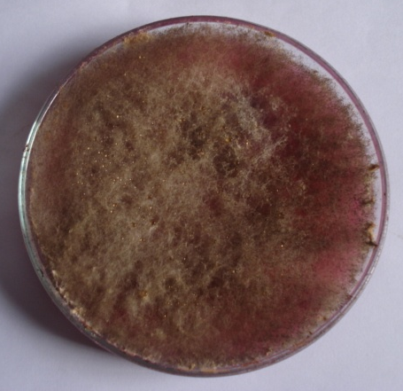

Rhizopus species
On rose bengal chloramphenicol agar medium white dense colony with rapidly grown aerial hyphae was found, which later becomes clotted with brown or black sporangia. The spores are oval, brown in colour, and the mycelium was non septate which give rise to straight sporangiophores.
PHASE III
4.3. OPTIMIZATION STUDIES FOR MALACHITE GREEN DECOLOURISATION USING Rhizopus SPECIES
4.3.1. Effect of dye concentration on malachite green decolourisation
The results of the decolourisation assay using different concentrations of malachite green were presented in table 2 and figure 1. Plate 2a portrays the decolourisation of malachite green using Rhizopus species at different dye concentration.
TABLE 2
Effect of dye concentration on malachite green decolourisation using Rhizopus species
INITIAL DYE CONCENTRATION (g) | DECOLOURISATION (%)
0.01 | 65.5
0.02 | 42.5
0.03 | 32.1
0.04 | 19.5
0.05 | 17.2

The malachite green at the concentration of 0.01g showed maximum decolourisation of 65.5 per cent by Rhizopus species within 5 days of incubation and minimum decolourisation of 17.2 per cent was observed at 0.05g. From the table 2 it was clear that by increasing the dye concentration the decolourisation is decreased considerably.

Figure 1 – Decolourization of malachite green by Rhizopus species at different dye concentrations
The results of the present study falls in line with the findings of Khehra et al. (2005) and Kalme et al. (2007) who reported that dye decolourisation was strongly inhibited when a high concentration dye stuff was used and it was due to the toxic effect of the dye on the degrading microorganisms.
The decrease in decolourisation rate at higher concentration of dye may be due to the blockage of active binding site of fungal degrading enzymes (Tony et al., 2009), sulfonic acid group (So₃H) on the aromatic ring which inhibit the growth of microorganism (Kalyani et al., 2009), toxicity to metabolic activities of microorganisms (Ramya et al., 2007), high molecular mass and structural complexity of dye (Hu and Wu, 2007) and inhibition of microbial nucleic acid synthesis (Chen et al., 2003).
4.3.2. Effect of inoculum concentration on malachite green decolourisation
In order to find out the optimum inoculum needed for high percentage decolourisation, Rhizopus species of varying concentration from 1% to 5% was inoculated in sabauroud dextrose broth amended with 0.01g of dye. The results are presented in
table 3 and figure 2.
Increase in inoculum concentration from 1% to 5% decreased the percentage decolourisation. Rhizopus species at 1% inoculum concentration exhibited maximum decolourisation of malachite
green (68.5%).
TABLE 3
Effect of inoculum concentration on malachite green decolourisation using Rhizopus species
INOCULUM CONCENTRATION (g) | DECOLOURISATION (%)
1 | 68.5
2 | 54.6
3 | 45.3
4 | 23.6
5 | 18.2

Figure 2 – Decolourization of malachite green by Rhizopus species at different inoculum concentrations
The result of the present study was in accordance with the findings of Sani and Baneyee (1999) who reported that there was no proportionate increase in the percentage decolourisation with increase in inoculum size when Kurtia species was inoculated into triphenyl methane dye.
The studies conducted by various researchers on the biosorption of dyes by fungal isolates such as of Aspergillus niger and Aspergillus flavus (Sivaraj et al., 2011) and Aspergillus terreus (Ponraj et al., 2011) and Rhizopus arrhizus (Kumar et al., 2009) revealed the fact that 1% of inoculum was optimum for textile waste water decolourisation.
High per cent decolourisation was due to dye sorption by the mycelium of fungi as well as reduction of dye intensity in the solution (Balan and Monterio 2001).

4.3.3. Effect of Incubation period on malachite green decolourisation
Incubation time is an important parameter in all phenomena including biosorption. It is important to study the effect on the capacity of dye removal. The effect of incubation period on decolourisation of malachite green using Rhizopus species was presented in table 4 and figure 3.
TABLE 4
Effect of incubation period on malachite green decolourisation using Rhizopus species
INCUBATION PERIOD (Days) | DECOLOURISATION (%)
1 | 18.3
2 | 20.6
3 | 43.6
4 | 54
5 | 65.5
6 | 55.1

The results of the present study show that the percentage decolourisation of malachite green by Rhizopus species was maximum at 5th day of incubation. Decolourisation of 65.5% was observed on fifth day of incubation period followed by 6th day (55.1%).The percentage decolourisation decreased in other incubation periods are shown in figure 3.

Figure 3 – Decolourization of malachite green by Rhizopus species at different incubation period
The results of the present study corroborate with the findings of Raj and Ganthi (2009) who indicated that Rhizopus microsporus when incubated in the synthetic textile dyes in potato dextrose broth showed remarkable breakdown action on green G and swiss pink within 5 days of incubation. Similarly Curvularia lunata showed the highest decolourisation activity in the swiss pink at fifth day of incubation. Gopalakrishnan and Jeyadoss (2011) stated that removal efficiency of dyes increases with increase in incubation time.
The maximum uptake of dyes during the early incubation period might be due to the availability of abundant dyes and empty dye binding sites in the microbes. As the incubation period increased the absorption capacity decreased which may be due to the saturation of dye binding sites (Garnham et al., 1992).

4.3.4. Effect of pH on malachite green decolourisation
pH is the most important parameter in the biosorption process which greatly affects the uptake of dye by microbes. The biosorptive capacity of textile dye depends on the pH values.
The effect of pH on decolourisation of malachite green using Rhizopus species was presented in table 5 and figure 4. Plate 2b portrays the decolourisation of malachite green using Rhizopus species at different pH.
Rhizopus species recorded the maximum uptake of
65.5 per cent of dye at the optimum pH 6, followed by pH 7 (52.3%) and the minimum uptake of dye was observed at pH 3 (30.5 %). Maximum decolourisation observed at pH 6 indicates the fact that fungi can degrade the synthetic dyes mostly at acidic conditions. Kaushik and Malik (2009) also stated that for majority of the fungi the optimum pH for the decolourisation lies in the acidic range.
TABLE 5
Effect of pH on malachite green decolourisation using Rhizopus species
pH | DECOLOURISATION (%)
3 | 30.5
4 | 45.3
5 | 59.5
6 | 65.5
7 | 52.3
8 | 48.6

Figure 4 – Decolourization of malachite green by Rhizopus species at different pH
pH has a significant effect on dye binding capacity of the fungus. The pH affects the surface charge of the biosorbent, ionization state and the solubility of the dye (Kalaiarasi and Lavanya, 2010).
The rate of biosorption increases when the pH was increased from (3 – 6) which might be due to a strong relation of biosorption to the number of negative charges on the biosorbent (Delgado et al., 1998). When pH was further increased the biosorption capacity subsequently decreased which might be due to the greater affinity of the proton at the binding sites (Vianna et al., 2000).
The findings of present study showed that the optimum pH for Rhizopus species was 6 which was in accordance with the reports observed in Phanerocheate chrysosporium which removed Navy-Hexie (Kumaran and Dharani, 2011), Pleurotus florida (Deepak et al., 2005) at pH 6 and Pleurotus species mycelial growth at pH 5.5 to 6.0 (Chang and Miles, 1989).

4.3.5. Effect of temperature on malachite green decolourisation
Temperature is an important environmental factor and the biodegradation activities of microorganisms are affected by changes in temperature. Temperature directly relates the chemical reactions in the solution and biochemical reactions of the microbes (Ali, 2010).
The effect of temperature on decolourisation of malachite green using Rhizopus species was presented in table 6 and figure 5. Plate 2c portrays the decolourisation of malachite green using Rhizopus species at different temperature.
TABLE 6
Effect of temperature on malachite green decolourisation using Rhizopus species
TEMPERATURE (°C) | DECOLOURISATION (%)
15 | 30.3
20 | 40.3
25 | 45.6
30 | 50.3
35 | 66.5
40 | 60.1

Figure 5 – Decolourization of malachite green by Rhizopus species at different temperatures
The maximum uptake of dye by Rhizopus species was recorded at 35º C (66.5 %) followed by 40º C (60.1 %), 30º C (50.3 %), 25º C (45.6 %) and 20º C (40.3 %) respectively. The minimum decolourisation was noticed at 15º C (30.3 %).
Thermodynamically, biosorption will be favoured by high temperature if the binding is endothermic, but weakened if it is exothermic. Singh (2007) reported that favouring or unfavouring of high temperature for the biosorption process is entirely dependent on the contribution of the carboxylate or amine ligands on the cell wall
or surface.
Temperature is well known to play an important role in both biosorption rate and equilibrium uptake of dyes by microorganisms. The result of the present study was in accordance with the findings of Ali et al., (2007) who reported the decolourisation of acid red by Aspergillus niger was maximum at 35º C.
Increase in temperature beyond optimum level affects the stability of the cell wall, its configuration and also causes ionization of chemical moieties (Gulay et al., 2003). The decrease of biosorption capacity at higher temperature may be due to the damage of active binding sites in the biomass (Ozer and Ozer, 2003).
The results of the present study also coincides with the findings of Ali (2010) who reported that beyond the optimum temperature the degradation activities of the microorganisms decreased because of slower growth, reproduction rate and deactivation of enzymes. Thus, the biosorption performance of microorganism will be best at the optimum temperature which is needed for their growth, reproduction and metabolic activities.
4.3.6. Effect of carbon sources on malachite green decolourisation
Extra supplements of carbon sources were included in the culture medium which was an attempt to enhance decolourisation performance of the degrading isolate.
The influence of different carbon sources on the decolourisation was presented in table 7 and figure 6. Plate 2d portrays the decolourisation of malachite green using Rhizopus species at different carbon sources.
All the carbon sources used in the study encouraged the growth of fungus. Rhizopus species exhibited maximum decolourisation activity (66.5 %) when glucose was supplemented in the medium as co-substrate. Followed by glucose, lactose (60.4 %), starch (58.2 %), mannitol (50.2 %), maltose (45.5 %) and sucrose
(39 %) recorded decolourization in the dye amended medium inoculated with Rhizopus species.
TABLE 7
Effect of different carbon sources on decolourisation of malachite green using Rhizopus species
Carbon Sources (g) | Decolourisation (%)
Glucose | 66.5
Sucrose | 39.0
Maltose | 45.5
Mannitol | 50.2
Starch | 58.2
Lactose | 60.4

Figure 6 – Decolourization of malachite green by Rhizopus species at different carbon sources
Glucose is an easily metabolizable carbon source and it not only acts as a reducing agent for dyes, but also promotes organisms growth and metabolism thereby increasing dye decolourisation.
When carbon sources were added to the medium the cells first build up the biomass, cells increases and start utilizing the dyes and hence makes the decolourisation efficient (Sharma et al., 2010).
In case of azo dyes, easily utilizable carbon sources acts as sources of electron donor, which are needed for azo bond cleavage (Mendezpaz et al., 2005 and Sponza and Isik, 2004). The reduction of azo dyes depends on the presence and availability of co-substrate because it acts as electron donor for the azo dye reduction
(Modi et al., 2010).
The result of present study coincides with the findings of Raghukumar and Rivonkumar (2001), who showed that the percentage decolourisation of methanated distillery spent wash (MSW) was higher when glucose was fed as carbon source
when Flavodon flavus isolated from marine habitat was used. Nosheen et al. (2000) reported that glucose showed maximum decolourisation of the azo dye, Reactive Black B.
4.3.7. Effect of various nitrogen sources on malachite green decolourisation
Biosorption of malachite green mainly depends on the nitrogen sources. Decolourisation and mineralization of azo dyes have been reported to be enhanced in nitrogen sufficient culture.
The results obtained from present study are depicted in table 8 and figure 7. Plate 2e portrays the decolourisation of malachite green using Rhizopus species at different nitrogen sources.

Plate II
DECOLOURISATION OF MALACHITE GREEN USING RHIZOPUS SPECIES UNDER DIFFERENT OPERATIONAL PARAMETERS
a – Dye concentration
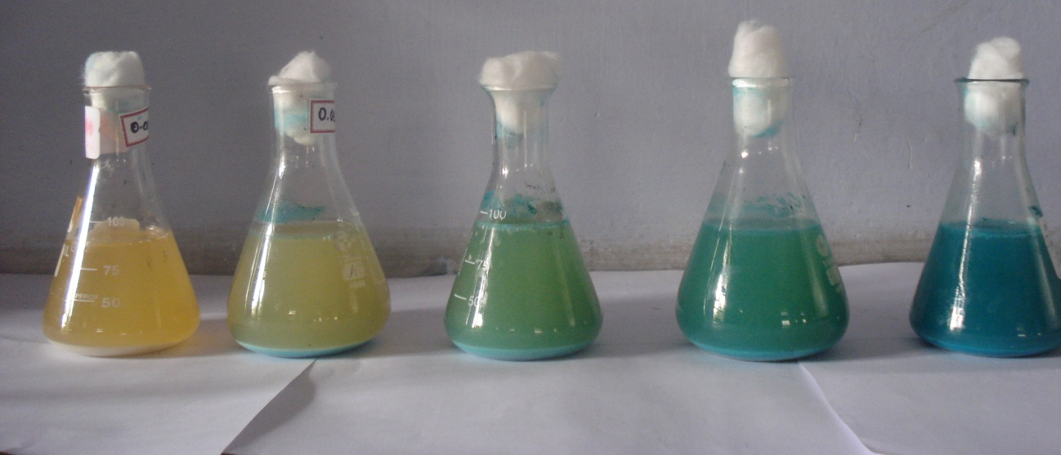
0.01 g 0.02 g 0.03 g 0.04 g 0.05 g
b – pH
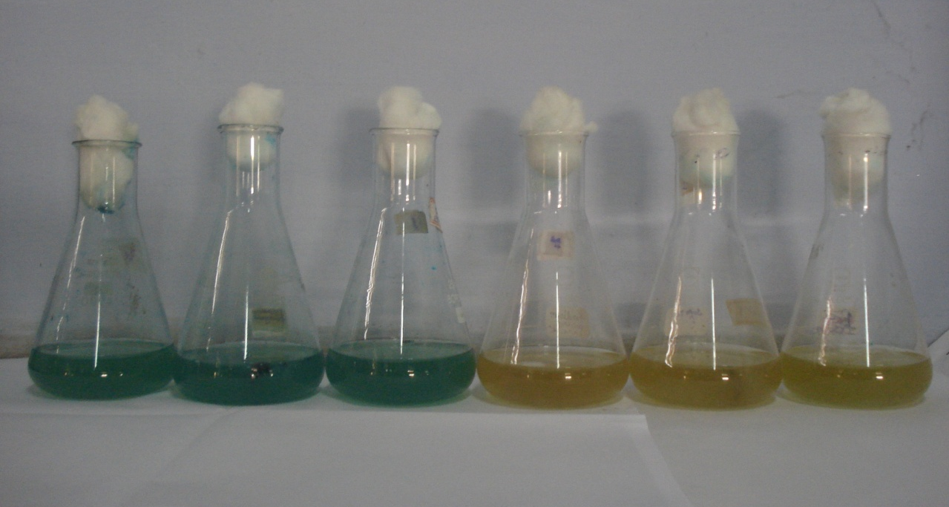
3 4 5 6 7 8

c – Temperature
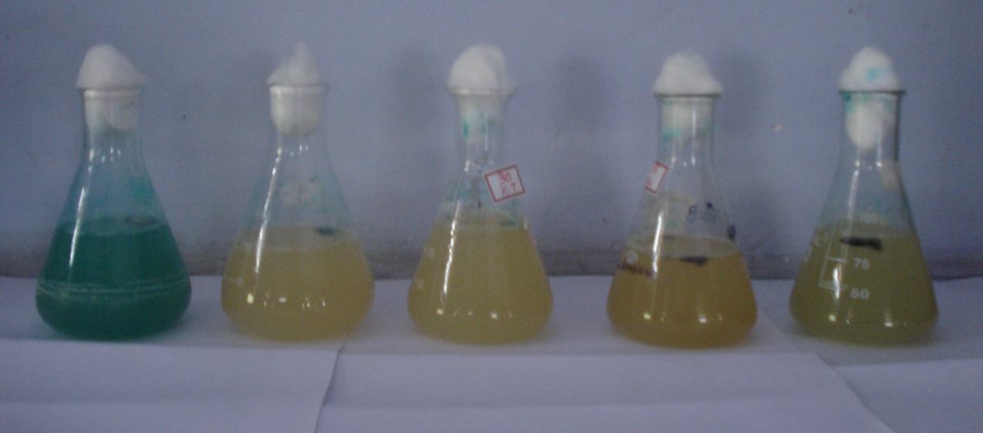
15º C 20º C 25º C 30º C 35º C
d – Carbon sources
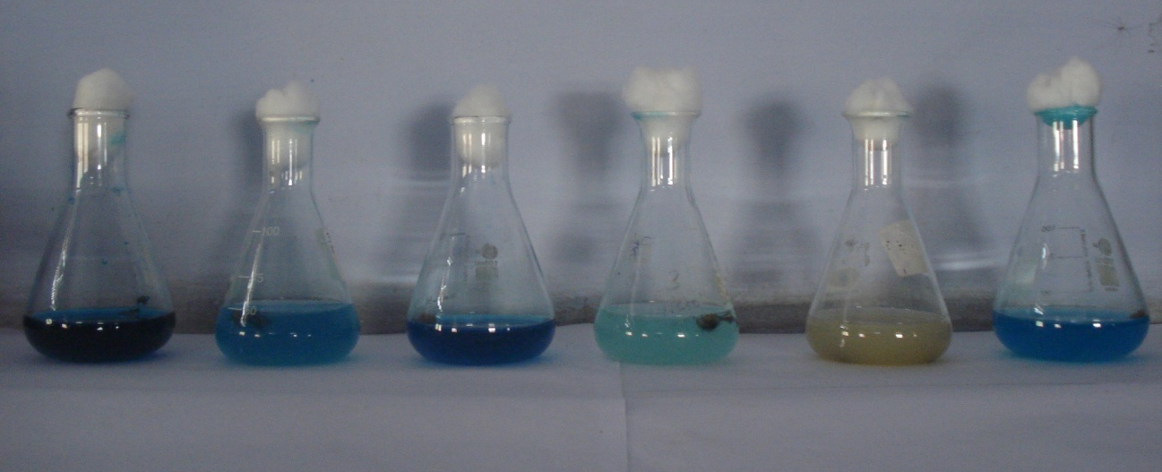
Maltose Mannitol Sucrose Lactose Glucose Starch
e – Nitrogen sources
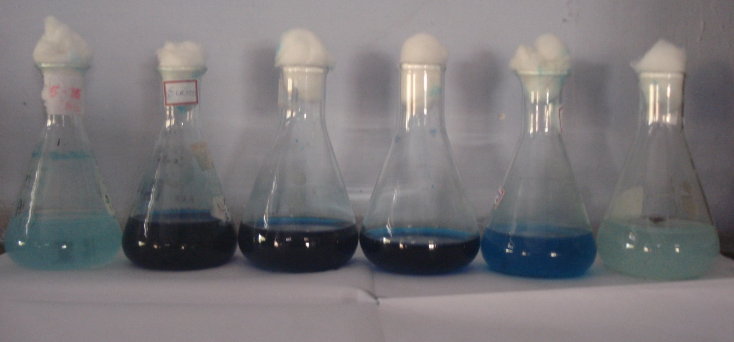
KNO₃ NH₄Cl NaNO₃ NaCl Yeast Glycine
TABLE 8
Effect of various nitrogen sources on decolourisation of malachite green using Rhizopus species
Nitrogen Sources (g) | Decolourisation (%)
NH₄Cl | 30.6
NaCl | 50.3
KNO₃ | 32.3
NaNO₃ | 60.2
Glycine | 64.3
Peptone | 54.8
Yeast extract | 46.1

Figure 7 – Decolourization of malachite green by Rhizopus species at different nitrogen sources
Result shows that among organic complexes, glycine showed maximum decolourisation (64.3%) of malachite green and among inorganic sources the sodium chloride exhibited maximum decolourisation (60.2%). Glycine shows maximum decolourization because it is an amino acid which easily gets converted to nitrogen complex.
The organic nitrogen sources are considered as essential medium supplements for the generation of NADH that acts as electron donor for the reduction of azo dyes by microorganisms
(Hu, 1994)
The result of present study falls in line accordance with findings of Vahidi et al., (2004) who reported that good growth and antifungal activities were observed when complex nitrogen sources were used compared to inorganic nitrogen sources.
PHASE IV
4.4. DECOLOURISATION OF MALACHITE GREEN USING Rhizopus SPECIES UNDER OPTIMAL CONDITIONS
Rhizopus species under optimized conditions degraded malachite green to 70 %. For effective decolourisation glucose and glycine (1g/100ml each), dye concentration (0.01g/100ml), inoculum concentration (1%), incubation period (5 days), pH (6) and temperature (35° C) should be in optimal level. Plate 3 portrays the decolourisation of malachite green using Rhizopus species at optimal conditions.
Of all the technologies investigated in waste cleaning, bioremediation has emerged the most desirable approach
for cleaning up many environmental pollutants. The general approaches to bioremediation are to enhance natural
biodegradation by native organisms to carry out environmental modification (Ashoka et al., 2002).

PLATE – 3
DECOLOURISATION OF MALACHITE GREEN DYE USING RHIZOPUS SPECIES UNDER OPTIMAL CONDITIONS

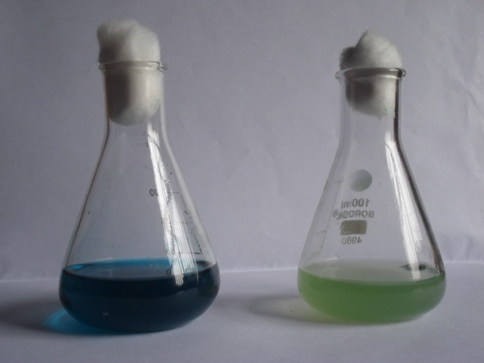
A B

A – UNTREATED MALACHITE GREEN DYE
B – MALACHITE GREEN DYE TREATED WITH RHIZOPUS SPECIES

Before developing a bioremediation technology for treating the dyes, it is necessary to isolate and identify the suitable microorganism having good degrading ability. Therefore, the present study was conducted to assess the degradation ability of synthetic waste water using indigenous Rhizopus species, which could be employed for decolourisation of the effluent containing dyes. Under the optimal environmental conditions maximum degradation was obtained which might be due to the presence of enzymes like laccase, cellulase and peroxidase secreted by Rhizopus species (Zope, 2007). The ability of microorganisms to transform a variety of chemicals has led to their use in agriculture. Diverse fungal cultures have been investigated recently for bioremediation processes (Aust, 1990). The high surface-to-cell ratio of filamentous fungi makes them better degraders under certain niches (Ashoka et al., 2002). Thus the approach of using microorganisms is cost effective, ecofriendly and scores greater attraction over physiochemical process which exerts lots of sludge.
PHASE V
4.5. BIOSORPTION ISOTHERM MODELING STUDIES
Equilibrium study on adsorption provides information on the capacity of the adsorbent. An adsorption isotherm is characterized by certain constant values, which express the surface properties and affinity of the adsorbent. It is also been used to compare the adsorptive capacities of the adsorbent for adsorbates.
In case of Langmuir model the value of R_{L} in Table 9 indicates the shape of the isotherm to be either unfavourable (R_{L} > 1), linear (R_{L} = 1), favourable (0 < R_{L} < 1) or irreversible (R_{L} = 0). The R_{L} value between 0 and 1 indicates favourable adsorption (Figure 8).

TABLE 9
Adsorption of malachite green by Rhizopus species in terms of Langmuir and Freundlich Adsorption Isotherm
LANGUMIR ADSORPTION ISOTHERMS
Incubation period  (Days) | Concentration of dye (mg/l) | Amount of dye left (Ce) | 1/Ce | m/x | Separation factor (R_{L}) | Intercept  k₁ / k₁' | Slope  1/ k₁'
5 | 100 | 8.85 | 0.11299 | 0.08695 | 0.02559 | -0.24842 | 2.627207
5 | 200 | 8.73 | 0.11454 | 0.07874 | 0.01296 | -0.24842 | 2.627207
5 | 300 | 8.04 | 0.12437 | 0.05102 | 0.00868 | -0.24842 | 2.627207
5 | 400 | 7.47 | 0.13386 | 0.03952 | 0.00652 | -0.24842 | 2.627207
5 | 500 | 5.74 | 0.17391 | 0.23474 | 0.00522 | -0.24842 | 2.627207
FREUNDLICH ADSORPTION ISOTHERM
Incubation period  (Days) | Initial concentration of dye (mg/l) | Ce | Log Ce | Log m/x | Intercept | Slope 1/n | n
5 | 100 | 8.85 | 0.9469 | 1.0607 | -1.07418 | 2.454049 | 0.4074815
5 | 200 | 8.73 | 0.9410 | 1.1038 | -1.07418 | 2.454049 | 0.4074815
5 | 300 | 8.04 | 0.9052 | 1.2922 | -1.07418 | 2.454049 | 0.4074815
5 | 400 | 7.47 | 0.8733 | 1.4031 | -1.07418 | 2.454049 | 0.4074815
5 | 500 | 5.74 | 0.7589 | 0.6294 | -1.07418 | 2.454049 | 0.4074815

Figure 8 - The linearized Langmuir sorption isotherms of malachite green by Rhizopus species (100g/L) at optimum incubation period (5 days)

Figure 9 - The linearized Freundlich sorption isotherms of malachite green by Rhizopus species (100g/L) at optimum incubation period (5 days)

In the present study, the calculated values of R_{L} are observed to be in the range of 0.00522 to 0.02559 at all studied incubation period indicating that the adsorption of malachite green onto the biosorbent was favourable.
In case of Freundlich model the calculated value of n was 0.4074815 which lies below 1 indicating the favourable adsorption of dyestuff by Rhizopus species (Figure 9 and Table 9).
The results of the present study coincides with the findings of Kumari and Abraham (2007) who reported that the non viable biomass of Rhizopus nigricans showed an optimal fit to Langumuir and Freundlich.
Thus the present study indicated that Rhizopus species have promising bioadsorption capacity of malachite green and highlighted the possible exploitation in dye polluted habitat.
PHASE VI
4.6. THIN LAYER CHROMATOGRAPHY (TLC) FOR BIODEGRADATION ANALYSIS
Dye decolourisation study of Rhizopus species was further supported by TLC analysis. TLC of the extracted metabolites confirmed the degradation of malachite green.
Thin layer chromatography (TLC) has a unique advantage in analysis of dyes because the colored spots can be easily seen in the plates. As an off-line analytical technique, TLC is broadly used in analysis of dyes and intermediates because of its simple and inexpensive properties.

PLATE 4
TLC PROFILE OF MALACHITE GREEN DYE (D) AND ITS METABOLITE (B) OBTAINED AFTER DECOLOURISATION USING RHIZOPUS SPECIES

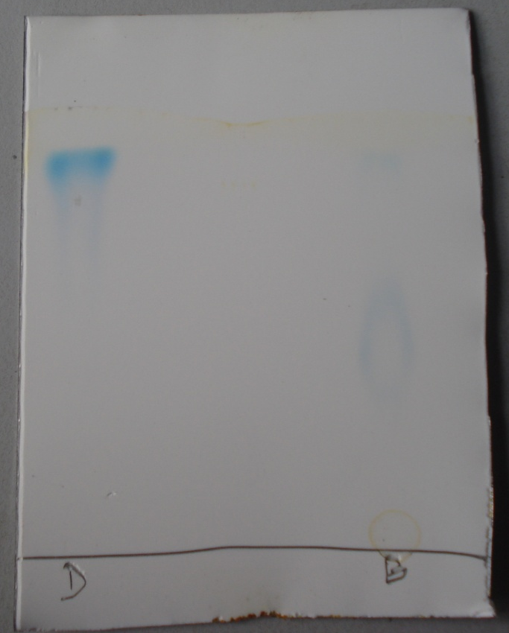

The result of TLC indicated that the spot of initial malachite green dye solution with RF value of 0.90 and that of decolourized medium is 0.60. When the dye chromatogram was observed in UV light, fluorescent bands with RF values were observed in the decolourized medium. Plate 4 portrays the metabolites formed during the degradation of malachite green using Rhizopus species by TLC.
The spots were observed in the initial dye solution and also in the decolourised medium, indicating that decolourisation was due to its degradation into unidentified intermediates. The initial step in fungal degradation of dye is due to the formation of aromatic amines. These aromatic amines are likely to be formed during reactive cleavage of bonds through which the amines are linked in the dye (Junnarker et al., 2006).
The analysis of the reaction product showed that during incubation the amount of malachite green in the medium decreased whereas the amount of product increased. This product comigrated with authentic leuco malachite green and this proves that some demethylated products might have formed during degradation.
PHASE VII
4.7. CHARACTERISATION OF FUNGAL SURFACE BEFORE AND AFTER BIOSORPTION OF MALACHITE GREEN
4.7.1. FT –IR Spectra of dye loaded and unloaded fungal isolates
Fourier Transform Infra Red is the preferred method of infra red spectroscopy. In infra red spectroscopy, IR radiation is passed through a sample. Some of the infra red radiation is absorbed by the sample. The resulting spectrum represents the molecules absorption and transmission creating a molecular fingerprint of the sample.
The dry powdered samples of Rhizopus species were subjected to Fourier Transform Infra Red analysis which resulted in many functional groups based on the wavelength and percentage of transmittance. Surface characterization of Rhizopus species by
FT-IR analysis without and with adsorbed malachite green was shown in Plate 5a and 5b. The complex nature of the biomass examined is indicated by a number of absorption peaks in the control sample. The spectra of decolourised sampled reveals shifting of some characteristic bands, which depict changes in functional group after decolourisation compared to untreated dye sample.
FT- IR study of the untreated fungal biosorbent shows that the band observed at 3262.61cm⁻¹ result from –NH₂ asymmetric stretching mode of amines, which is slightly broad indicating overlapping of amines and hydroxyl stretching on the fungal surface. The adsorption peak at 2925.06 cm⁻¹ can be assigned to -CH stretching of alkanes. The 2363.64 cm⁻¹ band was due to the vibration of -OH streching of carboxylate ions. The adsorption bands at 1744, 1637.54 and 1154 cm⁻¹ are the results of C=O stretching mainly conjugated to –NH deformation mode and can be attributed to the esters, amide and aromatic bands due to the protein peptide bonds. Plate 5a shows the FT – IR spectrum of Rhizopus species before biosorption.
In the fungal biosorbent treated with malachite green there was shifting of the band to 3338.92 cm⁻¹ from 3262.61 cm⁻¹ with substantial increase in intensity. There is also change of band to 2985.99 cm⁻¹ from 2925.06 cm⁻¹. There was a shift in the band to 2315.64 cm⁻¹ from 2363.64 cm⁻¹ and also a sharp decrease in the band intensity at 1600.02 cm⁻¹ to 1637.54 cm⁻¹ corresponding to C=O and C=C stretching after dye binding. Plate 5b shows the FT – IR spectrum of Rhizopus species after biosorption.

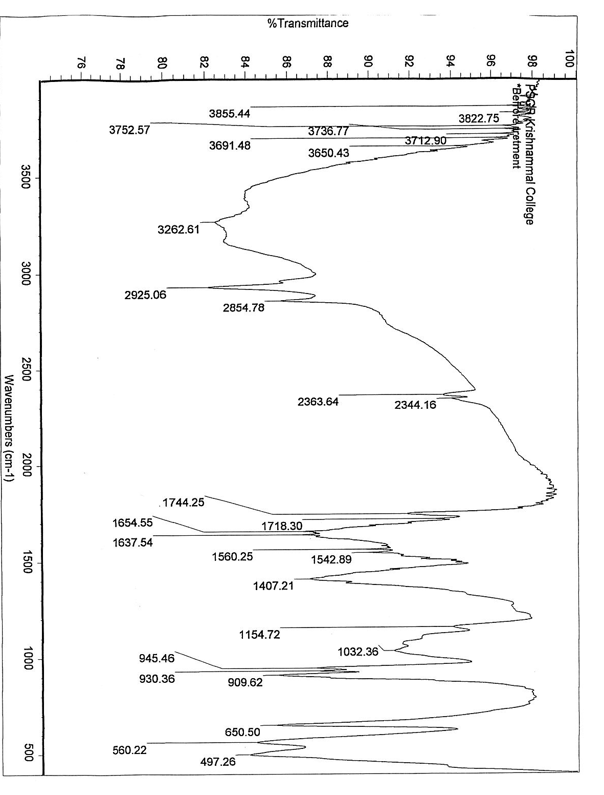
PLATE 5
- FT – IR SPECTRUM OF RHIZOPUS SPECIES BEFORE BIOSORPTION

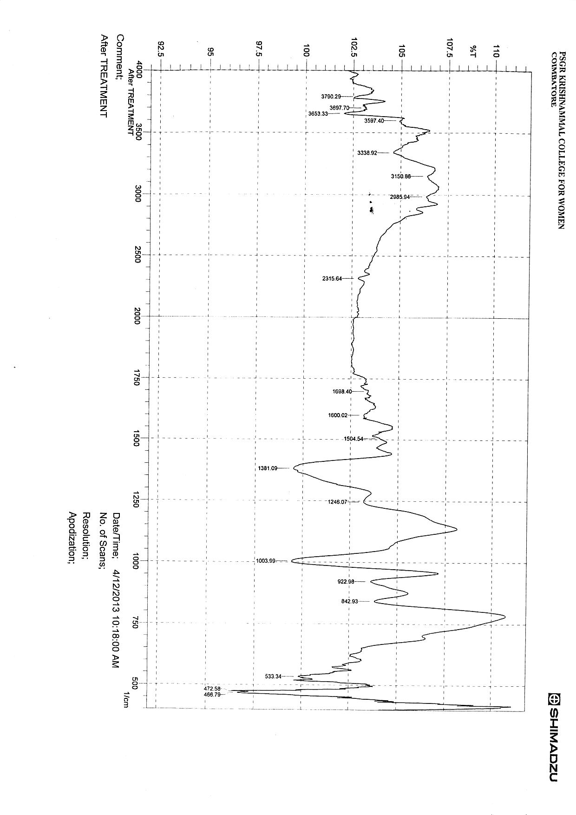

- FT – IR SPECTRUM OF RHIZOPUS SPECIES AFTER BIOSORPTION

On the basis of the change in the band, it was reasonable to assume that the peak value suggested the coordination of the dye with hydroxyl or carboxyl or amine groups, which may increase the hydrogen bondings or forms ligands between the dye and the
cell wall.
Considerable difference between the FT- IR spectrum of control malachite green and the metabolites obtained after complete decolourisation by Rhizopus species confirmed the biodegradation of dye into different metabolites.
The peak results in the samples give the functional groups carboxylic acids, amides, phenols and alcohols. This analysis had eventually confirmed the difference between functional groups in relation to biosorption of malachite green dye.
4.7.2. SCANNING ELECTRON MICROSCOPE ANALYSIS (SEM)
SEM provides high magnified image of the surface of the material. It images the electrons that are reflected from a sample. These images are useful for studying surface morphology, particle size, shapes and arrangement of the particles.
The assessment of morphological changes in response to malachite green accumulation in Rhizopus was performed by scanning Electron microscopy. SEM studies revealed that before malachite green biosorption the cells of Rhizopus species appeared to be plumpy and had smooth surface in a loosely bound form
(Plate 6a). The cells of Rhizopus species after biosorption of malachite green was found to be flocculated, agglomerated, grainy and showed shrinkage in the surface (Plate 6b).

PLATE 6

SCANNING ELECTRON MICROGRAPHS DEPICTING THE EFFECT OF MALACHITE GREEN ON THE CELL MORPHOLOGY AT DIFFERENT MAGNIFICATIONS
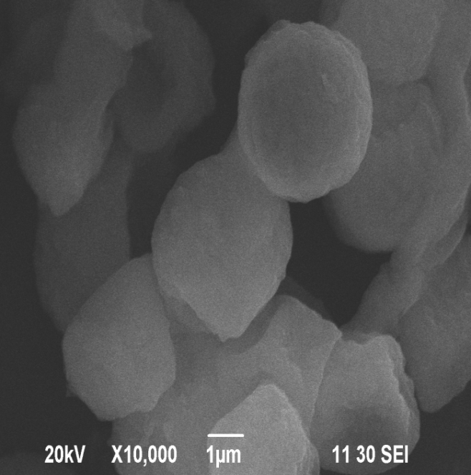 | 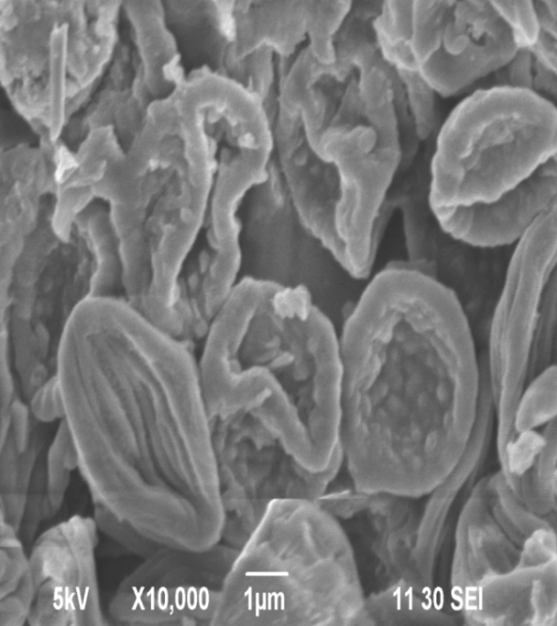
BEFORE BIOSORPTION | AFTER BIOSORPTION
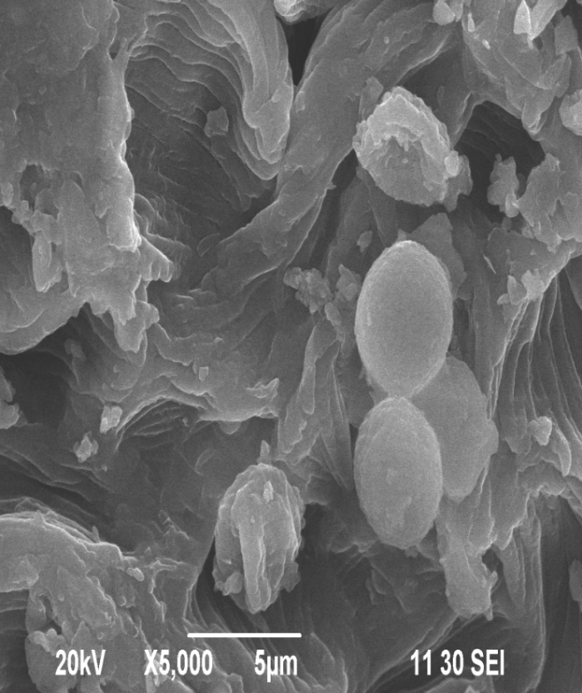 | 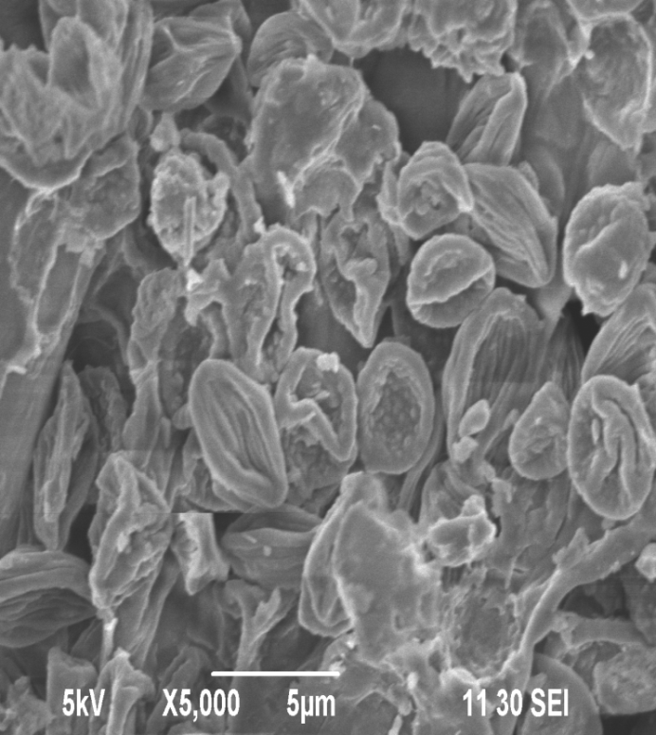
BEFORE BIOSORPTION | AFTER BIOSORPTION

Similar such SEM studies were conducted on the accumulation of chromium in the mycelium of Aspergillus niger after seven days of incubation (Srivastava and Thakur, 2006) and lead ions of Fusarium oxysporium after ten days of incubation (Sanyal, 2005). These results provide supportive evidences for the present study.
The result of present study also falls in line with the findings of Needham et al. (2005) who reported that severe agglomeration is due to the enhanced electrostatic attraction between surfaces which indicates the decreased particle size.
It was also reported by Carlile et al. (2001) that some fungi such as Mucor and Rhizopus shows excellent biosorption because of the high chitin and chitosan content of the cell wall. Generally, the fungal cell wall is made up of different polysaccharides. They are complexed with proteins, lipids and other substances. The outer layer of the fungal cell wall is formed of glucans, mannas or galactans, whereas the inner layer is formed of the chitin. The variation among fungal cell walls depends on the stages of life cycle of the organism and on culture conditions (Volesky, 1990).
PHASE VIII
4.8. IMPACT OF MICROBIALLY TREATED MALACHITE GREEN ON THE GROWTH OF COW PEA
The results of germination percentage, root length, shoot length, fresh weight, dry weight and vigour index of cow pea seedlings grown with microbially treated malachite green (T₁), untreated malachite green (T₂) and tap water (T₃) on 7th day favoured the growth of the experimental plant and the results were depicted in table 10. Plate 7 shows the growth of cow pea on 7th day.

Germination percentage and vigour index
A maximum of 87 percent germination was recorded in cow pea seeds grown with treated malachite green (T₁) followed by 53 percent in tap water (T₃). A minimum of 7 percent germination was recorded in seeds grown with untreated malachite green (T₂).
Seed germination and growth are vital to the plants for continuation of generation. For germination and seedling growth entrance of water into seeds is a basic requirement to initiate and trigger the sequence of metabolism (Mahapatra and Mohanty, 2007).
The germination percentage of the present study decreased in the seed grown with untreated malachite green (T₂) which would be attributed due to high salt concentration in the effluent (Shanmugavel, 1993; Kannabiran and Pragasam, 1993), Inhibition of enzyme activtiy (Umamaheswari et al., 2003; Vijayakumari, 2003) and physical and biological disturbance to the seeds (Debojit and Rao, 1994 and Umamaheswari et al., 2003).
Higher percentage of seed germination in cow pea grown with microbially treated malachite green effluent (T₁) may be due to the increased availability of nutrients in the effluent.
The reduction in seed germination was also observed by several researchers in various agricultural crops grown in dyeing (Kumar and Bishwas, 2005 and Rajeswari, et al., 2005), distillery (Virendra and Dhar, 2002 and Surendra et al., 2005),
tannery (Thangavel and Balagurunathan, 2002) and pulp mill
(Medhi et al., 2008) effluents which supports the findings of
present study.

The vigour index was maximum in T₁ (1847) followed by
T₃ (7366) and minimum was observed in T₂ (27) as shown
in table 10. Decrease in the vigour of seeds irrigated with untreated malachite green observed in the present study might be due to the interaction of different pollutants with the developing radical. Seed vigour may also be correlated with physiological and chemical properties of axes than with those of whole seeds (Andersen and Abdul Baki, 1971).
Shoot length and root length
Shoot length of seven day old cow pea seedlings after treatment with microbially treated malachite green (T₁), untreated malachite green (T₂) and tap water (T₃) were recorded in table 10. Plate 7 shows the root length and shoot length of 7 days old cow pea.
The values recorded for the shoot lengths of cow pea seedlings were 12.3, 1.0 and 9.93 cm in T₁, T₂ and T₃ respectively. The values recorded for the seedlings grown in microbially treated effluent (T₁) were highly significant when compared with control and T₂. The root length of cow pea was maximum (8.83 cm) in T₁ and minimum (0.33 cm) in T₂ treatment when compared with control (4 cm). T₁ showed an increase in root length when compared to T₂ and T₃ plants.
From the above results it was observed that the reduction in shoot and root length of seedlings grown using T₂ might be due to the presence of higher dye concentration of dye which exhibited the uptake of micro and macro elements by plant system. Microbially treated effluent has been reported to
favour root and shoot length due to the translocation of nutrients to the plants (Jothimani and Elayarajan, 2003).
PLATE 7 – POT CULTURE SUPPORTING THE GROWTH OF
7 DAYS OLD COW PEA
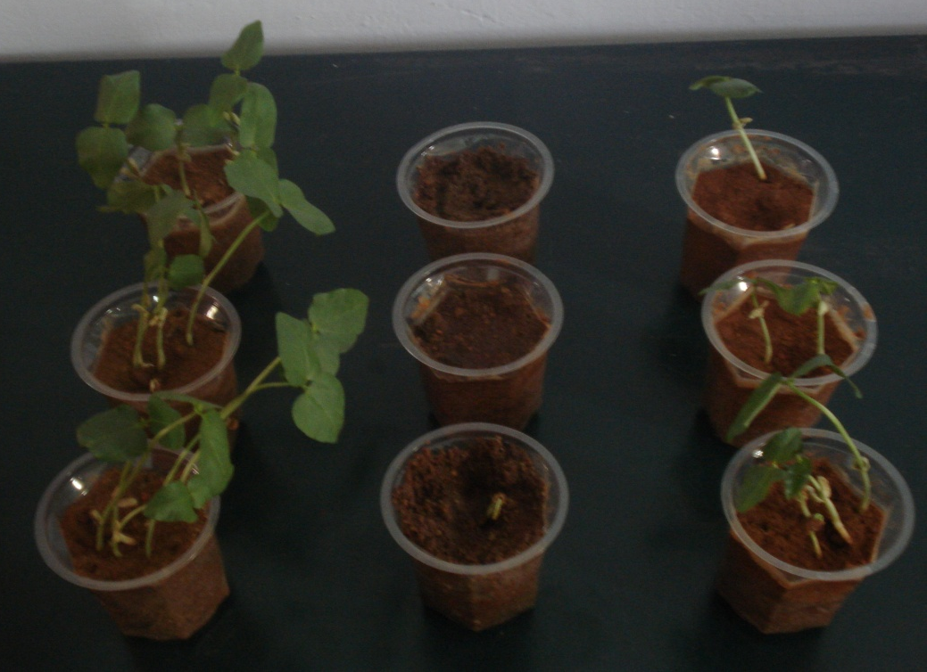
T₁ T₂ T₃
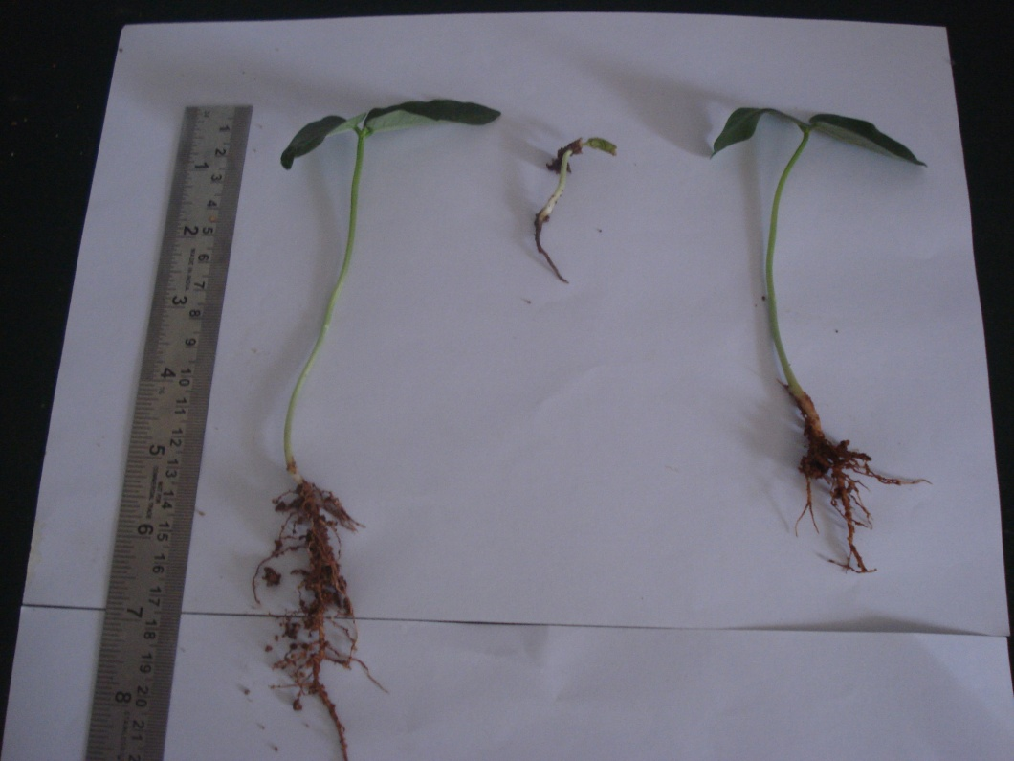
T₁ T₂ T₃
PLATE 8 – ROOT LENGTH AND SHOOT LENGTH OF
7 DAYS OLD COW PEA
TABLE 10
Biometric parameters in 7 days old seedlings of cow pea grown with different treatments
Treatments | Germination Percentage | Shoot length  (cm) | Root  Length  (cm) | Fresh weight  (g) | Dry weight (g) | Vigour  index
T₁ | 87 | 12.33 | 8.83 | 0.46 | 0.210 | 1847
T₂ | 7 | 1.0 | 0.33 | 0.050 | 0.030 | 27
T₃ | 53 | 9.93 | 4.0 | 0.24 | 0.137 | 766
SED |  | 0.7836 | 0.7935 | 0.0409 | 0.0185
CD (5%) |  | 2.1757 | 2.2031 | 0.1136 | 0.0513
The values are mean of triplicates
T₁ - Microbially treated malachite green dye
T₂ - Untreated reactive malachite green dye
T₃ - Control (Tap water)

Fresh weight and dry weight
The fresh weight of cow pea seedlings treated with different treatments was depicted in table 10. The highest fresh weight
(0.46 g) was observed in T₁ when compared with control (0.24 g) and least value (0.05 g) was recorded in T₂. The dry weight of cow pea was maximum (0.21g) in T₁ and minimum (0.03 g) in T₂ treatment when compared with control (0.139 g).There was an increase in the fresh and dry weight of T₁ plants when compared with control and T₂ plants.
The reduction in the fresh and dry weight of the cow pea plants selected for the present study may be due to the physiological stress with dissolved solids and salinity which restricted the plant growth by increasing the soil osmotic pressure (Jothimani and Elayarajan, 2003).
Increase in fresh and dry weight of plants grown in microbially treated effluent is in consonance with the results of Ramakrishnan
et al. (2001) who grown the paddy in sugar mill effluent treated with yeast.
The summary and conclusion for the present study is presented in the next chapter.

5. SUMMARY AND CONCLUSION
Synthetic dyes released into the environment cause considerable water and soil pollution because they may be toxic, carcinogenic, mutagenic and clastrogenic to living organisms. Over the last two decades, awareness and concern about the environmental and health hazards of synthetic dyes is increasing in the global community. Consequently, environmental and government legislations are becoming more and more stringent regarding the removal of these pollutants from industrial waster waters.
Different physical and chemical methods have been employed for the treatment of effluent released from the textile industries. These methods mostly suffer from serious limitations like high cost, low efficiency, limited versatility and production of secondary pollution.
In contrast bioremediation is a cost effective, efficient, biofriendly and environmentally benign method for the removal of dyes from industrial waster waters. It is the application of micro organisms for the removal of xenobiotics from polluted environment microorganisms are our microscopic allies and tiny biological reactors which can convert harmful synthetic substances into simple, less toxic or completely benign products. Microorganisms can even mineralize organic pollutants and convert them into water, carbon-di-oxide and salts.
The textile effluent spilled soil sample was collected and screened for the decolourisation of malachite green. The fungus which exhibited maximum decolourisation was selected for the study and characterized. Various parameters like pH, temperature, inoculum and dye concentration, incubation time, various carbon and nitrogen sources were optimized for effective decolourisation of malachite green by the isolated fungus. The fungal samples were subjected to FT –IR spectral and SEM analysis before and after treated with malachite green. The degraded metabolites of malachite green treated with isolated fungus was analysed by TLC. The impact of untreated and treated malachite green on the biometric parameters such as germination percentage shoot length, root length, dry weight, fresh weight and vigour index of cow pea was studied on 7th day after sowing.
Findings of the study
- The fungal species which exhibited maximum decolourisation was isolated and identified as Rhizopus species.
- The per cent decolourisation by Rhizopus species was found to be maximum in the medium amended with 0.01g of dye.
- Percent decolourisation was found to be maximum at 1% inoculum concentration of Rhizopus species.
- An incubation time of 5 days resulted in maximum decolourisation by Rhizopus species.
- The optimum pH for decolourisation of malachite green effluent by Rhizopus species was found to be at pH 6.
- The optimum temperature for decolourisation by Rhizopus species was found to be 35° C.
- Among the different carbon and nitrogen sources the maximum decolourisation activity was observed in the medium supplemented with 1% glucose and 1% glycine respectively.
- Rhizopus species under optimized conditions degraded malachite green to 70%.
- The experimental data fitted well in both Langmuir and Freundlich adsorption isotherms.
- TLC revealed the presence of metabolites in the malachite green decolourised medium.
- The results of FT – IR spectral analysis suggested that the dye binding sites on the fungal cell surface were most likely the carbonyl and amine groups.
- The malachite green removal capacity of Rhizpous species by scanning electron microscopic study proved the accumulation of dye within the fungal mycelium.
- Cow pea grown with microbially treated malachite green (T₁) exhibited maximum biometric parameters such as germination percentage, shoot length, root length, dry weight, fresh weight and vigour index when compared with control plants. The plants grown with untreated malachite green (T₂) recorded minimum growth when compared with T₁ and control on 7th day after sowing.
CONCLUSION
It is evident from the study that decolourisation of malachite green could be done using Rhizopus species and the treated dye could be utilized for agriculture. It possessed high biosorption efficiency, reusability and stability. The results of this study will form the basis for the development of cost effective, ecofriendly and robust indigenous technology for pollution free environment.

REFERENCES
Abdul Baki, A.S and Anderson, J.O. (1973), Vigour determination in soybean seed by multiple criteria, Crop Science, 13, 630 – 633.
Ai, Z., Li, J., Zhang,L. and Lee, S. (2010), Rapid decolourization of azo dyes in aqueous solution by an ultra sound assisted eletrocatalytic oxidation process, Ultrason sonochemistry, 17:370 – 375.
Akinci, E.I., Akinci, S. and Yilma, Z.K. (2010), Response of tomato (Solanum lycopersicum, L.) to lead toxicity : Growth element uptake, chlorophyll and water content, African Journal of Agricultural Research, 5(6), 416 – 423.
Aksu, Z. and Tezer, S. (2005), Biosorption of reactive dyes on the green algae Chlorella vulgaris, Process Biochemistry, 40:1347 – 1361.
Alaa, H., Hawari, A., Catherine, N. and Mulligan, T. (2006), Biosorption of Lead(II), Cadmium(II), Copper(II) and Nickel(II) by an aerobic granular biomass, Bioresource Technology, 97:692 – 700.
Ali, H. (2010), Biodegradation of synthetic dyes – A review, Journal of Water, Air and Soil Pollution, 213:251 – 275.
Ali, H. (2010), Biodegradation of Synthetic dyes – A Review, Water, Air, Soil Pollution, 213:251 – 273.
Ali, H. and Muhammad, S.H. (2008), Biodecolourisation of acid violet 19 by Alternaria solani, Journal of Biotechnology, 7(6):831 – 833.
Ali, H., Ahmad, W. and Haq, T. (2009), Decolourization and degradation of malachite green by Aspergillus flavus and Alternaria solani, Biodegradation, 20(1):215 – 217.
Ali, N., Jkramullah, S., Lutfullah, G., Hameed, A and Ahmed, S. (2007), Decolourisation of acid red 151 by Aspergillus niger SA1 under different physicochemical conditions, World Journal Microbiology and Biotechnology, 10, 9581 – 86.
Anderson, J.D and Abdul Baki, A.A. (1971), Glucose metabolism of embryos and endosperms from deteriorating barley and wheat seeds, Plant Physiology, 48: 270 – 272.
Anjaneyulu, Y., Sreedheira, M.L., Novais, J.M. and Pinheiro, H.M. (2005), Bioloigcal sulphate reduction and redox mediator effects on azo dye decolourization in anaerobic – aerobic sequencing batch reactors, Enzyme Microbiology Technology, 36:790 – 799.
Annuar, M.S., Adnan, S., Vikineswary, S. and Chisti, Y. (2009), Kinetics and energetics of azo dye decolorization by Pycnoporus sanguineus, Water, Air and Soil Pollution, 202:179 – 188.
Asamudo, N.U., Daba, A.S. and Ezeronye, O.U. (2005), Bioremediation of textile effluent using Phanerochaete chrysosporium, African Journal of Biotechnology, 4(13):1548 – 1553.
Asgher, M., Shah, S.A.H., Ali, M. and Legge, R.L. (2006), Decolorization of some reactive textile dyes by white rot fungi isolated in Pakisthan, World Journal of Microbiology and Biotechnology, 22:89 – 93.
Ashoka, C., Geetha, M.S. and Sudha, S.B. (2002), Bioleaching of composite textile dye effluent using bacterial consortia, Asian Journal of Microbiology Biotechnology and Environmental Sciences, 4:65 – 68.
Aust, S. D. (1990), Degradation of Environmental Pollutants, Microbial Ecology, 20:197 – 209.
Azmi, W., Saini, R.K. and Banerjee, V.C. (1998), Biodegradation
of triphenyl methane dyes, Enzyme and Microbial Technology, 22:185 – 191.
Balan, D.S.C. and Monterio, R.T.R. (2001), Decolourisation of textile
dye indigo dye by lignolytic fungi, Journal of Biotechnology,
89, 141 – 145.
Balan, D.S.C. and Monterio, R.T.R. (2001), Decolourization of the textile dyes indigo by lignolytic fungi, Journal of Biotechnology,
89:141 – 145.

Bhole, B.D., Ganguly, B., Madhuram, A., Deshpande, D. and Joshi, J. (2004), Biosorption of methyl violet, basic fuchsin and their
mixture using dead fungal biomass, Current Science,
86 (12), 1641-1645.
Cappuccino, J.G. and Sherman, N. (1999), Microbiology : A laboratory manual, an imprint on Addison Wesley longman inc.,25-28.
Carlile, Watkinson, M.J., Sarah, C., Gooday and Graham, W. (2001), The fungi, 2nd Edition, London, Academic Press, p.588.
Chamunorwa, A.T., Mutambanengwec, C.Z. and Whiteley, C.G. (2008), Decolourisation and degradation of textile dyes using a sulphate reducing bacteria (SRB) – biodigested microflora co-culture,
7(2), 114 – 121.

Chang, S.T. and Miles, P.G. (1989), Edible mushrooms and their cultivation, R.C.Press, Inc. of Bocaraton, Florida, USA.
Chen, K.C., Wu, J.Y., Liou, D.J. and Huang, S.C.J. (2003), Decolorization of the textile dyes by newly isolated bacterial strains, Journal of Biotechnology, 101:57 – 68.
Cheunbarn, T.S., Cheunbarn, K. and Khumjai, T. (2008), Prospects of bacterial granule for treatment of real textile industrial waste water, International Journal of Agricultural Biology, 10:689 – 692.
Chivukula, M. and Renganathan, V. (1995), Phenolic azo dyes oxidation by laccase from Pyricularia oryzae, Applied and Environmental Microbiology, 61:4374 – 4377.
Chung, K.T., Stevens, S.E., and Cerniglia, C.E. (1992), The reduction of azo dyes by the intestinal microflora, Critical review Microbiology, 18:175 – 190.
Cimrin, K.M., Turan, A. M. and Kapur, B. (2007), Effect of elemental sulphur on heavy metals solubility and remediation by plants
in calcareous soils, Fresenius Environment Bulletin,
16(19a):1113 –1120.
Corso, C.R. and Almeida, A.C.M. (2009), Bioremediation of dyes in textile effluent by Aspergillus oryzae, Microbial Ecology, 57:384 – 390.
Couto, S.R. (2009), Dye removal by immobilized fungi, Biotechnology Advances, 27:227 – 235.
Crini, G. (2006), Non conventional low cost adsorbents for dye removal - A review, Bioresource technology, 97:953 – 971.
Dawkar, V.V., Jadhar, V.V., Ghodake, G.S. and Govindwar, S.P. (2009), Effect of inducers on the decolorization and biodegradation of textile azo dye Navy blue 2GL by Bacillus species, VUS, Biodegradation, 20:777 – 787.
Debojit, K and Rao, N.J. (1994), Impact of crude oil on seed germination of French bean (Phaseolus vulgaris L.), Journal of Industrial Pollution Control, 10, 139 – 144.

Deepak, R.K., Shukla, K.K., Rajak, R.C. and Pandey, A.K. (2005), Optimization of physico-chemical parameters for mycelial growth of an indigenous species of Pleurotus florida (SNG), Journal of Microbial World, 7(1), 82-89.
Delgado, A., Anselmo, A.M and Novais, J.M. (1998), Heavy metal biosorption by dried powdered mycelium of Fusarium floccciferum, Water Environment Research, 70, 370 – 375.
Devarajan, S. and Sulaiman, S.M.H. (2012), Influence of pH, temperature and carbon and nitrogen sources on the growth of fungal species isolated from textile dye effluent contaminated soils, Department of Environmental Science, TNAU, Microbial Pollution.

Devi, M. and Kausik, K. B. D. (2005), Decolourisation of textile dyes and dye effluent by Aspergillus species, Indian Journal of Microbiology, 45(1), 41-44.
Dubey, S.K., Pandey, A., Bajaj, A.K. and Mishra, K. (2007), Some commercial azo dye and inhibitors of mushroom tyrosinase Dopaoxidase activity, Journal of Pharmacology, Toxicology,
2:718 – 724.
Emtiazi, G. (2000), Decolorization and Biodegradation of dyes by Aspergillus terreus grown on wheat straw with Mn peroxidase activity, Pollution Research, 19(1):31 – 35.
Esposito, A., Pagnanelli, F. and Veglio, F. (2002), pH related Equilibrium models for biosorption in single metal system, Chemistry Engineering Science, 57:307 – 313.
Ferraz, A.I., Teixeiraja, L. and Khasim, B. (2004), Cr(II) removal and recovery from Saccharomyces cerevisiae, Chemical Engineering Journal, 105:11 – 20.
Forgacs, E., Cserhati, T. and Oros, G. (2004), Removal of synthetic dyes from waste water a review, Environment International Journal, 30:953 – 971.
Forgacs, E., Cserhati, T. and Oros, G. (2004), Removal of synthetic
dyes from waste water : a review, Environment International,
30:953 – 971.
Fu, Y. and Viraraghavan, T. (2001), Dead fungal biomass of Aspergillus niger, Pollution Research, 53:51 – 53.
Fu, Y. and Viraraghavan, T. (2002), Dye biosorption sites in Aspergillus niger, Bioresource Technology, 82:139 – 145.
Garnham, G.W., Godd, G.A and Godd, G.M. (1992), Accumulation of cobalt, zinc and manganese by the estuarine green microalgae Chorella salina immobilized in alginate beads, Environment Science and Technology, 26, 1764 – 1770.
Gopalakrishnan, K. and Jeyadoss, T. (2011), Comparative study on biosorption of Zn (II), Cu (II) and Cr (VI) from textile dye effluent using activated rice husk and activated coconut fibre, Indian Journal of Chemical Technology, 18:61 – 66.

Goyal, N., Jain, S.C. and Banerjee, U.C. (2003), Comparative studies on the microbial adsorption of heavy metals, Advanced Environment Research, 2(11):311 – 319.
Gulay, B., Sema, B and Yakup, A.M. (2003), Biosorption of heavy metals ions on immobilized white-rot fungus Trametes versicolor, Journal of Hazardous material, 101, 285 – 300.
Hai, F.I., Yamamotom, K. and Fukushi, K. (2007), Hybrid treatment systems for dye waste waters, Critical Review of Environment Science Technology, 37:315 – 377.
Hao, O.J., Kim, H. and Chiang, P.C. (2000), Decolourization of waste water, Critical Review of Environmental Science and Technology, 30:449 – 505.
Harazono, K. and Nakamura, K. (2005), Decolorization of mixtures of different reactive textile dyes by the white-rot basidiomycetes Phanerochaete sordida and inhibitory effects of polyvinyl alcohol, Chemosphere, 59:63 – 68.
Hu, T. and Wu, S.L. (2001), Assessment of the effect of azo dyes RP2b on the growth of nitrogen fixing cyanobacterium – Anabena species, Bioresource Technology, 73:3 – 95.
Hu, T.L. (1994), Decolourization of reactive azo dyes by transformation with Pseudomonas luteola, Bioresource technology, 49:47-51
Jadhav, J.P., Phugare, S.S., Dhanve, R.S. and Jadhav, S.B. (2010), Rapid biodegradation and decolorization of Direct orange 39 (Orange TGLL) by an isolated bacterium Pseudomonas aeruginosa strain BCH, Biodegradation, 21:453 – 463.
Jin, X., Liu, G., Xu, Z. and Yao, W. (2007), Decolorization of a dye industry effluent by Aspergillus fumigatus XC6, Applied Microbiology and Biotechnology, 74:239 – 243.
John, B. (2006), American chemical society water analysis by atomic absorption and flame emission spectroscopy, trace inorganic matter in water, Advance Chemistry, 73, American Chemical Society, Washington DC.
Jothimani, P and Elayarajan, M. (2003), Effect of treated effluent on germination shoot length, root length and vigour index of crops, Journal of Ecobiology, 15(1): 49 – 54.
Jothimani, P and Elayarajan, M. (2003), Impact of dye effluents on Na, Ca and Mg levels in soil and nutrient content crops, Journal of Ecobiology, 15(2): 89 – 98.
Junnarker, N.M., Nikhil, D.S. and Datta, M. (2006), Decolourisation of diazo dye direct red 81 by a novel bacterium consortium, World Journal of Microbiology and Biotechnology, 22:163 – 168.
Kadirvelu, K., Senthilkumar, P., Thamaraiselvi, K. and Subburam, V. (2002), Activated carbon prepared from biomass as absorbent: Elimination of Ni(II) from aqueous solution, Bioresource Technology, 81:87 – 90.
Kalaiarasi, K. and Lavanya, A. (2010), Biosorption of reactive dye from textile industry effluent by Aspergillus fumigatus, Pollution Research, 29(2):171 – 174.
Kalaiarasi, K. and Lavanya, A. (2010), Decolourization of textile dye effluent by non – viable biomass of Aspergillus fumigatus, Brazilian Archives of Biology and Technology, 55:471 – 476.
Kalme, S., Chodako, G. and Govindwar, S. (2007), Red HETB degradation using desulfonation by Pseudomonas desmolyticum NCIM 2112, International Biodeterioriation and Biodegradation, 60:327 – 333.
Kalyani, D.C., Telke, A.A., Dhanve, R.S. and Jadhar, J.P. (2009), Ecofriendly Biodegradation and detoxification of Reactive Red 2 textile dye by newly isolated Pseudomonas species Suk I, Journal of Hazardous Material, 163 (2-3):735 – 742.
Kalyani, D.C., Telke, A.A., Dhanve, R.S. and Jadhav, J.P. (2009), Ecofriendly biodegradation and detoxification of reactive red 2 textile dye by newly isolated Pseudomonas sp. SUKI, Journal of Hazardous Material, 163, 735 – 742.
Kannabiran, B. and Pragasam, A. (1993), Effect of distillery effluents on seed germination, seedling growth and pigment content of Vigna mungo (Linn.) Kepper (C.V.T. 9), Geobiosphere, 20:108 – 112.
Karcher, S., Kornmuller, A. and Jekel, M. (2001), Screening of commercial sorbents for the removal of reactive dyes, Dyes Pigments,
51:111 – 125.
Kaushik, P. and Malik, A. (2009), Fungal dye decolourization - Recent advances and future potential, Environment International,
35:127 – 141.
Kaushik, P. and Malik, A. (2010), Colour removal from textile plant effluent, Bioresource Technology, 63:49 – 56.
Khataee, A.R., Vatanpour, V. and Amani, A. (2009), Decolourization of C.I. Acid blue 9 solution by UV/Nano – TiO_{2,} Fenton, Fenton – like, electro – fenton and electrocoagulation processes : a comparative study, Journal of Hazardous Material, 161:1225 – 1233.
Khedkar, D.D. and Dixit, A.J. (2005), Effect of textile waste water of Ambanala, Amaravai on seed germination and seedling
growth of spinach (Spinacea oleracea), Journal of Ecobiology, 17(5):429 – 436.
Khehra, D.C., Saini, H.S., Sharma, D.K., Chandha, B.S. and Chimi, S.S. (2005), Comparative studies on potential of consortium and constituent pure bacterial isolates to decolorize azo dyes, Water Research, 39:5134 – 5141.
Kilic, N.K., Nielson, J.P., Yuce, M. and Donmez, G. (2007), Characterization of a simple bacterial consortium for effective treatment of waste waters with reactive dyes and Cr(VI), Chemosphere, 67:826 – 831.
Koka, V. and Srivastava, m. (2012), Physiochemical characteristics of textile effluents through common effluent treatment plant, Journal of textile trends, Maharana Pratap University of Agricultural and Technology, Udaipur.
Kumar, A.G and Bishwas, R. (2005), Effect of dyeing industry effluent on seed germination, development of seedling and chlorophyll content of Withania somnifera, Nature Environment Pollution Technology, 4(3) 405 – 408.
Kumar, K., Dastidar, M.G. and Sreekrishnan, T.R. (2009), Effect of process parameters on aerobic decolorization of reactive azo dye using mixed culture, World Academy of Science, Engineering and Technology, 58:962 – 965.
Kumaran, N. and Dharani, G. (2011), Decolourisation of textile dyes by white rot fungi Phanerocheate chrysosporium and Pleurotus sajor-caju, Journal of Applied Technology in Environmental Sanitation, 1(4):361 – 370.
Kumaran, S.N. and Dharani, G. (2011), Decolourisation of textile dyes by white rot fungi Phanerocheate chrysosporium and Pleurotus sajor-caju, Journal of Applied Technology in Environmental Sanitation, 1(4):361 – 370.
Kumari, K. and Abraham, E.T. (2007), Biosorption of anionic textile dyes by nonviable biomass of fungi and yeast, Bioresource Technology, 98:1704 – 1710.
Lakshmi, S and Sundaramoorthy, P. (2001), Effect of sugar mill effluent on germination, seedling growth and biochemical changes in ragi (Eluesine coracana (L.) Gaertn), Indian Journal of Environment and Ecoplanning, 3(3), 501 – 506.
Lezcano, J.M., Gonzalez, F., Perez, I., Blazquez, M.L., Munoz, J.A., Ballester, A. and Hammaini, A. (2001), Use of waste biomass for decontamination liquid effluents by biosorption, Biohydrometallurgy : Fundamentals, Technology and Sustainable development,
217 – 226.
Li, J.P., Zhang, X., Ai, Z.H., Jia, F.L., Zhang, L.Z. and Lin, J. (2007), Efficient visible light degradation of rhodamine B by a photo electro chemical process based on a Bi₂WO₆ nano plate film electrode, Journal of Physical Chemistry, 111:6832 – 6836.
Mabrouk, E.M.M., Anima, S. and Yusef, H.H. (2008), Decolourization of fast Red by Bacilus subtilis HM, Journal of Applied Science Research, 4(3):262 – 269.
Mahapatra, M. and Mohanty, B.K. (2007), Effect of sugar mill effluent on germination of green gram (Phaseolus mungo) and growth behaviour ot its seedlings, Journal of Industrial Pollution Control, 23(1):55 – 59.
Mandezpaz, D., Omil, F. and Lema, J.M. (2005), Anaerobic treatment of azo dye acid orange T under fed batch and continuous conditions, Water Research, 39, 771 – 778.
Mattioli, D., Malpei, F., Bortone, G. and Rozzi, A. (2002), Water minimization and reuse in textile industry, Water Recycling and Resource recovery in Industry : Analysis, Technologies and Implementation, IWA Publishing, Cornwall, UK:677.
Medhi, U.J., Talukdar, A.K and Deka, S. (2008), Effect of pulp and paper mill effluent on seed germination and seedling growth of mustard (Brassica campestris), pea (Pisum sativum) and rice (Oryza sativa) seeds, Pollution Research, 27(3), 437 – 442.
Mishra, G. and Tripathy, M. (1993), A critical review of the treatment for decolorization of textile effluents, Colourage, 40:35 – 38.
Modi, H.A., Rajput, G. and Ambasana, C. (2010), Decolourisation of water soluble azo dyes by bacterial cultures, isolated from dye house effluent, Bioresource Technology, 101:6580 – 6583.
Mungasavalli, D.P., Viraraghavan, T and Jin, Y.C. (2007), Biosorption of chromium from aqueous solutions by pretreated Aspergillus niger : Batch and column studies, Colloids Surface A – Physicochemical Engineering Aspects, 301:214 – 223.
Needham, S.A., Wang, G.X. and Liu, H.K. (2005), Journal of Alloy and Compounds, 400:234.
Nigam, P., Banat, I.M., Marchant, R. and Singh, D. (1996), Microbial process for the decolourisation of textile effluent containing azo, diazo and reactive dyes, Process Biochemistry, 31:435 – 442.
Nosheen, S., Nawaz, H. and Rehman, K.U. (2000), Physiological characterization of effluents of local textile industries of
Faisalabad, Pakisthan, International Journal of Agriculture and Biology, 2(3):232 – 233.
Ogugbue, C.I., Sawidis, T. and Oranusi, N.A. (2012), Bioremoval of chemically different synthetic dyes by Aeromonas hydrophila in simulated waste water containing dyeing auxilaries, Annual Microbiology, 62:1141 – 1153.
Ozer, A. and Ozer, D. (2003), Comparative study of the biosorption of Pb (II), Ni (II) and Cr (VI) ions onto Saccharomyces cerevisiae : determination of biosorption heats, Journal of Hazardous Material, 100:219 – 229.
Parshetti, G., Kalme, S., Saratale, G. and Govindwar, S. (2006), Biodegradation of malachite green by Kocuria rosea MTCC 1532, Actachimica slovenica, 53:492 – 498.
Parshetti, G.K., Kalme, S.D., Gomare, S.S. and Govindwar, S.P. (2007), Biodegradation of reactive blue-25 by Aspergillus ochraceus NC1M-1146, Bioresource Technology, 98:3638 – 3642.
Pavadai, P., Dhanavel, D., Seetharaman, N and Selvaraju, M. (2004), Effect of zinc on germination and yield parameters in blackgram [Vigna mungo (L.) Hepper.var.co.3], Plant Archives, 4(2), 479 – 481.
Ponraj, M., Gokila, K. and Zambare, V. (2011), Bacterial decolourization of textile dye – orange 3R, International Journal of Advanced Biotechnology and Research, 2(1):168 – 177.
Ponraj, M., Jamunarani, P. and Zambare, V. (2011), Isolation and optimization of culture conditions for Decolourization of true blue using dye decolourizing fungi, Asian Journal of Experimental Biological Science, 2(2):270 – 277.
Ponraj, M., Jamunarani, P. and Zambare, V. (2011), Isolation and optimization of culture conditions for decolourization of true blue using dye decolourizing fungi, Asian Journal of Experimental Biological Sciences, 2(2):270 – 277.
Pourbabaee, A, A., Malekzadeh, F., Sarbolouki, M.N. and Najafi, F. (2006), Aerobic decolorization and detoxification of a disperse dye in textile effluents by a new isolate of Bacillus sp, Biotechnology and Bioengineering, 93:631 – 635.
Purdom, A. and Anderson, Y. (1980), Decolourization of triphenylmethane, azo and anthraquinone dyes by a newly isolated Aeromonoas hydrophila strain, Applied Microbiology and Biotechnology,
77:1316 – 1321.
Radha, K.V., Arunagiri, A. and Murugesan, A. (2005), Decolourization studies of synthetic dyes using Phanearocheate chrysosporium and their kinetics, Process Biochemistry,40: 3337 – 3345.
Raghukumar, C. and Rivonkumar, G. (2001), Decolourisation of molasses spent wash by white rot fungus Flavodon flavus isolated from marine habitat, Applied Microbiology Biotechnology, 55:510 – 514.
Rai, H.S., Bhattacharya, M.S., Singh, J., Bansal, T.K., Vats, P. and Banerjee, U.C. (2005), Removal of dyes from the effluent of textile and dyestuffs manufacturing industry : a review of emerging techniques with reference to biological treatment, Journal of Environment Science Technology, 35:219 – 238.
Raj, T.L.S. and Ganthi, S.A. (2009), Synthetic dye decolourization by fungal cultures under static conditions, Asian Journal of Microbiology, Biotechnology and Environmental Sciences, 11(4):769 – 772.
Rajan, R.M., Periyasamy, M. and Suresh, G. (2011), Effect of dye industry effluent on growth and some biochemical characteristics of certain tree species, Journal of Industrial Pollution Control, 27(2):97 – 101.
Rajeswari, M., Kalaichelvi, K., Manian, S and Indramuthu, J. (2005), Irrigational impact of dye house effluent on plant growth
and soil characteristics, Journal of Industrial Pollution Control,
21(2): 299 – 304.
Raju, S.N., Sharma, R.S. and Sivswami, A. (2007), Advanced oxidation process for degradation of polyphenols, International Journal of Chemistry, 5(3):1375.
Ramakrishnan, K., Thamizhiniyan, P., Sundaramoorthy, P and Sriramchandrasekaran, M.V. (2001), Effect of sugar mill effluent polluted soil on VAM fungi, Journal of Ecobiology, 13(3):187 – 192.
Ramya, M., Anusha, B., Kalavathy, S. and Devilakshmi, S. (2007), Biodecolourisation and degradation reactive blue by Aspergillus sp., African Journal of Biotechnology, 6(12),1141 – 1445.
Reddy, S.S., Kotaiah, B. and Reddy, N.S.A. (2008), Colour pollution control in textile dyeing industry effluents using tannery sludge
derived activated carbon, Bulletin Chemistry Society, Ethiop, 22(3):369 – 378.
Robinson, T., Mullar, G. and Marachant, R. (2001), Remediation of dyes in textile effluent : a critical review on current treatment technologies with a proposed alternative, Bioresource Technology, 77:247 – 255.
Rott, U. (2003), Multiple use of water in Industry, The textile industry case, Journal of Environment Science health, 38:1629 – 1639.
Sani, R. and Baneyee, U. (1999), Decolourization of triphenyl methane dyes and textile and dye stuff effluent by Kurthia sp., Enzyme and Microbial Technology., 24, 433 – 437.
Santos, A.B., Cerrantes, F.J. and Vanlier, J.B. (2007), Review paper on current technologies for decolourization of textile waste waters : Perspectives for anaerobic biotechnology, Bioresource Technology, 98:2369 – 2385.
Santos, A.B.D., Bisschops, I.A.E. and Cervantes, F.J. (2006), Closing process water cycles and product recovery in textile industry : perspective for biological treatment In : Cervantes, F.J., VanHaandel, A.C., Pavlostathis, S.G. (Eds.), Advanced Biological treatment processes for Industrial Waste Waters, Vol. 1, International Water Association, London : 298 – 320.
Santos, A.Z.D., Neto, J.M.C., Grahen, C.R. and Costa, S.M.G. (2004), Screening filamentous fungi for the decolorization of a commercial reactive dye, Journal of Basic Microbiology, 44(4):255 – 259.
Sanyal, A., Rautaray, D., Bansal, V., Ahmad, A and Sastry, M. (2005), Heavy metal remediation by a fungus as a means of production of lead and cadmium carbonate crystals, Langmuir, 51, 7220 – 7224.
Saraswathi, K. and Balakumar, S. (2009), Biodecolourization of azodyes (pigmented red 208) using Bacillus firmus and Bacillus laterosporus, Journal of Bioscience and Technology, 1:1 – 7.
Saratale, R.G., Saratale, G.D., Chang, J.S. and Govindwar, S.P. (2010), Decolorization and biodegradation of reactive dyes and dye waste water by a developed bacterial consortium, Biodegradation,
21:999 – 1015.
Sekar, P., Yumnam, N. and Ponmurugan, K. (2008), Screening and characterization of mycotoxin producing fungi from dried fruits and grains, Advance Biotechnology, 2(1): 11-16.
Selvam, K., Swaminathan, K. and Chae, K.S. (2003), Microbial decolourization of azo dyes and dyes industry effluent by fomes lividus, World Journal of Microbiology and Biotechnology,
19:591 – 593.
Shanmugavel, P. (1993), Impact of sewage, paper and dye industry effluents on germination of green gram and maize seeds, Journal of Ecobiology, 5, 69 – 71.
Sharma, M., Mathur, N., Nigam, V.K. and Ghosh, P. (2010), Decolourisation of different dyes by isolated bacterial strains, Asian Journal of Microbiology, 12(4): 751- 757.
Shedbalkar, U., Dhanve, R. and Jadhar, J. (2008), Biodegradation of triphenyl methane dye cotton blue by Penicillium ochrochloron MTCC 517, Journal of Hazardous Materials, 157:472 – 479.
Sheth, K.N. and Patel, M. (2004), Characterization, treatment and cost analysis studies of textile processing waste water of Vatva Industrial Complex, Journal of Environment Pollution Control, 7:11 – 15.
Singh, D. (2007), Biosorption of zinc (II) from aqueous solution by non living Spirogyra sp., Pollution Research, 26(2): 297 – 300.
Sivaraj, R., Doorthy, C.A.M. and Venkatesh, R. (2011), Isolation, Characterization and growth kinetics of fungi metabolizing textile effluent, Journal of Bioscience and Technology, 2:324 – 330.
Sponza, D.T. and Isik, M. (2004), Decolourisation and inhibition kinetic of direct black 38 azo dye with granulated anaerobic sludge, Enzyme Microbiology Technology, 34:147 – 158.
Srivastava, S and Thakur, I.S. (2006), Biosorption potency of Aspergillus niger for removal of chromium (VI), Current Microbiology,
53, 232 – 237.
Srivastava, S., Sinha, R., and Roy, D. (2004), Toxicological effects of malachite green, Aquatic Toxicology, 63:319 – 329.
Stampova, A., Smela, D., Vondrackova, D., Jancarova, I. and Kuban, V. (2001), Determination of synthetic colorants in food stuffs, Chemical history, 95:163 – 168.
Sundaramoorthy, P., Saravanan, S., Subramani, A and Lakshmanachary, A.S. (2000), Toxicity effect of fertilizer factory effluent on seed germination and seeding growth of some agricultural crops, Pollution Research, 19(4): 523 – 533.
Surendra, S.S., Sandeep, S., Pooja, V., Saruchi, S., Shyam, S and Gopesh, P. (2005), Impact of distillery effluent on seed germination and seedling growth of some plants, Nature Environment Pollution Technology, 4(3): 413 – 418.
Takashima, F. and Hibiya, T. (1995), an atlas of fish Histology, Normal and Pathological features, 2nd Edition, Gustav fischer verlag, Stuttgart, New York.
Tekere, M., Mswaka, A.Y., Zvauya, R. and Read, J.S. (2001), Growth, dye degradation and ligninolytic activity studies on Zimbabwean white rot fungi, Enzyme Microbiology Technology, 28(4-5): 420-426.
Thangavel, P and Balagurunathan, R. (2002), Effect of tannery effluent on germination and growth of certain crop plants, Bulletin of Pure and Applied Science, 121–125.
Tony, B.D., Goyal, D. and Khanna, S. (2009), Decolorization of direct red 28 by mixed bacterial culture in an upflow immobilized bioreactor, Journal of Indian Microbiology Biotechnology, 36:955 – 960.
Torres, E., Jaimes, I.B. and Borgne, L.S. (2003), Potential use of oxidative enzymes for the detoxification of organic pollutants, Applied Catalysis B : Environmental Studies, 46:1 – 15.
Umamaheswari, S., Balamurugan, V and Vijayalakshmi, G.S. (2003), Impact of textile mill effluent on germination and seedling growth of Vigna mungo, Journal of Ecotoxicology and Environment Monitoring, 3(1): 47 – 51.
Vahidi, H., Kobarfard, F. and Namjoyan, F. (2004), Effect of cultivation conditions on growth and antifungal activity of Mycena leptocephala, African Journal of Biotechnology, 3(11):606-609.
Valiappan, A., Melchias, G and Kasinathan, P. (2002), Effect of heavy metal toxicity on the nodulation pattern of legume cultivars, Journal of Ecotoxicology and Environmental Monitoring, 12(1), 17 – 20.
Vasanthy, M. and Thamaraiselvi, C. (2006), Decolourisation of diluted spent wash using chemical and biological agents, Journal of Industrial Pollution Control, 22(2):269 – 272.
Verma, P., Baldrian, P. and Nerud, F. (2003), Decolorization of structurally different synthetic dyes using cobalt(II) / ascorbic acid / hydrogen peroxide system, Chemosphere, 50:975 – 979.
Vianna, L.N.L., Andrade, M.C. and Nicoli, J.R. (2000), Screening of waste biomass from Saccharomyces cerevisiae, Aspergillus oryzae and Bacillus lentus fermentation for removal of Cu, Zn and Cd
by biosorption, World journal of Microbiology, biotechnology,
16:437 – 440.
Vijaya, P.P. and Sandhya, S. (2003), Decolourization and complete degradation of methylred by a mixed culture, Environmentalist, 23:145 – 149.
Vijayakumari, B. (2003), Impact of textile dyeing effluent on growth of soya bean (Glycine max L.), Journal of Ecotoxicology and Environment Monitoring, 13(1): 59 – 64.
Vinojkumar, V., Kaladharan, P. and Sharma, S. (2006), Biosorption of metals from contaminated water using sea water, Current Science, 90(9):1263 – 1267.
Virendra, M and Dhar, P.S. (2002), Effect of distillery effluent and leachates of industrial sludge on the germination of black gram (Cicer arietinum), Pollution Research, 21(4): 461 – 467.
Volesky, B. (1990), Biosorption of heavy metals, Boca caton, F., CRC Press, USA, p.396.
Wang, J. and Chen, C. (2006), Biosorption of heavy metals by Saccharomyces cerevisiae : A review, Biotechnology Advances, 24L427 – 451.
Wang, J.L. (2002), Immobilization technique biocatalyst and water pollution control, Beijing, Science Press, 24:427 – 451.
Wang, R.C., Fan, K.S. and Chang, J.S. (2009), Removal of acid dye by ZnFe₂O₄ / TiO₂ – immobilized granular activated carbon under visible light irridation in a recycle liquid – solid fluidized bed, Journal of Taiwan Institute of Chemical Engineering, 40:533 – 540.
Weisburger, J.H. (2002), Comments on the history and importance of aromatic and heterocyclic amines in public health, Mutation Research : 506 – 507.
WHO (2002), Water Pollutants : Biological agents, dissolved chemicals, non dissolved chemicals, sediments, heat, WHOCE HA, Amman, Jordan.
WHO (2003), The world Health Report 2003 : Shaping the Future, World Health Organization, 1211, Geneva 27, Switzerland.
Wong,Y. and Yu.J.(2003), Laccase –cataysed decolourisation of synthetic dyes, Water Research,33: 3512-3520.
Xu, M., Guo, J., Zeng, G., Zhong, X. and Sun, G. (2006), Decolourization of anthraquinone dye by Shewanella decolorization, Applied Microbiology and Biotechnology, 71:246 – 251.
Yasmin, A., Nawaz, S. and Ali, S.M. (2011), Impact of industrial effluent on germination and seedling growth of Lens esculentum varieties, Pakisthan Journal of Botany, 43(6): 2759 – 2763.
Zaghbani, N., Hafiane, A. and Dhahbi, M. (2007), Removal of safrain T from waste water using micellar enhanced ultrafiltration, Desalination, 222:348 – 356.
Zhang, F., Knapp, J.S. and Tapley, K.N. (1999), Deelopment of bioreactor systems for decolourization of orange II using white rot fungus, Enzyme and Microbial Technology, 24(1 – 2):48 – 53.
Zhang, F., Yediler, A., Liang, X. and Kettrup, A. (2004), Effects of dye additives on the ozonation process and oxidation by products : a comparative study using hydrolysed CI Reactive red 120, Dyes Pigments, 60:1 – 7.
Zhou, W. and Zimmermann, W. (1993), Decolourization of industrial effluents containing reactive dyes by actinomycetes, FEMS Microbiology Letters, 107:157 – 162.
Zollinger, H. (1991), Colour chemistry : Synthesis, properties and applications of organic dyes and pigments, 5th Edition, VCH Publications, Weinheim, pp:187 – 246.
Zope (2007), Biodegradation of synthetic textile dyes reactive red 195 and reactive green 11 by Aspergillus niger grp: An alternative approach, Journal of Scientific Industrial Research, 66, 411 – 414.

