COMPARATIVE STUDY ON ANTIMICROBIAL ACTIVITY USING SELECTED PLANTS EXTRACTS

By:
MERCY NEMNEINENG DOUNGEL
(17PTF010)

A Thesis Submitted To The
Avinashilingam Institute for Home Science and Higher Education for Women
Coimbatore- 641043

In partial fulfillment of the requirement for the degree of
MASTER OF SCIENCE IN TEXTILES AND FASHION APPAREL

APRIL 2019
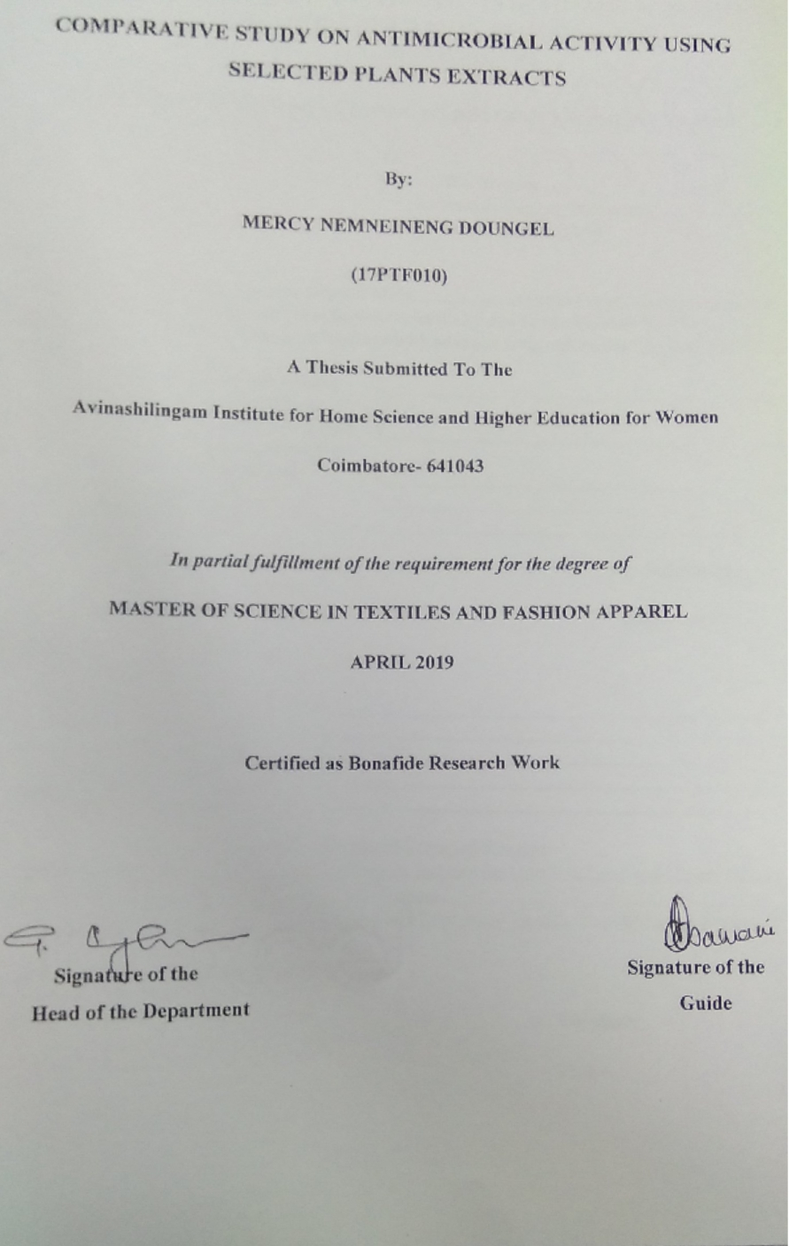ACKNOWLEDGEMENT
Words would not suffice the gratitude the investigator feels for the immense blessing of god ALMIGHTY for his grace and mercy showered on her for carrying out the study successfully and blessing her with such wonderful parents who were her moral and mental support throughout the study with whom the conduct of the study have been impossible.
The investigator expresses her sincere thanks to the former chancellors of Avinashilingam Institute for Home Science and Higher Education for Women, Coimbatore, Padmabushan. Dr. T.S. AVINASHILINGAM and HON. COL. Padmashri, Dr. (Tmt.) RAJAMMAL P. DEVADAS, M.A., M.Sc., Ph.D. (Ohio State) Hon, D.Sc, (Azad Agri, University, Kanpur) for heavenly blessing.
The investigator expresses her sincere thanks to Padmashri Dr. P.R. KRISHNAKUMAR, Chancellor of Avinashilingam Institute for Home Science and Higher Education for Women, Coimbatore, for providing the infrastructural facilities for the conduct of the study.
The investigator records her gratitude to Dr.(Mrs.) PREMAVATHY VIJAYAN, M.Sc., M.Ed., Dip. Spl. Edn., M.Phil.., Ph.D., Vice Chancellor, Avinashilingam Institute for Home Science and Higher Education for Women, Coimbatore, for providing all the amenties required for the conduct of the study.
The investigator records her gratitude to Dr. (Mrs.) S. KOWSALYA, M.Sc., M.Phil., Ph.D., Registrar, Avinashilingam Institute for Home Science and Higher Education for Women, Coimbatore, for providing all the help for the smooth conduct of the study.
The investigator records her respectful gratitude to Dr. (Tmt) N. VASUGI RAAJA, M.Sc., M.B.A., M.Phil, (Madras), Ph.D. Dean, Faculty of Home Science, Professor in Textiles and Clothing, Avinashilingam Institute for Home Science and Higher Education for Women, Coimbatore, for constant encouragement which have helped in the successful completion of this study.
The investigator records her gratitude to Dr. (Tmt.) G.BAGYALAKSHMI , M.Sc., M.Phil., Ph.D., Professor and Head, Department of Textiles and Clothing. AvinashilingamInstitute for Home Science and Higher Education for Women, Coimbatore, for constant guidance and encourage which have helped in the successful completion of this study.
The investigator feels extremely proud and privileged for having worked under the guidance of her esteem guide, Dr. (Mrs.) S. AMSAMANI M.Sc., M. Phil., Ph.D., (Avinashilingam)., Professor, Department of Textiles and Clothing, Avinashilingam Institute of Home Science and Higher Education for Women, Coimbatore, for her constant motivation, keen interest, untiring patience, innovative ideas, suggestion, constant love and easy approach throughout the study.
She also wishes to thank all the TEACHING, NON-TEACHING, STAFF and STUDENTS of the department of Textiles and Clothing who helped her to carry out the research work. She acknowledges her special thanks to Avinashilingam Institute of Home Science and Higher Education for Women, for the library facilities and guidance provided.
The investigator gratefully acknowledges the encouragement, timely help and support received from her friends. She expresses her deepest sense of gratitude to her Beloved Parents, Family Members and Friends for extending their support without them the study would never have been seen the light of the day.

CONTENTS
CHAPTER | TITLE | PAGE
1. | INTRODUCTION | 1
2. | REVIEW OF LITERATURE  2.1 Plant profile and botanical description of  2.1.1 Rhuschinensis mill  2.1.2 Citrus Maxima  2.1.3 Phlogacanthusthyrsiformis  2.2 Antimicrobial finishes  2.2.1 Applications of antimicrobial finishingactivity  2.2.2 Microorganism involve in textile  2.2.3 The Microbial Growth Promoters  2.2.4 Antimicrobial Finishing Methodologies  2.3 Cotton  2.3.1 Types of Cotton  2.3.1.1 Pima Cotton  2.3.1.2 Upland Cotton  2.3.1.3 Egyptain Cotton  2.1.3.4 Acala Cotton  - Physical properties of Cotton  2.3.3 Chemical properties of Cotton  2.3.4 Uses of Cotton | 6  7  7  10  13  16  17  17  17  20  20  21  21  21  22  22  22  23  23
CHAPTER | TITLE | PAGE
3 | EXPERIMENTAL PROCEDURE  3.1 Selection of the plant  3.2 Collection of Sources  3.3 Preparation and processing of coarse seed powder using various solvent extract for analysis  3.4 Antimicrobial activity  3.4.1 Selected microorganism  3.4.2 Preparation  3.4.3 Disc diffusion method  3.4.4 Incubation procedure  3.4.5 Mueller-Hinton agar  3.4.6 Preparation of Mueller Hinton plate  3.4.7 Kirby Bauer (Well diffusion) Method Protocol  3.5 Evaluation of fabric  3.651 Bursting strength  3.5.2 Thickness Tester  3.5.3 Fabric Weight  3.5.4 Fabric Stiffness  3.5.5 Abrasion resistance  3.5.6 Absorbency Test:  3.5.6.1 Sinking Test  3.5.6.2 Wicking Test  3.5.6.3 Spray Test  3.6 Statistical Analysis | 25  29  29  29  34  34  34  35  35  36  36  36  37  37  37  39  39  40  40  40  41  41
4 | RESULTSAND DISCUSSION  4.1 Antimicrobial testing  4.2 Physical property test  4.1.1 Fabric thickness  4.1.2 Fabric weight  4.3 Mechanical property test  4.2.1 Fabric stiffness  4.2.2 Fabric abrasion  4.4 Absorbency test  4.3.1 Fabric sinking  4.3.2 Fabric winking  4.3.3 Spray Test | 43  44  48  50  52  52  54  55  55  57  58
5 | SUMMARY AND CONCLUSION | 60
 | BIBLOGRAPHT | 65
 | APPENDICES | 74

LIST OF TABLES
TABLE NO | TITLE | PAGES
1 | Profile and botanical description of Rhuschinensis mill | 7
2 | Plant profile and botanical description of Citrus Maxima | 10
3 | Plant profile and botanical description of Phlogacanthusthyrsiformis | 13
4 | Micro-organism causing diseases | 16
5 | Zone of inhibition of bacteria of Rhuschinensis mill, Citrus maxima and Phlogacanthusthysiformis | 44
6 | Zone of inhibition of Fungi of Rhuschinensis mill, Citrus maxima and Phlogacanthusthysiformis | 46
7 | Fabric Stiffness | 48
8 | Fabric Abrasion | 50
9 | Fabric Wicking | 52
10 | Fabric Sinking | 54
11 | Spray Test | 55
12 | Fabric Thickness | 57
13 | Fabric Weight | 59

LIST OF PLATES
PLATENO | TITLE | PAGES
1 | Rhuschinensis mill | 8/
II | Herbarium collection of Rhuschinensis mill | 8
III | Citrus Maxima | 11
IV | Herbarium collection of Citrus Maxima | 11
V | PhlogacanthusThysiformis | 14
VI | Herbarium collection of PhlogacanthusThysiformis | 14
VII | Leaves of Phlogacanthusthysiformis | 31
VIII | Powder of Phlogacanthusthysiformis | 31
IX | Leaves of Citrus maxima | 31
X | Powder of Citrus maxima | 31
XI | Powder of Rhuschinensis mill | 32
XII | Powder of Rhuschinensis mill | 32
XIII | Leaves sample prepared for Extraction | 32
XIV | Extracted Samples | 33
XV | Bursting Tester | 38
XVI | GSM Cutter | 38
XVII | Thickness Tester | 38
XVIII | Stiffness Tester | 42
XIX | Spray Tester | 42
XX | Growth inhibition of S.aureus on methanol extract of Rhuschinensis mill | 45
XXI | Growth inhibition of S.aureus on methanol extract Citrus Maxima | 45
XXII | Growth inhibition of S.aureus on methanol extractPhlogacanthusthysiformis | 45
XXIII | Growth inhibition of Aspergillusniger on methanol extract of A) Phlogacanthusthysiformis, B) Rhuschinensis mill, C) Citrus Maxima | 47

LIST OF FIGURE
FIGURE NO | TITLE | PAGES
1 | Study Design | 27
2 | Graphical representation of Growth inhibition of Staphylococcus aureus on methanol extract of Rhuschinensismill, Citrus maxima and Phlogacanthusthysiformis | 44
3 | Graphical representation of Growth inhibition of Aspergillusniger on methanol extract of Rhuschinensismill, Citrus maxima and Phlogacanthusthysiformis | 46
4 | Thickness Test of the original and treated Fabric | 49
5 | Weight Test of The Original and after Treatment | 51
6 | Stiffness Test of the Original and after Treatment | 53
7 | Wicking Test of the Original and after Treatment | 56
8 | Sinking Test of the Original and after Treatment | 58

1.INTRODUCTION
“Fashion is part of the daily air and it changes all the time, with all the events. You can even see the approaching of a revolution in clothes. You can see and feel everything in clothes.”
—Diana Vreeland
“Solitude is the soil in which genius is planted, creativity grows, and legends bloom; faith in oneself is the rain that cultivates a hero to endure the storm, and bare the genesis of a new world, a new forest”.
― Mike Norton
Human wears different types of clothing to protect themselves from harsh climate. This clothing are also known as garments and dresses. Clothing is also introduced as a method of protecting the human body against extreme weather conditions like harsh wind, sun burn, protection from rain and snow causing people to feel discomfort and it helps in covering the body parts of an individual from embarrassment, (Jonathan, 2017). Clothing is very important because it defines one’s culture and personal preferences. Throughout the world clothing is view as fashion by the society and fashion trends are being set and developed every day. Fashion clothing has took the world by storm and numerous shops pop up and designers, depending on the seasons new collection of clothing are design and are found in the market. Fashion clothing inspired by past eras are now coming into trends, (Jack, 2008).
Textiles and clothing are always in contact with microorganism from the human body and the environment. Textiles and clothing is also known as a conducive to microorganism growth is found almost everywhere. These organism quickly grow depending upon the moisture and nutrients content and temperature respectively. Generally, textile is considered to be an excellent substrate for microbial growth because they are attached to the human skin as the sweat contains nutrient which is necessary foe bacterial growth. Microbes growth condition occurs at high moisture which is when human skin produces extreme sweat. Therefore, highly active person like sportsmen tends to produce more sweat which provides good condition growth for the microbes. Microorganism can cause serious problems resulting to fabric rotting, allergy, unpleasant odors, toxic responses, infection and diseases. Some bacteria population is double every 20-30 min under ideal conditions (36-40 °C, pH 5-9). This means that a single bacteria cell can increase to 1,048,576 cells in just seven hours. This can cause and affect the wearer as well as the textiles such as unpleasant odor, reduction in mechanical strength, discoloration and contamination. Therefore, the control of microorganism on textile is gaining importance and due to the growing public health awareness over the last few years, intensive research and development have been promoted in order to minimize and as well as eliminate microorganism growth on textiles, (Jyothi, 2009).
Today as consumers are being aware of the personal hygienic and health issue that can be caused by organism demands of antimicrobial textiles has increase in the markets. In recent report, 12% of Performance Apparel Markets is expected to increase for Antimicrobial fibers, fabrics and apparel, innovative weapons against infection in the global market for antimicrobial agents, (Intelligence, 2014).
Plants are living organism grown absorbing water and inorganic substance by its roots and the leaves synthesize its nutrients by photosynthesis using chlorophyll. These plants include trees, herbs, grasses, mosses etc. Plant maintains the environment as well as provides many benefits to the living beings. From the ancient period, plants are traditionally used for healing the wounds, antifungal and antiviral treatment. Today, the value of plants is being recognized more than it has been before and has play an important role in the development of textile industry to more greener world. It has become a very important ongoing topic for researcher and scholar to development many new raw materials with which clothes are made and introduced, and also experiment different kinds of activities which has now replace many harmful chemicals to eco-friendly ones. Use of herbal and eco-friendly natural products has been increasing rapidly day by day since these natural antibacterial agents are less harmful, at the same time they are biodegradable and they can be used for antibacterial finishes, (Sathinarayanam, 2010).

Finishing processes of textilestakes up a major role in both the field of fashion and medical. Some of the finishing process in textiles includes wrinkle resistance, soil resistance, water repellency, flame retardant. And among them, the antimicrobial activity is being considered to be very important and inevitable property specially cellulosic products used in direct contact with human body.
Moreover, the new development of efficient antimicrobial treatments is still a very important current topic of research because of alternative therapeutic strategy which is based on plant derived antimicrobials. For the future generations, prevention and control of such organism infection is not only important but the monitoring of practices and application of antimicrobial agents is also very important, (Nwosu, 2001).
Antimicrobial treatment performed on a textile has to satisfy all the different requirementsi,e. the concomitant requirement of non-toxicity to the consumer likeirritation, allergy etc,(Bshena, 2011). But there has been a serious concern among consumer that some agents silver nano-particles and triclosan as antimicrobial agents as they are toxic. Because these waste waters gets into contact with river and pollute the water and this causes skin irritation. Using these as a concern a study has been perform to developed an antimicrobial activity that are less likely to be harmful to human health and the environment, (Intelligence, 2014).
North-east India is a region of many culture, traditions and races. The folk culture is still vital in some parts of the north east region. Many tribal communities still depend on their traditional methods and application of medicine,(Ahvazi, 2012).
Many varieties of unknown plants and herbs are being found in the north eastern region of India. Numbers of studies and research has also been done for the past years now. By most researcher tribal societies is known to be the storehouse of valuable information about non-conventional food plants as well as traditional knowledge. In recent times traditional knowledge is gaining importance in view of the realization that such knowledge can be the basis for commercial profit and utility. (Kotoky, 2017).

Rhuschinensis millalso called “khongma” and “Heimag” in Manipuri and local dialect of the Manipurbelong to Anacardiaceae family, it is a taproot and perennial shrub. is a native Asian plants but there are some species found in Hawaii and Australia. In India it is only found in Jammu and Kashmir and north -eastern part of India. The plant is commonly found on the hilly region on the uncultivated land of each state. This plants does not need any maintenance and care for the growth, it is underutilized minor fruit crops. But however, In Manipur this plants is very common and is almost found in every corner of the market as well as on each individual house garden. The fruits are being sold by grinding it together with some salt,sugar and chilli powder and consume it as a digestion after food. Sometimes it is used as an alternative form of tealeaves and consume as a tea after food and the leaves are used as medicine from time to time either in raw or in the form of cooked or boiled and applied to body as for treatment of allergy and skin problems, (Tripathi, 2012).
Citrus maximais known as the largest citrus fruit which belongs to the Rutaceae family. It is also known as “Nobab” in Manipuri. It is a natural (non-hybrid) citrus fruit which is quiet similar to large grapefruit in their appearance. This fruits is used in many Chinese festive celebrations throughout Asia. In Manipur, the leaves are used for cooking curry as it enhancesthe smell, (Ahvazi,20012).
Phlogacanthusthyrsiformis also called “Nongmangkha” in Manipuri dialect belongs to the Acanthaceae family. It is a shrub 3-7 ft tall. The leaves are long and hairless which is about 20 cm long and about two cm wide. Flowers are borne in thyrses 10-30 cm long and the sepals (calyx teeth) are about 6-8 mm long. In Manipur, local people used it for curing coughs, colds, and asthma. Flowers and leaves are antidote to pox, prevents skin diseases like sore and scabies.The leaves are boiled, filter and set to cool down and is consumed to reduce high blood pressure. The flowers are fried along with potatoes. The plants are not cultivated for the commercial purpose, there are mostly found in hilly. In Manipur, the Meitei community used it as medicine to treat different ailments and are associated with various folklore and rituals, which are performed by traditional herbal healers of medicinal men and women locally known as “Maibas” and “Maibis”, (Singh, 2014).
History reveals that in the beginning of the 14th century there has been a good description of medicinal plants and herbal treatment for many diseases and the plant has become more important for using as a herbal medicine, (Khonbongmayum, 2015). To increase the availability and shelf life of the plants and to ensure the uses of the plant, a study has been conducted by extracting the leaves of the selected plants and finding out its antimicrobial activity present. Thus, the present study focuses on the following objectives:
- To select suitable natural sources with antimicrobial activity.
- To extract Antimicrobial solutions from plants sources.
- To treat the fabric with the extracts from the selected sources.
- To evaluate the treated fabric and know its properties.
- To compare the antimicrobial activity of the selected sources.

REVIEW OF LITERATURE
The review of available literature pertaining to the present study “Comparative study on Antimicrobial Activity of Selected plant Extracts” is discussed under the following headings:
2.1 Plant profile and botanical description of
2.1.1 Rhuschinensis mill
2.1.2 Citrus maxima and
2.1.3 Phlogacanthusthyrsiformis
2.2 Antimicrobial finishes
2.2.1Applications of antimicrobial finishing activity
2.2.2Microorganism involve in textile
2.2.3 The Microbial Growth Promoters
2.2.4 Antimicrobial Finishing Methodologies
2.3 Cotton
2.3.1 Types of Cotton
2.3.1.1 Pima Cotton
2.3.1.2 Upland Cotton
2.3.1.3 Egyptain Cotton
2.1.3.4 Acala Cotton
2.3.2 Physical properties of Cotton
2.3.3 Chemical properties of Cotton
    - Uses of Cotton

2.1 Plant Profile and Botanical Description
Plants are living things that are autotrophic eukaryotes of Kingdom Plantae. Plants include such as trees, herbs, grasses, vines, ferns, mosses and green algae. The scientific study of plants, known as botany, and has identified about 350,000 extant (living) species of plants.
2.1.1 Rhuschinensis mill
This plant belongs to the monophyletic group. It is belief that it migrates from North America to Asia via the Bering land bridge during the late Eocene. It is also reported that Rhuschinensismillis under cultivation in China, Korea, Japan, Java, Europe and USA (Hazzler , 2017).
Table I: Plant profile and botanical description of Rhuschinensis mill
Botanical Description |  | Vascular Name
Kingdom- Plantae | Family –Anacardiaceae | English- Wild varnish fruit, Chinese Sumac, Chineses gall, nutgall tree
Phylum - Tracheophyta | Specific Epithet- chinensis | Hindi- Tatri
Class –Magnoliopsida | Scientific name- Rhuschinensis mill | China- Yan Fu Mu
Order –Sapindales | Common name- Chinese Sumac, Chineses gall, nutgall tree | Nepal- Bhakiamilo
Family - Anacardiaceae | Synonyms- Rhussemialatamurr,Rhusjavanicaauct, Rhus japonica Buch, Rhusosbeckii. DC. | Manipuri- Heimang

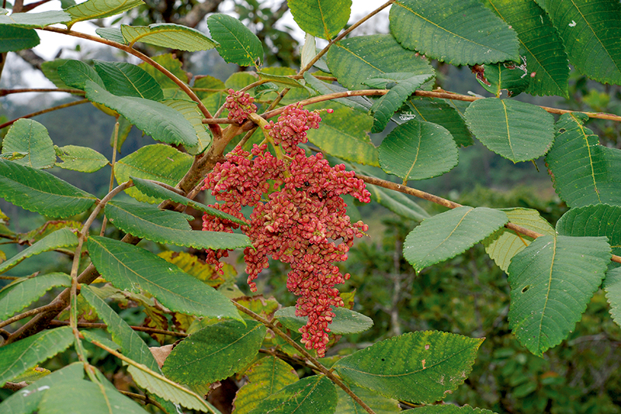
PLATE I:Rhuschinensis mill
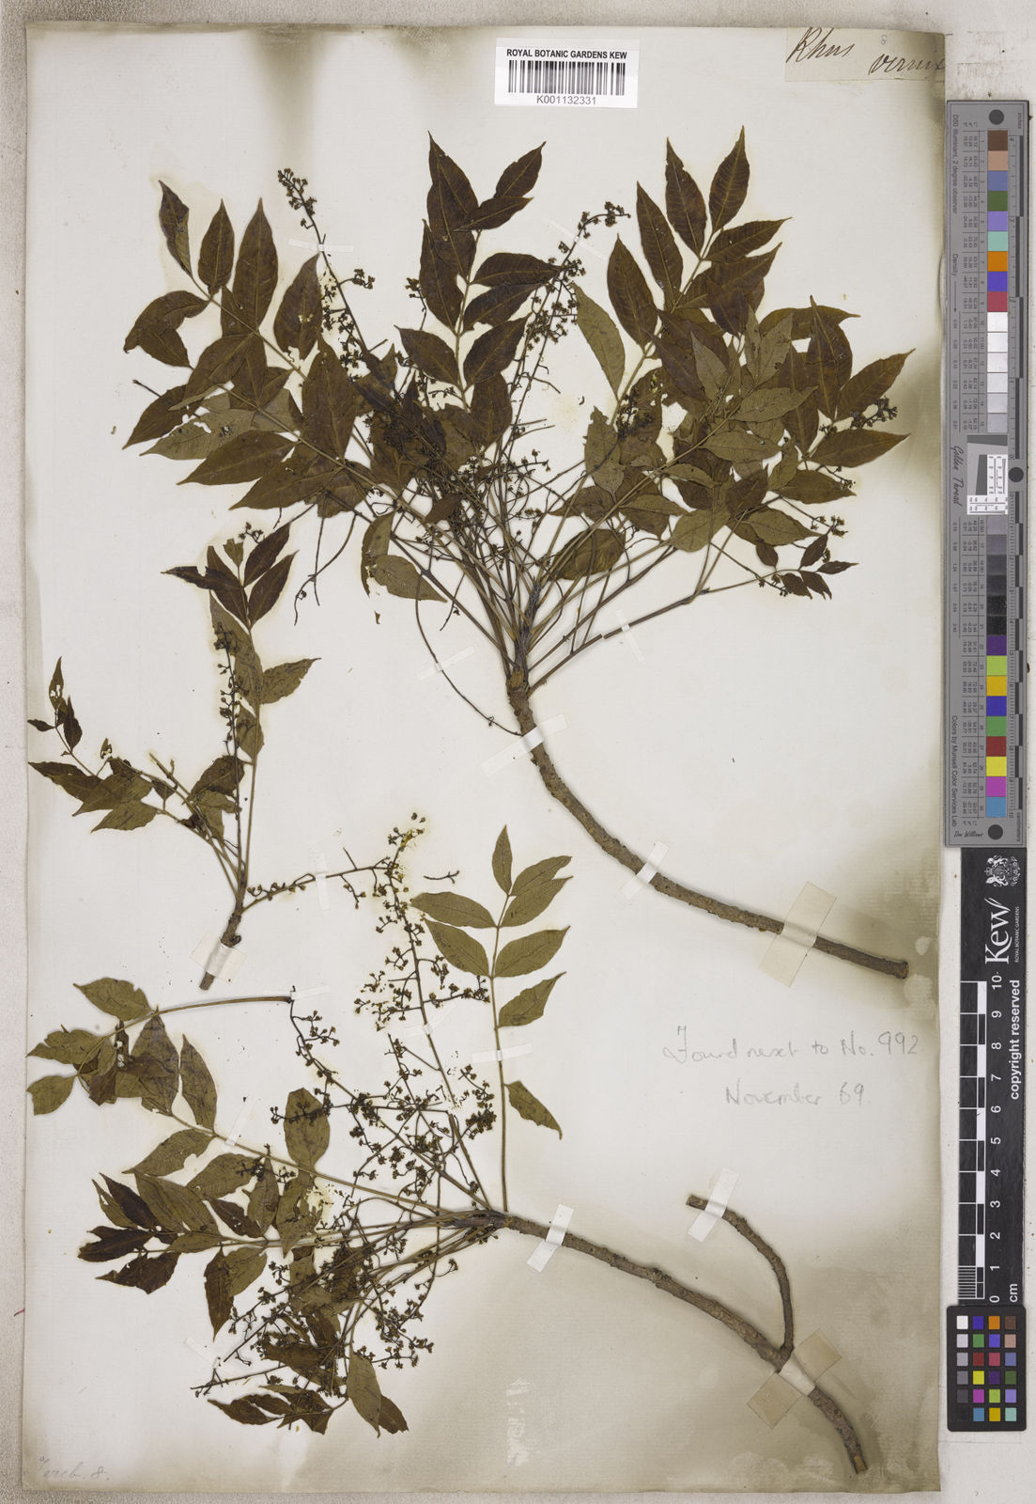
PLATE 2: Herbarium collection of Rhuschinensis mill
Rhuschinensis mill are recognized to therapeutic effects on different ailments such as diarrhea, dysentery, rectal and intestinal cancer, diabetes mellitus, sepsis, oral diseases and inflammation. The administration may be by decoction of the fruits, leaves and bark of the plant. Rhuschinensis mill is found on most of the soil type but the soil need Clay, acidic, alkaline, adaptable average, lean and well – drained condition, (Kenpei, 2013). It can be can be grown in dry to wet conditions (Rock, 2012) Mostly all part of the fruit is used for therapeutic purposes, but the leaves and fruit are the most frequently used. The fruit are soaked in water along with common salt and used in digestion as well as used for skin treatment. Leaf gall are expectorant and used in tonic, stimulant, diarrhoes and dysentery. Leaf galls contain tannin (50-80 percent). It also containgallotannic acid, gallotanin and gallic acid. Bark contains 10 percent tannin, (Singh, 2015).
RhusChinensis mill is a very promising plants as it has multi benefits uses for human health with activities like anticaries, antibacterial, antimicrobial, antidiarrhoeal, antiviral, antioxidant, anticholesterol and antidiabetic. Further exploratory studies are required to scientifically validate the existing traditional practices in relation to its health benefits. It is wildly distributed in temperate and subtropical Asia. In India, it is mainly found in Khasi, Jaintia Hills of Meghalaya, Manipur and as well as other part of the eastern Himalayas range including Bhutan. It has long been used as traditional medicine by the Asians, (Weirong Yao, 2010).
The leaves and the roots are depurative and they stimulate blood circulation.The stem bark is astringent and anthelmintic while root bark is cholagogue and fruit is used for the treatment of colic leaves and seeds for coughs, dysentery, fever, jaundice, malaria and rheumatism. Galls are very rich in tannin and are used internally for their astringent and styptic properties to treat conditions such as diarrhoea and haemorrhage. The leaves of Rhuschinensis mill is used in the treatment of persistent cough with blood, chronic diarrhoea, spontaneous sweating, night sweats, bloody stool. It is as well as applied externally to burns, bleeding due to traumatic injuries, haemorrhoids and ulcers in the mouth.
The leaves are be collected as they fall in the autumn and shade dry and used it as a brown dye or as a mordant. A blue dye can be obtained from insect galls on the plant, it can also be used as an ink.The galls are formed as a result of damage by the greenfly, Aphis chinensis. The galls contain up to 77% tannin but the reports do not mention if the galls are harvested before or after the insect has left the gall. The oil of Rhuschinensis mill is extracted from the seeds which attains a tallow-like consistency on standing and is used to make candles, (Jie He, 2012)
2.1.2 Citrus maxima
Citrus maxima are a perennial shrub commonly known as “Nobab” in Manipur Essential oil are extracted from the leaves and the unripe fruits are found to contain limonin, nerolol, nerolyl acetate and geraniol. As being a citrus plant pommelos are rich in Vitamin C. They are generally used eaten as fruit. The ansectral has been usingas a sedative in nervous affections, convulsive cough and in the treatment of hemorrhagic diseases and epilepsy. Citrus maxima fruits also contains high amount of polyphenolic compound like hesperidin, naringim, caffeic acid, P-Coumaric acid, Ferulic acid and vanillic acid, (Hazzler, 2017).
Table2: Plant profile and botanical description of Citrus Maxima
Botanical Description |  | Vascular Name
Kingdom- Plantae | Genus- Citrus | English- shaddock,pummelo,pumelo,chinese grapefruit,pompelmous
Division- Tracheophyta | Specific Epithet- maxima | Hindi-Batawinimbu
Class- Magnoliopsida | Scientific name-Citrus maxima | China- Shaddock
Order- Sapindales | Common name- Shaddock, Pomelo, Pumello | Tamil-Metukku
Family- Rutaceae | Synonyms- Citrus grandis ,  Citrus decumana | Manipuri- Nobab
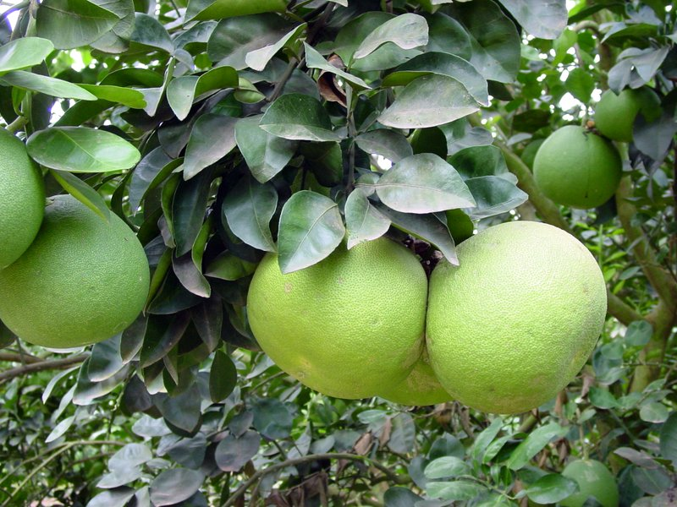

PLATE 3: Citrus Maxima
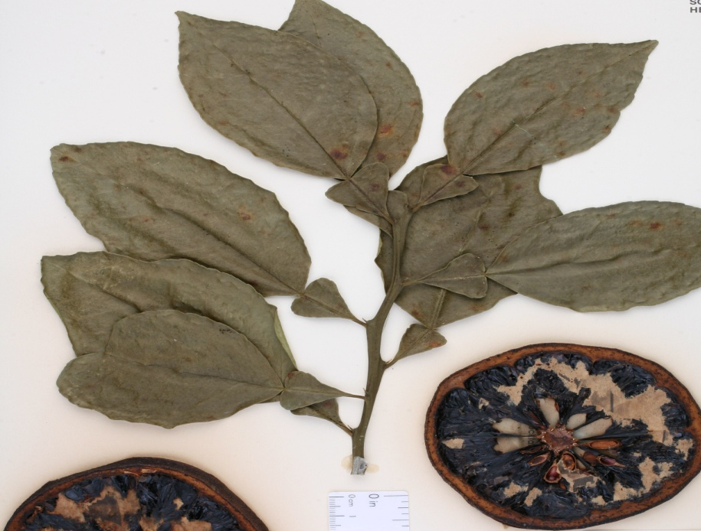
PLATE 4: Herbarium collection of Citrus Maxima
Citrus maxima are a perennial shrub which is commonly known as Pomelo. It is distributed throughout India and in Manipur it is very commonly found in every individual household gardens. The Pomelo, (citrus maxima) is usually a pale green to yellow wh2en ripe. It is larger than a grapefruit which have a sweet flesh or some sour taste while some very sweet with thick spongy rind covering the tender fruit inside. Some of the flesh has colour like pink, red while some white colour flesh. The largest pomelo fruit can reach upto 12" in diameter. The pomelo tree may be 16 to 50 ft tall, with a somewhat crooked trunk 4 to 12 in thick, and low, irregular branches with thorns ansd spines on the bark or branches. Some forms are distinctly dwarfed with no thorns and spine on them. Like other citrus plant pomelos are rich in Vitamin C. They are generally used eaten as fruit. (Dubey, 2004)
This plants has been used in indigenous system of medicine as sedative in nervous affections, convulsive cough and as well in the treatment of hemorrhagic diseases and epilepsy The leaves, dull-green, glossy surface with hairy beneath, (Aswini, 2012).
Traditional uses of this plants are:
- Leaves:leaves are used for the treatments of Epilepsy, chorea, Convulsive cough and also in the treatment of hemorrhage disease. Oil can be extracted from fresh leaves and past studies shows that it has anti dermatophytic activity, Fungicidal activity.
- Flower: flowers are used as sedative in nervous affection Fruits: Leprosy, Asthma, Cough, hiccough, mental aberration, Epilepsy, cardiotonic.
- Rind: the rind is used for treatment of Antiasthmatic, sedative in nervous affection, Brain tonic, Useful in vomiting, griping of abdomen, diarrhea, Headache and eye troubles.
- Root and Bark: Antimicrobial activity. (Kirtikar,2008)

    - Phlogacanthusthyrsiformis

Phlogacanthusthyrsiformis is a shrub whicbelongs to the Acanthaceae family. This plant has long dark or blackish tubular orange flowers, having spikes at the end of the branches which grows up to a height of 3 m. Leaves are deep green. It is commonly called “Nongmakha” in Manipuri and as “Rangabahaka” or “Teetaphool” in Assamese and “Lalbasak” in Bengali and “Kala adusa” Hindi. It is very commonly used as a folk medicine in Assamas well in Manipur. It is used as an anti-allergic treatment. Curry prepared from leaves and flowers portion is given orally with rice or leaves boil and liquid is consume to control high blood pressure. Coughs, colds, chronic bronchitis, asthma, and rheumatism are treated using this plants. Different parts of the plant have been used as an antiseptic and also as a good insecticide, (Ningombam, 2014).

Table 3: Plant profile and botanical description of Phlogacanthusthyrsiformis

Botanical Description |  | Vascular Name
Kingdom- Plantae | Genus- Phlogacanthus | Bengali- Ram basak
Phylum-Magnoliophyta | Sub family-Acanthoideae | Garo- Ellot
Class-Magnolipsida | Scientific name-Phlogacanthusthyrsiformis | Nepal- Chua
Order-Lamiales | Common name-Nongmangkha | Assam- Titaphul
Family-Acanthaceae | Synonyms-JusticiathysifloraRoxb,Phlogacanthusthysiflorus, PhlogacanthuslongisepalusBremek | Manipuri-Nongmangkha
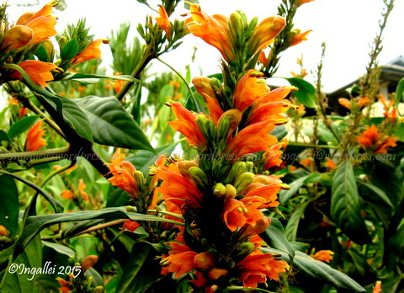
PLATE 5:PhlogacanthusThysiformis
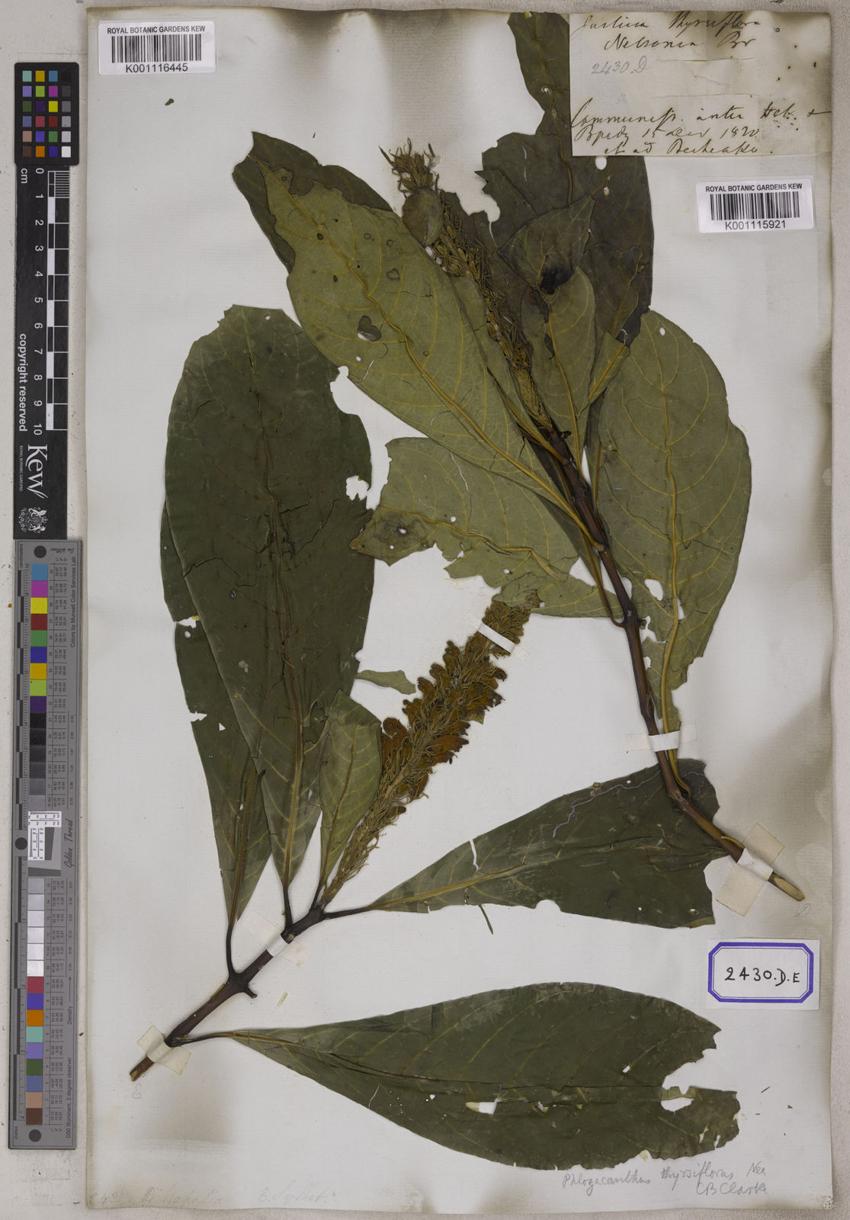
PLATE 6: Herbarium collection of PhlogacanthusThysiformis
The plant thrives easily in the climate of Imphal and does not need much extra care. The leaves are a deep glossy green which turns a shade lighter during the flowering season in spring. It flowers in spring around March. The blooms are orange in colour. The plant is valued as a cure for cough and sore throat. Both the leaves and flowers are edible and apart from being a medicinal plant, it is also a delicacy. It tastes bitter.
The orange blooming variety is more common but there are other varieties such as white and red. The red-blooming variety has slightly darker leaves but appear similar and also seem to have similar medicinal properties. This vareity is not very common and is considered more of a wild flower known as lam nongmangkha. The white blossoms isknown nongmankhaashinba (sour nongmangkha). Although identified under the same name in local termninology, the flowers are very different. This last variety has been identified as Indian pellet shrub, (Archana, 2009).
The plants are found to be growing mostly during December-April and are distributed throughout the tropics and in the entire North East Region of India. The all types of species is found in Manipur and is used in medicinal as well is taken in as a food in everyday life. The plant forms an integral part of rites and rituals, myths, food items, taboos, medicinal, customs, and traditions with the Meetei community.
Other Folk medicinal uses includes cold, cough, influenza, easy delivery of childbirth, abortion, irregular menstruation, diarrhea, dysentery, cholera, high blood pressure control, boils, smallpox, skin problems, sprains, body ache, constipation, and burns. Many customs, myths are related with this plant which is perpetuated from generation to generation and well dispersed into the valley districts. Several works on have been published on magico-religious, botanical folklore, folk medicine, and ethnobotanical aspects of the Manipuri. The whole plantbelive to haveits medicinal benefit. Leaf extract is used in cough, asthma, bronchial disorders, jaundice, diarrhea, dysentery, malarial fever, (Ningombam, 2014).

  - Antimicrobial Finishes
Microbes are bacteria, fungi, algae and viruses very small lives on the earth which can’t be seen by the naked eyes. This microbes grow very well on warmth and moist atmosphere They poses danger to both living and non living matters. Smell form the inner garments such as socks, spread of diseases, staining and degradation of textiles are some of the detrimental effects of bad microbes. Though the use of antimicrobials have been known for the decades, practices and attempts to development on finishing textiles with antimicrobial compounds has start only in the recent couple of years. Antimicrobial finish is a recent innovation in finishes so the consumers are now increasingly aware of the hygienic life style and there has been an icrease demand of anitimicrobial textiles in the market and it is also expected with a wide range of textile products finished with antimicrobial properties. Anitimicrobialfinishes to textiles avoidgrowth of bacteria and prevents garments from unpleasant odour, (Gopalakrishnan, 2002).
Under favourable conditions of humidity, heat and nutrition (sweat and urea), bacteria can grow rapidly on human skin and on the textiles. Different types of bacteria and fungi is shown on the table4 given below:
Table 4: Micro-organism causing diseases
Sr. No. | Type of Bacteria | Type of Fungi
1 | Staphylococcus pyogens | PenicilliumFuniculosum
2 | Staphylococcus aureus | Aspergilusniger
3 | Pseudomonas aeruginosa | Chaetomiunglolosum
4 | Coagulase-negative Staphylococci | Aureobasidiumpullulans
5 | Enterococci | TrichodermaSporogenes
6 | Escherichia coli | Epidermophylon
When organisim affected the textiles reactions like colour change, mould stains on textiles exist.. This bacteria most affected once are aqueous emulsions, dispersions, dyestuff liquors, printing paste etcThe infections acquired in hospitals may be caused by several species like Escherichia coli, Klebsiella pneumonia, Pseudomonas aeruginosa and Acinetobacterbaumannii, (Shahidi, 2016).
Antibacterial fabrics are important not only in medical applications but also in terms of daily life usage as clothing is the most basic needs worn by every man, (Brrion. 2013).
Antibacterial textile production has become increasingly its value and importance due to its hygienic and medical applications. Antimicrobial Finish is consider very important for general textiles and high performance applications where the chance of microbial growth is high as it gained significant importance due to their wide acceptance as surgical apparels, baby clothing and undergarments.
Following are the major requirement for an effective antimicrobial finish:
- Their durability to washing, dry cleaning and hot pressing.
- Selective activity to undesirable microbes.
- It should not produce harmful effects to the manufacture, user and the environment.
- It should compile with the statutory requirements of regulating agencies.
- Compatibility with the chemical processes.
- Easy method of application.
- No deterioration of fabric quality.
- Resistant to the body fluids.
- Resistant to disinfectant/sterilization.
- Quick acting and effective in killing or inhibiting the growth of a broad spectrum of microbes.
- Non-selective and non-mutable to pathogens.
- Fast to repeated laundering, dry cleaning and exposure to light.
- Safe and comfortable to wear (No irritation to skin).
- Minimal environmental impact.
- Compatible with other finishing agents.
- Low cost, (Yuan Gao, 2018).
2.2.1Applications of antimicrobial finishing activity:
Applications of antimicrobial activity can be done by pad-dry-cure method, coating method, spray and foam techniques. There are also various methods for improving the permanence of the finish such as:(Ammayappan L, 2009)
- Insolubilisation of the capable substances in/on the fibre;
- Apply the resin on the fibre, and improve the adhesion by cross linking agents;
- With the help of microbial agents protect the fibre matrix by micro covering;
- Application of finish on the fibre surface;
- Modifying the chemical structure of the fibre by forming the covalent bond; and
- Application of nano polymers, homo polymers and/or copolymer on to substrate.
2.2.2 Microorganisms involved in textiles
Mould, mildew, fungus, yeast, bacteria and virus (micro-organisms) are part of our everyday lives. There are thousandsspecies of micro-organisms existing and spreading everywhere in the environment, clothing and on our bodieseveryday. Microbes causesmultiple problems to textiles. These are human irritants, sensitizers, toxic-response agents, causers of disease and simple discomforting agents,(Shahidi, 2016).
2.2.3The Microbial Growth Promoters
The human body is always in contact and covered with innumerable invisible microbeeveryday. In favourable conditions certain bacteria can grow from a single germ to million in a very short period of time. They can double every 20 to 30 minutes in a warm and most micro climate that has plenty of food for them. The common promoters are as following:
- Temperature
- Moisture
- Dirt
- Receptive Surface
- Perspiration
- Food Particles
- Textile Finishes
Although microbes can bevery useful in many ways e.g. in food technology for fermenting, baking and biotechnology but at the same it can causes threat to both textile and humans. The various effects of microbes are stated as follows:
- Bad Odour
- Skin and Soft Tissue Infections
- Staining of Fabric
- Slick slimy handle
- Loss of Functional Properties
- Decrease in Life of textile
It is said that Cotton textiles has a very good environment for the growth of microbial as cotton is a soft material that absorb sweat or liquid very quickly. Therefore, cotton textiles tend to contact microbes faster than any other textiles materials. On the other hand, microbes are the tiniest creature not seen by naked eyes. They include a variety of microorganisms like bacteria, fungi, algae and virus. Bacteria are unicellular organisms which grow rapidly under ideal condition like moisture and warmth. Subdivision of the bacteria family includes two classes Gram positive and Gram negative, of which Staphylococcus aureus and Aspergillusniger respectively are the typical examples. Fungi, moulds or mildew are complex organisms with slow growth rate. This organism causes stain to the fabric and decreaseits performance and destroy its properties. To protect the textiles and mankind from pathogen and to avoid cross infection, a special finish like antimicrobial finish has become necessary (Ramaiy, 2014).
2.2.4Antimicrobial Finishing Methodologies
The antimicrobial agents can be applied to the textile by various kinds of method and techniques. The substances can also be applied by directly adding into the fibre spinning dope. The Various methods for improving the durability of the finish include:
- Insoulbilisation of the active substances in / on the fibre.
- Treatment of fibre with resin, condensates or cross linking agents.
- Micro encapsulation of
- Coating the fibre surface.
- Covalent bond formation.
- Use of graft polymers, homo polymers and / or co-polymerization on to the fibre,
(Ammayappan L, 2009)

  - Cotton
Cotton, cultivated plants from the genus Gossypium is a soft white fibrous substance which surrounds the seeds of the cotton plant and is made into textile fibre and thread for sewing.After the cotton is being harvested the cotton balls are being pull apart from the hard substances and it is then turn into fiber, spun into yarn or thread and make it into a very soft, breathable textile. Cotton has a good absorbencyproperty. Cotton is the most common and widely produced natural fiber in the world.,(Wang, 2009)
Cotton is also one of the largest leading agricultural crops. It is plentifully and economically produce. This makes the cotton products inexpensive and are found vast varieties of fabrics ranging from lightweight voiles, laces and thick piled velveteens suitable for a good variety of wearing wearing apparel, home furnishing, and industrial uses. Cotton fabrics can be extremely durable and resistant to abrasion and accepts many dyes as it is usually washable, and can be ironed at a very relatively high temperatures. It gives comfort to the wearer because it absorbs and releases moisture quickly and gives warmth when desired. In the past years various kinds of finishing processes have been developed and apllied to cotton fabric to make the fabric resistant to stains, water, and mildew. It is also been applied to increase its resistance and wrinkling. However, it reduces and or eliminates the need for ironing of textiles and reduces the shrinkage in laundering to not more than one percent of it. Nonwoven cotton made by fusing or bonding the fibres together are useful for making disposable products to be used as towels, polishing cloths, tea bags, tablecloths, bandages. This further includes disposable school uniforms and bedsheets for hospital and other medical uses.
    - Types of Cotton
From the sheets you sleep on to the clothes you wear, there are four main types of cotton available in stores.

Pima Cotton

Pima is considered to be the finest cotton on earth among evry other available cottons. This pima cotton has an extra-long staple (ESL) cotton and this long fibers makes it even more extra soft and extra strong than usual ones. It is luxuriously smooth fabric that is resistant to fraying, tearing, pilling, wrinkling, and fading. Among all other cotton only PimaCotton verifies that the you can feel the quality, see the fabric and feel it and you can trust it, (Smith, 2017).

2.1.1.2 Upland Cotton
Upland cotton is a relatively short cotton fibers. It is state that upland cotton has a perfect propertiesfor producing quality everyday products that everyone can afford. In USA this cotton fabric is the commonly used and planted with 95% of the cotton planted on American soil. For the purest Upland cotton, choose Home grown Cotton. Home grown Cotton verifies its cotton products contain pure Upland grown by hard-working family farmers on American soil., (Wang, 2009).

EgyptianCotton
Egyptian cotton also hasan extra-long staple cotton which is very similar to Pima cotton. This two cotton posses a properties of exceptional in softness, vibrancy, and good performance. They even share a scientific name. The only difference between the two is that Egyptian cotton is grown in the hot, dry climate of the Nile River Valley in Egypt
2.3.1.4AcalaCotton
Acala cotton is an upland variety most wisely grown in Southwest.California is the only state that produces a special variety of cotton called San Joaquin Valley Acala. This cotton has the highest quality Upland cottons in the world. However, due to irrigation requirements, Acalais very expensive in cost than other American grown Upland cottons.

Cotton is a cellulosic fiber which has a worldwide popularity for its variety of use. Cotton fabrics are comfortable to wear than the others fibers products throughout the whole season. Like all textiles fibers, cotton has its own physical and chemical properties which are required to know for better processing in spinning, weaqving, knitting, dyeing, printing as well as finishing.
    - Physical Properties of Cotton Fibre:
The physical properties of Cotton fiber are as follows:
- The length of the cotton should be 0.5ʺ - 2.5”
- The strength and tenacity of the cotton fabric is (gm per denier) 3 – 5
- The dimensional stability of the cotton should be medium
- The heat preventive power should medium.
- The moisture regain of the cotton should be 7-10% (standard 8.5%)
- The stiffness of the cotton is 57-60 g/d due to high crystallinity
- The elasticity of the cotton should be 1.50- 1.58 and its Resiliency is low
- The abrasion resistance is medium
- The density (gm/cc) of the cotton is less than both silk and wool but more than linen.
- The color consists of cream or yellowish like clean white.
- The specific gravity is 1.52-1.55
    - Chemical Properties of Cotton Fibre:
Chemical characteristics of cotton fiber are mention below:
- Alkali does not damage cotton fibre.
- Some strong acids destroy the cotton while the weak ones do not.
- There is no damage when action with bleaching takes place.
- Ultraviolet ray converts the cotton into oxi-cellulose.
- Mildew preventive power but not the untreated not easy. Dye ability:Affinity to color is good. Direct, reactive, sulphur and vat dyes are used.
- They are not affected by moth.
- The Conductive ironing temperature is 150°C where decompose is 2400°C and ignitiontemperature is 390°C, (Smith, 2017).

    - Uses of Cotton
Cotton has it’s own many uses from home to fashion to industry.The bulk of cotton production is consumed in the manufacture of woven goods, alone or in combination with other fibres. Some of the principal types of woven fabrics includes print cloth, yam fabrics, sheetings, fine cotton goods, napped fabrics, duck, tyre fabrics and towels..
Unspun cotton finds are use in mattresses, pads and upholsteries. Cotton produce one of the basic raw materials for cellulose industries and this cellulose include plastics, rayon and explosives. Sterilized absorbent cotton finds use in medical and surgical practice.Yarns of varying size and fineness are needed in the production of fabrics. Short staple fiber are converted into coarse yarns and long and uniform staples are utilized for yarns of high counts required for fine fabrics. The waste of cotton produce from spinning and weaving mills or any waste produced during combing and carding due to their short size are turned in various scarps. Cotton itself being considered very important also has a very important factor of its quality evaluation. This waste arecovertedblankets, sheets, towels and flannelettes. Cylindrical strips from carding machine, which are constituted of fibres of good strength, are used for warps, twines, ropes and nets. They are also useful for wadding, padding for upholstery, bed quiltsetc, (Gupta, 2012).
Short remnants and thread waste that cannot be respun are used as wiping and polishing material.The stalks contain a fibre that can be used in paper making or for fuel. The roots can possess a crude drug while seeds considered to be the greatest importance and every portion is utilized.
The hulls are used for stock feed; as fertilizer; for lining oil wells; as a source of xylose, a sugar that can be converted into alcohol and for many other purposes. The kernels yield one of the most important fatty oils, cottonseed oil and an oil cake and meal which are used for fertilizer, stock feed, flour, and as a dyestuff, (Gupta, 2012).

3. EXPIRIMENTAL PROCEDURE
The experimental procedure followed by carrying out the present investigation on “Comparative study on Antimicrobial Activity of Selected plant Extracts” is detailed under the following headings:
3.1Selection of the plant
3.2Collection of Sources
3.3Preparation and processing of leaves powder using various solvent extract for analysis
3.4 Antimicrobial activity
3.4.1 Selected microorganism

3.4.2 Preparation
3.4.3 Disc diffusion method

3.4.4 Incubation procedure
3.4.5 Mueller-Hinton agar
3.4.6 Preparation of Mueller Hinton plate
3.4.7 Kirby Bauer (Well diffusion) Method Protocol
3.5. Evaluation of fabric
3.5.1 Bursting strength
3.5.2 Thickness Tester
3.5.3 Fabric Weight
3.5.4 Fabric Stiffness
3.5.5 Abrasion resistance
3.5.6 Absorbency Test:
3.5.6.1 Sinking Test
3.5.5.2 Wicking Test
3.5.5.3 Spray Test

RESEARCH DESIGN
Selection of the plant

Sample processing (Shade drying and powdering

Methanol extraction

Selection of fabric

Anti- microbial activity

FABRIC FINISHES

Aspergillusniger
Staphylococcus aureus

Result and Discussion

Figure 1: Study design of the study

3.1Selection of Plant
The plant sample Rhuschinensis mill has many health benefits, the Chinese used this as a traditional medicine for centuries for treating heat-clearing drug, detoxicant, stasis-eliminating drug, ensuresis and vaginal prolapsed, reducing inflammation, antidiarrhea, skin health, swelling and hemostatic (stops bleeding drug) in traditional Chinese medicine (CTM). Citrus maximahave health benefit that includes digestion,reducing blood pressure, body cramps. Anti-ageing. Fights against cancer and prevent anaemia. On the other hand,Phlogacanthusthysiformisis used for treating cough, fever, asthma, skin diseases like sore and scabies. For all this particular reason this three plants source were selected for comparative study of antimicrobial activity present in them. Therefore they are selected for the study of antimicrobial activity and compare between them
3.2 Collection of Sources
These three plants source were collected from Imphal, Manipurin fresh form. This plants aregrown almost everywhere in Manipur. They do not need special care for cultivation, they are found on the hill areas, roadside and gardens. After the selection of the plant, the leaves were collected from the plants.
3.3Preparation and Processing of Leaves powder using Methanol Extract:
The leaves of Rhuschinensis mill, Citrus maxima and Phlogacanthusthysiformis was. Separating it from the plant and were shade dried for two – three days. After it is completely dry they are roughly crushed by hand and later grounded powdery using an electric grinder.
For the purpose of the study, solvent called methanol was used as solvent to carry out the antimicrobial activity. Methanol is used for the extraction because methanol dissolves a larger portion of polar compounds and the solubility of non-polar compounds may be reduced. Further methanol is inexpensive, it is easily evaporated and is free of regulation compare to ethanol.
Soxhlet extraction method can extract more sample mass than other methods with moderate investment and it is safe and rapid extraction works under high temperature and pressure to increase its efficiency. Therefore Soxhlet extraction method was selected for the study.
Firstly, the solvent 250 ml of methanol is added to a round bottom flask which is attached to a Soxhlet extraction and condenser on an isomental. The plant 20g each are loaded into the thimble which is placed inside thrSoxhlet extractor. The solvent is heated using the isomental and will begin to evaporate moving through the apparatus to the condenser. The condenser then drips into the reserviour containing the thimble. Once the level of the solvent reaches the siphon it pours back into yhr flask and the cycle begins again. The process is run for a total of 24 hours. After 24 hrs the yield% is calculated where Rhuschinensis mill is 10.43%, Citrus maxima is 3.96% and Phlogacanthusthysiformisis 7.58% respectively.

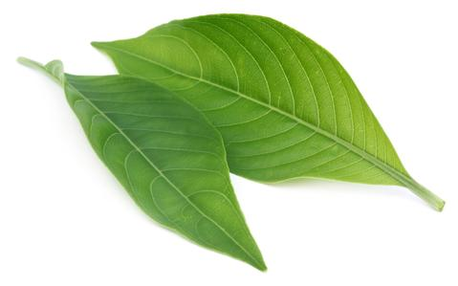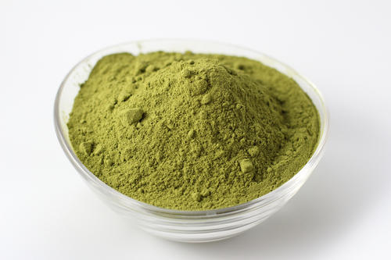
PLATE.8: Powder of Phlogacanthusthysiformis
PLATE 7 : Leaves of Phlogacanthusthysiformis

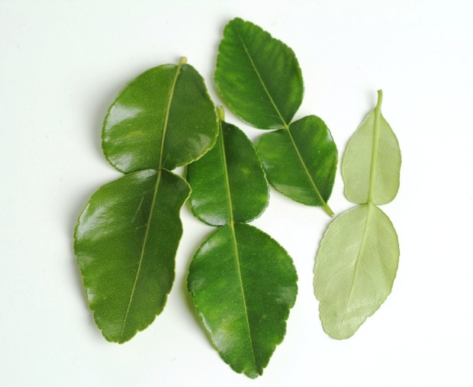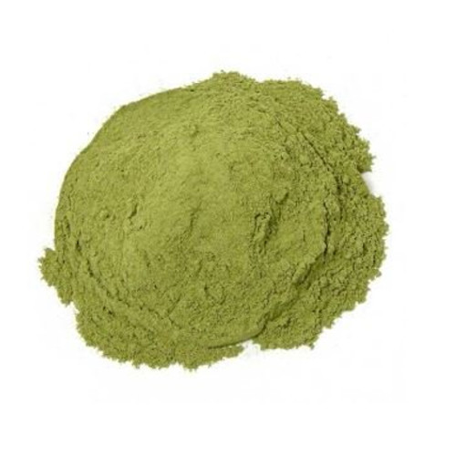
PLATE 10: Powder of Citrus maxima

PLATE 9: Leaves of Citrus maxima

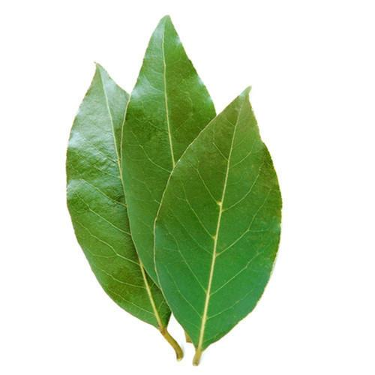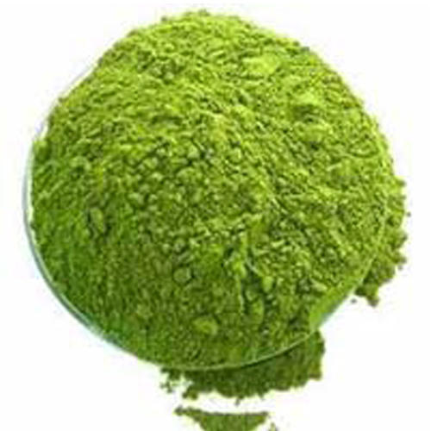
PLATE 11 : Leaves of Rhuschinensis mill

PLATE 12: Powder of Rhuschinensis mill

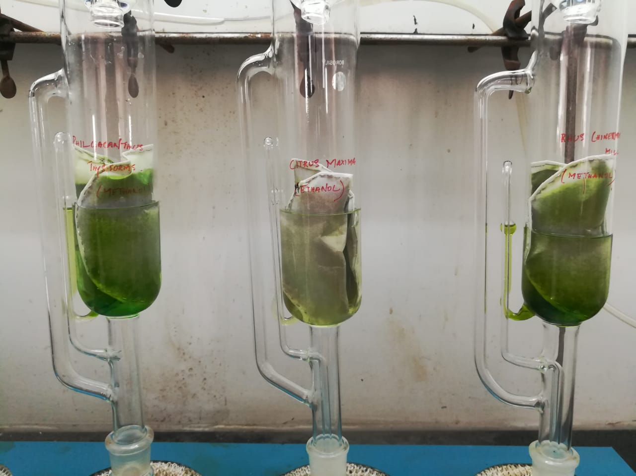
PLATES 13: Leaves sample prepared for Extraction
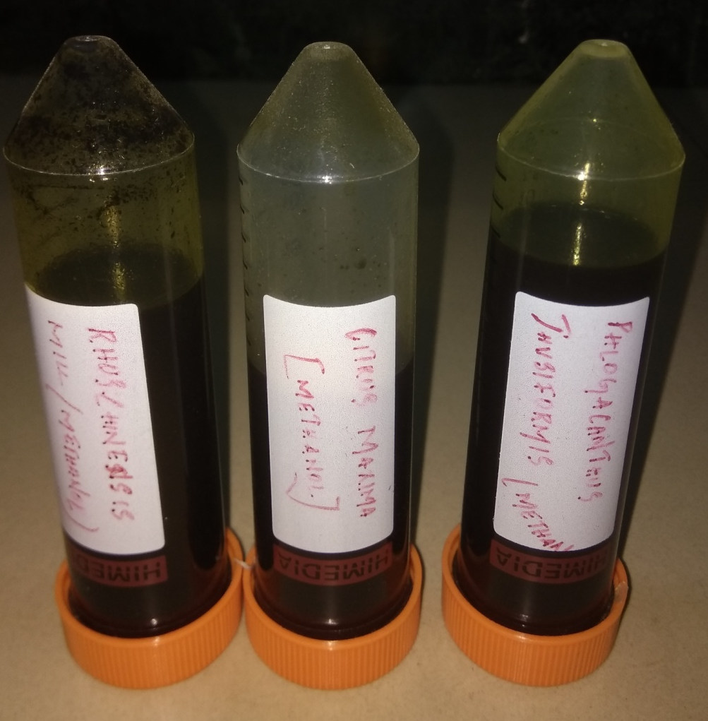
PLATE 14: Extracted Samples

3.4Antimicrobial Activity
Antimicrobial activity is anything that destroys bacteria, fungus or suppresses their growth or their ability to reproduce, an agent having such properties or drugs that destroy or inhibits the growth of bacteria in concentrations that are safe for the host and can be use as chemotherapeutic agents to prevent or treat bacterial infections, (Bonev, 2008).
3.4.1 Selected Microorganism
To perform antimicrobial activity using various bacterial and fungal species were selected viz., Staphylococcus aureus,ATCC 6538 and AspergillusnigerATCC 6275.Aspergillus Niger.Aspergillusniger is a haploid filamentous fungus which is used for waste management and biotransformations in addition to industrial importance, (Schuster,2002). Staphylococcus aureuswas selected because it is a major cause of nosocomial, community-acquired infections and skin lesions (boils, styes), (Foster, 1994).

3.4.2 Preparation
Kirby Bauer procedure for preparation of Antimicrobial activity was standardized to ensure consistency and accurate results without causing further faults. Muller Hinton agar at 4mm deep is used in Kirby Bauer testing. This 4mm deep agar is pour into either 100 mm or 150 mm petri dishes according to the observer convenience. However. The pH level of the agar should be between the level 7.2 and 7.4, (Bauer, 1996)
3.4.3 Disc Diffusion Method
Disc diffusion method for antimicrobial susceptibility test was carried out according to the standard method by Kirby-Bauer to assess the presence of antimicrobial activity of plant extract. A bacterial suspension adjusted to 0.5 McFarcland standard (1.5×10 8 CFU/ml) was used to inoculate Mueller Hinton agar plates evenly using a sterile swab. The plates were left for five minutes. Then, the discs impregnated with methanolic extract of leaves of Rhuschinensis mill were placed individually on the Mueller Hinton agar surface with flamed forceps and gently pressed down to ensure contact with the agar surface. The discs were spaced far enough to avoid both reflections waves from the edges of the petri dishes and overlapping of rings of inhibition, (Sahu, 2013).

3.4.4 Incubation Procedure
- Firstly by using an aseptic techniquea sterile swab is placed onto the broth culture of a specific organism.
- Then the excess liquids are removed by gently pressing or rotating the swab against the inside of the tube.
- Then using the swab the Mueller-Hinton agar plate is streak to form a bacterial lawn.
  - Lastly to obtain the uniform growththe plate is swab again in one direction and is then the plate is rotate in 90° and once again the plate is streak in that direction.
  - This rotation process is repeated for about 3 times to get the desire results.
- After the rotation process the plate is set for to drying for about approximately 5 minutes.
- An antibiotic disc dispenser is used to dispense the discs containing specific antibiotics onto the plate.
- After the antibiotics are placed onto the plates flame sterilized forceps is used by gently pressing each disc to the agar to ensure that the disc is attached to the agar correctly.
- Lastly the plates are taken forincubation overnight with a desire incubation temperature of 37 °Ci,e. (98.6 °F).(Sahu, 2013).
3.4.5 Mueller-Hinton Agar
MH agar is considered the best medium to use for routine susceptibility testing of nonfastidious bacteria due to the following reasons:
- The reproducibility for susceptibility testing shows acceptability batch to batch.
- The Muller Hinton agar is very low in sulfonamide, trimethoprim, and tetracycline inhibitors.
  - The Muller Hinton agar supports a satisfactory growth of most nonfastidious pathogens presents.
3.4.6 Preparation of Mueller Hinton Plate
- MH agar plate where one for each organism is allowed to be testedget the results in a room temperature. The agar plates are set to remain in the plastic sleeve while they are made warm to minimize the condensation.
- The excess liquid is allow to drain from the agar surface and set for evaporation by sett the plate inverted if the surface of the agar has visible liquid presentthe plates. Then they are incubated at a temperature at about a 37°C until dry for usually 10 to 30 minutes.
- After making sure it is completely dry with no more drain happeningeach MH agar plate for each organism is ready to be tested.(Bonev, 2008).
3.4.7Kirby Bauer (Well diffusion) Method Protocol:
24 h grown culture (staphylococcus aureus, and Aspergillusniger) was taken and diluted to 108 CFU / ml usingMcFarland standard. Muller hinton agar plates were prepared. The diluted cultures wereswabbed over the surface of the medium. The plates were dried for few minutes and using asterile cork borer (6 mm in dia) wells were punctured. 100 μl of the samples were loaded in thewell (Duplicates). All the plates were incubated (For bacteria 37°C for 24 h and for fungus 25°Cfor 7 days). After incubation period the zone of inhibiton was measured using antibiotic zonescale and reported, (Bauer, 1996).
3.5. Evaluation of Fabric:
The treated fabrics were evaluated for salient tests such as Bursting strength, abrasion resistance, absorbency test, moisture content, GSM, thickness test, antimicrobial activity and compared with the untreated sample.

3.5.1 Bursting Strength:(D3786M-18)
Bursting strength is a process of measuring the strength of the fabric in which the material is stressed in all directions at the same time. This results in giving a suitable material which be either knitted fabrics or non woven. Some examples include sacks, nets, parachutes etc. The British Standarddescribes a test in which the fabric to be tested is clamped over a rubber diaphragm and the pressure in the fluid increased at such a rate that the specimen burst within 20+3s. The extension of a diaphragm is recorded and the pressure to do this is noted. In this manner ten similar reading were taken for original and treated fabrics.
3.5.2 Thickness Tester
The thickness tester is used to measure the thickness of the fabricand it is one the basic properties of giving information about the fabric weather it has a warmth, heaviness, or stiffness when used. In practice thickness measurement are rarely used as they are very sensitive to the pressure used in the measurement. Prepare the sample are free from folds, crease or wrinkles. Place the sample on the anvil by uplifting the pressure foot and leave it gently down the pressure foot pressed on the specimen. Note the reading dial gauge shown. Place the sample in various places and make the readings. In this manner ten similar reading were taken for original and treated fabrics.
3.5.3 Fabric Weight:
(GSM)(ASTM D 2646/D3776,IS0 3801)
The fabric weight was measured in GSM(Grams per Square Meter). For this the GSM cutter is used to cut the specimen. The sample cutter cuts out rapidly and accurately circular specimen of 100cm² which is exactly one hundredth of a square meter. A taken specimen should be weighed and noted. The results in grams is multiplied by 100, gives the GSM directly. In this manner ten similar reading were taken for original and treated fabrics.
Grams per Square Meter = Specimen weight in grams * 100

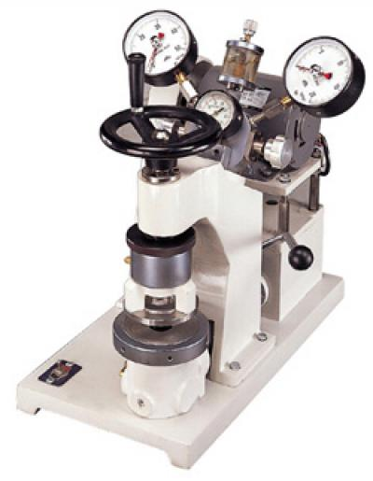
PLATE 15: BURSTING STRENGTH TESTER

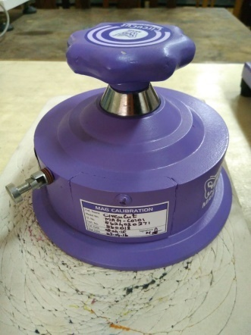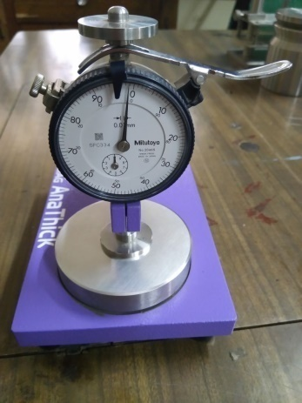
PLATE 16: GSM CUTTER

PLATE 17:THICKNESS TESTER

3.5.4 Fabric Stiffness:
(IS 6490:1971)
Method for determination of stiffness of fabrics as denoted by Indian standard 1971 that the tester should be placed on a table or bench so that horizontal platform and inclined reference line were at eye level of the operator. The platform was adjusted, with the help of a spirit level so that it was horizontal.
One of the specimens was placed on the platform with the scale on top of it lengthwise and the zero of scale coinciding with the leading edge of the specimen. The scale was held in the horizontal plane, the specimen was pushed, and the scale slowly and steadily moved, when the leading edge projected beyond the edge of the platform. An increasing part of the specimen would overhang and start bending under its own weight. If the specimen had a tendency to twist, a reference point was taken at the center of the leading edge. The specimen which twisted more than 45 degree was not measured. The length of the overhanging portion was noted from the 80 scale to the nearest millimetre. Five readings from each specimen was taken, with each side up, first at one end and then at the other. In this manner ten similar reading were taken for original and treated fabrics.
3.5.5 Abrasion Tester:
(ISO 12947 – 2: 1999)
Abrasion is defined as the wearing away of any part of the fabric by rubbing against another surface fabric that are subjected to abrasion during their life time and this may result in wear, deterioration, damage, and loss of performance. However the abrasion resistance is only one of the several factors way and can include fabric to fabric rubbing. In this manner ten similar reading were taken for original and treated fabrics.(Sumithra.,2013).

3.5.6 Absorbency Test:
Absorbency test includes the following:
3.5.6.1 Sinking Test:(AATCC 17-1994)
One very important dimensional change in apparel which occurs when a fabric is washed is known as shrinkage.Sinking involved a simple test for wet ability of fabric. This is a simple test for highly absorbent materials in which a 25mm X 25mm piece of fabric or 50mm length of yarn taken from the fabric is dropped onto the surface of distilled water and the length of the sinking time is measured. If sample does not sink within one minute and it is considered as having floated. In this manner ten similar reading were taken for original and treated fabrics (Saville, 1999).
3.5.5.2 Wicking Test:(AATCC197)
Wicking test is done to measure the rise of liquid present on the fabric. In this test the fabric is hang on a rod vertically with its lower edge in a reservoir of distilled water. The rate of rise of the leading edge of the water to the fabric is monitored. The measured height of rise in a given time is taken as a direct indication of the wick ability of the test fabric. Using a marking pen with soluble ink, a line across the end of each specimen at a distance of one cm from the end of the fabric side to be tested, was marked. The one cm line denoted the level to which a specimen was to be lowered in the water in the flask or beaker which was the test start time. In this manner ten similar reading were taken for original and treated fabrics.(Saville, 1999).
Using a marking pen with soluble ink, and measured from the 1cm line. Alternative wicking distances may be used depending on the desired end use of the fabric. When comparing results, the same wicking distance bench mark should be used. The specimen was allowed to hang in to the flask. Water was added up to the level at which the specimen’s one cm line was reached; and then the required water level marked on the outside of the flask to remain dry, to prevent premature bleeding of soluble ink marks on the specimen. The flask was filled with distilled water to the line marked as instructed. The specimen was inserted into the flask, the scissor jaw raised to position the specimen so that the water was at the one cm line.The stop watch or timer was started as soon as the water reached the 5±mm line and the soluble ink began to migrate upwards. the rise of the water was monitored. After a time finished the rise up water should be measured. In this manner ten similar reading were taken for original and treated fabrics.(Sumithra.,2013).
3.5.5.3 Spray Test:(AATCC-22,ISO-4920)
Spray tester is an instrument used to any textile fabric, which may or may not have been given a water-repellent finish. It measures the resistance of fabric to wetting by water. In the test three specimens are tested each one 180mm square. Each specimen in turn is held in taut over a 150mm diameter embroidery hoop which is mounted at 45º to the horizontal. A funnel which is fitted with a standard nozzle containing 19 holes of a specified diameter is held 150mm above the fabric surface. Into a funnel is poured 250ml of distilled water at 20ºc to give a continuous shower onto the fabric. After the water spray has finished the hoop and specimen are removed and tapped twice smartly against a solid object on opposite points of the frame the fabric being kept horizontal. This removes any large drops of water. The fabric is then assigned a spray rating using a photographic standards. In this manner ten similar reading were taken for original and treated fabrics.
3.6 Statistical Analysis:
. F-Test is defined as the ratio between the two independent chi square variates that are divided by their respective degree of freedom The F-test is used by a researcher in order to carry out the test for the equality of the two population variances.. The F-test is also used by the researcher to determine whether or not the two independent estimates of the population variances are homogeneous in nature It is also used by the researcher to test the significance of an observed sample correlation ratio. The sample correlation ratio is defined as a measure of association as the statistical dispersion in the categories within the sample as a whole.The researcher uses the F-test to test the significance of an observed multiple correlation coefficient. The significance wasalso tested by the researcher, (Sawilowsky,2015)..

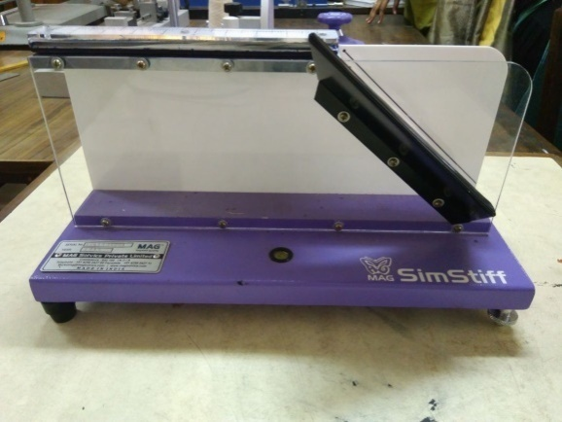

PLATE 18: STIFFNESS TESTER

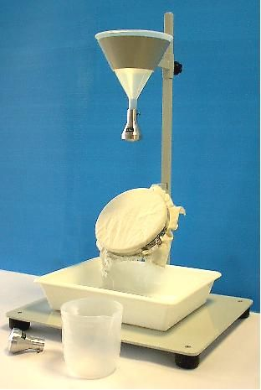
PLATE 19: SPRAY TESTER

4. RESULTS AND DISCUSSION
The findings and the result obtained from the study entitled “Comparative study on Antimicrobial Activity using selected Plants Extracts” are discussed under the following headings.
4.1 Antimicrobial testing
4.2 Physical property test
4.2.1 Fabric thickness
4.2.2 Fabric weight
4.3 Mechanical property test
4.3.1 Fabric stiffness
4.3.2 Fabric abrasion
4.4 Absorbency test
4.4.1 Fabric sinking
4.4.2 Fabric winking

4.1 Antimicrobial testing
Zone of inhibition of antimicrobial activity for Staphylococcus aureusand Staphylococcus aureus is describe below in the Table 5 and Figure 2:
Table 5: Zone of inhibition of bacteria of Rhuschinensis mill, Citrus maxima and Phlogacanthusthysiformis
ORGANISMS | Rhuschinensis mill | Citrus maxima | Phlogacanthusthysiformis
Staphylococcus aureus | 8mm | 3mm | 3mm

From the Table 5 and Figures 2, it shows the antibacterial activity is present in the all the treated and no growth beneath the fabric in antibacterial activity. The zone of inhibition are 8mm for Rhuschinensis mill, 3mm for Citrus maxima and 3mm for Phlogacanthusthysiformis respectively. Hence, it can conclude that Rhuschinensis mill, Citrus maximaand Phlogacanthusthysiformishas antibacterial activity.
FIGURE 2: Graphical representation of Growth inhibition of Staphylococcus aureus on methanol extract of Rhuschinensismill, Citrus Maxima and Phlogacanthusthysiformis

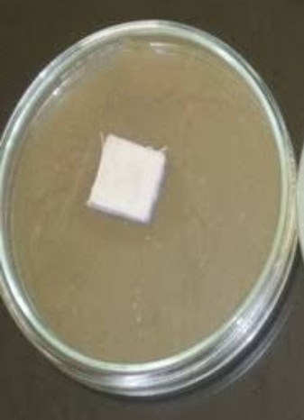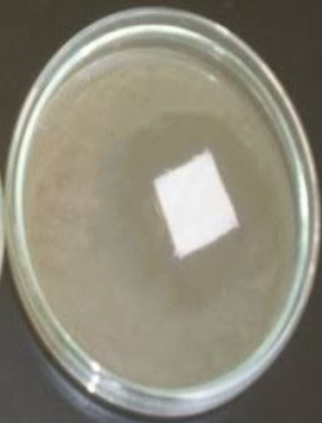
PLATE 21: Growth inhibition of S.aureuson methanol extractCitrus maxima

PLATE 20: Growth inhibition of S.aureus on methanol extract of Rhuschinensis mill

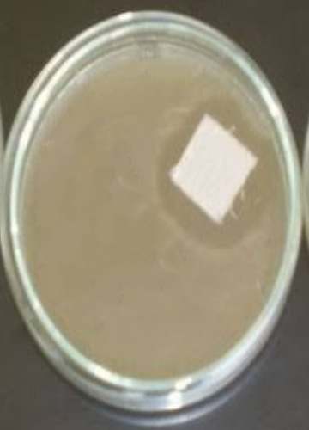
PLATE: 22 Growth inhibition of S.aureus on methanol extractPhlogacanthusthysiformis

PLATE: Growth inhibition of S.aureus on methanol extract of Phlogacanthusthysiformis

Table 6: Zone of inhibition of Fungi of Rhuschinensis mill, Citrus maxima and Phlogacanthusthysiformis
ORGANISMS | Rhuschinensis mill | Citrus maxima | Phlogacanthus  thysiformis
Aspergillusniger | 3mm | nil | Nil
The Table 6 and Figures 3, show the antifungus activity is present only in treated Rhuschinensismill with its zone of inhibition 3mm and nil for both Phlogacanthusthysiformis and Citrus Maxima. Hence it can be conclude that Rhuschinensismillhasantifugal activity whilePhlogacanthuthysiformis and Citrus maximahas no antifungal activity.

FIGURE 3: Graphical representation of Growth inhibition of Aspergillusniger on methanol extract of Rhuschinensismill, Citrus Maxima and Phlogacanthusthysiformis

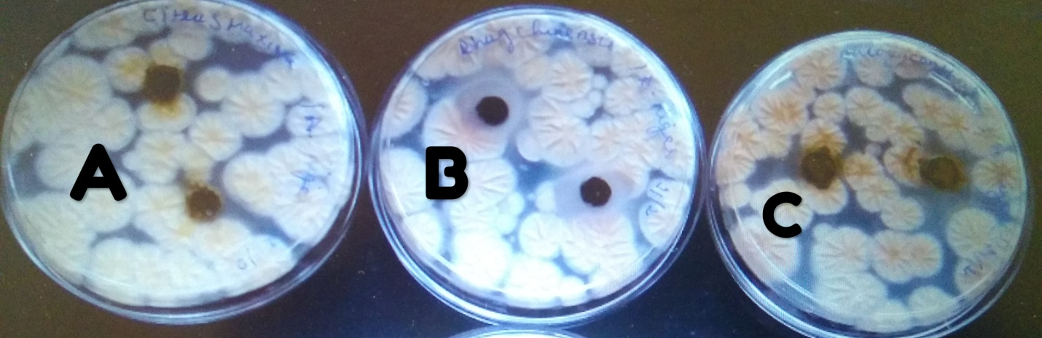
PLATE 23: Growth inhibition of Aspergillusniger on methanol extract of
A)Phlogacanthusthysiformis,
B)Rhuschinensis mill,
C)Citrus Maxima

4.2 Physical property test
The physical property test done on the fabric for before and after treatment are as follows:

4.2.1 Fabric Thickness
The fabric thickness and analysis of variance of original and treated fabrics is shown on Table 7, Table 7(A) and Figure 4.

Table 7 :Fabric thickness of the original and after treatment fabric:
Sample | Measurement  (mm) | Gain or Lose over Original sample | Percentage Gain or Lose
Cotton fabric | 0.5790 | - | -
Rhuschinensis mill | 0.6430 | 0.0644 | 9.9%
Citrus  maxima | 0.6430 | 0.064 | 9.9%
Phlogacanthusthysiformis | 0.6320 | 0.053 | 8.3%

From the Table 7and Figure 4, it is clear that the thickness of the original sample is 0.5790cm and the fabric sample Rhuschinensismill ,Citrus maxima and Phlogacanthusthysiformis shows increase in the thickness by 0.6430, 0.6430, 0.6320 respectively. The treated fabrics show an increase in thickness by 8-10%. From the Table 7(A), it is clear that the F-value for thickness between the original and treated samples show a ANOVA value of 10.997 which is significant at 1% level.Therefore, it could be concluded that that the absorption of finishing extracts has been the reason for increase in weight.

Table 7(A): ANOVA Table (between Variables) for the the fabric thickness of before and after treatment:
Variable | Fiber | Mean | SD |  | SE | F-value | Sig
Thickness | Cotton | .5790 |  | .04228 | .01337 | 10.997 | .000*
Thickness | RhusChinensis Mill | .6430 |  | .02214 | .00700 | 10.997 | .000*
Thickness | Citrus Maxima | .6430 |  | .01418 | .00448 | 10.997 | .000*
Thickness | Phlogacanthusthysiformis | .6320 |  | .03048 | .00964 | 10.997 | .000*
*= Significant at 1% level

Figure 4: Thickness Test of the original and treated Fabric

4.2.2 Fabric Weight
The fabric weight and analysis of variance of original and treated fabrics is shown on Table 8, Table 8(A) and Figure 5.

Table 8: Fabric weight of the original and after treatment fabrics:
Sample | Measurement  (g) | Gain or Lose over Original sample | Percentage Gain or Lose
Cotton fabric | 106.700 | - | -
Rhuschinensis mill | 115.0000 | 8.3 | 7.2%
Citrus  maxima | 116.3000 | 9.6 | 8.2%
Phlogacanthusthysiformis | 117.0000 | 10.3 | 10.3%

From the Table 8and Figure 5, there is an evident that the weight of the original sample is 106.700g and the fabric sample Rhuschinensismill , Citrus maxima and Phlogacanthusthysiformis shows increase in the weight by 115.0000, 116.3000, 117.0000 respectively due to to some compounds absorbed by the fabric during treatment process.. The treated fabrics show an increase in weight by 8-10%.From the Table 8(A), the weights of the treated sample hasan increase when compared to the original. Hence, it is evident that the ANOVA value of 127.720 is significant at 1% level.

Table 8(A): ANOVA Table (between Variables) for the the fabric weight of before and after treatment:
Variable | Fiber | Mean |  | SD | SE |  | F-value |  | Sig
Weight | Cotton |  | 106.7000 | 1.25167 |  | .39581 |  | 127.720 |  | .000*
Weight | RhusChinensis Mill |  | 115.0000 | 2.00000 |  | .63246 |  |  |  | .000*
Weight | Citrus Maxima |  | 116.3000 | .82327 |  | .26034 |  |  |  | .000*
Weight | PhlogacanthusThysiformis |  | 117.0000 | .94281 |  | .29814 |  |  |  | .000*
*= Significant at 1% level

Figure 5: WeightTest ofthe Original and after Treatment

4.43 Mechanical property Test
The mechanical property test of the fabric for before and after treatment are as follows:
4.3.1 Fabric Stiffness
The fabric stiffness and analysis of variance of original and treated fabrics is shown on Table 9, Table 9(A) and Figure 6.
Table 9: Fabric stiffness of the original and after treatment fabrics:
Sample | Measurement  (cm) | Gain or Lose over Original sample | Percentage Gain or Lose
Cotton fabric | 1.6400 | - | -
Rhuschinensis mill | 1.6800 | 0.04 | 2.3%
Citrus  maxima | 1.7300 | 0.09 | 5.2%
Phlogacanthusthysiformis | 1.800 | 0.16 | 0.16%

From the Table 10and Figure 6, it shows that the stiffness of the original sample is 1.6400cm and the fabric sample Rhuschinensismill , Citrus maxima and Phlogacanthusthysiformis shows increase in the weight by 1.6800, 1.7300, 1.800 respectively due to some compounds absorbed by the fabric during treatment process. From the Table 10(A), the treated sample shows an increase when compared to the original. However, it is evident that the ANOVA value of 1.901 is not significant
Table 9(A): ANOVA Table (between Variables) for the the fabric stiffness of before and after treatment:
Variable | Fiber | Mean | SD | SE | F-value | Sig
Stiffness | Cotton | 1.6400 | .10750 | .03399 | 1.901 | .147^{NS}
Stiffness | RhusChinensis Mill | 1.6800 | .12293 | .03887 | 1.901 | .147^{NS}
Stiffness | Citrus  Maxima | 1.7300 | .24518 | .07753 | 1.901 | .147^{NS}
Stiffness | PhlogacanthusThysiformis | 1.8000 | .11547 | .03651 | 1.901 | .147^{NS}
NS = Not Significant .

Figure 6: Stiffness Test of the Original and after Treatment

4.3.2 Fabric Abrasion
Fabric abrasion resistance of the original cotton sample and treated cotton sample

Table 10: Abrasion test between the original and treated fabrics:
Sample | Loss weight (gm)
Cotton  Fabric | 0.012
Rhus  chinensis mill fabric | 0.011
Citrus  maxima fabric | 0.010
Phlogacanthusthysiformis | 0.006

From the Table 10, it is obvious that the all the treated sample showed loss of weight, after abrasion test. Among treated samples the maximum loss was noted in sample Phlogacanthusthysiformis of 0.006gm followed by the samples Rhuschinensis mill fabric and Citrus maxima fabric of 0.010 and 0.006.Hence it could be concluded that, the abrasion resistance was highest in the original sample.

4.4 Absorbency test
The Absorbency test done on the fabric for before and after treatment are as follows:
4.4.1 Fabric Wicking
The fabric wicking and analysis of variance of original and treated fabrics is shown on Table 11, Table 11(A) and Figure 7.
Table 11: Fabric wicking of the original and after treatment of the fabric
Sample | Measurement | Gain or Lose over Original sample | Percentage Gain or Lose
Cotton fabric | 9.5700 | - | -
Rhuschinensis mill | 7.6500 | 1092 | 25.09
Citrus  maxima | 8.0800 | 1049 | 18.44
Phlogacanthusthysiformis | 8.5400 | 1.03 | 12.06

From the Table 11and Figure 7, it is clear that the wicking of the original sample is 9.5700and the fabric sample Rhuschinensismill , Citrus maxima and Phlogacanthusthysiformis shows decrease by 7.6500, 8.08000, 8.5400 respectively.From the Table 11(A), it is clear that weights of the treated sample has increase when compared to the original. Hence, it is evident that the ANOVA value of 248.154 is significant at 1% significance

Table 11 (A): ANOVA Table (between Variables) for the the fabric stiffness of before and after treatment:
Variable | Fiber | Mean | SD | SE | F-value | Sig
Wicking | Cotton | 9.5700 | .08233 | .02603 | 248.154 | .000*
Wicking | RhusChinensis Mill | 7.6500 | .27588 | .08724 | 248.154 | .000*
Wicking | Citrus  Maxima | 8.0800 | .12293 | .03887 | 248.154 | .000*
Wicking | PhlogacanthusThysiformis | 8.5400 | .10750 | .03399 | 248.154 | .000*
*= Significant at 1% level

Figure 7: Wicking Test of the Original and after Treatment

4.4.2 Fabric Sinking
The fabric sinking and analysis of variance of original and treated fabrics is shown on Table 12, Table 12(A) and Figure 8.
Table 12: fabric sinking of the original and after treatment of the fabric:
Sample | Measurement  (cm) | Gain or Lose over Original sample | Percentage Gain or Lose
Cotton fabric | 11.3000 | - | -
Rhuschinensis mill | 16.0000 | 4.7 | 29.37%
Citrus  maxima | 20.7000 | 9.4 | 45.41%
Phlogacanthusthysiformis | 21.5000 | 10.2 | 47.44%

From the Table 12and Figure 8, it is clear that the sinking of the original sample is 11.3000 and the fabric sample Rhuschinensismill , Citrus maxima and Phlogacanthusthysiformis shows increase by 16.000, 20.7000, 21.5000 respectively. From the Table 12(A), it is clear that weights of the treated sample has increase when compared to the original. Hence, it is evident that the ANOVA value of 279.585 is significant at 1% level

Table 12(A): ANOVA Table (between Variables) for the the fabric stiffness of before and after treatment:
Variable | Fiber | Mean |  | SD |  | SE |  | F-value |  | Sig
Sinking | Cotton |  | 11.3000 |  | .82327 |  | .26034 |  | 279.585 |  | .000*
Sinking | Rhus  Chinensis Mill |  | 16.0000 |  | .66667 |  | .21082 |  |  |  | .000*
Sinking | Citrus  Maxima |  | 20.7000 |  | .82327 |  | .26034 |  |  |  | .000*
Sinking | PhlogacanthusThysiformis |  | 21.5000 |  | 1.17851 |  | .37268 |  |  |  | .000*
*= Significant at 1% level

Figure 8:Sinking Test of the Original and after Treatment

4.4.3 Spray Test:
Table 13: Spray test of the original and treated fabrics.
Sample | Grade
Cotton fabric | 0
Rhuschinensis mill fabric | 0
Citrus maxima fabric | 0
Phlogacanthusthysiformis | 0

From the Table 14, it is clear that both the original and treated samples showed the good absorbency as these exhibited rating of zero depicting a complete wetting of both upper and lower surface of fabric.Hence it could be concluded that, the original and treated fabric has a good absorbency.

    - SUMMARY AND CONCLUSION
Plenty of medicinal plants are used from traditional system of medicine for the treatment of health problems. Especially in the North Eastern State of India there are various of plants that are being used by the local people of the state as an traditional medicine to treat certain disease since a long time back but without the knowledge of the pharmacological value present in it. Most of them are found in the forest that are not cultivated and are known as underutilized plant. Among the various type of medicinal plants, Rhuschinensis mill, Citrus maxima, Phlogacanthusthysiformis is one of the medicinal plants that are less utilized, but this plant and its fruits have been used to treat certain diseases like skin diseases, diarrhoea, dysentery and Chinese people also used to treat diabetes and also for renal disease. In this present study, theRhuschinensis mill, Citrus maxima, Phlogacanthusthysiformisleaves is used to carry out the present study on its antimicrobial activity present and compare them.
According to Humans, Clothing is considered to be the second most priority next to food. Clothing served as a protection of Human from harsh temperature and cold climates has now changed to “Health Based Clothing”. And this Health Based Clothing attracts the society where there is an increase of demand in the market today. This Clothing not only make clothing and fashion but health benefits that can protect an individual from unseen microorganism living and spreading every second in the surrounding. There are different types of finishes given to fabric found in the market and there is a good deal of demand for the fabrics having functional finishes. However among them in general antimicrobial finishes in particular is popular because this antimicrobial finish fabric helps in protecting human being against microbes. The application of antimicrobial textile finishes includes such as for medical, technical, industrial, home furnishing and apparel sectors.The antimicrobial finishes can offer an added value to textiles. This kind of antimicrobial finishes prevents the growth of bacteria, unpleasant odour and preventing diseases.

From this study the natural source Rhuschinensis mill, Citrus maxima, Phlogacanthusthysiformisshows an antibacterial activity on the treated fabric. But however only Rhuschinensis mill has the antifungal activity present while there is an absent in the other two. Thus, the present study focuses on the following:
- To control microorganisms
- To evaluate the treated fabric and know its properties.
- To select suitable natural sources with antimicrobial activity.
- To treat the fabric with the extracts from the selected sources.
- To compare the antimicrobial activity of the selected sourcs.
EXPERIMENTAL PROCEDURE
- Selection of the plant
Rhuschinensis mill, Citrus maxima and Phlogacanthusthysiformis are selected for the study as this plants has been used as a tradition medicine by the North -Eastern people as well as the Chinese people till today for treatment ok skin diseases, could and cough, anemia etc. For this reason this plants are being selected for antimicrobial activity and is compared between them.
- Collection of Soures
The plants source are collected from the market as well as on the hills and roadside of Imphal, Manipur State which is located at the North- Eastern part of India.
- Preparation and processing of leaves powder using various solvent extract for analysis
The leaves are clean and washed after removing them from the bark and branches. They are shade dry for days and they grind in a grinder machine till they are completely powdered. 20g of powder source is mixed with 250ml of methanol and is extracted using Soxhlet extraction for 24 hrs.
- Antimicrobial activity
Antimicrobial activity is anything that destroys bacteria, fungus or suppresses their growth or their ability to reproduce.
- Selected microorganism
Staphylococusaureus and aspergillusniger are the organism selected for the study.

Preparation
Kirby Bauer procedure is used for preparation of Antimicrobial activity. Muller Hinton agar at 4mm deep is used in Kirby Bauer testing.
- Disc diffusion method
Disc diffusion method for antimicrobial susceptibility test was carried out according to the standard method by Kirby-Bauer to assess the presence of antimicrobial activity of plant extract

Incubation procedure

Mueller-Hinton agar plate is streak to form a bacterial lawn and is are taken for incubation overnight with a desire incubation temperature of 37 °C i,e. (98.6 °F).
- Mueller-Hinton agar
MH agar is considered the best medium to use for routine susceptibility testing of non fastidious bacteria because it supports a satisfactory growth of most non fastidious pathogens presents.
- Preparation of Mueller Hinton plate
The plates are placed in a room temperature and are made warm to minimize the condensation where excess liquid is allow to drain from the agar surface and set for evaporation. They are incubated at a temperature at about a 37°C until dry for usually 10 to 30 minutes.
- Kirby Bauer (Well diffusion) Method Protocol
24 h grown culture (staphylococcus aureus, and Aspergillusniger) was taken and diluted to 108 CFU / ml using McFarland standard and after incubation period the zone of inhibiton was measured using antibiotic zonescale and reported.
- . Evaluation of fabric
For the evaluation of fabric Bursting strength, Thickness Tester, Fabric Weight, Fabric Stiffness, Abrasion resistance , Absorbency Test like Sinking Test, Wicking Test and Spray Test are performed.
FINDINGS
- The antibacterial activity is present in the all the treated and no growth beneath the fabric in antibacterial activity. Its zone of inhibition are 8mm for Rhuschinensis mill, 3mm for Citrus Maxima and 3mm for Phlogacanthusthysiformis respectively. Hence, it can conclude that Rhuschinensis mill, Citrus maxima and Phlogacanthusthysiformis has antibacterial activity
- The antifungus activity is present only in treated Rhuschinensismill with its zone of inhibition 3mm and nil for both Phlogacanthusthysiformis and Citrus Maxima. Hence it can be conclude that Rhuschinensis mill has antifugal activity whilePhlogacanthuthysiformis and Citrus maxima has no antifungal activity.
- The thickness of the original sample is 0.5790cm and the fabric sample Rhuschinensismill , Citrus maxima and Phlogacanthusthysiformis shows increase in the thickness by 0.6430, 0.6430, 0.6320 respectively. The treated fabrics show an increase in weight by 8-10%.
- The weight of the original sample is 106.700g and the fabric sample Rhuschinensis mill, Citrus maxima and Phlogacanthusthysiformis shows increase in the weight by 115.0000, 116.3000, 117.0000 respectively due to to some compounds absorbed by the fabric during treatment process
- The stiffness of the original sample is 1.6400cm and the fabric sample Rhuschinensis mill , Citrus maxima and Phlogacanthusthysiformis shows increase in the weight by 1.6800, 1.7300, 1.800 respectively due to some compounds absorbed by the fabric during treatment process
- The treated sample showed loss of weight, after abrasion test. Among treated samples the maximum loss was noted in sample Phlogacanthusthysiformis of 0.006gm followed by the samples Rhuschinensis mill fabric and Citrus maxima fabric of 0.010 and 0.006.Hence it could be concluded that, the abrasion resistance was highest in the original sample.
- The wicking of the original sample is 9.5700 and the fabric sample Rhuschinensis mill , Citrus maxima and Phlogacanthusthysiformis shows descrease by 7.6500, 8.08000, 8.5400 respectively
- The sinking of the original sample is 11.3000 and the fabric sample Rhuschinensismill , Citrus maxima and Phlogacanthusthysiformis shows increase by 16.000, 20.7000, 21.5000 respectively.
- The original and treated samples showed the good absorbency as these exhibited rating of zero depicting a complete wetting of both upper and lower surface of fabric. Hence it could be concluded that, the original and treated fabric has a good absorbency.
CONCLUSION
Textile finishes has taken over the market over the past years and demand is increasing more day by day. These textiles finishes includes such as eco friendly dyeing, antimicrobial finishes especially using natural plants sources. The antimicrobial finishes fabrics are used in the medical fields as well as everyday wears to protect one from affect microorganism. This microorganism gives bad ordor and discoloration,whichleads to rashes on the skin and allergy. The selected palntsnamely Rhuschinensis mill, Citrus maxima and Phlogacanthusthysiformis have antibacterial activity and Rhuschinensis mill has antifungal activity present. This extract can be later treated to tissues and wipes and used it for cleaning of wounds and hands.
RECOMMENDATION FOR FUTURE STUDIES
- Animal study can be conducted to find out for further studies.
- Other extracts can also be used to test the efficacy of the plant which would give us more results and correct utilization of the plants nature.
- Not only on the leaves but different parts of the plant can be used for further studies.
- Other areas of pharmacological aspects of the different plants can be tested to know its medicinal property.

BIBLOGRAPHY
- Abdul Mun.in. Ethnobotanical Study of Medicinal Plants Used by MalaiyaliInPachaimalai Hills Area of Trichirappalli District, Tamil Nadu, India. Journal of Engineering Research and Application.,2013, Vol7(5),1-5.
- Abdul Muneer Mt, Ashok Shenoy, KarunakarHegde, SayedAamer and Ar. Shabaraya. Evaluation of the anti-diabetic activity of ethanolic extract of Citrus maxima stem bark. `International Journal Of Pharmaceutical And Chemical Sciences 2014;3(3): 642-650.
- Aduloje A.R, KalayuMesfin, GebruTekle, TeklemichaelTesfay. Ethnobotanical Study of Traditional Medicinal Plants Used by Indigenous People of Gemad District, Northern Ethiopia. Journal of Medicinal Plants Studies.,2012, Vol 1(4), 32-37.
- Ahvazi and Francis Ariina, Tribal Philosophy and Culture of Mao Naga of North east, A Mittal Publication., 2012.1(1),118.
- Anonymous, author. RhussemialataMurr. In: Krisnamurthi A, editor. The Wealth of India. Vol IX. New Delhi, India: National Institute of Science Communication, CSIR., 2013,
- AnushaBalachandran and Abdul Mun.in. Ethnobotanical Study of Medicinal Plants Used by MalaiyaliInPachaimalai Hills Area of Trichirappalli District, Tamil Nadu, India. Journal of Engineering Research and Application.,2015, Vol6(7),1-5.
- AOAC International (2000) Official methods of analysis of AOAC International.17th Edition current through 1st revision.Association of Analytical communities, Gaithersburg.
- Aswini K., Mangesh K., Kailash V., Pratibha C. andMahavir G., Pharmacognostic investigation on leaves of Citrus maxima (Burm.) Merr. (Rutaceae). CIBTech J. Pharma. Sci., 2012; 1(1): 1-8
- AswiniKharjulEt.Al., Pharmacognostic investigation on leaves of Citrus maxima (Burm.) Merr. (Rutaceae); International Journal Of Pharmaceutical Sciences And Research, 2012 Vol 3 (12), 4913-4918.
- Aurelia Magdalena Pisoschi and Gheorghe PetreNegulescu.Methods for Total Antioxidant Activity Determination: A Review. Biochemistry and Analytical Biochemistry., 2011. Vol 1(1), 1-10.
- B.P.Saville, “Physical testing of textiles”, The Textile Institute, Woodhead Publishing limited, Cambridge, England.1999.
- Baleshwor Sharma Ph, PratapjyotiHandique, HuidromSunitibala Devi. Antioxidant properties, physio-chemical characteristics and proximate composition of five wild edible fruits of Manipur. Journal of Food science and technology.,2015, Vol 52(2),894-902
- Baroh M., Ahmed S., and Das S., A comparative study of the antibacterial activity of the ethanolic extracts of Vitexnegunda L., Fragariavesca L., Terminaliaarjuna and Citrus maxima. Asi J PharmaBiol Res, 2012; 2(3): 183-187.
- Barrion A.A., Mabesa R.C., Dizon E.T. and Hurtada W.A., Antibacterial activity of crude ethanolic extracts of pummelo [Citrus maxima (Burm.) Merr.] onListeriamonocytogenes and Staphylococcus aureus. The Asi. Int. J. Life Sci., 2013; 22(2): 503-14.
- Barrion, A.S.A., et al. Phytochemical composition, antioxidant and antibacterial properties of pummelo (Citrus maxima (Burm.)) Merr. against Escherichia coli and Salmonella typhimurium. Food and Nutrition Sciences, 2014;5:749-758.
- Bauer AW, Kirby WMM, Sherrie JC, Tuck M. Antibiotic susceptibility testing by a standardized disc diffusion method. Am J Clin Path 1966; 45: 493-96.
- Bhakdi S, Tranum-Jensen J. Alpha-toxin of Staphylococcus aureus. Microbiol Rev. 1991;55:733.
- Bonev, B; Hooper, J; Parisot, J (June 2008). "Principles of assessing bacterial susceptibility to antibiotics using the agar diffusion method". The Journal of Antimicrobial Chemotherapy. 61 (6): 1295–301
- Bose, SK, Dewanjee, S, Sen Gupta, S, Samanta, KC, Kundu, M, Mandal, SC “In vivo evaluation of antidiarrhoeal activity of Rhussemialata fruit extracts in rats”, African Journal of Traditional, Complementary and Alternative Medicines., (2008) 5, 97-102.
- Carrington, Damien (13 June 2012) GM crops good for environment, study finds Archived 5 October 2013 at the Wayback Machine The Guardian, Retrieved 16 June 2012
- Chinese Traditional Medicine.2017.
- Christine L.Case, Anti-bacterial Activity procedure, Well Agar Diffusion Assay.,1998.
- chuster, E., Dunn-Coleman, N., Frisvad, J., van Dijck, P. “On the safety of Aspergillusniger – a review”. Applied Microbiology and Biotechnology. 2002. Volume 59. p. 426-435.
- Cold Q.Traditional Herbal Medcine. Journal of Medicinal Plants Research.,2016.
- Das S., Baroh M., and Ahmed S.,Antibacterial Activity of the Ethanolic extract of Leaves of Citrus Maxima (Burm.) Merr. On Escherichiacoli and Pseudomonas aeruginosa.Asi. J. Pharma. Clin. Res., 2013; 6(4): 136-139.
- Devi KS, Devi YS, Singh PK. A census on edible flower found in the valley district of Manipur. J Econ Taxon Bot 2009;33:232-9..
- Dubeyjumar, KirtikarNgabam, “Tradutional medicine knowledge of underutilized minor crops as medicinein Manipur”, 2014.
- Easmon CSF, Adlam C: Staphylococci and staphylococcal infections. Vols 1 and 2. Academic Press, London, 1983 .
- Encyclopaedia of Medicinal Plants in Manipur
- Foster TJ, McDevitt D: Molecular basis of adherence of staphylococci to biomaterials. p. 31, In Bisno AL, Waldvogel FA (eds): Infections Associated with Indwelling Medical Devices, 2nd Edition. American Society for Microbiology, Washington, D.C., 1994.
- Foster TJ. Potential for vaccination against infections caused by Staphylococcus aureus. Vaccine. 1991;9:221.
- GaniyuOboh, Fatai O. Bello, Ayokunle O. Ademosun, Hypocholesterolemic properties of grapefruit (Citrus paradisii) and Shaddock (Citrus maxima) Juices and Inhibition of Angiotensin-1Converting Enzyme Activity. Journal of Food and Drug Analysis 2014;22:477-484.
- Gao Y., Cranston R. Recent advances in antimicrobial treatments of textiles. Text. Res. J. 2018;78:60–72.
- Gopalkhrishnanand R.K Ashwini, “Antimicrobial finish; Melliand International Journal, Vol-8:148-151, May 2012.
- Gupta, Bishnupriya. "COTTON TEXTILES AND THE GREAT DIVERGENCE: LANCASHIRE, INDIA AND SHIFTING COMPETITIVE ADVANTAGE, 1600-185 10 September 2016.
- HajaSherief Sheik, NiraimathiVedhaiyan, SengottuveluSingaravel. Evaluation of central nervous system activities of Citrus maxima leaf extract on rodents. J App Pharm Sci, 2014; 4(09): 077-082.
- Hazzler. V, “Introduction to Rhuschinensis mill”, August 2012.
- Intelligence T. Demand for Antimicrobial Fibres, Textiles and Apparel Is Set for Strong Growth Performance Apparel Markets. 2014.
- Jack Hollander,”why is Fashion important”, 2008.
- Jaisal Jain. Culture and ethnobotany of Jaintia tribal community of Meghalaya, NE, India. A mini-review.Journal of Traditional Knowledge.,2010, Vol 9,38-44.
- Jaisal, Ripu M. Kunwar, ChundamaniBurlakoti,Chhote L. Chowdhary, Rainer W. Bussmann. Medicinal Plants in Farwest Nepal: Indigenous Uses and Pharmacological Validity. Medicinal and Aromatic Plant Science and Biotechnology.,2010.
- Jonathan Harcastle,” The importance of Clothing”2017
- Jyothi D, “Experimental study on Antimicrobial Activity of cotton fabric treated with Aleovera plant for controlling the Staphylococcus aureus (bacterium). African journalof microbiological research, vol-3 no.5 pp 228-232;
- Jyoti V. Vastrad and Shameembanu A. Byadgi. 2018. Eco-friendly Antimicrobial Finishing of Cotton Fabric using Plant Extracts. Int.J.Curr.Microbiol.App.Sci. 7(02): 284-292.
- Kenpei. Description of Rhuschinensis mill, Journal of Chineses medicine.,2013
- Khonbongmayum. Traditional medicinal knowledge of underutilized minor fruits as a medicine in manipur. Internal Journal of Pharmacology.,2015, Vol 5(6).456-557.
- Kishore and Randhawa. Naturally occurring wild relatives of temperate fruits in Western Himalayan region of India, an analysis. Biodiversity and Conservation., 2013, Vol 16(140),3963-3991.
- Kotoky J, K.K.Sharma, J.C.Kalita, G.C.Sharma .Traditional use of medicinal plants for anti-ringworm therapy in some parts of Kamrup District of Assam, a North Eastern State of India.Asian Pacific Journal of Tropical Diseases.,2017, Vol 2(1),316-319.
- Kumar S, Choudhary HS, Seniya C. In vitro antibacterial study of aqueous and methanolic extracts of some selected medicinal plants. J. Chem. Pharm. Res 2011; 3(4):854-60.
- Kundusen et.al. Exploration of Anti-inflammatory potential of Citrus limettaRisso and Citrus maxima (J. Burm.) Merr. Pharmacologyonline 2011;1: 702-709.
- Lu y, W. K.; Wu, K.; Jiang, Y.; Guo, Y.; Desneux, N. (July 2012). "Widespread adoption of Bt cotton and insecticide decrease promotes biocontrol services". Nature. 487 (7407): 362–365.
- Lyon BR, Skurray R. Antimicrobial resistance in Staphylococcus aureus: genetic basis. Microbiol Reviews. 1987;51:88.
- M.Sumithra and N.VasugiRaaja, “EFFECT OF MEDICINAL HERB EXTRACTS TREATED ON COTTON DENIM FABRIC”,Department of Costume Design and Fashion, PSG College of Arts and Science.Department of Textiles and Clothing, Avinashilingam Institute for home science and higher education for women, Coimbatore- 641 043, India.Vol 2 Issue 4, Oct – Dec 2013.
- Maddala, G. S.; Lahiri, Kajal (2009). Introduction to Econometrics (Fourth ed.). Chichester: Wiley. pp. 155–160.
- MadhulikaParamar, “Textile Book for Finishing, Random Publications”, Ansari road, New Delhi-110002.(2013)
- Mahtab ALAM Khan.,Importance of traditional herbal medicine.Journal of Medicinal Plants Research.,2016,Vol 8(1),221-226.
- Market: Cotton. UNCTAD.
- Maxwell, Robyn J. (2003). Textiles of Southeast Asia: tradition, trade and transformation (revised ed.). Tuttle Publishing. p. 410.
- May, G., Adams, T. “The Importance of Fungi to Man”. Genome Research. 1997. Volume 7. p. 1041-1044.
- Ningombam DS, Singh PK. Ethnobotanical study of PhologacanthusthyrsiformisNees: A conserved medicinal plant of Manipur, Northeast India. Int J Herbal Med 2014;1:10-4.
- Nwosu V.C. Antibiotic resistance with particular reference to soil microorganisms. Res. Microbiol. 2001;152:421–430. doi: 10.1016/S0923-2508(01)01215-3
- Pekarek, E., Jacobson, K., Donovan, A. “High Levels of Genetic Variation Exist in Aspergillusniger Populations Infecting Welwitschia mirabilis Hook”. Journal of Heredity. 2006. Volume 97. p. 270-278.
- Phurailatpam AK, Singh SR, Chanu TM, Ngangbam P. Phlogacanthus-an important medicinal plant of north east India: A review. Afr J Agric Res 2014;9:2068-72.
- Ramaiya. Assessment of Total phenolic, Antioxidant, and anti-bacterial Activities of Passiflora Specie, Scientific World Journal Volume,2014.
- S., Walunj V., E., 2010. Antibakterial Finish For Cotton Fabric From Herbal Poducts. Indıan Journal Of Fibre And Textile Research, Vol 35, P.50-58
- Sahu B K, Antimicrobial properties of Aerial Part of Sesbaniagrandiflora (Linn.), The Pharmaceutical college Barpali,India,*th semester Project 2013
- Sathianarayanan, M. P., Chaudhari, B. M. and Bhat, N. V., 2011. Development of durable antibacterial agent from banajwaiin seed (Thymus serpyllum) for cotton fabric. Indian J. Fibre Tex. Res., 36(3): 234-241.
- Sawilowsky, S. (2002). "Fermat, Schubert, Einstein, and Behrens–Fisher: The Probable Difference Between Two Means When σ₁² ≠ σ₂²". Journal of Modern Applied Statistical Methods. 1 (2): 461–472. Archived from the original on 2015-04-03. Retrieved 2015-03-30
- Scora R.W. and Nicolson D.H. 1998. Taxon, 35: 592-595.
- Shalini.G, Anitha.D, “AReview: Antimicrobial Property of Textiles”, Department of Apparel and Textiles, College of Home Science, PJTSAU, Hyderabad. .International Journal of Science and Research (IJSR) ISSN, Volume 5 Issue 10, October 2016
- Shivananda A, MuralidharaRao D, and Jayaveera Kn. Analgesic and anti-inflammatory activities of Citrus maxima (J.Burm) Merr in animal models. Research Journal of Pharmaceutical, Biological and Chemical Sciences 2013;4(2):1800-1810.
- Singh A. and Navneet. Evaluation of Antimicrobial Potential and Phytochemical Assessment of Citrus maxima Burm. Seeds Extracts Against Respiratory Tract Pathogens. New Y Sci J, 2016a; 9(9): 4-10.
- Singh A. and Navneet., A review on medicinal plants and herbs of Uttrakhand (India): its traditional, ethanobotanical and antimicrobial potential. Nature and Science, 2016b;14(12), 90-107.
- Singh A., Pathak V.M. andNavneet., Screening of Antimicrobial Potential of Barleriaprionitis Linn aerial parts against common Respiratory Tract Pathogens. Int. J. Curr. Microbio. Appl. Sci., 2016; 5(7): 542-549.
- Singh PK, Singh TB. Some medicinal plants of Manipur: An ethnic approach. People SciNetw 1995;2:39-40
- Singh R. Medicinal Plants, A review. Journal of Plant Sciences. Special issue: Medicinal Plants. ,2015,3(1), 50-55.
- Singh S. R, A.K. Phurailatpam, L.wangchu, P.Ngangbam and T.M. Chanu.Traditional medicinal knowledge of underutilized minor fruits as Medicine in Manipur. International Journal of Agricultural Sciences.,2014, 4(8),241-247.
- Smith, C. Wayne; Cothren, J. Tom (1999). Cotton: Origin, History, Technology, and Production. 4. John Wiley & Sons. pp. viii. ISBN 978-0471180456. Archived from the original on 1 April 2017.
- Sonia Thiyam., Rhuschinensis mill.2015
- Takahashi, K., Inoue, H., Sakai, K., Kohama, T., Kitahara, S., Takishima, K., Tanji, M., Athauda, S., Takahashi, T., Akanuma, H. “The primary structure of Aspergillusniger acid proteinase A”. The Journal of Biological Chemistry. 1991. Volume 266. p. 19480-19483.
- Thaibinh, Nguyen. Importance of Herbal Medicine. Journal of Medicinal Plants Research., 2008, Vol (5),1-2.
- The Environmental Justice Foundation. "Environmental Justice Foundation: Reports on Cotton" retrieved 22 February 2010
- Tin-Yun Ho, Hsin-Yi Lo, Chia-Cheng, Jaw-Chyun Chen and Chein-Yun Hsiang.In-vitro and in Vivo bioluminescent imaging to evaluate anti-bacteria activity of Escherichia coli activity of Gallachinensis. BioMedicine.,2013,3(4),160.
- Traditional Herbal Medicine,2008
- Tyler V.E.,The Herbal Remedies Market. Chemtech, 1997, 27: 52-57.
- Unni B.G, Archana Borah, S.B. Wann, H.R. Singh, Basabrani Devi and MinakshiBhattacharjee. Phytochemical and Antibacterial Study of Traditional Medicinal Plants of North East India on Escherichia coli. Asian J. Exp. Sci., 2009, Vol. 23(1), 103-108.
- Van de Vondervoort, P., Poulsen, B., Ruijter, G., Schuleit, T., Visser, J., Iversen, J. “Isolation of a fluffy mutant of Aspergillusniger from chemostat culture and its potential use as a morphological stable host for protein production”. Biotechnology and Bioengineering. 2004. Volume 86. p. 301-307.
- Wang, Z.; Lin, H.; Huang, J.; Hu, R.; Rozelle, S.; Pray, C. (2009). "Bt Cotton in China: Are Secondary Insect Infestations Offsetting the Benefits in Farmer Fields?". Agricultural Sciences in China. 8: 83–90.
- Weirong Yao, Rhuschinensis and Gallachinensis--folklore to modern evidence: review. Phytother. Research. 2010, 24(12): 1739-47.
- YizhongCaiy.z, Luo q, Sun, M, Corke H. Antioxidant activity and phenolic compounds of 112 traditional Chinese medicinal plants associated with anticancer. Life Sciences., (2004), 74,2157-2184.
- Yuan -Chuen Wang and Tung -Liang Huang. Screening of anti-Helicobacter pylori herbs deriving from Taiwanese folk medicinal plants. Pathogens and Disease banner.,2015, Vol 43(2),295-300.
- Yumnam JY and Tripathi OP. Traditional knowledge of eating raw plants by the Meitei of Manipur as medicine/ nutrient supplement as a diet. NISCAIRCSIR, India.,2012, Vol 11(1), 45-50. •
- Zhenhua Yin, Wei Zheng, FajinFeng, Yong Zhang, Wenyi Kang., α-glucosidase inhibitors isolated from medicinal plants, Food Science and human Wellness.,2014,3,136-174.
- ZhenyuQiu. Mingli Tang, Guanjun Deng, HaoYang.Antioxidant and antigenotoxic activities of ethanol extracts from Rhuschinensis Mill leaves.Food Science and Biotechnology.,2014, Vol 23(4), 1213-1221.
- ZhongXin Yi Jie He ZaZhiXue. Rhuschinensismill.New Medicine.,2012, 979,3:20.

