PROTEIN PROFILING OF IN VITRO AND
IN VIVO TISSUES OF Withania somnifera

By
B.UMA MAHESWARI
(Reg. No.08PB22)

A THESIS SUBMITTED TO
AVINASHILINGAM DEEMED UNIVERSITY FOR WOMEN
COIMBATORE – 641 043

IN PARTIAL FULFILMENT OF THE REQUIREMENT FOR THE DEGREE OF

MASTER OF SCIENCE IN BIOCHEMISTRY
APRIL 2010

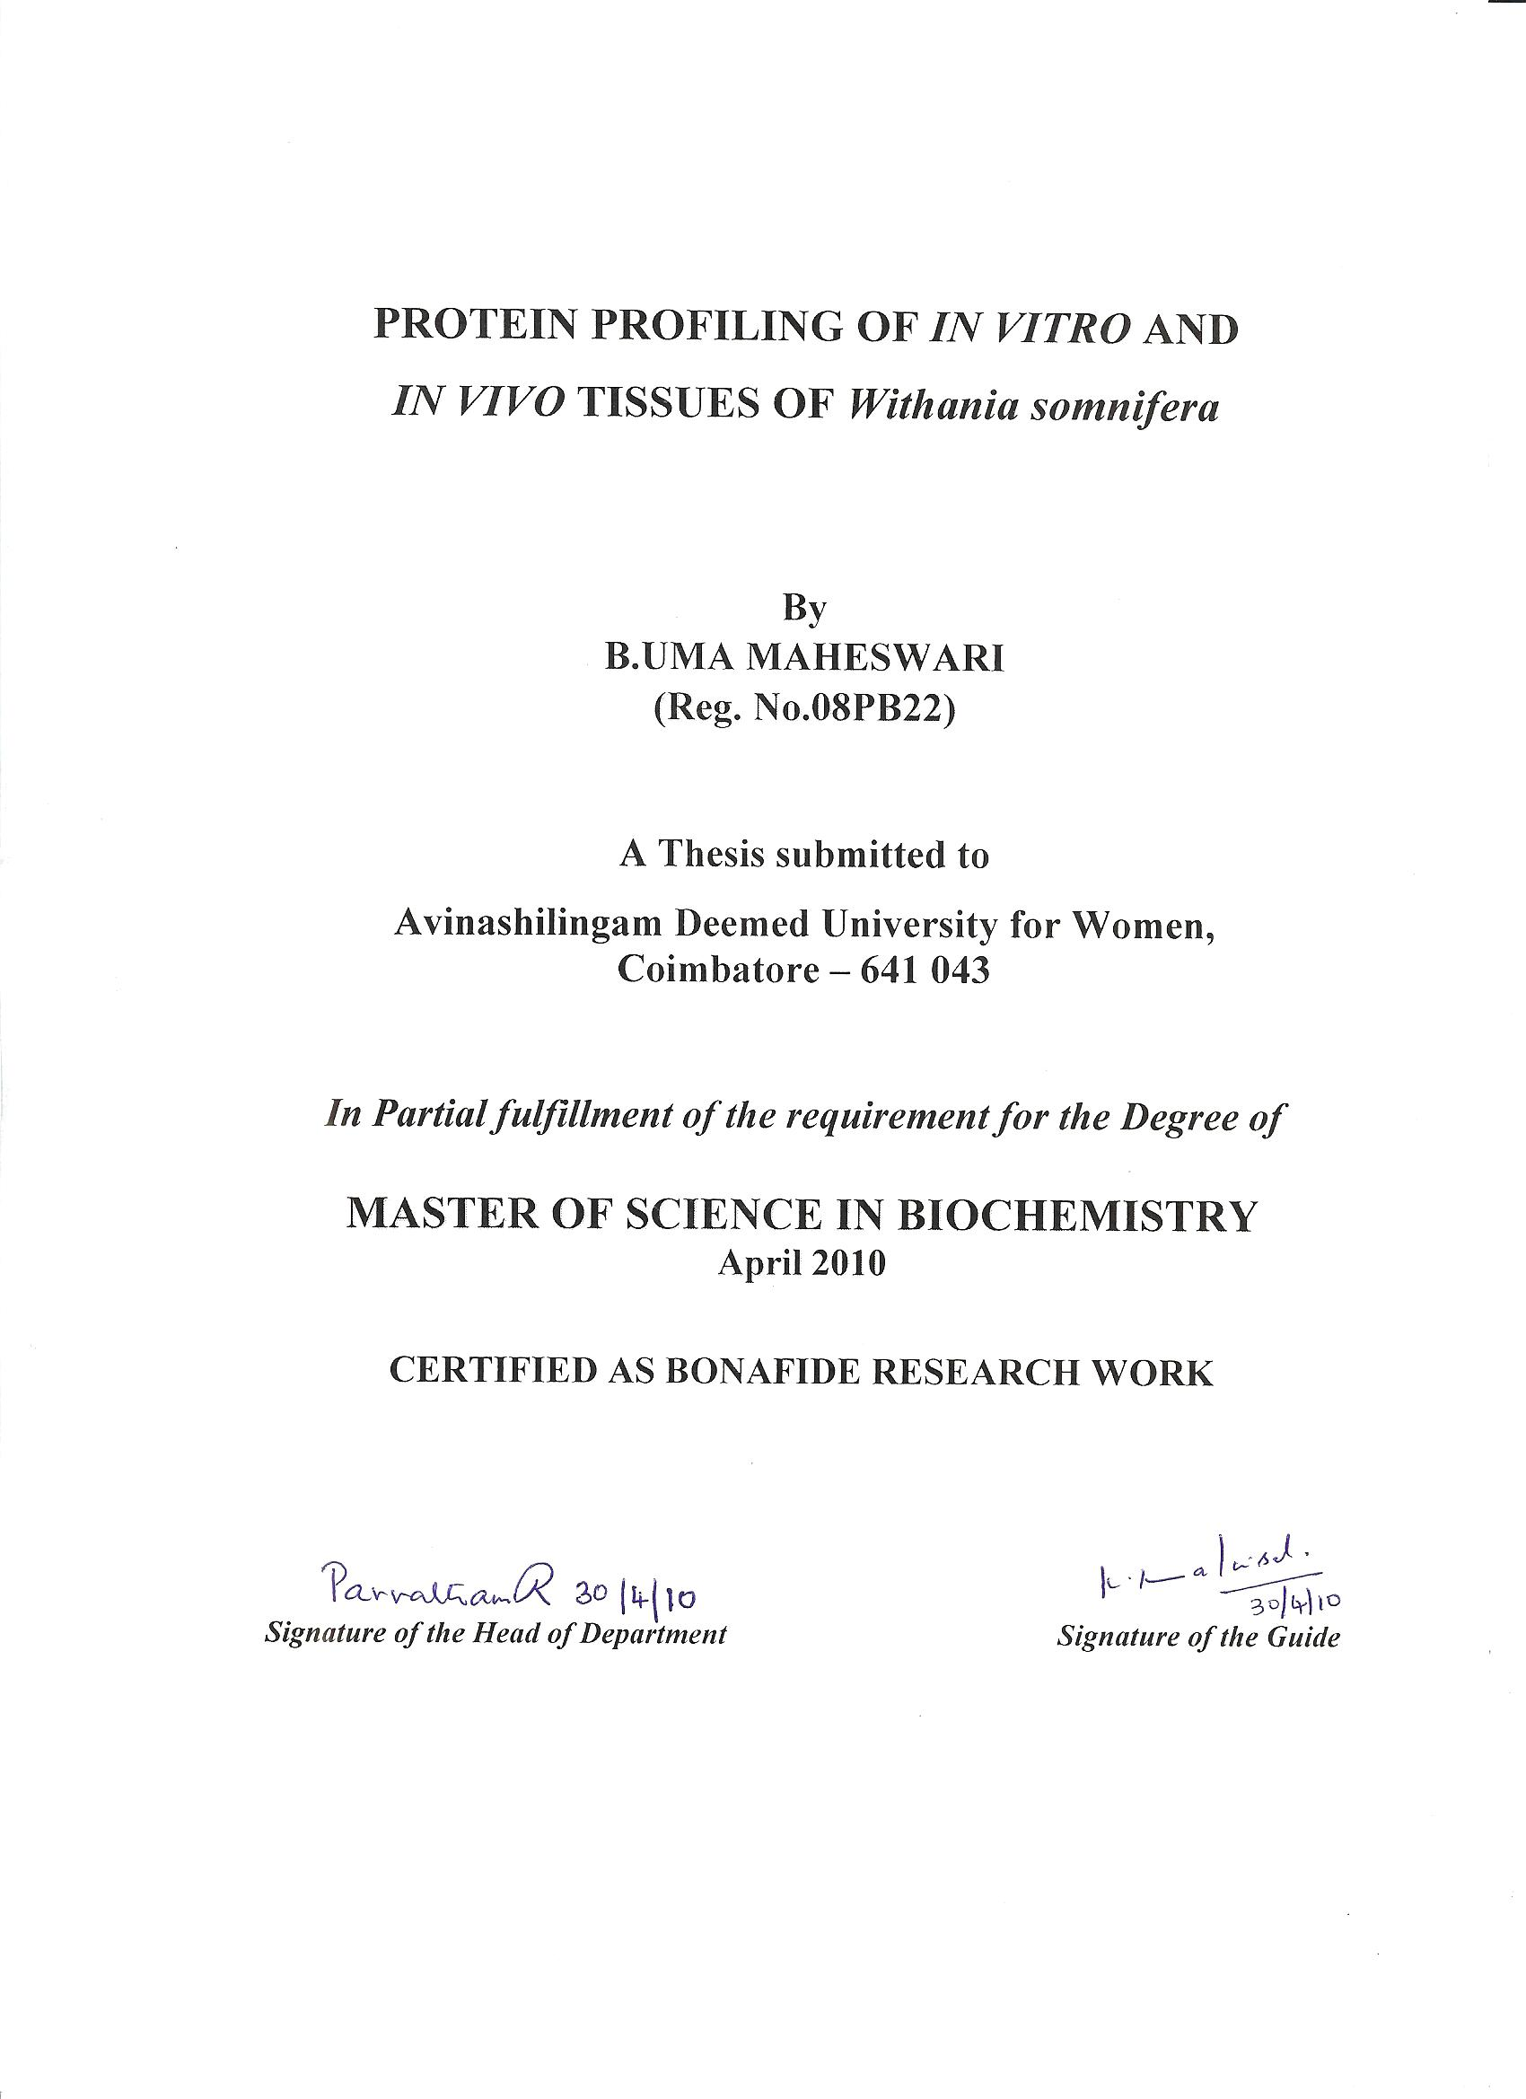

ACKNOWLEDGEMENT

“Peace on the outside comes from knowing the God from inside”. First and foremost I express my heartfelt respect and thanks to God Almighty for all the blessings and strength he gave me in all my endeavors.
“The best and the most beautiful things in this world can neither be seen nor be touched, but can be felt with the heart”. I sincerely thank Ayya Avargal and Amma Avargal for creating a portal to exhibit our abilities.
I owe my respectful gratitude and sincere thanks to Dr.T.K.Shanmughanadam B.A, B.L., Anna avargal, Chancellor, Avinashilingam Deemed University for Women, Coimbatore, for providing all the facilities to conduct the project.
I record my heartfelt thanks to Dr. (Mrs.) Saroja Prabhakaran, M.Sc., Dip.Ed., M.Phil., Ph.D., Dean, Faculty of Science, Vice Chancellor, Avinashilingam Deemed University for women, Coimbatore, for extending all possible help towards the completion of the study.
I express my sincere thanks to Dr. (Mrs.) Gowri Ramakrishnan, Registrar, Avinashilingam Deemed University for Women, Coimbatore, for providing opportunity to carry out this piece of work.
“To be simple is to be great”. I am indebted to Dr. R. (Mrs.) Parvatham, M.Sc., Dip.Ed., M.Phil., Ph.D., Dean, Faculty of Science, Head of the Department of Biochemistry, Biotechnology and Bioinformatics, Avinashilingam Deemed University for Women, Coimbatore, for her constant motivation, encouragement and support in eliciting this project in a facile manner.
“The good teacher explains. The superior teacher demonstrates. The great teacher inspires”. I articulate my reverential gratitude to my guide Dr. (Mrs.) K. Kalaiselvi, Assistant Professor, Department of Biochemistry, Biotechnology and Bioinformatics, for her inspiration and guidance rendered at every stage of the

dissertation. Without her dynamic guidance, valuable suggestions, untiring help, meticulous efforts and enduring support, this study would never have seen the light of the day.
I express my sincere thanks to Staff members of the Department of Biochemistry, Biotechnology and Bioinformatics, Avinashilingam Deemed University for Women, Coimbatore, for their help and cooperation.
"It’s great to work with somebody who wants to do things differently". A special word of thanks to Neha, Savitha.C, Sr.Viji, Pradeepa.D for their timely help and support throughout my project.
“A real friend is one who walks in when the rest of the world walks out”. All glories of this world are not worth a good friend. I deem it a great privilege to thank all my friends Gayathri.C, Dharsana.S, Swapna.G, Praphavathi.K, Sumithradevi.S, Renugadevi and well wishers for their immense help in times of dire need and for their constant support.
“Seek no praise, no reward for anything you do”. My heart has no bounds to thank my parents who have sacrificed many things in their life for me, expecting nothing in return since no great work can be done without sacrifice.
I dedicate my work to my parents, sister, brother, harini and friends. Their mental and emotional support, motivation, prayers and loving care provided has been the source of my strength.
B.UMA MAHESWARI

CONTENTS

Chapter No. | Title | Page No.
1.0 | INTRODUCTION | 01
2.0 | REVIEW OF LITERATURE | 04
3.0 | MATERIALS AND METHODS | 17
4.0 | RESULTS AND DISCUSSION | 23
5.0 | SUMMARY AND CONCLUSION | 45
 | BIBLIOGRAPHY | 46
 | APPENDICES | 52

LIST OF TABLES
Table No. | Title | Page No.
3.1 | Explants used in the study | 18
3.2 | Different combinations used for root induction | 20
4.1 | Effect of hormone concentration on root induction | 25
4.2 | Effect of media strength and light intensity on root induction | 28
4.3 | Effect of media strength on root induction | 28
4.4 | Growth index of roots in suspension culture | 34
4.5 | Estimation of protein in in vitro and in vivo tissues of W. somnifera | 42

LIST OF PLATES

Plate No. | Title | Page No.
4.1 | Effect of Auxin on Root Induction | 26
4.2 | Effect of light intensity on root Induction | 31
4.3 | Root tips Growth in suspension | 35
4.4 | Branches in suspension culture | 36
4.5 | Transverse section of in vitro and in vivo roots | 39
4 .6 | Staining of in vitro and in vivo roots of W.somnifera | 41

LIST OF FIGURES

Figure No. | Title | Page No.
4.1 | Effect of strength of MS Medium on root induction | 29
4.2 | Effect of light intensity on root induction | 30
4.3 | Root structure of vascular plants | 38
4.4 | Protein profiling of in vitro and in vivo leaves of  W. somnifera | 43

- INTRODUCTION

“Research is to see what everybody else has seen, and
to think what nobody else has thought”
- Albert Szent-Gyorgyi

Research can be defined as the search for knowledge or any systematic investigation to establish facts. Scientific research relies on the application of the scientific method, a harnessing of curiosity. This research provides scientific information and theories for the explanation of the nature and the properties of the world around us (Trochim, 2006).
Plants constitute an important natural wealth of a country. Plants still constitute one of the major raw materials for drugs and for treating various ailments of human being. The beneficial medicinal effects of plant materials typically result from the combinations of secondary products in the plant. The medicinal actions of plants unique to particular plant species or groups are consistent with the concept, as the combination of secondary products in a particular plant is taxonomically distinct (Parekh et al., 2006).
Plants show enormous versatility in synthesizing complex materials, which have no immediate obvious growth or metabolic functions (Akinmoladun et al., 2007). Thousands of secondary plant products have been identified and it is estimated that thousand more of these compounds still exist. Since secondary metabolites from natural resources have been elaborated within the living systems, they are often perceived as showing more “drug – likeness and biological friendliness than totally synthetic molecules” making them good candidates for further drug development (Kumaraswamy et al., 2008).
“A medicinal plant is any plant which, in one or more of its organ, contains substance that can be used for therapeutic purpose or which is a precursor for synthesis of useful drugs” (Sofowora, 1982).
Medicinal plants constitute an important natural asset of every country. They have been serving as therapeutic agents since ancient times and are important raw materials for the manufacture of traditional and modern medicine. However, medicinal plants are being over exploited and are facing the threat for extinction. A high number of herbal medicinal companies are using medicinal plants as raw materials. The therapeutic activities of a medicinal plant are attributed to the secondary metabolites synthesized in the plant.
Herbs have been used throughout history to enhance physical performance, but scientific scrutiny with controlled clinical trials has only recently been used to study such effects (Bucci, 2000). Plants exhibit varying degrees of therapeutic value some of which are useful in the treatment of cognitive dysfunction, epilepsy, insomnia, rheumatism, gout and dyspepsia (Russo et al., 2001). The search for new plant-derived chemicals should thus be a priority in current and future efforts toward sustainable conservation and rational utilization of biodiversity.
Withania somnifera Dunal, Family Solanaceae; commonly known as Ashwagandha, a subtropical undershrub, is known to have several medicinal properties such as sedative, hypotensive, anti-ageing, aphrodisiac, anti-inflammatory, bradycardiac, respiration stimulatory, anti-tumour, antiperoxidative, cardiotonic, radiosensitizing and thyroregulatory effects. Some herbalists refer to ashwagandha as Indian ginseng, since it is used in a way similar to that of ginseng in traditional Chinese medicine (Chaurasia et al., 2000).
Fruits, leaves and seeds of Withania somnifera have been used as aphrodisiacs, skin ointment, and diuretics and for treating memory loss and promoting reproductive fertility. Withania is reported to have anti-carcinogenic effects in animal and cell cultures by decreasing the expression of nuclear factor-kappa-β, suppressing intercellular tumor necrosis factor, and potentiating apoptotic signaling in cancerous cell lines. The roots and berries of the plant are used in herbal medicine. Of all the parts of this plant, the root has been considered to be the most active for therapeutic purposes (Ichikawa et al., 2006). The roots of the plant are categorised as rasayanas, which are reputed to promote health and longevity by augmenting defense against disease, arresting the ageing process, revitalising the body in debilitated conditions, increasing the capability of the individual to resist adverse environmental factors and by creating a sense of mental wellbeing (Gupta and Rana, 2007). For further research into the biochemical compositions and potential medicinal values of this plant, an efficient in vitro regeneration system for the production of plants is required because field-grown plants may be subject to seasonal and somatic variations, infestations of bacteria, fungi and insects as well as environmental pollution that can affect the medicinal value of the harvested tissues (Siddique et al., 2004).
Adventitious root induction will be an useful step towards the establishment of rapid production of roots in suspension which can useful to compare the morphology and protein profiling of in vivo tissues of W. somnifera.
With this basic information, the present study has been designed to:
- Study the Adventitious root induction of Withania somnifera
- Check which combination is best for root induction
- Check the morphology of those roots
- Protein profiling of In vitro and In vivo Tissues of Withania somnifera

2.0 REVIEW OF LITERATURE
Medicinal plants constitute an important natural wealth of every country. They have been serving as therapeutic agents since ancient times and are important raw materials for the manufacture of traditional and modern medicine. The search for new plant-derived chemicals should thus be a priority in current and future efforts toward sustainable conservation and rational utilization of biodiversity (Russo et al., 2001). Plant cell culture technologies were introduced at the end of the 1960’s as a possible tool for both studying and producing plant secondary metabolites. Different strategies, using an in vitro system, have been extensively studied to improve the production of plant chemicals (Winters, 2006).
This chapter deals with an extensive review of work carried out on “Protein profiling of in vitro and in vivo tissues of Withania somnifera”
2.1 Withania somnifera: Ashwagandha
2.2 Medicinal Properties of Withania somnifera
2.3 In vitro Culture Studies of Withania somnifera
2.3.1 Role of auxin in root induction
2.3.2 Suspension culture
2.3.3 Large scale production of roots using bioreactor
2.4 Root Morphology
2.5 Extraction for protein
2.6 Protein profiling
2.6.1 Protein Profiling in tissues of W.somnifera
Higher plants are the ultimate and renewable solar-powered biochemical factories. Today several distinct chemicals derived from plants, are important drugs currently used in one or more countries in the world. Many of the drugs sold today are simple synthetic modifications or copies of the naturally obtained substances( Kamboj 2000).

Taxonomical Classification (NPGS, GRIN 2009)
Kingdom – Plantae
Sub kingdom–Tracheobionta
Division – Magnoliophyta
Class – Magnoliopsida
Subclass – Asteridae
Order – Solanales
Family – Solanaceae
Genus – Withania
Species - somnifera

Withania somnifera Dunal (Ashwagandha) is widely used in Ayurvedic medicine. It is prescribed for a variety of musculo-skeletal conditions, eg. arthritis, rheumatism, and as a general tonic to increase energy, improve overall health and longevity, and prevent disease in athletes, the elderly and during pregnancy (Mishra et al., 2000). In the last forty years, the flow of biological discovery has swelled from a trickle into a torrent, driven by a number of new methodologies developed in Plant tissue culture and Recombinant DNA technology (Kulkarni et al., 2000).
Withania somnifera is considered as rasayana herb, which works on a non-specific basis to increase health and longevity. It is an important erect, evergreen, perennial shrub (Ray and Gupta, 1994). The roots and berries of the plant are used in herbal medicine. Some herbalists refer ashwagandha as Indian ginseng, since it is used in a way similar to that of ginseng in Chinese medicine.
The root of Withania somnifera is used to make the Ayurvedic sedative and diuretic. Ashwagandha is also considered to be an adaptogen. Other parts of the plant (e.g., seeds, leaves) are used as a pain reliever, to kill lice, and to make soap. The fresh berries have been used as an emetic. The principal bioactive compounds of Withania somnifera are withanolides, highly oxygenated C-28 steroid derivatives (Bessalle and Lavie,1992). More than 40 withanolides have been isolated and identified from Withania

somnifera. The roots also contain nicotine and assorted piperidine and pyrrolidine alkaloids. The leaves have been found to contain flavonol glycosides and phenolic acids (Kandil et al., 1994).
The main constituents of Ashwagandha are alkaloids and steroidal lactones. Among the various alkaloids, withanine is the main constituent. The other alkaloids are somniferine, somnine, somniferinine, withananine, pseudo-withanine, tropine, pseudo-tropine, cuscohygrine, anferine and anhydrine. Two acyl steryl glucoside viz. sitoindoside VII and sitoindoside VIII have been isolated from roots of Withania. The leaves contain steroidal lactones, which are commonly called withanolides. The withanolides have C28 steroidal nucleus with C9 side chain, having six membered lactone ring (Padmavathi et al., 2005).
2.2 Medicinal Properties of Ashwagandha
The root is regarded as a tonic, aphrodisiac and is used in consumption, emaciation, debility, dyspepsia and rheumatism. A decoction of the root is used for colds and chills. The plant is used in treating syphilis and a decoction of the root bark is administered in asthma (Davis and Kuttan, 2000). It is used for all age groups, in both sexes and even during pregnancy without any side effects.
It is known to have several medicinal properties such as sedative, hypotensive, anti-ageing, aphrodisiac, anti-inflammatory, bradycardiac, respiration stimulatory, anti-tumour, antiperoxidative, cardiotonic, radiosensitizing and thyroregulatory effects. Of all the parts of this plant, the root has been considered to be the most active for therapeutic purposes (Chaurasia et al., 2000).
The studies conducted by Mishra et al., (2000) indicate that ashwagandha possesses anti-inflammatory, antitumor, antistress, antioxidant, immunomodulatory, hemopoetic, and rejuvenating properties. It also appears to exert a positive influence on the endocrine, cardiopulmonary, and central nervous systems. Toxicity studies reveal that ashwagandha appears to be a safe compound. Preliminary studies have found various constituents of Ashwagandha exhibit a variety of therapeutic effects with little or no associated toxicity. Ashwagandha also appears to benefit the endocrine, cardiopulmonary, and central nervous systems.
Withania somnifera is one of the most valued medicinal plants in Ayurveda and other traditional systems of medicine. In Ayurveda, Withania somnifera is regarded as one of the most useful herbs having ‘Vata’ pacifying properties. In recent times, it has attracted tremendous pharmacological research interests. The plant has been reported to have adaptogenic, anticancer, anti-convulsant, immunomodulatory, anti oxidative and neurological effects. It is also considered efficacious in the treatment of arthritis, geriatric, behavioral and stress-related problems (Sangwan et al., 2004).

2.3 In vitro Culture Studies of Withania somnifera
Therapeutic properties of food and medicinal plants stem from the characteristic bioactive phytochemicals (mainly secondary metabolites) synthesized and amassed by them (Sangwan et al., 2004). The search for new plant-derived chemicals is a priority in current and future efforts toward sustainable conservation and rational utilization of biodiversity. In the search for alternatives to production of desirable medicinal compounds from plants, biotechnological approaches, specifically, plant tissue cultures, are found to have potential as a supplement to traditional agriculture in the industrial production of bioactive plant metabolites (Vanisree et al., 2004).
Plant cell culture technologies were introduced at the end of the 1960’s as a possible tool for both studying and producing plant secondary metabolites. Different strategies, using an in vitro system, have been extensively studied to improve the production of plant chemicals (Winters, 2006). The evolving commercial importance of secondary metabolites in recent years has resulted in a great interest in secondary metabolism, particularly in the possibility of altering the production of bioactive plant metabolites by means of tissue culture technology. Of all the parts of this, the root has been considered to be the most active for therapeutic purposes. In approximately 66% of the plants used in

traditional medicine, roots are the principle source of drug preparation (Kamboj, 2000). The commercial success largely depends on quality and yield of roots which is the product of commerce. The process of root growth and development has been studied in W.somnifera, it showed that the physicochemical constituents are lacking (Khanna et al., 2006).
Cell suspension culture systems could be used for large scale culturing of plant cells from which secondary metabolites could be extracted. The advantage of this method is that it can ultimately provide a continuous, reliable source of natural products. Discoveries of cell cultures capable of producing specific medicinal compounds at a rate similar or superior to that of intact plants have accelerated in the last few years. New physiologically active substances of medicinal interest have been found by bioassay (Vanisree et al., 2004).
Several products are found to accumulate in cultured cells at a higher level than those in native plants through optimization of cultural conditions (Rahman et al., 1993). This species is of economic interest for its wide ranging pharmacological activity and one of the major constraints in utilizing natural populations is the existence of plant to plant chemo-variability (Rani and Grover 1999).
It has been demonstrated that the biosynthetic activity of cultured cells can be enhanced by regulating environmental factors, as well as by artificial selection or the induction of variant clones. Some of the medicinal compounds localized in morphologically specialized tissues or organs of native plants have been produced in culture systems not only by inducing specific organized cultures, but also by undifferentiated cell cultures. The possible use of plant cell cultures for the specific biotransformations of natural compounds has been demonstrated. Due to these advances, research in the area of tissue culture technology for production of plant chemicals has bloomed beyond expectations.
The major advantages of a cell culture system over the conventional cultivation of whole plants are: (1) Useful compounds can be produced under controlled conditions independent of climatic changes or soil conditions; (2) Cultured cells would be free of microbes and insects; (3) The cells of any plants, tropical or alpine, could easily be multiplied to yield their specific metabolites; (4) Automated control of cell growth and rational regulation of metabolite processes would reduce of labor costs and improve productivity; (5) Organic substances are extractable from callus cultures (Vanisree et al., 2004).
In approximately 66% of the medicinal plants used in traditional medicine, roots are the principal source for drug preparation. The development of a fast growing root culture system would offer unique opportunities for producing root drugs in the laboratory without having to depend on field cultivation (Wadegaonkar et al., 2006).

In vitro rhizogenesis of Withania somnifera
The induction of plantlets directly from the parent tissue without intervening callus is of potential value for the in vitro multiplication and storage of a given phenotype. Axillary leaves (0.5-0.8) taken from 1st to 3rd node from the apical region of lateral branches were surface sterilized with 0.01 % (w/v) mercuric chloride for 2-3 minutes, washed 3-4 times with sterile double distilled water and inoculated on agar solidified MS (Murashige and Skoog, 1962) medium supplemented with different combination of hormones. The pH of the medium was adjusted to 5.6 before sterilization. Callus initiation appeared, for axillary leaves after 7-8 days callus was creamish white and supplemented with 2,4-D and kin (0.2mg1-1). Adventitious rooting increased when the shoots derived from hypocotyl or axillary shoot base callus were excised and cultured on MS medium with different concentrations of auxins. Shoots excised from shoot clusters rooted readily (80%) on growth regulator free liquid medium within 30 days. (Rani and Grover, 1999).
But adventitious roots the certain higher plants synthesize and secrete a remarkable diversity of secondary metabolites. The untransformed root (adventitious roots) necessitates a special mention because of the easy production of valuable pharmaceutical compounds without/genetic modification of the plant
genome (Martin et al., 2008).
2.3.1 Role of auxins on in vitro root induction
Root growth does not always occur in the earlier stages in plant cell culture, and is of course a requirement for successful plant growth after the micro propagation. It is performed in vitro by transferring the plantlets to a growth medium containing auxin(s). Various concentrations and combinations of IAA, IBA and NAA were added in the medium. The pH of the medium adjusted to 5.6 to 5.8 before sterilization. It is well established that root development is controlled by hormonal signals, especially auxins (Wadegaonkar et al., 2006).
Auxin produced in young leaves moves polarly in the vascular tissues specifically along their cambium and through the xylem parenchyma starch sheath and the root pericycle. This non-polar auxin flow in the phloem conduits originates in mature leaves. These fragments of important information have never been incorporated into a general concept for explaining where IAA moves in the plant body. This confusing situation hinders proper analysis of new findings, which could consequently result in incorrect interpretations.
Aloni et al., (2001) proposed that free auxin flows along three main pathways in the entire plant. All living cells in the plant body are capable of transporting auxin.
During plant development, initial auxin flows are canalized into three main routes of IAA transport. This canalization starts during embryogenesis. The first two pathways induce and control the vascular and protective tissues, while the third pathway controls the activity of the phloem conduits. In the primary root, IAA moves polarly in the vascular cylinder through (i) the vascular meristem, and (ii) the pericycle. In the secondary body the polar IAA streams descending from the primary shoot merge into one
pathway, which occurs in the cambium and differentiating vascular elements in the sieve tubes.
(Baburaj and Guneshakaren 1995) have also reported callus induction from leaf explants of W.somnifera using MS medium supplemented with NAA (2mg1-1). To examine the potential of different explants, to respond under in vitro conditions with the possibility of developing roots by using different combination of auxins (Gita et al., 2003). Regenerated shoots obtained from the axillary shoot base callus were rooted best on MS medium containing IBA (2and 4mg1-1) with IAA 2mg (Rani and Grover, 1999).
In auxin containing media induced roots, lateral root primordial formed from the pericycle of the root explants. However, on auxin free medium, no lateral root primordium was found in the pericycle of the explants. Slight differences could be observed in the lateral root primordia formed from IBA and IAA (Kim et al., 2006).
2.3.2 Suspension culture
Even though several types of cell culture methods are being used to produce important bioactive secondary metabolites, use of the cell suspension cultures is preferred for large scale production due to its rapid growth cycles. Thus cell suspensions are used for large amount of roots transferred from MS medium with growth responses and metabolism of novel chemicals (Vanisree et al., 2004).
2.3.3 Large scale production of roots using bioreactor
In contrast to cell suspensions, root cultures are large multicellular organs that can be considered in principle as a naturally immobilized system. The structural and biochemical characteristics of hairy roots (highly branched morphology, sensitivity of root hairs to shear and anaerobic stress, high surface of absorption/exchange) must be considered in designing bioreactors for root cultures. Sufficient mixing and mass transfer must also be ensuring to provide adequate nutrients to root growth (Singh et al., 2004).
The best in vitro root induction was obtained in 2.85µm IAA and 9.85µM IBA from 8 to 10 days of inoculation. The roots were transferred to half strength MS liquid medium with the same concentration of plant growth regulators.

From 200mg inoculum 6.15±0.2g fresh weight was obtained after 5 weeks under the shake flask conditions. The roots grown in shake flask were thicker and more in amount. Large scale cultivation of W. somnifera roots in bioreactor might be an alternative source to fulfill the global demands (Sudo et al., 2002).
2.4 Root Morphology
The morphology of the roots depends upon the in vitro and in vivo conditions where the plant is grown. Several histological and structural examinations studied in roots (Byrne, 1973). Compare the shoots the cell lineages are easily identified in roots because of the continuous files of cells that arise from repeated transverse divisions in meristematic cells. The cells of the root may arise from tiered sets of initials (closed type) as observed in tobacco and radish or there may be no separation of initials into tiers (open type) such as the organization seen in Pisum sativum or Fagussylvatica (Von Guttenberg, 1964) While the organization of cells in the meristem depends upon the species and structure of the root meristem may change during ontogeny. To understand the process of morphogenesis in roots, both the developmental history of cell files in the root and the ontogeny of the initial cells must be known. The morphologies, numbers and spatial relationships of the cells must be determined in higher plants. In the results of such analysis for the root of Arabidopsis thaliana, a plant ideally suited for subsequent genetic dissection of development (Meyerowitz, 1989).
In A. thaliana they reported the number, position and morphology of the cells in the root. It reveals elegant pattern, simplicity and little variance in the position and number of cells comprising the primary root. Anatomical data from roots in seedlings and in embryos, together with in vivo labeling experiments are combined in a model for the activity of the A. thaliana root meristem initials. It describes both the post embryonic meristematic activity and the generation of the meristem structure from cells of the suspensor (hypophysis) and the embryo-proper during embryogenesis, and thus provides the foundation for genetic analysis of root meristem formation and activity (Dolan et al., 1993).
2.5 Extraction for proteins
Xu et al., (2008) proved that protein extraction for two-dimensional gel electrophoresis (2-DE) from plant samples is challenging due to low protein content and high level of contaminants. Proteins were extracted from leaves and roots of mature plants using TCA/acetone extraction methods and separated by 2-DE. The TCA/acetone extraction had higher protein yield and resolution of protein separation for leaves, compared to the other methods.
For roots, both the TCA and phenol methods had higher protein yields and number of protein spots. The phenol method had more protein spots and higher spot intensities in the low molecular weight (M_{r}) region or high isoelectric point (pI) region than the TCA extraction, while more protein spots and higher spot intensity in the region of high M_{r} were detected by the TCA method than by the phenol method. The results suggested that the TCA method was the most effective among other methods for leaves, and a combination of the TCA and phenol methods may provide enhanced proteomic information for roots in turf grass.
Root cultures dried over night in an oven at 55ºC. Dried powdered material (200 mg was extracted using 2 ml methanol by sonication, for 20 minutes at room temperature). Methanolic extracts were evaporated to dryness at 45ºc in a vacuum oven. It was transferred to an (eppendorf tube) vortexed for 10s and centrifuged for 5 minutes at 3000g. After centrifugation, the clear supernatant was used for phytochemical analysis (Isaacson et al., 2006).
Extraction of proteins from P. ginseng roots
The extraction of proteins from P.gingeng roots and leaves on that Kim and colleagues attempted two general methods for the preparation of plant samples. Homogenization and grinding with liquid nitrogen. It is a more efficient method for the removal of interfering compounds. Ground samples were incubated in sample buffer containing detergent (0.3% SDS) reducing agent (200 mM DTT) for complete solubilization and with DNase and RNase for the removal of nucleic acids. Finally the supernatant of the sample was prepared by TCA precipitation for the removal of contaminants (Kim et al., 2004b).
Extraction of proteins from roots of cassava
Glausia and Carvahoi, (2001) studied in Adventitious roots and storage roots. There were washed, peeled, sliced, and homogenized. Then the samples were gone under constant agitation (150 RPM) in a rotary shaker overnight at 4°C. Extracts were filtered and centrifuged to eliminate debris and starch. The crude extracts were collected and proteins precipitated by addition of 2 volumes of cold ethanol. Samples were centrifuged and the pellets were dissolved in suspension buffer. Proteins were concentrated by lyophilization, and resuspended in H₂O. Insoluble material was removed by micro centrifugation. Protein concentration was estimated by standard Lowry’s method (Lowry et al., 1951).

2.6 Protein Profiling
In the last few years, substantial improvements in protein separation and identification techniques and the expansion of genomic knowledge have led to an increase in the application of proteomic methods to answer biological questions. The most popular technique for protein separation is currently two-dimensional gel electrophoresis, although alternative gel-free techniques that arebased on fractionation by liquid chromatography are becoming increasingly popular (Wang et al., 2003).
In W. somnifera, the presence of phyto-chemical constituents such as soluble protein, total amino acids, reducing sugars and non-reducing sugars, crude fibers and protein was studied and proved that the activity of protein in roots was enhance the root development and composition. Young roots showed low amount of protein. Increased protein content was observed at maturation stage which indicated structural protein requirement for growth and metabolism of roots (Khanna et al., 2006).
Electrophoresis is a versatile biochemical technique to detect genetic variation. Protein molecules migrate in an electric field because they are charged (Hamrick and Rickwood, 1990). Kim et al., 2003 studied recent technical improvements in 2-DE and MS make it possible to identify hundreds of proteins rapidly and thus provide information about protein expression, sub-cellular localization and post-translational modifications improvement for understanding the target tissue (hairy roots) in ginseng plant.
To determine the evolutionary relationship among the populations based on SDS-PAGE marker proteins for quick identification of populations and improvement of this valuable plant for introduction into new potential areas for commercial exploitation. SDS-PAGE provided valuable information for the identification of populations and could be utilized for population and varietal discrimination as well as seed quality tests in true to type seed producing plants (Ahmed et al., 2007).
Liang et al., (2006) studied the initial intention of the study was to profile the storage proteins using improved protein extraction method and to identify protein markers that could be used to separate subspecies of peanut, such as hypogaea and fastigiata in order to select diverse breeding lines for mapping population construction. The fact mentioned above combined with the duration of electrophoresis, protein concentration of samples, quality of samples, sample size, principles of staining gels (Vallejos, 1983).
Roots function as the interface with the edaphic environment. Understanding roots at functional and cellular levels is critical to both rhizosphere ecology and plant production. Roots are highly plastic and are able to adapt developmentally and physiologically to changing environmental conditions, including disease infection and feeding by nematodes. Cotton roots are typical of herbaceous dicotyledonous species (Oosterhuis and Jernstedt, 1999). The proteomic studies of plant roots have elucidated root tissue differentiation and development in response to internal growth regulators as well as environmental signals (Song et al., 2007).

Two-dimensional gel electrophoresis analysis was performed on adventitious and storage root in cassava (Manihot esculenta Crantz). Adventitious roots of cassava not have swelling formation. Saline buffer soluble proteins were extracted from cassava roots, separated in a high-resolution 2-D electrophoresis system, visualized with silver staining gel procedure, and digital image generated was subjected for further analysis.

Results revealed large variation in the complexity of the gel protein profile between the two root systems. About 90% of the protein spots appeared in the pI range value of 4.0 to 6.5 and between 14 to 80 kDa of molecular mass. Variation in the complexity of protein pattern was related with different type of root. Whereas the adventitious root showed, a more simple profile related to primary growth, the storage root showed to be a more complex profile related to secondary growth and starch accumulation (Glausia et al., 2001).
So various procedures have been previously attempted for the root induction of W.somnifera. The present study is aimed at analyzing the efficiency of the hormones IBA, IAA and their combination on adventitious root induction from the leaf explants of W. somnifera and check the morphology, protein profiling of tissues.
3.0 MATERIALS AND METHODS
The work “Protein profiling of in vitro and in vivo tissues of Withania somnifera” was carried out in the Plant Tissue Culture laboratory of Avinashilingam Deemed University for Women, Coimbatore. During the course of the work different techniques related to plant tissue culture were used. This chapter describes the general and common methods that were carried out to accomplish the above-mentioned work.
3.1 Plant Material
3.2 Preparation of Media
3.3 Inoculation of the Explants
3.4 Root Induction
3.4.1 Effect of Auxin Concentration and Light Intensity on Root Induction
3.4.2 Maintenance of Roots in Suspension Culture
3.4.3 Determination of Root weight and Growth Index
3.5 Root Staining
3.6 Protein Profiling
3.6.1 Extraction of Protein from Roots
3.6.2 Estimation of Protein by Lowry’s Method
3.6.3 Protein Profiling
3.7 Statistical Analysis

3.1 Plant Material
The selection of the explants depends on the culturing technique. The different types of explants that were used for the study are given below (Table 3.1).
Table 3.1. Explants Used in the Study
S.No. | Explants Used | Culture technique
1. | Nodal segments | Micropropagation
2. | MS0 leaves | Root induction
3. | Adventitious roots | Suspension culture

MS0 leafs obtained from the in vitro grown plantlets. Adventitious roots obtained from MS medium supplemented with Indole Butyric Acid (IBA) and Indole Acetic Acid (IAA) in different combination. These roots were then used for suspension cultures.
3.2 Preparation of Media
The MS nutrient medium (Murashige and Skoog, 1962) was used for micropropagation, root induction and suspension culture studies. The composition of the medium is given in Appendix 1. Elix-3 (Milli–Q) water was used for the preparation of culture media. After addition of all the media constituents, pH was adjusted to 5.8 using 0.1 N KOH or 0.1 N HCl. Gelling agent (agar-agar) at a concentration of 0.8% was added and the medium was steamed to melt the gelling agent. It was then dispensed into test tubes (10 ml per tube) or screw capped bottles (25 ml per bottle) or liquid medium without gelling agent into conical flasks (100 ml per 250 ml flask). The medium was autoclaved at 121° C at a pressure of 1.1kg.cm⁻² for 20 min. All the plant growth regulators in required concentration used during the course of the present work were added before autoclaving the medium.
3.3 Inoculation of the Explants
The working table of the laminar airflow chamber was first surface sterilized with 70% ethanol. Sterile Petri dishes and tools (forceps, scalpels, sterile cotton, and sterile paper towels) that were used for inoculation were kept in the laminar airflow chamber. The ultra violet light was switched on for 20 min. Prior to inoculation, hands were sterilized with 70 % ethanol. The forceps and scalpels were dipped in 70% alcohol and flamed, cooled and used for inoculation. For root induction studies, the leaves were trimmed into pieces of about 1 cm² and inoculated on to the medium. All these cultures were incubated at 25±2ºC. Each experiment had 15 replicates with three explants in each. A photoperiod of 16/8 h light or complete darkness was maintained for all experiments.
3.4 Root Induction
3.4.1 Effect of Different Auxins on Root Induction
To assess the percentage of induction of adventitious roots from leaf explants of Withania somnifera the explants were inoculated in half strength MS media and full strength MS media supplemented with IBA and IAA in different combination as given in the following table (Table 3.2).

Table 3.2 Different combinations used for root induction

Media  composition  Treatment | MS0 |  |  |  | Half MS
Media  composition  Treatment | Light |  | Dark |  | Light |  | Dark
Media  composition  Treatment | 1IBA+  0.25IAA | 2IBA+  0.5IAA |  | 4IBA+  1IAA | 1IBA+  0.25IAA | 2IBA+  0.5IAA |  | 4IBA+  1 IAA
Noof explants | - | - |  | - | - | - |  | -
Noof responded | - | - |  | - | - | - |  | -
Mean ± SD | - | - |  | - | - | - |  | -

15 Replicates with 3 explants in each were prepared.

3.4.2 Maintenance of roots in the suspension culture
The root tips and branches from in vitro induced adventitious roots were cultured in basal media (suspension) with the respective IBA and IAA combination. 30 root tips or branch (1.5 gm) measuring in length 2-3 mm were cut under sterile conditions and transferred to sterile conical flask containing 30 ml basal media with respective hormonal combinations. This was studied to analyze the growth pattern of roots in suspension culture under the influence of auxins. They were sub cultured regularly after every 15 days. The different media compositions used for the study are given below.
1. MS media + 0.25 IAA+ 1 IBA
2. MS media + 1 IAA+ 4 IBA
The growth in length of roots was observed and noted every 7 days from the time of inoculation.

3.4.3 Determination of Root weight and Growth Index

Roots were separated from the medium by passing through a 1mm stainless steel sieve. Root fresh weight (FW) was measured after rinsing once with sterile water, and root dry weight (DW) was recorded after roots were dried to a constant weight at 60ºC for several days. The growth index was calculated using following equation (Wu et al., 2008).
Harvested fresh weight (g) – Inoculated fresh weight (g)
Growth Index =
Inoculated fresh weight (g)

Table 3.3 Growth Index of Roots in Suspension culture
S.No | Media | Inoculated Fresh weight(g)  (3 months) |  | Harvested Fresh Weight(g)  (3 months) |  | Growth Index
S.No | Media | White root tips | Branches | White root tips | Branches | White root tips | Branches
1 | 1IBA+0.25IAA | 1.50 | 1.50 | - | - | - | -
2 | 4 IBA1IAA | 1.50 | 1.50 | - | - | - | -

3.5 Root staining
The root explants (root tips and branch point) were cut into thin horizontal sections and fixed using Serial 3 µm sections were cut with glass knives. For general histological examination, the sections were stained by 0.05 % toluidine blue (Dolan et al., 1993). The well grown roots in in vitro and in vivo were used for staining. The morphological differences between the in vitro and in vivo roots were analysed.

  - Protein Profiling
3.6.1 Extraction of protein from roots
Protein extraction from in vitro and in vivo leaves was carried out following the method of Kim et al., 2004b with slight modification. The The procedure briefly comprises of the following steps. The roots were homogenized and ground in liquid nitrogen. Then added the extraction buffer which contained (NaCl- 0.27g, Tris base, 3.02g, PMSF- 0.0087g, β-mercaptoethanol-5%, SDS- 1% pH-8)and added the reducing agent (200 mM DTT) for complete solubilization. Finally, the supernatant of the sample was precipitated by 10%TCA and gave the Acetone wash for the removal of contaminants.
3.6.2 Estimation of Protein by Lowry’s Method
Soluble protein in the supernatant was estimated by means of protein dye-binding (Lowry et al., 1951).The method was given in Appendix.7.2.
3.6.3 Protein profiling
Protein profiling was done using SDS-PAGE (Laemmeli 1970). The methods are presented in Appendix.7.3-7.4.
3.7 Statistical Analysis
The data generated from the various experiments were subjected to statistical analysis by using the statistical software AGRES, in completely randomized design (CRD).

4.0 RESULT AND DISCUSSION
The present work entitled “Protein profiling of In vitro and in vivo tissues of Withania somnifera” was carried out to produce in vitro roots using different combination of auxins and analyze which is the best combination and studying the protein pattern of different tissues of Withania somnifera. The results obtained during the course of the study are presented and discussed under the following headings.
4.1 In vitro rhizogenesis of Withania somnifera
4.1.1 Effect of hormonal combination on in vitro root induction
4.1.2 Effect of light intensity on in vitro root induction
4.2 Multiplication of in vitro roots in suspension cultures
4.2.1 Effect of root tips and branches in suspension
4.3 Morphology of Roots
4.3.1 Effect of root staining in in vitro and in vivo roots of W. somnifera
4.4 Protein profiling of in vitro and in vivo tissues of W. somnifera
4.4.1 Protein profiling of in vitro and in vivo leaves of W. somnifera
4.1 In vitro Rhizogenesis of Withania somnifera
Withania somnifera Dunal (Solanaceae), known in India as Ashwagandha and also known as Indian ginseng is one of the most valuable plants of the Traditional Indian Systems of Medicines. It is used in more than 100 formulations of Ayurveda, Unani and Siddha systems of medicine. The roots of W. somnifera are extensively used in most of the Indian herbal pharmaceuticals and nutraceuticals (Sangwan et al., 2004), which reportedly exhibit anti-inflammatory, antitumour, antistress, antioxidant, immunomodulatory, haematopoietic and rejuvenating properties (Mishra et al., 2000).
Roots play a vital role in whole plant growth and crop productivity. They are also a source of secondary metabolites, especially in plants producing pharmaceutical compounds in roots. It is well established that root development is controlled by hormonal signals; especially auxins and that environmental cues can act on the genetic programmes for root development and on their hormonal and metabolic control. Roots of certain higher plants synthesize and secrete a remarkable diversity of secondary metabolites. In such cases, mass production of roots through either the induction of transformed roots (hairy roots) using Agrobacterium rhizogenes or the development of adventitious roots (untransformed roots) by the manipulation of culture environment is a reliable route for the production of secondary metabolites. The untransformed root system necessitates a special mention because of the easy production of valuable pharmaceutical compounds without genetic modification of the plant genome (Martin et al., 2008).
In commercial cultivation of plants, losses occur due to poor quality of the root system. Furthermore, because of poor or slow rooting, massive use of fungicides and bactericides is often required to protect plants from fungal and bacterial attacks. Because of the economic importance of medicinal plants, researchers have attempted to develop new rooting treatments. In particular, the effects of all types of plant growth regulators have been examined. Many basic studies on rooting are now carried out in vitro. This has several advantages: tissue culture conditions facilitate administration of auxins and other compounds, avoid microbial degradation of applied compounds, allow addition of inorganic nutrients and carbohydrates (so that secondary causes of poor root formation, e.g. low photosynthetic capacity of cuttings, are avoided), and enable experiments with small, simple explants (Klerk et al., 1999).
4.1.1 Influence of hormones on Root Induction
The leaves of W. somnifera were used as explants for root induction. Fresh and healthy leaves from plantlets grown on full strength MS0 media were selected from plants of one-two months of age. These plants have been maintained in MS basal medium for at least two generations. This was done in order to rule out any residual hormonal effect.
Effect of selected combinations of IAA and IBA were checked for number of roots initiated per explants, the results showed higher response in 1IBA+0.25IAA followed by 4IBA+1IAA and 2IBA+0.5IAA.The result was shown in Table 4.1 Very small or no difference was observed in number of root initiated in 2IBA+0.5IAA. For 4IBA+1IAA, the difference in response shown by explants was high callus formation was observed in all of the above combinations which found to be more in 4IBA+1IAA followed by 2IBA+0.5IAA and 1IBA+0.25IAA.That was represented in Plate 4.1.

Table 4.1 Effect of hormone concentraton on root induction
S.No | Hormone combination (mg/L) | No of Roots Initiated
S.No | Hormone combination (mg/L) | Light | Dark
1 | MS0 | 0 | 0
2 | 1 IBA+ 0.25 IAA | 4.33 ± 0.33 | 3.4 ± 0.58
3 | 2 IBA+ 0.5 IAA | 4 ± 0.5 | 3.67 ± 0.33
4 | 4 IBA+ 1 IAA | 3.33 ± 0.33 | 3 ± 0.58
 | CD | (0.05)  (0.01) | 1.12  2.59
Data represents mean ±SE of 15 replications with 3 explants in per replicate

Among the three combinations studied in light,1IBA supplemented with 0.25 IAA shows a high degree of root induction i.e 4.33 ±0.33 roots per explant, this is followed by 2 IBA+ 0.5 IAA. Where as in the case of cultures incubated in dark resulted in maximum initiation in the combination 2 IBA+ 0.5 IAA i.e. 3.67 ± 0.33, which is followed by 1 IBA+ 0.25 IAA.
Along with differences in root initiation incubated in dark and light, morphological differences were noted such as callusing, root branching, growth as well as phenotypical changes. Callusing was high in the case of explants incubated in dark, also roots were thin and growth was comparatively slow than explants incubated in light.
Adventitious root formation is a complex process because of multiple endogenous factors of plant growth regulators and of environmental factors of light and wounding (Sorin et al. 2005). The central role of auxin on adventitious root formation and its interaction with other endogenous factors, as well as environmental stimuli such as light, have been described by Blakesley, (1994).

Plate 4.1 Effect of Auxin on Root Induction

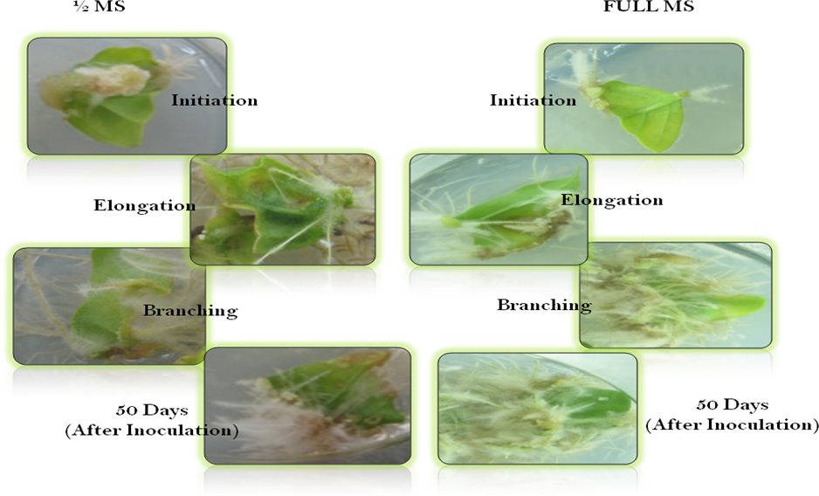

Our study corresponds to that of Mahalakshmi, (2008), where it was observed that a very minute amount of green callus induction was observed at the region were the leaf was cut. However, no root induction was found from this callus, incubated in light. No root induction was observed when the leaves were placed in MS basal medium devoid of any plant growth regulators.
Wynne and McDonald (2002) showed that, at high IBA levels (0.98–1.5mM) callus production increased prior to root formation; low levels of IBA (0.0–0.39mM) produced fewer calluses. Callus formation was more prominent around the leaf margins. Roots were initiated from the margin of leaf, callus and petiole. Roots initiated under 16 h photoperiod were long in length and thicker than roots induced and grown under dark which were thin and not much long as well.
4.1.2 Effect of Light intensity and Media strength on root induction
Using different combinations of IAA and IBA showed varied response for adventitious root induction. The results showed that among the different treatment groups, MS and ½ MS media supplemented with IBA and IAA in different combinations, MS with 1IBA+0.25 IAA incubated in 16 hr photoperiod show the maximum root Induction percentage in both media used. The bottles were incubated in light (16-hour photoperiod) and also complete dark. The various stages of adventitious root induction and elongations in light and dark is represented in Table 4.2

Table 4.2 Effect of media strength and light intensity on root induction

Treatment groups | Hormone Combination (mg/L) | ½ MS |  | MS
Treatment groups | Hormone Combination (mg/L) | Light | Dark | Light | Dark
T0 | MS0 | 0 | 0 | 0 | 0
T1 | 1IBA+0.25IAA | 5.3 ±2.3 | 1.5 ±1.5 | 9.4 ±1.9 | 1.5 ±0.8
T2 | 2 IBA+ 0.5IAA | 0.8 ± 1.3 | 4.2± 2.3 | 2.8 ± 1.9 | 1.6 ± 1.7
T3 | 4 IBA+ 1 IAA | 2.8 ± 1.2 | 3.2 ±1.2 | 5.0 ± 2.2 | 1.3 ±0.6
Data represents mean ± SE of 15 replication with 3 explants in per replicate

Table 4.3 Effect of media strength on root induction
S.No | Hormone Combination (mg/ L) | ½ MS | MS
T1 | MS0 | 0 |  | 0
T2 | 1IBA+0.25IAA | 14.7±4.1 |  | 3.0±2.3
T3 | 2 IBA+0.5 IAA | 3.6±3.2 |  | 5.8±4.0
T4 | 4 IBA+1IAA | 7.8±3.4 |  | 4.5±1.8

Effect of root induction on strength of MS medium was studied by modifying the method described by Wadegaonkar et al., 2006. Explants inoculated in half strength MS0 responded very slowly while comparing with full strength MS0. Maximum number of root induction was observed in full strength MS0 and also the growth rate was high than in half strength MS0.

Figure 4.1 Effect of strength of MS Medium on root induction

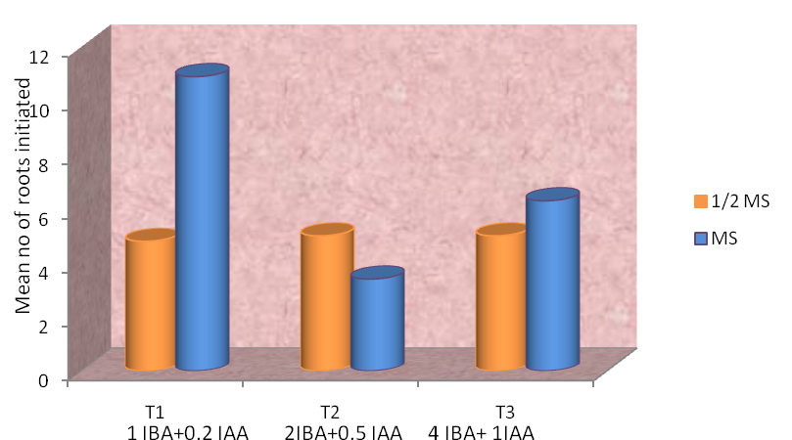

In vitro grown leaves of Withania somnifera for a period of 2 months was taken for this study, hence observation is contradictory to that of results exhibited by the above mentioned reference, might be because of nature of explants taken.

In an attempt to study the combinations of growth regulators on full strength and half strength in root induction, three combinations were used. Results from the above graph explains that full strength MS0 supplemented with 1IBA+0.25IAA gave rise to maximum number of healthy roots than the same combination supplied with half strength. Root induction in ½ strength MS was observed in all combinations of hormones. The number of roots induced per explant was on par in all combinations tested.

Figure 4.2 Effect of light intensity on root induction
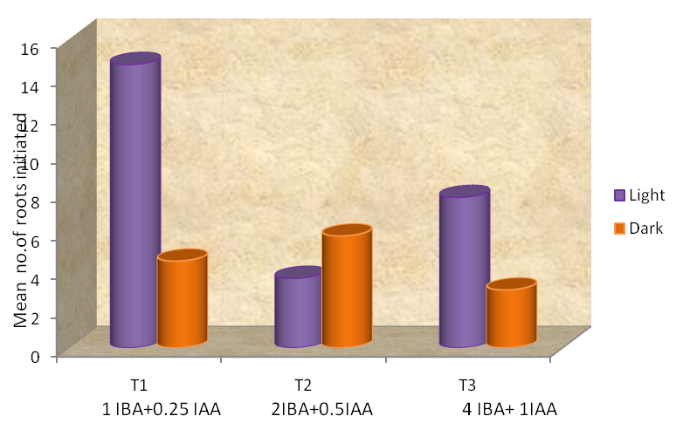
Root induction in response to light intensity under 16 hr photoperiod was analyzed. No significant influence of light intensity was observed on adventitious root induction as 100 % root induction was observed irrespective of photoperiod. But, the roots given per explant from dark incubation conditions were significantly lower than under light conditions. Full strength MS supplemented with1IBA+0.25IAA showed the best response in 16 hr photoperiod followed by 4IBA+1IAA and 2IBA+0.5IAA combination. Above three combinations in full MS when incubated in dark showed a very poor response. The influence of light intensity on root induction is presented in Plate 4.2
The roots formed in light as well as dark were pale white in color. As the elongation of roots occurred, the growing end would remain white in colour whereas the older part of the roots turned pale yellow in colour. Compared with that of dark condition, the roots induced in light were thick. As the age of the root increased, they became golden brown, then brown and darker brownish black. At the dark brown colour stage, the roots turn brittle and tend to lose weight and become fragile. No further growth is observed after this stage.

Plate 4.2 Effect of light intensity on root Induction

Light Dark
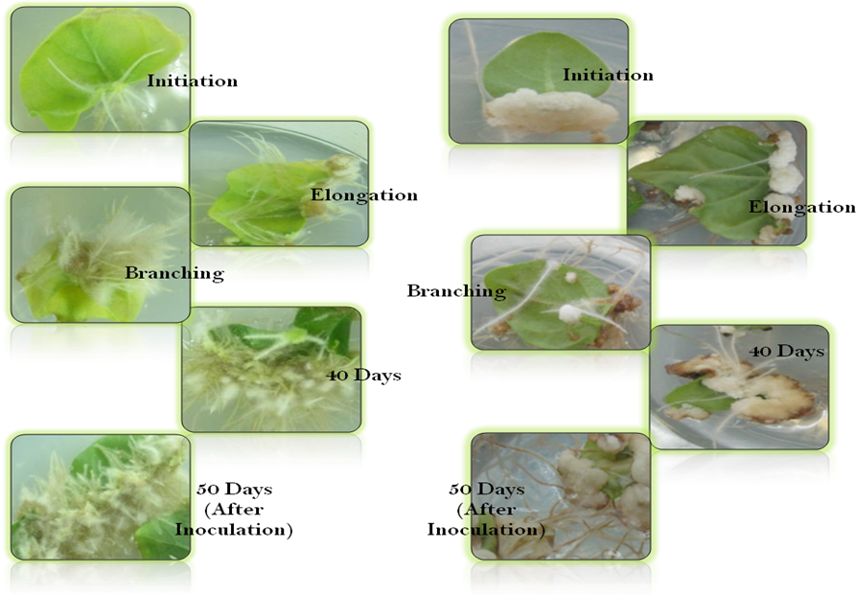

Our study is supported by studies of Morini et al. (2000), where light quality showed significant effects on adventitious root induction in Plumbago zeylanica . The development of organogenesis with respect to root, callus, or somatic embryogenesis depends markedly on the light source or plant growth regulators.
Generally, in light not much callus formation was observed as part of root induction. The length of the root was between 0.5- 1.0 cm at the end of 15-day observation period. The length of the root steadily increased and by the 30th day the length was approximately 2-4cm .The length of the roots was similar to that observed by Rani et al., (2003). The hormones IBA, IAA were employed and maximum of 65% of root induction was observed in their cultures. However, the percentage of cultures giving rise to roots was much higher in the present study.
It was interesting to note the fast growing nature of these adventitious roots. The increase in the length of the roots could be visibly seen as each day passed. With the increase in length of the main root, the rate of branching and length of branches also increased. At the end of 30 days, the whole base of the culture bottle was observed to be filled with roots.
4.2 Multiplication of in vitro roots in suspension cultures
Multiple use of the plant species have necessitated its large scale collection as raw material to the pharmaceutical industry, leading to over exploitation and disappearing in the wild. The conventional propagation is difficult therefore in vitro propagation methods developed by many researchers, however, plant grow quite slowly and take long time until the roots are suitable to use (Kitanov and Pashankov, 1994).
4.2.1 Effect of root tips and branches in suspension
The adventitious roots in Withania somnifera can be established in suspension. Due to their fast growing nature, they can be analyzed for the occurrence of useful protein in them. This can be done by culturing them in bottles or flasks. Therefore in this present study, the adventitious root induction was first studied and later these roots were subjected to suspension culture.

For the establishment of roots in suspension, the root tips of each type of root were individually taken. About 25-30 root tips were uniformly inoculated in a culture bottle containing 30 ml of liquid ½ MS basal medium containing 3% sucrose. The bottles were placed in a shaker at 75-80rpm in order to provide aeration to the growing culture. Since root tips are where the auxin is concentrated and it is the part that is healthiest, the root tips were chosen for the establishment of suspension cultures.
While inoculating into suspension, the roots from its origin (either part of leaf of callus) were cut under sterile conditions and then transferred to sterile conical flask containing 30 ml basal media. All media were supplemented with their respective concentrations of IAA and IBA. The explants used for suspension is white root tips and branches. Thirty root tips and 2-3 cm lengthy branches (1.5 gm) inoculated in suspension. All bottles were kept on an orbital shaker at 70 rpm at 23±2°C under16 hrs light. All roots were repeatedly sub cultured after every fifteen days. Growth in length of the root and extent of branching was observed and noted every two days from the time of inoculation. MS supplemented with 1.0 mg/L IBA + 0.25 mg/L IAA showed large increase in growth in both length and lateral rooting. Whereas and MS + 4.0 mg/L IBA + 1.0 mg/L IAA proved not as much of like 1.0 mg/L IBA + 0.25 mg/L IAA. The white root tips in 1 IBA+0.25 IAA gave the good root growth after 8 weeks (Wadegaonkar et al., 2006). After 60 days the fresh weight of the root was noted. Already we noted the inoculated fresh weight. Finally Growth index was calculated that was in Table 4.3 followed by preliminary studies of Wu et al. (2008).

Table 4.4 Growth index of roots in suspension culture
S.No | Media | Inoculated Fresh weight(g)  (3 months) |  | Harvested Fresh Weight(g)  (3 months) |  | Growth Index
S.No | Media | White root tips | Branches | White root tips | Branches | White root tips | Branches
1 | 1IBA+0.25IAA | 1.50 | 1.50 | 9.25 | 5.12 | 5.16 | 2.41
2 | 4IBA+1IAA | 1.50 | 1.50 | 4.87 | 7.13 | 2.24 | 3.75

Data represents growth index of roots in Suspension

The roots were healthy, white in colour. Towards the end of the 60-day period, the older parts of the roots i.e., the ones that had been initiated first start turning slightly pale in colour. Fresh medium was supplemented after every 28 days. The weight of the roots was noted. By the end of 90 days the older parts of the root start to turn pale golden yellow in colour and as time progresses the colour intensity was found to increase. After a point of time the roots stop growing further. Also at this point of time the roots are brown in color and also brittle in nature. Root growth in suspension was shown in Plate 4.3a and 4.3b.

Plate 4.3 Growth of Root tips in suspension

1 IBA + 0.25 IAA
4 IBA+1 IAA

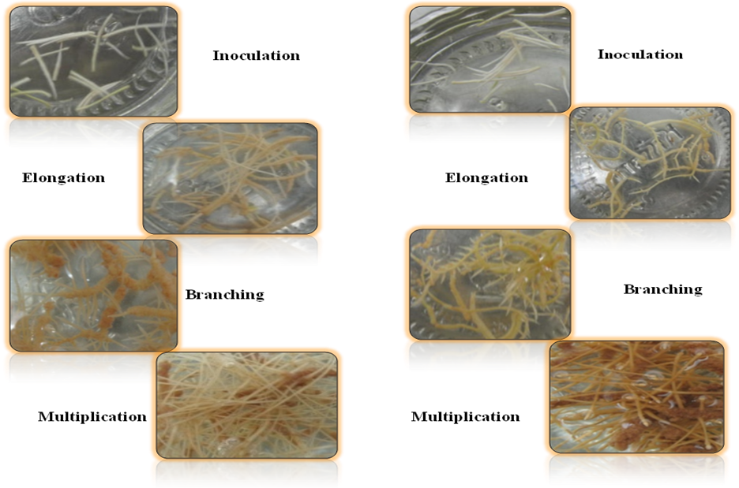

Plate 4.4 Branches in suspension culture

1 IBA + 0.25 IAA 4 IBA+1 IAA
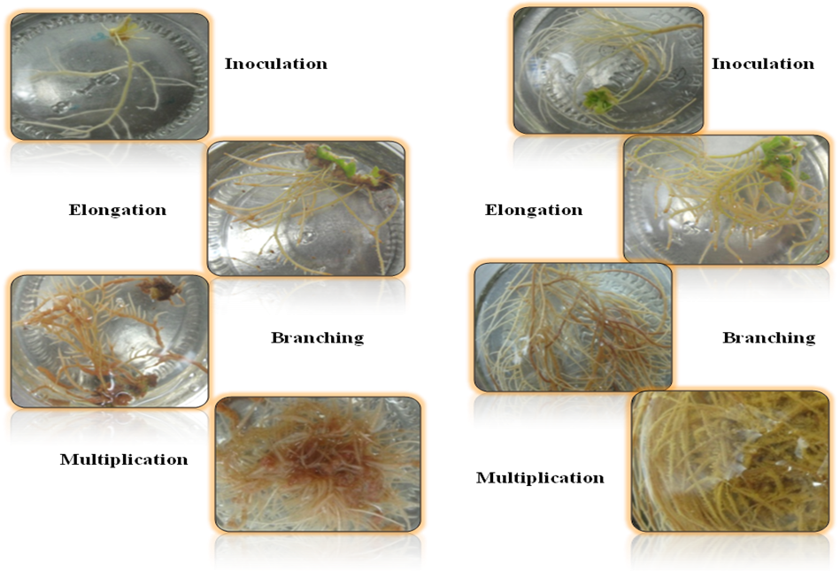
Murthy et al., (2008) found that MS basal medium was best for suspension culture of roots when compared to SH, N6 and LS medium. Also, they have indicated that MS basal medium with 4% sucrose is the best followed by one with 6%. This was standardized for the culture of transformed roots of Withania somnifera using the Agrobacterium rhizogenes strain R1601.
The ginseng adventitious roots were maintained by sub-culturing once in 40 days in 4 L working capacity balloon type bubble bioreactors containing Murashige and Skoog liquid medium (without NH4NO3) supplemented with 25μM indole-3-butyric acid (IBA) and 50 g L-1sucrose (Kim et al., 2004a). Echinacea adventitious roots were grown in half strength MS liquid medium (5:25 mM ammonium and nitrate ratio), supplemented with 9.8 μM IBA and50 g L-1 sucrose .The result showed the growth index of ginseng roots is 4:1 and Echinacea is 3:2 (Wu et al. 2007).

4.3 Morphology of in vitro and in vivo roots

In vascular plants, generally root is the organ that typically lies below the surface of the soil. This is not always the case, as a root can also be aerial (growing above the ground) or aerating (growing up above the ground or especially above water) as in the case of epiphytic orchids and mangroves. Furthermore, a stem normally occurring below ground is not exceptional either (rhizome). So, it is better to define root as a part of a plant body that bears no leaves, and therefore also lacks nodes. There are also important internal structural differences between stems and roots.
The first root that comes from a plant is called the radicle. The two major functions of roots are 1) absorption of water and inorganic nutrients and 2) anchoring of the plant body to the ground. In response to the concentration of nutrients, roots also synthesise cytokine, which acts as a signal as to how fast the shoots can grow. Roots often function in storage of food and nutrients. The roots of most vascular plant species enter into symbiosis with certain fungi to form mycorrhizas, and a large range of other organisms including bacteria also closely associate with roots. Early root growth is one of the functions of the apical meristem located near the tip of the root. The meristem cells divide continuously, producing more meristem, root cap cells (these are sacrificed to
protect the meristem), and undifferentiated root cells. The undifferentiated root cells become the primary tissues of the root, first undergoing elongation, a process that pushes the root tip forward in the growing medium. Gradually these cells differentiate and mature into specialized cells of the root tissues (Das et al., 2006)
Figure 4.3 Root Structure of Vascular Plants
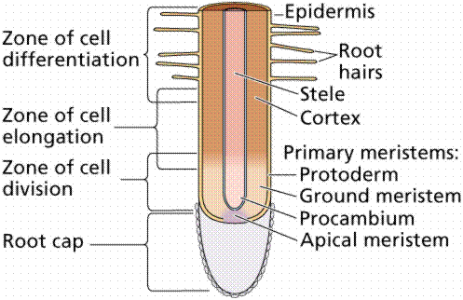

4.3.1 Root staining of in vivo and in vitro roots of W.somnifera
Roots are composed of rapidly dividing tissues that are non-photosynthetic, and therefore require sucrose from the source leaves. The fundamental differences between roots and leaves necessitate a high level of developmental, structural and metabolic divergence that has frequently been observed (Byrne and Ueda, 2005).

Plate 4.5 Transverse section of in vivo and in vitro roots (3 months)
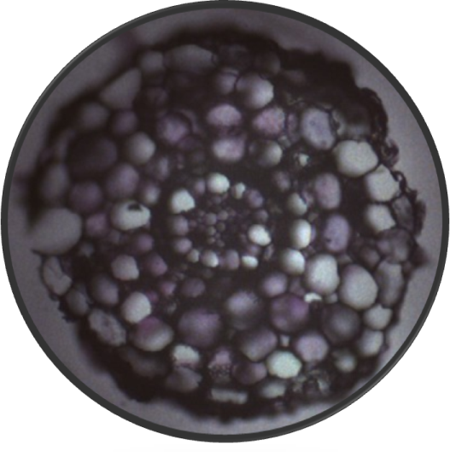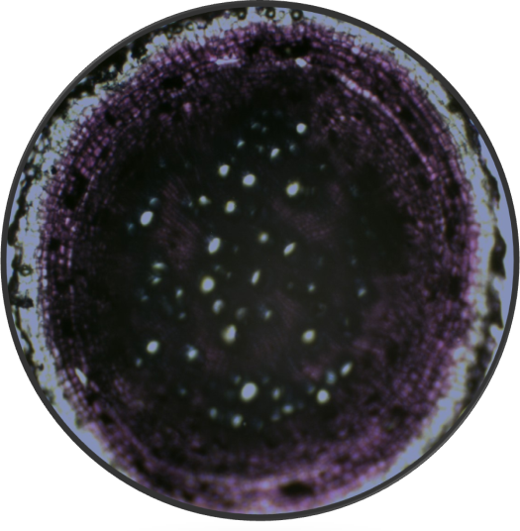
In vitro root
In vivo root
Plate 4.6 shows the transverse sectional staining pattern of in vitro and in vivo roots (3 months) of W.somnifera. In vitro root section shows clear cap layer, protoxylem, protophloem and vascular tissues whereas in vivo root section did not show clear root parts.
In A.thaliana transverse section taken approximately 1mm from the primary root tip, the central cylinder is diarchy with two clearly differentiated proto xylem and protophloem. Protoxylem elements exist always around pericycle cells which each face two endodermal cells. Protophloem cells always flank at least one pericycle cells which faces only endodermal cells. Cells of the mature part form contiguous cell files ending at or very close to the characteristic central cells. The hypocotyls region shows the typical presence of the second layer of cortical cells. The central cells are derived from the hypophysis (Peterson, 2001).
For the present study in 3 month old in vivo roots and in vitro grown roots in suspension (3 months) was taken. Phenotypically the in vivo roots are very thick and strong. They are rich in starch. In in vivo roots the cap layer was clearly visible and the vascular tissue was embedded. The hypocotyls region was clearly shown. The xylem and phloem cells were clearly present. In in vivo roots it was clearly shown during primary staining. The secondary staining clearly shows the Proto xylem and proto phloem. In
in vivo root the secondary thickening was present. Secondary thickening was the difference between in vivo and in vitro roots.
In in vitro roots the cap layer was clearly visible and the vascular tissue was not embedded. The hypocotyls region was clearly shown. The xylem and phloem cells were clearly present.The alterations in morphology of roots were also observed in A.thaliana roots (Dolan et al., 1993). The morphology of in vivo and in vitro roots was shown in Table 4.4.
Root staining was used to determine the morphology of the cell files in roots. Cell lineages are easily identified in roots because of the continuous files of cells arise from repeated transverse divisions in meristamatic cells. The cells of the root may arise from tiered sets of initials (closed type) as observed in tobacco and radish. No separation in tiers (open type) organization in Pisum sativum and Fagus sylvatica. Roots that arise from the pericycle of primary root and other roots are lateral roots. Trans verse section of the primary root reveals that the organization and number of cells is remarkably constant between roots (Von Guttenberg, 1947).

Plate 4.6 Staining of in vitro and in vivo roots of W.somnifera

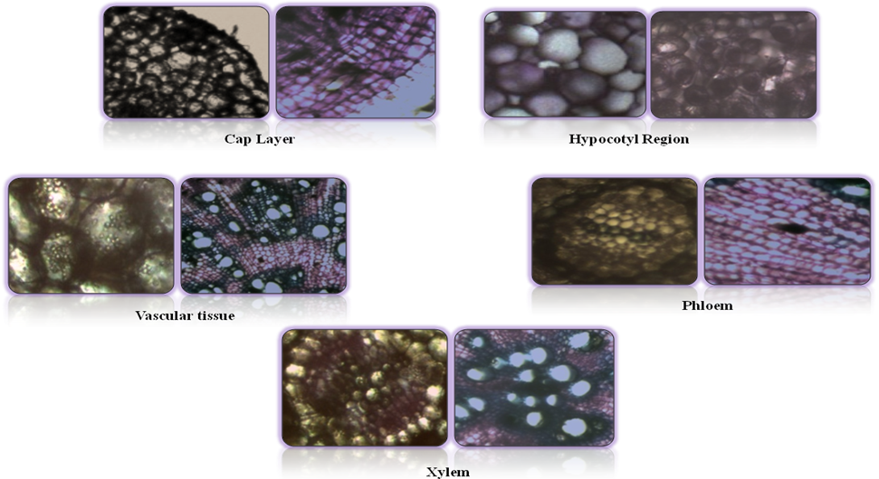
4.4 Protein profiling of in vivo and in vitro tissues of W.somnifera

Proteins are essential in maintaining the structure and function of all life. The word itself is derived from the Greek word “protos” meaning primary..
Plants proteins are incomplete protein and do not have all the essential amino acids. However, plant protein content is low in fat especially saturated fats. Plant proteins have phytochemicals that can form a barrier against diseases.
In the present study protein was extracted from (3 months old) in vivo and in vitro leaves by the extraction procedure followed by (Kim et al., 2004b). 5g of in vitro and in vivo leaves was taken for extraction. The amount of protein present in the tissues was quantified by Lowry’s method. The result was shown in Table 4.5.

Table 4.5 Estimation of protein in in vitro and in vivo tissues of W.somnifera
S.No | Sample | Amount of Tissue taken (g) | Amount of protein in mg/g
1 | In vitro leaf | 5 | 1.7
2 | In vivo leaf | 5 | 2.17

Khanna et al., 2006 showed the Quantity of the protein content in dry roots of W.somnifera. On that he observed young roots were shown low amount of protein. The previous report suggested that roots have low amount of proteins compare to leaves and seeds. Generally 18% proteins were profiled in leaves but roots have less than0.25% protein was also profiled in A.thaliana root (Cormack et al., 2001).

4.4 Protein profiling of in vivo and in vitro leaves of W.somnifera
Protein is an enormous chemical constituent present in plants. Leaves are having high amount of protein. Compare to root 158 proteins present in leaves.
In the present study 3 month old in vivo and in vitro leaves of W.somnifera were extracted. Then it was estimated by Lowry’s method. These samples were used for SDS- PAGE. 50µg concentration of sample was mixed with sample buffer and loaded in 12%
SDS- PAGE. The medium size marker (14-94 kDa) was used for the determination of molecular weight of the protein present in the sample. Protein band was approximately present in between 44-29kDa. Thickest band was present in approximately 35kDa.This was shown in Figure 4.5.

Figure 4.4 Protein profiling of in vitro and in vivo leaves of W.somnifera

Figure 1. SDS-PAGE profile of leaf proteins extracted from W.somnifera In the left lane M: molecular weight (MW) of protein standards are indicated.(25µg concentration of total protein well in lane 1, 2 - in vivo leaves and 3,4- in vitro leaves respectively) were used.

In Bruguiera gymnorrhiza leaf protein was extracted and used for the identification of protein using 12% SDS-PAGE. The results showed that protein bands in between 33-44kDa (Bisnupriya et al., 2009).
In A. thaliana leaf protein was extracted and used for the identification of protein using 10% SDS-PAGE. The results showed that the soluble protein bands in between 44-29kDa (Takemura et al., 2000).

Electrophoretic analysis of proteins in Aracea leaves showed total of 57 protein bands in 19 species. For ease of comparison, the 57 protein bands were clumped together into 7 categories of molecular masses and the number of bands from each category was scored for every species for identify the chromosome number (Mohammed et al., 2006).
Results showed the best combination for root induction was MS supplemented with 1 IBA+0.25 IAA incubated in photoperiod of 16 h of light. In vitro grown roots morphologically differed from in vivo roots on staining. The protein profiling of in vitro and in vivo leaves showed the slight difference in banding patterns due to difference in protein content.
The future studies will be focused on the mass cultivation of in vitro roots and protein profiling of in vitro cultivated roots from different hormone combinations.

5.0 SUMMARY AND CONCLUSION
In the present study entitled “Protein profiling of in vitro and in vivo tissues of Withania somnifera”, in vitro adventitious root induction, growth of different root types in suspension, root staining, extraction and protein profiling has been attempted. The results obtained at each step of the study are summarized as follows:
Adventitious roots were induced by inoculating leaves in ½ MS and MS basal medium supplemented with1IBA+0.25IAA, 2IBA+0.5 IAA, 4IBA+1IAA. Best root induction was observed in MS with 1IBA+0.25IAA in light.
The root tips and branches from these adventitious roots were taken into suspension in MS basal medium supplemented with same combination of hormones. Increase in weight of the roots was noted over a three month period with regular replacement of nutrient medium. The results showed the highest growth index (5.16) in white root tips inoculated in MS with 1IBA+0.25IAA as compared to the other combination media.
The in vitro roots in suspension (3 month) and in vivo roots were taken for root staining. The difference between the morphology of the roots was observed. Cellular differentiation was clearly visualized in in vivo roots than in vitro grown roots of Withania somnifera.
Estimated protein content was found to be high in in vivo leaves approximately 2.2 mg/g. Protein profiling was done by SDS-Poly Acrylamide Gel Electrophoresis. Both in vivo as well as in vitro leaves profiling shows a precise band of approximate molecular weight of 35kDa.
From the present study, to conclude, the low molecular weight proteins were present in leaves of W.somnifera. There is no difference between the protein profile of in vitro and in vivo leaf samples. Further studies can be focused on the mass cultivation of roots in different combination of hormones, staining studies, expression studies, root protein profiling, purification and characterization of proteins of W. somnifera tissues. Protein extraction procedure can be modified to extract the complete proteins from leaves of Withania somnifera.

BIBLIOGRAPHY
Ahmed S, Hahn EJ and Paek KY (2007) Aeration volume and photosynthetic photon flux affect cell growth and secondary metabolite contents in bioreactor cultures of Morinda citrifolia. Acta physiol. plant. 30: 891-896.
Akinmoladun AC, Ibukun EO, Oboutor EM and Farombi EO (2007) Phytpchemical constituents and antioxidant activity of extract from the leaves of Ocimum gratissimum. Scientific Research and Essay. 2: 163-166.
Aloni R, Davies PJ and Kluwer E (2001) The induction of vascular tissues by auxin and cytokinin. In Plant Hormones: Physiology, Biochemistry and Molecular Biology. Plant physiol. 42: 39-48.
Baburaj S and Gunasekaran K (1995) In vitro differentiation of shoots from leaf callus cultures of Withania somnifera (L.) Dunal. J. Ind. Bot. Soc. 74: 323–324.
Bessalle R and Lavie D (1992) Withanolide C, a Chlorinated Withanolide from Withania somnifera. Phytochemistry. Korean J Plant Tissue Cult. 27: 309-315.
Bishnupriya B, Das AB and Mdittra B (2009) Changes in proteins and antioxidative enzymes in tree mangroves Bruguiera parviflora and Bruguieragymnorrhiza under high NaCl stress. Bio. Di. Con. 2: 271-77.
Blakesley D (1994) Auxin metabolism and adventitious root initiation. In: Davis, TD, Haissig, BE Eds., Biology of Adventitious Root Formation, Plenum Press, New York and London, 143-154
Bucci LR (2000) Selected Herbals and Human Exercise Performance. The American Journal of Clinical Nutrition. 72: 624S-636S.
Byrne ME and Ueda (2005) Morphological studies of root development in Araceae. Curr. Opin. Plant Biol. 8: 59–66.
Byrne JM (1973) The root apex of Malva sylvestris: III. Lateral root development and the quiescent center. Am. J. Bot. 60: 657-662.
Chaurasia SS, Panda S and Kar A (2000) Withania somnifera Root Extract in the Regulation of Lead-Induced Oxidative Damage in Male Mouse. Pharmacological Research. 41: 663-666.
Cormack YW, Basin SM, Sahir Y and Liu JY (2001) Comparative proteomic analysis provides new insights into the fiber elongating process in leaves of Arabidopsis thaliana. J. Proteome Res.7: 4623–4637.
Das AB, Mishra S and Mohanty P (2006) Physiology of mangroves: strategies on stress adaptation with specialemphasis on tolerance to high salinity. In: Advances in Plant Physiology (Ed. Hemantaranjan, A.), ScientificPublishers, Jodhpur. 9: 101-154.
Davis L and Kuttan G (2000) Immunomodulatory Activity of Withania somnifera. Journal of Ethnopharmacology. 71: 193-200.
Dolan L, Janmaat K, Willemsen V, Linstead P, Poethig S, Roberts K and Scheres B (1993) Cellular organization of the Arabidopsis thaliana root. Dev.119: 71-84.
Gita R, Virk GS, Nagpal A (2003) Callus Induction and plant regeneration of W. somnifera. In vitro cel. Dev. Biol. 39: 468-474.
Glausia BC, Carvahoi LC (2001) Analysis of proteins associated with storage root formation in Cassava using two dimensional gel electrophoresis. R Bras. Fisiol. Veg. 13(1): 41-48.
Gupta GL and Rana AC (2007) Withania somnifera (Ashwagandha): A Review. Pharmacognosy Reviews. 1: 129-136.
Hamrick JL and Rickwood D (1990) Gel electrophoresis of proteins. Oxford University Press, 889-893
Ichikawa H, Takada Y, Shishodia S, Jayaprakasam B, Nair MG and Aggarwal BB (2006) Withanolides potentiate apoptosis, inhibit invasion, and abolish osteoclastogenesis through suppression of nuclear factor-kappaB (NF-kappaB) activation and NF-kappaB-regulated gene expression. Molecular Cancer Therapeutics. 5(6): 1434-45.
Isaacson T, Damasceno MB, Saravanan RS, He Y, Catala C, Saladie M and Rose KC (2006) Sample extraction techniques for enhanced proteomic analysis of plant tissues. Plant Biology. 28: 102.
Kamboj VP (2000) Herbal medicine. Curr sci.78: 35 – 39.
Kandil FE, Sayed NHE, Douh AMA, Ishak MS and Mabry TJ (1994) Flavonol Glycosides and Phenolics from Withania somnifera. Phytochemistry. 37: 1215-1216.
Khanna PK, kumar A, Ahuja A and Kaul MK (2006) Biochemical composition of roots of W. somnifera (L) Dunal. Asian Journal of Plant Sciences. 5: 1061-1063.
Kim II S, Kim JY, Kim EA, Kwon HK, Cho K, Lee JH, Nam MH, Yang DC, Yoo JS and Park YM (2003) Proteomic analysis of hairy root from Panax ginseng C.A.Meyer using peptide finger printing, internal sequencing and expressed sequence tag data. Proteomics. 3: 2379–2392.
Kim YS, Hahn EJ, Murthy HN and Paek KY (2004a) Adventitious root growth and ginsenoside accumulation in Panax ginseng cultures as affected by methyl jasmonate. Biotechnol. Lett. 26:1619–1622.
Kim II SMN, Nam JB, Lio JR, Yang DC, Lim YP, Kwon KH, Yoo JS and Park YM (2004b) Proteomic analysis of Korean ginseng. Procel.Bio. 34: 815149.
Kim YS, Hahn EJ, Yeung EC and Paek KY ( 2006) Lateral root development and saponin accumulation as affected by IBA or NAA in Adventitious root cultures of P.ginseng. In vitro Biol. 39: 245-249.
Kitanov GM and Pashankov PP (1994) Quantitative investigation on the dynamics of plumbagin in Plumbago europea L. roots. Plant physiol. 29: 39-43.
Klerk GJ, Krieken WV and De Jong JC (1999) The formation of adventitious roots: New concepts, new possibilities. In Vitro Cell. Dev. Biol. Plant. 35:189-199.
Kulkarni AA, Thengane SR and Krishnamurthy KV (2000) Direct Shoot Regeneration from Node, Internode, Hypocotyl and Embryo Explants of Withania somnifera. Plant Cell, Tissue and Organ Culture. 62: 203-209.
Kumaraswamy MV, Kavitha HU and Satish S (2008) Antibacterial evaluation and phytochemical analysis of Betula utilis D. Done against some human pathogenic bacteria. World journal of agricultural sciences. 4: 661-664.
Laemmli UK (1970) Cleavage of structure proteins assembly of the head of bacteriophage T4. Plant physiol. 123: 342-347.
Liang OX, Luo M, Holbrook C and Guo BZ (2006) Storage protein profiles in Spanish and runner market type peanuts and potential markers. BMC Plant Biology. 6: 24, 1471- 2229.
Lowry OH, Rosebrough NJ, Farr AL and Randall RJ (1951) Protein measurement with the Folin phenol reagent. J.Biol.chem.193: 265-275.
Mahalakshmi M (2008) In vitro Germination and Mass Cultivation of Roots in Withania somnifera. A thesis submitted to Avinashilingam University for Women, Coimbatore, TamilNadu, India. p 41-47.
Martin KP, Zhang CL, Hembrom ME, Slater A and Madassery J (2008) Adventitious root induction in Ophiorrhiza prostrata: a tool for the production of camptothecin (an anticancer drug) and rapid propagation. Plant Biotechnol. Rep. 2: 163–169.
Meyerowitz EM (1989) Arabidopsis, a useful weed. Cell. 56: 263-269.
Mishra LC, Singh BB and Dagenais S (2000) Scientific Basis for the Therapeutic Use of Withania somnifera (Ashwagandha): A Review. Alternative Medicine Review. 5: 334-346.
Mohammed T, Khalifa SF and Reem M (2006) Leaf protein Electrophoretic profiles and chromosome numbers of some Araceae. International journal of Agriculture & Biology. 8(2):231-234.
Morini S, Onofrio CD, Bellocchi G and Fisichella M (2000) Effect of light quality on callus production and differentiation from in vitro cultured quince leaves. Plant Cell, Tissue Organ Cult. 63: 47–55.
Murashige T and Skoog F (1962) A revised medium for rapid growth and bioassays with tobacco tissue cultures. Physiol Planta. 15: 472-497.
Murthy HN, Dijkstra C, Anthony P, White DA, Davey MR, Power JB, Hahn EJ and Paek KY (2008) Establishment of Withania somnifera Hairy root cultures for the production of Withanolide A. Journal of Intergrative Plant Biology. 50(8): 975-981.
Oosterhuis DM and Jernstedt J (1999) Morphology and anatomy of cotton plant. In W. Smith and J.T. Cothren (ed.) Cotton: Origin, History, Technology and Production. John Wiley and Sons, Inc., New York, NY. 175-206.
Padmavathi B, Rath PC, Rao AR and Singh RP (2005) Roots of Withania somnifera Inhibit Forestomach and Skin Carcinogenesis in Mice. eCAM. 2: 99-105.
Parekh J, Karathia N and Chanda S (2006) Evaluation of antibacterial activity and phytochemical analysis of Bauhinia variegate L. bark. African Journal of Biomedical Research. 9: 53-56.
Peterson RL (2001) Differentiation and maturation of primary tissues in white mustard root tips. Can. J. Bot. 45: 319-331.
Rahman AU, Abbas S, Shahwar DE, Jamal SA and Choudhary MI (1993) New Withanolides from Withania Spp. Journal of Natural Products. 56: 1000-1006.
Rani G and Grover IS (1999) In vitro Callus Induction and Regeneration Studies in Withania somnifera. Plant Cell, Tissue and Organ Culture. 57: 23-27.
Rani G, Virk GS and Nagpal A (2003) Callus Induction and Plantlet Regeneration in Withania somnifera. In Vitro Cell. Dev. Biol. 39: 468-474.
Ray AB and Gupta M (1994) Withasteroids, a growing group of naturally occurring steroidal lactones. Progress in the Chemistry of Organic Natural Products. 63:1-106.
Russo A, Izzo AA, Cardile V, Borrelli F and Vanella A (2001) Indian Medicinal Plants as Antiradicals and DNA Cleavage Protectors. Phytomedicine. 8: 125-132.
Sangwan RS, Chaurasiya ND, Misra LN, Lal P, Uniyal GC, Sharma R, Sangwan NS, Suri KA, Qazi GN and Tuli R (2004) Phytochemical Variability in Commercial Herbal Products and Preparations of Withania somnifera (Ashwagandha). Current Science. 86: 461-465.
Siddique NA, Bari MA, Shahnewaz S, Rahman MH, Hasan MR, Khan MSI and Islam MS (2004), Plant Regeneration of Withania somnifera (L.) Dunal (Ashwagandha) from Nodal Segments Derived Callus - An Endangered Medicinal Plant in Bangladesh. Journal of Biological Sciences. 4: 219-223.
Singh H, Curtis R and Bavur GJ (2004) Nutrient requirements of suspension cultures of soy bean root cells-Exp. Cell Res. 50: 151-158.
Sofowora A (1982) Research on Medicinal Plants and Traditional Medicine in Africa. John Wiley & Sons. 256: 435-439.
Song X, Ni Z, Yao Y, Xie C, Li Z, Wu H, Zhang Y and Sun Q ( 2007) Wheat (Triticum aestivum L.) root proteomeand differentially expressed root proteins between hybrid and parents. Proteomics. 7: 3538–3557.
Sorin C, Bussell JD, Camus I, Ljung K, Kowalczyk M, Geiss G, Mckhann H, Garcion C, Vaucheret H and Sandberg G (2005) Auxin and light control of adventitious rooting in Arabidopsis require argonaute1. Plant Cell. 17: 1343–1359.
Sudo H, Yamakawa T, Yamazaki M, Aimi N and Saito K (2002) Bioreactor production of camptothecin by root cultures of Ophiorrhiza pumila. Biotechnol. Lett. 24(5): 359–363.
Takemura T, Hanagata N, Sugihara K, Baba S, Karube I and Dubinsky Z (2000) Physiological and biochemical responses to salt stress in the mangrove, Bruguieragymnorrhiza. Aquat. Bot. 68: 15-28.
Trochim WMK (2006) Research Methods Knowledge Base Wild Health, Cindy Engel, World journal of agricultural sciences. 235.
Vallejos E (1983) Enzyme activity staining. In S.D.Tanskley etT.J.Orton (eds), Isozyme in plant genetic and breeding. Elsevier Science Publishers B.V. 469-516.
Vanisree M, Lee CY, Lo SF, Nalawade SM, Lin CY and Tsay HS (2004) Studies on the Production of Some Important Secondary Metabolites from Medicinal Plants by Plant Tissue Cultures. Bot. Bull. Acad. Sin. 45: 1-22.
von Guttenberg H (1947) Studien uber die Entwicklung des Wurzelvegetation spunktes der Dikotyledonen. Planta. 35: 360-396.
von Guttenberg H (1964) Die Entwicklung der Wurzel. Phytomorph. 14: 265-287.
Wadegaonkar PA, Bhagwat KA and Rai MK (2006) Direct Rhizogenesis and Establishment of Fast Growing Normal Root Organ Culture of Withania somnifera Dunal. Plant Cell, Tissue and Organ Culture. 84: 223-225.
Wang W (2003) Protein extraction for two-dimensional electrophoresis fromolive leaf, a plant tissue containing high levels of interfering compounds. Electrophoresis. 24: 2369–2375.
Winters MND (2006) Ancient medicine, modern use: Withania somnifera and its potential role in integrative oncology. Alternative medicine Rev.11: 269-277.
Withania somnifera information from “NPGS/ GRIN” (2009). http//www.ars.grin.gov/cgi-bin/npgs/html/taxo/p.102407.
Wu CH, Murthy HN, Hahn EJ and Paek KY (2008) Establishment of adventitious root co-culture of Ginseng and Echinacea for the production of secondary metabolites. Acta physiol. plant. 891-896.
Wu WW, Wang G, Baek SJ and Shen RF (2007) Comparative study of proteomics. Exp. Cell Res.50: 151-158.
Wynne J and McDonald MS (2002) Adventitious root formation in woody plant tissue: The influence of light and indole-3-butyric acid (IBA) on adventitious root induction in Betula pendula. In Vitro Cell. Dev. Biol. Plant. 38: 210-212.
Xu C, Sullivan JH, Garrett WM, Caperna TJ and Natarajan S (2008) Impact of solar ultraviolet-B on the proteome in soybean lines differing in flavonoid contents. Phytochemistry. 69: 38–48.

APPENDIX-I
COMPOSITION OF MS MEDIUM
Ingredients | Composition (mg/ L) | Stock Solution (W/V) (g)
MS Macro I (10 X) |  | 1000ml
NH₄NO₃ | 1650 | 16.5
KNO₃ | 1900 | 19
MgSO₄.7H₂O | 370.6 | 3.7
KH2PO4 | 170 | 1.7
100 ml
MS Macro II (10 X) |  | 1000 ml
CaCl_{2.}2H₂O | 439.8 | 4.398
100 ml
Fe-Na EDTA (1000 X) |  | 100 ml
Fe-Na EDTA | 36.7 | 36.7
1 ml
Micro Nutrients (1000 X) |  | 100 ml
NaMoO4.7H2O | 0.25 | 0.025
CuSO4.5H20 | 0.025 | 0.0025
CoCl2.2H2O | 0.025 | 0.0025
MnSO₄.4 H₂O | 13.2 | 1.32
ZnSO₄.4H₂O | 8.6 | 0.86
H3BO3 | 6.2 | 0.62
1 ml
KI (1000X) | 0.83 | 100ml
Myo-Inositol (100 X) |  | 100 ml
Myoinositol | 100 | 1
10 ml
MS Vitamins (1000 X) |  | 100 ml
Nicotinic Acid | 0.5 | 0.05
Pyridoxine HCl | 0.5 | 0.05
Thiamine HCl | 0.1 | 0.01
Glycine | 2 | 0.2
1 ml

APPENDIX-II
ESTIMATION OF PROTEIN BY LOWRY'S METHOD
(Lowry et al., 1951)

MATERIALS

Reagent-A
2% sodium carbonate in 0.1 N sodium hydroxide

Reagent-B
0.5% copper sulphate (CuSO₄ 5H₂O) in 1%potassium sodium tartrate

Reagent- C
Alkaline copper solution; Mix 50ml of A and 1ml of B (prior to use)

Reagent-D
Folin's-ciocalteau reagent

PROCEDURE
- Pipette out 0.2, 0.4, 0.6, 0.8 and 1ml of working standard in to a series of test tubes.
- Pipette out 0.1 and 0.2ml of the sample extract in two other test tubes.
- Make up the volume to 1ml in all the test tubes. A tube with 1ml of water serves as the blank.
- Add 5ml of reagent c to each tube including the blank. Mix well and allow to stand for 10 min.
- Then add 0.5ml of reagent D, mix well and incubate at room temperature in the dark for 30min, blue colour is developed.
- Take the readings at 660nm draw a standard graph and calculate the amount of protein in the sample.

APPENDIX-III

SEPARATION OF PROTEINS ON SDS-PAGE
The SDS-PAGE separation of protein was done in a discontinuous buffer system essentially as described by Singh et al., (1991) (modified procedure of Lamellie, 1970).

MATERIALS

Acrylamide monomer solution
Tank buffer (0.05M Tris, 0.192M glycine, 0.1% SDS)
Separating gel buffer (1.875M Tris Hcl)
Stacking gel buffer (0.6M Tris Hcl)

SDS, 10%

Ammonium persulphste (10%) prepared before use
Sample buffer 2x (125mMTris Hcl pH 6.8, 20% glycerol, 10% 2ME, and 0.025% bromophenol blue)

TEMED
Staning solution (0.05%CBB R-250, 40% methanol, 10% acetic acid)
Destaining solution 40% methanol, 10% acetic acid)

PROCEDURE

CASTING OF SEPARATING GEL
The gel unit was assembled as per manufacturer's instruction using the 1mm spacer set. In a side arm flask, 20ml of 12% gel solution was mixed as below.
Monomer - 20ml
Separating gel buffer - 12.5ml
Water - 16.75ml
SDS 10% -500µl
APS, 10% - 312.50µl
The solution was degassed for a few minutes and 43.75µl TEMED was mixed gently, poured in the gel sandwich up to level about 4 cm from the top overlaid with tank buffer and left for a few hours.

CASTING OF STACKING GEL
The buffer was removed and the top of the gel was washed with distilled water repeatedly to remove traces of buffer and then blotted out the water.

In a side arm flask 8ml of 4% stacking gel was mixed as
Monomer - 2.66ml
Stacking gel buffer - 5.0ml
SDS, 10% -150µl
APS, 10% - 110µl
Water - 12.5ml
Degassed, 30µl TEMED was added by gentle swirling, and poured over the separating gel, an appropriate comb was inserted in place and allowed to polymerize for 30 min.

SAMPLE PREPARATION
Protein sample was mixed with sample buffer (80µl sample +20 µl sample buffer) the tubes were placed in a boiling water bath for 2 min and place on ice till loading.

LOADING AND RUNNING THE GEL
- The comb was removed and the wells flushed with tank buffer to remove any unpolymerized acrylic acid.
- The gel assembly was placed in the lower buffer chamber with the heat exchanger in placed and filled with tank buffer.
- Samples were loaded in each well power supply was turned on and adjusted to 15 mA constant current until it reached stacking gel and then to 30 mA.
- When the dye reached the bottom of the gel, the power supply was discontinued and the assembly removed.

STAINING

COOMASSIVE BRILLIANT BLUE STAINING
0.5% CBB R-250
40% Methanol
7% Acetic acid
The gel was removed and stained in about 200ml stain overnight with constant shaking.
Rinsed briefly in distilled water and was allowed to destain on a rocking platform with several changes of destaining solution until the bands were visualized.

