CUSTOMER RELATIONSHIP MANAGEMENT

MARY STEFFY K.T
10PCR06

A Project Report submitted to Avinashilingam Deemed University for Women, Coimbatore in partial fulfillment of the requirements for the Master’s Degree in Computer Science.

April,2012

ACKNOWLEDGEMENT

I would like to express my sincere thanks to God Almighty, for His constant love and grace that He has showered upon me.

I am very grateful to Dr.T.S.K.Meenakshi Sundaram, M.A., M.Phil., Ph.D., Chancellor, Avinashilingam Institute for Home Science and Higher Education for Women, Coimbatore, for his support and encouragement during the course of my study.

I heartily thank Dr. (Mrs).Sheela Ramachandran M.Sc., P.G. Dip., Ph.D., Vice Chancellor, Avinashilingam Institute for Home Science and Higher Education for Women, Coimbatore, for extending all resources that facilitated the conduct of the present study.

I express my humble gratitude to Dr. (Mrs). Gowri Ramakrishnan M.Sc., M.Phil., Ph.D., Registrar, Avinashilingam Institute for Home Science and Higher Education for Women, Coimbatore, for providing all facilities necessary for the study.

I am also thankful to Dr. (Mrs). R. Parvatham M.Sc., Dip.Ed. M.Phil., Ph.D., Dean Faculty of Science, for granting the facility required.

I wish to place on record my deep sense of gratitude to Dr.(Mrs).G.Padmavathi M.Sc., M.Phil., Ph.D., Professor and Head, Department of Computer Science, for providing all the facilities to complete the project.

I owe great deal of gratitude to my esteemed Dr. (Mrs).S.N.Geetha Lakshmi, MCA., M.Phil., Ph.D., Assistant Professor , Department of Computer Science, for imparting the tremendous assistance and well timed support for triumph of my project.

I take this unique opportunity to express my sincere thanks to my project Coordinator Dr.(Mrs).P.Subashini, MCA., M.Phil., Ph.D., Associate Professor, Department of Computer Science, for her kind advice and knowledgeable suggestion, which helped me to complete my project successfully.

I would extend my hearty thanks to one and all who helped me directly or indirectly for successful completion of my project.

SYNOPSIS

The project entitled “Customer Relationship management (CRM)” offers an organization/company with a number of products and services that they may offer to their customers. Depending on the type of service offered, the customers may have several doubts/complaints/problems. The “Customer Relationship Management” helps to accomplish this task of solving and clarifying the customer’s queries. This product facilitates the user to submit online complaints independent of the system.
The “Customer Relationship Management” can be used by a business organization to provide online support to its customers. This may include questions about their services or even complaints the customers may have. Although a manual system can be done, time plays an important role in customer satisfaction.
A customer always expects services to be offered as soon as possible and the organization is responsible for making sure its customers stay satisfied. The manual submission of complaints and customer servicing has been the most tedious part of the business. The time delay for a response and accuracy of complaint solving plays a vital role for customer servicing. These scenarios and objectives play the mandatory development of application to serve the customer with customer service satisfaction. This System will allow the business process to run efficiently and will be used to assist or satisfy the customer by giving a brief solution for their complaint within a minimum time. The Customer receives the solution within a day online.

CONTENTS

S.NO PARTICULARLS PAGE NO

1. INTRODUCTION
1.1 Problem Definition 1
1.2 Overview of the project 1
1.3 Organization Profile 2
2. SYSTEM CONFIGURATION
2.1 Hardware Configuration 4
2.2 Software Configuration 4
2.3 About the Software 5
3. SYSTEM ANALYSIS
3.1 Existing System 8
3.2 Proposed System 10
3.3 Feasibility Study 11
4. SYSTEM DESIGN
4.1 Input Design 15
4.2 Output Design 16
4.3 Database Design 16
5. SYSTEM DEVELOPMENT
5.1 Module Description 18

6. SYSTEM TESTING AND IMPLEMENTATION
6.1 System Testing 21
6.2 System Implementation 23
7. CONCLUSION 25
8. SCOPE FOR FURTHER DEVELOPMENT 26
BIBLIOGRAPHY
APPENDIX
A Class Diagram
B Activity Diagram
C Dataflow Diagram
D Screen Shots

- INTRODUCTION

1.1 Problem Definition
The main aim of the business is the Customer satisfaction. This system helps the customers to give their problems online whenever the customer needs, without any constraints implied on them. This system helps the customers to briefly explain their complaint without any hesitation. Through this system the customers are assisted with some predefined complaints and immediate solutions which save the precious time of the customers. The customers receive the solutions for their complaint within a day and the customer can also view the status of the complaint at any time using the complaint number.
Through this system the customers receive a brief solution for their complaint. The company has maintained the records about the customer details and informing seasonal offers and other details. Based on this the company will get the goodwill and new customers. Customer relationship management, is a number of strategies and technologies that are used to build stronger relationships between companies and their customers. A company will store information that is related to their customers, and they will spend time analyzing those information. Customer relationship management is commonly used by corporations, and they will focus on maintaining a strong relationship with the clients.

1.2 Overview of the project
A customer always expects services to be offered as soon as possible and the organization is responsible for making sure its customers stay satisfied. The manual submission of complaints and customer servicing has been the most tedious part of the business. The time delay for a response and accuracy of complaint solving plays as vital role for customer servicing. These scenarios and objectives play the mandatory development of application to serve the customer with customer service satisfaction. This System will allow the business process to run efficiently and will be used to assist or satisfy the customer by giving a brief solution for their complaint within a minimum time. The Customer receives the solution within a day online.

A primary objective of customer relationship management is to provide the entire organization with a complete, view of the customer, no matter where the information resides. Today, many businesses manage different aspects of customer relationships with multiple information systems, which weaken customer service and ultimate reduce total sales potential. It is important to have an integrated solution across all customer information systems, tying together the front and back offices for a complete view of customers in order to service them better. Customer relationship management acts as a central repository of information on the customers.

1.3 Organization Profile
About US

Techies Network provides a complete solution for the technology need of clients with time bound development methodology and process. With a balanced view of strategy, people, process and technology, we work with our clients to understand their unique business needs, and to develop and implement practical business strategies and technology solutions. Clients benefit from our tradition of transferring knowledge throughout each engagement, and value our responsiveness, flexibility and authentic desire to help them meet, and often exceed, their goals.
Team Expertise

We are a team consisting of well-experienced technocrats efficient in solving the crucial software puzzles, having an invaluable experience, exposure, technical and tested knowledge, skills, computer proficiency and documentation. We are having capabilities and talents in developing and designing various applications according to the Enterprise or Customers complex business hitch with latest and cost effective tools.
Development Methodologies

Lot of companies embraces a fixed methodology. We use what’s best for you. Proper development methodology can enable you to improve your efficiency, eliminate risks and produce predictable results. We can help streamline your software development process by utilizing time-tested and proven development and project management methodologies. Our consultants have many years of experience customizing and implementing development methodologies.
Outsourcing
We can help you define a process that works for you. We can work with you to assess your current process, help you with process improvement planning, help you define an appropriate process tailored to your organization’s needs and mentor your people on implementing the process. Let us help you to develop processes, procedures, standards, and guidelines that work for you. We can also take on your project and subcontract the development of it under our control to our proven outsource software development and quality assurance partners. That way we can deliver a complete, low risk solution.

2. SYSTEM CONFIGURATION
The system configuration includes the requirements that are needed for a system to work efficiently and smoothly. This consists of both hardware and software configuration.

2.1 Hardware configuration
Hardware configuration denotes the system features that fall upon the hardware part. It includes mainly Processor, RAM, HardDiskDrive, Monitor etc.
Processor : Intel Pentium
RAM : 512MB
Hard Disk : 80GB
Clock Frequency : 2.0 GHZ
Monitor : Color Monitor
Pointing device : Scroll Mouse

2.2 Software configuration
Software configuration includes the software features that are needed for the implementation of the project.
Operating System : Windows XP
Development Technology : WAMP
Database Technology : MYSQL
Code Behind : PHP

2.3 About the Software

About PHP 5.2.9
PHP is a general-purpose server-side scripting language originally designed for Web development to produce dynamic Web pages. It is one of the first developed server-side scripting languages to be embedded into an HTML source document, rather than calling an external file to process data. Ultimately, the code is interpreted by a Web server with a PHP processor module which generates the resulting Web page. It also has evolved to include a command-line interface capability and can be used in standalone graphical applications. PHP can be deployed on most Web servers and also as a standalone shell on almost every operating system and platform free of charge. A competitor to Microsoft's Active Server Pages (ASP) server-side script engine and similar languages, PHP is installed on more than 20 million Web sites and 1 million Web servers.
The main implementation of PHP is now produced by The PHP Group and serves as the formal reference to the PHP language. PHP is free software released under the PHP License, which is incompatible with the GNU General Public License (GPL) due to restrictions on the usage of the term PHP.

PHP Features:
- Improved support for object-oriented programming
- The PHP Data Objects (PDO) extension (which defines a lightweight and
consistent interface for accessing databases)
- Numerous performance enhancements

MySQL 5.1.33
MySQL Server is a powerful database management system and the user can create application that requires little or no programming. It supports GUI features and an entire programming language. There are quite few reasons, the first being that SQL is a feature rich program that can handle any database related task. It can create places to store the data build tools that make it easy to read and modify the database contents, and ask the questions of the data.
SQL is a relational database, which stores information about related objects. In MySQL, database means a collection of tables that hold data. It collectively stores all the other related objects such as queries, forms and reports that are used to implement function effectively.
MySQL database can act as a backend database for PHP as a front end; it supports the user with its powerful database management functions. A beginner can create their own database very simply by some mouse clicks. Another good reason to use SQL as backend tool is that it is a component of the overwhelmingly popular Microsoft office software suite.
MySQL however is a relational database, which means that can define relationships among the data it contain. Relational database, are superior to flat file databases because it can store discrete information.
MySQL includes a complete set of graphical tools and command prompt utilities that allow users, programmers, and administrators to:
- Administer and configure SQL Server.
- Determine the catalog information in a copy of SQL Server.
- Design and test queries for retrieving data.
- Copy, import, export, and transform data.
- Provide diagnostic information.
- Start and stop SQL Server.
MySQL is a full-featured relational database management system (RDBMS) that offers a variety of administrative tools to ease the burdens of database development, maintenance and administration.

WAMP Server
WAMPs are packages of independently-created programs installed on computers that use a Microsoft Windows operating system. WAMP is an acronym formed from the initials of the operating system Microsoft Windows and the principal components of the package: Apache, MySQL and one of PHP, Perl or Python. Apache is a web server. MySQL is an open-source database. PHP is a scripting language that can manipulate information held in a database and generate web pages dynamically each time content is requested by a browser. Other programs may also be included in a package, such as phpMyAdmin which provides a graphical user interface for the MySQL database manager, or the alternative scripting languages Python or Perl.

3. SYSTEM ANALYSIS
The major area of effort for system study and analysis is problem evaluation and solution synthesis.

3.1 Existing System
The existing system in the organization is not completely computerized. Current System doesn’t extend its functionality for Online Service Process. The cost and human resource expenses towards building Customer Services for business prosperity within the locality are undesirable. The system cannot be enhanced to provide distribution of data for different services. The complaints are dropped in the complaint box and they are collected by the respective members for scanning process and served on day to day basis. This process model and business approach is inefficient and not dynamic for the future growth of the organization.
Generating reports are done manually which is time consuming. Accuracy in data maintenance also becomes a tedious task. Drafting required for trainees also done manually. Searching for information through multiple files and data analysis also becomes a tedious task.

Drawbacks of Existing System:
- Low Functionality:
With the existing system, the biggest problem was the low functionality of the department. The problem faced hampered the work of the department. For all the tasks like entering the customer data, product data, taking the orders, making bill, making reports etc. a large number of employees were appointed who would have been utilized in some other useful tasks.

- Erroneous Input and Output:
In the existing system, humans performed all tasks. As in the human tendency, errors are also a possibility. Therefore, the inputs entered by the salesman in the registers may not be absolutely foolproof and may be erroneous.

- Portability:
System that existed previously was manual. As a result, the system was less portable one has to carry the loads of so many registers to take the data from one place to another. A big problem was that the system was less flexible and if one wanted to make a change would need to change in all the registers that would also prove to be big headache.

- Security:
Security concerns were also one of the motives of the department for the need of the software. In the registers, the data is not secure as anybody can tamper with the data written in the registers. Also for the security of the registers, lots of problems arise to store the registers in a secure place and the appointments of security personnel can also cost a bit. Whereas in the software, just a password makes it absolutely secure from the reach of unauthorized users.

- Data Redundancy:
In the case of manual system, the registers are maintained in which, a lot of data is written. Therefore, there is a problem in the registers that the same data may be repeated again and again. Against the customer id, a lot of data will be repeated which will cause a lot of problems at the time of query as well as at the time of preparing the reports because a single data that will be left mistakenly will largely affect the report and subsequently, the performance of the department. In the software the concept of primary key and foreign key is used very efficiently, which will prevent the redundancy of data that will prove to be very beneficial to the organization because it will nullify the human error completely.
- Processing Speed:
In manual system, for a simple work, a number of employees are appointed and in case of keeping records of orders given by the customers, making bill & reports, they take a lot of time, which may affect the performance of the organization as well as hamper the progress of the organization. It also affects the speed of working in the organization and the work that should have been performed in very short duration can take a large amount of time.

- Manual Errors:
When a number of tough tasks are prepared by the humans like preparation of reports, keeping records of all the customers, salesman & available stock in company etc then some human errors are obvious due to a number of factors like mental strain, tiredness etc. But as we all know that computer never gets tired irrespective of the amount of work it has to do. So, this software can nullify the probability of manual errors that improves the company performance.

- Complexity in Work:
In a manual system, whenever a record is to be updated or to be deleted lot of cutting and overwriting needs to be done on all the registers that are concerned with the deleted or updated record, which makes the work very complex. However in the software, once a record is updated or deleted, all the concerned changes are made in the database automatically.

3.2 Proposed System
This is an integrated system. It combines all the department functions so easily we can share the information between departments. And this system will provide immediate result to the customers so the customer will get full satisfaction. The proposed system helps businesses use technology to gain insight into the behavior of customers and the value of those customers. This system provides a better customer service. This system also helps in selling the products more effectively and easily.
The system helps the customers to give their complaints online and they can also receive the solution for their complaints online within a very short period of time. This saves the time of the customers. This system delivers the customers a high quality service at all times. The proposed system help to track customer preferences and be aware of their account histories and also helps to resolve any issues promptly.
This system enables efficient productive customer interactions across all communication channels. It enables web collaboration to reduce customer service costs. This system enables multi-channel personal customer interaction. The proposed system integrates view of the customer while interaction at the transaction level.

Advantages of Proposed System:
- All the functions are integrated and information can be shared between
departments within a second so customer will get immediate reply for their
problems.
- It reduces the time for searching customer records and find out a particular
group of customers.
- Proposed system will be helpful for increasing the number of customers.
- It is helpful to increase the goodwill of the company.
- It provides better service to the customers.
- It helps to make better earnings from the customer.

3.3 Feasibility Study
A feasibility study is a preliminary study undertaken before the real work of a project starts to ascertain the likelihood of the project's success. It is an analysis of all possible solutions to a problem and a recommendation on the best solution to use. It involves evaluating how the solution will fit into the corporation. For example, it can decide whether an order processing can be carried out by a new system more efficiently than the previous one.

Technical Feasibility

Technical feasibility refers to the ability of the process to take advantage of the current state of the technology in pursuing further improvement. The technical capability of the personnel as well as the capability of the available technology should be considered. Number of technical issues which are generally realized during the feasibility stage of investigations include-
- Present technology, which is in case of this system is manual data
management which is highly inefficient and inconsistent.
- Technical capacity of proposed equipments to hold data is required using
the system.
- Upgradability of system if developed.
- Technical guarantee of accuracy, reliability, ease of access and data
security.

Economic feasibility
One of the most frequently used technique for evaluating effectiveness of the system is economic analysis. The procedure is to determine the benefits and saving that are expected with the proposed system and compare it with cost. This involves the feasibility of the proposed project to generate economic benefits. The analyst can conduct analysis of economic feasibility by considering following issues-

- The cost to conduct a full systems investigation.
- The cost of hardware and software for class of application is considered.
- The benefits in the form of reduced cost or fewer costly errors.

In case of “Customer Relationship Management” the company has to maintain large amount of manpower, money and time resources. Huge amount of money can be saved if this system is automated.

Operational Feasibility
This feasibility is related to human organizational and political aspects. This feasibility is carried out by a small group of people who are familiar with information system technique and understand the parts of the business that are relevant to the project and are skilled in system analysis and design process. Issues involve in testing operational feasibility-
- Support of management
- Acceptability of current business method
- Need of change in existing system
- Involvement of user in planning and development of the project
- Effect of implementation of the proposed system.

4. SYSTEM DESIGN

System design is the art of defining the architecture, components, modules, interfaces, and data for a system to satisfy specified requirements. It evaluates the system’s actual functionality in relation to expected or intended functionality, including all integration aspects. System design is to deliver the requirements as specified in the feasibility report. The main objectives of the design are

- Practicality
- Efficiency
- Cost
- Flexibility
- Security

System design is a process of planning a new system or to the complement of the existing system. The design based on the limitations of the existing system and the requirements specification gathered in the phase of system analysis.

System specialists often refer to this stage as logical description, in contrast to the process of developing the program software, which is referred to as physical design. The system design describes the data to be input, calculated or stored. Individual data items and calculation procedures are written in detail. The procedures tell how to process the data and produce the output.

4.1 Input Design
Input design is a very essential part in the project and should be concentrated well as it is prone to error. The data that are to be inserted plays an important role. In order to get the meaningful output and to achieve good accuracy the input should be acceptable and understandable by the user. It converts functional models from analysis into models that represent the solution. It is focused on technical issues and requires less user involvement than analysis. Design may use structured or Object oriented approaches as the database are relational.
This section is a description of the input media used by the operator for providing information to the system. For example, data entry screens, optical character readers, bar scanners, etc., include data element definitions.
They provide the layout of all input data screens (for example, windows). This provide a graphic representation of each interface. Define all data elements associated with each screen. This section should contain edit criteria for the data elements, including specific values, range of values, mandatory/optional, alphanumeric values, and length.
It focuses on the informational, functional, and behavioral domains of a problem. To better understand what is required, models are created, the problem is partitioned, and representation that depict the essence of requirements and later, implementation detail, are developed.
This system contains the following features :
- It contains the details about the customers such as name, id, address, product purchased, complaint etc., (Shown in Appendix D Screen 2, 3, 6)
- It maintains the product details such as product name, id, type, complaint about the product etc., (Shown in Appendix D Screen 10)
- It provides the login check feature so that the users who have not registered can not purchase any product. (Shown in Appendix D Screen 1)

4.2 Output Design
This section describes about the system output design relative to the user/operator. System outputs include reports, data display screens, query results, etc. The following should be provided, if appropriate:
- Identification of codes and names for reports and data display screens
- Description of report and screen contents
- Description of the purpose of the output, including identification of the primary users
- Report distribution requirements, if any (include frequency for periodic reports)
- Description of any access restrictions or security considerations
The output screens are shown in APPENDIX D.

4.3 Database Design
The database design phase involves the design of the database and constituent tables that are used by the system for storage and retrieval of data. Data elements and data structures to be stored have been identified at analysis stage. They are structured and put together to design the data storage and retrieval system.
A database is a collection of interrelated data, stored together in such a way to minimize redundancy and to serve a multiplicity of applications. Database design runs parallel with the system design. Database is designed to meet the overall goal of the project. Care should be taken while designing to avoid unnecessary duplication. The data flow of the system is shown in fig.1.

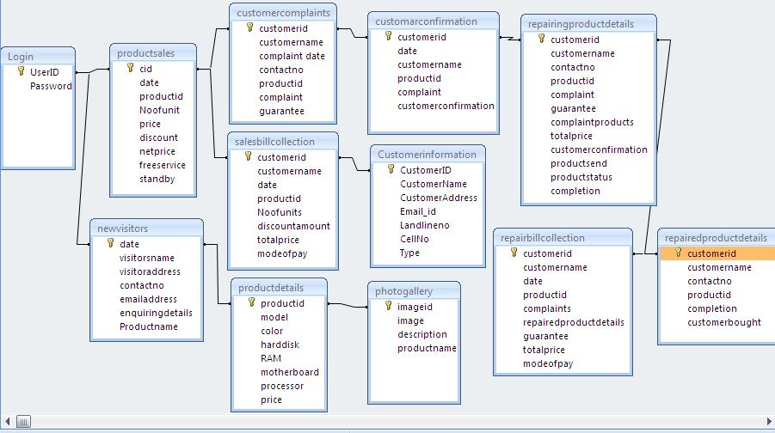
Fig.1

5. SYSTEM DEVELOPMENT

5.1 Module Description
Modules in this project are as follows
5.1.1. Sales Module
5.1.2. Purchase Module
5.1.3. Help Desk
5.1.4. Customer Service
5.1.5. Report

5.1.1. SALES MODULE:
Sales module contains the product details and purchased customer details. Product details contain different product name, related id, price, discount details and etc. Customer details contains customer name, id, address, email id and contact numbers and etc . While the time of selling, will be stored in the database and in this module we can view all the customer details and individual customer details and also the selling product details based on the product name or product id. Addition, deletion, display and updating of sales product details and customer data are done by this module.

5.1.2. PURCHASE MODULE:
Purchase module contains the purchased products for the services and also sales. The purchase department in charge will send report to the respected companies for buying the products. That report contains wanted product details and wanted date. Based on the report company will send product to this company. Accounts department will take care of the payment details. Addition, deletion, display and updating of sales product details and customer data are done by this module.

5.1.3. HELP DESK:
Help desk module is the main module in this customer relationship management. CRM is the bridge between customer and company. Help desk in charge will get the call from the customers then he will enter the customer id, name, product name and complaint, guaranty details and etc. this information will be stored in the database. These details will be displayed in service in charge person’s screen. Then he will call the customer and enquire his problem, if it is possible to solve through the phone he will solve otherwise he will inform to bring the product to the branch for solving the problem.

5.1.4. CUSTOMER SERVICE:
Service module maintains the service product details and the status of the product .And replying to the customers once they get a call from the customers. The help desk person can also view the reports and he will also inform the details to the customers.

5.1.5. REPORT:
Report module maintains the reports of the selling product details on date wise and monthly wise. This report is helpful to find out, which product is selling maximum. Based on this the company will take some decision about the product and send to the respected company for producing such product. This report helps to find out whether actual sale is above standards or below.
Various Reports are generated in this project-
1. Sales Report
2. Customer Report
3. Product Report
4. Complaint report
5. Accounts Reports

1. Sales Report
This report will display sales details. With the help of this report administrator can get information that what work is assigned to the salesman and what is the actual sale done by the salesman.

2. Customer Report
This report generate’s the list of customer on the basis of the type of customer (i.e., regular customers or new customers). This report will be helpful to choose a customer, based on the product and the type of the product chosed.

3. Product Report
This report will generate details about the product description and list of products available. This report will be helpful to tell the product information to the customers by the marketing department user.

4. Complaint Report
This report will generate details of complains, their solutions and status. This report will show details of different types of complaint, which product has maximum number of complains and which product has no complaint for particular period.

5. Accounts Report
This report will generate details of monthly collection of a particular product. This report will be helpful to know the collection amount for a particular product and sales for a particular month.

6. SYSTEM TESTING AND IMPLEMENTATION

6.1 System testing
Testing plays vital role in the success of the system. It is an iterative process of both validating functionality and attempting to break the software. It makes a logical assumption that if all the parts of the system are correct. The goal will be successfully achieved once program has been developed, testing begins.
The objective of system testing is to find the problems and fix them to improve quality. While testing tends to be considered a part of the development, it is really its own discipline and should be tracked as its own project. The testing steps are as follows

6.1.1 Unit testing
6.1.2 Integration testing
6.1.3 Validation testing
6.1.4 Acceptance testing

6.1.1 Unit testing
Unit testing focuses verification effort on the smallest unit of the software. This testing was carried out during programming stage itself. In this project each button is tested from private sub to end sub. Using the detailed design description important control paths are tested to establish errors within the bounds of the module. Firstly the unit testing on various modules and sub modules is performed in the project. Different modules are tested with different correct and incorrect data. For example in the purchase module order of 0 product is not allowed so in this case product id is used to find out whether the module performs all processes correctly. All modules are tested to find out that whether they are working properly

6.1.2 Integration testing
Integration testing is conducted to uncover errors associated with interface. All the modules in the system are combined together and are tested for the overall performance of the system. Once all the individual units have been tested there is a need to test how they were put together to ensure no data is lost across interface, one module does not have an adverse impact on another and a function is not performed correctly. Integration testing is a systematic approach that produces the program structure while at the same time producing tests to identify errors associated with interfacing. As the bottom up integration testing is used in this project, first lower level modules are tested. As the modules are integrated bottom up, processing required for module subordinates to a given level is always available and the need for stubs is eliminated.

6.1.3 Validation testing
The project undergoes this testing to test the username checkup for the login forms. User data is validating for the correctness of it. It provides final assurances that software meets all functional, behavior and performance requirement. In this project, validation testing is made in login form. In login form, the correct user only will be accepted. Invalid user will not be accepted. Additional inspection is performed using different techniques. In this phase tractability to software requirements is demonstrated.

6.1.4 Acceptance testing
Acceptance testing involves planning and execution of functional tests, performance tests and stress tests in order to demonstrate that the implemented system satisfies its requirements. When custom software is built for one customer, a series of acceptance tests are conducted to enable the user to validate all requirements.
6.2 System Implementation
The purpose of System Implementation can be summarized as follows: making the new system available to a prepared set of users (the deployment), and positioning on-going support and maintenance of the system within the organization. At the level of detail, deploying the system consists of executing all steps necessary to make known to the users on the use of the new system, placing the newly developed system into production, confirming that all data required at the start of operations is available and accurate, and validating that business functions that interact with the system are functioning properly. Transitioning the system support responsibilities involves changing from a system development to a system support and maintenance mode of operation, with ownership of the new system moving from the project team to the organization. Once the design model is created, it is implemented as a prototype, examined by end-users and modified by the developers. To accommodate this iterative design approach, a broad class of interface design and prototyping tools has evolved.
This phase consists of the following processes:

- Prepare for system implementation
In the implementation of any new system, it is necessary to ensure that the users community is best positioned to utilize the system once deployment efforts have been validated. Therefore, all necessary training activities must be scheduled and coordinated. As this training is often the first exposure to the system for many individuals, it should be conducted as professionally and competently as possible. A positive training experience is the first step towards user acceptance of the system. Often the performance of deployment efforts impacts many of the organization’s normal business operations. Examples of these impacts include: users may experience a period of time in which the systems that they depend onto perform their jobs are temporarily unavailable to them. Technical services may be required to assume significant implementation responsibilities while at the same time having to continue current levels of service on other critical business systems. Technical support may experience unusually high volumes of support requests due to the possible disruption of day-to-day processing.

- DEPLOY SYSTEM
Deploying the system is the culmination of all prior efforts where all of the meetings, planning sessions, deliverable reviews, prototypes, development, and testing pay off in the delivery of the final system. It is also the point in the project that often requires the most coordination, due to the breadth and variety of activities that must be performed. Depending upon the complexity of the system being implemented, it may impact technical, operational, and cultural aspects of the organization.

- TRANSITION TO PERFORMING ORGANIZATION
In many organizations, the team of individuals responsible for the long-term support and maintenance of a system is different from the team initially responsible for designing and developing the application. Often, the two teams include a comparable set of technical skills. The responsibilities associated with supporting an operational system, however, are different from those associated with new development. In order to affect this shift of responsibilities, the project team must provide those responsible for system support in the organization with a combination of technical documentation, training, and hands-on assistance to enable them to provide an acceptable level of operational support to the user.

7. CONCLUSION

The newly developed “Customer Relationship Management” runs efficiently after implementation. Depending on the type of service offered the customers may have several problems. The “Customer Relationship Management” helps to accomplish this task of solving and clarifying the customers’ queries. This product facilitates the user to submit online complaints independent of the system.
The “Customer Relationship Management” can be used by a business organization to provide online support to its customers. This may include questions about their services or even complaints the customers may have. Although a manual system can be done, time plays an important role in customer satisfaction. Thus this application is developed.

8. SCOPE FOR FURTHER DEVELOPMENT

There is always a room for improving any software package, however good or efficient it may be. But the important fact is that the system should be flexible enough for future modification whenever needed. Keeping in consideration about this important factor, the system is designed in such a way that the modules are efficient enough to introduce any change in the software to get more information.

Similarly, the present system can be implemented on Internet and in future software can be connected to the various branches of home appliance company, ofcourse with more security constraints added to it.

This project can be attached to website of the company which may provide information related to products and further enhancement of this project may also provide facility of registering product etc. It may also help in finding new prospective customer.

More modules can be added in the system such as it can provide facility to send email. Good customer relationships are at the heart of business success.

BIBLIOGRAPHY

Website References

- http://en.wikipedia.org/wiki/Customer_relationship_management
- http://www.zeelabs.com/CRM.htm
- http://www.crmnewz.com/
- http://www.microsoft.com/crm
- http://www.crystaldecisions.com/
- http://www.sugarcrm.com
- http://www.crmsolution.com

Book References

- “PHP 5 Power Programming” By Andi Gutmans, Stig Sæther Bakken,and Derick Rethans
- “PHP Basics In Pictures”By Paul Grhun

APPENDIX
APPENDIX A
Class Diagram

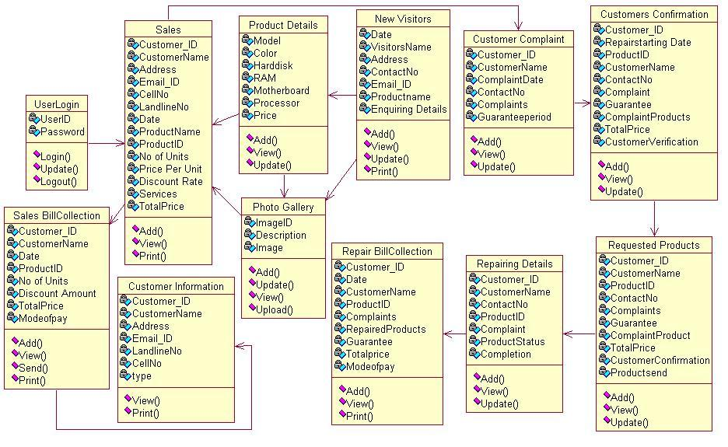
Fig.1

APPENDIX B
Activity Diagram
- Sales Department user activities
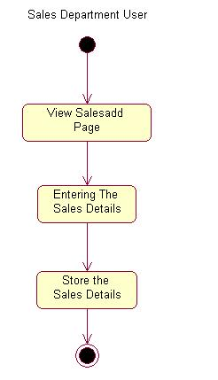

Fig.1

- Purchase Department user activities
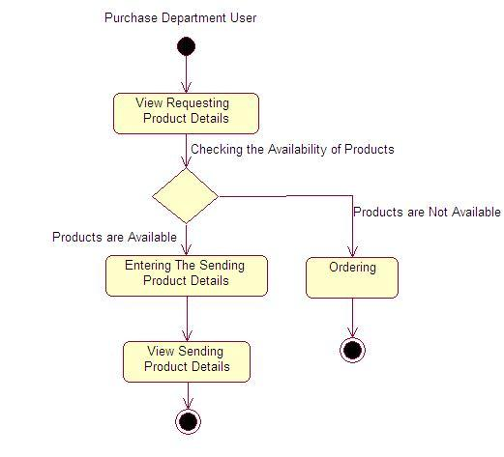
Fig.2

- Technical Department user activities

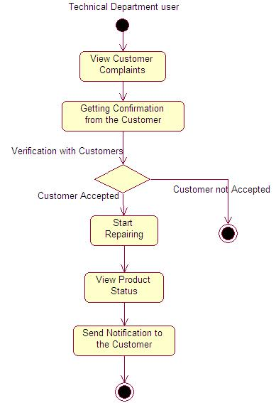

Fig.3

- Help Desk user activities

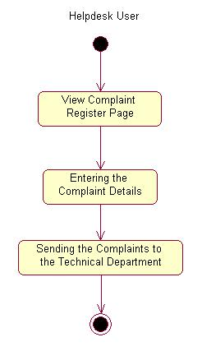
Fig.4

- Accounts Department user activities

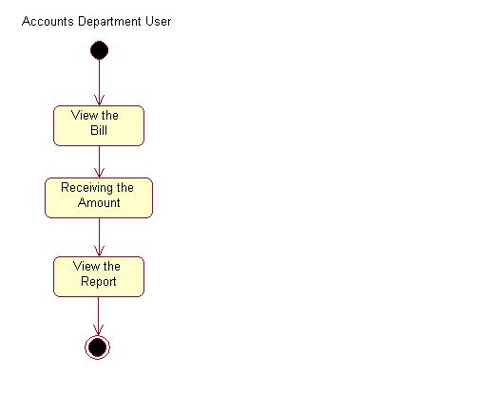
Fig.5

- Customer activities

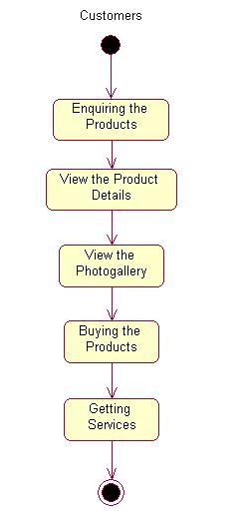
Fig.6

APPENDIX C

Data Flow Diagram
Level 0(Context level)

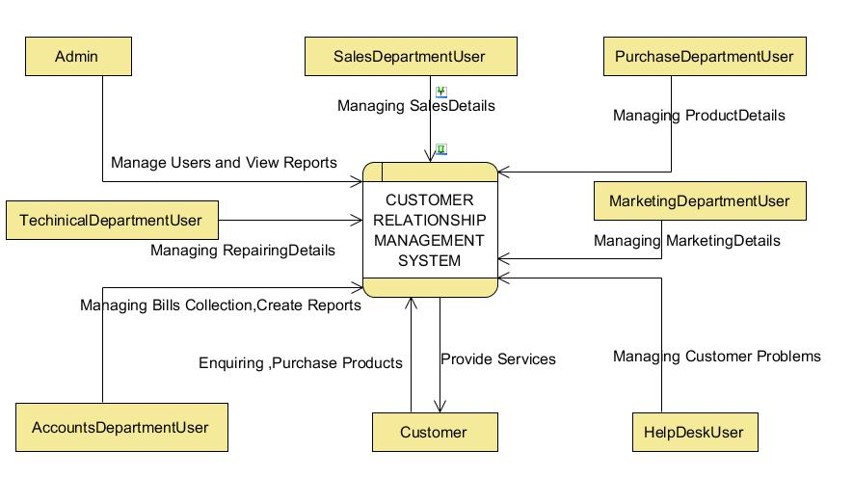
Fig.1

Level 1(Contex Level)
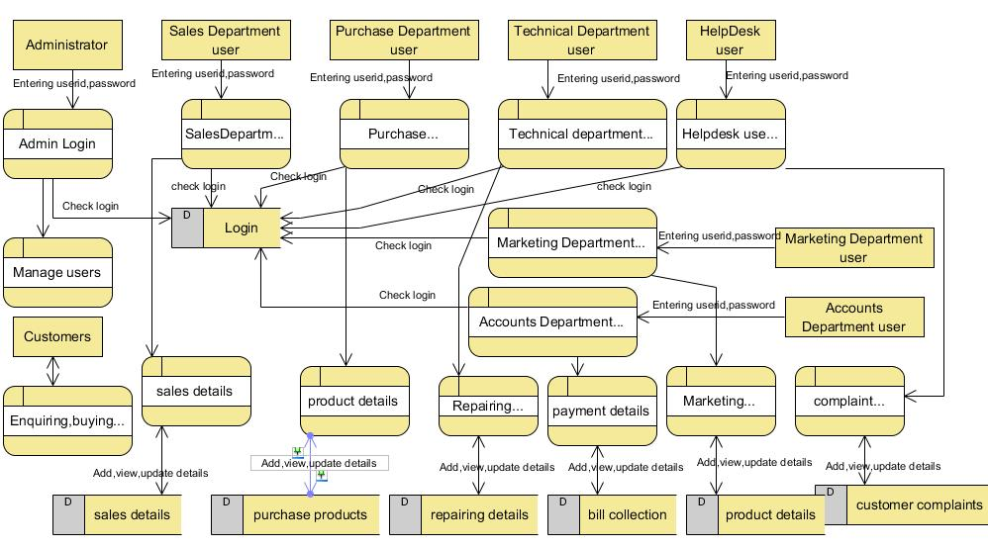
Fig.2

Level 2
Sales Details
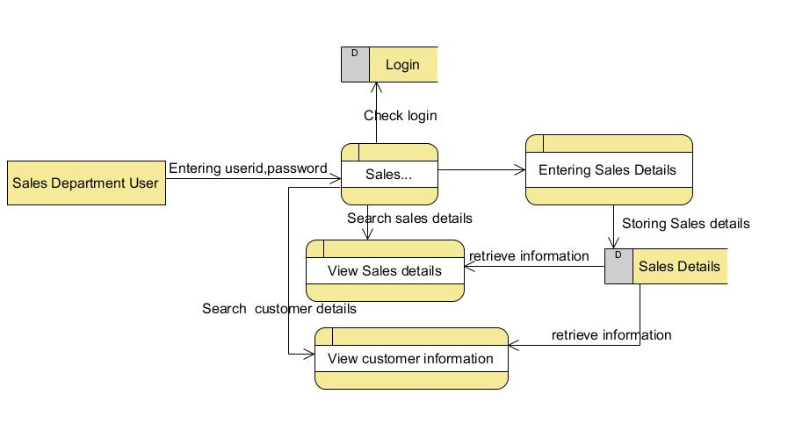
Fig.3

Purchase Details
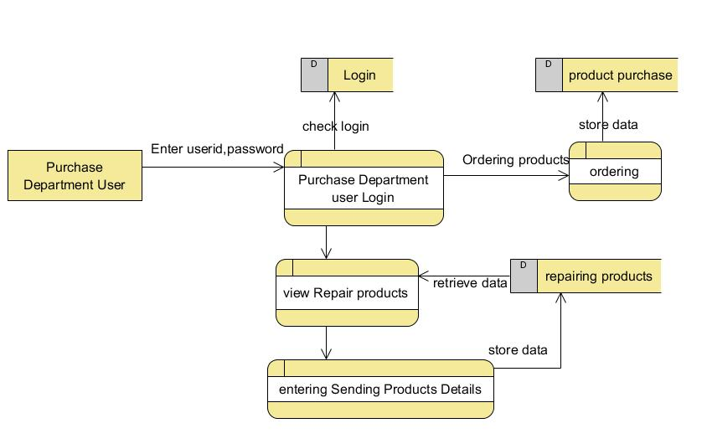
Fig.4

Marketing Department Details
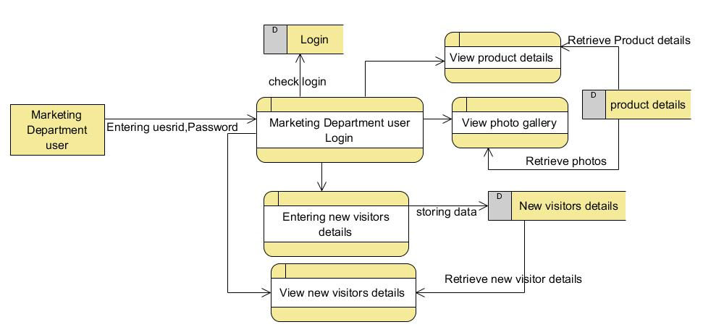
Fig.5

Technical Department Details
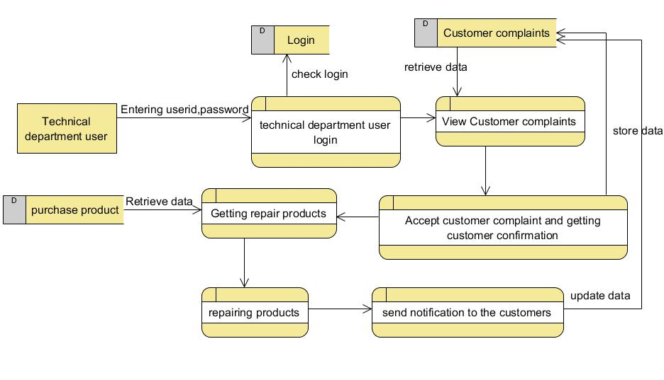
Fig.6

Accounts Department Details
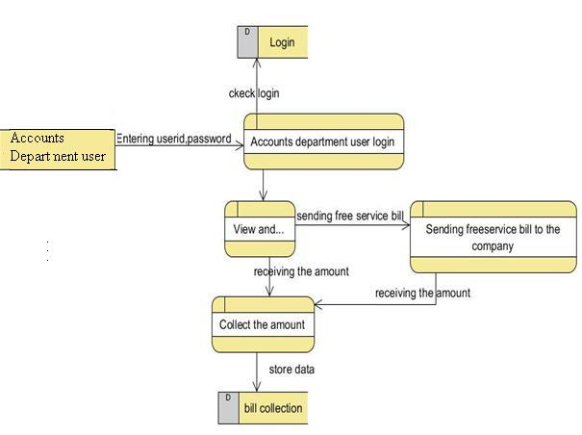
Fig.7

Help Desk Details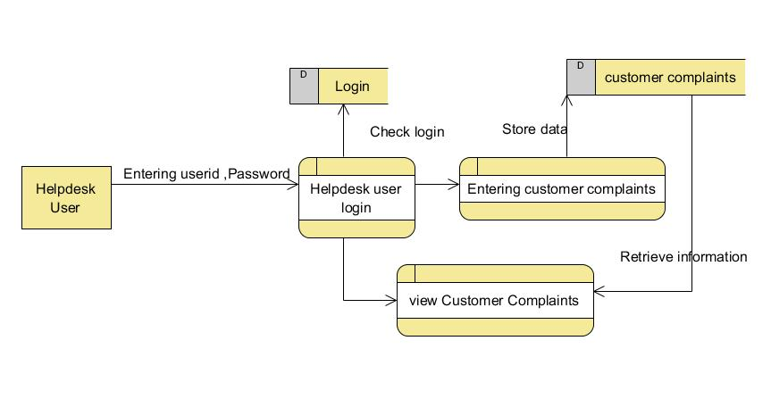
Fig.8

Login Details
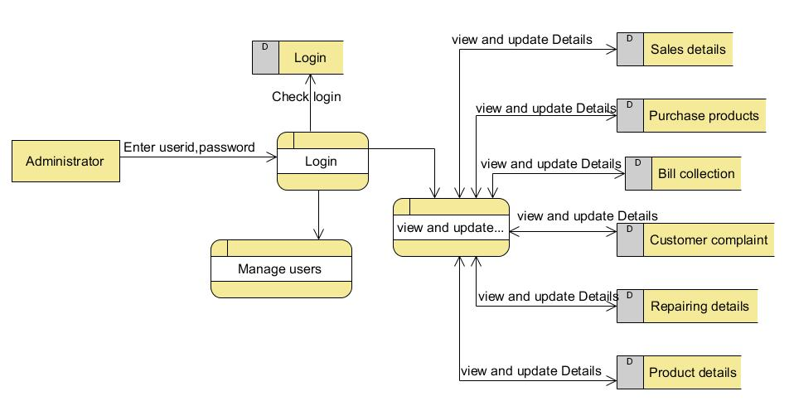
Fig.9

APPENDIX D

Screen Layouts
HOME PAGE
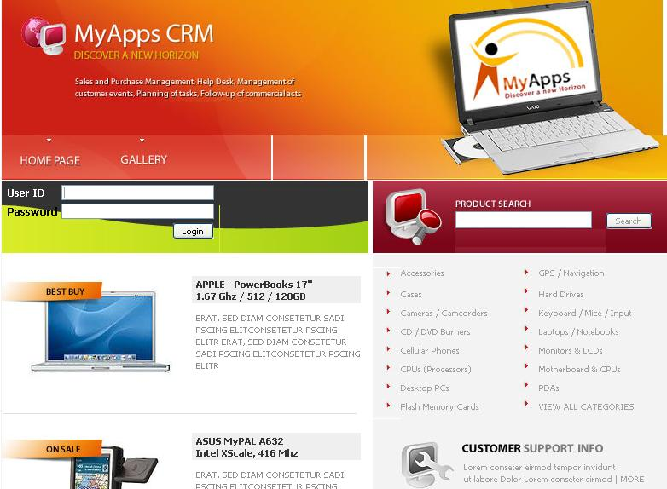

Screen 1

REGULAR CUSTOMER SALES
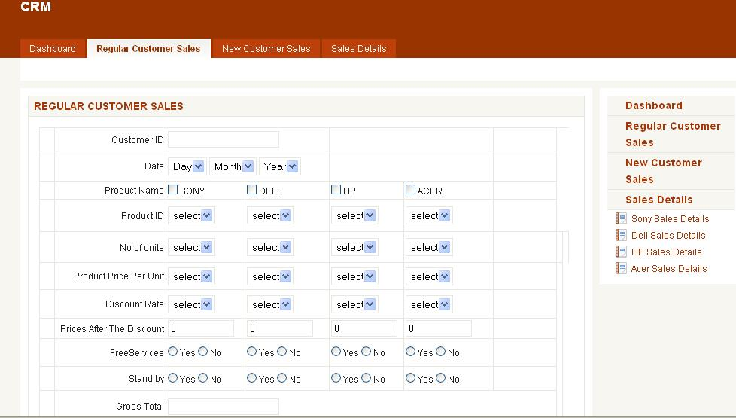

Screen 2

NEW CUSTOMER SALES
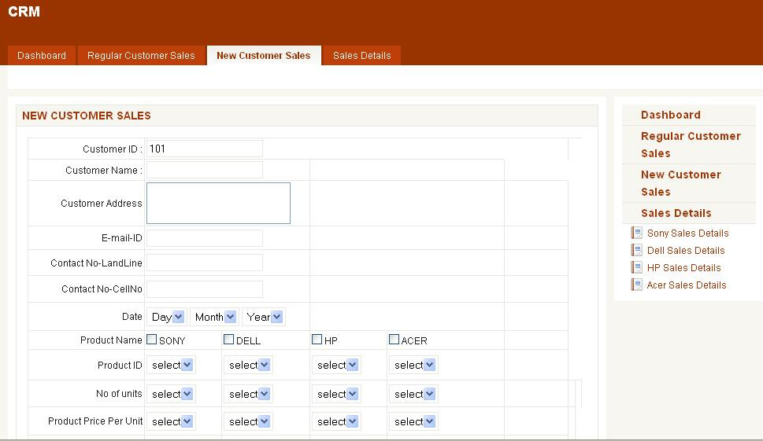
Screen 3
SALES DETAILS
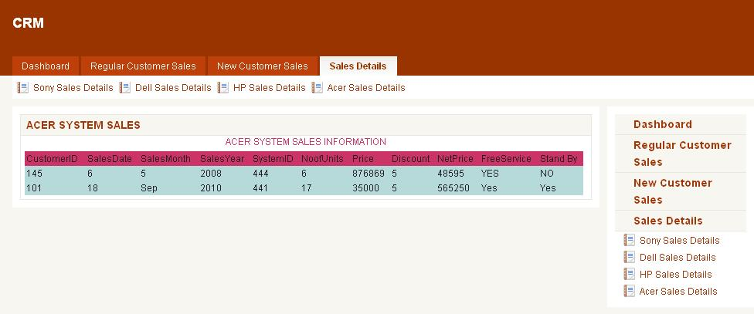
Screen 4

REGULAR CUSTOMER DETAILS
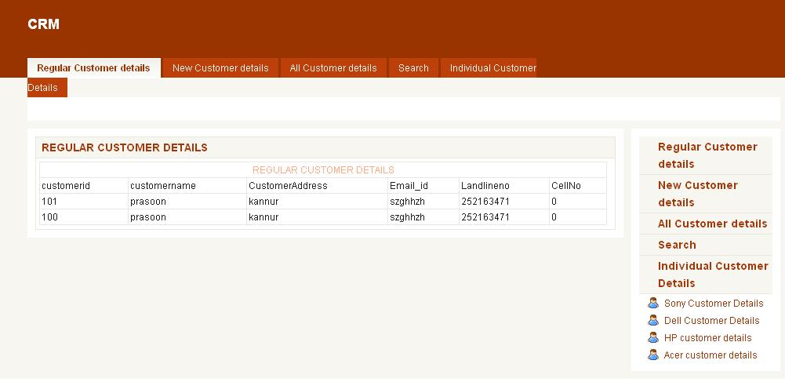
Screen 5

SEARCH CUSTOMERS
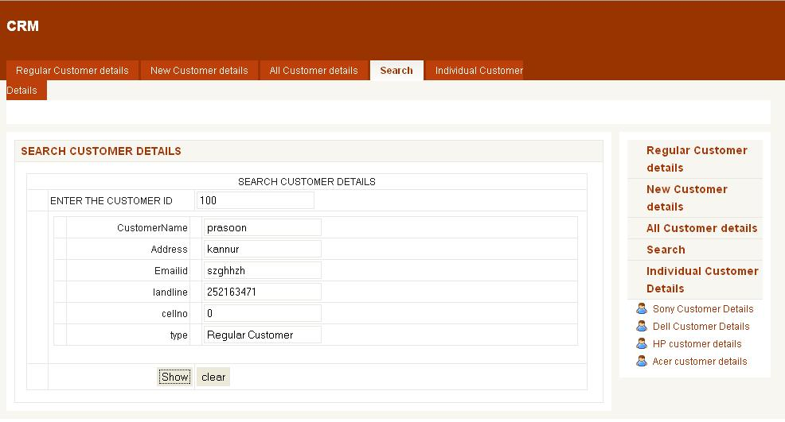
Screen 6

ALL CUSTOMER DETAILS
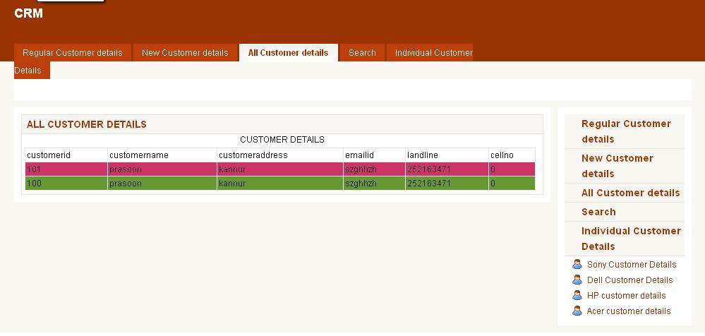
Screen 7

INDIVIDUAL CUSTOMER DETAILS
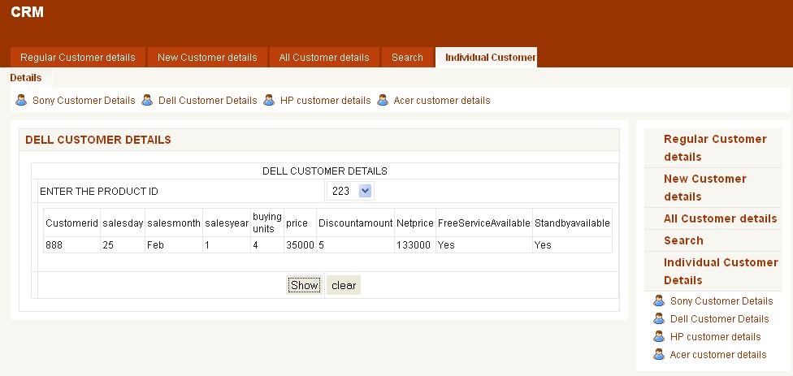
Screen 8

NEW VISITOR ENTRY FORM
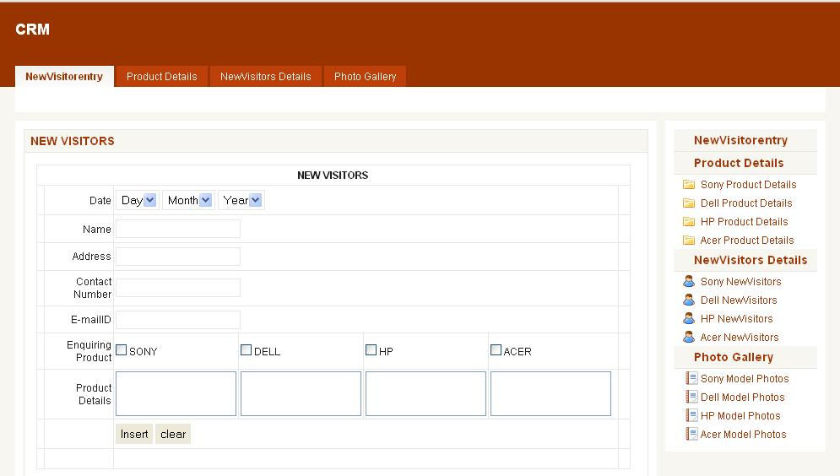
Screen 9

PRODUCT DETAILS
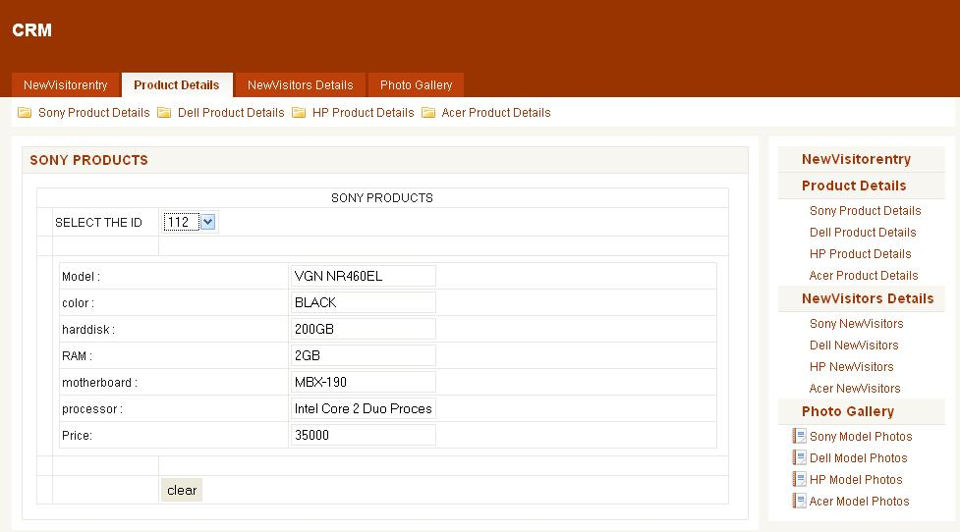
Screen 10

NEW VISITORS DETAILS
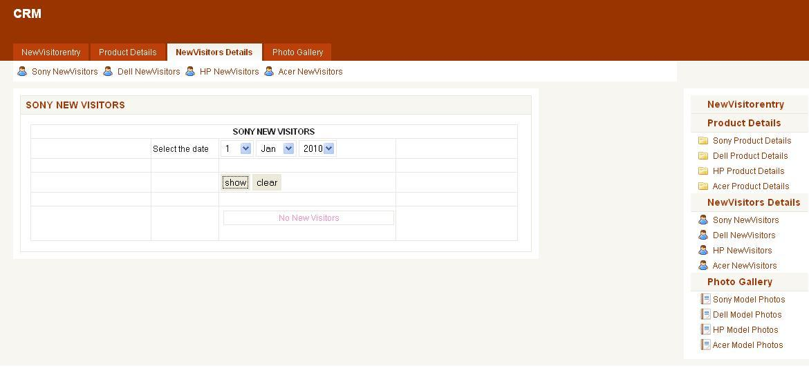

Screen 11

CUSTOMER COMPLAINTS
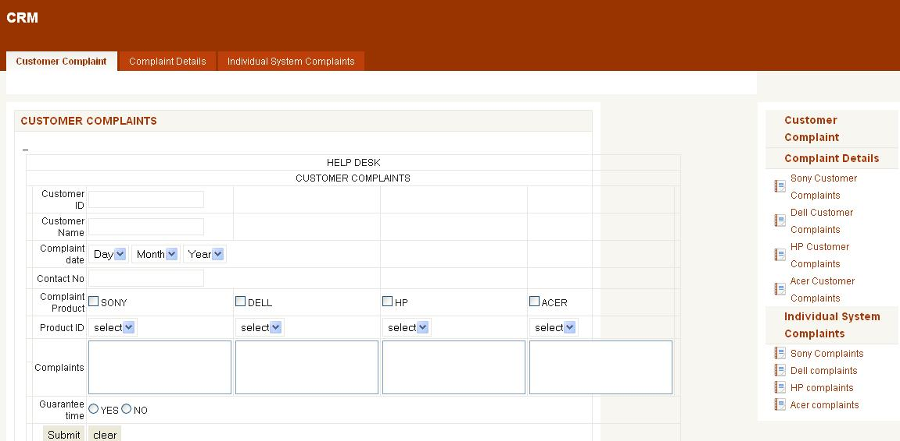

Screen 12

COMPLAINT DETAILS
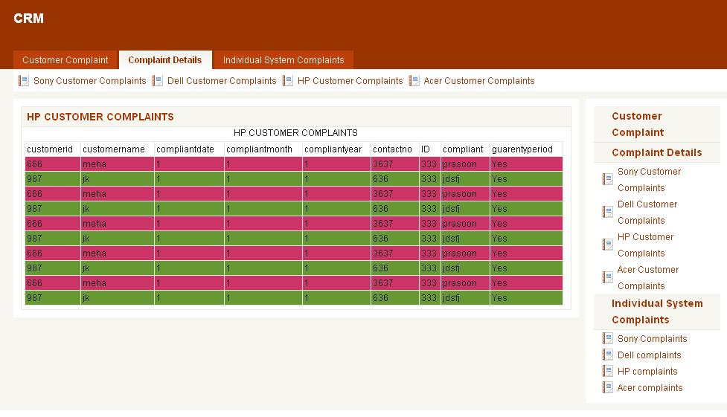
Screen 13
REQUEST PRODUCT PAGE
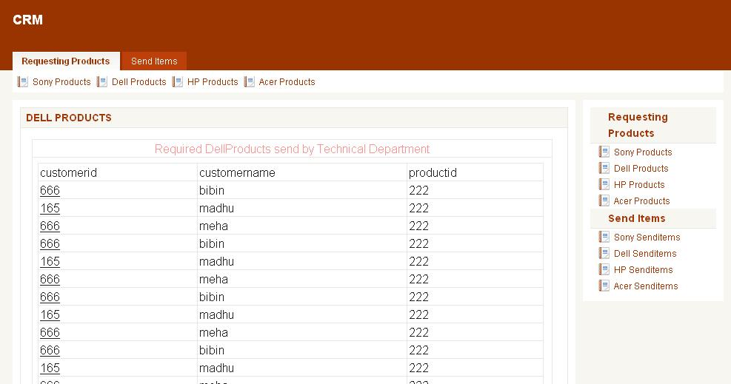

Screen 14

COMPLAINT DISPLAY
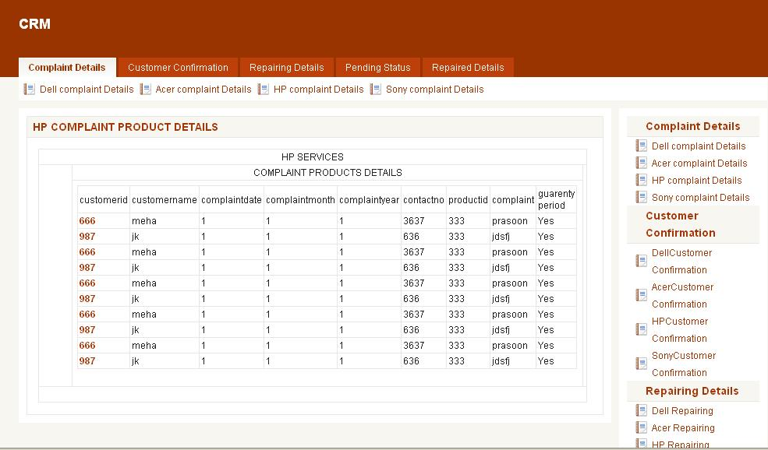

Screen 15

