Synthesis and characterization of cellulose hydrogel for immobilization of laccase

Manjula, S.
(16PBT005)

A Thesis submitted to Avinashilingam Institute for
Home Science and Higher Education for Women,
Coimbatore-641043

In partial fulfillment of the requirement for the Degree of
Master of Science in Biotechnology

April, 2018
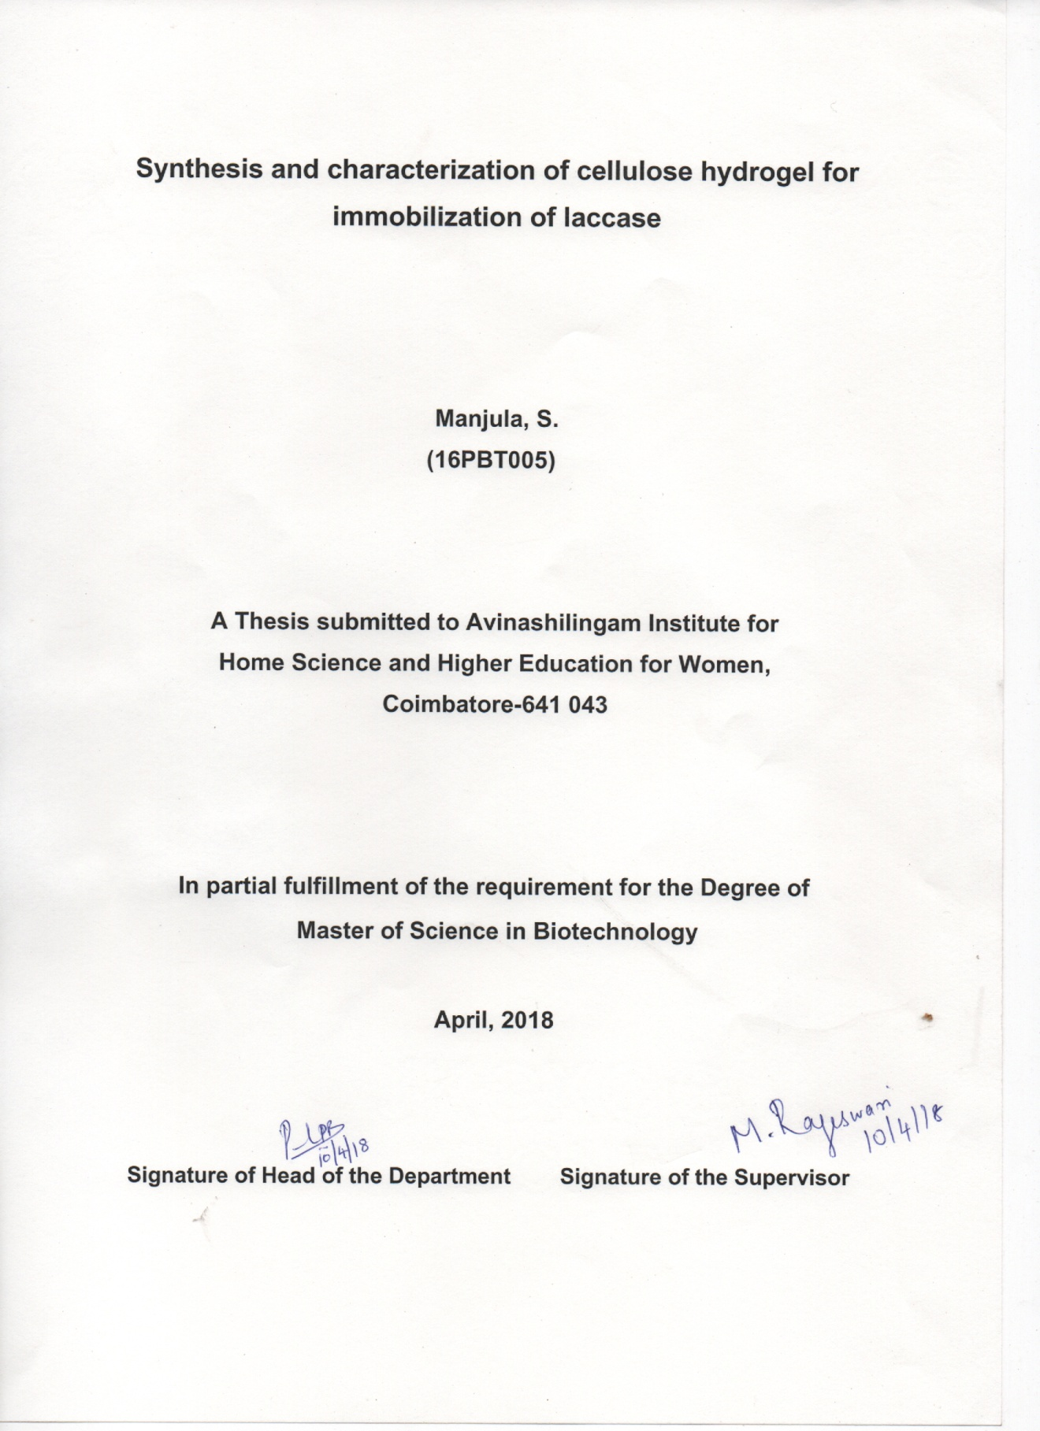
CONTENTS
CHAPTER NO. | TITLE | PAGE  NO.
 | LIST OF TABLES
 | LIST OF FIGURES
 | LIST OF PLATES
 | LIST OF APPENDIX
1. | INTRODUCTION | 1
2. | REVIEW OF LITERATURE | 5
3. | METHODOLOGY | 14
4. | RESULT AND DISCUSSION | 20
5. | SUMMARY AND CONCLUSION | 34
 | BIBLIOGRAPHY | 36
 | APPENDIX | 43

LIST OF TABLES
Table No. | Title | Page  No.
1 | Synthesis of cellulose hydrogel using varying concentration of lithium hydroxide and urea | 22
2 | Swelling ratio and water Content of the cellulose hydrogel | 23
3 | Laccase activity specific activity and immobilization yield of cellulose hydrogel | 25
4 | Laccase activity and specific activity of free enzyme and immobilized gel for different pH | 28
5 | Laccase activity and specific activity of free enzyme and immobilized gel for different temperature | 29
6 | Percentage degradation of RBBR by immobilized laccase | 32

LIST OF FIGURES
Figure No. | Title | Page  No.
1 | Sources of cellulose found in nature | 5
2 | Carriers used for enzyme immobilization by adsorption | 8
3 | Structure of cellulose | 10
4 | UV-Visible spectra of cellulose hydrogel | 23
5 | Scanning electron micrograph showing morphology cellulose hydrogel and laccase immobilized cellulose hydrogel | 26
6.a | FTIR spectrum of untreated cellulose hydrogel | 26
6.b | FTIR spectrum of laccase immobilized cellulose hydrogel | 27
7 | Effect of pH | 28
8 | Effect of Temperature | 30
9 | Line –Weaver Burk plot of free and immobilized laccase | 31
10 | Percentage Degradation of RBBR by Immobilized Laccase | 32

LIST OF PLATES
Plate No. | Title | Page  No.
1 | Cellulose Hydrogel | 21
2 | Immobilized Cellulose Hydrogel beads | 25

LIST OF APPENDIX
Appendix No. | Title | Page  No.
1 | Bradford Assay | 43

ACKNOWLEDGEMENT
On the very closet of this work I would like to extend my sincere and heartful obligation towards all the personages who have helped me in the endeavour. Without their active guidance, help, cooperation and encouragement I would not have made head way in this work. I humbly bow my head before the Lord Almighty for all the blessings, courage and confidence showered for the completion of this work.
Primarily, I would take the opportunity to express my gratitude to
Dr.P.R.Krishnakumar, Chancellor, Avinashilingam Institute for Home Science for Women, Coimbatore, for providing all the amenities for the project.
I feel grateful to Dr.PremavathyVijayan, Vice Chancellor, Avinashilingam Institute for Home Science for Women, Coimbatore, for providing all the facilities that are necessary for the project work.
With the heartfelt gratitude, I sincerely express my gratitude to Dr.(Mrs)S.Kowsalya, Registrar,Avinashilingam Institute for Home Science for Women, Coimbatore, for providing all the support that are adequate for the work.
With immense pleasure I thank Dr.(Mrs)A.Parvathi, Dean, Faculty of Science, Avinashilingam Institute for Home Science for Women, Coimbatore, for rendering her support and kind help
I owe my indebtnesstoDr.S.Annapurani, Former Professor and Head, and Dr.P.R.Padma, Professor and Head, Department of Biochemistry, Biotechnology and Bioinformatics, Avinashilingam institute of home science and higher education for women, Coimbatore, for her guidance and great support in the right direction during the course of study.
I feel priviledged to thank Dr.M.Rajeswari, Assistant Professor, Department of Biochemistry, Biotechnology and Bioinformatics, Avinashilingam institute for home science and higher education for women, Coimbatore, for her continuous encouragement to boldly step into any kind of situation with her meticulous care and innovative ideas and has also fuelled the thoughts to think broad and out of the box.
I owe my heart full thanks to all the Staff members of Department of Biochemistry, Biotechnology and Bioinformatics, Avinashilingam institute for home science and higher education for women, Coimbatore, for their constant support and help throughout the study.
I express my special thanks to my dear friends and all other hands for their constant support, infinite love and care.
I dedicate my research work to my Parents Mr.N.Subramaniam, Mrs.S.Kalamani, my sister Mrs.S.Sudha and my Brother-in-lawMr.C.Sudhakar.
I also thank my relatives and all other well-wishers for their direct or indirect help and for their moral support in this venture.

MANJULA.S

1.0 INTRODUCTION
Laccase are the oxidoreductase-containing copper atom found in the catalytic centre and can catalyse the oxidation of many substrates i.e particularly the phenolic compounds. Laccase is widely used in the drug analysis, clarification of wine, paper manufacturing and bioremediation of industrial effluents and other pollutants. Due to the ability of laccase to oxidize a wide range of compounds it is mainly used in many biotechnological, environmental and also the industrial applications (Beck et al., 2018). Like other free enzymes there are also free laccase that suffers from many disadvantages of low stability, recyclability, and also the reusability in industrial applications. Immobilization of laccase on a solid support can hence permit its reuse and can also improve its stability. The activity of the immobilized laccase mainly depends on the immobilization procedure and also the properties possessed by the carrier (Lin et al., 2016)
Immobilization is most commonly used inorder to use the enzymes in industry. The immobilized enzymes are the ones that generally refers to the enzymes that are physically confined or localized into a certain defined region of space along with the retention of their catalytic activities and also they can be used repeated and continuous manner (Barbosa et al., 2013). Generally, enzyme immobilization through the technique of physical adsorption is simple and it also have a higher commercial potential because of their simplicity, lower cost and also the ability to retain high enzyme activity as well as a chemical-free enzyme binding (Mohamad et al., 2014).
The properly designed immobilization are beneficial and they have almost all enzyme properties such as activity, specificity, selectivity, reduction of the inhibition and also the stability. Stability is presented by the nature because of the number of bonds between the enzyme and the support, degree of confinement, immobilization conditions and also the microenvironment that is created. Immobilized enzymes also gain certain other properties such as the higher volumetric activity and optimized performance under specific conditions (e.g. organic solvents, alkaline, acidic conditions etc., Other properties includes possible reusability, enzyme can be recycled and also can be used again for reducing the overall cost of production (Nery et al., 2015)
Cellulose exists as the pure form in the plants whereas it is usually accompanied by other components such as the hemicellulose, lignins and small amounts of other extractives (Heinze, 2015). Cellulose is one of the most abundantly found natural polymer that is renewable and also a biodegradable raw material that is available at an excellent low cost (Yin et al., 2016). Cellulose is also strong, dual hydrophilic/hydrophobici.e. amorphous in nature, nontoxic, and also chemically inert under physiological conditions that is the most helpful criteria for the survival of the enzymes. There are also a number of hydroxyl groups that are present on the cellulose surface that are capable of the chemical reactions. Therefore the cellulose materials are most suitable for the enzyme immobilization activity (Liu et al., 2016). Cellulose are usually extracted from wood, plants, bacteria, algae etc., A major component found in wood is the cellulose microfibrils that have approximately about 20-100 nm cross-sectional size with 100-200 nm long fiber length. Cellulose are sequentially arranged along the fiber direction in the form of row whereas amorphous regions separates the nanofibrils in cross section. It is impossible to break the crystal regions of cellulose due to their strong hydrogen bonding between the hydroxyl groups, whereas the amorphous regions of cellulose are relatively easy to be broken than the crystal regions (Kim et al., 2015).
There is only a small number of solvent systems that are known to directly dissolve cellulose and this involve rather uncommon chemicals such as aqueous transition-metal complexes (e.g.cuprammonium hydroxide), aqueous alkali (e.g.LiOH or NaOH) solutions, aqueous concentrated salt solutions (e.g. ZnCl₂, ammonium etc.,) etc., In case of cellulose dissolution, the solvent must have the ability to diffuse into the structure of the cellulose to disrupt both the amorphous and the crystalline regions that are found (Ghasemiet al., 2017)
Cellulose solvents also have the capability to disrupt and also to rearrange the complex intra- and inter-molecular hydrogen bond networks that are found in the different cellulose allomorphs inorder to achieve the cellulose solubility (Pircheret al., 2016). Cellulose can be dissolved very easily in aqueous solution of NaOH (7 wt%)/urea
(12 wt%) and when the mixture is precooled at -12°C then the cellulose dissolves within 2 minutes. The urea components are possibly been self-assembled at the surface of the NaOH hydrogen-bonded cellulose. The solutions are also rather unstable and acts sensitive to temperature, polymer concentration, and also the storage time. Alternative for NaOHincludesLiOH/urea andNaOH/thiourea solutions (Heinze, 2015). Cellulose also has a high chemical reactivity mainly because of the existence of three hydroxyl groups in every monomeric unit (glucose) because of its chemical structure.
These groups also have the potential to target the functional groups inorderto make covalent bonds with amino acids found in the enzymes for the immobilization to take place (Sharifi et al., 2018)
Hydrogels are defined as the three-dimensional i.e. 3D network structures that are been formed by natural or other synthetic polymers which swells in a huge amount of water. Recently, the biopolymer-based hydrogels have attracted the attention for its use in biomedical and biotechnological applications that including enzyme immobilization, tissue engineering and scaffolds, drug delivery and also in biosensors because of their inherent property of biocompatibility and biodegradability (Park et al., 2015). Nowadays, hydrogels based on cellulose have attained considerable attention due to their numerous advantages such as hydrophilic nature, biodegradability, biocompatibility, less cost and are also non-toxic. But the challenging part is, it is difficult to dissolve the cellulose in common solvents because of the strong intra molecular and inter molecular hydrogen bonding and also the partial crystalline structure (Geng, 2018).
The use of natural polymers that are usually termed as biopolymers, in hydrogel synthesis depends on the purpose of the related biomaterial. Hydrogels are generally biocompatible, biodegradable and are non-toxic, and therefore the polymers with these characteristics are used largely. The polymers of natural origin that are used frequentlyarehyaluronic acid, cellulose and its other derivatives, dextran, alginate, chitosan, gelatin and collagen. Particularly cellulose hydrogels, are the most optimal mediums that facilitate or supports the biomimetic framework design and also the space fillers or scaffolds that are used for tissue regeneration. Hydrogel scaffolds have good application in cell transplantation and tissue regeneration of cartilage, bone and muscle tissues and also in drug delivery mechanisms for the promotion of angiogenesis and also cellular encapsulation processes (Gyleset al., 2017)
Current Study is focused on the dissolution of the cellulose in the aqueous alkali solvent of Lithium hydroxide, urea and water under precooling procedures for a better dissolution. The transparent solution thus produced is made into a hydrogel using the cross linking agent Epichlorohydrin. This agent helps in binding the molecules in a better way and results in a transparent pure gel. The gel thus produced is used for the immobilization of laccase enzyme because of its wide application in the environment and in the industries.

Therefore the objective of the present study is
- To synthesis and characterize the cellulose hydrogel
- To immobilize laccase on cellulose hydrogel by physical adsorption
- To analyse kinetic parameters of free and immobilized laccase on cellulose hydrogel

2.0.REVIEW OF LITERATURE
Natural fibers are the fibers that are not synthetic or manmade and is available in the nature. It can be sourced either from the plants or animals. The use of natural fiber from both resources, renewable and nonrenewable such as cotton, oil palm, sisal, flax,and jute to produce composite materials has gained considerable attention past years.The plants that generally produce cellulose fibers can be classified into bastfibers, seedfibers, leaf fibers, grass and reed fibers and core fibers and also other kinds such as wood and roots (Mohammed et al., 2015).
Figure 1
Sources of cellulose found in nature
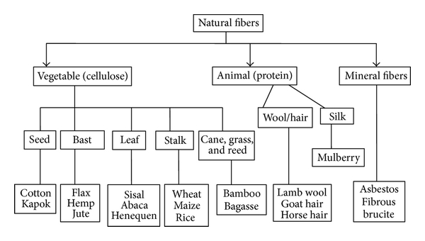
Natural fibers have attracted the attention of researchers, material scientists, and several other industries due to their specific benefits as compared to conventional or synthetic fibers from the past decades. Natural fibers are the natural composites consisting mainly ofhelically wound cellulose micro fibrils, embedded in amorphous lignin matrix. Cellulose,lignin, pectins, hemicellulose, and are the major components that constitute the natural fibers(Saba et al., 2014).
The review of literature pertaining on the current topic “Synthesis and Characterization of cellulose hydrogels for the immobilization of laccase” is discussed under the following headings.
2.1 Laccase
2.2 Enzyme Immobilization
2.3.1 Adsorption
2.3.2 Entrapment
2.3.3 Covalent Binding
2.3 Cellulose
2.3.1 Cellulose Structure
2.3.2 Cellulose Dissolution
2.3.3 Cellulose Regeneration
2.4 Hydrogel
2.1 Laccase
Laccase are oxidoreductaive enzymes that has various biotechnological applications mainly due to their ability in the non-specific reactions (Tavares et al., 2015). Laccases are extracellular and multicopper enzymes that use molecular oxygen as the co-substrate to oxidize various aromatic and non-aromatic compounds that is carried out by a radical-catalyzed reaction mechanism (Spinelliet al., 2013). The laccase is found among plants and fungi and is also present in bacteria. These enzymes are involved to carry out several physiological functions whereas in plants they are found to be involved in synthesis of lignin and in fungi they are involved in lignin degradation, pigmentation, and also the pathogenesis (Ravikumaret al., 2013).
Based on the substrate specificity,laccases can be classified into three groups such as catechol or o-cresol, p-cresol, and Cresolase or monophenol mono-oxygenase. Laccase is widely used for the biodegradation of various industrial pollutants and also it is used for synthesis of various important pharmaceutical/drug products like anti-cancerous compounds etc. Laccases have four copper atoms at the catalytic centre, the type 1 atom determines the colour of the enzyme and type 2, 3 and 4 atoms are for the catalytic reactions with the various substrates (Senthivelanet al.,2016). It is very effective in the oxidation of various organic pollutants,reduction of oxygen to water without the need of high temperature, pressure, and harsh chemical environments. Laccase has also shown the excellent application in the treatment of dyeing effluents from the industries (Sun et al., 2015).
Laccases from the various sources catalyses the oxidation of various phenolic and other aromatic compounds to the products that are often very colourful and can also be used as the dyes, especially in the textile industries for the fabrics (Polak and Jarosz-Wilkolazka 2012). Laccasesgenerally represent a large and metabolically unique family of enzymes and many of them have shown to participate in the degradation of complex natural polymers that are present. They catalyses the oxidation of several aromatic compounds with the effective concomitant reduction of oxygen to water
(Margot et al., 2013). Laccase have been immobilized on various supports by different immobilization techniques such as adsorption, encapsulation, entrapment or covalent attachment and also used for the degradation of dyes and other hazardous materials that are released from the industries (Sathishkumaret al., 2014). These enzymes are known for their several biotechnology applications such as the biodegradation of xenobiotic and industrial effluents and contaminants, discoloration of the dyes, bioremediation of the contaminated soils, ethanol production, clarification of wine and tea and also for the production of biosensors (Skoronskiet al., 2017).
2.2 Enzyme Immobilization
Enzymes are generally the proteins that catalysis many biochemical and many other chemical reactions. They are unique and are present in both plants and animals. As they are easy to produce, the substrate specificity and the green chemistry of these catalysts are broadly used in various sectors. Selecting and producing the specific support matrix are essential steps in the immobilization of the enzyme (Ahmad and Sardar, 2015).Biocatalysts have many potential in both scientific and industrial sectors because of their energy efficient catalytic mechanisms, distinct selection of the substrates, and enhancedstabile nature even under the harsh environment conditions (Jiaet al., 2014).
When comparing the free enzymes in solution the immobilized enzymes are found to be more robust and also more resistant to environmental changes. Immobilization is a technical process in which the enzymes are fixed to or kept within the solid supports or matrix thus creating a heterogeneous immobilized enzyme system. Immobilized form of enzymes has the same feature as that in their natural mode in living cells, where most of the enzymes are being attached to the cellular cytoskeleton, membrane, and the organelle structures (Homaeiet al., 2013). Enzyme immobilization may be defined as bounding he enzyme molecules to a solid matrix or support that is entirely different from the one in which the substrate or the products are being present (Sirishaet al., 2016). Reusability of the immobilized enzymes is one of the most essential criteria for industrial applications because these immobilized enzymes decreases the cost of production due to their repeated usage in the continuous and batch systems (Kalkanet al., 2012).
Figure 2.
Carriers used for enzyme immobilization by adsorption
Insoluble
Soluble
Soluble dextransPolyvinyl alcohol Polyoxy ethylene glycol

Organic
Silica Silicagel Metal oxides Diatomaceous earth Cordorite Porous glass
Natural
Synthetic
Polyacrylamide Polyurethane Polypropylene Polystyrene Silicones Ion-exchange resins Epoxy resins
Enzyme Carriers
Chitin Cellulose Chitosan Starch Alginate Collagen Agar-Agar Carrageenan
Inorganic

2.2.1 Adsorption
Enzyme immobilization byadsorption is a popular strategy that is generally used in most large-scale applications due to their ability in catalyst recycling, continuous operation, product purification,and also their stability of the enzyme activity after the adsorption (Ramírez-Montoya et al., 2015). Enzyme adsorption is a kind of hydrophobic interactions and salt linkages in which the support is immersed in the enzyme for the physical adsorption to take place or else the enzyme is dried onto the electrode surfaces (Dattaet al., 2013). Generally the carriers that are used for the immobilization of
enzyme by adsorption can be classified into two i.e. organic andinorganic origin (Jesionowskiet al., 2014). Adsorption of the enzymes in insoluble supports is an older and also a simple method that has many applications and also it has the highcapabilityfor the enzyme loading when compared to other immobilization methods that are followed (Ahmad and Sardar, 2015). In passive physical adsorption, enzymes are beingimmobilizedon carriers through intermolecular polar, hydrophobicinteractions and ionic bonds that are unstable methods when comparedtothe covalent binding method of enzyme immobilization(Jiaet al.,2013).
2.2.2 Entrapment
Entrapment is the easiest method of immobilization andit also induces no change in the structure of the enzyme. However, this methodology is generally being characterized by mass enzyme transfer limitations and also has low enzyme loading capability (Fernandez-Fernandez et al., 2013). There are different approaches that are brought for enzymes entrapment such as gel or fiber entrapping and micro-encapsulation methods (Vaghariet al.,2016). Entrapment through the inclusion of the enzyme in the polymer network that may be organic or inorganic polymer matrix such as the polyacrylamide and silica sol–gel or the membrane devices such as the hollow fibesr or a microcapsule is used for the entrapment of the enzyme(Sheldon et al., 2013). Encapsulation of these breakable macromolecules is a possible strategy for preventing their formation of aggregates and the denaturation (Homaeiet al., 2013).Identical behavior is found in the encapsulation of the laccasesincomparison to the entrapment method, the mass transfer represents as a serious limitation in both of types immobilization techniques (Fernandez-Fernandez et al., 2013).
2.2.3 Covalent binding
Covalent binding is the type of immobilization technique that mainly involves in the formationofthe covalent bonds between the enzyme and the corresponding support matrix. Thefunctional groups that are present in the enzymes are linked to the support matrices as these functional group are not bonded for the catalytic activity (Ahmad and Sardar, 2015). Covalent binding of the enzymes to the supports occurs due to their side chain amino acids such as arginine, aspartic acid,histidine and also due to their degree
of reactivity based on different functional groups such as imidazole, indolyl, phenolic hydroxyl,etc. (Dattaet al., 2012). By preventing the inactivation of the active site amino acid residues the essential enzyme activities can be gained (Sirishaet al, .2016)
2.3 Cellulose
Cellulose is the most abundantly present polysaccharide and telluric material that is found innature. It is easily obtainable and can be extracted from wood pulp, cotton fiber, hemp and other plant-based materials as well as synthesized by tunicates and microorganisms. There are about 700-800 billions of cellulose that is being produced each year (Xu et al., 2016). Cellulose is a suitable biopolymer that has the ability to synthesize a hydrogel with excellent mechanical properties. Cellulose has crystalline structure and therefore it shows high strength, high stiffness, and low densitychain depends on the source, e.g., n is almost 10,000 in woods and15,000 in cotton by
nature (Wang et al., 2016). Cellulose is a straight homopolysaccharideposessing
β-D-anhydroglucopyranose units and linked by β (1→4) ether bonds that are called as the glycosidic links. β-D-anhydroglucopyranose is a six-membered heterocycle with an anomeric carbon labeled as C1 and is generally found in the chair conformation . In the β anomer, the hydroxyl group at C1 is in the central position, while in the αanomer, the hydroxyl group is in the centroidal position. The relative stability of the two anomers α and β depends mainly on the surrounding environment (Eyley, 2014).
Figure 3
Structure of cellulose
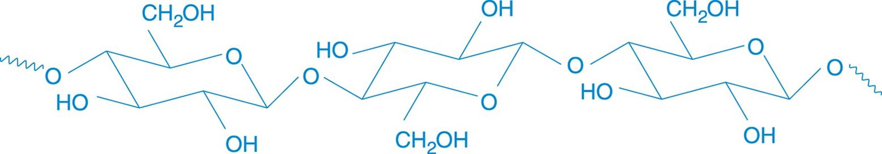
Cellulose is a highly stable biopolymer that consists of glucose and is attached with linear chains of about 12,000 residues. Naturally cellulose molecules exists as bundles that accumulate together in the form of micro-fibrils that has both crystalline and amorphous regions (Anwar et al., 2014).

2.3.2 Cellulose Dissolution
Cellulose dissolution precedes generally by polymer swelling where the solvent molecules penetrate and stabilize the cellulose structure to a certain extent where the volume and other physical properties of the biopolymer is incomparably altered while the other solid, or semi-solid portions that remains fundamentally unchanged.Cellulose dissolution results from the ability of the solvent to terminate theinter and other intramolecular hydrogen bonds found among the biopolymer molecules (Medronho and Lindman, 2015). Profound research has focused on the dissolution of cellulose, providing continuous improvements in the ability of solvents such as NaOH/urea aqueous solutions and similar other systems such as NaOH/urea/ thiourea, NaOH/polyethylene glycol, LiOH/urea because they are non-derivatizing, low-cost and less toxic cellulose solvents (Navarra et al., 2015).
The cellulose dissolution at low temperature arises due to the fast and dynamic self-assembly process among the solvent small i.e the micro molecules such as NaOH, urea and water and the cellulose macromolecules that are present. It represents the most rapid dissolution of cellulose and is a less-toxic system for the preparation of the cellulose solution because there is no evaporation of any chemical agents that takes place during the production process (Luo and Zhang, 2013). Effective cellulose solvents should have the ability to break down inter and intrahydrogen bonding of the molecules. The strong intermolecular interactions that is the hydrogen bonding and hydrophobic nature among the crystalline cellulose molecules need to be broken by the solvent, and the cellulose chains in amorphous regions should be unwinded from each other (Keshk, 2015). The dissolution mechanism of the cellulose and the solution properties of cellulose in LiOH/urea are identical to that in NaOH/urea aqueous system. The low-temperature step plays an prominent role in the formation of the hydrogen bond networks between cellulose and solvent molecules which results in creating the inclusion complex structure that leads to the good dissolution of macromolecules (Luo and Zhang, 2013).
Ionic liquids (IL) are the group of salts that generally exist as liquid at relatively low temperatures usually less than 100◦C with many adorable properties including
non-volatile, chemical and thermal stability, inflammability, and strikingly low vapor pressure (Wang et al., 2016). Up to date, two main views of the interactions between ionic liquids and cellulose prevail: (1) the dissolution process is generally carried by the interactions between the anion and the biopolymer and there is no specific key role for the cationand (2) the major compelling force for dissolution of the cellulose comes from the Hydrogen bond interactions of the cellulose hydroxyls with the anion and the cation of the ionic liquids (Medronho and Lindman, 2015).
Ionic liquids has the strong solvation capability for cellulose fibers that causes various alteration in the physical characteristics of any cellulose substrate (Habibi, 2014). Addition of urea seriously enhances the dissolution of cellulose incase of the aqueous alkali. This solvent has the greater ability to dissolve the native cellulose of high degree of polymerization without any pretreatments (Isobeet al., 2013).
2.3.3 Cellulose Regeneration
A basic understanding of the process, structural changes and other mechanism of the regeneration from the cellulose solution to its aggregation state is the basic parameter for the successful preparation of the regenerated cellulose material which dominates the physical features and other characteristics. Usually, the cellulose regeneration is a physical process that does not accompany the chemical reaction. The regeneration gives a simple mechanism to transform the native cellulose to other valuable materials in various forms such as the fibers, films/membranes, beads/microspheres, hydrogels/aerogels, bioplastics and many other components (Wang et al., 2016). The regeneration mechanism for the alkali systems prefers that the inclusion complex that is integratd with cellulose, NaOH, and urea or thiourea hydrates is being disturbed by the addition of non-solvent such as water which leads to the self-association of cellulose. The regenerated cellulose film is generally formed as the result of rearrangement of the hydrogen bonds (Medronho and Lindman, 2015).
2.4 Hydrogels
The features of supported enzyme preparations are directed by the characteristics of both the enzyme and the carrier material. The interaction preceeds between the two and provides an immobilized enzyme that has peculiar chemical, biochemical, mechanical, and kinetic properties (Homaeiet al., 2013). Hydrogels that are derived from the natural polymers especially from the polysaccharides are the interesting materials as they had found major application in many areas such as agriculture, tissue engineering, scaffolds, drug delivery, biosensors, etc. that has the advantage of being environmentally-friendly, renewable, and also low cost for the raw materials (Navarra et al., 2015).Hydrogels are the gels that are cross-linked either physically or chemically by three dimensional hydrophilic polymeric networks which has the ability of absorbing large amounts of water and also involves in swelling (Shen et al., 2016).
Hydrogels have gained appropriate attention among the humans because they are environmentalfriendly soft materials. Several natural and other synthetic polymers are widely used as the hydrophilic backbones of the three-dimensional network i.e 3D network in the hydrogels (Kimura et al., 2015). Hydrogels are adorable biomaterials because of their biocompatibleand biomimetic properties. Cellulose is a suitable biopolymer for synthesizing a hydrogel with a very good mechanical properties(Choeet al., 2018).Hydrogels are called as the physical gels because of their molecular complexity and other secondary forces such as ionic, Hydrogen bonding or hydrophobic forces that plays the key role in the formation of the network (Calo and Khutoryanskiy, 2015). Hydrogels are the polymer grids that imbibe and keep large quantities of water. There are hydrophilic groups that are present in the polymeric network that become hydrated in the aqueous media thus forming the hydrogel structure (Akhtar et al., 2015).
Cellulose hydrogels are attracting the attention because of their low cost, hydrophilic nature and indigenous advantages of safety, biocompatibility andbiodegradability,and many other features (Wang et al., 2016). The mechanical strength of a physically crosslinked hydrogel is generally enriched when the physical interactions between polymer chains and their complexity are promoted by increasing the concentration of the polymer (Kimura et al., 2015).
Hydrogels have become very popular because of their unique properties such as high wate content, softness, flexibility and also the biocompatibility. Natural and synthetic hydrophilic polymers can either be cross-linked physically or chemically to produce the hydrogels (Calo and Khutoryanskiy, 2015). Producing the hydrogels with enriched or higher mechanical strength is essential for bio-related applications. For such applications cellulose is the better biopolymer for the hydrogel synthesis due to their buit-in strength and stiffness (Choeet al., 2017). Hydrogels are soft and also viscoelastic materials that can imbibe a huge amount of water and it also maintains their networks structural integrity (Yang et al., 2013).
In the present study cellulose hydrogel was prepared using alkali solvent system and used as supporting material for immobilization of enzyme laccase. The kinetic properties of free and immobilized enzymes were compared. The immobilization of enzyme was assesed for its efficiency in degrading Remazol Brilliant Blue R_{250.}

3.0 METHODOLOGY
Laccase are multicopper oxidases, which not only catalyse the removal of a hydrogen atom from the hydroxyl groupofmethoxy-substituted monophenols, ortho- and para-diphenols, but also can oxidize other substrates such as aromatic amines, syringaldazine and non-phenolic compounds to form free radicals. Laccase are known to catalyse reactionsthat lead to the generation of antimicrobial species in the presence of methyl syringate or acetosyringone mediators, phenols, iodine, bromine, hypohalous acid and peracetic acid (Sampaioet al., 2016).
Cellulose gels are fabricated directly from native cellulose via cellulose dissolution and subsequent regeneration with water (hydrogels). Cellulose hydrogels have many favorable properties such as hydrophilicity, biodegradability, biocompatibility, transparency, low cost and non-toxicity. Therefore, they have wide applications in tissue engineering, controlled delivery system, sensor, water purification and more (Napsoet al., 2015).
In the present study the cellulose that is amorphous in nature is being dissolved with the help of the aqueous solvent mixtures. After these process the transparent solution that is obtained is mixed with the epichlorohydrin that acts as a cross linking agent and then the mixture is kept in hot air oven to obtain a transparent gel. The nature of the gel is analysed for swelling properties, determination of water content, thermal and storage stability. Further the gel is immobilized with laccase via physical adsorption and then checked for the activity assay at different pH and temperature. Then the immobilized gel is also analysed for its dye degradation ability.
The methodology adopted for the present study “Synthesis and Characterization of Cellulose Hydrogel for the immobilization of laccase” is discussed under the following headings:
3.1 Source of enzyme
3.2 Synthesis and characterization of cellulose hydrogel
3.2.1 Synthesis of cellulose hydrogel
3.2.2 Characterization of cellulose hydrogel
- UV visible spectroscopy
- Swelling property
- Water content
3.3 Immobilization of laccase by Physical Adsorption
3.4 Characterization of immobilized hydrogel
3.4.1 Scanning Electron Microscope (SEM) analysis
3.4.2 Fourier transform-infrared spectroscopy (FT-IR) Analysis
3.5 Kinetic parameters of free and immobilized laccase on cellulose hydrogel
3.5.1 Effect of pH
3.5.2 Effect of Temperature
3.5.3 Km and Vmax
3.6 Dye degradation Studies
3.1 Source of enzyme
Laccase from Trametesversicolor E.C (1.10.3.2) was purchased from Sigma-Aldrich.
3.2 Synthesis and Characterization of Cellulose Hydrogel:
3.2.1 Synthesis of Cellulose Hydrogel:
A mixture of the aqueous solution as solvent of cellulose is prepared by directly mixing Lithium hydroxide, urea and distilled water. All concentrations that are used are calculated by weightpercent. 8%LiOH/18% urea/74% Water are used as the solvent for the dissolution of Cellulose. After cooling the solvent to -15°C, the cellulose powder of about 4% is added to the aqueous solution and is stirred vigourously for about
5 minutes. Then the corresponding cellulose solution is stored at about -10°C for about 12 hours. After that the viscous solution that is obtained is centrifuged at about 3000rpm at 4°C for 10 minutes. Then the transparent solution that is obtained is poured on to petridish. To this the cross-linking agent that is Epichlorohydrin is added in drops and kept in stirrer at 25◦C for about 1 hour and the temperature increases slowly to 50◦C. After this the post treatment of the gel involves in heating the resultant mixture in
hot air oven at 50◦C for about 4 hours. Then the cellulose hydrogel is finally obtained (Caiet al.,2006, Zhou et al., 2007)

3.2.2 Characterization of cellulose hydrogel
UV-Visible Spectroscopy
Cellulose hydrogels were cut into thickness of l cm and the transmittance of hydrogels was measured over the wavelength range of 200–800nm by using an ultraviolet–visible spectrophotometer (Chang et al., 2010)
Swelling properties of the hydrogels
The swelling properties were determined by weighing 1 g of dried cellulose hydrogel in a Petri dish and the initial weight of the gel measured. The hydrogels was then immersed in 10mM phosphate buffered saline (PBS) pH 7.4 for 24 h and weighed again. The swelling efficiency in% was calculated using the following equation
W_{S} - W_{D}
Swelling efficiency(%) = x 100
W_{D}
Where W_{S} =weight of the swollen gel,
W_{D}= weight of a dried gel (Huber et al., 2018)
Determination of water content
The water content of the cellulose hydrogel was calculated using the following equation:
Water content (% ) = [(W −D)/W] × 100
Where W (g) is the weight of the Cellulose hydrogel,
D (g) is the weight of the heat-dried Cellulose hydrogel (Choeet al., 2018)
3.3 Immobilization of laccase by Physical Adsorption:
For the preparation of laccase solution, 20 mg of enzyme wasadded into 10 ml of Acetate buffer (pH 5.0) and shakenfor 10 min. To physically adsorb laccase onto cellulose hydrogel about 5 mg i.e the dried gel weights were ranging from 3.2 mg to
5.3 mg were cut into beads and added into 1 mL of laccase solution and then incubated under vigorous shaking at 120 rpm at 25◦C. After the incubation of cellulose hydrogel and laccase for 5 h, the gel were filtered to remove unbound enzyme and then washed three times with Acetate buffer (pH 5.0) for 5 min at 25◦C to remove the weakly adsorbed laccase. The filtrate and the washings were collected for proteinmeasurement. The amount of protein adsorbed on the cellulose hydrogel was indirectly estimated by calculating the difference between the initial protein content in the enzyme solution and the remained protein content in the filtrate and washing solutions. The protein content in the solutions was measured by Bradford assay that is stated in the appendix (Park et al., 2015)
Change in Absorbance at 490 nm X Total Volume
Activity = x 10⁶
Extinction Coefficient X Sample Volume

The immobilization yield of enzyme is defined as follows:
U _{act}
Immobilization Yield % = x 100
U_{total} - U_{remain}

Where U _{act} is the activity of immobilized enzyme (unit),
U_{total}is the activity of total enzyme (unit) used,
U_{remain}is the activity of laccase in filtration (unit).
Protein Concentration were measured with Bradford Reagent using the standard method
C_{i}V_{i}– C_{f}V_{f}
Loading Efficiency % = x 100
C_{i}V_{i}

Where C_{i} is the initial protein concentration (mg/ml),
V_{i}is the initial volume of enzyme solution (ml),
C_{f}is the protein concentration in the total filtrate (mg/ml),
V_{f}is the total volume of filtrate (ml).
3.4. Characterization of immobilized hydrogel
3.4.1 Scanning Electron Microscope (SEM)analysis
The surface morphology of the cellulose hydrogelwasobserved by Scanning Electron Microscopy (SEM).
3.4.2 Fourier transform-infrared spectroscopy (FT-IR) Analysis
FTIR spectra was recorded using a FTIR spectrometer. Prior to analysis, sample (2 mg) was mixed with 100 mg of dry KBr powder and then pressed as pellets for FTIR spectrometer analysis at a resolution of 4 cm⁻¹ from 4000 to 500 cm⁻¹ region (Dai et al., 2016).
3.5 Kinetic parameters of free and immobilized laccase on cellulose hydrogel
3.5.1 Effect of pH
Enzymatic activities for free and immobilized laccase weredetermined by monitoring the oxidation of 2, 2-azino-bis-(3-ethyl-benzthiazoline-6-sulfonic acid) (ABTS) to its cation radical(ABTS+) at 420 nm (εmax= 3.6 × 104L/(mol cm)). The reaction mixture consisted of 1mmol/L ABTS in a acetate buffer (pH 5.0)and a suitable amount of free or immobilized enzyme, and the reaction time was 5 min. During the process, the increase in the absorbance at 420 nm was measured using a UV-2450 spectrophotometer. The molar extinction coefficient of ABTS+ is 36,000 L/(mol cm). These activity assays were carried out over a pH range of 3.0–8.0(in acetate buffer) to determine the pH.
The results were converted to relative activities (percentage of the maximum activity obtained in that series).
3.5.2 Effect of Temperature
Enzymatic activities for free and immobilized laccase were determined by monitoring the oxidation of 2,2-azino-bis-(3-ethyl-benzthiazoline-6-sulfonic acid) (ABTS) to its cation radical(ABTS+) at 420 nm (εmax= 3.6 × 104L/(mol cm)). The reaction mixture consisted of 1mmol/L ABTS in a acetate buffer (pH 5.0) and a suitable amount of free or immobilized enzyme, and the reaction time was 5 min. During the process, the increase in the absorbance at 420 nm was measured using a UV-2450 spectrophotometer at a temperature range of 20–80◦C was employed to determine the temperature profiles for the free enzyme and immobilized enzyme. The results were converted to relative activities (percentage of the maximum activity obtained in that series) (Lin et al., 2016).
3.5.3 Km and Vmax
The kinetic constants, Km and Vmax values of the free and the immobilized laccase were determined by measuring initial rates of the reaction with ABTS (8–64 µM) in Acetate buffer (pH 5.0) at 25◦C. Km and Vmax values were calculated from
Lineweaver–Burk plot. The kinetic constants of the free and immobilized enzyme were calculated from the initial rate of the reaction data obtained during enzymatic oxidation of ABTS (Dinceret al., 2012).
3.6Dye degradation studies
The enzymatic decolorization reaction of Remazol brilliant blue R were carried out at room temperature for 9 days using a stock dye solution in a phosphate buffer
(pH 6.0, 50 mmol/L) containing 40 mg dye/L.
Percent dye decolorization= [(A_{I} - A_{F})/A_{I}x 100]
Where A_{I} is the initial absorbance at a given wavelength,
A_{F} is the final absorbance of the dye.

4.0 RESULTS AND DISCUSSION
Laccase are oxidative enzymes, which have been used in various biotechnological processes mainly due to their high ability in non-specific oxidations. Laccase catalyze the oxidation of various aromatic compounds, mainly phenols and anilines, with concomitant reduction of molecular oxygen (as electron acceptor) to water.Thelaccase substrate specificity has resulted in its application in biofuel cells, biosensors, bioremediation, and water treatment. However, low stability and poor reusability of laccase have limited its further dissemination in industrial applications. Efforts have been made to improve laccase activity and reusability by immobilizing it on different solid support (Tavares et al., 2015).
Cellulose is the most abundant renewable biopolymer. It has excellent thermal and mechanical properties and biocompatibility, and for economic and scientific reasons, is a promising material for biochemical engineering. In the present study the laccase enzymes is being immobilized into the cellulose hydrogels in order to enhance its activity and reusability. For this the cellulose which is amorphous in nature is hardly been dissolved into the solvent mixture and further been processed to produce the hydrogel. These hydrogels are then been checked for their transparency with UV-Visible spectroscopy, water content and swelling properties, FTIR analysis and their morphology via the SEM analysis. Then after immobilization with the enzyme they are assessed for the activity at different pH and temperature. Further the dye decolorization studies were carried out with the laccase enzyme that is immobilized on the cellulose hydrogel. The results are discussed under the following headings.
4.1 Synthesis and characterization of cellulose hydrogel
4.1.1 Synthesis of cellulose hydrogel
4.1.2 Characterization of cellulose hydrogel
- UV visible spectroscopy
- Swelling property
- Water content
4.2 Immobilization of laccase by Physical Adsorption
4.3 Characterization of immobilized hydrogel
4.3.1 Scanning Electron Microscope (SEM)analysis
4.3.2 Fourier transform-infrared spectroscopy (FT-IR) Analysis
4.4 Kinetic parameters of free and immobilized laccase on cellulose hydrogel
4.4.1 Effect of pH
4.4.2 Effect of Temperature
4.4.3 Km and Vmax
4.5 Dye Discoloration studies
4.1 Synthesis and characterization of cellulose hydrogel
4.1.1 Synthesis of cellulose hydrogel
Cellulose hydrogel can be prepared from a cellulose solution through physical crosslinking, because cellulose has abundant hydroxyl groups which can form hydrogen bonds. However, the development of cellulose hydrogel has been hampered by the difficulty of dissolving cellulose, because cellulose is highly crystalline (Kim et al., 2012).
In the present study, cellulose hydrogel is prepared by using 4 % cellulose with varying the concentration of LiOH (4 to 8 wt %) and urea (12 to 18 wt %) as shown in the Table 1. For the formation of cellulose hydrogel 3 to 4% epichlorohydrin is added.
Then the mixture is stirred vigorously in the magnetic stirrer at 25°C and gradually the temperature increases to 50°C and this takes place for about 1 hour. Further, the mixture is transferred to the hot air oven at 50°C for about 3-4 hours. Then the clear transparent cellulose hydrogel is obtained (Plate 1). From the table it is evident that 8% LiOH and 18 % urea resulted in the formation of hydrogel.
Plate 1
Cellulose Hydrogel
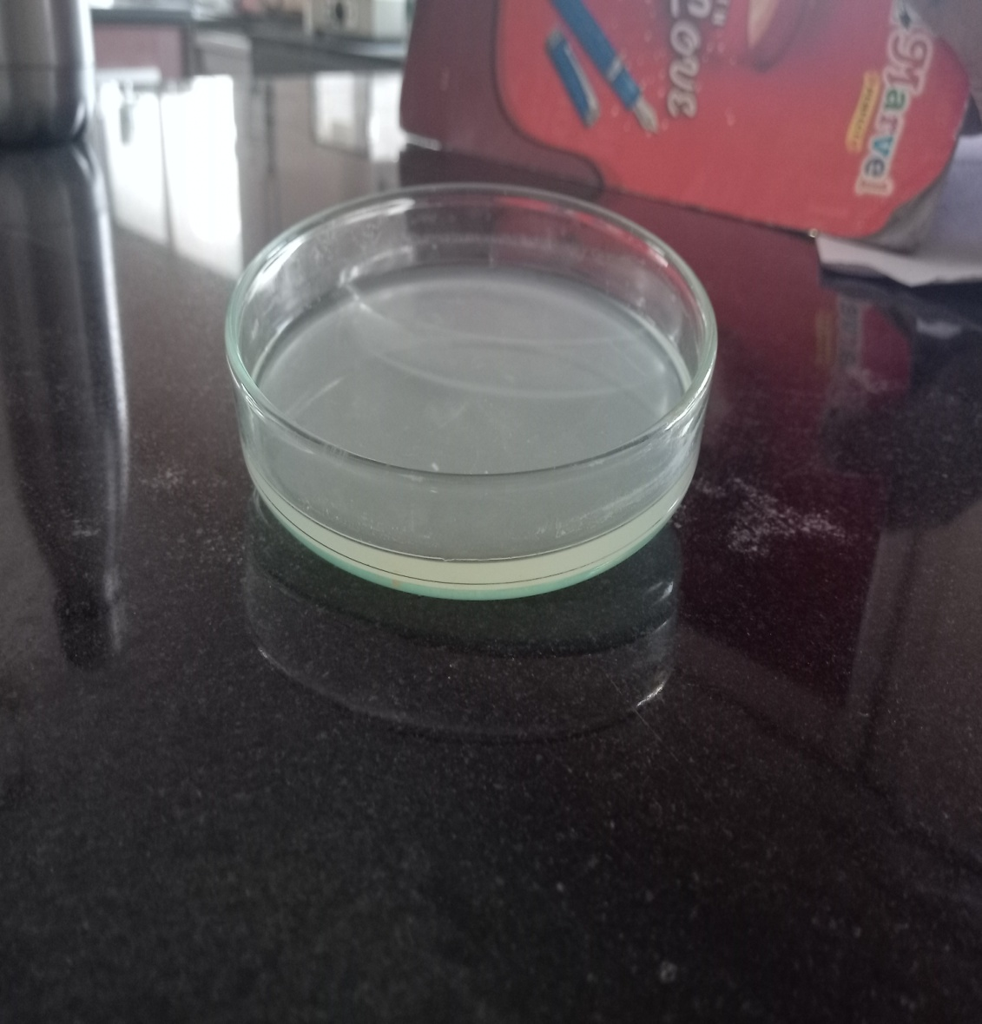
Table 1
Synthesis of Cellulose hydrogel using varying concentration of lithium
hydroxide and Urea
S.No | Cellulose (wt %) | Lithium Hydroxide (wt %) | Urea  (wt %) | Formation of Hydrogel
1 | 4 | 4 | 15 | -
2 | 4 | 4.6 | 15 | -
3 | 4 | 5 | 15 | -
4 | 4 | 6 | 15 | -
5 | 4 | 8 | 15 | Slightly viscous
6 | 4 | 4 | 12 | -
7 | 4 | 6 | 12 | -
8 | 4 | 8 | 12 | -
9 | 4 | 4 | 18 | -
10 | 4 | 6 | 18 | Slightly viscous
11 | 4 | 8 | 18 | +
Caiet al. (2006) reported that LiOH:urea:H₂O of4.6:15:80.4 by weight resulted in the formation of cellulose hydrogel. Whereas in the present study the gel is not obtained by adding 4.6% LiOH and 15% Urea, therefore the percentage of the both the chemicals were raised to 8% and 18% respectively and to this mixture a cross linking agent i.eepichlorohydrin is been added and stirred vigorously to reach the gelling capacity. The post treatment involves in keeping the mixture that is stirred in hot air oven for about 4 hours to obtain the transparent cellulose hydrogel.
4.1.2 Characterization of cellulose hydrogel
UV- Visible Spectroscopy
Transparency analysis of cellulose hydrogel was measured using UV-Visible spectroscopy. The hydrogel were cut into desired shape for transparency analysis and spectra recorded from 200 to 800 nm which is shown in Figure 4.
Figure 4
UV- Visible spectra of cellulose hydrogel
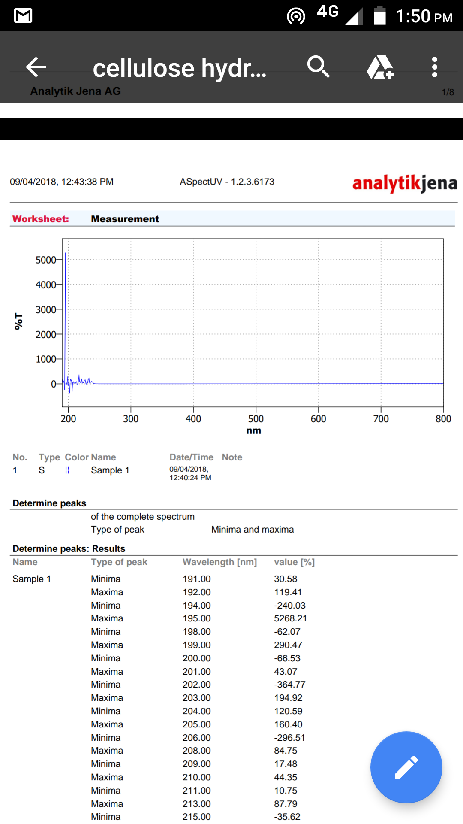
The characteristic absorption peak of the individual cellulose hydrogel appears a sharp peak around 198nm. Other peaks are absorbed around 220, 230 and 235nm and the spectra extends to 800nm. This shows the transmittance and the transparency of the gel.
Peng et al.(2017) reported the transmittance of the cellulose hydrogels showed the wavelength range of 200–800 nm.
Swelling Property
The swelling ratio is calculated by weighing the swollen gel and the cellulose hydrogel for a period of 5 days and result is presented in Table 2.
Table 2
Swelling ratio and water content of the cellulose hydrogel
Time (Hours) | Swelling ratio (%) | Water Content (%)
6 | 67.5 | 32
12 | 78 | 38
18 | 83.5 | 43
24 | 98.5 | 49
48 | 169 | 67.8
72 | 225 | 67.8
96 | 235 | 67.8
120 | 235 | 67.8
The swelling ratio of the gel gradually increased from 67.5 % and reached a maximum of 235% when immersed in the phosphate buffered saline solution (Table 2). The swelling efficiency of the gel seems to be rapid and it increased to 67.5% within
6 hours. Then the swelling of the gel increased gradually with respect to time. Then the swelling efficiency attained a constant level of about 235% at 4th day. After that the swelling ratio remained the same for the 5th day.
Peng et al. (2016) reported that the swelling ratio of Quaternized cellulose hydrogels ranging from 206.6 g/g to 983.9 g/g. Chang et al. (2008) stated the swelling degree of chemically crosslinked hydrogels was nearly 7000, indicating a high swelling. However, the degree of swelling degree of the physical crosslinked hydrogels was only 1000.
Water Content
The water content of the cellulose hydrogel was determined by weighing the heat dried gel at regular interval and it is present in Table 2.
The water content of the hydrogel was increased from 32 % to 67.8 % on 3rd day remained same upto 5th day.
Choeet al. (2017) reported the water content of microcrystalline cellulose as 2% and high strength microcrystalline Cellulose hydrogel as 96%.
4.2 Immobilization of laccase by Physical Adsorption
The cellulose hydrogel that is obtained is cut out into small beads with the help of the gel puncture. The beads that are obtained is weighed and each bead weigh roughly between 50 to 60 mg.Cellulose beads (500 mg) was immobilized with 26.8U of Tramatesversiocolorlaccase and incubate at 25°C with shaking of 120rpm for 5 hours. After the physical adsorption the beads are filtered. Then the beads are washed with acetate buffer pH 5.0 for 3 times. The laccase activity, specific activity, immobilization yield was calculated and is presented in Table 3.

Plate 2
Immobilized Cellulose Hydrogel beads
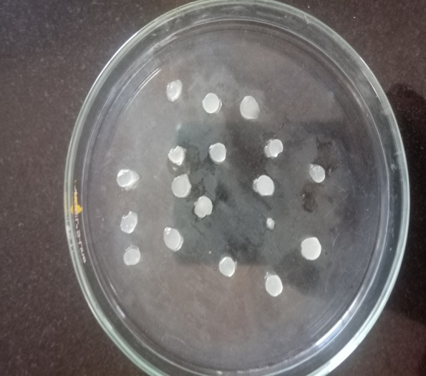
Table 3
Laccase activity Specific activity and immobilization yield of cellulose hydrogel
Time  (Hours) | Laccase Activity  (Units/mg) | Specific Activity  (Units/mg) | Immobilization  Yield(%)
1 | 0.285 | 0.212 | 7.1
2 | 0.714 | 0.532 | 17.8
3 | 1.285 | 0.958 | 32.1
4 | 1.857 | 1.385 | 45.3
5 | 2.571 | 1.918 | 64.3
The immobilization yield and loading efficiency of laccase on cellulose hydrogel was found to be 64.3% and 74.2 % respectively. Kim et al. (2012) reported that immobilization yield for lipase on cellulose hydrogel beads as 24%.
4.3. Characterization of immobilized hydrogel
4.3.1 Scanning Electron Microscope (SEM)analysis
The surface morphology of the cellulose hydrogel and laccase immobilize cellulose hydrogel was analysed using the Scanning Electron Microscopy. The untreated cellulose hydrogel is with diameter ranging between 10-20µm. The surface of the cellulose beads are found to be loosely packed, permeable membrane, rough and also porous in nature (Figure 5a). The immobilized cellulose hydrogel was found to be tightly packed, interconnected, compact and complex that is shown in the Figure 5b.
Figure 5
Scanning electron micrograph showing morphology of cellulose hydrogel and laccase immobilized cellulose hydrogel
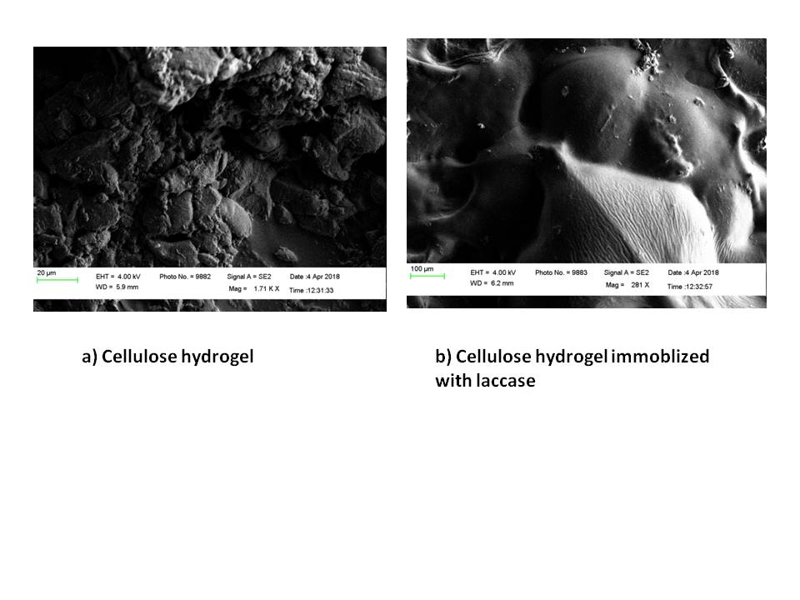
Fourier transform-infrared spectroscopy (FT-IR) Analysis
An FTIR spectrum for the untreated cellulose hydrogel and the immobilized cellulose hydrogel is shown in Figure 6a and 6b.
Figure 6a
FTIR spectrum of untreated cellulose hydrogel
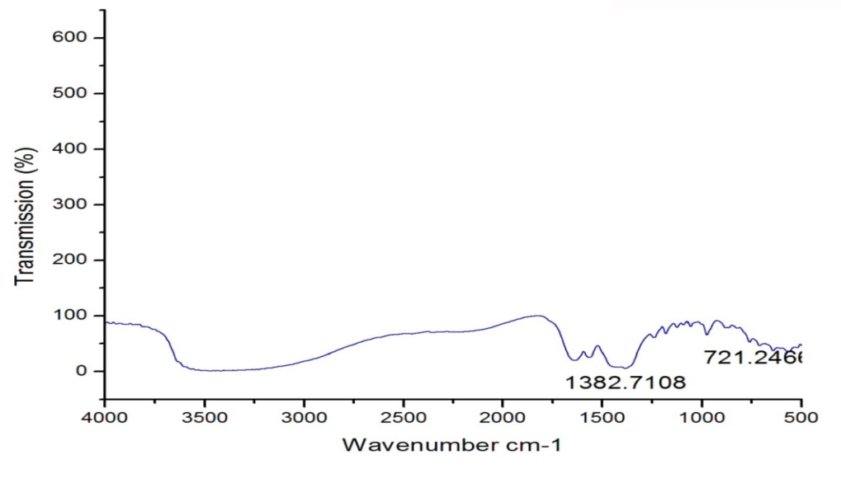
Figure 6b
FTIR spectrum of laccase immobilized cellulose hydrogel
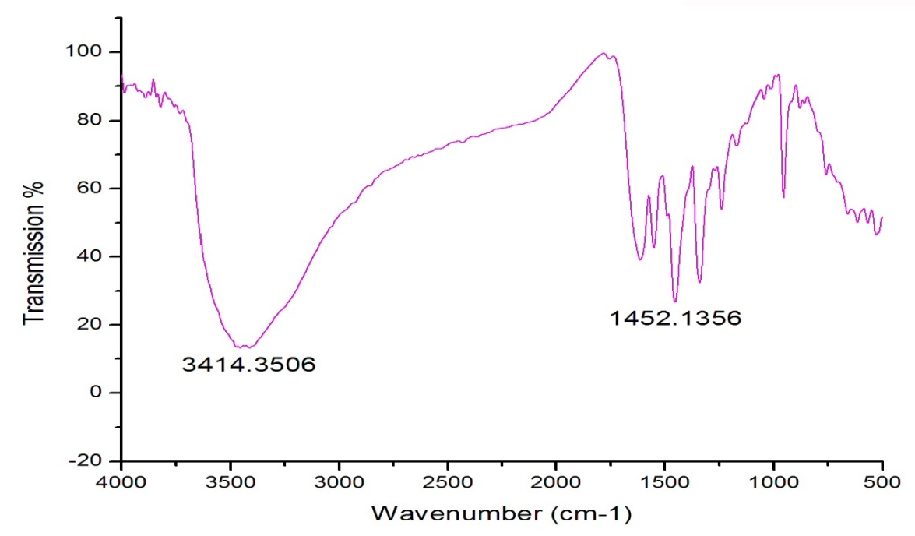
In the untreated cellulose hydrogel there were slight peaks at 3500 cm⁻¹ was assigned to O-H stretching vibration. Moreover, the presence of another additional absorption at 1382.71 and 721.42 cm⁻¹ was assignable to the C-N stretching vibration in spectrum. Whereas in the immobilized cellulose hydrogel there is a sharp peak at 3414.35 cm⁻¹ was assigned to O-H stretching vibration and the 1452.13 cm⁻¹ was assignable to the C-N stretching vibration in spectrum.
Cai et al. (2005) reported a peak of 3200-3400 cm⁻¹ during the dissolution of cellulose at low temperatures.
4.4 Kinetic parameters of free and immobilized laccase on cellulose hydrogel
4.4.1 Effect of pH
The optimum pH for the free laccase and for the immobilization oflaccase on cellulose hydrogel was carried out in the pH range 3–7 with ABTS as substrate.
The initial activity of the free enzyme and immobilized enzyme is 1.89 U and 2.89 U respectively. The enzyme activity and specificity of free and immobilized enzyme is shown in Table 4. The relative activity was calculated and is presented in Figure 4.

Table 4
Laccase activity and specific activity of free enzyme and immobilized gel for different pH
pH | Immobilized enzyme  Units/mg | Specific Activity of Immobilized enzyme  Units/mg | Free enzyme  Units/ml | Specific Activity of Free enzyme  Units/ml
3 | 1.571 | 1.172 | 0.571 | 0.426
4 | 2.000 | 1.492 | 1.571 | 1.172
5 | 2.571 | 1.918 | 1.142 | 0.852
6 | 2.285 | 1.705 | 1.285 | 0.958
7 | 0.571 | 0.426 | 0.428 | 0.319

Figure 7
Effect of pH

A bell shaped curve was obtained for free laccase in the studied pH range with the maximum activity at pH 4.0. The immobilization enzyme was also studied in the same pH range, a bell shaped curve was obtained with a maximum reaching at pH 5.0. The activity of the immobilized cellulose hydrogel was found to be 2.571 Units/mg and the specific activity was also found to be 1.918Units/mg as stated in the Table 4. Wheareas the free enzyme activity was found to be 1.515 Units/mg and the specific activity of the enzyme was found to be 1.172 Units/mg at pH 4.
Mazlan et al. (2017) reported that the optimum pH for the free laccase is pH4 and the immobilized enzyme is pH 5.
4.4.1 Effect of Temperature
The effect of temperature on free laccase and the immobilized laccase were investigated at pH 5.0 in the range 20 to 80 °C. The initial activity of the free enzyme and immobilized enzyme is 1 U and 2.5 U respectively. The enzyme activity and specificity of free and immobilized enzyme is shown in Table 5.The relative activity was calculated and is presented in Figure 8.
Table 5
Laccase activity and specific activity of free enzyme and immobilized gel for different temperature
Temperature  (°C) | Immobilized enzyme  Units/mg | Specific Activity of Immobilized enzyme  Units/mg | Free enzyme  Units/ml | Specific Activity of Free enzyme  Units/ml
20 | 1.571 | 1.172 | 0.285 | 0.212
30 | 1.000 | 0.746 | 0.428 | 0.319
40 | 1.428 | 1.065 | 0.857 | 0.639
50 | 2.000 | 1.492 | 0.714 | 0.538
60 | 1.714 | 1.279 | 0.571 | 0.426
70 | 1.285 | 0.958 | 0.428 | 0.319
80 | 0.714 | 0.532 | 0.142 | 0.105

Figure 8
Effect of Temperature

The maximum activity of free laccase was observed at 40°C with specific activity of 0.538 U/ml. In case of immobilized laccase, the maximum activity was observed at 50°C with specific activity of 1.492 U/ml. The results showed that enzyme activity is more susceptible to temperature in freestate than immobilized state. Thus immobilization results in increased thermostability of laccase.
Zhou et al. (2017) stated the optimum temperature of laccase for free enzyme at 55-65°C and immobilized laccase at 60°C.
4.4.3 Km and Vmax
Kinetic parameters (Km and Vmax) for the activity of free and immobilized laccase was calculated using the Line-Weaver Burk (LB) plot using ABTS (8 to 64μM) as substrate. The LB Plot is shown in Figure 9.

Figure 9
Line –Weaver Burk plot of free and immobilized laccase

The Km values signify the extent to which the enzymes have access to the substrate molecules. The lower Km value indicate high affinity of enzyme toward the substrate. The Km value of the free enzyme (82.3μM) is lower than immobilized enzyme (111 μM), indicating the affinity of enzyme towards ABTS is decreased after immobilization. The Vmax value of the free laccase and immobilized laccase was found to be 21.23 and 40.48 μM/ Min.
Rotkovaet al. (2009) reported the Km value of Trametesversicolor as 0.0337mM for the substrate ABTS. Bayramoglu and Arica(2009) stated the Km of free and immobilized laccase as 10mM and 23mM and the corresponding Vmax was found to be 21.7 and 15.4 Units/mg. Bayramogluet al.(2010) reported the Km of free and immobilized laccase as 9.4mM and 19.7mM and the corresponding Vmax as 21.7 and 15.6 Units/mg. Dodor et al.(2004) stated the Km of free and immobilized laccase as 0.262mM and 0.165mM and the corresponding Vmax was found to be 5.2 and
3.5 Units/mg. Makas et al.(2010) stated the Km of free and immobilized laccase as
6.7 x 10⁻³mM and 2.52 x 10⁻²mM and the corresponding Vmax was found to be 1.8·10−3 mM/min and 6.8·10−3 mM/min

4.5 Dye degradation Studies
Percentage degradation of RBBR by Immobilized Laccase
The immobilized laccase can degrade the RBBR solution. The percent degradation of RBBR of immobilized laccase is present in Table 6 and Figure 10.
Table 6
Percentage degradation of RBBR by Immobilized laccase
Time (Min) | Free laccase | Immobilized laccase
30 | 1.11 | 0.90
60 | 1.8 | 1.81
90 | 2.7 | 2.72
120 | 2.9 | 4.76
150 | 3.6 | 5.45
180 | 5.4 | 7.2
After 24 hour | 11.7 | 19.5
Figure 10
Percentage Degradation of RBBR by Immobilized Laccase

The percentage degradation of RBBR was found to be increase with increase in time of incubation from 30 minutes to 3 hours for both free and immobilized enzyme. And the Percentage degradation was more with immobilized enzyme when compared to free laccase after 24 hours of incubation.

5.0 SUMMARY AND CONCLUSION
Laccase are multicopperoxidoreductive enzymes that has the ability to degrade a large number of pollutants and also a wide variety complex polymers. In order to enhance the ability of these enzymes they are been immobilized. Laccase are immobilized on different supports by different immobilization techniques such as adsorption, encapsulation, entrapment or covalent attachment. These immobilized enzymes are used in several biotechnological applications and biodegradation studies.
Cellulose is the most commonly used polysaccharide that is complex in nature. Cellulose is the highly stable biopolymer with linear chains and they are both crystalline and amorphous in nature. Hydrogels are natural polymers and they are also possess several applications. Cellulose hydrogels are hydrophilic in nature and possess several indigenous applications. They act as good support for the enzymes.
In the present study the cellulose hydrogel were prepared with 8% lithium hydroxide, 18% urea and 4 % cellulose with epichlorohydrin as cross linking agent.
The characterization of the gel was carried out by doing UV-Visible spectroscopy, swelling properties and water content. In UV-Visible spectroscopy the cellulose hydrogel showed the transmittance ranging from 200-500 nm. This showed the clear transparency of the gel. The swelling properties of the cellulose hydrogel showed good swelling ratio of about 235% for a period of 5 days. The water content of the cellulose hydrogel was found to be 67.8 % at the end of 5 days.
The immobilization of the laccase enzyme on cellulose hydrogel was carried out by physical adsorption. The immobilization yield and the loading efficiency was 64.3% and 74.2 % respectively.
The immobilized cellulose hydrogel and untreated cellulose hydrogel was characterized by scanning electron microscopy and fourier transform infrared spectroscopy. The SEM results showed the loosely packed and porous nature of the cellulose hydrogel and the immobilized cellulose hydrogel are high complex, tightly packed and interconnected in nature. The FTIR analysis showed the O-H stretching of the spectrum at a correct range between 3200-3400cm⁻¹ in both cellulose hydrogel and immobilized hydrogel. There are also C-N stretching vibration in the spectrum of both the gels.
The optimum pH of free enzyme and immobilized enyzyme was found to be pH 4 and pH 5. The optimum temperature of free enzyme and immobilized enzyme was found to be 40°C and 50°C. The Km value of the free enzyme (82.3μM) is lower than immobilized enzyme (111 μM), indicating the affinity of enzyme towards ABTS is decreased after immobilization. The Vmax value of the free laccase and immobilized laccase was found to be 21.23 and 40.48 μM/ Min. The dye degradation studies showed the percentage degradation was more with immobilized enzyme when compared to free laccase after 24 hours of incubation.
To conclude, the laccase immobilized on cellulose hydrogel was found to have good catalytic efficiency and can be used for wide variety of biotechnological applications.
Future Studies
- Thermogravimetric analysis of treated and laccase immobilized cellulose hydrogel.
- Storage stability
- Reusability of immobilized gel for degradation

BIBLIOGRAPHY
- Ahmad R. and Sardar M. (2015) Enzyme Immobilization: An Overview on Nanoparticles as Immobilization Matrix, Biochemistry and Analytical Biochemistry, 4(2)1-8
- Akhtar, M.F., Hanif, M. and Ranjha, N.M. (2016) Methods of synthesis of hydrogels -A review, Saudi Pharmaceutical Journal, 24:554–559
- Anwar Z., Gulfraz, M. and Irshad M. (2014) Agro-industrial lignocellulosic biomass a key to unlock the future bio-energy: A brief review, Journal of Radiation Research and Applied Sciences, 7:163-173
- Barbosa, O., Torres, R., Ortiz C., Berenguer-Murcia, A., Rodrigues, R.C. and Fernandez-Lafuente, R. (2013) Heterofunctional Supports in Enzyme Immobilization: From Traditional Immobilization Protocols to Opportunities in Tuning Enzyme Properties, Biomacromolecules, 14:2433−2462
- Bayramoglu, G., Yilmaz, M. and Arica, M.Y. (2010) Reversible immobilization of laccase to poly(4-vinylpyridine) grafted and Cu(II)chelated magnetic beads: Biodegradation of reactive dyes, Bioresource Technology, 101:6615–6621
- Bayramoglu, G. and Arıca, M.Y. (2009) Immobilization of laccase onto poly(glycidylmethacrylate) brush grafted poly(hydroxyethylmethacrylate) films: Enzymatic oxidation of phenolic compounds, Materials Science and Engineering, 29:1990–1997.
- Beck, S., Berry, E., Duke, S., Milliken, A., Patterson, H., Prewett, D.L., Rae, T. C., Sridhar, V., Wendland, N., Gregory, B.W. and Johnson, C.M. (2018) Characterization of Trametesversicolorlaccase-catalyzed degradation of estrogenic pollutants: Substrate limitation and product identification, International Biodeterioration& Biodegradation, 127:146–159
- Cai, J. and Zhang, L. (2006) Rapid Dissolution of Cellulose in LiOH/Urea andNaOH/Urea Aqueous Solutions, Macromolecular Bioscience, 5:539–548
- Cai, J., Zhang, L., Liu, S., Liu, Y., Xu, X., Chen, X., Chu, B., Guo, X., Xu, J., Cheng, H., Han, C. C. and Kuga S. (2008) Dynamic Self-Assembly Induced Rapid Dissolution of Cellulose atLow Temperatures, Macromolecules, 41:9345-9351
- Calo, E. and Khutoryanskiy, V.V. (2015) Biomedical applications of hydrogels:
A review of patents and commercial products, European Polymer Journal, 65:
252–267
- Chang, C., Lue, A. andZhang, L. (2008) Effects of Crosslinking Methods on Structur and Properties of Cellulose/PVA Hydrogels, Macromol. Chem. Phys., 209:1266–1273
- Choe, D., Kim, Y.M., Nam, J.E., Nam K., Shin, C.S. and Roh, Y.H. (2018) Synthesis of high-strength microcrystalline cellulose hydrogel by viscosity adjustment, Carbohydrate Polymers, 180:231–237
- Dai, H. and Huang, H. (2016) Modified pineapple peel cellulose hydrogels embedded with sepia inkfor effective removal of methylene blue, Carbohydrate Polymers, 148:1–10
- Datta, S., Christena, L.R. and Rajaram, Y.R.S. (2013) Enzyme immobilization: an overview on techniques and support materials, Biotechnology, 3:1–9
- Dincer, A., Becerik, S. and Aydemir, T. (2012) Immobilization of tyrosinase on chitosan–clay composite beads, InternationalJournal of Biological Macromolecules, 50:815– 820
- Dodor, D.E., Hwang, H.M. and Ekunwe, S.I.N. (2004) Oxidation of anthracene and benzo[a]pyrene by immobilized laccase from Trametesversicolor, Enzyme and Microbial Technology, 35:210–217
- Eyley, S. and Thielemans, W. (2014)Surface modification of cellulose nanocrystals, Nanoscale, 6:7764–7779
- Fernandez-Fernandez, M., Sanroman, M.A. and Moldes, D. (2013) Recent developments and applications of immobilized laccase, Biotechnology Advances, 31:1808–1825
- Geng, H. (2018) A one-step approach to make cellulose-based hydrogels of various transparency and swelling degrees, Carbohydrate Polymers, 1-24
- Ghasemi, M., Tsianou, M. and Alexandridis, P. (2017) Assessment of solvents for cellulose dissolution, Bioresource Technology, 228:330-338
- Gyles, D.A., Castro, L.D., Silva J.O. C. and Ribeiro-Costa, R.M. (2017) A review of the designs and prominent biomedical advances of natural and synthetic hydrogel formulations, European Polymer Journal, 88:373–392
- Habibi, Y. (2014)Key advances in the chemical modification of nanocelluloses, Chemistry Society Reviews, 43:1519-1542
- Heinze, T. (2015) Cellulose: Structure and Properties, Advanced Polymer Science, 1-52
- Homaei, A.A., Sariri, R.,Vianello, F. and Stevanato, R. (2013) Enzyme immobilization: an update, Journal of Chemical Biology, 6:185–205
- Huber, D., Grzelak, A., Baumann, M., Borth, N., Schleining, G., Nyanhongo, G.S. and Guebitz G.M. (2018) Anti-inflammatory and anti-oxidant properties of laccase-synthesized phenolic-O-carboxymethyl chitosan hydrogels, New Biotechnology, 40:236–244
- Isobe, N., Noguchi, K., Nishiyama, Y., Kimura, S., Wada, M. and Kuga, S. (2013) Role of urea in alkaline dissolution of cellulose, Cellulose, 20:97–103
- Jesionowski, T., Zdarta, J. and Krajewska, B. (2014) Enzyme immobilization by adsorption: a review, Adsorption, 20:801–821
- Jia, F., Narasimhan, B. and Mallapragada, S. (2014) Materials-Based Strategies for Multi-Enzyme Immobilization and Co-Localization: A Review, Biotechnology and Bioengineering, 111( 2):209-222
- Kalkan, N.A., Aksoy, S., Aksoy, E.A. and Hasirci, N. (2012) Preparation of Chitosan-Coated Magnetite Nanoparticles and Application for Immobilization of Laccase, Journal of Applied Polymer Science, 123:707–716
- Keshk, S.M.A.S. (2015) Effect of different alkaline solutions on crystalline structure ofcellulose at different temperatures, Carbohydrate Polymers, 115:658–662
- Kim, J.H., Shim, B.S., Kim, H.S., Lee, Y.J., Min, S.K., Jang, D., Abas, Z. and Kim J. (2015) Review of Nanocellulose for Sustainable Future Materials, International Journal of Precision Engineering and Manufacturing-Green Technology, 2(2):197-213
- Kim, M.H., An, S., Won, K., Kim, H.J. and Lee S.H. (2012) Entrapment of enzymes into cellulose–biopolymer composite hydrogel beads using biocompatible ionic liquid, Journal of Molecular Catalysis B: Enzymatic, 75:68– 72
- Kimura, M., Shinohara, Y., Takizawa, J., Ren, S., Sagisaka, K., Lin, Y., Hattori, Y. and Hinestroza J.P. (2015) Versatile Molding Process for Tough Cellulose Hydrogel Materials, Scientific Reports, 5:16266,1-8
- Lin, J., Liu, Y., Chen, S., Le, X., Zhou, X., Zhao, Z., Ou, Y. and Yang, J. (2016) Reversible immobilization of laccase onto metal-ion-chelated magnetic microspheres for bisphenol A removal, International Journal of Biological Macromolecules, 84:189–199
- Lin, J., Fan, L., Miao, R., Le, X., Chen, S. and Zhou, X.(2015) Enhancing catalytic performance of laccase via immobilization on chitosan/CeO2microspheres, International Journal of Biological Macromolecules, 78:1–8
- Liu, Y. and Chen, J.Y. (2016) Enzyme immobilization on cellulose matrixes, Journal of Bioactive and Compatible Polymers, 1–15
- Luo, X. and Zhang L. (2013) New solvents and functional materials prepared from cellulose solutions in alkali/urea aqueous system, Food Research International, 52:387–400
- Makas, Y.G., Kalkan, N.A., Aksoy, S., Altinok, H. andHasirci, N. (2010) Immobilization of laccase in κ-carrageenan based semi-interpenetrating polymer Networks, Journal of Biotechnology, 148:216–220
- Margot, J., Maillard, J., Rossi, L., Barry, D.A. and Holliger C. (2013) Influence of treatment conditions on the oxidation of micropollutants by TrametesVersicolorlaccase, New Biotechnology, 30( 6):803-813
- Mazlan, S.Z. and Hanifah, S.A. (2017) Effects of Temperature and pH on Immobilized Laccase Activity in Conjugated Methacrylate-Acrylate Microspheres, International Journal of Polymer Science,1-8
- Medronho, B. and Lindman, B. (2015) Brief overview on cellulose dissolution/regeneration interactions and mechanisms, Advances in Colloid and Interface Science, 222:502–508
- Mohammed, L., Ansari, M. N. M., Pua, G., Jawaid, M. and Islam, M.S. (2015) A Review on Natural Fiber Reinforced Polymer Composite and Its Applications, International Journal of Polymer Science, 1-15
- Napso, S., Rein, D.M., Khalfin, R., Kleinerman, O. and Cohen, Y.(2016) Cellulose gel dispersion: From pure hydrogel suspensions to encapsulated oil-in-water emulsions, Colloids and Surfaces B: Biointerfaces, 137:70–76
- Navarra, M.A., Bosco, C.D., Moreno, J.S., Vitucci, F.M., Paolone, A. and Panero, S. (2015) Synthesis and Characterization of Cellulose-Based Hydrogels to Be Used as Gel Electrolytes, Membranes, 5: 810-823
- Nery, E.W. and Kubota, L.T. (2015) Evaluation of enzyme immobilization methods for paper-based devices—A glucose oxidase study, Journal of Pharmaceutical and Biomedical Analysis, 1-24
- Park, S., Kim, S.H., Kim, J.H., Yu, H., Kim, H.J., Yang, Y.H., Kim, H., Kim, Y.H., Ha, S.H. and Lee, S.H. (2015) Application of cellulose/lignin hydrogel beads as novel supports for immobilizing lipase, Journal of Molecular Catalysis B: Enzymatic, 119:33–39
- Peng, H., Wang, S., Xu H.andHao, X. Preparation, properties and formation mechanism of cellulose/polyvinyl alcohol bio-composite hydrogel membranes, New J. Chem., 2017, 41: 6564—6573
- Peng, N., Wang, Y., Ye, Q., Liang, L., An, Y., Li, Q. and Chang, C. (2016) Biocompatible cellulose-based superabsorbent hydrogels withantimicrobial activity, Carbohydrate Polymers, 137:59–64
- Pircher, N., Carbajal, L., Schimper, C., Bacher, M., Rennhofer, H., Nedelec, J.M., Lichtenegger, H.C., Rosenau, T. and Liebner, F. (2016) Impact of selected solvent systems on the pore and solid structure of cellulose aerogels, Cellulose, 23:
1949–1966
- Polak, J. and Wilkolazka, A.J. (2012) Fungal laccases as green catalysts for dye synthesis, Process Biochemistry, 47:1295–1307
- Ramirez-Montoya, L.A., Hernandez-Montoya, V., Montes-Moran, M.A., Jauregui-Rincon, J. and Cervantes, F.J. (2015) Decolorization of dyes with different molecular properties using free and immobilized laccases from Trametesversicolor, Journal of Molecular Liquids, 212:30–37
- Ravikumar, G., Kalaiselvi, M., Gomathi, D., Vidhya, B., Devaki, K. and Uma, C. (2013) Effect of laccase from Hypsizygusulmarius in decolorization of different dyes, Journal of Applied Pharmaceutical Science, 3:150-152
- Rotkova, J., Sulakova, R., Korecka, L., Zdrazilova, P., Jandova, M.,Lenfeld, J., Horak, D. and Bilkova Z. (2009) Laccase immobilized on magnetic carriers for biotechnology applications, Journal of Magnetism and Magnetic Materials, 321:1335–1340
- Saba, N., Tahir, P.M. and Jawaid, M. (2014) A Review on Potentiality of Nano Filler/Natural Fiber Filled Polymer Hybrid Composites, Polymers, 6:2247-2273
- Sampaio, L.M.P., Padrao, J., Faria, J., Silva, J.P., Silva, C.J., Dourado, F. and Zille, A. (2016) Laccase immobilization on bacterial nanocellulose membranes:Antimicrobial, kinetic and stability properties, Carbohydrate Polymers, 145:1–12
- Sathishkumar, P., Kannan, S.K., Cho, M., Kim, J.S., Hadibarata, T., Salim, M.R. and Oh, B.T. (2014) Laccase immobilization on cellulose nanofiber: The catalytic efficiencyandrecyclic application for simulated dye effluent treatment, Journal of Molecular Catalysis B: Enzymatic, 100:111– 120
- Senthivelan, T., Kanagaraj, J. and Panda, R.C. (2016) Recent Trends in Fungal Laccase for Various Industrial Applications:An Eco-friendly Approach - A Review, Biotechnology and Bioprocess Engineering, 21: 19-38
- Sharifi, M., Robatjazi, S.M., Sadri, M. and Mosaabadi, J.M. (2018) Covalent immobilization of organophosphorus hydrolase enzyme on chemically modified cellulose microfibers: Statistical optimization and Characterization, Reactive and Functional Polymers, 124:162-170
- Sheldon, R.A. and Pelt, S.V. (2013) Enzyme immobilisation in biocatalysis: why, what and how, Chemical Society Reviews, 42:6223-6235
- Shen, X., Shamshina, J.L., Berton, P., Gurau, G. and Rogers R.D. (2016) Hydrogels based on cellulose and chitin:fabrication, properties, and applications, Green Chemistry, 18:53–75
- Sirisha, V.L., Jain, A., and Jain, A. (2016) Enzyme Immobilization: An Overview on Methods, Support Material, and Applications of Immobilized Enzymes, Advances in Food and Nutrition Research, 1-33
- Skoronskia, E., Souza, D.H., Ely C., Broilo, F., Fernandes, M., Junior, A.F. and Ghislandi, M.G. (2017) Immobilization of laccase from Aspergillusoryzae on grapheme nanosheets, International Journal of Biological Macromolecules, 99:121–127
- Spinelli, D., Fatarella, E., Michele, A.D. and Pogni, R. (2013) Immobilization of fungal (Trametesversicolor) laccase onto Amberlite IR-120 H beads: Optimization and characterization, Process Biochemistry, 48:218–223
- Sun, H., Yang, H., Huang, W. and Zhang, S., (2015) Immobilization of laccase in a sponge-like hydrogel for enhanced durability in enzymatic degradation of dye pollutants, Journal of Colloid and Interface Science, 450:353–360
- Tavares, A.P.M., Silva, C.G., Drazic, G., Silva, A.M.T., Loureiro, J.M. and
Faria, J.L. (2015) Laccase immobilization over multi-walled carbon nanotubes: Kinetic,thermodynamic and stability studies,Journal of Colloid and Interface Science, 454:52–60
- Vaghari, H., Malmiri, H.J., Mohammadlou, M., Berenjian, A., Anarjan, N., Jafari, N. and Nasiri, S. (2016) Application of magnetic nanoparticles in smart enzyme immobilization, Biotechnology Letters, 38:223–233
- Wang, S., Lu, A. and Zhang, L. (2016) Recent advances in regenerated cellulose materials, Progress in Polymer Science, 53:169–206
- Xu, Q., Chen, C., Rosswurm, K., Yao, T. and Janaswamy S. (2016) A facile route to prepare cellulose-based films, Carbohydrate Polymers, 149:274–281
- Yang, J., Han, C.R., Duan, J.F., Xu, F. and Sun R.C. (2013) Mechanical and Viscoelastic Properties of Cellulose Nanocrystals Reinforced Poly(ethylene glycol) Nanocomposite Hydrogels, ACS Applied Materials and Interfaces, 5:3199−3207
- Yin, Y., Tian, X., Jiang, X., Wang, H. and Gao, W. (2016) Modification of cellulose nanocrystal via SI-ATRP of styrene and the mechanism of its reinforcement of polymethylmethacrylate , Carbohydrate Polymers, 142:206–212
- Zhou, J.,Chang, C., Zhang, R. and Zhang, L. (2007) Hydrogels Prepared from UnsubstitutedCellulose in NaOH/Urea Aqueous Solution, Macromolecular Bioscience, 7:804–809
- Zhou, W., Guan, Z.B., Cai, Y.J., Chen, Y., Zhang, N. andLia, X.R. (2017) Preparation and characterization of Immobilized Spores with laccase activity from Bacillus pumilusW3 on DEAE cellulose and their application in dye discolorization, Brazilian Journal of Chemical Engineering, 34: 41 – 52.

APPENDIX-I
BRADFORD ASSAY
Principle
The Bradford protein assay is used to measure the concentration of total protein in a sample. The principle of this assay is that the binding of protein molecules to Coomassie dye under acidic conditions results in a color change from brown to blue. This method actually measures the presence of the basic amino acid residues, arginine, lysine and histidine, which contributes to formation of the protein-dye complex. Unlike the BCA assay, reducing agents (i.e.,DTT and beta mercaptoethanol) and metal chelators (i.e., EDTA, EGTA) at low concentration do not cause interference. However, the presence of SDS even at low concentrations can interfere with protein-dye binding. This technique was invented by Bradford (1976).
Materials and Reagents
- Bovine Serum Albumin (BSA)
- Coomassie Brilliant Blue G-250
- Methanol
- Phosphoric acid (H₃PO₄)
- Bradford reagent: Dissolve 50 mg of Coomassie Brilliant Blue G-250 in 50 ml of methanol and add 100 ml 85% (w/v)phosphoricacid(H₃PO₄). Add the acid solution mixture slowly into 850 ml of H₂O and let the dye dissolve completely.
Filter using Whatman No.1 paper to remove the precipitates just before use.
Store in a dark bottle at 4 °C.
Procedure
Standard assay procedure (for sample with 5-100 µg ml⁻¹ protein)
  - Prepare five to eight dilutions of a protein (usually BSA) standard with a range of
20 to 100 µg protein.
  - Then take the unknown protein samples.
  - Add about 0.2-1ml each of standard solution and 0.5ml of unknown protein sample to the appropriately labeled test tube. Also set a blank tube.
  - Make up the solutions to about 1 ml in all the tubes with distilled water.
  - Add 1.5 ml of Bradford reagent to each tube and mix well.
  - Incubate at room temperature (RT) for at least 5 min. Absorbance will increase over time; samples should incubate at RT for no more than 1 h.
  - Measure absorbance at 595 nm.

