PREPARATION OF HERBAL NONWOVEN PADS
FOR HEALING PIMPLES

Uma maheswari, S
(12PTF017)

Thesis submitted to the
Avinashilingam Institute for Home Science and
Higher Education for Women
Coimbatore - 641 043

In Partial Fulfillment of the Requirements for the Degree of
Master of Science in Textiles and Fashion Apparel

March, 2014

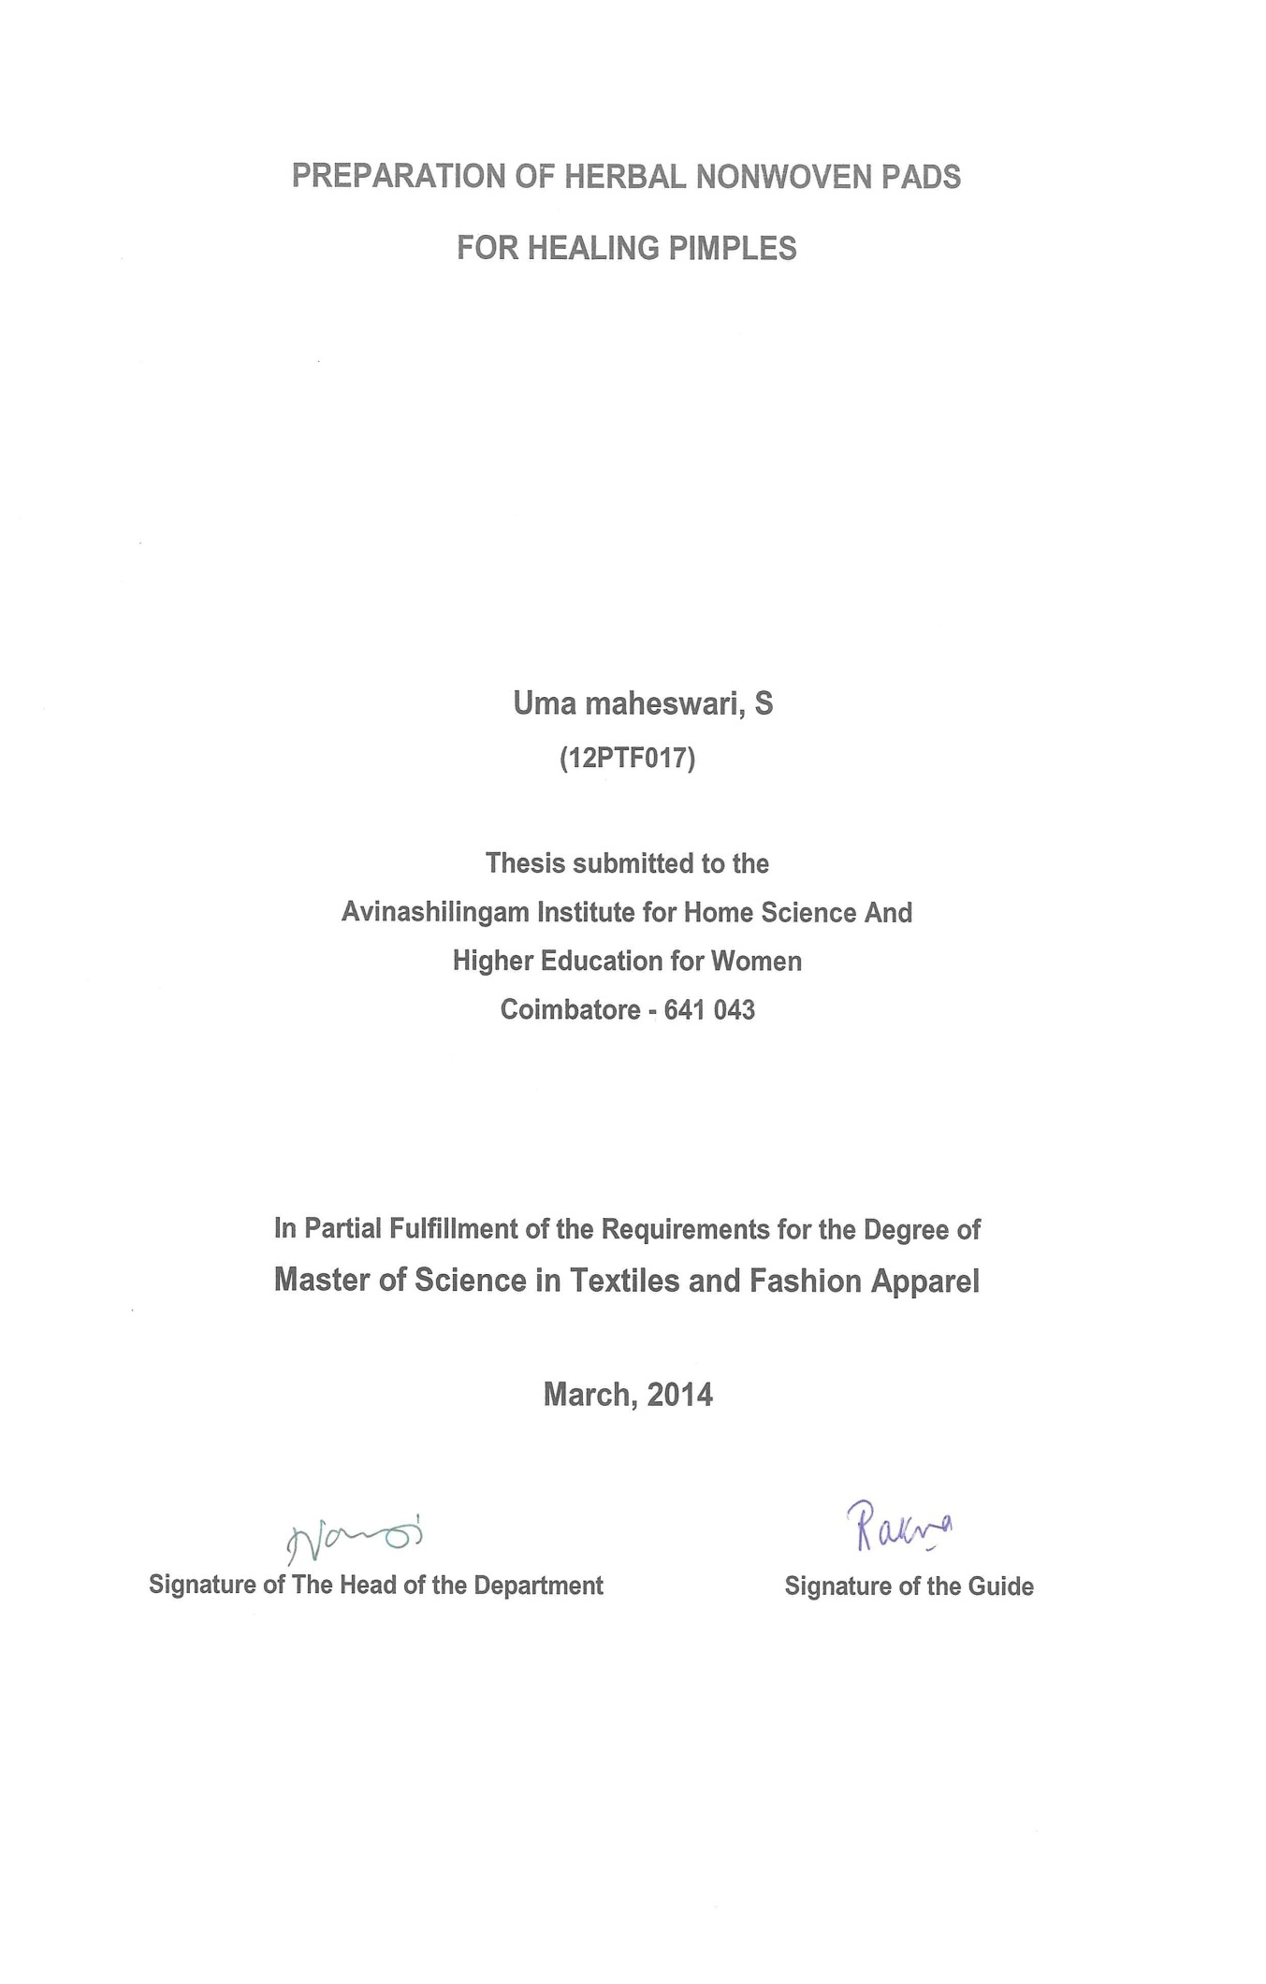

ACKNOWLDEGEMNT

ACKNOWLEDGEMENT
First, the investigator likes to say that she would not have been able to compute this without the ever-evident presence of God Almighty with her. It is the god who gave the courage, wisdom, desertion knowledge, strength, opportunity and will power to keep going all the trying times she had during the course of her project.
The investigator expresses her reverential gratitude to Hon. Colonel Thiru. T.S.AVINASHILINGAM, Founder and First Chancellor of Avinashilingam Institute for Home Science and Higher Education for Women, Coimbatore, University for providing the temple of learning and also for his heavenly blessings. She also owes her deep sense of gratitude to Hon. Colonel Dr. RAJAMMAL P.DEVADAS, Former Chancellor, Avinashilingam Institute for Home Science and Higher Education for Women University, Coimbatore, for blessing.
The investigator expresses her immense gratitude and thankfulness to Thiru.T.K.S.MEENASKSHI SUNDARAM M.A., M.Phil., Ph.D. Chancellor, Avinashilingam Institute for Home Science and Higher Education for Women University, Coimbatore, for his constant support and providing the required infrastructure for caring out the study.
The investigator wishes to extend her sincere thanks to Dr. (Tmt.) SHEELA RAMACHANDRAN M.Sc, PG.Dip., Ph.D. Vice Chancellor, Avinashilingam Institute for Home Science and Higher Education for Women University, Coimbatore, for her ever-ending motivation and encouragement.
The investigator extends her pleasure and sincere thanks to Dr. (Tmt.) GOWRI RAMAKRISHNAN, M.SC., M.Phil., Ph.D. Registrar, Avinashilingam Institute for Home Science and Higher Education for Women University, Coimbatore, for providing facilities during the study.
The investigator takes this opportunity to reveal her sincere and heart full thanks to Dr. (Tmt.) U.K.LAKSHMI M.SC., Dip.Ed, M.Phil., Ph.D. Dean, Faculty of home science and professor and head of the Department of Food Science and Nutrition, Avinashilingam Institute for Home Science and Higher Education for Women University, Coimbatore, for her valuable guidance, timely help and amenities provided for the successful completion of this research work.
The investigator is extremely obliged and thankful to Dr. (Tmt.) N.VASUGI RAJAA M.SC., MBA., M.Phil., Ph.D. Professor and Head , Department of Textiles and clothing, Avinashilingam Institute for Home Science and Higher Education for Women University, Coimbatore, for her encouragement given during the study.
With great sense of the truthfulness the investigator submit her heartfelt thanks to her guide Dr.(Tmt) U.RATNA, M.Sc., M.Phil., Ph.D. Assistant Professor, Department Of Textiles And Clothing, Avinashilingam Institute for Home Science and Higher Education for Women University, Coimbatore, for her great enthusiasm, inspiration, suggestions, continuous encouragement, patience and valuable ideas to complete her study successfully.
Out of deep sense of indebtedness the investigator expresses her sincere thanks to all the staff members and students of the Textiles and Clothing Department who helped her with their constructive suggestions at all times
She is thankful to Avinashilingam Institute for Home Science and Higher Education for Women University, Coimbatore, South Indian Textile Research Association (SITRA) and South Indian Mills Association (SIMA), for providing the library facilities.
Her deep indebtedness and gratefulness to her Parents, Sister, Friends and All Well Wishers for their patience, motivation and constant support throughout the course of the study.

CONTENTS

LIST OF CONTENTS
CHAPTER TITLE PAGNO
LIST OF TABLES
LIST OF FIGURES
LIST OF PLATES
LIST OF APPENDICES
1. INTRODUCTION 1
2. REVIEW OF LITERATURE 4
2.1. Bamboo 5
2.1.1 History of bamboo 5
2.1.2 Processing of bamboo 5
2.1.3 Advantages of bamboo 6
2.1.4 Properties of bamboo 8
2.2. Non woven 9
2.2.1 Origin 9
2.2.2 Classification of non woven structure 10
2.2.3 Processing of non woven 11
2.2.4 Advantages of non wovens 12
2.3. Spun lace 13
2.3.1 History 14
2.3.2 Properties of spun lace 14

CHAPTER TITLE PAGE NO
2.4. Skin 14
2.4.1. Classification of skin 15
2.4.2. Pimples 15
2.4.3. Types of pimples 15
2.5. Medicinal herb 16
2.5.1. History 16
2.5.2. Basil leaves 17
2.6. Finishing 17
2.6.1. Classification of finishes 18
2.6.2. Method of finishing 18
2.7. Cosmeto textiles 19
3. EXPERIMENTAL PROCEDURE 20
3.1 Selection of fabric 21
3.2 Selection of fabric formation 21
3.3 Selection of Medicinal Source 21
3.4 Collection and Extraction of Ocimum basillicum 22
3.4.1 Collection of natural source 22
3.4.2 Extraction of the natural source 22
3.5 Selection of Bacterial Species 23

CHAPTER TITLE PAGE NO
3.6 Finishing of the Fabric 23
3.7 Evaluation 26
3.7.1 Subjective Evaluation 26
3.7.2 Objective Evaluation 26
3.7.2.1. Fabric weight 26
3.7.2.2. Fabric thickness 27
3.7.2.3. Fabric abrasion resistance 27
3.7.2.4. Bursting Strength Tester 27
3.7.2.5. Draping 28
3.7.2.6. Drop Test 28
3.7.2.7. Sinking Test 31
3.7.2.8. Capillary Test 31
3.7.2.9. Antimicrobial Test 31
3.8 Nomenclature 32
3.9 Statistical Analysis 32
4. RESULT AND DISCUSSION 33
4.1 Subjective Evaluation 34
4.2 Objective Evaluation 36
4.2.1. Physical Property Test

CHAPTER TITLE PAGE NO
4.2.1.1. Fabric Weight 36
4.2.1.2. Fabric Thickness 37
4.2.2. Mechanical Property
4.2.2.1. Bursting Strength 39
4.2.2.2. Abrasion Resistance 40
4.2.3. Comfort Property
4.2.3.1. Drapability 42
4.2.4. Absorbency Test
4.2.4.1. Sink Test 43
4.2.4.2. Drop Test 45
4.2.4.3. Capillary Test 46
5. SUMMARY AND CONCLUSION 48
BIBLIOGRAPHY 51
APPENDICES 55

LIST OF TABLES
S.NO TITLE PAGE NO
I EVALUATION OF HERBAL PADS 34
II FABRIC WEIGHT 36
III FABRIC THICKNESS 37
IV BURSTING STRENGTH 39
V ABRASION RESISTANCE 40
VI DRAPABILITY 42
VII SINKING TEST 43
VIII DROP TEST 45
IX CAPILLARY TEST 46
X ANTIBACTERIAL TEST 48

LIST OF FIGURES
S.NO TITLE PAGE NO
I FABRIC WEIGHT 37
II FABRIC THICKNESS 37
III BURSTING STRENGTH 40
IV ABRASION RESISTANCE 40
V DRAPABILITY 43
VI SINKING TEST 43
VII DROP TEST 46
VIII CAPILLARY TEST 46

LIST OF PLATES
S.NO TITLE PAGE NO
I BAMBOO FABRIC 24
II OCIMUM BASILLICUM 24
III BASIL LEAVES POWDER 24
IV SOXHLET APPARATUS 25
V SOURCE EXTRACTION 25
VI PADDING MANGLE 25
VII ANTIBACTERIAL ACTIVITY 25
VIII HERBAL PADS 25
IX FABRIC WEIGHT 29
X THICKNESS GAUGE 29
XI BURSTING STRENGTH TESTER 29
XII ABRASION RESISTANCE TESTER 29
XIII DRAPE METER 30
XIII SINK TEST 30
XIV DROP TEST 30
XV CAPILLARY TEST 30

LIST OF APPENDICES
S.NO TITLE PAGE NO
I Fabric swatches 55
II Ethical Committee Form 56
III Evaluation of Herbal Pads 57

INTRODUCTION

- Introduction
“Face is the index of mind”, when you look good you feel good is a fact. No matter how people look at you and perceive your image, but all the grooming stuff you do is to look good. Similarly, for teenagers looks are even more important than the person inside (Alexander, 2010). Pimple is a common problem that affects about 90 % of teenagers. It occurs during a time of low self esteem and high concern about appearance.
With the growing vogue in enhancing beauty with health, customers request that the apparels and textiles not only have the basic characteristics such as maintaining warmth and providing comfort but also carry extra functions including environmental anti pollution and the most concerned function, health and beauty care in an attempt to provide a more natural and healthier life (Cheuk, 2008).
The world around us is changing rapidly, pacing in terms of culture, fashion and scientific advancements. The life styles of the people became so hectic, that they started searching for things that are easy to use and save their time (Srisha, et.al., 2011) In context to global wellness trends such as “selfness” and “wellbeing” textiles with incorporated active cosmetic ingredients (cosmeto textiles) here become more and more popular (Anton, 2008) Cosmeto textiles are known as the skin moisturizer, vitamins and pro vitamins are applied in garments, designed for wearing in contact with skin.
The textile industry is considered as the most ecologically harmful industry in the world. Environmental impacts occur at every stage of the life cycle of a product. The garment industry has contributed to the global warming from the stage of growing of fibers, yarn fabrication, fabric manufacture, wet processing and manufacturing of the garment, its distribution and transportation to stores and customers, its use by the consumers and finally the disposal of the product. So using of natural fibers for cosmetotextiles possess superior qualities of biodegradability, reusability, and preservation and are much more environment friendly than synthetic fibers in similar conditions and other desirable qualities are conducts heat, resist mildew and block ultra violet light (Subramaniam, 2011).
Being aware of global warming, nowadays consumers look upon eco friendly products. Today people have started looking for “green products” everywhere (Gopalakrishnan & karthik, 2012) Bamboo is a revolutionary new fiber that has unparalleled advantages including strength, versatility, softness and luxurious texture.
Bamboo grows more rapidly than trees and starts to yield within four or five years of planting. The establishment of a bamboo plantation requires a minimal capital investment and builds upon the inherent plant-cultivation skills of local farmers and foresters. Bamboos are excellent for restoring degraded lands and protecting against soil erosion (Rekha and Sudam, 2009).
Nonwoven are an important part of the textile sector and continue to grow in the global market. Over the past three decades, consumption of non woven products has grown at the rate of almost 10% per year. This tremendous growth has been due to their ease of manufacture, higher processing speeds, and ability to produce fabrics with a range of properties at lower cost (Uppal, et.al., 2010) Non-woven have been described by some as invisible fabrics as one uses them without realizing it. Non-woven have been a part of our daily life, and yet we may not even be aware of them (Chakrabarty, 2008).
Hydro entanglement is a versatile process because it can be used to produce non woven with a broad range of end-use properties. These differences are achieved because of a wide range of possible parameter adjustments. The process employs jets of water to entangle fibers and thereby provide web and eventually fabric integrity. The technology was officially introduced by Wilmington-based DuPont obtained five patents on spun laced non woven within the period from 1963 to 1970. Since the 1990s, the technology has been made more efficient and affordable for more manufacturers.
Herbs are known for their medicinal properties and have been used in traditional medicines from time immemorial. The world health organization (WHO) estimates that 4 billion people, 80 percent of the world population, presently use herbal medicine for some aspect of primary care (karthikeyan,et.al., 2010). Plant extracts or seed diffuses could be a substitute for costly chemicals for treatment (Peter, 2012). Basil leaves is a perennial plant which is antiseptic herb with aromatic leaves. It is used for their medicinal properties in Ayurveda (Garland, 2004).
Herbal textile is finished entirely with the herbal extractions without using any sort of chemicals. These herbs are applied directly to the fabric with the help of natural ingredients so that the medicinal value of the herbs kept intact. The trans dermal process of fiber with skin contact, through which the herbs are diffused into the pores of skin to restore vitality with balance for healing health. (Jayalakshmi & Manjusha, 2013) Herbal pads are excellent for treating pimples and speeding up the healing process, it works externally to help rid the body of pimples.
Considering the above points in mind, the investigator has made an attempt to study on “Preparation of Herbal Nonwoven Pads for Healing Pimples” with the following objectives
- Extract the solution from the selected sources
- Analyze anti bacterial property of the source
- Imparting herbal finish on the spun laced bamboo fabric
- Preparation of herbal pads
- Evaluation of herbal pads

REVIEW OF LITERATURE

2. REVIEW OF LITERATURE
The review of literature pertaining to the study on “Preparation of Herbal Nonwoven Pads for Healing Pimples” is discussed under the following headings
2.1. Bamboo
2.1.1 History of bamboo
2.1.2 Processing of bamboo
2.1.3 Advantages of bamboo
2.1.4 Properties of bamboo
2.2. Non woven
2.2.1 Origin
2.2.2 Classification of non woven structure
2.2.3 Processing of non woven
2.2.4 Advantages of non wovens
2.3. Spun lace
2.3.1 History
2.3.2 Properties of spun lace
2.4. Skin
2.4.1. Classification of skin
2.4.2. Pimples
2.4.3. Types of pimples
2.5. Medicinal herb
2.5.1. History
2.5.2. Basil leaves
2.6. Finishing
2.6.1. Classification of finishes
2.6.2. Method of finishing
2.7. Cosmeto textiles
2.1 Bamboo
Bamboo is the fastest growing plant in this planet and has the ability to grow in many different climates from jungles to high on mountain sides. Bamboo is just a grass, but varies in height from dwarf plant (30 m) to giant timber bamboos (30 cm) (Das & Hati, 2010).
Bamboo fiber is a regenerated cellulosic fiber and the raw material is bamboo pulp. As a regenerated cellulose fiber, bamboo fiber is 100% made from bamboo through a high tech process. Bamboo is a unique bio degradable textile material which come from nature and returns to nature. It praised as natural green and eco friendly textile material of 21st century (Parameswaran, 2008).
2.1.1 History
The production of bamboo fibers scientifically dates back between1900 to 1950s. The 1st US patent towards bamboo fiber textiles was made by Philipp Lichtenstadt in 1864(IS patent and trade mark office 2008). This patent out lined the invention of new and useful process for disintegrating the fiber of bamboo. So that it may be used in manufacture of the cloths. Bamboo fiber was first manufactured in 2002 in china by “Hebei Jigoa” chemical fiber Co Ltd, which appeared recently in textile market for apparels (Shankar and Krishnan, 2012).
2.1.2 Processing of bamboo fiber
Two processes are done to obtain bamboo fibers-Mechanical processing and Chemical Processing. However, in both the processes, the raw bamboo has to be split to get bamboo strips. After that, bamboo fiber is extracted either through chemical or mechanical processing.

2.1.2.1 Chemical processing
It is basically hydrolysis alkalization. The crushed bamboo is “cooked” with the help of sodium hydroxide (NaOH), which is also known as caustic soda or lye into a form of regenerated cellulose fiber. Hydrolysis alkalization is then done through carbon disulfide combined with multi phase bleaching. Although chemical processing is not environmental, many manufacturers prefer this and it is a less time consuming process.
2.1.2.2 Mechanical processing
In this method, the crushed bamboo is treated with biological enzymes. This breaks the bamboo into a mushy mass and individual fibers are then combed out. Although expensive, this process is eco friendly (Rekha and Sudam, 2009).
2.1.3 Advantages of bamboo fiber
- Anti bacterial
Bamboo can thrive naturally without the use of pesticides as it is seldom eaten by pests or infected by pathogens. Scientists have found that bamboo contains a unique anti bacteria and bacteriostasis bio agent named “bamboo Kun”. The substance is maintained in the finished bamboo fabric as it is bound tightly to the bamboo cellulose molecular structure. Bamboo fabric has excellent natural functions. It is both anti-bacterial and deodorizing in nature (kaur et.al, 2011).
- Protection from ultraviolet radiation
With the badly deterioration of atmosphere, pollution and the destruction to the ozonosphere, the ultraviolet radiation arrives the ground more and more. Long time exposure to ultraviolet radiation will cause skin cancer. But the apparels made from bamboo fiber can absorb ultra violet radiation in various wavelengths, thus lessening the harm to human body to the maximum extent (Waite, 2009).

- Water absorbent
In textile form, bamboo retains many of the properties as it has as a plant. Bamboo is highly water absorbent, able to take up three times its weight in water. In bamboo fabric this translates to an excellent wicking ability that will pull moisture away from the skin so that it can evaporate. For this reason, clothing made of bamboo fiber is often worn next to the skin (Prelitz, 2009).
- Deodorization
Bamboo also has many anti bacterial qualities, which bamboo fabric is able to retain, even though multiple washings. This helps to reduce bacteria that thrive on clothing and cause unpleasant odors. It can also kill odor causing bacteria that live on the skin, making the wearer and his or her clothing smell less. In addition, bamboo fabric has insulating properties and will keep the wearer cooler in summer and warmer in winter. The versatility of bamboo fabric makes it an excellent choice for clothing (Guptan et.al, 2007).
- Green and biodegradable
Bamboo grows quickly, requiring few farming inputs and no pesticides. When compared to other fibers such as cotton, it is far more sustainable. Cotton requires huge amount of water and extensive use of pesticides- that pollute the environment. Bamboo takes up more greenhouse gases and release more oxygen and does not need replanting, or fertilizers and its roots are very good at stabilizing erosion prone soil. It produces natural and eco friendly fiber without any chemical additives. More importantly bamboo fiber is a unique bio degradable textile material. As a natural cellulose fiber, bamboo fabric can be 100% biodegraded in soil by micro organisms and sunshine. The decomposition process doesn’t cause any pollution environment (Chand and Fahim, 2008).
- Breathable and cool
Bamboo fabric has an unusual level of breathability and coolness. This is because the cross section of the bamboo fiber is filled with various micro-gaps and micro-holes. It has much better moisture absorption and ventilation. With this unparalleled microstructure, bamboo fiber apparel can absorb and evaporate human sweat in a split second. Bamboo fabric garments make people feel extremely cool and comfortable in hot conditions (Alagirusamy and Das, 2010).
- Soft feel
Bamboo fabric is softer and smoother than cotton and can be worn directly next to the skin. Many people who experience allergic reactions to other natural fibers, such as wool or hemp, do not complain of this issue with bamboo. The fiber is naturally smooth and round without chemical treatment, meaning that there are no sharp spurs to irritate the skin. Strong and staple strength both vertically and horizontally with a good dependence, leads to natural look and elegance (Sharma and Goel, 2010).
2.1.4 Properties of bamboo
- Softer than cotton, feel similar to that of cashmere and silk blend
- Due to its cross section of various micro gaps and micro holes, it has good moisture absorption and ventilation properties
- The moisture absorption properties are twice that of cotton
- Extraordinary soil release property
- Due to bamboo Kun, it has excellent natural anti-microbial properties
- Can absorb and evaporate human sweat in split of seconds just like breathing, which keeps wearer extremely cool, comfortable and non-sticking to skin in hot summer
- 100% bamboo fibers have good elasticity, nearly 20%
- Bamboo fabrics need less dye stuff than cotton and better dye stuff absorption and shows better colors
- Anti ultraviolet nature make it suitable for summer clothing’s and children wear (Shankar and Krishnan, 2012)

2.2 Non wovens
Non wovens are unique engineered fabrics which offer cost effective solutions is an important of the textiles sector and continue to grow in the global market. Over the past three decades, consumption of non woven products has grown at the rate of almost 10% per year. This tremendous growth has been due to their ease of manufacture, higher processing speeds, and ability to produce fabrics with a range of properties at a lower cost (Uppal,et.al., 2010).
An assembly of textile fibres held together by mechanical interlocking in a random web or mat, by fusing of the fibres (in the case of thermo plastic fibres), or by bonding with cementing medium such as starch, glue, casein, rubber, latex, or one of the cellulose derivatives or synthetic resins. Initially, the fibers may be oriented in one direction or may be deposited in a random manner. This web or sheet of fibers is bonded together by one of the methods described above. Normally, crimped fibres used which range in length from 0.75 to 4.5 inches.
Non woven fabrics are used for expendable items, such as hospital sheets, napkins, diapers, and wiping clothes, as the base material for coated fabrics, and in a variety of other applications. They have also been used for semi-disposable items and for permanent items such as in interlinings and similar end uses (Manmade Fibre and Textile Dictionary).
Non woven: a sheet, web, or batt of natural and/or man-made fibers or filaments, excluding paper, that have not been converted into yarns, and that are bonded to each other by any of several means (INDA).
2.2.1 Origin
The non-woven industry has its origin in three distinctly different technologies and related businesses as follows- the traditional textile industry, the paper industry and the synthetic fiber industry. Each of these originating industries developed a distinctive type of non-woven process. The three basic processes gave rise to products that were quite similar and somewhat interchangeable.
The early years of the non-wovens industry were characterized by an emphasis on product substitution to replace traditional woven and knitted fabrics. Hence, non-wovens of a lower weight and higher speed of production with the resultant lower cost found it relatively easy to replace the heavier woven fabrics produced at much slower speeds. However, of, late if has become very difficult to find remaining applications that are suitable for replacement by non-woven products resulting in directing efforts towards developing totally new markets that can exploit the properties of non woven fabrics. Such fabrics are referred to as engineered fabrics. The non woven industry is now therefore market-driven and is constantly growing by developing new products and applications (chakrabarty 2008).
2.2.2 Classification of non woven structures

2.2.2.1 Fiber web structures
It includes all textile sheet structures made from fibrous webs, bonded by frictional/mechanical restraints and/or covalent bonds obtained through the use of resins, thermal fusion, or formation of chemical complexes. Here, fibers or filaments are bonded so that the average bond-to-bond distances are greater than 50-100 times the fiber diameter giving textile-like qualities of low bending and low in-plane stiffness.
2.2.2.2 Net-like structures
Structures formed by extruding one or more fiber-forming polymers in the form of a network or film. The film may then be uniaxially or biaxially oriented to fibrillate into a net-like structure.
2.2.2.3 Multiplex structures
This class of fabrics combine and utilize characteristics of several primary and/or secondary structures, at least one of which is a recognized non woven textile structure, into a single unitized structure (Hutten, 2007).
2.2.3 Processing of non woven
2.2.3.1 Web Formation
In all non woven web formation processes, fibres or filaments are either deposited onto a forming surface to form a web or are condensed into a web and fed to a conveyor surface. The conditions at this stage can be dry, wet, or molten- dry laid, wet laid, or polymer-laid. Web formation involves converting staple fibres or filaments into a two-dimensional or a three dimensional web assembly, which is the precursor for the final fabric. Their structure and composition strongly influences the dimensions, structure and properties of the final fabric.
The fiber orientation in the web is controlled during the process using machinery adapted from the textile, paper or polymer extrusion industries. The arrangement of fibres in the web, specifically the fiber orientation, governs the isotropy of fabric properties and most non wovens are anisotropic. Although it is possible to make direct measurements of the fibre orientation in a web, the normal approach is to measure the machine direction/cross direction ratio of the web or more usually the fabric. This ratio of fabric properties, usually tensile strength, measured in the machine direction and cross direction reflects the fibre orientation in the fabric (kittelmann et.al, 2003).
2.2.3.2 Web Bonding
Non woven bonding processes can be mechanical, chemical, or thermal. Hydrogen bonding is also important in bonding cellulosic webs. The degree of bonding is primary factor in determining fabric mechanical properties, porosity, flexibility, softness, and density. Bonding may be carried out as a separate and distinct operation, but is generally carried out in line with web formation. In some fabric constructions, more than one bonding process is used. Mechanical consolidation methods include needle punching, stitch bonding, and hydro entangling. The latter process has grown considerably in popularity over the past few years (Russel, 2007).
2.2.4 Advantages of non wovens
Non wovens as technical textiles have many advantages. Nonwovens’ resistance to tears, soil, chemicals, puncture, UV light exposure, mildew, rot, freeze/thaw conditions, excellent strength, breathability and barrier properties, attractive fibre and structural appearance of various surface tension at relatively low cost makes them an ideal choice for technical applications.
- Abrasion resistance
Non woven webs can be up to five times more durable than other traditional fabrics.
- Acoustic insulation
Polyester non woven webs have reached some or higher absorption value than comparable standard materials. Some non woven webs used for acoustic insulation can also weigh 50% less than comparable materials and withstand temperatures up to 180⁰c or higher (chapman, 2010).
- Barrier
Non woven webs can filter virtually all particles or aerosol or micro organisms larger than two microns and can be manufactured to filter smaller particles down to Nano scale in air or liquid. Non woven webs can be made with a high loading of activated carbon to remove hydrocarbon vapor, gases and other intolerable odors in the air (Singha and Maity 2013).
- Cost-effective
The quality and flexibility of non wovens webs make the materials more cost-effective than comparable materials. Since they are generally lighter than woven materials, they help manufacturers improve vehicles’ fuel efficiency to meet federal requirements and consumer demands.

- Durable
Relative to their weight, non woven webs can be designed to be stronger than traditional textiles. They can also be designed to be extremely abrasion and heat-resistant (Reichert and Young, 2000).
- Easily customized
Non woven webs are able to be molded and contoured to fit most interior and some complex surface. Manufacturers are also able to manipulate webs’ thickness, rigidity and fibre compositions for the most demanding requirements.
- Strength and weight
Non woven webs can be designed to be considerably stronger than woven or knit materials of the same weight (walczak, 2002).
- Thermal protection
Mechanically bonded glass fibres can be used at continuous operating temperatures of up to 800ºc, silica materials can be used up to 1100ºc.
2.3 Spun lace
Mechanical bonding, the oldest technique for consolidating fibres in a web, entangles the fibres to give strength to the web. The two most widely used methods are needle punching and spun lacing, also known as hydro entanglement. Spun lacing uses high-speed jets of water to strike a web to intermingle the fibres. Spun laced non-wovens made by this methods have specific properties such as soft hand and drapability.
The process employs jets of water to entangle fibres and thereby provide web and eventually fabric integrity. Softness, drape, conformability, and relatively high strength are the major characteristics that make spun laced products unique among all non wovens (Mathis 2008).

2.3.1 History
The spun lace technology was officially introduced by Wilmington, Delaware-based DuPont in 1973. DuPont obtained five patents on spun laced nonwovens within the period from 1963 to 1970.commercial hydro entangled products, notably wipes, appeared during the early 1970s trade named Sontara. The process technology and commercial manufacture of hydro entangled fabrics was restricted to a handful of companies until the mid 1970s. Other companies began to develop their own proprietary systems and in the 1980s new hydro entanglement installations became available for purchase. Since the 1990s, the technology has been made more efficient and affordable for more manufacturers (Batra and Pourdeyhimi, 2012).
2.3.2 Properties of spun lace
- Spun lace fabrics show high drape, softness and comfortable hand because increased fibre entanglement leads to increased strength without an increase in shear modulus
- The softness of the fabric is explained by the fact that the entangled structures are more compressible than bonded ones as well as having mobility and partial alignment of fibres in the thickness direction.
- The absence of a binder is seen to result in a fabric with more textile-like appearance. (Gulich and Schilde 2009)
- An increase of hydro entangling energy results in a decrease of absorbency capacity and absorbency rate
- The strength of hydro entangled fabrics is lower than that of woven and higher than that of knitted fabrics, whereas the wash durability is considerably lower than that of woven or knitted fabrics (Hedge et.al. 2004).
2.4 Skin
Our skin is our interface with the world and corresponds to our inner processes. Skin protects us and mirrors our health. It has a multitude of function; sensory device, excretory and respiratory organ, and temperature regulator.(Mars, 2006) The skin, which covers an area of 2 m², is the largest organ in the body and therefore, also subject to external influences such as heat and light; apart from, numerous agents, for example, bacteria, fungus, virus (Premila 2006).
2.4.2 Classification of Skin
Being the largest and the outermost organ of the human body, the skin is the unique organ interfacing with the environment and has, as such, direct and important regulatory functions allowing the body to ensure a permanent defense of the whole organism against external aggressions (Handa, 2000)
At the more external level is a very thin protective epithelium, constituting the epidermis, whose more superficial layer constitutes the stratum corneum. The epidermis serves mainly as protection of the organism against external aggressions.
At intermediate level, the dermis, dense conjunctive tissue, much thicker than the epidermis to which it is connected by the dermoepidermal junction, is an area of cohesion but also of intense exchanges.
Finally, at the most internal level is the hypodermis, loose conjunctive tissue, linked to the lower part of the dermis by expansions of collagen fibers and elastic fibers. The hypodermis mainly has a function of protection and reserve of fat (Maibach et.al, 2014).
2.4.1. Pimples
Pimple is a common inflammatory skin disease that mainly affects the face, neck, chest and upper back. It is caused by an interaction between hormones, bacteria and sebum produced by the sebaceous glands in the skin (Bekaert, 2011).

2.4.2. Types of pimples
Whiteheads - also known as a closed comedo. These are very small and remain under the skin, appearing as small, flesh-colored papules.
Blackheads - also known as an open comedo. These are clearly visible; they are black and appear on the surface of the skin.
Papules - these are small, solid, rounded bumps that rise from the skin. The bumps are often pink.
Pustules - these are pimples full of pus. They are clearly visible on the surface of the skin.
Nodules - these are morphologically similar (similar structure) to papules, but larger. They can be painful and are embedded deep in the skin.
Cysts - these are clearly visible on the surface of the skin. They are filled with pus and are usually painful. Cysts commonly cause scars (Fried, 2005).

2.5 Medicinal herb
Ayurveda and Siddha, the predominant herbal practices in India, are considered sciences of life, prevention of ailments and longevity. They are not a mere collection of healing practices, but contain methods of maintaining and prolonging the health rather than just healing. The holistic approach of these practices, which advocates the involvement of both mind and body in maintaining the body and healing the same, is a way of living itself (Daniel 2006).
From time immemorial, plants have been used as medicines around the world and plant-based medicines have been the mainstay of traditional societies in dealing with health problems. The global search for alternative strategies for healthcare has been driven by a growing dissatisfaction with the inadequacy of modern medicines. This dissatisfaction is combined with the urge to adopt a more natural way of relating to the world and to return to nature. The search has led to worldwide interest in the scientific validation of the therapeutic efficacy of traditional plant-based medicines (Premila 2006).
Herbal spices or leafy spices are annual/biennial/perennial plants, the leaves of which (fresh or dry) are primarily used for flavoring foods and beverages. Apart from being used as flavoring agents, herbal spices are also known to possess nutritional, antioxidant, antimicrobial and medicinal properties (Shylaja and Peter, 2012).
2.5.1 History
The history of medicine in India can be traced to the remote past. The earliest mention of medicinal use of plants is to be found in the Rig-Veda, which is one of the oldest , if not the oldest, repositories of human knowledge, having been written between 4500 and 1600 B.C. The advent of Buddhism in India brought considerable change in the practice of Ayurveda. Some of the Buddhist rulers, like Asoka, established several herb gardens, so that people could obtain drugs conveniently for the treatment of their diseases (kapoor, 2001).
2.5.2 Sweet Basil
Ocimum basilicum belongs to the family Labiatae and is commonly known as basil. It is a widespread plant cultivated in the world. It grows to a height of approximately 50 cm. The leaves are oval and slightly toothed, and the flowers are white or purple. Ocimum basilicum looks very similar, but grows a bit taller (50-80 cm). Ocimum basilicum is most widely used in cosmetics, liqueurs, medicines and perfumes. The plant is used as aromatic, antimicrobial, astringent in dysentery, while the leaves are antipyretic, carminative, antispasmodic and sedative (Sener, 2002).
2.6 Finishing
Textile finishing is a general term applied to various processes that the textile materials undergo after pretreatments, dyeing, or printing for final adornments to enhance their attractiveness as well as comfort and durability (kumar, 2014). A wide range of finishing methods is known for textiles to provide or enhance specific properties or functions of the end products. They can be achieved via chemical, mechanical or thermal means. They may be temporary or permanent. However, all finishing processes are designed to increase the attractiveness or serviceability of the textile product. Various techniques of application are required for finishing of medical textiles with specific finish that may include: coating, spraying, padding etc. such finishes must be applied in infection-free environment or the finished product may be required to be sterilized before use. The finish to be applied may have an auxiliary function or may be an integral part of the whole product (wen zhong, 2013).

2.6.1 Classification of finishing
Textile finishing can be divided into two distinct areas

Chemical finishing or wet processing involves the addition of chemicals to textiles to achieve the desired result. Typically, the appearance of the textiles is unchanged after chemical finishing. Mechanical finishing or dry finishing uses mainly physical refers to any process performed on yarn or fabric to improve the appearance, performance, or hand of the clothing (Schindler and Hauser, 2000).
Dry finishing refers to mechanical techniques. Dry finishes are generally considered environmentally preferable and more consumer friendly as they use machinery and heat rather than chemicals (Gulrajani 2013).
2.6.2 Method of Finishing
Padding mangle is defined as the impregnation of a substance with a liquor or paste followed by squeezing-usually by passing the substrate through a nip-to leave a specific quantity of liquor or paste on the substrate. A form of mangle for the impregnation of textiles in open width in which the textile is passed through one or more nips. The textile may be saturated before passing through the nip, or impregnating liquid may be carried as a film on the surface of one of the bowls forming the nip (Maitra, 2007). Chemical finishes are normally applied in the form of an aqueous solution or emulsion and may be applied via a variety of techniques, the main one being the pad mangle (Horrocks and Anand, 2000).
2.7. Cosmeto textiles
In step with a world that increasingly values youthful beauty, the textile industry has developed a number of new products designed to erase the years, called cosmetotextiles, these fabric-based cosmetic products assert many beauty claims, from removing wrinkles to smoothing out cellulite, while offering the advantage of working while you sleep, exercise, or go about your daily routine (Ginna, 2013). Recent years have seen vast evidence of research in the area of finishing of textiles to impart functional properties such as anti odor or fragrance finishing, antimicrobial finishing. Cosmeto-textiles for skin care and so on. Cosmetotextiles are fast emerging markets for new fabrics and clothes being introduced that have medicinal properties.

EXPERIMENTAL PROCEDURE

3. Experimental Procedure
Experimental procedure pertaining to the study “PREPARATION OF HERBAL NON WOVEN PADS FOR HEALING PIMPLES” is discussed under the following headings
3.1 Selection of fabric
3.2 Selection of fabric formation
3.3 Selection of Medicinal Source
3.4 Collection and Extraction of Ocimum basillicum
3.4.1 Collection of natural source
3.4.2 Extraction of the natural source
3.5 Selection of Bacterial Species
3.6 Finishing of the Fabric
3.7 Evaluation
3.7.1 Subjective Evaluation
3.7.2 Objective Evaluation
3.7.2.1. Fabric weight
3.7.2.2. Fabric thickness
3.7.2.3. Fabric abrasion resistance
3.7.2.4. Bursting Strength Tester
3.7.2.5. Draping
3.7.2.6. Drop Test
3.7.2.7. Sinking Test
3.7.2.8. Capillary Test
3.7.2.9. Antimicrobial Test
3.8 Nomenclature
3.9 Statistical Analysis
3.1 Selection of Fabric
Bamboo is a hot new organic fabric trend, which is one of the fastest growing, most vigorous plants in the world. Bamboo makes a cashmere-soft fabric, due to the round fibres it produces. Its smooth feel makes it great for allergy eczema sufferers as well as babies and young children. Bamboo fabric is breathable, and wicks away moisture from the skin. It’s actually three to four times more absorbent than cotton. Fabric made from bamboo is also antibacterial and antifungal. (Cooper 2008) The natural antibiotic property of bamboo fabrics provides hygienic conditions as well as preventing bad odour. Bamboo pulp is also used for making non-woven fabrics that are then used in making hygiene products. Bamboo garments protect against harmful UV rays, giving a reduction of 98% of rays reaching the skin where covered by the fabric.
3.2 Selection of Fabric Formation
Spun laced fabric can be formed by tangling filaments after extrusion, using jets of water to form a soft, unbinded structure that can have a repeating pattern. The steps characteristic for producing hydro entangled non woven fabric include Precursor web formation, Web entanglement, Water circulation, Web drying.
The water jet of the spun laced machine had the following features.
The diameter of the water jet of the spun laced machine holes ranges from 0.08 to 0.25, but in the maximum cases, the holes size is either 0.12 or 0.18. Density of the jets ranges from 10 – 30 jets/ cm, jet diameter varies from 80 – 800 mm, velocity of the water jets ranges from 10 – 350 m/ sec. The pressure as high as 2200 psi are used to direct the water jet. The water used for bonding was at neutral ph, without any particulate matter. It had low metallic ions such as Ca; it should be pure without any contamination of bacteria or any other micro organism.
The jet exhausted most of the kinetic energy primarily in rearranging fibres within the web. A vacuum below the conveyor belt in which the web was laid, removed water from the product, it prevented the flooding of the product. The product then passed through the drying machine and the fabric was completely dried. Thus the spun lace nonwoven fabric was produced using water jet spun laced machine.
3.3 Selection of Medicinal Source
Herbs are available in nature abundantly. They play a dominant role in the primary health care of about 80 percent of the world’s population, (Wood, 2006). Herbal sources are eco-friendly and these are less costly. Herbs are great important to the quality of an environment conditions with which it is grown. The selected natural herbal source Ocimum basillicum are known to have antimicrobial and antifungal properties after referring many research journals and medicinal books. Hence the investigator selected herbal source Ocimum basillicum for the study.
3.4 Collection and Extraction of Ocimum Basillicum
3.4.1. Collection of Source
The Ocimum basillicum leaves were collected from in and around Coimbatore, Tamil Nadu. The collected leaves were washed well individually with soft water to remove the dust content present in them. After rinsing thoroughly the leaves were wiped well with a clean cloth. The freshly collected herbs were dried in shade and made into a fine powder.
3.4.2. Extraction of Source
Extraction refers to separating the desired material by physical or chemical means with the aid of a solvent. Soxhlet extraction is a continuous extraction procedure that takes place in a special apparatus. The procedure is a very common technique for extracting organic compounds into a solvent and can be applied to solid and semi-solid samples (Moldoveanu and David, 2002). For extraction, the solid material to be extracted is placed in a thimble or in a fritted crucible and introduced in the middle extracting part of the soxhlet. The samples should be chopped, ground, or pulverized to produce a fine particulate matter with a larger surface area prior to soxhlet extraction. The temperature of the condenser must be low enough to avoid any loss of the solvent. The time required for the extracting solvent to diffuse into and out of the sample matrix is strongly influenced by the size of the particles. Soxhlet extraction time can be around 30 minutes to 1 hour. The extraction efficiency using the soxhlet apparatus can be very good.
3.5 Selection of Bacterial Species
Staphylococcus aureus is a gram-positive, coagulase-positive, facultatively anaerobic, spherical, bacterium that grows singly, in pairs, and irregular clusters. It is a human commensal organism found on the skin and in skin glands, on mucous membranes, and in the blood, intestinal, getino-urinary, and upper respiratory tracts. It is an opportunistic pathogen and has long been known as a common cause of human infections. These infections range from minor dermatological conditions to serious systematic illness, including small pustules i.e. Pimples, furuncles i.e. Boils etc (Sievert 2008).
3.6 Finishing of the Fabric
The uniform application of the extracts to the non woven bamboo fabric is the most crucial part of the continuous process and it is satisfactorily performed by the padding mangle process, (Fletcher, 2008). The finishing of fabric was done using padding mangle.
The objective of using padding mangle was to mechanically impregnate the fabric with the solution. Pad impregnation is common for the dyeing of fabric and applying finishes. Padding mangle offers continuous process of the fabric in concerned liquor, such as pretreatment, dyeing or any special finishing to the fabric.

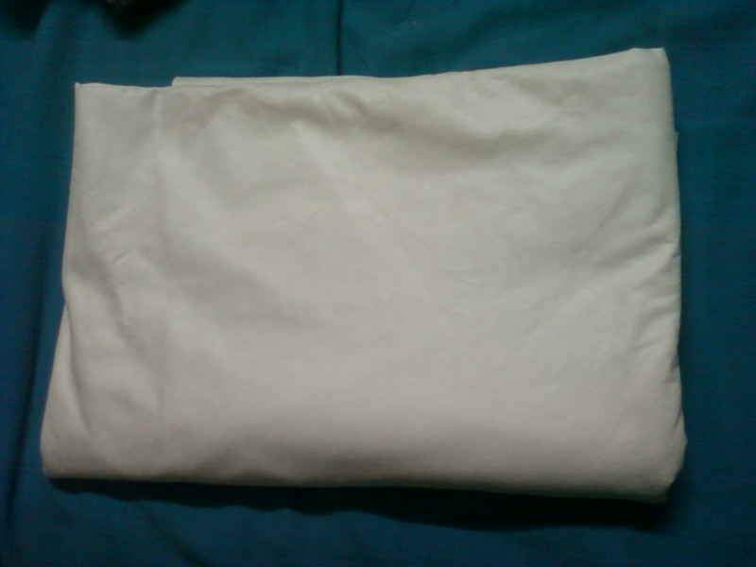

PLATE I
BAMBOO FABRIC

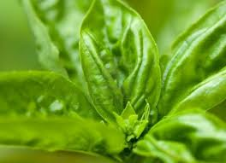

PLATE II
OCIMUM BASILLICUM

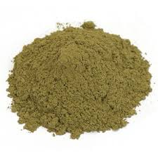

PLATE III
OCIMUM BASILLICUM
LEAVES POWDER

PLATE IV PLATE V
SOXHLET APPARATUS SOURCE EXTRACTION
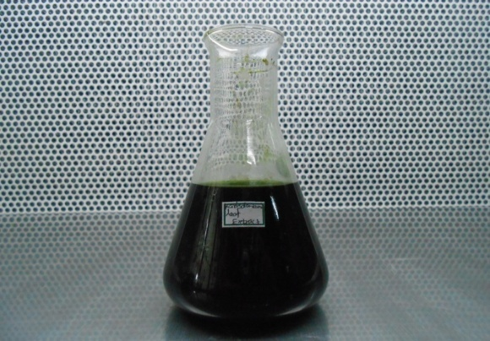
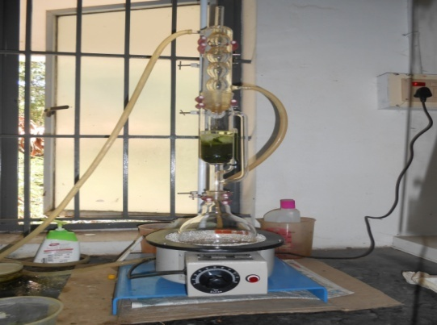

PLATE VI PLATE VII
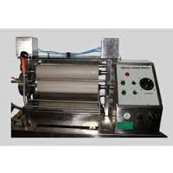
PADDING MANGLE ANTIBACTERIAL ACTIVITY
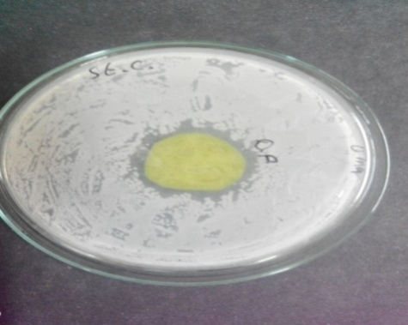

PLATE VIII
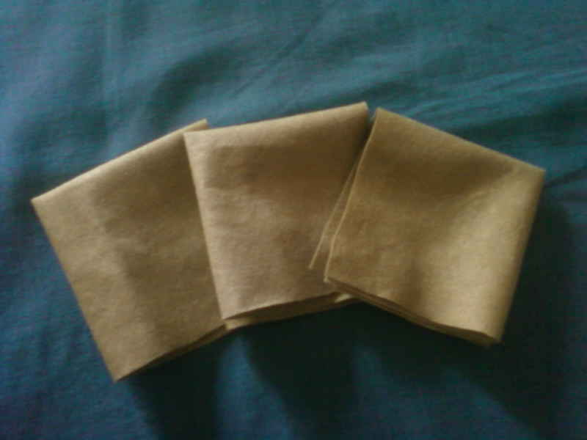
HERBAL PADS

The concentrated extract of Ocimum basillicum was poured inside the padding mangle, the fabric was passed into the solution of the extract, under the submerged roller and out of the bath. It was squeezed in between the roller in order to remove the excess solution and the fabric was subjected to drying. Thus the fabric finished with Ocimum basillicum extract.
3.7 Evaluation
The original and treated fabric was evaluated by both subjectively and objectively.
3.7.1 Subjective Evaluation
Thirty judges were selected from under graduate programme, Avinshilingam University, to evaluate the fabric appearance, texture, absorbency and intensity of healing pimples.
3.7.2 Objective Evaluation
The fabric treated with basil leaves was evaluated for various physical properties.
3.7.2.1 Fabric Weight
Weight measurement of a fabric is often a prerequisite for subsequent tests of other fabric properties. Weight can be determined by a mass per unit area or a mass per unit length of fabric. Specimens of known dimensions are taken by a cutting device or a template, to obtain a consistent specimen size (Jinlian, 2008).
Five specimens should be selected from fabric sample. Specimen selection should avoid taking samples from the fabric selvedge or close to the ends of a fabric piece. Cut the sample using GSM cutter and weighed using an electronic balance (Plate IX). Testing should be conducted in a conditioned atmosphere with preconditioned samples and care should be taken to avoid loss of fibres/threads during weighing. Results are commonly reported in grams per square metre (g/m²). ASTM D3776 – 96 (2002) Standard test methods for mass per unit area of fabric. Five readings taken are tabulated and recorded.
3.7.2.2 Fabric Thickness
Fabric thickness is defined as the distance between the upper and lower surface of the material measured under a standard pressure. The thickness of a fabric is one of its basic properties, giving information on its warmth, weight and stiffness (Plate X). Thickness measurements are very sensitive to the pressure and sample size used in the measurement. The fabric was placed between the pressure foot and anvil, the reading was noted from the dial (Saville, 2003). Five readings were taken and mean value is calculated.
3.7.2.3 Fabric Abrasion Resistance
Abrasion is defined as the wearing away of any part of the fabric by rubbing against another surface. Fabrics are subjected to abrasion during their lifetimes and this may result in wear, deterioration, damage and a loss of performance (Jinlian, 2008)
The Europe Martindale abrasion resistance tester (PlateXII) was used to determine abrasion resistance of the sample. Five samples were cut from different place of the same material at random using the template. The initial weight of the each sample was found out, recorded and then the sample was mounted on the sample holder. The sample holder with 200 gms weight was used for this test. The rubs were standardized to 10 rotations. The samples were made to rub against the abrasive surface. After 10 rotations, the sample was removed and the final weight of the sample was found out, weight loss due to abrasion was calculated. The test was repeated for five samples and one mean weight was calculated.
Weight loss percentage = Initial Weight - Final Weight

Initial Weight
3.7.2.4. Bursting Strength Tester
Bursting strength testing is the application of a perpendicular force to a fabric until it ruptures. The hydraulic diaphragm test method uses a diaphragm inflated by hydraulic pressure to apply the perpendicular force to the fabric (Plate XI). The diaphragm, normally made of rubber, is mounted below the clamped test piece. During a test hydraulic fluid is introduced behind the rubber diaphragm at a known rate and the burst pressure at rupture is measured using a pressure gauge. The upper clamp and sample is then removed and the tare pressure to distend the diaphragm is recorded. The tare pressure is subtracted from the burst pressure at rupture to give the actual burst pressure of the test sample. The readings for five samples are recorded and tabulated.
3.7.2.5. Drapability
Drape is defined as the extent to which a fabric will deform when it is allowed to hang under its own weight. Drape is a critical textile characteristic in determining how clothing conforms to the shape of the human silhouette. It prescribes the fabric deformation produced by gravity when a part of the fabric is directly supported (Kenkare and plumlee, 2005).
The drape tester (Plate XIII) is a simple but apt instrument which uses a parallel beam of light to cast a shadow from a circular piece of fabric, supported by a smaller circular disc. The area of shadow (a_{s}) is measured and compared with the area of the sample (a_{d}) and that of the supporting platform (a_{d}). The drape coefficient f is defined as
F = A_{s} – A_{d} A_{D} – A_{d} X 100
3.7.2.6. Drop test
The drop test is a count of number of drops required to penetrate through to the underside of the fabric when all the drops fall on the same spot (Jewel 2009). The fabric was spread without any wrinkles. A drop of distilled water was allowed to fall on the cloth. The stop watch was started immediately and the time required for the drop to penetrate into the fabric was noted in seconds (Plate XV). The average of five readings was taken.

PLATE IX PLATE X
FABRIC WEIGHT FABRIC THICKNESS
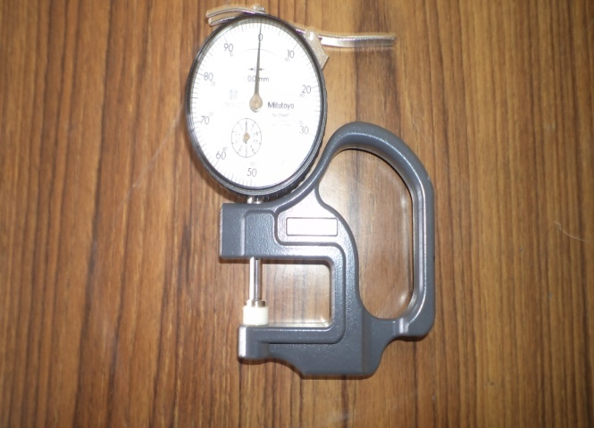
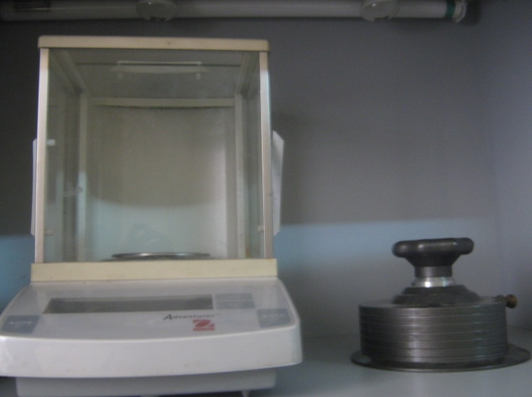

PLATE XI PLATE XII
BURSTING STRENGTH TESTER ABRASION RESISTANCE
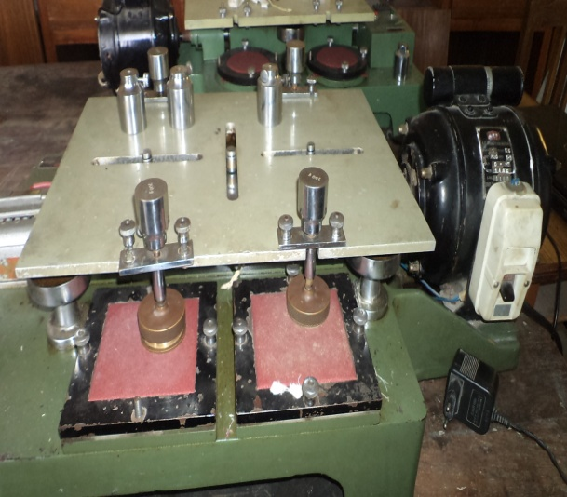
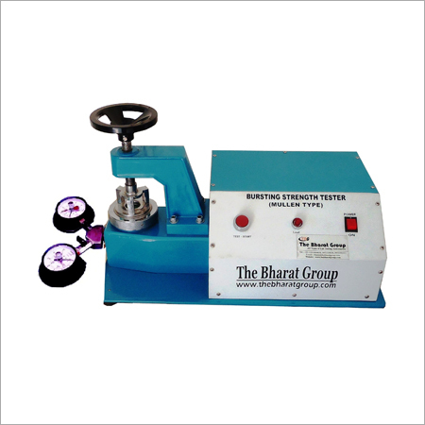
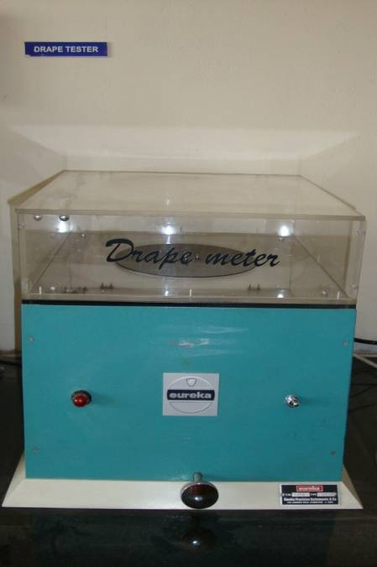
PLATE XIII
DRAPE METER

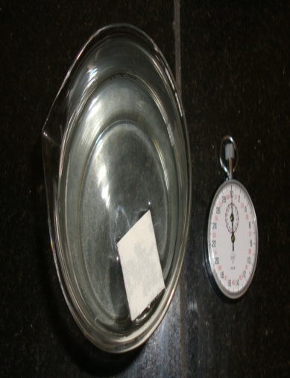

PLATE XIV
SINKING TEST

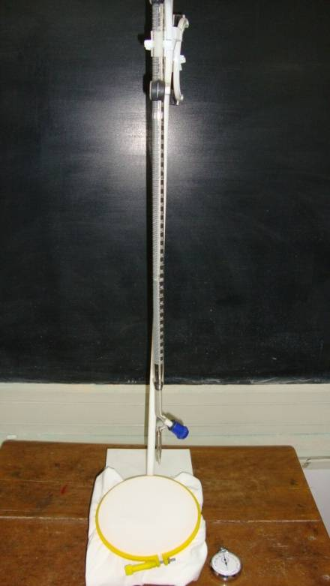

PLATE XV
DROP TEST

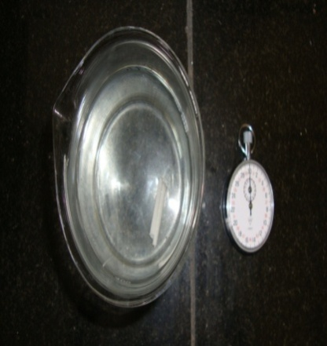

PLATE XVI
CAPILLARY TEST

3.7.2.7. Sinking test
Sinking test is a simple test of wettability of fabric. In this test, a small square specimen about 1” x 1” is cut and put it to the surface of water in a beaker. The time taken for the specimen to sink below the surface is observed (Plate XIV). Five readings of each sample were taken and the mean value was calculated.
3.7.2.8. Capillary test
The ability of fabric to absorb water, especially by wicking or capillary action may be observed by timing the rate at which water climates up a narrow strip of fabric suspended vertically with its lower end dipping in to the water. The wick ability of a fabric can be determined with a vertical strip method as described in BS 3424 or DIN 53924. A test specimen is hung vertically and the lower end immersed in water. After a certain time, the height of liquid wicking above the water surface is measured (Scott, 2005).
The rectangular strip of the fabric was cut in five samples and the measurement of 10 cm is marked in the fabric (Plate XVI). The fabric is immersed in the beaker containing distilled water and the time is kept at a constant level of one minute. After one minute the fabric is taken out and the readings are evaluated.
3.7.2.9. Antimicrobial Test
The quantitative test method of AATCC 100 is performed to evaluate the antibacterial activity of the product. The test microorganism staphylococcus aureus is grown in liquid culture. The concentration of the test microorganism is standardized. The AATCC plates were prepared by pouring 15 ml of AATCC media into sterile petri plates. The plates were allowed to solidify for 5 min and the bacterial culture was inoculated as single line followed by the four lines without refilling the inoculation loop. The fabric was cut into 5 x 2.5 size and immersed in treatment bath containing herbal agents with the M:L ratio of 1:1 for 15 minutes and air dried in at room temperature. The finished fabric with the diameter of 2.5 cm was placed on over the inoculated bacterial species and the plates were kept for incubation at 37ºC for 24 hours. At the end of incubation, zone of incubation formed around the fabric was measured in millimeter and recorded (plate VII).
3.8. Nomenclature of the samples
The nomenclature of the samples are expressed as
OBF – Original bamboo fabric
TBF – Treated bamboo fabric
3.9. Statistical Analysis
The results of the tests were analyzed statistically by selecting appropriate tests. The difference between the samples and within the samples was analyzed using ANOVA test. This analysis will help for exact results arrived in this study.

RESULTS AND DISCUSSION

4. RESULTS AND DISCUSSION
The results and discussion pertaining to the study on “PREPARATION OF HERBAL NON WOVEN PADS FOR HEALING PIMPLES” are discussed under the followings
4.1 Subjective Evaluation
4.1.1 Wear Study
4.2 Objective Evaluation
4.2.1. Physical Property Test
4.2.1.1. Fabric Weight
4.2.1.2. Fabric Thickness
4.2.2. .Mechanical Property
4.2.2.1. Bursting Strength
4.2.2.2. Abrasion Resistance
4.2.3. Comfort Property
4.2.3.1. Drapability
4.2.4. Absorbency Test
4.2.4.1. Drop Test
4.2.4.2. Sinking Test
4.2.4.3. Capillary Test
4.2.5. Antibacterial Test

4.1. Subjective evaluation
4.1.1. Wear Study
Thirty under graduate students from textiles and clothing department were selected for evaluating the herbal pads as given in table I
Table I
Sample | General appearance |  |  | Absorbency |  |  | Odour |  |  | Texture |  |  | Pimples healing
 | Very Good | Good | Fair | High | Medium | Low | Very Good | Good | Fair | Very Soft | Soft | Coarse | Good | Fair | Poor
TBF | 84 | 16 | - | 95 | - | - | 66 | 34 | - | 86 | 14 | - | 86 | 14 | -
Wear Study

Majority of the judges (95 %) ranked treated bamboo fabric have high absorbency. (86%) ranked that treated bamboo fabric have Very soft texture whereas (84%) of the judges ranked very good appearance. Majority (86 %) of the judges ranked that it has the good pimple healing capacity

4.1. Objective Evaluation
4.2.1. Physical Property Test
4.2.1.1. Fabric weight
The weight of non woven spun lace fabric before and after treatment is presented in the table II and fig.1
TABLE II
FABRIC WEIGHT
Sample | Mean value | Gain or loss over original | Percentage of gain or loss over original | F value
OBF | 1.03 | - | - | 3.379_{NS}
TBF | 1.05 | 0.02 | 1.94 | 3.379_{NS}
NS – Not Significant
From the table II and fig.1, it is clear that the weight of the treated spun laced fabric sample TBF (1.05) higher than the original spun laced sample. Hence it could be concluded that finishing with selected extract has increased the weight of the fabric

4.2.1.2. Fabric Thickness
The thickness of the original and treated non woven spun lace fabrics are tabulated in table III and fig.2
TABLE III
FABRIC THICKNESS
Sample | Mean value | Gain or loss over original | Percentage of gain or loss over original | F value
OBF | 0.51 | - | - | 2.306_{NS}
TBF | 0.54 | 0.03 | 5.88 | 2.306_{NS}
NS- Not Significant
From the table III and fig.2, it is clear that the treated sample (0.54) is greater than the original sample. The increase in thickness is due to the finishing given to the non woven spun lace fabric. In general, thickness increases after finishing

FIGURE – I
FABRIC WEIGHT

FIGURE – II
FABRIC THICKNESS

4.2.2. Mechanical Property
4.2.2.1. Bursting Strength
The bursting strength of the original and treated non woven fabric are indicated in the table IV and fig 3
TABLE IV
FABRIC BURSTING STRENGTH
Sample | Mean value | Gain or loss over original | Percentage of gain or loss over original | F value
OBF | 3.0 | - | - | 2.898 _{NS}
TBF | 3.08 | 0.08 | 2.6 | 2.898 _{NS}
NS-Not Significant
From the table IV and fig.3, it is obvious that the bursting strength of the sample TBF was higher as (3.08 kg/cm³), hence it could be concluded that the strength has been considerably increased on treatment with basil leaves extract, which in turn has strengthened the fabric.

4.2.2.2. Abrasion Resistance
The abrasion resistance of the original and treated non woven spun lace fabrics was recorded in the table V and fig. 4
TABLE V
FABRIC ABRASION RESISTANCE
Sample | Mean value | Gain or loss over original | Percentage of gain or loss over original | F value
OBF | 0.126 | - | - | 0.027_{NS}
TBF | 0.123 | -0.003 | -2.38 | 0.027_{NS}
NS- Not Significant
From the table V and fig.4, it is evident that the abrasion resistance of the treated fabric is decreased by (2.38 per cent) when compared to original fabric.

FIGURE – III
BURSTING STRENGTH

FIGURE – IV
ABRASION RESISTANCE

4.2.3. Comfort Property
4.2.3.1. Drapability
The drapability of the original and basil leaves extract treated fabric are depicted in the table VI and fig 5
TABLE VI
FABRIC DRAPABILITY
Sample | Mean value | Gain or loss over original | Percentage of gain or loss over original | F value
OBF | 1.228 | - | - | 2.350_{NS}
TBF | 1.343 | 0.115 | 9.36 | 2.350_{NS}
NS – Not Significant
The above table VI and figure.5,shows the drapability of original and treated bamboo fabric. The higher mean value shows the higher drapability of the fabric. The drapability of treated bamboo fabric is (1.343%) increased when compared to the original fabric. Statistical analysis proved that there is no significance between the samples

4.2.4. Absorbency Test
4.2.4.1. Sink Test
The sinking property of the original and treated spun lace non woven fabric are given in the table VII and fig 6
TABLE VII
SINK TEST
Sample | Mean value  (in secs) | Gain or loss over original | Percentage of gain or loss over original | F value
OBF | 1.80 | - | - | 0.849_{NS}
TBF | 1.54 | -0.26 | -14.44 | 0.849_{NS}
NS- Not Significant
From the table VII and fig.6, it is understood that the sinking time of the sample OBF is maximum in (1.80 seconds) and TBF sample (1.54 seconds) .Hence there was the maximum reduction in sinking time in the fabric treated with leaves of basil.

FIGURE – V
DRAPABILITY

FIGURE – VI
SINK TEST (SECONDS)

4.2.4.2. Drop Test
The results of drop test of the original and treated samples are presented in the table VIII and fig.7
TABLE VIII
DROP TEST
Sample | Mean value | Gain or loss over original | Percentage of gain or loss over original | F value
OBF | 1.08 | - | - | 9.000*
TBF | 1.05 | -0.03 | -2.77 | 9.000*
*Five per cent significant
From the table VIII and fig.7, it is clear that the time taken for the water droplet penetrate into the fabric was (1.08 second) in the sample OBF whereas a slight reduction in the time was noted in the sample TBF (1.05 seconds). Hence it could be concluded that through the water absorbance was very high in the treated fabric and statistically proved that there is a significant difference at five percent level.

4.2.4.3. Capillary Test
The results of the original fabric and non woven spun lace treated are tabulated in the table IX and fig.8
TABLE IX
CAPILLARY TEST
Sample | Mean value | Gain or loss over original | Percentage of gain or loss over original | F value
OBF | 7.9 | - | - | 18.69*
TBF | 8.6 | 0.088 | 8.86 | 18.69*
*Five per cent significant
From the table IX and fig.8, it is clear that the wicking was minimum in the OBF of (7.9 cms), whereas the capillary raise increased in the treated sample (8.6 cms) respectively. Hence it could be concluded that the basil leaves extract fabric increased the absorbency of the fabric and statistically proved that there was a significant difference at five percent level.

FIGURE – VII
DROP TEST (SECONDS)

FIGURE – VIII
CAPILLARY TEST

4.2.5. Antibacterial test
The anti bacterial activity of the treated bamboo fabric are tabulated in the table X.
Table X
S.No | Sample | Organism | Zone Inhibition (mm)
1. | Basil leaves treated bamboo fabric | Staphylococcus  aureus | 20 mm

From the table X, it is clear that the treated bamboo fabric has better anti bacterial property (20 mm). Hence it could be concluded that the treated bamboo fabric has increased antibacterial property

SUMMARY AND CONCLUSION

5. SUMMARY AND CONCLUSION
Pimple is an inflammation of the skin that results from clogged pores, affects mostly the teenagers. It is indeed difficult when pimple causes us to make a poor first impression and our health issues are so publicly announced on our face. Plants have been the basis for medical treatments through much of human history, and such traditional medicine is still widely practiced today.
Basil belongs to the genus Ocimum and is a member of the mint family. It is a widespread plant cultivated in the world. It is most widely used in cosmetics, liqueurs, medicines and perfumes. The plant is aromatic, antimicrobial, astringent in dysentery, while the leaves are antipyretic. Natural fibers play a major role in the 21st century since the growing concepts of “eco friendly” textiles. Bamboo fabric is a natural textile made from the pulp of the bamboo grass. Bamboo fabric has been growing in popularity because it has many unique properties and is more sustainable than most textile fibers. Bamboo fabric is light and strong, has excellent wicking properties, and is to some extent antibacterial. The use of bamboo fiber for clothing was a 20th century development, pioneered by several Chinese corporations.
In Asia the major producers of non wovens are Japan, China, Korea and Taiwan. Nonwoven fabrics provide specific functions such as absorbency, liquid repellency, resilience, stretch, softness, strength, flame retardancy, washability, cushioning, filtering, bacterial barriers and sterility. These properties are often combined to create fabrics suited for specific jobs while achieving a good balance between product use-life and cost. The application of herbal extract onto the non woven textiles substrate is a very new concept which actually enhances the properties of fabric.
Considering the above points in mind, the investigator has made an attempt to study on “Preparation of Herbal Nonwoven Pads for Healing Pimples” with the following objectives:
- Extract the solution from the selected sources
- Analyze anti bacterial property of the source
- Imparting herbal finish on the spun laced bamboo fabric

- Preparation of herbal pads
- Evaluation of herbal pads
Findings of the study
Evaluation of samples
Evaluation of basil leaves extract treated fabric by subjective and objective methods, such as physical, mechanical and comfort properties. The laboratory test was analyzed statistically.
Subjective Evaluation
Subjective evaluation study reported that Ocimum basillicum treated bamboo fabric shows high anti bacterial property, high absorbency, and proved to heal pimples
- 95 % of the judges ranked that bamboo fabric have good absorbency
- 86% of the judges ranked that it have good texture and appearance
- 86% of the judges reveals, the treated bamboo fabric have good healing capacity
Objective Evaluation
- Fabric weight of treated bamboo fabric (1.94%) increased when compared with original fabric. It is statistically proved that there is no significant between these two values.
- Fabric thickness of treated bamboo fabric (5.88%) increased when compared with original fabric. It is statistically proved that there is no significant between these two values.
- Fabric bursting strength of treated bamboo fabric (2.6%) increased when compared to the original fabric. It is statistically proved that there is no significant between the values
- Fabric abrasion resistance of treated bamboo fabric (2.38%) decreased when compared to original fabric. It is statistically proved that there is no significant between the values
- Fabric drapability of the treated bamboo fabric (9.36%) increased when compared with the original bamboo fabric. It is statistically proved that there is no significant between the values
- Fabric sink test of the treated bamboo fabric (14.44%) increased when compared with the original bamboo fabric. It is statistically proved that there is no significant between the values
- Fabric drop test of the treated bamboo fabric (2.77%) increased when compared to the original bamboo fabric. It is five percent significant
- Fabric capillary test of the treated bamboo fabric (8.86%) increased compared to the original bamboo fabric, which is statistically proved that five percent significant.
Conclusion
Cosmetics are no longer just simple creams and lotions. The boundaries of cosmetic innovation are being expanded with the inception of cosmetotextiles. These new products can be defined as textile articles containing a functional substance intended to be contact on the various surfaces of the body. These herbal pads are quick and convenient and save our time in this modern life. The nonwoven spun laced material treated with the basil leaves extract, proved to cure pimples and is a boon for teenagers. Since the herbal pads are proved to be excellent, it can be commercialized.
Recommendations
- The finish can be done using micro encapsulation method for better result
- Apart from bamboo fibre, other new eco friendly fibers can also be used

BIBLIOGRAPHY

BIBLIOGRAPHY
Book References
- Alagirusamy.R & Das.A, (2010), Technical Textile Yarns, Wood Head Publishing Limited, pg. 205
- Albrecht, W., Fuchs, H., Kittelmann, W., (2003), Nonwoven Fabrics(raw materials, manufacture, applications, characteristics, testing processes), WILEY-VCH Verlag GmbH & co, pg 1
- Alexander D.E., (2010), Ultimate Secrets To Eliminate Acne For Sure, KMS publishing, pg 3
- Barel.A.O., Paye, M., Maibach,H.I, (2014), Handbook Of Cosmetic Science And Technology Fourth Edition, CRC Press Taylor &Francis Group, Pp 3,4
- Batra, S.K. and Pourdeyhimi, B., (2012), Introduction To Non Woven Technology, DEStech publications, inc., pg 113
- Bekaert, S., (2011), Hot Topics in Adolescent Health, Radeliffe Publishing Limited, Pp 6 8
- Chand, N & Fahim, M.,(2008), Tribology of Natural Fiber Polymer Composites, Wood Head Publishing Limited, Pp 89 91
- Chapman, R.A., (2010), Applications of Nonwovens in Technical Textiles, wood head publishing limited Pp107 110
- Prelitz, C (2009), Green Made Easy, Hay House, Inc, pg.28
- Cooper, L, (2008), Live Organic, Infinite Ideas Limited,pg.203
- Daniel, M., (2006), Medicinal Plants Chemistry and Properties, Science publishers, pg 3
- Fried R.G., (2005), Healing Adult Acne, New Harbinger publications, Inc, pg.6
- Fletcher, K., (2008), Sustainable Fashionand Textiles, Earthscan publishers, pg.49
- Garland, S., (2004), The Complete Book Of Herbs & Spices, Frances Lincoln Limited, pg.84
- Gulrajani, M.L., (2013), Advances in the Dyeing & Finishing of Technical Textiles, Woodhead Publishing Limited, pg 6
- Handa, P., (2000), Speaking of Skin Care, Sterling Publishers (P) Ltd, pg.1
- Horrocks, A R.,& Anand S C.,(2004), Handbook of Technical Textiles, Woodhead Publishing Limited, pg 153
- Hutten, I.M., (2007), Handbook of Non-woven filter media, Elsevier Ltd, pg.4
- Jewel,R, (2009), Textile Testing, A P H Publishing Corporation, pg.57
- Jinlian, HU, (2008), Fabric Testing, Wood head Publishing Limited, Pp 113 114
- Kalia.S., Kaith.B.S.,& Kaur.I., (2011), Cellulose Fibers: Bio- and Nano-Polymers Composites, Springer-Verlag Berlin Heidelberg, pg.45
- Kapoor, L.D., (2001), Handbook of Ayurvedic Medicinal Plants, CRC Press LLC, Pp.1,2
- Khare, C.P., (2007), Indian Medicinal Plants, Springer Science + Business Media LLC, Pp 443,444
- Kumar, S.R., (2014), Textiles For Industrial Applications, CRC Press, Taylor & Francis Group Pp 101,102
- Maitra, K.K., (2007), Encyclopedic Dictionary Of Clothing And Textiles, A Mittal Publications, Pp 307 308
- Mars, B., (2006), Beauty by Nature, Healthy living publications, Pp 63 64
- Moldoveanu, S.C. & David,V., 2002, Sample Preparation In Chromatography, Elsevier Science B.V, Pp 306 307
- Peter, K.V., (2012), Handbook Of Herbs And Spices(Second Edition) Volume 2, Wood Head Publishing Limited, pg 1, 2, 13, 18, 20
- Premila, M.S., (2006), Ayurvedic Herbs- A Clinical Guide to the Healing Plants of Traditional Indian Medicine, The Haworth Press, Inc, Pg 1.2.193
- Qinguo Fan, (2005), Chemical Testing of Textiles, Woodhead Publishing Limited, Pg 107
- Russel, S.J., (2007), Handbook of non wovens, CRC press, pg.9
- Reichert, M & Young, J.H., (2000), Sterilization technology for the health care facility (Second Edition), Aspen publishers, pg.72
- Saville B P, (2000), Physical testing of textiles, Wood head Publishing Limited, CRC Press LLC, pg 7
- Schindler, W.D., & Hauser, P.T., (2004), Chemical Finishing of Textiles, Wood head Publishing Ltd, Pg 1
- Scott, R.A., (2005), Textiles for protection, Wood Head Publishing Limited, pg.242
- Sener, B., (2002), Biodiversity (Bio-molecular aspects of biodiversity and innovative utilization), Kluwer academic/plenum publishers, pg 279
- Siewert, D.M., (2009), Resistant Staphylococcus Aureus Infections in the United States, Proquest LLC. Pg 1
- Wen Zhong, (2013), An Introduction To Healthcare And Medical Textiles, DEStech Publications,Inc. pg,34
- Walczak, Z.K., (2002), Processes of fiber formation, Elsevier Science Ltd. pg. 33
- Wood, M., (2000), The Book of Herbal Wisdom, North Atlantic Books, pg.59
Journal References
- Bhat, G.S Eash, C & Uppal, R., (2010), Recent Development and Future Opportunities in Non Woven Tech Textiles, Asian Technical Textiles, vol.4 no.4, October-December, Pp 49 50
- Chakrabarty, S., (2008), Non Woven Textiles- A Good Avenue for Machinery Development, The Textile Magazine, vol.49 issue 7, May, pg.86,88,92
- Das, E.R. & Hati, S., (2010), Bamboo Fibers, Textile Review, vol.24 No.1 January, Pp17 19
- Ginna, M., (2013), The Fabric of Beauty, AATCC Review, vol.13 no.1, January/February, Pp34 39
- Gopalakrishnan D & Karthik T., (2012), Eco friendly Fibers- Textile Contribution to Minimize Global Warming, Textile Review, vol.7 issue 9, September, Pp.13 14
- Gulich, B & Schilde, W., (2009), Trends in Technical Non Wovens, Asian Technical Textiles, vol.15 no.1, January – March, pg.27
- Hayavadana, J, Pavan, R.M.V. & Sirisha, S.N., (2011), Wipes-Promising a Cleaner Vision Ahead, Technical Textile and Non Woven Excellence vol.2 no.3, April- June, pg 31
- Jayalakshmi, I & Manjusha, K., (2013), Ayurvedic Medicated Products and its Applications, Man-Made Textiles In India, vol.XLI no.4, April, pg.12
- Kenkare and Plumlee, (2005), Fabric Drape Measurement: A Modified Method Using Digital Image Processing, Journal of Textile and Apparel, vol.4 Issue 3, Pp 1, 2
- Mathis A G., (2008), Spun laced or Hydro Entangled Non Wovens, Asian Technical Textiles, vol.2 no.4, October-December, Pp 38 39
- Mhasavekar, U.P & Raibagi, A., (2012), Laminating Non Woven Fabrics, Textile Review, vol.12 no.6, June, pg.17
- Parameswaran, S., (2008), Bamboo- yarns & fibers, Colourage, vol.55 no.8, August, Pp 68, 74
- Ramachandran, T, Lakshmanan, R, Natarajan, M & karthikeyan, S., (2010), A Study On The Effect of Herbally Treated Non Woven Textiles Health Care Products, Man-Made Textiles In India, vol.LIII no.1, January ,Pp15 17
- Rekha R & Sudam, A., (2009), Bamboo: Green and Breathable Natural Fiber, Man-Made Textiles in India, vol. LII No.11, November, Pp 397 401
- Renuka Devi, M Poornima.N & Guptan, P.S., (2007), Bamboo- The Natural, Green and Eco-Friendly New Type Textile Material of the 21st Century, Journal of the Textile Association, vol.67 no.5, January – February Pp 221 224
- Saravanan, M & Thambidurai, A., (2013), Spun lace, Asian Textile Journal, vol.24 no.11, November, Pp 45 51
- Shankar GL & Krishnan, A.T., (2012), Bamboo Fibre and its Properties, Journal of the Textile Association, vol.73 no.2, July- August, Pp 78 80
- Sharma, V and Goel, A, (2010)., Bamboo Plant To Fibre: An approach to various implications, Man – Made Textiles in India, vol.42 no.8 August, Pp 291 295
- Singha, K & Maity, S., (2013), Methods of Measurements of Structure of Non Woven Fabrics, Asian Textile Journal , vol.17 no.6, June Pp73 78
- Waite, M., (2009), sustainable textiles: the role of bamboo and a comparison of bamboo textile properties, Journal Of Textile And Apparel, Technology And Management, Volume 6, Issue 2, pg.14

APPENDIX

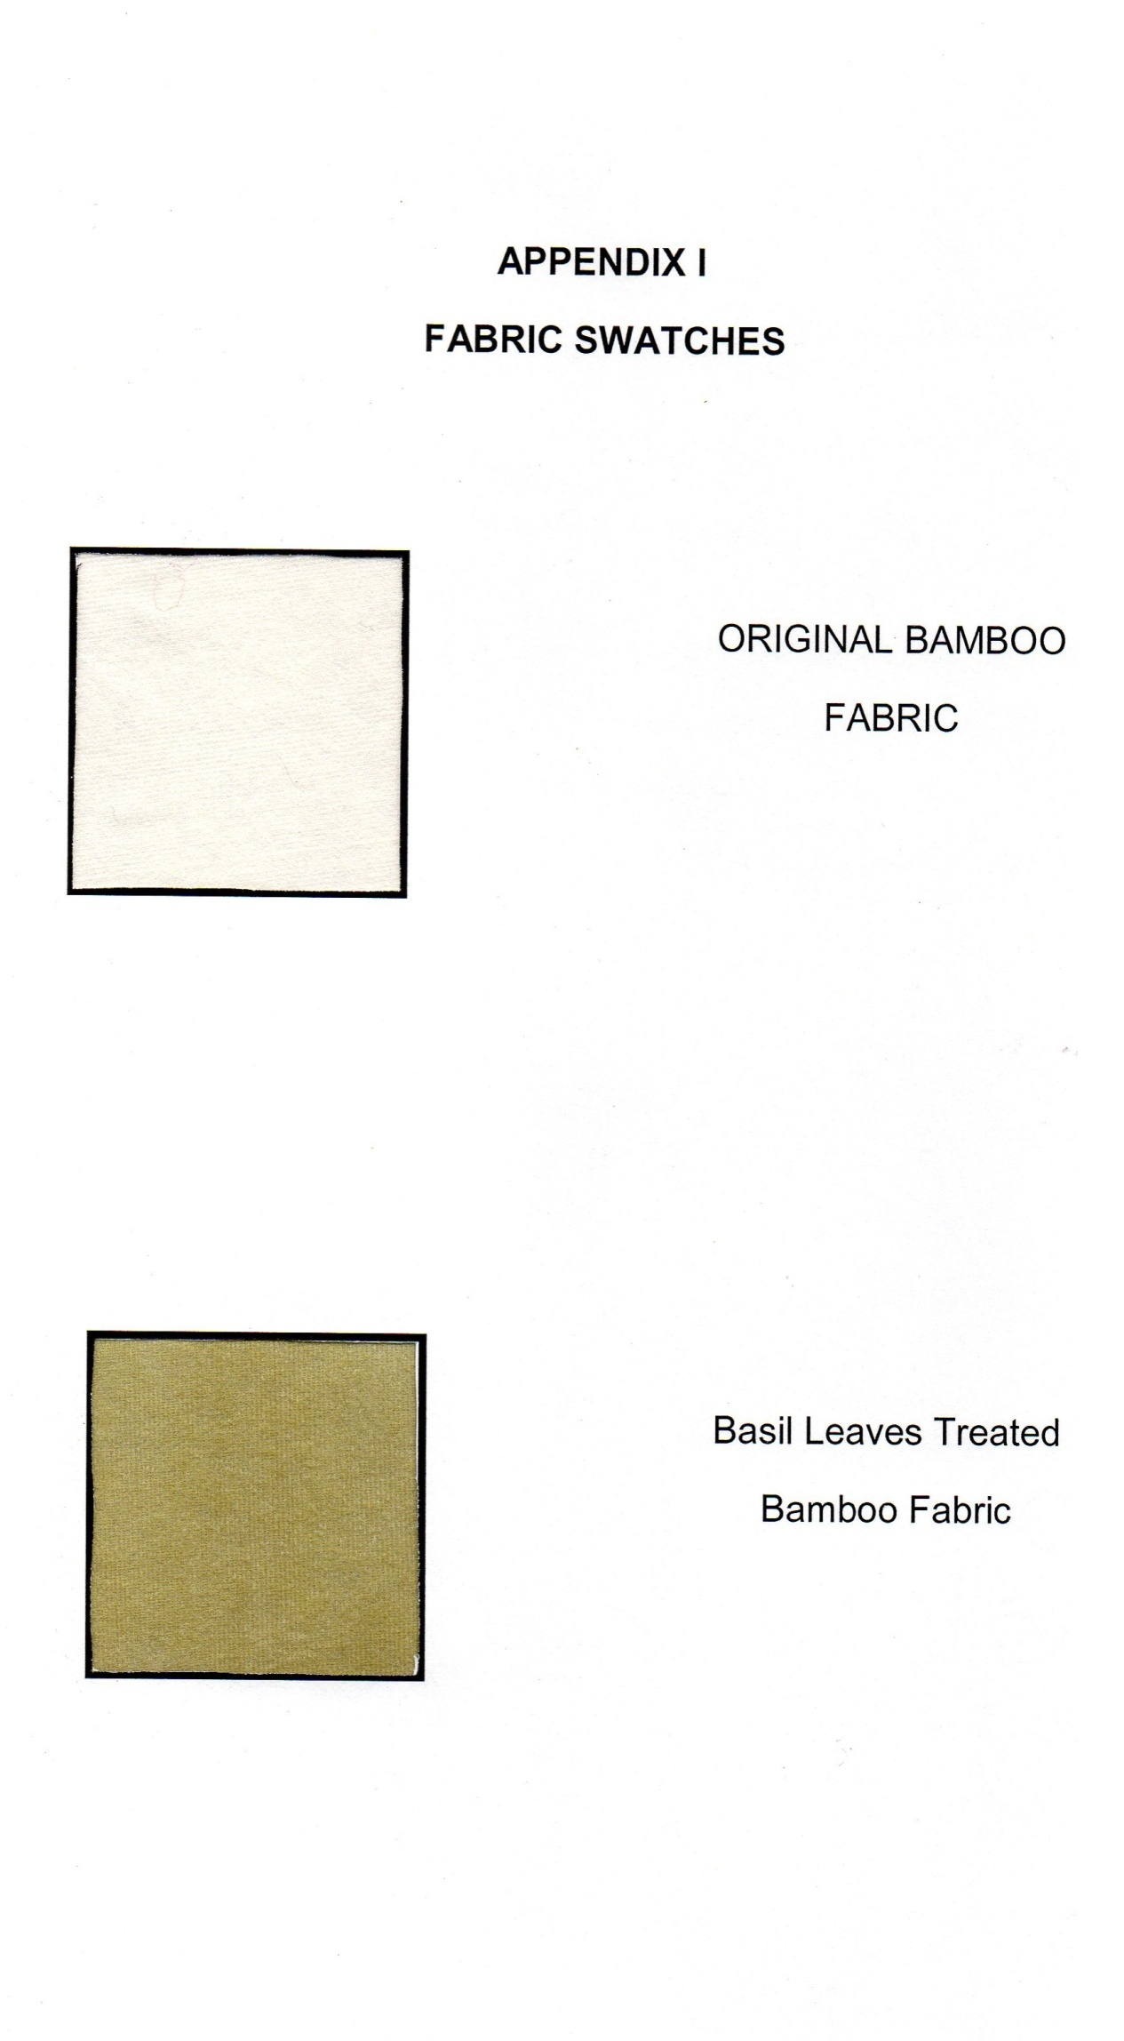
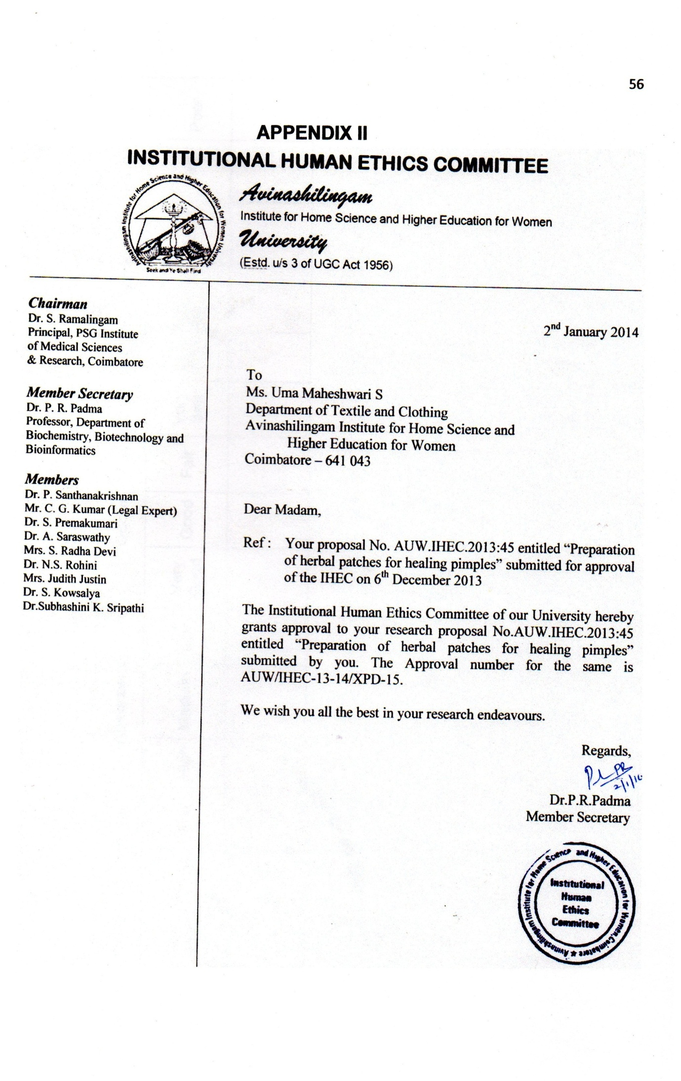
APPENDIX III
Proforma for Evaluation of Herbal Pads

Sample | General appearance |  |  | Absorbency |  |  | Odour |  |  | Texture |  |  | Pimples healing
 | Very Good | Good | Fair | High | Medium | Low | Very Good | Good | Fair | Very Soft | Soft | Coarse | Good | Fair | Poor

