Removal of nickel using Thespesia populnea bark

YUVABHARATHY, P.
(Reg. No. 11PZO10)

A thesis submitted to Avinashilingam Institute for Home Science and Higher Education for Women, Coimbatore

In partial fulfilment of the requirements for the

MASTER'S DEGREE IN ZOOLOGY

MAY 2013

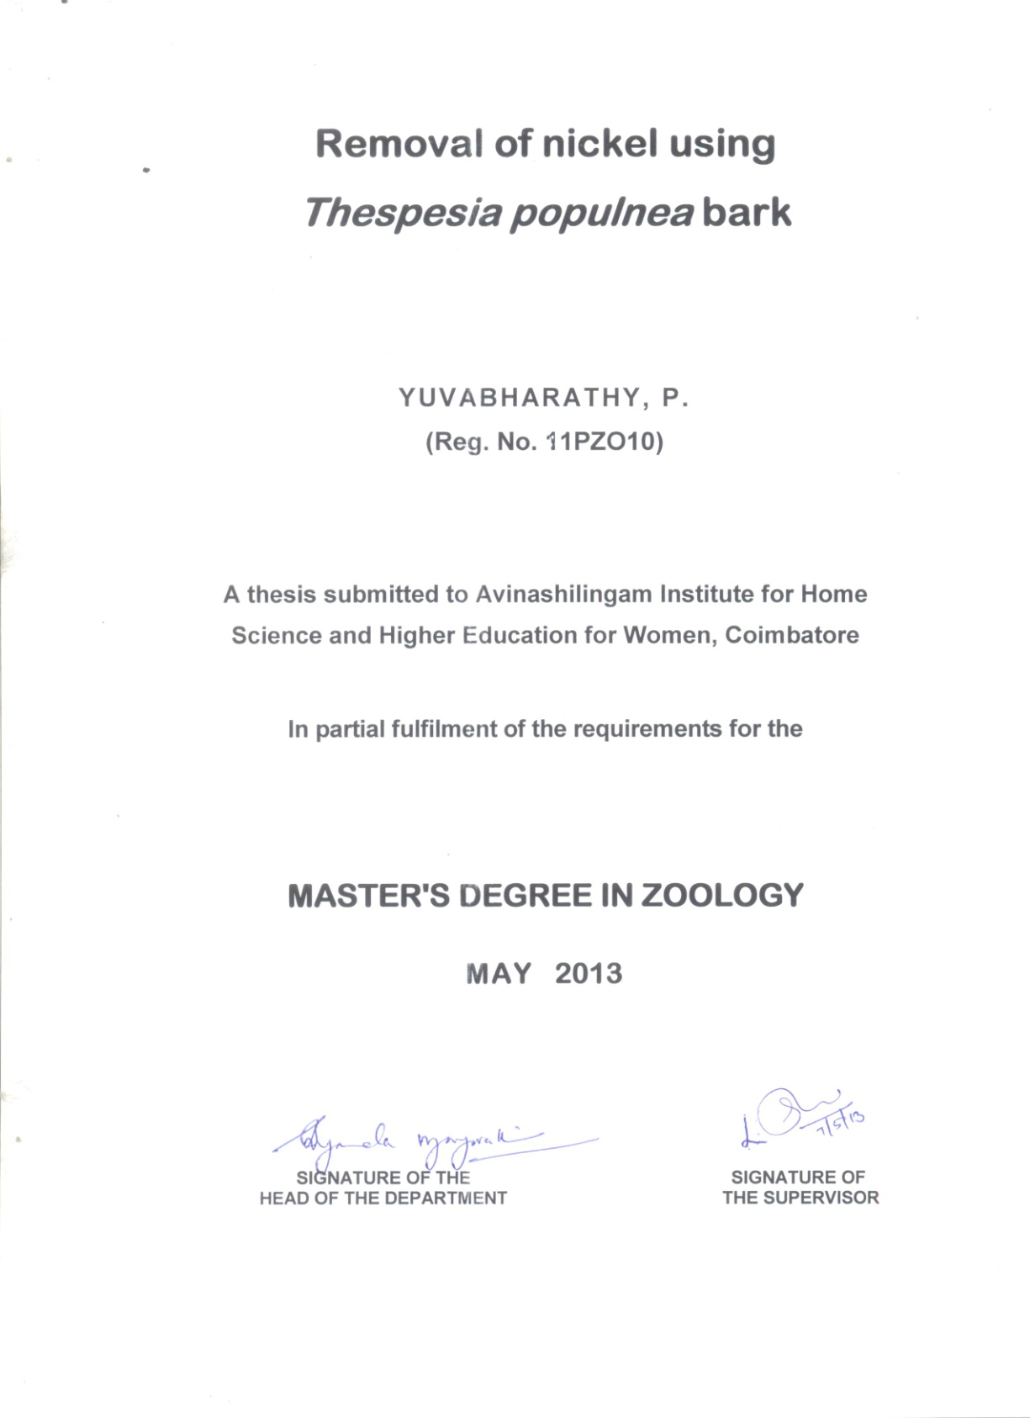

ACKNOWLEDGEMENT
I wish to record my sincere thanks and gratitude to
Thiru. Dr. T.S.K. Meenakshisundaram, M.A., M.Phil., Chancellor, Avinashilingam Institute for Home Science and Higher Education for Women, Coimbatore for providing me the opportunity to undertake this investigation in this esteemed institution.
I record my gratitude and heartfelt thanks to
Dr. (Mrs.) Sheela Ramachandran, M.Sc., P.G. Dip., Ph.D., (Avinashilingam), Vice Chancellor, Avinashilingam Institute for Home Science and Higher Education for Women, Coimbatore, for the facilities provided to carry out the project work.
I feel greatly indebted and thankful to Dr. (Mrs.) Gowri Ramakrishnan, M.Sc. (Madras), M.Phil., Ph.D. (Avinashilingam), Registrar, Avinashilingam Institute for Home Science and Higher Education for Women, Coimbatore, for her constant source of inspiration and strength.
I am greatly indebted and thankful to
Dr. (Mrs.) R. Parvatham, M.Sc., Dip. Ed. (Madras), M.Phil., (Madras), Ph.D. (Avinashilingam), Dean, Faculty of Science, Avinashilingam Institute for Home Science and Higher Education for Women, Coimbatore, for her continued interest and constant support in the conduct of project work.
I express my deep sense of gratitude to
Dr. (Mrs.) B. Shyamala Vijayavathi, M.Sc., Dip. Ed. (Madras), M.Phil., (Bharathiar), Ph.D. (Avinashilingam), Professor and Head, Department of Zoology, Avinashilingam Institute for Home Science and Higher Education for Women, Coimbatore, for the constant support given during the period of investigation.
I express my thanks and gratitude to my beloved guide (Mrs.) E. Shanthi, M.Sc., Dip.Ed. (Madras), M.Phil. (Bharathiar), Associate Professor in Zoology, Avinashilingam Deemed University for Women, Coimbatore for her incessant guidance, constant support, valuable help, patience and encouragement shown throughout the period of the study.
I take this opportunity to thank the Staff Members and Lab Assistants in the Department of Zoology for their help to carry out the study.
I express my thanks to my beloved parents
Mr. P. Patteeswarakumaraswamy and Mrs. A. Rukmani and friends for their motivation, encouragement and loving care.
Above all I thank God Almighty for his immense mercy for the successful completion of my research work.

CONTENTS
Chapter No. | TITLE | Page No.
 | LIST OF TABLES
 | LIST OF FIGURES
 | LIST OF PLATES
1 | INTRODUCTION | 1
2 | REVIEW OF LITERATURE | 6
 | 2.1. Studies on heavy metal pollution  2.2. Studies on heavy metal removal | 6  11
3 | MATERIALS AND METHODS  3.1. Adsorbate preparation  3.2. Adsorbent preparation  3.3. Adsorption optimization study  3.4. Desorption  3.5. Treatment of nickel electroplating effluent under optimal conditions  3.6. Nickel estimation  3.7. FTIR analysis  3.8. Adsorption isotherm | 27  27  27  27  33  34  34  35  35
4. | RESULTS AND DISCUSSION  4.1. Effect of pH  4.2. Effect of adsorption dose  4.3. Effect of metal ion concentration  4.4. Effect of Contact time  4.5. Desorption  4.6. Application to electroplating wastewater  4.7. FTIR analysis  4.8. Adsorption isotherms | 37  38  41  44  46  49  51  52  55
 | SUMMARY AND CONCLUSION | 59
 | REFERENCES
LIST OF TABLES

Table No. | Title | Page No.
1 | Details of operational parameters used in the study | 30
2 | Effect of pH on nickel adsorption | 38
3 | Effect of adsorbent dose on nickel adsorption | 41
4 | Effect of metal ion concentration on nickel adsorption | 44
5 | Effect of contact time on nickel adsorption | 47
6 | Effect of HCl concentration on nickel desorption | 50
7 | Nickel removal in electroplating effluent with Thespesia populnea bark under optimal conditions | 51

LIST OF FIGURES
Figure No. | Title | Page No.
1 | Tree and bark of Thespesia populnea | 28
2 | Powdered bark of Thespesia populnea | 29
3 | Experimental set up to study the effect of initial metal ion concentration (mg/l) | 31
4 | Experimental set up to study the effect of adsorbent dose (mg/50ml) | 31
5 | Experimental set up to study the effect of pH | 32
6 | Experimental set up to study the effect of contact time (minutes) | 32
7 | Experimental set up for nickel desorption from the adsorbent using HCl at different molar concentrations | 33
8 | Effect of pH on nickel adsorption | 39
9 | Effect of adsorbent dose on nickel adsorption | 42
10 | Effect of metal ion concentration on nickel adsorption | 45
11 | Effect of contact time on nickel adsorption | 48
12 | Effect of HCl concentration on nickel desorption | 51
13 | FTIR spectrum of unloaded adsorbent | 53
14 | FTIR spectrum of nickel loaded adsorbent | 54

- INTRODUCTION
The term 'heavy metal' although often not rigidly defined is commonly held for those metals, which have specific weights more than 5g cm³ (Holleman and Wiberg, 1985).
About 40 elements fall into the category of heavy metals. They are largely found in disperse form in rock formations. Industrialization and urbanization have increased the anthropogenic contribution of heavy metals in biosphere. Heavy metals have largest availability in soil and aquatic ecosystems and to a relatively smaller proportion in atmosphere as particulates or vapours (Wintz et al., 2002).
Heavy metals are essential trace nutrients of animal and human body. They are considered to be essential for plant growth. Some of the heavy metals like copper and zinc serve either as cofactor and activators of enzyme reactions in forming enzyme substrate metal complex or exert a catalytic property as prosthetic group in metalloproteins. These essential trace metal nutrients take part in redox reactions, electron transfer and structural functions in nucleic acid metabolism (Sharma and Agarwal, 2005).
Heavy metals are naturally occurring elements but their multiple industrial, domestic, agricultural, medical and technological applications have led to their wide distribution in the environment, raising concerns over their potential effects on human health and the environment (Tchounwou et al., 2012).
Heavy metals are continuously released into the environment from natural processes like volcanic activity and weathering of rocks and industrial processes greatly enhance their mobilization into the aquatic environment (Singh, 2007).
Due to their mobility in natural water ecosystems and their toxicity to higher life forms, the metal ions in surface and ground water have been prioritized as major inorganic contaminants in the environment (Atkinson et al., 1998).
Unlike organic contaminants heavy metals do not normally undergo biological decay (Qaiser et al., 2007). The non degradability of heavy metals leads to their accumulation in the environment and thus they are known as "Chemical time bombs" (Shi et al., 2008). Heavy metals are typical pollutants in the environment and are of particular concern due to their persistance in the environment (Odewande and Abimbola, 2008).
Metal ions though present in dilute and undetectable quantities in the environment, their recalcitrance and consequent persistence in the environment imply that through biomagnifications their concentrations may become elevated to an extent of exhibiting toxic characteristics (Atkinson et al., 1998).
Heavy metals are persistent and bioaccumulative, and do not readily break down in the environment or not easily metabolized. Such metals accumulate in ecological food chain through uptake at primary producer level and then through consumption at consumer levels (Sharma and Agarwal, 2005). Soil pollution with heavy metals is a universal problem, leading to agricultural losses and hazardous health effects as metals enter the food chain (Tchounwou et al., 2012). The non biodegradable and bioaccumulation properties
of heavy metals may pose serious threats to living organisms (Liu and Xu, 2007).
Nickel is well known as a heavy metal pollutant (Denkhaus and Salnikow, 2002). It finds its way into the environment through effluents from industries (Krishna and Swamy, 2011). Nickel has widely been used in industries because of its resistance to corrosion, high strength over a wide range of temperatures and good alloying properties (Sahare, 2012).
Nickel is released into the environment during nickel mining and by industries that make or use nickel, nickel alloys, or nickel compounds such as mineral processing, non – ferrous metal processing, paint formulation, electroplating, porcelain enameling, and copper sulfate manufacture. Nickel is also released into
the atmosphere by oil-burning power plants, coal – burning power plants and trash incinerators (Aslam et al., 2010). It is present in effluents of silver refineries, zinc base casting and storage battery industries. It is also used in coinage and costume jewellery (Krishna and Swamy, 2011).
Nickel ion concentration in different industrial effluents depends on the metal intensification in the process and type of industry.
While nickel (II) ion concentration in plating rinse can approach
2 – 900 mg/L, waste water from porcelain enameling, paint and ink formulation and copper sulphate manufacture industries record effluent nickel (II) ion concentrations varying over 0.25 - 67, 0 – 40 and around 22 mg/L ( Ozer and Ozer, 2003).
Environmental Protection Agency (EPA) has set the maximum discharge limits for nickel in waste water as 2 – 3 mg/L and according to WHO, the permissible limit of Ni(II) in drinking water is
0.01 mgdm³ mg/L.
In humans and animals nickel is an essential micronutrient because of its importance in the metabolic pathway (Uthus and Seaborn, 1996). It is one of the cofactors for urease enzyme in plants (Watt and Ludden, 1999). Though an essential micronutrient it is one of the heavy metal toxicants at higher concentrations (Maleva et al., 2009). The higher concentration of nickel causes poisoning effects like head ache, dizziness, nausea, tightness of the chest, dry cough, vomiting, chest pain, shortness of breath, rapid respiration,
cyanosis and extreme weakness (Revathi, 2005). Skin contact with nickel causes a painful disease called "nickel itch" which is fatal (Bailey et al., 2005). It is a well known carcinogen (Maleva et al., 2009), an embryotoxin and teratogen (Chen and Lin, 1998).
Increased awareness on the toxicological effects of metals released into environment has lead to a number of studies on metal recovery and removal from waste water. The conventional methods commonly used for nickel removal are physico-chemical oxidation or reduction, electrochemical treatment, evaporative recovery, filtration, ion exchange and membrane technologies (Krishna and Swamy, 2011). These processes may be ineffective or expensive when the heavy metal ions in the contaminated media are in the order of
1 – 100 mg/L (Revathi, 2005).
Biosorption may provide an attractive alternative to physico-chemical methods (Chen and Wang, 2007) and major advantages include low cost, high efficiency of metal removal from dilute solution, minimization of chemical and biological sludge, no additional nutrient requirement, regeneration of biosorbent and the possibility of metal recovery (Ashraf et al., 2010).
According to literature, biosorption can be divided into two main process : adsorption of the ions on cell surface and bioaccumulation within the cell (Deans and Dixon, 1992).
Liquid – solid adsorption systems are based on the ability of certain solids to preferentially concentrate specific substances from solutions on their surfaces. This principle is mainly applicable for the removal of pollutants such as metal ions, dyes and other organic compounds from waste waters (Prabakaran et al., 2011).
Adsorption using activated carbon is the most common method (Zayat and Smith, 2009) and is considered to be a competitive and effective process for the removal of heavy metals at trace quantities; however the use of activated carbon is not suitable in developing countries due to high cost associated with production and regeneration of spent carbon (Erdem et al., 2004).
The high cost of activated carbon inhibits its large scale use as adsorbent (Shukla et al., 2002) for the removal of trace elements from water and waste water.
Natural materials that are available in large quantities or certain waste from agricultural operations may have potential to be used as low cost adsorbents, as they represent unused resources, widely available and are environmentally friendly (Prasad and Abdulsalam, 2009). Different researchers have used different biomass such as Azadirachta indica bark, neem biomass, citrus pectin, tamarind bark, potato peel waste, Bengal gram husk (husk of Channa dall, Cicer arientinum) (Ashraf et al., 2011).
Apart from environment issues, technological aspects of metal recovery from industrial waste waters must also be considered (Wyatt, 1988), since metal resources are non - renewable and natural reserves are becoming depleted (Atkinsen et al., 1998).
Hence, the present study was undertaken with the objective develop an inexpensive and effective biosorbent for metal ion removal and recovery from waste water.

2. REVIEW OF LITERATURE
2.1. STUDIES ON HEAVY METAL POLLUTION
Heavy metals are naturally occurring elements that have a high atomic weight and a density at least five times greater than water. Their multiple industrial, domestic, agricultural, medial and technological applications have led to their wide distribution in the environment. Their toxicity depends on dose, route of exposure and chemical species as well as gender age, genetics and nutritional status of exposed individuals. Because of their high degree
of toxicity, arsenic, cadmium, chromium, lead and mercury
rank among the priority metals that are of public health significance. These metallic elements are considered systemic toxicants that are known to induce multiple organ damage, even at lower levels of exposure. They are also classified as human carcinogens (Tchounwou et al. 2012).
Chidambaram et al. (2012) analysed the probable sources of heavy metal pollution in ground water of Kalpakkam region, South India and found that the concentrations of Fe, Cd, Zn, Se, Ba, Mn, Ni, Pb and Al in some of the ground water samples exceeded maximum admissible concentrations (MAC). GIS based factor score maps suggest that the activities of tannery industries and land fill leachate are pervasive processes in the area and has provided the evidence that the effluents discharged from the tannery and auxiliary industries and land fill leachate are the main sources of heavy metal pollution in the ground water.
Quantification of different toxic heavy metals in the sediment samples of Vasai Creek of Mumbai was performed using Atomic Absorption spectroscopy technique. The study is of importance because it helps to understand long term pollution load in aquatic environment. The results of the study indicates that the concentration level of most of the toxic heavy metals like Al, As, Cd, Cr, Hg, Ni, Pb, Sr and Mn for the assessment year 2010 – 11 were higher than that obtained for the year 2009 – 10 by the factor of 1.0 to 2.5 µg/g. It is expected that the results of present investigation will help in rational planning of pollution control strategies so as to reduce the toxicity impact on marine life of Vasai Creek (Singare et al., 2012).
Yisa et al. (2011) estimated the heavy metals in the roadside sediments of Suleja streets of Nigeria. Thirty samples were collected from seven selected streets and analyzed for the metals Pb, Cu,
Cr, Zn, Cd and Ni using atomic adsorption spectrophotometer.
The metal concentrations (mg/kg dry weight) were : Zn (35.00 – 350.00), Pb (5.33 – 115.56), Cu (2.71 – 171.76), Ni (10.00 – 40.00). Cd (2.50 – 66.00), Cr (6.79 – 34.71). Multivariate statistical analysis revealed that Pb and Cr were related to traffic. Metal work stations in the area led to elevated levels of Cd and Ni while Cu and Zn were from dual origin of vehicular and industrial emissions.
Moore et al. (2011) investigated heavy metal contents of deposited sediments from runoff and industrial effluents in Shiraz city, Iran. Concentrations of heavy metals displayed the following decreasing trend : Ni > Cr > Zn > Cu > Mo > Cd. The higher enrichment factor values (EFs) for all heavy metals belong to drainage deposits collected from densely populated areas. Pearson correlation matrix as well as principal components and cluster analyses are applied on data to identify inter-relationships and sources of heavy metals. Cd, Cu, Mo, Pb and Cu are positively correlated showing an anthrophogenic origin. There is also a positive correlation between Ni, Cr and Mn probably indicating a geogenic source.
Lokhade et al. (2011) stated that dyes, paints, pharmaceutical and textile industries are some of the major industries contribute to heavy metals pollution of the surrounding aquatic environment. It was observed that paint manufacturing industries are the major contributors of toxic Cr, Zn and Pb amounting to 35.2, 33.1 and
31.4 mg/L respectively. It was also observed that major contribution of Cu (33.3 mg/L) was from dyes manufacturing units, while maximum Fe concentrations 12.8 mg/L found in the effluent samples was released from textile industries. The concentration of Cd and Ni was found maximum in effluent samples collected from pharmaceutical industries amounting to 35.8 and 33.6 mg/L respectively. The results pointed out high concentration of nearby water bodies affected the growth of vegetation and aquatic life. These toxic heavy metals when released in aquatic environment will enter the food chain through bio-magnification causing various health problems in humans.
Ato et al., (2010) conducted a study in the Tarkwa mining area of Ghana. In the surrounding areas ore stocks, mine wastes and waste rocks are dumped. Twelve parameters including trace elements (Cu, Mn, Cd, Fe, Pb, As, Hg and Zn) and physico - chemical parameters (pH, conductivity, turbidity and total dissolved salts) were monitored at 49 sampling points including surface and ground water. Data was analysed using factor analysis (FA) and the analysis identified four factors responsible for accounting 69% of total variance in surface water and two factors in ground water explaining 79% and allowed the grouping of selected parameters according to common features.
Koushik et al., (2009) assessed the concentrations of heavy metals (Cd, Cr, Fe, Ni) in water, sediments of river Yamuna and in plants cultivated using river water flowing in Haryana through Delhi. The river sediment showed enrichment with Cd and Ni indicating inputs from industrial sources. Concentrations of Cr were moderate. Fe was found to be Li, showing the effect of anthropogenic flux. Cd, Cr, Fe and Ni showed some accumulation in plants grown in contaminated river water.
Luo et al. (2009) studied heavy metal contamination of agricultural lands. They reported that in Asian countries the vegetables, grains and domestic animal feeds are severely contaminated with heavy metals in Asian countries. The sources of heavy metal estimation include natural sources, mining, smelting, agrochemical and sewage sludge applications, and live stock manure applications.
Qari and Siddiqui (2008) comparatively studied heavy metal concentrations in red sea weeds from different coastal areas of Karachi, Arabian Sea. There was great variation found in accumulation of metals at Buleji, paradise point and Nathia Gali. Concentrations of Mg, Ni, Zn, Cr, Pb, Co and Cd were high at Buleji as compared to paradise point and Nathia Gali. Accumulation of Mn and Cu were high at paradise point and Fe concentration was high at Nathia Gali as compared to Buleji and paradise point.
Saeed et al. (2008) studied the concentrations of heavy metals including Iron, Zinc, Copper, Manganese, Cadmium and lead in water and sediments in northern delta lakes and their bioaccumulation in Nile tilapia (Oreochromis niloticus). Muscle, gills and liver were investigated for bioaccumulation water, sediments and fish organs from Lake Manzala showed greater concentrations of most of the studied metals than those from lake Edku and lake Borollus. Fe, Mn, Cd and Pb (in lake Mansala) and Mn and Pb in lake Borollus recorded levels above the international permissible limits in water. In sediment samples Mn (in lake Edku) and Cd (in lake Manzala) recorded higher. Gills and liver of O. niloticus contained the highest concentration of the detected heavy metals, while muscles appeared to be the last preferred site for the bioaccumulation of metals.
Lin et al. (2007) conducted a study to investigate trace metal contamination in the sediment of the river Songhua in Jilin city of China which was subjected to raw or primary effluent discharge from chemical industries in the past. From 1960 to 1970 which has resulted in serious mercury pollution. Al, Fe, Mg, Ca, K, Na, Ti, Mn, V, Sc, Co, Cu, Cr, Ni, Pb and Zn in the sediment samples were estimated by ICP-MS or ICP-OES following digestion with various acids. Results showed that the concentrations of Co, Cr and Ni in the sediment were slightly higher while the concentrations of Cu, Pb and Zn were significantly higher. This could pose a potential threat to water column.
Singh and Chandel (2006) estimated the heavy metal
content (As, Cd, Cr, Cu, Fe, Mn, Ni, Pb and Zn) of effluents from industries in Jaipur, Rajasthan (India). The results showed that As, Cd, Cr and Pb were not found in the analysed waste water samples, while some of the heavy metals ranged from Cu (0.0 – 1.0 mg/L), Fe (0.1 – 0.4 mg/L), Mn (0.0 – 0.4 mg/L), Ni (0.01 – 0.07 mg/L) and Zn (0.68 – 60.84 mg/L). Cu, Fe, Mn and Zn were found above the standard limit, Ni was found below the regulated safety values for all studied samples.
Sekhar et al. (2006) carried out environmental risk assessment studied due to heavy metal contamination in the industrial areas of Katterdan near Hyderabad, Andra Pradesh, India; contamination with high concentrations of metals was attributed to industrial sources (battery manufacturing, metal plating, textile and pharmaceutical production). The concentrations of metals Zn, Cr, Cu, Ni, Co, Pb, Hg, Cd and As in soils, waters and vegetation of twelve different locations in the Kattedan industrial area were assessed. Application of sequential extraction technique for the soils revealed high percentages of Zn, Cu, Pb and Cr in forage grass samples and a high degree of bioavailability to humans. Human exposure assessment revealed high concentrations of Pb, Zn and Cr in blood and urine samples from the residents of the study area showing a direct pathway and a potential for toxicological hazard due o heavy metal pollution.
Heavy metals constitute a very heterogeneous group of elements widely varied in their chemical properties and biological functions. Heavy metals are categorized as environmental pollutants due to their toxic effects on plants, animals and human beings. Anthropogenic activities such as mining, smelting operations and agriculture have locally increased the levels of heavy metals such as Cd, Cr, Co, Pb, As and Ni in soil upto dangerous levels.
Heavy metals are persistent in nature and therefore get accumulated in soils and plants. Heavy metals interfere with physiological activities of plants such as photosynthesis, gaseous exchange and
nutrient absorption and cause reductions in plant growth, dry matter accumulation and yield. Heavy metals also interfere with the levels
of antioxidant in plants and reduce the nutritive value of the produce. Dietary intake of many heavy metals through consumption of
plant produces long term effects on human health (Sharma and Agarwal, 2004).
2.2. STUDIES ON HEAVY METAL REMOVAL
Sujatha et al. (2013) evaluated the optimization conditions such as kinetic and equilibrium isotherm models involved in the removal of Ni (II) from the aqueous solution by Trichoderma viride. The optimum biosorption conditions were determined as a function of pH, biomass dosage, contact time, initial metal ion concentration, and temperature. The biosorbent was characterized by FT-IR and SEM. The optimization study showed maximum Ni (II) biosorption at pH 4.5. The equilibrium data were better fit by the Langmuir isotherm model than by the Freundlich isotherm. The maximum biosorption capacity (qm) of Trichoderma viride biomass was found to be 47.6 mg/g for
Ni (II) ion and concluded that Trichoderma viride biomass
was effective and low-cost potential adsorbent to remove the toxic metal Ni (II) from aqueous solutions. The recovery of Ni (II)
form Trichoderma viride biomass using 0.25 M HNO₃ showed more than 98%.
Sahare (2012) used dried and powdered tree bark of Mangifera indica (Mango) for the removal of Cu (II) and Ni (II) metal ions from synthetically prepared waste water. The adsorption process was studied as a function of pH (2-9), contact time (0 – 120 min), initial concentration (20 – 55 mg/L), doses of bark (1 – 4 g) and temperature (32 – 90º C). About 80% removal of Cu (II) and 90% removal of Ni (II) took place at the pH range of 5 – 6 and contact time of 1 hour at initial concentration of 20 mg/L. The adsorption of Ni and Cu was tested by Freundlich adsorption isotherms and is inversely related to temperature. The column having 2 cm diameter with bed depth of 30 cm was used for the treatment of water containing Cu (II) and Ni (II) separately at concentration of 20mg/L and flow rage
9.5 ml/min. Adsorption at different time intervals was studied as the column parameters. The isotherm data were compared with experimental breakthrough curve. 0.01 N HNO₃ solution was used for desorption of adsorption column and column was regenerated using distilled water.
Muthusamy et al. (2012) studied the adsorption of Ni (II) on Maize cob using atomic adsorption spectroscopy for the metal estimation. Parameters like heavy metal concentration, adsorbent dose, contact time and agitation speed were studied. Langmuir and Freundlich isotherms were employed to the adsorption equilibrium and maximum amount of Ni adsorbed were evaluated by Freundlich isotherm. The study concluded that the maize cob, a waste material, have good potential as an adsorbent to remove toxic heavy metal, nickel from industrial waste water.
Chatterjee et al. (2011) evaluated the biosorption of Cr (VI) by Pseudomonas aeruginosa from synthetic solution and tannery effluents. The absorption was studied under different initial Cr (VI) concentrations at different pH values and in the presence of the other metals. A maximum adsorption was found at 30 mg/l of Cr (VI) at
pH 8, which decreased in the presence of cadmium.
Asbchin et al. (2011) tested the ability of Azolla filiculoides to absorb Ni from polluted waters. The maximum nickel ion uptake by the collected A.filiculoides biomass under the optimal conditions was approximately 45.32 mg/g of dry Azolla. Desorption experiments indicated EDTA was an efficient desorbent for recovery of nickel ions from the adsorbent.
Ashraf et al. (2011) tested low cost biosorbent, Banana Peel (Musa sapientum) biomass for the removal of lead, copper, zinc and nickel metal ions using batch experiments in single and binary
metal solution under controlled experimental conditions. The metal sorption increased when the equilibrium metal concentrations rises. For 150 mg/L of experimental solution concentration the removal of metal ions were 92.52% for lead, 79.55% for copper, 63.23% for zinc and 68.10% for nickel while for 25 mg/l of experimental solution concentration the removal of metal ions were 94.80% for lead, 86.81% for copper, 84.63% for zinc and 82.36% for nickel. Biosorption equilibrium isotherms were plotted for metal uptake capacity (q) against residual metal concentration (cf) and q versus cf sorption isotherm relationship was expressed mathematically by Langmuir and Freundlich models. The sorption of four tested
metals on the biosorbent was found favourable from the values of separation factor which was resulted between zero and one. The surface coverage values were approaching unity, with increasing solution concentration indicated effectiveness of the biosorbent. The non–living biomass of Musa sapientum was effective to remove metal ions from single metal solutions as well as in the presence of other co-ions with the main metal of aqueous solution.
Murthy and Marrayya (2011) studied on the removal of heavy metal ions from industrial effluents using ammonium pyrrolidine Dithio Carbanate (APDC) loaded Polyurethane Foams (PUF). The method found wide range of applications as good column materials for the concentration and removal of both organic and inorganic pollutants because of their high efficiency for sorption of various ionic and neutral materials. The results presented APDC loaded PUF was the good sorption materials which can be applied to develop commercially viable and highly efficient separation processes for the removal of heavy metals like Pb, Hg, Cd, Ni, Cu and Cr. The optimum conditions like flow rate, pH, Plasticizer concentration were established for the removal of these toxic heavy metals individually and presented in mixture with APDC loaded PUF. The studies revealed that a combination of modular columns in series will remove completely all toxic heavy metals when present together even at
100 – 1000 ppm. An experiment was worked out to treat 10 litres volume of waste water containing 100 – 1000 ppm each of this heavy metal. The study demonstrated the application of this new media for the removal of heavy metals from municipal sewage and the
chloro-alkali industrial wastes.
Krishna and Swamy (2011) used the powder of mosambi fruit peeling (PMFP) as an inexpensive and efficient adsorbent for
Ni(II) removal from aqueous solutions. The optimum results were obtained at an initial metal ion concentration of 50 mg/l pH = 4, agitation time of 90 min, adsorbent dose of 125 mg/ 50 ml and
0.6 mm of particle size. The percentage adsorption, Langmuir constants (Q₀ = 29.41 mg/g and b = 0.4789 L/mg), Freundlich constant Kf = 23.92 mg/g and n = 2.24 L/mg, Zagergren rate constants [Kad (min⁻¹) = 4.37X10⁻²] for Ni(II) 50mg/L were determined for the sorption system as a function of sorbate concentration.
Fu and Wang (2011) reviewed the current methods that have been used to treat heavy metal waste water and evaluated. The technologies included are chemical precipitation, ion-exchange, adsorption, membrane filtration, coagulation-flocculation, flotation and electrochemical methods. About 185 published studies (1988 – 2010) were reviewed. The literature survey articles evidenced that ion-exchange, adsorption and membrane filtration is the most frequently studied for the treatment of heavy metal waste water.
Chen and Song (2011) studied on biological method of heavy metal removal from urban sewage sludge. The agricultural use of municipal sludge as fertilizer appears to be most alternative owing to its abundant N.P.K. and organic matters. Bioleaching appeared to be more practical and economically viable alternative for sludge decontamination and management. The major microorganisms found responsible for bioleaching are a variety of acidophilic and chemoauto lithotrophic bacteria such as Thiobacillus ferrooxidans and Thiobacillus thiooxidans are isolated from sewage sludge. After few days of aerobic incubation, the leached sludge was dewatered using centrifuge or other solid-liquid separation methods. The leached sludge was neutralized with lime and the precious metals were recovered from the solution phase.
Can et al. (2010) studied zeolitic tuff as a low cost ion exchanger rich in clinoptilolite from Gordes Manisa Turkey to evaluate its ion exchange performance for the removal of copper, nickel and cobalt ions from metal (II) nitrate solutions at various concentrations by performing both batch and packed column experiments. Copper, nickel and cobalt exchange capacities of the tuff were determined as 8.3 mg (0.26meq) Cu ²⁺/g, 6.6 mg (0.23 meq) Ni²⁺/g and 4.5mg (0.15meq) Co²⁺/g respectively. Langmuir model described the equilibrium behaviour of the system. The experimental break through curves from the column experiments were fitted to solid diffusion control model. The results showed efficient metal ion removal can be done by using the local clinoptilite rich tuff.
Dave et al. (2010) studied copper biosorption using dried biomass of ceratophyllum, Eichhornia, Vallisneria and Salvinia in batch system. The optimum conditions were analysed in terms of pH, contact time, sorbate and biomass concentration. pH 5 was found to be optimum for all the four biomass for copper sorption. Contact time of 2h was found to be optimum for copper sorption by ceratophyllum and salvinia biomass, whereas 3hr was optimum for Eichhornia and Vallisneria biomass. The copper sorption was directly proportional to the biomass concentrations. 100ppm was the optimum copper concentration for all four biomass under experimental conditions. HNO₃ was found to be the better desorbing agent for salvia, vallisneria and eichhornia biomass when compared to HCl, whereas HCl was found to be the better desorbing agent for ceratophyllum. Langmuir adsorption isotherm fitted better for all biomass than Freundlich adsorption isotherm. Treatment of wastes showed 92, 80, 73 and 46% of copper removal with ceratophyllum, vallisneria, salvia and Eichhornia respectively.
Ong et al. (2010) assessed the ability of the powered activated carbon (PAC), activated sludge and dried sludge for the adsorption of Cu, Ni, Cd, Cr and Zn from synthetic solution. The adsorption efficiency increased rapidly from 30 min and then slowed down as it approached a steady state after 5h of time. PAC showed a better adsorption capacity for Cu, Ni, Cd, Cr and Zn than activated sludge. The maximum adsorption capacity as quantified by the Langmuir parameter Q for activated sludge was 44, 30, 24, 23 and 18 mg/g respectively for Cu, Ni, Cd, Cr and Zn. The acute toxicity of these five metals to the activated sludge microorganisms resulted in the reduction in the specific oxygen uptake rate (SOUR) which indicated the metal toxicity as Cu > Cd > Ni ≈ Cr > Zn.
Rani et al. (2010) isolated heavy metal resistant bacteria from the effluent samples. From aqueous solutions onto almond tree leaves (ATL) waste in single component system. The sorption rates based on pseudo second order rate constants were 0.018 (Ac³⁺), 0.016 (Cr⁶⁺), 0.023 (Zn²⁺), 0.021 (Ag⁺) and 0.022 (Mn²⁺) g/mg. 85% of these metal ions were removed within 180 min of agitation. The kinetic data showed over all adsorption process is endothermic and the rate = limiting step is a surface diffusion controlled process.
Sancey et al. (2010) carried out batch sorption experiments using starch – based sorbent to remove heavy metals present in industrial water discharges. The pollutant removed was dependent on the mass of sorbent and contact time, but independent of the contaminant load. The sorption leached equilibrium in 60 min irrespective to Zn, Pb, Cu, Ni, Fe and Cd in reducing concentrations below those permitted by law. The sorbent material also showed significant decrease in the residual chemical oxygen demand (COD) by removing residual turbidity present in the industrial water discharge. The germination of lettuce (Lactuca sativa) was used to study phytotoxicity of treated waste water. Sorption using a starch – based sorbent was found to be non-conventional material and a viable alternative for waste water treatment.
Rani et al. (2010) isolated heavy metal resistant bacteria Bacillus sp., Pseudomonas sp and Micrococcus sp. from the effluent samples of an electroplating industry and studied the biosorption of Copper (Cu), Cadmium (Cd) and Lead (Pb) from the industrial waste waters. The biosorption process was carried out using immobilized bacterial isolates and the dried biomass. The biosorption capacity of immobilized bacterial isolates was 69.34, 90.41 and 84.27% for Cu, Cd and Pb respectively whereas the dried biomass adsorbed only 44.73, 86.66 and 79.22% of Cu, Cd and Pb respectively. Experimental results reveal that all the immobilized strains have potential application for the removal of Cu, Cd and Pb from industrial waste water than the dried biomass.
Aslam et al. (2010) investigated the pollutant binding capacity of acid treated Ficus religiosa (peepal) leaves in a batch system under varying conditions. The results indicated that sorption equilibrium was established in 60 minutes with equilibrium capacity of 6.35 ± 0.54 mg/g. The Ni(II) sorption was highly dependent on pH and the maximum removal was observed at pH 7 above which the metal was precipitated. The sorption of Ni was decreased with increase in temperature. The Freundlich isotherm model fitted well to data with 0.94 regression co-efficient (R2).
Bansal (2009) assessed the potential of economically cheaper cellulose containing natural materials like rice husk for nickel adsorption from aqueous solutions. The nickel removal was found to be dependent on the physico-chemical characteristics of the adsorbent, adsorbate concentration, pH, contact time and temperature. The sorption data has been correlated with Langmuir, Freundlich and Dubinin – Radush kevich (D-R) adsorption models. Maximum nickel removal was observed at pH 6.0. The efficiency of rice husk for Nickel removal was 51.8% for dilute solutions at 20g/L adsorbent dose. FTIR, SEM and EDAX were recorded before and after adsorption. Pseudo-second order model effectively explained nickel kinetics. Reusability of the adsorbent was examined by desorption in which HCl as desorbing agent eluted 78.93% of nickel. The results revealed that nickel was considerably absorbed on rice husk and it was an economic method for nickel removal from aqueous solutions.
Chen et al. (2009) used constructed wetlands with two tested substrates coke and gravel for the heavy metal removal. For the first order dynamic model removal rate constants of Zn in CWS with coke and gravel were 0.2326 h⁻¹ and 0.1222 h⁻¹ respectively, and those of Cu in CWS with coke and gravel were 0.2017 h⁻¹ and 0.3739 h⁻¹. The removal efficiencies of Pb in the coke system and the gravel system were within 95 – 99%. Different adsorption efficiencies of heavy metal pollutions were obtained for the coke and gravel system.
Ahmed (2009) used wastes of the Iraqi date palm tree to remove heavy metal cations (Cu⁺², Cd⁺² and Zn⁺²) from simulated artificial waste water using batch adsorption process. The dried parts of the palm wastes were ground to a powder of ≤ 1 mm size. At 25º C and pH value of 5 – 6 the influence of contact time, initial metal ion concentration weight of adsorbent, on removal percentage of metal ion from 1000 ppm onwards were investigated. For 60 minutes and 30 g/l of adsorbent the removal of Cu⁺², Cd⁺² and Zn⁺² was 90%, 57.5% and 37.5% respectively. The removal values for mixed ions were lower due to competition and interaction between ions, and hence the removal percentage was 80, 51 and 33 for Cu⁺², Cd⁺² and Zn⁺² ions.
Olayinka et al. (2009) investigated the removal of chromium and nickel ions from aqueous solution by adsorption using modified and unmodified coconut husk. The result showed that the HCl modified adsorbent gave 96% ± 3.6 removal for Cr (VI) at a pH of 4.0 while about 99% ± 0.7 of Ni (II) was removed at a higher pH of 7.0. The unmodified adsorbent gave a 90% ± 8.8 adsorption for Cr (VI) and 97% ± 1.5 for Ni (II). The NaOH modified adsorbent gave the least adsorption of 40% ± 9.9 for Cr (VI) and 80% ± 6.1 for Ni (II). The Freundlich isotherm was found to be more suitable for Cr (VI) adsorption, while the Langmuir isotherm was observed to be better for Ni adsorption on coconut husk. The adsorption mechanism was found to fit with the second order kinetic models. The HCl modified adsorbent gave the best result for removal of Cr (VI) from synthetic industrial effluents.
Singh et al. (2009) used carbon slurry as an Indigenous adsorbent for the economic removal of Ni (II) form aqueous solutions at different experimental conditions such as time, initial concentration of Ni (II), particle size of adsorbent, adsorbent dose, temperature and pH in batch adsorption technique. The pH 10.0 favoured maximum of Ni (II) adsorption. Langmuir and Freundlich isotherms were applied and both isotherms were seen to be applicable over the studied concentration range. Thermodynamic parameters indicate the endothermic nature of Ni (II) adsorption on carbon slurry.
Kumar and Kirthika (2009) investigated the ability of bael tree (BT) leaf powder to adsorb nickel, Ni²⁺ from aqueous solutions through batch experiments. The Ni²⁺ adsorption was found to be dependent on adsorbent dosage, initial concentration, contact time, natural solution pH and a temperature of 30º C. The experimental isotherm data were analyzed using the Langmuir, Freundlich and Temkin equations. The monolayer adsorption capacity was 1.527 mg Ni/g of adsorbent. The optimal conditions showed highest removal of Ni²⁺ (60.21%). The kinetic data for the adsorption process obeyed pseudo-second-order rate equations. The BT leaf powder investigated in this study exhibited a high potential for the removal of Ni²⁺ from aqueous solution.
Johnson et al. (2008) estimated the removal of heavy metals (Cr, Cu, Pb and Zn) in primary treatment of raw waste water by coagulation and flocculation. The bench – scale tests were used to optimize the parameters and chemical doses. The metal removal efficiencies of the chemical treatment options using ferric chloride, alum and anionic polymer were compared using Jar tests. CEPT using ferric chloride and anionic polymer was more effective than CEPT using alum for the removal of metal. CEPT dosing of 40 mg/L ferric chloride and 0.5 mg/L polymer enhanced heavy metal removal efficiency for Cr, Cu, Zn and Ni. The efficient metal capture during CEPT resulted in lower metal levels in the outfall.
Ruparelia et al. (2008) studied heavy metal (Cd, Pb, Ni and Zn) sorption on indigenously synthesized carbon nano materials (CNMs). Two CNMs differing in surface morphology were synthesized using turpentine oil in a chemical vapour deposition (CVD) setup by varying the process parameters. Post treatment with HNO₃ and KOH achieved activation and catalyst removal. Characterization of the CNMs produced revealed that both comprised of graphitic amorphous carbon, however, while nanocarbon (NC) produced using cobalt catalyst in N₂ atmosphere comprised of varying grain sizes indicative of soot, the nanoporous carbon (NPC) produced using silica catalyst in H₂ atmosphere had a uniform porous surface morphology. Comparative sorption studied with Cd, Pb, Ni and Zn also revealed greater sorption on NPC compared to NC. The superior performance of NPC as a sorbent may be due to its unique nanoporous structure.
Jnr and Vincente (2007) studied the kinetics of sorption five metal ions (Al³⁺, Cr⁶⁺, Zn²⁺, Ag⁺ and Mn²⁺). Quaiser et al., (2007) utilized locally available agricultural waste biomass of Ficus religiosa leaves for the treatment of industrial waste water containing hexavalent chromium and lead. A time of one hour was sufficient for sorption to attain equilibrium and the concentration of lead and chromium at equilibrium sorption capacity was 16.95 ± 0.75 mg g⁻¹ and 5.66 ± 0.43 mg g⁻¹, pH optimized was 4 for lead and for chromium. The removal of lead decreased with increase in temperature where as for chromium the removal increased with increase in temperature of 40º C after which the removal was decreased. Ion exchange was found to be major removal mechanism along with physical sorption and precipitation. Langmuir adsorption model was used to fit the biosorption data and pseudo 2nd order kinetics model described the kinetics of biosorption.
Zafar et al. (2007) analysed Cd, Ni, Cr, Cu and Co in the agricultural field soil receiving long-term (>20 years) application of municipal and industrial waste water. Metal resistant
fungi Aspergillus, Penicillium, Alternaria, Geotrichum, Fusarium, Rhizopus, Monilia and Trichoderma from waste – water treated soil were isolated. The minimum inhibitory concentrations (MIC) was found for the analysing metals. The MIC ranged from 0.2 to 5 mg/l, 0.1 – 4 mg/l, 0.3 – 7 mg/l and 0.1 – 5 mg/l for Cd, Ni, Cr, Cu and Co respectively depending on the isolate. Aspergillus and Rhizopus isolates were used to test the metal biosorption potential for Cr and Cd invitro. Biosorption experiments were conducted with initial metal concentrations of 2, 4, 6 and 8 mM with a contact time of 4h and wet fungal biomass (1 – 5g) at 25º C. Maximum biosorption of Cr and Cd ions was found at 6mM initial metal concentration. Aspergillus sp. accumulated 1.20 mg of Cr and 2.72 mg of Cd per gram of biomass Accumulation of these two metals by very tolerant Aspergillus sp. 2 isolate was at par with relatively less tolerant with Aspergillus sp.1 isolate. Rhizopus sp. accumulated 4.33 mg of Cr and 2.72 mg of Cd per g of biomass. The findings indicted promising biosorption of cadmium and chromium by the Rhizopus and Aspergillus spp. from aqueous solution.
Hu et al. (2006) investigated the applicability of maghemite
(γ – Fe₂O₃) nanoparticles for the selective removal of toxic heavy metals from electroplating waste water. Sol – gel method was used to synthesize mahemite nanoparticles of 10nm. The nanoparticle synthesized was characterized suing x-ray diffraction (XRD) and transmission electron microscopy (TEM). 198m²/g was the surface area of the nanoparticle which was determined using Brunauer – Emmett – Teller method. Batch experiments were carried for the removal of Cr (VI), Cu (II) and Ni (II) from the industrial waste water. The adsorption processes was found to be highly pH dependent. Within 10 minutes the adsorption of heavy metals reached its equilibrium. The data obtained in the process was found to be well fitted with the Langmuir isotherm. Regeneration studies indicated that maghemite nanoparticles undergone successive adsorption – desorption processes. The study suggested that the mechanism of
Cr (VI) and Cu (II) adsorption could be due to electrostatic attraction and ion exchange, whereas Ni(II) adsorption was due to electrostatic attraction.
Nomanbhay and Palanisamy (2005) focused on understanding biosorption process and developing a cost effective technology for treatment of heavy metals – contaminated industrial waste water. The biosorbent has been prepared by coating chitosan onto acid treated oil palm shell charcoal (AOPSC). Chitosan loading on the AOPSC support is about 21% by weight. The shape of the adsorbent was spherical with diameter 100 ~ 150 µm. The adsorption capacity was found by measuring the extent of chromium metal ion adsorption from the water under equilibrium conditions at 25º C. Using Langmuir isotherm model the equilibrium data yielded 154 mg Cr/g for the coated biosorbent on a per gram basis of chitosan. After the biosorbent was saturated with metal ions, the adsorbent was regenerated with 0.1M sodium hydroxide. Maximum desorption of the metal took place within 5 bed volumes while complete desorption occurred within 10 bed volumes. The ionic interactions and complexation are found to be the dominant sorption mechanisms.
Anuratha (2005) conducted a laboratory experiment to study the adsorption of copper by five different soil collected from sewage – irrigated fields of Coimbatore. 24 hour shaking was sufficient for complete equilibrium time. The data followed Langmuir and Freundlich adsorption isotherms. Vertisol soils showed maximum copper adsorption capacity (2.98 mg g⁻¹) and the least was recorded by Alfisol (2.58 mg g⁻¹). The difference in copper adsorption was related to difference in soil physico chemical properties. The value of adsorption maxima was significantly correlated with soil reaction (pH), Organic carbon, cation exchange capacity (CEC) and clay content of soils. The constants of Freundlich isotherms followed the same trend as those of Langmuir constants.
Baran et al. (2004) studied biosorption of Cr⁶⁺ from aqueous solution on dried Halimeda tuna, Sargassum vulgare, Pterocladia capillacea, Hyphae musciformis and Laurencia papillasa. The total adsorbed quantities equilibrium uptakes and removal percentage of Cr⁶⁺ were determined by evaluating the breakthrough curves obtained at different inlet Cr⁶⁺ concentration for each sorbent. The maximum Cr biosorption was found at 120 min for Halimeda tuna, 180 min for Sargassam vulgare, Hypnea muciformis and Pterocladia capillacea, 60 min for Laurenica papillosa. The Freundlich and Langmuir adsorption model suitability were also investigated for each chromium – sorbent system. Results showed Sargassum vulgare was found suitable for removing chromium from aqueous solution. The maximum sorption capacities of Halimeda tuna, Sargassum vulgare, Pterocladia capillacea, Hypnea musciformis and Laurencia papillosa were determined as 2.3, 33.0, 6.0, 4.7 and 5.3 mg/g.
Vasudevan et al. (2001) studied metal uptake capacity of various biosorbents and the mechanism of metal uptake. Increasing environmental pollution by metal ions has led to the necessity of evolving efficient and cost effective treatment technologies. Biosorption of metal ions using microbial biomass was found useful especially for waste water treatment.
Grebenyuk et al. (1998) carried out hybrid electrosorption / electrodialysis process for removal of Ni and Cu ions from aqueous solutions. The process was shown to be effective in removal of Ni and Cu ions from aqueous solutions imitating electroplating effluents. The study involved Adsorption of the ions on the cation – exchange and amphoteric resins packed in the desalination compartment of the electro dialysis cell (electrosorption) with and without the influence of electric current. For the ion-saturation operation carried out before the electrosorption process, no direct relationship between the type of resin and the ion-removal efficiency was found. The process was found affected by over-equivalent adsorption resulting from electrochemical reactions taking place in the boundary layer between the resin and the solution. Under the influence of electrical current as high as six fold higher metal ion extraction than in a conventional adsorption process was observed. The presence of ion exchange resins in the desalination compartment also affected the performance of ion-exchange membranes used in the cell. The method was found more applicable for Cu containing solutions.
Atkinson et al. (1998) considered the application of biosorption technology to remediate metal – contaminated industrial effluents, when compared to physical and chemical methods. A pilot-plant feasibility study, using waste activated sludge to bioremediate a metal plating effluent, showed that the currently used method of chemical precipitation is more cost-effective. Biosorption technology, utilizing any natural form of biomass to passively adsorb and immobilise solubilised heavy metals or radionuclides, offered such an alternative method.

3. MATERIALS AND METHODS
The materials and the methods employed in the present study on "Removal of nickel using Thespesia populnea bark" are detailed below.
3.1. ADSORBATE PREPARATION
4.47 g of nickel sulphate was dissolved in 1000 ml of distilled water to obtain 1000 mg/L of Nickel stock solution. The stock solution was diluted with distilled water to obtain working solutions of desired concentrations.
3.2. ADSORBENT PREPARATION
The bark of Thespesia populnea tree was collected from a local school campus (Fig 1). The collected bark was dried and powdered in an electric grinder. The ground powder was sieved to get fine particles (Fig 2). The powdered bark was washed several times with distilled water and filtered to remove dirt. The residual material so obtained was dried at 80º C in a hot air oven for 24 hrs. The adsorbent was stored in a airtight plastic container for the experimental study.
3.3. ADSORPTION OPTIMIZATION STUDY
The operational conditions for Ni adsorption were optimized in terms of initial metal ion concentration, adsorbent dose, pH and contact time using batch experiments (Table 1).
In all batch experiments 300 mg of adsorbent was added to 50 ml of Ni solution of 100 mg/L concentration and the pH was adjusted to 6.0. The solution was taken in 100 ml conical flasks and agitated in an orbital shaking incubator at 150 rpm and 30±2º C for 60 minutes.


Fig. 1. TREE AND BARK OF Thespesia populnea

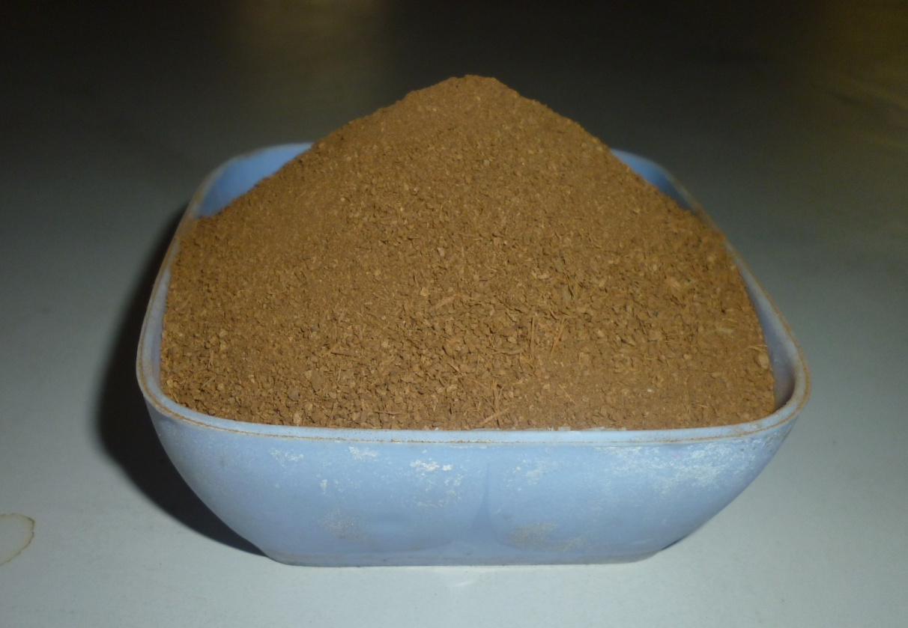

Fig. 2. POWDERED BARK OF Thespesia populnea

TABLE 1
DETAILS OF OPERATIONAL PARAMETERS USED IN THE STUDY
Parameters | Nickel solution (ml) | Nickel (mg/L) | Adsorbent (mg/50ml) | Contact time (min) | pH | Variation in parameter
pH | 50 | 100 | 300 | 60 | --- | 1 – 7
Contact time (Minutes) | 50 | 100 | 300 | --- | 6 | 10, 20, 30, 40, 50, 60, 90, 120, 150, 180
Adsorbent (mg/50ml) | 50 | 100 | --- | 60 | 6 | 100, 1000
Ni Conc. (mg/L) | 50 | --- | 300 | 60 | 6 | 20, 40, 60, 80, 100, 120, 140, 160, 180, 200

To study the effect of initial metal ion concentration varying concentrations (20 – 200 mg/L) of Ni solution were used (Fig 3). The effect of adsorbent dose on Ni adsorption was evaluated by varying the dose from 100 – 1000 mg with an increment of 100 mg. (Fig 4). Similarly the optimum pH and contact time for Ni adsorption were estimated by varying pH (1, 2, 3, 4, 5, 6 and 7) and contact time
(10 – 60 minutes with an increment of 10 minutes and 60 – 180 minutes with an increment of 30 minutes) (Fig 5 and Fig 6). The pH of the nickel solution was adjusted using 1N NaOH and 1N HCl. All the experimental set up were replicated thrice and results were averaged.

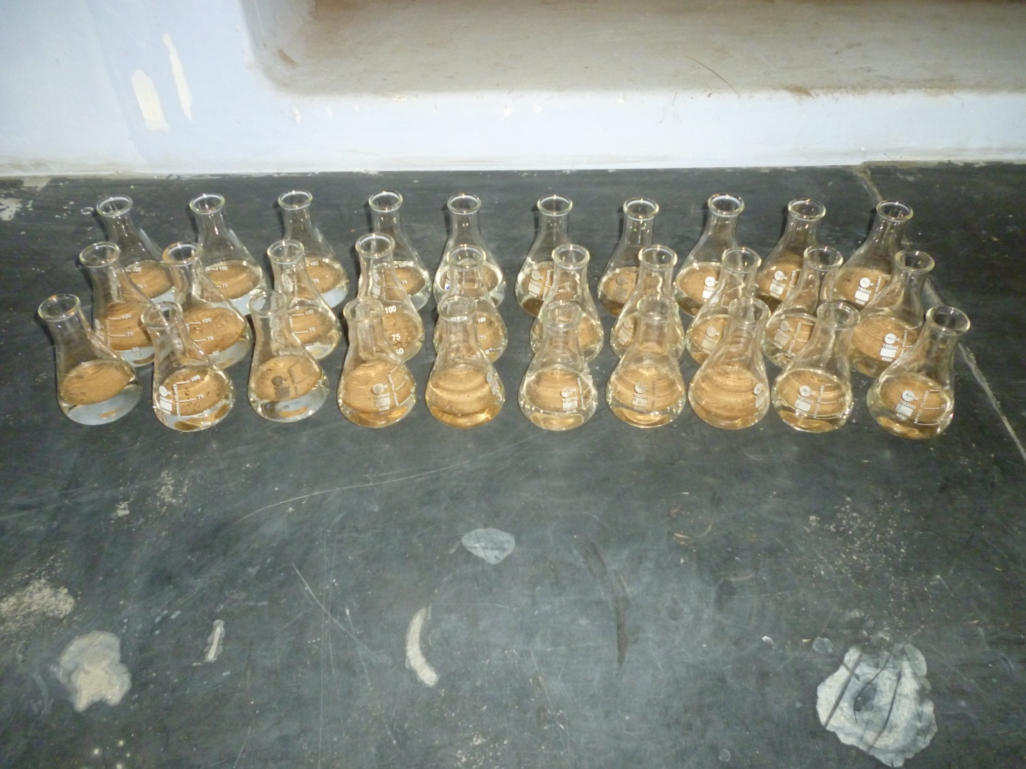
20 40 60 80 100 120 140 160 180 200

Fig. 3. EXPERIMENTAL SET UP TO STUDY THE EFFECT OF INITIAL METAL ION CONCENTRATION (mg/l)

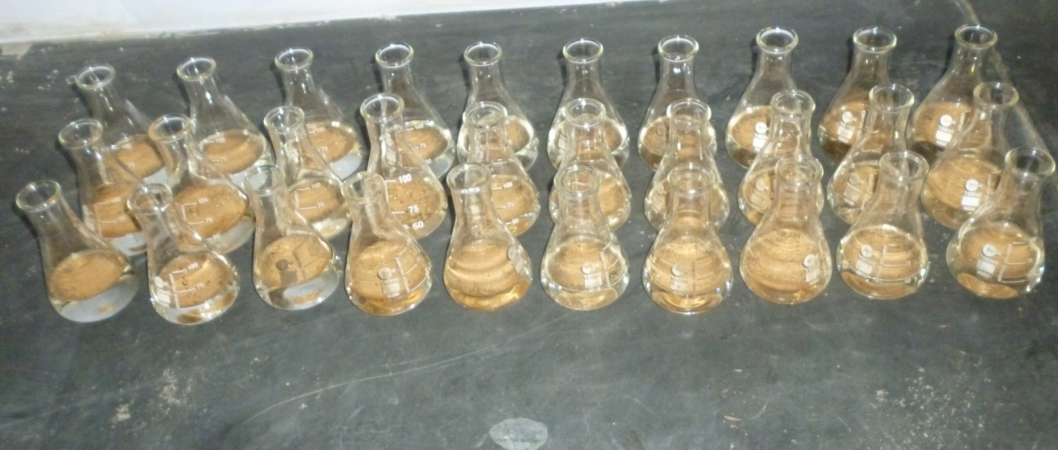
100 200 300 400 500 600 700 800 900 1000
Fig. 4. EXPERIMENTAL SET UP TO STUDY THE EFFECT OF ADSORBENT DOSE (mg/50ml)

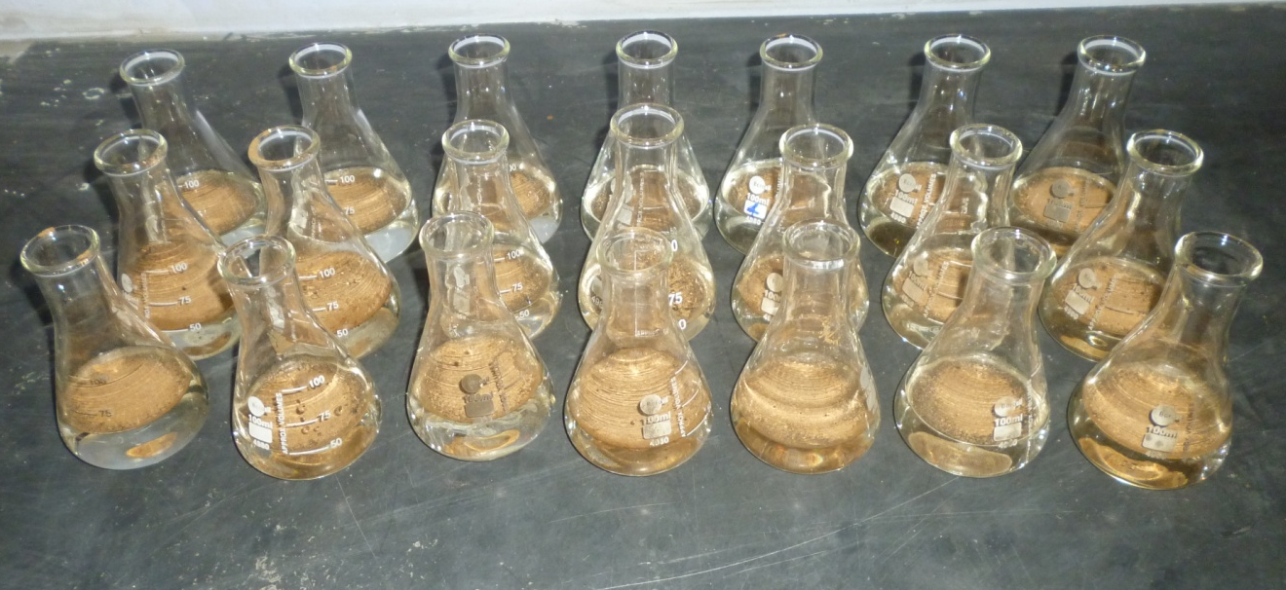
1 2 3 4 5 6 7
Fig. 5. EXPERIMENTAL SET UP TO STUDY THE EFFECT OF pH

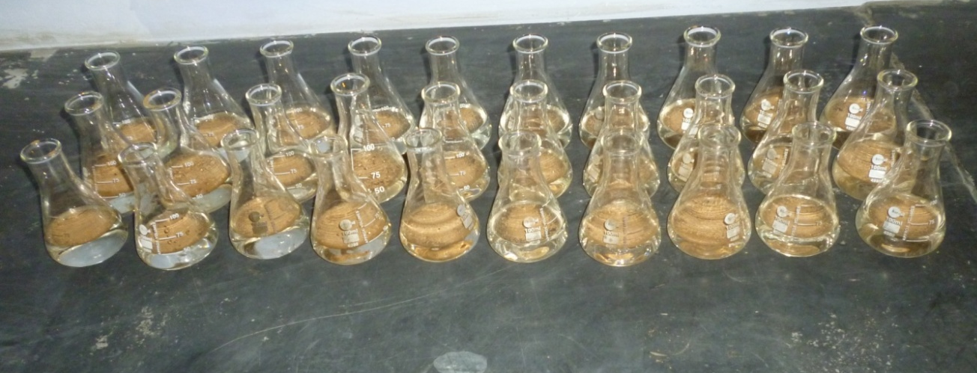
10 20 30 40 50 60 90 120 150 180
Fig. 6. EXPERIMENTAL SET UP TO STUDY THE EFFECT OF CONTACT TIME (MINUTES)

At the end of the experiment the Ni solution was separated from the adsorbent by filtration through Whatmann Filter paper no. 1. The residual Ni concentration in solution was estimated from the filtrate. The percent removal of Ni by the adsorbent was calculated using the given formula.
(C₀ – C)
Nickel removal (%) = ___________ X 100
C₀
Where, C₀ and C were the original and residual Nickel concentrations in solution respectively.
3.4. DESORPTION
After adsorption 300 mg of biosorbent was treated with 50 ml of HCl as desorbing agent for nickel desorption. HCl ranging from 0.025 to 0.200 M concentrations were used (Fig. 7). The conical flask containing the mixture was kept in orbital shaking incubator at 150 rpm and 30±2ºC for 60 minutes and then Ni content was estimated from the filtrate.
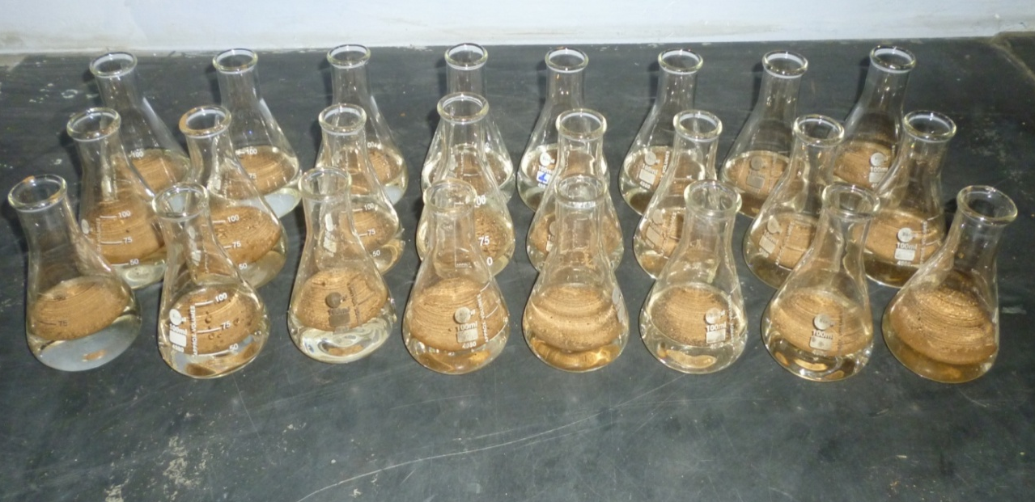
0.025 0.050 0.075 0.100 0.125 0.150 0.175 0.200

Fig. 7. EXPERIMENTAL SET UP FOR NICKEL DESORPTION FROM THE ADSORBENT USING HCl AT DIFFERENT MOLAR CONCENTRATIONS
3.5. TREATMENT OF NICKEL ELECTROPLATING EFFLUENT UNDER OPTIMAL CONDITIONS
The waste water from a local electroplating industry was collected and its nickel content was estimated. It was treated with the adsorbent under optimal operational conditions. Nickel content of the treated effluent was estimated and per cent nickel removal was calculated.
3.6. NICKEL ESTIMATION
Dimethyl glyoxime procedure (APHA, 1985) was used for the estimation of initial and residual Ni concentration in test solution and electroplating industrial waste water.
REAGENTS
0.5N Hydrochloric acid:
43ml conc. HCl was diluted to 1000 ml with distilled water
Sodium citrate solution
125g sodium citrate was dissolved in 500 ml distilled water.
0.05 N Iodine solution
20g potassium iodide was dissolved in 50 ml. distilled water. 6.4 g iodine was dissolved in this solution, and the solution was diluted to 1000 ml.
Dimethyl glyoxime solution:
1g dimethyl glyoxime was dissolved in 100 ml of concentrated ammonia solution. 100 ml distilled water was added and filtered if necessary.
PROCEDURE
The following reagents were added in order with mixing after each addition to the test solution (10 ml. sodium citrate solutions,
2 ml. iodine solution, and 4 ml. dimethyl glyoxime solution). The volume in all the flasks were made upto 50 ml. with distilled water and allowed to stand for 20 minutes. Optical density was measured in a spectrophotometer at 470 nm against the reagent blank. The result was expressed as mg nickel per litre of the test solution.
3.7. FT–IR ANALYSIS (Fourier Transformation Infrared Spectroscopy)
FT–IR spectroscopy was done to identify the chemical functional groups present on unloaded and nickel loaded bark powder biomass using IR spectrometer. IR absorption data were obtained for wavelengths in the range of 400 – 4000 cm⁻¹.
3.8. ADSORPTION ISOTHERM
Langmuir and Freundlich isotherm models were employed for the adsorption data obtained for different contact time.
The Langmuir equation can be represented in the form of following equation,
X/m = (k₁' C_{e} / 1 + k₁ C_{e})
Where,
X - Amount of nickel adsorbed (mg/l)
m - Weight of adsorbent (mg)
C_{e} - Concentration of nickel at equilibrium
k₁' and k₁ – are the Langmuir constants which are the measures of adsorption capacity and maximum energy of adsorption respectively.
On rearranging
1/x/m = 1/ k₁' /k₁ + 1 / k₁' C_{e}
The plot of (1/x/m) versus 1/Ce is linear with slope equal
to 1/ k₁' and intercepts (1/ k₁'/ k₁).
The essential features of Langmuir adsorption isotherms can be expressed in terms of a dimensionless constant, separation factor or equilibrium parameter ‘R_{L}’ which can be used to predict whether a sorption system is favourable or unfavourable in batch adsorption process. R_{L} was calculated from Langmuir isotherm based on the following equation.
R_{L} = 1/ (1 + bC_{i})
Where, C_{i} = initial concentration of the dye (mg/l)
b = Langmuir constant (k₁')
R_{L} value | Type of isotherm
R_{L} > 1  R_{L} = 1  R_{L} < 1 | Unfavourable  Linear  Favourable

The Freundlich equation can be represented in the form of following equation,
x/m = k_{f} C_{e}^{1/n}
log x/m = log k_{f} + 1/n log C_{e}
where,
x/m is the amount of nickel adsorbed on unit weight of adsorbent in equilibrium.
C_{e} is the concentration of solute in aqueous solution
K_{f} and 1/n are Freundlich constants related to the adsorption capacity and adsorption intensity respectively.
The Freundlich adsorption isotherms plot at different incubation time is plotted between log x/m versus log C_{e} for different concentrations of the nickel with 100 mg of the absorbent. K_{f} and 1/n values are evaluated from the slope and intercept respectively.

4. RESULTS AND DISCUSSION
Nickel is comparatively a rare metal in nature, but its widespread use in many industrial applications leads to relatively high concentrations of nickel in aquatic environment. Nickel (II) is present in small quantities (0.1 – 0.6 ppm) in plants, animals and occurs in trace amounts in sea water. The main symptom of nickel exposure includes headache, dizziness, nausea and vomiting, chest pain, tightness of the chest, dry cough and shortness of breath, rapid respiration, cyanosis and extreme weakness. In lieu of this, World Health Organization (WHO) has prescribed standards for desirable nickel concentration in drinking water as 0.1 mg/L and industrial effluents as 3.0 mg/L. Therefore, it is necessary to bring the nickel concentration below the prescribed limits.
There are numerous methods currently employed to remove metals from aqueous environment. Among these, adsorption is the most promising technique and economically feasible alternative for metal removal. Adsorption method offers the advantages of low operating cost and minimizing of secondary pollution. Plant material is easily available and relatively inexpensive and an investigation of its use as an adsorbent seems most appropriate. Hence in the present work, nickel ions adsorption capacity of Thespesia populnea tree bark was studied. The effect of pH, concentration of nickel (II) ions, contact time and adsorbent dose on percentage of adsorption has been investigated.
The plant, Thespesia populnea belongs to Malvacea family and is distributed in the tropics of the world. It is commonly known as false rose wood or Indian Tulip tree. The tree is largely being cultivated for ornament and shade and it blooms throughout the year in the tropics.
The bark of the tree has wide applications in various fields including medicine and its major industrial applications are its use as an adsorbent in the treatment of industrial effluent.
4.1. EFFECT OF pH
The effect of pH on nickel adsorption is presented in table 2 and figure 8.
Table 2
Effect of pH on nickel adsorption
Conditions :
Metal ion concentration : 100 mg/L
Adsorbent dose : 300mg
Time : 60 min
Temperature : 30 ± 2º C
RPM : 150
pH | Adsorbed nickel (mg/L) | Removal percentage %
1 | 17.2 | 17.2
2 | 40.0 | 40.0
3 | 47.6 | 47.6
4 | 60.6 | 60.6
5 | 64.6 | 64.6
6 | 69.8 | 69.8
7 | 68.6 | 68.6

Fig. 8. Effect of pH on nickel adsorption
The effect of pH was studied by varying the pH from 1.0 – 7.0. The study could not be carried beyond pH 7.0 due to the formation of precipitates in the nickel solution. At pH 1.0 the minimum adsorption of 17.2 % was observed. At pH 2.0 the adsorption percentage showed an increase to 40%. From pH 3.0 – 6.0 the percentage adsorption increased gradually and pH 6.0 showed the maximum adsorption of 69.8 %. At pH 7 a slight decrease in adsorption percentage was observed (68.6 %).
The above result reveals that nickel adsorption is minimum at low pH (highly acidic pH) and increases with increase in pH upto 6.0. The result also indicates that at pH above 7.0 (alkaline pH) nickel precipitates out of solution and therefore nickel adsorption on the surface of the adsorbent will not occur.
At low pH the hydrogen ion concentration is more and with increase in pH the hydrogen ion concentration decreases. The decrease in hydrogen ion concentration favours nickel adsorption. At higher pH hydroxyl ion concentration increases and nickel forms nickel hydroxide and precipitates out of solution.
From the above study it is evident that pH or hydrogen ion concentration plays a key role in metal ion adsorption on the surface of the adsorbent. According to Aregawi and Mengistie (2013) increases in pH increases percentage removal of metal ions and is explained on the basis of decrease in competition between proton (H⁺) and positively charged metal ions at the surface sites and also by decrease in positive charge near the surface resulting in a lower repulsion of the adsorbing metal ion and exposure of more negative groups for complexation of metal cations.
Patil et al. (2010) attributed the increase in percentage removal to higher degree of ionization of metal at higher pH besides reduced competition of H⁺ ions for adsorption sites.
Metal ion diffuse to the surface of biomass where they bind to active sites on cell surface formed with various chemical groups such as carboxylate, hydroxyl, amino and phosphate that exhibit affinity for metal ions (Aslam et al., 2010). Bansal et al. (2009) suggested that at highly acidic condition, adsorbent surface ligands would be closely asociated with H₃O⁺ that restricts access to ligands by metal ions as a result of repulsive forces. Further he added that with increase in pH values more and more ligands having negative charge would be exposed which could result in increase in attraction of positively charged metal ions.
The formation of precipitates at higher pH was reported by Patil et al. (2010). According to them at pH greater than 5, the nickel (II) ions get precipitated due to hydroxide ions forming nickel hydroxide precipitates.
Precipitation resulting in lower binding of metal ion was also reported by Bansal et al. (2009); Olayinka et al. (2007); Sujatha et al. (2013) and Singh et al. (2009).

4.2. EFFECT OF ADSORBENT DOSE
The effect of adsorbent dose on nickel adsorption is presented in table 3 and figure 9. The effect of adsorbent dose on adsorption was studied by increasing the adsorbent loading from 100 – 1000 mg/50 ml of nickel solution containing 100 mg/L of nickel.
Table 3
Effect of adsorbent dose on nickel adsorption
Conditions :
Metal ion concentration : 100 mg/L
pH : 6.0
Time : 60 min
Temperature : 30 ± 2º C
rpm : 150
Adsorbent dose (mg/50ml) | Adsorbed nickel (mg/L) | Removal percentage ( % )
100 | 39.0 | 39.0
200 | 55.8 | 55.8
300 | 69.8 | 69.8
400 | 76.0 | 76.0
500 | 80.6 | 80.6
600 | 79.0 | 79.0
700 | 79.6 | 79.6
800 | 80.0 | 80.0
900 | 79.6 | 79.6
1000 | 78.4 | 78.4

Figure 9
Effect of adsorbent dose on nickel adsorption
A gradual increase in nickel removal from 39% to 80.6% was observed when the adsorbent dose was increased from 100 mg to 500 mg. When the adsorbent dose was increased from 600 – 1000 mg there was no increase in nickel removal and it was almost stable. In this study the maximum nickel removal observed was 80.6% with 500 mg adsorbent dose.
Initial increase in percentage adsorption upto 500 mg of adsorbent loading with no significant changes with further increases in adsorbent is clearly seen from the graph (Fig. 9). This observation is in concordance with the results of the adsorption studies carried out in the past using different types of tree bark as adsorbent (Aregawi
et al., 2013; Prabakaran and Arivoli, 2012; Patil and Shrivastava, 2010 and Sahare, 2012).
The study shows that at lower doses there is a continuous increase in adsorption percentage but at higher doses there is no increase with the increase in adsorbent dose. This continuous increase in adsorption with the increase in adsorbent close may be explained as being due to an increase in the area of adsorption which adds more and more active sites that participate in metals ion binding. It is presumed that at higher doses there may be adsorbent overloading. Actually there is an increase in the number of active sites, but there may be the overlapping of active sites hindering their participation in metal ion binding. Though more active sites are available, all cannot participate in adsorption, thus a further increase in adsorption is not possible at higher doses.
Evaluation of the results in tune with the above explanation was given by Aregawi et al. (2013). He stated that the increase in the adsorption percentage with rise in adsorbent dose may be due to increase in the available adsorption active sites on the adsorbents, thus making easier penetration of the metal ion to the sorption sites. He also explained that any further addition of the adsorbent beyond the obtained optimum masses did not cause any significant change in adsorption. This may be due to overlapping of adsorption sites as a result of overcrowding of adsorbent particles and also may be due to decrease in contact time, required to reach apparent equilibrium with the increase in adsorbent dose.
Many attributed the initial increase in adsorption to the availability of more binding sites in the surface of the biosorbent for complexation of nickel ions (Olayinka et al., 2009; Muthusamy et al., 2012; Bansal et al., 2009; Prabakaran and Arivoli et al., 2012; Kumar and Kirthika, 2009).
The role of functional groups in adsorption was explained by Sahare (2012). He explained that the functional groups are involved in the formation of Vander Waals bonding for binding metal ions.
No significant change in adsorption observed at higher doses is attributed to the over lapping of adsorption sites due to overcrowding of adsorbent particles (Kumar and Kirthika, 2009; Aslam et al., 2010).
4.3. EFFECT OF METAL ION CONCENTRATION
Table 4 shows the effect of initial nickel ion concentration
on adsorption. Adsorption of Ni (II) decreased gradually from
86% to 52.3% with the increase in metal ion concentration from
20 – 200 mg / L.
Table 4
Effect of metal ion concentration on nickel adsorption
Conditions :
Adsorbent dose : 300mg
pH : 6.0
Time : 60 min
Temperature : 30 ± 2º C
rpm : 150
Nickel concentration (mg/L) | Adsorbed nickel (mg/L) | Removal percentage (%)
20 | 17.2 | 86.0
40 | 33.8 | 84.5
60 | 49.8 | 83.0
80 | 61.2 | 76.5
100 | 69.8 | 69.8
120 | 77.8 | 64.8
140 | 85.2 | 60.9
160 | 85.8 | 53.6
180 | 104.6 | 52.3
200 | 93.2 | 51.8

Figure 10 shows a steady decline in adsorption with the increase in nickel concentration from 20 – 200 mg / L. It is observed that at low metal ion concentration, the percent removal is high and at high metal ion concentration the percent removal is low. The high adsorption at lower concentrations of metal ion may be due to the availability of more active sites for adsorption. The lower adsorption at higher concentration of metal ion may be due to the saturation of active sites on the adsorbent.
Figure 10
Effect of metal ion concentration on nickel adsorption
According to Aslam et al. (2010), the initial concentration provides the important driving force to overcome mass transfer resistances of metal ions between aqueous and solid phase. At low concentrations, adsorption sites took up the available metal more quickly. However, at higher concentrations, metal ions need to diffuse to the biomass surface by inter particle diffusion and greatly hydrolyzed ions are likely to diffuse at slower rate.
Aregawi and Mengistie (2013) described the decrease in percent removal at higher concentration being due to fact that all the adsorbents have limited number of active sites, which would have become saturated above a certain metal ion concentration.
Prabakaran and Arivoli (2012) explained that as the concentration of metal ion increases, more and more surface sites are covered and hence at higher concentrations of metal ions the capacity of the adsorbent gets exhausted due to non-availability of the surface sites. It is therefore evident that at low concentration ranges the percentage of adsorption is high because of the availability of more active sites on the surface of the adsorbent.
Bansal et al. (2009) stated that at higher concentrations, most of the nickel (II) is left unabsorbed due to saturation of adsorption sites. As the ratio of sorptive surface to ion concentration decreases with increasing metal ion concentration, the metal ion removal is reduced. Sahore (2012) explained that the percent removal of the metal ions decreases with increasing initial concentration. This is due to more adsorption sites available on adsorbent at low concentration of metal ions. The adsorption sites become more saturated when the metal ion concentration is increased and the adsorbent concentration remains constant.
4.4. EFFECT OF CONTACT TIME
The effect of contact time on Nickel removal was observed by increasing the contact time from 10 to 180 minutes and the result is presented in table 5. The plot in figure 11 reveals an increase in nickel removal from 20.4 % at 10 min to 69.8 % at 60 min which then declines slightly when contact time was further increased to 180 min (65.8%).

Table 5
Effect of contact time on nickel adsorption
Conditions :
Metal ion concentration : 100 mg/L
Adsorbent dose : 300mg
pH : 6.0
Temperature : 30 ± 2º C
rpm : 150
Time  (Min) | Adsorbed nickel (mg/L) | Removal percentage  ( %)
10 | 50.4 | 20.4
20 | 56.6 | 32.0
30 | 60.0 | 43.8
40 | 63.0 | 50.2
50 | 65.8 | 61.2
60 | 69.8 | 69.8
90 | 65.8 | 65.8
120 | 65.8 | 65.8
150 | 64.0 | 64.0
180 | 65.8 | 65.8

Figure 11
Effect of contact time on nickel adsorption
Similar observations were made by Bansal et al. (2009). He described that the adsorption rate increased with the increase in contact time and the maximum Nickel removal was achieved within 120 minutes, after which Nickel concentration in the test solution became constant.
In the present study equilibrium contact time was found to be 60 minutes which coincides with the reports of Aslam et al. (2010) who concluded that one hour was sufficient for the sorption to attain equilibrium. Equilibrium time is the maximum time taken by the sorption experiment to achieve equilibrium after which no further metal uptake is observed. Higher percent Nickel removal in
the early stages of adsorption was also reported by Kumar and Kirthika (2009) and Aregawi and Mengistie (2013).
The effect of contact time on adsorption was explained by different researchers. Aregawi and Mengistie (2013) explained that the percent removal is higher at the beginning because of large number of vacant surface sites available for adsorption. After equilibrium contact time, the metal ion competes for the adsorption sites on the adsorbent causing a decrease in the amount adsorbed. He stated that this competition could affect the diffusion properties and also the adsorption capacity of metal ions.
Bansal et al. (2009) described that initially for adsorption, large number of vacant sites are available, which slowed down later due to exhaustion of remaining surface sites and repulsive force between surface molecules and bulk phase.
Aslam et al. (2010) explained that the uptake of heavy metal ions by biosorbent has often been observed to occur in 2 stages, namely rapid and quantitatively predominant and slower and quantitatively insignificant stage. The rapid stage is probably due to abundant availability of active sites on the biomass. With gradual occupancy of these sites, the sorption becomes less efficient in later stages.
4.5. DESORPTION
Results of desorption study show the maximum desorption efficiency of 82.9% of nickel (II) at 0.150 M concentration of HCl as desorbing agent. Increasing the concentrations of HCl to 0.200 M the nickel (II) uptake capacity from the adsorbent has been reduced to 80.0 %. Table 6 and figure 12 shows the desorption of nickel (II) by varying the molar concentrations of HCl (0.025 – 0.200 M). Desorption studies show the possibility of recycling the adsorbent.
Bansal et al. (2009) has explained the process of desorption. When HCl is used as a desorption agent, the biosorbent surface
is covered with H⁺ ions and the coordination spheres of chelated nickel (II) ions are disrupted. Thereafter the nickel (II) ions could not compete with H⁺ ions for exchange sites and subsequently heavy metal ions are released from the solid surface into the solution.
Table 6
Effect of HCl concentration on nickel desorption
Conditions :
Metal ion concentration : 100 mg/L
Adsorbent dose : 300mg
Time : 60 min
Temperature : 30 ± 2º C
rpm : 150
HCl  (M) | Adsorbed nickel  (mg/L) | Removal percentage  (%)
0.025 | 38 | 54.3
0.050 | 44 | 62.9
0.075 | 48 | 68.6
0.100 | 50 | 71.4
0.125 | 54 | 77.1
0.150 | 58 | 82.9
0.175 | 56 | 80.0
0.200 | 56 | 80.0

Figure 12
Effect of HCl concentration (M) on nickel desorption
4.6. APPLICATION TO ELECTROPLATING WASTE WATER
In order to assess the performance of Thespesia bark for the removal of Ni (II) from electroplating waste water, experiment was carried out under the conditions of pH 6, contact time of 60 minutes and biosorbent dose of 300mg/ 50ml. The result showed 74.5% removal of Ni (II) from waste water. With subsequent treatments the nickel content was reduced to 2.8mg/l which was within the limits prescribed for waste water.
Table 7
Nickel removal in electroplating effluent with Thespesia populnea bark under optimal conditions
Initial Nickel concentration  (mg/l) | Final Nickel concentration  (mg/l) | Removal percentage  (%)
97.8 | 24.2 | 74.5
24.2 | 2.8 | 88.4

4.7. FT-IR ANALYSIS
The pattern of sorption of metals onto plant materials
is attributed to the active groups and bonds present on them (Krishnani et al., 2008). Plant cell walls, mainly consisting of polysaccharides, proteins and lipids, offer many functional groups such as carboxyl, carbonyl, hydroxyl, and amino which can be involved in metal binding (Macfie and Welbourn, 2000). The FT-IR spectra of Thespesia populnea bark before nickel adsorption was shown in figure 13.
The IR spectrum of unloaded Thespesia populnea bark showed peaks at 3424.29 cm⁻¹ which is due to –NH stretching presenting amino group as well as –OH ground bound to alcohol (Park et al., 2005). The bands that are observed at 2925.502 and 2854.85 cm⁻¹ suggest the presence of C-H group of aliphatic acids (Farinella et al., 2007). The peak observed at 1746.45 cm⁻¹ may be assigned to the vibration of C=O of the ester group (Kamala et al., 2005). The peak at 1620.74 cm⁻¹ was the result of CO stretching mode with NH deformation and was indicative of amide (Mukhopadhyay, 2008). The peak at 1458.81 cm⁻¹ may be attributed to symmetric stretching vibration of C=O (Yuan et al., 2009). The band observed at 1318.48 cm⁻¹ can be ascribed to –COOH group the bands in range of 1159.95 and 1111.60 cm⁻¹ can be assigned to the –CN stretching vibration of protein fractions (Kapoor and Virraghavan 1997). The peaks less than 1000 cm⁻¹ represents the "fingerprint" region which attributed to the phosphate group which is one of the functional groups of which nucleic acids are composed (Guibaud
et al., 2003).
The IR spectrum of Thespesia populnea bark after nickel biosorption was shown in figure 14.

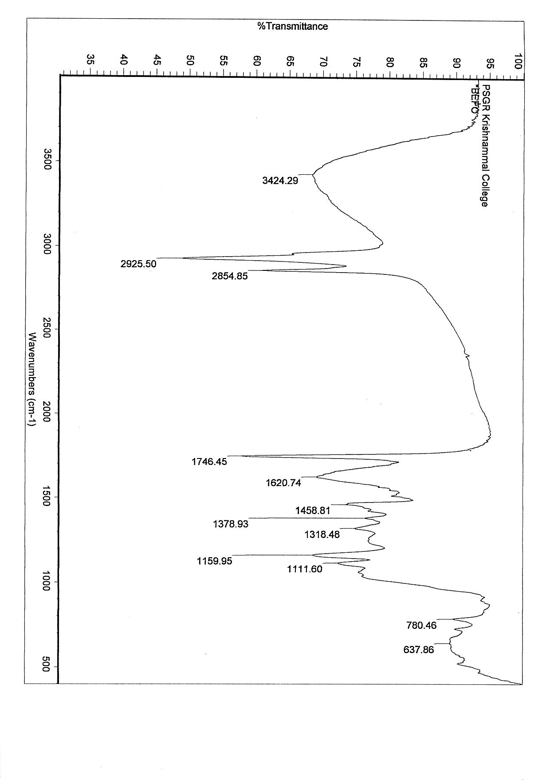
Fig. 13. FTIR Spectrum of unloaded adsorbent

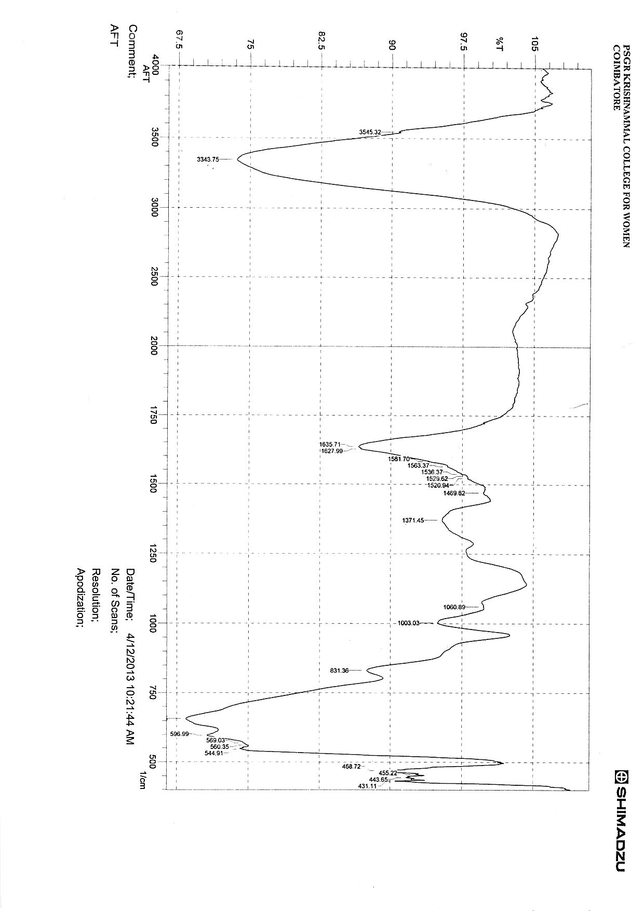
Fig. 14. FTIR Spectrum of loaded adsorbent

The results showed that the band at 3424.29 cm⁻¹ shifted to 3343.75 cm⁻¹ and became more sharper with greater intensity. This may be due to change in nature of binding (Pradhan et al., 2007) after interaction with nickel ions. It also showed the disappearance of peaks at 2925.50 cm⁻¹, 2854.85 cm⁻¹ and 1746.45 cm⁻¹. The peak shift from 1620.74 cm⁻¹ to 1635.71 cm⁻¹ and 1627.99 cm⁻¹ was also observed.
The bond intensity at 520 and 611 cm⁻¹ decreased after nickel biosorption. The above observations indicated that the main functional groups involved in biosorption process were hydroxyl, carboxyl, amine and phosphate groups.
4.8. ADSORPTION ISOTHERMS
Modeling equilibrium sorption is important for industrial applications of biosorption. It yields data that facilitates designing and optimization of adsorption process the process. In this study, Langmuir and Freundlich isotherm models were employed for describing the adsorption data obtained for different contact time.
The Langmuir isotherm model is based on the assumption that a maximum adsorption corresponds to a saturated monolayer of solute molecules on the adsorbent surface, that the energy of adsorption is constant, and that there is no transmigration of adsorbate in the plane of the surface.
The Freundlich adsorption isotherm was applied to study the biosorption behaviour assuming a heterogeneous adsorption surface and active sites with different energy.
The two models could not be fitted to the experimental data.
The findings of this study revealed that Thespesia populnea bark powder is a promising biosorbent for the removal of nickel from contaminated wastewater.
5. SUMMARY AND CONCLUSION
- An attempt has been made to evaluate the potential of Thespesia populnea bark as an adsorbent for nickel removal from electroplating effluent.
- The bark of Thespesia populnea was collected from a local school campus. It was dried, powdered and sieved to get fine particles.
- The powdered bark was washed with distilled water to remove dirt, then dried in an oven at 80º C for 1 hour and stored in air tight containers for experimental use.
- The operational conditions for nickel adsorption were optimized prior to its application to plating effluent in terms of four parameters namely initial metal ion concentration, adsorbent dose, pH and contact time using batch experiments.
- To study the effect of these parameters on adsorption, the parameter studied was varied, keeping the other parameters as constant.
- The initial metal ion concentration was varied from 20 to 200 mg/L and adsorbent dose from 100 to 1000 mg/50 ml of nickel solution.
- pH of nickel solution was varied from 1 to 7 and contact time from 10 to 180 minutes.
- In all batch experiments 50ml of nickel working solution (adsorbate) containing 100 mg/L was mixed with 300 mg of adsorbent. The mixture was taken in conical flasks and agitated in an orbital shaker, rotating at 150 rpm and 30 ± 2º C for 60 minutes.
- Nickel stock solution was prepared by dissolving 4.47 g of nickel sulphate in 1000 ml of distilled water. By diluting the stock solution the desirable concentrations of nickel working solutions were prepared.
- Nickel desorption studies were carried out using 0.025 M to 0.200 M concentrations of HCl as a desorbing agent.
- After the experiment the residual nickel in the solution was estimated, after the removal of adsorbent by filtration through Whatmann No.1 filter paper and percent nickel removal was calculated.
- For nickel estimation dimethyl glyoxime procedure was employed.
- Electroplating waste water collected from a local plating industry was treated with the adsorbent under optimal operating condition.
- FTIR analysis of unloaded and nickel loaded bark was done to identify the chemical functional groups that participate in nickel adsorption.
- Langmuir and Freundlich adsorption isotherm models were applied to the experimental data obtained for contact time.
- Modeling was done to study the potential of the adsorbent for industrial applications.
The study shows that pH, adsorbent dose, metal ion concentration and contact time play a major role in adsorption.
- Percentage adsorption increased with increase in pH and maximum adsorption was obtained at pH 6 (69.8%).
- The increase in adsorption with the increase in pH may be due to decrease in competition between H⁺ and positively charged metal ion at the surface sites.
- A gradual increase in nickel removal from 39% to 80.6% was observed when the adsorbent dose was increased from 100mg to 500mg.
- When the adsorbent dose was increased from 600 – 1000 mg there was no increase in nickel removal and it was almost stable.
- In this study the maximum nickel removal observed was 80.6% with 500 mg adsorbent dose.
- Increase in the adsorption percentage with rinse in adsorbent dose may be due to increase in the available adsorption active sites on the adsorbents.
- No significant change in adsorption observed at higher doses is attributed to the overlapping of adsorption sites due to overcrowding of adsorbent particles.
- Adsorption of Ni(II) decreased gradually from 86% to 52.3% with the increase in metal concentration from 20 – 200 mg/L.
- At low concentrations, adsorption sites took up the available metal more quickly.
- The decrease in percent removal at higher concentration may be explained by the fact that all the adsorbents have limited number of active sites, which would have become saturated above a certain metal ion concentration.
- Increase in nickel removal from 20.4% at 10 min to 69.8% at 60 min which then declines slightly when contact time was further increased to 180 min (65.8%).
- Higher percent removal at the beginning may be due to a large number of vacant surface sites available for adsorption.
- After equilibrium contact time, the metal ion competes for the adsorption sites on the adsorbent causing a decrease in the amount adsorbed.
- Results of desorption show the maximum desorption efficiency of 82.9% of nickel (II) at 0.150 M concentration of HCl as desorbing agent. Desorption studies shows the possibility of recycling the adsorbent.
- FT-IR spectral analysis shows the shifting of bands in the treated adsorbent when compared to untreated adsorbent.
- Langmuir and Freundlich isotherm models could not be fitted to the experimental data.
The results obtained for the present study revealed that the sorption efficiency was dependent on operating conditions such as pH, contact time, biomass dosage and initial metal concentrations. As pH increased, the metal biosorption increased up to pH 6.0. Increases of biomass dosage led to increase in nickel adsorption due to increase in the surface area. The adsorption isotherm of nickel could not be described by either Langmuir or Freundlich isotherm. The kinetic data also indicated that the equilibrium was attained within the initial 60 minutes of contact time between the sorbate and sorbent. The FTIR analysis indicated that the functional group of hydroxyl, carboxyl, amine and phosphate were responsible for nickel binding. The results showed that the recovery of metal and the reusability of biosorbent are possible. The findings of this study revealed that Thespesia populnea bark powder is a promising biosorbent for the removal of nickel from contaminated wastewater.

REFERENCES

- Ahmed, A. and Layla, A. (2009), Removal of Heavy metals from waste water by date palm tree wastes, Engineering and Technology Journal, Vol. 28(1), pp:119 – 125.
- Anuratha, A. (2005), Adsorption of copper in sewage irrigated soils, Journal of Ecotoxicology Environmental Monitor, Vol. 15(4), pp:341 – 345.
- APHA (1985), Standard methods for the examination of water and waste water, American Public Health Association, Washington, D.C,16th Edi., 245 – 246.
- Aregawi, B.H. and Mengistie, A.A. (2013), Removal of Ni(II) from aqueous solution using leaf, bark and seed of Moringa stenopetala Adsorbents, Bull. Chem. Soc. Ehtio., 27(1):
35 – 47.
- Asbchin, S.A., Mohammadi, M., Bahrami, A., Monfared, A.L. and Jafari, N. (2011), Batch studies on the removal of Ni(II) from aqueous solution by Azolla filliculoides, African Journal of Biotechnology, Vol. 10, No. 38, pp: 7427 – 7431.
- Ashraf, M.A., Maah, M.J. and Yusoff, I. (2010), Study of Mango biomass (Mangifera indica L.) as a cationic biosorbent, Int. J. Environ. Sci. Tech., 7(3):581 – 590.
- Ashraf, M.A., Mahmood, K. and Wajid, A. (2011), Study of low cost biosorbent for biosorption of heavy metals, International Conference on Food Engineering and Biotechnology, Vol. 9, pp:60 – 68.
- Aslam, M.Z., Naveed, S., Ramzan, N. and Feroze, N. (2010), Ni(II) removal by biosorption using ficus religiosa (peepal) leaves, Journal of the Chilean Chemical Society, Vol. 55, No. 1, pp:81 – 84.
- Atkinson, b.W., Bux, F. and Kasan, H.C. (1998), Considerations for application of biosorption technology to remediate metal contaminated industrial effluents, ISSN:0378-4738, Water SA Vol. 24., No. 2., pp:129 – 135.
- Ato, A.F., Samuel, O., Oscar, Y.D. and Moi, P.A.N. (2010), Mining and Heavy metal pollution : Assessment of Aquatic environments in Tarkwa (Ghana) using multivariate statistical analysis, Journal of Environmental Statistics, Vol. 1, No. 4.
- Bailey, R.A., Clark, H.M., Ferris, J.P., Krause, S. and Strong, R.L. (2002), The environmental chemistry of some important elements, Chemistry of the environment, Academic press, San Diego, pp:347 – 414.
- Bansal, M., Singh, D., Garg, V.K. and Rose, P. (2009), Use of agricultural waste for the removal of Nickel ions from aqueous solutions : Equilibrium and Kinetics studies, International Journal of Civil and Environmental Engineering, Vol. 1, No. 2, pp:108 – 114.
- Baran, A., Baysal, S.H. and Sukatar, A. (2005), Removal of Cr⁶⁺ from aqueous solution by some algae, Journal of Environmental Biology, 26(2):329 – 333.
- Can, O., Balkose, D. and Ulku, S. (2010), Batch and column studies on heavy metal removal using a local zeolitic tuff, Desalination, 259(1-3):17 – 21.
- Chatterjee, S., Chosh, I. and Mukherjea, K.K. (2011), Uptake and removal of toxic Cr(VI) by Pseudomonas aeruginosa : Physico – chemical and biological evaluation, Current Science, Vol. 101, No. 5, pp:645 – 652.
- Chen, C. Wang, J.C. (2007), Characteristics of Zn²⁺ biosorption by Saccharomyes cerevisiae, Biomed. Environ. Sci., 20(6),
478 – 482.
- Chen, C.Y. and Lin, T.H. (1998), Nickel toxicity to human termplacenta : invitro study on lipid peroxidation, Journal of toxicology and Environmental Health, Vol. 54, pp:37 – 47.
- Chen, J. and Song, X. (2011), Study on biological method of heavy metal removal from urban sewage sludge, International Conference on Electrical and Control Engineering,
pp:4090 – 4092.
- Chen, M., Tang, Y., Li, X. and Yu, Z. (2009), Study on the heavy metals removal efficiencies of constructed wet lands with different substrates, Journal of Water Resource and Protection, Vol. 1, pp:1 – 57.
- Chidambaram, S., Karmegam, U., Prasanna, M.V. and Sasidhar, P. (2012), A study on evaluation of probable sources of heavy metal pollution in ground water of Kalpakkam region, South India, Indian Journal of Pharmacol., 43(8):246 – 253.
- Dave, S.R., Damani, M.S., Tipre, D.R. and Dutt, P.S. (2010), Copper bioremediation from aqueous solution and pigment industries waste using dried Aquatic Plant Biomass, Research Journal of Biotechnology, Vol. 5, No. 4, pp:15 – 19.
- Dean, J.R. and Dixon, B.G. (1992), Uptake of Pb²⁺ and Cu²⁺ by novel biopolymers, Wat. Res., 26(4):469 – 472.
- Denkhaus, E. and Salnikow, K. (2002), Nickel essentiality, toxicity and carcinogenicity, Gitical Reviews in Oncology / Hematology, Vol (42), No.1, pp:35 – 56.
- Erdem, E., Karapinon, N. and Donat, R. (2004), The removal of heavy metal cations by natural zeolites, Journal of Colloid Interface Science, 280: 309 – 314.
- Farinella, N.V., Matos, G.D. and Arruda, M.A.Z. (2007), Grape bagasse as a potential biosorbent of metals in effluent treatments, Bioresource Technology, Vol. 98, pp:1940 – 1946.
- Fu, F. and Wang, Q. (2011), Removal of heavy metal ions from waste waters : A Review, Journal of Environmental Management, 92(3):407 – 418.
- Grebenyuk, V.D., Linkov, N.A. and Linkov, V.M. (1998), Removal of Ni and Cu ions from aqueous solutions by means of a hybrid electrsorption / eletrodialysis process, ISSN 0378-4738, Water SA., 24(2):123 – 127.
- GSR 801 (E), EPA (1986), December 31, 1993.
- Guibaud, G., Tixier, N., Bouju, A. and Baudu, M. (2003), Relation between extracellular polymers composition and its ability to complex Cd, Cu and Pb, Chemosphere, Vol. 52, pp:1701 – 1710.
- Holleman, M. and Wiberg, E. (1985), Lehebuch du Anoranischen Chemic Water de Gruyter, Berlin, p.868.
- Hu, J., Chen, G., Irene, M.C., Lo, M. ASCE (2006), Selective removal of heavy metals from industrial waste water using maghemite Nanoparticle : Performance and Mechanisms, Journal of Environmental Engineering, 132(7): 709 – 715.
- Jnr, M.H. and Vicente, J.L. (2007), Kinetic study of Liquid-phase adsorptive removal of heavy metal ions by almond tree (Terminalia Catappa L.) Leaves Waste, Bulletin of Chemical Society of Ethiop., Vol. 21, No. 3, pp:349 – 362.
- Johnson, P.D., Girinathannair, P., Ohlinger, K.N., Ritchie, S., Teuber, L. and Kirby, J. (2008), Enhanced removal of heavy metals in primary treatment using coagulation and flocculation, Water Environmental Research, Vol. 80, No. 5, p:472.
- Kapoor, A. and Viraraghavan, T. (1997), Heavy metal biosorption sites in Aspergillus niger, Bioresource Technology, Vol. 61, pp:221 – 227.
- Kaushik, A., Kansal, A., Santosh, Meena, Kumar, S. and Kaushik, C.P. (2009), heavy metal contamination of river Yamuna, Haryana, India : Assessment by metal enrichment factor of the sediments, Journal of Hazardous materials, Vol, 164, No. 1, pp:265 – 270.
- Krishna, R.H. and Swamy, A.V.V.S. (2011), Studies on the removal of Ni(II) from aqueous using powder of Mosambi Fruit peelings as a low cost sorbent, Chemical Science Journal, Vol. 2011, CSJ – 31, pp:1 – 13.
- Krishnani, K.K., Xiaoguang, M.X., Christodoulatos, C. and Boddu, V.M. (2008), Biosorption, Mechanism of nine different heavy metals onto biomatrix from rice husk, Journal of Hazardous Materials, Vol. 153, pp:1222 – 1234.
- Kumar, P.S. and Kirthika, K. (2009), Equilibrium and kinetic study of adsorption of Nickel from aqueous solution onto Bael Tree Leaf powder, Journal of Engineering Science and Technology, 4(4):351 – 363.
- Lin, C., He, M., Zhou, Y., Guo, W. and Yang, Z. (2008), Distribution and contamination assessment of heavy metals in sediment of second Songhua River, China, Environ. Monit. Assess, Vol. 37(1-3), pp:329 – 342.
- Liu, Y. and Xu, H. (2007), Equilibrium, thermodynamics and mechanisms of Ni²⁺ biosorption by aerobic granules, Biochemical Engineering Journal, Vol. 35, No. 2., pp:174 – 182.
- Lokhande, R.S., Singare, P.U. and Pimple, D.S. (2011), Toxicity study of Heavy metals pollutants in waste water effluent samples collected from Taloja Industrial Estate of Mumbai, India, Journal Resource and Environment, Vol. 1, No. 1, pp:13 – 19.
- Luo, Y., Wu, L., Liu, L., Han, C. and Li, Z. (2009), Heavy metal contamination and Remediation in Asian Agricultural Land, Laboratory of soil Environment and Pollution Remediation, Chinese Academy of Sciences, pp:1 – 9.
- Macfie, S.M. and Welbourn, P.M. (2000), The cell wall as a barrier to uptake of metal ions in the unicellular green alga Chlamydomonas reinhardtii (chlorophyceae), Archieves
of Environmental Contamination and Toxicology, Vol. 39, pp:413 – 419.
- Maleva, M.G., Nekrasova, G.F., Malec, P., Prasad, M.N.V. and Strzalka, K. (2009), Ecophysiological tolerance of Elodea canadensis to nickel exposure, Chemosphere, Vol. 77, No. 3, pp:392 – 398.
- Moore, F., Attar, A. and Rastmanesh, F. (2011), Anthropogenic sources of heavy metals in deposited sediments from runoff and industrial effluents, Shiraz, SW Iran, International Conference on Environmental Science and Technology, Vol. 6, pp:215 – 219.
- Mukhopadhyay, M. (2008), Role of surface properties during biosorption of copper by pretreated Aspergillus niger biomass, Colloids and Surfaces A : Physicochemical and Engineering Aspects, Vol. 329, pp:95 – 99.
- Murthy, K.S.R. and Marayya, R. (2011), Studies on the removal of heavy Metal Ions from Industrial effluents using Ammonium Pyrrolidine Dithio Carbamate (APDC) Loaded Polyurethane Foams (PUF), World Applied Sciences Journal, 12(3):
358 – 363.
- Muthusamy, P., Murugan, S. and Samitha, M. (2012), Removal of Nickel ion from industrial waste water using maize cob, Journal of Biological Sciences, Vol. 1, No. 2, pp:7 – 11.
- Nomanbhay, S.M. and Palanisamy, K. (2005), Removal of heavy metal from industrial waste water using chitosan coated oil palm shell charcoal, Electronic Journal of Biotechnology, 8(1):101 – 112.
- Odewande, A.A. and Abimbola, A.F. (2008), Contamination indices and heavy metal concentrations in urban soil of Ibadan metropolis, South Western Nigeria, Environmental Geochem. Health, Vol. 30, pp:243 – 254.
- Olayinka, K.O., Adu, T. and Alo, B.L. (2007), Sorption of heavy metals from electroplating effluents by low-cost adsorbents use of waste tea, coconut shell and coconut husk, Pakistan, J. Applied Science, Vol. 7., pp:2307 – 2313.
- Olayinka, O.K., Oyedeji, O.A. and Oyeyiola, O.A. (2009), Removal of chromium and nickel ions from aqueous solution by adsorption on modified coconut husk, African Journal of Environmental Science and Technology, 3(10):286 – 293.
- Ong, S.A., Toorisaka, E., Hirata, M. and Hano, T. (2010), Adsorption and toxicity of heavy metals on activated sludge, Science Asia, Vol. 36, pp:204 – 209.
- Ozer, A. and Ozer, D. (2003), Comparative study of the biosorption of Pb(II), Ni(II) and Cr(VI) ions onto S. cerevisiae : determination of biosorption heats, J. Hazard Material, 100:
219 – 229.
- Park, D., Yun, Y.S. and Park, J.M. (2005), Studies on hexavalent chromium biosorption by chemically-treated biomass of Ecklonia species, Chemosphere, Vol. 60,
pp:1356 – 1364.
- Patil, A.K. and Shrivastava, V.S. (2010), Adsorption of Ni(II) form aqueous solution of Delonix regia (Gulmohar) tree bark, Archives of Applied Science Research, 2(2):404 – 413.
- Prabakaran, R. and Arivoli, S. (2012), Adsorption kinetics, equilibrium and thermodynamic studies of nickel adsorption onto Thespesia populnea bark as biosorbent from aqueous solutions, European Journal of Applied Engineering and Scientific Research, Vol. 1(4), pp:134 – 142.
- Prabhakaran, R. (2011), Biosorption of Ferrous ions from aqueous solutions by using activated carbon prepared
from Thespesia populnea bark, Arch. Appl. Sci. Res.,
3(6):218 – 232.
- Pradhan, S., Singh, S. and Rai, L.C. (2007), Characterization of various functional groups in the capsule of Microcystis and study of their role in biosorption of Fe, Ni, Cr., Bioresource Technology, Vol. 98, pp:595 – 601.
- Prasad, D. and Abdulsalam, M.A. (2009), Biosorption of Fe(II) from aqueous solution using Tamarind bark and potato peel waste : Equilibrium and kinetic studies, J. App. Sci. In Environ. San., 4(3):273 – 282.
- Qaiser, S., Saleemi, A.R. and Ahmad, M.M. (2007), Heavy metal uptake by agro based waste material, Electron Journal of Biotechnology, Vol. 10(3), p.409.
- Qari, R. and Siddiqui, S.A. (2010), A comparative study of heavy metal concentrations in red seeweeds from different coastal areas of Karachi, Arabian Sea, Indian Journal of Marine Sciences, Vol. 39, No. 1, pp:27 – 42.
- Rani, J., Hemambika, B., Hemapriya, J. and Rajeshkannan, V. (2010), Comparative Assessment of heavy Metal Removal by Immobilized and dead Bacterial Cells : A Biosorption Approach, Global Journal of Environmental Research, Vol. 4, No. 1,
pp:23 – 30.
- Revathi, M. (2005), Removal of nickel ions from industrial plating effluents using activated alumina as adsorbent, Journal of Environmental Engineering, 47(1), pp:1 – 6.
- Ruparelia, J.P., Duttagupta, S.P., Chatterjee, A.K. and Mukherji, S.O.U.M.Y.A. (2008), Potential of carbon nanomaterials for removal of heavy metals from water, Desalination, Vol. 232(1), pp:145 – 156.
- Saeed, S.M. and Shaker, I.M. (2008), Assessment of heavy metals pollution in water and sediments and their effects on oreochromis niloticus in the Northern delta lakes, Egypt, 8th International Symposium on Tilapia in Aquaculture,
pp:475 – 490.
- Sahare, A.B. (2012), Removal of Copper(II) and Nickel(II) using mangifera indica (mango) bark, Research Journal of Chemistry and Environment., Vol(16), No(1), pp:28 – 31.
- Sancey, B., Trunfio, G., Charles, J., Minary, J.F., Gavoilee, S., Badot, P.M. and Cirni, G. (2010), Heavy metals removal from industrial effluents by sorption on cross – linked starch : Chemical study and impact on water toxicity, Journal of Environmental Management, pp:1 – 8.
- Sekhar, K.C., Chary, N.S., Kamala, C.T., Vairamani, M., Anjaneyulu, Y., Balaram, V. and Sorlie, J.E. (2006), Environmental risk assessment studies of heavy metal contamination in the industrial area of Katteda, India, Human and Ecological risk assessment, Vol. 12, pp:408 – 422.
- Sekhar, K.C., Subramanian, S., Modak, J.M. and Natarajan, K.A. (1998), Removal of metal ions using an industrial biomass with reference to environmental control, International Journal of Miner. Process., 53:107 – 120.
- Sharma, R.K. and Agarwal, M. (2005), Biological effects of heavy metals : An overview, Journal of Environmental Biology, 26 ( 2 Supplements), pp:301 – 313.
- Sharma, R.K. and Agrawal, M. (2005), Biological effects of heavy metals : An overview, Journal of Environmental Biology, 26(2):301 – 313.
- Shi, G., Xu, Z., Chen, S., Zang, J., Wang, L., Bi, C. and Teng, J. (2008), Potentially toxic metal contamination of urban soils and road side dust in Shanghai, China, Journal of Environmental Pollution, Vol. 156, pp:251 – 260.
- Shukla, A., Zhang, Y.H., Dubey, P., Margrave, J.L. and Shukla, S.S. (2002), The role of saw dust in the removal of unwanted materials from water, J. Hazard Matter, Vol. 95, pp:137 – 152.
- Singare, P.U., Trivedi, M.P. and Mishra, R.M. (2012), Sediment heavy metals contaminants in Vasai Creek of Mumbai : Pollution impacts, American Journal of chemistry, Vol. 2, No. 3, pp:171 – 180.
- Singh, D. (2007), Biosorption of Zinc(II) from aqueous solution by non-living Spirogyra species, J. Poll. Res., Vol. 26(2), pp:297 – 300.
- Singh, R.S., Singh, V.K., Tiwari, P.N., Singh, U.N. and Sharma, Y.C. (2009), An economic removal of ni(II) from aqueous solutions using an indigenous adsorbent, The Open Environmental Engineering Journal, Vol. 2., pp:30 – 36.
- Singh, v. and Chandel, C.P.S. (2006), Analytical study of heavy metals of industrial effluents at Jaipur, Rajasthan (India), Journal of Environmental Science and Engineering, Vol. 48, No. 2, pp:103 – 108.
- Sujatha, P., Kalarani, V. and Kumar, B.N. (2013), Effective biosorption of Nickel (II) from aqueous solutions using Trichoderma viride, Journal of Chemistry, Vol. 2013., pp.1 – 7.
- Tchounwou, P.B., Yedjou, C.G., Patlolla, A.K. and Sutton, D.J., (2012), Heavy metal Toxicity and the environment, Molecular, Clinical and Environmental Toxicology Experientia Supplementum, Vol. 101., pp:133 – 164.
- Uthus, E.O. and Seaborn, C.D. (1996), Deliberations and evaluations of the approaches, end points and paradigms for dietry recommendations of the other trace elements, Journal of Nutrition, Vol. 126, No. 9, pp:2452S – 2459S.
- Vasudevan, P., Padmavathy, V., Tewari, N. and Dhingra, S.C. (2001), Biosorption of heavy metal ions, Journal of Scientific and Industrial Research, 60:112 – 120.
- Watt, R.K. and Ludden, P.W. (1999), Nickel – binding proteins, cellular and molecular life sciences, Vol. 56, No. 7-8.,
pp:604 – 625.
- Wintz, H., Fox, T. and Vuple, C. (2002), Responses of plants to iron, zinc and copper deficiencies, Biochem. Soc. Tan., Vol. 30, pp:766 – 768.
- World Health Organisation, (2006), Guidelines for Drinking - water quality, First addendum to Third Edition, Geneva, Switzerland, Vol. 1, pp:1 – 515.
- Wyatt, J.M. (1988), Biotechnological treatment of industrial waste water, Microbial Science, Vol. 5(6), pp:186 – 191.
- Yisa, J., Jacob, J.O. and Onoyima, C.C. (2011), Identification of sources of heavy metals pollution in Road deposited sediments using multivariate statistical analysis, Journal of Emerging Trends in Engineering and Applied Sciences,
Vol. 2(4), pp:658 – 663.
- Yuan, H-p., Zhang, J-h., Lu, Z-m., Min, H. and Wu, C. (2009), Studies on biosorption equilibrium and kinetics of Cd²⁺ by Streptomyces species, K33 and HL-12, Journal of Hazardous Materials, Vol. 164, pp:423 – 431.
- Zafar, S., Aqil, F. and Ahmad, I. (2007), Metal tolerance and biosorption potential of filamentous fungi isolated from metal contaminated agricultural soil, Science Direct, Bioresource Technology, Vol. 98, pp:2557 – 2561.
- Zayzat, M.E. and Smit, E. (2009), Removal of heavy metals by using activated carbon produced from cotton stalks, a thesis submitted in partial fulfillment of Requirements for the degree of Master of Science in Environmental Engineering, American University in Cairo, pp:1 – 104.

