
Avinashilingam Institute for Home Science and Higher Education for Women
(Deemed to be University under Category ‘A’ by MHRD, Estd. u/s 3 of UGC Act 1956)
Re-accredited with ‘A+’ Grade by NAAC. Recognised by UGC Under Section 12B
Coimbatore - 641 043, Tamil Nadu, India

Master’s Degree Examination – November 2019
III Semester

Class: II PG Time: 3 hours
Major: Master of Computer Applications Max. Marks: 60

17MCAC16 Data Mining and Warehousing
Part-A
Choose the correct answer 10X1/2=5
1. To gathering data from multiple heterogeneous sources is called ______________.
a. Data extraction b. Meta data c. Data selection d. Data collection
2. An essential process where intelligent methods are applied to extract data patterns is known as_______
a. Data transformation b. Knowledge representation
c. Pattern evaluation d. Data mining

3. A seminal algorithm for mining frequent item sets for boolean association rule is
called______________.
a. Apriori b. Treap c. Tertius d. Both b & c
4. An algorithm for the classification of both linear and non linear data is
called_______________.
a. Support vector machine b. Partitioning
c. Frequent pattern growth d. Hash based technique

5. A statistical methodology that is often used for numeric prediction is
called________________.
a. Classification b. Regression analysis c. Data cleaning d. Correlation analysis
6. The ability to construct the classifier or predictor efficiently given large amounts of data is
known as________________.
a. Scalability b. Speed c. Robustness d. Interpretability
7. Clustering is also called__________________.
a. Grouping b. Partition c. Data segmentation d. Data reduction
8. If the outcomes of the states are not equally important then it is
called________________.
a. Asymmetric b. Symmetric c. Ordinal d. Ratio scaled variable

9. To partitions the data into a set of contiguous buckets is called_______________.
a. Sketches b. Histogram c. Sliding windows d. Multi resolution methods
10. The database which consist of sequences of values or events obtained over repeated
measurements of time is known as________________.
a. Cyclic variations b. Time series database
c. Forecasting time series d. Modeling time series

Part-B 5X4=20
Answer the following
Each answer should not exceed 200 words or one page

11. a) What are the major tasks in data pre-processing?
(Or)
11. b) Explain about the advantages of Multidimensional Databases.

12. a) What is association rule mining? Explain Apriori algorithm.

(Or)
12. b) Explain in detail about the binning.
13. a) Compare the classification and prediction methods.
(Or)
13. b) Why is naïve bayesian classification called naïve? Briefly outline the major ideas of naïve
Bayesian classification.
14. a) Assume, you want to cluster 7 observations into 3 clusters using K-Means clustering
algorithm. After first iteration clusters, C1, C2, C3 has following observations:
C1: {(2,2), (4,4), (6,6)} C2: {(0,4), (4,0)} C3: {(5,5), (9,9)}
What will be the cluster centroids if you want to proceed for second iteration?
(Or)
14. b) Describe about the interval-scaled variable.

15. a) Explain in detail about basic Measures for Text Retrieval.
(Or)
15. b) Differentiate between random sampling and histograms.

Part-C 5X7=35
Answer the following
Each answer should not exceed 600 words or three pages

16. a) Discuss in detail about the Three-Tier Data Warehouse Architecture.
(Or)
16. b) For example, suppose minimum support is 25% and we want to create an Iceberg-Cube
using Table 1 as input. For a combination of attribute values to appear in the Iceberg-
Cube, it must be present in at least 25% of tuples in the input table, or 2 tuples.
Find out the solution for the following data.

Part | Store Location | Customer
P1 | Vancouver | Vance
P1 | Calgary | Bob
P1 | Toronto | Richard
P2 | Toronto | Allison
P2 | Toronto | Allison
P2 | Toronto | Tom
P2 | Ottawa | Allison
P3 | Montreal | Anne

17. a) Explain in detail about any two kinds of association rules.
(Or)
17. b) Enjoys drinking coffee scored 33%, while Wears sneakers scored 0% and Likes the color
Red scored 33%, how does "Wears sneakers" have a stronger relationship with Enjoys
drinking coffee?

18. a) How does tree pruning work? Explain the two approaches of tree pruning.
(Or)
18. b) Explain about the classification by back propagation.
19. Describe about the hierarchical methods.
(Or)
19. b) Consider the example for finding frequent itemsets and
Consider the dataset with given transactions.

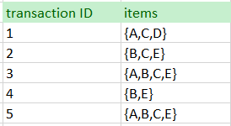

20. a) Discuss in detail about the Similarity search in time series analysis.
(Or)
20. b) Explain any two data mining applications.

******

SET I
SCHEME OF VALUATION
AVINASHILINGAM INSTITUTE FOR HOME SCIENCE AND HIGHER EDUCATION FOR WOMEN
(DEEMED TO BE UNIVERSITY)COIMBATORE-641043

Class : II PG Time:3 Hrs
Major: Master of Computer Applications Max.Marks: 60
Paper Title: 17MCAC16 Data Mining and Warehousing
Part A

1. Data extraction
2. Data mining
3. Apriori
4. Support vector machine
5. Regression analysis
6. Scalability
7. Data segmentation
8. Symmetric
9. Histogram
10. Time series database
Part B
11. a) Data pre-processing:

(i) Data cleaning to remove noise and inconsistent data.
(ii) Data integration where multiple data sources may be combined.
(iii) Data selection where data relevant to the analysis task are retrieved from the
database.
(iv) Data transformation where data are transformed and consolidated into forms
appropriate for mining by performing summary or aggregation operations.
(v) Data mining an essential process where intelligent methods are applied to extract
data patterns.
(vi) Pattern evaluation to identify the truly interesting patterns representing knowledge
based on interestingness measures.
(vii) Knowledge presentation where visualization and knowledge representation techniques
are used to present mined knowledge to users.
Give brief explanation for Data pre-processing
(Or)

11. b) Advantages of Multidimensional Databases:
(i) Increased performance
The performance of the multidimensional databases is much superior to that of normal
databases such as relational database.
(ii) Easy maintenance
The multidimensional database is easy to handle and maintain
(iii) Better data presentation
The data in a multidimensional database is multi faceted and contains many different
factors. Hence, the data presentation is far superior to conventional databases.
Give brief explanation for Multidimensional Databases.

12. a) Apriori algorithm:
(i) Association rule mining seeks to discover associations among transactions encoded in a
database.
(ii) Apriori is an algorithm for frequent item set mining.
(iii) Association rule learning over transactional databases.
(iv) It proceeds by identifying the frequent individual items in the database
(v) And extending them to larger and larger item sets as long as those item sets appear
sufficiently often in the database.
Give brief explanation for Association rule & Apriori algorithm.
(Or)
12. b) Binning:
(i) Data binning, bucketing is a data pre-processing method used to minimize the effects
of small observation errors.
(ii) The original data values are divided into small intervals known as bins
(iii) And then they are replaced by a general value calculated for that bin.
(iv) There are 3 methods of dividing data into bins
(v) Equal Frequency Binning : bins have equal frequency.
(vi) Equal Width Binning: bins have equal width with a range of each bin
are defined as [min + w], [min + 2w] …. [min + nw]
where w = (max – min) / (no of bins).
(vii) Cluster based binning: Where clustering is performed on the quantitative attributes
to groups neighboring points.
Give brief explanation for Binning.

13. a) Comparison of Classification and Prediction Methods:
(i) Accuracy − Accuracy of classifier refers to the ability of classifier.
(ii) Speed − This refers to the computational cost in generating and using the classifier
or predictor.
(iii) Robustness − It refers to the ability of classifier or predictor to make correct
predictions from given noisy data.
(iv) Scalability − Scalability refers to the ability to construct the classifier or predictor
efficiently given large amount of data.
(v) Interpretability − It refers to what extent the classifier or predictor understands.
Give brief explanation for Comparison of Classification and Prediction Methods
(Or)
13. b) Naïve bayesian classification called naïve and the major ideas of naïve
Bayesian classification:
(i) Naïve Bayes machine learning algorithm is considered Naïve because the assumptions
the algorithm makes are virtually impossible to find in real-life data.
(ii) Conditional probability is calculated as a pure product of individual probabilities of
components.
(iii) The Naive Bayes algorithm affords fast, highly scalable model building and scoring.
(iv) It scales linearly with the number of predictors and rows.
(v) Naive Bayes can be used for both binary and multiclass classification problems.
Give brief explanation for naïve bayesian classification called naïve.

14. a) (i) Finding centroid for data points in cluster C1 = ((2+4+6)/3, (2+4+6)/3) = (4, 4)
(ii) Finding centroid for data points in cluster C2 = ((0+4)/2, (4+0)/2) = (2, 2)
(iii) Finding centroid for data points in cluster C3 = ((5+9)/2, (5+9)/2) = (7, 7)
(iv) Hence, C1: (4,4), C2: (2,2), C3: (7,7).
(Or)
14. b) Interval-scaled variable:
(i) Standardize data

(ii) Calculate the mean absolute deviation:
(iii) where
(iv) Calculate the standardized measurement (z-score)
(v) Using mean absolute deviation is more robust than using standard deviation.
Give brief explanation for Interval-scaled variable.

15. a) Basic Measures for Text Retrieval:
(i) We need to check the accuracy of a system when it retrieves a number of documents on
the basis of user's input. This can be shown in the form of a Venn diagram as follows −
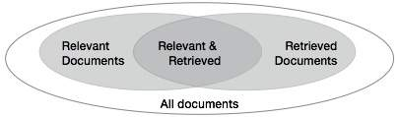
(ii) There are three fundamental measures for assessing the quality of text retrieval −
- Precision
- Recall
- F-score

(iii) Precision
Precision is the percentage of retrieved documents that are in fact relevant to the query.
Precision can be defined as
Precision= |{Relevant} ∩ {Retrieved}| / |{Retrieved}|

(iv) Recall
Recall is the percentage of documents that are relevant to the query and were in fact
retrieved. Recall is defined as
Recall = |{Relevant} ∩ {Retrieved}| / |{Relevant}|
(v) F-score
F-score is the commonly used trade-off. The information retrieval system often needs to
trade-off for precision or vice versa. F-score is defined as harmonic mean of recall or
precision as follows
F-score = recall x precision / (recall + precision) / 2
Give brief explanation for Basic Measures for Text Retrieval.
15. b) Random sampling and Histograms:
(i) Random sampling (but without knowing the total length in advance)
(ii) Reservoir sampling: maintain a set of s candidates in the reservoir,
which form a true random sample of the element seen so far in the stream.
(iii) As the data stream flow, every new element has a certain probability (s/N) of
replacing an old element in the reservoir:
(iv) Histograms Approximate the frequency distribution of element values in a stream
(v) Partition data into a set of contiguous buckets.
Give brief explanation for Random sampling and Histograms.

Part C
16. a) Three-Tier Data Warehouse Architecture:
Following are the three tiers of the data warehouse architecture.
(i) Bottom Tier − The bottom tier of the architecture is the data warehouse database server.
(ii) It is the relational database system. We use the back end tools and utilities to feed data into the bottom tier.
(iii) These back end tools and utilities perform the Extract, Clean, Load, and refresh functions.
(iv) Middle Tier − In the middle tier, we have the OLAP Server that can be implemented in either of the following ways.
(v) By Relational OLAP (ROLAP), which is an extended relational database
management system.
(vi) The ROLAP maps the operations on multidimensional data to standard relational
operations.
(vii) By Multidimensional OLAP (MOLAP) model, which directly implements the
multidimensional data and operations.
(viii) Top-Tier − This tier is the front-end client layer.
(ix) This layer holds the query tools and reporting tools, analysis tools and data mining
tools.
The following diagram depicts the three-tier architecture of data warehouse
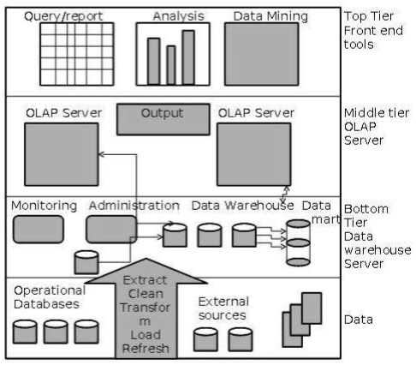
16. b) The resulting Iceberg-Cube is shown in the Table.
Those cells in the full cube whose counts are less than 2,
such as ({P1, Vancouver, Vance},1), are not present in the Iceberg-Cube.
Combination | Count
{P1, ANY, ANY} | 3
{P2, ANY, ANY} | 4
{ANY, Toronto, ANY} | 4
{ANY, ANY, Allison} | 3
{P2, Toronto, ANY} | 3
{P2, ANY, Allison} | 3
{ANY, Toronto, Allison} | 2
{P2, Toronto, Allison} | 2
Table 2 : Sample Iceberg-Cube with Minimum Support of at least 25%
17. a) Two kinds of association rules:
- Mining Multilevel Association Rules:
(i) For many applications, it is difficult to find strong associations among data items at
low or primitive levels of abstraction due to the sparsity of data at those levels.
(ii) Strong associations discovered at high levels of abstraction may represent
commonsense knowledge.
(iii) Data mining systems should provide capabilities for mining association rules at
multiple levels of abstraction, with sufficient flexibility for easy traversal among
different abstraction spaces.
- Using uniform minimum support for all levels (referred to as uniform support):
(iv) The same minimum support threshold is used when mining at each level of
abstraction.
(v) For example, a minimum support threshold of 5% is used throughout
(e.g., for mining from “computer” down to “laptop computer”).
(vi) Both “computer” and “laptop computer” are found to be frequent, while “desktop
computer” is not.
(Or)
17. b) Correlation analysis uses the full scale to calculate the strength of the relationship, the
33%(coffee), 0% (red) and 33% (sneakers) are irrelevant. In this instance:
(i) Respondent A showed a strong pattern of: when they scored high on coffee, they
responded lower on"Wears sneakers" and "liking the colour Red"
(ii) Respondent C showed somewhat of a pattern of: when they scored low on coffee,
they also responded low on ""Wears sneakers" and "liking the colour Red".
Although "Wearing sneakers" and "liking the colour Red" were not rated lower,
the important take out is that they weren't rated highly.
(iii) However, the biggest difference comes from Respondent B where they rated 3 on
coffee, then a 1 on "Wears sneakers" then a 5 on "Likes the color Red".
(iv)The way that this respondent rated "Likes the color Red" weakens the relationship pattern
between coffee and red.
Therefore the pattern of the way people rated to"Enjoys drinking coffee" and "Wears
sneakers" showed a stronger relationship than the way that people rated "Enjoys drinking
coffee" and "Likes the colour Red"
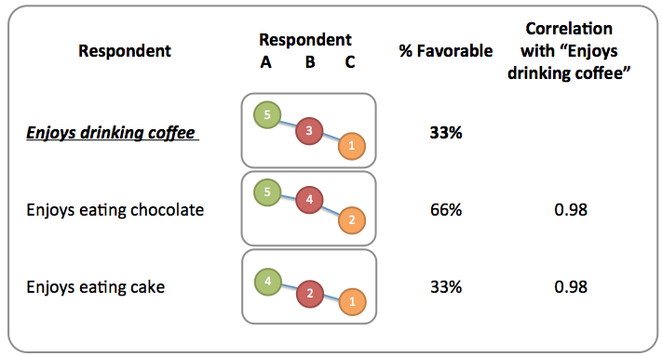

18. a) Pruning:
(i) Pruning is a technique in machine learning and search algorithms that reduces the size
of decision trees by removing sections of the tree that provide little power to classify
instances.
(ii) Pruning reduces the complexity of the final classifier, and hence improves predictive
accuracy by the reduction of overfitting.
(iii) Pre-pruning that stop growing the tree earlier, before it perfectly classifies the training
set.
(iv) Post-pruning that allows the tree to perfectly classify the training set, and then
post prune the tree.
(v) One of the simplest forms of pruning is reduced error pruning. Starting at the leaves,
each node is replaced with its most popular class.
(vi) If the prediction accuracy is not affected then the change is kept. While somewhat naive,
reduced error pruning has the advantage of simplicity and speed.
(Or)
18. b) Classification by Back propagation:
(i) A neural network learning algorithm
· Started by psychologists and neurobiologists to develop and test computational analogues of neuron.
· A neural network: A set of connected input/output units where each connection has a weight associated with it
· During the learning phase, the network learns by adjusting the weights so as to be able to predict the correct class label of the input tuples
· Also referred to as connectionist learning due to the connections between units
(ii) Neural Network as a Classifier
High tolerance to noisy data
Ability to classify untrained patterns
Well-suited for continuous-valued inputs and outputs o Successful on a wide array of real-
world data.
Algorithms are inherently parallel
(iii)Techniques have recently been developed for the extraction of rules from trained neural
networks
A Multi-Layer Feed-Forward Neural Network
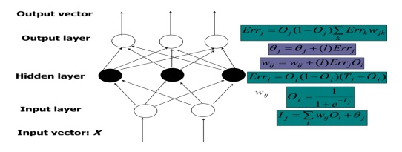
(iv) The inputs to the network correspond to the attributes measured for each training tuple
(v) Inputs are fed simultaneously into the units making up the input layer
(vi)They are then weighted and fed simultaneously to a hidden layer
(vii) The number of hidden layers is arbitrary, although usually only one
(viii) The weighted outputs of the last hidden layer are input to units making up the output layer,
which emits the network's prediction
(ix) The network is feed-forward in that none of the weights cycles back to an input unit or to
an output unit of a previous layer.

19. a) Hierarchical Methods:
(i) This method creates a hierarchical decomposition of the given set of data objects.
(ii) We can classify hierarchical methods on the basis of how the hierarchical
Decomposition is formed. There are two approaches here:
- Agglomerative Approach
- Divisive Approach
- Agglomerative Approach
(iii) This approach is also known as the bottom-up approach.
(iv) In this, we start with each object forming a separate group.
(v) It keeps on merging the objects or groups that are close to one another.
(vi) It keep on doing so until all of the groups are merged into one or until the termination
condition holds.
- Divisive Approach
(vii) This approach is also known as the top-down approach.
(viii) In this, we start with all of the objects in the same cluster.
(ix) In the continuous iteration, a cluster is split up into smaller clusters.
(x) It is down until each object in one cluster or the termination condition holds.
Give brief explanation for Hierarchical Methods.
(Or)
19. b) Lets say minimum support count is 3
Relation hold is maximal frequent => closed => frequent
1-frequent:
{A} = 3; // not closed due to {A, C} and not maximal
{B} = 4; // not closed due to {B, D} and no maximal
{C} = 4; // not closed due to {C, D} not maximal
{D} = 5; // closed item-set since not immediate super-set has same count. Not maximal
2-frequent:
{A, B} = 2 // not frequent because support count < minimum support count so ignore
{A, C} = 3 // not closed due to {A, C, D}
{A, D} = 3 // not closed due to {A, C, D}
{B, C} = 3 // not closed due to {B, C, D}
{B, D} = 4 // closed but not maximal due to {B, C, D}
{C, D} = 4 // closed but not maximal due to {B, C, D}
3-frequent:
{A, B, C} = 2 // ignore not frequent because support count < minimum support count
{A, B, D} = 2 // ignore not frequent because support count < minimum support count
{A, C, D} = 3 // maximal frequent
{B, C, D} = 3 // maximal frequent
4-frequent:
{A, B, C, D} = 2 //ignore not frequent

20. a) Similarity search in time series analysis:
Similarity search in time series databases is an important research direction.
Several methods have been proposed in order to provide algorithms for efficient query
processing in the case of static time series of fixed length.
(i) Data reduction and transformation techniques
(ii) Indexing methods for similarity serach
(iii) Query language for time sequence.
(Or)
20. b) Two applications for data mining:
(i) Financial Data Analysis
The financial data in banking and financial industry is generally reliable and of high quality which facilitates systematic data analysis and data mining. Some of the typical cases are as follows −
- Design and construction of data warehouses for multidimensional data analysis and data mining.
- Loan payment prediction and customer credit policy analysis.
- Classification and clustering of customers for targeted marketing.
- Detection of money laundering and other financial crimes.

(ii) Retail Industry
Data Mining has its great application in Retail Industry because it collects large amount of data from on sales, customer purchasing history, goods transportation, consumption and services. It is natural that the quantity of data collected will continue to expand rapidly because of the increasing ease, availability and popularity of the web.
Data mining in retail industry helps in identifying customer buying patterns and trends that lead to improved quality of customer service and good customer retention and satisfaction. Here is the list of examples of data mining in the retail industry :
- Design and Construction of data warehouses based on the benefits of data mining.
- Multidimensional analysis of sales, customers, products, time and region.
- Analysis of effectiveness of sales campaigns.
- Customer Retention.
- Product recommendation and cross-referencing of items.

*******

SET II
AVINASHILINGAM INSTITUTE FOR HOME SCIENCE AND HIGHER EDUCATION FOR WOMEN
(DEEMED TO BE UNIVERSITY)COIMBATORE-641043

Class : II PG Time:3 Hrs
Major: Master of Computer Applications Max.Marks: 60
Paper Title: 17MCAC16 Data Mining and Warehousing
CO1: Apply the various steps of the KDD process and apply the relevant preprocessing
techniques in large datasets.

CO2: Delineate the processes involved in the construction of a data warehouse.
CO3: Apply data mining tools to demonstrate association, classification and clustering using
different algorithms.
CO4: Differentiate and choose appropriate functionalities to solve specific needs.
CO5: Relate and apply the various DM functionalities to specific areas like financial data,
biological data, WWW.
Part-A
Answer all the questions 10X1/2=5
1. A repository of information collected from multiple sources is called__________________.

a. Data mining b. Data warehouse c. Data pre-processing d. KDD

2. Which of the following helps us to represent the data in multiple dimensions?

a. OLAP b. Data Marting c. Data cube d. OLTP
3. The attributes which are numeric and have an implicit ordering among values is
called________________.
a. Quantitative b. Nominal c. Categorical d. FP growth
4. A neural network algorithm for classification that employs a method of gradient descent
is_______________.
a. Back propagation b. Association mining c. Correlation analysis d. Data mining
5. CART referred as_____________.
a. Class and Regression trees b. Classification and Root trees
c. Classification and Regression trees d. Class and Region trees
6. A tree is pruned by halting its construction early is called_______________.
a. Post pruning b. Pre pruning c. Cost complexity pruning d. Pessimistic pruning
7. Which of the following does not confined itself to any sample at any given time.
a. CLARANS b. PAM c. AGNES d. DIANA
8. A tree structure called a dendrogram is commonly used to represent the process
of _____________.
a. Agglomerative b. K-means method c. K-medoids d. Hierarchical clustering
9. The dynamic programming approach is commonly used for __________________.
a. Sequence alignments b. Periodicity analysis c. Markov chains d. Trend analysis
10. The estimation of the frequency moments can be done by synopses that are known
as_______________.
a. Histograms b. Sketches c. Reservoir sampling d. Sliding windows
Part-B
Answer the following
Answer should not exceed 200 words or one page 5X4=20

11. a) Describe about the Relational databases with example.
(Or)
11. b) What are the steps to build the data warehouse?

12. a) What is support and confidence with example?
(Or)
12. b) Explain about the constraint based association mining.

13. a) Briefly outline the major steps of decision tree classification.
(Or)
13. b) What is boosting? State why it may improve the accuracy of decision tree induction.

14. a) In the figure below, if you draw a horizontal line on y-axis for y=2. What will be the
number of clusters formed?

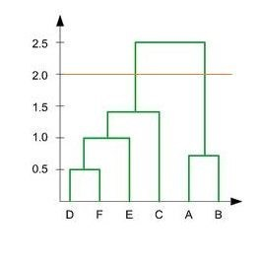
(Or)
14. b) Describe about the Ordinal variable.

15. a) What are the new challenges in stream query processing.
(Or)
15. b) Explain about the data reduction and transformation techniques.

Part-C
Answer the following
Answer should not exceed 800 words or four pages 5X7=35

16. a) Explain about the architecture of a typical data mining system.
(Or)
16. b) Describe about the star schema with example.
17. a) Explain about the correlation analysis.
(Or)
17. b) Enjoys eating chocolate (66%) scored a lot higher than Enjoys eating cake (33%), how can
they both have the same driver strength (0.98, Very Strong)?
18.a) Describe about the issues in classification.
(Or)
18. b) Explain in detail about rule based classification.

19. a) How can we compute the dissimilarity between objects described by categorical ,ordinal
and ratio-scaled variables?
(Or)
19. b) Discuss in detail about k-means algorithm.
20. a) Explain about the challenges in web mining.
(Or)
20. b) Describe about the trends in data mining.

******

SET II
SCHEME OF VALUATION
AVINASHILINGAM INSTITUTE FOR HOME SCIENCE AND HIGHER EDUCATION FOR WOMEN
(DEEMED TO BE UNIVERSITY)COIMBATORE-641043

Class : II PG Time:3 Hrs
Major: Master of Computer Applications Max.Marks: 60
Paper Title: 17MCAC16 Data Mining and Warehousing
Part A

1. Data warehouse
2. Data cube
3. Quantitative
4. Back propagation
5. Classification and Regression trees
6. Pre pruning
7. CLARANS
8. Hierarchical clustering
9. Sequence alignments
10. Sketches
Part B
11. a) Relational databases:
(i) Relational data mining is the data mining technique for relational databases.
(ii)Unlike traditional data mining algorithms, which look for patterns in a single table .
(iii) Relational data mining algorithms look for patterns among multiple tables.
(iv) Relational databases use tables to store information.
(v) The standard fields and records are represented as columns (fields) and rows (records) in a
table.
(Or)
11. b) Data warehouse:
Following are the steps to be followed to build the data warehouse:
(i) Gathering business requirements.
(ii) Identifying the necessary sources.
(iii) Identifying the facts.
(iv) Defining the dimensions
(v) Defining the attributes
(vi) Redefine the dimensions and attributes if required.
12. a) Support and confidence with example:
(i) Support is the no of times an item appears in total transactions.
(ii) First , support is calculated for each time.
(iii) On the other hand, confidence is the what we set where Y is the item that is purchased
when X is purchased.
(iv) So out of total no of times X is purchased , no of times Y is purchased when X is
purchased.
(Or)
12. b) Constraint based association mining:
(i) Constraint-based association rule mining aims to develop a systematic method by
which the user can find important association among items in a database of
transactions.
(ii) Types and quantities of different items can vary significantly among transactions
and/or customers.
(iii) Knowledge type constraints: These specify the type of knowledge to be mined, such
a s association or correlation.
(iv) Data constraints: These specify the set of task-relevant data.
(v) Dimension/level constraints: These specify the desired dimensions of the data, or levels
of the concept hierarchies, to be used in mining.
(vi) Interestingness constraints: These specify thresholds on statistical measures of rule
interestingness, such as support, confidence, and correlation.
(vii) Rule constraints: These specify the form of rules to be mined.

13. a) (i) A decision tree is a structure that includes a root node, branches, and leaf nodes.
(ii) Each internal node denotes a test on an attribute, each branch denotes the outcome of a
test, and each leaf node holds a class label.
(iii) The topmost node in the tree is the root node.
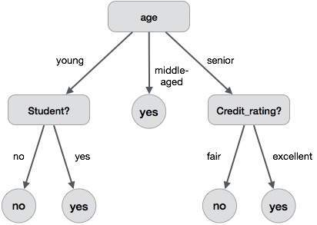
(iv) The benefits of having a decision tree are as follows −
- It does not require any domain knowledge.
- It is easy to comprehend.
- The learning and classification steps of a decision tree are simple and fast.
(Or)
13. b) Boosting & State why it may improve the accuracy of decision tree induction:
(i) A strong learner is a classifier that is arbitrarily well-correlated with the true
classification.
(ii) Pruning could be applied to decision tree induction to help improve the accuracy of the
resulting decision trees.
(iii) Boosting is a method for improving the predictive.
(iv) It builds upon approaches other than boosting, that improve accuracy of Decision Trees.
14. a) Since the number of vertical lines intersecting the red horizontal line at y=2 in the

dendrogram are 2, therefore, two clusters will be formed.
(Or)
14. b) Ordinal variable:
(i) An ordinal variable can be discrete or continuous
(ii) order is important, e.g., rank
(iii) Can be treated like interval-scaled
(iv) replacing x_{if} by their rank
(v) Map the range of each variable onto [0, 1] by replacing i-th object in the f-th
variable by

(vi) Compute the dissimilarity using methods for interval-scaled variables.
15. a) Challenges in stream query processing:
(i) Query types
One-time query vs. continuous query (being evaluated continuously as stream
continues to arrive)
(ii) Predefined query vs. ad-hoc query (issued on-line)
(iii) Unbounded memory requirement
(iv) For real-time response, main memory algorithm should be used
(v) Memory requirement is unbounded if one will join future tuples
(vi) Approximate query answering
With bounded memory, it is not always possible to produce exact answers
(vii) High-quality approximate answers are desired
(viii) Data reduction and synopsis construction methods.
Sketches, random sampling, histograms, wavelets, etc.
(Or)
15. b) Data reduction and transformation techniques:
(i) Three major dimensionality reduction techniques have been proposed
(ii) Singular Value Decomposition (SVD), the Discrete Fourier transform (DFT)
(iii) And more recently the Discrete Wavelets Transform (DWT).
(iv) In this work we introduce a new dimensionality reduction technique
which we call PAA (Piecewise Aggregate Approximation).

Part C
16. a) Data Mining Architecture:
The major components of any data mining system are data source,
data warehouse server, data mining engine, pattern evaluation module,
graphical user interface and knowledge base.

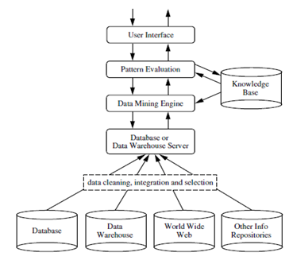
(i) Data Sources
Database, data warehouse, World Wide Web (WWW), text files and other documents are the
actual sources of data.

(ii) Different Processes
The data needs to be cleaned, integrated and selected before passing it to the database or data
warehouse server.
(iii) Database or Data Warehouse Server
The database or data warehouse server contains the actual data that is ready to be processed.

(iv) Data Mining Engine
The data mining engine is the core component of any data mining system.

(v) Pattern Evaluation Modules
The pattern evaluation module is mainly responsible for the measure of interestingness of the
pattern by using a threshold value.

(vi) Graphical User Interface
The graphical user interface module communicates between the user and the data mining
system.

(vii) Knowledge Base
The knowledge base is helpful in the whole data mining process.

16. b) Star Schema
(i) Each dimension in a star schema is represented with only one-dimension table.
(ii) This dimension table contains the set of attributes.
(iii) The following diagram shows the sales data of a company with respect to the four
dimensions, namely time, item, branch, and location.
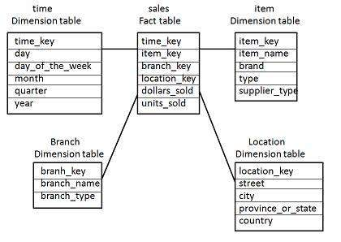
(iv)There is a fact table at the center. It contains the keys to each of four dimensions.
(v)The fact table also contains the attributes, namely dollars sold and units sold.
17. a) Correlation analysis:
(i) Most association rule mining algorithms employ a support-confidence framework.
(ii) Often, many interesting rules can be found using low support thresholds.
(iii) Although minimum support and confidence thresholds help weed out or exclude the
exploration of a good number of uninteresting rules, many rules so generated are still not
interesting to the users
(iv) Whether or not a rule is interesting can be assessed either subjectively or objectively.
(v) Ultimately, only the user can judge if a given rule is interesting, and this judgment, being
subjective, may differ from one user to another.
(Or)
17. b) Correlations look at the patterned relationship between two variables, again the scores
aren't relevant. In this instance:
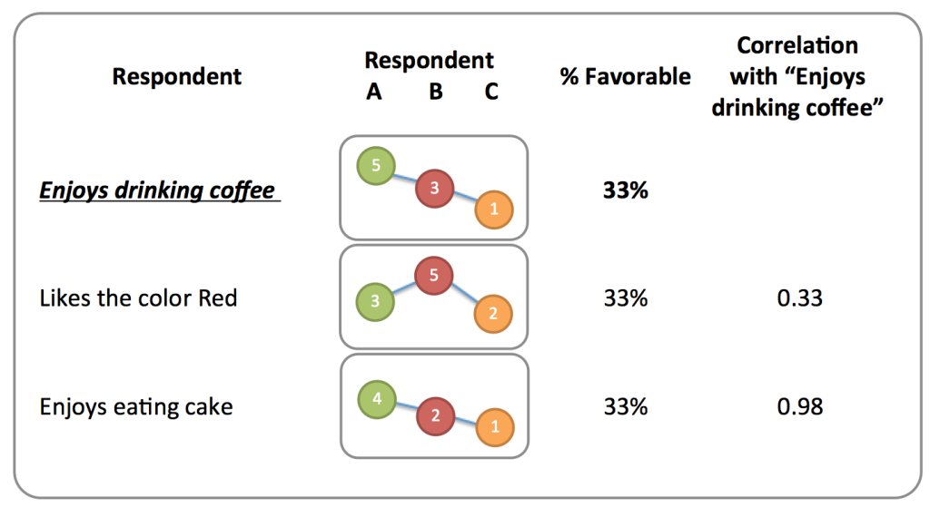
- Those that enjoy drinking coffee, are likely to also enjoy eating chocolate and eating cake (respondent A = 5, 5, 4)
- Likewise, those that don't enjoy drinking coffee' are likely to also not enjoy eating chocolate and cake (respondent C = 1, 2, 1)
- Similarly, if you score somewhere in between (respondent B = 3) on coffee, you are likely to score somewhere in between on chocolate and cake (respondent B = 4, 2)
The way that each respondent scored on the 3 questions were very similar, and the pattern of the relationship is very strong between "Enjoys drinking coffee" and "Enjoys eating chocolate" as well as between "Enjoys drinking coffee" and "Enjoys eating cake"
18. a) Issues in classification:
(i) DATA PREPARATION: The preprocessing steps may be applied to the data for
classification and prediction are : Data cleaning ,feature selection, and data
transformation.
• Data cleaning: This preprocesses the data in order to reduce noise and handle missing values.
• Data transformation: it is used to generalize or normalize data.
• Relevance analysis: Removes irrelevant or redundant attributes.
(ii) EVALUATING CLASSIFICATION METHODS:

Hypothesis are used to infer classification of examples in the test set .
Accuracy gives percentage of examples in the test set that are classified correctly.
Other attributes used to evaluate classification methods:
• Speed and Scalability: Time to construct the model and also time to use the model.
• Robustness: This is the ability of the classifier to make correct predictions given noisy data or data with missing values
• Scalability: This refers to the ability to construct the classifier efficiently given large amounts of data.
• Interpretability: This refers to the level of understanding and insight that is provided by the classifier
• Goodness of rules: Decision tree size compactness of classification rules
(Or)
18. b) Rule-based classification:
(i) IF-THEN Rules
Rule-based classifier makes use of a set of IF-THEN rules for classification. We can
express a rule in the following from
IF condition THEN conclusion The IF part of the rule is called rule
antecedent or precondition.
- The THEN part of the rule is called rule consequent.
- The antecedent part the condition consist of one or more attribute tests and these tests are logically ANDed.
- The consequent part consists of class prediction.
(ii) Rule Extraction
Here we will learn how to build a rule-based classifier by extracting IF-THEN rules from
a decision tree.
To extract a rule from a decision tree
- One rule is created for each path from the root to the leaf node.
- To form a rule antecedent, each splitting criterion is logically ANDed.
- The leaf node holds the class prediction, forming the rule consequent.

19. a) (i) Qualitative (Nominal (N), Ordinal (O), Binary(B)).
(ii) Quantitative (Discrete, Continuous)
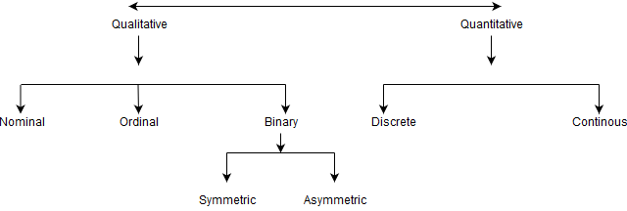
Qualitative Attributes
(iii)Nominal Attributes – related to names : The values of a Nominal attribute are name of things, some kind of symbols.
(iv) Binary Attributes : Binary data has only 2 values/states. For Example yes or no, affected or unaffected, true or false.
i) Symmetric : Both values are equally important (Gender).
ii) Asymmetric : Both values are not equally important (Result).
(v) Ordinal Attributes : The Ordinal Attributes contains values that have a meaningful sequence or ranking(order) between them, but the magnitude between values is not actually known, the order of values that shows what is important but don’t indicate how important it is.
(vi) Quantitative Attributes:
1.Numeric : A numeric attribute is quantitative because, it is a measurable quantity,
represented in integer or real values. Numerical attributes are of 2 types, interval and ratio.
i) An interval-scaled attribute has values, whose differences are
ii) A ratio-scaled attribute is a numeric attribute with an fix zero-point. If a measurement is ratio-scaled, we can say of a value as being a multiple (or ratio) of another value.
2. Discrete : Discrete data have finite values it can be numerical and can also be in
categorical form.
3. Continuous : Continuous data have infinite no of states. Continuous data is of float type.
(Or)
19. b) K-means algorithm:
(i) We are given a data set of items, with certain features, and values for these features
(ii) The task is to categorize those items into groups.
(iii) To achieve this, we will use the k-Means algorithm;
an unsupervised learning algorithm.
The algorithm works as follows:
(iv) First we initialize k points, called means, randomly.
(v) We categorize each item to its closest mean and we update the mean’s coordinates,
which are the averages of the items categorized in that mean so far.
(vi) We repeat the process for a given number of iterations and at the end, we have our clusters.

20. a) Trends in data mining:
Data mining concepts are still evolving and here are the latest trends that we get to see in this field −
- Application Exploration.
- Scalable and interactive data mining methods.
- Integration of data mining with database systems, data warehouse systems and web database systems.
- SStandardization of data mining query language.
- Visual data mining.
- New methods for mining complex types of data.
- Biological data mining.
- Data mining and software engineering.
- Web mining.
- Distributed data mining.
(Or)

20. b) Challenges in Web Mining:
The web poses great challenges for resource and knowledge discovery based on the
following observations:
(i) The web is too huge − The size of the web is very huge and rapidly increasing. This seems that the web is too huge for data warehousing and data mining.
(ii) Complexity of Web pages − The web pages do not have unifying structure. They are very complex as compared to traditional text document. There are huge amount of documents in digital library of web. These libraries are not arranged according to any particular sorted order.
(iii)Web is dynamic information source − The information on the web is rapidly updated. The data such as news, stock markets, weather, sports, shopping, etc., are regularly updated.
(iv) Diversity of user communities − The user community on the web is rapidly expanding. These users have different backgrounds, interests, and usage purposes. There are more than 100 million workstations that are connected to the Internet and still rapidly increasing.
(v) Relevancy of Information − It is considered that a particular person is generally interested in only small portion of the web, while the rest of the portion of the web contains the information that is not relevant to the user and may swamp desired results.

*****

