GAUGING INDOOR AIR QUALITY BY GROWING SNAKE PLANT (SANSEVIERIA TRIFASCIATA)

By
MERCY R.L.
(12PIR014)

A THESIS SUBMITTED TO THE
AVINASHILINGAM INSTITUTE FOR HOME SCIENCE AND
HIGHER EDUCATION FOR WOMEN
COIMBATORE – 641 043.

In partial fulfillment of the requirement for the degree of
MASTER OF SCIENCE
IN
INTERIOR DESIGN AND RESOURCE MANAGEMENT

MARCH 2014


Acknowledgement

ACKNOWLEDGEMENT
The investigator places her humble salutations and prayer to God Almighty for sound, wisdom, knowledge, strength, showering mercies which enable her to bring the study to successful completion.
The investigator owes her reverential gratitude to Dr. T.S. Avinashilingam, Hon Colonel Padmashri, Founder and First Chancellor of Avinashilingam Institute for Home Science and Higher Education for Women, Coimbatore, for providing this temple of learning and Dr.(Tmt). Rajammal P. Devadas, M.A, M.Sc., Ph.D., (Ohio State) Hon D.Sc C.Azad Agri University (kanpur) Hon D.Sc. University of Ulster Northern Ireland, Former Chancellor, Avinashilingam Institute for Home science and Higher Education for Women, Coimbatore for her wishes blessings and inspiration in conducting the research.
The investigator expresses her deep sense of gratitude and sincere thanks to Thiru T.S.K. Meenakshisundaram, M.A., M.Phil., Ph.D., Chancellor, Avinashilingam Institute for Home Science and Higher Education for Women, Coimbatore, for providing the facilities for conducting the study in this esteemed institution.
The investigator expresses her immense gratitude to Dr. (Tmt). Sheela Ramachandran, M.Sc., P.G.Dip., Ph.D, Vice chancellor, Avinashilingam Institute for Home Science and Higher Education for Women, Coimbatore, for her help, support and being the central inspiration to carry out the study.
The investigator records her gratitude to Dr. (Tmt). Gowri Ramakrishnan, M.Sc., M.Phil., Ph.D., Registrar, Avinashilingam Institute for Home Science and Higher Education for Women, Coimbatore, for immense co-operation in this study.
The investigator is more gratitude to Dr. U.K.Lakshmi, M.Sc,Dip.Ed,M.Phil, Ph.D Dean Faculty of Home Science, Avinashilingam Institute for Home Science and Higher Education for Women, Coimbatore, for her support and encouragement in conducting the study.
The investigator expresses her respectful regards and heartfelt thanks to Dr. A. Venmathi, M.Sc., Dip.Ed., M.Phil., Ph.D., Professor and Head, Department of Resource Management, Avinashilingam Institute for Home Science and Higher Education for Women, Coimbatore, for her support and encouragement in conducting the study.
The investigator feels extremely happy and fortunate to place under the able guidance of her esteemed, honoured guide and deeply indebted to Dr. (Tmt). K. Manimozhi, M.Sc., B.Ed., M.Phil., Ph.D., Associate Professor, Department of Resource Management, Avinashilingam Institute for Home Science and Higher Education for Women, Coimbatore, for her affectionate guidance, encouragement, innovative, meticulous supervision, valuable advice and critical suggestion that had given the final shape to the thesis. Right from beginning she inspired her, took tremendous efforts and devoted valuable time for this study.
The investigator extends her profound thanks to selected Homemakers and Microbiologists for the co-operation extended and willingness to participate at all stages of implementation of the research.
The investigator wishes to thank her loving Sister, Brother and Relatives whose motivation, constant encouragement, care, concern and steady support cannot be expressed in words.

Contents
CONTENTS
CHAPTER | TITLE | PAGE NO
 | LIST OF TABLES
 | LIST OF FIGURES
 | LIST OF PLATES
 | LIST OF APPENDICES
I | INTRODUCTION | 1
II | REVIEW OF LITERATURE | 8-28
 | - Environmental Condition and Pollution | 8
 | - Vital of Air Quality and Crucial of Air Pollution | 10
 | - Importance of Housing | 14
 | - Indoor Air Pollution | 16
 | - Role of Plants in Indoor Environment | 23
III | METHODOLOGY | 29-42
 | - Household Survey | 29
 | - Trial on Improving Indoor Air Quality by Growing Snake Plant (sansevieria trifasciata) | 32
 | - Creating Awareness on use of Snake plant to Control Indoor Air Pollution  - Evaluating the Impact of the Awareness Programme Conducted | 38  41
CHAPTER | TITLE | PAGE NO
IV | RESULTS AND DISCUSSION | 43-66
 | - Household Survey | 43
 | - Trial on Improving Indoor Air Quality by Growing Snake Plant (sansevieria trifasciata) | 57
 | - Evaluating the Impact of the Awareness Programme Conducted. | 63
V | SUMMARY AND CONCLUSION | 67-71
 | BIBLIOGRAPHY | 72-77
 | APPENDICES | 78-82

LIST OF TABLES

TABLE NO. | TITLE | PAGE NO
I | Socio-Economic profile of the selected households | 44
II | Size of the house | 46
III | Size of the kitchen | 47
IV | Opinion on Ornamental plant placement | 48
V | Average time spent per day for kitchen activities | 49
VI | Frequency of using the kitchen for cooking | 50
VII | Supplementary activities in the kitchen | 50
VIII | Existing condition of kitchen in the selected households | 52
IX | Reasons for moisture generation in the selected households | 53
X | Ventilation access in the kitchen | 55
XI | Features of the plants and the areas | 58
XII | Responsiveness about the plants | 59
XIII | Level of bacterial contamination in the kitchen before and after plant implementation | 61
XIV | Percentage of knowledge gained by the homemakers | 64
XV | Opinion regarding the adoption of snake plant | 66

LIST OF FIGURES
FIGURE NO. | TITLE | PAGE NO
I | Supplementary activities in the kitchen | 51
II | Reasons for moisture generation in the selected households | 54
III | Ventilation access in the kitchen | 56
IV | Level of bacterial contamination in the kitchen before and after plant implementation | 62
V | Percentage of knowledge gained by the homemakers | 65

LIST OF PLATES

PLATE NO. | TITLE | PAGE NO
I | Snake plant (Sansevieria trifasciata) | 34
II | Experiment study conducted in the selected households | 37
III | Collecting air sample from the selected households | 39
IV | Conduct of awareness programme | 42

LIST OF APPENDICES

APPENDIX NO. | TITLE | PAGE NO
I | Questionnaire on Gauging Indoor Air Quality by growing Snake plant (Sansevieria trifasciata) | 78
II | Level of Bacterial Contamination Result in the Kitchen Before Plant Implementation | 81
III | Level of Bacterial Contamination Result in the Kitchen After Plant Implementation | 82

Introduction

I. INTRODUCTION
“When we heal the earth, we heal ourselves"
- David Orr
Earth is one of the most beautiful planets of the solar system. It supports life and hence is home to numerous species. But today, our planet is suffering from several complicated situations among which environmental issues are the most important and dangerous ones. Today water, air, soil, and everything is polluted (www.essaydepot.com).
Environment is defined more comprehensively as a holistic view of the world as it functions at any point of time, with a multitude of spatial, elemental and socio- economic systems, distinguished by quality and attributes of space, and mode of behaviour of abiotic and biotic forms (Agrawal et al., 2002).
Healthy, clean and pure environment is a precious gift of native to the humanity. Like many other organisms, man has to depend, for his life on his environment. He receives his basic necessities like water, air and shelter from it (Kanagasabai, 2010). For the first time in his entire cultural history, man is facing one of the most horrible ecological crisis- the problem of pollution of his environment which sometime in past was pure, virgin, undisturbed, uncontaminated and basically quite hospitable for him (Katyal and Satake, 1989). Any undesirable change in the physical, chemical or biological characteristics of air, water and soil that may create a hazard or potential hazard to the health, safety or welfare of any living species is called pollution (Agrawal, 1999).
Today the cry of “pollution” is heard from everywhere across the world and it has became a major threat to our existence on earth. The pollution of various resources has gone to such as extent that we are unable to breathe fresh air and drink fresh water. On the one hand advancement of science and technology have added to our comforts by giving us automobiles, electrical appliances, supersonic jets, space crafts, better medicines, better chemicals to control harmful insects and other pests etc. but on the other hand, they have given us very serious problem to face i.e. pollution (Ghose, 2003).
Environmental pollution is the act of introduction, by man, of extraneous substances or energy in the environment that induces unfavourable changes. These changes may affect man directly or indirectly by endangering his health, harming his living resources and ecosystem, or by interfering with legitimate uses of the environment (Kannan, 1997). In earth we live, the relationship of the human being with nature is based on accountability and friendship, not enmity or devastation. God has created the earth for the comfort of human beings, so an enabling environment for their advancement and excellence can be created. Nonetheless, the more human beings developed and addressed their curiosities, the more they shut their eyes towards realities and intentionally damaged the environment (Shafahi, 2010). The changes in the environment have put the survival of man in danger.
One of the most important needs of modern times is clean, sufficient and assured air supply of acceptable quality for a beneficial use. Environmental pollution has permeated in the every walk of our life. Pollution of environment is most serious problem facing the mankind today. So, protection of the environment is one of the most vital issues of the world today. Preservation of the environment is, therefore, essential for the very existence of the human race. Proper management of the environment is the only way to ensure sustained development of the society. It is, therefore, essential to make the masses aware of the changes in the quality of our environment and strategies to prevent the situation from worsening further (Bhatia, 2002). Man has played a very important part in shaping his environment. He has been responsible for degrading the quality of his environment, ever since he appeared on the earth.
Air is a free gift of nature to society and its quality degrades as result of the development processes (Kanagasabai, 2010). Atmosphere is a mixture of gases that surround sphere of earth which we call air. Air is one of the most important constituents of man’s environment. A normal human being breaths about 25,000lt/day i.e. about 30 to 60kg of air per day. Thus the quantity of air consumed by an average man is about 25 times more by weight and 20,000 times, more by volume than the quantity of water consumed.
The air we breathe has not only life supporting properties but also life damaging ones. Under ideal conditions, the air we inhale has qualitative and quantitative balance that maintains the well- being of man. But when the balance among the air components is distributed or, in other words, if it is polluted, it may affect human health (Agrawal et al., 2002).
Air cannot remain pure for a long period of time. For all the living creatures, air is the important and one of the closest component of environment. Oxygen for respiration is being provided by the air. It is through the air present in the atmosphere that the various kinds of sounds and smells are being transmitted from one place to another. When the various hazards elements get mixed in the air, air become polluted. When foreign matter in the air get concentrated in a large quantity, air is called to have been polluted. Throughout the world, the problem of air pollution is becoming more serious (Aggarwal, 2010).
Air pollution is caused when air is contaminated with poisonous substances, particulate matter, and droplets of liquid, which damage the health of human beings and other living organisms (www.buzzle.com/articles). Air obviously the first and foremost susceptible component of our environment prone to pollution (Agrawal, 2005).
The India air pollution rate is one of the highest in the world making it one of the most dangerous places to live with roughly 2.2 million people each and every year dying as a direct result of air pollution (www.all-about-india.com/India-Air-pollution.html).
Air pollution has become a life-threatening factor in the world. Clean air is a vital requirement for the continued existence of mankind. The study of air quality at this alarming level of air pollution has become very necessary. People must be made more aware of the importance of air for life and the level to which air has already been polluted. A solution for air pollution requires tracking it in a systematic way. Every terrestrial life requires air to thrive and the quality of the air we breathe should be of concern to all. Man requires clean air in his dwelling especially in in-door environments where a larger portion of time is spent working or resting (Ayanbimpe. 2010). The environmental concern for air pollution has so far been largely focussed on the outdoor air pollutants. Recently, it has been realized that pollutants found inside homes. i.e. indoor pollutants can be equally dangerous. They reach such high levels simply because; they are emitted into small volume of a room from where they cannot easily escape out (Agrawal, 1999).
The acceptable IAQ may be defined as, Air in an occupied space in which there are no contaminants in concentrations leading to exposure that pose a significant health risk. (Kudesia and Kudesia, 2002). Indoor air levels of many pollutants may be 2-5 times, and occasionally, more than 100 times higher than outdoor levels. Indoor air pollutants are of particular concern because most people spend as much as 90% of their time indoors (www.epa.gov). A report from the American Lung Association with help from The Environmental Protection Agency states "it has identified indoor air quality as one of the top five most urgent environmental risks to public health (www.dylosproducts.com).
There is no dearth of Indian studies on adverse impact of indoor air pollution on one's health, especially the women. The Energy and Resources Institute (TERI) in a recent study said that 27.5 % of under-five infant mortality in India is because of indoor air pollution. Another study said that about 80 % of women in India are affected by indoor air pollution (Chauhan, 2013). According to the Human Development Report, 1998, nearly two-thirds of the deaths from indoor air pollution take place in Asia. In India, 5, 89,000 people die due to indoor air pollution- 4, 96,000in rural areas and 93,000 in urban areas (Agrawal, 2006). The major concern is that increased humidity levels will cause excessive growth of mold spores and other airborne microbes, and thus create a greater indoor air pollution problem (Wolverton, 1996).
Bio aerosols are airborne microbiological particulate matters, derived from viruses, bacteria, protozoa, algae, mites, pollen and their cellular or cell mass component. Bioaerosols are present in both indoor and outdoor environment (Kudesia and Kudesia, 2002). Biological pollutants are or were living organisms. They can travel through the air and are often invisible. Fungi (molds and mildew), infectious agents (bacteria and viruses), pollen from plants, animal dander, cockroach parts, human skin cells and dust mites are some of the common biological pollutants found inside the home. Even a spotless home may permit the growth of biological pollutants. Two major factors that create conditions for biological pollutants to grow are: 1) nutrients and 2) constant moisture with poor air circulation (fcs.tamu.edu).
Some mold and bacteria are present in the air of all buildings. Damp buildings may support the growth of mold and bacteria on indoor surfaces, increasing the levels of mold, bacteria, and their by-products in indoor air. Mold and bacteria can release microscopic particles into the air. The particles released include spores — the reproductive agents produced by molds and by some bacteria. In addition, fragments of molds and bacteria, often much smaller than spores may be released into the air, potentially in much higher numbers than the spores. These particles may settle on indoor surfaces and then be resuspended by human activities or by air movement. (www.iaqscience.lbl).
Housing as a unit of the environment has profound influence on the health, efficiency, social behaviour, satisfaction and general welfare of the community. It reflects the cultural, social and economic values of a society, as it is the best physical and historical evidence of the civilization of a country (Omole, 2010). Poor housing conditions are associated with a wide range of health conditions, including respiratory infections, asthma, lead poisoning, injuries, and mental health. Substandard housing may also adversely affect mental health, although the evidence is more tentative. Excessive indoor temperature has been linked with irritability and social intolerance. Damp, moldy, and cold indoor conditions may be associated with anxiety and depression.
House is a physical setting for every family, of which the kitchen is an important domain of an Indian woman’s life. In India, the kitchen is the heart of the house where the homemaker spends three- fourths of her work time (Gandotra et al, 2009). In the houses, kitchen is the main part which has the poor IAQ comparing with other area. In the study, Investigation of indoor air quality at residential homes in Hong Kong—case study proved. In that, the majority of the domestic living rooms and kitchens studied had average concentrations of airborne bacteria higher than 500 CFU/m³. The mean total bacteria count recorded in kitchens was greater than that obtained in living rooms by 23% (Lee et al. 2002).
Plants are the backbone of all life on Earth and an essential resource for human well-being. Since planet Earth’s clean air originates from living, green plants, the concept of designing houseplants inside tightly sealed buildings to purify and revitalize indoor air has a valid scientific basis. As early as 1772,Joseph Priestly demonstrated how plants could restore air made bad by products of animal respiration and burning candles. This concept will require treating each building as a miniature earth with its own built-in living air purification system (Wolverton, 1996).

Air plays dual role i.e. creating the health and diseased condition. The cold mild breeze coming through a garden brings fragrance and solace to humans. In such a condition one experiences comfort. Moreover, air containing foul smelling and a pathogenic microorganism is not fit for human health. Such air causes many human diseases including allergy (Dubey and Maheshwart, 1999). Plants kept indoors can help purify the air and smell better than a fake air freshener. Today houseplants are an integral part of indoor decor. Thus, plants are a bio aesthetic addition to a home. A delightful house with plants has a soothing effect and healthful aspects are recognised. However, plants are not only beautiful in the home but they are functional too. They help in cleansing the air and thus in better breathing. They are effective pollution fighters (Gandotra et al, 2009). Research by a number of authors is reviewed here, demonstrating a range of capacities of indoor plants to improve IAQ and promote occupant wellbeing (Tarran et al, 2007). Plants not only remove pollution from the air, providing their own form of fresh air exchange.
While selecting the species for pollution control the following are the important characteristics could be considered. Plants should be evergreen, large leaved, rough bark, indigenous, ecologically compatible, low water requirement, minimum care, high absorption of pollutants, resistant pollutants, agro-climatic suitability, height and spread, Canopy architecture, Growth rate and habit (straight undivided trunk), Aesthetic effect (foliage, conspicuous and attractive flower colour), Pollution tolerance and dust scavenging capacity (Kumar et.al 2012).
The Snake Plant and the closely related Mother-in-Law's Tongue (Sansevieria trifasciata) are architectural plants with stiff, upright leaves up to 3 or 4 feet tall. The Snake plant has green banded leaves. These plants are among the toughest of all houseplants—they can withstand virtually any conditions, from dark to bright. The only way to surely kill them is to overwater or never water at all (houseplants.about.com).
Therefore, by providing the importance of indoor air quality, to maintain the good indoor environment and improve the quality of life among people living in urban areas, eradicate the indoor air pollution and make the clean environment in the house. This study addresses the influence of interior plants on the bacterial contamination, not in experimental chambers but in the “real world” of a kitchen area in the domestic building. Hence, the present study has been undertaken with the following objectives:
- To evaluate the indoor air quality from selected households.
- To introduce the snake plant (Sansevieria trifasciata) into the selected households.
- To analyze the ability of condense the indoor pollution level by the selected plant.
- To examine the absolute consequence of the indoor air quality and to improve the indoor air quality.
- To create awareness on use of snake plant to control indoor air pollution and
- To evaluate the impact of the awareness programme conducted.

Review of literature

II. REVIEW OF LITERATURE
No research will answer all queries that the future may raise. It is wiser to praise the work for what it has accomplished and then to formulate the problems still to be solved.
— Theobald Smith
The literature pertaining to the study on “GAUGING INDOOR AIR QUALITY BY GROWING SNAKE PLANT (SANSEVIERIA TRIFASCIATA)” are reviewed under the following headings:
- Environmental condition and pollution
- Vital of air quality and crucial of air pollution
- Importance of housing
- Indoor air pollution
- Role of plants in indoor environment
- ENVIRONMENTAL CONDITION AND POLLUTION

The “Environment” is defined as an aggregate of all external conditions and influence affecting the life and development of an organism, human behaviour and society (Gandotra et al, 2009). Environment consists of all living and non living things which surround us. Environment influence and shaped our life. It is from the environment that we get food to eat, water to drink, air to breathe and all necessities of day to day life are available from our environment. Thus it is the life support system (www.preservearticles.com).
Environment is very essential in every aspect of life. All the living beings are depend upon the environment. All the components required for survival of living organisms are gained through environment. Air, water, soil, food etc. required for survival are acquired through the environment. All the development of living creatures are done in environment. Human beings utilizes the natural resources for development of civilization of human beings .For standardise the quality of human life, man use the environment in different sectors of development activities. Plant and animals are also depend upon the environment. Therefore, all the pros such as survival, reproduction, growth and development etc. of living organisms are done under the environment (enviroment-dipshikha.blogspot.).
On the earth, various kinds of living creatures lead their life various kinds of things surround them. Whatever surrounds these creatures is collectively known as environment (Aggarwal, 2010).
Pollution is the introduction by man into the environment of contaminants that cause harm or discomfort to humans or other living organisms, or damage the environment (Choudhary, 2009). Any change in the environment which contributes to its deterioration is called pollution of the environment and the agent which causes the pollution is called the pollutant (Dhameja, 2000). Pollutants are chemical, physical, or biological agents that exert undesirable effects on human health, his environment or belongings. The air we breathe, the water we drink, the food we consume and the land we live on are all contaminated with one form or other of pollutants (Kannan, 1997).
Pollution of the environment is one of the most horrible ecological crises to which we are subjected today. We know that are basic amenities for living organisation are air, land or soil and water. Sometimes in the past, these amenities were pure, virgin, undisturbed, uncontaminated and basically more hospitable for living organisms. But the situation is just reverse today, because of increased human activity following the progress in science and technology in present day scenario, leading to population of environment and serious ecological imbalance which in long run, may prove disastrous for society (Hooda and Kaur, 1999). All living beings are dependent on their environment for existence. Humans are no exception. But every man- made activity has some impact on the environment. Often it is more harmful than beneficial (Manjunath, 2007).
There is a wide range of factors involved in the destruction of living conditions and the environment, which [if identified and addressed], can play a pivotal role in creating an appropriate living environment. On the one hand human beings have developed and become more civilized, but on the other hand, they have taken intentional steps towards their destruction (Shafahi, 2010).
Environmental pollution is a global problem and is common to both developed as well as developing countries. Like other advanced countries India too has woken up to this problem of atmospheric pollution (Agrawal, 1999).
The ever increasing pressure on natural resources and their indiscriminate use is visible in the form of air, water and soil pollution, deforestation and unprecedented climate change. The health impacts of environmental hazards are assuming serious dimensions more so in developing countries which face lack of access to essential resources such as clean air, water etc. As per the World Development Indicators report, 1.5 billion people live exposed to dangerous levels of air pollution, 1 billion live without clean water and 2 billion live without sanitation (Desai and Patel, 2010). Humans are one of the important resources. They are the ones which are directly affected by environmental conditions of the city. Thus crude death rate and infant mortality rate are taken as indicators. Ideally population affected by respiratory diseases is also a good indicator of impact of air pollution (www.mpcb.gov.in). The quality of our local living environment has a direct impact on our health and well-being. An unspoiled environment is a source of satisfaction, improves mental well-being, allows people to recover from the stress of everyday life and to perform physical activity (www.oecdbetterlifeindex.org).
- VITAL OF AIR QUALITY AND CRUCIAL OF AIR POLLUTION
Air is a precious resource that most of us take for granted. Air supplies us with oxygen, which is essential for our bodies to live. Without it, we would die within minutes (www.bcairquality.ca/101/what-is-air.html). Air is an important natural life sustaining resource. Man consumes daily about 2kg of food, 3kg of water and about 15kg of air. Air is actually a mixture of gases that constitutes out atmosphere. Surrounding the earth and extending outward from its surface. Air is invisible and tasteless, and pure air has no odour (Mowli and Subbayya, 1989). Air constitutes about 80% of man’s daily intake by weight. Human beings breathe 22, 000 times a day, inhaling about 16kg of oxygen. (Kannan, 1997).
Pure air is a mixture of several gases that are invisible and odourless. It consists of about 78% nitrogen, 21% oxygen, and less than 1% of argon, carbon dioxide, and other gases — as well as varying amounts of water vapour (www.bcairquality.ca/101/what-is-air.html). When clean air gets contaminated with pollutants; it is referred to as air pollution (www.buzzle.com/articles/).
Air pollution is caused by the presence of deleterious substances in the air, in such concentrations as to be harmful to human beings, animals, plants and materials. The World Health Organization (WHO) describes air pollution as a situation in which the outdoor atmosphere contains materials in concentrations which are harmful to people or their environment (Mishra and Das, 2001). According to WHO, air pollution may be defined as follow: “Substances but into air by the activity of mankind into concentration sufficient to cause harmful effect to his health, vegetables, properly or to interfere with the enjoyment of his property” (Katyal and Satake, 1989).
The term “air quality” means the state of the air around us. Good air quality refers to clean, clear, unpolluted air. Clean air is essential to maintaining the delicate balance of life on this planet — not just for humans, but wildlife, vegetation, water and soil. Poor air quality is a result of a number of factors, including emissions from various sources, both natural and “human-caused” (www.bcairquality.ca). Pure air is always needed for inhaling. If we take pure air, our health improves. On the other hand impure air causes diseases and impairs our health and causes our death (www.preservearticles.com).
Air is never found clean in nature, due to natural and man- made pollution (Bhatia, 2007). Air pollution is responsible for major health effects. Every year, the health of countless people is ruined or endangered by air pollution (library.thinkquest.org). Air pollution is a major environmental health problem, affecting developed and developing countries around the world. Increasing amounts of potentially harmful gases and particles are being emitted into the atmosphere on a global scale, resulting in damage to human health and the environment. It is damaging the resources needed for the long-term sustainable development of the planet (whqlibdoc.who.int).
Air pollution and irrational over-consumption of natural resources have disruptive impact and negative effects on the beings on earth. The ever-increasing pollution and destruction of the environment causes irreparable damage and poses formidable challenges for the safety and survival of human beings and other creatures (Shafahi, 2010). The problems of air pollution are being felt prominently in India with the accelerated industrial tempo. Almost all Indian cities are highly polluted in term of air pollution (Sharma, 1994).
According to data collection and environment assessment studies of World Bank experts, between 1995 through 2010, India has made one of the fastest progress in the world, in addressing its environmental issues and improving its environmental quality. Still, India has a long way to go to reach environmental quality similar to those enjoyed in developed economies. Pollution remains a major challenge and opportunity for India (en.wikipedia.org/wiki/Environmental_issues). Air pollution levels in urban areas are increasing and causing grave concern. Therefore, continuous efforts are being made to formulate appropriate control and management strategies to deal with this problem (Sharma, 1994).
Thus, a typical human lifespan can be reduced by 1-2 years from inhaling polluted air (www.buzzle.com/articles/air-pollution-facts.html). A very large percentage of people all around the world today have difficulty in breathing, either in a small or a big way. This is all due to the ever-increasing levels of air pollution (www.buzzle.com/articles/effects-of-air-pollution.html). It has become increasingly evident that air pollution is affecting the vegetation to same extent as it affecting human and animal lives. “Fight against pollution” has become the need of the day (Hooda and Kaur, 1999).
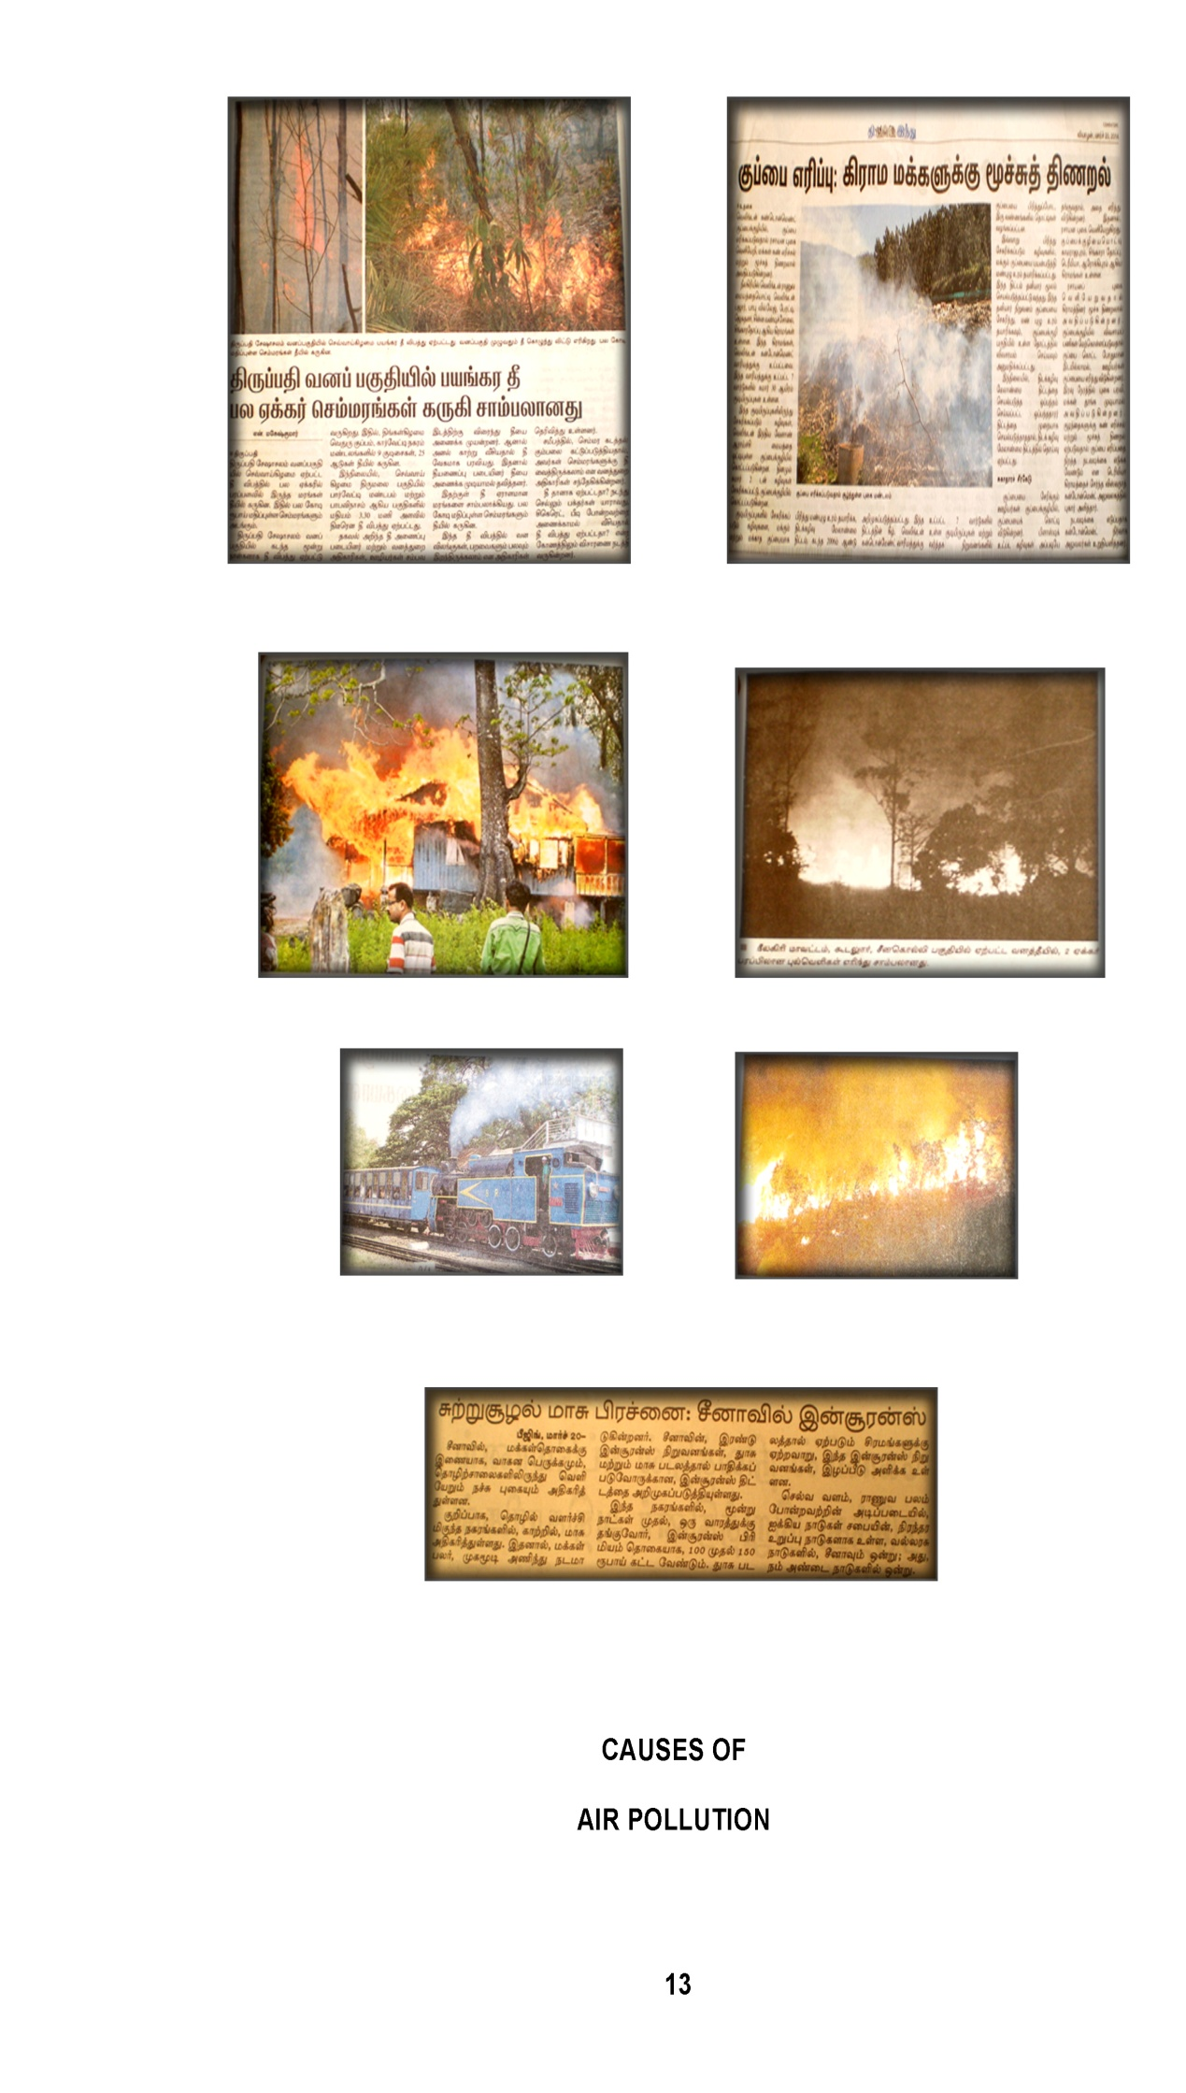
- IMPORTANCE OF HOUSING
A house is a building that functions as a home for humans or other creatures, including simple dwellings ranging from rudimentary huts of nomadic tribes and complex structures composed of many systems. The social unit that lives in a house is known as a household. Most commonly, a household is a family unit of some kind, although households may also be other social groups or individuals (en.wikipedia.org). Technically, a house can be defined as a building or structural edifice comprising of walls with foundation, floors, roofs etc. in which man lives thereby sheltering himself from the harsh effects of weather, wild animals and the element.
A house is basically built on a piece of land commonly known as a plot. Housing encompasses all social services and utilities that make life meaningful and the environment habitable (www.scribd.com/doc/16567804). Housing is a basic need of man. In importance, it is third after food and clothing. The importance of housing was universally accepted from the dawn of history. Even the Neolithic man who lived between 10,000 and 2000 B.C. built durable habitation like pit dwellings, lake dwellings and beehive huts. However, its functions increased manifold over the years. Primitive men sought some kind of protection against wild animals and natural calamities. Housing protection is also sought against enemies as well.
The safety place for a man is his family dwelling house. This is the place which provides a man with the desired peace and comfort, and charges him with the energy to commence his routine work with added enthusiasm and zeal. The very existence of an individual cannot be thought of without a house. The WHO representatives use the term “residential environment” which is defined as the “physical structure that man uses and the environs of that structure including all necessary services, facilities, equipment and devices needed or desired for the physical and mental health and the social well being of the family and the individual” (Gandotra et al, 2009)
Housing fulfils physical needs by providing security and shelter from weather and climate. It fulfils psychological needs by providing a sense of personal space and privacy. It fulfils social needs by providing a gathering area and communal space for the human family, the basic unit of society. In many societies, it also fulfils economic needs by functioning as a centre for commercial production (www.hrea.org/index.php?base_id=149).
Shelter represents one of the most basic human needs and has no doubt a profound impact in the health, welfare and productivity of the individual. The importance of shelter to man cannot be overemphasized; apart from giving protection from elements of nature, shelter in accordance with contemporary modern standards, must offer such infrastructure and services that would make dwellings conducive (Esqsenior, 2009).
Living in satisfactory housing conditions is one of the most important aspects of people’s lives. Housing is essential to meet basic needs, such as shelter, but it is not just a question of four walls and a roof. Housing should offer a place to sleep and rest where people feel safe and have privacy and personal space; somewhere they can raise a family. All of these elements help make a house a home (www.oecdbetterlifeindex.org).
Housing and development are mutually supportive. Housing provides a base for achieving crucial goals in all sectors of economy and upgrades the quality of life. Improvement in the quality of life of people depends to a great extent on the quality of housing and related facilities which determine the physical environment.
Kitchen is the major part of the house around which several home activities revolve. Earlier, the kitchen was not given due attention and consideration, but now it should be given so to make working hours pleasant and enjoyable (Gandotra et al, 2009). In the recent years, a major shift is taking place in the amount of time the homemaker gives to kitchen activities (Bhatt and Sidhu, 2012). A study conducted by Datar, in December 2000 on “Time management” revealed that the homemaker spends about six- seven hours on an average per day in her kitchen (cooking, cleaning and washing) An Indian homemaker spends about five to six hours a day in the kitchen, which may amount to approximately one- fourth of her lifespan (Kishtwaria et al, 2007).
Today, public health departments can employ multiple strategies to improve housing, such as developing and enforcing housing guidelines and codes, implementing “Healthy Homes” programs to improve indoor environmental quality, assessing housing conditions, and advocating for healthy, affordable housing. Now is the time for public health to create healthier homes by confronting substandard housing. Current public health efforts to improve housing conditions include a continuation of these historical activities as well as new strategies based on emerging issues such as indoor environmental quality (Krieger and Higgins, 2002).
- INDOOR AIR POLLUTION
Pollution of the atmosphere indoors (inside enclosed buildings, residence, office, etc.) is called indoor air pollution (Kannan, 1997). Indoor air pollution, like the name suggests, is air pollution that is inside a building like a home, an office building, or even a department store. Indoor air pollution is a major health risk because the toxins and pollutants in the indoor air pollution is confined within a small space. Because of this it has less of a chance to disperse in larger volumes of open air which would reduce the harmful impacts on humans and other indoor organisms (voices.yahoo.com/what-know-indoor-air-pollution-10493.html?cat=58). Indoor air pollution mediates the release of gases or particles into the air which are the primary cause of indoor air quality problems in homes. Inadequate ventilation can increase indoor pollutant levels by not bringing in enough outdoor air to dilute emission from indoor sources and by not carrying indoor air pollutants out of the home (Mondal et al, 2010).
Good IAQ consists of many aspects; it is an interaction of a functioning and efficient ventilation and the lowest achievable amounts of chemical, inorganic or organic, and microbial compounds which should not evoke symptoms in the occupants (Lignell, 2008). People spend a remarkable part of their time indoors, and hence the quality of the indoor environment contributes to their environmental health conditions. Several factors determine the quality of the indoor environment and its influence on human health. These factors include building-related aspects including climate, culture, social values and technical issues. Different physical, chemical and biological agents affect the quality of the indoor environment and the health and comfort of the building occupants (Nevalainen and Morawska, 2009).
According to Mukesh Khare and Sanjeev Gupta the inside environment of houses often has a higher level of air pollution than the surroundings in cities and town. Unfortunately, indoor pollution has not been given much importance, although most people spend as much as 80-90% of their time indoors (Kudesia and Kudesia, 2002).
Clean air is considered to be a basic requirement of human health and well-being. However, air pollution continues to pose a significant threat to health worldwide (www.who.int).
Worldwide, the numbers of deaths from the disease are expected to fall by half by 2050. And fewer people will die from unsafe drinking water and poor sanitation in the future. But the number of deaths caused by air pollution — which includes ground-level ozone, particulate matter, and “indoor pollution” — are expected to skyrocket, killing more than 6 million people per year by mid-century (Plumer, 2012). The EPA has found that indoor concentrations of toxic air pollutants are often higher than outdoors – up to twenty times higher for some toxins. Furthermore, people generally spend more time inside than out and therefore are exposed to higher doses of these pollutants (Bhaskar, 2009).
Indoor air pollution is bigger killer than outdoor air pollution in India with the recent global burden of diseases report listing the former as second biggest killer and latter as fifth largest. Around 1.3 million people died of indoor air pollution in 2010 whereas death because of outdoor air pollution was around 6.20 lakh. Indoor air pollution is second biggest killer after high blood pressure in India, the report said (Chauhan, 2013). In India housewives spent over 80% of the time in an indoor environment, of which 4-6 hours is spent in kitchen for cooking. Pollutants released indoors are far more hazardous than those released outdoors because of their close proximity to people (Agrawal et al., 2002).
Indoor spaces generally have higher concentrations of pollutants than outdoor spaces. This is true not only of industrial workplaces and offices, but also of schools and residences. As a result, the health effects from indoor air pollution outweigh those from outdoor air pollution. One recent estimate, from Australia’s Commonwealth Science Council in 1999, attributed 14 times as many deaths globally to indoor air pollution as to outdoor air pollution, with a total of 2.8 million deaths annually from indoor sources. Another estimate, from the U.N. Development Programme in 1998, attributed 2.2 million deaths to indoor air pollution alone, takes 6,000 to 8,000 lives each day (Brennan and Withgott, 2005).
Indoor air pollution has been ranked as one of the world's greatest public health risks. The United Nations Development Program estimated (1998) that more than two million people die each year due to the presence of toxic indoor air, while other studies estimate that 14 times as many deaths occur globally from poor indoor air quality compared with outdoor air pollution (www.sciencedaily.com). According to the global health risks - a comprehensive assessment of leading risks to global health by the World Health Organization (WHO), 2.7% of the total diseases in the world are attributed to indoor air pollutants (www.buzzle.com/articles/causes-of-indoor-air).
Environmental microbes, i.e., fungi and bacteria, are ubiquitous being found in both natural and man-made habitats (Lignell, 2008). In recent years, there has been increasing concern about indoor air quality in houses. The family home can sometimes become a source of microbial contamination, where molds and bacteria proliferate. Inadequate ventilation and high moisture levels resulting from water damage episodes or excess humidity often cause the proliferation of fungi (molds) and bacteria on visible surfaces or hidden inside structures. In such a context, a good diagnosis of the degree of microbial contamination in homes becomes more important (Ruest, 2004).
Mold growth in any building is in itself undesirable and controllable, but in addition it is an indicator that conditions of relative humidity may also be favourable for yeasts, bacteria and mites, which (especially in the case of mites) can likewise affect respiratory health. Air is an extreme environment for bacteria, where their survival is limited by environmental stress (Schleibinger et.al, 1993).
Moisture damage and microbial growth indoors are associated with adverse health effects among the occupants. Dampness or moisture damage is a common problem in buildings all over the world. When building or surface materials become wet due to moisture damage, it is only a matter of time before microbes will start to grow. In fact, moisture is often the growth-limiting factor for microbes, since the other critical factors such as nutrients and suitable temperatures are usually fulfilled. Microbial growth refers to the growth of fungi, bacteria and other microorganisms (Lignell, 2008)
Biological contamination of indoor environments is essentially regulated by humidity and moisture conditions, i.e., by different forms of water. Water is used in practically all buildings. In dwellings, water is used daily in cooking and washing. Running water is present in the plumbing and sewage network, and liquid water is also present in the drip pans of air cooling system and in various humidification systems. Excess humidity or moisture can also contribute to development of sources of allergens such as dust mites or cockroaches.
The presence of water is a critical factor for most biological contaminants, regulating their survival and proliferation. Constant or repeating moistening of materials may lead to microbial growth, chemical deterioration and undesired increase of dampness in the immediate surroundings of the damage, which in part increases the risk of many types of other biological contamination, such as rot fungi, insects and mites. Small quantities of most biological agents can be found practically everywhere as part of our normal environment. Fungi, bacteria and other biological agents occur in nature, often in connection with soil, plants and animals. It is totally normal to have some bacteria and fungi in indoor air, on different surfaces and materials (Nevalainen and Morawska, 2009).
Microorganisms are ubiquitous in our environment: they are present in water, soil, air, plants, animal and humans. The interest of an industrial hygiene viewpoint mainly relates to the bio aerosols or microorganisms in the air, and more specifically the bacteria, molds and yeasts and their metabolites, toxins or fragments. Bacteria are abundant in the environment and in humans. There are more than 150,000 known species of bacteria. They are single-celled organisms that reproduce by simple cell division. The majority of bacteria contain the necessary genetic information and energy capacity to ensure their growth and reproduction. An aerosol can be defined as a suspension of microscopic solid or liquid particles in air for an appreciable period of time. Biological aerosols include bacteria, yeasts, moulds, spores of bacteria and moulds, viruses (Pasquarella et.al, 2000).
Bacteria are different than all other life forms on earth because they are single celled, prokaryotic organisms. “Prokaryotic” refers to the lack of membrane-bound nuclei and organelles in their cellular make-up. Bacteria are free-living and can utilize a variety of carbon sources as food. The environment is literally teeming with bacteria, many of which are innocuous and not associated with human disease. Of concern to IAQ investigators are the potentially pathogenic (disease-causing) bacteria that can proliferate in homes and offices. Bacteria require greater levels of available water than fungi in order to proliferate. Moisture condensation on building materials promotes growth of bacteria and any standing water is a potential breeding ground for bacteria. Staphylococcus aureus, is a serious potential pathogen that can cause skin, eye and gastrointestinal infections. (www.emsl.com).
High moisture load in a building can also be found in repeatedly damp facilities, such as institutional kitchens. This may lead to microbial growth on surfaces and structures (Lignell, 2008). The airborne bio pollutants are not only present in the outdoor atmosphere, but are also prevalent in the indoor atmosphere. A survey conducted on the indoor bio pollutants in the kitchen, and Hospital at Jabalpur showed the presence of a variety of bio pollutants (Agrawal, 2005). Indoor storage of organic waste was associated with significantly increased concentrations of bacterial endotoxins and fungal antigens in dust from both kitchen and living room floors (Inge, 2000). Biological contaminants deteriorate the atmosphere and their effects on human health are still worst. These exists numerous air borne micro- organisms, pathogens, bacteria, viruses and parasite which are added as air pollutants in the atmosphere. Their effects on living organisms are obviously undesirable (Lignell, 2008).
The vast majority of airborne pathogens are uniquely adapted for spreading in indoor environments. The conditions of temperature, humidity and protection from sunlight and from oxidants which man controls for his own comfort serve also to protect pathogens during their exposed and vulnerable period when they transmit themselves form one person to the next. Most airborne pathogens die out rapidly in outdoor air but as individual species they depend entirely on man and his indoor environment for their propagation (Ramesh, 2004).
Sampling for biological agents may be needed for monitoring purposes of indoor air quality, for exposure assessment in health risk evaluation, for identifying a pollution source (e.g., moisture damage) associated with complaints or suspicions of degraded indoor air quality, establishing concentration levels or for other study purposes of the characteristics and behaviour of indoor air pollutants (Nevalainen and Morawska, 2009).
There are many methods available for detecting microbes in the indoor environment. They can be sampled from air, surfaces, materials, and dust and subsequently detected by culturing, molecular methods or by using chemical markers. Sampling methods are needed to quantify and describe the microbial populations in indoor environments. Microbes can be sampled from air, surfaces, dust, and materials. Since there is no technique that would cover all aspects of environmental sampling, the methods need to be selected according to the needs of the investigation (Lignell, 2008).
Air sampling of microorganisms is a very favoured method, as it allows a direct toxicological evaluation, as results can be related to a concentration expressed in colony forming units per cubic meter (Schleibinger et.al, 2004). All the results of the bacterial and fungal counts are expressed as the number of colony- forming units per cubic meter of air (CFU m-3) (Dacarro et al., 2003). Colony morphology is a method that scientists use to describe the characteristics of an individual colony of bacteria growing on agar in a Petri dish. It can be used to help to identify them (www.microbiologyonline.org.uk).
Counting microbes in the air is not an easy task. Many different methods are in use, which can be divided into four groups; the count of colony forming units per cubic meter of air (cfu/m3); the count of cfu on settle plates; measurement of a chemical component of the microbial cells/m3 of air; the count under the microscope. At the moment, the only effective means of quantifying airborne microbes is limited to the count of cfu. The cfu count is the most important parameter, as it measures the live micro-organisms which can multiply. Air samples can be collected in two ways: by active air samplers or by passive air sampling (the settle plates). Both methods are widely used.
Passive air sampling is performed using settle plates. Petri dishes containing a solid nutrient medium are left open to air for a given period of time. Microbes carried by inert particles fall onto the surface of the nutrient, with an average deposition rate of 0.46 cm/s being reported.45 After incubation at 36_1°C they grow colonies in a number proportional to the level of microbial contamination of the air. Settle plates are sterile, economical and readily available. The results obtained by settle plates are reproducible and reliable. Many places in an environment can be checked at the same time. Data collected on settle plates set in different places, by different operators, can be compared and understood. The natural trend of the microbial population in the air is not disturbed during the sampling time nor is the laminar air flows interrupted in any way. Settle plates give the measurement of the harmful part of the airborne population which falls on to a critical surface in a given time. Settle plates allow the evaluation of surface contamination settling from the air.
On the other hand, in any environment, the number of micro-organisms falling is related to the number of micro-organisms present in the air: the greater the air contamination, the higher the number of micro-organisms sedimenting due to gravity (Pasquarella et.al, 2000).
- ROLE OF PLANTS IN INDOOR

Plants play the most important part in the cycle of nature. Without plants, there could be no life on Earth. They are the primary producers that sustain all other life forms. This is so because plants are the only organisms that can make their own food (www.blueplanetbiomes.org/plants.htm). Human ecology (ie humans in their relationships with the environment) has a history extending up to two million years. Our species has continued to be biologically well adapted to ‘nature’ as we have encountered it. We are reliant on plants for all our needs - from food to shelter, and (unknown to our ancestors) our supply of oxygen and removal of carbon dioxide. Our ancestors also recognised an essential role for plants in providing pleasure, perfumes, peace, piety and glimpses of ‘paradise’ (Burchett et.al, 2008).
We live on this planet by the courtesy of the earth’s green cover. Plants are our natural heritage, which we have to preserve the posterity. The plants constitute the key elements of the life support system, forms on the planet earth. We depend on plants not only for food, medicine, clothing and shelter but also the precious life sustaining oxygen. It is nice to live with plants. Growing plants indoors is an interesting, satisfying and rewarding hobby and an increasing number of people are discovering for themselves the pleasure to be derived from living with beautiful plants. People suffer if they are consistently deprived of contact with nature. The strains and tensions of modern life have perhaps, made more obvious. The plants growing indoors provide living bioaestheticity for the home, a means of decorating which mankind has used throughout the world for centuries. Houseplants, the living, growing objects of nature indoors, affect the emotional experience. Plants are the most natural and cost effective means of decorating one’s home. They provide a warm, snug and comfortable ambience and a home is almost incomplete without them (Asnani and Dwivedi, 2007).

Plants have had and still have a key role in the history of life on earth. They are responsible for the presence of oxygen, a gas needed for most organism who currently inhabit our plant and need it to breathe (www.botanical-online.com). Plants are the actual resources for existence of humans and all other living forms in the world. Their presence is inevitable for substance of life on the earth. Our earth is termed as green planet due to presence of plants. The importance of plants lies in that they contribute to almost all the phases of a living beings i.e. small or big, those on land or water, young or old survive on plants. Even growing plants in school, indoor, gardens & maintenance of plants in office is very advantages (www.rajaha.com/importance-plants-life).
Nature constantly works its balancing act with it. To be more pointed, pollution from air is constantly being removed by plants. When pollution is at a greater level than plants can absorb, then we have trouble. Besides cleaning up the air, plants are cheaper to attain and they're quieter. They're prettier, too and they will usually outlast any air purifier. And they're cheaper to operate (voices.yahoo.com/a-simple-solution-indoor-pollution-6364.html?cat=5).
Indoor plants do more then just add a splash of colour to your home; they also fight indoor air pollution. Currently, consumers have so many things in their homes, which cause indoor air pollution such as fireplaces, carpet, pets, and even our computer desk if they come in pieces that you must assemble, but having some, indoor plants can reduce this bad air quality greatly. Indoor air pollution causes many health problems, and it is so much cheaper to buy some indoor plants to combat this problem rather then all the expensive prescription medicines. No one should stop prescribed medications without their doctors' orders, but by having these plants inside a home will help greatly. Plants take in the indoor air pollution and turn it into clean fresh oxygen that our bodies need to grow (voices.yahoo.com/best-indoor-air-pollution-reducing-plants-1804647.html?cat=32).
In fact, air in homes or offices is contaminated to some degree. Fortunately, there are ways to stop air pollution indoors, with which the quality of indoor air can be increased for better health. Several studies and clinical researches have been conducted on prevention of air pollution. Simple solutions to improve indoor air quality are maintaining proper ventilation in homes, growing houseplants, using air purifiers and reducing the sources that release contaminants (www.buzzle.com/articles/indoor-air-pollution.html).
Another paper on “Role of plants” recommends that house plants could be one of the vital bio aesthetic element that enhances the beauty of indoor and outdoor interiors. The functional role of house plants recommends that planning of houseplants should be encouraged as they serve “Green livings” or “Mechanical filters” for reducing air pollution. At the same time they also control the indoor odour, noise and dust. Moreover they add privacy, provide relaxation, and are essential for improving the quality of a healthier life (Gandotra et al, 2009).
City-dwellers also need continuing psychological links with ‘nature’. The evidence is that humans can only function ‘to the extent that they maintain a micro-environment similar to that from which they have evolved’. City mental health problems are increasing. Both urban green ‘oases’ and indoor plants aid wellbeing and productivity of building occupants. It is expected that, in future, along with normal fittings, indoor plants will be utilised as a portable, flexible, beautiful, useful, effective, and a relatively low-cost, standard installation to improve indoor environmental quality (IEQ). Hence, eg, the Green-Star ratings from the Green Building Council for building designs that include indoor-plant installations (Burchett et.al, 2008).
Additionally, keeping plants indoors will affect the moisture content of the air, which must be regulated so as not to promote mold growth. In summary, plants can generally be used to enhance the aesthetic environment and the air quality inside buildings (www.nachi.org). Houseplants bring life into a room. As ornamental as houseplants are, many also provide health benefits by purifying the air and increasing humidity (gardening.about.com). Ornamental plants used indoors help purify the air and create a pleasant atmosphere (www.ehow.com/list).
Ornamental plants can also be used as cover mat on eroded areas, they help in eliminating dust, and they reduce glare, air pollution, heat build up and noise pollution. Ornamental plants also serve as complementor, attractors, emphasizers, diverters, indicators and provide aesthetic function by creating attractiveness for human activities. The presence of some plants in an environmental makes it beautiful and a beautiful environment is always cool and inviting. Plants flavouring shrubs around homes often add aesthetic values to our surrounding (Baiyewu et al., 2005).
All indoors plants (flowering or not) are able to purify indoor air to some degree through their normal photosynthesis processes. But some were found to be more beneficial than others in removing harmful household toxins, even removing 90% of chemicals in the air in only twenty-four hours! (www.sustainablebabysteps.com). The National Aeronautics and Space Administration (NASA) and the Associated Landscape Contractors of America (ALCA) conducted research using popular varieties of ornamental plants to determine their effectiveness in removing several key pollutants associated with indoor air pollution. Indoor plants are capable of removing low levels of pollution from the air through the tiny openings in their leaves (www.hgtvremodels.com).
Studies Show Plants Work
Several studies have indicated that indoor plants can help us breathe cleaner air.
- Study 1: A research team from Pennsylvania State University published the results of a study on the effects of three common houseplants on indoor ozone levels in HortTechnology. They released ozone into two chambers—one with houseplants, and one without—and found the ozone depletion rates were higher in the chambers that contained plants. Ozone is the main component of air pollution, or smog, and frequently infiltrates indoor environments. Toxic effects on humans include pulmonary edema, inflammation, and reduction of lung function.
- Study 2: In 1989, a two-year study by NASA and the Associated Landscape Contractors of America found that certain tropical plants commonly used as houseplants were effective in removing formaldehyde, benzene, and trichloroethane from the air and replacing it with breathable oxygen. Though all plants provide some benefit to air quality, the tropical ones proved more effective at processing gas and chemicals.
- Study 3: Studies over the past five years by the University of Technology, Sydney, found that installing small groups of the Janet Craig and Sweet Chico plants in offices reduced total levels of volatile organic compounds (VOCs) by up to 75 per cent, and dust by 20 per cent, with results consistent over the 5-12 weeks studied. Researchers estimate that six or more plants in a 1,200- to 1,500-square-foot house could achieve significant reduction of indoor air pollution.
- Study 4: Research from the Washington State University found that dust was reduced as much as 20 per cent when a number of plants were placed around the perimeter of a computer lab and small office for one week (Story, 2013).
Selection of houseplants to mitigate air pollution in offices and homes depends not only on their ability to clean the air but also on their growth habit, the ease of growing and maintaining them, their light requirement, and, of course, your personal taste. In an office or home, plants can have a profound influence on peoples’ psychological well-being and serenity. It has been shown that plants in living and work spaces have a measurable beneficial effect on people. In addition to plants adding beauty to a room and making it an inviting place to live or work, research has found that when people are near or tending plants, they feel relaxed and calm. Health and discomfort symptoms were found to be lower when indoor plants were present. These positive factors also need to be considered in the selection of appropriate houseplants (Kobayashi et.al, 2007).
Sansevieria trifasciata has broad strap-like, upright leaves that are dark green and marked with a pattern of wavy cross stripes in a lighter colour. The striping gives it the common name of “snake plant”. It is also called mother-in-laws tongue, perhaps because of the sharp point to the leaves (www.wikihow.com/Care-for-a-Sansevieria-or-Snake-Plant). It is an evergreen perennial plant forming dense stands, spreading by way of its creeping rhizome, which is sometimes above ground, sometimes underground. Its stiff leaves grow vertically from a basal rosette. Mature leaves are dark green with light gray-green cross-banding and usually range between 70–90 centimetres (28–35 in) long and 5–6 centimetres (2.0–2.4 in) wide (en.wikipedia.org/wiki/Sansevieria_trifasciata). Tough, durable and incredibly easy to grow, snake plants thrive readily in the low light conditions typical of most indoor environments. They also tolerate poor watering practices and benign neglect, making them perfect for beginners as well as for frustrated would-be gardeners who are all brown thumbs (homeguides.sfgate.com/grow-snake-plant-68402.html). This houseplant prefers to be watered once every 7 - 10 days thoroughly, allowing the soil to dry in between watering (houseplants-care.blogspot.in/2006/05/).
The great thing about snake plants is they actually absorb more of the harmful chemicals in the air than other tropical plants and they clean the air better (video.about.com/houseplants/Tropical-Plants-You-Won-t-Kill.htm). NASA conducted a study that shows it can provide a significant amount of oxygen to indoor environments. Removes contaminants from air and produces large amounts of oxygen (www.snake-plant.com/). Snake Plant – Unlike most plants which release Carbon-dioxide at night, Snake Plant (also known as Mother-in-law’s Tongue) does the reverse as it converts CO2 into Oxygen at night (www.labnol.org/home/best-indoor-plants-for-clean-air/10654/).

Methodology

III. METHODOLOGY
Man is not born to solve the problem of the universe, but to find out where the problem begins and then restrain himself within the limits of the comprehensible.
— Johann Wolfgang von Goethe
Indoor air pollution is a concern in the developed countries, where energy efficiency improvements sometimes make houses relatively airtight, reducing ventilation and raising pollutant levels. (edugreen.teri.res.in). Among all the indoor air pollution, biological contamination pollutions are the major pollution in the kitchen of the residence. Common indoor plants may provide a valuable weapon in the fight against rising levels of indoor air pollution. (Seaman, 2009). And also plants add aesthetic and biological comfort to interior spaces.
The research design for the study on “GAUGING INDOOR AIR QUALITY BY GROWING SNAKE PLANT (SANSEVIERIA TRIFASCIATA)” consisted of the following steps:
- Household Survey
- Trial on improving indoor air quality by growing snake plant (sansevieria trifasciata)
- Creating awareness on use of snake plant to control indoor air pollution and
- Evaluating the impact of the awareness programme conducted
- HOUSEHOLD SURVEY
Surveys are concerned with describing, recording, analysing and interpreting conditions that either exist or existed (Saravanavel, 2003). To identify the problems which were faced by the household in the poor indoor air quality and to recognize the environmental conditions, a household survey was found necessary. The reality is that not all the data needs of a country can be met through census-taking; therefore, household surveys provide a mechanism for meeting the additional and emerging needs on a continuous basis. The flexibility of household surveys makes them excellent choices for meeting data users’ needs for statistical information which otherwise would not be available or are insufficient.
Accordingly, a household survey was conducted to gather information on general description and prevailing environmental condition of the selected houses. The household survey included the following steps:
      - Selection of the Area
      - Selection of the Sample
      - Conduct of the Survey and
      - Analysis and Interpretation of the Data Collection
- Selection of the Area
The success of any study depends on the careful selection of the sample. The choice of sample must be based on factors such as nature of the study, size of the universe, size of sample, degree of precision desired and availability of resources (Kothari, 1997).
The level of indoor pollution is mostly high in the urban areas than the rural region. The urban areas of India are nowadays growing into bigger agglomerations with ever increasing pollution due to haphazard and uncontrolled developmental activities. This increasing pollution can be attributed to a score of factors like lack of environmental planning, economic issues, social policies and a lot others.
Coimbatore (population 1.25 million) is the second biggest city of the southern state of Tamilnadu, India and is identified as one of the fast developing metros of India. There are about 50,000 small, medium and large scale industries. (www.kct.ac.in). Coimbatore is well known for its textile and automobile parts industries and has excellent potential for industrial growth (www.ccmc.gov.in). The presence of industrial activities on a large scale, in and around Coimbatore, tends to have a strong impact on the environmental quality of the City, particularly the vital component of air (www. boloji.com).The urban environment area not only affected the outdoor air, it also causes for the indoor air pollution. Because, in the urban area, most of the buildings were constructed in the manner of energy- efficient sort, this is the main sources to generate the indoor air pollution. So, the area selected for the present study was Saibaba colony in Coimbatore city. In the selected area, the male is 16, 874 and the female is 16, 895 which contribute the total population is 33, 769. The number of households of the selected area is 7,773 (www.ccmc.gov.in/ccmc/).
- Selection of the Sample
A sample is composed of some fraction or part of the total number of elements or units in a defined population (Saravanavel, 2003). According to Gupta (2001) a random sample is one where each item in the universe has an equal or known opportunity of being selected. In the words of W.M. Harper, “A random sample is a sample selected in such a way that every item in the population has an equal chance of being included”. Random sampling is more suitable in more homogenous and comparatively larger groups. Hence in this study, simple random sampling procedure was followed.
The selection of the sample is adjusted in accordance with the object of the enquiry, so that no significant item may be ignored. For the household survey, 50 households were selected based on their ingenuity, eagerness and courteousness with the investigator. Since the homemakers play a predominant role in the kitchen, they were selected as the respondents for the household survey.
- Conduct of Survey
Saravanavel (2003) opined that the personal interview helps to establish close personal contact between the interviewer and interviewee and by its means detailed knowledge about intimate and personal aspects of the individual can be had. It is a two way method which permits exchange of ideas and information. It is unique method in that it involves the collection of data through direct verbal interaction between the interviewee and the interviewer. Therefore the method selected for this study was interview method.
Questionnaire is that form of inquiry which contains a systematically complied and organised series of questions that are to be sent to the population samples (Saravanavel, 2003). And also the questionnaire is one of the tools to collect the primary data from the respective samples. Primary data refers to information that is generated to meet the specific requirements of the investigation at hand. Hence questionnaire was selected as tool to conduct the survey. The questionnaire is given in Appendix I.
- Analysis and Interpretation of Data Collection
The data collected from primary source were tabulated, analysed, interpreted and presented under chapter IV, Results and Discussion.
- TRIAL ON IMPROVING INDOOR AIR QUALITY BY GROWING SNAKE PLANT (SANSEVIERIA TRIFASCIATA)
This experimental part of the study consisted of the following aspects:
- Selection of the plant
- Selection of households
- Conduct of the experiment
- Selection of the Plant
Recent reports characterize plants as “nature’s clean air machine”, claiming that plants remove indoor air pollutants.
Several studies proved that indoor plants have the ability to reduce the level of indoor air pollutants and improve the indoor environment as high-quality. Following research indicated that indoor plants can help us to breathe cleaner air.
Study 1: According to B.C. Wolverton (1996), Interior Plants: Their Influence on Airborne microbes inside Energy- efficient Buildings. This study addresses the influence of large numbers of houseplants on airborne microbial levels inside energy- efficient buildings. It indicates that large quantities of houseplants may be used to increase humidity levels and suppress levels of mold spores and other airborne microbes inside energy- efficient buildings, while reducing air polluting substances. This study also indicates that plants are directly or indirectly suppressing the growth of airborne microbes in their immediate area. Technical data in this report further supports the concept of living plant filters for improving indoor air quality.
Study 2: According to Kobayashi et al., (2007) Using Houseplants To Clean Indoor Air. This study found that the plants add aesthetic and biological comfort to interior spaces. When plants are added to rooms, relative humidity can increase and particulate matter (dust) accumulation can decrease.
These studies have the proof that the snake plant (Sansevieria trifasciata) as ornamental plant to involve more than the other to reduce the biological contamination in the air. Most house plants require a bright, sunny location to do their best. Unfortunately, many buildings do not provide much light. This plant recommended in the study can tolerate low light. Care of this plant is relatively simple. Water requirement is also very low. And this plant is also easily available in Coimbatore with low cost.
Hence the plant selected for the study is Sansevieria trifasciata, also called snake plant or mother-in-law's tongue, is a species of flowering plant in the family Asparagaceae, native to tropical West Africa from Nigeria east to the Congo. This plant is the architectural plants with stiff, upright leaves up to 3 or 4 feet tall. It can withstand virtually any conditions, from dark to bright while helping filter out air pollutants. It is a commonly used decorative plant. This plant removes contaminants from air and produce large amounts of oxygen (www.snake-plant.com). And it is available easily in the nurseries. It is easy to grown in the indoor, maintenance also easy by the housekeeper. Plate I represents the snake plant (Sansevieria trifasciata) which was used for this study.
- Selection of Households
According to the contemplation of the household survey, five household were selected from the 50 households for the experiment analysis, due to the

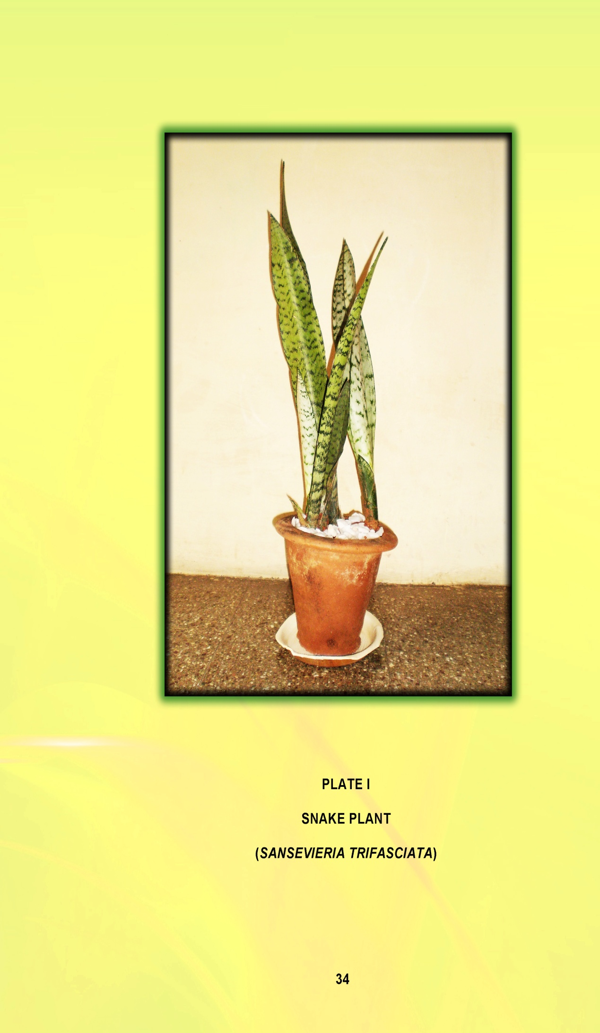
time constraint and economical limitation. And also these five households were appealing to examine the indoor air quality level in their area.
- Conduct of the experiment
      - Selection of area
      - Requirement of plants
      - Duration of the experiment conducted and
      - Evaluation of the impact of the experiment conducted
- Selection of area
According to Scott et al., (1982) in the study, An investigation of microbial contamination in the Home, the frequent contamination of dishcloths and other wet cleaning utensils with large numbers of organisms suggests that these items may act not only as reservoirs but also as disseminators of contamination in the kitchen.
Another study which conducted by Ojima et al (2002) on Bacterial contamination of Japanese households and related concern about sanitation, revealed that kitchens to have the greatest degree of bacterial contamination, followed by bathing rooms. Kitchens contain many items and places that are subject to primary contamination from bacteria brought in from outside the home – through foodstuffs. Moreover, the cross-contamination by the frequent and complex traffic in the area may additionally contribute to contamination. An overall comparison showed aerobic mesophilic bacteria counts to be highest in the kitchen.
- Requirements of plants
In the late 1980s, a study by National Aeronautics and Space Administration (NASA) and the Associated Landscape Contractors of America (ALCA) was conducted to find ways to purify the air for extended stays in orbiting space stations. NASA studies suggested the use of 15-18 plants will improve air quality in an average 1,800 square foot home. More or less kitchen should not cross above 200 sq.ft. According to NASA one plant is sufficient in the entire room of 200 sq.ft. Five plants were implemented in every area which was selected for this study. The cost of a plant is Rs. 150. Five plants were procured and grew in the kitchen of the five selected households.
- Duration of the experiment conducted
Recent studies have addressed how Sansevieria trifasciata plant influence removal of biological contamination in the indoor environment during the period of three months plant implementation.
By the reference of the studies Interior Plants: Their Influence on Airborne microbes inside Energy- efficient Buildings investigated by Wolverton (1996), the extent of the plant functioning phase is predetermined. This study conducted their experiment during six months which was dividing like one half was carried in summer and another half was carried in winter for comparison those seasons. Hence this study was conducted only three months (from November to January) to analyze the level of bacterial contamination in the kitchen before after by growing snake plant. Following the plant introduction, the selected houses were closely perceived by the researcher through direct visit concerning the condition of the selected houses and plants. Plate II represents the experimental study conducted in the selected households.
- Evaluation of the impact of the experiment conducted
To evaluating the indoor air quality in the pre and post of the plant implementation by the following procedure were adopted:
      - Collection of the air sample
      - Analysis the air Quality Testing
- Collection of the air sample
The air samples were collected from the selected five households by the following method:
According to the microbiologist instruction, petri dishes containing plate count agar (PCA) were used to collect the sample and culture airborne microbes. It was placed 4 hours in each location which was selected for this
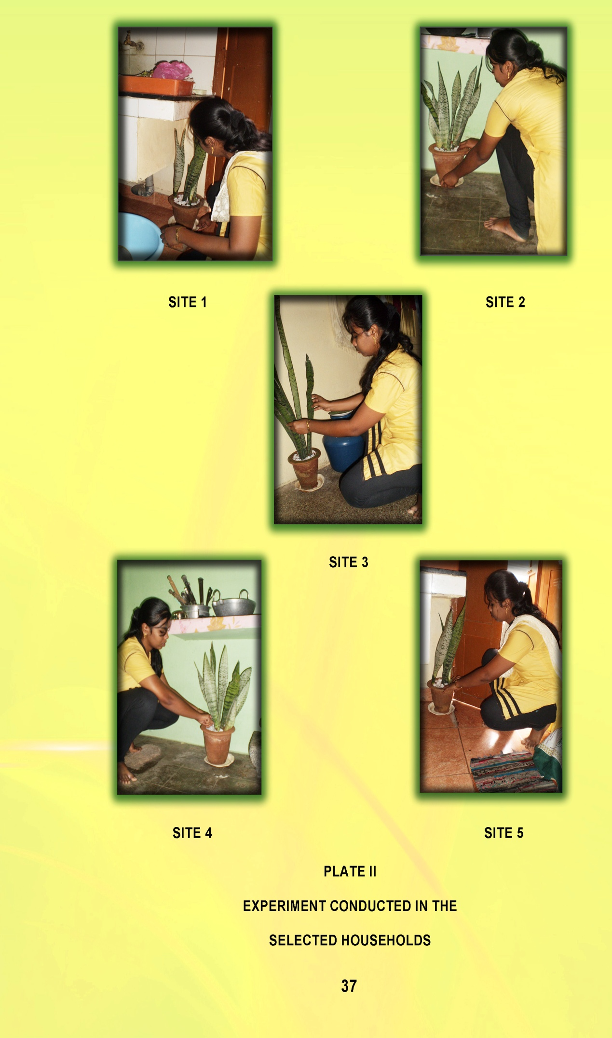
study for collecting the air sample. Plate III shows collecting the air sample from the selected households.
After completion of that collection process, the petri dishes were given to the laboratory for analysing the air quality with the help of the lab technician. The lab which was selected to testing the air quality for this study was the ALPHA Lab & technologies which is located in Velandipalayam, Coimbatore.
- Analysis the air Quality Testing
After, Petri dishes were placed in an incubator at 28⁰C for 48 hours. After 48 hours, Petri dishes were removed from the incubator and the number of “colony Forming Units” (CFU) was record.
Colony forming units, usually abbreviated as CFU, refer to individual colonies of bacteria, yeast or mold. A colony of bacteria or yeast refers to a mass of individual cells of same organism, growing together. For molds, a colony is a group of hyphae (filaments) of the same mold growing together. Colony forming units are used as a measure of the number of microorganisms present in or on surface of a sample. Colony forming units may be reported as CFU per unit weight, CFU per unit area, or CFU per unit volume depending on the type of sample tested. To determine the number of colony forming units, a sample is prepared and spread or poured uniformly on a surface of an agar plate and then incubated at some suitable temperature for a number of days. The colonies that form are counted. CFU is not a measure for individual cells or spores as a colony may be formed from a single or a mass of cells or spores. (www.moldbacteriaconsulting.com)
The result of the two phases which were, the phase without the plant and another phase with the plant were analyzed for interpreting the net result of the air quality status.
- CREATE AWARENESS ON USE OF SNAKE PLANT TO CONTROL INDOOR AIR POLLUTION
Based on the experimental results by using snake plant (Sansevieria trifasciata) to control the indoor air pollution, the researcher felt that it has to
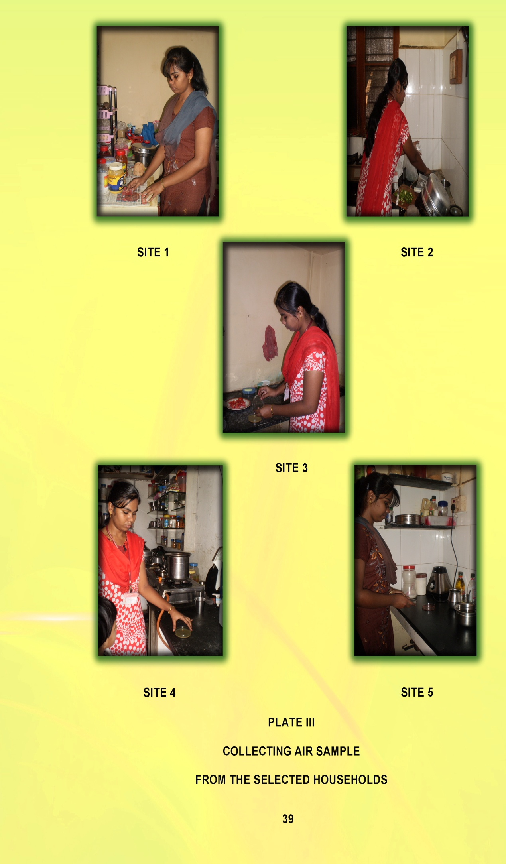
be communicated to all the selected households. Awareness programme is an important role to provide knowledge and enthusiasm among the people to encouraging the social activity especially to act upon the environmental problems, a awareness programme was carried out.
The following are the steps involved in this stage:
- Formulation of the course content on use of snake plant to control indoor air pollution.
- Selection of Sample and
- Organization of the Awareness Programme.
- Formulation of course content on use of snake plant to control indoor air pollution
The role of indoor plant in improving indoor air quality proven by the experiment, the awareness programme was arranged. The major motives to engender this awareness programme for instigate the awareness about the indoor environment and the role of plant which supply fresh air to the indoor environment among the public. The awareness programme enveloped the following criteria:
- Vital of indoor environment
- Preface of the indoor air quality
- Origin of the indoor air pollution
- Impact of the poor indoor air quality and
- Role of plant for improving the indoor air quality
- Selection of Sample
It is a well known fact that women play an important role in household activity especially in kitchen. Women can be used as effective disseminators and communicators. Women’s potential and skills to be improved and enhanced to protect and preserve the environment automatically and improve the indoor air quality.
Hence it becomes a paramount importance to create awareness among homemaker on role of snake plant (Sansevieria trifasciata) in controlling the indoor air pollution.
- Organization of the Awareness Programme
The purpose of the study and the awareness programme were elucidated them and their co-operation was sought for the success of the programme. The tools used for the programme were special lectures and participating discussion. Plate 4 shows conduct of the awareness programme; poster and chart were used as visual aids during the programme. A pamphlet on crucial of good indoor air quality and the role of indoor plant to remove the bacterial agents which affect the indoor air quality was prepared and distributed during the awareness programme. Plate IV also represents the pamphlet, distributed during the training programme.
- EVALUATION OF THE IMPACT OF THE AWARENESS PROGRAMME CONDUCTED
The impact of the awareness programme was assessed in order to find out the effectiveness of the awareness programme. It would also reflect how far the homemakers have understood the simple technology of growing snake plant to control indoor air pollution.
The impacts of the awareness programme were assessed in terms of the following criteria:
- Knowledge gained by the homemakers on role of snake plant to control indoor air pollution – In the end of the programme, the homemakers were given their feedback about the information of snake plant to control the indoor air pollution before and after awareness programme.
- Opinion regarding the growing of Snake plant (Sansevieria trifasciata) to control the indoor air pollution.
It is hoped that the study would through light on the effective use of snake plant (Sansevieria trifasciata) to maintain good air circulation.

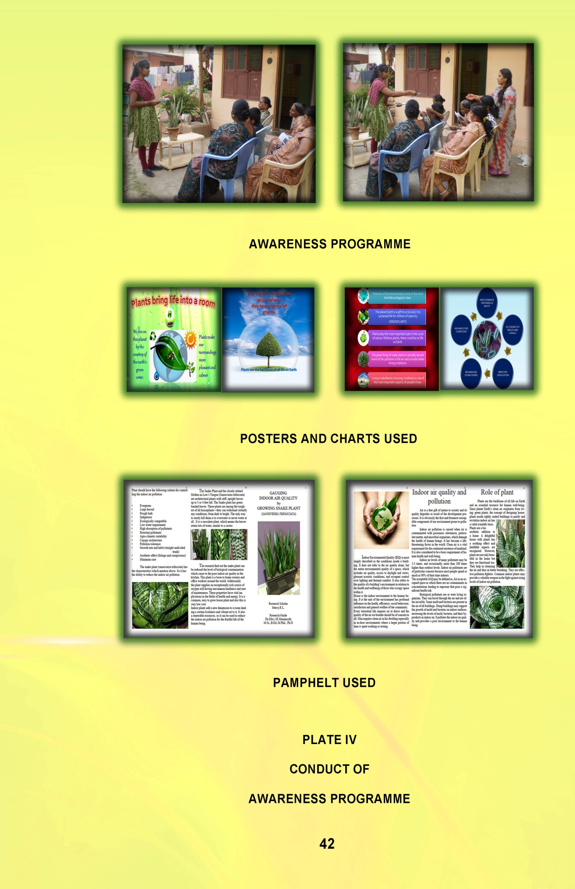

Results and Discussion

IV. RESULTS AND DICUSSION
"All truths are easy to understand once they are discovered; the point is to discover them."
- Galileo Gililei
The Results and Discussion for the present study on “GAUGING INDOOR AIR QUALITY BY GROWING SNAKE PLANT (SANSEVIERIA TRIFASCIATA)” are presented under the following heads:
- Household Survey
- Trial on improving indoor air quality by growing snake plant (sansevieria trifasciata)
- Creating awareness on use of snake plant to control indoor air pollution and
- Evaluating the impact of the awareness programme conducted.
- HOUSEHOLD SURVEY
A household survey was conducted to analyse socio economic profile and prevailing condition of the house and activities in the kitchen by the selected households. The findings of the household survey are discussed under the following headings:
- Socio-economic profile of the Selected Households
- Prevailing condition of the house and activities in the kitchen of the selected
- Socio-Economic Profile of the Selected Households
The socio-economic profile helps to understand the socio-economic characteristics of the selected households Table I presents the socio-economic profile of the selected households.

TABLE I
SOCIO-ECONOMIC PROFILE OF THE SELECTED HOUSEHOLDS
S.No. | Category | Classification |  | Households
S.No. | Category |  |  | Number | Percentage
1. | Age in Years | Below 30  30 – 40  40 – 50  Above 50 |  | 10  30  8  2 | 20  60  16  4
2. | Education status | Illiterate  Primary  Secondary  Under Graduation  Post Graduation |  | 5  8  15  20  2 | 10  16  30  40  4
3. | Family Income  (Monthly) | 5,000 – 7,000  7,000 – 9,000  Above 9,000 |  | 5  15  30 | 10  30  60
4. | Type of Family | Nuclear family  Joint family |  | 44  6 | 88  12
5. | Family Size | Small (1-3 members)  Medium (3-6 members)  Large (7 and above members) |  | 10  38  2 | 20  76  4
6. | Occupational Status | House wives  Teaching Profession  Private Sector  Own Business  Government Job |  | 28  3  5  11  3 | 56  6  10  22  6
7. | Type of the House | Own | Apartment  Individual house | 6  14 | 12  28
7. | Type of the House | Rented | Apartment  Individual house | 12  17 | 26  34

Age is an important variable which determines ones behaviour to maintain the kitchen area. Majority (60 per cent) of the respondents were in age group of 30 – 40 years. Twenty per cent were below 30 years while 16 per cent belonging to the age group of 40-50 years.
Education is an important indicator of social status. Majority 40 per cent of the respondents had the level of education been under graduation. Thirty per cent respondents had secondary and 16 per cent respondents had primary level of education in the selected households. Ten per cent respondents were illiterate. It emphasised that after so many education campaign on awareness of necessitate the education for the people, the problem was still occurred.
The standard of living of a household is mostly based on the family income which would affect the economic and environmental status of the families. It is evident from the above table, according to HUDCO (2009) that a majority (60 per cent) of the households earned above Rs 9000 per month whereas a lower proportion of ten per cent of them earned income in the range of Rs 5,000 to 7,000.
Family is very important as it shapes our development and personality. Family units take a variety of forms, all of which involve individuals living under one roof. The above Table illustrate the type of family of the respondents. It indicates that a majority (88 per cent) of the households belonged to nuclear family while 12 per cent belonged to joint family.
The family gives the status to the society. Seventy six per cent of the households medium sized (3–6 members) while 20 per cent of the family belonging to the small family (1–3 members).
Occupational status is always considered as the important key to determine the social class. The occupation decides the standard of living of the households. Fifty six per cent of the respondents were housewives who were involved in household chores at the full time. Six per cent of the respondents were involved in teaching profession. Respondents were also involved in private sectors jobs, business and government jobs.
Twenty eight per cent of the respondents were living in their own individual house while 12 per cent of the respondents were residing in their own apartment. Thirty four per cent of the respondents were living in the rented individual house and 26 per cent of respondents were in the rented apartment.
- Prevailing condition of the house and activities in the kitchen of the selected households
Prevailing condition of the house and activities in the kitchen of the selected households are discussed under the following aspects:
- Size of the house
- Size of the kitchen
- Opinion on ornamental plant placement
- Average time spent per day for kitchen activities
- Frequency of using the kitchen for cooking
- Supplementary activities in the Kitchen
- Existing condition of kitchen in the selected households
- Reasons for Moisture generation in the selected households
- Ventilation access in the Kitchen
- Size of the House
The size of the house is an important variable to determine the status of the family. Table II presents the size of the selected house.
TABLE II
SIZE OF THE HOUSE
S.No. | Size of the House | Households
S.No. | Size of the House | Number | Percentage
1. | Below 500 Sq.ft. | 10 | 20
2. | 500 – 750 Sq.ft. | 8 | 16
3. | 750 – 1000 Sq.ft. | 25 | 50
4. | 1000 – 1500 Sq.ft. | 4 | 8
5. | 1500 Sq.ft. and above | 3 | 6
The above Table implies that 50 per cent of the respondents live in house of 750 to 1000 sq.ft area. Only six per cent of the respondents were living in the 1500 sq.ft.
- Size of the Kitchen
Kitchen is the heart of the house where several home activities are performed. The size of the kitchen is considered as the important index, which affect the environmental aspect of the families. Table III shows the kitchen size range of the selected households.
TABLE III
SIZE OF THE KITCHEN
S.No. | Size of the Kitchen | Households
S.No. | Size of the Kitchen | Number | Percentage
1. | Below 100 Sq.ft. | 10 | 20
2. | 100 – 150 Sq.ft. | 13 | 26
3. | 150 – 200 Sq.ft | 25 | 50
4. | Above 200 Sq.ft. | 2 | 4

It is evident from the above table that large proportions (50 per cent) of the respondent’s kitchen were area in the range of 150 Sq.ft. to 200 Sq.ft. The average size of the kitchen area did not exceed above 200Sq.ft in the selected households.
- Opinion on ornamental Plant placement
The beautiful plant in the house provide unquantifiable aesthetic look and also comfort to the people by grant healthy indoor environment. The Table IV gives the opinion of respondents towards the purpose of placing ornamental plant inside the houses.

TABLE IV
OPINION ON ORNAMENTAL PLANT PLACEMENT
S.No. | Opinion on ornamental plant placement * | Households
S.No. | Opinion on ornamental plant placement * | Number |  | Percentage
1. | Decorating interior space | 30 |  | 60
2. | As interest | 28 |  | 56
3. | Improving indoor environment | 5 | 10
4. | For fragrance | 22 | 44
5. | Traditional attitude | 9 | 18
*Multiple response
A majority (60 per cent) of the respondents opined that the ornamental plants were mostly used for decorating the interior space. Fifty six per cent of the respondents expressed their interest in growing ornamental plants. Only ten per cent believed that the indoor plant improves the indoor air quality.
So, the majority of the respondents were not aware of the potential of the ornamental plant to control the indoor air pollution.
- Average time spent per day for kitchen activities
The duration for which the homemakers spent in the kitchen for performing the various activities denotes the effect of indoor air pollution on them. Health effect is determined not just by the pollution level, but also and more importantly, the time people spend breathing polluted air, i.e. the exposure level. Exposure refers to the concentration of pollution in the immediate breathing environment during a specified period of time (Bruce et al., 2000). Table V shows the average time spent by the respondents in the kitchen.

TABLE V
AVERAGE TIME SPENT PER DAY FOR KITCHEN ACTIVITIES
S.No. | Average Time spent Per day for Kitchen Activities | Households
S.No. | Average Time spent Per day for Kitchen Activities | Number | Percentage
1. | Less than 3 hours | 10 | 20
2. | 3 to 7 hours | 38 | 76
3. | Above 7 hours | 2 | 4

From the above table, it could be revealed that 76 per cent of the respondents spend about 3 to 7 hours a day in the kitchen, followed by 20 per cent of respondents spending less than 3 hours in a day. Thus, homemakers are exposed to very high levels of pollution for about 3–7 hours daily over many years. Because of their customary involvement in cooking, women’s exposure is much higher than men’s (Bruce, 2000).
- Frequency of using the kitchen for cooking
Moisture is generated in a kitchen mainly through cooking. Boiling or simmering of foods on a cook top is particularly a problem. In addition, microwave ovens and conventional ovens remove moisture from food and vent it into the kitchen space. The amount of moisture released in cooking will vary, dependent on the type of food, whether or not the food is covered while cooking, and the length of cooking. Gas cooking appliances will increase the moisture generated as water vapour is a by-product of gas combustion (Parrott et al., 2003). So time of cooking is very important variable to determine the causes for moisture generation. Table VI shows the frequency of using the kitchen for cooking.

TABLE VI
FREQUENCY OF USING THE KITCHEN FOR COOKING
S.No. | Frequency of using the kitchen for cooking | Households
S.No. | Frequency of using the kitchen for cooking | Number | Percentage
1. | Twice | 14 | 28
2. | Three times | 25 | 50
3. | Four times | 8 | 16
4. | Five times | 3 | 6

Cooking is one of the main aspects to generate more moisture in the kitchen. The above table indicates that 50 per cent of respondents were using the kitchen three times a day followed by 28 per cent of the respondents using two times a day, while 16 per cent of the respondents were using the kitchen four times a day. It shows the role of homemaker and the importance of kitchen in day to day living.
- Supplementary activities carried out in the Kitchen
The activities performed in the kitchen apart from the routine work will be additional sources for bacterial contamination in that area. The respondents were enquired about those activities and their response is given in Table VII and Figure 1.
TABLE VII
SUPPLEMENTARY ACTIVITIES IN THE KITCHEN
S.No. | Supplementary activities in the kitchen* | Total Number | Households
S.No. | Supplementary activities in the kitchen* | Total Number | Often | Sometimes | Never
1. | Mopping the kitchen floor | 50 | 80 | 20 | 0
2. | Cleaning and arranging the storage equipments | 50 | 24 | 70 | 6
3. | Eat in the kitchen | 50 | 28 | 62 | 10
4. | Pet/s sits & eats in the kitchen | 50 | 12 | 48 | 40
*Multiple response

The Table VII and Figure1 clearly indicate that 80 per cent of the respondents were mopping the kitchen floor often. Seventy per cent of the respondents were cleaning and arranging the storage equipments sometimes. The other activities were eating in the kitchen also under in the level of Sometimes.
- Existing condition of kitchen in the selected households
Clean kitchen is mandatory for a healthy environment. The kitchen is where people prepare their food and so high standards of personal and environmental hygiene must be followed. At home, it is always important to keep high levels of cleanliness in the kitchen. The kitchen, more than any other location, is the room most prone to the growth and development of disease-causing bacteria and pests. The homemakers were enquired about the cleanliness aspects in their kitchen and the data is given in Table VIII.
TABLE VIII
EXISTING CONDITION OF KITCHEN IN THE SELECTED HOUSHOLD
S.No. | Existing condition of kitchen in the selected households* | Households
S.No. | Existing condition of kitchen in the selected households* | Number | Percentage
1. | Indiscriminate throwing of waste in the kitchen | 27 | 54
2. | Occurrence of molds or fungus | 25 | 50
3. | Cockroaches and rodents | 15 | 30
4. | Mishandling of waste bins | 5 | 10
*Multiple response
Majority (50 per cent) of the house had problem due to occurrence of molds in the kitchen. Indiscriminate throwing of waste was observed 54 per cent of the households being the main causes for the biological contamination in the kitchen. A clean sink is the greatest indicator of the level of hygiene in the kitchen. Disposing of garbage as soon as practically possible discourages infestation by pests and rodents (mice).
The cleanliness of the kitchen environment is also important. Before beginning cooking, clean counter tops, tables and other surfaces in the kitchen is vital. This is not just about wiping surfaces down; it is also about sanitizing surfaces to discourage growth of bacteria.
- Reasons for moisture generation in the selected household
One area of the home where moisture is generated is the kitchen. The kitchen is clearly a source for moisture and air pollutants. Although most experts recommend controlling moisture in the kitchen, it is difficult to find information on just how much moisture is generated in the kitchen and how moisture in the kitchen impacts on moisture problems in the home (Parrott et al., 2003). The responses are shown in Table IX and Figure 2.
TABLE IX
REASONS FOR MOISTURE GENERATION IN THE SELECTED HOUSEHOLDS
S.No. | Reasons for moisture generation* | Households
S.No. | Reasons for moisture generation* | Number | Percentage
1. | Habitually using sink | 45 | 90
2. | Dampness during rainy season | 39 | 78
3. | Drying kitchen cloths | 22 | 44
4. | Plumbing leaks | 13 | 26
*Multiple response
A majority (90 per cent) of the households stated habitual use of sink as the reason for moisture generation in the kitchen. Forty four of the respondents stated drying kitchen cloths as the reason for moisture generation. Adequate plumbing leaks were also responsible for raising the moisture content as expressed by 26 per cent of the respondents.
Since the majority of the households were using sink frequently, it not only affects the kitchen area but also the surrounding areas were also affected. Excess moisture is an issue since it increases biological pollutants such as mold, dust and mites. Other biological contaminants include mildew,
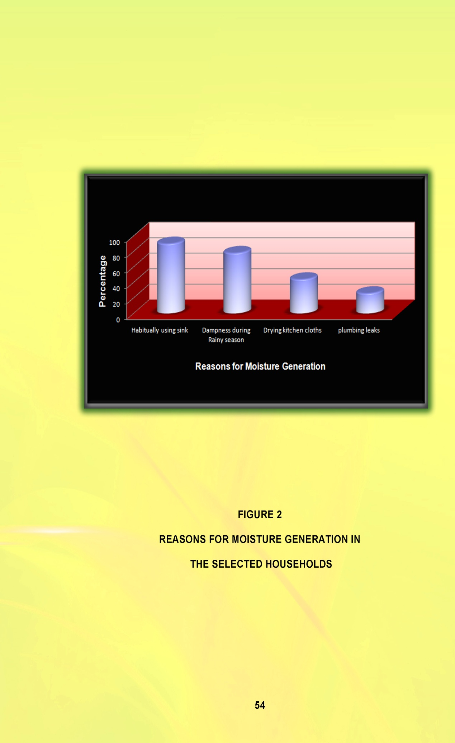
dust mites, animal dander and cockroaches that might occur due to increased moisture content, all of which require moisture and thrive in high humidity levels.
- Ventilation access in the Kitchen
Proper kitchen ventilation is a simple a way of improving the airflow in the kitchen while cooking. It can be done naturally or mechanically. Kitchen ventilation is required to create a safe and comfortable working environment. Ventilating the kitchen using exhaust or other natural ways while cooking results in a cleaner, healthier and more pleasant smelling home with lower levels of indoor air pollution. Improper ventilation leads to health hazards.
Moisture and other pollutants will build up inside the home unless there is adequate exhaust ventilation with make-up or replacement air (Parrott et al., 2003). Dampness and poor ventilation led to growth of microbes such as molds, fungi and bacteria that emits spores, cells and volatile organic compounds that pollutes indoor air. It directs the space into poor air quality. So households should pay extra attention to ventilation and take effective measures to avoid health problems caused by indoor air pollutants. Table X and Figure 3 show the ventilation access available in the kitchen of the selected households.
TABLE X
VENTILATION ACCESS IN THE KITCHEN
S.No. | Ventilation access in the kitchen | Households
S.No. | Ventilation access in the kitchen | Number | Percentage
1. | Closed Kitchen | 30 | 60
2. | Door open | 11 | 22
3. | Door & Window open | 5 | 10
4. | Hole in Roof | `4 | 8

It is clear from the above table that 60 per cent of the households have closed kitchens and so improper ventilation. Twenty two per cent of the
households kept the door open for ventilation. Hole in roof, keeping the windows open for ventilation were also observed in the selected households.
- TRIAL ON IMPROVING INDOOR AIR QUALITY BY GROWING SNAKE PLANT (SANSEVIERIA TRIFASCIATA)
- Observation phase while introducing Snake plant (sansevieria trifasciata)
- Evaluation of the impact of the experiment conducted
- Observation phase while introducing ornamental plant
Clean air is one of the basic natural resource necessary to ensure well being of the human population. The ornamental plants can bring the fresh air inside the rooms. From the survey, it was observed that the majority of the households were familiar about beautification through plants but very few were aware about functionality of those plants. By launching the ornamental plant in the indoor environment not only improves the indoor air quality but also make them aware about the potential of the ornamental plant to condense the pollution.
The observation of the plants and the areas during the implementation and at the middle phase of the experiments are discussed under the following headings:
- Features of the plants and the areas
- Responsiveness about the plants
- Features of the plants and the areas
The selected homemakers actively involved and enthusiastically agreed to keep the plant in their kitchen. Table XI shows the information about the dimension of the kitchen area where the plants were kept and the plants characteristics.

TABLE XI
FEATURES OF THE PLANTS AND THE AREAS
S.No. | Location | Dimensions of the areas | Dimension of the plants  Height (ft) | Placement of the plants
1. | House 1 | 130 sq.ft. | 1.84 | Near the sink
2. | House 2 | 150 sq.ft. | 1.54 | Under the sink
3. | House 3 | 150 sq.ft. | 1.48 | Under the sink
4. | House 4 | 180 sq.ft. | 1.77 | Near the storage rack
5. | House 5 | 200 sq.ft. | 1.64 | Near the sink

From the above table, it is seen that all the plants were kept in the room having floor area ranging from 130 sq.ft. to 200 sq.ft. The dimensions of the plants given well-matched to the selected area. From the evidence of its size, the plants were in the category of tall plants not scattered type, so it grows in the upright manner and thus it only takes up the narrow space of the kitchen. So these plants do not disturb the working area even it will grow large and longer. The placement of the plants in the kitchen will also not disturb the family members as they are kept in the area (mainly under the sink) which is not so often used area.
- Responsiveness about the plants
After the execution of placement of the ornament plants, during the conduct of the experiment, the following data were collected from the five selected households by the direct visit to the houses.

TABLE XII
RESPONSIVENESS ABOUT THE PLANTS
S.No. | Responsiveness about the Plants |  | Households
S.No. |  |  | Number | Percentage
1. | Requires Water | Once in two days | 2 |  | 40
1. | Requires Water | Once in a Week | 3 |  | 60
2. | Care and maintenance | Convenient | 5 |  | 100
2. | Care and maintenance | inconvenient | 0 |  | 0
3. | Insect attack | Positive | 0 |  | 0
3. | Insect attack | Negative | 5 |  | 100
4. | Any fertilizers | Required | 0 |  | 0
4. | Any fertilizers | Not required | 5 |  | 100
5. | Horrible smell from the plant | Recognized | 0 |  | 0
5. | Horrible smell from the plant | Not recognized | 5 |  | 100
6. | Growth status | Diminutive | 0 |  | 0
6. | Growth status | Ordinary | 3 |  | 60
6. | Growth status | Extraordinary | 2 |  | 40
7. | Affected by any disease | Positive | 0 |  | 0
7. | Affected by any disease | Negative | 5 |  | 100

From the above Table, the homemaker’s opinion and observation about plants characteristics could be revealed (placed in indoor). Two households stated that, watering once in two days was enough (40 per cent), but the remaining households reported that watering once in a week was enough and sufficient. This shows that the plant requires only little amount of water and it needs only minimal attention from the people and so people who are not interested to care for and watering the plants frequently can also adopt this plant in their house. With regard to the growth status, it was observed at ordinary level in three households (60 per cent). But two households reported that the plants had growing condition in the extraordinary level (40 per cent).

- Evaluation of the impact of the experiment conducted
The evaluation of the impact of the experiment conducted in the pre and post snake plant implementation.
Air sampling was done to analyze the biological contamination so as to ascertain the indoor air quality. Air sampling is a tool used to characterize the nature and extent of contaminants in air and whether the contaminant sources affect indoor air quality. The samples were collected from the internal environment of the five selected houses both during pre and post plant implementation and their outcomes were given in the following tables. All the result of bacterial counts was expressed in Colony Forming Units (CFU).
The level of bacterial contamination of the kitchen area before and after plant placement all the selection sites are given in the following table XIII and Figure 4, the phase I shows the results of pre plant placement period in the selected area and phase II shows the results of post plant placement period.

TABLE XIII  LEVEL OF BACTERIAL CONTAMINATION IN THE KITCHEN BEFORE AND AFTER PLANT IMPLEMENTAION | Results | Site 5 | After cfu*/g* | Absent | Absent | Absent | 7 | *Colony Forming Unit  * Gram
 | Results | Site 5 | Before cfu*/g* | 6 | Absent | 9 | 18 | *Colony Forming Unit  * Gram
 | Results | Site 4 | After cfu*/g* | Absent | Absent | 2 | 2 | *Colony Forming Unit  * Gram
 | Results | Site 4 | Before cfu*/g* | Absent | 6 | 6 | 16 | *Colony Forming Unit  * Gram
 | Results | Site 3 | After cfu*/g* | Absent | Absent | 1 | 4 | *Colony Forming Unit  * Gram
 | Results | Site 3 | Before cfu*/g* | 4 | Absent | 8 | 17 | *Colony Forming Unit  * Gram
 | Results | Site 2 | After cfu*/g* | Absent | Absent | 4 | 8 | *Colony Forming Unit  * Gram
 | Results | Site 2 | Before cfu*/g* | Absent | 4 | 5 | 13 | *Colony Forming Unit  * Gram
 | Results | Site 1 | After cfu*/g* | Absent | Absent | 5 | 6 | *Colony Forming Unit  * Gram
 | Results | Site 1 | Before cfu*/g* | 3 | Absent | 6 | 15 | *Colony Forming Unit  * Gram
 | Parameters |  |  | Escherichia coli | Yeast | Staphylococcus aureus | Bacillus spp | *Colony Forming Unit  * Gram
 | S.No. |  |  | 1. | 2. | 3. | 4. | *Colony Forming Unit  * Gram
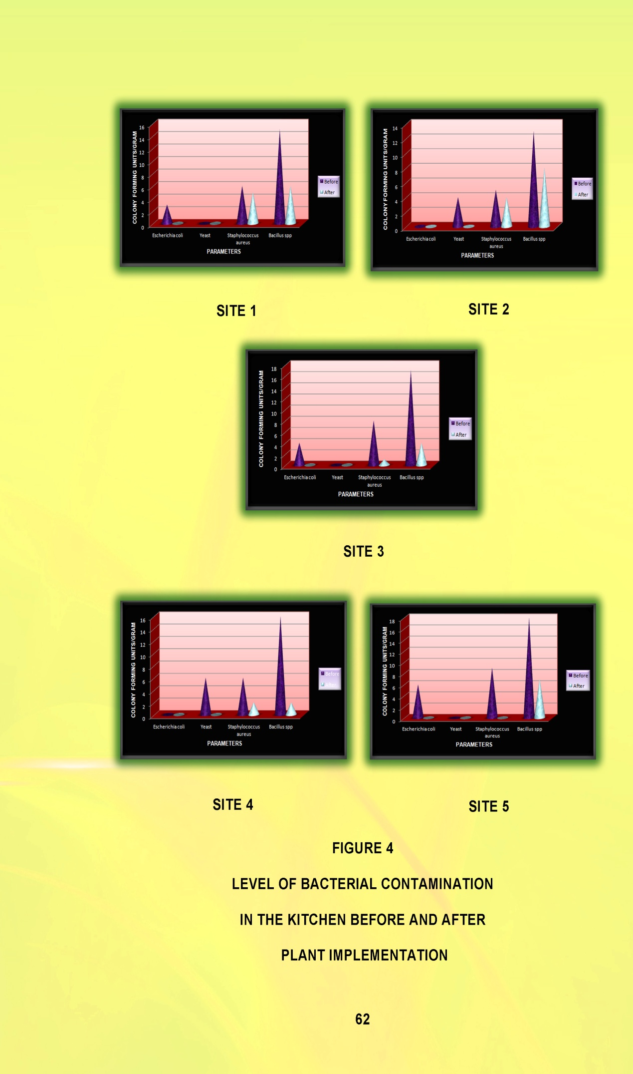
Table XIII clearly emphasis the effectiveness of snake plant (sansevieria trifasciata) to control indoor air pollution. The two bacteria such as Escherichia coli and Yeast were totally absent in the second phase i.e. post plant placement period. Remaining two bacteria such as Staphylococcus aureus and Bacillus spp were reduced to a great extent in the selection sites 3, 4 and 5. But in the selection site1 and 2, those bacteria were not reduced as much as the other selection sites.
Data in Table XIII indicate that ornamental plant especially snake plant can be used to reduce the biological contamination from the indoor air.
- EVALAUTION OF THE IMPACT AWARENESS PROGRAMME CONDUCTED
The impact of the awareness programme was assessed under the following headings:
- Knowledge gained by the homemakers on the role of snake plant to control indoor air pollution.
- Opinion regarding growing Snake plant (Sansevieria trifasciata) to control the indoor air pollution.

- Knowledge gained by the homemakers on the role of snake plant to control indoor air pollution
TABLE XIV
PERCENTAGE OF KNOWLEDGE GAINED BY THE HOMEMAKERS
S.No. | Aspects | Percentage of Homemakers
S.No. | Aspects | Before Awareness | After awareness
1. | Environment and Health | 20 | 100
2. | Air pollution and its impact | 30 | 90
3. | Indoor air circulation | 30 | 80
4. | Impact of the poor air quality | 25 | 95
5. | Need for good air circulation inside the house | 30 | 90
6. | Technique to control indoor air pollution | 15 | 100
7. | Role of plant in improving indoor air quality | 20 | 90

Table XIV and Figure 5 exhibits the percentage of knowledge gained by the homemaker through awareness programme. It is clear from the table that there was an important attain in knowledge among the recipients towards the awareness on role of ornamental plants especially snake plant (Sansevieria trifasciata). Their knowledge on the snake plant to control indoor air pollution seems to be better after the awareness programme.
- Opinion regarding growing Snake plant (Sansevieria trifasciata) to control the indoor air pollution
After the awareness programme, the homemakers showed great interest in growing snake plant (Sansevieria trifasciata) in their house, out of 50 homemakers 38 homemakers procured snake plant to control indoor air pollution.


The opinion regarding growing Snake plant for controlling the indoor air pollution is presents in the Table XV
TABLE XV
OPINION REGARDING THE ADOPTION OF SNAKE PLANT
S.No. | Opinion | Number of Homemakers | Percentage of Homemakers
1. | Easy to adopt | 50 | 100
2. | Readily available | 45 | 90
3. | Low cost | 40 | 80
4. | Tolerate low light | 50 | 100
5. | Low water requirement | 50 | 100
6. | More convenient | 50 | 100
7. | Maintain air quality | 45 | 90
8. | Simple technology | 50 | 100
.
The above table clearly stated that cent per cent of the homemakers opined that the snake plant is an easy to adopt; tolerance low light, less water requirement, more convenience to grow and it is simple technology to control the indoor air pollution. Ninety per cent of the homemakers accept that the snake plant is available readily and it maintains the indoor air quality and 80 per cent of the homemakers agreed that the snake plant is low cost.
The homemaker perceives this method to be very economical (low cost), and effective in protecting the house from the indoor air pollution.

Summary and Conclusion

V. SUMMARY AND CONCLUSION
Air is the gift of the nature to the human being for well – being. Clean air is considered as the basic necessity of human health. Peoples spend most of their time in indoors, so the indoor air quality is of major concern for the benefit of people. A healthy indoor environment keeping the air free of biological contaminants is important to the family. Establishing the level of bacterial contamination that causes the indoor air pollution and recommend solution to reduce the pollution in air cost effective manner is essential to solve this problem in the households. Hence the present study on “Gauging indoor air quality by growing snake plant (Sansevieria trifasciata)” was undertaken with the main objectives of measuring the bacterial contamination in the indoor air by passive sampling method and condenses the pollution by using the Sansevieria trifasciata (Snake plant). Snake plant was selected after reviewing several studies which were conducted in the earlier days. This plant is a species of a family of Asparagaceae.
To conduct the research, Saibaba colony area in the Coimbatore district was selected. The samples are selected based on simple random sampling technique. For the household survey, 50 houses were randomly selected. A comprehensive survey would be valuable as a basis for improving standards of hygiene in the home. A household survey was conducted Interview method using structured questionnaire was applied to identify the prevailing environmental condition was all the households. The findings of the household survey revealed that the indoor air quality was poor, five households were selected and the air sample was collected from these households. The sample underwent laboratory test to determine the air contamination and pollution level in before and after the introduction of plant in the building. The plants are involved three months in the indoor environment for reducing the indoor air pollution.
Air samples are collected from the selected five households. The absolute consequences of the indoor air quality are determined by comparing the two sets (with plant and without plant) for a period of three month.
The major findings of the household survey are summarized here under:
- Majority (60 per cent) of the respondents were in age group of 30 – 40 years. Twenty per cent were below 30 years while 16 per cent belonging to the age group of 40-50 years.
- Majority 40 per cent of the respondents had the level of education been under graduation. Thirty per cent respondents had secondary and 16 per cent respondents had primary level of education in the selected households. Ten per cent respondents were illiterate.
- According to HUDCO (2009) that a majority (60 per cent) of the households earned above Rs 9000 per month whereas a lower proportion of ten per cent of them earned income in the range of Rs 5,000 to 7,000.
- Majority (88 per cent) of the households belonged to nuclear family while 12 per cent belonged to joint family.
- Seventy six per cent of the households medium sized (3–6 members) while 20 per cent of the family belonging to the small family (1–3 members).
- Fifty six per cent of the respondents were housewives who were involved in household chores at the full time. Six per cent of the respondents were involved in teaching profession.
- Twenty eight per cent of the respondents were living in their own individual house while 12 per cent of the respondents were residing in their own apartment. Thirty four per cent of the respondents were living in the rented individual house and 26 per cent of respondents were in the rented apartment.
- Fifty per cent of the respondents’ lives in house of 750 to 1000 sq.ft area. Only six per cent of the respondents were living in the 1500 sq.ft.
- Large proportions (50 per cent) of the respondent’s kitchen were area in the range of 150 sq.ft. to 200 sq.ft. The average size of the kitchen area did not exceed above 200Sq.ft in the selected households.
- A majority (60 per cent) of the respondents opined that the ornamental plants were mostly used for decorating the interior space. Fifty six per cent of the respondents expressed their interest in growing ornamental plants. Only ten per cent believed that the indoor plant improves the indoor air quality.
- Seventy six per cent of the respondents spend about 3 to 7 hours a day in the kitchen, followed by 20 per cent of respondents spending less than 3 hours in a day. Thus, homemakers are exposed to very high levels of pollution for about 3–7 hours daily over many years.
- Fifty per cent of respondents were using the kitchen three times a day followed by 28 per cent of the respondents using two times a day, while 16 per cent of the respondents were using the kitchen four times a day.
- Eighty per cent of the respondents were mopping the kitchen floor often. Seventy per cent of the respondents were cleaning and arranging the storage equipments sometimes. The other activities were eating in the kitchen also placed in the level of Sometimes.
- Majority (50 per cent) of the house had problem due to occurrence of molds in the kitchen. Indiscriminate throwing of waste was observed 54 per cent of the households being the main causes for the biological contamination in the kitchen.
- A majority (90 per cent) of the households stated habitual use of sink as the reason for moisture generation in the kitchen. Forty four of the respondents stated drying kitchen cloths as the reason for moisture generation. Adequate plumbing leaks were also responsible for raising the moisture content as expressed by 24 per cent of the respondents.
- Sixty per cent of the households have closed kitchens and so improper ventilation. Twenty two per cent of the households kept the door open for ventilation. Hole in roof, keeping the windows open for ventilation were also observed in the selected households.
The observation of the plants and the areas are summarized here under:
- All the plants were kept in the kitchen room having floor area ranging from 130 sq.ft. to 200 sq.ft. With regard to the growth status three households stated that, it was observed at ordinary level. But two households reported that the plants had growing condition in the extraordinary level.
The results of the air sample test before launching selected plant were summarized here under:
- The effectiveness of snake plant (Sansevieria trifasciata) to control indoor air pollution. The two bacteria such as Escherichia coli and Yeast were totally absent in the second phase i.e. post plant placement period. Remaining two bacteria such as Staphylococcus aureus and Bacillus spp were reduced to a great extent in the selection sites 3, 4 and 5. But in the selection site1 and 2, those bacteria were not reduced as much as the other selection sites.
The impacts of the awareness programme were summarized under:
- There was an important attain in knowledge among the recipients towards the awareness on role of ornamental plants especially snake plant (Sansevieria trifasciata). Their knowledge on the snake plant to control indoor air pollution seems to be better after the awareness programme.
- Cent per cent of the homemakers opined that the snake plant is an easy method to adopt; tolerance low light, less water requirement, more convenience to grow and it is simple technology to control the indoor air pollution. Ninety per cent of the homemakers accept that the snake plant is available readily and it maintains the indoor air quality and 80 per cent of the homemakers agreed that the snake plant is low cost.

CONCLUSION
“A person can survive for five weeks without food and five days without water but only five minutes without air” (Gupta, 2009). Hence, air we breathe must be of good quality. Introducing the plant having a potential to control indoor air pollution in the selected households made an momentous impact on improving the indoor air quality. The level of bacterial contamination in the indoor air evidently decreased by placing selected plant Sansevieria trifasciata (Snake plant).
To conclude, plants can generally be used to enhance the aesthetic environment and reduces stress and changes the mood. This is will be an inspiration having to the younger generation to develop values attitude of growing plants.
The results of this study clearly projected the need to keep plants in the interior to control the pollution of the indoor environment and to improve the human health as well as refresh the mind.
SUGGESTIONS AND RECOMMENDATIONS
The following suggestions and recommendation are emerged out of the present study.
- Scientific and technical research to blend extracts of these speciality plants in building materials.
- People should be motivated to grow plants in the indoor environment of the building.
- Home scientist should develop positive attitude towards keeping interior clean and tidy and also should motivate their fellow being and share their opinion and experience.
- Students should come forward to protect the indoor environment by providing the basic information to the people about the causes of the indoor air pollution and ways through the National Social Service scheme and Community Social Services for improving indoor air quality.

Bibliography

BIBLIOGRAPHY
- Aggarwal V. (2010), Environmental Studies, Prerna Prakashan, ISBN: 81-89102-86-9, P.165-166 and I73.
- Agrawal K.C. (1999), Environmental Biology, Agro Botanical publishers, India, P. 258, 322 and 332.
- Agrawal K.C. (2006), Environmental Pollution: Causes, Effects and Contols, Nidhi publishers, Bikaner, ISBN: 81-89153-01-3, P.97.
- Agrawal S.K. (2005), Air pollution, APH publishing corporation, New Delhi, ISBN: 81-7048-831-3, P.49, 136.
- Agrawal K.M, Sikdar D.K. and Deb S.C. (2002), A Textbook of Environment, Macmillan India Limited, ISBN: 0333 937473, P. 255
- Asnani, B., and Dwivedi, S., (2007), Bioaestheticity and Functionality of Houseplants: Information Empowerment of Urban Women, J. Hum. Ecol., 22(4): 281.
- Baiyewu, R.A., Amusa, N.A., and Olayiwola, O., (2005), Survey on the Use of Ornamental Plants for Environmental Management in Southwestern Nigeria, Research Journal of Agriculture and Biological Sciences 1(3): 237-238.
- Bhaskar P. (2009), Air pollution and Plant Biotechonolgy, Manglam publications, Delhi, ISBN: 978-81-906785-3-7, P.100.
- Bhatia S.C. (2002), Environmental Chemistry, CBS Publishers and Distributors, ISBN: 81-239-0826-1, P.3.
- Bhatia S.C. (2007), Textbook of Air pollution and its control, Atlantic publishers and Distributors (P) Ltd, P.23.
- Bhatt, H., and Sidhu, M., (2012), An Epidemiological Study to Assess Fatigue Patterns at Kitchen Workstation, J Hum Ecol, 39(1): P.20.
- Brennan S. and Withgott J. (2005), Environment The Science Behind the Stories, Benjamin Lummings, ISBN 0-8053-4427-6, P.347.
- Bruce, N., Perez-Padilla, R., and Albalak, R., (2000), Indoor air pollution in developing countries: a major environmental and public health challenge, World Health Organization, P.1078-1080 and 1087.
- Burchett, M., Torpy, F., and Tarran, J., (2008), Interior plants for sustainable facility ecology and workplace productivity, Plants and Indoor Environmental Quality Group, Faculty of Science, University of Technology, Sydney.
- Chauhan, C., (2013), Indoor air pollution kills a million people every year in India, Hindustan Times, New Delhi.
- Choudhary C.K. (2009), Basics of Environmental Chemistry, Anmol publications Pvt.Ltd, ISBN: 978-81-261-3774-9, P.1.
- Dacarro, C., Picco, A.M., Grisoli, P., and Rodolf, M., (2003), Determination of aerial microbiological contamination in scholastic sports environments, Journal of Applied Microbiology, P.904, 906.
- Desai, G.S., and Dr. Patel, R.M., (2010), Environmental Conditions and Health Status in India: Examining the Linkages, The Maharaja Sayajirao University of Baroda, Vadodara, P.1.
- Dhameja S.K. (2000), Environmental Engineering and Management, S.K. Kataria and Sons Publishers and Distributors, P.30.
- Dubey R.C. and Maheshwart D.K. (1999), A textbook of Microbiology, S. Chand and Company Ltd, ISBN: 81-219-2559-2, P.802, 805
- Esqsenior, T.O., (2009), housing needs and land administration in nigeria, department of private and property law, faculty of law university of lagos akoka lagos.
- Gandotra V., Shukul M., Jaju N., Jaiswal N. (2009), Housing Changing Needs and New Directions, Author Sprees Global Network, P.3, 28, 32, 63, 74-75, 79.
- Ghose S. (2003), Environmental Chemistry, Dominant Publishers and Distributors, ISBN: 81-7888-138-1, P.63.
- Gupta P.K. (2009), Methods in Environmental Analysis Water, Sand and Air, Agrobios publications (India).
- Gupta S. (2001), Research Methodology and Satistical Techniquees, Deep and Deep Publication, New Delhi, ISBN: 81-7100-501-2, P.105.
- Hooda S. and Dr. Kaur S. (1999), Laboratory Manual for Environmental Chemistry, S. Chand and Company ltd (New Delhi), ISBN: 81-219-1807-3, P.1 and 59.
- Kanagasabai S. (2010), Textbook on Environmental Studies, PHI Learning private limited, ISBN: 978-81-203-4164-7, P.1, 6, 35, 75 and 79.
- Kannan K. (1997), Fundamental of environmental pollution, S. Chand and Company Ltd., New Delhi, ISBN: 81-219-1009-9, P.1, 7, 12, 18 and 20.
- Katyal T. and Satake M. (1989), Environmental pollution, Anmol publications Pvt.ltd, New Delhi, P. 1 and 15
- Kishtwaria, J., Mathur, P., and Rana, A., (2007), Ergonomic Evaluation of Kitchen Work with Reference to Space Designing, J. Hum. Ecol., 21(1): 43.
- Kobayashi, K.D., Kaufman, A.J., Griffis, J., and McConnell, J., (2007), Using Houseplants To Clean Indoor Air, Department of Tropical Plant and Soil Sciences, University of Guam, Ornamentals and Flowers OF-39, P.1-3.
- Kothari C.R. (1997), Research Methodology Methods and Techniques, Wiswa Prakashan, New Delhi, P.15.
- Krieger, J., and Higgins, D.L., (2002), Housing and Health: Time Again for Public Health Action, Am J Public Health, PMCID: PMC1447157.
- Kudesia V.P. and Dr. Kudesia R. (2002), Air pollution, K.K. Mittal for Pragati Prakasha, ISBN: 81-7556-410-5, P.323-324 and 334.
- Kumar, R.S., Arumugam, T., Anandakumar, C.R., Balakrishnan, S., and Rajavel, D.S., (2012), Use of Plant Species in Controlling Environmental Pollution- A Review, Academy for Environment and Life Sciences, India, ISSN 2277-1808, P.52-53, 58, 62.

Lee, S.C., Li, W., Chio- Hang Ao, (2002), Investigation of indoor air quality at residential homes in Hong Kong—case study, The journal of Atmospheric Environment, Volume 36 (2), P. 225-237.
- Lignell, U., (2008), characterization of microorganisms in indoor Environments, National Public Health Institute, P.14, 16, 21, 24-25 and 44.
- Manjunath D.L. (2007), Environmental studies, Dorling Kindersley Pvt.Ltd., ISBN: 978-81-317-0912-2, P.11.
- Mishra P.C. and Das R.C. (2001), Environment and Society, Macmillan India Limited. SBN 0333 93640 X, P. 1 and 17.
- Mondal.N.K, Konar.S, Banerjee.A, Datta, J. K, (2011), A comparative assessment of Status of indoor air pollution of few selected families of rural and urban area of Burdwan town and its adjoining area, International Journal of Environmental Sciences, Volume 1, No.5, ISSN 0976 – 4402. P.736
- Mowli P. P. And Dr. Subbayya V. N. (1989), Air pollution and control, Geo- Environ Academia and Divyajyoti prakashan, ISBN 81-85312-02-8 (HC), P.1, 2.
- Nevalainen, A. and Morawska, L., (2009), Biological Agents in Indoor Environments Assessment of Health Risks, WHO Expert Group.
- Ojima, M., Toshima, Y., Koya, E., Ara, K., Kawai, S., and Ueda, N., (2002), Bacterial contamination of Japanese households and related concern about sanitation, International Journal of Environmental Health Research, P.12, 41, 50.
- Omole, K.F., (2010), An Assessment of Housing Condition and Socio-Economic Life Styles of Slum Dwellers in Akure, Nigeria, Contemporary Management Research Pages 273-274, Vol. 6, No. 4.
- Park, D., Yeom, j., Lee, w.j., and Lee. K., (2013), Assessment of the Levels of Airborne Bacteria, Gram-Negative Bacteria, and Fungi in Hospital Lobbies, International Journal of Environmental Research and Public Health, ISSN 1660-4601, P.542.
- Parrott, K., Emmel, J., and Beamish, J., (2003), Use of Kitchen Ventilation: Impact on Indoor Air Quality, The Forum for family and consumer issues, ISSN 1540 5273.
- Pasquarella, C., Pitzurra, O., and Savino, A., (2000), The index of microbial air contamination, Journal of Hospital Infection, P.241, 244.
- Plumer, B., (2012), What’s going to kill us in 2050? Air pollution — and lots of it, Wonk Blog.
- Ramesh V. K. (2004), Environmental Microbiology, MJP Publishers, ISBN: 81-8094-003-9, P.57.
- Ruest, K. (2004), House dust: a useful tool to assess microbial contamination in homes, Canada Mortgage and Housing Corporation CMCH.
- Saravanavel (2003), Research Methodology, Published by Kitabmahil Agencies, P. 35, 57, 89.
- Schleibinger, H., Keller, R., and Rüden, H., (2004), Indoor Air Pollution by Microorganisms and Their Metabolites, The Handbook of Environmental Chemistry Volume 4F, 2004, pp 149-177.
- Scott, E., Bloomfield, S.F. and Barlow, C.G. (1982), An investigation of microbial contamination in the home, J. Hyg., Camb, P.279 and 282.
- Seaman, G., (2009), The top 10 plants for removing Indoor Toxins, The journal of EathEasy Solutions of Sustainable Living.
- Shafahi, N., (2010), Protecting the Environment is Every Citizen’s Ethical Responsibility, Heinrich Boll Stiftung, Afghanistan.
- Sharma V.K. (1994), Atmospheric pollution by Aerosols, Scientific publishers, ISBN: 81-7233-074-X, P.366.
- Story, C.M., (2013), Plants that Clean Your Indoor Air of Toxic Chemicals, Renegade health Live Healthy. Live Awesome.
- Tarran,J., Torpy, F., and Burchett, M., (2007), Use of living pot-plants to cleanse indoor air – research review, Proceedings of Sixth International Conference on Indoor Air Quality, Ventilation & Energy Conservation in Buildings – Sustainable Built Environment, Sendai, Japan, Volume III, 249.
- Wanner, H., Verhoeff, A., Colombi, A., Flannigan, B., Gravesen, S., Mouilleseaux, A., Nevalainen, A., Papadakis, J., Seidel, K., (1993), Biological Particles in Indoor Environments, commission of the European communities.
- Wolverton, B.C., and Wolverton, J.D., (1996), Interior plants: their influence on airborne microbes inside energy-efficient buildings, Wolverton environmental services, Inc., 514 Pine Grove Road, Picayune, MS 39466, P.99 and 101.

- Wouters, I.M., Douwes, J., Doekes, G., Thorne, P.S., Brunekreef, B., and Heederik, D.J.J., (2000), Increased Levels of Markers of Microbial Exposure in Homes with Indoor Storage of Organic Household Waste, Applied Environmental Microbiology.

WEBSITES
- http://en.wikipedia.org/wiki/Environmental_issues_in_India
- http://enviroment-dipshikha.blogspot.in/2010/08/importance-of-environment.html
- http://en.wikipedia.org/wiki/Sansevieria_trifasciata
- http://fcs.tamu.edu/housing/healthy_homes/indoor_air_quality/biological_pollutants/reducing_biological_pollutants.php
- http://gardening.about.com/od/houseplants/tp/FloweringHouseplants.htm
- http://homeguides.sfgate.com/grow-snake-plant-68402.html
- http://houseplants.about.com/od/foliageplants/p/SnakePlant.htm
- http://houseplants-care.blogspot.in/2006/05/snake-plant-care.html
- http://library.thinkquest.org/26026/Environmental_Problems/environmental_problems_article.html
- www.mpcb.gov.in
- http://video.about.com/houseplants/Tropical-Plants-You-Won-t-Kill.htm
- http://voices.yahoo.com/eliminate-indoor-air-pollution-2185100.html?cat=5
- http://voices.yahoo.com/best-indoor-air-pollution-reducing-plants-1804647.html?cat=32
- http://voices.yahoo.com/a-simple-solution-indoor-pollution-6364.html?cat=5
- http://voices.yahoo.com/what-know-indoor-air-pollution-10493.html?cat=58
- http://whqlibdoc.who.int/hq/2000/WHO_SDE_OEH_00.02_pp1-104.pdf
- http://www.all-about-india.com/Environmental-issues-in-India.html
- http://www.ask.com/question/what-are-the-best-indoor-plants
- http://www.ask.com/question/why-there-would-be-no-people-without-plants
- http://www.bcairquality.ca/101/what-is-air-quality.html
- http://www.bcairquality.ca/101/what-is-air.html
- http://www.blueplanetbiomes.org/plants.htm
- http://www.boloji.com/index.cfm?md=Content&sd=Articles&ArticleID=5442
- http://www.botanical-online.com/theimportanceofplants.htm
- http://www.buzzle.com/articles/causes-of-air-pollution.html
- http://www.buzzle.com/articles/air-pollution-facts.html
- http://www.buzzle.com/articles/effects-of-air-pollution.html
- http://www.buzzle.com/articles/causes-of-indoor-air-pollution.html
- http://www.buzzle.com/articles/indoor-air-pollution.html
- http://www.ccmc.gov.in/ccmc/index.php/city-information
- https://www.ccmc.gov.in/ccmc/
- http://www.dylosproducts.com/stabinairqu.html
- http://www.epa.gov/air/basic.html#indoor
- http://www.essaydepot.com/doc/45596/Air-Pollution-Essay-12
- http://www.ehow.com/list_7156577_uses-ornamental-plants.html
- http://www.emsl.com/index.cfm?nav=Pages&ID=121
- http://www.hgtvremodels.com/home-systems/cleaning-indoor-air-with-plants/index.html
- http://www.hrea.org/index.php?base_id=149
- http://www.iaqscience.lbl.gov/dampness-impacts.html
- http://www.kct.ac.in/conf/coimbatore.htm
- http://www.labnol.org/home/best-indoor-plants-for-clean-air/10654/
- http://www.microbiologyonline.org.uk/teachers/observing-microbes/observing-bacteria-in-a-petri-dish
- http://www.moldbacteriaconsulting.com/fungi/colony-forming-units-cfu.html
- http://www.nachi.org/plants-indoor-air-quality.htm
- http://www.oecdbetterlifeindex.org/topics/housing/
- http://www.oecdbetterlifeindex.org/topics/environment/
- http://www.rajaha.com/importance-plants-life-earth/
- http://www.sciencedaily.com/releases/2009/09/090908103634.htm
- http://www.snake-plant.com/
- http://www.sustainablebabysteps.com/types-of-houseplants.html
- http://www.who.int/phe/health_topics/outdoorair/outdoorair_aqg/en/index.html
- http://www.zone10.com/nasa-study-house-plants-clean-air.html

Appendix

APPENDIX I
Avinashilingam Institute for Home Science and Higher Education for Woman, Coimbatore- 43.
Questionnaire on Gauging Indoor Air Quality by growing Snake plant (Sansevieria trifasciata).
Name of the Interviewer :
Name of the Interviewee :
Address :
- GENERAL DETAILS
- Type of the family :
- Size of family :
- Stages in the family
life cycle :
- Type of house : Own apartment Rented apartment
Own Individual house Rented individual house
- Size of the house :
- Size of the kitchen :

S. No. | Family Members | Age | Education | Occupation | Income / Month
1. | Head of the family
2. | House wife
3. | Son
4. | Daughter
5. | Grand parents

- INFORMATION REGARDING INDOOR AIR QUALITY
- How many time you cleaning the kitchen in a week?
Once Twice None

- How many times you spend in the kitchen for the kitchen activities?
Less than 3 hours 3 to 7 hours Above 7 hours
- How many times using for cooking in the kitchen?
Once Twice Three Four Five
- Do you clean the vessels in the kitchen?
Yes No
- Do you used your kitchen sink frequently?
Yes No
- Do you keep your waste bin inside of your kitchen?
Yes No
- Do you storage any cleaning agents inside your kitchen?
Yes No
- Do you drying your cloths inside your kitchen area?
Yes No
- Can you see dust particles in your home recurrently?
Yes No

- Do you regularly (several times a week) sit and eat in your kitchen?
Yes No

- Which ventilation access is having in your kitchen?
Closed kitchen Hole in Roof Door open Door & Window open
- Do you feel your house is well ventilated?
Yes No
- Does your home feel humid?
Yes No
- Can you see moisture on the windows or on other surfaces, such as walls and ceilings?
Yes No
- Have you recently had water damage?
Yes No
- Is there any obvious mold or mildew?
Yes No
- Is your pets sit and eat in your kitchen?
Often Sometimes Never
- Does your home have cockroaches or rodents?
Yes No
- Do you grow any indoor plants?
Yes No
Give reasons for having the indoor plant in your home?

- Do you have the awareness of indoor pollution?
Yes No
APPENDIX II
LEVEL OF BACTERIAL CONTAMINATION RESULT IN THE KITCHEN BEFORE PLANT IMPLEMENTATION


APPENDIX III
LEVEL OF BACTERIAL CONTAMINATION RESULT IN THE KITCHEN AFTER PLANT IMPLEMENTATION


