GYM MANAGEMENT SYSTEM

Submitted by
SIVARANJANI K
REG.NO: 17PCC018

Under the guidance of
Ms. SARANYA.S M.Com(CA)., M.Phil.,

Thesis submitted to
AVINASHILINGAM INSTITUTE FOR HOME SCIENCE
AND HIGHER EDUCATION FOR WOMEN,
COIMBATORE – 641043

In Partial Fulfilment of the Requirements for the award of the degree of
Master of Commerce with Computer Applications
DEPARTMENT OF COMMERCE

APRIL-2019

CERTIFICATE
This is to certify that the project work entitled “Gym Management System” submitted to Department of Commerce, Avinashilingam Institute for Home Science and Higher Education for Women, Coimbatore, in partial fulfilment of the requirement for the award of degree of Master of Commerce with Computer Applications is the record of the original project work done by K.Sivaranjani during the period of her study, under my supervision and guidance.

Signature of the Guide

Signature of Head of the Department

Submitted for the viva voice examination held on___________

Internal Examiner External Examiner

DECLARATION
We hereby declare that this work entitled “Gym Management System” is submitted to Department of Commerce, Avinashilingam Institute for Home Science and Higher Education for Women, Coimbatore, in partial fulfilment of the requirement for the award of degree of Master of Commerce with Computer Applications is the record of original project work done by me during the period of my study, under the supervision and guidance of Ms. SARANYA.S M.Com(CA)., M.Phil., Department of Commerce.

Place: Coimbatore Signature of the Candidate
Date: (K.SIVARANJANI)

ACKNOWLEDGEMENT
First and Foremost, I thank the God Almighty who has been a power of strength towards the successful completion of the project work
I express my gratitude to our chancellor PadmaShri. Dr. P.R. krishnakumar of Avinashilingam Institute for Home Science and Higher Education for Women, Coimbatore, for his support and kindness.
I express my sincere and heartfelt gratitude to our vice chancellor Dr.(Mrs.) PremavathyVijayan M.Sc., M.Ed., Dip.spl.Edn., M.Phil., Ph.D., Avinashilingam Institute for Home Science and Higher Education for Women, Coimbatore for the resources facilitated for completion of my project.
I express my gratitude to our registrar Dr.(Mrs.) S.Kowsalya., M.SC.,M.Phil.,Ph.D., Avinashilingam Institute for Home Science and Higher Education for Women, for providing all facilities necessary for the project.
My special thanks to Dr.(Mrs.) U.Jerinabi M.com., Dip.Ed., M.Phil., Ph.D., Dean, Department of Commerce and Dr.(Mrs.) D.Geetha M.Com., Dip.Ed., M.Phil., Ph.D., Head of the Department and Professor of Commerce for her encouragement and for giving necessary help and support for completing the project successfully.
I take this opportunity to express my sincere thanks to my supervisor and guide Ms. SARANYA.S M.Com(CA)., M.Phil., Department of Commerce for her valuable guidance and for her timely support, suggestions and motivation throughout the project.
I have a great pleasure in expressing my deep and sense of gratitude to all other staff and non-teaching staff, Department of Commerce, Avinashilingam Institute for Home Science and Higher Education for Women.
Let yet importantly, I would like to thank all the partners in “Gym Management System” Coimbatore for the support throughout my endeavor and also I thank my parents, friends and well-wisher who have contributed directly or indirectly to the successful completion of the project.
CONTENTS
CHAPTER | TITLE | PAGE NO
I | INTRODUCTION
I | 1.1 OVERVIEW OF THE PROJECT | 1
I | 1.2 MODULES DESCRIPTION | 2
I | 1.3 OBJECTIVES OF THE PROJECT | 3
I | 1.4 PROFILE | 4
II | SYSTEM ANALYSIS
II | 2.1 EXISTING SYSTEM | 5
II | 2.2 PROPOSED SYSTEM | 6
III | SYSTEM SPECIFICATION
III | 3.1 HARDWARE SPECIFICATION & SOFTWARE SPECIFICATION | 7
III | 3.2 SOFTWARE FEATURES | 8
IV | SYSTEM DESIGN
IV | 4.1 SYSTEM DESIGN | 11
IV | 4.2 SYSTEM MODEL | 12
IV | 4.3 DATA FLOW DIAGRAM | 13
IV | 4.4 TABLE DESIGN | 15
V | SYSTEM TESTING AND IMPLEMENTATION
V | 5.1 TESTING | 17
V | 5.2 TYPES OF TESTING | 17
V | 5.3 SYSTEM IMPLEMENTATION | 19
VI | CONCLUSION AND FURTHER SCOPE | 20
 | BIBLIOGRAPHY | 21
 | ANNEXURE
 | FORMS  REPORT  CODING | 22  27  28
CHAPTER -I
INTRODUCTION
OVERVIEW OF THE PROJECT
The project “Gym Management System is designed to facilitate a gyming and fitness center to automate its operations of keeping records and store them in form of a large and user friendly database further facilitating easy access to the personnel. It is developed by using vb.net as frontend and sql server is backend. Gym management system helps us to maintain the records of equipments, members, trainers, and other related information. Its helps us to increase the efficiency of the gym and it becomes easy to maintain the database. We can also maintain past records, present records, and also in future the records can be maintained which helps to increase the loyalty of members.
Gym management system is an easy to use gym and health club membership management system. It helps to keep records of the members and their membership, and allows easy communication between trainers and members. Searching a particular data specific to particular requirements is very tedious in manual system. In order to retrieve records, the responsible person needs to manually locate the appropriate register and locate the appropriate placement of that particular record which may be very time consuming.
The main purpose of this project is to automate a gym or a fitness center and therefore facilitating its operations. It make the clients and staff data and schedule easily accessible and also making it easy to keep records in a secure database. The gym management requires a system that will handle all the necessary and minute details easily and proper database security accordingly to the user.
MODULES:
- Admin login
- Member details
- Instructor details
- Payment
- Work allocation
- Class schedules
- Report

MODULE DESCRIPTION
ADMIN LOGIN
The admin has a unique username and password to manage the gym. The admin only has an authorization to enter all the information about the gym.
MEMBER DETAILS
This module is used to store the information about all the members in the gym. It includes personal and family characteristics. It should also use to maintain the number of classes schedules, and number of members in a session etc..,
INSTRUCTOR DETAILS
Instructor details module deal with information about the staff. This module should contain data regarding instructor personal characteristics, year of service, gym experience status, special skills, and performance. This information assists for proper arrangement of schedules to the particular classes.
PAYMENT
This module deals with fees wise details for the classes. This module data should consist of date of fees paid and the amount balance for a member etc.., when a candidate takes admission in the gym and renews it for the same or new class. After collection of the fee, a system generates a classes schedule for every new candidate.
WORK ALLOCATION
In this module contains work allocation to particular instructor. The admin enter into the allocation section select available instructor and assign the particular class. This module contains allocation date, time and batch. Instructor can view allocation details in particular section.
CLASS SCHEDULES
In this module instructor can view class schedule and time. Admin enter the class schedules details in his section.

REPORT
The administrator can view all the reports like attendance details report, day to day workouts, workout timings and member information.
OBJECTIVE OF THE PROJECT
- It increases the accuracy of the system.
- The software is made user friendly so that work becomes easier.
- Time consuming as data entry which includes calculations takes a lot of time.
- The cost of maintaining data and records of transactions is very high.
- The proposed system is expected to be faster than the existing system.
- Reports can also be generated.

PROFILE
The fitness club is a top company in the category of fitness centers. The gym facilitates many different machines Each machine can do separate workouts. This gym is running successfully for more than five years. The gym can team of dedicated and experienced fitness instructors. It is comfortable and has good facilities when compared to other gyms. They allow free times to play games for customers.
They have female trainers to train women. It maintains the day to day record of the usage of various machines and the workouts by the members. With dedicated trainers and good quality equipment, spark gym is a place that will help meet a person’s fitness goals.
- A good place to work out in this locality.
- Motivating and friendly staff can treat like family.
- Well experienced trainers are working in this gym.
- A filled with well-equipped machines and highly knowledgeable fitness trainers.

CHAPTER-II
SYSTEM ANALYSIS

SYSTEM ANALYSIS
System analysis is a process of gathering the facts concerning the system breaking them into elements and relationship between elements. It provides a framework for visualizing the organizational and environmental factors that operate in a system. The quality of work performed by a machine is usually uniform, neat and more reliable when compared to doing the same operations manually.

EXISTING SYSTEM
Existing system is manual system which contains many ledgers for storing all the information regarding member, class schedules etc. the member and billing are done with the help of manual feeding of data. Since human manages all the activities belonging to the employee working in the company there are large chances for human error.
As there is lot of data work involved, skilled staffs are used. So it becomes dependable for the management on these people. The reports are not verified to the highest extend to avoid any miscommunication and misfortune of the company. Existing system is a manual one in which all the transactions are maintained and produces report manually. It is a slow process.
DRAWBACKS OF THE EXISTING SYSTEM
The drawbacks faced by the existing system are as follows:
- There may be errors occurring while entering the details manually.
- Various activities are difficult to carryout manually.
- Time consumption is very high.
- Reporting by manual process is unreliable.

PROPOSED SYSTEM
The proposed system overcomes all the drawbacks in the existing system. This project gets the details of the member, class schedules and payment through the software so that gym personnel can view the data easily.
The proposed system has its own advantage such as quick in processing. The proposed system would avoid all the errors in the manual system. It also reduces time. The existing system is found necessary to reduce the lot of manual work in the system. Proposed system is the computerization of the system with web based application, which takes care of the process involved. The tracking of class schedules and instructor records are done in efficient manner.
BENEFITS
- Efficient recording of details at various stages.
- More efficient insertion, deletion and modification capabilities of the recorded details.
- New system with user friendly menus.
- Data redundancy is avoided.

CHAPTER-III
SYSTEM ENVIRONMENT
HARDWARE SPECIFICATION
Hard disk : 80 GB
Ram : 512 MB
Processor speed : 3.00 GHz
Processor : Pentium IV processor
Monitor : LG 15.6 inch

SOFTWARE SPECIFICATION
Operating system : windows XP professional
Environment : visual studio.NET 2008
.net framework : version 3.5
Front end : VB.NET
Back end : SQL SERVER

SOFTWARE FEATURES
MICROSOFT VISUAL BASIC.NET
Visual basic .NET is one of the two flagship languages (with C#) for the .NET framework from Microsoft. Despite being called visual basic, it is actually not backwards-compatible with VB6, and any code written in the old version will not compile under VB.NET.
VB.NET includes full-blown support for object –oriented concepts, including simple inheritance, everything in VB.NET is an object, including all of the primitives (short, long, string, Boolean, etc.) as well as types, events, and even assemblies. As the name implies, VB.NET runs on top of Microsoft’s .NET framework, meaning the language has full access to all of the supporting classes in the framework. It’s also possible to run VB.NET programs on top of mono, the open-source alternative to .NET, not only under windows, but even Linux or Mac OSX.
FEATURES OF VB.NET
- First of all, VB.NET provides managed code execution that runs under the common language runtime (CLR), resulting in robust, stable and secure applications. All feature of the .NET framework are readily available in VB.NET.
- The .NET framework comes with ADO.NET, which follows the disconnected paradigm.
- VB.NET uses XML to transfer data between the various layer in the DNA architecture i.e. data are passed as simple text strings.
- Error handling has changed in V B.NET. a new try-catch-finally block has been introduced to handle errors and exception as a unit.
- Security has become more robust in VB.NET. in addition to the role based security in VB6, VB.NET comes with a new security model, code access security.

Working with SQL Server through the Server Explorer.
Using Visual Studio.NET there is no need to open the enterprise the manager from SQL Server.Visual Studio.NET as the SQL Server tab within the server explorer that gives the list of all the servers that are connected to those having SQL Server on them. Opening up a particular server tab gives three options.
- Tables
- Views
- Query
- Form
- Report
TABLES
The Server explorer allows working directly with the tables in SQL server. It gives a list of tables contained in the particular database selected. To add a new row of data, move to the bottom of the table and type in a new row of data after selecting the first column of the first blank row.
VIEWS
To create a new, view right click the view node and select new view. The add table dialog box enables to select the tables form which the view is produced.
QUERY
A Query is question that has to be asked the data . Access gather data that answers the question from one or more tables.
FORMS
The Forms is used to view and edit information in the database record by record a form displays only the information.

REPORT
A Report is used to view and print information from the database. The report can ground records into many levels and compute totals and average by checking values form many records at once.
MICROSOFT SQL SERVER 2005
SQL server 2005 is the successor to SQL server 2000. It included native support for managing XML data, in addition to relational data. For this purpose, it defined an XML data type that could be used either as a data type in database schemas. XML data being stored is verified against the schema. XML is converted to an internal binary data type before being stored in the database.
Specialized indexing methods were made available for XML data. XML data is queried using XQuery. Common language runtime (CLR) integration was a main feature with this edition, enabling one to write SQL code as managed code by the CLR. SQL server 2005 added some extensions to the T-SQL language to allow embedding XQuery queries in T-SQL. In addition, it also defines a new extension to XQuery, called XML DML that allows query-based modifications to XML data.
FEATURES OF SQL SERVER
- Database mirroring
- T-SQL (transaction SQL) enhancements
- CLR integration
- Service broker
- DDL triggers
- Ranking functions
- Row versioning-based isolation levels
- XML integration
- TRY…CATCH
- Database mail
- Data encryption.
CHAPTER-IV
SYSTEM DESIGN
SYSTEM DESIGN
The software requirements have been analyzed and specified software design has three technical activities such as design code and test that are required for building and verifying software. Software design is conducted in two steps such as input design and output design.
INPUT DESIGN
Input design is the process of converting user-originated inputs to a computer-based format. Input design is one of the most expensive phases of the operation of computerized system and is often the major problem of a system.
In the project, the input design is made in various windows forms with various methods. For example, in the user creation form, the empty username and password is not allowed. The user name if exists in the database, the input is considered to be invalid and is not accepted. Likewise, during the login process, the username is a must and must be available in the user list in the database. Then only login is allowed. Input design includes entry of CIA mark details, assignment details, attendance details.
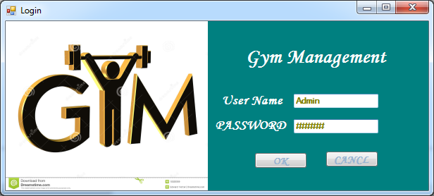

OUTPUT DESIGN
Output design generally refers to the results and information that are generated by the system for many end-users; output is the main reason for developing the system and the basis on which they evaluate the usefulness of the application. In this project output design includes report generation of student details, calculated mark details.
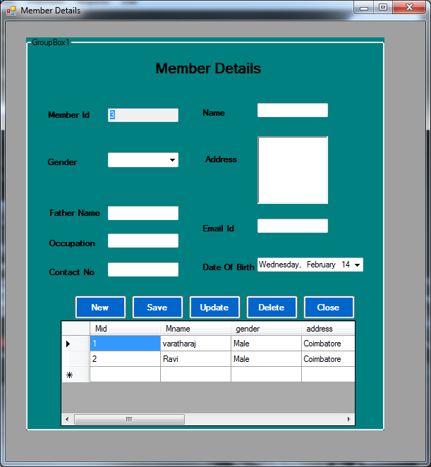
DATAFLOW DIAGRAM
A data flow diagram (DFD) is a graphical representation of the flow of data through an information system. Data flow diagram can be used for visualization of data processing.
A data flow diagram shows kind of information will be an input to and output from the system where the data will come from and go to where the data will be stored.
ADVANTAGES OF USING DATAFLOW DIAGRAM
- It is a simple graphical technique which is easy to understand.
- It helps in defining the boundaries of the system.
- It is useful for communicating current system knowledge to the users.
- It is used as the part of system documentation file.
- It explains the logic behind the data flow within the system.

DATA FLOW DIAGRAM
Level 0

Username, password
Store
GYM MANAGEMENT SYSTEM

Gymdetails
Admin

Retrieve
Get details

Level 1
Username, password
Validation

Login table
Login
Admin

Sid,sname, address etc

Member details
Username, password
Validation
Member Details
Username, password
Validation

Iid,iname,add,dob

Staff table
Staff Details

Bno,sid,name,amt
Aid,iid,sid,name,date,time

Work allocation Details
Work allocation Details

Payment Table

View work allocation report
View staff report
View
View stuent report
Member details
Staff Details
Work allocation Details
Payment
Schedule

ER DIAGRAM
Instructor
Iid
Iname
Address
Phone no
Member
Mid
Name
Address
Assign

Work allocation
Iid

anumber
Iname
mid
Allocate
Do
Payment
bno
Name
Amounttt
Mid
Equipment
icode
iname
rate
use
Make
Schedule
Iname
Iid
Sno
Date

Table Name: Equipment
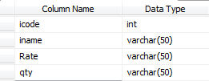

Table Name: Instructor_Details
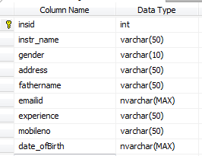
Table Name: Member
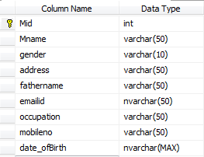
Table Name: Payment_details
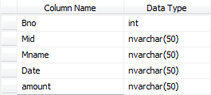
Table Name: Work_Allocation
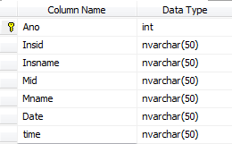

CHAPTER -V

SYSTEM TESTING AND IMPLEMENTATION

Testing

Introduction
The most important phase in system development life cycle is system testing. The number and nature of errors in a newly designed system depends on the system specifications and the time frame given for the design.
A newly designed system should have all the subsystems working together, but in reality each subsystems work independently. During this phase, all the subsystems are gathered into one pool and tested to determine whether it meets the user requirements.
Testing is done at two level -Testing of individual modules and testing the entire system. During the system testing, the system is used experimentally to ensure that the software will run according to the specifications and in the way the user expects. Each test case is designed with the intent of finding errors in the way the system will process it.
Testing plays a very critical role in determining the reliability and efficiency of software and hence is a very important stage in software development. Software testing is done at different levels. They are the unit testing and system testing which comprises of integration testing and acceptance testing.
TYPES OF TESTING
Unit Testing
This is the first level of testing. The different modules are tested against the specifications produced during the integration. This is done to test the internal logic of each module. Those resulting from the interaction between modules are initially avoided. The input received and output generated is also tested to see whether it falls in the expected range of values. Unit testing is performed from the bottom up, starting with the smallest and lowest modules and proceeding one at a time.

The units in a system are the modules and routines that are assembled and integrated to perform a specific function. The programs are tested for correctness of logic applied and detection of errors in coding. Each of the modules was tested and errors are rectified. They were then found to function properly.
Integration Testing
In integration testing, the tested modules are combined into sub-systems, which are then tested. The goal of integration testing to check whether the modules can be integrated properly emphasizing on the interfaces between modules. The different modules were linked together and integration testing done on them.
Validation Testing
The objective of the validation test is to tell the user about the validity and reliability of the system. It verifies whether the system operates as specified and the integrity of important data is maintained. User motivation is very important for the successful performance of the system.
All the modules were tested individually using both test data and live data. After each module was ascertained that it was working correctly and it had been "integrated" with the system. Again the system was tested as a whole. We hold the system tested with different types of users. The System Design, Data Flow Diagrams, procedures etc. were well documented so that the system can be easily maintained and upgraded by any computer professional at a later
System Testing
The integration of each module in the system is checked during this level of testing. The objective of system testing is to check if the software meets its requirements. System testing is done to uncover errors that were not found in earlier tests. This includes forced system failures and validation of total system as the user in the operational environment implements it. Under this testing, low volumes of transactions are generally based on live data. This volume is increased until the maximum level for each transactions type is reached. The total system is also tested for recovery after various major failures to ensure that no data are lost during the breakdown.

SYSTEM Implementation
Implementation is the process that actually yields the lowest-level system elements in the system hierarchy (system breakdown structure). The system elements are made, bought, or reused. Production involves the hardware fabrication processes of forming, removing, joining, and finishing; or the software realization processes of coding and testing; or the operational procedures development processes for operators' roles. If implementation involves a production process, a manufacturing system which uses the established technical and management processes may be required.
The purpose of the implementation process is to design and create (or fabricate) a system element conforming to that element’s design properties and/or requirements. The element is constructed employing appropriate technologies and industry practices. This process bridges the system definition processes and the integration process.
System Implementation is the stage in the project where the theoretical design is turned into a working system. The most critical stage is achieving a successful system and in giving confidence on the new system for the user that it will work efficiently and effectively. The existing system was long time process.
The proposed system was developed using .Net The existing system caused long time transmission process but the system developed now has a very good user-friendly tool, which has a menu-based interface, graphical interface for the end user. After coding and testing, the project is to be installed on the necessary system. The executable file is to be created and loaded in the system. Again the code is tested in the installed system. Installing the developed code in system in the form of executable file is implementation.

CHAPTER -VI
CONCLUSION

It is concluded that the application works well and satisfy the end users. The application is tested very well and errors are properly debugged. The application is simultaneously accessed from more than one system. Simultaneous login from more than one place is tested.

This system is user friendly so everyone can use easily. Proper documentation is provided. The end user can easily understand how the whole system is implemented by going through the documentation. The system is tested, implemented and the performance is found to be satisfactory. All necessary output is generated. Further enhancements can be made to the application, so that the application functions very attractive and useful manner than the present one. The speed of the transactions become more enough now.

SCOPE FOR FUTURE ENHANCEMENT
There is scope for future development of this project. The world of computer fields is not static; it is always subject to be dynamic. The technology which is famous today becomes outdated the very next day. To keep abstract of technical improvements, the system may be further refined. So, it is not concluded. Yet it will improve with further enhancements.
Enhancements can be done in an efficient manner. We can even update the same with further modification establishment and can be integrated with minimal modification. Thus the project is flexible and can be enhanced at anytime with more advanced features.

BIBLIOGRAPHY
REFERENCES
TEXT BOOKS REFERRED

- Microsoft Visual Basic.NET Programmer’s Cook Book-MATTHEW MACDONALD(Tata McGraw Hill Edition)
- Microsoft Visual Basic.NET Programmer’s CookBook-MATTHEW MACDONALD(Tata McGrawHill Edition)
- Grey Buczek, .NET developers guide 2002, Prentice-Hall India.
- BenoltMarchal, VB.NET by example 2003 – TataMcGraw- Hill.
- System Analysis & Design – Alenis Leon.
- An Integral approach to software engineering – Pankaj Jalole.

Web Reference
- www.dotnetspider.com
- www.programersheaven.com
- www.sql-server-performance.com
- www.developerfusion.com
- www.winsocketdotnetworkprogramming.com

REPORT
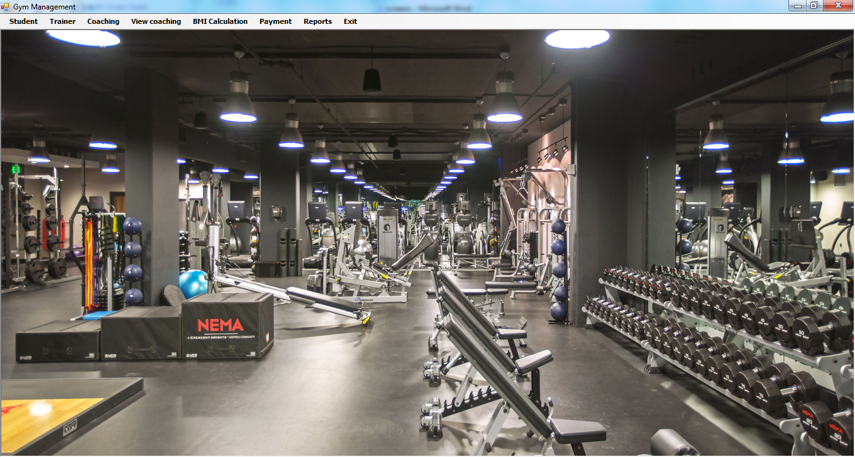

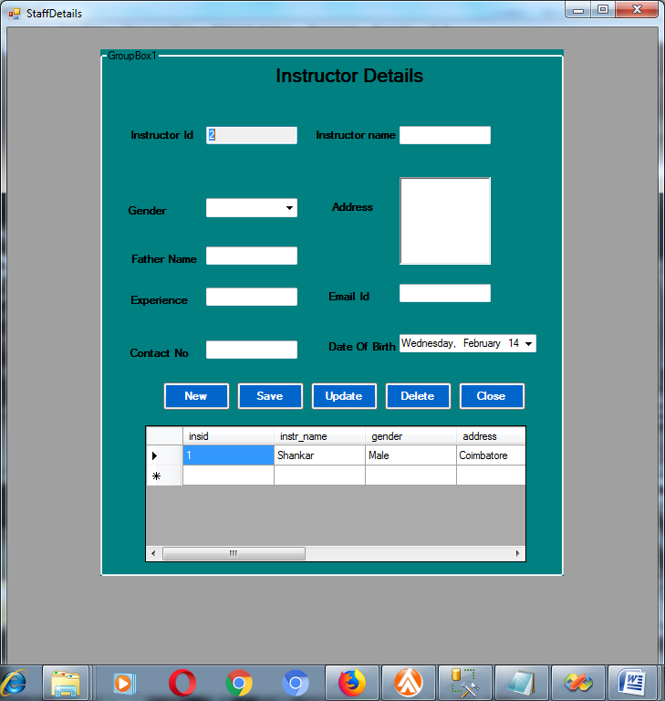

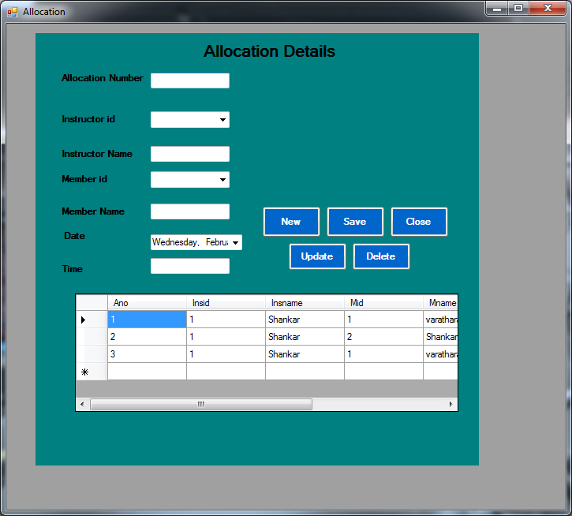

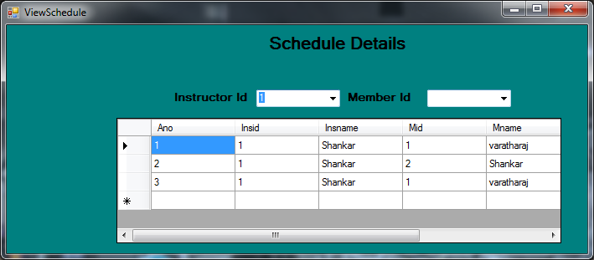

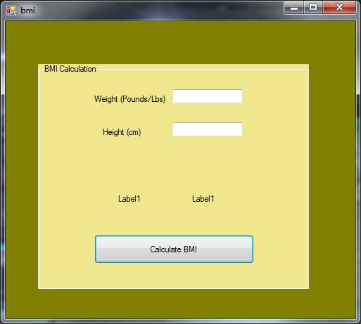

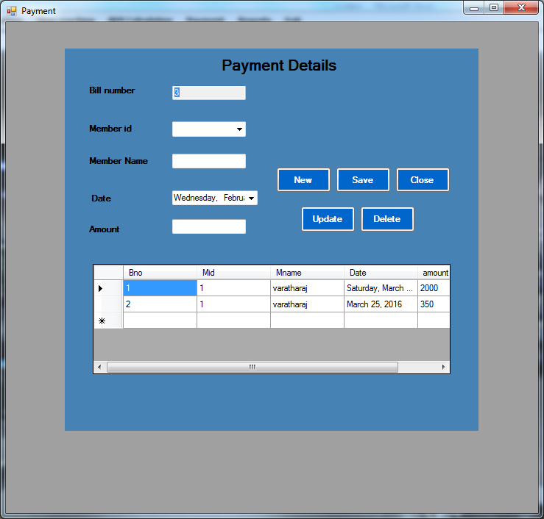

CODINGS
LOGIN
Imports System.Data.SqlClient

Public Class Login

Private Sub Button1_Click(ByVal sender As System.Object, ByVal e As System.EventArgs) Handles Button1.Click
If cn.State = ConnectionState.Closed Then cn.Open()
'cmd = New SqlCommand("SELECT * FROM logDet WHERE uid = '" & TextBox1.Text & "' and pass='" & TextBox2.Text & "' ", cn)
'Dim dr As SqlDataReader = cmd.ExecuteReader
'If dr.Read Then
' uName = dr(0)
' uType = dr(2)
' MsgBox("Welcome " & TextBox1.Text & "")

' Dim frm As New main1
' frm.Show()
' Me.Hide()
If TextBox1.Text = "Admin" And TextBox2.Text = "Admin" Then
Main.Show()
Else
MsgBox("Invalid User ID ! Please Try Again")

End If
cn.Close()

End Sub

Private Sub Button2_Click(ByVal sender As System.Object, ByVal e As System.EventArgs) Handles Button2.Click
End
End Sub

Private Sub Login_Load(ByVal sender As System.Object, ByVal e As System.EventArgs) Handles MyBase.Load

End Sub
End Class

MEMBER DETAILS
Imports System.Data.SqlClient
Public Class Memberdtails

Dim dt As New DataTable
Dim dt1 As New DataTable
Dim da As New SqlDataAdapter
Dim cid As String
Dim id As String
Private Sub ComboBox2_SelectedIndexChanged(ByVal sender As System.Object, ByVal e As System.EventArgs)

End Sub

Private Sub button1_Click(ByVal sender As System.Object, ByVal e As System.EventArgs) Handles button1.Click

If cn.State = ConnectionState.Closed Then cn.Open()
cmd = New SqlCommand("insert into Member values('" & textBox1.Text & "','" & textBox2.Text & "','" & ComboBox5.Text & "','" & RichTextBox1.Text & "','" & textBox5.Text & "','" & TextBox6.Text & "','" & TextBox7.Text & "','" & TextBox8.Text & "','" & DateTimePicker1.Text & "')", cn)
cmd.ExecuteNonQuery()
MsgBox("Successfully Saved", MsgBoxStyle.Exclamation)
cn.Close()

textBox1.Text = ""
textBox2.Text = ""

textBox5.Text = ""
data()

ComboBox5.Text = ""

refreshform()
ident()
End Sub

Private Sub Button2_Click(ByVal sender As System.Object, ByVal e As System.EventArgs) Handles Button2.Click
refreshform()
End Sub

Private Sub Button3_Click(ByVal sender As System.Object, ByVal e As System.EventArgs) Handles Button3.Click
cn.Open()
cmd = New SqlCommand("update Member set Mname='" & textBox2.Text & "',gender='" & ComboBox5.Text & "',address='" & RichTextBox1.Text & "',fathername='" & textBox5.Text & "',emailid='" & TextBox6.Text & "',occupation='" & TextBox7.Text & "',mobileno='" & TextBox8.Text & "' where Mid='" + cid + "'", cn)
cmd.ExecuteNonQuery()
MsgBox("Updated Successfully")
cn.Close()
ident()
Data()
refreshform()
End Sub
Private Sub DataGridView1_CellContentClick(ByVal sender As System.Object, ByVal e As System.Windows.Forms.DataGridViewCellEventArgs) Handles DataGridView1.CellContentClick
cn.Open()
Dim da As New SqlDataAdapter("select *" & " from Member where Mid='" & cid & "' ", cn)
Dim ds As New DataSet
Dim dt As New DataTable
da.Fill(ds)
da.Fill(dt)

textBox1.Text = ds.Tables(0).Rows(0).Item(0)
textBox2.Text = ds.Tables(0).Rows(0).Item(1)

ComboBox5.Text = ds.Tables(0).Rows(0).Item(2)
RichTextBox1.Text = ds.Tables(0).Rows(0).Item(3)
textBox5.Text = ds.Tables(0).Rows(0).Item(4)
TextBox6.Text = ds.Tables(0).Rows(0).Item(5)
TextBox7.Text = ds.Tables(0).Rows(0).Item(6)

TextBox8.Text = ds.Tables(0).Rows(0).Item(7)

cn.Close()
End Sub
Private Sub DataGridView1_SelectionChanged(ByVal sender As System.Object, ByVal e As System.EventArgs) Handles DataGridView1.SelectionChanged
cid = DataGridView1.CurrentRow.Cells(0).Value
End Sub

Private Sub studentdtails_Load(ByVal sender As System.Object, ByVal e As System.EventArgs) Handles MyBase.Load
data()
ident()
End Sub
Public Sub ident()
cn.Open()
dt.Rows.Clear()
dt.Columns.Clear()
dt1.Rows.Clear()
dt1.Columns.Clear()
cmd = New SqlCommand("select max(Mid) from Member", cn)

id = cmd.ExecuteScalar

id = id + 1
TextBox1.Text = id.ToString()
cn.Close()

End Sub

Private Sub Button4_Click(ByVal sender As System.Object, ByVal e As System.EventArgs) Handles Button4.Click
cn.Open()
Dim cmd As New SqlCommand("delete from Member where Mid='" & cid & "' ", cn)
cmd.ExecuteNonQuery()
MsgBox("Deleted SuccessFully")
cn.Close()

ident()
Data()

refreshform()
End Sub
Private Sub refreshform()
TextBox1.Text = ""
TextBox8.Text = ""
TextBox2.Text = ""

textBox5.Text = ""
TextBox6.Text = ""

TextBox7.Text = ""
TextBox8.Text = ""
RichTextBox1.Text = ""
ComboBox5.Text = ""

End Sub
Public Sub data()
Try
cn.Open()
Dim da As New SqlDataAdapter("select * from Member", cn)
Dim ds As New DataSet
da.Fill(ds)
DataGridView1.DataSource = ds.Tables(0)
cn.Close()
Catch ex As Exception
End Try
End Sub

Private Sub Button5_Click(ByVal sender As System.Object, ByVal e As System.EventArgs) Handles Button5.Click
Me.Close()

End Sub
End Class

PAYMENT DETAILS
Imports System.Data.SqlClient
Public Class Payment
Dim dt As New DataTable
Dim dt1 As New DataTable
Dim da As New SqlDataAdapter
Dim cid As String
Dim id As String
Private Sub Payment_Load(ByVal sender As System.Object, ByVal e As System.EventArgs) Handles MyBase.Load
data()
data1()
ident()

End Sub
Public Sub ident()
If cn.State = ConnectionState.Closed Then cn.Open()
dt.Rows.Clear()
dt.Columns.Clear()
dt1.Rows.Clear()
dt1.Columns.Clear()
cmd = New SqlCommand("select max(Bno) from Payment_details", cn)

id = cmd.ExecuteScalar

id = id + 1
TextBox1.Text = id.ToString()
cn.Close()

End Sub
Public Sub data1()
Try
If cn.State = ConnectionState.Closed Then cn.Open()
Dim da As New SqlDataAdapter("select Mid from Member", cn)
Dim dt As New DataTable
Dim dr As DataRow
da.Fill(dt)
cn.Close()
For Each dr In dt.Rows
ComboBox5.Items.Add(dr.Item(0))
Next
Catch ex As Exception

End Try
End Sub
Private Sub Button5_Click(ByVal sender As System.Object, ByVal e As System.EventArgs) Handles Button5.Click
Me.Close()

End Sub

Private Sub ComboBox5_SelectedIndexChanged(ByVal sender As System.Object, ByVal e As System.EventArgs) Handles ComboBox5.SelectedIndexChanged
If cn.State = ConnectionState.Closed Then cn.Open()
Dim da As New SqlDataAdapter("select Mname from Member where Mid='" & ComboBox5.Text & "' ", cn)
Dim ds As New DataSet
Dim dt As New DataTable
Dim dr As DataRow
da.Fill(ds)
da.Fill(dt)
cn.Close()
For Each dr In dt.Rows
TextBox4.Text = dr.Item(0)

Next
End Sub

Private Sub button1_Click(ByVal sender As System.Object, ByVal e As System.EventArgs) Handles button1.Click
If cn.State = ConnectionState.Closed Then cn.Open()
cmd = New SqlCommand("insert into Payment_details values('" & textBox1.Text & "','" & ComboBox5.Text & "','" & TextBox4.Text & "','" & DateTimePicker1.Text & "','" & TextBox7.Text & "')", cn)
cmd.ExecuteNonQuery()
MsgBox("Successfully Saved", MsgBoxStyle.Exclamation)
data()
ident()
End Sub

Private Sub DataGridView1_CellContentClick(ByVal sender As System.Object, ByVal e As System.Windows.Forms.DataGridViewCellEventArgs) Handles DataGridView1.CellContentClick
If cn.State = ConnectionState.Closed Then cn.Open()
Dim da As New SqlDataAdapter("select *" & " from Payment_details where Bno='" & cid & "' ", cn)
Dim ds As New DataSet
Dim dt As New DataTable
da.Fill(ds)
da.Fill(dt)

textBox1.Text = ds.Tables(0).Rows(0).Item(0)
ComboBox5.Text = ds.Tables(0).Rows(0).Item(1)

TextBox4.Text = ds.Tables(0).Rows(0).Item(2)

TextBox7.Text = ds.Tables(0).Rows(0).Item(4)

cn.Close()
End Sub
Private Sub DataGridView1_SelectionChanged(ByVal sender As System.Object, ByVal e As System.EventArgs) Handles DataGridView1.SelectionChanged
cid = DataGridView1.CurrentRow.Cells(0).Value
End Sub

Private Sub Button3_Click(ByVal sender As System.Object, ByVal e As System.EventArgs) Handles Button3.Click
If cn.State = ConnectionState.Closed Then cn.Open()
cmd = New SqlCommand("update Payment_details set Mid='" & ComboBox5.Text & "',Mname='" & TextBox4.Text & "',Date='" & DateTimePicker1.Text & "',amount='" & TextBox7.Text & "' where Bno='" + cid + "'", cn)
cmd.ExecuteNonQuery()
MsgBox("Updated Successfully")
cn.Close()

data()
refreshform()
ident()
End Sub

Private Sub Button4_Click(ByVal sender As System.Object, ByVal e As System.EventArgs) Handles Button4.Click

If cn.State = ConnectionState.Closed Then cn.Open()
Dim cmd As New SqlCommand("delete from Payment_details where Bno='" & cid & "' ", cn)
cmd.ExecuteNonQuery()
MsgBox("Deleted SuccessFully")
cn.Close()

Data()

refreshform()
ident()
End Sub
Private Sub refreshform()
TextBox1.Text = ""
TextBox4.Text = ""

TextBox7.Text = ""

ComboBox5.Text = ""

End Sub
Public Sub data()
Try
If cn.State = ConnectionState.Closed Then cn.Open()
Dim da As New SqlDataAdapter("select * from Payment_details", cn)
Dim ds As New DataSet
da.Fill(ds)
DataGridView1.DataSource = ds.Tables(0)
cn.Close()
Catch ex As Exception
End Try
End Sub

Private Sub Button2_Click(ByVal sender As System.Object, ByVal e As System.EventArgs) Handles Button2.Click
refreshform()
End Sub
End Class

WORK ALLOCATION

Imports System.Data.SqlClient
Public Class StaffDetails

Dim dt As New DataTable
Dim dt1 As New DataTable
Dim da As New SqlDataAdapter
Dim cid As String
Dim id As String
Private Sub button1_Click(ByVal sender As System.Object, ByVal e As System.EventArgs) Handles button1.Click

Try
If cn.State = ConnectionState.Closed Then cn.Open()
cmd = New SqlCommand("insert into Instructor_Details values('" & textBox1.Text & "','" & textBox2.Text & "','" & ComboBox5.Text & "','" & RichTextBox1.Text & "','" & textBox5.Text & "','" & TextBox6.Text & "','" & TextBox7.Text & "','" & TextBox8.Text & "','" & DateTimePicker1.Text & "')", cn)
cmd.ExecuteNonQuery()
MsgBox("Successfully Saved", MsgBoxStyle.Exclamation)
cn.Close()
Catch ex As Exception
MsgBox(ex.Message, MsgBoxStyle.Critical)
End Try

textBox1.Text = ""
textBox2.Text = ""

textBox5.Text = ""

ComboBox5.Text = ""
data()

End Sub
Private Sub Button2_Click(ByVal sender As System.Object, ByVal e As System.EventArgs) Handles Button2.Click
refreshform()
End Sub

Private Sub Button3_Click(ByVal sender As System.Object, ByVal e As System.EventArgs) Handles Button3.Click
cn.Open()
cmd = New SqlCommand("update Instructor_Details set instr_name='" & textBox2.Text & "',gender='" & ComboBox5.Text & "',address='" & RichTextBox1.Text & "',fathername='" & textBox5.Text & "',emailid='" & TextBox6.Text & "',experience='" & TextBox7.Text & "',mobileno='" & TextBox8.Text & "' where insid='" + cid + "'", cn)
cmd.ExecuteNonQuery()
MsgBox("Updated Successfully")
cn.Close()
ident()
Data()
refreshform()
End Sub
Private Sub DataGridView1_CellContentClick(ByVal sender As System.Object, ByVal e As System.Windows.Forms.DataGridViewCellEventArgs) Handles DataGridView1.CellContentClick
cn.Open()
Dim da As New SqlDataAdapter("select *" & " from Instructor_Details where insid='" & cid & "' ", cn)
Dim ds As New DataSet
Dim dt As New DataTable
da.Fill(ds)
da.Fill(dt)

textBox1.Text = ds.Tables(0).Rows(0).Item(0)
textBox2.Text = ds.Tables(0).Rows(0).Item(1)

ComboBox5.Text = ds.Tables(0).Rows(0).Item(2)
RichTextBox1.Text = ds.Tables(0).Rows(0).Item(3)
textBox5.Text = ds.Tables(0).Rows(0).Item(4)
TextBox6.Text = ds.Tables(0).Rows(0).Item(5)
TextBox7.Text = ds.Tables(0).Rows(0).Item(6)

TextBox8.Text = ds.Tables(0).Rows(0).Item(7)

cn.Close()
End Sub
Private Sub DataGridView1_SelectionChanged(ByVal sender As System.Object, ByVal e As System.EventArgs) Handles DataGridView1.SelectionChanged
cid = DataGridView1.CurrentRow.Cells(0).Value
End Sub

Private Sub studentdtails_Load(ByVal sender As System.Object, ByVal e As System.EventArgs) Handles MyBase.Load
data()
ident()
End Sub
Public Sub ident()
cn.Open()
dt.Rows.Clear()
dt.Columns.Clear()
dt1.Rows.Clear()
dt1.Columns.Clear()
cmd = New SqlCommand("select max(insid) from Instructor_Details", cn)

id = cmd.ExecuteScalar

id = id + 1
TextBox1.Text = id.ToString()
cn.Close()

End Sub

Private Sub Button4_Click(ByVal sender As System.Object, ByVal e As System.EventArgs) Handles Button4.Click
cn.Open()
Dim cmd As New SqlCommand("delete from Instructor_Details where insid='" & cid & "' ", cn)
cmd.ExecuteNonQuery()
MsgBox("Deleted SuccessFully")
cn.Close()

ident()
Data()

refreshform()
End Sub
Private Sub refreshform()
TextBox1.Text = ""
TextBox8.Text = ""
TextBox2.Text = ""

textBox5.Text = ""
TextBox6.Text = ""

TextBox7.Text = ""
TextBox8.Text = ""
RichTextBox1.Text = ""
ComboBox5.Text = ""

End Sub
Public Sub data()
Try
cn.Open()
Dim da As New SqlDataAdapter("select * from Instructor_Details", cn)
Dim ds As New DataSet
da.Fill(ds)
DataGridView1.DataSource = ds.Tables(0)
cn.Close()
Catch ex As Exception
End Try
End Sub

Private Sub Button5_Click(ByVal sender As System.Object, ByVal e As System.EventArgs) Handles Button5.Click
Me.Close()

End Sub
End Class
CLASS SCHEDULE
Imports System.Data.SqlClient
Public Class ViewSchedule

Dim dt As New DataTable
Dim dt1 As New DataTable
Dim da As New SqlDataAdapter
Dim cid As String
Dim id As String
Private Sub ViewSchedule_Load(ByVal sender As System.Object, ByVal e As System.EventArgs) Handles MyBase.Load
data1()
data2()

End Sub
Public Sub data2()
Try
If cn.State = ConnectionState.Closed Then cn.Open()
Dim da As New SqlDataAdapter("select Mid from Member", cn)
Dim dt As New DataTable
Dim dr As DataRow
da.Fill(dt)
cn.Close()
For Each dr In dt.Rows
ComboBox1.Items.Add(dr.Item(0))
Next
Catch ex As Exception

End Try
End Sub
Public Sub data1()
Try
If cn.State = ConnectionState.Closed Then cn.Open()
Dim da As New SqlDataAdapter("select insid from Instructor_Details", cn)
Dim dt As New DataTable
Dim dr As DataRow
da.Fill(dt)
cn.Close()
For Each dr In dt.Rows
ComboBox5.Items.Add(dr.Item(0))
Next
Catch ex As Exception

End Try
End Sub

Private Sub ComboBox5_SelectedIndexChanged(ByVal sender As System.Object, ByVal e As System.EventArgs) Handles ComboBox5.SelectedIndexChanged
If cn.State = ConnectionState.Closed Then cn.Open()
Dim da As New SqlDataAdapter("select * from Work_Allocation where insid='" & ComboBox5.Text & "' ", cn)
Dim ds As New DataSet
da.Fill(ds)
DataGridView1.DataSource = ds.Tables(0)
cn.Close()
End Sub

Private Sub ComboBox1_SelectedIndexChanged(ByVal sender As System.Object, ByVal e As System.EventArgs) Handles ComboBox1.SelectedIndexChanged
If cn.State = ConnectionState.Closed Then cn.Open()
Dim da As New SqlDataAdapter("select * from Work_Allocation where Mid='" & ComboBox1.Text & "' ", cn)
Dim ds As New DataSet
da.Fill(ds)
DataGridView1.DataSource = ds.Tables(0)
cn.Close()
End Sub
End Class

