

Avinashilingam Institute for Home Science and Higher Education for Women
(Deemed to be University under Category ‘A’ by MHRD, Estd. u/s 3 of UGC Act 1956)
Re-accredited with ‘A+’ Grade by NAAC. Recognised by UGC Under Section 12B
Coimbatore - 641 043, Tamil Nadu, India

Master’s Degree Examination – November 2019
III -Semester
Class : II PG Time: 3 hours Major : Information Technology Max. Marks: 60

17MITC16 - Information Security
Course Outcomes:
- Explore about attacks and gain ideas of handling it.
- Establish a view about mathematical concepts and key distribution methods.
- Compare different security techniques and identify the benefits.
- Acquire opportunity to learn about various securities.
- Develop knowledge in detail and ensure ideas about security standards,intrusion,wireless security and secured routing

Part A 10 x ½ =5
Choose the correct answer

1. ____ prevents or inhibits the normal use of communication facilities. CO1K2
- Denial of Service b. Replay c. Masquerade d. Access Control

2. ____ attack is based on finding linear approximations essential in DES transformations. CO1K1
a. Differential Cryptanalysis b. Linear Cryptanalysis
c. Non-Linear Cryptanalysis d. Timing
3. ______ encryption can be used for confidentiality and authentication. CO2K2
a. Symmetric b. Asymmetric c. Message d. Conventional
4. Encryption is also referred as ___________ CO2K1
a. Enciphering b. Decryption c. Decoding d. Ceasing
5. ____ encryption offers authentication amongst those who share secret key.CO3K3
a. Symmetric b. Asymmetric c. Message d. Conventional
6. _____ function maps a variable length message into a fixed length hash value. CO3K2
a. Hash b. Digest c. Password d. Key

7. Authentication makes use of the ____ message authentication code. CO4K1
a. HMAC b. Encrypted c. Decrypted d. Converted
8. ___ incorporates tools for developing public key model and management. CO4K4
a. PGP b. S/MIME c. DKIM d. SSH
9. _____ property ensures the unaltered delivery of data to the receiver. CO5K4
a. Confidentiality b. Integrity c. Availability d. Non- Repudiation
10. ______ attack is specific to the transport layer in the network protocol stack. CO5K1
a. Wormhole b. Blackhole c. Byzantine d. Session hijacking

Part B 5 x 4 = 20
Answer ALL questions
Each answer should not exceed 200 words or one page

11.a. Define Encryption and list out the ingredients exist in symmetric encryption Scheme. CO1K1
(or)
11.b. Demonstrate the applicability of Blowfish Encryption Algorithm. CO1K3

12.a. Illustrate Fermats Theorem with essential representation CO2K3 (or)
12.b. Summarize the procedure involved in Elliptic Curve Cryptography. CO2K5
13.a. Review the applicability of Hash Function. CO3K2 (or)
13.b. Survey the implementation requirement of Authentication Protocols. CO3K4

14.a. State the principles of Remote User Authentication. CO4K1
(or)
14.b. Express the role of Web Security in reliable communication. CO4K6
15.a. Discuss Malicious Software in brief. CO5K4 (or)
15.b. Recall the issues involved in providing security in adhoc wireless networks. CO5K1

Part C 5 x 7 = 35
Answer ALL questions
Each answer should not exceed 600 words or three pages

16.a. Describe the process involved in Advanced Encryption Standard (AES). CO1K2
(or)
16.b. List out the modes of encryption operation with suitable scenario. CO1K3

17.a. Analyze the importance of RSA algorithm CO2K4 (or)
17.b. Represent the implementation procedure of Diffie Hellman Key Exchange. CO2K2

18.a. Explain Message Authentication in detail. CO3K2
(or)
18.b. Discuss the role of Digital Signatures in brief. CO3K2

19.a. Generalize the concept of user authentication using Symmetric Encryption. CO4K6
(or)
19.b. Outline the IP Security process. CO4K4

20.a. Write short notes on role of intruders and intrusion process. CO5K2
(or)
20.b. Examine the Key Management process in adhoc wireless networks. CO5K1

*********

Scheme of valuation

Master’s Degree Examination – November 2019
III - Semester

Class : II PG Time: 3 hours Major : Information Technology Max. Marks: 60

17MITC16 - Information Security ( SCHEME – SET A)
Part A10 x ½ = 5
- A) Denial of Service
- B) Linear Cryptanalysis
- B)Asymmetric
- A)Enciphering
- A)Symmetric
- A)Hash
- A)HMAC
- A)PGP
- B)Integrity
- D)Session hijacking

Part B (5 * 4 =20)
11. a. Define Encryption and list out the ingredients exist in symmetric encryption Scheme
Symmetric-key algorithms are algorithms for cryptography that use the same cryptographic. Keys for both encryption of plaintext and decryption of cipher text. The keys may be identical or there may be a simple transformation to go between the two keys. The keys, in practice, represent a shared secret between two or more parties that can be used to maintain a private information link. This requirement that both parties have access to the secret key is one of the main drawbacks of symmetric key encryption, in comparison to public-key encryption also known as asymmetric key encryption.
11. b. Demonstrate the applicability of Blowfish Encryption Algorithm.
Blowfish is a symmetric-key block cipher, designed in 1993 by Bruce Schneider and included in a large number of cipher suites and encryption products. Blowfish provides a good encryption rate in software and no effective cryptanalysis of it has been found to date. However, the Advanced Encryption Standard (AES) now receives more attention, and Schneier recommends Twofish for modern applications. Schneier designed Blowfish as a general-purpose algorithm, intended as an alternative to the aging DES and free of the problems and constraints associated with other algorithms. At the time Blowfish was released, many other designs were proprietary, encumbered by patents or were commercial or government secrets. Schneier has stated that, &quot;Blowfish is unpatented, and will remain so in all countries. The algorithm is hereby placed in the public domain, and can be freely.
12. a. Illustrate Fermats Theorem with essential representation
This article collects together a variety of proofs of Fermat little theorem, which states that for every prime number p and every integer a (see modular arithmetic). Some of the proofs of Fermat little theorem given below depend on two simplifications. The first is that we may assume that a is in the range 0 ≤ a ≤ p − 1. This is a simple consequence of the laws of modular arithmetic; we are simply saying that we may first reduce a modulo p. This is consistent with reducing modulo p, as one can check.

12.b. Summarize the procedure involved in Elliptic Curve Cryptography.
Elliptic-curve cryptography (ECC) is an approach to public-key cryptography based on The algebraic structure of elliptic curves over finite fields. ECC requires smaller keys compared to non-EC cryptography (based on plain Galois fields) to provide equivalent security. Elliptic curves are applicable for key agreement, digital signatures, pseudo-random generators and other tasks. Indirectly, they can be used for encryption by combining the key agreement with a symmetric encryption scheme. They are also used in several integer factorization algorithms based on elliptic curves that have applications in cryptography, such as Lenstra elliptic-curve factorization.
13. a. Review the applicability of Hash Function.
A hash function is any function that can be used to map data of arbitrary size to fixed-size values. The values returned by a hash function are called hash values, hash codes, digests, or simply hashes. Hash functions are often used in combination with a hash table, a common data structure used in computer software for rapid data lookup. Hash functions accelerate table or database lookup by detecting duplicated records in a large file. One such application is finding similar stretches in DNA sequences. They are also useful in cryptography. A cryptographic hash function allows one to easily verify whether some input data map onto a given hash value, but if the input data is unknown it is deliberately difficult to reconstruct it (or any equivalent alternatives) by knowing the stored hash value. This is used for assuring integrity of transmitted data, and is the building block for HMACs, which provide message authentication.
13. b. Survey the implementation requirement of Authentication Protocols.
- Need an authentication protocol for an online stock broker - Need to be very secure when users login to the system - Two-way authentication is needed because users don’t want to give out their stock account and password to wrong place, and broker don’t want hacker to steal money. - Efficiency is also important when users making orders, but the protocol will focus on the authentication. - Using shared key algorithm with Hash
14. a. State the principles of Remote User Authentication.
In most computer security contexts, user authentication is the fundamental building g block and the primary line of defense. User authentication is the basis for most types of access control and for user accountability. RFC2828 defines user authentication. The process of verifying an identity claimed by or for a system entity. An
Authentication process consists of two steps:
• Identification step: Presenting an identifier to the security system. (Identifiers should be assigned carefully, because authenticated identities are the basis for other security services, such as access control service.)
• Verification step: Presenting or generating authentication information that corroborates the binding between the entity and the identifier.
14.b. Express the role of Web Security in reliable communication.
Web security, cyber security or information technology security (IT security) is the protection of computer systems from the theft of or damage to their hardware, software, or electronic data, as well as from the disruption or misdirection of the services they provide. The field is becoming more important due to increased reliance on computer systems, the Internet and wireless network standards such as Bluetooth and Wi-Fi, and due to the growth of devices, including smartphones, televisions, and the various devices that constitute the of things . Due to its complexity, both in terms of politics and technology, cyber security is also one of the major challenges in the contemporary world Malicious software, commonly known as malware, is any software that brings harm
15. a. Discuss Malicious Software in brief.
Computer system. Malware can be in the form of worms, viruses, Trojans, spyware, adware and rootkits, etc., which steal protected data, delete documents or add software not approved by a user. Malware (a portmanteau for malicious software) is any software intentionally designed to cause damage to a computer, server, client, or computer network. Malware does the damage after it is implanted or introduced in some way into a computer and can take the form of directly executable code, scripts, so-called active and other forms of data.
15.b. Recall the issues involved in providing security in adhoc wireless networks.
Ad-hoc networks are an emerging area of mobile computing. There are various challenges that are faced in the Ad-hoc environment. These are mostly due to the resource poorness of these networks. They are usually set up in situations of emergency, for temporary operations or simply if there are no resources to set up elaborate networks. Ad-hoc networks therefore throw up new requirements and problems in all areas of networking. The solutions for conventional networks are usually not sufficient to provide efficient Ad-hoc operations. The wireless nature of communication and lack of any security infrastructure raise several security problems. In this paper we attempt to analyze the demands of Ad-hoc environment. We focus on Ad-hoc routing. The key issues concerning these areas have been addressed here. We have tried to compile solutions to these problems that have been active areas of research.
Part C 5 x 7 = 35
Answer ALL questions
Each answer should not exceed 600 words or three pages
16.a. Describe the process involved in Advanced Encryption Standard (AES).
The more popular and widely adopted symmetric encryption algorithm likely to be encountered nowadays is the Advanced Encryption Standard (AES). It is found at least six time faster than triple DES. A replacement for DES was needed as its key size was too small. With increasing computing power, it was considered vulnerable against exhaustive key search attack. Triple DES was designed to overcome this drawback but it was found slow.
The features of AES are as follows
- Symmetric key symmetric block cipher
- 128-bit data, 128/192/256-bit keys
- Stronger and faster than Triple-DES
- Provide full specification and design details
- Software implementable in C and Java
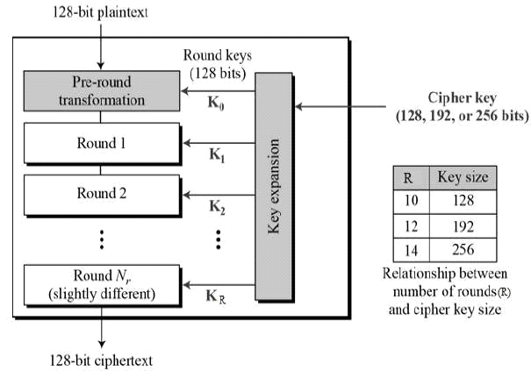

16.b. List out the modes of encryption operation with suitable scenario.
In cryptography, a block cipher mode of operation is an algorithm that uses a block cipher to provide information security such as confidentiality or authenticity.^{[1]} A block cipher by itself is only suitable for the secure cryptographic transformation (encryption or decryption) of one fixed-length group of bits called a block.^{[2]} A mode of operation describes how to repeatedly apply a cipher's single-block operation to securely transform amounts of data larger than a block.[
Most modes require a unique binary sequence, often called an initialization vector for each encryption operation. The has to be non-repeating and, for some modes, random as well. The initialization vector is used to ensure distinct ciphertexts are produced even when the same plaintext is encrypted multiple times independently with the same key.[ Block ciphers may be capable of operating on more than one block size, but during transformation the block size is always fixed. Block cipher modes operate on whole blocks and require that the last part of the data be padded to a full block if it is smaller than the current block size.[There are, however, modes that do not require padding because they effectively use a block cipher as a stream cipher.

17.a. Analyze the importance of RSA algorithm
RSA (Rivest–Shamir–Adleman) is one of the first public-key cryptosystems and is widely used for secure data transmission. In such a cryptosystem, the encryption key is public and it is different from the decryption key which is kept secret (private). In RSA, this asymmetry is based on the practical difficulty of the factorization of the product of two large prime numbers, the "factoring problem". The acronym RSA is made of the initial letters of the surnames of Ron Rivest, Adi Shamir, and Leonard Adleman, who first publicly described the algorithm in 1977. Clifford Cocks, an English mathematician working for the British intelligence agency Government Communications Headquarters (GCHQ), had developed an equivalent system in 1973, but this was not declassified until 1997.
A user of RSA creates and then publishes a public key based on two large prime numbers, along with an auxiliary value. The prime numbers must be kept secret. Anyone can use the public key to encrypt a message, but only someone with knowledge of the prime numbers can decode the message. Breaking RSA encryption is known as the RSA problem. Whether it is as difficult as the factoring problem remains an open question. There are currently no published methods to defeat the system if a large enough key is used.
17.b.Represent the implementation procedure of Diffie Hellman Key Exchange.
Diffie–Hellman key exchange (DH)[ is a method of securely exchanging cryptographic keys over a public channel and was one of the first public-key protocols as originally conceptualized by Ralph Merkle and named after Whitfield Diffie and Martin Hellman. DH is one of the earliest practical examples of public key exchange implemented within the field of cryptography.
Traditionally, secure encrypted communication between two parties required that they first exchange keys by some secure physical channel, such as paper key lists transported by a trusted courier. The Diffie–Hellman key exchange method allows two parties that have no prior knowledge of each other to jointly establish a shared secret key over an insecure channel. This key can then be used to encrypt subsequent communications using a symmetric key cipher.
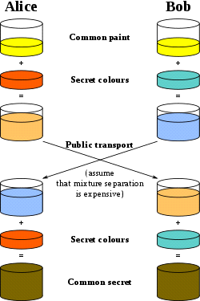

18.a. Explain Message Authentication in detail.
Another type of threat that exist for data is the lack of message authentication. In this threat, the user is not sure about the originator of the message. Message authentication can be provided using the cryptographic techniques that use secret keys as done in case of encryption.
Message Authentication Code (MAC)
MAC algorithm is a symmetric key cryptographic technique to provide message authentication. For establishing MAC process, the sender and receiver share a symmetric key Essentially, a MAC is an encrypted checksum generated on the underlying message that is sent along with a message to ensure message authentication.
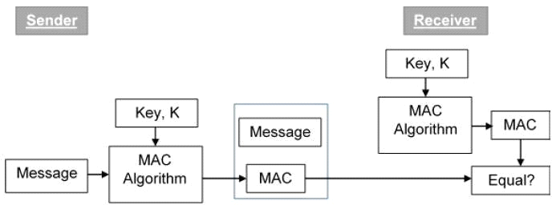
18.b. Discuss the role of Digital Signatures in brief.
A digital signature is a mathematical scheme for verifying the authenticity of digital messages or documents. A valid digital signature, where the prerequisites are satisfied, gives a recipient very strong reason to believe that the message was created by a known sender (authentication), and that the message was not altered in transit (integrity).
Digital signatures are a standard element of most cryptographic protocol suites, and are commonly used for software distribution, financial transactions, contract management software, and in other cases where it is important to detect forgery or tampering.
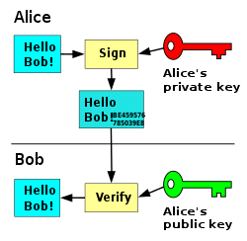

19.a.Generalize the concept of user authentication using Symmetric Encryption.
we presented one approach to the use of public-key encryption for the purpose of session-key distribution. This protocol assumes that each of the two parties is in possession of the currentpublic key of the other. It may not be practical to require this assumption.
A protocol using timestamps is provided One-Way Authentication
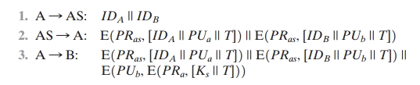
19.b. Outline the IP Security process.
In computing, Internet Protocol Security (IPsec) is a secure network protocol suite that authenticates and encrypts the packets of data sent over an Internet Protocol network. It is used in virtual private networks (VPNs).
IPsec includes protocols for establishing mutual authentication between agents at the beginning of a session and negotiation of cryptographic keys to use during the session. IPsec can protect data flows between a pair of hosts (host-to-host), between a pair of security gateways (network-to-network), or between a security gateway and a host (network-to-host) Internet Protocol security (IPsec) uses cryptographic security services to protect communications over Internet Protocol (IP) networks. IPsec supports network-level peer authentication, data-origin authentication, data integrity, data confidentiality (encryption), and replay protection.
The initial IPv4 suite was developed with few security provisions. As a part of the IPv4 enhancement, IPsec is a layer OSI model or internet layer end-to-end security scheme, while some other Internet security systems in widespread use operate above layer such as Transport Layer Security (TLS) and Secure Shell (SSH), both of which operate at the Application layer. IPsec can automatically secure applications at the IP layer.
20.a. Write short notes on role of intruders and intrusion process.
An intrusion detection system (IDS) is a device or software application that monitors a network or systems for malicious activity or policy violations. Any malicious activity or violation is typically reported either to an administrator or collected centrally using a security information and event management (SIEM) system. A SIEM system combines outputs from multiple sources, and uses alarm filtering techniques to distinguish malicious activity from false alarms.
Analyzed activity - Network intrusion detection systems - Host intrusion detection systems - Detection method-Signature-based -Anomaly-based.
An intrusion detection system (IDS) is a system that monitors network traffic for suspicious activity and issues alerts when such activity is discovered. While anomaly detection and reporting is the primary function, some intrusion detection systems are capable of taking actions when malicious activity or anomalous traffic is detected, including blocking traffic sent from suspicious IP addresses.
20.b. Examine the Key Management process in adhoc wireless networks.
Key distribution is an important issue in wireless sensor network (WSN) design WSNs are networks of small, battery-powered, memory-constraint devices named sensor nodes, which have the capability of wireless communication over a restricted area. Due to memory and power constraints, they need to be well arranged to build a fully functional network.
Key predistribution is the method of distribution of keys onto nodes before deployment. Therefore, the nodes build up the network using their secret keys after deployment, that is, when they reach their target position.
Key predistribution schemes are various methods that have been developed by academicians for a better maintenance of PEA management in WSNs. Basically a key predistribution scheme has 3 phases:
- Key distribution
- Shared key discovery
- Path-key establishment
**************

