

Avinashilingam Institute for Home Science and Higher Education for Women
(Deemed to be University under Category ‘A’ by MHRD, Estd. u/s 3 of UGC Act 1956)
Re-accredited with ‘A+’ Grade by NAAC. Recognised by UGC Under Section 12B
Coimbatore - 641 043, Tamil Nadu, India

Master’s Degree Examination – November 2019
III Semester
Class : II PG Time: 3 hours Major : Biochemistry Max. Marks: 60

17MBCC16 – Genetic Engineering

Part A 10 x ½ = 5
Choose the correct answer

- The restriction endonuclease is having a defence mechanism in the bacterial system against foreign DNA such as viruses.
(a) By methylation of bacterial DNA by restriction enzyme
(b) By methylation of foreign DNA by restriction enzyme
(c) By phosphorylation of bacterial DNA by restriction enzyme
(d) By phosphorylation of foreign DNA by restriction enzyme
- The extra chromosomal, self-replicating, closed, double stranded and circular DNA molecule is generally termed as
(a) Chromosome (b) Plasmid (c) Genomic DNA (d) Bacteriophage

- Which of the statement is true for pBR322?
(a) It contains only an ampicillin resistance gene
(b) It contains both ampicillin resistant and tetracycline resistant gene
(c) The cloning site is present only in the ampicillin resistant gene
(d) It is a natural vector

- The size of the Ti plasmid is around ___________
(a) Less than 100 kb (b) More than 200 kb (c) Less than 50 kb (d) More than 75 kb

- Introduction of DNA into cells by exposing to high voltage electric pulse is
(a) electrofusion (b) electrofision (c) electrolysis (d) electroporation
6. Which of the following statements are true for agrobacterium mediated gene transfer?
(a) Vir genes are essential for gene transfer
(b) T-DNA borders are essential for gene transfer
(c) both a and b
(d) none of these
7. The set of DNAs generated by using random primers in a PCR reaction is called
(a) RAPD (b) RFLP (c) AFLP (d) in situ hybridization

8. Process of determining precise order of nucleotides within DNA is
(a) DNA replication (b) denaturation (c) blotting (d) DNA sequencing

9. The insulin prepared through genetic engineering is called
(a) Human insulin (b) microbial insulin (c) Bio insulin (d) Humulin
10. Inability to replicate in certain viruses provides an ultimate advantage in the
(a) Gene therapy (b) Drug therapy (c) Physiotherapy (d) Chemotherapy

Part B 5 x 4 = 20
Answer ALL questions
Each answer should not exceed 200 words or one page

11. a) Mention the role of nucleases and Topoisomerases in DNA Manipulation.
(OR)
b) List out the importance of gene cloning.

12. a) Discuss about the applications of pBR322 vector.
(OR)
b) Write a note on cosmids.

13. a) Explain the Electroporation technique.
(OR)
b) Describe the technique of Agrobacterium mediated gene transfer.

14.a) How will you construct the gene library?
(OR)
b) Enumerate the steps involved in PCR.

15.a) Describe insulin production by genetic engineering technique.
(OR)
b) Comment on Antisense RNA technology.

Part C 5 x 7 = 35
Answer ALL questions
Each answer should not exceed 600 words or three page

16. a) How will you perform the Restriction digestion and restriction mapping.
(OR)
- Explain about the isolation and purification of Total cell DNA and plasmid DNA.

17. a) Write about the role of bacteriophages M₁₃ and λ as cloning vectors.
(OR)
b) Elaborate on Ti plasmid and Ri plasmid.
18. a) Explain any two methods of transgenic animals production.
(OR)
b) Write an essay on IPR and its types.

19. a) Discuss on the technique and application of southern Blotting.
(OR)
b) Describe the stages in DNA finger printing and mention its applications.

20.a) List out the applications of genetic engineering in the field of medicine.
(OR)
b) Elaborate on the production of insect and virus resistant plant.

Avinashilingam Institute of Home Science and Higher education for Women,
Coimbatore -641043
Master’s Degree Examination – November 2019
Class: II M.Sc. Semester - III Max Marks: 60
Major: Biochemistry Time: 3 Hours

17MBCC16- Genetic Engineering

SCHEME OF VALUATION

Part A 10 x ½ =5
Answer the following
Choose the correct answer

- (a) By methylation of bacterial DNA by restriction enzyme
- (b) Plasmid
- (b) It contains both ampicillin resistant and tetracycline resistant gene
- (b) More than 200 kb
- (d) electroporation
- (c) both a and b
- (a) RAPD
- (d) DNA sequencing
- (d) Humulin
- (a) Gene therapy
Part B 5 x 4 = 20
Answer ALL questions
Each answer should not exceed 200 words or one page
- a) (i) Nucleases can be regarded as molecular scissors, which cleave phosphodiester bonds between the sugars and the phosphate moieties of DNA. They contain conserved minimal motifs, which usually consist of acidic and basic residues forming the active site. These active site residues coordinate catalytically essential divalent cations, such as magnesium, calcium, manganese or zinc, as a cofactor. However, the requirements for actual cleavage, such as the types and the numbers of metals, are very complicated, but are not common among the nucleases. It appears that the major role of the metals is to stabilize intermediates, thereby facilitating the phosphoryl transfer reactions.
(ii) Topoisomerases are enzymes that participate in the overwinding or underwinding of DNA. The winding problem of DNA arises due to the intertwined nature of its double-helical structure. During DNA replication and transcription, DNA becomes overwound ahead of a replication fork. If left unabated, this torsion would eventually stop the ability of DNA or RNA polymerases involved in these processes to continue down the DNA strand.

11.b) Gene cloning is the process in which a gene of interest is located and copied(cloned) out of DNA extracted from an organism. When DNA is extracted from an organism, all of its genes are extracted at one time. This DNA, which contains thousands of different genes. The traditional technique for gene cloning involves the transfer of a DNA fragment of interest from one organism to a self-replicating genetic element, such as a bacterial plasmid. This technique is commonly used today for isolating long or unstudied genes and protein expression.

12.a) pBR322 DNA is a commonly used plasmid cloning vector in E. coli. pBR322 contains the genes for resistance to ampicillin and tetracycline, and can be amplified with chloramphenicol. pBR322 was found to be most versatile by many and was therefore the one most popularly used. It has two antibiotic resistance genes, as selectable markers, and a number of convenient unique restriction sites that made it suitable as a cloning vector. The plasmid was constructed with genetic material from 3 main sources – the tetracycline resistance gene of pSC101, the ampicillin resistance gene of RSF 2124, and the replication elements of pMB1, a close relative of the ColE1 plasmid.

.12.b) A cosmid is a type of hybrid plasmid that contains a Lambda phage cos sequence . Cosmids (cos sites + plasmid = cosmids) DNA sequences are originally from the lambda phage. They are often used as a cloning vector in genetic engineering. Cosmids can be used to build genomic libraries. cosmids can contain 37 to 52 (normally 45) kb of DNA, limits based on the normal bacteriophage packaging size. They can replicate as plasmids if they have a suitable origin of replication (ori): for example SV40 ori in mammalian cells, ColE1 ori for double-stranded DNA replication, or f1 ori for single-stranded DNA replication in prokaryotes. They frequently also contain a gene for selection such as antibiotic resistance, so that the transformed cells can be identified by plating on a medium containing the antibiotic. Those cells which did not take up the cosmid would be unable to grow.

13.a) Electroporation, or electropermeabilization, is a microbiology technique in which an electrical field is applied to cells in order to increase the permeability of the cell membrane, allowing chemicals, drugs, or DNA to be introduced into the cell. In microbiology, the process of electroporation is often used to transform bacteria, yeast, or plant protoplasts by introducing new coding DNA. If bacteria and plasmids are mixed together, the plasmids can be transferred into the bacteria after electroporation, though depending on what is being transferred cell-penetrating peptides or CellSqueeze could also be used. Electroporation is also highly efficient for the introduction of foreign genes into tissue culture cells, especially mammalian cells. For example, it is used in the process of producing knockout mice, as well as in tumor treatment, gene therapy, and cell-based therapy. The process of introducing foreign DNA into eukaryotic cells is known as transfection. Electroporation is highly effective for transfecting cells in suspension using electroporation cuvettes. Electroporation has proven efficient for use on tissues in vivo, for in utero applications as well as in ovo transfection. Adherent cells can also be transfected using electroporation, providing researchers with an alternative to trypsinizing their cells prior to transfection.

13.b) Agrobacterium is a gram-negative pathogenic bacteria involved in causing crown gall formation disease in plant species. The crown gall formation is due to the transfer of a segment of oncogenic (cancer causing) DNA into the plant cell at wounded sites. This DNA segment (transfer DNA or T-DNA) is present on large plasmid called Tumor- inducing (Ti) plasmids in the bacterium. The T-DNA (about 20 kb long) is integrated into the plant chromosome by recombination. A series of virulence (vir) genes are involved in directing the infection process. So when a plant root or a stem is wounded it gives off certain response.
In response to those signals, the vir genes of A. tumefactions become activated, and direct a series of events required for the transfer of the T-DNA from the Ti plasmid to the plant’s chromosome. The function of different vir genes include a copy of T-DNA, followed by attachment of a product to the copied T-DNA strand to act as a leader, subsequently add proteins along with the length of the T-DNA, possibly as a protective mechanism.
These eventually open a channel in the bacterial cell membrane, through which the T-DNA passes. The T-DNA then enters the plant through the wound. However, it still is not clear how the bacterial DNA moves from the cytoplasm to the nucleus of the plant cell, or how the T- DNA becomes integrated into the plant chromosomes.
To use these bacteria as a vector its T-DNA region is removed excepting the border regions and the vir genes. The transgene is then inserted between the T-DNA regions, where it is transferred to plant cell and becomes integrated into the plant’s chromosome (Fig. 1). The T-DNA is cloned in Ti-plasmids, which are cut to size and replicated in E.coli to facilitate further manipulation. These vectors are mobilized into Agrobacterium host strains and used to infect the plant tissues.
14.a) 1. Extract and purify DNA.
- Digest the DNA with a restriction enzyme. ...
- Insert the fragments of DNA into vectors that were cut with the same restriction enzyme.

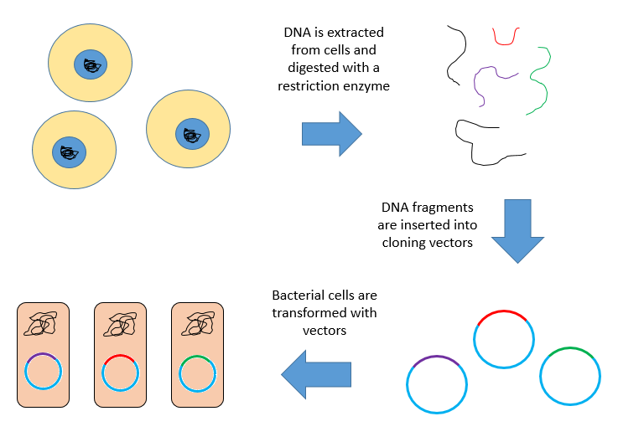
14.b) The first step in a PCR cycle is the denaturation step. This is the PCR step in which the hydrogen bonds holding the complementary strands of DNA together are broken. The second step in a PCR cycle is the annealing step. The annealing step is the PCR step in which the primers anneal, or attach, to the DNA template.
15.a) A small piece of circular DNA called a plasmid? is extracted from the bacteria or yeast cell. A small section is then cut out of the circular plasmid by restriction enzymes, 'molecular scissors'. The gene for human insulin is inserted into the gap in the plasmid. ... The more the cells divide, the more insulin is produced.
15.b) The first effort that definitely demonstrated the blockage in translation due to the use of antisense RNA in cell-free extracts (CFEs) was carried out by Singer et al. (1963) They showed that synthesis of polyphenylalanine in CFE with polyuridylic acid as template was completely inhibited when polyadenylic acid was added to the translation mixture. This write-up briefly describes the basic and applied aspects of antisense RNA technology, particularly in plant systems.
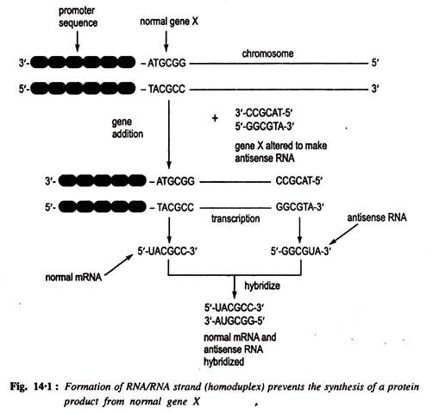
Part C 5 x 7 = 35
Answer ALL questions
Each answer should not exceed 200 words or one page

16. a) Restriction mapping involves the positioning of relative locations of restriction sites on a DNA fragment. ... When a large genomic DNA is digested with a frequent cutting enzyme, millions of DNA fragments are generated. Separation of these fragments by conventional agarose gel electrophoresis results in no discrete bands. A restriction digest is a procedure used in molecular biology to prepare DNA for analysis or other processing. It is sometimes termed DNA fragmentation (this term is used for other procedures as well). A restriction map is a map of known restriction sites within a sequence of DNA. Restriction mapping requires the use of restriction enzymes. ... Based on the sizes of the resultant DNA fragments the positions of the sites can be inferred.
16.b)Isolation and Purification of total DNA from bacterial cells.
1. Growing and harvesting of bacterial culture.
2. bacterial cell lysis and removal of cell debris.
3. Removal of contaminating biomolecules from cell extract.
4. Removal of RNA contamination.
5. precipitation and concentration of DNA.
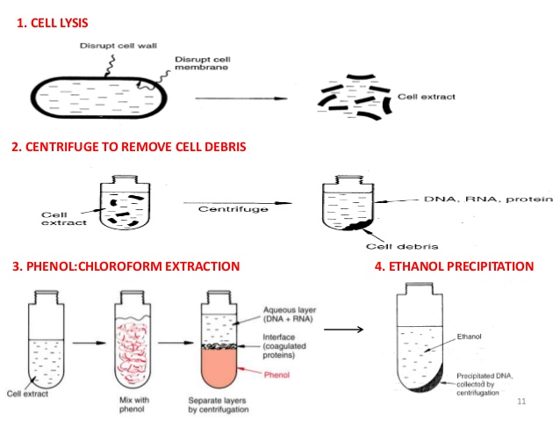

ISOLATION OF PLASMID DNA : Many methods have been developed to isolate plasmid DNA from the bacteria. These , methods invariably involve three steps: Growth of the bacterial culture: Plasmids are always purified from cultures grown in liquid media containing appropriate antibiotics that have been inoculated with a single bacterial colony picked from an agar plate. Many of the currently used plasmid vectors (e.g. pUC series) replicate to such a high copy number that they can be purified with a high yield from cultures that have been grown in late log phase in LB medium. Harvesting and lysis of bacteria: Bacteria are recovered by centrifugation and lysis by any one of the large number of methods including treatment with ionic or non ionic organic solvents, alkali or heat. The choice of the method is dictated by: (a) size of the plasmid; (b) the strain of E. coil; and (c) technique that will be subsequently used to purify the plasmid DNA. Purification of plasmid DNA: All the methods in common use exploit equilibrium centrifugation in CsCI- ethidium bromide gradient.
17.a) M13 Bacteriophage
- It is a filamentous bacteriophage composed of circular single stranded DNA
- The length is 6407 nucleotides
- It is encapsulated in 2700 copies of the major coat protein P8, capped with 5 copies of two different minor coat proteins (P9, P6, and P3).
- The minor P3 attaches to the receptor at the tip of the host E.Coli.
- It is not lethal but causes plaques in the bacterial cell
- It is a non-lytic virus
- The M13 phage is used for many recombinant DNA processes due to its extreme size and the virus has also been studied for its uses in nanostructures and nanotechnology
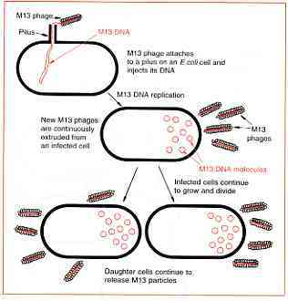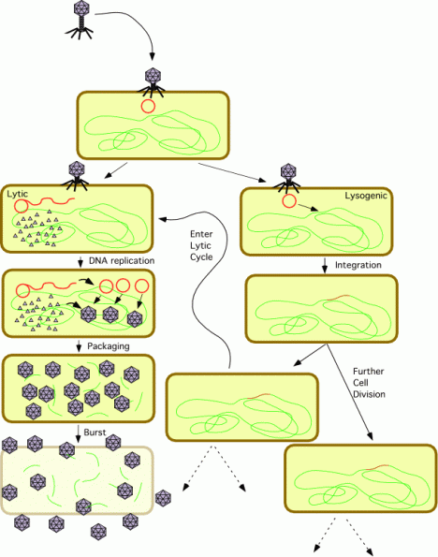
Lytic cycle
In this case the phage particle infects the bacterial cell and inserts the viral genetic material into it. The viral genetic material if is RNA uses reverse transcriptase enzyme to convert it to DNA and thus translates other building materials for a potential virion. The number of this virions increase at an exponential rate to burst the bacterial cell and set free to attack other baterial cells in the vicinity. This is a pretty fast rate of replication.
Lysogenic cycle
In this case the viral genetic material is incorporated into the bacteria’s own chromosome and thus is transferred to its progeny. When integrated with the host DNA the formation is called a prophage. And the phages able to cause lysogeny are called temperate phages. The virus remains dormant until the host conition deteriorates and once the stage reaches the viral DNA becomes active and thus causes lysis of the cell.
The prophages sometimes add more functions to the host cell. This is called lysogenic conversion. One famous example is the conversion of harmless viobrio cholerae by a phage into a highly virulent one. This is one reason why temperate phages are not used for phage therapy.
17.b) A Ti or tumour inducing plasmid is a plasmid that often, but not always, is a part of the genetic equipment that Agrobacterium tumefaciens and Agrobacterium rhizogenes use to transduce their genetic material to plants.
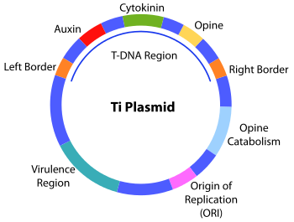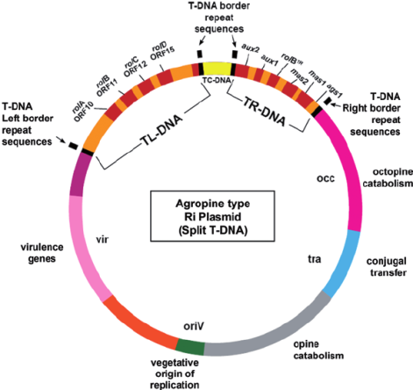
The abilities of Agrobacterium tumefaciens and A. rhizogenes to transform dicotyle‐dons and cause crown gall and hairy root disease are caused by the presence of tumor inducing (Ti) and root inducing (Ri) plasmids. During transformation plasmidT‐DNA (transferred DNA) is inserted into the plant genome.
18.a) There are three basic methods of producing transgenic animals:
- DNA microinjection
- Retrovirus-mediated gene transfer
- Embryonic stem cell-mediated gene transfer
Gene transfer by microinjection is the predominant method used to produce transgenic farm animals. Since the insertion of DNA results in a random process, transgenic animals are mated to ensure that their offspring acquire the desired transgene. However, the success rate of producing transgenic animals individually by these methods is very low and it may be more efficient to use cloning techniques to increase their numbers. For example, gene transfer studies revealed that only 0.6% of transgenic pigs were born with a desired gene after 7,000 eggs were injected with a specific transgene. 1. DNA Microinjection
The mouse was the first animal to undergo successful gene transfer using DNA microinjection. This method involves:
- transfer of a desired gene construct (of a single gene or a combination of genes that are recombined and then cloned) from another member of the same species or from a different species into the pronucleus of a reproductive cell.
- the manipulated cell, which first must be cultured in vitro (in a lab, not in a live animal) to develop to a specific embryonic phase, is then transferred to the recipient female.
2. Retrovirus-Mediated Gene Transfer
The second method produces chimeras, altered animals with mixed DNA.
A retrovirus is a virus that carries its genetic material in the form of RNA rather than DNA. This method involves retroviruses used as vectors to transfer genetic material into the host cell, resulting in a chimera, an organism consisting of tissues or parts of diverse genetic constitution chimeras are inbred for as many as 20 generations until homozygous (carrying the desired transgene in every cell) transgenic offspring are born
The method was successfully used in 1974 when a simian virus was inserted into mice embryos, resulting in mice carrying this DNA.
3. Embryonic Stem Cell-Mediated Gene Transfer
The presence of transgenes can be tested at the embryonic state in this third method.
This method involves isolation of totipotent stem cells (stem cells that can develop into any type of specialized cell) from embryos the desired gene is inserted into these cells
cells containing the desired DNA are incorporated into the host’s embryo, resulting in a chimeric animal Unlike the other two methods, which require live transgenic offspring to test for the presence of the desired transgene, this method allows testing for transgenes at the cell stage.

18.b) Intellectual property (IP) is a category of property that includes intangible creations of the human intellect, and primarily encompasses copyrights, patents, and trademarks. It also includes other types of rights, such as trade secrets, publicity rights, moral rights, and rights against unfair competition.
- Patents. A patent grants property rights on an invention, allowing the patent holder to exclude others from making, selling, or using the invention. ...
- Trademarks. ...
- Trade Secrets. ...
- Copyrights.
Intellectual Property Rights (IPRs) are dealt with by administrative procedures and legal proceedings. In terms of civil liabilities, the infringer may be ordered to stop the infringing act, eradicate the damage done, make public apologies or compensate for damages. In terms of administrative measures and criminal liabilities, they include warnings, orders to stop the infringing act, confiscation of unlawful gains, fines, and compensation for damages.

19.a) Biochemistry studies molecules such as DNA, RNA and proteins. Blotting techniques are what scientists use to separate these types of molecules. In cells, they exist as a mixture. Blotting allows researchers to find one protein among many, like a needle in a haystack. Blotting is generally done by letting a mixture of DNA, RNA or protein flow through a slab of gel. This gel allows small molecules to move faster than bigger ones. The separated molecules are then pressed against a membrane, which helps move the molecules from the gel onto the membrane. The molecules stick to the membrane, but stay in the same location, apart from each other, as if they were still in the gel.
Western Blot: Western blotting is a common technique for separating proteins by size, but in straight columns. These parallel columns allow researchers to compare the amount of a protein across different samples that are run right next to each other, like bowling lanes. For example, if you were testing the effect of different amounts of a drug on cell growth, you would treat four different groups of cells with a different amount of drug. Then you could break the cells open and run the proteins of each group in separate lanes on a gel. Spreading the proteins out in this way allows you to see what an increasing concentration of drugs does to a certain protein.
Northern Blot: Northern blotting is used to detect RNA. Cells can be broken open to release their RNA. The RNA from different cell types can be run on separate lanes on a gel. The gel spreads the different RNA by size. These neat, parallel rows of RNA allow a researcher to compare which cell type has how much of which RNA. This method allows a researcher to determine if cells from a certain disease have more of this RNA or less of that RNA. Northern blotting may reveal how a disease is working at the level of RNA production.

19.b) DNA fingerprinting is a technique used to identify and analyze the variations in various individuals at the level of DNA. It is based on variability and polymorphism in DNA sequences.Application:(1) It is used in forensic science to identify potential crime suspects.(2) It is used to establish paternity and family relationships.(3) It is used to identify and protect the commercial varieties of crops and livestock.(4) It is used to find out the evolutionary history of an organism and trace out the linkages between groups of various organisms.
20.a) In medicine, genetic engineering has been used to mass-produce insulin, human growth hormones, follistim (for treating infertility), human albumin, monoclonal antibodies, antihemophilic factors, vaccines, and many other drugs. In research, organisms are genetically engineered to discover the functions of certain genes. By genetic engineering a variety of medical products are available today. Among these products, insulin and human growth hormone were first commercially available products obtained from recombinant E. coli. Recombinant insulin is the result of successful genetic engineering. The initial production of insulin involved the separate synthesis of the insulin A- and B-chains in two bacterial strains. Both the insulin A and B chains genes were placed under the control of the lac promoter for inducible expression by lactose inducer. After purification of the A- and B-chains from the bacteria, the chains were then linked chemically to produce the final insulin. Recombinant-insulin is now commercially available in several forms and is involve in diabetes therapy.
20.b) Several commercial genetically engineered insect resistant crops have been released are transgenic corn, cotton potato which expresses Bt toxins. In North America these crops are already growing in vast area and many more transgenic plants are in the pipeline to release in other countries. Bacillus Thuringiensis — A Weapon for Insect Control:Bacillus thuringiensis is spore-forming gram-positive bacteria exist in many locations such as soil, plant surface, dust and grain storage. These are used as bioinsecticide for four decades. The bacteria were first discovered in 1901 from diseased silk worm larvae. Dr. Berliner isolated these killer bacteria from diseased flour moth larvae. They exhibit specific toxicity to mediterranean flour moth (Ephestia kuhnella) larvae and not to meal worm larvae.
VIRUS RESISTANCE PLANT
(i) Replication of inducer virus (mild strain) prevent availability of host cell component to challenge virus and prevent its replication, (ii) Coat protein produced by inducer virus encapsulate the RNA of challenger, thereby preventing its replication (iii) Uncoating or recoating of the challenge virus is blocked by free-coat protein of inducing virus. (iv) Sense or antisense RNA annealing between inducer and challenger virus and thereby preventing replication of the challenge virus.

*************

