A STUDY ON EXTRACTION, APPLICATION AND EVALUATION OF PADAUK WOOD DYE ON COTTON FABRIC

By
NITHYA, M.
(Reg. No. 11PBS08)

A THESIS SUBMITTED TO THE
AVINASHILINGAM INSTITUTE FOR HOME SCIENCE AND
HIGHER EDUCATION FOR WOMEN, UNIVERSITY
COIMBATORE – 641 043

IN PARTIAL FULFILLMENT OF THE REQUIREMENTS FOR THE DEGREE OF
MASTER OF SCIENCE IN BIO-TEXTILES

MAY 2013

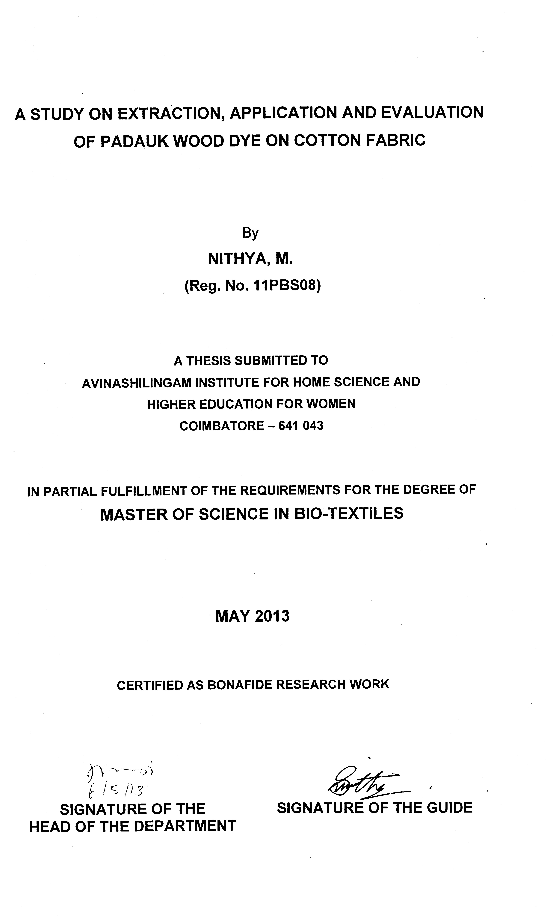

ACKNOWLEDGEMENT

First and foremost, the investigator places her humble salvations at the feet of GOD ALMIGHTY who has given sound wisdom and desertion knowledge, strength and opportunity to do the investigation effectively.
The investigator expresses her immense gratitude and thanks to THIRU.Dr.T.S.AVINASHILINGAM AYYA, Founder and First Chancellor of Avinashilingam Institute for Home Science and Higher Education for Women, Coimbatore, and HONY.COLONEL PADMASHRI Dr.(Tmt.) RAJAMMAL P. DEVADAS, M.A., M.Sc., Ph.D. (Ohio State), Hon. D.Sc. (Azad Agri. University, Kanpur), Former Chancellor, Avinashilingam Institute for Home Science and Higher Education for Women, Coimbatore, for providing and shaping this temple of learning.
The investigator wishes to express her immense gratitude to Dr.(Thiru) MEENAKSHI SUNDARAM, M.A., M.Phil., Ph.D. (Honoris Caussa), Anna Avl., Chancellor, Avinashilingam Institute for Home Science and Higher Education for Women, Coimbatore, for the opportunity to conduct research in this esteemed university.
The investigator owes her deep sense of gratitude and thankful to Dr.(Tmt.) SHEELA RAMACHANDRAN, M.Sc., P.G.Dip., Ph.D. (Avinashilingam), Vice-Chancellor, Avinashilingam Institute for Home Science and Higher Education for Women, Coimbatore, for providing all the amenities required and for her immense support in the conduct of the study.
The investigator expresses her respectful regards and sincere thanks to Dr.(Tmt.) GOWRI RAMAKRISHNAN, M.Sc. (Madras), M.Phil., Ph.D. (Avinashilingam), Registrar, Avinashilingam Institute for Home Science and Higher Education for Women, Coimbatore, for her encouragement towards the research.
The investigator expresses her respectful regards and heartful gratitude to Hon.Colonel. Dr.(Tmt.) SAROJA PRABHAKARAN, M.A., Dip. Ed. (Madras), Ph.D. (Mother Teresa), Former Vice-Chancellor, Director, Halls of Residence, Avinashilingam Institute for Home Science and Higher Education for Women, Coimbatore, for her encouragement and constructive suggestions for the successful conduct of the study.
The investigator records her respectful regards and tribute to Dr.(Tmt.) K.THANGAMANI, M.Sc., Dip. Ed., M.Phil., Ph.D., Dean, Faculty of Home Science, Avinashilingam Institute for Home Science and Higher Education for Women, Coimbatore, for her constant help and support at all times of need.
The investigator takes this opportunity to reveal thanks to Dr.(Tmt.) N.VASUGI RAAJA, M.Sc., M.B.A., M.Phil. (Madras), Ph.D. (Avinashilingam), Professor and Head, Department of Textiles and Clothing, Avinashilingam Institute for Home Science and Higher Education for Women, Coimbatore, for her encouragement and valuable help during the progress of her study.
The investigator expresses immensely indebted and extremely privileged to have worked under the supervision of her esteemed guide, Dr.(Tmt.) R.SUNITHA, M.Sc., M.Phil., Ph.D., Assistant Professor, Department of Textiles and Clothing, Avinashilingam Institute for Home Science and Higher Education for Women, Coimbatore, for her valuable guidance, technical support, timely help and constant encouragement throughout the study.
The investigator expresses her deep sense of gratitude to all the STAFF MEMBERS of the Department of Textiles and Clothing, Avinashilingam Institute for Home Science and Higher Education for Women, Coimbatore, for being supportive, suggestive, understanding and encouragement rendered towards the completion of her study.
The investigator expresses her special thanks to AVINASHILINGAM INSTITUTE FOR HOME SCIENCE AND HIGHER EDUCATION FOR WOMEN, SITRA and SIMA for providing library facilities and guidance provided.
Last, but not the least the investigator expresses her heartfelt thanks to her PARENTS, FAMILY MEMBERS and FRIENDS for their constant prayers, moral support and help rendered for the completion of the study.

CONTENTS

CHAPTER | TITLE |  |  |  |  |  |  | PAGE NO.
 | LIST OF TABLES
 | LIST OF FIGURES
 | LIST OF PLATES
 | LIST OF APPENDICES
1 | INTRODUCTION |  |  |  |  |  |  | 1
2 | REVIEW OF LITERATURE |  |  |  |  |  |  | 4
 | 2.1 | Natural Fibres |  |  |  |  |  | 5
 | 2.2 | Cellulosic Fibres |  |  |  |  |  | 5
 |  | 2.2.1 |  | Cotton |  |  |  | 5
 |  | 2.2.2 |  | History of Cotton |  |  |  | 6
 |  | 2.2.3 |  | Properties of Cotton |  |  |  | 6
 |  | 2.2.4 |  | Uses of Cotton |  |  |  | 7
 |  | 2.2.5 |  | Advantages of Cotton |  |  |  | 7
 |  | 2.2.6 |  | Disadvantages of Cotton |  |  |  | 7
 | 2.3 | Pretreatment |  |  |  |  |  | 7
 |  | 2.3.1 |  | Objectives of Pretreatment |  |  |  | 7
 | 2.4 | Natural Dye |  |  |  |  |  | 8
 |  | 2.4.1 |  | Classification of Natural Dye |  |  |  | 10
 |  | 2.4.2 |  | Advantages of Natural Dye |  |  |  | 10
 |  | 2.4.3 |  | Limitations of Natural Dye |  |  |  | 10
 | 2.5 | Mordant |  |  |  |  |  | 10
 |  | 2.5.1 |  | Classification of Mordants |  |  |  | 11
 |  | 2.5.2 |  | Mordanting Techniques |  |  |  | 11
 | 2.6 | Infants |  |  |  |  |  | 11
 |  | 2.6.1 |  | Infant Garments |  |  |  | 11
 |  | 2.6.2 |  | Requirement of Infant Clothing |  |  |  | 12
CHAPTER | TITLE |  |  |  |  |  |  | PAGE NO.
 |  | 2.6.3 |  | Jabla |  |  |  | 12
 |  | 2.6.4 |  | Panty |  |  |  | 12
 | 2.7 | Statistical Analysis |  |  |  |  |  | 12
3 | EXPERIMENTAL PROCEDURE |  |  |  |  |  |  | 13
 | 3.1 | Selection of Fabric |  |  |  |  |  | 14
 | 3.2 | Preparation of the Fabric |  |  |  |  |  | 14
 |  | 3.2.1 |  | Desizing |  |  |  | 14
 | 3.3 | Selection of Natural Dye Source |  |  |  |  |  | 15
 | 3.4 | Selection of Mordant |  |  |  |  |  | 15
 | 3.5 | Extraction of Dye |  |  |  |  |  | 18
 | 3.6 | Extraction of Mordant |  |  |  |  |  | 18
 | 3.7 | Pilot Study |  |  |  |  |  | 18
 |  | 3.7.1 |  | Optimization of Dyeing Parameters |  |  |  | 18
 |  |  |  | 3.7.1.1 |  | Optimization of Dye Concentration |  | 19
 |  |  |  | 3.7.1.2 |  | Optimization of Mordant Concentration |  | 19
 |  |  |  | 3.7.1.3 |  | Optimization of Temperature |  | 19
 |  |  |  | 3.7.1.4 |  | Optimization of time |  | 19
 | 3.8 | Mordant Dyeing of Fabric |  |  |  |  |  | 20
 |  | 3.8.1 |  | Pre Mordanting |  |  |  | 20
 |  | 3.8.2 |  | Simultaneous Mordanting |  |  |  | 20
 |  | 3.8.3 |  | Post Mordanting |  |  |  | 20
 | 3.9 |  | Product Preparation |  |  |  |  | 21
 |  |  | 3.9.1 |  | Construction of Garment |  |  | 21
 | 3.10 |  | Evaluation |  |  |  |  | 23
 |  |  | 3.10.1 |  | Subjective Evaluation |  |  | 23
 |  |  |  |  | 3.10.1.1 |  | Visual Assessment | 23
 |  |  | 3.10.2 |  | Objective Evaluation |  |  | 24
 |  |  |  |  | 3.10.2.1 |  | Optical Density | 24

CHAPTER | TITLE |  |  |  |  | PAGE NO.
 |  |  | 3.10.2.2 | Tensile Strength and Elongation |  | 24
 |  |  | 3.10.2.3 |  | Fabric Stiffness | 25
 |  |  | 3.10.2.4 |  | Fabric Thickness | 25
 |  |  | 3.10.2.5 |  | Fabric Weight | 26
 |  |  | 3.10.2.6 |  | Pillng Test | 26
 |  |  | 3.10.2.7 |  | Crease Recovery | 26
 |  |  | 3.10.2.8 |  | Drapeability | 28
 |  |  | 3.10.2.9 |  | Sinking Test | 28
 |  |  | 3.10.2.10 |  | Drop Test | 30
 |  |  | 3.10.2.11 |  | Capillary Rise Test | 30
 |  |  | 3.10.2.12 |  | Colour Fastness Test | 30
 |  |  | 3.10.2.13 |  | Analysis of Effluent | 32
 |  |  | 3.10.2.14 |  | Wear Study of the Prepared Garment | 35
 | 3.11 | Cost Estimation |  |  |  | 35
 | 3.12 | Nomenclature |  |  |  | 36
 | 3.13 | Statistical Analysis |  |  |  | 36
4 | RESULTS AND DISCUSSION |  |  |  |  | 37
 | 4.1 | Optimization of Dyeing Parameters |  |  |  | 37
 | 4.2 | Visual Assessment |  |  |  | 39
 | 4.3 | Comparison of Optical Density |  |  |  | 41
 | 4.4 | Tensile Strength |  |  |  | 43
 | 4.5 | Fabric Elongation |  |  |  | 47
 | 4.6 | Fabric Stiffness |  |  |  | 50
 | 4.7 | Fabric Thickness |  |  |  | 54
 | 4.8 | Fabric Weight |  |  |  | 55
 | 4.9 | Pilling Test |  |  |  | 57
 | 4.10 | Crease Recovery |  |  |  | 58
 | 4.11 | Drapeability |  |  |  | 60

CHAPTER | TITLE |  | PAGE NO.
 | 4.12 | Sinking Test | 61
 | 4.13 | Drop Test | 63
 | 4.14 | Capillary Rise Test | 64
 | 4.15 | Colour Fastness | 66
 | 4.16 | Biological Oxygen Demand | 68
 | 4.17 | Chemical Oxygen Demand | 68
 | 4.18 | Total Suspended Solids | 69
 | 4.19 | Total Dissolved Solids | 69
 | 4.20 | Cost Estimation | 71
5 | SUMMARY AND CONCLUSION |  | 72
 | BIBLIOGRAPHY
 | APPENDICES

LIST OF TABLES

TABLE NO. | TITLE | PAGE NO.
I | Recipe Used for Desizing | 15
II | Nomenclature | 36
III | Optimization of Dyeing Parameters | 37
IV | Visual Assessment (%) | 39
V | Pre Mordanting Technique | 41
VI | Post Mordanting Technique | 42
VII | Simultaneous Mordanting Technique | 43
VIII | Tensile Strength in Warp Direction | 44
IX | Tensile Strength in Weft Direction | 45
X | Fabric Elongation in Warp Direction (%) | 47
XI | Fabric Elongation in Weft Direction (%) | 49
XII | Fabric Stiffness in Warp Direction (inches) | 51
XIII | Fabric Stiffness in Weft Direction (inches) | 52
XIV | Fabric Thickness | 54
XV | Fabric Weight | 56
XVI | Pilling Test | 57
XVII | Crease Recovery Angle | 58
XVIII | Draepability | 60
XIX | Sinking Test | 61
XX | Drop Test | 63
XXI | Capillary Rise Test | 65
XXII | Colour Fastness Test | 66
XXIII | Biological Oxygen Demand | 68
XXIV | Chemical Oxygen Demand | 68
XXV | Total Suspended Solids | 69
XXVI | Total Dissolved Solids | 70
XXVII | Comparison Between Dyed and Wear Studied | 70
XXVIII | Cost Estimation | 71
LIST OF FIGURES

FIGURE NO. | TITLE | PAGE NO.
1 | Methodology | 13
2 | Optimization of Dyeing Parameters | 38
3 | Tensile Strength in Warp Direction | 44
4 | Tensile Strength in Weft Direction | 46
5 | Fabric Elongation in Warp Direction | 48
6 | Fabric Elongation in Weft Direction | 49
7 | Fabric Stiffness in Warp Direction | 51
8 | Fabric Stiffness in Weft Direction | 53
9 | Fabric Thickness | 55
10 | Fabric Weight | 56
11 | Crease Recovery | 59
12 | Drapeability | 60
13 | Sinking Test | 62
14 | Drop Test | 64
15 | Capillary Rise Test | 65

LIST OF PLATES

PLATE NO. | TITLE | PAGE NO.
1 | Padauk Bark | 16
II | Padauk Dye Powder | 16
III | Copper Sulphate | 16
IV | Potassium Di Chromate | 16
V | Sodium Sulphate | 17
VI | Pomegranate Rind Powder | 17
VII | Myrobalan | 17
VIII | Alum | 17
IX | Dye Solution | 22
X | Garment | 22
XI | Strength and Elongation Tester | 27
XII | Stiffness Tester | 27
XIII | Thickness Tester | 27
XIV | GSM Cutter | 27
XV | Electronic Weight Balance | 29
XVI | Crease Recovery Tester | 29
XVII | Pilling Tester | 29
XVIII | Drapability Tester | 29

LIST OF APPENDICES

APPENDIX NO. | TITLE
I | Cotton Sample
II | Dyed Sample
III | Proforma to Elicit Information Regarding Dyed Fabrics
IV | Jabla
V | Panty

1. INTRODUCTION

The Indian textile industry is one of the largest in the world with a massive raw material and textiles manufacturing base. Our economy is largely dependent on the textile manufacturing and trade in addition to other major industries. About 27 per cent of the foreign exchange earnings are on account of textiles and clothing export alone. The textiles and clothing sector contributes about 14 per cent to the industrial production and three per cent to the gross domestic product of the country (www.fibre2fashion.com).
Textile industry uses a wide assortment of natural fibres, changing fads, innovations in the textile technology, globalization, amount of disposable income in the hands of consumers and supply chain have all influenced the consumption of fibres considerably. Besides their input in textile production, natural fibres contribute to providing employment opportunities to millions of people, and enable economic development in many countries (www.fibre2fashion.com). Worldwide emphasis is given today for production of fabric using and application techniques with minimum damage to ecology (Patra, 1998).
Natural fibres are those renewable fibres that are obtained from plants, and animals which are transformed into yarn for textiles. They are taken from plant, leaf, inner bark, or fruit seed, insect cocoon, animal wool or hair, or from any mineral product. The average annual production of natural fibres globally is estimated to be around 30 million tonnes (Kozlowski, 2012).
Cotton the natural vegetable fibre which is considered for its natural aesthetic and comfort characteristics is the oldest raw material for textiles and is suitable for all weather. The consumption of cotton is almost half of the world’s total fibre consumption and it is expected to maintain this position during the current century (Mangut et al., 2008).
Dyeing is the process of adding colour to textile products like fibre, yarn and fabric. The temperature and time controlling are two key factors in dyeing. There are two main classes of dye natural and manmade. The primary source of dye, historically has generally been nature, with the dyes being extracted from animals or plants. Since the mid 18th century, however, humans have produced artificial dyes to achieve a broader range of colours and to render the dyes more stable to resist washing and general use (Broughton, 1996).
Natural dyes have been used since ancient times for colouring and printing fabric. Until the middle of last century most of the dyes were derived from plants or animal sources by long elaborate processes (Smith, 2006). Until the latter half of the 19th century people were using natural dye for colouring the textile fabric. After the invention of synthetic dye, natural dyes are not used because of the advantages of synthetic dye over natural dye in respect of application, colour range and availability. But some of the synthetic dyes are not good due to their toxic effect and it creates allergic reaction to skin and contaminant our environment (Saha and Datta, 2008).
The use of natural dyes have increased substantially during the last couple of years because of the carcinogenic nature of the synthetic dyes. The production of synthetic dyes involves many violent reactions and during the manufacturing process such chemicals are required which cause environmental pollution (Gahlot et al., 2008). Textile processing industry is one of the major environmental polluters. In order to process a ton of textiles, one might have to use as much as 230 to 270 tonnes of water. The effluent generated by this such water would pollute the environment as it contains heavy load of chemicals including dyes used during textile processing (Korkmaz et al., 2007).
Worldwide emphasis is given today for production of fabric using products and application techniques with minimum damage of ecology (Patra, 1998). Due to health hazards and environmental problems associated with the use of synthetic dyes, people have realized the utility of natural dyes and moved towards it with scientific background (Khan et al., 2004).
Dyes do not interact directly with the material they are intended to colour. Natural dyes are substantive and require a mordant to fix to the fabric and prevent the colour from either fading with exposure to light or washing out. These compounds bind the natural dyes to the fabrics (Shivankar et al., 2011). The mordant used for enhancement in fastness as well as to obtain variability in colour (Dheeraj et al., 2003).
Considering all the above facts, the investigator selected the “STUDY ON EXTRACTION, APPLICATION AND EVALUATION OF PADAUK WOOD DYE ON COTTON FABRIC” with the following objectives.
OBJECTIVES
- To extract dye from natural source
- To apply the extracted dye on cotton fabric
- To compare the eco-friendly and metallic mordants
- To evaluate the dyed fabrics.

2. REVIEW OF LITERATURE
The review of literature pertaining to “A STUDY ON EXTRACTION, APPLICATION AND EVALUATION OF PADAUK WOOD DYE ON COTTON FABRIC” are discussed under the following headings :
2.1 Natural Fibres
2.2 Cellulosic Fibres
2.2.1 Cotton
2.2.2 History of Cotton
2.2.3 Properties of Cotton
2.2.4 Uses of Cotton
2.2.5 Advantages of Cotton
2.2.6 Disadvantages of Cotton
2.3 Pretreatment
2.3.1 Objectives of Pretreatment
2.4 Natural Dye
2.4.1 Classification of Natural Dye
2.4.2 Advantages of Natural Dye
2.4.3 Limitations of Natural Dye
2.5 Mordant
2.5.1 Classification of Mordants
2.5.2 Mordanting Techniques
2.6 Infants
2.6.1 Infant Garments
2.6.2 Requirement of Infant Clothing
2.6.3 Jabla
2.6.4 Panty
2.7 Statistical Analysis

2.1 NATURAL FIBRES
Natural fibres are those which are obtained from natural source or grow in nature. Among them cotton, jute, flax, wax and silk are important in terms of production, industrial activity and usage pattern (Jindal, 2006). These biodegradable fibres are considered as sustainable, environmentally responsible fibres (Yates, 2002).
2.2 CELLULOSIC FIBRES
Natural cellulosic fibres means fibres comprising of celobiase monomers as their main compounds (Hollen and Saddler, 1973). The properties of cellulosic fibres that they have relatively low elasticity and resilience, high absorbency and moisture regain, easy dye affinity and wear and good conductors of heat and electricity (Gollier and Tortora, 2001)
2.2.1 Cotton
Cotton is a fibre that grows from the surface of seeds in the pods, or bolls, of a bushy mallow plant. It is composed basically of a substance called cellulase (Palsingh, 2004). Cotton is a soft, staple fibre that grows in a form known as a bool around the seeds of the cotton plant a shrub native to tropical and subtropical regions are the world, including the America, India and Africa (Rastogi, 2009).
Cotton is dyeable in either fabric, yarn or fibre. For the cotton to the dyed efficiently, it has to be properly prepared by employing operation such as desizing, scouring and bleaching. These treatments are designed to clean cotton by removing impurities, non-cellulosic constituent and other unwanted substances and to increase the affinity of cellulose of dyes (Meena and Nachane, 2001).
Each fibre is a single elongated cell that is flat, twist and ribbon like with a wide inner hollow. It is composed of about 90 per cent cellulose and about six per cent moisture, the remaining consist of natural impurities. The outer surface of fibre is covered with protective wax like coating, which gives the fibre a somewhat adhesive quality (Ghosh, 2004).
2.2.2 History of Cotton
Cotton has been cultivated for more than 5000 years. Archeological finds indicate cotton was grown and used for textile purpose in the Indus valley well before 2100 B.C. in Mexico by 3500 B.C. in Perce by 2500 B.C. Cotton was used extensively in med passion Empire and may have been used in ancient Egypt as well. The word cotton comes from the Arabic word “Qutum” (Joseph, 1980). Cotton is the backbone of the world’s textile trade. It is also known as “king of fibres” and “white gold” (Bhat and Choudhari, 2011).
2.2.3 Properties of Cotton
Cotton chemically consists of 88.96 per cent pure cellulose along with protein, pectin substances (Naik and Wilson, 2006). Cotton fibres are made up of cellulose, which constitutes approximately 90 per cent. In additional to this water in 5.8 per cent and the rest weight is contributes by other natural impurities (Gupta, 2009).
Mostly cotton fibres 8.5 per cent of moisture but it has the ability to absorb 15 per cent to 20 per cent of the moisture due to these properties it takes time while drying (Vankar, 2008). Cotton fibres have the ability to conduct heat energy, minimizing and destructive heat accumulation and they cannot withstand ironing temperature excessive application of heat energy, causes the cotton fibre to burn without any prices melting (Gohl and Vilensky, 2008). Exposure to air in presence of sunlight for a long period will have an effect on cotton like that of heat (Banis et al., 2007). Strength of fibre is indicated by the ability to resist being pulled or torn apart when subjected to stress or tension (Narinder and Singh, 2004).

2.2.4 Uses of Cotton
Cotton is used to make a number of textile products. It has many versatile intrinsic qualities that make it a fibre for all masses and occasion, cotton upholstery fabrics are attractive and durable, comfortable, easy to spot clean and retain their appearance (Rastogi, 2009).
2.2.5 Advantages of Cotton
Cotton can be easily dyed with various colours, because of its high absorbent property. Cotton is a good conductor of heat. Cotton does not contain any chemicals and therefore is a natural product (Devi et al., 2002). Cotton has ability to take up a wide range of dye stuff, production, cost in low and is comfortable to wear (Rathi et al., 1999).
2.2.6 Disadvantages of Cotton
Cotton fabric fades quickly, which means they are not colour fast. Cotton wrinkles easily and often needs special care after it is washed, ironing, pressing and steaming are usually needed cotton blends will hold their value and shape much longer (Further et al., 2007).
2.3 PRETREATMENT
The aim of pretreatment is to remove all natural and added impurities from cotton, impart uniform and instant absorbency and uniform whiteness required for dyeing and optical brightening (Naresh et al., 2005).
2.3.1 Objectives of Pretreatment
Pretreatment of the fabric is done
- to convert it from hydrophobic to hydrophilic state,
- to remove dust, dirt, and other materials from it.
- to achieve the degree of desire whiteness (Hauser, 2011).
Desizing is the process of removing the size material from the warp yarns in woven fabrics. Desizing process involves impregnation of the fabric with the desizing agent and allowing it to degrade or solubilise the size materials and finally to wash out degradation products (www.wikipedia.org). Bleaching is the process of removal of natural colouring matters and add-ons in the form of pesticides, fungicides, sizes and lubricants. The objective of bleaching operations is to reduce the formation of polluting by products, particularly organo chlorinated products (Kumaresan et al., 2012). Mercerization is a treatment with caustic soda for the purpose of increasing strength, lustre and dye affinity of cotton yarn or cloth (Hollen and Saddler, 1973).
2.4 NATURAL DYE
Natural dyes are the colourants extracted from vegetable matter, minerals or insects (Indi and Chinta, 2008). Natural dyes containing natural colouring matter which is neither carcinogenic nor hazardous to environment (Adeer and Osman, 2012). Natural dyes are famous for creating variety of shades with the help of natural and metallic mordants. The unexpected discovery of synthetic dye “mauvein” by Sir W.H.Perkin in 1856, sounded the death kneel of natural dyes, industries of world. But, now with the increased environmental awareness and health hazards associated with the use of synthetic dyes have led to the revival of natural dyes (Anjali et al., 2007).
Natural dyes exhibit better biodegradability and have higher compatibility towards environment due to which they are attracting the attention around the globe. The natural colouring substances, which passed through competitions with their synthetic counterparts are now developing an increasing trend for their use all over the world because of health hazards, long use poison, effects and toxicity problems created by synthetic dyes (Agarwal, 1997).
Use of natural dyes on textile material has become very much popular throughout the world due to its eco-friendliness, environ-friendliness, ancient heritage and aesthetic approach. Since 1990 till date so many research workers are giving their enormous efforts behind searching different new sources and different method of application (Kumar, 2006).
Today consumer understand the value for money and therefore, organic non-toxic products in every field have created a new icon. So, textiles using eco-friendly natural dyes on natural fibre is a present trend in its field. Natural dyes application on textiles is acknowledged since ancient past (Ghosh et al., 1994). Today the protection of environment has become a challenge for the chemical industry worldwide and the water pollution caused by synthetic dyes in particular. The control of effluent continue to be a problem. Although the most attention has been paid to modifying synthetic dyeing process, the need to realize the importance and explore the technology of natural dyes is more urgent. It is considered that natural dyes yield luster, rich colour, aromatic smell, soft light and shadow, soothing to human eyes and so very good source of colour experimentation on quality on natural fibres (Mukherjee, 1999).
In recent years a lot of awareness concern has developed over the environmental issues. Health hazards caused by synthetic dyes in particular continue to be serious problem. Therefore, a large number of synthetic dyes have been banned by Germany so there is a need to carry out extensive research work for developing natural dyes which can be used as safer alternative to synthetic dyes (Gill and Singh, 2005). Presently there is trend towards the use of natural dyes throughout the world, it is due to the eco-friendly nature of these colours as their production and application do not cause pollution or disturb our eco-system. Moreover, these are obtained from renewable sources having no health hazards and no disposable problems (Sachan and Kapoor, 2004).

2.4.1 Classification of Natural Dye
The natural dyes can be classified, based on various features like Colour – Red, blue, yellow, Chemical Structure Classification – Amines, Ketone, Polymethine, Anthraquanides, Flavines, Indigoids and Source Classification – Animal, Plant (Bark, root, fruits, leaves) and minerals (Shivankar et al., 2011).
2.4.2 Advantages of Natural Dye
The advantages of natural dyes that they have high diversity of rich and complex natural dye colours, beauty of colours, they allow for endless experimentation and replication of ancient techniques and are not dependent on non-renewable source (Gotipamul and Velapure, 2012). The natural dyes are harmonized with nature as extraction involves mild or no chemical reaction and pose no health hazards (Kumar et al., 2012). There is no disposal problem in natural dyes (Kumar and Choudhury, 2006).
2.4.3 Limitations of Natural Dye
The limitation of natural dyes are poor availability, poor colour yield, complexity of conventional dyeing process, inadequate degree of fixation and inadequate fastness properties (Das and Shah, 2011). The limitation of natural dyes are that they are difficult to standardize and blend and they need lengthy dyeing procedures and their non availability (Kumar et al., 2006).
2.5 MORDANT
Mordant is the fixing agent which prevents the colour either fading with exposure to light or washing out. Mineral salts help the dye to adhere the material while dyeing. Some natural dyes also have properties of mordant (Saha and Datta, 2008). Majority of natural dyes have no strong affinity for the fibres and require a chemical in the form of metal salts to create an affinity between the fibre and the dye. These chemicals are known as ‘mordant’. A mordant has an affinity both the dye and fibre, where some substantive dyes are capable of being fixed directly, the mordants helps to produce faster shades by forming an insoluble compound (Karamakar, 2007).
2.5.1 Classification of Mordants
The mordants are classified as metal salts or metallic mordants, tannins or tannic acid and oils and oil mordants. Metal salts or metallic mordants – alum potassium dichromate, ferrous sulphates, copper sulphate, stannous chloride, tannins and tannic acid – harda and tannic acid, etc. Oil mordants – madder oil (Nadiger et al., 2004).
2.5.2 Mordanting Techniques
The mordanting is of three types namely, (1) Premordanting, (2) Simultaneous mordanting and (3) Post mordanting (Rani and Sing, 2004). In pre mordanting, the sample is mordanted and then dyed. Post mordanting the sample is first dyed and the mordanted simultaneous mordanting in which mordanting and dyeing are carried out the same time (Kumar et al., 2012).
2.6 INFANTS
Infancy, period from birth to about two years of age. This first stage of life is an important time, characterized by physical and emotional growth and development. During the first 24 months the average child makes considerable gains in height and weight. Hence, special emphasis should be placed upon children and their needs. The clothes should be designed and stitched according to their age and activities (Shodh and Mulyankan, 2009).
2.6.1 Infant Garments
According to the seasons, the material should be selected like thick or thin. Normally soft materials with light weight should be selected. Infants garments are most suitable and appropriate when made of fine materials by hand and with very little trimmings. The very narrow laces ¼ to ½ inch wide, fine tatting, tiny embroidery headings. During this age, the head does not correctly stand on their neck, so garments should be selected with full opening (www.chesofbooks.com).
2.6.2 Requirements of Infant Clothing
The ideal infant clothing should be soft, comfortable, easy to put on and take off and comparatively loose. It should be easy access to his / her nappy because it requires frequent changing. They should be non-flammable, light weight, non-irritating. Underclothes should be essentially made of organic fibres it should be. Allow quick transmission of sweat from skin to environment (www.indiantextilejournal.com).
2.6.3 Jabla
Jabla is a loose garment. In order to protect children from the heat jabla is used. These are made in raglon, maghyar, sleeve and sleeveless it is decorated by painting, lace and embroidery (Verma and Dev, 1999).
2.6.4 Panty
It is for the use by an infant and child. It is made in different design and is decorated. It is made both elastic and simple.
2.7 STATISTICAL ANALYSIS
The ‘F’ test is named in honour of the great statistician R.A.Fisher. The object of the ‘F’ test is to find out whether the two independent estimates of populations variance differ significantly or whether the two samples may be regarded as drawn from the normal populations having the same variance for carrying out the test of significance (Gupta, 2009).

3. EXPERIMENTAL PROCEDURE

The experimental procedure followed for the study has been explained in Figure – 1.
Objective – Optical Density Value
Subjective – Visual Assessment
Effluent
Fabric
Selection of fabric
Pretreatment
Selection of dye source
Selection of mordant
Pilot study
(Dyeing and mordanting optimization)
Selection of Temperature, Dye Concentration, Time and Mordant Concentration
Evaluation
Selection of mordanting technique
Mordant dyeing of fabric
Evaluation
Preparation of product
Wear study

FIGURE – 1
METHODOLOGY
3.1 SELECTION OF FABRIC
Cotton possess the property of being a naturally breathing fibre is suitable for absorbing body fluids such as perspiration, blood and other body fluids and so useful for clothes that directly touch the skin. Cotton possesses many excellent qualities such as coolness, durability, good absorbency, high tensile strength, good abrasion resistance and low cost (Kaplan, 2002). Cotton fabrics have ability to conduct heat energy, minimize heat accumulation and can be easily dyed with various colours, because of its high absorbent property (David, 2005). Hence the plain woven 100 per cent cotton fabric was selected for the study. The details and swatch of the cotton fabric are given in Appendix – I.
3.2 PREPARATION OF THE FABRIC
The aim of the preparatory process is improving the quality, by removing impurities and foreign matters thoroughly and uniformly from the fabric to make the fabric suitable for follow up process (Antappan et al., 2006). Hence to improve the quality of the fabric, it was prepared by desizing.
In textile wet processing the main raw material used virtually at every stage is water. The quality of textile products by every manufacture which employs wet processes such as preparatory, dyeing and printing, finishing is affected by water quality (Nachane and Desai, 2011). So soft water was used for each and every stage of the dyeing process.
3.2.1 Desizing
Desizing is done in order to remove the sizing material from the woven fabrics (Horrocks et al., 2000). Therefore desizing was carried out as the preparatory process for improving the dye affinity of the fabric. The recipe used for desizing is given in Table – I.

TABLE – I
RECIPE USED FOR DESIZING
S.No. | Particulars | Parameters
1. | Material (kg) | 1
2. | Water (litres) | 10
3. | Detergent powder (grams) | 25
4. | Temperature (°C) | 100
5. | Time (minutes) | 60
Ten litres of cold water was taken with 25 grams of detergent powder. This was mixed thoroughly. The material was immersed in the solution in the water bath and boiled for 60 minutes. Then the material was taken out, rinsed thoroughly in several changes of cold water and dried in shade.
3.3 SELECTION OF NATURAL DYE SOURCE
Dyeing with natural dye is carried out mainly from natural raw materials in powder from original root, bark, leaves and flowers (Bhattacharya et al., 2004). The dye source selected for the study was padauk wood (Pterocarpus echinatus) powder (Plates – I and II) obtained from the bark of the padauk tree.
3.4 SELECTION OF MORDANT
Mordant is considered as an integral part of the natural dyeing process to improve the affinity and uptake of the dye (Bhargava et al., 2011). Majority of natural dyes require chemical in the form of metal salts to create an affinity between the fabric and the dye, which are used as mordants (Aspland, 1997). Hence the few metallic mordants namely copper sulphate, potassium dichromate and sodium sulphate (Plates – III, IV and V), and natural mordants namely pomegranate rind and myrobolan (Plates – VI and VII) and the safe mordant Alum (Plate – VIII) were selected for the study.

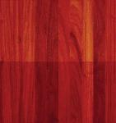 | 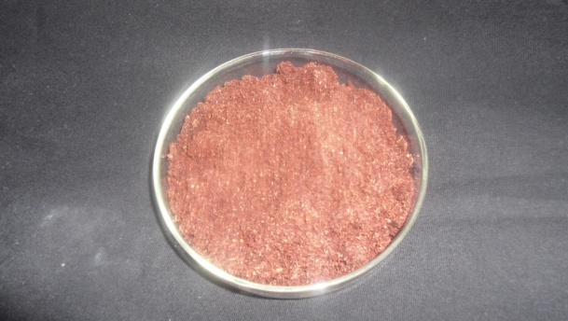
PLATE – I  PADAUK BARK | PLATE – II  PADAUK DYE POWDER
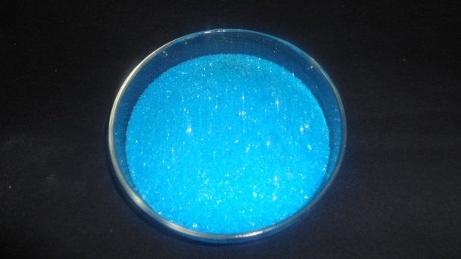 | 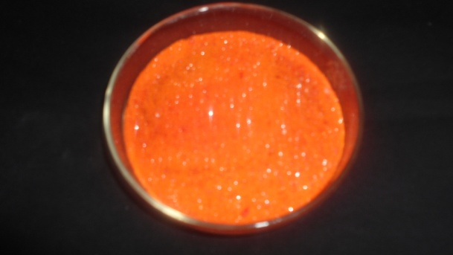
PLATE – III  COPPER SULPHATE | PLATE – IV  POTASSIUM DI CHROMATE

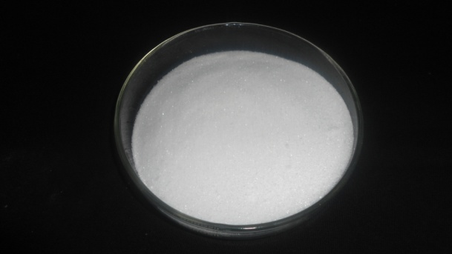 | 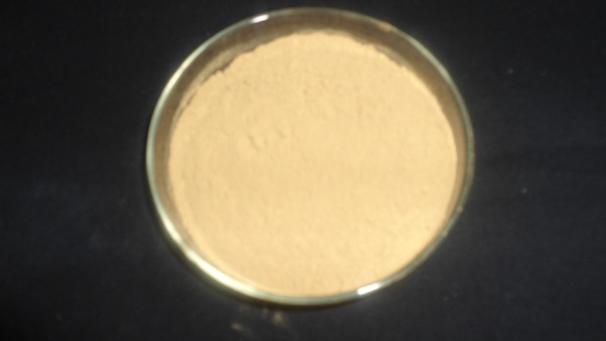
PLATE – V  SODIUM SULPHATE | PLATE – VI  POMEGRANATE RIND POWDER
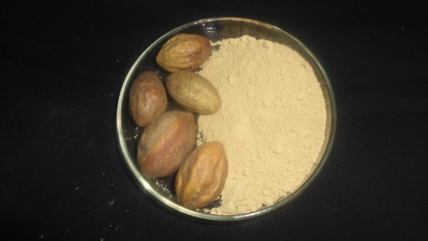 | 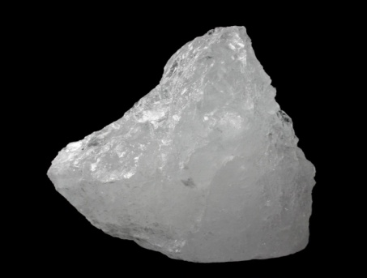
PLATE – VII  MYROBALAN | PLATE – VIII  ALUM

3.5 EXTRACTION OF DYE
Required quantity of dye powder was taken and soaked in water for 24 hours, it was then boiled at simmering point (90 - 92°C) for 60 minutes. The solution was filtered with a clean filter paper, thus the filtrate obtained is the extracted liquid dye (Plate – IX).
3.6 EXTRACTION OF MORDANT
Required quantity of mordant powder was taken and soaked in water for 4 hours. After soaking it was boiled at simmering point for 30 minutes. The boiled solution was filtered using clean filter paper. This extracted mordant solution was used for mordanting.
3.7 PILOT STUDY
Pilot study is a preliminary study conducted on a limited scale before the original studies are carried out in order to gain some primary informations, on the basis of which the main project would be planned and formulated. The preliminary study of the universe helps to acquire a general knowledge about the problem which ultimately helps to know the nature and different aspects of the problem (Saravanavel, 2009). Hence the pilot study was carried out for the study and the parameters namely dye concentration, mordant concentration, temperature and time were optimized.
3.7.1 Optimization of Dyeing Parameters
Optimization is a very important technique for dyeing of the fabric and is carried out to make the dyeing process more effective. It helps to choose the optical parameters for further process. Dyeing with natural dyes was optimized for various parameters namely dye concentration, mordant concentration, dyeing time and dyeing temperature.

3.7.1.1 Optimization of Dye Concentration
The dye concentration was optimized by keeping temperature and time as constant. The various concentrations tried were 10, 15, 20 and 25 grams with 250 ml of water. For each concentration optical density value was assessed using nano UV visible spectrophotometer. The concentration which gave the highest optical density value was considered for further study.
3.7.1.2 Optimization of Mordant Concentration
Various quantities of mordants were taken separately and fabric samples were entered separately in each mordant bath and mordanted. The mordant concentrations namely 5, 10, 15 and 20 grams per 100 ml water were selected for optimization. The optical density of mordant solution before and after dyeing at different mordant concentrations was measured with help of a Nano UV visible spectrometer and the percentage of absorption by each sample was noted. The mordant concentration which gave the highest OD value was selected for further study.
3.7.1.3 Optimization of Temperature
Four different temperatures namely 60°C, 70°C, 80°C and 90°C were selected for optimization. The optical density values were noted at different temperature. The temperature at which the optical density value was the highest was selected for further study.
3.7.1.4 Optimization of Time
Dye extraction temperature and dye concentration were kept constant. Four different time durations such as 15, 30, 45 and 60 minutes were selected for the study. The optical density of the solution was measured at different timings. The duration which gave maximum optical density reading was taken for further study.
Thus from the pilot study the dye concentration, mordant concentration, time and temperature were determined.
3.8 MORDANT DYEING OF FABRIC
The optimized conditions were utilized for mordant dyeing. There are three types of mordanting techniques namely pre mordanting, post mordanting and simultaneous mordanting. These methods were adopted for the study.
3.8.1 Pre Mordanting
The cotton material was wetted and squeezed well. The fabric was entered into mordant bath. The mordanting was carried out for 30 minutes. After mordanting the fabric was entered into dye bath. The dyeing was carried out for one hour. After dyeing the fabric was taken out, washed with soft water and dried in shade.
3.8.2 Post Mordanting
The cotton material was wetted and squeezed well. The material was entered into dye bath. The dyeing was carried for one hour. After dyeing the fabric was squeezed and entered into solution bath containing mordant. After mordanting the material was washed thoroughly in soft water and dried in shade.
These dyed fabric samples (Appendix – II) were subjected to evaluation and the sample which gave the best result for strength and comfort properties were selected for this study.
3.8.3 Simultaneous Mordanting
In this method mordanting and dyeing were carried out simultaneously. The cotton material was wetted and squeezed well and entered into the dye bath containing dye and mordant. The dyeing was carried out for one hour. After dyeing the fabric was taken out, washed with soft water and dried in shade.

3.9 PRODUCT PREPARATION
The evaluation of fabric for various salient properties were done and dyed fabric which gave the best results for essential properties was selected for preparation of product. The products developed were Jabla and Panties for the infant (Plate – X).
3.9.1 Construction of Garment
The products prepared were jabla and panties for infant. About four sets of jablas and panties were prepared as per the instructions. Two extra panties were prepared as bed wetting in the common problem of an infant (Plate – X).
- Jabla
- Measurements used for Jabla
Full length - 32.5 cm
Chest round - 36 cm
Armhole circumference - 13 cm
Sleeve length - 5 cm
- Drafting Procedure
AB - Full length
AC - 1/4 chest
CE - 1/2 of armhole circumference
DF - 1/4°
CJ - 62 cm
GH - Front neck
GI - Back neck
AG - 1/2 chest
- Construction Method
The armhole was finished with bias binding and an extension for tubing was given for tieing finish the side seam finish the neck line and finish the hem line. The sides, seam neckline and hemline were finished (Appendix – III).
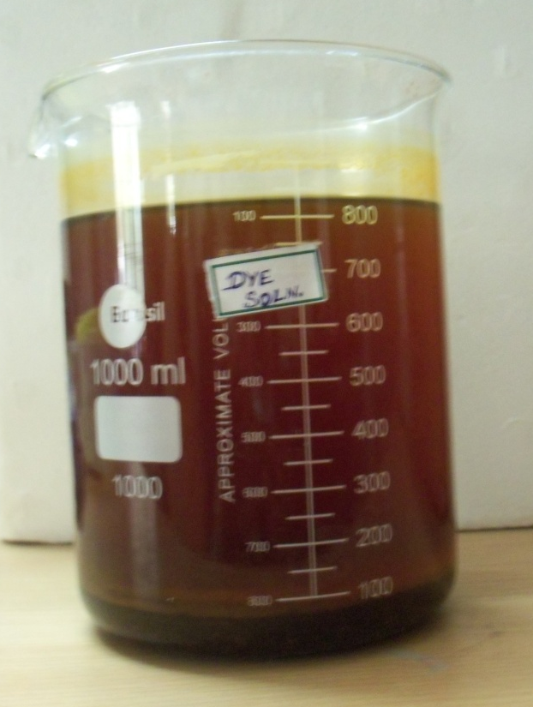
PLATE – IX
DYE SOLUTION


PLATE – X
GARMENT
- Panty
- Measurements used for Panty
Seat round - 32 cm
- Drafting Procedure
AB - 1/3 Seat round + 5 cm
BF - 1/12 Seat round
E is mid point of DC
Joint EF
G is midpoint of EF
GG₁ and GG₂ - 1.25 cm
AH - 1.25 cm
- Construction Method
The side seam and crotch seams were finished. The waist line was finished with the attachment of elastic. The leg opening was completed by folding. Thus the jablas and panties were constructed. The constructed garments were wear studied and analysed for colour fastness (Appendix – IV).
3.10 EVALUATION
The evaluation was carried by both subjective and objective tests.
3.10.1 Subjective Evaluation
The samples were subjectively analysed by visual assessment.
3.10.1.1 Visual Assessment
The dyed samples were evaluated by 20 judges comprising of post graduate students of Textiles and Clothing Department, Avinashilingam Institute for Home Science and Higher Education for Women, Coimbatore. The samples were displayed and the judges were asked to evaluate the samples as per the proforma for the parameters namely evenness in dye, brilliancy of colour texture, luster and general appearance (Appendix – III).
3.10.2 Objective Evaluation
The textile testing plays a crucial part in production process, as a result of mechanical properties on fabrics for undergoing evaluations. The desized original sample and the dyed samples were tested for their respective laboratory tests namely fabric weight, fabric thickness, tensile strength and elongation, pilling test, stiffness, crease recovery, wet ability and absorbency tests, and colour fastness tests.
3.10.2.1 Optical Density
Nano UV visible spectrophotometer instrument was used to find out the optical density value for optimization of dyeing. One drop of dye solution is kept at sample surface and then click measure option. The UV nano spectrophotometer shows the percentage of absorbency level. The same procedure was repeated for before and after dyeing. A absorbency percentage was calculated using the formula.
Optical density =x 100
3.10.2.2 Tensile Strength and Elongation
Tensile strength is the force required to break the fabric when it is under tension (Vaishnav and Joshi, 2000). Elongation is the extent to which the fabric under tension extends, till it gets cut off (Nakamura, 2000). To determine the fabric strength, strip method was selected. The tensile strength and elongation was tested using Eureka Model Tensile Strength Tester (Plate – XI). The rate of transverse and capacity of the machine was 45 cm per minute. The gauge length was kept as 25 cm and the dial of the machine was calibrated in pounds and kilograms.
The test sample from each of the dyed material with minimum length of 33 cm and width of 7 cm were cut from the warp and weft directions separately. Each sample was ravealed from both the edges until the width measured 5 cm, each sample was mounted between two jaws. Care was taken to see that the sample was perpendicular to the load. The load was applied until the sample was torn. The dial reading in kilogram for tensile strength and elongation in centimeters in the scale was noted. The samples were tested and readings were noted for each sample or original, desized and dyed samples. Mean value was calculated and recorded. The tensile strength and elongation of each material separately for both warp and weft directions were observed.
3.10.2.3 Fabric Stiffness
This test method covers the measurement of stiffness properties of fabrics. Bending length is measured and flexural rigidity is calculated. ASTM D 1388. To carry out a test the specimen is cut to size 6 inches x 1 inch with the aid of the template. Both the template and specimen are transferred to the platform with the fabric underneath. Both are slowly pushed toward. The strip of the fabric will commence to droop over the edge of the platform and the movement of template and the fabric is continued until the tip of the specimen viewed in the mirror cuts both index lines. The bending length can immediately be read off from the scale mark opposite a zero line engraved on the side of the platform. Each specimen is tested four times, at each end and again with the strip turned over in this way five samples are tested. Finally mean values for the bending length in warp and weft directions were calculated and recorded (Plate – XII).
3.10.2.4 Fabric Thickness
Fabric thickness is defined as the distance between upper and lower surface of the material as measured under standard pressure (Storer, 1999). The difference in thickness of the samples were found out by using Thickness Tester.
The fabric was placed between the pressure foot and anvil. The reading was noted from the dial. The readings were taken from original, desized and the dyed samples. The mean value was then calculated and recorded (Plate – XIII).
3.10.2.5 Fabric Weight
Fabric weight is an important component when comparing two similar fabric constructions, it refers to the relative weight of the fabric it may be expressed as the weight of particular size such as gram per square meter or ounce per square yard (Paul, 2005). A sample was cut using GSM cutter (Plate – XIV) and it was weighed in the electronic weighing balance (Place – XV). The same procedure was repeated for the original, desized ad dyed samples and their mean value was calculated and recorded.
3.10.2.6 Pilling Test
The pilling of a fabric is a fault on the fabric surface characterized by little “pills” to the cloth surface and giving the garment an unsightly appearance. Pills are termed during wear and washing by the entanglement of loose fibres which produce from the fabric surface. These loose fibres under the influence of the rubbing action, develop into small spherical bundles, anchored to the fabric by two broken fibres (Raul, 1984).
Fold each specimen face side inwards so that the notches coincide exactly at this points sewn exactly along the line between the pairs of notches. Place the mounted specimen edge of about 7 mm. Close the lids set the machine to run for 3 hours. After the set time the machine will stop, remove the specimen and access the pilling photographic standards. Thus pilling was observed and recorded (Plate – XVI).
3.10.2.7 Crease Recovery
Creasing of a fabric during wear is not a change in appearance that is generally desired. The ability of fabric to resist creasing is in the first instance

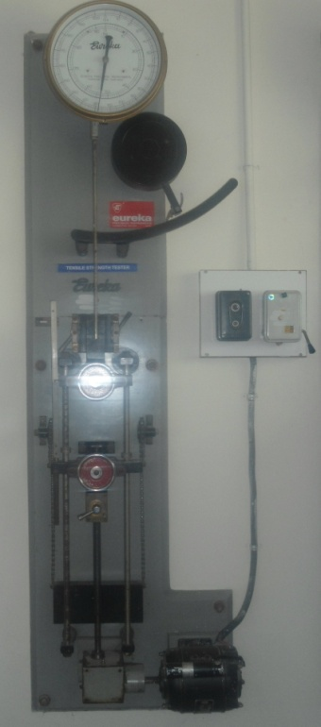 | 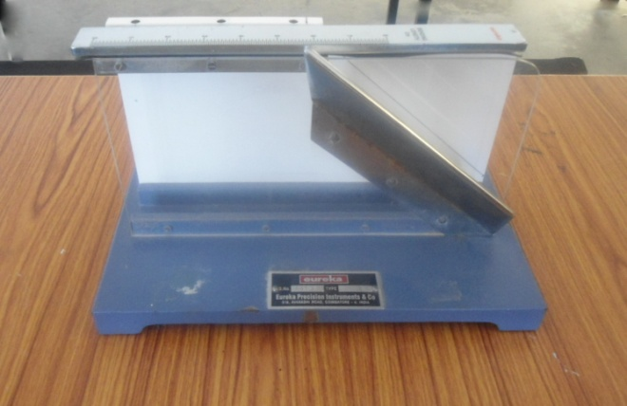
PLATE – XI  STRENGTH AND ELONGATION TESTER | PLATE – XII  STIFFNESS TESTER
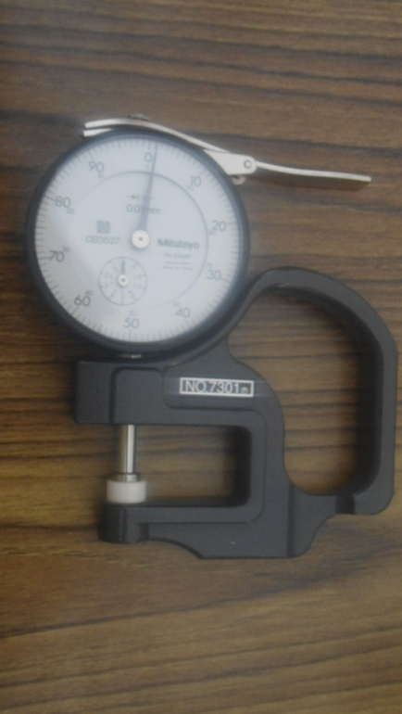 | 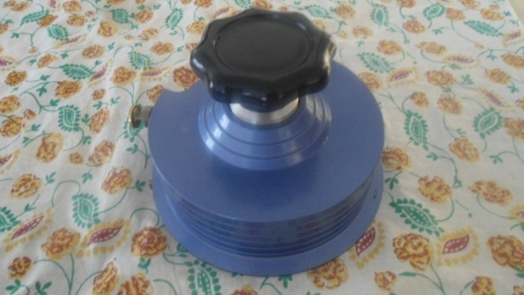
PLATE – XIII  THICKNESS TESTER | PLATE – XIV  GSM CUTTER
dependent on the type of fibre used in its construction. The basic principle of this test is that a small fabric specimen is folded in two and placed under a load for a given length of time to form a crease and it is then allowed to recover for a further length of time and the angle of crease that remains is measured. The magnitude of the crease recovery angle is an indication of the ability of a fabric to recover from accidental creasing (Plate – XVII).
3.10.2.8 Drapeability
Drape is the term used to describe the way a fabric hangs under its own weight. It has an important bearing on how good a garment looks in use (Raul, 1999). To determine drapeabiltiy drape meter (Plate – XVIII) was used. Five samples were cut according to the size of the templates. A brown paper was also cut to the same size of the fabric. Each sample was placed between two small circular plates, so that its free edges drape down under their own weight image of the draped samples found on the brown paper was traced and cut along the outline it was weighed using an electronic balance. a drape co-efficient was calculated for each sample using the formula.
Drape co-efficient =
W_{S} = Weight of the paper whose area is equal to the projected area of the specimen
W_{d} = Weight of the paper whose area is equal to the area of the supporting disc
W_{D} = Weight of the paper whose area is equal to the area of the specimen
3.10.2.9 Sinking Test
Sinking test is a simple test of wettability of fabric. The time taken for the material to sink below the surface is observed. The shorter the time, the greater is the wettability (Paul, 2005). For the sinking test the samples were cut with the size of 5 cm x 5 cm square. A 1000 ml beaker was filled with distilled water. The sample was dropped on surface of the water from a standard height. The stop watch was started when the fabric struck the
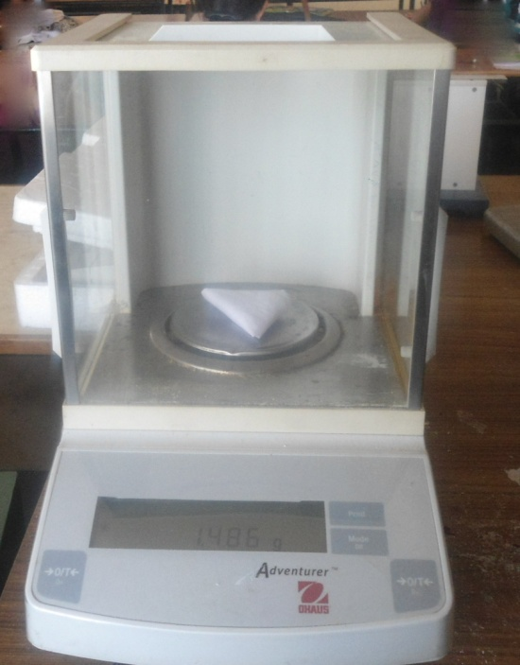 | 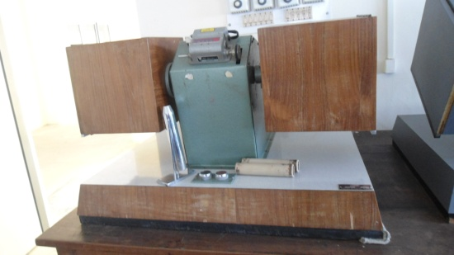
PLATE – XV  ELECTRONIC WEIGHING BALANCE | PLATE – XVI  PILLING TESTER
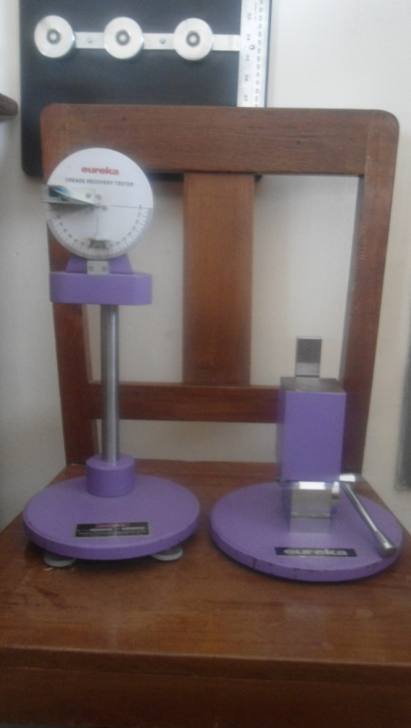 | 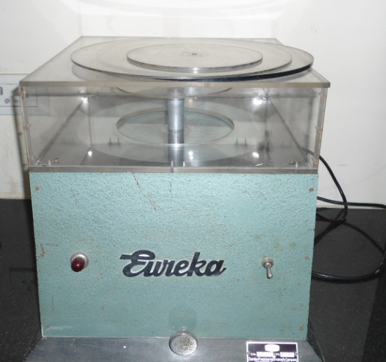
PLATE – XVII  CREASE RECOVERY TESTER | PLATE – XVIII  DRAPEABILITY TESTER
surface of water and stopped when the last corner sank below the water surface and the time required for the sample to sink was noted. The same procedure was repeated for all the samples. The mean values were calculated and recorded.
3.10.2.10 Drop Test
The ability of a fabric to take up moisture is determined as absorbency. Wettability is the time take in seconds for a drop of water to sink into the fabric. If it takes more than 200 seconds to absorb the water through fabric is considered as unwettable.
A burette filled with distilled water was cramped in a stand. The sample was mounted in an embroidery frame and was placed at the base of the stand. The distance between sample and nozzles of burette was kept constant. The nozzle of the burette was opened just to allow a drop of water to fall on the sample. The stop watch was started simultaneously and it was stopped when the drop of the water fully sank into material. The time taken for this was noted. The same procedure was repeated for all the samples. The mean values were calculated and recorded.
3.10.2.11 Capillary Rise Test
The capillary rise test method measures the rapidity of absorption. Samples were cut into size of 15 cm length and 2.5 cm width from all the samples. One end of the sample strip was placed with a glass rod and to other end two gram weight was attached to keep the sample straight. The sample placed in glass rod was placed on heavy wooden blocks. The weight end 2 cm of the sample was allowed to immerse in a tray of distilled water. The rise of the water level in the strip was measured. The same procedure was repeated for all the samples were calculated and recorded.
3.10.2.12 Colour Fastness Test
Colour fastness is defined as the resistance of a material to change in any of its colour characteristic, to transfer of its colourants of adjacent material or both, as a result of the exposure of the material to any environment that might be encountered during the processing, testing or use of the material (AATCC, 2001). The possible to compare loss of colour or staining of any hue irrespective of depth, it is necessary to use two scales called “grey scales”. One for assessing change in colour and the other for staining (Wells, 2000). Accordingly the scales were used for evaluation. The colour fastness tests were carried out for all the dyed samples for sunlight, washing, crocking and pressing.
- Colour Fastness to Washing
According to ISO 105-106 (1994) the wash fastness of the dyed sample was tested using Laundrometer. The laundrometer consist central axis with four rods with eight stainless steel jars with tight fitting lids which rotate inside the hot water bath in forward direction when the machine is in working condition. Due to the high alkali sensitivity of natural dyes, it is recommended that these textiles can be washed with non-alkaline soap only. Hence the non-alkaline soap detergent was used for washing. The composite samples, measured 20 cm were washed with 4 gm / 1000 ml of water at 40°C for 45 minutes in laundrometer. Specimen and degree of staining of the two adjacent undyed fabrics were evaluate during grey scale.
- Colour Fastness to Sunlight
According to Bureau of Indian Standards (1989), the samples of the textile material were exposed to day light under prescribed conditions including protection from rain. The fastness was assessed by comparing the change in colour of the specimen with that of the standard patterns. An area of textile product not less than 1 cm x 6 cm should be used so that each exposed portion is not less than 1 cm x 2 cm. The specimen may be a strip of cloth parallel to the machine direction. The specimen and the standard pattern were simultaneously exposed to day light every day from sunrise to sunset. Until the contrast between the posed and the unexposed portions of the specimen or the standard pattern was equal to grey scale.
- Colour Fastness to Pressing
This method was intended for the determination of colour fastness of textile material of all kinds and in all forms to ironing and to processing on hot cylinders. Tests are given for hot pressing when the textile is dry and wet. The dry and wet specimens were placed separately on undyed cotton adjacent fabric and pressed for 15 seconds with heat press. The specimen was allowed to condition for 4 hours in the standard atmosphere for testing textiles. Then the change in colour of the specimen and the standing of the cotton adjacent fabric was assessed with the appropriate grey scale.
- Colour Fastness to Crocking
Dyed fabric was wrapped lengthwise on rectangle card board of size 14 x 5 cm. The undyed cotton sample of size 5 cm x 5 cm was fixed to the finger of rubbing device of crockmeter and wrapped test specimen of size 14 cm x 5 cm was fixed at the base of rubbing device. The specimen were rubbed to and fro with undyed pieces with a downward force straight line along a track of 10 cm for 10 minutes. The test samples were graded for the change in colour and staining using grey scale. The test was carried in both dry and wet conditions.
3.10.2.13 Analysis of Effluent
The dyed effluents obtained through the process were analyzed for Total Suspended Solids (TSS), Total Dissolved Solids (TDS), Biochemical Oxygen Demand (BOD) and Chemical Oxygen Demand (COD). These parameters were determined as per suggestion.
- Biochemical Oxygen Demand (BOD)
Biological oxygen demand is measured in the aquatic body of organic materials which can support the growth of microbial organisms (Mukherjee, 2011). Analysis of the BOD of dyed effluent samples was carried by the following procedure. About 91 gm of manganous sulfate monohydrate, MnSO₄.H₂O was dissolved in 250 ml of distilled water for the preparation of manganous sulfate solution. About 175 gm of potassium hydroxide and 37.5 gm of potassium iodide were dissolved in 250 ml of distilled water. About 2.5 gm of sodium oxide in 10 ml distilled water. Pour the azide solution to the alkali iodide solution and mix well. Concentrated sulfuric acid was also used as a reagent for the process. Sodium thiosulfate solution (0.1 N) solution of required volume was dissolved in 1000 ml of distilled water in a volumetric flask, the the preparation of sodium, thiosulfate solution.
The Starch Solution was prepared by mixing one gm of starch by mixing one gm of starch in a litre of water.
The samples were collected in a BOD bottle. About 2 ml manganous sulfate solution was taken in BOD bottle followed by the addition of 2 ml alkali-iodide-oxide reagent. The bottle was stoppered without the entertainment of air and mixed by inverting the bottle for 10 times. The precipitate was allowed to settle completely which leave a clear supernatant liquid. The stopper is removed and 2 ml concentration sulphuric acid was added by the sides of the bottle and mixed thoroughly. About 203 ml of the solution from the bottle was transferred into a conical flask of 500 ml capacity. The sample was titrated immediately with 0.025 N sodium thio sulfate solution by using starch as the indicator. For determination the BOD, use one set of sample dilution and dilution water found out the initial dissolved oxygen content, the other set of samples dilution water was kept in the BOD incubator at 200°C (in dark) for five days, determined the DO content of dilution water and sample dilutions, using the procedure.
The calculation of BOD was done using the formula :
DO₅ (mg / l) =
where,
N = Normality of sodium thiosulfate
V = Volume of thiosulfate
V₁ = Volume of sample
DO₅ = Dissolved Oxygen after five day
DO = Dissolved Oxygen at initial BOD (mg / l) = DO – DO₅
- Chemical Oxygen Demand (COD)
Chemical oxygen demand is the quantity of oxygen is required for the complete of all reducing substances (both organic and inorganic) present in water (Mukherjee, 2000).
Analysis of COD of the dyed effluent samples was carried by the following procedure. About 12.2 gm of dried potassium dichromate was mixed in 100 ml of distilled water for preparation of potassium dichormate solution (0.25 N). About 2 gm of potassium iodide and one gram of iodine was dissolved in 300 ml distilled water, for the preparation of potassium iodine solution. Sodium thiosulfate solution (0.1 N) of required volume was dissolved in 1000 ml of distilled water in a volumetric flask for the preparation of sodium thiosulfate solution, 0.025 N. About one gram of starch was dissolved in a little water for preparation starch solution. Concentrated sulfuric acid was also used as a reagent for the process.
About 50 ml of both effluent samples were taken in COD flask and 5 ml of potassium dichromate solution was added. And the solution was kept at 100°C for 1 hour. About 5 ml of potassium iodine solution and 10 ml of sulphruic acid were mixed in the samples. Then the samples were titrate with sodium thiosulphate, until it disappeared to pale yellow colour. Then 1 ml of starch was added as indicator and then the colour burnt to blue. The samples were again titrated with sodium thiosulphate till blue disappeared.
The calculations of COD was done using the formula :
COD = x 1000
where
C = Concentration of Titrant
A = Titrant of sample
B = Blank
V = Volume of sample
- Total Suspended Solids (TSS)
Suspended solids of the dyed effluent samples were estimated by centrifuge method. About 50 ml of conventional and enzymatic effluent samples was centrifuged and after centrifugation the residue was washed with distilled water, recentrifuged and the suspended solids in the centrifuge tubes were filtered through a pre-weighed Whatman No. 1 filter paper and then the filter paper was dried at 105°C. The increase in weight was equal to the amount of suspended solids (Kenkal, 2002). The suspended solids present in the sample were calculated by using the formula.
Total Suspended solids (mg/l) =
- Total Dissolved Solids (TDS)
About 50 ml of the dyed effluent samples were taken in a pre-weighed silica dish and the sample was evaporated to dryness using water bath. After complete evaporation the final weight of the silica dish was taken (Kenkal, 2002). The total dissolved solids present in the samples were calculated by using the following formula.
Total dissolved solids (mg/l) =
3.10.2.14 Wear Study of the Prepared Garments
The jablas and panties were worn by an infant for 3 hours from 10 am to 1 pm. This was collected and washed using standard detergent by hand wash method and dried in shade. This was repeated after every wear on alternate days. Thus the garments were subjected to 10 consecutive washes and studied. These garments were then analysed colour-fastness tests.
3.11 COST ESTIMATION
The cost of the mordants were noted for comparison.
3.12 NOMENCLATURE
The details of nomenclature used in the Chapter 4 is presented in the Table – II.
TABLE – II
NOMENCLATURE
S.No. | Sample details | Nomenclature
1. | Simultaneous mordanting with Potassium Dichromate on Fabric | SPDF
2. | Simultaneous mordanting with Copper Sulphate on Fabric | SCSF
3. | Simultaneous mordanting with Sodium Sulphate on Fabric | SSSF
4. | Simultaneous mordanting with Alum on Fabric | SAF
5. | Simultaneous mordanting with Myrobolan on Fabric | SMF
6. | Simultaneous mordanting with Pomegranate on Fabric | SPF
7. | Simultaneous mordanting with Potassium Dichromate | SPDW
8. | Simultaneous mordanting with Copper Sulphate | SCSW
9. | Simultaneous mordanting with Sodium Sulphate | SSSW
10. | Simultaneous mordanting with Alum | SAW
11. | Simultaneous mordanting with Myrobolan | SMW
12. | Simultaneous mordanting with Pomegranate | SPW
13. | Premordanting Potassium Dichromate | PrPDW
14. | Premordanting Copper Sulphate | PrCSW
15. | Premordanting Sodium Sulphate Water | PrSSW
16. | Premordanting Alum Water | PrAW
17. | Premordanting Myrobolan Water | PrMW
18. | Premordanting Pomegranate Water | PrPW
19. | Postmordanting Potassium Dichromate Water | PoPDW
20. | Postmordanting Copper Sulphate Water | PoCSW
21. | Postmordanting Sodium Sulphate Water | PoSSW
22. | Postmordanting Alum Water | PoAW
23. | Postmordanting Myrobolan Water | PoMW
24. | Postmordanting Pomegranate Water | PoPW
25. | Simultaneous mordanting with Copper Sulphate Fabric Wear Study | SCSFWS
3.13 STATISTICAL ANALYSIS
The result of the tests were analysed statistically by selecting appropriate tests. The difference between the samples and within the samples was analysed “F” test and “ANOVA”. This analysis will help in exact results arrived in this study.
4. RESULTS AND DISCUSSION

The obtained results are discussed under the following headings :
4.1 OPTIMIZATION OF DYEING PARAMETERS
The optimization of dying parameters are presented in Table – III and Figure – 2.
TABLE – III
OPTIMIZATION OF DYEING PARAMETERS
S.No. | Parameters |  | OD value before dyeing | OD value after dyeing | Absorbency (%)
1. | Dye Concentration (gms) | 10 | 0.71 | 0.68 | 4.22
2. | Dye Concentration (gms) | 15 | 0.70 | 0.63 | 10.00
3. | Dye Concentration (gms) | 20 | 0.73 | 0.59 | 19.17
4. | Dye Concentration (gms) | 25 | 0.71 | 0.54 | 23.94
 |  |  | OD value before mordanting | OD value after mordanting | Absorbency (%)
5. | Mordant Concentration (gms) | 5 | 0.63 | 0.59 | 6.34
6. | Mordant Concentration (gms) | 10 | 0.71 | 0.67 | 5.63
7. | Mordant Concentration (gms) | 15 | 0.69 | 0.60 | 15.00
8. | Mordant Concentration (gms) | 20 | 0.59 | 0.54 | 8.47
9. | Temperature (°C) | 60 | 0.79 | 0.73 | 7.59
10. | Temperature (°C) | 70 | 0.86 | 0.81 | 5.81
11. | Temperature (°C) | 80 | 0.83 | 0.79 | 2.40
12. | Temperature (°C) | 90 | 0.89 | 0.72 | 19.10
13. | Time (minutes) | 15 | 0.71 | 0.68 | 4.22
14. | Time (minutes) | 30 | 0.79 | 0.72 | 8.86
15. | Time (minutes) | 45 | 0.86 | 0.81 | 5.81
16. | Time (minutes) | 60 | 0.89 | 0.73 | 17.97

FIGURE – 2
OPTIMIZATION OF DYEING PARAMETERS

From the Table – III and Figure – 2, it is obvious that at 25 grams dye concentration, the absorbency per cent was the maximum of 23.94 followed by 20 grams, 15 grams and 10 grams with 19.17, 10 and 4.22 percentages respectively.
As far as the temperature is concerned the maximum absorbency per cent was observed at 90°C (19.10 per cent) followed by 60°C, 70°C and 80°C with 7.59, 5.81 and 2.40 percentages respectively.
The maximum absorbency was noted at highest time span of 60 minutes with 17.97 per cent followed by 30, 45 and 15 minutes with 8.86, 5.81 and 4.22 percentages respectively.
As for the mordant concentration, the maximum absorbency was noted at 15 grams concentration of 15 per cent followed by the concentration of 20, 5 and 10 grams with 8.47, 6.34 and 5.63 percentages respectively.
Hence, it could be concluded that the optimized dye concentration was 20 grams, mordant concentration was 15 grams, temperature was 90°C and time was 60 minutes.
4.2 VISUAL ASSESSMENT
The results of visual assessment is presented in Table – IV.
TABLE – IV
VISUAL ASSESSMENT (%)
S.No. | Sample |  | Rating in Percentage
S.No. |  |  | Evenness in dyeing |  |  | Brilliancy of colour |  |  | Texture |  |  | Lustre |  |  | General appearance
S.No. |  |  | Good | Fair | Poor | Good | Fair | Poor | Very soft | Soft | Medium | Good | Fair | Poor | Good | Fair | Poor
1. | Set A | SPDF | 65 | 30 | 5 | 55 | 40 | 5 | 40 | 60 | - | 50 | 45 | 5 | 55 | 45 | -
2. | Set A | SCSF | 80 | 20 | - | 85 | 15 | - | 70 | 30 | - | 50 | 45 | 5 | 85 | 10 | 5
3. | Set A | SSSF | 70 | 30 | - | 65 | 35 | - | 85 | 10 | 5 | 50 | 45 | 5 | 75 | 25 | -
4. | Set B | SAF | 15 | 85 | - | 45 | 55 | - | 20 | 80 | - | 55 | 45 | - | 55 | 45 | -
5. | Set B | SMF | 90 | 10 | - | 90 | 10 | - | 60 | 40 | - | 65 | 25 | 10 | 85 | 15 | -
6. | Set B | SPF | 10 | 80 | 10 | 25 | 70 | 5 | 35 | 55 | 10 | 35 | 55 | 10 | 65 | 35 | -

- Evenness in Dyeing
From the Table – IV, it is clear that among the samples in set A, the maximum number of judges of 80 per cent rated the sample SCSF as good in general appearance followed by the samples SSSF and SPDF with 70 and 65 per cent respectively. As for the set B, the maximum judges of 90 per cent rated the sample SMF as good in evenness of dyeing.
In the comparison made between the set A and set B, the samples namely SCSF and SMF had good evenness in dyeing of which it was better in the sample SMF.
- Brilliancy of Colour
The brilliancy of colour was rated to be good by the maximum judges in sample SCSF (85 per cent) followed by samples SSSF (65 per cent) and SPDF (55 per cent). In the comparison made between the samples in set B, the maximum judges rated sample SMF to have good brilliancy of colour with 90 per cent.
As for the comparison made between the samples in set A and set B it was noted that the sample SMF had good brilliancy in colour.
- Texture
As for the texture, the maximum judges of 85 per cent rated the sample SSSF to have very soft texture. In the set B, the maximum judges of 60 per cent rated the sample SMF to have very soft texture. In the comparison made between the sets A and B, the sample SSSF had the very soft texture.
- Lustre
As for as lustre is concerned, all the samples namely SSSF, SPDF and SCSF had equal ratings with 50 per cent expressing good lustre in the dyed samples. Among the samples of set B, the sample SMF and SAF showed the ratings of 65 and 55 percentages respectively, whereas the sample SPF showed only fair lustre.
- General Appearance
Among the samples in set A the sample SCSF showed the maximum ratings with 85 per cent expressing good general appearance followed by samples SSSF (75 per cent) and SPDF (55 per cent). As for the samples in the set B, the maximum ratings were noted in sample SMF (85 per cent) followed by the samples SPF (65 per cent) and SAF (55 per cent).
Hence it could be calculated that the samples SCSF and SMF had good evenness in dyeing, good brilliancy of colour, good lustre and good general appearance with very soft texture in the sets A and B respectively.
In the comparison made between the sets A and B, the sample SMF exhibited the best result in evenness of dyeing, brilliancy of colour, lustre and also general appearance.
4.3 COMPARISON OF OPTICAL DENSITY
The optical density of different mordanting techniques with various mordants are presented in Tables – V, VI and VII.
TABLE – V
PRE MORDANTING TECHNIQUE
S.No. | Sample |  | Before Dyeing | After Dyeing | Absorbency (%)
1. | Set A | PrPDW | 0.63 | 0.64 | 4.47
2. | Set A | PrCSW | 0.58 | 0.55 | 5.17
3. | Set A | PrSSW | 0.63 | 0.60 | 4.76
4. | Set B | PrAW | 0.67 | 0.64 | 4.47
5. | Set B | PrMW | 0.60 | 0.57 | 5.00
6. | Set B | PrPW | 0.71 | 0.68 | 4.20

As for the optical density of samples in pre mordanting technique, in the comparison made between samples in set A, the percentage of absorption was the highest in sample PrCS of 5.17 per cent followed by samples PrSS (4.76 per cent) and PrPD (4.47 per cent). In the comparison made between samples of set B, the highest absorption percentage was noted in sample PrM of 5 per cent followed by samples PrA and PrP with 4.47 and 4.2 percentages respectively.
When set A was compared with set B the best absorbency was expressed in the sample PrCS (57 per cent).
Hence it could be concluded that optical density was the highest in samples PrCS and PrA among the respective sets of comparison of which PrCS showed better absorption than PrA.
TABLE – VI
POST MORDANTING TECHNIQUE
S.No. | Sample |  | Before Dyeing | After Dyeing | Absorbency (%)
1. | Set A | PoPDW | 0.68 | 0.64 | 5.88
2. | Set A | PoCSW | 0.76 | 0.71 | 7.04
3. | Set A | PoSSW | 0.63 | 0.59 | 6.34
4. | Set B | PoAW | 0.71 | 0.67 | 5.63
5. | Set B | PoMW | 0.72 | 0.67 | 6.94
6. | Set B | PoPW | 0.56 | 0.53 | 5.35
As for the post mordanting technique, in the comparison of OD made among the samples in set A, the sample PoCS showed the highest absorbency of 7.04 per cent followed by samples PoSS of 6.34 per cent and PoPD of 5.88 per cent. In the comparison made among the samples in set B, the maximum absorbency was noted in the sample PoM of 6.94 per cent followed by the samples PoA and PoP with 5.63 and 5.35 percentages respectively. When sets A and B were compared, the maximum absorbency was exhibited by the sample PoCS (7.04 per cent).
Hence it could be concluded that the best absorbency was expressed by the samples PoCS and PoM with their respective sets of comparison of which the highest was observed in the sample PoCS.
TABLE – VII
SIMULTANEOUS MORDANTING TECHNIQUE
S.No. | Sample |  | Before Dyeing | After Dyeing | Absorbency (%)
1. | Set A | SPDW | 0.84 | 0.76 | 9.52
2. | Set A | SCSW | 0.67 | 0.59 | 11.9
3. | Set A | SSSW | 0.79 | 0.74 | 10.12
4. | Set B | SAW | 0.69 | 0.63 | 8.69
5. | Set B | SMW | 0.68 | 0.61 | 10.29
6. | Set B | SPW | 0.62 | 0.57 | 8.06
In the case of simultaneous mordanting technique used among the samples in set A the maximum absorbency was observed in the sample SCS of 11.9 per cent followed by the samples SSS of 10.12 per cent and SPD of 9.52 per cent. Among the samples of set B, the sample SM showed the maximum absorbency of 10.29 per cent followed by samples SA (8.69 per cent) and SP (8.06 per cent). Hence it could be concluded that as for the simultaneous mordanting technique adopted, the dyed absorbency by the fabric was the highest in samples SCS and SM of which it was higher in the sample SCS.
- Comparison of OD Between Mordanting Techniques
In the comparison made between the adopted techniques, the best absorbency was exhibited in the simultaneous mordanted samples, in both the sets of comparisons.
4.4 TENSILE STRENGTH
The tensile strength in both warp and weft directions are presented in Tables – VIII and IX (Figures – 3 and 4).
- Warp Direction
TABLE – VIII
TENSILE STRENGTH IN WARP DIRECTION
S.No. | Sample |  | Mean value (kg) | Loss or gain value | Loss or gain (%)
1 | Original |  | 64.8 | - | -
2. | Set – A | SPDF | 46.0 | 18.8 | 29.01
3. | Set – A | SSSF | 45.2 | 19.6 | 30.2
4. | Set – A | SCSF | 52.6 | 12.2 | 18.82
5. | Set – B | SAF | 57.6 | 17.2 | 11.11
6. | Set – B | SPF | 55.6 | 9.2 | 14.19
7. | Set – B | SMF | 64.0 | 0.8 | 1.23

STATISTICAL ANALYSIS FOR TENSILE STRENGTH – WARP
S.No. | Samples | ‘F’ Value | Significance
1. | O with A | 66.33 | **
2. | O with B | 10.32 | **
3. | B/W A and B | 0.47 | NS
** Significant at one per cent level.
NS – Not Significant.
Set A Set B
FIGURE – 3
TENSILE STRENGTH IN WARP DIRECTION
From the Table – VIII and Figure – 3, it is clear that the tensile strength was reduced in all the dyed samples among samples in set A. The strength was the highest in sample SCSF (52.6 kg) and the loss was 18.8 per cent followed by samples SPDF and SCSF of 18.8 per cent and 19.6 per cent respectively. Among the samples in set B, the highest strength was noted in the sample SMF (64 kg) and the sample loss was 1.23 per cent over the original sample whereas in samples SPF and SAF the loss was 14.19 per cent and 11.11 per cent respectively over the original. In the comparison made between the set A and B, highest tensile strength was noted in sample SMF of 64.
As per statistical analysis the comparison of original with set A shows a significance at one per cent level with ‘f’ value of 66.33. As for the comparison of original with set B, also it was noted to have a significance of one per cent level with ‘f’ value of 0.67.
Hence it could be concluded that in warp direction, the highest strength was noted in the samples SCSF and SMF when compared with their respective sets of which the maximum was expressed in the sample SMF. The loss in strength was also lesser in set B than in set A.
- Weft Direction
TABLE – IX
TENSILE STRENGTH IN WEFT DIRECTION
S.No. | Sample |  | Mean value (kg) | Loss or gain value | Loss or gain (%)
1 | Original |  | 54.6 | - | -
2. | Set – A | SPDF | 36.4 | 18.2 | 33.3
3. | Set – A | SSSF | 34.2 | 20.4 | 37.36
4. | Set – A | SCSF | 43.4 | 11.2 | 20.51
5. | Set – B | SAF | 46.6 | 8.0 | 14.65
6. | Set – B | SPF | 52.0 | 2.6 | 4.76
7. | Set – B | SMF | 53.3 | 1.3 | 2.38

STATISTICAL ANALYSIS FOR TENSILE STRENGTH – WEFT
S.No. | Samples | ‘F’ Value | Significance
1. | O with A | 115.44 | **
2. | O with B | 11.59 | **
3. | B/W A and B | 15.21 | NS
** Significant at one per cent level.
NS – Not Significant.
Set A Set B
FIGURE – 4
TENSILE STRENGTH IN WEFT DIRECTION
If weft direction among samples in set A the maximum strength loss was observed in sample SSSF (37.36 per cent) followed by samples SPDF and SCSF with 33.3 and 20.51 per cent respectively over the original. Among the samples in set B the highest loss in strength was noted in the sample SAF of 14.5 per cent followed by samples SPF (4.76%) and SMF (2.38%). In the comparison made between the set A and B, the minimum loss in strength was noted in the samples of set B than sample A.
The statistical analysis also exhibit a significant difference of one per cent on comparison of the samples in set A and B with the original samples with ‘f’ value of 115.44 and 11.59 respectively.
Hence it could be concluded that in weft direction, the strength was the highest in samples SCSF and SMF with their respective sets of comparison of which the sample SMF was better in strength than sample SCSF.
- Comparison of the Samples Between Warp and Weft Directions
From the Tables – VIII and IX, it is obvious that all the samples had higher strength in warp direction than in weft direction.
4.5 FABRIC ELONGATION
Fabric elongation in both warp and weft directions is presented in Tables – X and XI (Figures – 5 and 6).
- Warp Direction
TABLE – X
FABRIC ELONGATION IN WARP DIRECTION (%)
S.No. | Sample |  | Mean value (per cent) | Loss or gain value
1 | Original |  | 12.4 | -
2. | Set – A | SPDF | 25.2 | 12.8
3. | Set – A | SSSF | 25.0 | 12.6
4. | Set – A | SCSF | 26.8 | 14.4
5. | Set – B | SAF | 31.4 | 19.0
6. | Set – B | SPF | 24.0 | 11.6
7. | Set – B | SMF | 25.2 | 12.8

STATISTICAL ANALYSIS FOR FABRIC ELONGATION – WARP
S.No. | Samples | ‘F’ Value | Significance
1. | O with A | 144.03 | **
2. | O with B | 184.81 | **
3. | B/W A and B | 33.64 | *
** Significant at one per cent level.
* Significant at five per cent level.
Set A Set B
FIGURE – 5
FABRIC ELONGATION IN WARP DIRECTION
From the Table – X and Figure – 5, it is clear that the fabric has gained elongation property in all the dyed samples among sample in set A of which it was the highest in sample SCSF of 26.8 followed by samples SPDF and SCSF of 25.2 and 25 respectively. Among the samples in set B, the highest elongation was noted in the sample SAF of 31.4 followed by samples SMF 25.2 and SPF 24.0. In the comparison made between the sets A and B the highest elongation was noted in sample SAF.
It is evident in the statistical analysis that there was one per cent significance in the comparison of the samples in set A and B with the original sample. The comparison made between the sets A and B exhibits a significant difference of five per cent.
Hence it could be concluded that in warp direction, the highest elongation was noted in the samples SAF and SCSF when compared with their respective sets of which the maximum was expressed in the sample SAF. The loss in elongation was also lesser in set B than in set A.
- Weft Direction
TABLE – XI
FABRIC ELONGATION IN WEFT DIRECTION (%)
S.No. | Sample |  | Mean value (inches) | Loss or gain value
1 | Original |  | 24 | -
2. | Set – A | SPDF | 33 | 9
3. | Set – A | SSSF | 32 | 8
4. | Set – A | SCSF | 33.2 | 9.2
5. | Set – B | SAF | 37.2 | 13.2
6. | Set – B | SPF | 31.8 | 7.8
7. | Set – B | SMF | 34.8 | 10.8
STATISTICAL ANALYSIS FOR FABRIC ELONGATION – WEFT
S.No. | Samples | ‘F’ Value | Significance
1. | O with A | 16.32 | **
2. | O with B | 160.82 | **
3. | B/W A and B | 1.57 | NS
** Significant at one per cent level.
NS – Not Significant.
Set A Set B
FIGURE – 6
FABRIC ELONGATION IN WEFT DIRECTION
In weft direction among samples in set A the maximum elongation per cent was observed in sample SCSF (33.2%) followed by samples SPDF and SSSF with 33 and 32 percentages respectively over the original. Among the samples in set B the highest gain of elongation was noted in the sample SAF of 37.2 per cent followed by samples SMF (34.8%) and SPF (31.8%). In the comparison made between the sets A and B, the maximum gain in elongation was noted in the samples set B than set A.
As per the statistical analysis, the comparison of set A and B with the original sample exhibits a significance at one per cent level with ‘F’ value of 16.32 and 160.82 per cent.
Hence it could be concluded that in weft direction, the elongation was the highest in samples SAF and SCSF with their respectively sets of comparison of which the sample SAF should better elongation than sample SCSF.
- Comparison of the Samples Between Warp and Weft Directions
From the Tables – X and XI, it is obvious that all the samples showed higher elongation in weft direction than in warp direction.
4.6 FABRIC STIFFNESS
The fabric stiffness in warp and weft directions are presented Tables – XII and XII and Figures – 7 and 8.

- Warp Direction
TABLE – XII
FABRIC STIFFNESS IN WARP DIRECTION (INCHES)
S.No. | Sample |  | Mean value (inches) | Loss or gain value | Loss or gain (%)
1 | Original |  | 2 | - | -
2. | Set – A | SPDF | 2.2 | -0.2 | 10
3. | Set – A | SSSF | 2.4 | -0.4 | 20
4. | Set – A | SCSF | 2.6 | -0.6 | 30
5. | Set – B | SAF | 1.8 | 0.2 | 10
6. | Set – B | SPF | 2.1 | -0.1 | 50
7. | Set – B | SMF | 2.4 | -0.4 | 20
STATISTICAL ANALYSIS FOR FABRIC STIFFNESS – WARP
S.No. | Samples | ‘F’ Value | Significance
1. | O with A | 10.35 | **
2. | O with B | 13.51 | **
3. | B/W A and B | 3.95 | NS
** Significant at one per cent level.
NS – Not Significant.

Set A Set B
FIGURE – 7
FABRIC STIFFNESS IN WARP DIRECTION
From the Table – XII and Figure – 7, it is clear that the stiffness was increased in all the samples of set A of which it was highest in sample SCSF 2.6 inches (30%) followed by samples SSSF and SPDF of 2.4 inches (20%) and 2.2 inches (10%) respectively. Among the samples in set B, the highest stiffness was noted in the sample SMF 2.4 inches (20%) followed by samples SPF 2.1 inches (50%) and SAF 1.8 inches (10%). In the comparison made between the sets A and B the maximum stiffness was noted in the samples of set A than set B. Both the sets A and B on comparison with the original sample express a significance at one per cent as per statistical analysis also.
Hence it could be concluded that in warp direction, the stiffness was the highest in samples SCSF and SMF with their respective sets of comparison of which the sample SCSF showed better strength than sample SMF.
- Weft Direction
TABLE – XIII
FABRIC STIFFNESS IN WEFT DIRECTION (INCHES)
S.No. | Sample |  | Mean value (inches) | Loss or gain value | Loss or gain (%)
1 | Original |  | 1.46 | - | -
2. | Set – A | SPDF | 1.72 | -0.26 | 17.80
3. | Set – A | SSSF | 1.64 | -0.18 | 12.32
4. | Set – A | SCSF | 1.96 | -0.50 | 34.24
5. | Set – B | SAF | 1.68 | -0.22 | 15.06
6. | Set – B | SPF | 1.74 | -0.28 | 19.17
7. | Set – B | SMF | 1.94 | -0.46 | 31.50
STATISTICAL ANALYSIS FOR FABRIC STIFFNESS – WEFT
S.No. | Samples | ‘F’ Value | Significance
1. | O with A | 3.72 | *
2. | O with B | 3.20 | *
3. | B/W A and B | 3.31 | NS
* Significant at five per cent level.
NS – Not Significant.
Set A Set B
FIGURE – 8
FABRIC STIFFNESS IN WEFT DIRECTION

If weft direction among samples in set A, the maximum stiffness was observed in sample SCSF of 1.96 inches (34.24%) followed by samples SPDF and SSSF with 1.72 inches (17.8%) and 1.64 inches (12.32%) respectively. Among the samples in set B the highest stiffness was noted in the sample SMF of 1.94 inches (31.50%) followed by samples 1.74 inches (19.17%) and 1.68 inches (15.06%). In the comparison made between sets A and B, the maximum stiffness was noted in the samples set B than set A. As far as the statistical analysis is concerned, a significant difference at five per cent level was noted in the comparison made between the sets of samples A and B with the original sample.
Hence it could be concluded that in weft direction, the stiffness was the highest in samples SCSF and SMF with their respective sets of comparison of which the sample SCSF showed better stiffness than sample SMF.

- Comparison of the Samples Between Warp and Weft Directions
From the Tables – XII and XIII, it is obvious that all the samples showed higher stiffness in warp direction than in weft direction.
4.7 FABRIC THICKNESS
The thickness of the samples are presented in Table – XIV and Figure – 9.
TABLE – XIV
FABRIC THICKNESS
S.No. | Sample |  | Mean value (mm) | Loss or gain value | Loss or gain (%)
1 | Original |  | 28.0 | - | -
2. | Set – A | SPDF | 31.8 | -3.8 | 13.57
3. | Set – A | SSSF | 30.6 | -2.6 | 9.28
4. | Set – A | SCSF | 31.4 | -3.4 | 12.14
5. | Set – B | SAF | 30.4 | -2.4 | 8.57
6. | Set – B | SPF | 30.8 | -2.8 | 16.00
7. | Set – B | SMF | 29.4 | -1.4 | 5.00

STATISTICAL ANALYSIS FOR FABRIC THICKNESS
S.No. | Samples | ‘F’ Value | Significance
1. | O with A | 2.59 | NS
2. | O with B | 1.70 | NS
3. | B/W A and B | 0.61 | NS
NS – Not Significant.

Set A Set B
FIGURE – 9
FABRIC THICKNESS

From the Table – XIV and Figure – 9, it is clear that the fabric thickness had increased in all dyed samples among samples in set A of which it was highest in sample SPDF of 31.8 (13.57%) followed by samples SCSF and SSSF of 31.4 (12.14%) and SSF 30.6 (9.28%) respectively. Among the samples in set B the highest thickness was noted in the sample SPF 30.8 (16%) followed by samples SAF 30.4 (8.57%) and SMF 29.4 (5%). In the comparison made between the set A and set B highest thickness was noted in sample SPDF of 31.8 (13.57%).
Hence it could be concluded that the highest thickness was noticed in the samples SPDF and SPF when compared with their respective sets of which the maximum was expressed in the sample SPDF. The gain in thickness was also lesser in set A than in set B.
4.8 FABRIC WEIGHT
The fabric weight is exhibited in the Table – XV and Figure – 10.
TABLE – XV
FABRIC WEIGHT
S.No. | Sample |  | Mean value (GSM) | Loss or gain value | Loss or gain (%)
1 | Original |  | 1.17 | - | -
2. | Set – A | SPDF | 1.27 | -0.10 | 8.54
3. | Set – A | SSSF | 1.25 | -0.08 | 6.83
4. | Set – A | SCSF | 1.24 | -0.07 | 5.98
5. | Set – B | SAF | 1.23 | -0.06 | 5.12
6. | Set – B | SPF | 1.25 | -0.08 | 6.83
7. | Set – B | SMF | 1.22 | -0.05 | 4.27

STATISTICAL ANALYSIS FOR FABRIC WEIGHT
S.No. | Samples | ‘F’ Value | Significance
1. | O with A | 16.06 | **
2. | O with B | 8.35 | **
3. | B/W A and B | 2.71 | NS
** Significant at one per cent level.
NS – Not Significant.
Set A Set B
FIGURE – 10
FABRIC WEIGHT
From the Table – XV and Figure – 10, it is clear that the weight had increased in all dyed samples, among samples in set A of which it was the highest in sample SPDF of 1.27 GSM (8.54%) followed by samples SSSF and SCSF of 1.25 (6.83%) and 1.24 (5.98%) respectively. Among the samples in set B the highest gain in weight was noted in the sample SPF of 1.25 (6.83%) followed by samples SAF 1.23 (5.12%) and SMF 1.22 (4.27%). In the comparison made between the sets A and B the highest weight was noted in sample SPDF of 1.27 (8.54%).
One per cent significant difference was observed in the comparisons made between samples of sets A and B with the original sample.
Hence it could be concluded that the highest weight was noted in samples SPDF and SPF when compared with their respective sets ; of which the maximum was expressed in the sample SPDF. The gain in strength was also lesser in set A than in set B.
4.9 PILLING TEST
The results of pilling test are expressed in the Table – XVI.
TABLE – XVI
PILLING TEST
S.No. | Sample |  | Pilling
1. | Set A | SPD | Slight Pilling
2. | Set A | SSS | Moderate Pilling
3. | Set A | SCS | Slight Pilling
4. | Set B | SA | Moderate Pilling
5. | Set B | SM | Moderate Pilling
6. | Set B | SP | Slight Pilling
Moderate Pilling – Good ; Slight Pilling – Very Good
From the above Table – XVI, it is clear that there was an indication of slight pilling in the samples SPD, SCS, SM and SA and moderate pilling in the samples SSS and SP.
Hence, it could be concluded that there was only slight pilling exhibited in samples SPD, SCS, SM and SA.
4.10 CREASE RECOVERY
The results of crease recovery of the fabrics are expressed in Table – XVII and Figure – 11.
TABLE – XVII
CREASE RECOVERY ANGLE
S.No. | Sample |  | Mean value | Loss or gain value | Loss or gain (%)
1 | Original |  | 169 | - | -
2. | Set – A | SPDF | 170.8 | -0.1 | 8.54
3. | Set – A | SSSF | 171.8 | -0.08 | 6.83
4. | Set – A | SCSF | 164.4 | -0.07 | 5.98
5. | Set – B | SAF | 169.8 | -0.06 | 5.12
6. | Set – B | SPF | 173.0 | -0.08 | 6.83
7. | Set – B | SMF | 176.0 | -0.05 | 4.27

STATISTICAL ANALYSIS FOR CREASE RECOVERY
S.No. | Samples | ‘F’ Value | Significance
1. | O with A | 11.19 | **
2. | O with B | 0.83 | NS
3. | B/W A and B | 1.33 | NS
** Significant at one per cent level.
NS – Not Significant.
Set A Set B
FIGURE – 11
CREASE RECOVERY
From the Table – XVII and Figure – 11, it was clear that the crease recovery angle had increased in some dyed samples among the sample in set A of which it was the highest in sample SSSF 171.8 (6.83%) followed by samples SPDF 170.8 (8.54%) and SCSF 164.4 (5.98%). Among the samples in set B the highest crease recovery angle was noted in the sample SMF 176 (4.27%) followed by the samples SPF and SAF of 173 (6.83%) and 169.8 (5.12%) respectively. In the comparison made between the sets A and B, the maximum crease recovery was noted in the samples of set B than set A.
The significant difference of one per cent was noted in the comparison made between the samples set A and original sample with the ‘F’ value of 11.19.
Hence it could be concluded that the crease recovery was the highest in samples SSSF and SMF with their respective sets of comparisons of which the sample SMF showed better crease recovery than sample SSSF.

4.11 DRAPEABILITY
The results of drapeability of the fabrics are expressed in Table – XVIII and Figure – 12.
TABLE – XVIII
DRAPEABILITY
S.No. | Sample |  | Mean value (%) | Loss or gain value (%) | Loss or gain (%)
1 | Original |  | 0.55 | - | -
2. | Set – A | SPDF | 0.71 | -0.15 | 27.27
3. | Set – A | SSSF | 0.63 | -0.8 | 145.45
4. | Set – A | SCSF | 0.59 | -0.4 | 72.72
5. | Set – B | SAF | 0.62 | -0.7 | 127.27
6. | Set – B | SPF | 0.66 | -0.11 | 20.00
7. | Set – B | SMF | 0.61 | -0.6 | 109.09
STATISTICAL ANALYSIS FOR DRAPEABILITY
S.No. | Samples | ‘F’ Value | Significance
1. | O with A | 47.10 | **
2. | O with B | 28.43 | **
3. | B/W A and B | 33.97 | *
* Significant at five per cent level.
** Significant at one per cent level
Set A Set B
FIGURE – 12
DRAPEABILITY
From the Table – XVIII and Figure – 12, it I clear that the drapeability had decreased in all the dyed samples among samples in set A of which it was the highest in sample SCS of 72.72 per cent followed by samples SSSF and SPDF of 45.45 per cent and 27 per cent. Among the samples in set B the highest drapability was noted in the sample SAF of 127.2 per cent loss over original whereas in samples SMF and SPF 109.9 per cent and 20 per cent respectively over the original. In the comparison made between the sets A and B highest drapability was noted in sample SCSF of 72.72 per cent.
Hence it could be concluded that the highest drapability was noted in the samples SCSF and SMF when compared with their respective sets of which the maximum was expressed in the sample SCSF. The gain in drapability was also lesser in set B.
4.12 SINKING TEST
The results of sinking test are expressed in the Table – XIX and Figure – 13.
TABLE – XIX
SINKING TEST
S.No. | Sample |  | Mean value (seconds) | Loss or gain value | Loss or gain (%)
1 | Original |  | 8.58 | - | -
2. | Set – A | SPDF | 11.84 | -3.48 | 41.62
3. | Set – A | SSSF | 9.16 | -0.08 | 9.06
4. | Set – A | SCSF | 8.36 | -0.78 | 10.10
5. | Set – B | SAF | 9.36 | 0.78 | 9.09
6. | Set – B | SPF | 11.1 | -2.74 | 32.77
7. | Set – B | SMF | 6.6 | 1.98 | 23.13

STATISTICAL ANALYSIS FOR SINKING TEST
S.No. | Samples | ‘F’ Value | Significance
1. | O with A | 5.69 | **
2. | O with B | 2.86 | NS
3. | B/W A and B | 0.64 | NS
** Significant at one per cent level.
NS – Not Significant.
Set A Set B
FIGURE – 13
SINKING TEST
From the Table – XIX and Figure – 13, it is clear that the absorbency had increased in all dyed samples among the sample in set A of which it was the highest in sample SCSF of 8.36 seconds (10.10%) followed by samples SSSF and SPDF of 9.16 seconds (9.56%) and 11.84 seconds (41.62%) respectively. Among the samples in set B, the highest absorbency was noted in the sample SMF with 6.6 seconds (23.13%) followed by sample SA with 9.36 seconds (9.09%) and SPF with 11.1 seconds (32.77%). In the comparison made between the sets A and B, the maximum absorbency was noted in the samples of set A than set B.
From the statistical analysis also it is evident that there is significant difference of one per cent in the comparison made between the samples in sets A and the original sample.
Hence it could be concluded that the absorbency was highest in samples SCSF and SMF with their respective sets of comparison of which the sample SMF showed better absorbency than sample SCSF.
4.13 DROP TEST
The results of the drop test are expressed in the Table – XX and Figure – 14.
TABLE – XX
DROP TEST
S.No. | Sample |  | Mean value (seconds) | Loss or gain value | Loss or gain (%)
1 | Original |  | 0.76 | - | -
2. | Set – A | SPDF | 1.22 | -0.46 | 60.52
3. | Set – A | SSSF | 0.96 | -0.20 | 26.31
4. | Set – A | SCSF | 0.92 | -0.16 | 21.05
5. | Set – B | SAF | 1.0 | -1.31 | -172.36
6. | Set – B | SPF | 1.1 | -0.34 | 44.73
7. | Set – B | SMF | 0.64 | -0.12 | 15.78

STATISTICAL ANALYSIS FOR DROP TEST
S.No. | Samples | ‘F’ Value | Significance
1. | O with A | 2.33 | NS
2. | O with B | 4.65 | *
3. | B/W A and B | 3.47 | NS
* Significant at five per cent level.
NS – Not Significant.

Set A Set B
FIGURE – 14
DROP TEST
From the Table – XX and Figure – 14, it is clear that the absorbency was increased in all the dyed samples among the samples in Set A of which it was the highest in sample SCSF (21.05%) followed by samples SSSF and SPDF (26.31%) and (60.52%) respectively. Among samples in set B the highest absorbency was noted in the sample SM (15.78%) followed by samples SAF (172.36%) and SPF (44.73%). In the comparison made between the sets A and B, the maximum absorbency was noted in the samples of set B than set A.
The statistical analysis exhibits five per cent significant difference in the comparison made between the samples in set B with the original sample.
Hence it could be concluded that the absorbency was highest in samples SCSF and SMF with their respective sets of comparison of which the sample SMF should better absorbency than sample SCSF.
4.14 CAPILLARY RISE TEST
The capillary rise of the fabric samples are presented in Table – XXI and Figure – 15.
TABLE – XXI
CAPILLARY RISE TEST
S.No. | Sample |  | Mean value (cms) | Loss or gain value | Loss or gain (%)
1 | Original |  | 3.90 | - | -
2. | Set – A | SPDF | 2.32 | 1.58 | 40.51
3. | Set – A | SSSF | 3.86 | 0.04 | 1.02
4. | Set – A | SCSF | 3.88 | 0.02 | 0.51
5. | Set – B | SAF | 3.74 | 0.16 | 4.10
6. | Set – B | SPF | 3.56 | 0.34 | 8.71
7. | Set – B | SMF | 4.64 | -0.74 | 18.97

STATISTICAL ANALYSIS FOR CAPILLARY RISE TEST
S.No. | Samples | ‘F’ Value | Significance
1. | O with A | 11.59 | **
2. | O with B | 6.98 | **
3. | B/W A and B | 32.18 | *
** Significant at one per cent level.
* Significant at five per cent.

Set A Set B
FIGURE – 15
CAPILLARY RISE TEST
From the Table – XXI and Figure – 15, it is clear that the absorbency was increased in some dyed samples, among sample in set A of which it was the highest in sample SCSF of (0.51%) followed by samples SSSF and SPDF of (1.02%) and (40.51%) respectively. Among the samples in set B, the highest absorbency was noted in the sample SMF (18.97%) followed by samples SAF (4.10%) and SPF (8.71%). In the comparison made between the sets A and B, the maximum absorbency was noted in the samples of set B than set A.
A significant difference of one per cent was observed in the comparison made between the sets A and B with the original sample. The comparison made between the samples in sets A and B expressed a significant difference of one five per cent as for the capillary rise is concerned.
Hence it could be concluded that the absorbency was highest in samples SCSF and SMF with their respective sets of comparison of which the sample SMF showed better absorbency than sample SCSF.
4.15 COLOUR FASTNESS
The results of colour fastness tests are presented in Table – XXII.
TABLE – XXII
COLOUR FASTNESS
S.No. | Sample |  | Colour fastness to washing | Colour fastness to sunlight | Colour fastness to crocking |  | Colour fastness to pressing
 |  |  |  |  | Dry pressing | Wet pressing | Dry crocking | Wet crocking
1. | Set A | SPDF | 4 | 4/5 | 4/5 | 3 | 4 | 3
2. | Set A | SSSF | 5 | 5 | 5 | 4/5 | 4/5 | 4
3. | Set A | SCSF | 4 | 4 | 4/5 | 4 | 4 | 3
4. | Set B | SAF | 4/5 | 4 | 4 | 3 | 4/5 | 3
5. | Set B | SMF | 4/5 | 4/5 | 4/5 | 4 | 4/5 | 4
6. | Set B | SPF | 4 | 4/5 | 4/5 | 4 | 4 | 3
5 – Excellent ; 4/5 – Very Good ; 4 – Good ; 3 – Fair ; 2 – Poor ; 1 – Very Poor.
From the Table – XXII, it was clear that sample SSSF had excellent colour fastness to dry crocking followed by samples SPDF, SCSF, SMF, SPF which exhibited very good colour fastness to dry crocking. The sample SAF had good colour fastness to dry crocking. In wet crocking sample SSSF showed very good colour fastness to dry crocking followed by samples SSSF, SMF, SPF which showed good colour fastness to wet crocking and sample SPDF and SPF showed fair colour fastness property to wet crocking.
The samples SSSF, SAF and SMF exhibit very good colour fastness to dry pressing, followed by samples SPDF, SCSF, SPF which show good colour fastness property to dry pressing. In wet pressing the sample SSSF, SMF exhibited a good colour fastness property to wet pressing followed by samples SPDF, SCSF, SAF, SPF with fair colour fastness property to wet pressing.
The sample SSF showed excellent colour fastness property to washing followed by samples SAF and SMF which showed very good colour fastness property to washing and samples SPDF, SCSF and SPDF showed good colour fastness property to washing.
The sample SSSF had an excellent colour fastness property to sun light followed by samples SPDF, SMF and SPF which showed good colour fastness property to sunlight and sample SCSF and SAF had a good colour fastness property to sunlight.
Hence it could be concluded the sample SCSF in set A showed good colour fastness property and in set B the sample SMF showed good colour fastness property when compared with their respective sets.

4.16 BIOLOGICAL OXYGEN DEMAND (BOD)
The findings of biological oxygen demand are presented in Table – XXIII.
TABLE – XXIII
BIOLOGICAL OXYGEN DEMAND (BOD)
S.No. | Sample | BOD Value (mg / l)
1. | SPDW | 69.0
2. | SSSW | 62.0
3. | SCSW | 68.0
From the Table – XXIII, it is obvious that the BOD was noted to be the highest in the sample SPDW of 69.0 mg / l followed by the samples SCSW and SSSW with 68.0 mg / l and 62.0 mg / l respectively.
4.17 CHEMICAL OXYGEN DEMAND (COD)
The findings of the chemical oxygen demand are expressed in Table – XXIV.
TABLE – XXIV
CHEMICAL OXYGEN DEMAND (COD)
S.No. | Sample | COD Value (mg / l)
1. | SPDW | 520.0
2. | SSSW | 460.0
3. | SCSW | 480.0
In the Table – XXIV, the COD was observed to be the highest in sample SPDW of 520 mg / l followed by the samples SCSW (480 mg / l) and SSSW (460 mg / l).
Hence it could be concluded that the BOD and COD values were the maximum in the sample SPDW.
The COD is always higher than the BOD, because all the pollutants are not mineralized in biochemical process, but this occurs when the samples are oxidized by a strong oxidant, stresses Mukherjee (2000).
This is proved in this study also.
4.18 TOTAL SUSPENDED SOLIDS (TSS)
The results of total suspended solids are presented in Table – XXV.
TABLE – XXV
TOTAL SUSPENDED SOLIDS (TSS)
S.No. | Sample |  | TSS (g / l)
1. | Set A | SPDW | 0.11
2. | Set A | SCSW | 0.9
3. | Set A | SSSW | 0.6
4. | Set B | SAW | 0.3
5. | Set B | SMW | 0.2
6. | Set B | SPW | 0.2
From the Table – XXV, it is obvious that the level of TSS was the maximum of 0.11 g / l in the sample SPDW followed by the samples SCSW (0.9 g / l) and SSS (0.6 g / l) among the set of samples in A. Among the set B, the maximum TSS level was observed in the sample SAW (0.3 g / l) followed by both the samples SMW and SPW with TSS of 0.2 g / l. In the comparison made between the sets A and B, the highest level of TSS was noted in the sample SPDW of 0.11 g / l.
Hence it could be concluded that the samples SPDW and SAW exhibited the highest levels of TSS among their respective comparison of which it was higher in the sample SPDW.
4.19 TOTAL DISSOLVED SOLIDS (TDS)
The results of TDS are expressed in the Table – XXVI
TABLE – XXVI
TOTAL DISSOLVED SOLIDS (TDS)
S.No. | Sample |  | TDS (g / l)
1. | Set A | SPDW | 0.8
2. | Set A | SCSW | 0.11
3. | Set A | SSSW | 0.7
4. | Set B | SAW | 0.4
5. | Set B | SMW | 0.1
6. | Set B | SPW | 0.2
From the Table – XXVI, it is obvious that the level of TDS was the maximum of 0.11 g / l in the sample SCSW followed by the sample SPDW (0.8 g / l) and SSSW (0.7 g / l) among the samples in set A. Among set B, the maximum TDS level was observed in the sample SAW (0.4 g / l) followed by the samples SPW (0.2 g / l) and SMW (0.1 g / l). In the comparison made between sets A and B, the highest level of TDS was noted in the sample SCSW of 0.11 g / l.
Hence it could be concluded that the samples SCSW and SAW exhibited the highest level of TDS among their respective sets of comparison of which it was higher in the sample SCSW.
TABLE – XVII
COMPARISON BETWEEN DYED AND WEAR STUDIED SAMPLE
S.No. | Test |  | SCSF | SCSFWS | SMFW
1. | Washing |  | 5 | 4 | 4
2. | Sunlight |  | 5 | 4 | 4
3. | Pressing | Dry | 4/5 | 3 | 3
3. | Pressing | Wet | 4 | 3 | 3
4. | Crocking | Dry | 5 | 4 | 4/5
4. | Crocking | Wet | 4/5 | 3 | 4
4/5 – Very Good ; 4 – Good ; 3 – Fair
From the Table – XXVII, it is clear that the colour fastness had decreased in all samples of SCSFWS and SMFW. Colour fastness to washing, sunlight and crocking was rated to be 4 expressing Good fastness. Colour fastness to pressing in both dry and wet conditions showed 3 (Fair). As the crocking in dry and wet condition exhibited the fastness of 4 (Good) and 3 (Fair) respectively in sample SCSFWS.
In the sample SMFW, the colour fastness to washing, sunlight and wet crocking was 4 (Good) ; to dry crocking was 4/5 (very good) ; and to pressing was 3 (fair).
Hence it could be concluded that the colour fastness property of the wear studied samples exhibited lesser colour fastness property than the original sample.
4.20 COST ESTIMATION
The cost estimation are presented in Table – XXVIII.
TABLE – XXVIII
COST ESTIMATION
S.No. | Particulars |  | Amount (`)
1. | Fabric (per metre) |  | 200
2. | Dye powder (per kg) |  | 20
3. | Natural mordants | Myrobalan (500 grams) | 100
3. | Natural mordants | Pomegranate rind (500 grams) | 120
3. | Natural mordants | Alum (500 grams) | 100
4. | Metallic mordants | Potassium di chromate (500 grams) | 260
4. | Metallic mordants | Sodium sulphate (500 grams) | 300
4. | Metallic mordants | Copper sulphate (500 grams) | 340
From the Table – XXVIII, it is clear that the cost of the natural mordants namely myrobalan, pomegranate rind and alum weighing 500 grams were ` 100/-, ` 120/- and ` 100/-respectively, whereas the cost of the metallic mordants namely potassium di chromate, sodium sulphate and copper sulphate weighing 500 grams were ` 130/-, ` 150/- and ` 170/- respectively.
Hence it could be concluded that the cost of the metallic mordants were higher than the cost of the natural mordants.
5. SUMMARY AND CONCLUSION

INTRODUCTION
The Indian textile industry is one of the largest in the world with a massive raw material and textiles manufacturing base. Our economy is largely dependent on the textile manufacturing and trade in addition to other major industries. Natural fibres are those renewable fibres that are obtained from plants, and animals which are transformed into yarn for textiles. They are taken from plant, leaf, inner bark, or fruit seed, insect cocoon, animal wool or hair, or from any mineral product.
Dyeing is the process of adding colour to textile products like fibre, yarn and fabric. The temperature and time controlling are two key factors in dyeing. There are two main classes of dye natural and manmade. The primary source of dye, historically has generally been nature, with the dyes being extracted from animals or plants. The use of natural dyes have increased substantially during the last couple of years because of the carcinogenic nature of the synthetic dyes. The production of synthetic dyes involves many violent reactions and during the manufacturing process such chemicals are required which cause environmental pollution (Gahlot et al., 2008).
Worldwide emphasis is given today for production of fabric using products and application techniques with minimum damage of ecology (Patra, 1998). Due to health hazards and environmental problems associated with the use of synthetic dyes, people have realized the utility of natural dyes and moved towards it with scientific background (Khan et al., 2004).
Considering all the above facts, the investigator selected the study on “EXTRACTION, APPLICATION AND EVALUATION OF PADAUK WOOD DYE ON COTTON FABRIC” with the following objectives.

OBJECTIVES
- To extract dye from natural source
- To apply the extracted dye on cotton fabric
- To compare the eco-friendly and metallic mordants
- To evaluate the dyed fabrics.
EXPERIMENTAL PROCEDURE
Cotton possess the property of being a naturally breathing fibre is suitable for absorbing body fluids such as perspiration, blood and other body fluids and so useful for clothes that directly touch the skin to improve the quality of the fabric, it was prepared by desizing. The dye source selected for the study was padauk wood (Pterocarpus echinatus) powder obtained from the bark of the padauk tree.
Few metallic mordants namely copper sulphate, potassium dichromate and sodium sulphate, and natural mordants namely pomegranate rind and myrobolan and the safe mordant alum were selected for the study.
Required quantity of dye powder was taken and soaked in water for 24 hours, it was then boiled at simmering point (90 - 92°C) for 60 minutes. The solution was filtered with a clean filter paper, thus the filtrate obtained is the extracted liquid dye. Required quantity of mordant powder was taken and soaked in water for 4 hours. After soaking it was boiled at simmering point for 30 minutes. The boiled solution was filtered using clean filter paper. This extracted mordant solution was used for mordanting.
The pilot study was carried out for the study and the parameters namely dye concentration, mordant concentration, temperature and time were optimized. The optimized conditions were utilized for mordant dyeing. There are three types of mordanting techniques namely pre mordanting, post mordanting and simultaneous mordanting. These methods were adopted for the study. The products prepared were jabla and panties for infant. About three sets of jablas and panties were prepared as per the instructions. Three extra panties were prepared as bed wetting in the common problem of an infant.
The evaluation was carried out as explained under :
- The tests carried out for the fabric were subjective – visual assessment and objective – tensile strength, elongation, stiffness, thickness, weight, pilling, crease and colour fastness tests and wettability tests.
- The effluent was analysed for TSS TDS, BOD and COD.
- The prepared garments were wear studied and evaluated for important properties.
FINDINGS OF THE STUDY
- The samples SCSF and SMF had good evenness in dyeing, good brilliancy of colour, good lustre and good general appearance with very soft texture in the sets A and B respectively.
- In the comparison made between the sets A and B, the sample SMF exhibited the best result in evenness of dyeing, brilliancy of colour, lustre and also general appearance.
- The optimized dye concentration was 20 grams, mordant concentration was 15 grams, temperature was 90°C and time was 60 minutes.
- Optical density the highest in samples PrCSW and PrAW among the respective sets of comparison of which PrCS showed better absorption than PrAW.
- The best absorbency was expressed by the samples PoCSW and PoMW with their respective sets of comparison of which the highest was observed in the sample PoCSW.
- The best absorbency was exhibited in the simultaneous mordanted samples, in both the sets of comparisons.
- In warp direction, the highest strength was noted in the samples SCSF and SMF when compared with their respective sets of which the maximum was expressed in the sample SMF. The loss in strength was also lesser in set B (Alum, myrobalan and pomegranate rind) than in set A (Metallic mordants).
- In weft direction, the strength was the highest in samples SCSF and SMF with their respective sets of comparison of which the sample SMF is better in strength than sample SCSF.
- It is obvious that all the samples had higher strength in warp direction than in weft direction.
- In warp direction, the highest elongation was noted in the samples SAF and SCSF when compared with their respective sets of which the maximum was expressed in the sample SAF. The loss in elongation was also lesser in set B than in set A.
- In weft direction, the elongation was the highest in samples SAF and SCSF with their respectively sets of comparison of which the sample SAF should better elongation than sample SCSF.
- It is obvious that all the samples showed higher elongation in weft direction than in warp direction.
- In warp direction, the stiffness was the highest in samples SCSF and SMF with their respective sets of comparison of which the sample SCSF showed better stiffness than sample SMF.
- In weft direction, the stiffness was the highest in samples SCSF and SMF with their respective sets of comparison of which the sample SCSF showed better stiffness than sample SMF.
- It is obvious that all the samples showed higher stiffness in warp direction than in weft direction.
- The highest thickness was noticed in the samples SPDF and SPF when compared with their respective sets of which the maximum was expressed in the sample SPDF. The gain in thickness was also lesser in set A than in set B.
- The highest weight was noted in samples SPDF and SPF when compared with their respective sets ; of which the maximum was expressed in the sample SPDF. The gain in strength was also lesser in set A than in set B.
- There was only slight pilling exhibited in samples SPD, SCS, SM and SA.
- The crease recovery was highest in samples SSSF and SMF with their respective sets of comparison of which the sample SMF showed better crease recovery than sample SSSF.
- The highest drapeability was noted in the samples SCSF and SMF when compared with their respective sets of which the maximum was expressed in the sample SCSF. The gain in drapability was also lesser in set B.
- The absorbency was highest in samples SCSF and SMF with their respective sets of comparison of which the sample SMF showed better absorbency than sample SCSF.
- The absorbency was highest in samples SCSF and SMF with their respective sets of comparison of which the sample SMF showed better absorbency than sample SCSF.
- The absorbency was highest in samples SCSF and SMF with their respective sets of comparison of which the sample SMF should better absorbency than sample SCSF.
- The sample SCSF in set A shows good colour fastness property and in set B the sample SMF showed good colour fastness property to their respective sets.
- The BOD was noted to be the highest in the sample SPDW of 69.0 mg / l followed by the samples SCSW and SSSW with 68.0 mg / l and 62.0 mg / l respectively.
- The BOD and COD values were the maximum in the sample SPDW.
- The samples SPDW and SAW exhibited the highest levels of TSS among their respective comparison of which it was higher in the sample SPDW.
- The samples SCSW and SAW exhibited the highest level of TDS among their respective sets of comparison of which it was higher in the sample SCSW.
- The colour fastness property of both the samples SCSFWS and SMFW exhibited lesser colour fastness property than the original sample after wash and wear.
CONCLUSION
It could be concluded that the cotton fabric dyed with Padauk wood dye gave the best results in strength, colour fastness and comfort properties with metallic and natural mordants namely copper sulphate and myrobalan respectively of which it was better with natural mordant. It had also been proved that deeper colour was obtained from metallic mordants and the colour fastness also was very good. The pollutants were also noted in the effluent from metallic mordants dyeing. All the natural mordants were cost effective also.
RECOMMENDATIONS
- The padauk wood dye could be tried for other cellulosic fibres also.
- Many other end products also could be developed from the dyed fabric.
- Other natural sources of mordants also may be used for fixing the dye.

BIBLIOGRAPHY

BOOKS
AATCC, (2001), American Association of Textile Colurists and Chemist.
BIS (1989), Bureau of Indian Standards.
Broughton, K., (1996), “Textile Dyeing”, Quayside Publishing Group, P. 10.
Deulkar and Tarabai, (2007), “Household Textiles and Laundry Work”, Atma and Ram Sun Publishers, New Delhi, P. 132.
Ghosh, P., (2004), “Fibre Science and Technology”, Tata McGraw Hill Publication, P. 38.
Gohl, E.P.G. and Vilensky, L.D., (2008), “Textile Science”, C.B.S.Publications, New Delhi, P. 41.
Gollier, B. and Tortora, P., (2001), “Understanding Textiles”, Prentice Hall, New Delhi.
Gulrajani, (1999), “Present Status of Natural Dyes”, Convention on Natural Dyes, Department of Textile Technology, IIT, Delhi, P. 48.
Gupta, S.P., (2009), “Statistical Method”, Sultan Chand Sons, New Delhi, P. 1006.
Hargrave, H., (1997), “From Fibre to Fabric”, C & T Publication, P. 21.
Hauser, (2011), “Textile Dyeing”, Intech Publication, New Delhi, P. 18.
Hollen, N. and Sadder, J., (1973), “Textiles”, Macmillan Publication, New York, P. 136.
Hollen, N. and Sadder, J., (1973), “Textiles”, Macmillan Publishing Co. Inc., New York, P. 113.
Horrocks, A.R., Anand, S. and Anand, S.C., (2000), “Handbook of Technical Textiles”, Wood Head Publishing, P. 204.
ISO (1994), Indian Standard Organization.
Jindal, A. and Jindla, R., (2006), “Textile Raw Material”, Abhishek Publication, Chandigarh, P. 27.
Joseph, M., (1980), “Essentials of Textiles”, Winston Publication, New Delhi, P. 30.
Kaplan, N.S., (2002), “Fibre Science”, Abhishek Publication, New Delhi, P. 17.
Karmakar, S.R., (2007), “Chemical Technology in the Colouration of Textiles”, Colour Publication Pvt. Ltd., Mumbai, P. 386.
Kenkel, J., (2002), “Analytical Chemistry”, Technicians LRC Press, Florida, P. 420.
Kozlowski, R., (2012), “Handbook of Natural Fibres”, Wood Head Publishing Co., P. 2.
Kumar, A. and Choudhury, R., (2006), “Textile Preparation and Dyeing”, Oxford and IBH Publishing Co., P. 823.
Mukherjee, (2000), “Environmental Management”, Vikas Publishing House, New Delhi, P. 250.
Mukherjee, A., (1999), “Dyeing of Cotton Fabric with Kigelia pinnata, Spathode a companulata and Carissa congesta”, Convention on Natural Dyes, Department of Textile Technology, IIT, Delhi, P. 114.
Mukherjee, B., (2011), “Environmental Biology and Toxicology”, Silverline Publication, New Delhi, P. 449.
Naik, S.D. and Wilson, T.A., (2006), “Surface Designing of Textile Fabrics”, New Age International Publishers, New Delhi, P. 16.
Nakamura, A., (2000), “Fibre Science and Technology”, Oxford and IBH Publishing Company Pvt. Ltd., Calcutta, P. 151.
Narinder, K. and Singh, D., (2004), “Introduction to Textiles”, Kalyani Publishers, New Delhi, P. 90.
Palsingh, K.V., (2004), “Introduction to Textiles”, Kalyani Publishers, P. 25.
Paul, (2005), “Textile Testing”, APH Publishing Corporation, New Delhi, P. 140.
Potter, D. and Corbman, B., (1955), “Fibre to Fiabric”, GREGG Publishing Division, New Delhi, P. 113.
Rastogi, M., (2009), “Fibres and Yarns”, Sonali Publications, New Delhi, P. 83.
Rastogi, M., (2009), “Plant Textile”, Sanah Publication, New Delhi, P. 43.
Rathi, D. and Godbole, K., (1999), “Dyeing Behaviour with Jute and Cotton”, Convention of Natural Dyes, Replika Press, New Delhi, P. 217.
Raul, (1999), “Textile Testing”, APH Publishing Co., New Delhi, P. 35.
Raul, A., (1984), “Textile Testing”, APH Publishing Corporation, New Delhi, P. 51.
Saravanavel, (2009), “Research Methodology”, Kitab Mahal Publication, Allahabad, P. 249.
Smith, J.L., (2006), “Textile Processing”, Abishek Publication, P. 69.
Vaishnav, N.A. and Joshi, H.D., (2000), “Textile Testing and Analysis”, Popular Prakashan Publicatns, Surat, P. 240.
Verma, G. and Dev, K., (1999), “Cutting and Tailoring Course”, Asian Publishers, Delhi, P. 103.
Wells, K., (2000), “Fabric Dyeing and Printing”, Conran Octopus Limited, P. 74.
Yates, M.P., (2002), “Fabrics”, W.W.Norton and Company, New York, P. 36.
JOURNALS
Adeel, S. and Osman, E., (2012), “Influence of UV Radiations on the Extraction and Dyeing of Cotton Fabric with Cucuma longa”, Indian Textile Journal, Vol. 37, March, P. 83.
Agarwal, S.C., (1997), “Lac as a Natural Dyes”, The Indian Textile Journal, Vol. 107, July, P. 26.
Anjali, S., Asha, B.S.R. and Anjali, S., (2007), “Eupatosium – An Excellent Source for Mulberry Silk”, Colourage, Vol. LIV, January, P. 45.
Anthappan, P., Dalvi, P., Parade, N., Kanoogo and Adivarakar, R., (2006), “Amylase and Pectinase from Single Source for Combined Desized and Dcouring”, Colourage, Vol. III, August, P. 49.
Aspland, J.R., (1997), “Textile Dyeing and Coloration”, AATCC Board, P. 244.
Banis, S., Kang, S. and Koshan, P.K., (2007), “Effect of Combination of Mordants on Colour Fastness Properties of Wool Dye with Golden Drop Dye”, Colourage, Vol. LIC, October, P. 44.
Bhargava, A., Brhandukar, S., Roy, P.K. and Singh, V., (2011), “Eco-Friendly Dyeing of Cotton with Madder and Lac Mixture by Various Mordants”, Asian Dyer, Vol. 8, June-July, P. 29.
Bhat, V. and Choudhar, R., (2012), “Organic Cotton Vs. B^{T} Cotton”, Colourage, Vol. LIX, January, P. 46.
Bhattacharyya, N., Batra, S. and Khedkar, K., (2004), “Gamma irradiation of Natural Dyes”, Colourage, Vol. LI, April, P. 30.
Das, D. and Shah, R., (2011), “Natural Dyes and Its Application”, Asian Textile Journal, Vol. 20, May, P. 54.
David, T.P., (2005), “Migration – A Moving Experience Reactive Dye on Cellulose”, Textile Trends, Vol. LII, May, P. 33.
Devi, S.A., Sumathy, B.S. and Katyayini, (2002), “A Fast Natural Colour of Cotton Amaltas”, New Cloth Market, IIMS Publishers, Vol. 15, P. 27.
Dheeraj, T., Monika, M. and Priyanka, T., (2003), “Dyeing with Turmeric”, Colourage, Vol. LIII, July, P. 50.
Further, R., Ghorashi, H. and Schreth, A., (2007), “Cloth Classification is Basic for Quality Assessment and Price Determination”, Textile Magazine, Vol. 48, June, P. 12.
Gahlot, M., Fatima, N. and Papnai, N., (2008), “Jatropa Flowers, Natural Colourant for Dyeing of Cotton, Wool, Silk”, Colourage, Vol. LV, February, P. 96.
Gill, P. and Singh, O.P., (2005), “Dyeing Wool Natural Dyes and Natural Mordants”, Colourage, Vol. LII, January, P. 43.
Gotipamul and Velapure, G.S., (2012), “Axur vasta”, Asian Textile Journal, Vol. 21, P. 80.
Gupta, D., (2009), “Mechanism of Dyeing synthetic Fibres with Natural Dyes”, Colourage, Vol. XIVIII, April, P. 23.
Indi, Y.M. and Chinta, S.K., (2008), “Application and Properties of Natural Dyes on a Phyllanthus reticulates”, Colourage, Vol. LV, June, P. 52.
Khan, M., Khan, M.A., Srivastava, P.K. and Mohammad, F., (2004), “Natural Dyeing on Wool with Tesu, Dolu and Amalts”, Colourage, Vol. LI, May, P. 38.
Korkmaz, A., Ozdogan, E. and Okpem, T., (2007), “An Alternative Approach for Polyester Dyeing”, Colourage, Vol. LIV, July, P. 45.
Kumar, P.E., Kulandaivelu, A.R. and Boopathi, T.S., (2005), “Eco-friendly Dyes from Hibiscus vitifolins and Sesbania aegyptica for Dyeing”, Colourage, Vol. LII, October, P. 33.
Kumar, R., Onial, P., Dobhal, P.C. and Dayal, R., (2012), “Natural Dye from Eupatorium glandulosum”, Asian Dyer, Vol. 7, March, P. 52.
Kumaresan, P.N., Palanisamy and Kumar, P.E., (2012), “Application of Eco-Friendly Natural Dye Obtained from Cordial subestena on Cotton Using Combination of Mordants”, Journal of Natural Products and Plant Resources, Vol. 2, February, P. 32.
Mangut, M., Becerir, B. and Alpay, H.R., (2008), “Effects of Repeated Domestic Launderings and Non-Durable Press on the Colour Properties of Plain Woven Cotton Fabrics”, Colourage, Vol. LV, September, P. 104.
Meena, S. and Nachane, R.P., (2011), “Dyeing of Pretreated Cotton Substrate with Madder Extract”, Colourage, Vol. LI, February, P. 23.
Moses, J., (2008), “A Novel Finishing Treatment on Cotton Fabric”, The Textile Industry and Trade Journal, Vol. 1, October, P. 7.
Nachane, S. and Desai, S.M., (2011), “Textile Wet Processing and Water”, Asian Dyer, Vol. 8, February, March, P. 72.
Nadiger, G.S., Sharma, K. and Jarag, P., (2004), “Screening of Natural Dyes”, Colourage, Annual, Vol. LI, P. 130.
Naresh, M., Saref, Deepak, V. and Alat, (2005), “Processing of Cotton”, Colourage, Vol. LII, November, P. 73.
Patra, S.K., (1998), “Potential of Lac Dye”, Indian Textile Journal, Vol. 108, September, P. 40.
Rani and Singh, (2004), “History of Natural Dyes”, Colourage, Vol. 11, March, P. 45.
Saha, P. and Datta, S., (2008), “Dyeing of Textile Fibre Using Marigold”, Colourage, Vol. LV, May, P. 52.
Shivankar, V.S., Vyas, S.K., Rojha and Kedar, V., (2011), “Extraction of Natural Dye Pomegranate Rind and its Fastness Properties”, Asian Dyer, Vol. 8, February and March, P. 58.
Shodh and Mulyankan, S.A., (2009), “Criteria for Selection of Fabric for Infant Clothing”, International Research Journal, Vol. II, August, P. 3.
Vankar, P.S., Shanker, R., Dixit, S., Mahanta, D. and Tiwari, S.C., (2008), “Sanilator Dyeing of Cotton with the Leaves Extract Beilschmildia fagifolia”, Colourage, Vol. LV, November, P. 84.
WEBSITES
www.chest-of-books.com
www.fibre2fashion.com
www.IndianTextileJournal.com

APPENDIX – I
COTTON SAMPLE

Material - 100% Cotton
Weave - Plain weave
Count - 40’s
Cost - 200 Rs/1 mtr
Width - 38”

APPENDIX – II
DYED SAMPLES
SET A | SET B
SPDF | SAF
SSSF | SMF
SCSF | SPF
APPENDIX – III
PERFORMANCE TO ELICIT INFORMATION
REGARDING DYED FABRICS

S.No. | Sample | Evenness in dyeing |  |  | Brilliancy of colour |  |  | Texture |  |  | Lustre |  |  | General appearance
S.No. | Sample | Good | Fair | Poor | Good | Fair | Poor | Very soft | Soft | Medium | Good | Fair | Poor | Good | Fair | Poor
 | Set A
1. | SPDF
2. | SSSF
3. | SCSF
 | Set B
4. | SAF
5. | SMF
6. | SPF

APPENDIX – IV
JABLA

APPENDIX – V
PANTY

