INSURANCE MANAGEMENT SYSTEM

NANDHINI.C.G
09PCA12

A Project Report submitted to Avinashilingam University for Women, Coimbatore in partial fulfilment of the requirements for the Master’s Degree in Computer Applications

April, 2012

ACKNOWLEDGEMENT

I would like to express my sincere thanks to God Almighty, for his constant love and grace that he has showered upon me.

I am very grateful to Dr.T.S.K.MeenakshiSundaram, M.A., M.Phil., Ph.D., Chancellor, Avinashilingam Institute for Home Science and Higher Education for Women, Coimbatore, for his support and encouragement during the course of my study.

I heartily thank Dr. (Mrs).Sheela Ramachandran M.SC., P.G DIP., Ph.D., Vice Chancellor, Avinashilingam Institute for Home Science and Higher Education for Women, Coimbatore, for extending all resources that facilitated the conduct of the present study.

I express my humble gratitude to Dr.(Mrs). Gowri Ramakrishnan M.Sc., M.Phil., Ph.D., Registrar, Avinashilingam Institute for Home Science and Higher Education for Women, Coimbatore, for providing all facilities necessary for the study.

I am also thankful to Dr.(Mrs). R. Parvatham M.Sc., Dip.Ed. M.Phil., Ph.D., Dean Faculty of Science, for granting the facility required.

I wish to place on record my deep sense of gratitude to Dr.(Mrs).G.Padmavathi M.Sc., M.Phil., Ph.D., Professor and Head, Department of Computer Science, for providing all the facilities to complete the project.
I take this unique opportunity to express my sincere thanks to my project Coordinator Dr.(Mrs).P.Subashini, MCA.,M.Phil., Ph.D., Associate Professor, Department of Computer Science, for imparting the tremendous assistance and well timed support for her triumph of our project.
I owe great deal of gratitude to my esteemed guide Mrs. V.Rachel., MCA., Assistant Professor, Department of Computer Science for her kind advice and knowledgeable suggestion, which helped me to complete my project successfully.
We have great pleasure in expressing our deep sense of gratitude to all other staff members and non-teaching staff members who stood behind the screen in making of project.
I would extend my hearty thanks to one and all who helped me directly or indirectly for successful completion of my project.
Last yet importantly, I would like to thank my parents, my brother, my friends, and all my well-wishers for their kind inspiration.

CONTENTS

S NO PARTICULARS PAGE NO
- INTRODUCTION
1.1 OVERVIEW OF THE PROJECT 1
1.2 OBJECTIVE OF THE PROJECT 1

2. SYSTEM SPECIFICATION
2.1 APPLICATION SPECIFICATION 3
2.2 HARDWARE SPECIFICATION 6
2.3 SOFTWARE SPECIFICATION 6
3. SYSTEM ANALYSIS
3.1. BACKGROUND STUDY
3.1.1 EXISTING SYSTEM 7
3.1.2 PROPOSED SYSTEM 8
4. SYSTEM DESIGN AND DEVELOPMENT PROCESS
4.1 FUNDAMENTAL DESIGN CONCEPTS 9
4.1.1 SYSTEM DESIGN 9
4.2 DESIGN NOTATIONS 10
4.2.1 DATA FLOW DIAGRAMS 10
4.3 DESIGN PROCESS 12
4.3.1 DATABASE DESIGN 12
4.3.2 INPUT DESIGN 19
4.3.3 OUTPUT DESIGN 21
4.3.4 DEVELOPMENT APPROACH 22
5. SYSTEM DEVELOPMENT
5.1 MODULE DESCRIPTION 23
6. SYSTEM IMPLEMENTATION AND TESTING
6.1 IMPLEMENTATION PROCEDURES 25
6.2 USER TRAINING 26
6.3 OPERATIONAL DOCUMENTATION 27
6.4 SYSTEM TESTING 28
7. CONCLUSION 31
8. SCOPE FOR FUTURE ENHANCEMENT 32
9. BIBLIOGRAPHY
10. SCREEN SHOTS

1. INTRODUCTION

  - OVERVIEW OF THE PROJECT
Insurance Management system is an intranet based private system, which is designed for an insurance company, to make their application work of insurance policies and claims process easier and flexible. The web based application is used within their organization under the distributed accessibility to check the status of the customers who have taken new policies and to keep proper track and to remind of policy premium payments and claim conditions. The system is actually developed to cater to the process speed up in their business process such that the customer satisfaction rates increase and the generic flow of customers into this domain follow a smooth and steady fashion.
The major problem under the manual process is to keep track of the existing insurance policy holders, and to remind them at regular intervals about their policy premium payments. In order to render the ordinary services it takes a lot of time in just searching through the registers for the existing customer’s base.
The actual purpose of going for this system is to make the organizational process to get speed up. The agents can have the expected information at its desk at any time, with respect to any instance. Generating required reports as per the operational requirements becomes much easier and information availability at hand.
  - OBJECTIVE OF THE PROJECT
- The agent at any time can view the required information whether it is policies, or customers at the click of a mouse and instance of a second
- If planned in an organized manner the customers can be provided an online terminal where they can access the information at their own hands without the basic intervention manually
- The customers or policyholder’s reminders can be generated for the specific customers
- The information while it is collected can referentially be segregated into their respective databases from single window
- The customers policy premium payment status can be viewed in a systematized manner by the agents and cross verify the defaulters
- The claim status raised by a specific policyholder can be tracked very clearly in a transparent manner, and checked until the claim is settled
- Above all the overall system can at any time provide consistent and reliable information authenticated upon its operations.

2. SYSTEM SPECIFICATION
2.1 APPLICATION SPECIFICATION

ASP.NET
ASP.NET is a web application framework developed and marketed by Microsoft to allow programmers to build dynamic web sites, web applications and web services. It was first released in January 2002 with version 1.0 of the .NET Framework, and is the successor to Microsoft's Active Server Pages (ASP) technology. ASP.NET is built on the Common Language Runtime (CLR), allowing programmers to write ASP.NET code using any supported.

Characteristics

Pages
.NET pages, known officially as "web forms", are the main building block for application development. Web forms are contained in files with an ".aspx" extension; in programming jargon, these files typically contain static (X)HTML markup, as well as markup defining server-side Web Controls and User Controls where the developers place all the required static and dynamic content for the web page. Additionally, dynamic code which runs on the server can be placed in a page within a block <% -- dynamic code -- %> which is similar to other web development technologies such as PHP, JSP, and ASP, but this practice is generally discouraged except for the purposes of data binding since it requires more calls when rendering the page.

Code-behind model
It is recommended by Microsoft for dealing with dynamic program code to use the code-behind model, which places this code in a separate file or in a specially designated script tag. Code-behind files typically have names like MyPage.aspx.cs or MyPage.aspx.vb based on the ASPX file name (this practice is automatic in Microsoft Visual Studio and other IDEs). When using this style of programming, the developer writes code to respond to different events, like the page being loaded, or a control being clicked, rather than a procedural walk through the document.
ASP.NET's code-behind model marks a departure from Classic ASP in that it encourages developers to build applications with separation of presentation and content in mind. In theory, this would allow a web designer, for example, to focus on the design markup with less potential for disturbing the programming code that drives it.

Directory structure
In general, the ASP.NET directory structure can be determined by the developer's preferences. Apart from a few reserved directory names, the site can span any number of directories. The structure is typically reflected directly in the urls. Although ASP.NET provides means for intercepting the request at any point during processing, the developer is not forced to funnel requests through a central application or front controller.
The special directory names are,
- App_Browsers -Holds site-specific browser definition files.
- App_Code
This is the "raw code" directory. The ASP.NET server automatically compiles files (and subdirectories) in this folder into an assembly which is accessible in the code of every page of the site. App_Code will typically be used for data access abstraction code, model code and business code. Also any site-specific http handlers and modules and web service implementation go in this directory. As an alternative to using App_Code the developer may opt to provide a separate assembly with precompiled code.
- App_Data
Default directory for databases, such as Access mdb files and SQL Server mdf files. This directory is usually the only one with write access for the application.
- App_LocalResources
Contains localized resource files for individual pages of the site. E.g. a file called CheckOut.aspx.fr-FR.resx holds localized resources for the french version of the CheckOut.aspx page. When the UI culture is set to french, ASP.NET will automatically find and use this file for localization.
- App_GlobalResources
Holds resx files with localized resources available to every page of the site. This is where the ASP.NET developer will typically store localized messages etc. which are used on more than one page.
- App_Themes -Holds alternative themes of the site.

- App_WebReferences
Holds discovery files and WSDL files for references to web services to be consumed in the site.
- Bin Contains compiled code (.dll files) for controls, components, or other code that you want to reference in your application. Any classes represented by code in the Bin folder are automatically referenced in your application.
Microsoft SQL Server
It’s a relational database management system (RDBMS) produced by Microsoft. Its primary query languages are ANSI SQL and T-SQL.

SQL Server 2005
SQL Server 2005 (codenamed Yukon), released in October 2005, is the successor to SQL Server 2000. It included native support for managing XML data, in addition to relational data. For this purpose, it defined an xml data type that could be used either as a data type in database columns or as literals in queries. XML columns can be associated with XSD schemas; XML data being stored is verified against the schema. XML is converted to an internal binary data type before being stored in the database. Specialized indexing methods were made available for XML data. XML data is queried using XQuery; SQL Server 2005 added some extensions to the T-SQL language to allow embedding XQuery queries in T-SQL. In addition, it also defines a new extension to XQuery, called XML DML, which allows query-based modifications to XML data. SQL Server 2005 also allows a database server to be exposed over web services using TDS packets encapsulated within SOAP (protocol) requests. When the data is accessed over web services, results are returned as XML.

2.2 HARDWARE SPECIFICATION

System : Pentium IV 2.4 GHz
Hard Disk : 40 GB
Floppy Drive : 1.44 MB
Monitor : 15 VGA Colour
Mouse : Logitech
Ram : 512 Mb

2.3 SOFTWARE SPECIFICATION

Operating System : Microsoft Windows XP
Coding Language : ASP.NET 3.5 with C#
Browser : Internet Explorer
Backend : SQL Server

3. SYSTEM ANALYSIS

System analysis focuses on specifying for what the system or the application is required to do. It allows the individuals to see the logical elements (what the system should do) apart from the physical components it uses (computers, terminals and storage system). It is the process of gathering and interpreting facts, diagnosing problems and using the information to recommend improvements to the system.
System analysis is the first step in any kind of project development. If the system analysis is not done properly, then it could lead to faulty system. According to the various experienced professional and project management groups, this step takes the maximum percentage of total time allotted to the project.
3.1 BACKGROUND STUDY
3.1.1 EXISTING SYSTEM
The existing system is the manual system. The manual system is prone to error. It is time consuming. It is very difficult for a person to produce the report. There are chances for changing the scheme report and do malpractice. This system involves a lot of manual entries with the applications to perform the desired task. Usage of papers in the payment process leads to less efficiency, less accuracy and less productivity.
- Increasing expenditure for papers shuffling and storage
- Increasing labors and hence errors
- Less control of amounts
- Time delay between the payment and its receipt
- Persons who are present in different part of the world cannot transact efficiently

DISADVANTAGE OF THE EXISTING SYSTEM
The manual system is prone to error. It is time consuming. It is very difficult for a person to produce the report. There are chances for changing the scheme report and do malpractice. This system involves a lot of manual entries with the applications to perform the desired task. Usage of papers in the payment process leads to less efficiency, less accuracy and less productivity.

3.1.2 PROPOSED SYSTEM
The proposed system is designed to eliminate the drawbacks of the existing system. This application is designed to eliminate the drawbacks of the existing system in order to provide a permanent solution to the problems. The primary aim of the new system is to speedup transactions.
Since the advent of Online Insurance services in the middle-ages, the policy agents and policy holder have used paper-based instrument to move money between insurance transactions. It comes as no surprise to one that when everything is being converted to computerize. Already the business has become global with the coming of Internet.
This system is user friendly for the policy holder, agents and the administrator.

4. SYSTEM DESIGN AND DEVELOPMENT PROCESS
4.1 FUNDAMENTAL DESIGN CONCEPTS
The design phase is a multi step process which focuses on system creation with the help of the user specifications and information gathered in the above phases. It is the phase where the system requirements are translated to operational details.

4.1.1 SYSTEM DESIGN
The process of design involves “conceiving and planning out in the mind” and “making a drawing, pattern or sketch of it”. The design is concerned with identifying software components, the general modular structure of the software, the function provided by each module and the internal data streams and stores that make up the interface between modules.
System Design plays an important role while developing a new system or enhancing the functions of the existing system. System Design helps us to find perfect steps towards the solution.
Designing a model of the required system helps us to determine the problem areas and the steps to be followed to overcome those problems. Designing a model of the required system also helps us to continue the development without any break as we have found the problem areas and the necessary steps to be followed at design time itself.
The system should be designed in some method through which the flow of data and the process steps are understandable. If any prediction of error, it should be noted down and the assumption and if possible the steps to be followed can also be noted down. This will help us to minimize the occurrence of errors in other parts; also as we know the problem we can determine the solution for the problem also.
In the software engineering contexts, design focuses on four major area of concern: data, architecture, interfaces and procedural. At the data and architectural levels design focuses on patterns as they apply to the application to be built. At the interface level human ergonomics often dictate our design approach. At the procedural level, a “programming approach” leads to effective data and procedural designs.

The System Design involves the
- Data flow diagram
- Structure chart
- Database design
- Input design
- Output design.

4.2 DESIGN NOTATIONS
4.2.1 DATA FLOW DIAGRAM
Data Flow Diagram is a way of expressing system requirements in a graphical form. It has the purpose of identifying major transformation that will become programs in system design.
A Data Flow Diagram (DFD) or a Bubble chart is a graphical tool for structured analysis. DFD models a system by using external entities from which data flows to a process, which transforms the data and creates, output-data-flows which go to other processes or external entities or files.
There are various symbols used in a DFD. Bubbles represent the processes. Named arrows indicate the data flow. External entities are represent by rectangles and are outside the system such as vendors or customers with whom the system interacts. They either supply or consume data.
Entities supplying data are known as sources and those that consume data are called sinks. Data are stored in a data store by a process in the system. Each component in a DFD is labeled with a descriptive name. Process names are further identified with a number.

DATA FLOW DIAGRAM:

Insurance
Admin
Policy Agent
Policy Holder
View Own Policy Details
Policy
Agent
Policy Holder
Add / Modify / Delete and View
View Own /Client Details
Data Base

4.3 DESIGN PROCESS
4.3.1 DATABASE DESIGN
The database design is a must for any application developed especially more for the data store projects. Since the chatting method involves storing the message in the table and produced to the sender and receiver, proper handling of the table is a must.
In the project, login table is designed to be unique in accepting the username and the length of the username and password should be greater than zero. The users can view the data in different format according to the privileges given.

1) TABLE NAME : Agent_master
PRIMARY KEY : agent_id
Column name | Data type | Description
agent_id | Int | Agent’s ID
agent_name | varchar(50) | Agent’s name
agent_address | varchar(50) | Agent’s address
agent_phone_no | varchar(50) | Agent’s phone number
agent_email_id | varchar(50) | Agent’s Email ID
agent_dob | Datetime | Agent’s date of birth
agent_gender | varchar(50) | Agent’s gender
agent_experience | Int | Agent’s experience

2) TABLE NAME : Agent_security_master
PRIMARY KEY : agent_id
Column name | Data type | Description
agent_id | Int | Agent’s ID
agent_pwd_old | varchar(50) | Agent’s old password
agent_pwd_new | varchar(50) | Agent’s new password
agent_pwd_change_date | Datetime | Agent’s password changed date

3) TABLE NAME : customer_master
PRIMARY KEY : cust_id
Column name | Data type | Description
cust_id | Int | Customer’s ID
cust_name | varchar(50) | Customer’s name
cust_dob | Datetime | Customer’s date of birth
cust_address | varchar(50) | Customer’s address
cust_email_id | varchar(50) | Customer’s Email id
cust_phone | varchar(50) | Customer’s phone number
cust_marital_status | varchar(50) | Customer’s marital status
cust_gender | varchar(50) | Customer’s gender

4) TABLE NAME : Customer_security_master
PRIMARY KEY : cust_id
Column name | Data type | Description
cust_id | Int | Customer’s ID
cust_pwd_old | varchar(50) | Customer’s old password
cust_pwd_new | varchar(50) | Customer’s new password
cust_pwd_change_date | Datetime | Customer’s password changed date

5) TABLE NAME : Cust_policies_master
PRIMARY KEY : cust_id
Column name | Data type | Description
cust_policy_no | Int | Customer’s policy number
cust_id | Int | Customer’s ID
policy_id | Int | Policy’s ID
policy_date | Datetime | Policy due date
policy_term | Int | Policy’s term years
policy_amount | Int | Policy’s amount
policy_prem_amount | Int | Policy’s premium amount
policy_prem_pay_mode | varchar(50) | Policy’s premium pay mode
policy_prem_months | Int | Policy’s premium installments
nominee_status | varchar(50) | Nominee’s status
agent_id | Int | Agent’s ID

6) TABLE NAME : Customer_payments
PRIMARY KEY : cust_id
Column name | Data type | Description
avail_bal | Int | Available balance
cust_id | Int | Customer’s ID
cust_name | varchar(50) | Customer’s name
agent_id | Int | Agent’s ID
cust_policy_no | Int | Customer’s policy number
company_id | Int | Company ID
creditcard_type | varchar(50) | Card type
creditcard_no | Int | Card number
validity_from | Int | Card Valid from
validity_to | Int | Card valid till
date_register | Datetime | Date of registration
prem_amount | Int | Premium amount

7) TABLE NAME : Insu_companies_agent_master
PRIMARY KEY : agent_id
Column name | Data type | Description
company_id | Int | Company ID
agent_id | Int | Agent ID
agent_accepted_date | Datetime | Agent acceptation date

8) TABLE NAME : Insurance_companies_master
PRIMARY KEY : company_id
Column name | Data type | Description
company_id | Int | Insurance company’s ID
company_name | varchar(50) | Insurance company’s name
company_address | varchar(50) | Insurance company’s address
company_email | varchar(50) | Insurance company’s Email id
company_phone | varchar(50) | Insurance company’s phone number
company_fax_no | varchar(50) | Insurance company’s fax number
company_website_link | varchar(50) | Insurance company’s website link

9) TABLE NAME : Admin_login
PRIMARY KEY : admin_id
Column name | Data type | Description
admin_id | Int | Administrator’s ID
admin_name | varchar(50) | Administrator’s username
admin_pass | varchar(50) | Administrator’s password

10) TABLE NAME : Nominee_details
PRIMARY KEY : cust_policy_no
Column name | Data type | Description
nominee_id | Int | Nominee’s ID
nominee_name | varchar(50) | Nominee’s name
nominee_address | varchar(50) | Nominee’s address
nominee_dob | Datetime | Nominee’s date of birth
nominee_email | varchar(50) | Nominee’s Email Id
nominee_relationship | varchar(50) | Nominee’s relationship with customer
cust_policy_no | Int | Customer’s policy number

11) TABLE NAME : Policies_master
PRIMARY KEY : policy_id
Column name | Data type | Description
policy_id | Int | Policy’s ID
policy_name | varchar(50) | Policy’s name
policy_launched | Datetime | Policy’s launched date
policy_type_field_id | Int | Policy’s type field ID
policy_min_value | Int | Policy’s minimum value
policy_max_value | Int | Policy’s maximum value
policy_min_age_limit | Int | Policy’s minimum age limit
policy_max_age_limit | Int | Policy’s maximum age limit
company_id | Int | Company ID
policy_type_field_desc | varchar(50) | Policy’s type field description

12) TABLE NAME : Policy_claim_master
PRIMARY KEY : cust_policy_no
Column name | Data type | Description
claim_id | Int | Claim ID
status_desc | varchar(50) | Policy status description
cust_policy_no | Int | Customer’s policy number
claim_date | Datetime | Claimed date
claimed_amt | Int | Claimed amount
status_code | nchar(10) | Policy status code

4.3.2 INPUT DESIGN
The input design is the link between the information system and the user. It comprises the developing specification and procedures for data preparation and those steps are necessary to put transaction data in to a usable form for processing and can be achieved by inspecting the computer to read data from a written or printed document or it can occur by having people keying the data directly into the system.
The design of input focuses on controlling the amount of input required, controlling the errors, avoiding delay, avoiding extra steps and keeping the process simple. The input is designed in such a way so that it provides security and ease of use with retaining the privacy. Input Design considered the following things:
- What data should be given as input?
- How the data should be arranged or coded?
- The dialog to guide the operating personnel in providing input.
- Methods for preparing input validations and steps to follow when error occur.
Input Design is the process of converting a user-oriented description of the input into a computer-based system. This design is important to avoid errors in the data input process and show the correct direction to the management for getting correct information from the computerized system.
- It is achieved by creating user-friendly screens for the data entry to handle large volume of data. The goal of designing input is to make data entry easier and to be free from errors. The data entry screen is designed in such a way that all the data manipulates can be performed. It also provides record viewing facilities.
- When the data is entered it will check for its validity. Data can be entered with the help of screens. Appropriate messages are provided as when needed so that the user will not be in maize of instant. Thus the objective of input design is to create an input layout that is easy to follow.

The forms included in the Input Design are:
- Customer Registration
- Agent Registration
- Policy Registration
- Policy Type Details
- Password Change Details form

In customer registration form customer identification, customer name, DOB, Address, E-Mail, Phone, Marital Status and gender are the options that are present in this form. After registration, the customer will get a unique ID and Password.
In agent registration form agent id, agent name, address, phone no, E-Mail Id, DOB, gender, experience are the options in this form. After registration, the agent will get a unique id and password.
In the Policy Registration form, the policy details are about policy name, policy id, launched date, maximum amount, minimum amount, age limit of the policy are registered.
In policy type details the policy type and name in given.
In password change details is designed for the agent, customer and the administrator where they can change their password if needed.

4.3.3 OUTPUT DESIGN
A quality output is one, which meets the requirements of the end user and presents the information clearly. In any system results of processing are communicated to the users and to other system through outputs. In output design it is determined how the information is to be displaced for immediate need and also the hard copy output. It is the most important and direct source information to the user. Efficient and intelligent output design improves the system’s relationship to help user decision-making.
- Designing computer output should proceed in an organized, well thought out manner; the right output must be developed while ensuring that each output element is designed so that people will find the system can use easily and effectively. When analysis design computer output, they should Identify the specific output that is needed to meet the requirements.
- Select methods for presenting information.
- Create document, report, or other formats that contain information produced by the system.
The output form of an information system should accomplish one or more of the following objectives.
- Convey information about past activities, current status or projections of the Future.
- Signal important events, opportunities, problems, or warnings.
- Trigger an action.
- Confirm an action.
Once the inputs are given the reports will be stored in the database and it can also be viewed when needed.

4.3.4 DEVELOPMENT APPROACH
In this project bottom up approach is handled. A bottom-up approach is the piecing together of systems to give rise to grander systems, thus making the original systems sub-systems of the emergent system. In a bottom-up approach the individual base elements of the system are first specified in great detail.
A software development method describes how to model and build software systems in a reliable and reproducible way. In general, methods allow the building of models from model elements that constitute the fundamental concept for representing systems or phenomena. A methodological approach to software development result in fewer defects and, therefore, ultimately provides shorter delivery times and better value.
- Extreme Programming is been used to build the software.
- First a very simple design is developed, and gets incrementally improved.
- Continuous integration was also used where each code was compiled run and tested before adding to the system after which the system must meet all the criteria.
Advantages of methodology
- Good progress tracking due to clear development stages.
- Milestones and deliverables can be clearly identified.
- Project management and control is facilitated by the need to complete each stage before moving to the next.

5. SYSTEM DEVELOPMENT
In the flexibility of the user, the interface has been developed as a graphics concept associated through a browser interface. The GUI’S at the top level have been categorized as
- Administration users interface
- Agents and Customer users interface
The Administration users interface concentrate on the consistency that is practically a part of organizational activities and which needs proper authentication for data collation.
The Agents and policyholders user interface helps the respective customers in transactions the actual information as per their necessities with specific to the required services. The GUI’s restrict the ordinary users from mismanipulating the systems data, which can make the existing system no operational. The information with specific to their personal standards and strategies can be changed through proper privileges.

5.1 MODULE DESCRIPTION:
The Modules are:
- Insurance company information
- Agent’s information
- Customer’s information
- Policies Information
- Policy payments
- Policy claims
- Security information

1) Insurance company information module This module maintains the information of all the insurance companies that exist within the Business domain. This module integrates itself to the policies module and the customer policies module to maintain the proper integration and consistency that can arise necessary from time to time.
2) Agent’s information module This module maintains the information of all the Agents who got registered upon the system. This module fairly maintains the integration between the modules related to companies and the policyholders who have come up onto the system for registering themselves for a new policy. This module also binds itself with the customer’s claims and premium payment schedules.
3) Customer’s information module This module maintains the information of the customers who have been signed upon to the system. The module integrates itself with the other modules like the policies that are provided by the company. This module acts as a major integrator with customer’s premium and the claims that are raised by the customers.
4) Policies Information module This module manages the information of the policies that are uniquely launched by the companies. The entire policy information is revealed in this module. The module manages itself to have an integrated relational approach with the customer policies and the premium payments that are executed by the customers. The module takes care of the overall integration among the systems existence with specific to the general necessities.
5) Policy payments module This module manages and keeps track of the policy payments by the registered policyholders. It has interaction to policy information module to keep track of the consistency of information form time to time as they are executed.
6) Policy claims module This module manages and keeps track of the policy claims that are raised by the policyholders. Its priority of check is executed with modules of policy payments and policy information modules. This module integrates with the above two modules to keep track of the specification like consistency and integrity.
7) Security information module This module standardizes the security issues that come up on to the system when an authorized person should make his entry onto the database. The system manages the information related to the authorized staff who are entitled to work upon the existing database in a confidential manner.

6. SYSTEM IMPLEMENTATION AND TESTING
6.1 IMPLEMENTATION PROCEDURES
Implementation uses the design to produce code. The code is validated by demonstrated that the program satisfies its specifications. Typically, sample runs of the program demonstrating the behavior for expected data values and boundary values are yet may take several iterations of the model to produce a working program. As programs get more complicated, testing and debugging alone may not be enough to produce reliable code. Instead, programs can be written in a manner that will help that errors are caught or avoided.
Implementation of software requirements presents the real world manifestly of processing functions and information structures. A physical representation is developed as the first step in software design. The implementation phase is the important phase in the project development. Only in this phase the project is implemented, and it is ready for implementation after a number of tests.
While implementing the system should satisfy the needs of the customer. The system that is implemented should be flexible, compatible, and accurate. The system should work in a friendly manner so that it will be easy to operate.

In the home page form of this project various details such as Administrator, Agent, Customer, New Agent, New Customer and Companies Details are appear.
The Administrator can view the details of the agent and the customers who are registered. The Administrator will have a unique ID and Password. By entering the correct ID and Password the administrator can view the customer and agent details and can also include the policy names introduced by a company, if needed.
The Agent can view the details of their customer and can view for the policies that are newly updated by the administrator and also the existing policies.
The Customer can view the policies and can choose the policy which suits them.
The Company’s Detail view presents various company details at the agent, customer and administrator’s desk. The Administrator, Agent and also the Customer can view the details of the company to know about them.
If the Customer/ Agent are new for registering then they can proceed by New Customer/ New Agent, respectively.

6.2 USER TRAINING
Training requirements are easy to determine. They arise directly from the changes which the system analysis is bringing about. The implementation of the proposed system includes the training of system operators. Training the system operators includes not only instruction in how to use the equipment, but also in how to diagnose mall functions and what step to take when they occur to proper training should be provided to the system operators. No training is completed without familiar user with simple system maintenance activities. Since the proposed system is developed in a GUI, training will be comparatively easy than a system development in a Non-GUI. There are different types of training we can select off site to give depth knowledge to the system operator.
Success of the system depends on the way in which it is operated and used. Therefore the quality of training given to the operating person affects the successful implementation of the system. The training will be most successfully if conducted by the supervisor with system analyst to sort out any query, new method will gain acceptance more quickly in the way, and this also applies to user manuals, if the user writes the own manuals they will be intelligible and more acceptable.

6.3 OPERATIONAL DOCUMENTATION
The operational documentation outline presents a complete description of the software. The design specification is described in the system objective, hardware, software, human interface, major software functions, design content and limitations.
The system specification references the supporting of system documentation and technical references. The specification of the documentation includes the preliminary design moves into detail design modules. In the specifications it includes the description of the each module.
6.4 SYSTEM TESTING
Testing has become an integral part of any system or project especially in the field of information technology that systematically uncover different classes of errors. When the software is developed, before it is given to the user the software must be tested whether it is solving the purpose for which one can ensure the software is reliable.
6.4.1 TESTING METHODOLIGIES
The types of testing are:
- Validation testing
- Integration testing
- Acceptance testing
- Unit testing

- VALIDATION TESTING
Validation testing provides the final assurance that software meets all functional, behavioral and performance requirements. Validation testing can be defined in many ways, but a simple definition is that validations succeed when the software functions in a manner that is expected by the user.
The software once validated must be combined with other system element. System testing verifies that all elements combine properly and that overall system function and performance is achieved. After the integration of the modules, the validation test was carried out over by the system. It was found that all the modules work well together and meet the overall system function and performance.
- INTEGRATION TESTING
Integration testing is a systematic technique for constructing the program structure while at the same time conducting test to uncover errors associated with interfacing. The objective is to take unit – tested modules and build a program structure that has been dictated by design. Careful test planning is required to determine the extent and nature of system testing to be performed and to establish criteria by which the result will be evaluated.
All the modules were integrated after the completion of unit test. While Top- Down integration was followed; the modules are integrated by moving downward through the control hierarchy, beginning with the main module. Since the modules were unit- tested for no errors, the integration of those modules was found perfect and working fine. As a next step to integration, other modules were integrated with the former modules.
After the successful integration of the modules, the system was found to be running with no uncovered errors, and also all the modules were working as per the design of the system, without any deviation from the features of the proposed system design.

- ACCEPTANCE TESTING
Acceptance testing involves planning and execution of functional tests, performance tests and stress tests in order to demonstrate that the implemented system satisfies its requirements. When custom software is built for one customer, a series of acceptance tests are conducted to enable the customer to validate all requirements.
In fact acceptance cumulative errors that might degrade the system over time will incorporate test cases developed during integration testing. Additional testing cases are added to achieve the desired level functional, performance and stress testing of the entire system.

- UNIT TESTING
Static analysis is used to investigate the structural properties of source code. Dynamic test cases are used to investigate the behavior of source code by executing the program on the test data. This testing was carried out during programming stage itself.
After testing each and every field in the modules, the modules of the project is tested separately. Unit testing focuses verification efforts on the smallest unit of software design and field. This is known as field – testing.

7. CONCLUSION

The project works on windows technology. The system can be uploaded into any windows operating system to make it available globally and secured. The software used to develop the system makes it more flexible, portable, and more secure. It also supports dynamic content forms.
The project is full-fledged and user friendly. The system has greatly reduced the critical overhead and drastically reduced the time taken in creating many customer ids. The system satisfies all requirements needed by the user. I conclude the software as best to my knowledge.

8. SCOPE FOR FUTURE ENHANCEMENT

This system can be used for a single insurance company. Here the company’s manager, policy agents and the customer of the respective company is alone benefitted. In future, the system can be further enhanced for more than one company. Once it hosted to Internet any user from anywhere can work with the application.

9. BIBLIOGRAPHY

- Alex Homer, “Professional C#3.0”, 2004 Edition, Wrox Publications
- Stephen Holzner, “Visual C# Black Book”, 2003 Edition, Dreamtech Publications
- Roger S Pressman, “Software Engineering”, 2000 Edition, Dreamtech Publications
- Karli Watson, Richard Anderson, “Professional ASP.NET1.1”, 2004 Edition, Wrox Publications

Websites:
- www.msdn.microsoft.com//http://msdn.microsoft.com/hi-in/default.aspx
- www.windowsclient.net//http://windosclient.net/default.aspx
- www.codeplex.com//http://www.codeplex.com
- www.csharpcorner.com//http://www. csharpcorner.com
- www.codegur.com//http:// www.codegur.com

10. SCREEN SHOTS
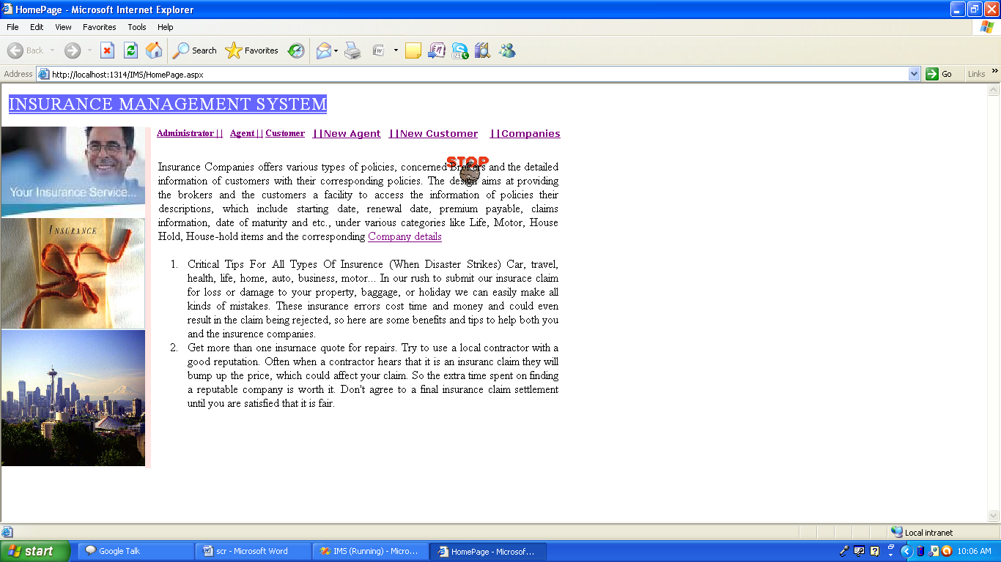
Home Page

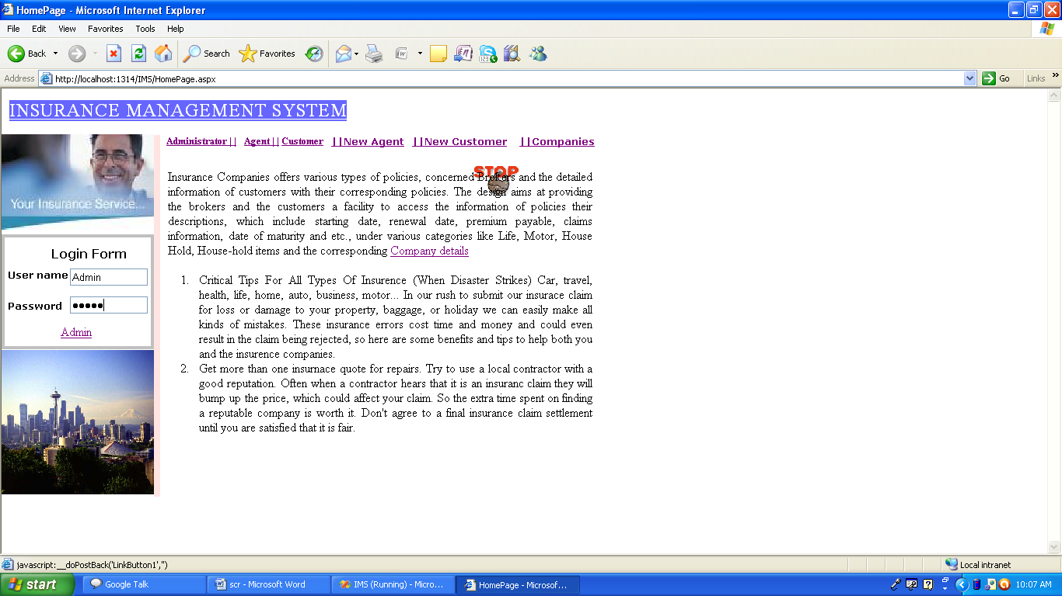

Logging in to admin

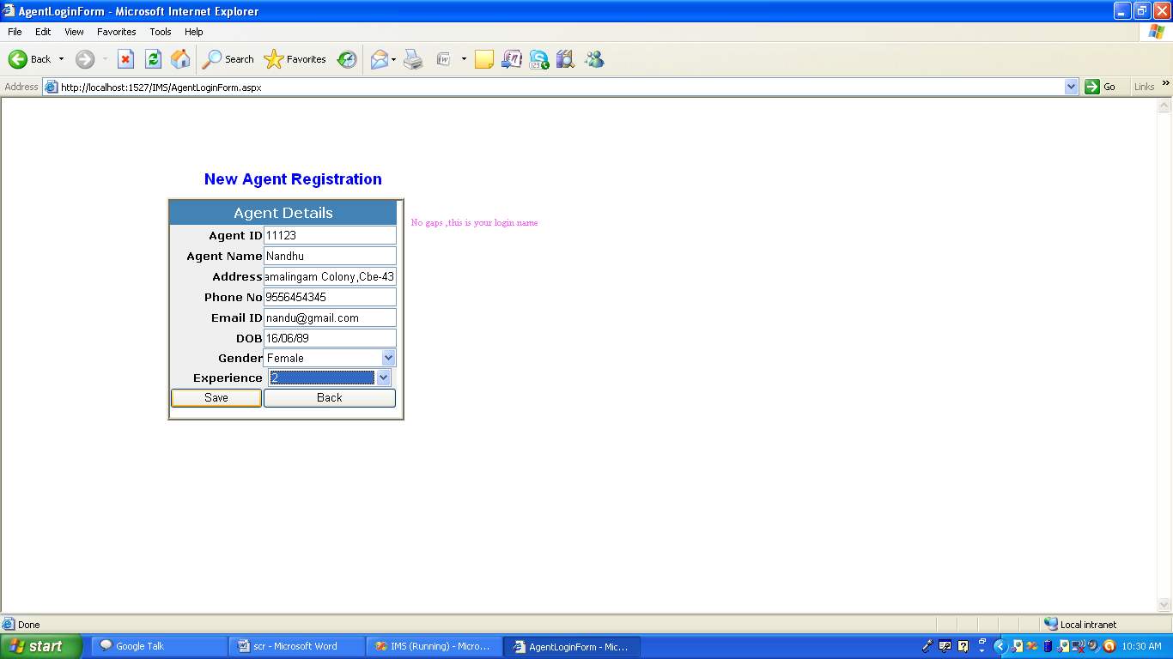
New Agent Registration

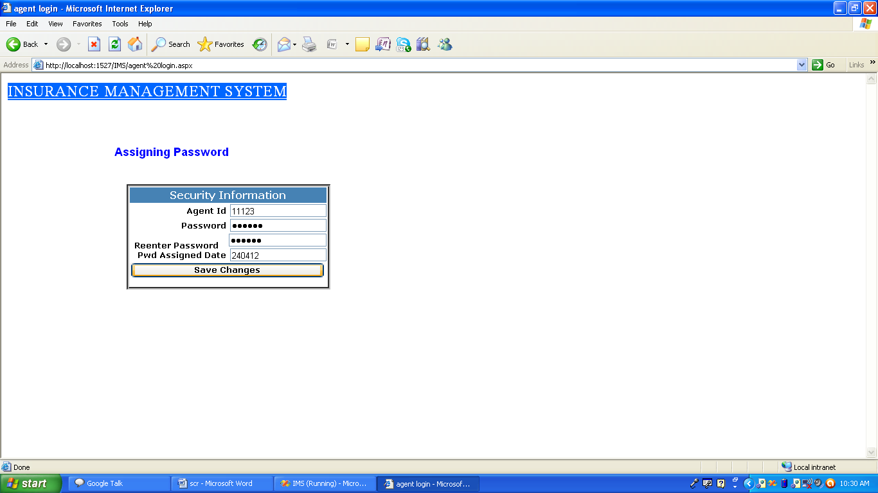

Password Assignment to Agent

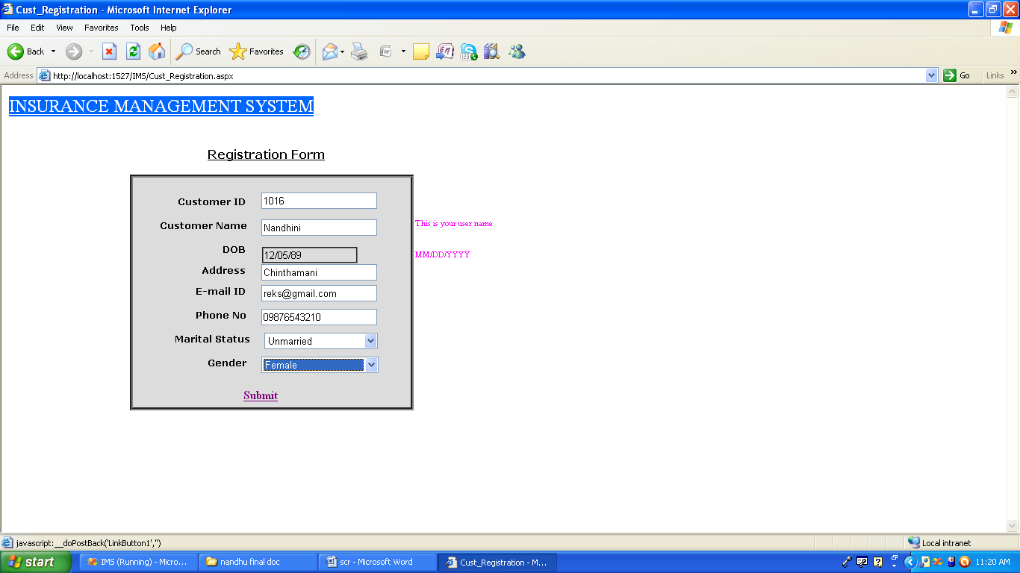
Customer Registration

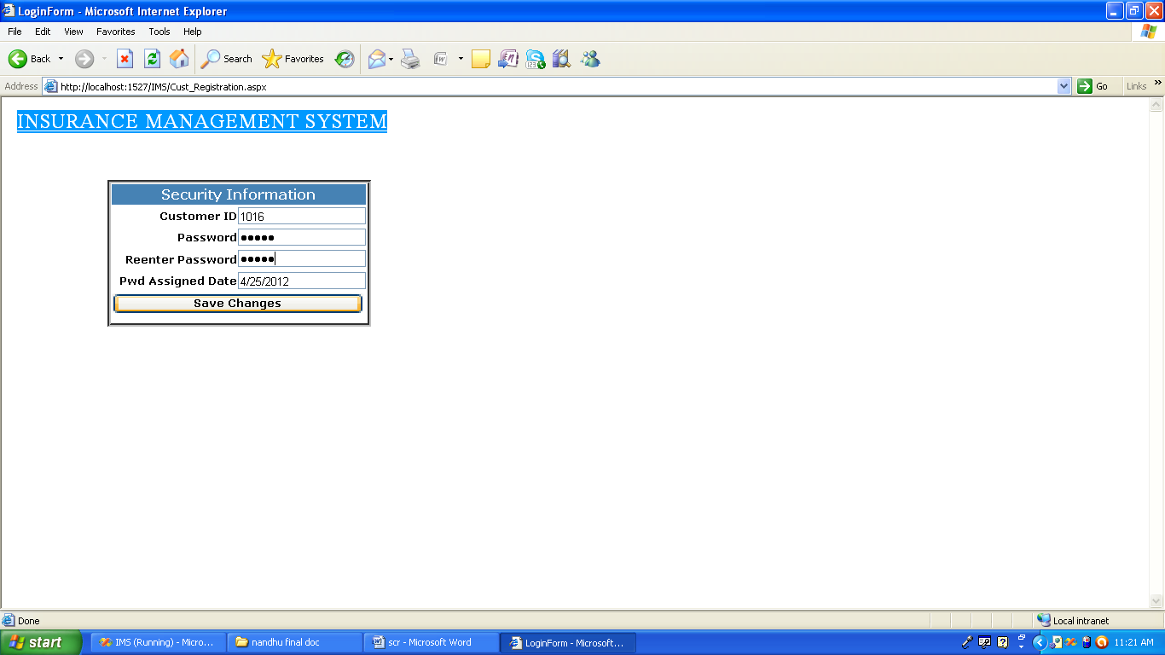
Assigning Password to Customer

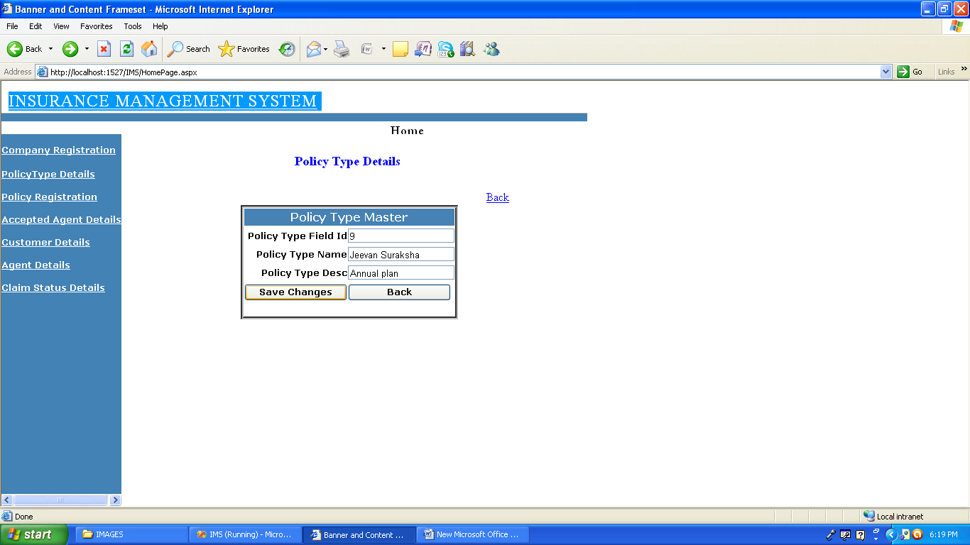

Policy Entry
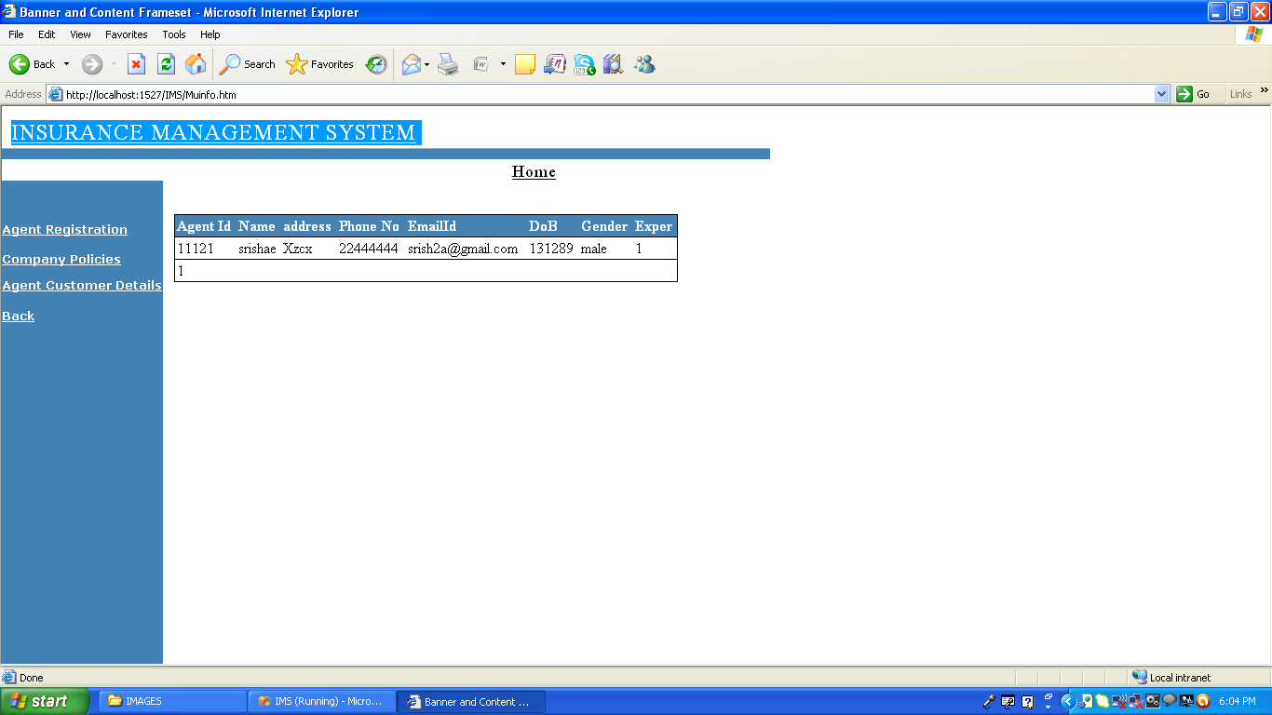

Detail of the Agent
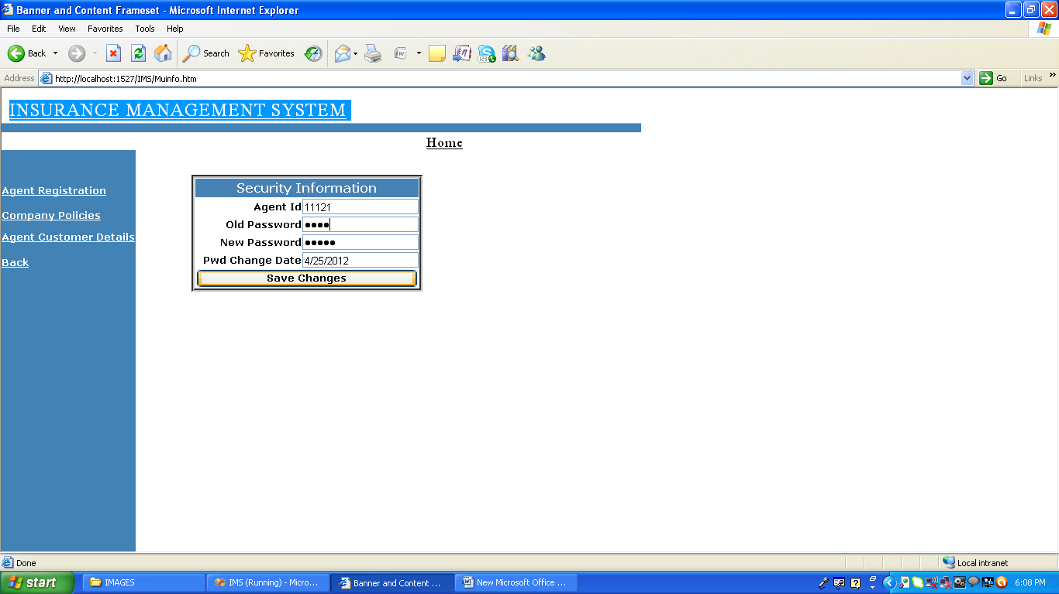

Password Change Details

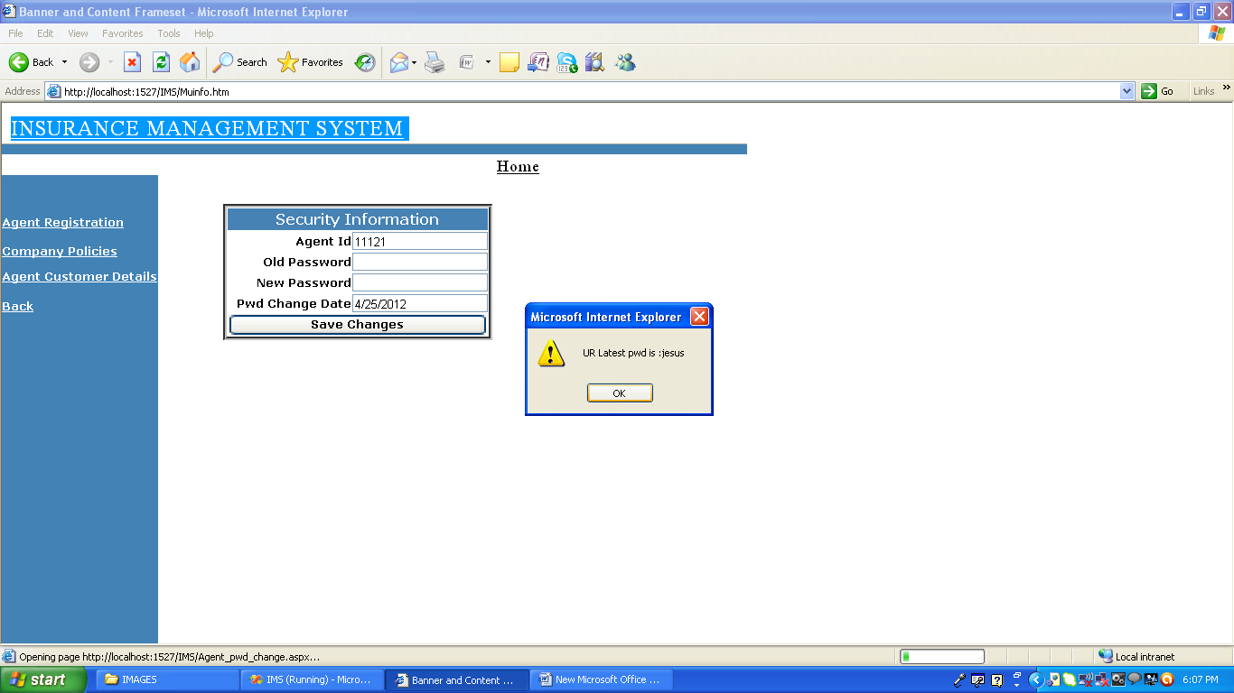
New Password Display

