COMPUTER AIDED THEME BASED DESIGNING FOR
GRADE SCHOOL GIRLS’ MULTIWEAR GARMENTS

By
UTHRA, K.
(Reg. No. 11PFA15)

A THESIS SUBMITTED TO THE
AVINASHILINGAM INSTITUTE FOR HOME SCIENCE AND
HIGHER EDUCATION FOR WOMEN, UNIVERSITY,
COIMBATORE – 641 043

IN PARTIAL FULFILLMENT OF THE REQUIREMENTS FOR THE DEGREE OF
MASTER OF SCIENCE
IN
TEXTILES AND FASHION APPAREL

MAY 2013

COMPUTER AIDED THEME BASED DESIGNING FOR
GRADE SCHOOL GIRLS’ MULTIWEAR GARMENTS

By
UTHRA, K.
(Reg. No. 11PFA15)

A THESIS SUBMITTED TO
AVINASHILINGAM INSTITUTE FOR HOME SCIENCE AND
HIGHER EDUCATION FOR WOMEN, UNIVERSITY,
COIMBATORE – 641 043
IN PARTIAL FULFILLMENT OF THE REQUIREMENTS FOR THE DEGREE OF
MASTER OF SCIENCE
IN
TEXTILES AND FASHION APPAREL

MAY 2013

CERTIFIED AS BONAFIDE RESEARCH WORK

SIGNATURE OF THE  HEAD OF THE DEPARTMENT | SIGNATURE OF THE GUIDE

ACKNOWLEDGEMENT

First and foremost, the investigator places her humble salvations at the feet of GOD ALMIGHTY who has given sound wisdom and desertion knowledge, strength and opportunity to do the investigation effectively.
The investigator expresses her immense gratitude and thanks to THIRU.T.S.AVINASHILINGAM AYYA, Founder and First Chancellor of Avinashilingam Institute for Home Science and Higher Education for Women, Coimbatore, and Dr.(Tmt.) RAJAMMAL P. DEVADAS, M.A., M.Sc., Ph.D. (Ohio State), Hon. D.Sc. (Azad Agri. University, Kanpur), Former Chancellor, Avinashilingam Institute for Home Science and Higher Education for Women, Coimbatore, for providing and shaping this temple of learning.
The investigator wishes to express her immense gratitude to THIRU.T.S.K.MEENAKSHI SUNDARAM, M.A., M.Phil., Chancellor, Avinashilingam Institute for Home Science and Higher Education for Women, Coimbatore, for the opportunity to conduct research in this esteemed university.
The investigator owes her deep sense of gratitude and thankful to Dr.(Tmt.) SHEELA RAMACHANDRAN, M.Sc., P.G.Dip., Ph.D. (Avinashilingam), Vice-Chancellor, Avinashilingam Institute for Home Science and Higher Education for Women, Coimbatore, for the amenities provides for the successful completion of the study.
The investigator expresses her respectful regards and heartful gratitude to Hon.Colonel. Dr.(Tmt.) SAROJA PRABHAKARAN, M.A., Dip. Ed. (Madras), Ph.D. (Mother Teresa), Former Vice-Chancellor, Director, Hall of Residence, Avinashilingam Institute for Home Science and Higher Education for Women, Coimbatore, for her encouragement and constructive suggestions for the successful conduct of the study.
The investigator expresses her respectful regards and sincere thanks to Dr.(Tmt.) GOWRI RAMAKRISHNAN, M.Sc. (Madras), M.Phil., Ph.D. (Avinashilingam), Registrar, Avinashilingam Institute for Home Science and Higher Education for Women, Coimbatore, for her encouragement towards the research.
The investigator records her respectful regards and tribute to Dr.(Tmt.) K.THANGAMANI, M.Sc., Dip. Ed., M.Phil., Ph.D., Dean, Faculty of Home Science, Avinashilingam Institute for Home Science and Higher Education for Women, Coimbatore, for her constant help and support at all times of need.
The investigator takes this opportunity to reveal thanks to Dr.(Tmt.) N.VASUGI RAAJA, M.Sc., M.B.A., M.Phil. (Madras), Ph.D. (Avinashilingam), Professor and Head, Department of Textiles and Clothing, Avinashilingam Institute for Home Science and Higher Education for Women, Coimbatore, for her encouragement and valuable help during the progress of her study.
The investigator expresses immensely indebted and extremely privileged to have worked under the supervision of her esteemed guide, Dr.(Tmt.) R.SUNITHA, M.Sc., M.Phil., Ph.D., Assistant Professor, Department of Textiles and Clothing, Avinashilingam Institute for Home Science and Higher Education for Women, Coimbatore, for her valuable guidance, technical support, timely help and constant encouragement throughout the study.
The investigator expresses her deep sense of gratitude to all the STAFF MEMBERS of the Department of Textiles and Clothing, Avinashilingam Institute for Home Science and Higher Education for Women, Coimbatore, for being supportive, suggestive, understanding and encouragement rendered towards the completion of her study.
The investigator expresses her special thanks to AVINASHILINGAM INSTITUTE FOR HOME SCIENCE AND HIGHER EDUCATION FOR WOMEN, SITRA and SIMA for providing library facilities and guidance provided.
The investigator expresses her gratitude and sincere thanks to all the respondents of N.A.KONDU RAJA MEMORIAL HIGH SCHOOL, THENI and also the investigator records her gratitude to the Mothers of the Grade School Girls for their kind cooperation, whole hearted participation and help to collect the data during the study.
Last, but not the least, the investigator is proud to acknowledge the love, support of parents, family members and friends for valuable help, encouragement, steady support which has led to the completion of her study. The investigator is deeply thankful who have helped her directly and indirectly towards the completion of this dissertation.

CONTENTS

CHAPTER | TITLE |  |  | PAGE NO.
 | LIST OF TABLES
 | LIST OF FIGURES
 | LIST OF PLATES
 | LIST OF APPENDICES
1 | INTRODUCTION |  |  | 1
2 | REVIEW OF LITERATURE |  |  | 5
 | 2.1 | Importance of Clothing |  | 5
 | 2.2 | Standard Measurement |  | 6
 | 2.3 | Design Development |  | 7
 |  | 2.3.1 | Pre Requisites in Surface Designing | 7
 |  | 2.3.2 | Elements of Design | 7
 |  | 2.3.3 | Types of Design | 8
 |  | 2.3.4 | Principles of Design | 9
 |  | 2.3.5 | The Colour Wheel | 10
 | 2.4 | Computer Aided Designing |  | 10
 | 2.5 | Garments and their Fit |  | 11
 | 2.6 | Multiwear Garment |  | 13
3 | EXPERIMENTAL PROCEDURE |  |  | 14
 | 3.1 | Conducting Survey |  | 15
 |  | 3.1.1 | Selection of Tool | 15

CHAPTER | TITLE |  |  | PAGE NO.
 |  | 3.1.2 | Conduct of the Study | 15
 |  | 3.1.3 | Analysis of Data | 15
 | 3.2 | Standardizing Measurement for Grade School Girls |  | 16
 |  | 3.2.1 | Selecting the Sample | 16
 |  | 3.2.2 | Taking Body Measurements | 16
 |  | 3.2.3 | Standardizing the Body Measurements | 19
 | 3.3 | Nomenclature |  | 19
 | 3.4 | Design Development through Manual Sketching for Multiwear Garment Based on Themes |  | 20
 |  | 3.4.1 | Preparation of Theme Based Manual Sketching | 21
 |  | 3.4.2 | Evaluation and Selection of Manually Sketched Themes | 24
 | 3.5 | Computer Aided Designing |  | 34
 |  | 3.5.1 | CAD Application | 34
 |  | 3.5.2 | Evaluation and Selection of Design | 34
 | 3.6 | Construction of Garments |  | 40
 |  | 3.6.1 | Selection and Scouring of the Materials | 40
 |  | 3.6.2 | Drafting | 41
 |  | 3.6.3 | Altering the Basic Pattern to Multiwear Garment | 41

CHAPTER | TITLE |  |  | PAGE NO.
 |  | 3.6.4 | Preparation of Fabric for Cutting | 41
 |  | 3.6.5 | Layout, Transferring and Cutting the Material | 41
 |  | 3.6.6 | Construction of Multiwear Garment | 42
 | 3.7 | Trimmings for Multiwear Grament |  | 44
 | 3.8 | Accessories |  | 48
 | 3.9 | Evaluation of the Constructed Garments |  | 48
 |  | 3.9.1 | Visual Inspection | 48
 |  | 3.9.2 | Feedback through Self Assessment | 48
 | 3.10 | Cost Estimation |  | 48
4 | RESULTS AND DISCUSSION |  |  | 50
 | 4.1 | Survey Among Mothers |  | 50
 |  | 4.1.1 | Preference for Purchasing Garments for Child | 51
 |  | 4.1.2 | Preference for Allotting amount (`) for Garment | 52
 |  | 4.1.3 | Consideration of Factors While Choosing Garments | 53
 |  | 4.1.4 | Awareness About Multiwear Garment | 54
 |  | 4.1.5 | Purchase Rating of Multiwear Garments | 54
 |  | 4.1.6 | Reasons for not Purchasing Multiwear Garments | 55
 |  | 4.1.7 | Frequency of Purchasing Garments | 55
CHAPTER | TITLE |  |  | PAGE NO.
 |  | 4.1.8 | Preference for Colour | 56
 |  | 4.1.9 | Preference for Texture | 57
 |  | 4.1.10 | Preference for Themes | 58
 |  | 4.1.11 | Preference for Surface Embellishment | 59
 |  | 4.1.12 | Preference for the Type of Surface Embellishment | 60
 | 4.2 | Consolidated Rating of Manual Sketching |  | 61
 | 4.3 | Consolidated Rating of the Design Created with Corel Draw |  | 62
 | 4.4 | Visual Inspection of Multiwear Garment |  | 63
 | 4.5 | Feedback through Self Assessment |  | 65
 | 4.6 | Cost Estimation |  | 65
5 | SUMMARY AND CONCLUSION |  |  | 66
 | BIBLIOGRAPHY
 | APPENDICES

LIST OF TABLES

TABLE NO. | TITLE | PAGE NO.
I | Nomenclature | 20
II | Preference for Purchasing Garments for Child | 51
III | Preference for Allotting Amount (`) for Garment | 52
IV | Consideration of Factors While Choosing Garments | 53
V | Awareness About Multiwear Garments | 54
VI | Purchase Ratings of Multiwear Garments | 54
VII | Reasons for Not Purchasing Multiwear Garments | 55
VIII | Frequency of Purchasing Garments | 55
IX | Preference for Colour | 56
X | Preference for Texture | 57
XI | Preference for Themes | 58
XII | Preference for Surface Embellishment | 59
XIII | Preference for the Type of Surface Embellishment | 60
XIV | Consolidated Rating of Manual Sketching | 61
XV | Consolidated Rating of the Design Created with Corel Draw | 62
XVI | Visual Inspection of Multiwear Garment | 63
XVII | Feedback through Self Assessment | 64
XVIII | Cost Estimation | 65

LIST OF FIGURES

FIGURE NO. | TITLE | PAGE NO.
1 | Body Measurements – Front | 18
2 | Body Measurements – Back | 18
3 | Preference for Purchasing Garments for Child | 51
4 | Preference for Allotting Amount (`) for Garment | 52
5 | Consideration for Factors while Choosing Garment | 53
6 | Frequency of Purchasing Garments | 56
7 | Preference for Colour | 57
8 | Preference for Texture | 58
9 | Preference for Themes | 59
10 | Preference for the Type of Surface Embellishment | 60

LIST OF PLATES

PLATE NO. | TITLE | PAGE NO.
I | Body Measurements | 18
II | Manual Sketching for Multiwear Garments | 25
III | Computer Aided Designing | 35
IV | Constructed Garments | 45
V | Accessories | 49

LIST OF APPENDICES

APPENDIX NO. | TITLE
I | To Elicit Information about Mother’s Preferences Towards the Selection and Purchase of Garments for Girl Child
II | Various Body Measurements of Grade School Girls
III | Calculation of Standardized Measurement
IV | Fabric Swatches
V | Instructions for Drafting Basic Bodice (Front and Back)
VI | Instructions for Drafting Sleeve
VII | Instructions for Basic Skirt (Front and Back)
VIII | Proforma to Elicit Information Regarding the Multiwear Garment through Visual Inspection
IX | Proforma to Elicit Information Regarding Feedback through Self Assessment

1. INTRODUCTION

“A history of fashion, is a history of life
To be out of fashion, is to be out of”
Fashion is change ; the new ideas becoming old and old ideas becoming new again – but always with a fresh twist. The continual search for something fresh is the designer’s greatest challenge (Chauhan and Saboo, 2000). “Clothes make the man” is an old saying which we accept as a truism without giving it much thought (Kulshrestha and Kashyap, 2007).
Fashion is an offspring of the beautiful, of vision, not of mathematics. Therefore it is not static. The concept of beauty varies with different individuals and people from time to time (Chauhan, 2003). Clothing refers to coverings and garments intended to be worn on a human body. Fashion refers to the kind of clothing in a desirable style worn at a particular time. Clothing historians trace the development of dress by studying various sources, including magazines, catalogues, paintings, photographs, hats, shoes and other surviving items (Jefferson, 2005).
Clothing is one of the basic needs of life, fabric has always been found to be most suitable and acceptable medium of expression of art. At times colours, fabrics and symbols signified a high status. The clothing that we wear were dyed to stimulate and gratify the sense with colours (Jayashree, 2000).
Clothing is the ‘second skin’ ranking with food and shelter as essential for human survival, may also serve other less critical needs. Clothes are an outward expression of how people feel about themselves and kind of world they tend to live in (Patil et al., 2001). Comfort may be defined as a pleasant state of psychological and physical harmony between a human being and the environment. All three aspects are equally important, since people feel uncomfortable if anyone of them is absent. Designers of clothing can take care of psychological and physical aspects of comfort by suitable selection of colour, design, texture, style and garment fit (Kholiya and Goel, 2007).
Designers choose the colours, silhouettes and fabrics of their collections ‘what inspires a designer’ the entire world. Designers attend art galleries, read and listen to the media, go to movies, travel, study history and observe what people are wearing. From all of these things the designers get an inspiration (Gatterson and Stewart, 2009). Children are gift from paradise no doubt. Baby women are a little more charming than boys, possibly because of their tender skin and flesh, when they’re five to 10 years of age. In colours also, inside the fundamental seven colours from the rainbow, countless combinations are produced and are available towards the market worldwide (http://daaira.com/kidsfrockcollection).
The children’s interest in clothing is affected by two conditions. The first condition is that, all children learn from parents about the importance of right clothes for the right occasion and how certain garments help to improve one’s looks. Later, children learn from peers that clothing helps to increase popularity among peer group and facilitate playing leadership role by reinforcing the amount of value placed by the social group on clothing (Raul, 2000). Children clothing are clothing who has not grown to full height. Now-a-days children are very fashion conscious and they have been exposed through various media. They themselves are the very choosy customers of different fashionable functional clothing. So the children wear designers concentrate on simplicity, comfort, new look and functionality in design a garment. The ideal party clothing should be attractive, soft, comfortable, fit for play, taking rest, comparatively loose and easy to put on and take off (Basak and Das, 2012).
Design involves basic elements like line, form, shape, colour, rhythm, unity and space. A well designed garment has beauty and appropriateness which makes it suitable for the wearer and for the occasion. Fashion is the prevailing mode which cannot be ignored, but which can seldom be used as a guide for attractive clothes for everyone. Fashion forecasting is the most important for a designer.
Designers are of great importance when it comes to give an enchanting and intriguing look to the textile products. They play a vital role in bringing about a drastic change in appearance of different items produced by the textile industries. A fabric with designs is capable of having a more capable impression than the ones without them (Sangama and Rani, 2012).
In the present world, computers have grown to be foremost requirement of almost every conceivable profession, which requires creativity, accuracy and a good implementation of time. The two most popular and influential software’s used in the world of fashion are Corel Draw and Adobe Photoshop (Luther, 2008). CAD has become an especially important technology within the scope of computer aided technologies. It enables the designers to layout and develop work on screen, print it out and save it for future editing, saving time on their drawing (Neelima, 2009).
Garment construction is one of the basic content of fashion designing. Every fashion designer should have detailed knowledge of the process of garment construction. Surface designing refers to superficial embellishment on the fabric or structural and applied design on any substrate. There are innumerable varieties of decorations that enrich the fabric surface but techniques limited to substrate sources. The yardage of cloth, sometimes chosen for embellishing depends on the specific end use. The most predominating techniques that enhance the consumer acceptance by beautifying the textile materials are dyeing, printing, painting embroidery and surface finish (Naik and Wilson, 2006). A portfolio is a representative collection of a designer’s best work. Designers who have CAD skills should be sure to include computer designs in their portfolio and should note the software programs used to create the designs (Tate, 2004). A portfolio displays the sampling of work done by an artist, designer or illustrator. Multiwear clothing can be worn in more than one way or that serve multiple purposes. They can usually be altered by utilizing attached stripes of cloth, ties, buttons or other built-in modifiers.
Considering the above facts, the investigator decided to take up a study on “COMPUTER AIDED THEME BASED DESIGNING FOR GRADE SCHOOL GIRLS’ MULTIWEAR GARMENTS” with the following objectives.
- To standardize body measurements for grade school girls.
- To design theme based mutliwear garment
- To evaluate and develop selected designs with CAD.
- To construct and evaluate selected theme based garments.

2. REVIEW OF LITERATURE

The Review of Literature pertaining to the study on “COMPUTER AIDED DESIGNING FOR GRADE SCHOOL GIRLS’ MULTIWEAR GARMENTS” are discussed under the following headings :
2.1 Importance of Clothing
2.2 Standard Measurement
2.3 Design Development
2.3.1 Pre Requisites in Surface Designing
2.3.2 Elements of Design
2.3.3 Types of Design
2.3.4 Principles of Design
2.3.5 The Colour Wheel
2.4 Computer Aided Designing
2.5 Garments and their Fit
2.6 Multiwear Garment
2.1 IMPORTANCE OF CLOTHING
Clothing is very ancient technology of fibre and textile material worn on the body and it is one among the most important three basic needs in every human being. Clothing is a feature of nearly all human societies and it protects our body from various climates, toxic chemical and gives us a good comfort, appearance (Basak and Das, 2012).
Apparel is used to describe the clothes worn by people. There are many different types of apparel worn to suit different occasions and places. Many factors can therefore affect the type of clothes one wears. The four factors are the climate of the country, its customs and tradition, the people’s religion and the different status of a certain group of people in a country (Thomas, 2006).
Clothing is an integral part of human life. The primary role of clothing is to form a layers of barriers that protect the body against unsuitable physical environment. This protection of body fulfils number of functions like maintaining the right thermal environment to the body, which is essential for its survival and preventing the body from being injured by abrasion, radiation, wind, electric, chemical and microbial substances. These traditionally classified functions of clothing clearly indicate that it plays a vital role at the interface between human body and its surrounding environment in determining the perception of comfort status of the wearer (Bhargava and Gahlot, 2012).
Clothing plays an important role in social development, as definite ideas about clothing likes and dislikes are developing. The children from the age group of 5 to 11 years are belonging to the group and what the group wears is very important (Gupta et al., 2005). Sewing is primarily used for clothing. The primary purpose of clothing is to warm the wearer. In hot climates the function is minimal, while in very cold climates it is very high. Shelter usually reduces the functional needs for clothing (Neelima, 2009). Costume is an expression of the person, reflecting personality, way of living, way of thinking and especially, pride in self or family. Thus clothing should be no more than a tool, an aid in expressing what and who the person is. It is a reflection of one’s taste, one’s life and value (Mehta, 2013).
2.2 STANDARD MEASUREMENT
Standard measurements are a given set of measurements that comply with a commercial sizing. These measurements are a result of extensive anthropometric studies carried out on different age groups, heights and girths (Saluja, 2006).
Anthropometry has been an integral part of anthropological research since the 19th century when the need first arose for a scientific method of describing living and extinct populations. This discipline provides for the systematic collection and correlation of measurements of a human body in order to supply data for various purposes, other than anthropological research. Apart from the sizing of clothing anthropometric data is also used for the engineering of dynamic environment in which human beings can function with ease, efficiency and safety (Cooklin, 1991).
2.3 DESIGN DEVELOPMENT
2.3.1 Pre Requisites in Surface Designing
A design is a surface enrichment of proper fabric or garment by combination of elements and principles of art. The creation of design involve appropriate selecting and organization of fundamental elements (Nidhikalra et al., 2008).
Structural Design includes the all over design of a garment. Its form and shape plus all the details involved in assembling the sections of a garment such as darts, pleats and tucks. It may add a decorative quality if emphasized by colour contrast or row of top stitching to outline the basic garment parts. In apparel, structural design is more important because it is the fundamental component of design (Sumathi, 2002).
Decorative Design is the surface enrichment of structural design. Any lines, colours or materials that have been applied to a structural design for the objective of adding a richer quality to it, constitutes its decorative design. Decorative design adds to the luxury of design such as frills, belts, tucks, embroidery and pockets. Beautiful decorative effects in dress may be obtained through the use of well-planned tucking or bands (Neelima, 2009).
2.3.2 Elements of Design
Designing process involves the combining of known design components in varied ways to create new products. Elements of design are those components which the designers employ in all forms of art and design, whether the designing of garments, music, buildings, paintings and sculptors. Understanding of these elements and using them in different ways enables the designer to produce different art and visual effects (Sodhia, 2004).
Lines in clothes are an important part of design. When line is used correctly it becomes a very important factor in the development of a pleasing appearance. The most important lines in our clothes are the outlines of our figure or silhouette. Lines can play tucks on the eyes. Line may lead the eye vertically, horizontally or diagonally (Gupta et al., 2005).
Texture refers to the surface quality of a fabric such as smooth, rough, shiny or dull. The feel or hand such as soft crisp or hard also is determined by the texture of a material. The texture can be used along with colour, shape and lines to create the effect desired (Jacob, 1996).
Colour plays an important role while illustrating. A picture gets attractive and lively through colours. Various emotions and feelings can express through them. For example red corresponds with anger, danger, fire, youth, strength etc. yellow symbolizes joys, uniqueness, wealth and prosperity (Narang, 2006). Symbolic meanings of colour have psychological connotations. Nevertheless, colours affect us psychological effect regardless of any symbolism. And the psychological effect of are colour can be very different from its symbolical significance. Black may signify mourning, but a black gown or suit, such as tuxedo, is distinguished and elegant as well, depending upon circumstances (Mahadevan, 2008).
A shape is defined as an area that stands out from the space next to or around it due to a defined or implied boundary, or because of differences of value, colour or texture. It is formed when a line encloses an area. These lined enclosures create an illusionary focus termed as shapes. Shapes can vary endlessly and can suggest physical form and direct eye movement based on the directional movement of lines. Shapes define figure, create ground relationships and relate forms and figures (Neelima, 2009).
2.3.3 Types of Design
Natural design is a design imitating nature or the usual natural surroundings. Abstract design is a design which has no referrants to anything concrete in the real world. Historical design is a design that semantics in everyday objects and architecture (www.fabsugar.com).
Conventional design is one that depicts some real creature or object. But a conventional doesn’t have to a picture of the world. Geometrical design using simple geometric forms such as circles and squares in design and decoration (Meller and Elffers, 2002).
2.3.4 Principles of Design
Balance is a sense of stability when applied to opposing visual attractions or forces. There is a natural desire for balance, and in nature balance is ever present. In formal balance, the design elements are almost equally distributed. Asymmetry uses informal balance, a centre line or point is ignored, with the design elements being balanced visually, rather than in a symmetrical manner (Wilson, 2001).
Harmony is the unity of all the elements to convey a message. The whole dominates the parts in implying agreement visually or conceptually, such elements refer to lines, shape, size, colour, texture, ideas or themes. Harmony is achieved through proximity isolation or variations of the elements (Colussy and Greenberg, 2007). Harmony is colour is not governed by fixed principles and any combination of hues that is pleasing and gives full satisfaction to the observer may be said to constitute harmony. The colour sense in different persons, however, varies being more highly developed in some than in others and what may appear harmonies to one may be more or less in harmonies (Grosicki, 2004).
Emphasis creates a centre of interest by focusing the viewer’s attention on a specific area of the garment. It is basically the use of subordination in various parts in order to emphasize and highlight certain parts (Davis, 2008).
Rhythm may be defined as a pleasing sense of organized movement that gives continuity to a design. It provides a transition from one unit to another and leads the eye in a fluid movement throughout the design. Without rhythm, a design may appear spotty or disconnected. It results from a regular repeat, or a gradual change giving the feeling of continuity throughout the design (Jacob, 1996).
Proportion includes planning of the basic shape within a design. It may involve the scale of the forms within the design like diversion of space to create attractive space relationship where the variety of shapes, size and the general idea of unity of principles of designs are to be expressed. Optical illusion is created by changing partial arrangements to enhance the attractive position that one wish to enhance (Sumathi, 2002). Proportion refers to the linear sub-division of objects of shapes and concerns the balance of shape, volume, colour, fabric, texture and scale. The combination of these elements make the design of garment infinitely diverse (Kelvey and Munslow, 2003).
2.3.5 The Colour Wheel
All visual colour comes from three primary colours namely, Red, Blue and Yellow. The secondary and tertiary colours happen when 2 primaries are mixed to create new colours, such as red and blue make purple. The colour wheel is the device that helps artists and designers to combine, contrast or blend colours successfully (Gorden, 2002).
2.4 COMPUTER AIDED DESIGNING
Software packages for CAD applications provide the designer with a multi window environment. The various windows can show enlarged sections for closed view of objects. When object design is complete, realistic lighting models and surface rendering are applied to produce displays that will show the appearance of the final product (Mishra, 2010).
Computer graphics can also show the repeat of a fabric pattern, simulate fabric drape on the figure and help designers experiment with colours and fabric changes quickly (Stephens, 2002). Computer can be programmed to generate a variety of different colours and colours combinations for a particular design, which can be selected as per needs. As computer is very fast, all this can be done within very less time. Rendering and 3D modeling can provide presentation of fabric designs generated on CAD systems in room settings and can be mapped onto a 3D model complete with realistic folds and lighting conditions on models (Jothi and Grover, 2009).
Computer software may also be used to repeat a shape, outline or silhouette so that a variety of treatments may be applied. Once the user has gained experience and skill this can save a lot of time. The software could allow designs to be mirrored, inverted, all kind of approaches to stop the presentation from becoming too repetitive (Kelvey and Munslow, 2003).
Corel Draw is a vector graphics editor developed and marketed by Corel Corporation of Ottawa, Canada. It is also the name of Corel’s Graphics Suite, which bundles Corel draw with a bitmap image editor and other graphics related programs (http://en.wikipedia.org/wiki). Corel Draw is an enormously powerful graphic package. It is different from bitmap graphic design package, and is a vector based program. It creates and handles images as mathematically defined vectors. Vectors are objects with magnitude and direction. We can define smooth curves in Corel Draw. It will retain the smoothness when they are enlarged, but this is not the same with bitmap graphics. Bitmap graphics images become grainy when they are enlarged. Corel Draw images are great for printed output. Corel Draw images can be exported as ‘gif’ or ‘jpeg’ for the webpage. A complete Corel Draw page can also be saved for the worldwide web. The tools and other special features of Corel Draw help us to design stunning vector graphics (http://webserver.ignou.ac.in).
2.5 GARMENTS AND THEIR FIT
The factors which determine whether a garment has good fit or not are ease, line, grain, set and balance. These factors are referred to as “Standards for a good fit”. They are interrelated (Mathews, 1985).
The well fitted and properly stitched garments enhance the personality of the wearer. The first requisite of good clothing is the proper fitting, which depends on correct body measurements, proper drafting, cutting and the good stitching which grace to the wearer (Jayashree, 1997). Dress making can be one of the most rewarding forms of handicrafts. Almost anyone can sew pieces of fabric together to make a dress, but it takes a good deal of skill, imagination and application to give this basic dress a perfect finish. The finishing touch by way of trimmings can change a plain dress into sting very distinctive (Patil et al., 2000).
The longevity of any garment depends on the seam parameters and fabric quality. The garment parameters depend on the seam parameters like various factors such as seam strength, seam slippage, seam puckering and yarn severance. Good seams are essential factors in garment quality. The characteristics of a properly constructed seam depend on the type of seam and the stitches per unit length of the seam, the thread tension and the seam efficiency (Bharani et al., 2012).
Fabric is any piece of cloth. A close look reveals that all fabrics are not the same. Some are thick, some thin, while other are soft, and still others may have lot of shine or lustre. These differences occur due o the method employed in the construction of the fabric. The qualities of the fibres greatly affect the appearance and performance of a fabric (Mullick, 2006).
Lining is the inner fabric of a sewn item. We use a lining when we don’t want the seams and construction of a outer layer to show. When selecting a lining we may want to check the bolt end of the fabric for an “antistatic” finish. This prevent the garment from building static as we move. The most common choices for lining are silk, satin, sateen, crepe batiste, tafeeta, blouse weight fabrics, cotton blend and cotton (Colgrove, 2006).
Fullness is introduced into garments for various reasons such as to give good shape and proper fit to the garment, to allow freedom of movement and comfort to the wearer, and to make the garment look attractive. Darts, tucks, pleats, godets, flare and gathers are some of the devices for introducing fullness (Mathews, 1985).
Trims are the necessary supplies used to finish and adorn both garments and accessories. The huge array of decorative trimmings includes buttons, buckles, frog closures, belts, braids ribbons, fringe, bows, laces, emblems and sequins. Often functional trimmings such as threads, elastics, tapes, fasteners, interfacings and shoulder pads are classified as notions (Stephens, 2002).
A fastners is a hardware device that mechanically joins or affixes 2 or more objects together. Velcro is a substitute for zippers, buttons and adjustable waistlines on garments for men, women and children. Velcro is available in many widths and colours. One layer has a hook side and the other layer has a loop side. When these two layers are pressed together, they lock into place until pulled apart (Amaden, 1994).
2.6 MULTIWEAR GARMENT
Multi wear dresses are very unique in pattern and fascinating in designs. Multi wear dresses are specially made for various types of special occasions (http://www.indiamart.com). Multiwear kids dresses are very versatile clothing which enables mixing and matching to create beautiful stylish ensemble for kids (http://www.tcnext.com).
Buying one dress and wearing it in casual, semi casual and formal settings, by altering the way it is worn is a wonder made possible by multi wear dresses. Infinite styles can be created with a single dress from conservative patterns to skimpy numbers by wrappings it in different ways. Saving on budget and closet space, multi wear dresses are becoming all the rage (http://fashion.amillionlives.net).
Multi functional garments (also called convertibles and transformers) are articles of clothing that can be worn in more than one way or that serve multiple purposes. They can usually be altered by utilizing attached stripes of cloth, ties, buttons or other built-in modifiers (http://confedcratearticles. wordpress.com).
3. EXPERIMENTAL PROCEDURE

Experimental procedure pertaining to the study “COMPUTER AIDED DESIGNING FOR GRADE SCHOOL GIRLS’ MULTIWEAR GARMENTS” is discussed under the following headings :
3.1 Conducting Survey
3.1.1 Selection of Tool
3.1.2 Conduct of the Study
3.1.3 Analysis of Data
3.2 Standardizing Measurement for Grade School Girls
3.2.1 Selecting the Sample
3.2.2 Taking Body Measurements
3.2.3 Standardizing Body Measurements
3.3 Nomenclature
3.4 Design Development through Manual Sketching for Multiwear Garment Based on Themes
3.4.1 Preparation of Theme Based Manual Sketching
3.4.2 Evaluation and Selection of Manually Sketched Themes
3.5 Computer Aided Designing
3.5.1 CAD Application
3.5.2 Evaluation and Selection of Design
3.6 Construction of Garments
3.6.1 Selection and Sourcing the Materials
3.6.2 Drafting
3.6.3 Altering the Basic Pattern to Multiwear Garment
3.6.4 Preparation of Fabric for Cutting
3.6.5 Layout, Transferring and Cutting the Material
3.6.6 Construction of Multiwear Garment
3.7 Trimmings for Multiwear Garment
3.8 Accessories
3.9 Evaluation of the Constructed Garments
3.9.1 Visual Inspection
3.9.2 Feedback Through Self Assessment
3.10 Cost Estimation
3.1 CONDUCTING SURVEY
The steps involved for conducting the survey are explained under :
3.1.1 Selection of Tool
Questionnaire is a device for securing answers to questions by using a form by which the respondents fill by themselves (Gupta, 2009). Questionnaire method was adopted for the collection of data. The questionnaire was formulated in order to elicit information about mother’s preference towards the selection and purchase of garments for girl child of age 10 years old. This was pretested and modified as required. Thus finalized questionnaire is presented in Appendix – I.
3.1.2 Conduct of the Study
A good rapport was established with the mothers of the subjects. Then the information was collected from the respondents with the help of the questionnaire.
3.1.3 Analysis of Data
The data after collection has to be processed and analysed in accordance with the outline laid down for the purpose at the time of developing the research plan. Technically processing implies editing, coding, classifying and tabulating the collected data, so that they are amendable to analysis. The collected data was consolidated, tabulated and statistically analysed (Gupta, 2009).
The data collected was thus tabulated and analysed.

3.2 STANDARDIZING MEASUREMENT FOR GRADE SCHOOL GIRLS
The steps involved to standardize the body measurements are expressed under :
3.2.1 Selecting the Sample
Sampling, is a process of selecting a few (a sample) from a bigger group (the sampling population) to become the basis for estimating or predicting the prevalence of an unknown piece of information, situation or outcome regarding the bigger group. A sample is a subgroup of the population you are interested in (Kumar, 2005).
Simple Random Sampling is the most simple procedure of drawing a sample from a given universe. In this sampling each unit has an equal chance of being selected. It is called an equal probability sampling. The process of selection is a random are but in practice we note that random sample usually is a representative sample and gives reasonably accurate data (Chaudhary, 2009).
The investigator planned to select the simple random method of sampling to gather information for the study as careful selection of sample will give good results. 100 grade school girls of age 10 years from N.A.Kondu Raja Memorial High School in Theni was selected as subjects for the study.
3.2.2 Taking Body Measurements
Good fit is a combination of two components namely good and comfortable. Although the concept of good fit varies depending on our different shapes and tastes. The first and most important ingredient for proper fit is your measurements (Sodhia, 2004). In order to construct garments that fit well body measurements must be taken with precision. The body measurements of 100 grade school girls were taken in a proper order (Mathews, 1996). The various body measurements taken by the investigator for the study are given below.
- Chest measurement was taken around the fullest part of the chest just under the arms and straight across the back, keeping the tape parallel to the floor.
- Waist measurement was taken around the waist line with the tape close, but not tight and parallel to the floor.
- Hip measurement was taken around the widest part of the hip 17.5 cm below the waist line, keeping the tape parallel to the floor.
- Back width was taken across the back from armhole to armhole about 7.5 cm below base of neck.
- Back waist length was taken from the base of neck at the centre back to waist line.
- Sleeve length measurement was taken from shoulder end to the desired length of the sleeve.
- Armscye depth was taken from base of neck at centre back to point directly below it and in level with the bottom of the arm where it joins the body.
- Sleeve circumference measurement was taken around the bottom of the sleeve.
- Waist to hip measurement was taken down from the waist at centre back to fullest part of the hip.
- Waist to ankle was taken down from waist at centre back to the ankle.
- Skirt length measurement was taken down from the centre back from waist to desired length of skirt (upto knee)
- Blouse length was taken down from neck at highest point of shoulder to desired length of blouse.
- Full length measurement were taken down from the shoulder line, close to the neck to the ankle. Figures 1 and 2 show the various body measurements taken. The various body measurements taken for the subjects are given in Appendix – II (Plate – I).

KEY :
1 - Chest
2 - Waist
3 - Hip
4 - Back width
5 - Back waist length (A to B)
6 - Sleeve length
7 - Armscyc depth
8 - Sleeve circumference
9 - Waist to hip (B to C) (Figure – 1)
10 - Waist to ankle (B to D) (Figure – 1)
11 - Skirt length (B to E) (Figure – 1)
12 - Blouse length (A to B) (Figure – 1)
13 - Full length (A to D) (Figure – 1)

FIGURE – 1 FIGURE – 2

FIGURES – 1 AND 2
BODY MEASUREMENTS (FRONT AND BACK)
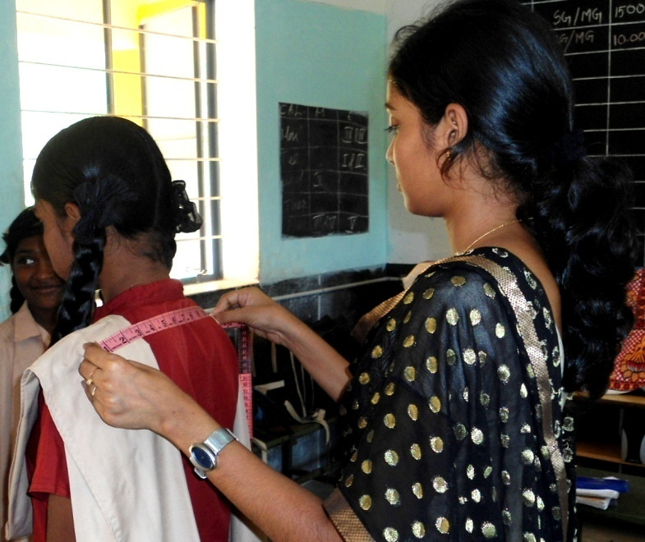
PLATE – I
BODY MEASUREMENTS
3.2.3 Standardizing the Body Measurements
Standard measurements are a given set of measurements that comply with a commercial sizing. These measurements are a result of extensive anthropometric studies carried out on different age group, heights and girths (Saluja, 2006). The mode of a distribution is the value of the point around which the item tends to be most heavily concentrated. Mode is defined as the variable which occurs most frequently in a distribution. The mode in a distribution is that item around which there is a maximum concentration (Pillai and Bagavathi, 2000).
Standardization of the body measurements is necessary to get a specific set of body measurements which is said to be representation of the whole sample. The mode is often said to the value which occurs most frequently. The body measurements were standardized by finding the modal value by using the formula.
M₀ =
where ,
L is the lower limit of the modal class, Δ₁ is the difference between the frequency of the modal class and the post modal class, C is the class interval of the modal class. A sample calculation of the modal value is given in Appendix – III.
3.3 NOMENCLATURE
The details of nomenclature used in the Chapters 3 and 4 are presented in the Table – I.

TABLE – I
NOMENCLATURE
S.No. | Particulars | Nomenclature
1. | Manual sketching | MS
2. | Computer Aided Designing | CAD
3. | Constructed garment | G

3.4 DESIGN DEVELOPMENT THROUGH MANUAL SKETCHING FOR MULTIWEAR GARMENT BASED ON THEMES
The designs were developed for the multiwear garment through manual sketching for the themes, which were selected based on the mother’s preferences.
Fashion illustration is the communicate of fashion that originates with illustration, drawing and painting. Fashion illustration has been around for nearly 500 years. Ever since clothes have been in existence and there was need to translate an idea or image into a garment there has been a need for fashion illustration. It shows the presence of hand and is said to be visual luxury (Kumar, 2010).
Mood, theme and storyboards are essentially a distillation of research. In a sense they are the ‘presentation’ version of a research book. They are made up a collages and as the name suggests, ‘generally mounted on board, which makes them more durable. They are used to communicate the themes, concepts, colours and fabrics that will be used to design the season’s collection (Sorger and Udale, 2006). Twenty five themes were selected for the preparation of multiwear garments for the 10 year old girls. The girls have a fascination towards certain colours, fruits, flowers and icecreams. Based on that the themes selected were Peacock, Rust, Chocolate, Bird, Tulips, Gems, Pearls, Geometrical Design, Lines / Stripes, Forest Apple, Rose, Maple leaf, Mushroom, Butterfly, Icecream, Tree, Angry Bird, Lotus, Musical Instruments, Abstract Design, Watermelon, Lemon, Zebra, Sunflower. Manual sketching was done for all 25 themes .
3.4.1 Preparation of Theme Based Manual Sketching
The theme based manual sketching for the multiwear garments was prepared for 25 different themes (Plates – IIa – IIi).
MS 1 : The sketch MS 1 exhibits the sketching made using the theme “Peacock” split complementary colour harmony was followed. Repetitions of shape and size was used in the design. The textures namely cotton, netted and dobby have been rendered in the garment.
MS 2 : The sketch MS 2 shows the sketching made using the theme “Lemon”. Analogous colour harmony was used. Repetition of lines, shape and size was used. Texture used for this design is cotton have been rendered in the garment.
MS 3 : The sketch MS 3 expresses the sketching with the inspiration of the theme (harmony) “Cherry”. Complementary colour has been used. Repetitions of shape, colour and size are used. Textures namely cotton have been rendered in the garment.
MS 4 : The sketch MS 4 reveals the sketching made using the theme “Rose”. Neutral and monochromatic colours were used. Formal balance has been applied and repetition of shape and size was used in this design. The textures used for rendering the garment was poly cotton.
MS 5 : The sketch MS 5 explains the sketching made using the theme “Geometric Design”. Double complementary colour was use. A repetition of shape and size was applied in the design. The textures used for rendering the garment were cotton and synthetics.
MS 6 : The sketch MS 6 expresses the sketching made with the inspiration of the theme “Chocolate”. Analogous colour harmony was used. Formal balance was followed in this design. The texture used for rendering the garment was cotton blended material.
MS 7 : The sketch MS 7 shows the sketching made using the theme “Tulips”. Analogous colour Harmony was used. Repetition of shape, size was used in this design. The textures namely cotton blended and synthetics were used for rendering the garment.
MS 8 : The sketch MS 8 exhibits the sketching made using the theme “Abstract Design”. Double complementary colour harmony was followed. Informal balance and repetition of shape and size was used in this sketch. The texture, cotton has been rendered in the garment.
MS 9 : The sketch MS 9 shows the sketching made using the theme “Lotus”. Split complementary colour harmony was used. The principles of informal balance formal balance and repetition of shape, colour and size were used in this sketch. The textures namely, cotton, netted and synthetics have been rendered in the garment.
MS 10 : The sketch MS 10 reveals the sketching made using the theme “Ice cream”. Analogous colour harmony was used. The principles namely, repetition of colour and formal balance were focussed in this design. The textures namely cotton, netted and denim have been incorporated in the garment.
MS 11 : The sketch MS 11 reveals the sketching made using the theme “Pearls”. Neutral and monochromatic colours was used. Repetition of shape was applied. The satin texture has been rendered in the garment through the sketch.
MS 12 : The sketch MS 12 shows the sketching made using the theme “Sunflower”. Analogous colour harmony was used. The principles of repetitions shape and colour was used. The cotton texture has been rendered in the garment.
MS 13 : The sketch MS 13 expresses the sketching made with the inspiration of the theme “Tree”. Analogous colour harmony was used. Diagonal lines and repetition of shape and colour were applied. The poly cotton textures has been rendered in garment.
MS 14 : The sketch MS 14 exhibits the sketching made by the inspiration of the theme “Butterfly”. Complementary colour harmony was used. Informal balance and repetition of shape were used. The textures namely, synthetics and tissue have been rendered in the garment.
MS 15 : The sketch MS 15 shows the sketching made using the theme “Stripes / Lines”. Analogous colour harmony was used. Vertical lines and repetition of colour and shape were used. The textures of synthetic and satin have been rendered for the garment.
MS 16 : The sketch MS 16 exhibits the sketching made using the theme “Leaf”. Analagous colour harmony was used. Repetition and shape and size and colour was used. The textures namely, cotton and synthetics have been rendered for the garment.
MS 17 : The sketch MS 17 shows the sketching with the inspiration of the theme “Rust”. Analogous colour harmony was used. Radial balance and repetition of shape were applied. The silk cotton texture has been rendered for the garment.
MS 18 : The sketch MS 18 views the sketching made using the theme “Bird”. Complementary colour harmony was used. Formal balance was applied. The textures, poly cotton and denim have been rendered for the garment.
MS 19 : The sketch MS 19 explains the sketching made with the inspiration of the theme “Angry Birds”. Radical balance was used and colour harmony applied in the design was double complementary. The textures namely, cotton, denim and poly cotton have been rendered in the garment.
MS 20 : The sketch MS 20 shows the sketching made using the theme “Gems”. Analogous colour harmony was used. Formal balance and repetition of size and shape was followed in the design. The textures, namely cotton, and synthetics have been rendered in the garment.
MS 21 : The sketch MS 21 express the sketching made using the theme “Musical Instrument”. Analogous colour harmony was used. Radical balance was applied in the design. The textures, cotton and netted have been rendered for the garment.
MS 22 : The sketch MS 22 shows the sketching made using the theme “Watermelon”. Split complementary colour harmony was used. Formal balance, repetition of shape, size and colour were applied in the design. The textures namely, cotton, synthetics and tissue have been rendered for the garment.
MS 23 : The sketch MS 23 explains the sketching made using the theme “Mushroom”. Analogous colour harmony was used. Repetition of colour, shape and size were applied in the design. The texture namely, poly cotton and synthetics have been rendered in the garment.
MS 24 : The sketch MS 24 shows the sketching using the theme “Maple Leaf”. Analogous colour harmony was used. Repetition of shape, colour and size were applied. The texture, cotton have been rendered in the garment.
MS 25 : The sketch MS 25 exhibits the sketching with the inspiration of the theme “Zebra”. Neutral colours were used. Formal balance and repetition of shape and colour were applied in this design. The textures namely satin, brasso and crepe have been rendered in the garment.
3.4.2 Evaluation and Selection of Manually Sketched Themes
The designs were ranked according to the preference of the subjects by displaying the manually sketched designs of the multiwear garments to the grade school girls (subjects). From their preferences, 10 designs were selected for Computer Aided Designing.
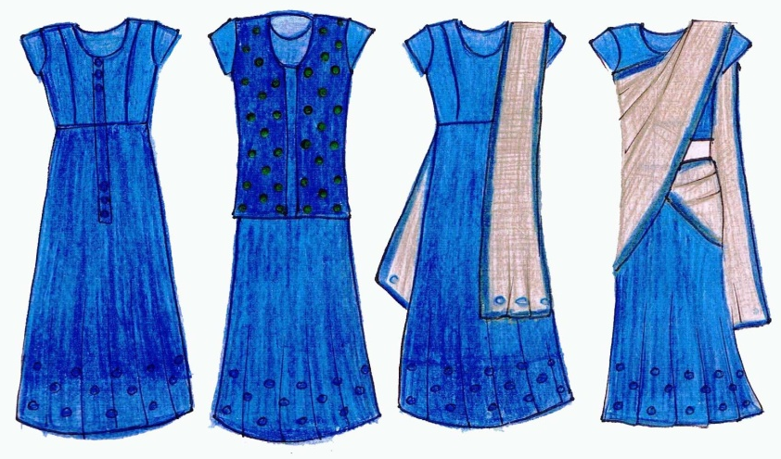
a b c d

MS – 1 : PEACOCK (COLOUR)
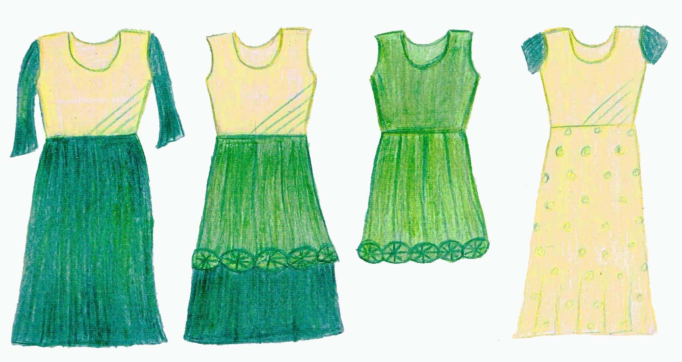
a b c d

MS – 2 : LEMON (SHAPE AND COLOUR)
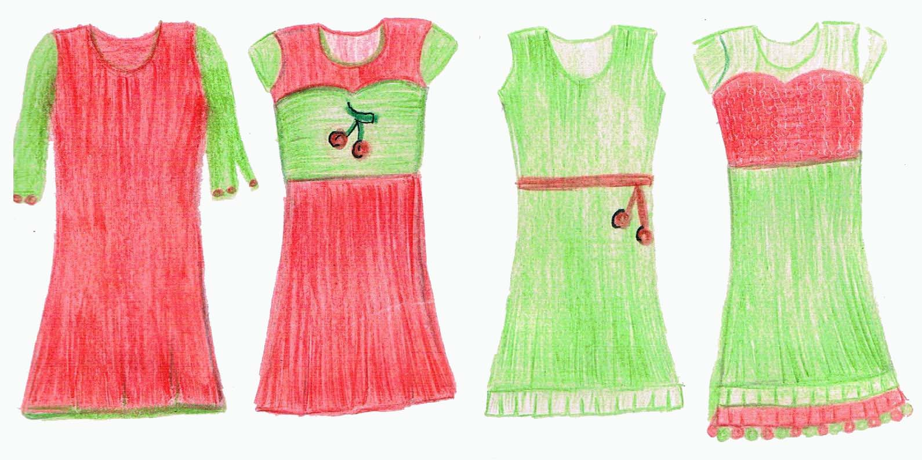
a b c d

MS – 3 : CHERRY (SHAPE AND COLOUR)
PLATE – II (a)
MANUAL SKETCHING
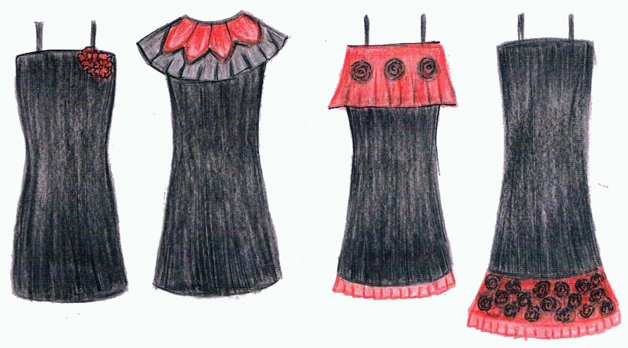
a b c d

MS – 4 : ROSE (SHAPE AND COLOUR)
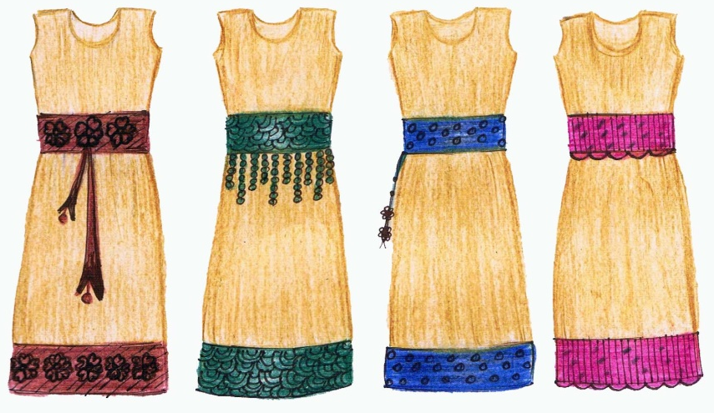
a b c d

MS – 5 : GEOMETRIC DESIGN
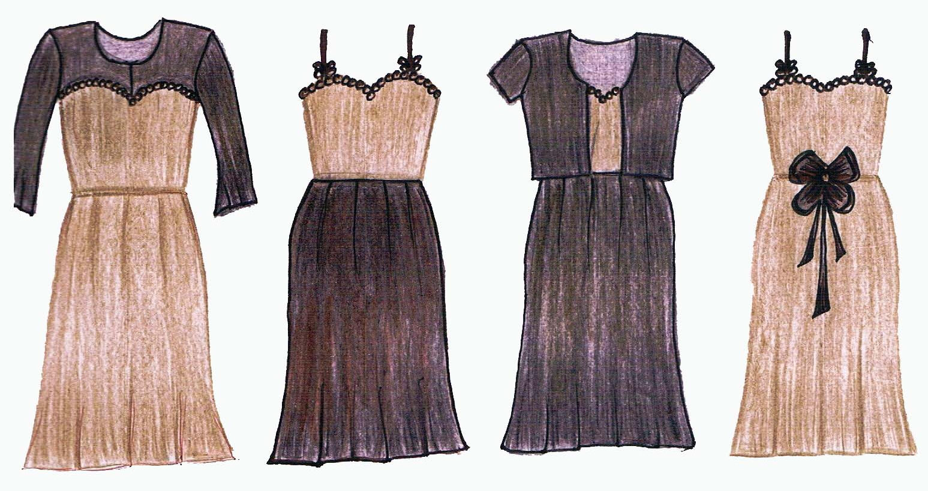
a b c d
MS – 6 : CHOCOLATE (COLOUR)
PLATE – II (b)
MANUAL SKETCHING
.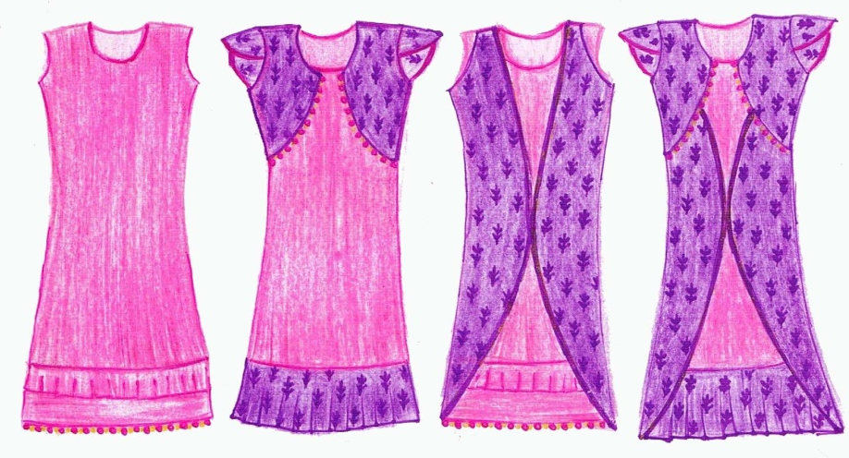
a b c d

MS – 7 : TULIP (COLOUR AND SHAPE)
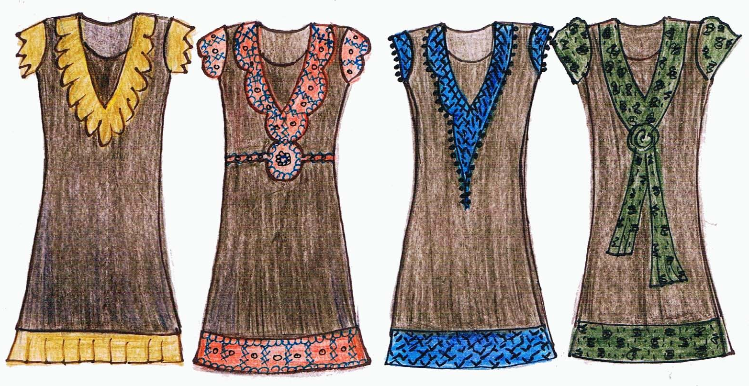
a b c d

MS – 8 : ABSTRACT DESIGN
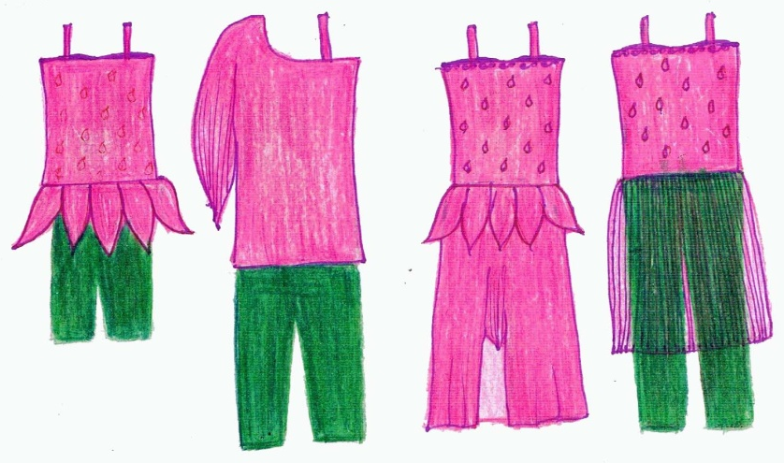
a b c d
MS – 9 : LOTUS (SHAPE AND COLOUR)
PLATE – II (c)
MANUAL SKETCHING
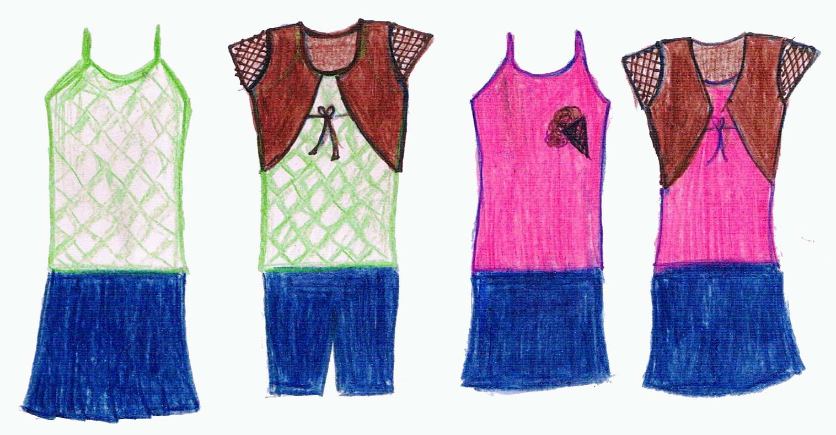
a b c d

MS – 10 : ICE CREAM (COLOUR AND SHAPE)
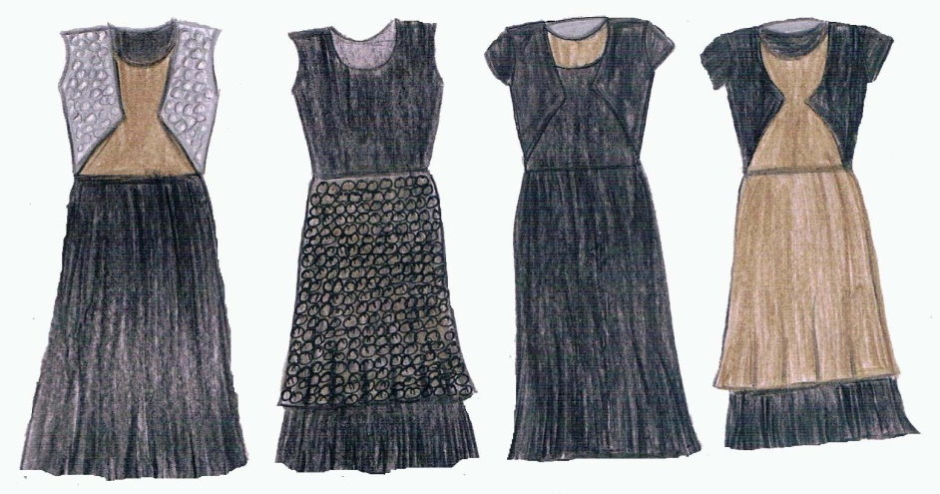
a b c d

MS – 11 : PEARL (SHAPE, COLOUR AND TEXTURE)
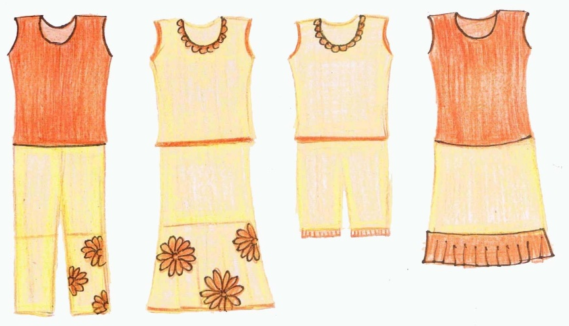
a b c d

MS – 12 : SUNFLOWER (SHAPE AND COLOUR)
PLATE – II (d)
MANUAL SKETCHING
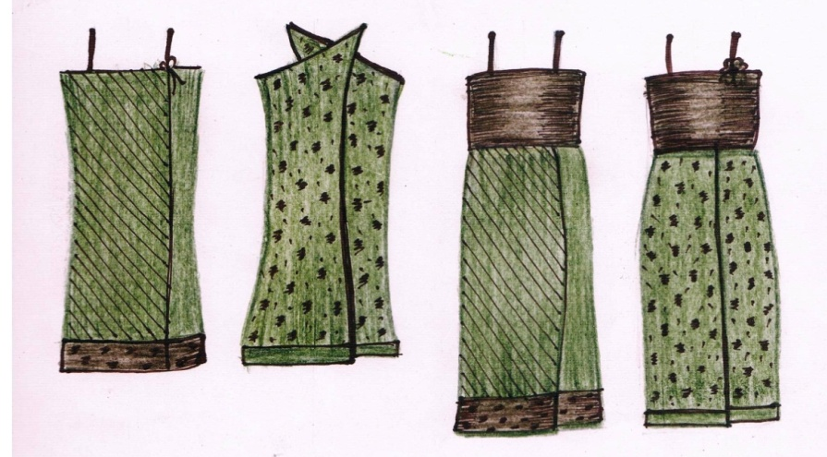
a b c d
MS – 13 : TREE (COLOUR)
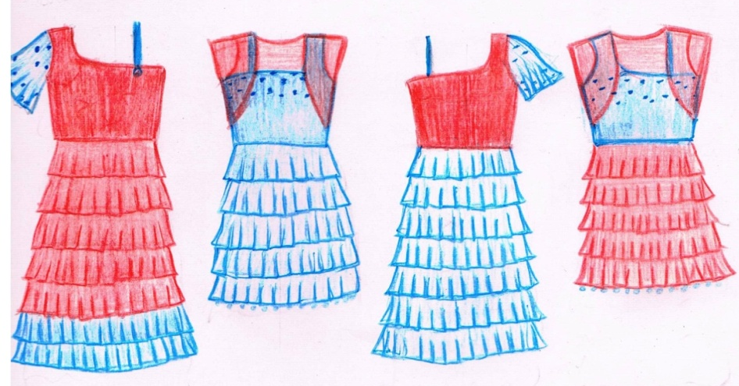
a b c d

MS – 14 : BUTTERFLY (COLOUR AND SHAPE)
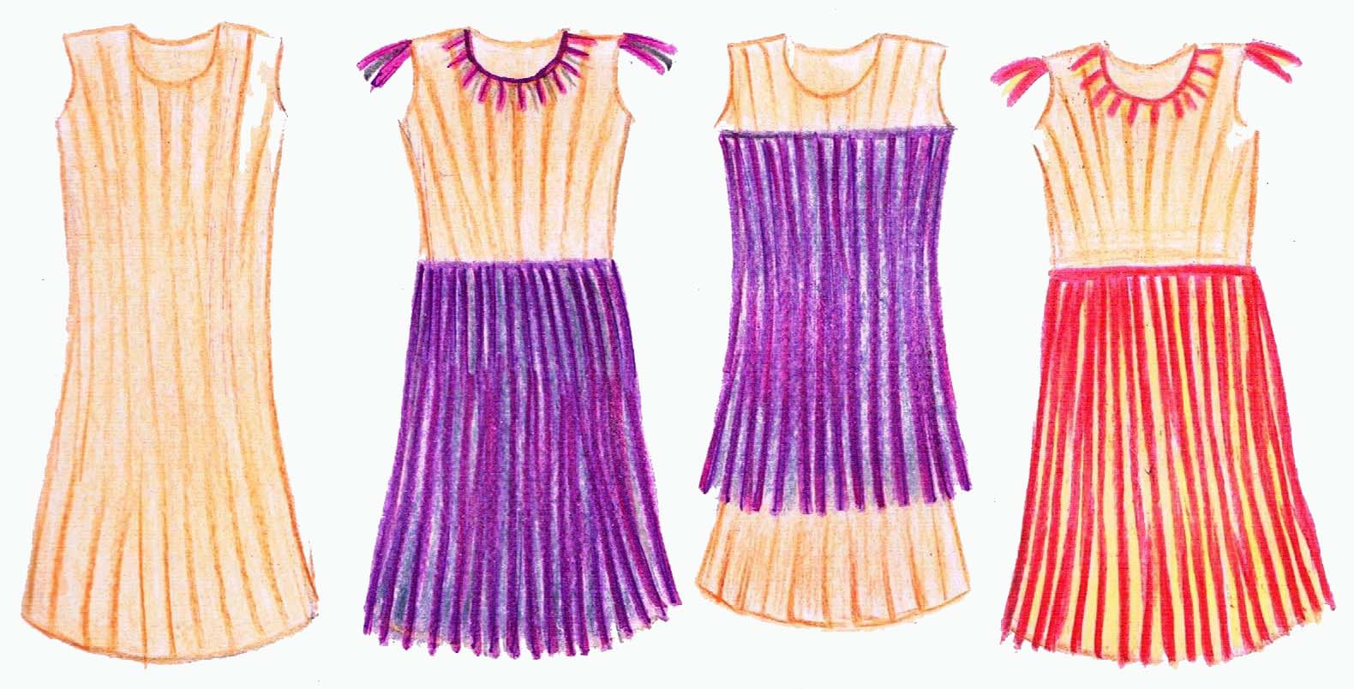
a b c d

MS – 15 : LINES (SHAPE)
PLATE – II (e)
MANUAL SKETCHING
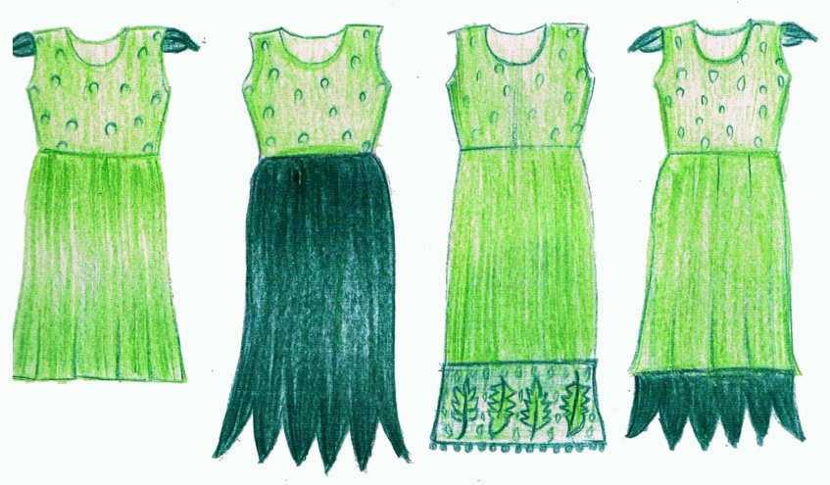
a b c d

MS – 16 : LEAF (SHAPE AND COLOUR)
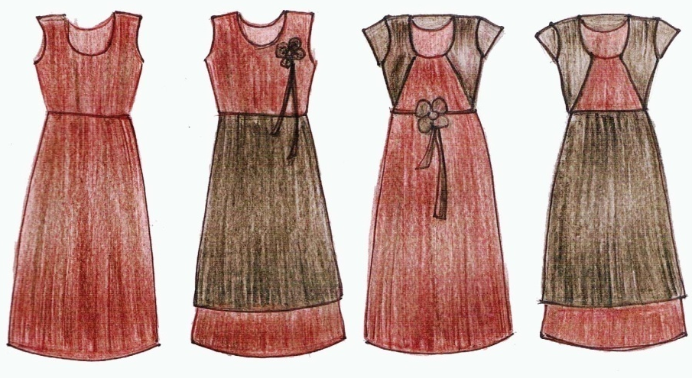
a b c d

MS – 17 : RUST (COLOUR)
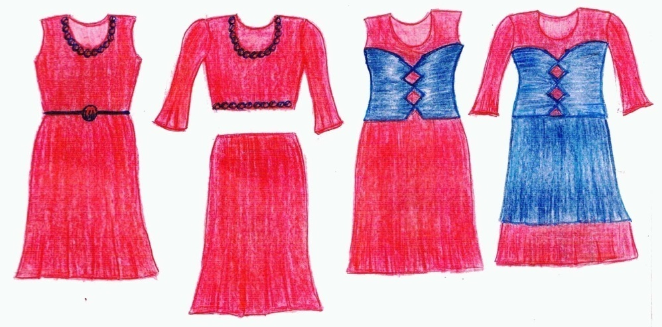
a b c d

MS – 18 : BIRD (COLOUR)
PLATE – II (f)
MANUAL SKETCHING
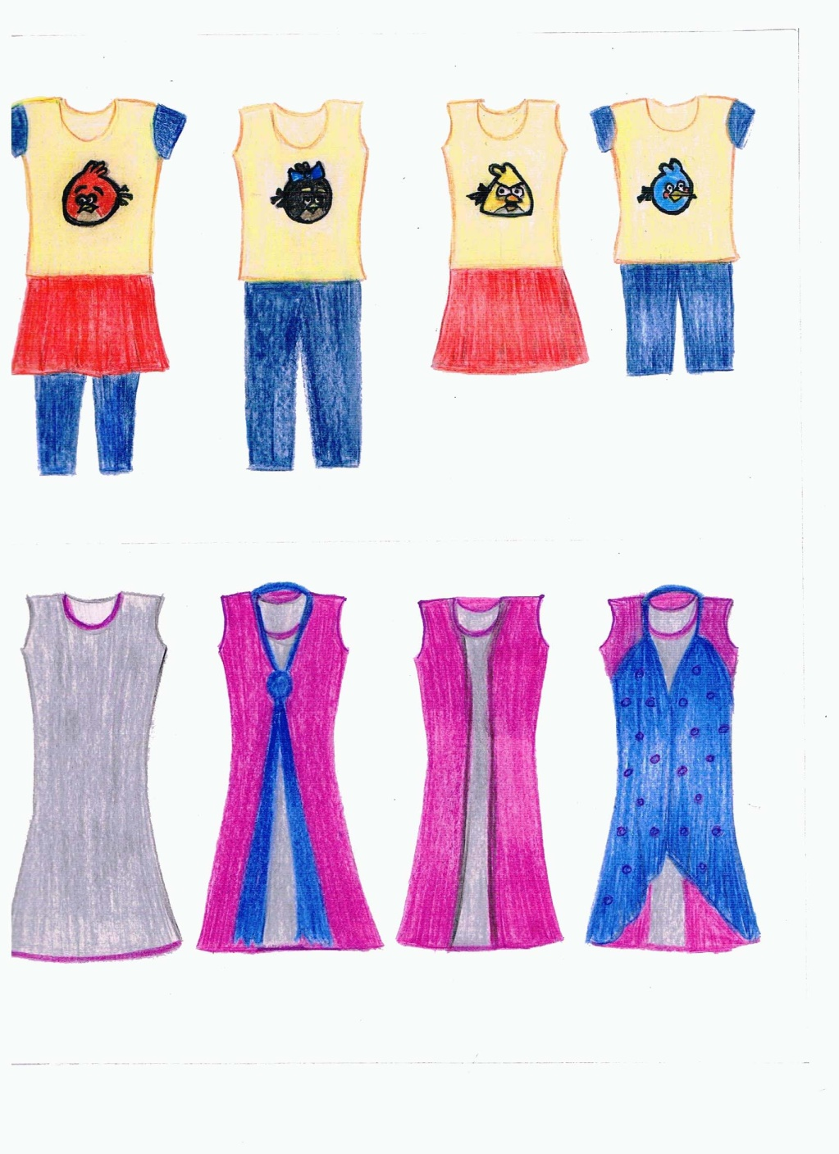
a b c d

MS – 19 : ANGRY BIRD (FACE AND COLOUR)
a b c d

MS – 20 : GEMS (COLOUR AND SHAPE)
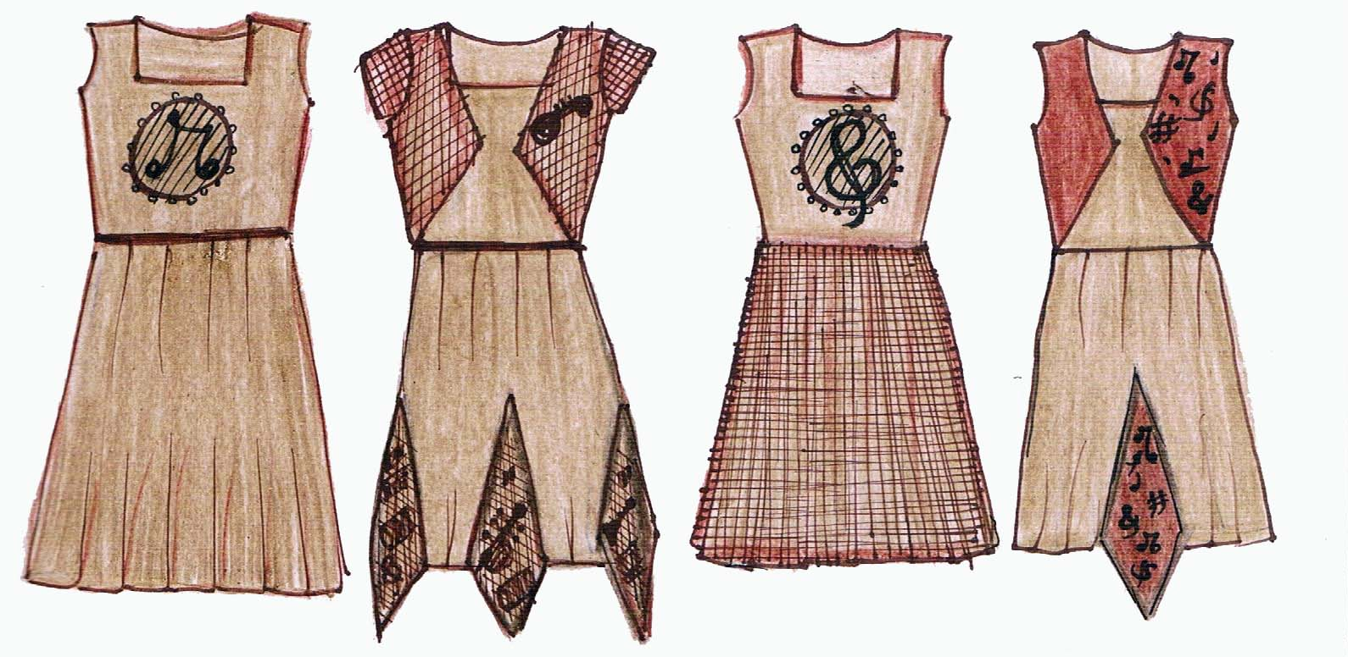
a b c d

MS – 21 : MUSICAL INSTRUMENTS (COLOUR AND SHAPE)
PLATE – II (g)
MANUAL SKETCHING
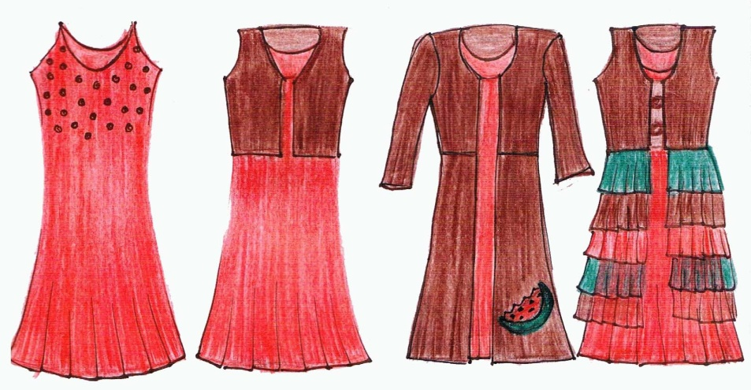
a b c d

MS – 22 : WATER MELON (COLOUR AND SHAPE)
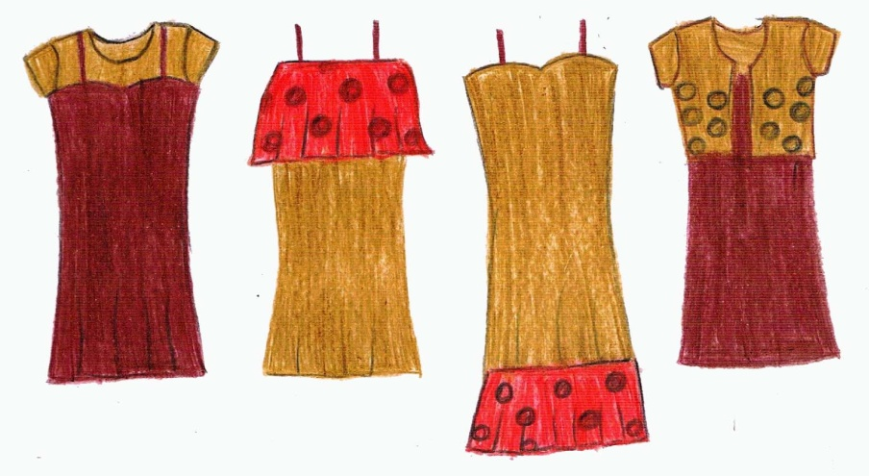
a b c d

MS – 23 : MUSHROOM (COLOUR AND SHAPE)
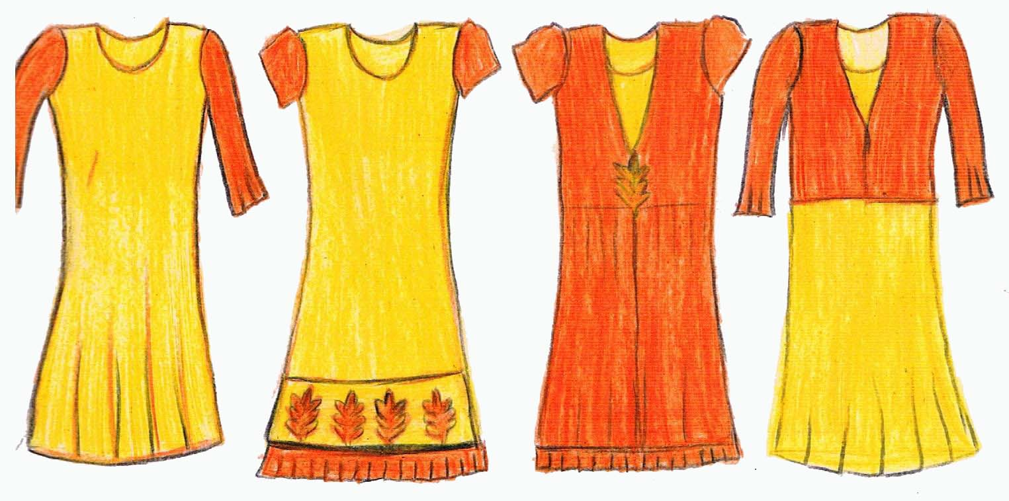
a b c d

MS – 24 : MAPLE LEAF (SHAPE AND COLOUR)
PLATE – II (h)
MANUAL SKETCHING

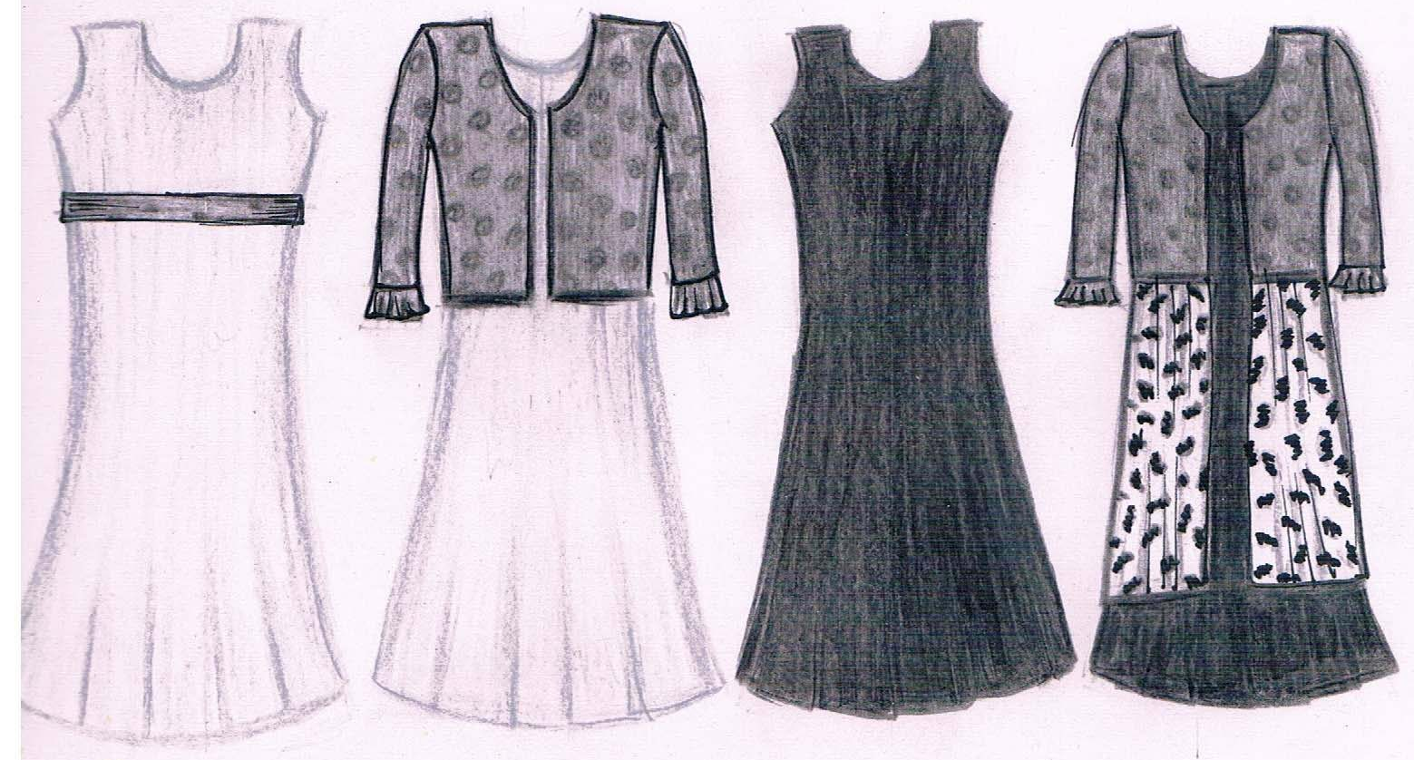
a b c d

MS – 25 : ZEBRA (COLOUR, SHAPE AND TEXTURE)
PLATE – II (i)
MANUAL SKETCHING

3.5 COMPUTER AIDED DESIGNING
CAD systems used in apparel design have features similar to those used in textile design. In addition, the systems allow the designer to graphically simulate the drape and appearance of the garment in 3D forms (NIIR Board). Corel Draw software, creativity and power come together in Corel draw, with increased speed, more accurate colour control, enhanced vector illustration tools and new web capabilities (www.corel.com).
The preferred manually sketched designs were further designed using Corel Draw (Plate – IIIa - IIIe).
3.5.1 CAD Application
The Corel Draw was used by the following procedure.
To draw an outline of the garment pen tool was used. Using the shape tool, the neckline, side seam, armhole and hemline were given shape. The eyedropper tool was utilized for colour selection to select from the image. Selection tool was used for selecting the particular feature. Rectangular tool, circle tool were used for trimmings in the garment. Using freehand tool, motifs were made for the garment.
The same set of tools were utilized for designing garments for all the themes namely Peacock, Chocolate, Tulips, Pearl, Sunflower, Rust, Bird, Gems, Maple Leaf and Zebra (CAD 1 to CAD 10).
3.5.2 Evaluation and Selection of Design
The designs were evaluated and ranked according to the preference of the subjects (students of grade school girls) by showing the computer aided multiwear designed garments with the help of visual aids. From their preferences, 3 designs were selected for garment construction.

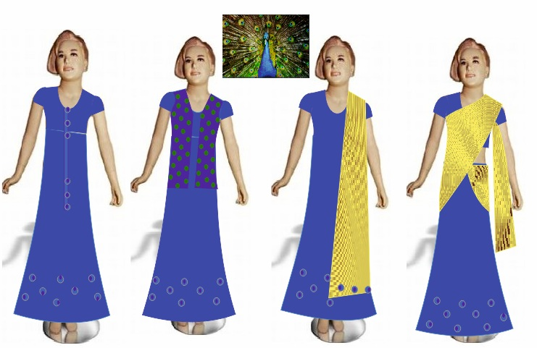
a b c d
CAD – 1 : INSPIRATION PEACOCK COLOUR
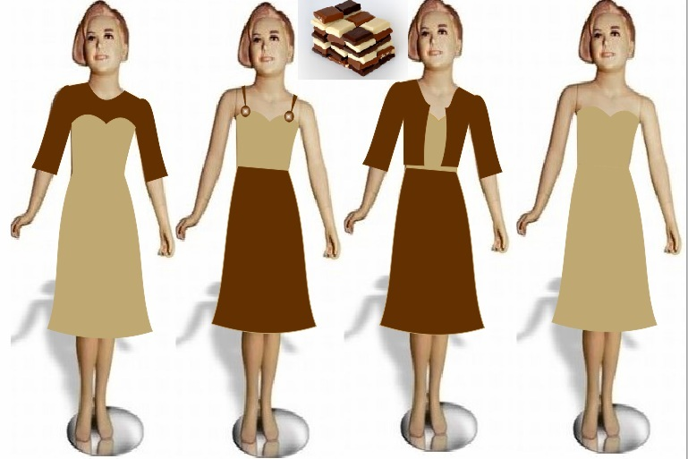
a b c d
CAD – 2 : INSPIRATION CHOCOLATE COLOUR
PLATE – III (a)
GARMENTS DESIGNED THROUGH CAD
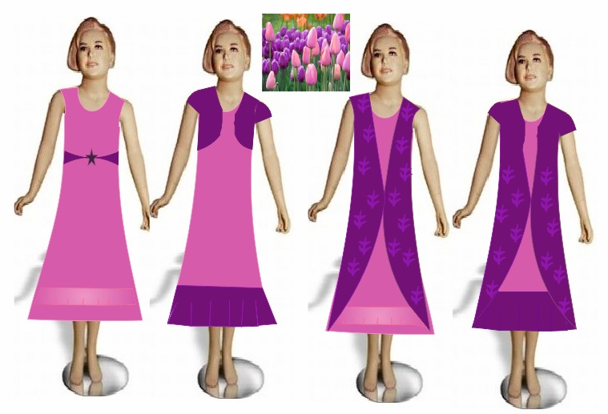
a b c d

CAD – 3 : INSPIRATION TULIPS SHAPE AND COLOUR

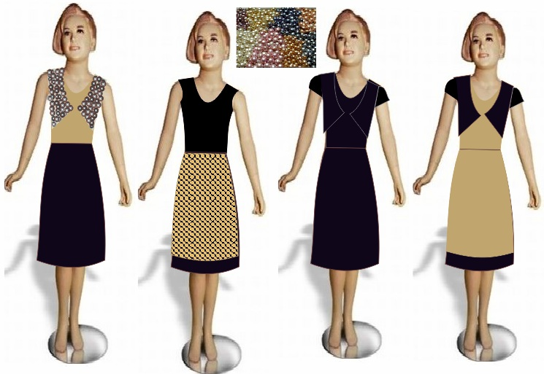
a b c d

CAD – 4 : INSPIRATION PEARL SHAPE AND COLOUR
PLATE – III (b)
GARMENTS DESIGNED THROUGH CAD
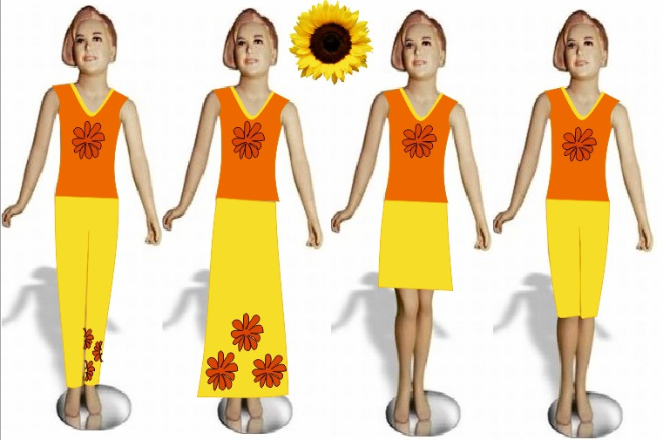
a b c d
CAD – 5 : INSPIRATION SUNFLOWER SHAPE AND COLOUR
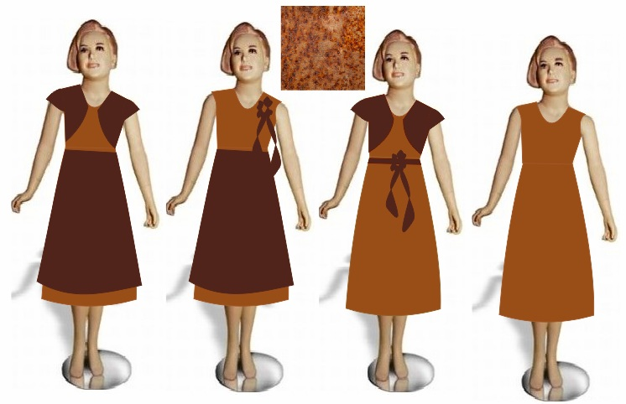
a b c d
CAD – 6 : INSPIRATION RUST COLOUR
PLATE – III (c)
GARMENTS DESIGNED THROUGH CAD
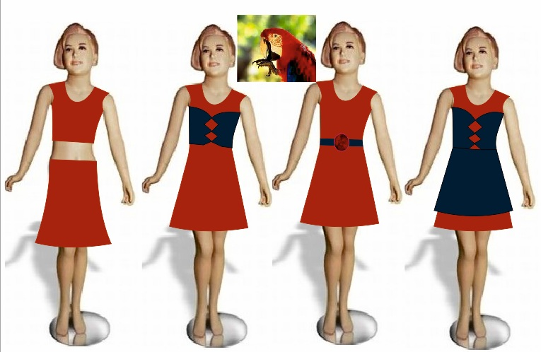
a b c d

CAD – 7 : INSPIRATION BIRD, COLOUR
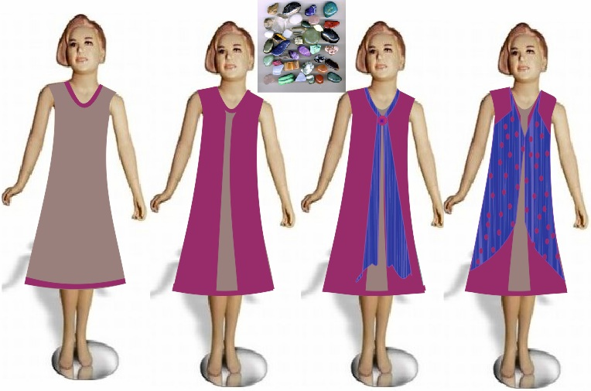
a b c d
CAD – 8 : INSPIRATION GEMS COLOUR AND SHAPE
PLATE – III (d)
GARMENTS DESIGNED THROUGH CAD
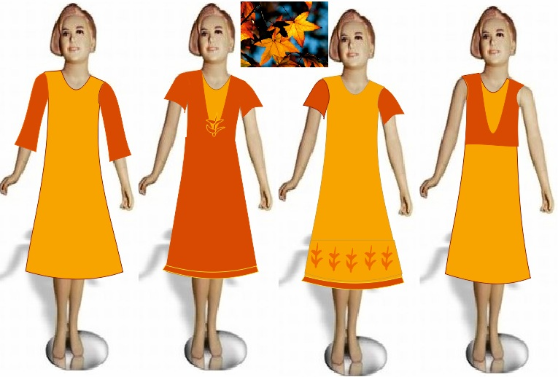
a b c d

CAD – 9 : INSPIRATION MAPLE LEAF SHAPE AND COLOUR

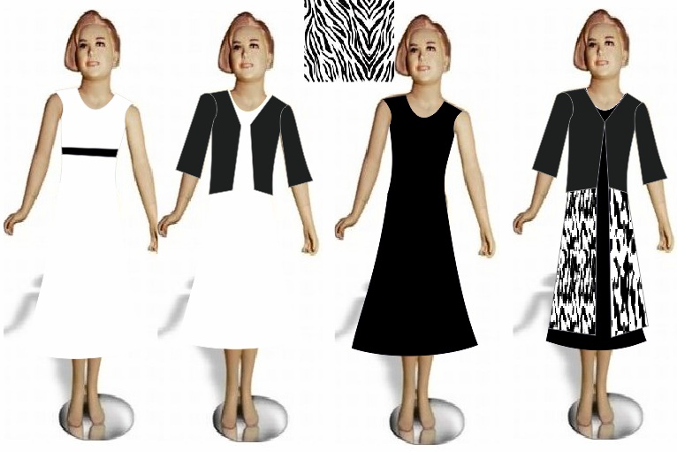
a b c d

CAD – 10 : INSPIRATION TEXTURE, COLOUR AND SHAPE
PLATE – III (e)
GARMENTS DESIGNED THROUGH CAD
3.6 CONSTRUCTION OF GARMENTS
The multiwear theme based garments were constructed by the following steps.
3.6.1 Selection and Sourcing of the Materials
According to the selected designs fabrics and accessories were sourced. All the materials were procured from their respective shops as per the requirement. According to the selection of theme, the designs of the garment, trimmings, decorations involved also varied.
Cotton is the most versatile fabric. It’s been used for textiles for centuries. Either as pure cotton or mixed with synthetic fabrics, cotton is often the best choice because it is soft, washable, generally color fast and easy to work with. It is very popular cloth for outdoor wear because it breathes, that is, it allows air to pass through it. It is also absorbent and wicks sweat away from your body (Detrixhe, 2004). Hence, the cotton blended material was selected for the study. It was commercially procured from CCD, Coimbatore. Satin a fabric in a warp effect or filling effect satin weave, as acetate, rayon, nylon or silk often having a glossy face and soft, slippery texture (Mahadevan, 2003). So to get glossy effect, the satin material was used for the requirement which was procured from Arihant Fabrics, Coimbatore.
Net an open fabric, which is created by connecting the intersections in a woven, knitted, or crocheted constructions to form a mesh like appearance that won’t ravel. Fabric made in a variety of geometric shaped meshes of different sizes and weights (Brown, 2004). Net material was selected for the study. It was procured commercially from Ganapathy Silks, Coimbatore. Brasso fabric is a unique type of fabric in which the layers are burnt to form the design (www.ehow.com). This material was selected for the study. It was procured from Ganapathy Silks, Coimbatore. Crepe is a fabric with a finely wrinkled or pebbled surface and crisp fell (www.goldensilks.com). This material was selected for the study which was procured from CPC, Coimbatore. Synthetic fabrics are useful because they have very different or enhanced improved properties to natural materials (www.infoplease.com). This material was selected for the study which was procured from Arihant Fabrics, Coimbatore (Appendix – IV).
3.6.2 Drafting
Drafting enhances the accuracy of cutting, stitching and fitting of an attire when worn. It is one of the important steps in achieving good fitting of a garment (Patil et al., 2001). Paper patterns were prepared for multiwear garments based on standardized measurements. The instructions followed as per Zarapkar (2011) for drafting the bodice front, bodice back, sleeve and skirt pattens have been presented in Appendices – V, VI and VII.
3.6.3 Altering the Basic Pattern to Multiwear Garment
The basic pattern was altered according to the multiwear garment. The overcoat and sleeve were altered according to the selection of theme.
3.6.4 Preparation of Fabric for Cutting
Before cutting, the fabric was washed, dried and pressed as per requirement.
3.6.5 Layout, Transferring and Cutting of the Material
Trial layouts were made by keeping weights or 2 pins per pattern to make sure that the cloth would be sufficient. Straight grain line on patterns was kept parallel to the fabric selvedge. To ensure this, the pattern was measured, adjusted and pinned on the fabric as suggested by Saluja (2006).
Seam allowances width vary with the type of garment. Basic seams for example : side seam, style seams – 1 to 1.5 cm. Enclosed seams, for collar, cuffs – 0.5 cm depth and decorative seams usually require more seam allowance. No seam allowance is required on the fold line. It is important that seam allowances added to the pattern are accurate and clearly marked (Aldrich, 2003).
Accordingly, the patterns were placed on the fabric in the most economical way. Adequate seam allowances were left for each piece of the fabric. The pattern details such as seam lines, grain line, name of the pattern and cut number were marked on the fabric. Enough material was left for cutting belts, facings and pipings.
The drafted and altered patterns were transferred using different tools namely tailors’ chalk and tracing wheel suitable for various materials (cotton, satin, brasso, crepe, netted and synthetic). After transferring the fabrics were cut accordingly with seam allowance.
3.6.6 Construction of Multiwear Garment
Every design is composed of different elements. These elements are dot, line, shape, value, colour and texture. These elements of design may be used on a garment in a variety of ways (Sodhia, 2004). Thus the elements were used in the construction of the garment like seams, tucks, darts, pleats, hemlines and panels (Plates – IV A – IV C).
Garment 1 (G₁)
It has 4 components – Blouse, Skirt, Overcoat and Shawl. Skirt can be detached to the blouse with the help of Velcro. Velcro is attached to both skirt (back) and the blouse (front) and attachable piece of fabric is given to hide the Velcro of blouse (Plate – IVA - a, b, c and d)
- Blouse – The placket was finished at back. Then the neckline was finished by shaped facing and the shoulder seam, sleeve and side seam were attached. Then hemline was finished at the bottom. At last velcro was attached to the hemline of the blouse.
- Skirt – The side seam and placket opening were attached. Then the waistband was attached to it, at the backside of waist band Velcro was attached. Then bottom circumference was finished.
- Overcoat – The placket opening at front was finished. Then shoulder seam, side seam and prepared Chinese collar were attached, at last bottom hemline was completed.
- Shawl – The four sides of the fabric was finished and then piping was given to all four sides.
Garment 2 (G₂)
Garment 2 consists of frock, 2 different types of overcoats and 2 detachable pieces which could be attached to the hemline of frock (Plate – IV B – a, b, c and d).
- Frock – The back slit was finished by continuous placket and then shoulder seam, side seam and armhole lines were joined. Neckline was finished by shaped facing. Then hemline of frock was finished. Velcro was attached to the bottom circumference. Then belt was given to hide the Velcro of frock, the provision for which was attached at the backside of belt.
- Overcoat – One overcoat was designed at the chest, with sleeves attached to it. Side, shoulder seams were joined first. Then the neckline and placket opening were finished by shaped facing. Then sleeve was attached to the bodice. Another overcoat designed was the full length of the garment. This was constructed by joining side seam and shoulder seam lines. Then the neckline and placket opening were finished by shaped facing.
- Attachable piece – A removable piece of material was attached at the hemline of frock. All the four sides of the fabric were finished first and double pleats were made on the entire piece of the fabric. The Velcro was attached at the top of the material. And provision was made to attach another strip of material of another colour which was finished with knife pleats.
Garment 3 (G₃)
Garment 3 consists of 3 components namely, reversible frock, overcoat and the skirt piece (Plate – IV – a, b, c and d).
- Reversible Frock – The shoulder seam, armhole, neckline, side seam and 3/4th of hemline were finished by keeping the wrong sides of the fabric facing each other. This is then turned inside out through the remaining 1/4th of the unfinished hemline. The ¼ hemline was then finished by top stitch.
- Overcoat – The placket opening was finished. Then shoulder seam was attached and neckline was finished by shaped facing. Then the 3/4th sleeve was attached to the bodice and hemline was finished. The Velcro was then attached to the hemline. A piece of material was given to hide the Velcro which could be attached and detached. Velcro was attached at backside of the fabric.
- Skirt – A provision was given at the hemline of the overcoat for attaching. First all the four sides of the rectangular fabric were finished. Pleats were made on both the ends of the fabric and the skirt piece was attached to it.
3.7 TRIMMINGS FOR MULTIWEAR GARMENT
The items which are used for decorating the garments are known as trimming materials. Some of the trimmings are embroidery, painting, smocking, honeycomb darts and pleats. Some of the readymade trimmings are purchased from the market like lace, ribbon and flower (Verma, 2003).
Trims are an integral part of garment design, may be decorative and or functional. Decorative trims are selected and applied to enhance the aesthetic appeal of garment but not essential to garment function and performance. Functional trims are an integral part of garment structure and use (Ruth and Grace, 2011).
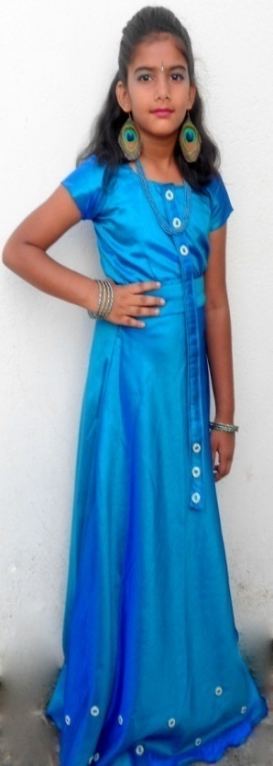 | 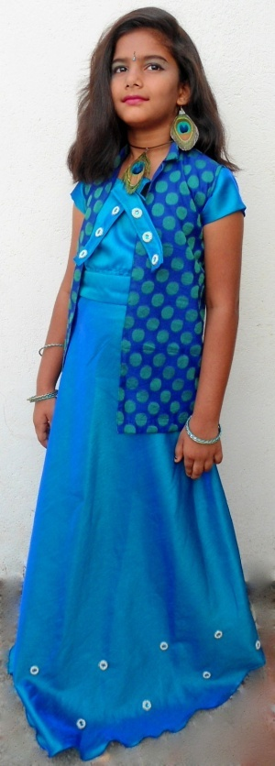
a | b
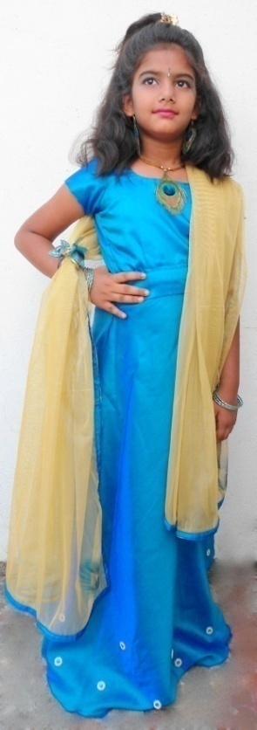 | 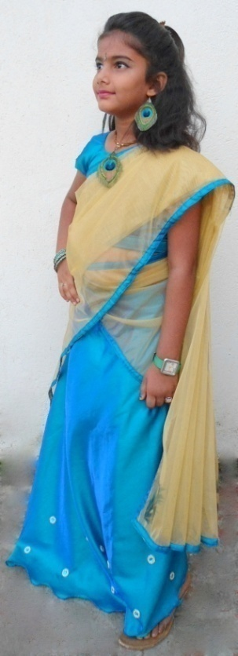
c | d
G₁ – INSPIRATION PEACOCK COLOUR
PLATE – IV A
CONSTRUCTED MULTIWEAR GARMENT
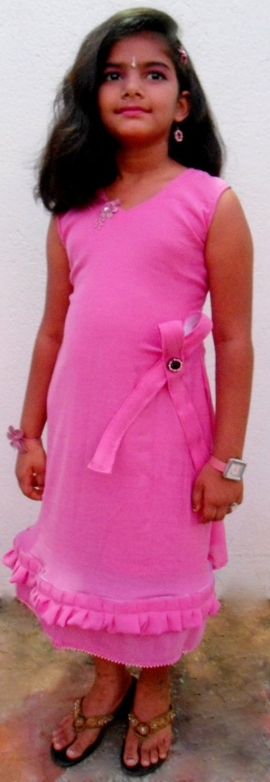 | 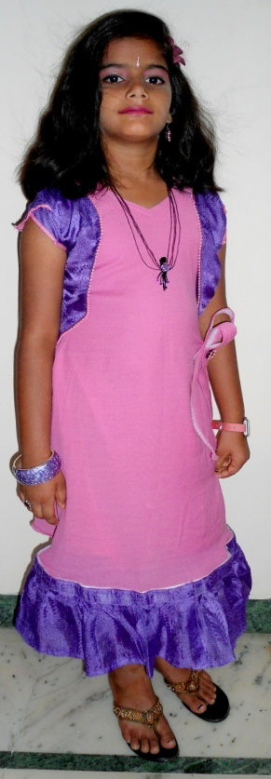
a | b
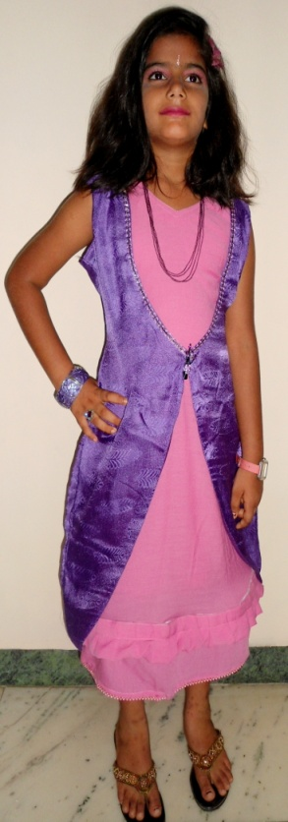 | 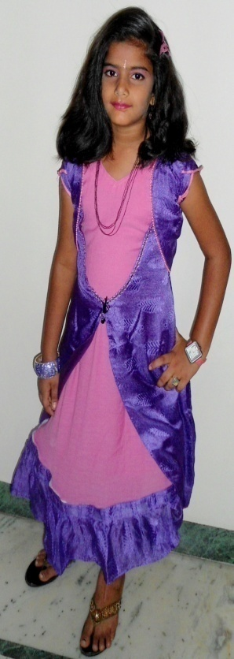
c | d
G₂ – INSPIRATION TULIP SHAPE AND COLOUR
PLATE – IV B
CONSTRUCTED MULTIWEAR GARMENT
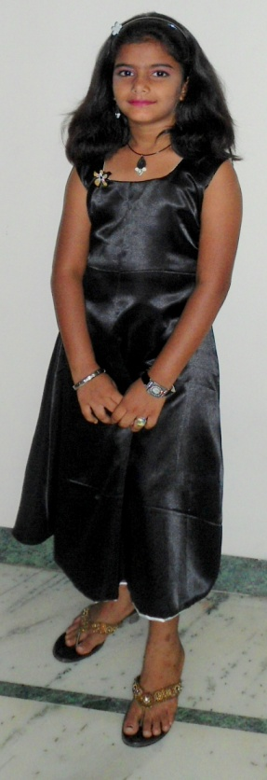 | 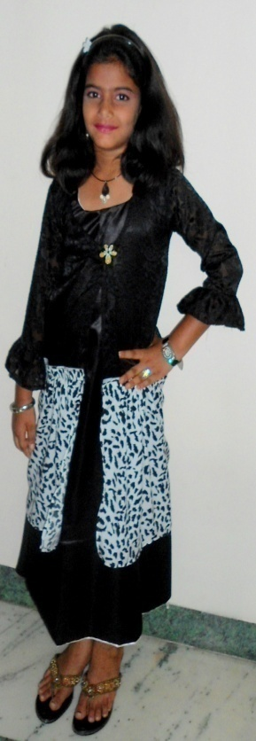
a | b
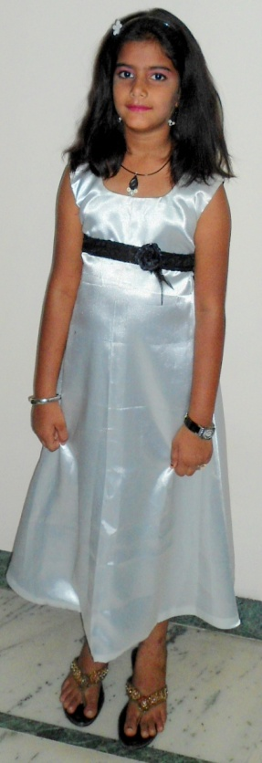 | 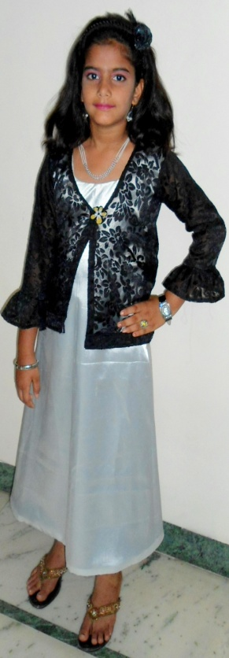
c | d
G₃ – INSPIRATION ZEBRA COLOUR, TEXTURE AND SHAPE
PLATE – IV C
CONSTRUCTED GARMENT
The functional trims like buttons and belts were used for the multiwear garments. The decorative trims namely embroidery, lace work, painting, sequins work, pleats, panels and hemlines were applied on the garments.
3.8 ACCESSORIES
Accessories play a very important role in designer outfit. Accessories make a dress complete and enhance its beauty. These special additions can give each outfit a new and distinctive look. With the right accessories, we can wear the same outfit again and again. Accessories highlight the wearers personality which purely dresses cannot do (Sodhia, 2005).
Accessories were made for all the three prepared garments. Earrings, pendants, hair accessories were made based on the respective themes and colour combinations (Plate – V).
3.9 EVALUATION OF THE CONSTRUCTED GARMENTS
The constructed garments were evaluated in two ways as explained under.
3.9.1 Visual Inspection
The visual inspection was made for the garments by ten judges by making the subject selected grade school girl wear garment. The judges were post graduate students of Textiles and Fashion Apparels of Avinashilingam University, Coimbatore. The proforma used for the assessment is presented in Appendix – VIII.
3.9.2 Feedback Through Self Assessment
The self assessment about the garment was made on wearing by the subject herself by wearing to evaluate certain salient features about good fit namely ease, line, grain, set and balance. The proforma used for this has been presented in Appendix – IX.
3.10 COST ESTIMATION
The cost of the constructed multiwear garments were calculated and recorded.
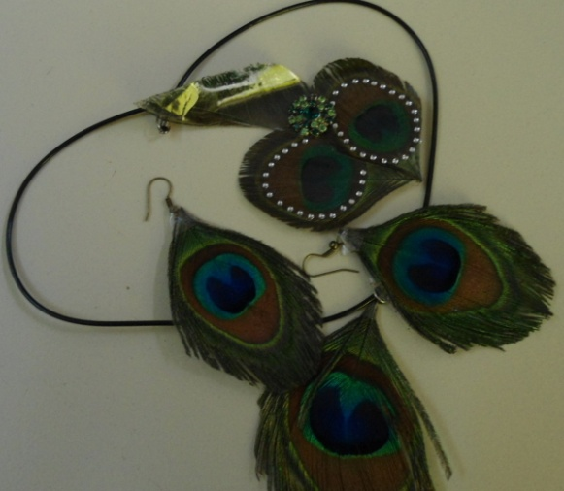
a. INSPIRATION PEACOCK COLOUR FOR G₁
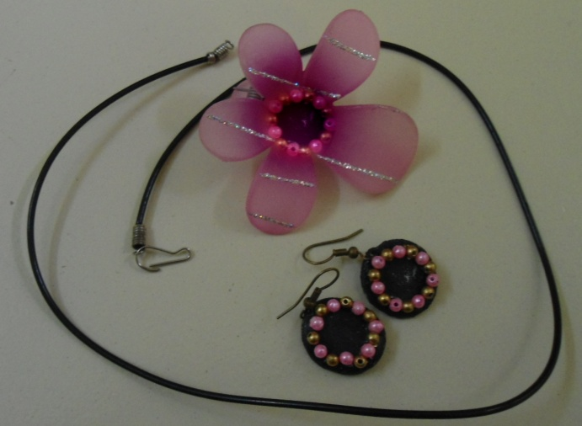
b. INSPIRATION TULIP COLOURF FOR G₂
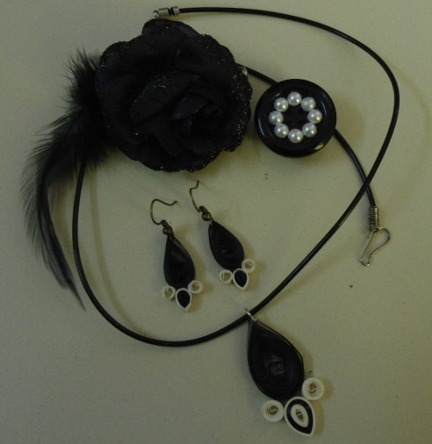
c. INSPIRATION ZEBRA COLOUR FOR G₃
PLATE – V
ACCESSORIES
4. RESULTS AND DISCUSSION

The obtained results are discussed under the following headings :
4.1 Survey of Mothers
4.1.1 Preference for Purchasing Garments for Child
4.1.2 Preference for Allotting Amount (`) for Garment
4.1.3 Consideration of Factors While Choosing Garments
4.1.4 Awareness About Multiwear Garments
4.1.5 Purchase Ratings of Multiwear Garments
4.1.6 Reasons for Not Purchasing Multiwear Garments
4.1.7 Frequency of Purchasing Garments
4.1.8 Preference for Colour
4.1.9 Preference for Texture
4.1.10 Preference for Themes
4.1.11 Preference for Surface Embellishment
4.1.12 Preference for the Type of Surface Embellishment
4.2 Consolidated Rating of Manual Sketching
4.3 Consolidated Rating of the Design Created with Corel Draw
4.4 Visual Inspection of Multiwear Garment
4.5 Feedback Through Self Assessment
4.6 Cost Estimation
4.1 SURVEY OF MOTHERS
The results obtained from the survey made among the mothers of the grade school girls are presented and discussed under the following heads.

4.1.1 Preference for Purchasing Garments for Child
The preference of the mothers for purchasing garments for the child is presented in Table – II and Figure – 3.
TABLE – II
PREFERENCE FOR PURCHASING GARMENTS FOR CHILD
S.No. | Occasions | Preference | Percentage
1. | Festival | 10 | 20
2. | Auction sales | 8 | 16
3. | Family functions | 6 | 12
4. | All | 26 | 52

FIGURE – 3
PREFERENCE FOR PURCHASING GARMENTS FOR CHILD

As for the preference for purchasing garments, for the child, 52 per cent of mothers expressed that they would purchase garments for all occasions followed by 20, 16 and 12 percentages of mothers who expressed the purchase for festivals, auction sales and family functions respectively.
Hence it could be concluded that the maximum mothers purchased the garments for children irrespective of functions or festivals.
4.1.2 Preference for Allotting Amount (`) for Garment
The preference for allotting amount (`) is presented in Table – III and Figure – 4.
TABLE – III
PREFERENCE FOR ALLOTTING AMOUNT (`) FOR GARMENT
S.No. | Amount allotted per year (`) | Preference | Percentage
1. | Below 1000 | 9 | 18
2. | 1000 – 1500 | 13 | 26
3. | 1500 – 2000 | 14 | 28
4. | 2000 – 2500 | 8 | 16
5. | 2500 – 3000 | 3 | 6
6. | Above 3000 | 3 | 6

FIGURE – 4
PREFERENCE FOR ALLOTTING AMOUNT (`) FOR GARMENT
From the Table – III and Figure – 4, it is clear that the maximum of 28 per cent mothers expressed that they would allot amount of ` 1500 to 2000 for the purchase of garments for the child followed by ` 1000 – 1500, below ` 1000, ` 2000 – 2500 by 26, 18 and 16 percentages of mothers respectively. The least of only 6 per cent of mothers expressed that they would spend ` 2500 – 3000 and above 3000 for the purchase of garments for the child.
Hence it could be concluded that among the samples, the maximum mothers expressed that they would allot ` 1500 – 2000 per year for the child for purchase of garments.
4.1.3 Consideration of Factors while Choosing Garments
The consideration of factors while choosing garments is presented under the Table – IV and Figure – 5.
TABLE – IV
CONSIDERATION OF FACTORS WHILE CHOOSING GARMENTS
S.No. | Factors | Preference | Percentage
1. | Childs interest | 20 | 40
2. | My choice | 16 | 32
3. | Husband choice | 9 | 18
4. | Budget | 5 | 10

FIGURE – 5
CONSIDERATION OF FACTORS WHILE CHOOSING GARMENT
From the Table – IV and Figure – 5, it is clear that the maximum of 40 per cent of the mothers expressed that they would purchase the garments based on the child’s interest followed by the mothers who purchased based on their own choice (32 per cent), husband’s choice (18 per cent) and budget (10 per cent).
Hence it could be concluded that the maximum mothers purchased garments based on their child’s interest.
4.1.4 Awareness About Multiwear Garments
The awareness about multiwear garments is presented under the Table – V.
TABLE – V
AWARENESS ABOUT MULTIWEAR GARMENTS
S.No. | Awareness | Preference | Percentage
1. | Yes | 41 | 82
2. | No | 9 | 18
From the Table – V, it is obvious that the maximum of 82 per cent of mothers expressed that they were aware of the availability of multiwear garment whereas only 18 per cent expressed that they were not aware of multiwear garment.
Hence it could be concluded that the maximum number of mothers were aware of the multiwear garments.
4.1.5 Purchase Ratings of Multiwear Garments
The purchase ratings of multiwear garments is presented under the Table – VI.
TABLE – VI
PURCHASE RATINGS OF MULTIWEAR GARMENTS
S.No. | Purchase ratio | Preference | Percentage
1. | Yes | 19 | 38
2. | No | 31 | 62
From the Table – VI, it is clear that the maximum of 62 per cent of mothers expressed that they had not purchased the multiwear garment.
4.1.6 Reasons for not Purchasing Multiwear Garments
The reasons for not purchasing multiwear garments is presented under the Table – VII.
TABLE - VII
REASONS FOR NOT PURCHASING MULTIWEAR GARMENTS
S.No. | Reasons | Number | Percentage
1. | Dislike | 8 | 16
2. | Cost | 42 | 84
From the Table – VII, it is obvious that the maximum of 84 per cent of mothers expressed the reason for not purchasing the multiwear garment as the cost of the garments.
Hence it could be concluded that the maximum per cent of the mothers in the sample expressed that they have not purchased the multiwear garments because these were expensive.
4.1.7 Frequency of Purchasing Garments
The frequency of purchasing garments are presented under the Table – VIII and Figure – 6.
TABLE – VIII
FREQUENCY OF PURCHASING GARMENTS
S.No. | Frequency | Preference | Percentage
1. | Once in 6 months | 7 | 14
2. | Once in 3 months | 15 | 30
3. | Once in 2 months | 28 | 56

FIGURE – 6
FREQUENCY OF PURCHASING GARMENTS
From the Table – VIII and Figure – 6, it is clear that the maximum of 56 per cent mothers expressed that the frequency of their purchase as once in 2 months followed by their expressions as once in 3 months (30 per cent) and once in 6 months (14 per cent).
Hence it could be concluded that the maximum mothers of the samples surveyed, expressed that their frequency of purchase of garments for the child as once in 2 months.
4.1.8 Preference For Colour
The preference for colour is presented under the Table – IX and Figure – 7.
TABLE – IX
PREFERENCE FOR COLOUR
S.No. | Colour | Preference | Percentage
1. | Red | 8 | 16
2. | Pink | 14 | 38
3. | Blue | 12 | 24
4. | Yellow | 9 | 18
5. | Any other | 7 | 14

FIGURE – 7
PREFERENCE FOR COLOUR
From the Table – IX and Figure – 7, it is obvious that the maximum of 38 per cent of mothers preferred pink colour for their child followed by the preferences for blue, yellow and red with 24, 18 and 16 percentages respectively. Few mothers expressed that they did not have any specific preference for colour.
Hence it could be concluded that the maximum preference of the mothers among the samples was for the pink colour for their child.
4.1.9 Preference for Texture
The preference for texture is presented under the Table – X and Figure – 8.
TABLE – X
PREFERENCE FOR TEXTURE
S.No. | Material | Preference | Percentage
1. | Cotton | 20 | 40
2. | Synthetic | 6 | 12
3. | Netted | 9 | 18
4. | Polycotton | 4 | 8
5. | Any other | 11 | 22

FIGURE – 8
PREFERENCE FOR TEXTURE
From the Table – X and Figure – 8, it is clear that the maximum of 40 per cent of the mothers preferred cotton material for the child. This was followed by 22 per cent of mothers who expressed that they do not have any specific preference for the material which was followed by 18, 12 and 8 percentages of mothers preferences for netted, synthetic and polycotton materials.
Hence it could be concluded that the maximum per cent of mothers preferred cotton material for the child.
4.1.10 Preference for Themes
The preference for themes is presented under the Table – XI and Figure – 9.
TABLE – XI
PREFERENCE FOR THEMES
S.No. | Themes | Preference | Percentage
1. | Floral | 18 | 36
2. | Animal | 5 | 10
3. | Bird | 12 | 24
4. | Any other (Fruits and Cartoon figures) | 15 | 30

FIGURE – 9
PREFERENCE FOR THEMES
From the Table – XI and Figure – 9, it is clear that the maximum of 36 per cent of mothers preferred floral themes for their children followed by fruits and cartoon figures (30 per cent), bird (24 per cent) and animal (10 per cent).
Hence it could be concluded that the maximum preference of the mothers was for floral themes.
4.1.11 Preference For Surface Embellishment
The preference for surface embellishment is presented under the Table – XII.
TABLE – XII
PREFERENCE FOR SURFACE EMBELLISHMENT
S.No. | Preference | Preference | Percentage
1. | Yes | 46 | 92
2. | No | 4 | 8
From the Table – XII, it is obvious that the 92 per cent of the samples surveyed expressed to have surface embellishments for the garments for their children.
4.1.12 Preference for the Type of Surface Embellishment
The preference for the type of surface embellishment is presented under the Table – XIII and Figure – 10.
TABLE – XIII
PREFERENCE FOR THE TYPE OF SURFACE EMBELLISHMENT
S.No. | Type of surface embellishment | Preference | Percentage
1. | Embroidery | 16 | 32
2. | Lace work | 8 | 16
3. | Patch work | 10 | 20
4. | Painting | 8 | 16
5. | Any other | 4 | 8

FIGURE – 10
PREFERENCE FOR THE TYPE OF SURFACE EMBELLISHMENT
From the Table – XII and Figure – 10, it is obvious that the maximum of 32 per cent of the mothers preferred embroidery followed by patch work (20 per cent), both lace work and painting (16 per cent) and others (8 per cent).
Hence it could be concluded that the maximum mothers preferred to have surface embellishments of which embroidery was given the first priority.
4.2 CONSOLIDATED RATING OF MANUAL SKETCHING
Consolidated rating of manual sketching are resented under the Table – XIV.
TABLE – XIV
CONSOLIDATED RATING OF MANUAL SKETCHING
S.No. | Design code | Excellent | Good | Fair
1. | MS₁ | 96.6 | 3.4 | -
2. | MS₂ | 76.6 | 23.4 | -
3. | MS₃ | 66.6 | 30.0 | 3.4
4. | MS₄ | 73.3 | 26.7 | -
5. | MS₅ | 76.6 | 20.0 | 3.4
6. | MS₆ | 86.6 | 13.4 | -
7. | MS₇ | 93.2 | 3.4 | 3.4
8. | MS₈ | 80.0 | 10.0 | 10.0
9. | MS₉ | 76.6 | 10 | 13.4
10. | MS₁₀ | 80.0 | 13.4 | 6.6
11. | MS₁₁ | 90.0 | 10.0 | -
12. | MS₁₂ | 83.4 | 10.6 | -
13. | MS₁₃ | 66.6 | 30.0 | 3.4
14. | MS₁₄ | 70.0 | 26.6 | 3.4
15. | MS₁₅ | 66.6 | 26.6 | 6.8
16. | MS₁₆ | 63.4 | 30.0 | 6.6
17. | MS₁₇ | 86.6 | 10.0 | 3.4
18. | MS₁₈ | 83.4 | 16.6 | -
19. | MS₁₉ | 76.6 | 16.6 | 6.8
20. | MS₂₀ | 73.2 | 23.4 | 3.4
21. | MS₂₁ | 80.0 | 20.0 | -
22. | MS₂₂ | 83.4 | 10.0 | 6.6
23. | MS₂₃ | 70.0 | 30.0 | -
24. | MS₂₄ | 83.4 | 16.6 | -
25. | MS₂₅ | 93.4 | 6.6 | -

From the Table – XIV, it is obvious that the maximum rating of 96.6 per cent was noted in sample MS₁ to be excellent followed by samples MS₂₅ (93.4 per cent), MS₃ (93.2 per cent), MS₁₁ (90 per cent), MS₁₇ and MS₆ (86.6 per cent) and MS₁₂, MS₁₈, MS₂₂ and MS₂₄ (83.4 per cent). The designs namely MS₂, MS₄, MS₅, MS₈, MS₁₀, MS₉, MS₁₀, MS₁₄, MS₁₉, MS₂₀, MS₂₃ were rated between 70 – 80 per cent of judges to have excellent general appearance. And the designs MS₃, MS₁₃, MS₁₅ and MS₁₆ were rated below 70 per cent to have excellent general appearance.
Hence it could be concluded that ten of the design namely MS₁, MS₆, MS₇, MS₁₁, MS₁₂, MS₁₇, MS₁₈, MS₂₂, MS₂₄ and MS₂₅ had excellent general appearance.
4.3 CONSOLIDATED RATING OF THE DESIGN CREATED WITH COREL DRAW
The consolidated rating of the design created with Corel draw is presented under the Table – XV.
TABLE – XV
CONSOLIDATED RATING OF THE DESIGN CREATED WITH COREL DRAW
S.No. | Design code | Excellent | Good | Fair
1. | CAD₁ | 96.6 | 3.4 | -
2. | CAD₂ | 86.6 | 6.6 | 6.6
3. | CAD₃ | 93.2 | 6.6 | -
4. | CAD₄ | 76.6 | 20.0 | 3.4
5. | CAD₅ | 90.0 | 10.0 | -
6. | CAD₆ | 90.0 | 3.4 | 6.6
7. | CAD₇ | 80.0 | 16.6 | 3.4
8. | CAD₈ | 83.4 | 10.0 | 6.6
9. | CAD₉ | 73.3 | 20.0 | 6.6
10. | CAD₁₀ | 96.6 | 3.4 | -

From the Table – XV, it is clear that the designs CDA₁, CAD₃ and CAD₁₀ were rated to have excellent general appearance by 96.6, 93.2 and 96.6 percentage of judges respectively. The other designs namely CAD₂, CAD₅, CAD₆, CAD₂₂ had the ratings between 80 – 90 per cent to have excellent general appearance. The design CAD₉ and CAD₄ were rated with 76.6 per cent and 73.3 per cent respectively.
Hence it could be concluded that the maximum ratings for excellent general appearance was noted for the samples CAD₁, CAD₃ and CAD₁₀.
4.4 VISUAL INSPECTION OF MULTIWEAR GARMENT
The visual inspection of multiwear garment is presented under the Table – XVI.
TABLE – XVI
VISUAL INSPECTION OF MULTIWEAR GARMENT
S.No. | Garment Code | Design |  |  |  | Colour selection |  |  |  | Trimmings and decoration |  |  |  | Overall appearance
S.No. | Garment Code | Ex | VG | G | F | Ex | VG | G | F | Ex | VG | G | F | Ex | VG | G | F
1. | G₁ | 80 | 15 | 5 | - | 90 | 10 | - | - | 85 | 15 | - | - | 100 | - | - | -
2. | G₂ | 70 | 20 | 10 | - | 85 | 15 | - | - | 90 | 10 | - | - | 95 | 5 | - | -
3. | G₃ | 90 | 10 | - | - | 80 | 15 | 5 | - | 80 | 15 | 5 | - | 100 | - | - | -

From the Table – XVI, it is clear that the maximum of 90 per cent of judges rated the garment G₃ as excellent in design followed by the garments G₁ and G₂ with 80 and 70 percentages respectively.
The maximum of 90 per cent of judges rated the garment G₁ to have excellent colour selection followed by the garments G₂ and G₃ with 85 and 80 percentages respectively.
As for the trimmings and decorations are concerned, the maximum of 90 per cent of judges rated the garment G₂ as excellent followed by the garments G₁ and G₃ with 85 and 80 percentages respectively.
The overall appearance was rated as excellent by cent per cent judges for both the garments G₁ and G₃ as G₂ was rated by 95 per cent of judges.
Hence it could be concluded that the garment G₁ had excellent colour selection and overall appearance, the garment G₂ had excellent trimmings of decoration incorporated and the garment G₃ had excellent design and general appearance.
4.5 FEEDBACK THROUGH SELF ASSESSMENT
The feedback through self assessment was presented under he Table – XVII.
TABLE – XVII
SELF ASSESSMENT
S.No. | Garment code | Ease |  | Line |  | Grain |  | Set |  | Balance
S.No. | Garment code | Good | Fair | Good | Fair | Good | Fair | Good | Fair | Good | Fair
1. | G₁ | 85 | 15 | 100 | - | 100 | - | 95 | 5 | 100 | -
2. | G₂ | 95 | 5 | 100 | - | 100 | - | 95 | 5 | 95 | 5
3. | G₃ | 90 | 10 | 100 | - | 100 | - | 100 | - | 100 | -
Ease
From the Table – XVII, it is clear that the maximum of 95 per cent of the subjects rated the garment G₂ to have good ease followed by the garments G₃ and G₁ of 90 and 85 percentages respectively.
Line and Grain
As for the line of the garment, cent per cent of the subjects rated all the garments G₁, G₂ and G₃ to have good line and grain in the garment.
Set
As far as the set of the garment is concerned, the maximum of cent per cent subjects rated the garment G₃ to have good set followed by both the garments G₁ and G₂ with 95 percentages.
Balance
The balance was rated to be good by cent per cent subjects in both the garments G₁ and G₃ whereas it was 95 per cent in the garment G₂.
Hence it could be concluded that all the garments had good line and grain, garment G₁ had good balance, G₂ had good ease and garment G₃ had good set and balance.
4.6 COST ESTIMATION
The cost estimation is presented in Table – XVIII.
TABLE – XVIII
COST ESTIMATION
S.No. | Garment code | Particulars | Cost (`) | Total cost (`)
1. | G₁ | Material cost | 683 | 1233
1. | G₁ | Trimmings and Decorations | 80 | 1233
1. | G₁ | Stitching charge | 450 | 1233
1. | G₁ | Accessory cost | 20 | 1233
2. | G₂ | Material cost | 594 | 1084
2. | G₂ | Trimmings and Decorations | 120 | 1084
2. | G₂ | Stitching charge | 350 | 1084
2. | G₂ | Accessory cost | 20 | 1084
3. | G₃ | Material cost | 349 | 789
3. | G₃ | Trimmings and Decorations | 20 | 789
3. | G₃ | Stitching charge | 400 | 789
3. | G₃ | Accessory cost | 20 | 789
From the Table – XVIII, it is clear that the cost of the multiwear garments G₁, G₂ and G₃ were ` 1233, ` 1084 and ` 789 respectively.
Hence it could be concluded that the cost of constructed multiwear garments were more economical of which it was the least in the garment G₃ of ` 789 followed by garments G₂ and ` 1084 and garment G₃ of ` 1233. The garment can also preferred by middle income groups too.
5. SUMMARY AND CONCLUSION

INTRODUCTION
Fashion is change ; the new ideas becoming old and old ideas becoming new again – but always with a fresh twist. The continual search for something fresh is the designer’s greatest challenge. Fashion is an offspring of the beautiful, of vision, not of mathematics. Therefore it is not static. The concept of beauty varies with different individuals and people from time to time. Clothing is one of the basic needs of life, fabric has always been found to be most suitable and acceptable medium of expression of art. At times colours, fabrics and symbols signified a high status. The clothing that we wear were dyed to stimulate and gratify the sense with colours.
Clothing is the ‘second skin’ ranking with food and shelter as essential for human survival, may also serve other less critical needs. Clothes are an outward expression of how people feel about themselves and kind of world they tend to live in. Designers choose the colours, silhouettes and fabrics of their collections ‘what inspires a designer’ the entire world. Designers attend art galleries, read and listen to the media, go to movies, travel, study history and observe what people are wearing. From all of these things the designers get an inspiration. The children’s interest in clothing is affected by two conditions. The first condition is that, all children learn from parents about the importance of right clothes for the right occasion and how certain garments help to improve one’s looks. The ideal party clothing should be attractive, soft, comfortable, fit for play, taking rest, comparatively loose and easy to put on and take off.
Design involves basic elements like line, form, shape, colour, rhythm, unity and space. A well designed garment has beauty and appropriateness which makes it suitable for the wearer and for the occasion. Fashion is the prevailing mode which cannot be ignored, but which can seldom be used as a guide for attractive clothes for everyone. Fashion forecasting is the most important for a designer. In the present world, computers have grown to be foremost requirement of almost every conceivable profession, which requires creativity, accuracy and a good implementation of time. Multiwear clothing can be worn in more than one way or that serve multiple purposes. They can usually be altered by utilizing attached stripes of cloth, ties, buttons or other built-in modifiers.
Considering the above facts, the investigator decided to take up a study on “COMPUTER AIDED THEME BASED DESIGNING FOR GRADE SCHOOL GIRLS’ MULTIWEAR GARMENTS” with the following objectives.
- To standardize body measurements for grade school girls.
- To design theme based mutliwear garment
- To evaluate and develop selected designs with CAD.
- To construct and evaluate selected theme based garments.
METHODOLOGY
- Questionnaire was used to conduct the survey. The survey was done to collect information regarding the mothers’ preferences. The data collected was tabulated and analysed.
- The simple random method of sampling was used to gather information for the study as careful selection of sample would give good results. Hundred grade school girls of age 10 years from N.A.Kondu Raja Memorial High School in Theni was selected as subjects for the study.
- The various body measurements taken were Chest, Waist, Hip, Back width, Back waist length, Sleeve length, Armscye depth, Sleeve circumference, Waist to hip, Waist to ankle, Skirt length, Blouse length and Full length. These measurements were standardized .
- The designs were developed for the multiwear garment through manual sketching for the themes, which were selected based on the mothers’ preferences.
- The girls have a fascination towards certain colours, fruits, flowers and icecreams. Based on that the themes selected were Peacock, Rust, Chocolate, Bird, Tulips, Gems, Pearls, Geometrical Design, Lines / Stripes, Forest Apple, Rose, Maple leaf, Mushroom, Butterfly, Icecream, Tree, Angry Bird, Lotus, Musical Instruments, Abstract Design, Watermelon, Lemon, Zebra, Sunflower. So manual sketching was done for all these 25 themes.
- The theme based manual sketching for the multiwear garments was prepared for 25 different themes. Then the designs were ranked according to the preference of the subjects by displaying the manually sketched designs of the multiwear garments to the grade school girls (subjects). From their preferences, 10 designs were selected for Computer Aided Designing.
- The preferred manually sketched designs were further designed using CAD. The Corel Draw was used. Various tools used were pen tool, shape tool, eyedropper tool, selection tool, rectangular tool, circle tool and freehand tool, for designing garments for the themes namely Peacock, Chocolate, Tulips, Pearl, Sunflower, Rust, Bird, Gems, Maple Leaf and Zebra (CAD 1 to CAD 10).
- These designs were evaluated and ranked according to the preference of the subjects (students of grade school girls) by showing the computer aided multiwear designed garments with the help of visual aids. From their preferences, 3 designs were selected for garment construction.
- The multiwear theme based garments were constructed. According to the selected designs, fabrics and accessories were sourced. All the materials were procured from their respective shops as per the requirement. According to the selection of theme, the designs of the garment, trimmings, decorations involved also varied. The materials used were cotton, satin, net, brasso, crepe and synthetic fabrics.
- Paper patterns were prepared for multiwear garments based on standardized measurements. The basic pattern was altered according to the multiwear garment. The overcoat and sleeve were altered according to the selection of theme. The pattern details such as seam lines, grain line, name of the pattern and cut number were marked on the pattern. Before cutting, the fabric was washed, dried and pressed.
- Trial layouts were made in the most economical way. Adequate seam allowances were left for each piece of the fabric. Enough material was left for cutting belts, facings and pipings.
- The drafted and altered patterns were transferred using different tools namely tailor’s chalk and tracing wheel suitable for various materials (cotton, satin, brasso, crepe, netted and synthetic). After transferring the fabrics were cut accordingly with seam allowance.
- The Garment 1 comprised of 4 components – Blouse, Skirt, Overcoat and Shawl. The Garment 2 consists of frock, 2 different types of overcoats, 2 detachable pieces. Garment 3 consists of 3 components namely, reversible frock, overcoat and the skirt piece.
- The functional trims like buttons and belts were used for the multiwear garments. The decorative trims namely embroidery, lace work, painting, sequins work, pleats, panels and hemlines were applied on the garments.
- Accessories were made for all three prepared garments. Earrings, pendants, hair accessories were made based on themes and colour combinations.
- The visual inspection was made for the garments by ten judges by making the subjects selected grade school girl wear the garment.
- The self assessment about the garment was made by the subject herself by wearing the garment to evaluate certain salient features about good fit namely ease, line, grain, set and balance.

FINDINGS OF THE STUDY
The findings of the study are given under :
- The maximum mothers purchased the garments for children irrespective of functions or festivals.
- The maximum mothers expressed that they would allot ` 1500 – 2000 per year for the child for purchase of garments and they purchased garments based on their child’s interest.
- The maximum number of mothers were aware of the multiwear garments but most of them had not purchased these due to the cost of the garments.
- The maximum mothers of the samples surveyed, expressed that their frequency of purchase of garments for the child as once in 2 months.
- The maximum preference of the mothers among the samples was for the pink colour and cotton material for their child.
- The maximum preference of the mothers of the sample preferred was for floral themes and they expressed that they wanted to have surface embellishments of which the first priority was given for embroidery in the garments for their children.
- The ten of the designs namely MS₁, MS₆, MS₇, MS₁₁, MS₁₂, MS₁₇, MS₁₈, MS₂₂, MS₂₄ and MS₂₅ had excellent general appearance as per the subjects views.
- The maximum ratings for excellent general appearance was noted for the samples CAD₁, CAD₃ and CAD₁₀.
- The garment G₁ had excellent colour selection and overall appearance, the garment G₂ had excellent trimmings of decoration incorporated and the garment G₃ had excellent design and general appearance.
- The garments had good line and grain, garment G₁ had good balance, G₂ had good ease and garment G₃ had good set and balance.
- The cost of constructed multiwear garment were more economical such that it fulfills the middle income groups.
CONCLUSION
It could be concluded that the mothers purchased garments irrespective of functions for their child. Though they were aware of the multiwear garments, they didn’t purchase due to the cost of the garments. They preferred the garments with surface embellishments. The theme based multiwear garments were well appreciated. The garments also gave good fit for the child and enhanced the beauty of the child. Both the casual as well as the party wear types are possible in the single set of multiwear garment.
RECOMMENDATION
- This type of theme based multiwear garment could be prepared for boys, women and men also.
- More varieties could be developed with many more themes.

BIBLIOGRAPHY
BOOKS
Aldrich, W., (2003), “Metric Pattern Cutting”, 3rd Edition, Blackwell Science Limited, P. 52.
Amaden, C., (1994), “A Guide to Fashion Sewing”, 2nd Edition, Fairchild Publications, P. 148.
Bajaj, A., (2011), “Embroidery Techniques”, Sonali Publication, P. 71.
Betzina, S., (2003), “Fast Fit Easy Pattern Alternations for Every Figure”, The Taunton Press, pp. 6, 7.
Brown, M., (2004), “A Comprehensive Dictionary of Textiles”, Abhishek Publication, P. 164.
Chaudhary, C.M., (2009), “Research Methodology”, RBSA Publishers, P. 52.
Colgrove, D., (2006), “Teach Yourself Visually Sewing”, Wiley Publishers, P. 44.
Colussy, M.K. and Greenberg, S., (2007), “Rendering Fashion, Fabric and Prints”, Pearson Education, P. 141.
Cooklin, G., (1991), “Pattern Grading for Children’s Clothes : The Technology of Sizing”, Blackwell Science Publishers, P. 7.
Davis, J., (2008), “Fashion – Introduction, Lifestyle, Communication”, Abhishek Publications, pp. 84, 85.
Detrixhe, S., (2004), “The Everything Sewing Book”, Adams Media, P. 30.
Gallerson, B.K. and Stewart, B.L., (2009), “Apparel Concepts and Practical Applications”, Fairchild Publications, pp. 96, 97.
Gordon, M.M., (2002), “The Ultimate Sewing Book”, Collins and Brown Publications, P. 140.
Grosicki, Z.J., (2004), “Watson’s Textile Design and Colour, Elementary Weaves and Figures Fabrics”, 7th Edition, Woodhead Publications, pp. 139, 140.
Gupta, S. et al. (2005), “Text Book of Clothing Textiles and Laundry”, Kalyani Publishers, P. 97.
Gupta, S., (2001), “Research Methodology and Statistical Techniques”, Deep and Deep Publications P. 140.
Gupta, S.P., (2009), “Statistical Methods”, Sultan Chand and Sons, P. 61.
Jefferson, S., (2005), “Know All About Clothing Technology”, Abhishek Publication, P. 1.
Jindal, R., (1998), “Handbook for Fashion Designing”, Mittal Publications, P. 1.
Kelvey, K.M. and Muslow, J., (2003), “Fashion Design Process, Innovation and Practice”, Blackwell Publishing, P. 32.
Kothari, C.R., (2007), “Research Methodology and Techniques”, New Age International Publishers, pp. 55, 56.
Kulshrestha, U. and Kashyap, R., (2007), “Clothing Behaviour Psychological Analysis”, Pointer Publishers, P. 1.
Kumar, A., (2010), “Fashion Tourism”, Sonali Publication, P. 17.
Kumar, R., (2005), “Research Methodology : A step by Step Guide for Beginners”, Pearson Education, P. 164.
Luthur, C., (2008), “Career in Textile and Fashion Designing”, Abhishek Publications, pp. 118, 119.
Mahadevan, M.G., (2003), “Dictionary of Textiles”, Abhishek Publication, P. 161.
Mahadevan, M.G., (2008), “Textile Colouring”, Abhishek Publication, pp. 260, 261.
Mathews, M., (1985), “Practical Clothing Construction – Part I and II”, Bhattarams, P. 21 and 20.
Meller, S. and Elffers, J., (2002), “Textile Designs”, Thames and Hudson Publications, P. 245.
Mishra, R., (2010), “Computer Graphics”, Global Vision Publishing House, P 4.
Mullick, P., (2006), “Textbook of Textile Designing”, Kalyani Publishers, P. 28.
Naik, S.D. and Wilson, J.A., (2006), “Surface Designing of Textile Fabrics”, New Age International Publishers, P. 33.
Narang, M., (2006), “Fashion Technology Handbook”, Asian Pacific Business Press Inc., P. 105.
Neelima, (2009), “Fashion and Textile Design”, Sonali Publications, pp. 279, 283.
Neelima, (2009), “Wearing, Knitting and Crocheting and Knotting”, Sonali Publications, P. 98.
NIIR Board, “Textile Processing with Effluents Treatment”, Asia Pacific Business Press, P. 215.
Panneerselvam, R., (2005), “Research Methodology”, Prentice Hall of India Private Limited, P. 36.
Pillai and Bagavathi, (2000), “Statistics”, S. Chand and Company Ltd., pp. 32, 70.
Ruth, E.G. and Grace, I.K., (2011), “Apparel Manufacturing Sewn Product Analysis”, Pearson Education, P. 571.
Saluja, N., (2006), “Recent Development in Clothing Construction”, University Book House (P.) Ltd., P. 53.
Sarkar, S., (2010), “Fashion Pattern and Dress Design”, Arise Publishers and Distributors, P. 36.
Sharma, K.R., (2002), “Research Methodology”, National Publishers, P. 45.
Sodhia, M., (2004), “Advanced Drafting and Draping”, Kalyani Publishers, P.7.
Sodhia, M., (2004), “Design Studies”, Kalyani Publishers, P. 58.
Sodhia, M., (2005), “Dress Designing”, Kalyani Publishers, P. 96.
Sorger, R. and Udale, J., (2006), “The Fundamentals of Fashion Design”, AVA Publications, P. 26.
Stephens, G., (2002), “Fashion from Concept to Consumer”, 7th Edition, Pearson Education Inc., pp. 154, 209.
Sumathi, G.J., (2002), “Elements of Fashion and Apparel Design”, New Age International (P.) Ltd. Publishers, P. 31.
Tate, S.L., (2004), “Inside Fashion Design”, 5th Edition, Pearson Education, pp. 84, 85.
Thomas, K., (2006), “Know About Fabric and their Manufacture”, Abhishek Publication, P. 10.
Verma, G. and Dev, K., (2003), “Cutting and Tailoring Course”, (Illustrated), Asian Publishers, P. 50.
Wilson, J., (2001), “Handbook of Textile Design : Principle, Processes and Practice”, Woodhead Publications, P. 37.
Zarapkar, K.R., (2011), “Zarapkar System of Cutting”, Navneet Publications, pp. 36, 46, 84.
JOURNALS
Basak, S. and Das, M., (2012), “Party Wear for Children”, Textile Trends, Vol. LV, No. 7, P. 47.
Bharani, M., et al. (2012), “Characteristics of Seam Strength and Seam Slippage on Cotton Fabric with Woven Structures and Finish”, Textile Trends, No. 9, P. 35.
Bhargava, D. and Gahlot, M., (2012), “Clothing Comfort, Theories and Principles”, Textile Trends, No. 8, P. 48.
Chauhan, V.R. and Saboo, R., (2000), “Designing and Constructing of Dresses Taking Inspiration from Gothic Cathedrals Featuring Stained Glass Patterns”, The Textile Industry and Trade Journal, Vol. 38, No. 11-12, P. 169.
Chauhan, V.R., (2003), “Designing and Construction of Garments with peplums”, Textile Trends, Vol. 46, No. 9, P. 39.
Gandhad, R.S. and et al., (2001), “Constructional Details of (Lambani) Costume”, The Textile Industry and Trade Journal, Vol. 39, No. 3-4, P. 37.
Grover, E. and Jyothi, (2009), “Designing and Printing of Bed Cover using CAD Technology”, Textile Trends, P. 32.
Jacob, M., (1996), “Principles and Elements of Design and their Application in Costume Designing”, The Indian Textile Journal, Vol. CVII, No. 2, P. 168.
Jayashree, Y. and Bhavimani, V., (1997), “Farm Women’s Preference for Home Made Versus Tailor Made Blouses”, Textile Trends, Vol. XL, No. 3, P. 19.
Jayashree, Y., (2000), “Colour Consciousness in Clothing”, Textile Trends, Vol. XLIII, No. 5, P. 31.
Malik, T. and Parmar, S., (2013), “Latest Trends in Fashion”, Textile Review, Vol. 8, P 24.
Mehta, S., (2013), “Impact of Globalization on Kathodi Tribe Women Costume”, Textile Trends, Vol. LV, No. 11, P. 38.
Naik, S.D. and et al. (2001), “Factors Considered While Garment Purchases”, The Textile Industry and Trade Journal, Vol. 39, No. 1-2, P. 93.
Nidhikalra and et al., (2008), “Existing Design Features in Upper and Lower Garments of Preschooler Boy”, Textile Trends, Vol. LI, No. 7, P. 41.
Patil, L.A. et al., (2000). “Garment Decoration – A Study”, The Textile Industry and Trade Journal, Vol. 38, No. 5-6, P. 107.
Raul, J., (2000), “Attitude of Preschoolers Toward Clothing – A Micro Level Study in the Capital of Orissa – Bhubaneswar”, The Textile Industry and Trade Journal, Vol. 38, No. 3-4, P. 47.
Sangama, E.M. and Rani, A., (2012), “Development of Design for Textile Designing”, Textile Trends, Vol. LV, No. 3, P. 29.
WEBSITES
http://confederatearticles.wordpress.com/
http://daaira.com/kids/frockcollection/
http://en.wikipedia.org/wiki/coreldraw
http://fashion.amillionlives.net/
http://multiwearclothing.com/
http://webserver.ignou.ac.in
http://www.indiamart.com/
http://www.tcnext.com/
www.corel.com
www.ehow.com
www.fabsugar.com/definitions
www.goldensilk.com
www.infoplease.com

