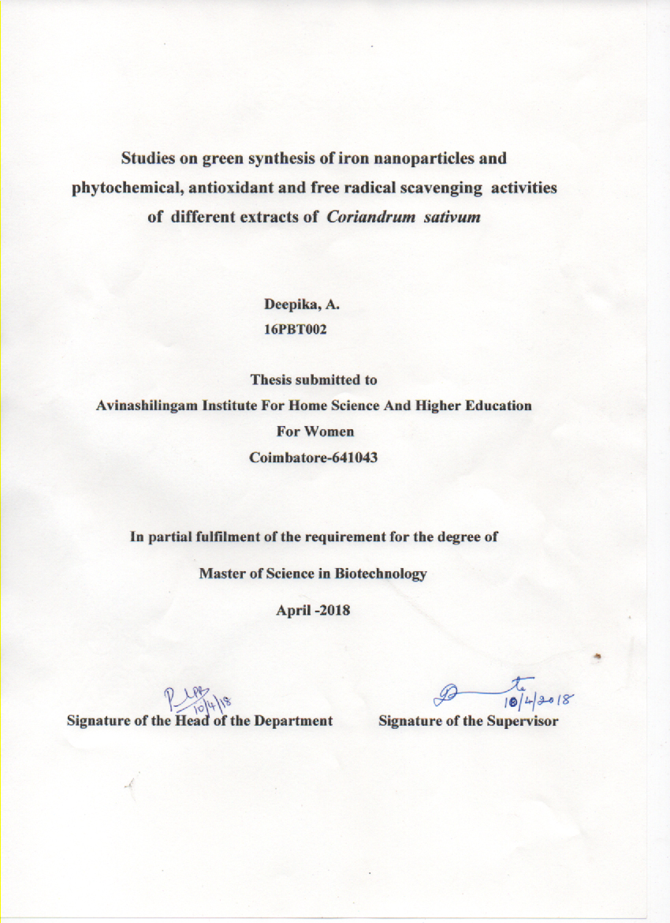
Studies on green synthesis of iron nanoparticles and phytochemical, antioxidant and free radical scavenging activities of different extracts of Coriandrum sativum’

Deepika.A
16PBT002

Thesis submitted to
Avinashilingam Institute For Home Science And Higher
Education For Women
Coimbatore-641043

In partial fulfillment of the requirements for the degree of
Master of Science in Biotechnology
March -2018

CERTIFICATE

Studies on green synthesis of iron nanoparticles and phytochemical, antioxidant and free radical scavenging activities of different extracts of Coriandrum sativum

Deepika.A
16PBT002

Thesis submitted to
Avinashilingam Institute For Home Science And Higher Education For Women
Coimbatore-641043

In partial fulfillment of the requirements for the degree of
Master of Science in Biotechnology
March -2018

Signature of the Supervisor Signature of the Head of the Department

ACKNOWLEDGEMENT

ACKNOWLEDGEMENT

It is with the blessings and the divine grace of Lord Almighty that any human endeavour is achieved. In addition to the will of the supreme divinity, the willingness of many subject experts and erudite scholars to extend their assistance and help for the completion of a work plays, indeed a vitally important role.
‘The best and the most beautiful things in this world can neither be seen nor be touched, but can be felt with the heart’. .
I take the opportunity of expressing my sincere thanks to Padma Shri Dr.P.R.Krishnakumar, Chancellor, Avinashilingam Institute for Home Science and Higher Education for Women, Coimbatore, for providing the opportunity and infrastructure to undertake this investigation.
I immensely thank Dr.(Mrs). Premavathy Vijayan, Vice Chancellor, Avinashilingam
Institute for Home Science and Higher Education for Women, Coimbatore, for providing facilities essential to carry out and complete the study.
I record my sincere thanks to Dr. (Mrs). S. Kowsalya, Registrar, Avinashilingam
Institute for Home Science and Higher Education for Women, Coimbatore, for the timely
help rendered to carry out my work.
I owe my indebtedness to Dr. (Mrs). A. Parvathi, Dean, Faculty of Science, for all the support rendered.
I owe my gratitude to Dr.(Mrs).S.Annapurani, former Professor and Head, Department of Biochemistry, Biotechnology and Bioinformatics, Avinashilingam Institute for Home Science and Higher Education for Women, Coimbatore and Dr. P.R. Padma, Professor and Head, Department of Biochemistry, Biotechnology and Bioinformatics, Avinashilingam Institute for Home Science and Higher Education for Women, Coimbatore, for the support extended to me during the period of investigation. My heart is sparkling with joy to thank Dr. (Mrs). Anitha. Subash, Professor, Department of Biochemistry, Biotechnology and Bioinformatics, Avinashilingam Institute for Home Science and Higher Education for Women, Coimbatore, who with her constant love and guidance made me overcome the fear that good things are difficult to achieve in this world and for her great patience and meticulous care.
A special mention to my tutor Dr.(Mrs).D.Kavitha, professor, Department of Biochemistry, Biotechnology and Bioinformatics, for the support and care through out my work
I owe my heart felt thanks to all the Staff Members and Lab Attenders of the Department of Biochemistry, Biotechnology and Bioinformatics, Avinashilingam Institute for Home Science and Higher Education for Women Coimbatore, who extended their kind support and constant encouragement in relishing the sweetness of success.
I deem it a great privilege to thank miss B.Nandhini and Mrs. S.J.S.Banupriya for their valuable guidance, timely help and suggestions given during the course of the study. I express my special thanks to my friends for their help.
I dedicate my research work to my Parents Mr.A.Arumugam and Mrs. A.Shanthi and my husband Mr.N.Suresh, for having given me moral support and lovable care, which has been source of strength for the successful completion of this dissertation.
I acknowledge the contribution of all other unseen hands for the help rendered in the successful completion of the study.

Deeepika A.

CONTENTS
S.No | Title | Page.no
 | LIST OF TABLES
 | LIST OF FIGURES
 | APPENDICES
1.0 | INTRODUCTION | 1
2.0 | REVIEW OF LITERATURE | 4
3.0 | METHODOLOGY | 14
4.0 | RESULTS AND DISCUSSION | 19
5.0 | SUMMARY AND CONCLUSION | 48
 | BIBLIOGRAPHY

LIST OF TABLES
S.No | Title | Page No
1 | Phytochemical screening of seeds and shoots of Coriandrum sativum | 20
2 | Levels of enzymic antioxidant activities in seeds and shoots of Coriandrum sativum | 22
3 | Levels of non enzymic antioxidant in seeds and shoots of Coriandrum sativum | 23
4 | Changes in colour of the solution during iron nanoparticle synthesis | 30
5 | Change in pH during iron nanoparticle synthesis | 31

LIST OF FIGURES
Figure | Title | Page  No
1 | Effects and sources of free radicals | 7
2 | Oxidative damage due to imbalance between antioxidant and free radicals | 8
3 | Classification of antioxidants based on their nature | 10
4 | DDPH radical scavenging activity of seeds of  Coriandrum sativum | 24
5 | DDPH radical scavenging activity of shoots of Coriandrum sativum | 25
6 | ABTS scavenging activity of seeds of Coriandrum  Sativum | 25
7 | ABTS scavenging activity of shoots of Coriandrum  Sativum | 26
8 | H₂O₂ scavenging activity of seeds of Coriandrum sativum | 27
9 | H₂O₂ scavenging activity of shoots of Coriandrum sativum | 27
10 | Solution of seeds and shoot extract of Coriandrum sativum and ferric chloride and synthesized iron nanoparticles | 30
11 | Surface morphology of the synthesized nanoparticle –  SEM analysis | 32
12 | EDAX spectrum of iron nanoparticle of seeds and shoots of Coriandrum sativum | 33
13 | UV- visible spectrum of synthesized iron nanoparticles | 35
14 | XRD analysis of FeNps from seeds of Coriandrum sativum | 36
15 | XRD analysis of FeNps from shoots of Coriandrum sativum | 37
16 | FTIR analysis of FeNps from seeds of Coriandrum sativum | 38
17 | FTIR analysis of FeNps from shoots of Coriandrum sativum | 39
18 | DPPH radical scavenging activity of synthesized iron nanoparticles from seeds of Coriandrum sativum | 41
19 | DPPH radical scavenging activity of synthesized iron nanoparticles from shoots of Coriandrum sativum | 41
20 | ABTS scavenging activity of synthesized iron nanoparticles from seeds of Coriandrum sativum | 42
21 | ABTS scavenging activity of synthesized iron nanoparticles from shoots of Coriandrum sativum | 43
22 | H₂O₂ scavenging activity of synthesized iron nanoparticles from seeds of Coriandrum sativum | 44
23 | H₂O₂ scavenging activity of synthesized iron nanoparticles from shoots of Coriandrum sativum | 45

INTRODUCTION

1.0.INTRODUCTION
Herbal medicine is the oldest medicine. It was the main stay of many early civilizations and still the most widely practiced form of medicine in the world today. (Al-Snafi, 2016).
“Nature” makes a tremendous interest in the scientific world, which ultimately led to the isolation of a vast number of chemical agents with potentials for multipurpose uses (Kumar et al., 2014).
Several of herbal medications in various medicinal systems is used for the treatment of illnesses, while herbal medicines had the major provenance of essential health care in many nations. Medicinal plants that are used to relief pain and illness because of the presence of several bioactive compounds. Conventional medications available as a source of new pharmaceutical, healthiness maintenance product and alternative medicine. (Edrah, 2017).
India is one of the largest producers of medicinal herbs and is rightly called the botanical garden of the world as it is sitting on a gold mine of well-recorded and traditionally well practiced knowledge of herbal medicine. Medicinal plants are considered as non toxic and easily affordable they play a vital role not only for pharmacological research and drug development, but also when plant constituents are used directly as therapeutic agents and as starting materials for the synthesis of drugs. (Verma, 2016).
The active compounds that have naturally occurring chemicals or phytochemicals that present in plants, which protect plant cells from environmental hazards such as pollution, stress, drought, UV exposure and pathogenic attack. These compounds are secondary plant metabolites that provide health benefits to humans. (Nyamai et al., 2016).
The important bioactive constituents are alkaloids, tannins, flavonoids and phenolic compound, the preliminary phytochemical screening of plants is the need of the hour in order to discover and develop novel therapeutic agents with improved efficacy. (Yadav et al., 2014).
Preliminary phytochemical screening of plants is needed in order to discover and develop novel therapeutic agents with improved efficacy. Phytochemical analyses of several species of medicinal plants and allelopathic activities of the crude chemical compounds on crops and plants have yielded positive results. (Nandagoapalan et al.,2016).
Reactive oxygen species (ROS) that are produced as a result of cellular metabolism are highly toxic and are involved in the etiology of many chronic diseases due to oxidative damage to lipids, nucleic acids and proteins. Although an internal system of antioxidant exists in our body but to get rid of excessive free radicals, exogenous antioxidants are recommended.
(Akhtar et al., 2016).
Antioxidants either synthetic or natural are potent scavengers of free radicals and have beneficial effects on human health and disease prevention. (Malick et al., 2016).
The search for naturally occurring antioxidants as alternatives of synthetic antioxidants is of great interest both in industry as well as in scientific research. It has been mentioned the antioxidant activity of plants might be due to their phenolic compounds. (Saxena et al., 2016).
The revolution of nanotechnology has lifted to a new level of science, by adding new dimensions and novelty in the current scenario research. Nanoparticles exhibit various enhanced properties, distribution and morphological parameters than the conventional system of particles. (Basker, 2016).
Nanoparticles are considered as important structural masses of nanotechnology. The unique and most important property of the nanoparticles is that they unveil superior activity (Naseem and Farrukh, 2015).
A wide variety of physicochemical approaches are used for the synthesis of nanoparticles (NPs). However, biogenic reduction of metal precursors to produce corresponding NPs is eco-friendly, less expensive, free of chemical contaminants for medicaland biological applications where purity of NPs is of major concern. (Hussain et al., 2016).
Green synthesis is more advanced method than chemical and physical method as it is cost effective, environment friendly, easily scaled up for large scale synthesis and in this method there is no need to use high pressure, energy, temperature and toxic chemicals.
(Gottimukkala, 2017).
Many researchers are diverting themselves from using synthetic methods. They are trying to turn themselves towards biological systems, Nanoparticle synthesis from plant is cost effective and can be easily scaled up to be used for large scale production (Pattanayak and Nayak, 2013). Nanoparticles have unique chemical properties such as behaving as an antimicrobial agent and free radical scavenging agent. (Siregar et al., 2017).
Currently, the nanomaterials open up a window for a range of applications in numerous fields as well as usual products and processes. (Wannoussa et al., 2015).
Coriander (Coriandrum sativum L.) is a medicinal plant from Apiaceae family and cultivated throughout the sub continent for both seed as well as tender leaves. The whole plant has a pleasant aroma. Coriander seeds are reported to have phenolics and good antioxidant properties Similarly, coriander leaves also showed good antioxidant potential.
(Agarwalet al., 2016).
It is a slender juicy plant growing in arid zones and is native to the Mediterranean countries. Its seeds are generally small, dry and globular. Now a days, these plants are grown all over the countries. They are extensively used in culinary aspects because of their unique aroma. These plants are rich in vitamins such as A, D & K and minerals such as manganese, magnesium, selenium, iron and calcium. (Gayathri et al., 2016).
In parts of Europe, coriander referred as "anti-diabetic" plant. In some parts of India , it has traditionally been used for its anti-inflammatory properties. (Dharmalingam and Nazni, 2013). It is reported to exhibit several pharmacological effects such anti-mutagenic activity, anthelmentic activity, sedative-hypnotic activity, anticonvulsant activity , diuretic activity, cholesterol lowering activity, protective role against lead toxicity, antifungal activity , anti-feeding activity, anticancer activity, anxiolytic activity, hepatoprotective activity ,anti-protozoal activity, anti-ulcer activity, post-coital anti-fertility activity, heavy metal detoxification, In Ayurvedic medicine it stimulate intellect and sharping memory. (Momin et al., 2012).
Fresh juice of Coriander is useful in curing many deficiencies related to vitamins and iron. The seeds, leaves , flower and fruit of coriander possess antioxidant activity, anti-diuretic activity, anti-mutagenic, antimicrobial activity, anthelemintic activity. (Shrivastava, 2017).
In the present work, an attempt was initiated with the following objectives:
- To analysis the phytochemical constituents and antioxidants in the shoots and seeds extracts of Coriandrum sativum
- To Synthesis iron nanoparticles from the shoot and seed extracts of Coriandrum sativum
- To Compare the free radical scavenging activity of the shoot and seed extracts and synthesized iron nanoparticles from the seeds and shoots of Coriandrum sativum

The background study pertaining to the above topic was carried out and briefed in the following chapter.

REVIEW OF LITERATURE

2.0. REVIEW OF LITERATURE
Plants are considered as the main source of medicines since ancient times. They are known for their medicinal properties. Currently all human societies utilize plants not only for their sources of nutrition but also as treatment against diseases. Plants contain various phytochemical that are used to reduce many diseases by boosting up functions of various organ of the human body. They are acting as antioxidants by supplying necessary nutrients. (Azam et al., 2014).
Herbalists use plant extracts in not a purified form containing various constituents. The effect of whole herb is greater than the summed effects of its components. Inspite of using isolated ingredients the whole herbs are used which reduce the toxicity. (Gunjan et al., 2015).
A brief review of literature present to the current topic of ‘Green synthesis of iron nanoparticles and phytochemical, antioxidant and free radical scavenging activities of different extracts of Coriandrum sativum’

2.1. Coriandrum sativum - Medicinal Plant
2.2. Free Radicals
2.2.1. Mechanism of Free radicals
2.3. Oxidative Stress
2.3.1. Aging
2.3.2. Diabetics
2.3.3. Alzhemier’s disease
2.3.4. Cancer
2.4. Antioxidant
2.4.1. Enzymic antioxidant
2.4.1.1. Catalase
2.4.1.2. Peroxidase
2.4.1.3. Polyphenol Oxidase
2.4.1.4. Superoxide Dismutase
2.4.1.5. Glutathione S Tranferase
2.4.2. Non enzymic antioxidant
2.4.2.1. Ascorbic Acid
2.4.2.2. α- Tocopherol
2.4.2.3. Flavanoids
2.4.2.4. Polyphenols
2.4.2.5. Reduced Glutathione
2.4.3.6. Phytochemicals
2.5. Nanotechnology and nanoparticles
2.5.1. Characterization of nanoparticles
2.5.2. Application of Nanoparticles

2.1. Coriandrum Sativum- Medicinal Plant
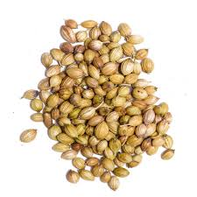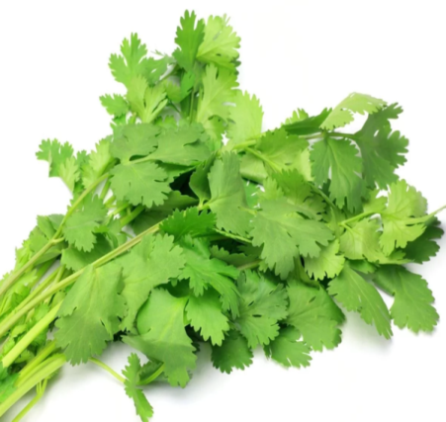

Taxonomical / Scientific Classification

Kingdom | : | Plantae
Subkingdom | : | Angiosperm
Division | : | Eudicot
Class | : | Asteroid
Order | : | Apiales
Family | : | Apiaceae
Genus | : | Coriandrum
Species | : | Sativum
Botanical description
The leaves are small that has many branches and sub-branches. New leaves are oval in shape and aerial leaves are elongated. Flowers are white with slightly brinjal like shades ,Fruit are round in shape.
Macroscopic characteristics
Fruit are globular, mericarps united by their margins, uniformly brownish-yellow or brown, glabrous, sometimes they are crowned by of sepals and styles, it has 10 wavy primary ridges, and 8 straight secondary ridges, it has aromatic odour. It has spicy and characteristic taste. (Nimish et al., 2011)
Phytochemistry
Seeds
The fruit (seeds and pericarp) is the important component of the coriander plant containing essential oil and the fatty oil. It contain 25% of fatty oil, which is yellow in color and while the essential oil content is usually less than 1% with good odour.
Leaves and Stem
The leaves contain Essential oil, flavanoids, phenolic acids and polyphenols. The immature green leaves of C. sativum are widely used as fresh herbs, garnishes in chutneys and sauces.
Nutritional Constituent
Nutritional constituents of Coriander are water, food energy, proteins, fat, carbohydrates, calcium, phosphorus, sodium, potassium, iron, vitamin A etc.
Toxicology
Consuming Coriander sativum is non toxic to human body (Shrivastava, 2017).
The biological activities of coriander seed extracts, such as antioxidant, antimicrobial, antidiabetic, anti-carcinogenic and anti-mutagenic and for treatment of rheumatism and pain in the joints. Such diversity of these activities is the main reason why coriander still attracts considerable attention of scientific community. (Zekovic et.al., 2016).
Potential sources of antioxidants have been found in leaves, oil seeds, barks and roots. Natural antioxidants from plant sources are potent and safe due to their harmless nature, wild herbs have been investigated for their antioxidant properties. (Selvam, 2013). The antioxidant activities of Coriandrum sativum, that are capable to scavenge hydroxyl- and superoxide-radicals, high reducing power, and protection against biological macromolecular oxidative damage and by increasing the level of glutathione. (Al-Snafi, 2013)
2.2. Free Radicals
Free radicals are atomic or molecular structures with unpaired electrons. Free radicals have an important role in food, pharmacological, biological processes, and in a variety of pathophysiological conditions. Free radical capable of oxidizing biomolecules that contain amino acids, proteins, carbohydrates, lipids, and nucleic acids. (Koksal et al., 2017).
Reactive oxygen species (ROS), is the type of Free radical containing all highly reactive, oxygen-containing molecules. Types of ROS include the hydroxyl radical, the super oxide anion radical, hydrogen peroxide, singlet oxygen, nitric oxide radical, hypochlorite radical, and various lipid peroxides. These react with lipid protein causing a cellular damage. (Harsha and Anilakumar, 2014).
Free radicals attack major class of biomolecules, mainly the polyunsaturated fatty acids (PUFA) of cell membranes.The oxidative damage causes the PUFA to degrade by process of lipid peroxidation. (Nimse and Pal, 2015).
Fig 1. Effects and sources of free radicles
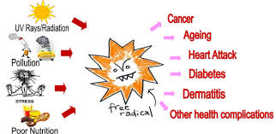http://www.holisticvanity.ca/aged-test-free-radical-levels/
2.2.1. Mechanism of action of free radicals
1. DNA damage
2. Lipid peroxidation (through activation of cycloxygenase and lipooxygenase pathway)
3. Protein damage
4. Oxidation of important enzymes.
5. Stimulation of pro inflammatory cytokine release by monocytes and macrophages by
Depleting intracellular thiolcompounds and activating nuclear factor.
(Nagarajappa, 2015)
2.3. Oxidative stress
Oxidative stress in which oxidation rises than the antioxidant present in the body, that causes the secondary loss of the balance between them. (Parwez, 2017). Oxidative stress can cause tissue injury or even cell death which can takes place by two mechanisms, necrosis and apoptosis.

Fig 2. Oxidative damage due to imbalance between antioxidant and free radicals

OXIDATIVE STRESS

Oxidative stress is responsible for developing of chronic and degenerative diseases such as cancer, arthritis, aging, autoimmune disorders, cardiovascular and neurodegenerative diseases. (Bhattacharya, 2016).

2.3.1. Aging
Aging is not a reversible processes and cannot be determined by one self, It is biological phenomenon affecting all multicellular organisms (with few apparent exceptions) and probably
common among unicellular organisms, including protozoa, yeast, and bacteria (Sadowska-Bartosz and Bartosz, 2014). Aging occurred by progressive functional decline of an organism, that causes the increased susceptibility to age-related diseases, and eventually the death of an organism.(Naidoo and. Birch-Machin.,2016). The production of free radicals increases with age, while some of the endogenous defense mechanisms decrease. The imbalance between these causes cellular damage, that predominantly cause aging. (Poljsak et al., 2013).
2.3.2. Alzhemier’s Disease
Alzheimer's disease (AD) is the most common form of dementia characterized by progressive loss of memory and other cognitive functions. ( Moneim, 2015). The two reason that AD occur are extracellular deposition of amyloid beta (Aβ) and intracellular formation of neurofibrillary tangles (NFT). (Singh, 2017). Lipid peroxides occured by free radicals this in turn decreases the antioxidant enzyme activities that leads to senile plaques formation, and neurofibrillary tangles in Alzheimer disease brains. (Pisoschi and Pop, 2015)
2.3.3. Diabetics
In diabetes, the elevation of ROS level may leads to the disturbances in antioxidant defense system. Decreases the levels of antioxidant enzymes that causes oxidative stress leading to the development of diabetic complications. (Jebur et.al., 2016).Increased oxidative stress can be observed in both insulin dependent (type 1) and noninsulin- dependent diabetes (type 2).Among various factors that are responsible for increased oxidative stress. Glucose autoxidation is most responsible for the production of free radicals. (Sindhi et al., 2013)
2.2.4. Cancer
Cancer is a multistage process defined by three stages: initiation, promotion, and progression. Oxidative stress interfere with three stages of this process. In initiation stage, ROS causes DNA damage by mutation . In promotion stage, ROS causes abnormal gene expression, by blocking cell- to cell communication, and modification of second messenger systems, Finally, in progression stage oxidative stress causes DNA alterations, lipid peroxidation and protein oxidation (Khanna et al.,2014).Oxidative stress is major causes for the accumulation of mutations in the genome, antioxidants provides protection against cancer (Neeraj et al., 2013).
2.4. Antioxidants
Antioxidants that prevent against free radical damage because of their radical scavenging potential. Antioxidant compounds donate hydrogen atoms to the radical species and form nonradical products. Thus, antioxidants neutralize the free radicals to prevent the lipid peroxidation to occur. (Aras et al.,2017).

Fig 3. Classification of antioxidant based on their nature

Cells possess enzymic (for example, superoxide dismutase, glutathione oxidase and catalase) and non-enzymic (for example, vitamin C and E) antioxidant defense system. The most commonly used synthetic antioxidants at present are Butylated Hydroxyanisole (BHA), Butylated Hydroxytoluene (BHT), Propyl Gallate and Tert-Butylhydroquinone (Sasikumar and Kalaisezhiyen, 2014)
A balance exists between the production of these reactive species and antioxidant defense of the cell. In pathological conditions there is an need of extra antioxidants. (Sandeepa et al., 2017)

2.4.1. Enzymic antioxidant
Enzymic antioxidants is used to nullify the effect of free radical (Reactive Oxygen Species (ROS)) .This is accomplished by a set of endogenous antioxidant enzymes such as catalase (CAT), superoxide dismutase (SOD), peroxidase (Px) and polyphenol oxidase (PPO) (Muthu and Durairaj, 2015).
2.4.1.1. Catalase
The catalase structures contain looped polypeptide chains arranged in form of dimers or tetramers bearing iron or manganese ion. (Grigoras, 2017). This enzyme is present in the peroxisome of aerobic cells and is very efficient in promoting the conversion of hydrogen peroxide to water and molecular oxygen. (Sisein, 2014).

2H₂O₂ CATALASE 2H₂O + O₂

2.4.1.3. Polyphenol Oxidase
Polyphenol Oxidases (PPOs) has copper that utilize molecular oxygen to oxidize common ortho-diphenolic compounds such as catechol to their respective quinines (Lokhandwala and Bora, 2014).
2.4.1.4. Superoxide dismutase (SOD)
Superoxide dismutase is the enzyme that catalyse conversion of superoxide anion into oxygen and hydrogen peroxide .They are present in almost all aerobic cells and in the extracellular fluids (Kabel, 2014).
2.4.1.5. Glutathione S-Transferases
Glutathione S-transferases (GSTs), a family of cytosolic multifunctional enzymes. It catalyzes the conjugation of glutathione with a variety of reactive electrophilic compounds, thereby neutralizing their active electrophilic sites and subsequently making the parent compound more water soluble. (Starlin et al, 2013).
2.4.2. Non enzymic antioxidant
Non Enzymic antioxidants plays a important role in second line defense mechanism against damage induced by oxidative stress Antioxidant vitamins that are derived from the diet can be considered under non enzymic antioxidants. (Muthu and Durairaj, 2015).

2.4.2.1. Ascorbic Acid
Vitamin C is defined as the generic term for all compounds exhibiting the biological activity of L-ascorbic acid. (Kumar.V.G,2013).Ascorbic acid (vitamin C) is one molecule has a preventive functions against the stresses. It is a powerful antioxidant that defends the cells from oxidative damage occurring due to aerobic metabolism and a biotic stress. (El-Salam et al., 2013)
2.4.2.2. Flavonoids
Flavonoids are an important class of natural products, belonging to a class of plant secondary metabolites having a polyphenolic structure, widely found in fruits, vegetables and certain beverages. They have favourable biochemical and antioxidant effects associated with various diseases such as cancer, Alzheimer’s disease (AD), atherosclerosis. (Panche, 2016)
2.4.2.3. Polyphenols
Polyphenols represent a large group of at least 10,000 different compounds that contain
one or more aromatic rings with one or more hydroxyl groups attached to them.it is acting as a protection against reactive oxygen and nitrogen species, UV light, pathogens, parasites and plant predators. (Mojzer, 2016)
2.4.2.4. α-Tocopherols
Vitamin E is a strong antioxidant ,Polyunsaturated fatty acids(PUFA) and phospholipids which are found in cell membranes. It also takes part in metabolic processes. vitamin E protects the body from ageing, as these compounds can neutralize free radicals. (Zielińska and Nowak, 2014)
2.4.2.5. Reduced Glutathione
Glutathione are present in a reduced form (GSH) or an oxidized disulfide form (GSSG).It plays important roles in biosynthetic pathways, detoxification, antioxidant biochemistry and redox homeostasis. It is acting as redoxactive, because of oxidation and reduction that occurs.. GSSG is reduced to GSH by the enzyme glutathione reductase, which requires NADPH as the reducing power. GSH acts as an anti-oxidant that quench reactive oxygen species and eliminates the damaging peroxides. (Kasote etal., 2013)

GSSG GLUTATHIONE REDUCTASE GS
NADPH
2.4.3.6. Phytochemicals
In recent year Phytochemicals are classified as primary or secondary constituents, depending on plant metabolism. Primary constituent include the common sugars, amino acids, proteins, purines and pyrimidines of nucleic acids, chlorophyll’s etc. Secondary constituents includes alkaloids, terpenes, flavonoids, lignans, plant steroids, curcumines, saponins, phenolics, flavonoids and glucosides. (Saxena et al., 2013).
2.5. Nanotechnology and nanoparticles
Nanotechnology is the ability to measure, manipulate and manufacture things on an atomic or molecular scale, usually between 1-100nm. These tiny products also have a large surface area to volume ratio, Thus It uses the nanomaterials in mechanics, optics, electronics, biotechnology, microbiology, environmental remediation, medicine, numerous engineering fields and material science. (Saif et al.,2016).
2.5.1. Characterization of nanoparticles
Nanoparticles are generally characterized based on their size, morphology and surface charge, using advanced microscopic techniques as scanning electron microscopy (SEM), transmission electron microscopy (TEM) and atomic force microscopy (AFM). The average particle diameter, their size distribution and charge affect and the physical stability and the in vivo distribution of the nanoparticles. Electron microscopy techniques that assign the overall shape of polymeric nanoparticles, which may determine their toxicity. The surface charge of the nanoparticles affects the physical stability and redispersibility of the polymer dispersion as well as their in vivo performance. (Ranjit and Baquee.,2013)
2.5.2. Applications of nanoparticles
The major applications include Targeted drug delivery. Magnetic and gold nanoparticles are useful to detect cancer. Useful in stem cell therapy. Nanoparticles are useful in gene probing, Protein detection, vaccines, Biodetection of pathogens. Nanoparticles are used in medical field namely MRI( Magnetic Resonance Imaging), Optical Imaging, gene delivery and Neurodegenerative diseases. Nanoparticles are used in the preparation of cosmetics especially sun screen lotions. As the particles are smaller they tend to absorb more UV light. Useful in the manufacture of scratch proof eye glasses, paints, ceramic coatings for solar cells. They are useful in processing of food. Used in the preparation of chips, semiconductors. (Deepika.M,2015).
With this background literature, the study was designed as given in the following chapter.

METHODOLOGY

3.0. METHODOLOGY

The aim of the present work entitled ‘Studies on green synthesis of iron nanoparticles and phytochemical, antioxidant and free radical scavenging activities of different extracts of Coriandrum sativum’. The work was divided into three phases - Phase I, Phase II and Phase III.
3.1. Phase I –Sample preparation and phytochemical and antioxidant analysis
3.1.1. Collection of plant samples
3.1.2. Preparation of plant extracts
3.1.3. Phytochemical screening of the extracts of
Coriandrum sativum
3.1.4. Determination of antioxidant activity
3.1.5. Determination of free radicle scavenging activity
3.2. Phase II –Nanoparticle synthesis and characterization
3.2.1. Preparation of plant extracts
3.2.2. Synthesis of iron nanoparticles
3.2.3. Characterization of iron nanoparticles
3.3. Phase III- Determination of free radical scavenging activity of
synthesized iron nanoparticles
3.3.1. Determination of free radicle scavenging activity
3.3.2. Statistical analysis
3.1. Phase I- Sample preparation and phytochemical and antioxidant analysis
3.1.1. Collection of plant samples
Shoots and seeds of Coriandrum sativum (coriander) were collected from a local market near Karamadai, Coimbatore District. The collected samples were cleaned and dried in the shade at room temperature. They were then powdered and used for further investigation.

3.1.2. Preparation of plant extract
Extracts from powdered shoots and seeds of coriander were prepared in six different solvents of increasing polarity - chloroform, petroleum ether, ethyl acetate, ethanol , methanol and water. 10 gm each of the powdered shoots and seeds were taken in a conical flasks containing 100 ml of each solvent, then placed them in a water bath for 30 minutes. Finally each extract was filtered through Whatmann No.1 filter paper and concentrated by drying in a water bath at 60˚C. (Madhu et al.,2016). The weights were noted before and after evaporation of the filtrate, to know how much residue was obtained. The dried extracts were dissolved in DMSO and stored at 4° C in sterile bottles. Further, the extracts were used for analysis. (Santhi and Sengottuvel ,2016)
3.1.3. Phytochemical screening of the shoot and seed extracts of Coriandrum sativum
Preliminary phytochemical analysis of the plant extracts were carried out by methods
described in Appendix- I
3.1.4. Determination of antioxidant activity
The enzymic antioxidants and non enzymic antioxidants namely catalase, peroxidase, polyphenol oxidase , superoxide dismutase ,glutathione- S -transferase and ascorbic Acid, polyphenols, α –Tocopherols and gluthathione were determined.
3.1.4.1. Estimation of catalase
Catalase activity for the plant samples were estimated as detailed in Appendix - II (Luck,1974)
3.1.4.2. Estimation of peroxidase activity
The peroxidase activity was determined as described in Appendix - III (Reddy et al.,1995)
3.1.4.3. Estimation of polyphenol oxidase
Polyphenol oxidase activity for the plant samples were determined according to the procedure given in Appendix- IV (Esterbauer et al.,1977)
3.1.4.4. Estimation of superoxide dismutase activity
Superoxide dismutase activity was determined based on the method given in
Appendix –V ( Misra and Fridovich,1972)
3.1.4.5. Estimation of glutathione - S - transferase activity
Glutathione -S- transferase activity was analysed and the method is described in Appendix V (Habig et al.,1974)

3.1.4.6. Estimation of Ascorbic acid
Ascorbic acid was estimated based on the procedure given in Appendix –VII (Roe and Kuether,1943)
3.1.4.7. Estimation of α- tocopherol
α- Tocopherol activity for the plant samples were determined by the Method of Emmerie–engel are given in Appendix- VIII (Rosenberg, 1992)
3.1.4.8. Estimation of flavonoids
Flavonoids were determined and the procedure is recorded in Appendix- IX
(Cameron et al.,1943)
3.1.4.9. Estimation of polyphenols
Polyphenols were estimated for the plant sample and described in Appendix - X (Malick and Singh ,1980)
3.1.4.10. Estimation of reduced glutathione
Reduced glutathione was estimated and the method is given in Appendix- XI
(Moran et al.,1979)
3.1.5. Determination of free radicle scavenging activity
3.1.5.1. DPPH scavenging activity
DPPH Scavenging activity was estimated according to the procedure given in Appendix- XII (Mesor et al., 2001).
3.1.5.2. ABTS scavenging activity
ABTS Scavenging activity was studied by the method of Shirwaikar et al., 2006. The details are given in Appendix- XIII
3.1.5.3. Hydrogen peroxide scavenging activity
Hydrogen peroxide scavenging activity was studied by Ruch. et al., 2006 and the procedure as described in Appendix- XIV
3.2. Phase II - Nanoparticle synthesis and characterization
3.2.1. Preparation of plant extracts
Coriander shoots and seeds were collected, dried and powdered. For preparing the plant extract, 6 g of shoots and 6 g of seeds of Coriandrum sativum were added in 100 ml of distilled water and the beakers were kept in boiling water bath for 20 minutes they were then filtered to get a filtrate. (Wang et al.,2014)
3.2.2. Synthesis of iron nanoparticles
Fe nanoparticles were synthesized by adding 0.1 FeCl₃ and plant extract in the volume of 1:3 ratio at 10 °C with continuous magnetic stirring for 30 minutes. The immediate appearance of black colour indicates the reduction of Fe ⁺³ ions. The solutions were then centrifuged to 5000 rpm for 10 min in a cooling centrifuge at 5 °C. The pellets were dissolved in deionized water and then characterized. (Turakhia et al.,2017).
3.2.3. Characterization of iron nanoparticles (Fe Np’s)
Iron nanoparticles obtained from shoots and seeds of Coriandrum sativum was characterized using SEM , EDAX , UV visible spectroscopy, XRD and FTIR
3.2.3.1. SEM-EADX analysis of iron nanoparticle
SEM (Zeiss EVO 40) and EDAX (Bruker) analyses were performed for each sample. Each sample was sampled on to different glass pieces and dried at 80 °C for 1 hour. Gold palladium coating was made for these samples before SEM-EDX analysis. (Ogutveran et al., 2016).
3.2.3.2. UV visible spectra analysis
The reduction of Fe ³⁺ to Fe⁰ was monitored by measuring the UV- visible spectrum by sampling a drop of the solution of iron nanoparticles. The analysis was done using UV visible spectrometer which is read at 200-700 nm (Muthukrishnan et al.,2015).
3.2.3.3. X-Ray Diffraction (XRD) analysis of FeNP’s
FeNPs in the powder form was used for XRD analysis. The XRD patterns were collected on Bruker AXS D8 Advanced X-ray diffractometer with Cu Kα radiation and scanning angle 2θ over the range of 10-80°. XRD patterns were calculated using X‘per Rota flex diffraction meter. (Saranya et al.,2017).
3.2.3.4. Fourier Transform Infra-Red Spectrophotometric (FTIR) analysis of FeNP’s
The FTIR analysis of powder samples was prepared similarly as for powder diffraction. The samples were placed in the two cells of NaCl, after this the two cells contain the sample put in the holder of KBr pellet cells and eventually the detection occurs from the program on the computer to get the signal by their absorbance wavelength. (Alaqad and Saleh, 2016).

3.3. Phase III -Determination of free radicle scavenging activity of synthesized
iron nanoparticles
3.3.1. Determination of free radicle scavenging activity
3.3.1.1. Estimation of DPPH scavenging activity
DPPH scavenging activity was estimated and the procedure is given in Appendix- XII (Mesor et al., 2001)
3.3.1.2. Estimation of ABTS scavenging activity
ABTS savenging activity for the plant sample is described in Appendix- XIII. (Shirwaikar et al., 2006)
3.3.1.3. Estimation of hydrogen peroxide scavenging activity
Hydrogen peroxide scavenging activity was analysed and is presentated in
Appendix- XIV (Ruch. et al., 2006).
3.3.2. Stasistical analysis
The data obtained were tested to find if they are statistically significant .

RESULTS AND DISCUSSION
4.0. RESULTS AND DISCUSSION
The study entitled the ‘Green synthesis of iron nanoparticles and phytochemical, antioxidant and free radical scavenging activities of different extracts of Coriandrum sativum’
The seeds and shoots were shade dried and homogenized. The powdered samples were extracted using six different solvent (chloroform, petroleum ether, ethyl acetate, ethanol, methanol and water). These extracts were used for phytochemical analysis . For nanoparticle synthesis, the aqueous extracts of the seeds and shoots and ferric chloride is added which produce iron nanoparticles and the obtained nanoparticle, it is then characterized.
The results of the above are discussed under following headings
4.1. Phase I - Phytochemical screening of seeds and shoots of Coriandrum sativum
4.2. Phase II - Nanoparticle synthesis and characterization
4.3. Phase III - Determination of free radical scavenging activity of synthesized
Iron nanoparticles

4.1. Phase I- Phytochemical screening of seeds and shoots of Coriandrum sativum
4.1.1. Phytochemical Analysis
The preliminary screening tests are useful in the detection of bioactive constituents. The beneficial properties of edible plants are perhaps due to the presence of a variety of phytoconstituents such as polysaccharides, flavonoids, glycosides, phenols, saponins, tannins etc. Preliminary phytochemical analysis of Coriandrum sativum shoot and seed extract was done using standard test procedures to confirm the availability of active phytochemicals in the various extract.
In this phytochemical screening secondary metabolites such as alkaloids, phenolics, flavonoid, tannins, glycosides, terpenoids, steroids and saponin, and analysed in petroleum ether, chloroform, ethanol, methanol, ethyl acetate and aqueous extract shoot and stem of Coriandrum sativum.
The results of phytochemical screening depicted in Table

Table I
Phytochemical screening of seeds and shoots of Coriandrum sativum
 | Solvents
Phytochemical  Parameters | Petroleum Ether |  | Chloroform |  | Ethanol |  | Methanol |  | Ethyl Acetate |  | Aqueous
Phytochemical  Parameters | Seeds | Shoots | Seeds | Shoots | Seeds | Shoots | Seeds | Shoots | Seeds | Shoots | Seeds | Shoots
Alkaloids | - | - | - | - | - | - | - | - | - | - | - | -
Phenols | - | - | - | - | + | - | + | - | + | + | - | -
Flavonoids | - | - | - | - | - | - | + | + | + | + | + | -
Tannins | - | - | - | - | + | - | + | - | + | + | - | -
Glycosides | - | - | + | - | - | - | + | + | - | - | + | +
Terpenoids | - | - | + | + | - | - | + | + | + | + | - | +
Steroids | + | - | + | + | - | - | + | - | + | - | - | +
Saponin | - | - | - | - | - | - | + | - | + | - | - | -
+Presence - Absence
Table I presents the phytochemical screening of various extract of seeds and shoots of Coriandrum sativum.
From the Table I it is clear that presence of glycosides, terpenoids and steroids and absence of saponin, tannin, flavonoid and alkaloids were observed in chloroform extract of seeds. In the shoots of chloroform extract only terpenoids and steroids were present. In the ethanolic extract of seeds only phenols and tannins were present. In the methanolic extracts of seeds except alkaloids all others were present and in shoot flavonoids , glycosides and terpenoids were present. Except glycosides and terpenoids all other compounds are present in ethyl acetate extract of seeds and in shoots only phenols flavanoids, tannins and terpenoids were present.
In the aqueous extract, phytocompounds such as flavonoids and glycosides are present in seeds and in shoots glycosides, terpenoids and steroids were present. The petroleum ether extract of seeds gives positive result only for steroids.
Similar results were obtained as Minakshi et al.,(2016) who reported that Mentha piperita showed positive results for saponins, tannins, flavonoids, terpenoids, glycosides, alkaloids, carbohydrates and steroids.
Mushtaq et al.,(2014) study reveals the different extracts of Eremurushi malaicus shows positive result for tannins, saponins, terpenoids, flavonoids, phenolics, and cardiac glycosides.
Another study by Mir et al.,(2013) stated that Phytochemical screening of the various extracts of Taraxacum officinale showed the presence of alkaloids, flavonoids, steroids, saponins, tannins and triterpenoid.
Kalaiselvi et al.,(2016) conducted the preliminary phytochemical analysis of leaf extracts (petroleum ether, chloroform and water) of Mimusopselengi L. Alkaloid was present in both petroleum ether and chloroform extracts. Whereas in chloroform extract, flavonoids, terpenoids, saponins and phenols were only present. Steroid were present in both petroleum ether and aqueous extracts. Tannins was present only in petroleum ether extract. Carbohydrates, protein and amino acid were present in all the extracts.
4.1.2. Antioxidant activity of Coriandrum sativum
Antioxidants are the molecules that have an extra electron to share with the roaming free radicals and come to rescue when the body is affected by the damage caused due to excess of free radicals. The nature of antioxidants is to neutralize free radicals in the body. (Sree, 2014)
The major enzymatic antioxidants directly involved in the neutralization of ROS are: superoxide dismutase (SOD), catalase (CAT), glutathione peroxidase (GPx), and glutathione reductase. (Gupta et al.,2014)
4.1.2.1. Enzymic antioxidants
Enzymic antioxidants such as catalase, peroxidase, polyphenol oxidase, superoxide dismutase and glutathione s tranferase were assessed in the seeds and shoots of Coriandrum sativum.
Table - 2 decipited the levels of enzymic antioxidant activity of seeds and shoots of C.sativum
Table - 2
Levels of enzymic antioxidants in seeds and shoots of
Coriandrum sativum
S.No | Enzymic Antioxidants | Samples
S.No | Enzymic Antioxidants | Seeds | Shoots
1 | Catalase U/g | 0.86 ±0.02 | 1.18 ± 0.07
2 | PeroxidaseU/g | 0.83 ±0.02 | 0.95 ±0.01
3 | Polyphenol oxidase U/g | 1.6±0.01 | 1.09± 0.01
4 | Superoxide DismutaseU/g | 0.76 ±0.02 | 1.04 ±0.07
5 | Glutathione S Transferase U/g | 1.95±0.07 | 2.025 ± 0.06

The triplicate value is expressed in Mean ± standard deviation
From the table , it concluded that shoots shows maximum level of catalase and the lowest value were observed in the seeds and the activity is expressed in U/g . The level of peroxidase were low in seeds and moderate value were observed in shoots. The activity of polyphenol oxidase was found to be maximum in shoots (1.09± 0.01) and lowest value was estimated in seeds(1.6 ± 0.01 ). Glutathione-S-transferase was found to be maximum in shoot (2.03 ±0.06) compared to seeds (1.95 ±0.06). Superoxide dismutase has least activity while comparing other samples. It is clear from the above table shoots have better activity than the seeds of Coriandrum sativum
The above result is supported by the work of Alici and Arabaci, (2016) who revealed that Rumexobtusifolius L. significantly shows higher SOD activity than other enzymes and the activity was found to be 1159.6±262 Unit /g for superoxide dismutase and for other enzymes such as catalase, peroxidase, polyphenol oxidase was found to contain 3866.9±36 , 19533.8±436 Unit/g 1284.6±56 Unit/g, it can be supposed that Rumexobtusifolius L. has good antioxidant capacity.

4.1.2.2. Non-enzymic antioxidant
Non enzymic antioxidant such as ascorbic acid, α-tocopherols, flavonoids, polyphenols and reduced glutathione were assessed in seeds and shoots of Coriandrum sativum.
Table - 3 details the levels of non enzymic activities of Coriandrum sativum
Table - 3
Levels of non-enzymic antioxidants in seeds and shoots of Coriandrum sativum
S.No | Non- enzymic antioxidant | Samples
S.No | Non- enzymic antioxidant | Seeds | Shoots
1 | Ascorbic acid (mg/g) | 3.03±0.03 | 4.03±0.03
2 | α- Tocopherols(mg/g) | 2.06 ± 1.5 | 1.95 ± 0.02
3 | Flavonoids (mg/g) | 0.98 ±0.02 | 0.98 ± 0.02
4 | Polyphenols (mg/g) | 0.81±0.03 | 0.94±0.01
5 | Reduced Glutathione (ng/g) | 1.08±0.07 | 2.04 ±0.08

The triplicate value is expressed in mean ± standard deviation
It is evident from the above Table -3, it shows significantly highest value of ascorbic acid, reduced glutathione , α-tocopherol, flavanoids and total polyphenol as 4.03±0.03,2.04 ±0.08, 1.95 ± 0.02, 0.98 ± 0.02 and 0.94±0.01 respectively were observed in shoots. Seeds were found to exhibit the lowest ranges of various non enzymaic antioxidants comparing to shoots are ascorbic acid 3.03±0.03 (mg/g), α-tocopherol (2.06 ± 1.5mg/g) and total polyphenol (0.81±0.03), Reduced glutathione(1.08 ±0.07) ,α-tocopherol (1.95 ± 0.02), flavanoids (0.98 ±0.02). Flavonoids which exhibit moderate in seeds as well as shoots .
Similar result were obtained as the result of Vijayakumari et al.,(2013) that Rotula aquatic roots shows highest value of ascorbic acid, α-tocopherol and total polyphenols. Leaf was found to exhibit the lowest ranges of various non enzymatic antioxidants viz., ascorbic acid, a-tocopherol and total polyphenol. The level of ascorbic acid, α-tocopherol and polyphenol were found to be moderate in stem comparing to roots.
4.1.3. Free radical scavenging activity
4.1.3.1. DPPH radical scavenging activity of seeds and shoots of Coriandrum sativum
DPPH scavenging activity of seeds of Coriandrum sativum and percent of inhibition was shows in Figure -4

Figure – 4
DPPH radical scavenging activity of seeds of Coriandrum sativum

From the above Figure- 4, it is understood that the antioxidant activity of various extracts of coriander shows increased inhibition at higher concentration. Among the various extract, petroleum ether shows maximum activity at high concentration (45µg/ml) and the percent of inhibition was found to be 85%, followed by ethyl acetate, ethanol, methanol and then aqueous. The decreasing order of DPPH activity of the seeds of C. sativum was petroleum ether >ethyl acetate >ethanol >methanol >chloroform > aqueous.
Chittam et al., (2016) investigated that the extract of Chlorophytum tuberosum tested against DPPH stable radicals scavenging activity of ethanolic extract possessed excellent antioxidant capacity as compared to aqueous extract.
Similar results were expressed by Geetha et al., (2013) who stated that the ethanolic extract of Aesculus hippocastanum (Concentration of 100 μg/ml) and standard ascorbic acid shows 92.72% and 97.35 % inhibition of DPPH scavenging activity.
Percent of inhibition of DPPH scavenging activity of shoots of Coriandrum sativum and was shows in Figure -5

Figure - 5
DPPH radical scavenging activity of shoots of Coriandrum sativum

From the Figure, it indicates that antioxidant activity of various extracts of shoots shows increases percent of inhibition of ABTS with increase in concentration.While comparing the activity of different extract, methanol shows maximum at 45 µg /ml that is found to be 85% of inhibition followed by Petroleum ether, chloroform, ethanol, aqueous and ethyl acetate. The increasing order of DPPH activity of the seeds of C. sativum was methanol >petroleum ether > chloroform > ethanol >aqueous > ethyl acetate.
4.1.3.2. ABTS scavenging activity of seeds and shoots of Coriandrum sativum
Percent of inhibition of ABTS scavenging activity of seeds of Coriandrum sativum was shown in Figure -6.
Figure – 6
ABTS scavenging activity of seeds of Coriandrum sativum

From the above figure, it was understood that ethyl acetate extract has a capability to scavenge the ABTS free radical, at higher concentration and the percent of inhibition was found to be 88%,comparing to other extract (aqueous, methanol ,chloroform, ethanol and petroleum ether). The order of ABTS Scavenging activity of shoots of C. sativum was aqueous > methanol > chloroform > ethanol > petroleum ether.
ABTS scavenging activity of shoots of Coriandrum sativum and percent of inhibition of ABTS is presents in the figure – 7
Figure -7
ABTS scavenging activity of shoots of Coriandrum sativum

From the above figure, it is clearly understood that aqueous extracts has a capability to scavenge the ABTS free radical, comparing to other extract (chloroform, ethanol, petroleum ether, methanol and ethyl acetate).The increasing order of ABTS Scavenging activity of shoots of C. sativum was aqueous > ethanol > chloroform > petroleum ether >methanol >ethyl acetate
Another study by Gupta et al.,(2016) stated that the percentage of inhibition against different concentrations of both extracts of Glycyrrhiza glabra is determined as 575 ±26.694 in alcoholic extract, 683.9 ±49.220 in aqueous extract of Glycyrrhiza glabra. It is also observed that inhibition percentage values go on increasing with increases in concentration that neutralizing ABTS free radical.
4.1.3.3. H₂O₂ scavenging activity of seeds and shoots of coriandrum sativum
The percent of inhibition of hydrogen peroxide scavenging activity of seeds are shown in the figure - 8.

Figure – 8
H₂O₂ scavenging activity of seeds of Coriandrum sativum

From the above figure, seeds of aqueous extract shows higher hydrogen peroxide scavenging activity. The increasing order of ABTS Scavenging activity of seeds of C. sativum was aqueous > ethanol > chloroform> ethanol> petroleum ether > methanol > ethyl acetate.
Hydrogen peroxide scavenging activity of various extract of shoots of C. sativum was given in Figure -9
Figure – 9
H₂O₂ scavenging activity of shoots of Coriandrum sativum

From the figure, methanolic extract of shoots shows higher percent of inhibition of hydrogen peroxide that is found to be 72%. The order of ABTS scavenging activity of seeds of C. sativum was methanol >chloroform >ethanol >petroleum ether >ethyl acetate >aqueous
Similar work is in part with the results of Ngonda (2013) who stated that hydrogen peroxide scavenging activity of methanolic extract of Trichodesma zeylanicumm showed good scavenging capability compared to the standard compound. The scavenging percentages was found to be 74.82% .

4.2. Phase - II - Nanoparticle synthesis and characterization
4.2.1. Synthesis of iron nanoparticles
The seed and shoot extract of Coriandrum sativum produce iron nanoparticle with treatment of ferric chloride. Iron nanoparticles were produced by the reduction of Fe³⁺ to Fe⁰ ions. while adding plants extracts to ferric chloride this causes the reduction in pH values. Changes of pH is observed from high acidic to low acidic. Colour change was observed from dark yellow to black in seeds and brownish green to black in shoots due to reduction of iron. (Pattanayak and Nayak,2013)
4.2.2. Visual observation studies
The reduction process from Fe ⁰ to Fe ³ ⁺ was observed by direct visual observation of the solution by the method as described. The conversion of dark yellow and greenish brown to black color clearly indicates the iron nanoparticle formation.
Seeds
Beaker 1 - 0.1 M Ferric chloride solution
Beaker 2 -Aqueous seed extract of C. sativum
Beaker 3- Ferric chloride solution + seed extract(Fe Nps )

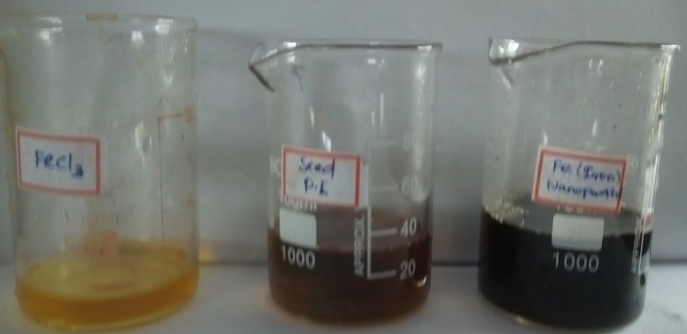
Shoots
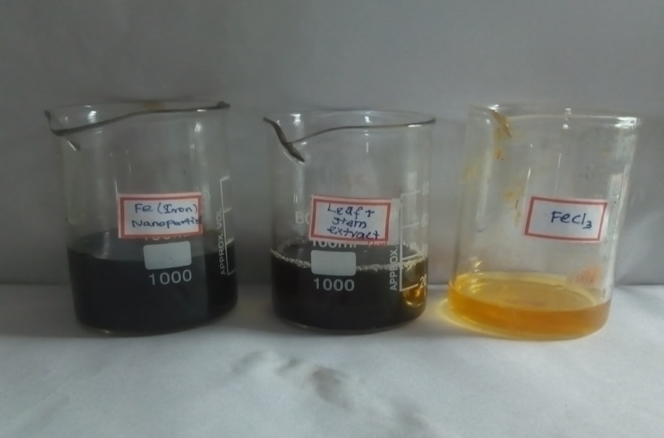
Beaker 1 -Ferric chloride solution + shoot extract(Fe Nps)
Beaker 2 - Aqueousshoot extract of C. sativum
Beaker 3 - 0.1 M Ferric chloride solution

The colour change of the solution before and after iron nanoparticle synthesis is recorded in the table 4 and pH changes is shown in the table 5
Table 4
Changes in colour of the solution during iron nanoparticle synthesis

S.No | Sample | Before nanoparticles  Synthesis | After nanoparticles  synthesis | Colour Intensity
1. | Coriander seed extract +  0.1 M Ferric chloride | Dark yellow + Bright dark yellow | Black | +++
2. | Coriander Shoot extract + 0.1 M Ferric chloride | Dark greenish brown  + Bright dark yellow | Black | +++
Figure 10
a)Shoot and seed extract of Coriander Sativum (i) shoot and seed extract (ii) 0.1 M Ferric chloride solution
i)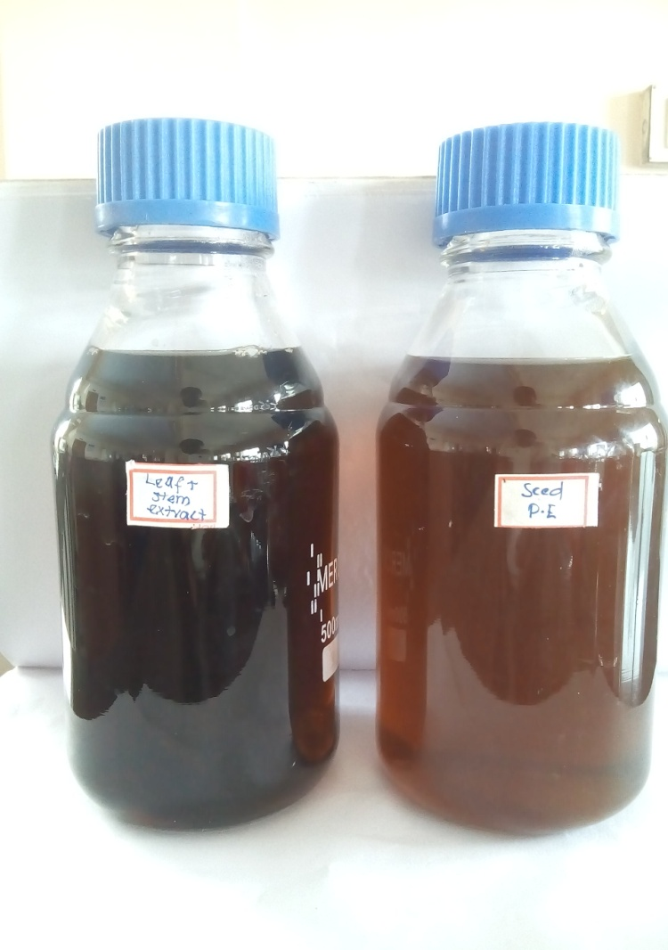ii)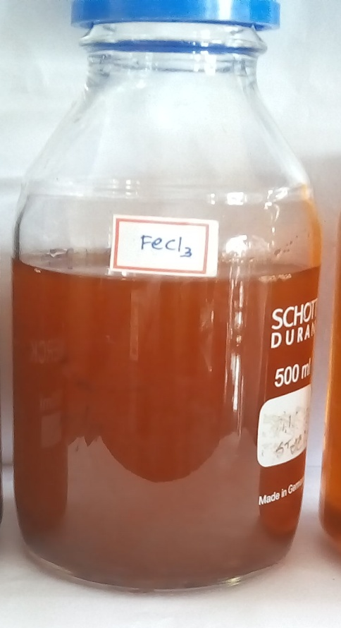

b) Synthesized iron nanoparticles
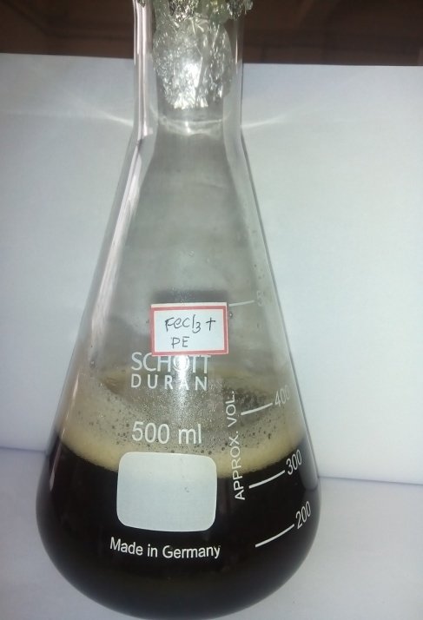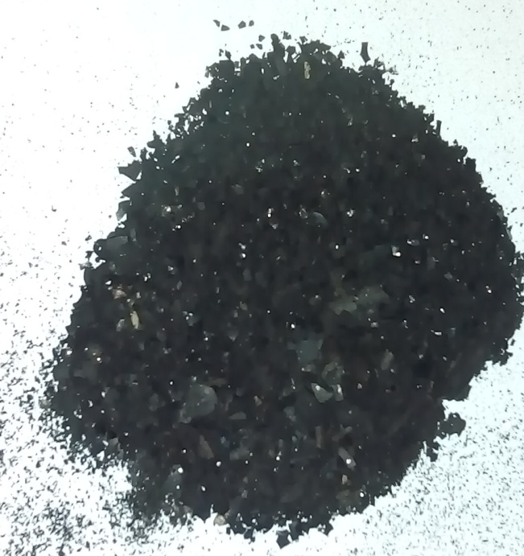

Table- 5
Change in pH of during nanoparticle synthesis
Sample | Extract | Before nanoparticle synthesis | After nanoparticle synthesis
Coriandrum sativum | Seeds | 3.99 | 1.19
Coriandrum sativum | Shoots | 3.89 | 1.11
4.2.3. Characterization of iron nanoparticles
Characterization of nanoparticles is significant to evaluate the nature of nanoparticles. The characterization of nanoparticles can be performed by scanning microscopy (SEM) with EDAX , UV–Vis spectroscopy, X-ray diffractometry (XRD), and Fourier transform infrared spectroscopy (FTIR)
4.2.3.1. SEM analysis
The Scanning Electron Microscopic image that examine the nature and morphology of iron nanoparticles from seeds and shoots of Coriander sativum is shown in the Figure.11

Figure -11
Surface morphology of the synthesized nanoparticles using SEM – Coriander seed Fe Nps at (a )20000X (b) 10000X ,Coriander Shoot Fe Nps at (c) 6000X and (d) 4000X
- b)
- d)
The surface morphology of the synthesized iron nanoparticles from shoots and seeds of Coriandrum sativum was studied using scanning electron microscopy. The shape is rod and the surface is smooth for seeds and for shoots it is irregular rhombic shapes.
Similar results were obtained as Veeramanikandan et al.,(2017) synthesized iron oxide nanoparticles had irregular rhombic shapes with panoramic view.
Another study by Srivatsan et.,al (2016) who reported that iron oxide nanoparticles were more or less spherical in shape. The bimetallic Fe : Zn (1 : 1) nanoparticles were mostly irregular in shape and had characteristic morphology that was observed in both iron oxide and ZnO nanoparticles with both flakes and spherical morphology.
In order to confirm the presence of both iron and oxides in the synthesized nanoparticle, elemental analysis was also performed using energy dispersive X-ray (EDAX) spectrometry.
4.2.3.2. EDAX measurements
The energy dispersive X-ray Diffractive (EDX) study was carried out for the synthesized Fe nanoparticles to know about the elemental composition. (EDAX) equipped within the SEM was used to determine the chemical composition of the synthesized nanoparticles. EDAX revealed the chemical composition of synthesized nanoparticles
Figure -12

EDAX spectrum of iron nanoparticle of seeds and shoots of Coriandrum sativum

. a) EDAX spectrum of Iron nanoparticles from seeds of Coriandrum sativum
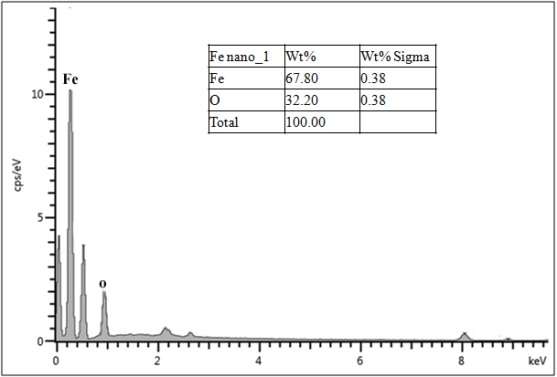
From the figure 12(a), elemental analysis of the nanoparticle from coriander seeds yielded 67% of iron and 32% of oxygen of coriander seeds which proves that the produced nanoparticle is in its highest purified form.
Figure 12 (b)
EADX spectrum of Iron nanoparticles from shoots of Coriandrum sativum
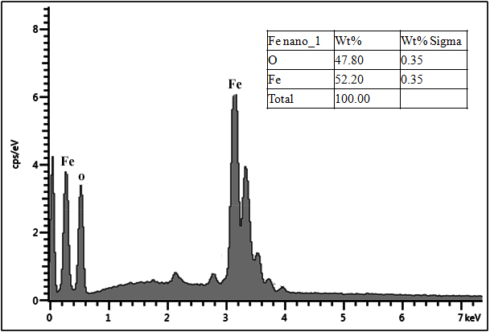

The analysis of the iron nanoparticle obtained from seeds yielded 52% of iron and 47% of oxygen proves that the produced nanoparticle is in its highest purified form is given in the above Figure 12 (b).
The result are in accordance with the work of Sebastian et.,al (2016) who used a extract of Bauhinia natalensis leaves treated with ferric chloride producing iron nanoparticles. Wavelength absorption maxima was observed at 270 nm whereas absorption band was seen in the wave length range 200–290 nm which is typical of iron oxides. Atomic percentage of Fe and O in the particle aggregate was 2.28 and 32.09 respectively.
Another work by Sravanthi et al.,(2018) that EDX spectrum of ZVIN, the highest peak due to absorption of elemental iron indicates the presence of iron nanoparticles and another peaks corresponding to carbon and oxygen atoms reveal the vital role of organic molecules from flower extract in the stabilization of ZVIN .

4.2.3.3. UV visible specteroscopy
UV-vis spectrum of the seeds extract obtained a broad peak extending from 260-350 nm with absorption maxima at 250 nm was seen in Fig-13(a). The reduction of the prominent extract peak at 272 nm indicates the polyols were actually involved in the reduction process.The complete disappearance of the Fe³⁺ peak at 280 nm and the smaller hub at around 350 nm have been shown to be due to the presence of the iron nanoparticles. From Fig 14(b) hub was seen at 240 nm, and the complete reduction of peak were seen from 260 nm - 320nm observed in shoots.
UV-visible spectrum analysis of synthesized iron nanoparticles of seeds and shoots of Coriandrum sativum recorded in figure 13 (a) seeds and 13 (b) shoots.

Figure 13
UV- visible spectrum of synthesized iron nanoparticles

a)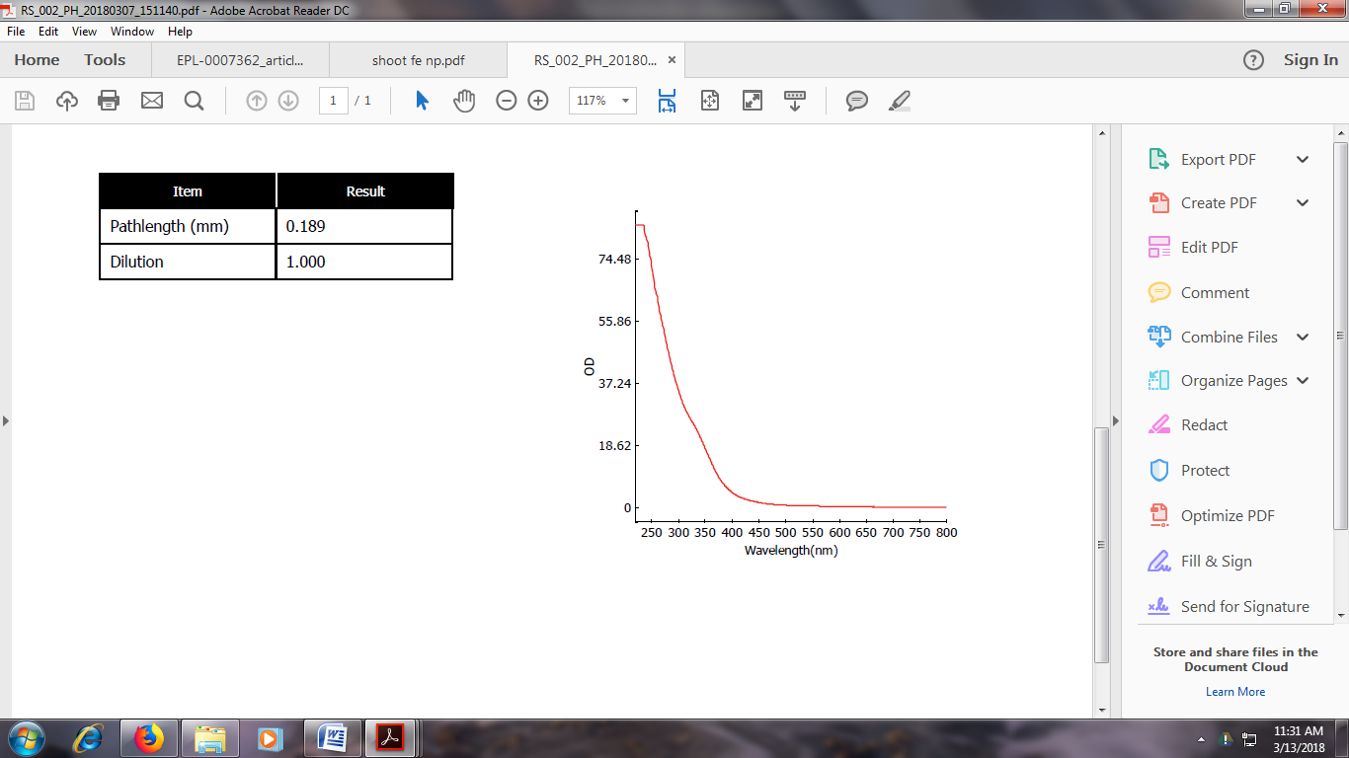 b)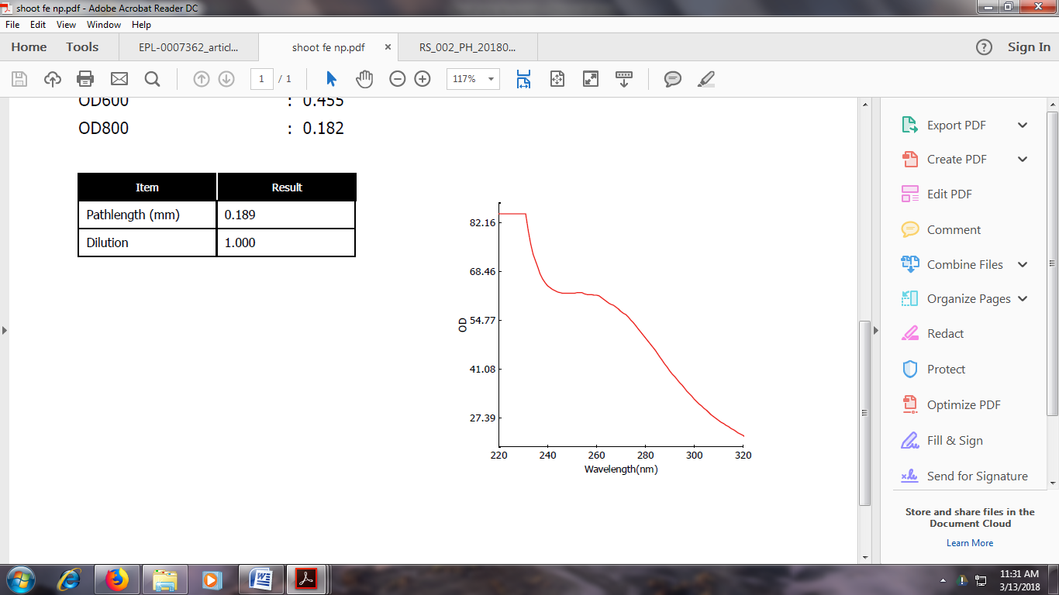

Similar work is on part with the result of Michira et al.,(2014) who reported that synthesised iron nanoparticles from green tea extracts causes the complete disappearance of the Fe³⁺ peak at 298 nm. The new peak formed was slightly shifted at 280 nm and the smaller hub at around 350 nm have been shown to be due to the presence of the iron nanoparticles in the Fe⁰ state, and the reduction of the prominent extract peak at 272 nm indicates the polyols were actually involved in the reduction process and the consequent formation of a new compound.
The work is agreement to the result of Sravanthi et al.,(2018),who reported that the spectra of the black colored colloidal solution show the disappearance of strong absorption peaks at the region 300 to 350 nm and emerge broad absorption at higher wavelengths, suggesting the formation of polydispersed.

4.2.3.4. XRD analysis
XRD analysis clearly indicates the presence of high crystalline phases. The patterns have been widely used in nanoparticle research to characterize critical features such as a crystal structure, crystallite size, and strain.
The XRD pattern of iron nanoparticles obtained from seeds of Coriandrum sativum was shown in the figure -14
Figure- 14
XRD analysis of FeNps from seeds of Coriandrum sativum
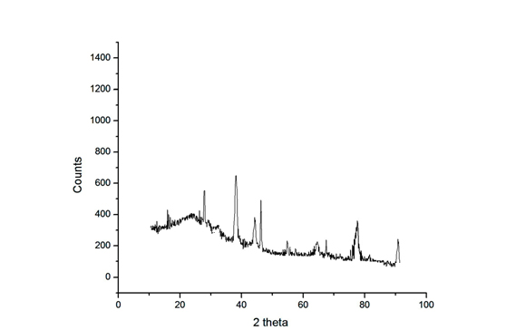

Structures of Iron oxide crystal obtained from seeds and shoots were characterized using XRD. The resulted diffractogram shows six peaks corresponding to the standard data for iron nanoparticles synthesized by the seeds .The characteristic diffraction peaks of the synthesized iron nanoparticle are seen in 2θ = 29.93°, 38.13°, 43.30°, 63.78°,78.93° and 91.54° can be indexed to (220), (311), (400), (511), (440) and (533).The obtained nanoparticles showed some broad peaks, indicating the ultrafine nature and small crystallite size of the particles. The analysis of the diffraction pattern showed the formation of a cubic structure, which is due to the strongest reflection that proceeds from the (400) plane. The XRD pattern of FeO NPs is records in Fig 14.
The diffractogram of iron nanoparticles from shoot extract shows six peaks corresponding to the standard data for iron nanoparticles synthesized by shoots shown in the Fig 15.
Figure -15
XRD analysis of FeNps from shoots of Coriandrum sativum
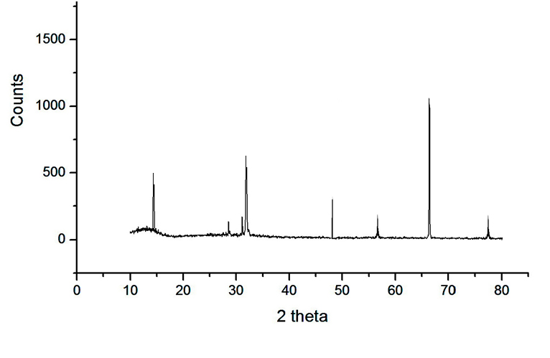
The characteristic diffraction peaks of the synthesized iron nanoparticle seen in 2θ = 15.93°, 32.13°, 47.30°, 57.78°,67.93° and 77.54° and can be indexed to (220), (311), (400), (511), (440) and (533). The samples showed broad peaks, indicating the ultrafine nature and small crystallite size of the particles. The analysis of the diffraction pattern showed the formation of a cubic spinel structure, which is due to the strongest reflection that proceeds from the (440) plane.
The work is on Part with Umoren et al., (2017) who reported that XRD pattern of Ag obtained four peaks at 2θ = 38.5º, 45.7º, 65.6º, and 78.7º and can be indexed to the (111), (200), (220), and (311) of a pure silver. However, two peaks are observed at 2θ = 28º and 32º respectively. These might infer the presence of impurities in the biosynthesized AgNPs.
4.2.3.5. FTIR (Fourier-Transform Infrared Spectroscopy Measurement)
The FTIR technique can identify unknown materials, quality or consistency and components amount determination. It mainly identifies the functional groups present in Coriandrum sativum extract. Figures showing the FT-IR spectrum of prepared iron nanoparticles from seeds and shoots of Coriandrum sativum.
4.2.3.5.1. FTIR spectrum of the FeNPs synthesized using Coriandrum Sativum Seeds
FTIR spectra analysis (400 - 4000 cm⁻¹) was carried out in order to characterize NP’s that are used to determine the presence of surface functional groups. FT-IR analysis of FeNP’s obtained from seeds and shoot of Coriandrum sativum were conducted to determine the involvement of the functional groups in the synthesis of iron NP’s.
FTIR spectrum obtained a frequency for synthesized FeNP’s from Coriandrum sativum seeds and shoots were shown in figure 16 and 17.
Figure – 16
FTIR analysis of FeNps from seeds of Coriandrum sativum
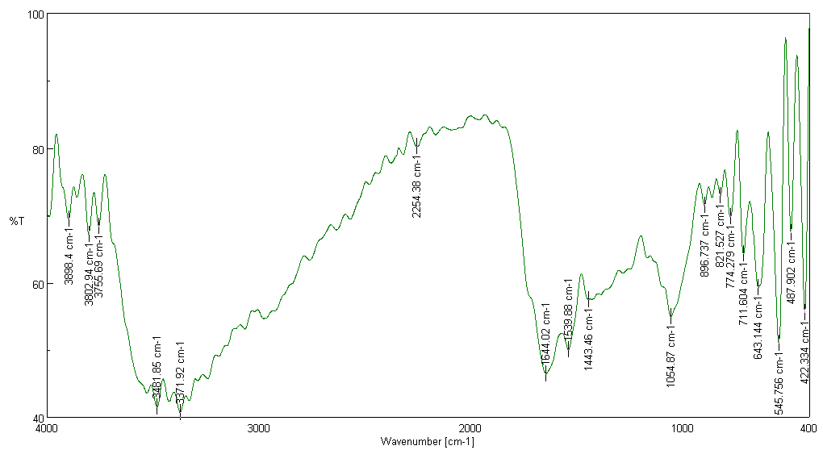
FTIR measurements of the dried, powdered sample of iron nanoparticles from seed extract showed the presence of 18 bands in the frequency ranging from 422cm⁻¹ to 3898 cm⁻¹ in Fig 16 and for shoots 13 peaks were observed with frequency ranging from 479 cm⁻¹ to 3975cm⁻¹ in Fig 17.
The spectra of seed extract showed the absorptions peak at different frequency of 3898.4, 3802.94 and 3755.69. In shoot extract , the strong bands were observed at 3975.53, 3881.04, 3371.92 and 3837.65 cm⁻¹. Both the seed and shoot extract shows the presence of O-H stretching and bending bands.
Shoots with frequency 3406.64 and 3484.74 and Seeds with 3481.85cm⁻¹ were conforms the presence of polyphenols . The synthesized iron nanoparticles shows peaks at 2254.38 cm⁻¹of seeds and 2345.02 cm⁻¹ of shoots shows some interactions of particles along with proteins. Shoots corresponds to peak of 1635.34 cm ⁻¹ denotes the presence of C = O stretching .C-O stretching and OH out-of-phase plane is observed in shoots at 1381.75 cm ⁻¹.The bands 1054 cm ⁻¹ of seeds and 1043.3cm ⁻¹ of seeds corresponds to C-O-C stretching vibration.

Figure -17
FTIR analysis of FeNps from seeds of Coriandrum sativum
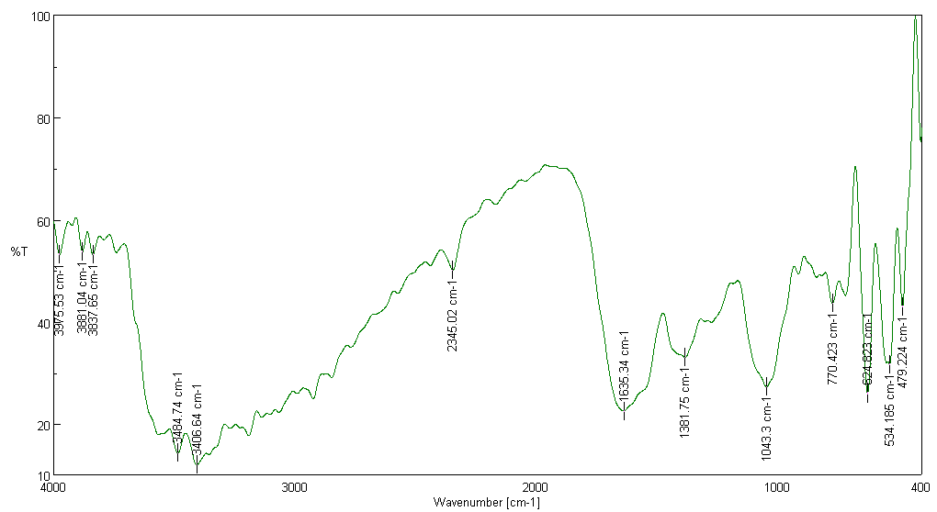
The absorption bands at 1443 and 1054 cm⁻¹ can be attributed to the C–H bending vibration and C–N stretching vibration of shoots and seeds respectively. The bands at 624 cm⁻¹ corresponds to presence of water molecules. Frequency at 3371.92, 1644.02, 1539.88, 896.73, 821.57, 774.27, 711.604, 643.14, 487.902 and 422.334 cm⁻¹ of seeds corresponds to C=C Stretch O-H Stretch, aromatic nitro compounds, C-H bend (out of plane ), C-C vibration, Alkyne C-H bend and S-S Stretch.
In shoots, 770 cm ⁻¹, 534.18 cm⁻¹, 479.22 cm⁻¹ corresponds to C-H bend, O-H bend and S-S Stretch. Seeds of 545.75 cm⁻¹ frequency corresponds to Fe-O stretch of Fe₂O₃ and Fe₃O₄.
The present study was similar to the studies conducted by Al- Timmimi and Ahmed,2017 who reported that FTIR spectrum of iron oxide nanoparticles shows bands at 3950–3263 cm⁻¹ corresponding to O–H stretching and bending bands.
In the studies of Fazlzadeh,et.al (2017).the frequency ranging between 3400 and 3430 cm⁻¹,corresponds to polyphenols. But it is generally found that the presence of phenolic compounds can reduce Fe²⁺ to Fe ⁰. This indicates the existence of stronger functional groups.

The study is in part with Umoren , et al.,(2017) who reported that characterization frequency of FTIR was found to be 3400 and 3430 cm^{-1,} the highest peak corresponds to polyphenols.
Similar frequency is similar to Huang et al.,(2014) study who reported that the FTIR bands of oolong tea extracts displaying bands at 3388 cm⁻¹, 1636 cm⁻¹, and 1039 cm⁻¹ refer to O-H, C-C, C-O-C stretching vibrations and the adsorption bands around 460 cm⁻¹ and 546 cm⁻¹ corresponded to Fe-O stretches of Fe₂O₃ and Fe₃O₄.
Similar frequency is revealed in the study of Ghiyasiyan-Arani et al.,(2015)who reported that the bands around 3300, 1610, 930 and 620 cm⁻¹ can be related to water molecules. The absorption bands at 1440 and 1054 cm⁻¹ can be attributed to the C–H bending vibration and C–N stretching vibration, respectively.
4.3. Phase-III- Determination of free radical scavenging activity of synthesized Iron
nanoparticles
4.3.1. DPPH scavenging activity of iron nanoparticles from seeds and shoots of
Coriandrum sativum
The DPPH radical scavenging activity of seeds of synthesized iron nanoparticles from Coriandrum sativum shown in figure 18.

Figure – 18
DPPH radical scavenging activity of synthesized iron nanoparticles from seeds of Coriandrum sativum

From the Figure, it indicated that the DPPH scavenging activity of Fe Np’s from various extracts, methanol shows maximum activity, followed by ethanol ,petroleum ether, ethyl acetate, chloroform and then aqueous. The increasing order of DPPH activity of the seeds of C. sativum was >methanol > ethanol > petroleum ether > ethyl acetate >chloroform >aqueous .
The DPPH scavenging activity of iron Np’s from various extracts of shoots of Coriandrum sativum were presents in the figure -19
Figure -19
DPPH radical scavenging activity of synthesized iron nanoparticles from shoots of C.sativum

It is evident from the figure-19, the methanol extract of iron nanoparticles of shoots has the capability to scavenge the DPPH free radical, at higher concentration and the percent of inhibition was found to be 96%. Methanol has higher percent of inhibition than any other extract (ethanol, petroleum ether, ethyl acetate, chloroform and aqueous).The increasing order of ABTS scavenging activity of shoots of C. sativum was methanol > ethanol > ethyl acetate > chloroform > petroleum ether > methanol >aqueous.
Similar studies were conducted by Muthukumar and Matheswaran (2015),who reported that the antioxidant capacity of leaf extract of Amaranthus spinosus and studied by varying concentration from 50 to 250 μg/mL. The percentage of inhibitory activity was increased with increasing of extract concentration from 50 to 250 μg/mL.
The study is on agreement with the result of Patraaand and Baek,(2017) who investigated that FeNPs exhibited moderate DPPH radical scavenging potential of 27.30% and 26.98% at 100 μg/mL compared with ASA which showed a value of 42.46% DPPH.
Ajayi and Afolayan (2017), reported that the LG-AgNPs nanoparticles showed a maximum scavenging activity of DPPH is 70.12% at a concentration of 500 μg ml−1, whereas ascorbic acid and rutin at the same concentration exhibited 95.50% and 93.02% inhibition.
4.3.2. ABTS scavenging activity of iron nanoparticles from seeds and shoots of
Coriandrum sativum
The ABTS scavenging activity of iron Np’s from various extracts of seeds were presents in the figure -20
Figure -20
ABTS radical scavenging activity of synthesized iron nanoparticles from seeds of C. sativum

From the figure 20, it is clears that methanol has a capability to scavenge the ABTS free radical, comparing to other extract (ethyl acetate, aqueous, ethanol,chloroform and petroleum ether). The increasing order of ABTS scavenging activity of shoots of C.sativum was methanol > ethyl acetate >aqueous > ethanol >chloroform > petroleum ether.
In the studies of Patraa and Baek,(2017) who reported that lower activity of ABTS scavenging potential of both the MH-FeNPs and CCP-FeNPs nanoparticles compared to ASA might be due to the presence of different functional groups attached to the Fe₃O₄ NP’s, which affects its ability to react with ABTS radicals, or due to the stereo selectivity of the radicals.
The ABTS scavenging activity of iron Np’s from various extracts of seeds were records in the figure -21
Figure - 21
ABTS radical scavenging activity of synthesized iron nanoparticles from shoots of C.sativum

From the above figure, it is clearly understood that chloroform has capability to scavenge the ABTS free radical, at higher concentration is found to be 89% ,comparing to other extracts (methanol, ethanol, petroleum ether, ethyl acetate and aqueous). The increasing order of ABTS scavenging activity of shoots of C .sativum was chloroform > ethanol > methanol > petroleum ether> ethyl acetate > aqueous.
The study is similar to the study of Sloan-Dennison et al., 2017, who stated that iron nanoparticles have an intrinsic catalytic activity and they can catalyse the oxidation of ABTS.
Madhanraj et al.,2017, works on mushroom mycelial extracts and has found that the scavenging effect of Schizophyllum commune has the highest ABTS activity in case of AuNPs and Pleurotus cystidiosis has the highest value in case of AgNPs.
4.3.3. H₂O₂ scavenging activity of seeds and shoots synthesized iron nanoparticles from Coriandrum sativum
The percent of inhibition of hydrogen peroxide scavenging activity of iron Np’s from various extracts of seeds were presents in the figure -22
Figure - 22
H₂O₂ radical scavenging activity of synthesized iron nanoparticles from seeds of C.sativum

The hydrogen peroxide activity is higher in methanolic extract comparing to the other extracts. The increasing order of ABTS scavenging activity of seeds of C. sativum was methanol > ethanol > ethyl acetate > chloroform > petroleum ether > aqueous.
The study of Selvi and Sivakumar ,2014, reveals that hydrogen peroxide scavenging activity of the F.oxysporum silver nanopartilces is in the increasing trend with the increasing concentration of the plant extract, ascorbic acid and AgNPs. Among this AgNPs possess hydrogen peroxide scavenging activity as compared with F.oxysporumsilver nanopartilces.
The hydrogen peroxide scavenging activity of iron Np’s from various extracts of shoots were details in the figure -24
Figure – 23
H₂O₂ radical scavenging activity of synthesized iron nanoparticles from shoots of C. sativum

The percent of inhibition of hydrogen peroxide scavenging activity of various extracts of shoots of C. sativum was found in Figure XVI .The Hydrogen Peroxide Activity is higher in methanol extract . The order of ABTS Scavenging activity of seeds of C. sativum was methanol> petroleum ether > ethyl acetate> ethanol > chloroform > aqueous.
Similar Study were conducted by Essa ,2017 that the iron nanoparticles were capable of scavenging hydrogen peroxide in a dose dependent manner.

Highlights of the study
- Coriandrum sativum shows good antioxidant properties.
- Green synthesis of iron nanoparticle from seeds and shoots of C. sativum
- Iron nanoparticles are capable to scavenge free radicals
- Plant extract shows better free radical scavenging activity than the obtained nanoparticles
- Iron nanoparticles are obtained in aqueous extracts

Future studies
- Antimicrobial activity of iron nanoparticles obtained from seeds and shoots of
C .sativum can be studied
- Anti-inflammatory properties of iron nanoparticles obtained from seeds ashoots of C.sativum can be analysed.
- The effect of iron nanoparicles obtained from seeds and shoots of C.sativum used in treatment of Alzhemier in mice model may be attempted.

SUMMARY AND CONCLUSION

5.0. SUMMARY AND CONCLUSION
The term medicinal plant includes a variety of plants which has a medicinal activities. These medicinal plants has a rich source of ingredients which can be used for drug development and synthesis. Active ingredients obtained from medicinal plant is used in synthesis of different drugs. Medicinal plant having a promising future because there are million of plants around the world, and most of them their medical activities have not investigate yet, and their medical activities could be decisive in the treatment of present and future studies.
Coriander has been widely used as a culinary ingredient as well as traditional remedies for the treatment of different disorders in the folk medicine systems of different civilizations. Coriander has a long history of medicinal use for preventing convulsions, anxiety, insomnia and loss of appetite. All parts of this plant are edible, although they have very distinct flavors and uses.
Nevertheless, some comprehensive reviews have been recently published on coriander, they focused only on its bioactive components especially the phenolic ones as well as their numerous pharmacological activities
The present review summarizes some numerous reports on phytochemical analysis of coriander seed and herb from the recent literature and supports the potential of coriander as a medicinal plant. However, to the best of our knowledge, there has been no report dealing with green synthesis of iron nanoparticles from shoots of Coriandrum sativum .Thus comparing the activity of free radical scavenging activity of seeds and shoots and synthesized iron nanoparticles. In Ayurvedic literature, the regular use of a coriander seed decoction was reported to be effective in lowering blood lipid levels.
The result of the percent study are summerized as follows
The preliminary phytochemical screening of shoot and seeds of various extracts of
C .sativum revealed the presence of glycosides, flavonoids, terpenoids, steroids and tannins. These active principles could be responsible for the antioxidant properties.
Levels of enzymic and non enzymic antioxidant were calibrated in seeds and shoots, where shoot shows effective activity than seeds.
The seed and shoot extracts of C. sativum showed high DPPH scavenging activity revealed that the petroleum ether extract of seeds of C. sativum methanol extract of shoots showed the strongest scavenging activity among the six extracts. ABTS Scavenging activity of ethyl acetate extract of seeds and aqueous extract of shoots shows maximum scavenging activity
H₂O₂ Scavenging activity of aqueous extract of seeds and methanolic extract of shoots shoes higher scavenging activity.Thus, both the seeds and shoots have a capability to scavenge free radicles
The iron nanoparticles obtained from seeds and shoots were characterized using scanning electron microscope(SEM), EDAX, UV –visible spectroscopy, XRD and FTIR.
SEM images of iron nanoparticle obtained in seeds shows rod shape and the surface is smooth and shoots shows irregular spherical shape. In EDAX, seeds shows 67.80 % of iron and shoots shows only 47.80% of iron. So, seeds yield more iron comparing to shoots.
The normal absorbance of iron nanoparticle is ranged from 260-350 nm .Uv spectrum of iron nanoparticles obtained from seeds and shoots shows peak at 260 to 280, thus it confirms that the obtained nanoparticle is iron.
Usually peak obtained in XRD indicates that substance is crystalline or not, the XRD images of nanoparticles synthesized from seeds and shoots were obtained as a sharph peak,that indicate that iron nanoparticles are crystalline in nature.
FTIR techniques used to determine the functional group, the frequency obtained in FTIR analysis of seeds and shoots, shoots contains number of functional group while comparing to seeds.
In free radical scavenging activity of nanoparticles methanolic and ethanolic extract of nanoparticles shows a more prominent result comparing to the the other extracts.
Thus nanoparticle obtained from seeds and shoots of C. sativum has a capability to scavenge free radicles
Free radical scavenging activity of iron nanoparticle obtained from seeds and shoots shows a moderate scavenging activity, while fresh seeds and shoot extract have higher scavenging activity .
Thus it is concluded that the seeds and shoots extract shows higher scavenging activity than the synthesized iron nanoparticle.

BIBLIOGRAPHY

REFERENCES

- Agrawal,D., Sharma L.K., Shirsat, M.K., and Saxena,S. N., (2016) Genetic variation in phenolics and antioxidant content in seed and leaf extracts of coriander (Coriandrum sativum L.) genotypes, International J. Seed Spices, 6(2), 7-12.
- Ajayi , E., and Afolayan ,A.,( 2017) Green synthesis, characterization and biological activities of silver nanoparticles from alkalinized cymbopogon citratus Stap f, Advances in natural sciences: Nanoscience and Nanotechnology,8,1-8.
- Akhtar, N., Ihsan-ul-Haq ., Mirza, B., (2014) Phytochemical analysis and comprehensive evaluation of antimicrobial and antioxidant properties of 61 medicinal plant species, Arabian Journal of Chemistry,1-13.
- Alaqad, K., and Saleh, T.A., (2016) Gold and Silver nanoparticles: synthesis methods, characterization routes and applications towards drugs, Journal of Environmental & Analytical Toxicology,6(4), 1-10.
- Alici, E.H., and Arabaci, G., (2016) Determination of SOD, POD, PPO and CAT enzyme activities in Rumex obtusifolius L. Annual Research & Review in Biology,11(3), 1-7.
- Al-Snafi, A.E., (2013) Medicinal plants with antioxidant and free radical scavenging effects (Part 2): plant based review. Journal of Pharmacy 6(7) (2), 62-82.
- Al-Snafi.A.E., (2016) A review on chemical constituents and pharmacological activities of Coriandrum sativum, Journal Of Pharmacy,6(7)3 ,17-42.
- Al-Timmimi, S., and Sundus, Ahmed H., (2017) The effect of iron nanoparticle prepared from Punica granatum peel on microrganisms, International Journal of Sceince and nature,8 (3),608-610.
- Aras, A., Silinsin, M., Bingol, M.N., and Bursal, E.,(2017) Identification of bioactive polyphenolic compounds and assessment of antioxidant activity of Origanum acutidens, International Letters of Natural Sciences, 66, 1-8.
- Azam, N.M.K., Mannan. M.A., and Ahmed. M.N., (2014) Medicinal plants Used by the traditional medical practitioners of barendra and shamatat (Rajshahi & Khulna Division) Region in Bangladesh for treatment of Cardiovascular Disorders, Journal of Medicinal Plants Studies,2(2),9-14.
- Basker, S.G., (2016) Ecofriendly Synthesis of Silver Nanoparticles from Eichhorniacrassipes, International Journal of Current Research in Biosciences and Plant Biology,3(3),56-61.
- Bhattacharya, S., (2016) Reactive Oxygen Species and Cellular Defense System, Free Radicals in Human Health and Disease,18-29.
- Cameron, G. R., Milton, R .F., Allen ,J. W., (1943) Estimation of Flavanoids. Lancet, 179.
- Chittam, K.P., Deoreb, S.L., and Deshmukh. T.A., (2016) Free radical scavenging activity of plant extracts of Chlorophytum tuberosum B, Der Pharmacia Lettre, 8 (9),107-111.
- Deepika, M., (2015) An Overview on Nanoparticles,Research and Reviews: Journal of Pharmaceutics and Nanotechnology,3(1),9-13.
- Dharmalingam, R. and Nazni, P., (2013) Phytochemical Evaluation of Coriandrum flowers, International Journal of Food and Nutritional Sciences, 2(4), 34-39.
- Edrah, S. M., (2017) Screening for Phytochemical Constituents of Selected Medicinal Plants from Al-Khums Region, Libya, Journal of Clinical Review & Case Reports,1(3),1-5.
- El-Salam, M.A., Ibrahim, G.E., El-Desoukey Shiha, A.,(2016) Evaluation of Antioxidant Capacity And Ascorbic Acid In Children With Urinary Tract Infection, Journal Of Pharmacy, 6(10)(3) ,01-06.
- Essa, R.H., Mahmood, M., Ahmed, S.H., (2017) Evaluation, antioxidant, antimitotic and anticancer activity of iron nanoparticles prepared by using water extract of vitis vinifera l. leaves, Journal of Advanced Laboratory Research in Biology,(8), (3), 67-73.
- Esterbauer, H., Schwartz, E., Hyan, M., (1977) A Rapid assay for Catechol Oxidase and Loccase using nitro -5- thiobenzoicacid , Analysis Biochemistry,77,489-494.
- Fazlzadeh , M., Rahmani, K., Zarei, A., Abdoallahzadeh, H., Nasiri, F., Khosravi, R., (2017) A novel green synthesis of zero valent iron nanoparticles (NZVI) using three plant extracts and their efficient application for removal of Cr(VI) from aqueous solutions,Advanced Powder Technology, 122–130.
- Gayathri, P .K., Rithika, J., Dhanasree, S., (2016) Preliminary Phytochemical analysis and anti-microbial evaluation of the Cilantro extract, Journal of Chemical and Pharmaceutical Sciences,9(3),1633-1637.
- Geetha ,R. V., (2013) In vitro antioxidant and free radical scavenging activity of the of the ethanolic extract of Aesculus hippocastanum, Int. J. Drug Dev. & ResSeptember,5 (3): 403-407.
- Ghiyasiyan-Arani, M., Masjedi-Arani, M., Ghanbari, D., Samira .,B & Salavati-Niasari, M.,(2015) Novel chemical synthesis and characterization of copper pyrovanadate, nanoparticles and its influence on the flame retardancy of polymeric nanocomposites Scientific Reports,1-9.
- Gomathi, D., Kalaiselvi, M., Ravikumar, G., and Uma, C., (2012), Evaluation Of enzymatic and non-enzymatic antioxidant potential of Evolvulus alsinoides (L.)L. Asian Journal of Pharmaceutical and Clinical Research,5(2), 159-163.
- Gottimukkala, K.S.V., (2017) Green synthesis of iron nanoparticles using green tea leaves extract, Journal of Nanomedicine & Biotherapeutic Discovery,7(1),1-4
- Gunjan, M., Naing, T.W., Saini, R.S., Ahmad ,A.B., Naidu, J.R., and Kumar, I., (2015) Marketing Trends & Future Prospects Of Herbal Medicine In The Treatment Of Various Disease, World Journal of Pharmaceutical Research,4(9),133-155.
- Gupta, M., Karmakar, N ., Sasmal, S., Chowdhury, S., Biswas, S., (2016) Free radical scavenging activity of aqueous and alcoholic extracts of Glycyrrhiza glabra Linn. measured by ferric reducing antioxidant power (FRAP), ABTS bleaching assay (αTEAC), DPPH assay and peroxyl radical antioxidant assay, International Journal of Pharmacology and Toxicology ,4 (2) 235-240.
- Gupta, R.K., Patel, A.K., Shah, N., Choudhary, A K., Jha, U.K., Yadav, U.C ., Gupta, P K., Pakuwal, U., (2014) Oxidative Stress and Antioxidants in Disease and Cancer: A Review. Asian Pacific Journal of Cancer Prevention,15, 4405-4409.
- Habig, W. H., Pabst, M. J., and Jocoby,W.B .,(1974) Glutathione -S- transferease : The first enzymatic step in mercapturic acid formation, Journal of Biological Chemistry,7310 -7339.
- Hala, E.Y., Mohamed. A.A., Samiha, G.M., (2016) Green synthesis of iron oxide (Fe3O4) nanoparticles using two selected brown seaweeds :Characterization and application for lead bioremediation, Acta Oceanol. Sin 35(8), 89–98.
- Harsha, S. N. &. Anilakumar. K. R., (2014), In vitro free radical scavenging and dna damage protective property of Coriandrum Sativum L. Leaves Extract,Food Science Technology ,51(8):1533–1539
- Huang, L., Luo, F.,Chen, Z., Megharaj, M., Naidu, R., (2015) Green synthesized conditions impacting on the reactivity of Fe NPs for the degradation of malachite green Spectrochimica Acta,154-159.
- Huang, L., Wenga, X., Chen, Z., Megharaj, M., Naidu, R., (2014) Synthesis of iron-based nanoparticles using oolong tea extract for the degradation of malachite green. Spectrochimica Acta, 117 ,801–804.
- Hussain, I., Singh, N. B., Singh, A., Singh, H ., Singh,S. C., (2016) A Review -Green synthesis of nanoparticles and its potential application, Springer Science, Business Media Dordrecht, 545–560.
- Iyenger, M .A ., (1995) Study of crude drugs, Manipal Power Press ,India 2(8).
- Jebur, A.B., Mokhamer, M.H., and El-Demerdash, F. M., (2016) A Review on Oxidative stress and role of antioxidants in diabetes Mellitus, Austin Publishing Group. 1(1), 1-6.
- Kabel, A.M., (2014) Free radicals and antioxidants: Role of enzymes and nutrition,World Journal of Nutrition and Health, 2(3), 35-38.
- Kalaiselvi, V., Binu T.V., Radha. S.R., (2016) Preliminary phytochemical analysis of the various leaf extracts of Mimusops elengi L, South Indian Journal Of Biological Sciences 2(1), 24‐29.
- Kasote, D.M., Katyare, S.S., Hegde, M.V., Bae,HM (2015) Significance of antioxidant potential of plants and its relevance to therapeutic applications, International Journal of Biological Science,11,982-990.
- Khan, N.T., (2017) Nanoparticles mediated drug delivery, Journal of Pharmacogenomics & Pharmacoproteomics,8(3),1-3.
- Khanna, H.D., Karki, K., Pande, D., Negi, R., and Khanna., R.S. (2014) Inflammation, Free radical damage, Oxidative stress and cancer, Inter. J.Microinflammation,1:1,1-5.
- Koksal, E., Bursal, E., Gulçin, I., Korkmaze, M., Çaglayan ,C., Goren A.c., and Alwaseld, S.H.,(2017) Antioxidant activity and polyphenol content of turkish thyme (Thymus Vulgaris) monitored by liquid chromatography and tandem mass spectrometry, International Journal Of Food Properties,20( 3), 514–525.
- Kumar, S.R., Balasubramanian, P., Govindaraj, P., Krishnaveni, T., (2014) Preliminary studies on phytochemicals and antimicrobial activity of solvent extracts of Coriandrum sativum L .roots (Coriander), Journal of Pharmacognosy and Phytochemistry; 2 (6), 74-78.
- Lokhandwala, A., and Bora, M. (2014). Comparative analysis of polyphenol oxidase, catalase and ;lycopene production in Lycopersicon esculentum Mill., International Journal of Current Microbiology and Applied Science, 3(4), 969-983.
- Luck ,H., (1974) Methods of enzymatic analysis, Academic Press :885- 894.
- Madhanraj, R., Eyini, M., Balaji.P. (2017) Antioxidant Assay of Gold and Silver Nanoparticles from Edible Basidiomycetes Mushroom Fungi Free Radicals and Antioxidants, Free Radicals and Antioxidants, 7(2),137-142.
- Madhu, M., Sailaja, V., Sathyadev, T.N.V.S.S., and Satyanarayana, M.V. (2016) Quantitative Phyochemical analysis of selected medicinal plant species by using various organic solvents,Journal of Pharmacognosy and Phytochemistry,5(2),25-29.
- Malick, C.P., and Singh, M.B.,(1980) Plant enzymology and histoenzymology, Kalyani publishers,286.
- Mallick, M., Bose, A., and Mukhi, S., (2016) Comparative evaluation of the antioxidant activity of some commonly used spices, International Journal of PharmTech Research,9(1),01-08.
- Mensor, L.H., Menezes , F .S., Leitae G.G., Reis, A.S., Dos Santos., T, Coube ,C.S., Leitao, S .G. (2001) Screening of brazilian plant extracts for antioxidants activity by the use of DPPH free radical method ,Phytother ,Res,15,127-130.
- Michira, I. N., Katithi, D.N., Guto, P., Kamau, G. N., Bakere ,P., Iwuohaf, E. (2014) Synthesis, characterization of Green tea stabilized iron nanoparticles and their synergistic effect on polyaniline, International Journal of Sciences: Basic and Applied Research (IJSBAR), 13(2), 63-76.
- Minakshi, B., Jharna, D., Devi ,C. E., Nayan, T., Partha ,P.K., Kundal ,N ., and Manash PS .,(2016) Phytochemical analysis of traditional medicinal plants and their antimicrobial Activity: An experience from phytochemical analysis of traditional medicinal plants and their antimicrobial activity: An Experience from North East India North East India, Journal of Pharmaceutical Research,1(1), 1-5.
- Mir, M. A., Sawhney, S.S., Jassal, M.M.S.(2013) Qualitative and quantitative analysis of phytochemicals of Taraxacum officinale wudpecker, Journal of Pharmacy and Pharmocology ,2(1), 001 – 005.
- Misra, M.P., Fridovich, I .(1972) The role of superoxide anion in the autooxidtion of epinephrine and simple assay for superoxide dismutase, Journal of Biological Chemistry, 247, 31-70.
- Mohanraj, V.J., and chen, Y.(2006) Nanoparticles –A Review ,Tropical Journal of pharmaceutical Research ,5(1),561-573.
- Mojzer, E.B., Hrnˇciˇc M.K., Škerget, M., Knez, Z and Bren,U (2016) Review -Polyphenols: extraction methods, antioxidative action, bioavailability and anticarcinogenic effects, 21, 90, 1-38,
- Momin, A.H., Acharya, S. S., and Gajjar, A.V. (2012) Coriandrum sativum- Review of advances in phytopharmacology, International Research of Pharmaceutical Science and Research, 3(5), 1233-1239.
- Moneim, A.E.A., (2015) Oxidant/Antioxidant imbalance and the risk of Alzheimer's disease, current alzheimer Research,12, 335-349.
- Moran, M.S., Bepierre, J.W., Manner wick, B., (1979) Levels of glutathione reductase and glutathione s –transferase in rat lung and liver, Biochem. Biophy. Acta,582,67.
- Mushtaq, A., Akbar, S., Zargar, M.A .,Wali, A. F., Malik, A, H., Dar M. Y., Hamid, R., and Ganai, B.A. (2014) Phytochemical screening, physicochemical properties, acute toxicity testing and screening of hypoglycaemic activity of extracts of Eremurus himalaicus Baker in Normoglycaemic Wistar Strain Albino Rats, Hindawi Publishing Corporation BioMed Research International, 1-6.
- Muthu, S.K., and Durairaj, B. (2015) Evaluation of antioxidant and free radical scavenging activity of Annona muricata European Journal of Experimental Biology, 5(3),39-45.
- Muthukrishnan, S., Bhakya, S., Kumar, T.S and Rao, M.V .(2015), Biosynthesis, characterization and antibacterial effects of plant mediated silver nanoparticles using Ceropegiathwaitesii –An endemic species .Industrial Crops and Products,119-124.
- Muthukrishnan,S ., Murugan,S and krishnamoorthy.P., (2014) Enzymatic And Non Enzymatic Antioxidant Activity of Tephrosia Purpurea (Linn) ,World Journal Of Pharmacy And Pharmaceutical Sciences ,3( 11), 402-410.
- Muthukumar, H., and Matheswaran, M., (2015) Amaranthus spinosus Leaf Extract Mediated Fe O Nanoparticles: Physicochemical Traits, Photocatalytic and Antioxidant Activity, ACS Sustainable Chem. Eng,3149−3156
- Nagarajappa, A.K., Pandya, D., Sreedevi and Ravi, K.S (2015) Role of free Radicals and common antioxidants in oral Health, an Update, British, Journal of Medicine & Medical Research,9(4), 1-12.
- Naidoo, K., and Birch-Machin, M.A (2017) Review Oxidative Stress and Ageing: The influence of environmental pollution, sunlight and diet on skin, Cosmetics,4(4),1-8
- Nandagoapalan, V., Doss, A., and Marimuthu, C. (2016) Phytochemical analysis of some traditional medicinal plants, Bioscience Discovery,7(1),17-20.
- Naseem ,T., and Farrukh, M.A., (2015) Antibacterial activity of green synthesis of Iron nanoparticles using Lawsoniainermis and Gardenia jasminoides Leaves Extract, Journal of Chemistry,1-7.
- Neeraj., Pramod, J., Singh, S., and Singh, J. (2013) Role of free radicals and antioxidants in human health and disease, IJCRR 05 (19), Int J Cur Res Rev, 05 (19),1- 14.
- Ngonda, F., (2013) In- vitro anti-oxidant activity and free radical scavenging potential of roots of Malawian Trichodesma zeylanicumm (burm. f.), Asian Journal of Biomedical and Pharmaceutical Sciences, 3(20), 21-25.
- Nimish, P.L., Sanjay, K.B., Nayna, B.M., and Jaimik, R.D. (2011) Phytopharmacological properties of Coriander Sativum as a Potential Medicinal Tree: An Overview, Journal of Applied Pharmaceutical Science,01(04),20-25.
- Nimse, S.B., and Pal, D.(2015) Free radicals, natural antioxidants, and their reaction mechanisms, The Royal Society of Chemistry advances, 27986–28006.
- Nyamai, D.W., Arika, W., Ogola, P.E., Njagi E.N.M., Ngugi, MP. (2016) Medicinally important phytochemicals: An Untapped research avenue, Research and Reviews: Journal of Pharmacognosy and Phytochemistry ,4(1),35-49.
- Ogutveran, Ulcer ., Karaer, F., Kacar, E., and Koparal, S.A. (2016) Green synthesis of iron nanopartoicles using Camellia sinensis extract, The IRES International Conference, Cape Town,South Africa,52-3, 4-6.
- Panche, A.N., Diwan A.D., and Chandra, S.R.,(2016) flavonoids: an overview, Journal of Nutritional Science, 5, (47), 1 -15
- Parwez, A.M .(2017) Oxidative stress: An Overview, An Official Journal of NMC, Birgunj,2(1),1-2.
- Patraa, J.K., Baek, K. (2017) Green biosynthesis of magnetic iron oxide (Fe3O4) nanoparticles using the aqueous extracts of food processing wastes under photo-catalyzed condition and investigation of their antimicrobial and antioxidant activity, Journal of Photochemistry & Photobiology,291–300.
- Pattanayak, M., and Nayak, P.L. (2013) Ecofriendly green synthesis of iron nanoparticles from various plants and spices extract, International Journal of Plant, Animal and Environmental Sciences, 3(1) ,68-78.
- Pisoschi, A.M., Pop, A., (2015) The role of antioxidants in the chemistry of oxidative stress: A review, European Journal of Medicinal chemistry ,97, 55-74.
- Poljsak,B., Šuput, D., and Milisav,I. (2013) Review Article Achieving the Balance between ROS and Antioxidants: When to Use the Synthetic Antioxidants, Hindawi Publishing Corporation Oxidative Medicine and Cellular Longevity,1-11.
- Raaman, N . (2006) Phytochemical techniques, New India Publishing Agency, 19-22.
- Rangit. K., and Baquee. A.A.,(2013) Nanoparticle An Overview, preparation, characterization and application, International Research Journal Of Pharmacy,4(4),47-57.
- Reddy, K.P., Subhani, S.M., Khan, P.A., Kumar, K.B. (1995) Effects of light and benzyl adenine on dark treated growing rice leaves II changes in peroxidase activity,Plant cell Physiology ,987-994.
- Roe, J.H., Keuther, C.A., (1943) Journal of Biological Chemistry,147, 399-404.
- Rosenberg, H.R.,(1992) Chemistry and physiology of the vitamins ,Inter Science Publishers, Inc ,New York ,452-453
- Ruch, R.J., Cheng, S.J., Klaunig, J.E. (1984) Prevention of cytotoxicity and inhibition of interecellular communication by antioxidant catechins isolated from Chinese green tea. Carcinogenesis,(10),1003 -1008.
- Sadowska-Bartosz, I., and Bartosz, G. (2014) Review Article effect of antioxidants supplementation on aging and longevity, Hindawi Publishing Corporation Biomed Research International 1-17.
- Saif, S., Tahir, A., and Chen, Y. (2016),Review green synthesis of iron nanoparticles and their environmental applications and implications, Nanomaterials,
- Sandeepa, K.H., Harsha, T. S., Prashanth, M., Kekuda, P.T. R., and Raghavendra, H. L. (2017)In vitro antioxidant activity of Anaphalis lawii (Hook. f) Gamble and Helichrysum buddleioides DC - a comparative study, Journal of Bioscience and Agricultural . Residency,12(02), 1064-1073.
- Santhi, K., and Sengottuvel, R. (2016) Qualitative and quantitative phytochemical analysis of Moringacon canensis nimmo, International Journal of Current Microbiology and Applied Sciences,5(1),633-640.
- Saranya, S., Vijayarani , K., and Pavithra, S. (2017)Green synthesis of iron nanoparticles using aqueous extract of Musa oranata flower sheath against pathogenic bacteria, Indian Journal of Pharmaceutical Science ,79(5),688-694.
- Sasikumar, V., and Kalaisezhiyen, P.(2014) Evaluation of free radical scavenging activity of various leaf extracts from Kedrostis foetidissima (Jacq.) Cogn., Biochemistry & Analytical Biochemistry, 3(2).1-7.
- Saxena ,S. N, Rathore ,S.S., Maheshwari, G., Saxena, R., Sharma, L. K., and Ranjan, J .K. (2016) Analysis of medicinally important compounds and anti-oxidant activity in solvent extracts of coriander (Coriandrum sativum L.) plant parts, Journal of Spices and Aromatic Crops ,25 (1) , 65-69.
- Saxena, M., Saxena, J., Nema, J., Singh, D., and Gupta, A. (2013) Phytochemistry of Medicinal Plants,Journal of Pharmacognosy and Phytochemistry,1(6) Page | 168-182.
- Sebastian, A., Nangia, A., Prasad ,M.N.V. (2017) Green Synthesis of Iron Nanoparticles from Selected Plant Materials of Peninsular India Natl. Acad. Sci., India, Sect. A Phys. Sci.1-9.
- Selvam, K., Rajinikanth, R ., Govarthanan, M., Paul, A., Selvankumar, T., and Sengottaiyan, A. (2013) Antioxidant potential and secondary metabolites in Ocimum sanctum L. at various habitats, Journal of Medicinal Plants Research ,7(12), 706-712.
- Selvi, K.V., and Sivakumar., T. (2014) Antihelminthic, Anticancer, Antioxidant Activity Of Silver Nanoparticles Isolated From F.oxysporum ,International Journal of Current Research in Chemistry and Pharmaceutical Sciences , 1 (1) ,105-111.
- Sheng Y., Abreu I.A., Cabelli, D.E., Marone, M.J., Miller .A., Teixeira, M., and Selverstone V.J., (2014) Superoxide Dismutases and Superoxide Reductases,Chemical Reviews, 3854−3918.
- Shirwaikar, A.N., Sirwaikar ,A .R ., Rajendrar,K .,Punitha ,I.S.R .,(2006) Invitro antioxidant studied on the benzyl tetra isoquinolinealkaloid,BiologicalPharmology ,Bull 29,(9),1906-1910.
- Shrivastava, D.K., (2017) Phytochemical analysis of a Miracle herb Coriander sativum, Indian J.Sci ,13 (2), 09-14.
- Siddiqui, A.A., and Ali, M ., (1997), Practical Pharmaceutical Chemistry, CBS Publishers and Distributors,New Delhi,126 -131.
- Sindhi, V., Gupta, V., Sharma. K., Bhatnagar.S.,Kumar,R.,Dhaka, N. (2013) Potential applications of antioxidants -A review ,Journal of pharmacy research,(828-835).
- Singh, S.K. (2017), Oxidative Stress and Alzheimer’s Disease, Journal of Clinical & Experimental Neuroimmunology , 2(2),1-2.
- Siregar, T.M., Cahyana,A.H., and Gunawan,R.J., (2017) Characteristics and Free radical scavenging activity of Zinc Oxide (ZnO) nanoparticles derived from Extract of Coriander (Coriandrum sativumL.), Reaktor ,17(3),144-150.
- Sisein, E.A. (2014) Biochemistry of free radicals and antioxidants, Scholars Academic Journal of Biosciences (SAJB), 2(2), 110-118.
- Sloan-Dennison, S., Shand, N.C., Grahama, D., and Faulds, K., (2017) Resonance raman detection of antioxidants using an iron oxide nanoparticle catalysed decolourisation assay The Royal Society of Chemistry,4715–4720.
- Sonam, S.K. and Tiwari, A.(2016) An In vitro Evaluation of Enzymatic Antioxidant Properties in Selected Aloe species, International Journal of Recent Biotechnology,. 4 (2): 1-8
- Sravanthi, K., Ayodhya D., and Swamy, Y,P. (2018) Green synthesis, characterization of biomaterial-supported zero-valent iron nanoparticles for contaminated water treatment, Journal of Analytical Science and Technology, 9(3),1-11.
- Sree, K.V., (2014) Oxidative stress and antioxidant, The Link to Cancer Journal of Human Nutrition & Food Science, 2(4), 1-5.
- Srivatsan, K. V., Lakra, R., Saiab, K. P., and Kiran,M. S. (2016) Effect of bimetallic iron:zinc nanoparticles on collagen stabilization, Journal of Materials Chemistry, 1437-1447.
- Starlin.T. and Gopalakrishnan, K.V. (2013) Enzymatic and Non-enzymatic antioxidant Properties of Tylophora pauciflora Wight and Arn. – An In vitro study, Asian journal of Pharmceutical Clinical Residency, 6( 4), 68-71.
- Thiruvengadam, R., and Sankar, S., (2015) Comparison of In vitro antioxidant activity of olmesartan and amlodipine, International Journal of Pharmacology and Clinical Sciences ,4(4),90-93.
- Tiruwa, R., (2015) A Review on nanoparticles – Preparation and evaluation parameters ,Indian Journal of Pharmaceutical and Biological Research (IJPBR),4(2):27-31 27-31
- Turakhia, B., Chapla, K., and Turakhia. P., (2017) Green synthesis of zero valent Iron Nanoparticles from Coriandrum sativum (coriander) and its application in reduction Chemical Oxygen Demand and Biological Oxygen Demand in Wastewater ,South Asian Journal; of Multidisciplinary Studies (SAJMS),5(1),132-139.
- Umoren, S. A., Nzila, A. M., Sankaran, S., Solomon, M.M., Umoren, P.S.,( 2017) Green synthesis, characterization and antibacterial activities of silver nanoparticles from strawberry fruit extract ,1(14) ,128-136.
- Veeramanikandan, V., Madhu ,G. C., Pavithra ,V., Jaianand, K., and Balaji, P.,(2017) Green Synthesis, Characterization of iron oxide nanoparticles using Leucas aspera Leaf extract and Evaluation of antibacterial and antioxidant studies, International Journal of Agriculture Innovations and Research, 6( 2), 242-251.
- Verma, S. (2016) Medicinal plants used in cure of skin diseases ,Pelagia Research Library, 7(3),65-67.
- Vijayakumari, B., Sumithra, S., Sasikala, V., Radha ,S.R. (2013) Evaluation of enzymatic and non-enzymatic antioxidant potential of Rotula aquatica Lour, BioMedRx,1 (5) ,442-444.
- Wang, T., Jin, K ., Chen, Z., Megharaj, M., and Naidu .R .,(2014) Green synthesis of Fe nanoparticles using eucalyptus leaf extracts for treatment of eutrophic wastewater, Science of Total Environment,466-467.
- Wannoussa, W., Masy, T., Lambert, S.D., Heinrichs., B, Tasserou,L ., Al-Ahmad,A., Weekers, F., Thonart,P., Hiligsmann, S., (2015) Effect of iron nanoparticles synthesized by a Sol-Gel Process on Rhodo coccuserythropolis T902.1 for Biphenyl Degradation, Journal of Water Resource and Protection ,264-277.
- Yadav, J P., Kumar, S., Budhwar, L., Yadav, A and Yadav, M.(2016) Characterization and Antibacterial Activity of Synthesized Silver and Iron Nanoparticles using Aloe vera Journal of Nanomedicine & Nanotechnology,7(3),1-7.
- Yadav, M., Chatterji, S., Gupta, S.K., and Watal. G., (2014) Preliminary phytochemical Screening of Six medicinal plants used in traditional medicine, International Journal of Pharmacy and Pharmaceutical Sciences,6(5),539-442.
- Zekovic, Z., Pavlic, B., Cvetanovic, A., Durovic,S. (2016) Supercritical fluid extraction of coriander seeds: Process optimization,chemical profile and antioxidant activity of lipid extracts, Industrial Crops and Products ,94 ,353–36.
- Zielińska, A., Nowak, I. (2014), Tocopherols and tocotrienols as vitamin E,68, (7), 585 -591.

APPENDIX I
QUALITATIVE PHYTOCHEMICAL ANALYSIS
Detection of Alkaloids (Raaman, 2006)
Mayer’s test
A fraction of the extract was treated with Mayer’s reagent (1.36 g of mercuric chloride and 5 g of potassium iodide in 100 ml of distilled water) and observed for the formation of cream coloured precipitate.
Dragenodorff’s test
An aliquot of the extract was tested with Dragendorff’s reagent (Solution A: Bismuth nitrate (0.7 g) in glacial aceticacid (2 ml) and distilled water (8 ml) Solution B: Potassium iodide (4 g) in glacial aceticacid (10 ml) in water (20 ml), Mix solutions A and B and dilute to 100 ml with distilled water and observed for the formation of reddish orange precipitate.
Wagner’s test
A fraction of the extract was treated with Wagner’s reagent (1.2 g of iodine and 2g of potassium iodide in 100 ml of distilled water) and observed for the formation of reddish brown coloured precipitate.
Hager’s test
To a few ml of filtrate 1 or 2 ml of Hager’s reagent (saturated aqueous solution of picric acid) was added. A prominent yellow precipitate was formed.
Detection of phenols (Raaman, 2006)
Ferric chloride test
To a fraction of the extract, 5% FeCl₃ solution was added and observed for the formation of deep blue colour.
Lead acetate test
A fraction of the extract was treated with 10 % lead acetate solution and observed for the formation of white precipitate.
Gelatin test
The extract (50 mg) was dissolved in 5 ml of distilled water and 2 ml of % solution of gelatin containing 10 % sodium chloride was added to it. White precipitate indicated the presence of phenolic compounds.

Detection of Flavonoids
Aqueous NaOH test
To a fraction of the extract, a drop of 1N aqueous NaOH solution was added and observed for the formation of yellow orange colouration.
Schinodo’s test
A fraction of the extract was treated with a piece of magnesium turnings followed by a few drops of concentration hydrochloride acid, heated slightly and observed for the formation of dark pink colour.
Conc. Sulphuric acid test
A small amount of extract and few drops concentrated sulphuric acid was added orange colour was formed it indicates the presence of flavonoids.
Alkaline reagent test
An aqueous solution of the extract was treated with 10 % ammonium hydroxide solution. Yellow fluorescence indicated the presence of flavonoids.
Detection of Tannin (Iyengar, 1995)
The extract was treated with a few drops of lead solution. The formation of white precipitation indicates the presence of tannin.
Identification of glycosides (Raaman, 2006)
For detection of glycosides, 50 mg of extract was hydrolysed with concentrated hydrochloric acid for 2 hrs on water both, filtered and the hydrolysate was subjected to the following tests.
Borntrager’s test
To 2 ml of filtered hydrolysate, 3 ml of chloroform was added,and the content was shaken well, chloroform layer was separated and 10 % ammonia solution was added to it pink colour indicated the presence of glycosides.
Legal’s test
50 mg of the extract was dissolved in pyridine, sodium nitroprusside solution was added and made alkaline using 10 % sodium hydroxide. Presence of glycosides was indicated by pink colour.
KellarKillani test
Ethanolic extract in glacial acetic acid was dissolved containing a trace of ferric chloride.The amount of ferric chloride was dissolved in conc. H₂SO₄ along the sides of the test tubes to settle at the bottom. Appearance of a reddish green colour at the junction of two reagents within 2-5 minutes spreading slowly into the acetic acid layer confirms the presence of cardiac glycosides.From the syringe at a speed of 10s/ml. These critical parameters were maintained for all the analysis performed.
The mobile phase components were ethyl acetate, methanol, and water (10;1;65;1;35). 1% ethanolic aluminium chloride were used as the spray reagent over the plate and heated at
110 ^{ᴼ}C for 5 minutes in hot air oven and UV detection at 366nm.
Detection of Saponin (Raaman, 2006)
Frothing test
A portion of the extract was added along with 5 ml of distilled water in a test tube.The solution was shaken vigorously and observed for stable persistant froth.
Sodium bicarbonate test
In a test tube, about 5 ml of extract drop of sodium bicarbonate was added. The mixture was shaken vigorously and was kept for 3 minutes. The formation of a honey comb like froth showed the presence of saponins.
Detection of terpenoids (siddiqui and ali 1997)
5 ml of extract was mixed with 2 ml of chloroform and conc. H₂SO₄ (3 ml) was carefully added to form a layer. A reddish brown colouration of the interface formed to show positive for the presence of terpenoids.
Detection of steroids (Siddiqui and Ali 1997)
Liebermann Burchard reaction
A portion of the extract was treated with 10 ml chloroform and filtered. To 2 ml of filtrate was treated with 2 ml of acetic anhydride and conc. sulphuric acid. The occurrence of blue, green ring indicates the presence of steroids.
Test of Phytosterols
To 1 ml of plant extract, equal volume of chloroform and 3 drops of concentrated sulphuric acid were added. Formation of brown ring indicates the presence of steroids and formation of bluish green colour indicates the presence of phyosterols.

APPENDIX II
ESTIMATION OF CATALASE ACTIVITY
(Luck, 1974)
Principle
The UV light absorption of H₂O₂ can be easily measured between 230-250nm. On decomposition of hydrogen peroxide by catalase, the absorption decreases with time. The enzyme activity can be estimated by this decrease in absorption.
Reagents
- Phosphate buffer: 0.067 M (pH 7.0)
3.522 g of KH₂PO₄ and 7.268 g of KHPO₄.2H₂O was dissolved in distilled water and made up the volume to one liter.
- Hydrogen peroxide in phosphate buffer (2 mM)
0.16 ml of hydrogen peroxide (10 % W/V) was dissolved in 100 ml phosphate buffer, was prepared fresh. The absorbance of the solution should be about 0.5 at 240 nm with 1 cm light path.
Procedure
A 20 % homogenate of the plant sample were prepared in phosphate buffer (0.006 M, pH 7.0) and the homogenate was employed for the assay. The sample were read against a control without homogenate, but containing the H₂O₂- phosphate buffer. To the experimental cuvette,
3 ml of H₂O₂ -phosphate buffer was added, followed by the rapid addition of 40 µl enzyme extract and mixed thoroughly. The time interval required for a decrease in absorbance by 0.05 units was recorded at 240 nm. The enzyme solution containing H₂O₂ free phosphate buffer served as control. One enzyme unit was calculated as the amount of enzyme required to decrease the absorbance at 240 nm by 0.05 units.
Calculation
Calculated the concentration of the H₂O₂ using the extinction coefficient 0.036 µmole/ml.

APPENDIX III
ESTIMATION OF PEROXIDASE ACTIVITY
(Reddy et al., 1995)
Principle
Peroxidase catalyses the conversion of H₂O₂ to H₂O and O_{2,} in the presence of the hydrogen donor pyrogallol. The oxidation of coloured product called purpurogalli can be measured spectrophotometrically at 430 nm with the specified time interval. The intensity of the product is proportional to the activity of the enzyme.
Reagents
- Pyrogallol (0.05 M in 0.1 M phosphate buffer, pH 6.5)
- of pyrogallol in100 ml of 0.1M phosphate buffer.
- H₂O₂ (1% in 0.1 M phosphate buffer)
Procedure
The plant samples was prepared as 20% homogenate in 0.1 M phosphate buffer (pH 6.5) and used for the assay. Pyrogallol solution (3.0 ml) and enzyme extract (0.1 ml) were pipetted out into a cuvette. The spectophotometer was adjusted to read zero at 430 nm followed by the addition of 0.5 ml of 1% H₂O₂ and mixed. The change in absorbance was recorded every 30 seconds upto 3 minutes.
Calculation
Change in absorbance / min = x
Weight of the plant material taken = 300 mg
Volume of the extract taken for the assay = 0.02 ml
Change in absorbance for 1.5 ml extract = (X / 0.02 ml) x 1.5 - Y
(i.e) peroxidase activity in 300 mg plant tissue = Y
Peroxidase activity / g plant tissue = Y x (1000 / 300) units

APPENDIX IV
ESTIMATION OF POLYPHENOL OXIDASE (PPO)
(Esterbauer et al., 1977)
Principle
Phenol oxidases are copper proteins of wide occurrence in nature, which catalyes the aerobic oxidation of phenolic substrates to quinines, which are auto oxidized to dark brown pigments generally known as melanins, which can be estimated spectro-photometrically at 495nm.
Reagents
- Tris HCl (50 mM, pH 7.2)
- Sorbitol (0.1 M)
- NaCl (10 mM)
- Catechol (0.01 M) in phosphate buffer (0.1 M. pH 6.5).
Procedure
The leaves was homogenized in 20 ml medium containing 50 mM Tris HCl, pH 7.2, 0.4 M sorbitol and 10 mM NaCl. The homogenate was centrifuged at 2000rpm for 10 minutes and the supernatant was used for the assay. The assay mixture contained 2.5ml of 0.1 M phosphate buffer and 0.3 ml of catechol solution (0.01M). The spectrophotometer was set at 495nm. The enzyme extract (0.2 ml) was added to the same cuvette and the change in absorbance was recorded every 30 seconds up to 5minutes.
Enzyme unit = K x (A/ min)
Where,
K for catechol oxidase = 0.272
K for laccase = 0.242

APPENDIX V
ESTIMATION OF SUPEROXIDE DISMUTASE ACTIVITY
(Misra and Fridovich, 1972)
Principle
Superoxide dismutase uses the photochemical reduction of riboflavin as oxygen generating system and catalyses the inhibition of nitro blue tetrazolium (NBT) reduction, the extent of which can be assayed spectrophotometrically at 600nm.
Reagents
- Potassium phosphate buffer (500 mM, pH 7.8)
- Methionine (450 µM)
- Riboflavin (50 mM)
- Nitro blue tetrazolium NBT(840µM)
- Potassium cyanide (200 µM)
Procedure
The incubation medium contained a final volume of 3.0 ml, 50 mM potassium phosphate buffer (pH 7.8), 45µM methionine, 5.3mM riboflavin, 84µM NBT and 20µM potassium cyanide. The amount of homogenate added to this medium was kept below one unit of enzyme to ensure sufficient accuracy.
The tubes were placed in an aluminium foil-lined box maintained at 25ºC and equipped with 15W fluorescent lamps. After exposure to light for 10 minutes, the reduced NBT was measured spectrophotometrically at 600 nm. The maximum reduction was observed in the absence of the enzyme giving a 50% inhibition of the reduction of NBT.

APPENDIX VI
ESTIMATION OF GLUTATHIONE S-TRANSFERASE ACTIVITY
(Habig et al., 1974)
Principle
Glutathione S- transferase conjugates GSH with CDNB and the extent of conjugation is used as a measure of enzyme activity from the proportional change in the absorption at 340 nm.
Reagents
- Tris HCl
- K₂HPO₄ buffer (0.5 ml, 0.5 M, pH 6.5)
- CDNB (25 mM)
- 20 mM glutathione
Procedure
Ground about 5.0 g of the sample in a medium and made upto 20 ml with the medium containing 50 mM Tris HCl (pH 7.2, 0.4 M sorbitol and 10 mM NaCl). Centrifuged the homogenate at 2000 rpm for 10 min and used the supernatant for the assay. K₂HPO₄ buffer (0.5ml, 0.5 M, pH 6.5) was taken in the tube and 0.1 ml of CDNB (25 mM) was added and 8.8ml of distilled water was added. Incubated the tubes at 37˚C for 10minutes. Then 0.5 ml of 20 mM glutathione was added to the reaction mixture. 0.2 ml of enzyme extract was added to the reaction mixture. Run a blank like test without the addition of enzyme. Measured the absorbance at 340 nm. Glutathione S- transferase activity in the extract was expressed as µmoles of CDNB-GSH conjugate / min /mg protein.

APPENDIX VII
ESTIMATION OF ASCORBIC ACID
(Roe and Kuether, 1943)
Principle
Ascorbate is converted to dehydroascorbate by treatment with activated charcoal or bromine. Dehydroascorbic acid then reacts with 2, 4 – dinitrophenyl hydrazine to form osazones, which dissolves in sulphuric acid to give an orange coloured solution. The coloured product can be measured spectrophotometrically at 540 nm.
Reagents
- Trichloroacetic acid (4 %)
- Sulphuric acid (9 N)
- 2, 4 dinitrophenyl hydrazine reagent (2% in 9 N sulpuric acid)
- Thiourea solution (10 %)
- Sulphuric acid (85 %)
- Standard ascorbate solution: 10 mg ascorbate in 100ml of 4% TCA.
- Working standard solution: Diluted 10 ml of the stock solution to100ml with 4% TCA.
Procedure
The plant sample of 1g was taken and homogenized with 4% TCA to extract the ascorbate and the final volume was made up to 10ml with 4 % TCA. The supernatant obtained after centrifugation at 2000 rpm for 10minutes was treated with pinch of activated charcoal, shaken well and kept for 10 minutes. Centrifugation was repeated once again to remove the charcoal residue. The volume of the clear supernatants obtained was noted. Two different aliquots of the supernatant was taken for the assay (0.5 ml and 1.0 ml). The volumes were made up to 2.0 ml with 4% TCA. A range of 0.2 to 1.0 ml of the working standard solution containing 20 – 100 g of ascorbate respectively was pipetted into clean dry test tubes, the volumes of which was made up to 2.0 ml with 4% TCA, DNPH reagent (0.5ml) was added to all tubes. Followed by two drops of 10 % thiourea solution. The osazones formed after incubation at 37˚C for 3 hours, was dissolved in 2.5 ml of 85% H₂SO₄, in cold condition, to avoid an appreciable rise in temperature. To the blank alone, DNPH reagent and thiourea were added after the addition of H₂SO₄. After incubation for 30 minutes at room temperature, the sample was read at 540 nm and calculate the content of ascorbic acid in the sample using standard graph.

APPENDIX VIII
ESTIMATION OF α - TOCOPHEROL
(method of Emmerie- Engel 1938 ( Rosenberg, 1992)
Principle
The estimation of tocopherol can be done using Emmerie- Engel reaction, based on the reduction of ferric to ferrous ions by tocopherols, which forms a red colour with 2, 2’ – dipyridyl. Tocopherols and carotenes are first extracted with xylene and read at 460 nm to measure carotenes. A correlation is made for this after adding ferric chloride and read at 520 nm.
Reagents
- Absolute alcohol
- Xylene
- 2,2’- dipyridyl (1.2 g in 1 litre of n- propanol)
- Ferric chloride (1.2 g in 1 litre of ethanol stored in brown bottle)
- Standard solution
Dissolved 10mg/10mg of α-tocopherol, 10 mg/1L in absolute alcohol. 91mg of α- tocopherol is equivalent to 100 mg of tocopherol acetate.
Procedure
The plant sample (2.5 g) was homogenized in a small volume of 0.1 N sulphuric acid and the volume was finally made upto 50 ml by adding 0.1 N sulphuric acid slowly, without shaking and the contents were allowed to stand overnight. The contents of the flask was shaken vigourously on the next day and then filtered through Whatman No.1 filter paper. Aliquots of the filtrate were used for the estimation of tocopherol. The plant extract, standard and water of 1.5ml were pipetted out into three centrifuge tubes namely test, standard and blank respectively. To all the tubes, 1.5 ml each of ethanol and xylene was added, stoppered, mixed well and centrifuged. After centrifugation, the xylene layer was transferred into another tube, taking care not to include any ethanol or protein. To 1.0 ml of xylene layer, 1.0 ml of 2, 2’ dipyridyl reagent was added, stoppered and mixed. This reaction mixture was taken in the spectrophotometric cuvettes and the extinction of the test and the standard were read against the blank at 460 nm. Then, in turn, beginning with the blank, 0.33 ml of ferric chloride solution was added, mixed well and exactly after 15 minutes, the test and the standard were read against the blank at 520nm. The levels of tocopherol can be calculated by using the formula

Reading at 520nm – Reading at 460nm
Amount of tocopherols in µg = X 0.24X15
Reading of standard at 520nm

APPENDIX – IX
ESTIMATION OF FLAVONOIDS
(Cameron et al., 1943)
Reagents
1. Methanol
2. Chloroform
Procedure
A portion of the sample was weighed out and the extraction was carried out in two steps, first, with methanol : H₂O (9:1) and second, with methanol : H₂O (1:1). At each step, sufficient solvent was added to make liquid slurry and the mixture was left for 6-12 hrs. Filtration to separate the extract from the sample was carried out rapidly by using a glass wool or cotton wool plug in the neck of a filter funnel. The two extracts were then combined and evaporated to about 1/3 the original volume or until most of the methanol had been removed. The resultant aqueous extract was cleared off the contaminants such as fats, terpenes, chlorophylls and xanthophylls by extraction (in a separatory funnel) with hexane or chloroform. This was repeated several times and the extracts combined. The solvent-extracted aqueous layer containing the bulk of the flavonoids was then concentrated. An aliquot of the extract was pipetted into a test tube and evaporated to dryness. Then added 4.0 ml of vanillin reagent (1 per cent vanillin in 70 per cent H₂SO₄) and heated for 15 minutes in a boiling water bath. The standard (catechin 20-100 μg) was also treated in the same manner. Then the absorbance was measured at 360 nm.

APPENDIX – X
ESTIMATION OF POLYPHENOLS
(Malick and Singh, 1980)
Principle
Phenols react with phosphomolybdic acid in Foli -Ciocalteau reagent in alkaline medium and produce blue coloured complex (molybdenum blue), which is read in a spectrometer at 650 nm.
Reagents
1. 80 % ethanol
2. Diluted Folin- Ciocalteau reagent
3. 20 % Sodium carbonate
4. Stock solution:
100 mg of catechol was made up with 100 ml distilled water
5. Working standard:
10 ml of stock standard was diluted to 100 ml. 1.0 ml of this contains 100 μg of catechol.
Procedure
1g of sample was homogenized using 20 ml of 80% ethanol. The homogenate was centrifuged at 10,000rpm for 20 minutes. The supernatant was saved. The residue was reextracted with 10 ml of 80 % ethanol, centrifuged and collected the supernatant and evaporated to dryness. The residue was dissolved in a known volume of distilled water (50 ml) and 2.0 ml was taken for the experiment. A working standard of 0.5 – 2.5 ml catechol solution corresponding to 50 – 250 μg of catechol were pipetted out into a series of test tubes. The volume was made upto 2.5ml with water. To all the tubes added 0.5ml of diluted Folin–Ciocalteau reagent. After 3 minutes, added 2.0 ml of 20% Na₂CO₃ solution to each tube and mixed thoroughly.
The tubes was placed in a boiling water bath for exactly one minute. Cooled and measured at 650nm against a reagent blank. Constructed a standard graph by plotting the concentration of catechol on X-axis and absorbance on Y-axis.
From the graph, the amount of polyphenols present in the sample was estimated and expressed as mg of polyphenols per g of the sample.

APPENDIX – XI
ESTIMATION OF REDUCED GLUTATHIONE
(Moron et al., 1979)
Principle
Reduced glutathione (GSH) is measured by its reaction with 5, 5-dithio- 2 -nitrobenzoic acid (DTNB) (Ellman’s reaction) to give a compound that absorbs at 412 nm.
Reagents
1. DTNB
2. 5%TCA
3. 0.2M Sodium phosphate buffer
Procedure
1 g of the sample was homogenized in 5% TCA to give a 20% homogenate. The precipitated protein was centrifuged at 1000rpm for 10 minutes. The homogenate was cooled on ice and 0.1 ml of supernatant was taken for the estimation. The volume of the aliquot was made up to 1.0 ml with 0.2 M sodium phosphate buffer (pH 8.0), 2ml of freshly prepared DTNB solution (0.6 mM) in 0.2 M phosphate buffer (pH 8.0), was added to the tubes and intensity of the yellow colour formed was read at 412nm in a spectrophotometer after 10 minutes.
A standard curve of GSH was prepared using concentration ranging from 2 to 10 nmoles of GSH in 5%TCA.

APPENDIX XII
ESTIMATION OF DPPH SCAVENGING ACTIVITY
Mensor et al. (2001)
Principle
DPPH (2,2- diphenyl- 2-picryl hydrazyl), a stable free radical, when acted upon by an antioxidant is converted into diphenyl-2-picryl hydrazine with a colour change from deep violet to light yellow colour. This can be quantified spectrophotometrically at 518 nm to indicate the extent of DPPH scavenging activity by the plant extracts.
Reagents
- DPPH (0.3mM in methano)
- Methanol

Procedure
The extracts of sample (25µl) and 0.48ml of methanol was added to 0.5 ml of methanolic solution of DPPH. The mixture was allowed to react at room temperature for 30 minutes. Methonal alone served as blank and DPPH in methanol, without the plant extracts, served as positive control. After 30 minutes of incubation, the discolouration of the purple colour was measured at 518nm. The radical scavenging activity was calculated as follows
A518(control) – A518 (sample)
Scavenging activity (%) = X 100
A518 (control)

APPENDIX XIII
ESTIMATION OF ABTS SCAVENGING ACTIVITY
(Shirwaikar et al., 2006)
Principle
ABTS the antioxidant, is generated by per sulphate oxidation of 2,2-azinobis
(3-ethylbenzoline- 6-sulphonic acid) based on the inhibition of the absorbance of the radical cation ABTS +, which has characteristic long wavelength absorption spectrum. This can be measured spectrophotometrically at 745nm to analyse the ABTS scavenging ability of the plant extracts
Reagents
- ABTS solution (7 mM ABTS with 2.45 mM ammonium persulfate)
- Ethanol
Procedure
ABTS radical cation (ABTS+) was produced by reacting ABTS solution (7mM) with 2.45mM ammonium per sulphate. The mixture was allowed to stand in the dark at room temperature for 12-16 hours before use. All the four different extracts (each 0.5 ml) were added to 0.3 ml of ABTS solution and final volume was made up to 1 ml with ethanol. The absorbance was read at 745nm and the percent inhibition by the plant extracts was calculated using the formula

(Control - test)
Inhibition (%) = X 100
Control

APPENDIX XIV
ESTIMATION OF HYDROGEN PEROXIDE SCAVENGING ACTIVITY
Ruch et al., (1989)
Principle
The UV light absorption of hydrogen peroxide can be easily measured at 320nm. On scavenging of hydrogen peroxide by the plant extracts, the adsorption decreases at this wavelength, which property can be utilized to quantify their H₂O₂ scavenging activity.
Reagents
1. Phosphate buffer (40 Mm, pH 7.4)
2. H₂O₂ in phosphate buffer (40 mM)
Procedure
A solution of hydrogen peroxide (40mM) was prepared in phosphate buffer (pH 7.4). Plant extracts at the concentration of 10mg /10µl were added to 0.6ml of H₂O₂ solution. The total volume was made up to 3ml with phosphate buffer. The absorbance of the reaction mixture was recorded at 230nm. The blank solution contained phosphate buffer without H₂O₂. The percentage of H₂O₂ scavenging by the plant extracts was calculated as
A0 – A1
% scavenged hydrogen peroxide = X 100
A0
A0 – Absorbance of control
A1 – Absorbance in the presence of plant extract

