A STUDY ON THE EFFECT OF ACORUS CALAMUS AND CALENDULA OFFICINALIS FOR ANTIMICROBIAL FINISHING ON COTTON

By
DEEPIKA, M.
(Reg. No. 10PBS05)

A THESIS SUBMITTED TO
AVINASHILINGAM DEEMED UNIVERSITY FOR WOMEN
COIMBATORE – 641 043.

In Partial Fulfilment of the Requirements for the Degree of
MASTER OF SCIENCE
IN
BIO-TEXTILES

APRIL 2012

A STUDY ON THE EFFECT OF ACORUS CALAMUS AND CALENDULA OFFICINALIS FOR ANTIMICROBIAL FINISHING ON COTTON

By
DEEPIKA, M.
(Reg. No. 10PBS05)

A THESIS SUBMITTED TO
AVINASHILINGAM DEEMED UNIVERSITY FOR WOMEN
COIMBATORE – 641 043.
In Partial Fulfilment of the Requirements for the Degree of
MASTER OF SCIENCE
IN
BIO-TEXTILES

APRIL 2012

Signature of the  Head of the Department |  | Signature of the  Guide
ACKNOWLEDGEMENT
First and foremost the investigator wishes to thank “GOD ALMIGHTY” for endowing the investigator with his immense blessings which helped to overcome the hurdles, paving way for the successful completion of the study.
The investigator owes her reverential gratitude to Dr.T.S.AVINASHILINGAM, Founder and First Chancellor of Avinashilingam Deemed University for Women, Coimbatore, for providing the temple of learning. She also owes her sincere gratitude to HONY. COLONEL PADMASHRI Dr.(Tmt.) RAJAMMAL P. DEVADAS, M.A., M.Sc., Ph.D. (Ohio State), Hon. D.Sc. (Azad Agri. University, Kanpur), Former Chancellor, Avinashilingam Deemed University for Women, Coimbatore, for heavenly blessings.
The researcher also extend her profound gratitude to
Dr. (Thiru)T.S.K. MEENAKSHI SUNDARAM, M.A., M.Phil., Ph.D. (Honoris Caussa), Chancellor, Avinashilingam Deemed University for Women, Coimbatore, for providing opportunity to expose herself to the world of knowledge.
The researcher would like to express her sincere gratitude to Dr. (Tmt) SHEELA RAMACHANDRAN, M.Sc., P.G. Dip., Ph.D (Avinashilingam), Vice-Chancellor, Avinashilingam Deemed University for Women, Coimbatore, for providing all the amenities required for the conduct of the study.
The researcher renders her deepest sense of gratitude to
Dr. (Tmt) GOWRI RAMAKRISHNAN, M.Sc., (Madras), M.Phil., Ph.D, (Avinashilingam), Registrar, Avinashilingam Deemed University For Women, Coimbatore, for providing all the administrative support and help required to carry out the project.
The investigator is extremely obliged and thankful to
Dr. Mrs. S. PREMA KUMARI, M.Sc., Dip.Ed., M. Phil., Ph.D., (Avinashilingam), Dean Faculty of Home Science, Avinashilingam Deemed University for Women, Coimbatore, for constant support, guidance and encouragement rendered to enable us to complete the research work.
The investigator expresses sincere thanks to her Head of the Department Dr. (Mrs). N. VASUGI, M.Sc., MBA., M.Phil (Madras), Ph.d. (Avinashilingam), Department of Textiles and Clothing, Avinashilingam Deemed University for Women, Coimbatore for propounding all the help needed for the study.
The investigator records her indebtedness, deep respect and heartful thanks to her esteemed and honourable guide Dr.(Tmt.)G. BAGNYALAKSHMI, M.Sc., M.Phil., Ph.D. (Avinashilingam), Assistant Professor (ss), Department of Textiles and Clothing, Avinashilingam Deemed University for Women, Coimbatore, without whose faith, forbearance and persistence, this research would not have seen the light of this day. Her deep insight and sustained enthusiasm and encouragement, valuable suggestion and constant support and guidance helped the investigator towards the successful completion of the study.
The investigator expresses her sincere thanks to SITRA, SIMA and AVINASHILINGAM DEEMED UNIVERSITY for providing library facilities to carry out the investigation successfully.
The investigator expresses her sincere thanks to BELOVED TEACHING STAFFS and NON TEACHING STAFFS in the Department of Textiles and Clothing for their valuable advice and support.
Last but not least, the investigator wish to record her deep sense of gratitude to all her AMMA (M. KALA), APPA
(R. MURUGESAN), ANNA, THAMBI AND DEAR FRIENDS and all well wishers constant prayers, moral support, motivation and loving care which have been the source of her strength to reach to this height.

CONTENTS
CHAPTR | TITLE |  | PAGE NO.
 | LIST OF TABLES
 | LIST OF FIGURES
 | LIST OF PLATES
 | LIST OF APPENDICES
1 | INTRODUCTION |  | 1
2 | REVIEW OF LITERATURE |  | 3
 | 2.1. | Cotton | 4
 |  | 2.1.1. Introduction | 4
 |  | 2.1.2. History of cotton | 5
 |  | 2.1.3. Properties of cotton | 6
 |  | 2.1.3.1. Physical property  2.1.3.2. Chemical property | 6  6
 | 2.2.  2.3.  2.4.  2.5.  2.6.  2.7. | 2.1.4. Advantages of cotton  2.1.5. Disadvantages of cotton  Herbal textiles/ Ayurvastra  Acorus Calamus (Sweet Flag)  2.3.1. Description  2.3.2. Medical use  2.3.3. Chemical composition  Calendula Officinalis (Marigold)  2.4.1. Description  2.4.2. Medical use  2.4.3. Chemical composition  Antimicrobial  2.5.1. Introduction  2.5.2. Antimicrobial treatment for textiles  2.5.3. Textiles as career of micro organisms  2.5.4. Effects of microbial growth on textiles  2.5.5. Effect on human health  2.5.6. Mechanism of antimicrobial activity  Antimicrobial finishing agents  2.6.1. natural antimicrobial agent  Microbes  2.7.1. Introduction  2.7.2. Bacteria  2.7.3. Fungi | 6  7  7  8  8  9  9  9  9  10  10  10  10  11  12  12  13  13  14  15  16  16  17  18
3 | EXPERIMENTAL PROCEDURE |  | 19
 | 3.1. | Selection of Fabric | 20
 | 3.2. | Pretreatment of Fabric  3.2.1. Desizing  3.2.2. Bleaching | 21  21  21
 | 3.3. | Selection of antimicrobial source | 22
 | 3.4. | Collection of source  3.4.1. Extraction of source | 22  22
 | 3.5. | Selection of binder | 23
 | 3.6. | Optimization of finishing product  3.6.1. Materials to liquor ratio  3.6.2. Concentration of source  3.6.3. Concentration of citric acid  3.6.4. p^{H}  3.6.5. Time and temperature | 24  24  24  25  25  25

 | 3.7.  3.8.  3.9  3.10 | Nomenclature  Evaluation  3.8.1. Subjective evaluation  3.8.1.1. Visual inspection  3.8.2. Objective evaluation  3.8.2.1. Fabric count  3.8.2.2. Fabric thickness  3.8.2.3. Fabric weight  3.8.2.4. Fabric strength and elongation  3.8.2.5. Wettability and Absorbency tests  i. Drop test  ii. Sinking test  iii. Capillary rise test  3.8.2.6. Colour fastness tests  i. Fastness to washing  ii. Fastness to sunlight  iii. Wet and dry pressing  iv. Fastness to crocking  v. Dry and wet crocking  Antimicrobial Test  3.9.1. Agar Diffusion Method  Statistical analysis | 26  26  26  26  26  27  27  27  28  28  28  29  29  29  30  30  31  31  31  32  32  33
4 | RESULTS AND DISCUSSION |  | 42
5 | SUMMARY AND CONCLUSION |  | 62
 | BIBLIOGRAPHY
 | APPENDIX

LIST OF TABLES

TABLE NO. | TITLE | PAGE NO.
I | Fabric Weight | 44
II | Fabric Thickness | 46
III | Tensile Strength (Warp) | 48
IV | Tensile Strength (Weft) | 50
V | Fabric Elongation (warp) | 52
VI | Fabric Elongation (Weft) | 54
VII | Drop test | 56
VIII | Sinking Test | 58
IX | Capillary Rise Test | 60

LIST OF FIGURES

FIGURE NO. | TITLE | PAGE NO.
1 | Fabric Weight | 45
2 | Fabric Thickness | 47
3 | Tensile Strength (Warp) | 49
4 | Tensile Strength (Weft) | 51
5 | Fabric Elongation (warp) | 53
6 | Fabric Elongation (Weft) | 55
7 | Drop test | 57
8 | Sinking Test | 59
9 | Capillary Rise Test | 61

LIST OF PLATES

PLATE NO. | TITLE | PAGE NO.
I | Sweet Flag | 34
II | Marigold | 34
III | Powdered Sweet Flag | 35
IV | Powdered Marigold | 35
V | Citric acid | 36
VI | Source Subjected for extraction | 36
VII | Separation of extraction | 37
VIII | Pick Glass | 37
IX | Fabric Thickness Tester | 38
X | Electronic Weighing Balance | 38
XI | Fabric Tensile Strength Tester | 39
XII | Drop Test | 39
XIII | Sinking Test | 40
XIV | Capillary Rise Test | 40
XV | Grey Scale | 41
XVI | Crock Meter | 41

LIST OF APPENDICES

APPENDIX NO. | TITLE
1.  2.  3. | Selected fabric  Antimicrobial finished fabric  Proforma for visual inspection

INTRODUCTION
The first clothes were made from natural elements like animal skins, furs, grasses, leaves, bones and shells. Clothing was earlier designed only for protection. The word of textile is derived from the Latin word textiles for coven fabrics. Together with food and shelter, clothing is one of the three basic needs of human beings. It plays multiphase roles like being used as clothing, a part of covering material for equipment, roof material, choke an oil spill, replace an artery, hold on safely in car seat, become tea bags, Support tyres in vehicles. Line roads, warp wounds and so on and so forth says Pakshift and Hira (2003). Hence textiles in apparel has retained an important place in human life starting from historical era today’s modern world. In the past textiles were considered primarily for economical and fundamental and also functional point of view. Now fashion is incorporating many performance oriented functions to enhance human living in a different ways says Burnett (2011).

Cotton is a wonderfully versatile and globally important fiber that is used for a vast variety of fibre and food products it is popular because of its comfortaness throughout the year . It is the most widely used textile fibre. Because of its inherient properties it has been able to have an important position in spite of the advent of the regenerated synthetic man-made fibers, say Bhattacharya and Patel (2004). Cotton is the “King of fiber”, “Miracle Fiber” and “White gold” respectively, states Mahalingam (2006).

Finishing is anything that is done to a fibre, Yarn or fabric to improve their appearance, properties or to an intended end use. Finishing is one properties of the most ecologically or critical process. It involves a wide range of chemical part of textile production that is harmful to the environment. But recently two main trends in the industries have come up. The first includes the demand from improving quality product and production control, the second trend is simultaneous demand for more ecological process. The textile sector is facing new challenges. This gave birth to the emergence of textile with some functional finishes applied on it to perform specific functions. The need for such fabrics performing specific functions is ever increasing and is indeed coming up at rapid pose, affirms Dudeja (2002).

The textile industry has become somewhat conscious about its negative contribution to the environment pollution through textile, chemicals that are used in its various manufacturing processes. As a result many textile manufacturers have opted for herbal textiles. When the textile is moved over with extractions obtained from various herbs, they are used for many processing. Therefore an attempt has been made to study examine carry out the study on “A STUDY ON THE EFFECT OF SWEET FLAG AND MARIGOLD FOR ANTIMICROBIAL FINISHING ON COTTON”
Objectives
- To select and extract the natural antimicrobial agents from the selected herbs.
- To optimize parameters for finishing cotton fabric with selected source.
- To evaluate the effect of antimicrobial effect of selected source.
- To conduct test for the performance of antimicrobial treated fabric.

2. REVIEW OF LITERATURE
2.1. Cotton
2.1.1. Introduction
2.1.2. History
2.1.3. Properties of Cotton
2.1.3.1. Physical Properties
2.1.3.2. Chemical Properties
2.1.4. Advantages
2.1.5. Disadvantages
2.2. Herbal Textiles / Ayurvastra
2.3. Acorus Calamus (Sweet Flag)
2.4.1. Description
2.4.2. Medicinal Uses
2.4.3. Chemical Constituents
2.4. Calendula Officinalis (Marigold)
2.5.1. Description
2.5.2. Medicinal Uses
2.5.3. Chemical Constituents
2.5. Antimicrobial Finish
2.5.1. Introduction
2.5.2. Antimicrobial treatment for textiles
2.5.3. Textile as career of microorganisms
2.5.4. Effect of microbial growth in textiles
2.5.5. Effect on human health
2.5.6. Mechanism of antimicrobial activity
2.6. Antimicrobial finishing agent
2.6.1. Natural antimicrobial agent
2.7. Microbes
2.7.1. Introduction
2.7.2. Bacteria
2.7.3. Fungi
2.1 Cotton
2.1.1. Introduction
Cotton is one of the most important fibers in the world of textiles, Says Sekar (2001). Mishra (2000) point out that, Cotton is the oldest fiber used for textile purpose. Cotton consists of 88.96% cellulose along with protein and pectin substances, state Nair et .al (2009). It is the most important apparel fibre throughout the world, Corbman (1983) remarks that, the cotton filament is a single elongated cell that is flat twisted and ribbon like with a wide inner hollow. The property of cotton is to withstand severe treatment especially during dyeing and finishing, quote Barker and Midgley (2007). It is exclusively used in apparel fabrics for man and women and household fabrics like bed sheets, towels, rugs and carpets. Cotton is blended with other manmade fibers like polyester, Viscose, acrylic, etc, to be used for variety of purpose, Moses (2003).

Cotton is the oldest and important textile fiber, states Nimkar (2006). Cotton is the most popular among natural fiber, is admired by consumers, the world over for its fascinating feel, comfort and versatility. Cotton is a strong and is the most commonly used textile fiber, reveals Mahadevan (2001). It is the white clown fibrous substance, says Kiran (2007). This is a hydroscopic material hence it is easily adapts to the atmospheric air conditions, describes Kaplan (2002). It is the most important commercial crop of India cultivated mainly for its fiber and other by products, reveal Arbortum et .al (2005). It is considered as a chief international commodity and plays a crucial role in several sectors of the national economy, remarks Narayanan (2006).

2.1.2. History of cotton
Cotton has been cultivated for more than 5000 years ago, says Tiwari (2000). Archeological findings indicates that cotton was used for textile purpose in the Indus valley well before 2100 BC, in Mexico by 3500 BC, in Peru by 2500 BC, and in the Southern United States by 5000 BC, States Corbman (1983). The word “Cotton” comes from the Arabic word “Qutun”. The use of cotton in England is mentioned in writing of the thirteenth century.

According to Kalidasan (2008), in ancient past people most of the countries were not aware about the cotton fiber. They were dependent only on animal fibers for apparel as well as other requirements. In fact climatic conditions in India and the constituents of soil in areas nearby to Indus river were considered as some of the major conducive factor for the growth of cotton, express Pan et .al (2000).

Cotton is the first major and world’s leading textile fiber with some million tonnes grown every year by about eighty producing countries, say Sharma et .al (2003).More than hundred varieties of cotton are grown commercially in different parts of India. The quality of cotton is directly related to span length and is the parameter that is commonly quoted while referring to any cotton, reports Sidhu (2005).

2.1.3. Properties of cotton
2.1.3.1Physical properties
The quality of cotton is based on the length and brightness of the fibre, states lyle (1982). Cotton fabrics have a pleasant feel or handle. They are cool in hot weather and versatile in its use Mishra (2000). Needles (1986) say that the properties of cotton fabrics are such that it serves as nature’s ability. The superior absorbency of cotton coupled with its ability to absorb moisture makes it very comfortable fabric to wear. The resistance to cotton is used commonly in household chemicals, sunlight and heat makes it durable in most textile applications.

Cotton fibre have 8-5 percent of moisture, it has ability to absorb, remarks Gienandt (2006). Cotton offers an excellent resistance to heat as well as dimensional stability and strength even at temperatures of up to 175ºC usually cotton with a staple length of 7.25 mm.

2.1.3.2Chemical Properties
Cotton absorbs moisture and long exposure to water or moisture has no harmful effect on cotton. Thus when it is worn next to the skin, it absorbs perspiration readily, says Dantyagi(1996). Deulkar and Bai (1988), state that cotton shrink to an extent and are not affected by moisture content. Cotton has great affinity to dyes. Goh and Vilensky (1999) say that cotton are resistant to alkali and acid, are relatively unaffected by normal laundering. Cotton is easy to dye.

Cotton is cellulosic in nature. Cotton chemically consists of 88-96% of pure cellulose along with protein, pectic substances, state Naik and Wilson (2006). Cotton is attacked by hot dilute or concentrated acid solution. Acid hydrolysis of cellulose produces hydrocellulose, expresses Lait (2000).

2.1.4. Advantages of Cotton
Cotton can be easily dyed with various dyes because of its high adsorbent property. Cotton is a good conductor of heat. Cotton does not contain any chemicals and therefore is a natural product, point out Devi et al (2002).The advantages of working with voile are that it creases well and ranges from gauzy to ultra fine. The can also be dyed. Voile has a clear surface, which is achieved by singeing. Voile is best characterized by ability to drape and gather particularly, states Yates (2002).

2.1.5. Disadvantages of Cotton
Cotton fabric fades quickly, which means they are not colour fast. Cotton wrinkles easily and often needs special care after it is washed. Ironing, pressing and steaming are usually needed. Cotton blends will hold their value and shape much longer, denotes Further et al (2007) Voile material can be easily crease. It weakens on exposure to light mildews on exposure to dampness, soils easily and burns readily, says Hoye (1942).

2.2. HERBAL TEXTILES / AYURVASTRA
Ayurveda is an ancient medical treatise summarizing art of healing and prolonging life. Ayurveda is the knowledge of life to live a vigorous and disease-free life. Ayurveda treats man as a whole which is a combination of body, doshas, Vata, Pitta and Kapha, which govern the internal and external health of the body, explains Jain (2010).
Conventional western medicine and traditional eastern medicine recognize the skin as being the body’s largest organ. The skin can act as a barrier but also as a conduct for outside substances it enters the body. Many environmental toxins and chemicals in conventional clothing are assimilated into the body through the skin. Anything which can improve the skin’s natural ability to block and resist harmful chemicals and toxins from entering the body will be beneficial to health.
Ayurveda identifies seven unique layers comprising the skin. Each layer has a distinct function and supports the layers about it. Starting at the outer most layer, the seven layers defined by Ayurveda are Avabhasini, Lohita, Shweta, Tamra, Vedini, Rohini and Mamsadhara. The fourth layer, Tamra supports the immune system and performs the function of acting as barrier. According to Maharishi Ayurveda, “Skin infections reflect an imbalance in this layer”. If Ayurvastra cloth and clothing can improve the skin’s ability to act as a barrier to external and environmental toxins, the wearer’s health might be improved.

2.3. ACORUS CALAMUS (SWEET FLAG)
2.3.1 Description
Acorus Calamus Species is made by the number of prominent leaf veins. It has a single prominent midvein and then on both sides slightly raised secondary veins and many fine tertiary veins. This makes it clearly distinct from Acorus Calamus.

It grows in northern altitudes around the globe. It is water loving and is usually found in wetlands and around the edges of lakes and streams (www. Wikipedia com).Acorus calamus root has a long history of usage. Many native American Fritos familiar with calamus. It was used as an anesthetic for toothache and headaches. In mild doses Acorus Calamus root was commonly used as a stimulant to combat fatigue while large doses were thought to produce a psychedelic effects.

The leaves of Acorus calamus are between 0.7 and 1.7 cm wide, with average of 1 cm. The sympodial leaf of Acorus calamus is somewhat shorter than the vegetative leaves. The flowers are longer too, between 3 and 4mm Acorus calamus is infertile and shows an abortive ovary with a Shriveled appearance.

2.3.2. Medicinal uses
Methonalic extract of Acorus calamus rhizomes possesses antimicrobial activity against bacteria, fungi and yeast. It has a strong inhibition against filamentous fungi like, Trichophytum rubrum and Microsporum gypseum. Moderate inhibitor effect against yeast and low against bacteria (www.wikipedia. Com)

2.3.3 Chemical composition
Calamus contains mucilage, upto 3% volatile oil, bitter principles, glycoside, tannin. (www.herbs2000.com)

2.4 CALENDULA OFFICINALIS (MARIGOLD)
2.4.1. Description
Marigold is a hardy annual that prefers full sun and groups well almost anywhere, from well drained moist rich soil to poor soil. It grows from seeds and it is often self seeding and produces a rich bright orange or yellow colour. Marigold is a traditional medicine for treatment of wounds, sores and other skin problems. In recent years, its action has been considered to compete with numerous other wound treatments now on the market, marigold is still one of the most popular herbs for stimulating the immune system (www.womens-health.com)

Recent research most of which has been done indicates simple water or alcohol extracts of marigold significantly stimulate healing and tissue regeneration in wounds. Contributing to the healing effect of marigold is its proven bacterial activity (www. herbs.com).Marigold is said to have antiseptic and anti bacterial properties. The marigold flower is said to provide relief to bee stings if rubbed on to affected area.

2.4.2. Medicinal uses
Marigold is also believed to have anti-fungal properties and is believed that a mixture or extract of marigold leaves soothe and give comfort to tired feet. It has been topically used for wound treatment. Since ancient times, it has been shown to display bacteriocidal, antiseptic, and anti-inflammatory, as well as free radical scavenging properties. Marigold is approved by German Commission as a wound healing agent. A recent prospective trial in patients who underwent surgical treatment of breast cancer and received post surgical radiation therapy compared the effectiveness of a calendula 10% ointment with the standard therapy in the prevention of radisdermetitis.
2.4.3. Chemical constitutes
Calendula contains saponins, flavonoids, mucilage, essential oil, bitter principle, resin, steroidal compounds.

2.5. ANTIMICROBIAL
2.5.1. Introduction
An antimicrobial is a substance that kills or inhibits the growth of microorganisms such as bacteria, fungi or protozoan. Antimicrobial drugs either kill microbes or prevent the growth of microbes. Disinfectants are antimicrobial substances used on non-living objects or outside the body.

The history of antimicrobials begins with the observations of Pasterus and Joubert, who discovered that one type of bacteria could prevent the growth of another. They did not know at that time that the reason one bacterium failed to grow was that the other bacterium was producing an antibiotic. Technically antibiotics are only those substances that are produced by one Micro organism that kill or prevent the growth of another microorganism. The discovery of antimicrobials like penicillin and tetracycline paved the way for better health for millions around the world. A patient with infected wounds often has to have a wound limb removed, or face death from infection. Now most of these infections can be cured easily with a short course of antimicrobials.

With the development of antimicrobials, micro organisms have adapted and become resistant to previous antimicrobial agents. The old antimicrobial technology was based either on poison or leave metals, which may not have killed the microbe completely, allowing the microbe to survive, change and become resistant to the poison or heavy metals. Antimicrobial nanotechnology is a recent addition to the fight against disease causing organisms, replacing heavy metals and toxins and may someday be a viable alternative.

2.5.2. Antimicrobial treatments for textiles
Micro organisms can be found almost everywhere in the environment. NASA researchers have found micro organisms even at a height of 32 Km and to a depth of 11 Kms in the sea. In the ground, micro organisms have been found oil drilling to a depth of 400m, for their growth and multiplication the minimum nutritional requirements are water, a source of carbon, nitrogen and some inorganic salts. These are naturally present in environment. Textile by virtue of their character is the proximity to human body, provide an excellent medium for the adherence, transfer and propagation of infection causing microbial species, states Deepthi (2007).

In the last few years the market for antimicrobial textiles has recorded a double digit growth. This growth has been felled by the increased need among the consumers for fresh, clean and hygienic clothing. Extensive research is going on to develop new antimicrobial finishes, reveals Gupta (2007).

2.5.3. Textiles as career of micro organism
Bacteria, both pathogenic and odour causing interact with fibers in several phases including the initial adherence, subsequent growth and damage to the fiber and dissemination from them. The attachment of bacteria to the fabric is dependent upon the type of bacteria and physio – chemical characteristics of the fabric substrate. Microbial adherence is also affected by the substrate and bacterial cell wall hydrophobicity while the retention has been shown to depend on the time of contact between the fabric and microbes. Cotton, wool, Jute and flax are reported to be most susceptible to microbial attack, States Somesh (2006).

Growth of micro organisms are slower on synthetic fibers as compared to their natural counterparts because their polymer backbone does not retain much water, synthetic fibers also become susceptible to microbial degradation if the finishing agents like polyethylene and palysiloxane emulsion are used. These additives allow the micro organisms to degrade the polymer into “Chewable bites”. Synthetic fibers allow greater degree of viral persistence and transfer then cotton. When subjected to laundering, the viruses get physically removed but it is not inactivated as it was found to be present in extracted water, says Bhumik (2006).

2.5.4. Effects of Microbial growth on Textiles
Textile products can provide all such requirements for bacterial growth, which results in a range of undesirable side effects. The presence and growth of these micro organisms can cause health problems, odour and finally fabric deterioration. As microbes often attack the additives applied to textiles, discolouration and loss of textile’s functional properties such as elasticity or tensile strength can also occur. When microorganisms grow, they metabolize nutrients such as sweat and soiling present in it and produce odour causing molecules. The micro organisms convert human perspiration into foul smelling substances, such as carboxylic acid, aldehydes, and amines. The usage of antimicrobials to prevent the formation of odour causing compounds by inhibiting the growth of bacteria, reveals KishnaBala (2007).

2.5.5. Effect on Human Health
The occurrence of various bacteria on human skin and their persistence after one year in the same person. The normal skin supports resident micro organism and different micro organism are predominant on different parts of body and on the people of different age groups
- Under Shirts contain staphylococcus epidermis and coryne form bacteria, which are responsible for body odour.
- Trouser legs and pockets contain Bacillus and lesser amount of staphylococcus epidermis. Skin of groin perineum and feet contain staphylococcus aurous, gram – negative bacteria, yeast and fungi Candida albicans, which produce skin infections, as that the simple laundering failed to eliminate these pathogens, some microorganisms can also directly cause diseases, example, mould fungus of the Aspergillus type cures lung disease, states Purushottam (2003).

2.5.6. Mechanism of Antimicrobial Activity
When a product has a negative influence on the validity of a microorganism it is generally termed as an antimicrobial, when the microbes are killed, the suffix cide and when only the growth is stopped the suffix static is used.
Antimicrobial agent act in various ways like,
- Protein coagulation
- Disruption of cell membrane resulting in exposure, damage or lose of the contents.
- Removal of free sulphydryl groups essential for the functioning of enzymes. Microorganisms contain a semi-permeable cell wall which maintains the integrity of cellular contents.

2.6. Antimicrobial Finishing Agents:
According to Chauhan (2003), these agents add value to textiles and garments by providing protection in different ways such as
- Prevent the growth of bacteria and fungi, thus protecting textiles against unpleasant odour, mildew spots and the premature loss of functional properties
- Protect the wearer or user of a textile against bacteria, yeast, dermatophytic fungi and other related micro organism.
- Protect the textile itself against bio – deterioration caused by mould mildew and rot producing fungi.
- Protect the fungi from insects and other pests for preservation of the fiber and / or protection of persons wearing clothing from insects and pests.
An antimicrobial for textiles would have to be low toxicity to the consumers, now negative influence on textile properties or appearance and compatible with common textile processing method such as dyeing, finishing and laundering. The antimicrobial agent should be durable to repeat laundering, reveals Bhumik (2006).

2.6.1Natural Antimicrobial Agents
Ankur Laha (2007) states that traditional medicinal systems, like the Ayurveda and siddha mentioned the use of plants in treatment of various human elements. India has about 45,000 plant species and among them several thousand have been claimed to possess medicinal properties over the past decade. Substantial progress has been made in research on the natural products for the treatment of several dreaded diseases, like AIDS and cancer. Although a significant number of studies have used known purified plant chemicals as antimicrobial.

Natural antimicrobial agents are non-toxic and non-allergenic and do not cause the problems of microbial resistance, states Narayan (2000). According to Thilagavathi (2007), there are many natural plants which shows antimicrobial properties. Extracts from roots, stem, leaves, flowers, fruits and seeds of diverse species of plants exhibit antimicrobial properties. These extracts can be used as textile finishing agents in the crude form or as microcapsules to enhance the durability and controlled release of the extract. These herbal extractions are directly applied onto cotton fabric as antimicrobial finishing agents.

Health and hygiene are the primary requirements for human beings to live comfortably and work with maximum efficiency. To protect the man kind from pathogens and to avoid cross infection a special finish like antimicrobial finish has become necessary. The demand for antimicrobial finished clothing is increasing. In selecting the active substances for hygienic finishing, it must be ensured that these substances are not only permanently effective, but also compatible with the skin. Microbial infestation is problematical with clothing worn especially next to the skin.
According to Krishna Bala (2007), the consumer’s preference has changed and higher demands are placed on the functional fabrics. These new requirement necessitate a production process that is environment friendly. There are many natural plant products, which slow antimicrobial properties. Sivakumar and Rajendran (1989) state that, extracts from roots, stem, leaves, flowers, fruits and seeds of diverse species of plant exhibit antibacterial properties.

Rathinamoorthy (2010) reveals that, during World War II, when cotton fabric was used extensively for teenage, tarpaulins and truck covers, these fabrics needed to be protected from rotting caused by microbial attack. This was particularly a problem in the south pacific campaign where much of the fighting took place under jungle like conditions.

2.7. Microbes
2.7.1 Introduction
Microbes are the tiniest creatures not seen by the naked eye. They include a variety of Micro – organisms like bacteria, fungi, algae and viruses. Bacteria are unicellular organisms which grow very rapidly under warmth and moisture. Further, sub divisions in the bacteria family are Gram positive, Gram negative, spore bearing or non- spore bearing type, Sakthivel (2009).

Some specific types of bacteria are Pathogenic and cause cross infection, fungi, molds or mildew is complex organism with slow growth rate. They stain the fabric and deteriorate the performance properties of the fabrics. Fungi are activating at a pH level of herbal extracts for microbial resistance. Algae require continuous source of water and sunlight to grow and develop darker stains on the fabrics. Algal are active in the pH range of 7.0 – 8.0. Dust mites are eight legged creatures and occupy the household textiles such as blanket bed lines, pillows, mattresses and carpets. The dust mites feed on human skin cells and liberated waste products, can cause allergic reactions and respiratory disorders, affirms Kumar (2009).

According to Batzing (2002), there are five main characteristics which are typical of most microorganisms such as,

- They are microscopic
- They occur as independent units
- They are comparatively less complex than plants and animals.
- They reproduce rapidly and
- They are present everywhere.

These microbes require a certain medium to grow such as moisture, temperature, dirt and respective surfaces, reports Patel (2005). Microbes consist of harmful and useful organisms. These harmful microbes may cause serious effects to the human life. The microbes such as bacteria and fungi are normal parts of the natural environment; they can cause specific problems such as odour, staining, allergic reactions, discolouration and even deterioration of the fabric. The inherit properties and the structure of the substrate and the chemical procuress may induce the growth of microbes.

2.7.2. Bacteria
Bacteria are living things that are neither plants nor animals, but belong to a group all by themselves. They are very small individually not more than one single cell. However there are normally millions of them together and multiply fast. Bacteria are prokaryotes (single cells that do not contain a nucleus). It may seem weird to classify organisms according to such details, but having or not having a nucleus is not trivial at all. The division between prokaryotes and eukaryotes (all organisms with a nucleus inside their cells) is of extreme importance in biology, and is the result of a major evolutionary breakthrough. (www.mmgc.eu)
2.7.3. Fungi
A fungus is a member of a large group of eukaryotic organisms that includes microorganisms such as yeasts and molds , as well as the more familiar mushrooms. These organisms are classified as a kingdom, fungi, which is separate from plants, animals, and bacteria. One major difference is that fungal cells have cell walls that contain chitin, unlike the cell walls of plants, which contain cellulose. These and other differences show that the fungi form a single group of related organisms, named the Eumycota that share a common ancestor. The discipline of biology devoted to the study of fungi is known as mycology, which is often regarded as a branch of botany, even though genetic studies have shown that fungi are more closely related to animals than to plants (www.wikipedia.org).

3. EXPERIMENTAL PROCEDURE

3.1. Selection of Fabric
3.2. Pretreatment of Fabric
3.2.1. Desizing
3.2.2. Bleaching
3.3. Selection of antimicrobial source
3.4. Collection of source
3.4.1. Extraction of source
3.5. Selection of binder
3.6 Optimization of finishing product
3.6.1. Materials to liquor ratio
3.6.2. Concentration of sources
3.6.3. Concentration of citric acid
3.6.4. P^{H}
3.6.5. Time and temperature
3.7. Nomenclature
3.8. Evaluation
3.8.1. Subjective evaluation
3.8.1.1. Visual inspection
3.8.2. Objective Evaluation
3.8.2.1. Fabric count
3.8.2.2. Fabric thickness
3.8.2.3. Fabric weight
3.8.2.4. Fabric strength and elongation
3.8.2.5. Wettability and absorbency tests
i. Drop test
ii. Sinking test
iii. Capillary rise test
3.8.2.6. Colour Fastness Tests
i. Fastness to washing
ii. Fastness to sunlight
iii. Wet and Dry pressing
iv. Fastness to crocking
v. Dry and Wet crocking
3.9. Antimicrobial Test
3.9.1. Agar diffusion method
3.10. Statistical Analysis
3.1. SELECTION OF FABRIC
Weaving is one of the oldest arts known and the most common method of making fabric. Weaving is probably the oldest art which was used originally for making baskets and mats, say Seyam (2006). Weaving means an art of forming a fabric by interlacing two or more sets of yarns at right angle. Weaving can be carried out suing hand loom, power loom or by pit loom, states Somaseker (2003).
Cotton is an eco friendly fabric. The process involves no environmental pollution and is extremely eco-friendly and skin friendly. The richness of cotton is indisputable has an aura of ethnicity and purity that draws attention of the people of all ages, quotes Gayal et al., (2012).Hence the investigator selected 100 per cent cotton fabric.
3.2. PRETREATMENT OF FABRIC
Cotton in the form of fiber, yarn or fabric requires some form of treatment to make them suitable for dyeing and finishing which is said to be pretreatment. Alat (2001) remarks that, pretreatment will improve the quality of fabric by removing the natural or added impurities, improves absorbency without changing the properties of cotton. Thus desizing process was chosen to prepare the fabric before finishing.

3.2.1. Desizing
Desizing is the process of removing size compounds to yarns during treasuring process and there are three methods of desizing namely, explains Smith (2006). Desizing was carried out by soaking the cotton material in adequate quantity of boiling water overnight and washed with five percent detergent solution at 60ºC and the fabric was thoroughly rinsed in three changes of water and dried.

3.2.2. Bleaching
Bleaching is to impart perfect whiteness to the fabric by removing the natural colouring matter from the fabric explain Patel et al. (2006).The cloth was bleached with cow’s urine, which has high medicinal value. Many Ayurvedic doctors consider cow’s urine to be highly beneficial in balancing an individual’s ‘doshas’ or basic constituents of an individual’s physiology and psychology, strengthening the immune system and as an elixir in giving life express Jain (2010).Two meters of fabric was immersed in 2 liters of cow’s urine and 1 liter of water for 12 hours at room temperature. Then the fabric was rinsed thoroughly.

3.3. SELECTION OF ANTIMICROBIAL SOURCES:
The use of synthetic chemical for the antimicrobial finishing process will possess hazardous effect during the disposal and create pollution problems. Syed and Jawale (2006) feel, in order to prevent the risk, antimicrobial agents are derived from the natural herbal extracts which is used in the treatment of various ailments like headache, open wounds, skin diseases and other areas where microbial attack occurs. Some of the herbal compounds obtained from plants are well known from time immemorial as antibacterial and antifungal products. Herbs like marigold and sweet flag possess all these properties. They are also cheap, non irritant and non toxic. Therefore these two sources were selected.

Botanical Name | English name | Local Name  (Tamil)
Acorus Calamus  Calendula  Officinalis | Sweet Flag  Marigold | Vasambu  Samandhi

3.4. COLLECTION OF SOURCE
The selected natural antimicrobial agent sweet flag (acorus calamus) dried stems (Plate I) which is extensively used as a cure for inflammation and it was used as an anesthetic for toothache and headaches (www.wikipedia.org) were bought from the herbal retail store.

Marigold (Calendula Officinalis) flowers (Plate II ) is said to have antiseptic and anti-bacterial properties. The marigold flower is said to provide relief to bee stings if rubbed on to the affected area (www.womens-health.com). marigold is abundantly available and was obtained from the flower market, Mettupalayam and is utilized for this study.
3.4.1. Extraction of Source
Extraction refers to separating the desired material by physical or chemical means with the aid of a solvent. The extraction of selected natural antimicrobial sources can be carried out by various methods like alkaline, acidic or alcoholic method. As water is said to be the “Universal solvent” it is used for the aqueous extraction, where plant parts are steeped in hot water to extract the antimicrobial agents, say Kavitha et al (2006). In case of alkaline and acidic extraction, solutions of any alkalis or acids are used. In alcoholic extraction, alcohols like ethanol or methanol are extensively used for extraction purpose.

According to Sreenivasa et al. (2007), alcoholic extraction using ethanol is more effective to extract the active ingredients of the natural antimicrobial sources. Thus the collected source of marigold and Acores calamus were shade dried, ground in to a coarse powder and subjected to alcoholic extraction, the powder was soaked in absolute ethanol in the ratio 1:5 in a beaker and it is left closed for 24 hours, so that the ethanol takes the active components from the source. After 24 hours the ethanol was let to evaporate and the residue gets settled at the bottom of the beaker. The extract or the slurry was filtered and used for the further process.

3.5. Selection of Binder
The binder is a film forming agent made up of long chain macro molecules which when applied to the textile together with the pigment produces a three dimensionally linked network, explain Khoja et al (203). In recent years formaldehyde based cross linking agents are used as binders for cellulosic textiles which are highly toxic, irritant, allergic, carcinogenic and continuous exposure to human body may even cause dermatitis and respiratory problems, state Das and Ghosh (2005).

In the view of Bhat et al (2005), citric is a low priced bin functional carboxylic acid. Added to this citric acid is less toxic, relatively non – corrosive and biodegradable (www. answers.Com). It is considered as the best formaldehyde fine cross linkage agent, OpineTeli et al. (2002). Hence the investigator selected citric acid as the suitable binder along with marigold and sweet flag for antimicrobial finishing.

3.6. Optimization of parameters for antimicrobial finishing
Optimization is defined as the process by trying to find maxima and minima of a function and also the methodologies for improving the efficiency of the production process (www.wikipedia.Com).

3.6.1. Material to Liquor ratio
Liquor is an important aspect for the preparation of the finishing solution. The ratio between the source and the liquor is termed to be the material to liquor ratio and is taken in different ratio such as 1:10, 1:20 and 1:30. According to Kavitha et al (2007), the material to liquor ratio 1:20 is seemed to be effective for finishing. Therefore the material to liquor ratio was opted as 1:20.

3.6.2. Concentration of Sources
The collected sources were cleaned, powdered and kept aside for processing. The antimicrobial sources were taken in various concentrations and mixed in a proportion such as 1:30, 20:20 and 30:10. It was noted that the antimicrobial activity was maximum at 20:20 percent concentration while subjected to parallel streak method of testing. Hence marigold and sweet flag concentration was selected as 20: 20 percent concentration for the final study.

3.6.3. Concentration of Citric Acid
Citric acid is relatively strong acid and is readily soluble in water, they are also non toxic, safe to handle and easily biodegradable. It is the most commonly used cross linking agent and its concentration was taken as 15.25, 35 gm / 100 ml of water and allowed to dissolve. The Citric acid solution was added to the extended antimicrobial sources in the ratio 50:50, 70:30, 90:10. The ethanolic extract of the sources were mixed with citric acid in the ratio 90: 10 as that ratio seemed to be more effective in the finishing process. This ratio was also suggested by Sreenivasa et al (2007). Hence for the final study the sources and citric acid were mixed in the ratio 80:20.

3.6.4. pH
Kardia (2005) explain that bacteria grow at natural temperature and their growth is hindered in acidic or alkaline p^{H} since citric acid is used as the cross linking agent, finishing can be done only in acidic p^{H}. Thus a pH nearer to natural pH is maintained for the study.

3.6.5. Time and Temperature
Time and temperature were considered an important aspect in finishing. Hence the fabric was treated in the prepared antimicrobial solution for 60,90 and 120 minutes at different temperature like 60ºC, 80ºC and 100ºC. Among these, 90 minutes of duration at 80ºC were opted as the suitable finishing time and temperature. After finishing the samples were taken out dried and cured at 120ºC for two minutes so as to get better results. Then the finished fabric was rinsed thoroughly to remove the unfixed substance in the fabric.

3.7. NOMENCLATURE
The nomenclature of samples is as follows:
SAMPLES | CODE
Desized cotton sample  Antimicrobial finished cotton sample | DC  FC

3.8. EVALUATION
Textile testing is necessary to measure the properties of new fibers, fabric constructions and finishes developed in it, says Taylor (1972). Therefore the sample was subjected to both subjective and objective evaluation.
3.8.1. Subjective Evaluation
It is the method of describing the fabrics handle based on the experience and variable sensitivity of human being. Textiles are rubbed, touched, squeezed or handled to obtain information about physical parameters, Opine Mandai and Zhiming (2006).

3.8.1.1. Visual inspection
The sample was examined by 20 post graduate students specializing in Bio-Textiles and Textile and Fashion Apparel in Avinashilingam Deemed University for women, Coimbatore. The characteristic features like general appearance, texture and luster were taken into consideration and according to the survey, the finished sample were found to be good when compared with the desized sample.

3.8.2 Objective Evaluation
Textile testing is the process of inspecting, evaluating and measuring the characteristics and properties of textile materials. Hence the physical tests thus used for the selected fabric are explained as follows:

3.8.2.1. Fabric count
In a woven fabric the warp yarns are commonly refuse as ends and the number of warp threads per inch width cloth is ‘ends per inch’ and the threads used in the weft direction are called picks. Thus a fabric therefore described as in terms of ends and Picks, explains Booth (1996). Hence the number of ends and picks per inch is counted using a one inch pick glass at five different places of the sample and recorded for tabulating the mean value.

3.8.2.2. Fabric Thickness
Thickness of a fabric is measured as the distance between the reference plate on which the specimen rests and a parallel circular pressure foot that exerts a specified pressure on the area under the rest. Also the thickness of a fabric is one of its basic properties to give information on its warmthness, heaviness or stiffness in use, ISI Handbook (1982).Heals Thickness Gauge (Plate)shown was used for determining the fabric thickness. The readings were taken at five different places leaving selvedges and wrinkles while taking measurements and the mean is calculated.

3.8.2.3. Fabric Weight
The weight of the fabric is measured as mass per unit which is expressed in gram per square meter, describes ASTM (1993) and Angappan (2001) points out that the weight per unit area can be used as one of the qualities for defining the structure of fabric. The instrument known as Paramount GSM cutter was used to determine the GSM of the fabric. The samples were cut at five different places using the cutter and they are weighed in Ohanus Adventure TM Balance. The readings were noted and the mean was calculated and is expressed in grams per square meter.

3.8.2.4. Fabric Strength and Elongation
Breaking Strength is a measure of resistance of the fabric to a tensile load in either warp or weft direction, state Angappan and Gopalakrishan (2002). It is the ability of the material to rapist rupture due to the external pressure or stress. As different types of forces act upon fabric such as tension, compression bending and friction, the fabric shows stress or strain behavior. He also adds that elongation is the extension of the specimen at the breaking point during a tension test.

The Eureka Tensile Strength Tester(Plate ) was used for the study. Test specimen of size 11” x 2” was taken both in warp and left direction. The dial of the machine is calibrated in pounds and in Kilograms. The sample was clamped firmly between the two jaws of the tester and local was applied until the sample was broken. The dial readings in pounds and elongation in inches were noted for both warp and weft samples.

3.8.2.5. Wettability and Absorbency Test
- Drop test
The ability of a fiber or a fabric to take up moisture is termed as absorbency. Wettability is the time taken in seconds for a drop of water to sink in to the fabric. If any fabric takes more than 200 seconds to absorb water the same is considered to be unwettable, describes Saville (2004).

A burette filled with distilled water was clamped in a stand. The specimen was clamped onto an embroidery frame and placed at the base of the stand under the tip of the burette. The distance between the sample and burette tip was kept constant. The nozzle of the burette was opened to allow a drop of water to fall on the surface of the sample. The stop watch was started simultaneously and it was stopped when the drop of water fully sank into the material. The time taken for this was noted and the same was repeated by keeping at five different places. The readings were noted and mean was calculated.

- Sinking test
Sinking test is a simple test to determine the wettability of a fabric, says Jewel (2005). In this test, a small square sample of size 1x1" is cut. A beaker filled with distilled water added with few drops of wetting agent was taken. The sample was dropped on the surface of the water from a standard height, the stop watch was started as the fabric struck the surface of water and it was stopped when the last corner of the sample sank below the water surface. The same procedure was repeated for all samples and the mean value was calculated.

iii. Capillary Rise Test
The capillary rise test measures the rapidity of absorption. The samples were cut in the size of 15cm length and 2.5 cm width. One end of the sample was hung on a glass rod which was placed on heavy blocks on the other end of the sample two grams of weight was attached in order to keep the sample straight. At the weighted end, 2 cm of the sample was allowed to immerse in distilled water filled in a beaker. The rise of water level through the strip of fabric for 1 min was noted by keeping the time as constant. The same procedure was repeated for all the samples and the mean was calculated.

3.8.2.6. Colourfastness Tests
The durability of antibacterial finish applied on the fabric should be evaluated by the fastness tests which are conducted using the procedure of AATCC colour fastness test methods which are as follows.

S.No | Sample | Crocking |  | Pressing |  | Washing |  | Sunlight
S.No | Sample | Wet | Dry | Wet | Dry | Staining | Colour Change | Sunlight
1. | FC | 2/3 | 4 | 5 | 5 | 4 | 5 | 5

i. Fastness to washing
The loss in colour during laundering is referred to as lack of wash fastness or bleeding, state Gohl and Vilensky (1997). The treated sample of size 5 x 5 cm was subjected to washing by sandwiching between plain white desized cloth, in five percent soap solution for 30 minutes for the wash test. After that the samples were taken out rinsed well in soft water, squeezed and dried. The colour change and staining of the samples were assessed, comparing them with the respective unwashed sample using AATCC Gray Scale as suggested by Karablina and Mendapara (2007).

ii. Sunlight
A Sample of 16 cm x 5cm was taken from each of the treated sample. The entire sample was divided into eight parts by marking distance of two inches in the larger side marked up to eight. Each sample was covered with black paper to prevent the samples from direct sunlight. The first portion was exposed to direct sunlight for eight hours and remaining parts of the sample were kept away from direct sunlight for the successive seven days. The other portions were exposed accordingly along with first portion. The first portion was exposed for seven days and the last portion got exposed for a day to sunlight. The changes in colour of the dyed sample were compared with original and the specimens were rated with gray scale.

iii. Wet and dry pressing
The National Bureau of Standards suggested a test to determine colour fastness to dry and wet pressing. A hot iron was used to ascertain the fastness of finished textiles to wet and dry pressing. Test samples were cut into 5cm x 10cm. They were kept between the white materials both in dry and wert condition and were pressed with a heavy iron for five seconds at room temperature at 425ºF and ten seconds at 350º F respectively.
The colour transfers from the treated sample were assessed using AATCC gray scale. The same procedure was repeated for all the samples of treated materials. The fastness of each treated material to wet and dry pressing was carefully observed and recorded separately.

iv. Crocking
AATCC (1995) defines crocking as the surface of a coloured yarn or fabric to another surface or to an adjacent area of the same fabric principally by rubbing. Crocking test determines the extent to which colour is transferred from the surface of the dyed fabric to another by rubbing, states Adanur (1995).

v. Dry and Wet crocking:
As suggested by AACC (1995) Sasmira Crock Meter was used for ascertaining the fastness of treated fabric for wet and dry crocking. The crock meter consists of two metal blocks. The bare block is stationary, while the upper blocks had an arrangement to move to and fro on the bare by means of a rotating handle. There was a finger knob attached to the upper block to hold the material with ring.

Each test sample was mounted on the flat base of the crock meter. The white material (5x5 cm) was wrapped around the finger knob of the upper movable block with a rub. The material was rubbed to and fro against the finished samples along a track of 10 cms with pressure of 900g of the finger knob. The colour transfer from the treated sample to the white material was assessed using AATCC Gray scale. The same procedure was repeated for all the samples.

For wet crocking, the damp white material was used and the same procedure was followed and repeated for the finished samples. The colour fastness of the finished material to dry and wet crocking was carefully observed and recorded.

3.9. Antimicrobial Test
The antimicrobial test is carried out to find out the amount of bacterial and fungal colonies present in the substrate. In order to access the reduction amount in the microbial count, the agar diffusion test was carried out and the procedure used is discussed below.

3.9.1. Agar Diffusion Method
The agar diffusion technique is commonly used for determination of microbes in solid media. It involves the application of antimicrobial treated sample on the surface of or the solution punched in to the agar plates seeded with the bacterial and fungal strains. Antibiotic diffusion from these sources into the agar medium leads to inhibition of bacterial or fungal growth in the victinity of the source and the formation of clear zone without bacterial and fungal lawn. Then the diameter of the zone is calculated.

Fifty ml of prepared sterilized agar medium was poured in to 100mm diameter flat bottom Petri dish. The agar was allowed to get firmly, then using a micro pipette 1ml of organism was transferred to a sterile agar plate and it is made to spread all over the surface of agar. A rectangular shaped test specimen was gently pressed transversely on to the agar surface. The samples were incubated at 32˚C for 24 hrs. The incubated plates were examined for interruption of growth along the surface, a clear zone formed around the sample was measured.

3.10. Statistical Analysis
Statistics is used for presenting facts in a definite form, statistics simplifies mass of figures facilitates compression and also help in prediction and formulating hypothesis, states Gupta (2004). Thus statistical analysis has been done for the parameters and the findings are presented in result and discussion.

PLATES

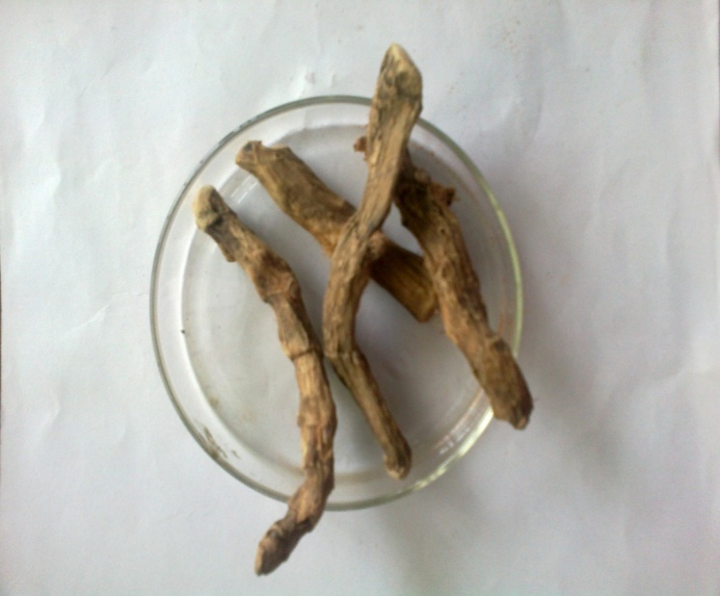
PLATE-I
SWEET FLAG

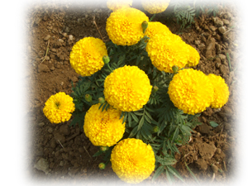
PLATE-II
MARIGOLD

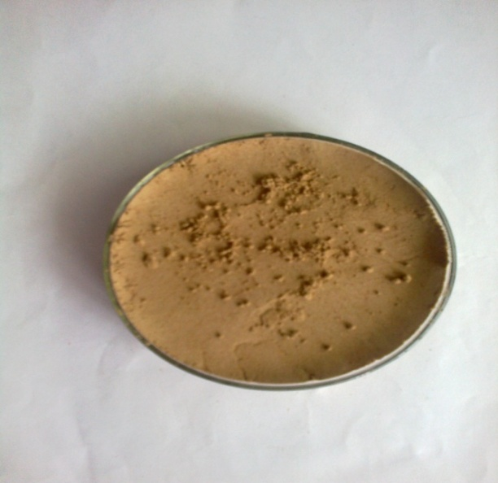
PLATE-III
POWDERED SWEET FLAG

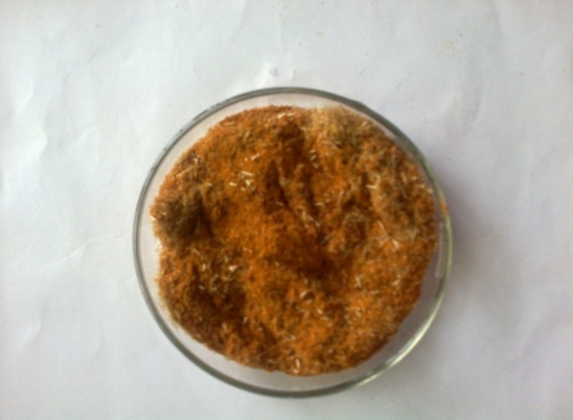
PLATE-IV
POWDERED MARIGOLD

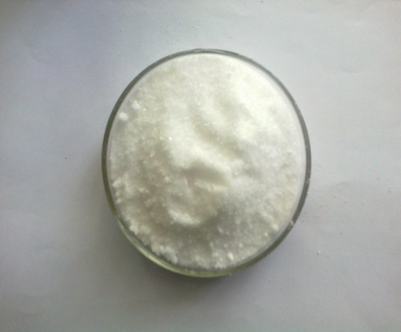
PLATE-V
CITRIC ACID
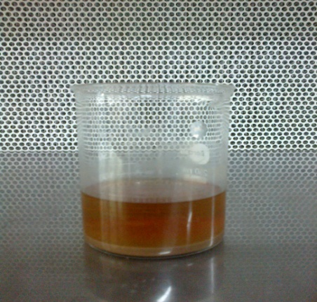
PLATE-VI
SOURCE SUBJECTED FOR EXTRACTION

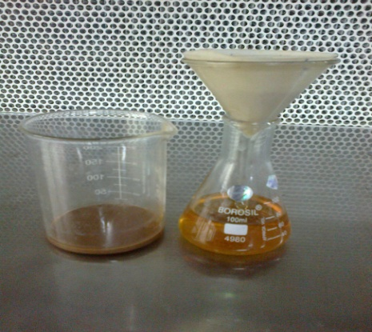
PLATE-VII
SEPERATION OF EXTRACTION

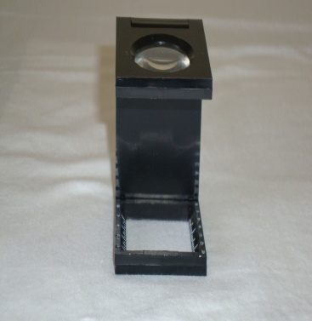
PLATE-VIII
PICK GLASS

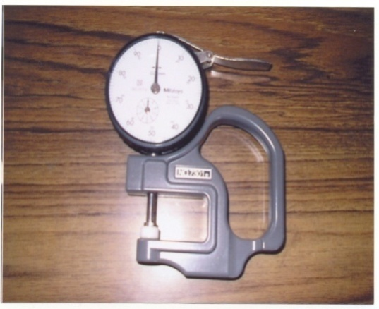
PLATE-IX
FABRIC THICKNESS TESTER
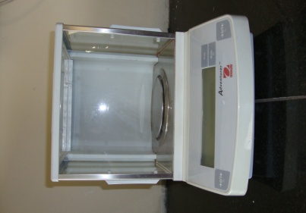
PLATE-X
ELECTRONIC WEIGHING BALANCE

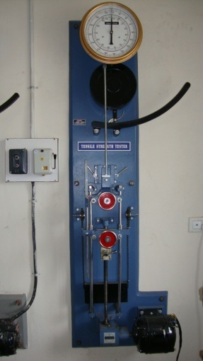
PLATE-XI
FABRIC TENSILE STRENGTH TESTER
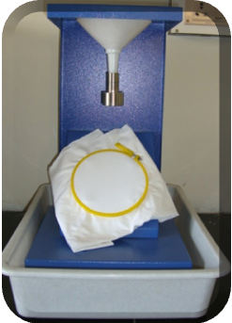
PLATE-XII
DROP TEST

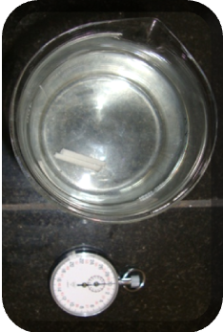
PLATE-XIII
SINKING TEST

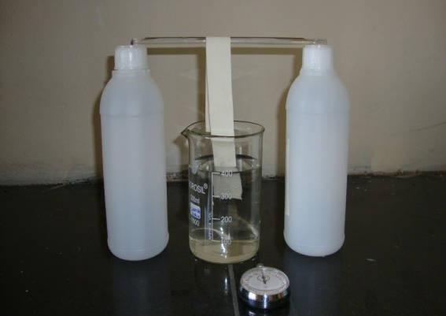
PLATE-XIV
CAPILLARY RISE TEST

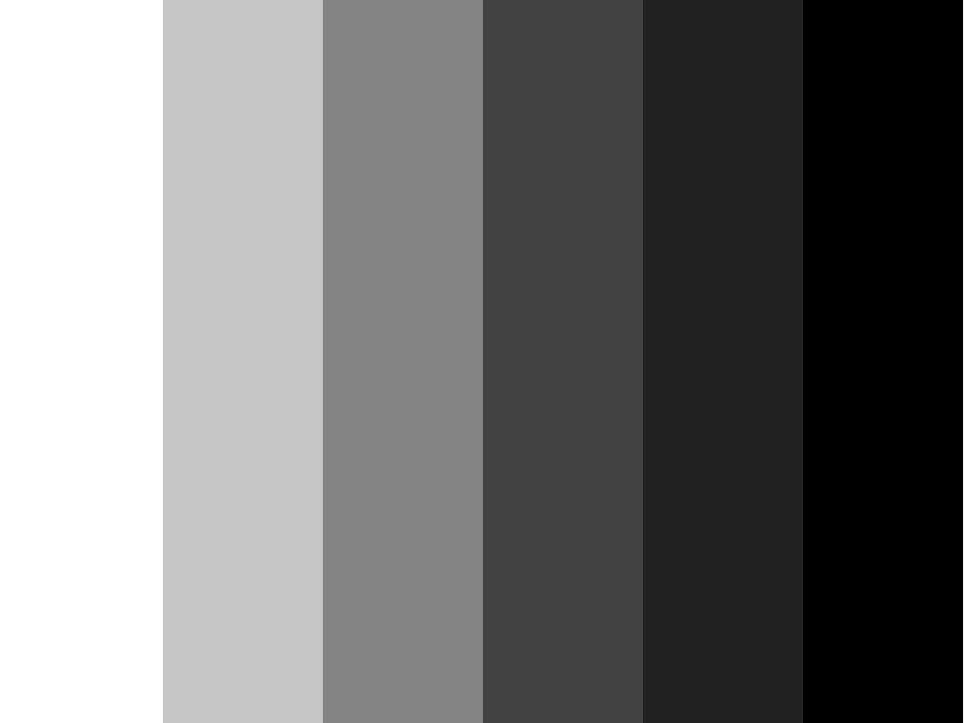
PLATE-XV
GREY SCALE


PLATE-XVI
CROCK METER

4. RESULTS AND DISCUSSION
4.1. Subjective Evaluation
4.1.1. Visual inspection
4.2. Objective Evaluation
4.2.1. Fabric Weight
4.2.2. Fabric Thickness
4.2.3. Fabric Strength- Warp
4.2.4. Fabric Strength- Weft
4.2.5. Fabric Elongation- Warp
4.2.6. Fabric Elongation- Weft
4.2.7. Wettability and Absorbency test

4.1. SUBJECTIVE EVALUATION
4.1.1. Visual Inspection

The visual inspection of the desized as well as antimicrobial finished sample is presented below

Samples | General appearance |  |  | Texture |  |  | Lustre
 | Excellent | Good | Fair | Coarse | Rough | Smooth | High | Medium | Low
DC | 8 | 12 | - | - | 12 | 8 | 9 | 9 | 2
FC | 9 | 11 | - | - | 5 | 15 | 2 | 16 | 2

- General Appearance
As regard the general appearance, it is clear that the desized and antimicrobial finished samples were rated as good. Eight members out of 20 rated desized as excellent and 9 out of 20 rated finished sample as excellent.
- Texture
Regarding the texture, the antimicrobial finished sample, was rated as smooth by15 members and 8 for desized sample.
- Luster
The desized and antimicrobial finished samples were rated as medium lustured by 9 and 16 members respectively.

4.2.1. FABRIC WEIGHT
The Table I represents the results pertaining to fabric weight of desized cotton and antimicrobial finished cotton.
TABLE I
FABRIC WEIGHT
S.No | Sample | Mean ± SD  (gm) | Gain / Loss  Over original | Percent  Gain/ Loss | ‘t’ value
1  2 | DC  FC | 2.15 ± 0.008  2.17 ± 0.008 | 0.02 | 0.93 | 3.38*

*significant at 5% level
From the Table I and Figure 1, it is evident that the weight of treated fabric has increased by 0.93 percent when compared to original fabric. Though there is a mere difference in weight, an increase may be due to compactness of yarn along warp and weft directions. The statistical analysis shows that there is a significant difference of 5 percent between the original and the treated sample.

Fabric weight (g)
2.15
2.17
2
2.05
2.1
2.15
2.2
DC
FC
Figure 1
FABRIC WEIGHT

4.2.2. FABRIC THICKNESS
The Table II shows the result of thickness of the desized cotton and antimicrobial finished cotton.
TABLE II
FABRIC TICKNESS
S.No | Sample | Mean ± SD  (mm) | Gain / Loss Over original | percent  Gain/ Loss | ‘t’ value
1  2 | OC  FC | 0.21 ± 0.003  0.30 ± 0.006 | 0.09 | 42.86 | 32.31**

** - significant at 1% level
The Table II and Figure 2 show that, the thickness of the fabric increases upto 42.86 percent after treatment. The increased thickness of treated fabric is due to the compactness of the warp and weft yarns after the antimicrobial finishing. The statistical analysis also shows that there is a significant difference at 1 percent between the original sample and the finished sample.

0.24
0.3
0
0.05
0.1
0.15
0.2
0.25
0.3
Fabric thickness in mm
DC
FC
Figure 2
FABRIC THICKNESS

4.2.3. FABRIC TENSILE STRENGTH- WARP
The result regarding the strength of the desized cotton and antimicrobial finished cotton in warp direction is presented in Table IV.

TABLE III
FABRIC TENSILE STRENGTH - WARP

S.No | Sample | Mean ± SD  (kg) | Gain / Loss over original | Percent  Gain/ Loss | ‘t’ value
1  2 | DC  FC | 66.20 ± 2.58  69.40 ± 2.40 | 3.20 | 4.83 | 1.81*

* - significant at 5% level
Table III and Figure 3 reveal that, there is an increase in the tensile strength of 4.83 percent in the treated fabric. From the statistical analysis it can be noted that there is a significant difference of 5 percent between the original sample and the treated sample.

66.2
69.4
64
65
66
67
68
69
70
Tensile strength warp in kg
DC
FC
Figure 3
FABRIC TENSILE STRENGTH-WARP

4.2.4. FABRIC TENSILE STRENGTH-WEFT
The result of the fabric strength in weft direction is shown in the Table IV.

TABLE IV
FABRIC TENSILE STRENGTH - WEFT

S.No | Sample | Mean ± SD  (kg) | Gain / Loss  Over original | Percent  Gain/ Loss | ‘t’ value
1  2 | DC  FC | 52.00 ± 2.23  57.20 ± 1.78 | 5.20 | 10 | 3.63*

* - significant at 5% level
From Table IV and Figure 4, it is clear that there is an increase in the strength of 10 percent in antimicrobial treated fabric. The statistical analysis also reveals that there is a significant difference of 5 percent level with treated sample and original sample.

52
57.2
0
10
20
30
40
50
60
70
Tensile strength in kg
DC
FC
Figure 4
FABRIC TENSILE STRENGTH-WEFT

4.2.5. FABRIC ELONGATION-WARP
The result of fabric elongation in warp direction is presented in the Table V.

TABLE V
FABRIC ELONGATION-WARP

S.No | Sample | Mean ± SD  (inches) | Gain / Loss  Over original | Percent  Gain/ Loss | ‘t’ value
1  2 | DC  FC | 2.60 ± 0.13  3.50 ± 0.19 | 0.9 | 34.62 | 7.34**

** significant at 1% level
The Table V and the Figure 5 reveal that there is an increase in the elongation upto 34.62 percent for the antimicrobial treated sample when compared to the original sample. Statistical analysis shows that there is a significant difference of 1 percent with the treated sample and the original sample.

2.6
3.5
0
0.5
1
1.5
2
2.5
3
3.5
4
4.5
5
Elongation in inches
DC
FC
Figure 5
FABRIC ELONGATION-WARP

4.2.6. FABRIC ELONGATION-WEFT
The fabric elongation results in the weft direction is provided in the Table VI.

TABLE VI
FABRIC ELONGATION-WEFT

S.No | Sample | Mean ± SD  (inches) | Gain / Loss  Over original | Percent  Gain/ Loss | ‘t’ value
1  2 | DC  FC | 2.10 ± 0.14  2.24 ± 0.20 | 0.14 | 6.67 | 1.11*

* significant at 5% level
The Table VI and Figure 6 show that, there is an increase in the elongation of 6.67 percent in the antimicrobial treated fabric and the statistical analysis shows that there is 5 percent significant difference between the original and the antimicrobial treated sample.

2.1
2.24
0
0.5
1
1.5
2
2.5
3
Elongation in inches
DC
FC
Figure 6
FABRIC ELONGATION-WEFT

4.2.9. DROP TEST
The result for the drop test for both desized and treated is given in Table VII.

TABLE VII
DROP TEST
S.No | Sample | Mean ± SD  (sec) | Gain / Loss over original | Percent  Gain/ Loss | ‘t’ value
1  2 | DC  FC | 0.09 ± 0.015  0.11 ± 0.012 | 0.02 | 22.22 | 1.75*

* - significant at 5% level
From the Table VII and Figure 7, it is noted that the absorbency time of treated fabric has increased by 22.22 percent when compared with original sample. A wide difference in the absorbency is noted and the finished sample with herbal extract did not hinder the absorbency. The statistical analysis shows 5 percent significant difference with the original sample and the treated sample.

0.09
0.11
0
0.02
0.04
0.06
0.08
0.1
0.12
Time in sec
Absorbency time of
Original sample
Absorbency time of
treated sample
Figure 7
DROP TEST

4.2.7. SINKING TEST
The result of sinking test of original sample and treated sample is shown in Table VIII.
TABLE VIII
SINKING TEST
S.No | Sample | Mean ± SD  (sec) | Gain / Loss over original | Percent  Gain/ Loss | ‘t’ value
1  2 | DC  FC | 0.11 ± 0.008  0.15 ± 0.008 | 0.04 | 34.46 | 6.76**

** significant at 1% level
The Table VIII and Figure 8, reveal that there is an decrease in the sinking time of treated fabric by 34.46 percent than the original fabric. The application of herbal extracts to the fabric did not affect the sinking property of the fabric. The statistical analysis also show 1 percent significant difference between the original sample and the treated fabric.

0.11
0.15
0
0.02
0.04
0.06
0.08
0.1
0.12
0.14
0.16
Sinking time in sec

DC

FC
Figure 8
SINKING TIME

4.2.8. CAPILLAY RISE TEST
The result of the capillary rise of the desized and treated fabric is provided in Table
IX.
TABLE IX
CAPILLAY RISE
S.No | Sample | Mean ± SD  (sec) | Gain / Loss over original | Percent  Gain/ Loss | ‘t’ value
1  2 | DC  FC | 0.22 ± 0.006  0.24 ± 0.007 | 0.02 | 9.92 | 4.39**

** - significant at 1% level
The Table IX and Figure 9 show that there is an increase of 9.92 percent in the capillary rise time of antimicrobial treated fabric when compared with the original fabric. However the treatment with the herbal extract did not affect the absorbency of the fabric. The statistical analysis shows that there is a significant difference of 1 percent with the original sample and the treated sample.

0.22
0.24
0
0.05
0.1
0.15
0.2
0.25
0.3
Capillary rise time in sec

DC

FC
Figure 9
Capillary Rise Time

SUMMARY AND CONCLUSION
Increasing global competition in textile has created many challenges for textile researchers and industrialists. The rapid growth in technical textiles and their end uses has generated more opportunities for the application of innovative finishes Joshi et al. (2008). Textiles have always played a central role in the evolution of human culture by being at the forefront of both technological and artistic development. They are not just pertinent to clothing but also to the technical, medical and protective aspects. Among these medical textiles are the textile material that are used in medical field such as surgical apparels, bandages and orthopedic implants, are more susceptible to the attack of microbes due to its continuous exposure to the environment where microbes are present. The textile and mankind are to be protected from microbes and to avoid cross infection, a special finish like antimicrobial has become necessary. The mechanism of antimicrobial agents, which acts upon micro-organism, is either on the cell during the metabolism or within the core substances reveals, Sathiyanarayanan (2011).Antimicrobially finished fabric will protect the wearer for aesthetic, hygienic or medical purpose against bacteria, fungi, viruses and other microbes and also protect the fiber and textile substrate from bio-deterioration caused by moulds, mildew and also from other insects (New Cloth Market, 2008).
Nowadays, value addition in clothing has changed the global textile scenario. Research has quite convincingly shown that apparel consumers all over the world are demanding functionality in products that they use. This has led to the revolution in the functional finishes worldwide. Cotton is widely used for apparel due to its comfort property but it deteriorates bacterial degradation because of human perspiration, sweat provides a suitable shelter for bacterial growth, containing 1.4 million bacteria per gram which increases to 9000 million at 50 percent moisture level state Anjali and Snehal (2007).
Due to the environmental pollution caused by the chemical antimicrobial agents, customers are mostly going for eco-friendly products. There are many natural or herbal products which show antimicrobial activities. Proper extracts from different parts of diverse species exhibit antimicrobial properties states Chaudhari (2011). These finishes when applied to the fabric will reduce the adverse effect like staining, smell and degradation of fabric caused by microbes, which will minimize risk of infection. So this antimicrobial finishing using sweet flag and marigold extract can be used on the fabric like home textiles, apparels and also on medical textiles to prevent the transfer and growth of infectious microbes. Hence the investigator has made an attempt to extract and finish natural antimicrobial agent on cotton fabric, through the study on “A STUDY ON THE EFFECT OF SWEET FLAG AND MARIGOLD FOR ANTIMICROBIAL FINISHING ON COTTON” with the following objectives.
- To select and extract the natural antimicrobial agents from the selected herbs.
- To optimize parameters for finishing cotton fabric with selected source.
- To evaluate the effect of antimicrobial effect of selected source.
- To conduct test for the performance of antimicrobial treated fabric.
Experimental procedure
There are various textile fabrics produced worldwide, among those fabrics cotton is widely used for apparel, home furnishing and also for medical applications due to its property like high wet strength, bio-degradability, non-toxicity and softness. Thus, 100% plain weave cotton fabric was selected for the study. As a part of weaving cotton yarn should undergo certain sizing process, and before finishing this material should be removed from fabric completely as these materials hinder the finishing process. Hence the pretreatment of the fabric was done prior to antimicrobial finishing. Desizing was carried out to remove the starch present in the fabric by boiling and washing with 5 percent detergent solution at 60˚C, so as to prepare the fabric for finishing.
The usage of hazardous chemical agents for antimicrobial finishing will cause pollution and harmful to the skin. Therefore natural herbal extracts like sweet flag and marigold are selected for the study as they inherit antimicrobial property. For the extraction of antimicrobial agents from these sources, the hard stem of sweet flag and petals of marigold were collected, dried in shade and ground into fine powder which were then soaked in absolute ethanol in the ratio 1:5 and left closed for 24 hours then it is allowed to evaporate and the extract is filtered off. Citric acid was used as a fixing agent.
The optimization process was carried out to standardize where in the material in to liquor ratio was taken as 1:20, the extracted source were mixed in the ratio 20:20 where sweet flag, 20% and marigold 20% to obtain 40% concentration of the extract and the citric acid was taken as 20% (20gm/100ml of water) and it was mixed with the extract in the ratio 90:10. The pH value was maintained to neutral. Time and temperature opted were 90 minutes at 80˚C in water bath. Curing was carried out at 120˚C for 2 minutes. After finishing process the fabric must be evaluated for determining physical as well as mechanical properties. The nomenclature of the desized sample and the antimicrobial finished sample are given below:
Desized cotton sample - DC
Antimicrobial finished cotton sample - FC
The samples were tested for their properties like fabric count, weight, thickness, strength, elongation, colorfastness, wettability and absorbency. In addition the antimicrobial finished samples were subjected to agar diffusion test. Finally the readings obtained were analyzed statistically.

Findings
Subjective Evaluation
- As per visual inspection, the appearance of antimicrobial treated sample was rated as good, and also the texture of the treated sample was smooth and also lustrous than the original sample.
Objective Evaluation
- The antimicrobial finishing has increased the count of the fabric both in warp and in weft direction. This is due to compactness of the yarn after the removal of starch.
- There was maximum increase in the thickness of the fabric after finishing.
- After finishing there was an increase in the weight of the fabric. The weight increased to 0.93 percent than original sample.
- The tensile strength has increased in both the warp and weft direction after finishing, whereas, the warp strength was lesser when compared to weft.
- The elongation of the finished fabric increased in both the direction. There was an increase of 34.63 percent in warp and 6.67 percent increase in the weft direction.
- In colourfastness tests the finished sample, showed moderate to good colour fastness. In wet crocking the finished sample shows moderate fastness and in dry crocking the fastness was considerably good. In wash fastness and fastness to sunlight the sample shows moderate colour change.
- The antimicrobial finished sample, showed maximum wettability and absorbency. The antimicrobial treated sample showed more absorbency in drop test when compared to the desized sample.
- In sinking test the antimicrobial finished sample was rated as more absorbency in capillary test, the antimicrobial finished sample showed maximum wickability.
- The sample treated with sweet flag and marigold exhibits good antimicrobial activity. The antimicrobial treated sample was subjected to agar diffusion test using E-coli and Aspergillus.
- As per the result there was a reduction in the growth of bacterial and fungal colonies on the sample. This shows that the antimicrobial treated sample shows very good activity against microbial action.
- In pour plate method, a zone of inhibition is found to be 5mm for the sample and prove that the selected sources are excellent agents for antimicrobial finishing.

PLATES

PLATE-I
VASAMBU

PLATE-II
MARIGOLD

PLATE-III
POWDERED VASAMBU

PLATE-IV
POWDERED MARIGOLD

PLATE-V
CITRIC ACID
PLATE-VI
SOURCE SUBJECTED FOR EXTRACTION
PLATE-VII
SEPERATION OF EXTRACTION

PLATE-VIII
PICK GLASS
PLATE-IX
FABRIC THICKNESS TESTER
PLATE-X
ELECTRONIC WEIGHING BALANCE
PLATE-XI
FABRIC TENSILE STRENGTH TESTER
PLATE-XII
DROP TEST
PLATE-XIII
SINKING TEST

PLATE-XIV
CAPILLARY RISE TEST
PLATE-XV
GREY SCALE
PLATE-XVI
CROCK METER

APPENDIX-I
SELECTED FABRIC

Fabric : Cotton
Weave : Plain
Warp/inch : 82
Weft/inch : 65
Cost : Rs.72/m

APPENDIX-II
ANTIMICROBIAL FINISHED FABRIC

Antimicrobial Sources : Sweet Flag, Marigold

BIBLIOGRAPHY
BOOKS
- Ananth Narayanan and Paniker, C. K (2000), Textbook of Microbiology, 6th edition, Longman Ltd, Hyderabad.
- Amrit Dhillon (2007), “Roll up for India’s miraculour healing herbal cloth, but where’s the rub?”, The age 15th, Sep, 2007, New Delhi.
- ASTM (2000), Annual book for ASTM standards, p:81
- Bhattacharjee, S.K. (2004), “Hand book of medicinal plants”, Pointer publishers, Pg.55.
- Corbman, B., (1983), Fiber to Fabric, Gregg publications division, USA, Pp. 160,305.
- Dantyagi, S., (1983), Fundamental of Textile and Their Care, Orient Longman Ltd, New Delhi, p.11.
- Delukar, D., (1994), Household Textile and Laundry Work, Atma Ram and Sons, Delhi, p.40.
- Gohl, E.P.H and Vilensky (1999), Textile Science, CBS publishers and distributors, Delhi, Pp. 42,120,155.
- Kaplan (2001), Textile fibers, Chandigarh.
- Mahadevan, M.G, (2001), Textile Spinning Weaving and Designing, Abishek publication, Chandigarh, p.12.
- Manivasakam (1995), Water used in textile processing quality treatment and analyzing.
- Mishra, S.P., (2000), A text book of fiber science and technology, New Age International Ltd, New Delhi, Pp. 79,98.
- Mulick, P., (2001), text book of textile designing, kalyani publication, New Delhi, P.46.
- Roger (2000), Encyclopedia for medical plants, Vol: 2, Spain.
- Smith, G.D. and Jacobson, T.L., (2001), “Chemical Finishing of Textiles”, Woodhead publications, P. 165-166.
- Trivedi P.C. (2010), “Herbal Drugs and Biotechnology”, Pointer Publishers, Jaipur, Pg.190.
- Vidyasagar P.V. (2002), “Hand Book of Textiles”, Second Edition, A Mittal Publications, New Delhi, Pg.5.

JOURNALS
- Anjali Karolia and Snehal mendapara (2007), “Impacting antimicrobial and fragrance finish on cotton”, Indian journal of fiber and textile research, vol.32, March, Pp-99-104
- Bhattacharya, S.D and Patel, D.D (2004), “finishing and simultaneous dyeing of cotton”, The Indian textile journal, vol. LXIV, no.12, September, p.13.
- Deepti Gupta and Ankur Laha (2007), “antimicrobial activity of cotton fabric treated with quercus infectoria extract”, Indian journal of fiber and textile research, vol.32, March, Pp.88-92
- Dudeja, V.D, (2002), “role of human research development and IDT”, journal of textile association, January, vol.62, no.4, p.177
- Gautam, S. Mishra, a and Goel (2007), “Textile magazine”, vol.48, no.12, October, p.102
- Ganesh, P., (2009), “extreme textiles”, Asian textile journal, PP-75-76, September
- Gopalakrishnan, Mahendran, Aravindan, (2007), Asian Textile Journal, January, vol: 4, no. 1. P: 71.
- Joshi, M., Wazed Ali, S and Pawar, R., (2008), “Ecofriendly antimicrobial finishing of textile using bioactive agents based on natural products”, Indian journal of fiber and textile research, vol.34, September, p.259
- Kalidasan, S. (2008), “Indian textile journal”, January, vol. IXO, no.4, p.22
- Kavitha, Padmeshwini, Giridev, Neelakandan, (2006). “Antimicrobial finishes for textiles from plants synthetic fibers”, Vol. XXXV, No. 4, December/October.
- Pan, N.C., Day, A., Mahalanabis, K., (2000), colourage, January, vol. XLVI, no.1, p.15
- Rakshift, A.k and Hira, M.A (2003), “technologies for technical textiles in powerloom”, the Indian textile journal, vol 113, no.4, January, p.21.
- Ram, R.M., (2007), “Moisture management on cotton and its blend”, Colourage.
- Rathinamoorthy, R and Thilagavathi, G (2010), “antibacterial finishing for cotton fabric using terminalia chebbula fruit extract”, International journal of pharma research, June, vol.5, pp 79-85
- Mahalingam, N. (2006), “Cotton textiles often winder opportunities”, Textile magazine, vol.47, No.5, May, Pp. 72-76.
- Menezes, E. (2007), “organic cotton processing”, colourage, vol54, no.9-12, December, p.79.
- Sakthivel, J.C. (2009), “extraction properties and spinnability of mudar fiber”, vol.60, no.1, p11
- Sathianarayanan, M.P., Bhat, N.V.,Kokate, S.S. and Walnuj, V.E., (2009), “Antimicrobial finishing for cotton fabric from herbal products”, Indian journal of fiber and textile research, vol.35, march, p.50
- Sathianarayanan, M.P., Chaudhri. B.M. and Bhat, N.V (2011),” development of durable antimicrobial agent from ban- ajarani seed for cotton fabric”, Indian journal of fiber and textile research September, p.234
- Sekar, N. (2001), “Antibacterial finishes on cotton developments”, colourage, December, vol. XLVIII, no.12, p.37.
- Senthilkumar, M (2009), “right first time dyeing”, colourage, December
- Sharma, V.C., Pal, A. and Rao, J.V (2003)”Indian cotton”, The Indian textile journal,January, vol.113, no.10, p.23
- Shokla, S.R, (2005), “ Quality of raw material and the fiber”, Colourage, vol. LII, no.8, August, p.61
- Sidhu, S.P., Mahajan,S and Grewal, J (2005), “textile magazine”, March, vol.46, no.5, p.80
- Sivaramakrishnan, C.N (2007), “functional finishing agents”, colourage, vol 54, no. 1-4, January, p.52.
- Srinivasa, Krupanadhi, Rao, Shanmughappa, (2007), Diuretic activity of ethanolic extract of justicia beddomei leaves, Biomed, January, vol: 1, no: 4, p:368.
- Syed, Jawale (2006), Applications of herbs on fabrics, colourage, April, vol: LIII, no: 4, p: 129
- Thilagavathi, G and Kannian, T. (2008), “duel antimicrobial and blood repellent finishes for cotton hospital fabric”, Indian journal of fiber and textile research
- Watzel, A. and Eisenacher (2002), “ Indian textile journal”, October, vol.CXIII, no.1, Pp. 15,16

WEBSITES
- http://www.wikipedia.com
- http://www.fibertofashion.com
- http://bacteriamuseum.org/cms/Evolution/evolution-in-bacteria.html
- http://en.wikipedia.org/wiki/Eukaryote
- http;//www.herbs2000.com
- http://www.organicindia.com/marigold-facts-ph
- http://www.expresstextiles.com
- http://answers.com

